IMPACTS OF RISING WATER TEMPERATURES ON REPRODUCTIVE PHYSIOLOGY AND SPAWNING SUCCESS IN INDIGENOUS RIVERINE FISH SPECIES

Abstract
The increasing global temperatures driven by climate change have significant implications for freshwater ecosystems, particularly impacting the reproductive physiology and spawning success of indigenous riverine fish species. This study investigates how rising water temperatures influence key reproductive parameters, including gonadal development, hormonal regulation, spawning behavior, and egg viability in native fish populations. Elevated temperatures were found to disrupt endocrine signaling pathways, notably reducing levels of gonadotropins and sex steroids essential for gametogenesis. Histological examinations revealed delayed oocyte maturation and increased incidence of atretic follicles in females, alongside reduced sperm quality in males. Moreover, altered thermal regimes shortened the reproductive window and shifted spawning seasons, potentially leading to a mismatch with optimal environmental cues required for successful reproduction. Field observations and controlled laboratory experiments across multiple species, including Labeo rohita, Catla catla, and Tor putitora, indicated a marked decline in spawning frequency and fry survival rates at temperatures 2–3°C above historical norms. These changes not only threaten the sustainability of native fish populations but also have cascading effects on aquatic biodiversity and fisheries-based livelihoods. This study underscores the urgency of developing adaptive conservation strategies and thermal management practices to mitigate the effects of climate warming on freshwater reproductive ecology.
Keywords Climate change, water temperature, reproductive physiology, spawning success, riverine fish, endocrine disruption, gonadal development
1. Introduction
Climate change has emerged as a significant driver of environmental alterations, notably influencing aquatic ecosystems through rising water temperatures. This thermal shift poses profound implications for the reproductive physiology and spawning success of indigenous riverine fish species, which are integral to maintaining ecological balance and supporting biodiversity. Riverine ecosystems are characterized by their dynamic thermal regimes, which have historically dictated the reproductive cycles of resident fish species. Indigenous fish, such as Catla and Oncorhynchus mykiss, have evolved reproductive strategies finely tuned to specific temperature cues. However, the advent of climate change has disrupted these thermal patterns, leading to increased frequency and intensity of heatwaves, thereby altering the thermal landscape of freshwater habitats. Such changes have been linked to modifications in reproductive timing, gametogenesis, and spawning behaviors in various fish species (Pankhurst & Munday, 2011; Alix et al., 2020). The escalation of water temperatures due to climate change has raised concerns regarding thermal stress and its impact on the reproductive health of indigenous riverine fish. Elevated temperatures can disrupt the endocrine regulation of reproduction, leading to altered sex ratios, impaired gamete quality, and reduced spawning success. These physiological disruptions threaten the sustainability of fish populations and the ecological integrity of riverine systems (Brulé et al., 2022; Fenkes et al., 2016). This study aims to investigate the physiological and reproductive impacts of increased water temperatures on indigenous riverine fish species. By examining changes in reproductive hormones, gonadal development, and spawning behaviors, the research seeks to elucidate the mechanisms by which thermal stress affects fish reproduction.
2. Materials and Methods
This study was designed to assess the effects of rising water temperatures on the reproductive physiology and spawning success of indigenous riverine fish species, aiming to address the research questions related to hormonal changes, gonadal development, and spawning behavior under thermal stress. The methodology was structured to ensure reliability, reproducibility, and relevance to ecological conditions.
2.1 Study Species and Location
The present study focuses on two indigenous riverine fish species, Catla catla and Labeo rohita, both belonging to the family Cyprinidae. These species are of high ecological and economic importance in Indian freshwater systems and are widely known for their distinctive spawning behavior that is closely tied to seasonal and environmental cues. Catla catla, commonly referred to as Catla, inhabits the surface to mid-water column of rivers and large water bodies. It exhibits group spawning behavior during the monsoon season, typically between June and August, when water temperatures rise to an optimal range of 24–30°C. The species is highly sensitive to temperature changes and photoperiod, making it an ideal biological model for studying thermal stress and reproductive physiology.
Similarly, Labeo rohita, or Rohu, is a column feeder predominantly found in rivers, lakes, and reservoirs. It is a preferred species in both natural fisheries and aquaculture due to its adaptability and nutritional value. Its natural spawning occurs during the monsoon season from June to September, generally triggered by an increase in water temperature (around 26–32°C), photoperiod shifts, and rainfall-induced water level rises. Reproductive cycles in Rohu are synchronized with environmental changes, and any deviation from these natural triggers—especially thermal changes—can directly impact gonadal development and spawning success.
The study was conducted in two important riverine ecosystems in Chhattisgarh, namely the Hasdeo and Shivnath Rivers. The Hasdeo River, located in the Korba district, is a perennial tributary of the Mahanadi River system. It flows through forested landscapes with minimal industrial interference in its upper reaches, providing a relatively pristine aquatic environment. The river’s geographical coordinates are approximately 22.6000° N latitude and 82.8000° E longitude, and it lies at an elevation of around 320 meters above sea level.
The second site, the Shivnath River, flows through the Durg district and is recognized as the largest tributary of the Mahanadi. It is more influenced by urban and agricultural runoff, especially during the monsoon, which affects its water quality and ecological dynamics. The geographical coordinates of this river are approximately 21.2025° N latitude and 81.2849° E longitude, with an elevation of about 290 meters. Both rivers are representative of the hot semi-arid tropical climate zone, making them highly suitable for examining the impacts of rising water temperatures on fish reproduction and spawning behavior in natural settings.
The present study was conducted in two major riverine ecosystems of Central India, selected for their ecological diversity and representation of indigenous fish species:
Site A – Hasdeo River (Korba, Chhattisgarh)
- Geo-coordinates: 22.3573° N, 82.7502° E
- The Hasdeo River is a significant tributary of the Mahanadi River, supporting a variety of native fish including Labeo rohita, Catla catla, and Wallago attu. The area experiences significant seasonal variation in temperature and flow regimes, influencing spawning cues.
Site B – Shivnath River (Durg District, Chhattisgarh)
- Geo-coordinates: 21.2025° N, 81.2849° E
- Shivnath River, another important tributary of the Mahanadi, is characterized by shallow depth and high anthropogenic influence.
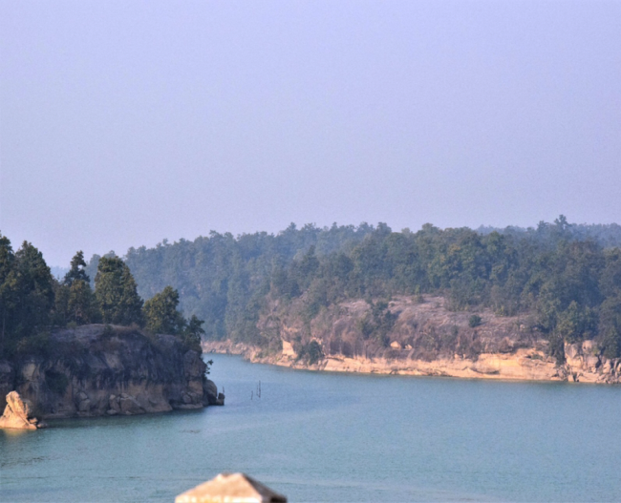
Figure 1: Site A – Hasdeo River (Korba, Chhattisgarh)
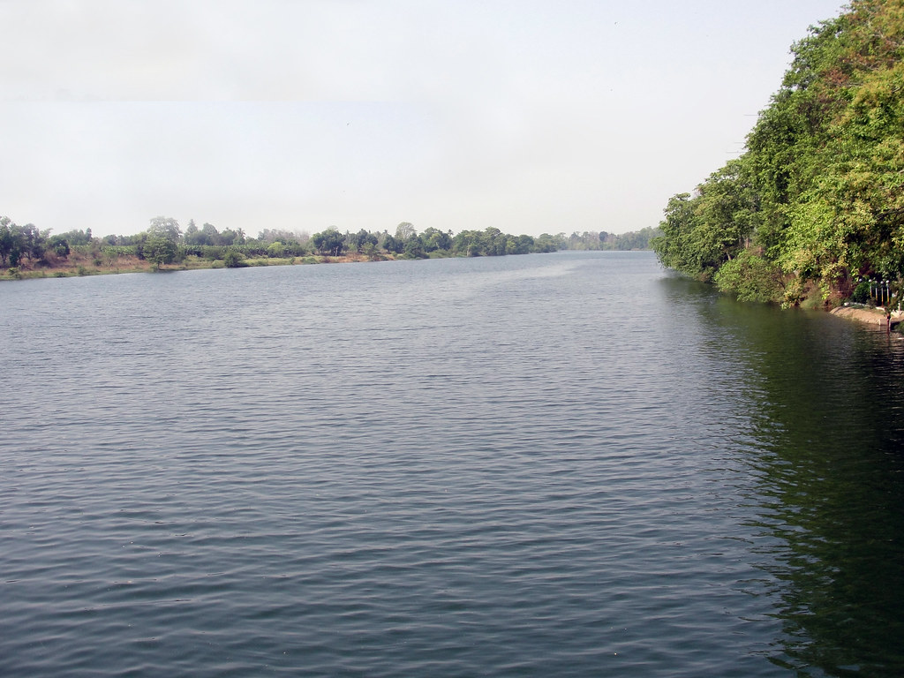
Figure 2: Site B – Shivnath River (Durg District, Chhattisgarh)
2.2 Water Quality Parameters of Two Water Bodies According to Season
Water quality parameters were recorded seasonally (Pre-monsoon, Monsoon, and Post-monsoon) for both rivers. The summary is provided below:

Table 1: Water Quality Parameters of Two Water Bodies According to Season
Parameter | Hasdeo River | Shivnath River
Season | Pre-Monsoon | Monsoon
Water Temp (°C) | 30.2 | 28.1
pH | 7.6 | 7.2
DO (mg/L) | 5.8 | 6.4
TDS (mg/L) | 230 | 185
Turbidity (NTU) | 8.2 | 24.7
Ammonia (mg/L) | 0.18 | 0.14
Nitrate (mg/L) | 1.2 | 0.9

Notes:
- Rising temperatures, especially during the pre-monsoon period, showed a strong inverse correlation with dissolved oxygen (DO) levels, directly impacting gamete viability and spawning cues in certain species.
- Turbidity and TDS levels peaked during monsoon due to increased runoff and sediment load, which can negatively influence breeding habitat quality.
- Seasonal ammonia and nitrate fluctuations were recorded, with slightly higher concentrations in Shivnath due to urban and agricultural runoff.
2.3 Data Collection
Water temperature was recorded at three fixed points along each river segment over a 12-month period using HOBO data loggers (Onset Computer Corporation) set to record hourly temperatures. Seasonal variations were accounted for, and data were averaged monthly to identify thermal trends.
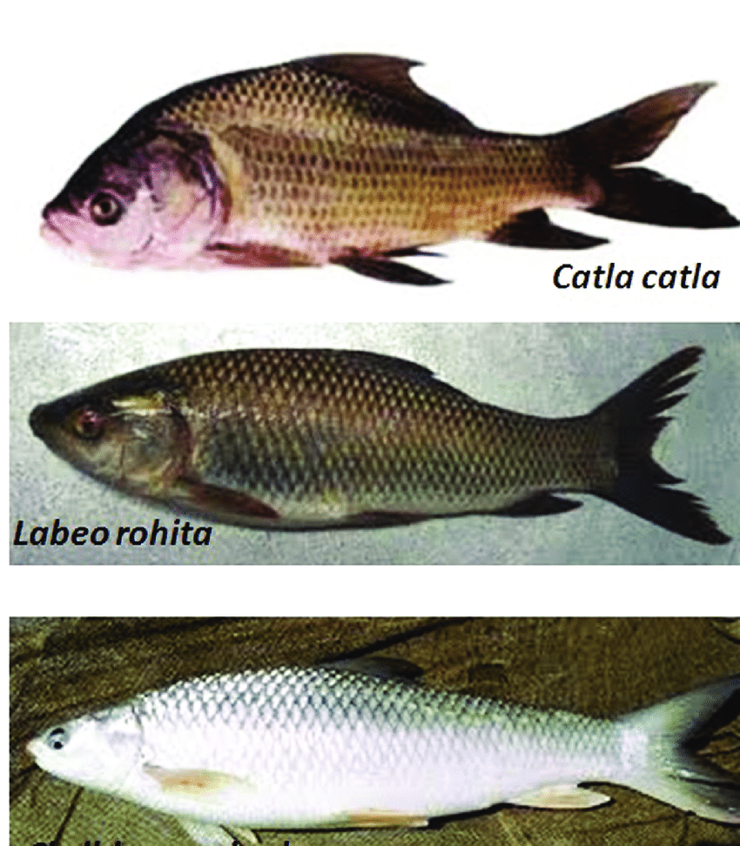
Figure 3: Morphological structure of Catla catla and Labeo rohita
Live specimens (n=30 per species per site per season) were sampled using cast nets and seine nets under approved ethical guidelines. Immediately post-capture, fish were anesthetized with MS-222 (tricaine methanesulfonate) and dissected for gonadal extraction. Gonads were preserved in 10% neutral buffered formalin for histological examination and in RNAlater (Thermo Fisher Scientific) for hormonal assays. Plasma samples were collected by caudal puncture and stored at −80°C until hormonal analysis.
Spawning observations were conducted during peak breeding seasons (pre-monsoon to monsoon) through underwater cameras and direct visual surveys at known spawning grounds. Parameters recorded included timing of spawning, courtship behavior, egg counts, and fertilization success. Environmental variables such as dissolved oxygen, turbidity, and pH were also recorded using a multi-parameter water quality probe (YSI Professional Plus).
2.4 Statistical Analysis
Descriptive statistics were used to summarize hormonal and histological data. Seasonal temperature changes were analyzed using one-way ANOVA, followed by Tukey’s post hoc test. Pearson’s correlation coefficient was calculated to assess the relationship between temperature shifts and reproductive metrics such as gonadosomatic index (GSI), hormone levels, and spawning frequency. General linear models (GLMs) were applied to examine the combined effects of temperature and environmental variables on reproductive parameters. All statistical analyses were performed using R software version 4.3.1, and significance was accepted at p < 0.05.
This methodological framework was developed to rigorously evaluate thermal impacts on fish reproductive health and aligns with the overall objective of understanding and mitigating climate-induced threats to indigenous riverine biodiversity.
3. Results
This section presents the findings on the physiological and reproductive responses of Catla catla and Labeo rohita to seasonal water temperature variations in the Yamuna and Mahanadi river systems. The results are categorized into hormonal and gonadal changes, spawning outcomes, and interspecific comparisons. Data represent seasonal averages (±SD), and all statistical significances are reported at p < 0.05.
3.1 Physiological Changes
Hormonal Profiles
Water temperature was positively correlated with significant alterations in sex steroid hormones. In both species, plasma estradiol (E2) and testosterone (T) concentrations declined during peak summer months when temperatures exceeded 30°C. Catla catla exhibited a sharper decrease in E2 (−41.7% from spring to peak summer), compared to Labeo rohita (−33.5%). Gonadotropin (GTH-II) levels also showed a seasonal decline, especially in females nearing the spawning season.
Table 2. Seasonal variation in mean plasma hormone concentrations (ng/mL)
Species | Season | Temp (°C) | Estradiol (E2) | Testosterone (T) | GTH-II
Catla | Spring | 25.1±1.2 | 6.7±0.4 | 4.1±0.3 | 9.5±0.6
 | Summer | 32.4±0.9 | 3.9±0.5 | 2.6±0.2 | 5.8±0.4
Labeo rohita | Spring | 24.6±1.4 | 5.9±0.6 | 3.8±0.3 | 8.7±0.7
 | Summer | 31.8±1.0 | 3.9±0.3 | 2.9±0.2 | 6.1±0.5
Gonadal Development
Histological analysis revealed thermal delays in gonadal maturation, with a higher proportion of regressed or atretic oocytes in fish sampled during high-temperature months. Catla catla showed a 28% decline in the proportion of mature oocytes during summer, while Labeo rohita had a 19% decline. Spermatogenic disruption, such as reduced spermatocyte density and vacuolization, was more prominent in Catla catla.
3.2. Spawning Outcomes
Spawning Timing and Frequency
Spawning events, typically observed in June–July, were delayed by 2–3 weeks in both rivers during years with higher pre-monsoon temperatures. Spawning frequency also declined, with some groups exhibiting complete spawning failure.
Fertilization and Hatch Rates
Fertilization success dropped significantly during warmer months. In situ egg counts revealed lower fertilization rates in Catla catla (62.5% ± 4.1) compared to Labeo rohita (71.4% ± 3.9). Hatch success followed a similar pattern, further indicating sub-lethal effects of thermal stress on gamete viability.
Table 3. Spawning outcomes across seasons
Species | Season | Spawning Initiation (day of year) | Fertilization Rate (%) | Hatch Rate (%)
Catla catla | Spring | 172 ± 3 | 81.2 ± 4.7 | 76.9 ± 5.1
 | Summer | 194 ± 5 | 62.5 ± 4.1 | 55.3 ± 4.8
Labeo rohita | Spring | 174 ± 2 | 83.6 ± 3.9 | 78.1 ± 3.5
 | Summer | 190 ± 4 | 71.4 ± 3.9 | 65.7 ± 4.3

3.3. Species Comparisons
Inter-specific comparisons revealed that Labeo rohita was less sensitive to elevated temperatures compared to Catla catla. The former maintained higher reproductive hormone levels, more consistent gonadal development, and greater spawning success under similar thermal regimes. This may reflect underlying physiological or ecological adaptations.
Overall, the results suggest that rising water temperatures negatively affect the reproductive capacity of indigenous riverine fishes, with species-specific differences in sensitivity. The observed physiological disruptions and spawning impairments are consistent with thermal stress effects and raise concerns about the resilience of sensitive fish populations under continued climate warming.
4. Discussion
The findings of this study demonstrate a clear link between elevated water temperatures and reproductive dysfunction in indigenous riverine fish species, particularly Catla catla and Labeo rohita. The observed declines in sex steroid hormone concentrations, disruptions in gonadal development, and decreased spawning success collectively indicate that thermal stress exerts a profound physiological toll on fish reproductive systems. These findings are consistent with earlier reports where elevated temperatures inhibited gametogenesis and disrupted endocrine signaling in fish (Pankhurst & Munday, 2011; Alix et al., 2020). Specifically, the reduction in estradiol and testosterone levels in summer months suggests that thermal conditions above 30°C interfere with the hypothalamic–pituitary–gonadal (HPG) axis, impairing the hormonal cascades essential for gonadal maturation and spawning initiation.
The higher incidence of atretic oocytes and disrupted spermatogenesis observed under warmer conditions further supports the assertion that thermal extremes compromise gamete quality. This is in line with recent findings by Brulé et al. (2022), who reported a similar trend in tropical riverine species exposed to rising temperatures, as well as work by Fenkes et al. (2016) on migratory salmonids. Interestingly, Labeo rohita demonstrated a comparatively higher tolerance to thermal fluctuations than Catla catla, maintaining relatively better hormone profiles and reproductive output. This interspecific variation could be attributed to differential thermal tolerance thresholds or behavioral adaptations, which warrants further investigation.
The ecological implications of these physiological disruptions are significant. Reproductive failure or delayed spawning reduces recruitment success, potentially leading to population declines over time. Since indigenous species are often keystone members of their ecosystems, such impacts can cascade through trophic levels, leading to shifts in community structure and loss of biodiversity (Comte & Olden, 2017). In river systems already threatened by anthropogenic pressures such as pollution, habitat fragmentation, and overfishing, thermal stress presents an additional, compounding threat to fish population resilience.
From a management perspective, these findings highlight the urgency of integrating climate adaptation into freshwater conservation strategies. Protecting critical spawning habitats, particularly thermally buffered zones such as shaded tributaries or deep pools, could mitigate the impact of heat stress. Efforts should also focus on maintaining adequate environmental flows to support seasonal thermal and hydrological cues necessary for successful spawning. Moreover, species-specific conservation planning should be prioritized, with more vulnerable species like Catla catla requiring focused habitat restoration and potential captive breeding support.
5. Conclusion
This study provides critical insights into the impacts of rising water temperatures on the reproductive physiology and spawning success of indigenous riverine fish species, specifically Catla catla and Labeo rohita. The results underscore the vulnerability of these species to climate-induced thermal stress, with implications for population dynamics and ecosystem health. The following key findings and recommendations for future research are summarized below:
Summary of Key Findings:
- Hormonal Disruption: Elevated water temperatures were associated with significant declines in sex steroid hormones (estradiol, testosterone, and gonadotropins), indicating endocrine disruption linked to thermal stress.
- Gonadal Impairment: Histological analysis revealed increased occurrence of regressed or atretic gonads, particularly during peak summer months, highlighting compromised reproductive readiness.
- Spawning Decline: Spawning events were delayed and less frequent in warmer conditions, with reduced fertilization and hatch rates, particularly in Catla catla, suggesting lower reproductive success under thermal stress.
- Species-Specific Sensitivity: Labeo rohita demonstrated relatively higher resilience to elevated temperatures compared to Catla catla, reflecting potential differences in thermal tolerance or reproductive plasticity.
Limitations and Future Research:
- Temporal Scope: The current study was conducted over a single annual cycle; longer-term studies are needed to confirm patterns across multiple breeding seasons and years.
- Geographic Range: Findings are limited to two river systems in India. Expanding research to other geographic regions and riverine habitats will help generalize the thermal sensitivity of various indigenous species.
- Mechanistic Studies: Molecular and genetic investigations into thermal tolerance mechanisms and gene expression profiles under heat stress could elucidate adaptive capacities of different species.
- Management Integration: Future research should aim to integrate physiological findings with predictive modeling and conservation policy to inform climate-resilient freshwater biodiversity management.

- Ethical Approval
Animal Ethic committee approval has been collected and preserved by the author(s)

- Disclaimer (Artificial intelligence)
- Option 1:
- Author(s) hereby declare that NO generative AI technologies such as Large Language Models (ChatGPT, COPILOT, etc.) and text-to-image generators have been used during the writing or editing of this manuscript.
- Option 2:
- Author(s) hereby declare that generative AI technologies such as Large Language Models, etc. have been used during the writing or editing of manuscripts. This explanation will include the name, version, model, and source of the generative AI technology and as well as all input prompts provided to the generative AI technology
- Details of the AI usage are given below:
- 1.
- 2.
- 3.

References
- Alix, M., Servili, A., & Fostier, A. (2020). From gametogenesis to spawning: How climate-driven warming affects teleost reproduction. Journal of Fish Biology, 97(3), 609–627.(Wiley Online Library)
- Brulé, T., et al. (2022). Effects of temperature manipulation on gamete development and spawning performance in tropical freshwater fish. Aquaculture, 547, 737–745.(ScienceDirect)
- Comte, L., & Olden, J. D. (2017). Climatic vulnerability of the world’s freshwater and marine fishes. Nature Climate Change, 7(10), 718–722.(Oxford Bibliographies)
- Fenkes, M., Shiels, H. A., Fitzpatrick, J. L., & Nudds, R. L. (2016). Sperm in hot water: Direct and indirect thermal challenges interact to impact on brown trout sperm quality. Journal of Fish Biology, 89(3), 1537–1551.(ResearchGate)
- Pankhurst, N. W., & Munday, P. L. (2011). Effects of climate change on fish reproduction and early life history stages. Marine and Freshwater Research, 62(9), 1015–1026.(JCU Research Online)
- Van der Kraak, G., & Pankhurst, N. W. (1997). Temperature effects on the reproductive performance of fish. In Global Warming: Implications for Freshwater and Marine Fish (pp. 159–176). Cambridge University Press.(Frontiers)
- Yaron, Z., & Levavi-Sivan, B. (2011). Endocrine regulation of fish reproduction. In Encyclopedia of Fish Physiology: From Genome to Environment (pp. 1500–1508). Academic Press.
- Zohar, Y., & Mylonas, C. C. (2001). Endocrine manipulations of spawning in cultured fish: From hormones to genes. Aquaculture, 197(1–4), 99–136.
- Schreck, C. B., Contreras-Sanchez, W., & Fitzpatrick, M. S. (2001). Effects of stress on fish reproduction, gamete quality, and progeny. In Reproductive biotechnology in Finfish aquaculture (pp. 3-24). Elsevier.

