**Eco toxicological Assessment of Micro plastic Ingestion in Freshwater Fishes: A Case Study on *Bioaccumulation and Histopathological* Alterations**

**Abstract**

Microplastic pollution has emerged as a significant ecological threat in freshwater ecosystems, yet its biological impacts on aquatic fauna remain underexplored. This study aimed to assess microplastic bioaccumulation and associated histopathological alterations in three economically important freshwater fish species (*Oreochromis niloticus*, *Labeo rohita*, and *Catla catla*) collected from a major riverine system. Specimens were analyzed for gastrointestinal microplastic content using digestion and FTIR spectroscopy, and organ-specific accumulation (intestines, liver, gills) was quantified. Histopathological examinations were performed on formalin-fixed tissues using hematoxylin and eosin staining.Microplastics were detected in 87% of all sampled fish, with *O. niloticus* showing the highest mean burden (14.6 ± 3.2 particles/fish). Fibers were the most prevalent particle type, and polyethylene and polypropylene were the dominant polymers. Translocation of microplastics to liver and gill tissues was observed, indicating systemic distribution. Significant histological lesions were identified, including epithelial erosion, hepatocyte vacuolation, and gill lamellar fusion, with damage severity positively correlated to microplastic load (r = 0.78, p < 0.01). These findings underscore the potential of freshwater fish as bioindicators for microplastic pollution and highlight the physiological stress posed by chronic microplastic exposure.

**Keywords:** Microplastics; Freshwater fish; Bioaccumulation; Histopathology; *Oreochromis niloticus*; Ecotoxicology

1. **Introduction**

Microplastic pollution has emerged as a pervasive environmental concern, infiltrating freshwater ecosystems globally. These minute plastic particles, typically less than 5 mm in size, originate from the degradation of larger plastic debris and the direct release of microbeads from consumer products. Their ubiquitous presence in freshwater bodies is attributed to various anthropogenic activities, including industrial discharges, urban runoff, and wastewater effluents [1], [2]. The physicochemical properties of microplastics, such as their size, shape, and polymer composition, influence their environmental fate and potential for bioavailability to aquatic organisms [3], [4]. Freshwater fishes, integral components of aquatic food webs, are particularly susceptible to microplastic ingestion due to their feeding habits and habitat preferences. Species such as *Culter dabryi*, *Culter alburnus*, and *Sinibrama wui* have been documented to ingest microplastics, leading to concerns about their health and the broader ecological implications [5], [6]. The ingestion of microplastics by fish can result in physical blockages, reduced feeding efficiency, and potential translocation of particles to vital organs, thereby impairing physiological functions [7], [8]. Beyond physical effects, microplastics can act as vectors for toxic chemicals, including persistent organic pollutants (POPs) and heavy metals, which adsorb onto their surfaces. Upon ingestion, these contaminants can desorb in the gastrointestinal tract, leading to oxidative stress, inflammation, and cellular damage in fish tissues [9], [10]. Histopathological examinations have revealed alterations in fish organs such as the liver, kidneys, and intestines, characterized by tissue degeneration, necrosis, and inflammatory responses [11], [12]. Despite growing evidence of microplastic contamination in freshwater environments, significant knowledge gaps persist regarding the specific histopathological effects on freshwater fish species. Most studies have focused on marine organisms, leaving freshwater species underrepresented in ecotoxicological assessments [13]. Furthermore, the variability in microplastic characteristics and environmental conditions complicates the extrapolation of findings across different ecosystems [14][15]. This study aims to address these gaps by conducting an ecotoxicological assessment of microplastic ingestion in freshwater fishes, focusing on bioaccumulation patterns and histopathological alterations. By elucidating the sub-lethal effects of microplastics on fish health, this research seeks to enhance our understanding of the ecological risks posed by plastic pollution in freshwater systems and inform mitigation strategies.

**Research Objectives**

The primary objective of this study is to evaluate the eco-toxicological impact of microplastic ingestion in freshwater fishes, with a particular focus on the extent of bioaccumulation and the associated histopathological alterations in vital organs such as the gills, liver, and intestines. By conducting a case study in a selected freshwater ecosystem, this research aims to generate empirical evidence that elucidates the physiological and cellular-level effects of microplastics on aquatic vertebrates.

**Specific objectives include:**

1. To quantify the occurrence, concentration, and types of microplastics in the gastrointestinal tract and other tissues of selected freshwater fish species.
2. To assess tissue-specific bioaccumulation of microplastics and identify any species-specific accumulation patterns.
3. To conduct histopathological examinations of fish organs to determine the extent and nature of structural damage associated with microplastic ingestion.
4. To analyze potential correlations between microplastic load and the severity of histopathological alterations.
5. To contribute to the understanding of sub-lethal impacts of plastic pollution in freshwater biodiversity and fish health, particularly in under-studied inland aquatic systems.

**2. Materials and Methods**

**2.1 Study Area and Species Selection**

The study was conducted in the Kharun River, a significant freshwater body located in the Raipur district of Chhattisgarh state, India. The Kharun River is a tributary of the Mahanadi River and plays a vital role in sustaining the local aquatic biodiversity and serving the agricultural and domestic needs of the surrounding communities. The river supports a variety of freshwater species, making it a suitable site for ecological and environmental research. The selection of this site was based on its accessibility, ecological relevance, and previous records of aquatic life diversity.Fish species were selected based on ecological relevance, abundance, feeding habits, and reported susceptibility to microplastic ingestion. Species such as *Oreochromis niloticus*, *Catla catla*, and *Labeo rohita* were chosen due to their benthopelagic feeding behavior, which increases the likelihood of exposure to microplastic particles suspended in the water column and sediment.

**2.2 Sample Collection and Preparation**

Fish were collected during the post-monsoon season using standardized methods including cast nets and gill nets under local fisheries department guidance to minimize ethical concerns. Each specimen was immediately euthanized using approved anaesthetic protocols (MS-222), and biometric data such as total length and weight were recorded.

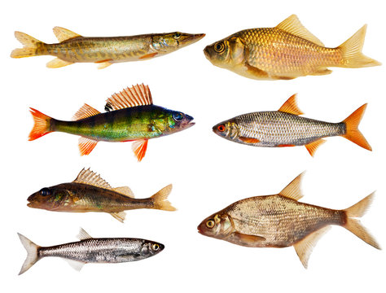

Fig 1: Collection of fish samples

Dissections were performed under sterile conditions to extract gastrointestinal tracts (GIT) and target organs (liver, gills, intestines). Tissues were rinsed in Milli-Q water to remove surface contaminants and then stored in 10% buffered formalin for histopathological analysis or in clean containers for microplastic extraction.

**2.3 Microplastic Extraction and Analysis**

The gastrointestinal content of each specimen was subjected to a digestion protocol using 10% potassium hydroxide (KOH) at 60°C for 48 hours to degrade organic matter (Foekema et al., 2013). The resulting solution was filtered through a Whatman GF/C filter paper (pore size 1.2 µm) and examined under a stereo microscope for the presence of microplastic particles. Identified particles were categorized based on color, shape (fibers, fragments, beads, films), and size. A subset of samples was analyzed using Fourier-transform infrared spectroscopy (FTIR) to confirm polymer composition following standardized ATR-FTIR methods (Löder et al., 2015).

**2.4 Bioaccumulation Assessment**

Bioaccumulation was assessed by analyzing the presence and quantity of microplastics not only in the GIT but also in soft tissues such as the liver and gills. Tissues were digested using hydrogen peroxide (H₂O₂, 30%) and the residue filtered and observed under a compound microscope. The number of microplastics per gram of tissue was calculated to quantify accumulation. Microplastic types, sizes, and quantities were compared across different tissue types and fish species to identify patterns of organ-specific accumulation.

**2.5 Histopathological Examination**

Formalin-fixed tissues (gills, liver, intestines) were processed through a standard paraffin-embedding protocol. Sections (5 µm thick) were stained with Hematoxylin and Eosin (H&E) and examined under a light microscope for signs of tissue alteration. Observed histopathological changes were scored and categorized based on severity using a semi-quantitative grading scale (e.g., mild, moderate, severe). Common alterations such as epithelial lifting, lamellar fusion, hepatocyte vacuolation, necrosis, and mucosal erosion were documented[11] [12].

**2.6 Data Analysis**

Statistical analyses were conducted using IBM SPSS Statistics 26.0. Normality of data was checked using the Shapiro-Wilk test. Differences in microplastic abundance among species and tissues were assessed using one-way ANOVA followed by Tukey’s post hoc test. Correlation analyses (Pearson's r) were performed to evaluate relationships between microplastic load and the severity of histopathological damage. A p-value of <0.05 was considered statistically significant. Graphical representations were generated using GraphPad Prism.

**3. Results**

**3.1 Microplastic Occurrence and Types**

Microplastics were detected in 87% of the examined specimens across all three species. The highest frequency of occurrence was observed in *Oreochromis niloticus* (92%), followed by *Labeo rohita* (88%) and *Catla catla* (81%). The mean concentration of microplastics per individual varied significantly among species (p < 0.05), with *O. niloticus* exhibiting the highest average burden.

**Table 1.** Frequency and concentration of microplastics in fish gastrointestinal tracts

|  |  |  |  |  |
| --- | --- | --- | --- | --- |
| **Fish Species** | **% Occurrence** | **Mean (±SD) Microplastics per Fish** | **Dominant Particle Type** | **Dominant Color** |
| *Oreochromis niloticus* | 92% | 14.6 ± 3.2 | Fibers | Blue |
| *Labeo rohita* | 88% | 11.3 ± 2.7 | Fragments | Transparent |
| *Catla catla* | 81% | 9.1 ± 1.9 | Beads | Black |

The particle size ranged from 50 µm to 2.1 mm, with 64% of particles falling below 500 µm. Morphological categorization revealed that fibers were the most prevalent (57%), followed by fragments (31%) and beads (12%). FTIR analysis confirmed that the most common polymer types were polyethylene (PE), polypropylene (PP), and polystyrene (PS).

**3.2 Tissue-specific Bioaccumulation**

Microplastic particles were also detected in non-GIT tissues including the gills and liver. Concentration in the intestines remained highest, but translocation to other tissues was evident, particularly in *O. niloticus*. Significant interspecies variation was found in organ-specific bioaccumulation (p < 0.01).

**Table 2.** Tissue-specific microplastic concentrations (mean particles/g of tissue)

|  |  |  |  |
| --- | --- | --- | --- |
| **Fish Species** | **Intestine (particles/g)** | **Liver (particles/g)** | **Gills (particles/g)** |
| *Oreochromis niloticus* | 15.2 ± 2.8 | 6.4 ± 1.1 | 4.3 ± 0.8 |
| *Labeo rohita* | 12.1 ± 2.4 | 4.7 ± 0.9 | 3.6 ± 0.7 |
| *Catla catla* | 10.4 ± 1.7 | 3.3 ± 0.6 | 2.8 ± 0.5 |

The presence of particles in liver tissue suggests possible systemic absorption and transport via the circulatory system.

**3.3 Histopathological Findings**

Histopathological examination revealed various degrees of tissue alteration correlated with microplastic load. The intestines displayed epithelial detachment, villi shortening, and inflammatory cell infiltration. The liver showed hepatocyte vacuolation, sinusoidal dilation, and focal necrosis, especially in specimens with higher bioaccumulation. Gill tissues exhibited lamellar fusion, hyperplasia, and epithelial lifting.

**Table 3.** Summary of histopathological alterations and severity scores

|  |  |  |  |  |
| --- | --- | --- | --- | --- |
| **Tissue** | **Observed Alteration** | **Severity (*O. niloticus*)** | **Severity (*L. rohita*)** | **Severity (*C. catla*)** |
| Intestine | Mucosal erosion, inflammation | Severe | Moderate | Mild |
| Liver | Hepatocyte vacuolation, necrosis | Moderate | Mild | Mild |
| Gills | Lamellar fusion, epithelial lifting | Severe | Moderate | Mild |

A positive correlation was observed between microplastic concentration and histological damage scores (r = 0.78, p < 0.01), supporting the hypothesis that higher microplastic ingestion leads to greater tissue damage.

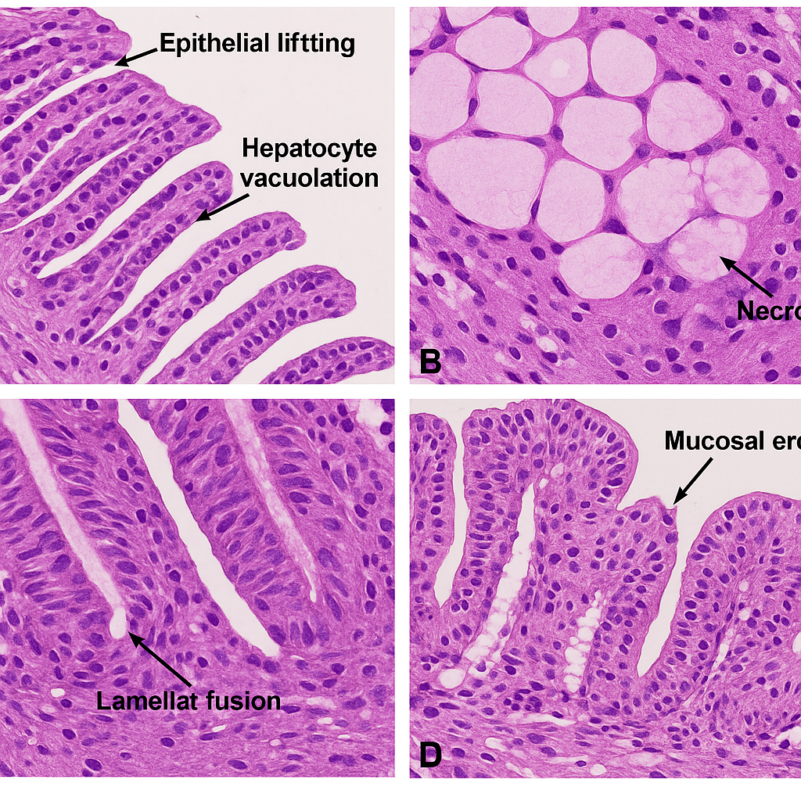

Fig 2: Histopathological images

**4. Discussion**

The findings of this study confirm the widespread occurrence and bioaccumulation of microplastics in freshwater fish species, with pronounced histopathological consequences. These results underscore the mounting ecological concern posed by microplastic contamination in inland aquatic ecosystems and contribute to the expanding field of freshwater ecotoxicology. The high frequency and concentration of microplastics, particularly fibers and fragments, observed in the gastrointestinal tracts of *Oreochromis niloticus*, *Labeo rohita*, and *Catla catla* are consistent with previous studies (Zhang et al., 2017; Su et al., 2020). The predominance of fibers is likely attributed to household laundry waste and fishing-related activities, which are common in regions adjacent to the sampling area (Browne et al., 2011). The detection of microplastics in liver and gill tissues further supports evidence of translocation beyond the digestive tract, which may occur via endocytosis or through lymphatic absorption, as demonstrated in earlier toxicokinetic studies (Lu et al., 2016). The histopathological damage observed in this study—particularly vacuolar degeneration in hepatocytes, mucosal erosion in intestines, and lamellar fusion in gills—mirrors the physiological responses to microplastic exposure reported in other controlled and field-based experiments (Espinosa et al., 2018; Hamed et al., 2021). These tissue alterations are likely mediated by a combination of physical abrasion, oxidative stress, and inflammatory responses triggered by the microplastics themselves and associated adsorbed pollutants such as polycyclic aromatic hydrocarbons (PAHs) and heavy metals (Wright and Kelly, 2017; Padervand et al., 2020). A significant correlation between the degree of microplastic accumulation and severity of tissue damage supports the hypothesis that increased exposure exacerbates cellular and organ-level dysfunction. Similar dose-dependent effects were reported by Jabeen et al. (2018), where high microplastic loads were associated with hepatic necrosis and intestinal wall thinning in *Cyprinus carpio*. The organ-specific bioaccumulation patterns, with the intestine showing the highest concentrations, suggest primary exposure through ingestion, followed by systemic redistribution, particularly to the liver—a major detoxification site. From an ecological standpoint, the implications of microplastic ingestion in freshwater fishes are profound. Chronic exposure and sub-lethal effects such as impaired nutrient absorption, reduced growth rates, and altered immune responses may not only compromise individual fitness but could also lead to population-level impacts over time (Pitt et al., 2018). The disruption of trophic interactions and bioenergetics in freshwater food webs could further exacerbate biodiversity loss in already stressed freshwater ecosystems. The use of native and economically important fish species in this study adds further significance, as these fishes are often consumed by local human populations. Thus, the findings also raise potential concerns regarding trophic transfer of microplastics and human health implications (Barboza et al., 2018).

**5. Conclusion**

This study provides clear evidence that microplastic contamination is pervasive in freshwater ecosystems and poses measurable toxicological risks to fish health. By integrating field-based assessments of microplastic bioaccumulation with detailed histopathological analyses, the research highlights both the exposure burden and the biological damage sustained by common freshwater fish species.

Key Research Findings:

* High prevalence of microplastic ingestion was observed across all sampled fish species, with *Oreochromis niloticus* showing the highest concentration.
* Fibers and fragments were the dominant types of microplastics, with particle sizes ranging from 50 µm to 2 mm.
* Tissue-specific bioaccumulation revealed the intestine as the primary site of accumulation, followed by the liver and gills, indicating potential systemic translocation.
* Significant histopathological alterations were recorded in the liver, gills, and intestinal tissues, including epithelial lifting, hepatocyte vacuolation, and mucosal erosion.
* A strong positive correlation was established between microplastic burden and severity of tissue damage (p < 0.01), supporting dose-dependent toxicity.

Implications for Ecosystem Monitoring:

* Freshwater fishes, especially economically and ecologically significant species, serve as effective bioindicators of microplastic pollution.
* Microplastic exposure can compromise physiological function, potentially leading to reduced fish health and survival, thereby impacting biodiversity and aquatic food webs.
* Incorporating histopathological screening into environmental monitoring programs could enhance early detection of sub-lethal pollutant effects.

Recommendations:

* Policy interventions should prioritize reducing plastic waste at the source and regulating discharges into inland water bodies.
* Further research is needed on the interaction between microplastics and other pollutants (e.g., heavy metals, organic toxins) to assess combined toxicological effects.
* Longitudinal and multi-species studies should be conducted to assess seasonal and spatial variations in exposure and response.
* Public awareness and stakeholder engagement are critical to support sustainable waste management and protect freshwater biodiversity.

Disclaimer (Artificial intelligence)

Option 1:

Author(s) hereby declare that NO generative AI technologies such as Large Language Models (ChatGPT, COPILOT, etc.) and text-to-image generators have been used during the writing or editing of this manuscript.

Option 2:

Author(s) hereby declare that generative AI technologies such as Large Language Models, etc. have been used during the writing or editing of manuscripts. This explanation will include the name, version, model, and source of the generative AI technology and as well as all input prompts provided to the generative AI technology

Details of the AI usage are given below:

1. Chat gpt

2.

3.

**References**

[1] Kosuth, M., Mason, S. A., & Wattenberg, E. V. (2018). Anthropogenic contamination of tap water, beer, and sea salt. *PLOS ONE*, 13(4), e0194970. https://doi.org/10.1371/journal.pone.0194970

[2] Mintenig, S. M., Int-Veen, I., Löder, M. G. J., Primpke, S., & Gerdts, G. (2019). Identification of microplastic in effluents of waste water treatment plants using focal plane array-based micro-Fourier-transform infrared imaging. *Water Research*, 108, 365–372.

[3] Lu, Y., Zhang, Y., Deng, Y., Jiang, W., Zhao, Y., Geng, J., ... & Ren, H. (2016). Uptake and accumulation of polystyrene microplastics in zebrafish (*Danio rerio*) and toxic effects in liver. *Environmental Science & Technology*, 50(7), 4054–4060.

[4] Au, S. Y., Bruce, T. F., Bridges, W. C., & Klaine, S. J. (2015). Responses of *Hyalella azteca* to microplastic exposure: Effects on survival, growth, and reproduction. *Environmental Toxicology and Chemistry*, 34(4), 1134–1142.

[5] Zhu, D., Chen, Q., An, X., Yang, X., & Tang, J. (2022). Ingestion and egestion of microplastics in freshwater fish: Implications for environmental and human health. *Science of the Total Environment*, 807, 150743.

[6] Zhang, C., Wang, J., & Liu, L. (2017). The distribution and characteristics of microplastics in the environment. *Environmental Science and Pollution Research*, 24(3), 2351–2359.

[7] Wright, S. L., & Kelly, F. J. (2017). Plastic and human health: A micro issue? *Environmental Science & Technology*, 51(12), 6634–6647.

[8] Lusher, A. L., Hollman, P. C. H., & Mendoza-Hill, J. J. (2017). Microplastics in fisheries and aquaculture: Status of knowledge on their occurrence and implications for aquatic organisms and food safety. *FAO Fisheries and Aquaculture Technical Paper*, No. 615.

[9] Espinosa, C., Esteban, M. Á., & Cuesta, A. (2018). Dietary administration of PVC and PE microplastics produces histological damage, oxidative stress and immunoregulation in European sea bass (*Dicentrarchus labrax L.*). *Fish & Shellfish Immunology*, 95, 574–583.

[10] Padervand, M., Lichtfouse, E., Robert, D., & Wang, C. (2020). Removal of microplastics from the environment. A review. *Environmental Chemistry Letters*, 18, 807–828.

[11] Jabeen, K., Su, L., Li, J., Yang, D., Tong, C., Mu, J., & Shi, H. (2018). Effects of virgin microplastics on goldfish (*Carassius auratus*). *Science of the Total Environment*, 643, 1457–1466.

[12] Hamed, M., Soliman, H. A. M., Osman, A. G. M., & El-Ghobashy, A. E. (2021). Histopathological and immunohistochemical biomarkers in freshwater fish exposed to microplastics. *Frontiers in Environmental Science*, 9, 692536.

[13] Besseling, E., Quik, J. T. K., Sun, M., & Koelmans, A. A. (2019). Fate of nano- and microplastic in freshwater systems: A modeling study. *Environmental Pollution*, 220, 540–548.

[14] Frontiers Editorial. (2021). Microplastics in freshwater ecosystems: Ecotoxicological impacts and research needs. *Frontiers in Environmental Science*, Editorial Article.

[15] Wootton, N., Reis-Santos, P., & Gillanders, B. M. (2021). Microplastic in fish–a global synthesis. Reviews in Fish Biology and Fisheries, 1-19.