Short Research Article

First Breeding Record and Photographic Documentation of the Indian Pitta (Pitta brachyura) in Ajmer, Rajasthan

.
ABSTRACT
Aims: The aim of this study is to identify the sites of occurrence of the Indian Pitta (Pitta brachyura) in Ajmer and its surrounding areas, which possess ecological features conducive to the species' presence.
Place and Duration of Study: The study was carried out at Aravalli hill ranges of Ajmer, Rajasthan, India. From May 2023 to May 2025.
Methodology: A total of 171 study grids of 1 km2 was marked in the study area. We used Line transect, Road transect, Point observations and Acoustic observations to record the presence of Indian Pitta.
Results: Indian Pitta was recorded and photographed at three sites of study, two nests at different sites were also recorded indicating the breeding of Indian Pitta in Ajmer, Rajasthan.
Conclusion: This article provides first photographic record of Indian Pitta from Aravalli’s of Ajmer, Rajasthan along with confirmation of its breeding in this area. The results will be pivotal for further studies that focuses on conservation of Indian Pitta and other Aravalli birds.

Keywords: Indian Pitta, Ajmer, Birds, Aravalli, Biodiversity

1. INTRODUCTION

Six species of Pittidae family are found in India. The migratory Indian Pitta Pitta brachyura is one of the six species breeds mainly in the plains and foothills of the Himalayas, winters in South India and Sri Lanka (Jathar & Rahmani 2007; Grimmett et al. 2011; Ganpule 2016). The Indian Pitta favors broad-leaved deciduous and semi-deciduous forests with extensive undergrowth, particularly damp places dominated by bamboo, prickly plants, and scrub jungle for foraging (Lambert & Woodcock 1996). Its nests are mostly made in the multifurcations of the lower branches of trees (Kala 2008). There is no sexual dimorphism in the species except that the width of the coronal stripe might differ between the sexes (Harper 1903). The species status is Least Concern (BirdLife International 2024).
Ajmer and its surrounding landscapes serve as an ecotonal range between Thar desert and semi-arid biogeographic zone in India (Choudhary et al., 2022), nestled within the Aravalli range, are notable for their rich diversity of terrestrial bird species (Upadhyay et al., 2020; Choudhary et al., 2020), making the region a significant site for birdwatching and ecological studies. The varied topography ranging from scrub forests and rocky outcrops to dry grasslands supports a wide array of ground-dwelling and low-canopy birds (Choudhary et al., 2025a; 2025b). Species such as the Indian Courser (Cursorius coromandelicus), Yellow-wattled Lapwing (Vanellus malabaricus), Indian Thick-knee (Burhinus indicus), and Painted Sandgrouse (Pterocles indicus) are commonly found in these open habitats. The region is also home to several species of larks, pipits, and quails, including the Barred Buttonquail (Turnix suscitator) and Rain Quail (Coturnix coromandelica), which are well-adapted to the arid and semi-arid conditions. These birds contribute to the ecological balance by aiding in seed dispersion and insect population control. Other than birds this region supports several other taxonomic groups like Lepidopterans (Jangid et al., 2016; Sharma et al., 2023, Choudhary et al., 2024) and Reptiles (Singh et al., 2022; Sharma et al., 2024). The unique combination of terrain, climate, and limited urban interference in certain pockets allows Ajmer’s terrestrial bird population to thrive, marking the area as an important zone for avian terrestrial biodiversity in Rajasthan. Here we report the first photographic record of Indian pitta and confirmation of breeding from Ajmer, Rajasthan.

2. material and methods

Study Area
This study was carried out in the Aravalli hill ranges in Semi-arid biogeographic zone of Ajmer, Rajasthan, India from June 2023 to June 2025. The study site included sparse vegetation dominated by small- to medium-sized Prosopis juliflora, Acacia tortilis and Acacia senegal trees, ranging from four to eight meters in height. The broader surrounding landscape was characterized as semi-arid scrubland and thorn forest, featuring Ziziphus mauritiana, Capparis decidua, and scattered stands of Anogeissus pendula. The forest floor was generally dry, with limited leaf-litter and patches of exposed rocky soil. The terrain around the study area was gently undulating with scattered rocky outcrops, seasonal rivulets, and agricultural plots interspersed with rural settlements. The region receives an average annual rainfall of approximately 400–600 mm, concentrated between July and September during the southwest monsoon.
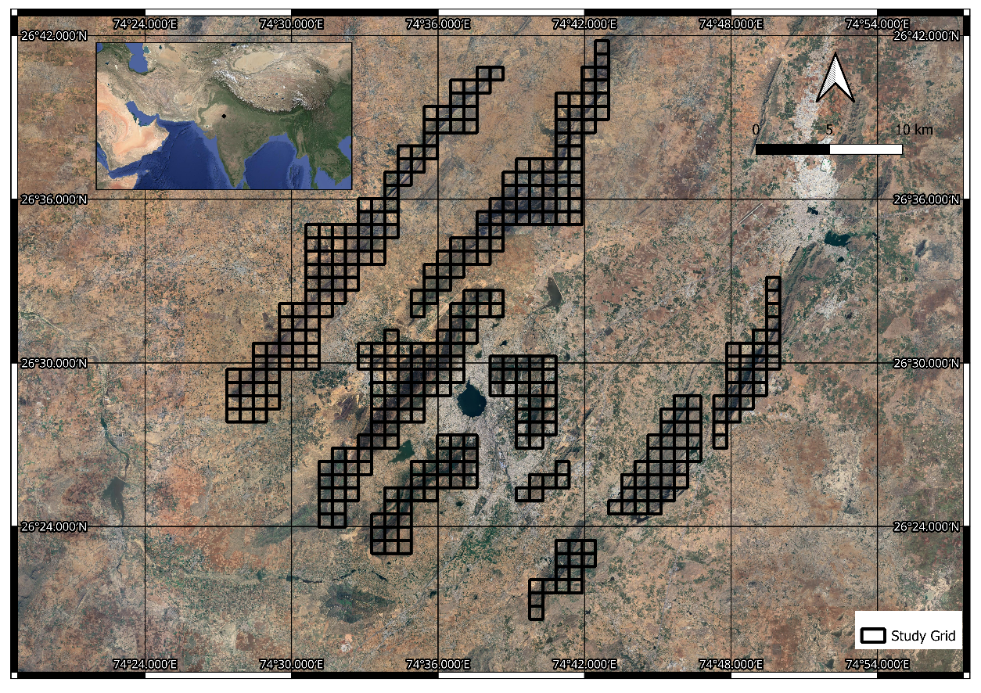
Figure 1: Study area divided into grids of same size.

Methodology
Fieldwork was carried out between May 2023 to May 2025. 171 grids of 1 km² were marked in the study area (Fig.1), covering the onset and peak of the Indian Pitta’s known breeding season (May-July) in northwestern India. Surveys were carried out during the early morning (05:30 to 08:30 hrs) and late evening (17:30 to 19:00 hrs), coinciding with peak activity of Indian Pitta. To maximize detection probability, a combination of road transects, line transects, and point count observations was employed across varied habitat patches. Road transect surveys were conducted by slow-moving vehicle or on foot along drivable forest trails and village access roads. Observers moved at a speed of ~10 km/h, recording all visual or auditory detections of Indian Pittas. Each transect was surveyed multiple times to increase reliability. Line transects were laid out across scrubland and hill slopes where vehicle access was limited. Observers walked slowly along predetermined straight paths, recording all individual birds seen or heard within a fixed width (typically 50 m, i.e., 25 m on either side). Point counts were conducted at fixed stations located every 200–300 m along each transect. Observers remained stationary at each point for 10–15 minutes and recorded all Indian Pittas seen or heard within a 50 m radius. This method was particularly useful in denser vegetation or areas with complex terrain. High-resolution photographs and videos were taken using a Canon EOS 90D DSLR with a 100–400mm lens. Audio recordings of vocalizations were captured using a directional microphone for comparison with known call records from Xeno-canto and eBird and compared using RavenPro software. All sightings were confirmed using standard field guides (Grimmett et al., 2011) and vetted with experienced ornithologists. GPS coordinates, behavior, and ecological notes were logged digitally in field data sheets. Data were organized and analyzed to identify breeding patterns and compare with known regional and national records.

3. results and discussion

During the study conducted across 171 grids in and around the Ajmer region of Rajasthan, the Indian Pitta was recorded in only three grids (Fig. 2), indicating a patchy and localized presence within the landscape. Observations spanned both 2024 and 2025, with evidence ranging from vocalizations to confirmed breeding activity.
The first record was made in the valley region of the Aravalli hills at coordinates 26°29'25.9"N, 74°38'34.4"E, where a Indian Pitta was detected through its distinctive call in June 2024. The distinct two-noted whistle call of Indian Pitta was visualized as a spectrogram using raven pro software. The spectrogram shows a up slur of 0.5 sec and a down slur of 0.2 sec, frequency between 2 kHz to 3 kHz. The interval between both the notes remains around 0.2 seconds and matches with reference visualizations of calls downloaded from eBird and Xeno-canto, confirming the presence of Indian Pitta in the study area (Fig. 3).
A single sub-adult individual was later photographed in May 2025. No nesting activity was observed at this site, and the bird was solitary throughout the observation period.
A second record came from another valley section of the Aravalli range in May 2025 at 26°25'48.3"N, 74°36'38.2"E, where a breeding pair was observed in 2025. A total of four individuals were noted at the site, including possibly offspring or additional adults. Nest-building behavior was documented, with both adults seen collecting nesting material, confirming the onset of breeding activity.
The third confirmed site was an open woodland habitat at 26°33'11.4"N, 74°35'49.8"E, where another breeding pair was observed visually and through vocalizations on 2nd June 2025. A total of two individuals were documented, and a complete nest was found, indicating a slightly more advanced stage of breeding compared to the second site. Both observed nests were recorded on Acacia tortilis trees. Figure 4 shows the photographic evidences of Indian Pitta and its nesting in the area.
In all three locations (Table 1), the birds were detected both visually and acoustically, with calls typically heard during the early morning hours. Vocal activity was particularly high after brief pre-monsoon showers, aligning with known behavioral patterns of the species. Breeding activity was observed only in 2025, supporting the view that Indian Pitta's breeding in this region is likely triggered by seasonal climatic cues such as rising humidity and rainfall.
Notably, the confirmed breeding sites were located in habitats with dense undergrowth, natural leaf litter, and minimal human disturbance features critical for nesting and foraging. The presence of nests in two of the three locations, along with active breeding behaviors, represents the first photographic and breeding record of the Indian Pitta from the Ajmer region, contributing valuable data to the known distribution of the species in Rajasthan.

Table 1: Summary of Observations on Indian Pitta.
Site | Habitat Type | Coordinates (Lat/Long) | Detection Type | Notes | Year of Observation | Number of Individuals | Nest | Nesting Stage
1 | Valley region of Aravallies | 26°29'25.9"N 74°38'34.4"E | Visual & Call | Single Sub-adult, vocalizing | 2024 (Call Only); 2025 (Photographed | One | No | NA
2 | Valley region of Aravallies | 26°25'48.3"N 74°36'38.2"E | Visual & Call | Breeding pair observed | 2025 | Four | Yes | Nest building started
3 | Open woodland | 26°33'11.4"N 74°35'49.8"E | Visual & Call | Breeding pair observed | 2025 | Two | Yes | One Complete Nest

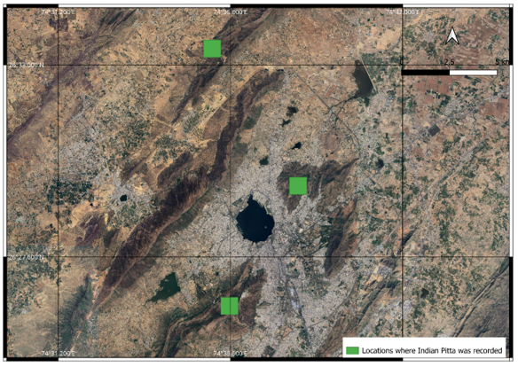
Fig 2: Observation locations of Indian Pitta.

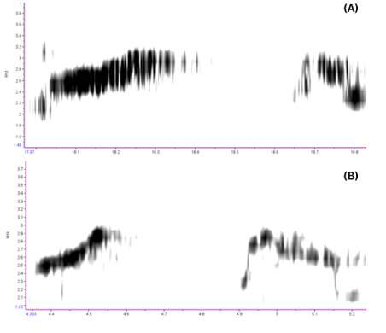

Figure 3: Spectrogram of Indian Pitta call recorded from study locations showing its distinct two-noted whistle call. A) Recorded in 2024 and B) in 2025.

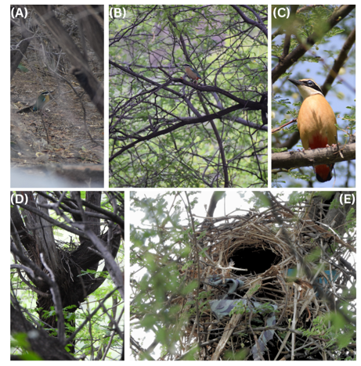

Figure 4: A-C Photographs of Indian Pitta from 3 different sites and D-E its nest at different sites and stages.

Conclusion
The present observations were made in May and June, which is when the Indian Pitta is known to nest (Chowdhury et al. 2013). The nest's position and description were in agreement with those of Solanki et al. (2018), who discovered that the nests were situated at the forks of trees. The materials used to build the nest that we saw were consistent with those described by Ali (1941) and Dharmakumarsinhji (1955), who note the use of fine twigs, grasses, roots, dry leaves, and other materials as nesting material.
Ajmer and the surrounding areas have been fascinating due to numerous notable observations of avian diversity, including endemic species like as the White-naped Tit, White-tailed Iora, Indian Spotted Creeper (Choudhary et al., 2025a, 2025b), and Oriental Pied Hornbill (Singh et al., 2025). Choudhary et al. (2024) reported many new species records from the Todgarh-Raoli Wildlife Sanctuary near Ajmer. Several anomalies, such as intersex plumage in Plum-headed Parakeets (Choudhary et al., 2024), erythrism in House Sparrows (Jangir et al., 2024), and brown plumage aberration in Indian Pied Starlings (Jangir et al., 2023), have been observed in Ajmer, making it a susceptible habitat for bird species. We conclude that it is the first published photographic record of Indian Pitta along with confirmation of its breeding from Ajmer. Occurrence of Indian Pitta is not previously documented in published records from Ajmer and the surrounding areas (Upadhyay et al., 2020; Das et al., 2022). Thus, this record adds a new species in fauna of Ajmer, Rajasthan.
Disclaimer (Artificial intelligence)
Option 1:
Author(s) hereby declare that NO generative AI technologies such as Large Language Models (ChatGPT, COPILOT, etc.) and text-to-image generators have been used during the writing or editing of this manuscript.
Option 2:
Author(s) hereby declare that generative AI technologies such as Large Language Models, etc. have been used during the writing or editing of manuscripts. This explanation will include the name, version, model, and source of the generative AI technology and as well as all input prompts provided to the generative AI technology
Details of the AI usage are given below:
1.
2.
3.
References

Ali S. The book of Indian birds. 1st ed. Bombay: Bombay Natural History Society; 1941. p. i–xxxix, 1–395.
BirdLife International. Species factsheet: Indian Pitta Pitta brachyura. 2024. Available from: https://datazone.birdlife.org/species/factsheet/indian-pitta-pitta-brachyura [Accessed 6 Jun. 2025].
Choudhary R, Dutta S, Jangir DK, Sharma V, Mathur P. A photographic record of Charaxes solon from Aravalli hills of Rajasthan, India. Bugs R All - Zoos' Print. 2024;39(11).
Choudhary R, Sharma V, Mathur P. Avifaunal composition of various microhabitats of southern Nagaur (Parbatsar, Kuchaman, Nawa and Makrana), Rajasthan. International Journal of Research – GRANTHAALAYAH. 2020;8(11):112–128. doi:10.29121/granthaalayah.v8.i11.2020.2318.
Choudhary R, Sharma V, Mathur P. Diurnal activity patterns of five distinct bird species in agricultural landscapes of Central Rajasthan during their non-breeding period in India. Journal of Agriculture and Environmental Science. 2022;7(2):59–68. doi:10.5281/jaes.v7i2.1226.
Choudhary R, Sharma V, Dutta S, Mathur P, Singh P, Sahu H. Habitat suitability for endemic and vulnerable White-Naped Tit (Machlolophus nuchalis) in arid and semi-arid landscapes of India. Journal of Landscape Ecology. 2025;18(2):125–138. doi:10.2478/jlecol-2025-0016.
Choudhary R, Sharma V, Jangir DK, Dutta S. Intersex plumage in Plum-headed Parakeet (Psittacula cyanocephala). Rivista italiana di Ornitologia - Research in Ornithology. 2024. doi:10.4081/rio.2024.807.
Choudhary R, Sharma V, Singh P, Dutta S. Area sensitivity & conservation strategies for three woodland bird species in arid and semi-arid landscapes of Rajasthan. Third National Conference of the Indian Regional Association for Landscape Ecology (IRALE 2025). 2025a. doi:10.13140/RG.2.2.29182.70728.
Choudhary R, Sharma V, Upadhyay M, Dutta S, Mathur P, Sahu H, Jangir DK. Additions to the avifauna of Todgarh-Raoli Wildlife Sanctuary, Rajasthan. Species. 2024;25(75):e19s1657. doi:10.54905/disssi.v25i75.e19s1657.
Chowdhury SU, Sourav MSH, Mohsanin S. Observations on the breeding of Indian Pitta Pitta brachyura in a human-dominated environment, Gazipur, Dhaka, Bangladesh. BirdingASIA. 2013;20:44–48.
Das S, Choudhary R, Sharma V, Chandra S, Mathur P. Vertical distribution of terrestrial birds in certain urban green spaces of Ajmer city, Rajasthan. International Journal of Creative Research Thoughts. 2022;10(9):c415–c424.
Dharmakumarsinhji RS. Birds of Saurashtra, India: with additional notes on the birds of Kutch and Gujerat. 1st ed. Bhavnagar, Saurashtra: Published by the author; [1955]. p. i–liii, 1–561.
Ganpule P. The birds of Gujarat: Status and distribution. Flamingo. 2016;8(3)–12(4):2–40.
Grimmett R, Inskipp C, Inskipp T. Birds of the Indian Subcontinent. 2nd ed. London: Oxford University Press & Christopher Helm; 2011. p. 1–528.
Harper EW. The sex of the Bengal Pitta Pitta brachyura. Avicultural Magazine [NS]. 1903;1(1):29.
Jangid A, Yadav Y, Meena D, Sharma V, Kachhawa JBS. Butterflies of Central Aravalli Ranges. Jaipur: Centre for Advanced Research and Development; 2016. ISBN: 978-93-85818-98-1.
Jangir DK, Choudhary R, Sharma V, Dutta S. First record of brown plumage aberration in Indian Pied Starling (Gracupica contra) from India. Ornis Hungarica. 2023;31(2):165–167. doi:10.2478/orhu-2023-0027.
Jangir DK, Choudhary R, Sharma V, Mathur P. Erythrism in House Sparrow (Passer domesticus): a record from Rajasthan, India. International Studies on Sparrows. 2024;45. doi:10.59443/ISSpar-2023-0004.
Jathar GA, Rahmani AR. Endemic birds of India. Buceros. 2007;11(2&3):1–53 [2006].
Kala H. Bird communities in different forest types of southern Aravalli Hills, north Gujarat, India [dissertation]. Tiruchirappalli, Tamil Nadu: Bharathidasan University; 2008.
Lambert FR, Woodcock M. Pittas, Broadbills and Asities. 1st ed. Mountfield, UK: Pica Press; 1996. p. 1–271.
Sharma B, Choudhary R, Sharma V, Dutta S, Chandra S. Community composition and dynamics of butterflies in different microhabitats of Central Aravalli Hill regions of Ajmer District, Rajasthan, India. African Journal of Biology. 2023;19(3):13–20. doi:10.9734/AJOB/2023/v19i3368.
Sharma V, Choudhary R, Dutta S, Singh P, Kumawat RK, Sharma KK. New sightings and habitat suitability mapping of endemic Platyceps gracilis (Günther, 1862). Biogeographia – The Journal of Integrative Biogeography. 2024;39(2). doi:10.21426/B6.39859.
Singh P, Choudhary R, Sharma V, Chandra S. Community composition and microhabitat preference by saurian fauna of MDS University campus and nearby areas of Central Aravalli foothills. 2022;4(2):1–5.
Singh P, Choudhary R, Sharma V, Dutta S. Sighting of Oriental Pied-Hornbills from arid region of Rajasthan, India. Zoos Print. 2025;40(2):24–25.
Solanki R, Upadhyay K, Patel MR, Bhatt RD, Vyas R. Notes on the breeding of the Indian Pitta Pitta brachyura. Indian BIRDS. 2018;14(4):113–118.
Upadhyay M, Vyas R, Sharma V, Mehra SP. Studies of the avifauna in urban limits of Ajmer, Rajasthan, India. International Journal of Research – GRANTHAALAYAH. 2020;8(3):281–296. doi:10.29121/granthaalayah.v8.i3.2020.159.

