**UNRAVELLING THE PAST, UNDERSTANDING THE PRESENT: A DEEP DIVE INTO INDIA'S INFECTIOUS DISEASE TRENDS- A REVIEW**

**ABSTRACT**

India is undergoing a complex triple transition—economic, demographic, and epidemiological—that is reshaping its public health priorities. Economic development and urbanization have improved infrastructure and access but have also contributed to lifestyle-related non-communicable diseases (NCDs). Simultaneously, demographic changes such as population aging have increased the vulnerability to chronic conditions. Despite this shift, communicable diseases (CDs) remain a major concern, especially in low Epidemiological Transition Level (ETL) states like Bihar, Jharkhand, and Uttar Pradesh. While the share of CDs in the total disease burden declined from 53.6% in 1990 to 27.5% in 2016, India still contributes 26% of global tuberculosis cases and over 65% of malaria cases in the WHO South-East Asia Region. The dual burden of CDs and NCDs imposes a significant economic burden, disproportionately affecting vulnerable populations due to persistent health inequities and poor access to care. This challenge is compounded by low public health expenditure, which stood at only 1.84% of GDP in 2019–20, and high out-of-pocket expenses (39.4%), increasing household financial strain. Addressing this requires a strengthened public health system—equitable, integrated, and adequately funded—to effectively manage the coexisting burdens of infectious and chronic diseases, and respond to the evolving needs of India’s transitioning population.

**Keywords**

Triple transition, epidemiological burden, public health expenditure, non-communicable diseases, Communicable diseases, Trends

**INTRODUCTION:**

The ongoing demographic and epidemiological transitions are placing unprecedented pressure on public health systems in low- and middle-income countries (LMICs). Addressing these challenges is crucial for ensuring the health and well-being of their population. These global health shifts are marked by a distinct transformation in disease burden, with a gradual shift from the predominance of communicable diseases (CDs) to a rising incidence of non-communicable diseases (NCDs). This epidemiological transition is deeply interlinked with concurrent social changes, such as urbanization, lifestyle modifications, and ageing populations, which collectively contribute to new and compounded health burdens in these regions. Despite advancements, LMICs continue to grapple with a dual burden of disease, wherein persistent infectious diseases coexist with the rising tide of NCDs, thereby complicating resource allocation and public health responses. (1)

Infectious diseases (IDs) remain a significant cause of morbidity and mortality in LMICs, contributing to substantial human suffering. These nations bear a disproportionately high burden of IDs compared to high-income countries, owing to factors such as limited access to healthcare, inadequate sanitation, and socioeconomic disparities. Over the past few decades, rapid economic growth in many LMICs has led to considerable improvements in public health infrastructure, including the widespread deployment of vaccines, enhanced diagnostics, improved therapeutics, and strengthened infection control practices. Nonetheless, these advancements have not fully mitigated the impact of IDs, which continue to hinder progress toward achieving health-related Sustainable Development Goals. (2) (3)

In the Indian scenario, the burden of these diseases remains substantial despite measurable progress in health indicators resulting from economic development, expanded immunization coverage, and the availability of antimicrobials. IDs continue to constitute a significant proportion of the national disease burden. Notably, four of the top ten leading causes of death in India are of infectious origin, with COVID-19 emerging as a prominent contributor in recent years.

According to the WHO, conditions related to communicable diseases, maternal health, perinatal health, and nutrition (CMPNDs) collectively account for approximately 38.4% of all deaths in India, underscoring the persistent public health challenge these conditions pose, even amidst considerable progress in disease prevention and control efforts.(4) Complementing this perspective, data from the India State-Level Disease Burden Initiative further illustrate the shifting landscape of morbidity and mortality. In 1990, the five leading contributors to disease burden in India were predominantly infectious in origin—namely, diarrheal diseases, lower respiratory infections, neonatal preterm birth complications, tuberculosis, and measles. However, the progression of the epidemiological transition has markedly altered this profile. By 2016, three of the five leading causes of disease burden had shifted to non-communicable diseases (NCDs), specifically ischemic heart disease, chronic obstructive pulmonary disease (COPD), and cerebrovascular disease. The remaining two—lower respiratory infections and neonatal disorders—retained an infectious etiology. Not only these, significant disparities were also observed across states. To provide a standardized comparative metric, the concept of the *Epidemiological Transition Ratio* (ETR) has been employed by researchers. This ratio is defined as the proportion of disease burden attributable to non-communicable diseases and injuries relative to that from communicable, maternal, neonatal, and nutritional diseases. An ETR greater than one indicates that a region has transitioned towards a predominance of NCDs and injuries. In 1990, only a few regions—specifically the states of Kerala and Goa, along with union territories other than Delhi—had achieved this transition. However, by 2016, this pattern had expanded to include all Indian states. Some states, such as Bihar (0.74), Jharkhand (0.69), and Uttar Pradesh (0.68), faced a more acute challenge of the double burden of disease, indicating a nationwide shift in disease prevalence.(5)

**GLOBAL CONTEXT:**

IDs continue to place a heavy strain on global health systems and economies, with the greatest impact felt by vulnerable and underserved communities. In 2013 alone, these diseases accounted for over 45 million years lived with disability and more than 9 million deaths across the world.(6) Some of the major contributors to this global burden include lower respiratory tract infections, diarrheal diseases, HIV/AIDS, malaria, and tuberculosis.(7)

In addition to well-known infections, the landscape of communicable diseases also includes emerging and re-emerging threats. These are illnesses that are either newly identified—such as Middle East Respiratory Syndrome (MERS)—or those that are rapidly increasing in prevalence or spreading to new regions. Examples include extensively drug-resistant tuberculosis (XDR-TB) and the Zika virus, both of which pose growing public health challenges.(8)

Even though there has been a noticeable global shift toward non-communicable diseases (NCDs) as the dominant health burden, infectious or communicable diseases (CDs) continue to be significant causes of illness and death, especially in low- and middle-income countries. In fact, among the top ten causes of death globally, two—lower respiratory infections and tuberculosis—are still of infectious origin, highlighting their persistent threat.(9)Fig 1

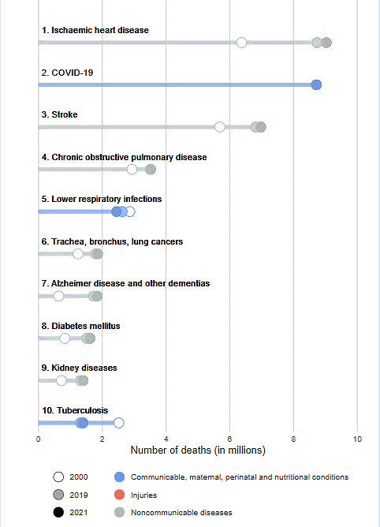

**Figure 1 WHO: Leading causes of Death Globally in 2021**

To better understand and respond to health challenges, causes of death are generally grouped into three main categories:

1. Communicable, maternal, perinatal, and nutritional conditions
2. Non-communicable diseases (NCDs)

3. Injuries

Traditionally, the impact of infectious diseases on public health has been measured mainly by looking at the number of deaths they cause or counting lab-confirmed cases linked to specific pathogens. While these figures are important, they don’t always tell the full story. Many infectious diseases have a wide range of symptoms, can vary in how deadly they are, and often leave people with long-term health problems. Because of these complexities, it's important to use more comprehensive ways of measuring their true impact.

One such measure is the *Disability-Adjusted Life Year* (DALY), developed by the World Health Organization (WHO). DALYs offer a more complete picture by combining two factors: the years of life lost due to early death, and the years lived with illness or disability. This makes it possible to understand not just how many people die from a disease, but also how much it affects the quality of life for those who survive. DALYs are especially useful because they allow health experts to compare the burden of different diseases across countries, regions, and time periods in a consistent way. Since the 1990s, the Global Burden of Disease (GBD) study—led by the Institute for Health Metrics and Evaluation (IHME)—has used DALYs as a key tool to track and compare the impact of diseases worldwide, helping guide better public health decisions.(10) In 1990, CDs contributed to 44.75% of global DALYs, but by 2021, this proportion had decreased to 29.6%. (11) Fig 2

However, in 2019, IDs still accounted for approximately 704 million DALYs globally, involving 85 different pathogens, including bacteria, viruses, parasites, and fungi. Of these 704 million DALYs, 309 million, or 27.7%, were attributed to children under the age of five. Bacterial infections contributed 415 million DALYs while viral infections contributed up to 178 million, and parasitic infections 218.5 million(12). More than 52 million deaths each year around the world are accounted for by IDs *.*(13)

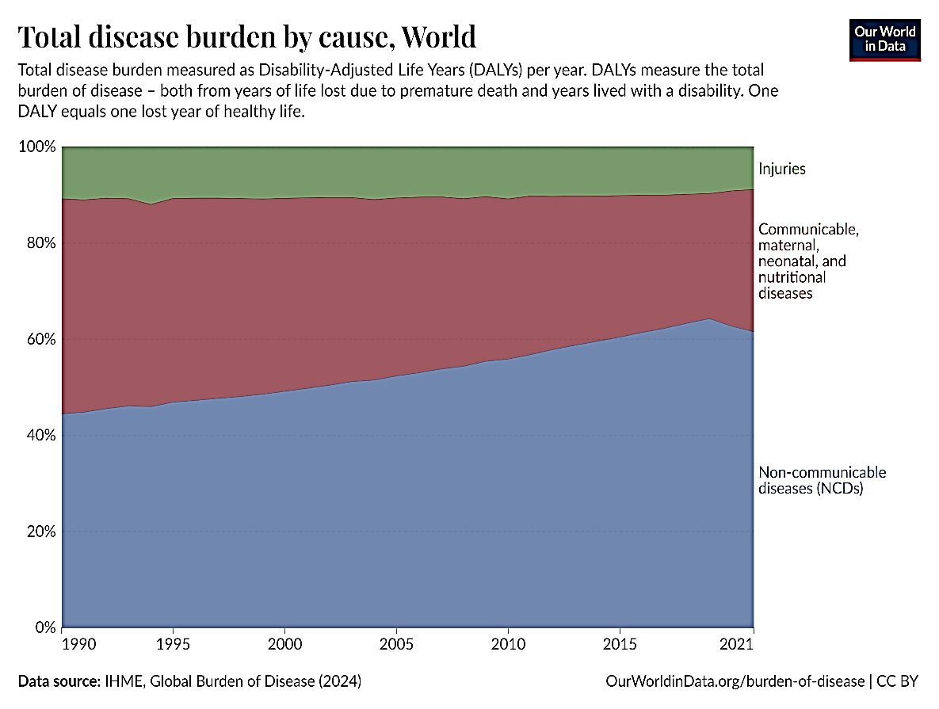

**Figure 2 Data source-IHME, Global Burden of Disease (2021**)

**INDIAN CONTEXT:**

**PUBLIC HEALTH EXPENDITURE TRENDS AND ECONOMIC BURDEN OF INFECTIOUS DISEASES**India, the world’s second-largest country by population and seventh-largest geographically, has become the third-largest economy, contributing around $14.59 trillion of the global gross domestic product (GDP) by purchasing power parity Index (PPP) but spends only 1.84% of its GDP on public health system.(14) The National Health Policy 2017 saw the government renew its call to raise health spending along with fostering economic growth to attain UHC. In the period from 2014 to 2022, though the share of spending on healthcare as a percent of GDP has increased year after year, such growth has been uneven. Compared to the allocation in the previous year's budget, this represents a 0.34% increase in the GDP share, but is still substantially lower than the targeted 2.5% required to achieve UHC. Furthermore, India is lagging behind other countries in healthcare spending. On average, the Organization for Economic Co-operation and Development (OECD) countries allocate 7.6% of their GDP to healthcare. In contrast, the BRICS nations—Brazil, Russia, India, China, and South Africa—spend only 3.6% of their GDP on healthcare..(15)

**Figure 3: Graph showing government health expenditure as % of GDP**

Healthcare spending in India remains considerably lower compared to other densely populated developing and developed countries. The World Health Organization's Global Health Expenditure database shows that in 2020, China's and Brazil's per capita current health expenditure was $583.48 and $700.71, respectively. (16)

This limited health investment has resulted in a heavy dependence on out-of-pocket (OOP) expenses for healthcare services in India. According to the recent National Health Accounts estimates for 2021-2022, OOP expenditure made up 45.1% of current health expenditure (CHE) and 39.4% of total health expenditure (THE*)* (17)

|  |  |  |  |  |  |  |
| --- | --- | --- | --- | --- | --- | --- |
| S. No | Indicator | 2017-2018 | 2018-2019 | 2019-2020 | 2020-2021 | 2021-2022 |
| 1. | **Out of pocket expenditure (OOPE) as THE** | 48.8% | 48.2% | 47.1% | 44.4% | 39.4% |
| 2. | **Government Health Expenditure (GHE) as CHE** | 33.2% | 34.5% | 35.3% | 36.7% | 41.1% |
| 3. | **Out of pocket expenditure (OOPE) as CHE** | 55.1% | 53.2% | 52.0% | 49.5% | 45.1% |
| 4. | **Social Security Expenditure on Health as CHE** | 10.1% | 10.3% | 10.1% | 9.4% | 9.7% |
| 5. | **Private Health Insurance Expenditures as percent of CHE** | 6.6% | 7.3% | 7.7% | 8.1% | 8.5% |
| 6. | **Household Health Expenditure (incl. insurance contributions) CHE** | 61.4% | 60.1% | 59.2% | 57.1% | 50.6% |

**Table 1** **Key Health Financing Indicators for India as percentage of Current Health Expenditure for NHA**

To more accurately assess the economic implications of infectious diseases, Ram and Thakur conducted a detailed analysis focusing on out-of-pocket (OOP) expenditures related to these illnesses. Their study utilized cross-sectional data from the National Sample Survey Organization's (NSSO) 75th Round (2017-2018), examining 10,960 patients affected by infectious diseases. They found that the average per capita OOP expenditure for inpatient care was INR 7.28, while the average monthly per capita OOP expenditure was INR 881.56. For outpatient care, the average per capita OOP expenditure across India was INR 29.38.

The study also highlighted significant variations in OOP spending based on demographic and socio-economic factors. OOP costs were higher among rural residents, Hindus (0.35%), and individuals aged 60 and above (0.47%). Among various social groups, individuals from other social categories spent 0.36% of their total consumption expenditure (TCE) on infectious diseases. Educational background played a crucial role as well, with illiterate individuals allocating 0.49% of their TCE to healthcare for contagious diseases. Economically, the poorest wealth quintile had a higher OOP share at 0.41%. Households with more than the average number of members also spent a greater proportion of their TCE on healthcare, accounting for 0.37%. Furthermore, households residing in the eastern region allocated a higher percentage (0.53%) of their TCE to healthcare compared to those in other parts of the country.(18)

**TRIPLE TRANSITION: ECONOMIC, DEMOGRAPHIC, AND EPIDEMIOLOGICAL**

India is undergoing a unique triple transition—economic, demographic, and epidemiological—which presents both challenges and opportunities for the transformation of its health sector*.* (19)The epidemiological transition interlinked with demographic transition provide the central narratives for health. The transition is marked by a decline in death rates from acute childhood infectious diseases, which has led to more children surviving to adulthood resulting into increase life expectancy. There has been a general rise in life expectancy in the world, and hence populations are aging. Life expectancy at birth has considerably improved in India. During the year 1990, average life expectancy at birth for males in India was 58.3 years and that of females was 59.7 years. In the year 2016, it rose to 66.9 years for males and 70.3 years for females, by showing impressive gains. However, even after this improvement at the national level, life expectancy still remained very unequal between states in the country. In 2016, life expectancy among females varied from 66.8 years in Uttar Pradesh to 78.7 in Kerala, while for males, it ranged from 63.6 years in Assam to 73.8 years in Kerala.(5) This increase in life expectancy affects family planning decisions and often results in smaller family sizes. However, fertility rates typically decline slower than mortality rates. Over time, childhood infectious diseases are replaced by chronic, non-infectious conditions associated with aging population.(1)

**Figure 4 Life expectancy by sex in India 1990-2016**

Alongside these trends in life expectancy, India surpassed a population of 1.42 billion, becoming the most populous country in the world, with 17.78% of the global population spread across 28 states and 8 Union Territories which vary widely in terms of their ecology, economy, and demography, all of which impact health outcomes.(20) Several of these states have populations larger than many European and American nations (21)

According to projections by the Ministry of Statistics and Programme Implementation (MOSPI), over a quarter of India’s population will be in the 15-29 age group by 2029. This large demographic dividend is expected to drive economic growth, but its full potential is hindered by the ongoing epidemiological transition. Phases of epidemiological transition during the period of 1995 to 2004, in India, resulted in high morbidity, low mortality, and a double burden of communicable diseases and chronic diseases where crude morbidity rose by more than 60% and 90% among urban and rural populations.(22) (23)

Top of Form

Bottom of Form

**PUBLIC HEALTH SYSTEM: BURDEN OF INFECTIOUS DISEASES AND NCDS**

Despite notable progress in public health—such as the eradication of polio and the successful containment of HIV/AIDS—India still faces a significant burden of IDs. Tuberculosis remains a major public health challenge, especially with the emergence of multidrug-resistant strains, which have complicated treatment and containment efforts. Recurrent outbreaks of vector-borne diseases like dengue and chikungunya further strain the healthcare infrastructure, especially in rapidly urbanizing areas. These diseases place a heavy burden on urban healthcare systems, which are already under pressure due to growing populations. At the same time, India and other LMICs are seeing a rise in NCDs, including cardiovascular diseases, diabetes, and cancers. These chronic conditions, along with injuries, now account for over half of the disease burden in the country. The coexistence of infectious diseases and NCDs presents a "double burden" for healthcare systems, requiring diverse and simultaneous strategies to address these health challenges. (19)

The South-East Asia Region contributes up to 31.76% of the global burden of communicable, maternal, neonatal, and nutritional diseases (CMNNDs), with India alone accounting for 34.32% of this burden (11) (Fig 6). And as per the estimates of India state level disease burden initiative, the burden of infectious and associated diseases stands at 33% of total disease burden in India(5) (Fig.7)

Compared to populations in high-income countries, populations in South Asia have a relatively higher risk of acquiring infectious diseases due to environmental, socioeconomic, and health-related factors. South Asia encompasses a wide variation in countries where the burden of infectious diseases has been enhanced through all forms of pathogens such as bacteria, viruses, and parasites. These conditions are optimally found in the poorest sanitation, scant clean water access, and crowding that is common across South Asia(24).

Furthermore, much of the health infrastructure across the low- and middle-income countries of the region lacks resources for effective prevention, timely diagnosis, and comprehensive treatment. As such, this enhances the risk and severity of initiating infectious diseases, especially those brought about by the drug-resistant pathogens (25)

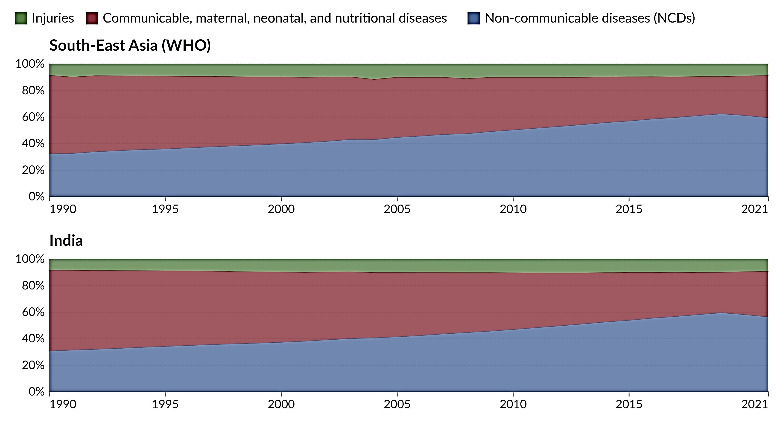

**Figure 5 Data source- IHME, Global Burden of Disease (2021)**

According to the World Health Organization, a disproportionately high fraction of morbidity and mortality from infectious diseases, such as tuberculosis and malaria, falls on low- and middle-income countries. Among these, TB is regarded as one of the top global health problems. The WHO aims to reduce TB incidence by 90% between 2015 and 2035, but significant challenges remain in diagnosis, treatment, and prevention. In 2022, TB accounted for 1.3 million deaths worldwide, down from an estimated 1.4 million in 2020 and 2021. It remains the biggest killer of people with HIV, causing 167,000 deaths that year. About 7.5 million people were diagnosed with TB, with 46% of cases in Southeast Asia, 23% in Africa, and 18% in the Western Pacific—the highest number since global TB monitoring began in 1995. Around 10.6 million people live with active TB, including 5.8 million men, 3.5 million women, and 1.3 million children. Additionally, about a quarter of the global population is infected with latent TB, of which 5% to 10% may develop active TB(26)

India alone contributed about 2.64 million cases in 2021, representing roughly 25% of the global TB burden. Excluding those co-infected with HIV, the mortality rate was about 450,000, highlighting TB's severe impact on India's public health system. Complications such as drug resistance, HIV co-infections, socioeconomic factors, and healthcare disparities further exacerbate the issue(27).

Similarly, malaria remains a significant public health concern. In 2022, an estimated 249 million malaria cases were recorded globally, up by 5 million compared to 2021, across 85 malaria-endemic countries and regions. The WHO South-East Asia Region included nine malaria-endemic countries, contributing 5.2 million cases (2% of the global malaria burden), with India accounting for approximately 65.7% of all malaria cases in the region (28)

**Figure 6 Contribution of major disease groups to total DALY's In India 1990-2016**

After independence, the country bore a high infectious and parasitic disease burden that continued up to 1980. However, by the 1990s, chronic illnesses became the leading health burden. Non-communicable diseases mortality showed a downward trend, dropping from 47.7% in 1969 to 22.1% in 1995, while deaths from non-communicable diseases increased from 35.9% to 55% during the same period (29). The proportion of all deaths in India due to CMNNDs reduced from 53.6% in 1990 to 27.5% in 2016, those due to NCDs increased from 37.9% to 61.8%, and those due to injuries changed from 8.5% to 10.7%(5)

A study conducted by Liu et al. analyzed trends in infectious disease-related mortality in BRICS countries from 1990 to 2019, using data from the Global Burden of Disease. In BRICS nations, the proportion of deaths due to infectious diseases decreased from 39% in 1990 to 32% in 2019. During both years, the leading causes of death were lower respiratory infections, tuberculosis, and diarrheal diseases. The study employed the Age-Standardized Mortality Rate (ASMR) to compare regions and periods, and trends in infectious disease mortality were quantified using the Estimated Annual Percentage Change (EAPC). Additionally, the study outlined the top 10 leading causes of infectious diseases and their respective ASMR for the period from 1990 to 2019 in India. (30) (Table 2&3)

Brahmankar and Dhar conducted a comprehensive analysis to examine morbidity transitions at both national and subnational levels in India from 1995 to 2018. Their study utilized data from four rounds of the National Sample Survey Organization (NSSO): the 52nd, 60th, 71st, and 75th rounds in Figure 7. The findings revealed a steady and significant increase in various morbidities, which doubled consistently from 1995 to 2018, following a parabolic pattern over the three decades. Infectious and communicable diseases (In&CDs), non-communicable diseases (NCDs), and disabilities (excluding injuries) showed a decline in prevalence since 2004. However, despite this modest reduction, NCDs surged threefold, while In&CDs experienced a twofold increase, illustrating India's dual burden of disease. This trend aligns with the epidemiological transition observed in several other countries. The study also highlighted significant regional variations in disease prevalence across India. The southern region bears the highest burden, particularly in terms of NCDs and disabilities, while the northeastern and western regions show a greater prevalence of infectious and communicable diseases (In&CDs). Among the northeastern states, Manipur has the lowest prevalence of morbidity, followed by Mizoram, Nagaland, Meghalaya, and others in the region.(31).

The incidence of infectious as per another author’s calculation of NSSO 75th round is depicted in figure 8. Among various infectious disease Acute viral hepatitis, malaria, tuberculosis, typhoid, dengue fever and chikungunya have a relatively higher incidence among rural population (32)

**Figure 7. Prevalence of self-reported morbidities (per 1000) in India, 1995–2018**.

**Figure 8 Incidence of various diseases from NSSO 75th Round**

Top of Form

Bottom of Form

**Table 2 Leading 10 infectious diseases of number of deaths in India (1990 and 2019).**(30)

|  |  |  |  |
| --- | --- | --- | --- |
| Leading causes 1990 | Number of deaths(thousands)1990 | Leading causes 2019 | Number of deaths(thousands)2019 |
| 1. Diarrheal diseases | 1081-10 | 1. Diarrheal diseases | 632.34 |
| 1. Lower respiratory infections | 690-91 | 2. Lower respiratory infections | 433.66 |
| 3. Tuberculosis | 614-00 | 3. Tuberculosis | 422.63 |
| 4. Malaria | 162.37 | 4. Typhoid and paratyphoid | 66.42 |
| 5. Measles | 156.02 | 5. Encephalitis | 51.89 |
| 6. Typhoid and paratyphoid | 128.09 | 6. HIV/AIDS | 46.30 |
| 7. Tetanus | 112.53 | 7. Meningitis | 34.74 |
| 8. Meningitis | 98.36 | 8. Malaria | 33.37 |
| 9. Encephalitis | 79.26 | 9. Acute hepatitis | 30.99 |
| 10. Whooping Cough | 73.50 | 10. Dengue | 19.20 |
| 11. Acute hepatitis | 61.78 | 11. Whooping cough | 17.35 |
| 16. Dengue | 8.25 | 14. Tetanus | 7.33 |
| 24. HIV/AIDS | 1.14 | 16. Measles | 4.86 |

**Table 3 The number of deaths and age-standardized mortality rates of infectious diseases in India in 1990 and 2019, and their temporal trends from 1990 to 2019**

|  |  |  |  |  |  |
| --- | --- | --- | --- | --- | --- |
| Age standardized mortality rate | | | Number(thousands) | | |
| HIV/AIDS and STDs | | | | | |
| 1990 | **2019** | **EAPC (%)**  **(95%CI)** | **1990** | **2019** | **Change (%)** |
| 1.77 (0.89 to 3.37) | 4.09 (3.50 to 4.99) | 3.14 (0.11 to 6.26) | 19.11 (8.19 to 38.8) | 55.89 (48.41 to 67.37) | 192.52 (64.58 to 526.72) |
| Respiratory infection and tuberculosis | | | | | |
| 212.86 (190.80 to 233.62) | 79.73 (70.34 to 90.67) | -3.53 (-3.66 to -3.4) | 1309.49 (1177.83 to 1438.36) | 857.09 (753.94 to 976.65) | -34.55 (-43.72 to -24.35) |
| Enteric infections | | | | | |
| 285.72 (187.61 to 389.36) | 76.26 (45.05 to 121.63) | -4.64 (-4.84 to -4.44) | 1213.64 (871.95 to 1592.59) | 701.67 (419.72 to 1121.82) | 42.18 (-59.07 to -15.4) |
| Neglected tropical studies | | | | | |
| 21.03 (10.68 to 41.97) | 5.06 (2.92 to 9.02) | -4.82 (-5.2 to -4.43) | 203.96 (100.43 to 404.88) | 61.87 (35.11 to 112.62) | -69.66 (-84.41 to -42.07) |
| Other infectious diseases | | | | | |
| 62.68 (50.47 to 80.65) | 14.13 (11.57 to 17.53) | -5.08 (-5.39 to -4.76) | 603.72 (459.57 to 812.95) | 164.66 (133.51 to 205.44) | -72.73 (-80.27 to -62.46) |

**CONCLUSION:**

In conclusion, the evidence presented in this review highlights that India’s health trajectory closely aligns with global patterns. While mortality from infectious diseases has significantly declined but still it continues to impose a substantial burden on both individual health and the overall public health system. While the country has achieved considerable economic progress and enhancements in its healthcare system, several persistent challenges remain. These challenges encompass insufficient healthcare funding, which contributes to inadequacies of public healthcare facilities and high reliance on private healthcare services, an inadequate workforce including doctors, nurses, and paramedical staff, and a fragmented healthcare delivery system with a complex mix of public and private providers with varying degrees of quality and regulation. To effectively address these interconnected issues, it is imperative to implement a fundamental shift in approach.

Moving from disease-specific solutions to comprehensive, integrated, and person-centered healthcare systems is crucial. This transformation requires increased investment in primary healthcare, enhanced government funding, collaborative initiatives across various sectors, and the development of strategies to address the social determinants of health.

Moreover, employing data-driven tools such as Disability-Adjusted Life Years (DALYs) and Epidemiological Transition Ratios will provide precise evidence to support informed policymaking. In the context of low- and middle-income countries, tackling public health challenges demands more than just technical solutions; it requires robust political advocacy, proactive local engagement, and the establishment of reliable health infrastructures. Closing the gap between the management of communicable and non-communicable diseases is vital for improving overall health outcomes.

**CONFLICT OF INTEREST:** No conflict of interest to be disclosed

**FUNDING STATEMENT:** Nil

**ETHICAL APPROVAL**: Not applicable

Disclaimer (Artificial intelligence)

Option 1:

Author(s) hereby declare that NO generative AI technologies such as Large Language Models (ChatGPT, COPILOT, etc.) and text-to-image generators have been used during the writing or editing of this manuscript.

Option 2:

Author(s) hereby declare that generative AI technologies such as Large Language Models, etc. have been used during the writing or editing of manuscripts. This explanation will include the name, version, model, and source of the generative AI technology and as well as all input prompts provided to the generative AI technology

Details of the AI usage are given below:

1.

2.

3.

**REFERENCES**

1. Dye C. After 2015: infectious diseases in a new era of health and development. Philosophical Transactions of the Royal Society B: Biological Sciences. 2014 Jun 19;369(1645):20130426.

2. Zaidi AKM, Awasthi S, deSilva HJ. Burden of infectious diseases in South Asia. BMJ. 2004 Apr 3;328(7443):811–5.

3. Health in 2015: from MDGs to SDGs [Internet]. [cited 2025 May 13]. Available from: https://www.who.int/publications/i/item/9789241565110

4. datadot [Internet]. [cited 2025 May 8]. India. Available from: https://data.who.int/countries/356

5. 2017-India-State-Level-Disease-Burden-Initiative-Full-Report.pdf [Internet]. [cited 2024 Sep 6]. Available from: https://phfi.org/wp-content/uploads/2018/05/2017-India-State-Level-Disease-Burden-Initiative-Full-Report.pdf

6. Global, regional, and national age-sex specific all-cause and cause-specific mortality for 240 causes of death, 1990-2013: a systematic analysis for the Global Burden of Disease Study 2013. Lancet. 2015 Jan 10;385(9963):117–71.

7. Global, regional, and national incidence, prevalence, and years lived with disability for 301 acute and chronic diseases and injuries in 188 countries, 1990–2013: a systematic analysis for the Global Burden of Disease Study 2013. Lancet. 2015 Aug 22;386(9995):743–800.

8. Morse SS. Factors in the emergence of infectious diseases. Emerg Infect Dis. 1995;1(1):7–15.

9. The top 10 causes of death [Internet]. [cited 2025 May 4]. Available from: https://www.who.int/news-room/fact-sheets/detail/the-top-10-causes-of-death

10. Weltbank, editor. Investing in health: world development indicators. 1. print. New York, NY: Oxford Univ. Pr; 1993. 329 p. (World development report).

11. Roser M, Ritchie H, Spooner F. Burden of Disease. Our World in Data [Internet]. 2024 Feb 29 [cited 2024 Sep 11]; Available from: https://ourworldindata.org/burden-of-disease

12. Naghavi M, Mestrovic T, Gray A, Gershberg Hayoon A, Swetschinski LR, Robles Aguilar G, et al. Global burden associated with 85 pathogens in 2019: a systematic analysis for the Global Burden of Disease Study 2019. The Lancet Infectious Diseases. 2024 Aug;24(8):868–95.

13. Rana MS, Usman M, Alam MM, Tahir M, Ikram A, Zaidi SSZ, et al. Changes in the prevalence of infectious diseases before and after the COVID-19 pandemic in Pakistan. J Infect. 2023 Apr;86(4):415–6.

14. MFK. GDP (PPP) by Country – 2025 Rankings (IMF Statistics) [Internet]. WORLDOSTATS. 2024 [cited 2025 May 14]. Available from: https://worldostats.com/country-stats/gdp-ppp-by-country-imf-data/

15. Majhi MM, Mishra A, Garg S, Kumar R. How healthy is the health budget of Amrit Kaal: 2023-24? J Family Med Prim Care. 2024 Jan;13(1):5–9.

16. Das T, Guha P. The puzzle of public health expenditure and healthcare infrastructure in India: An empirical investigation. Regional Science Policy & Practice. 2024 Feb 1;16(2):12710.

17. NHA 2021-22.pdf [Internet]. [cited 2025 May 5]. Available from: https://nhsrcindia.org/sites/default/files/2024-09/NHA%202021-22.pdf

18. Ram B, Thakur R. Epidemiology and Economic Burden of Continuing Challenge of Infectious Diseases in India: Analysis of Socio-Demographic Differentials. Front Public Health. 2022 Jun 30;10:901276.

19. 9789290229049-eng.pdf [Internet]. [cited 2025 May 6]. Available from: https://iris.who.int/bitstream/handle/10665/352685/9789290229049-eng.pdf?sequence=1&isAllowed=y

20. India Population (2024) - Worldometer [Internet]. [cited 2024 Sep 22]. Available from: https://www.worldometers.info/world-population/india-population/

21. Total Population by Country 2025 [Internet]. [cited 2025 May 6]. Available from: https://worldpopulationreview.com/countries

22. XIIFYP_SocialSector.pdf [Internet]. [cited 2025 May 6]. Available from: https://www.education.gov.in/sites/upload_files/mhrd/files/document-reports/XIIFYP_SocialSector.pdf

23. INDIA - Survey on Health Care: NSS 52nd Round, Schedule 25, 1995 - 1996 [Internet]. [cited 2025 May 6]. Available from: http://www.icssrdataservice.in/datarepository/index.php/catalog/32/related_materials

24. Zaidi AKM, Awasthi S, deSilva HJ. Burden of infectious diseases in South Asia. 2004 Apr 1 [cited 2025 May 6]; Available from: https://www.bmj.com/content/328/7443/811

25. Gavazzi G, Herrmann F, Krause KH. Aging and Infectious Diseases in the Developing World. Clinical Infectious Diseases. 2004 Jul 1;39(1):83–91.

26. Tobin EH, Tristram D. Tuberculosis Overview. In: StatPearls [Internet]. Treasure Island (FL): StatPearls Publishing; 2025 [cited 2025 May 6]. Available from: http://www.ncbi.nlm.nih.gov/books/NBK441916/

27. Padhi A, Agarwal A, Bhise M, Chaudhary A, Joshi K, Katoch CDS. Progress and challenges in achieving tuberculosis elimination in India by 2025: A systematic review and meta-analysis. PLOS ONE. 2024 Mar 27;19(3):e0301060.

28. World malaria report 2023 [Internet]. [cited 2025 May 6]. Available from: https://www.who.int/publications/i/item/9789240086173

29. The Continuing Fertility Transition | Twenty-First Century India: Population, Economy, Human Development, And The Environment | Oxford Academic [Internet]. [cited 2025 May 6]. Available from: https://academic.oup.com/book/51980/chapter-abstract/420801554?redirectedFrom=fulltext

30. Getzzg. Health disparity and mortality trends of infectious diseases in BRICS from 1990 to 2019 [Internet]. JOGH. 2022 [cited 2024 Sep 19]. Available from: https://jogh.org/2022/jogh-12-04028/

31. Bramhankar M, Dhar M. Morbidity transition at the national and sub-national level and their determinants over the past and contemporary period in India. PLoS One. 2024 Jun 21;19(6):e0304492.

32. Thakur R, and Sangar S. Socioeconomic differentials in the burden of paying for healthcare in India: a disaggregated analysis. Health Systems. 2022 Jan 2;11(1):48–58.