Original Research Article
Parasites of Callinectes amnicola and Cardisoma armatum crabs in Degema LGA, Rivers State, Nigeria

ABSTRACT
Aim: Parasite infestation/infection of crabs are a public health concern in Nigeria especially in the riverine regions due to possible zoonoses after crab consumption by humans. Therefore, a comparative study was conducted to evaluate the parasites of Callinectes amnicola and Cardisoma armatum crabs in Degema LGA, Rivers State, Nigeria.
Study Design: A cross-sectional randomized study
Place and Duration of Study: The study was conducted in Bakana town, Degema Local Government Area, Rivers State, Nigeria from July to December 2024.
Methodology: In this study, 700 randomly selected crabs (350 Callinectes amnicola and 350 Cardisoma armatum) from the Bakana reaches of the New Calabar River, Nigeria were examined. The body parts (appendages, external regions, gills, gastro-intestinal tract and haemolymph) of the crabs were analyzed for parasites using standard laboratory techniques. All data generated were analyzed statistically using student T test and analysis of variance (ANOVA) with Turkey’s HDS post hoc as well as all statistical results were considered significant at P<0.05.
Results: An overall parasite prevalence of 530 (75.7%) was recorded (P < 0.05); parasite prevalence of 250 (71.4%) and 280 (80.0%) were recorded for C. amnicola and C. armatum respectively. Male and female crabs had an overall parasite prevalence of 240 (77.4%) and 290 (74.4%) respectively. For weight, C. amnicola had a parasite prevalence of 40 (66.7%), 110 (78. 6%) and 100 (66.7%) for 21 – 50g, 51 – 80g, 81 – 120g respectively (P > 0.05) while C. armatum had a parasite prevalence of 180 (75.0%), 70 (87.5%) and 30 (100.0%) for 61 – 120g, 121 – 180g and 181 – 240g respectively. For carapace width, C. amnicola had a parasite prevalence of 40 (66.7%), 110 (78. 6%) and 100 (66.7%) for 7.1 – 9.0cm, 9.1 – 11.0cm, 11.1 – 14.0cm respectively while C. armatum had a parasite prevalence of 250 (78.1%) and 30 (100.0%) for 4.1 – 7.0cm and 7.1 – 10.0cm respectively. The parasites observed in this study were Cheloniba, Ergasilus, Monocystis, Gregarine, Myxidium, Hystherothylacium, Enterobius, Neoaplectana, Branchionus, Habrotrocha, Scepanotrocha, Otostephanos and Adineta with parasite abundance of 112 (23.4%) and 234 (67.6%) for Callinectes amnicola and Cardisoma armatum crabs respectively P<0.05).
Conclusion: Although most parasites recorded in the study were not of zoonotic importance, crabs should always be washed and cooked properly before human consumption.

Keywords: Callinectes amnicola, Cardisoma armatum, Prevalence, Parasites, Rivers State

1. INTRODUCTION
Crabs are decapods (crustaceans) and are a popular food source in various countries (Onadeko et al., 2015). It is estimated that about 20% of all marine crustaceans caught and farmed globally are crabs, with over 1.5 million tonnes being consumed annually (Onadeko et al., 2015). Crabs constitute a large source of animal protein and contain a high level of minerals (Adeyeye et al., 2010, Adeogun et al., 2011). Crabs are majorly caught in creeks, lagoons, rivers and other sources such as estuaries and even on land (Adeogun et al., 2011). Compared to the temperate regions, tropical and sub-tropical regions have more crabs (Fransozo et al., 1996). In Nigeria there are several available species of crabs; these include the Land (or Freshwater) crab, Cardisoma armatum, and the blue crab, Callinectes amnicola. These two species are among the edible species (Abby-Kalio, 1982, Hart and Chinda, 1998). Crabs are mostly found in marine habitats, although there are also various freshwater and brackish water crab species occupying littoral and shore zones (Onadeko et al., 2015). Crabs play an important predatory role in the ecosystem because of their forage for food and they are also prey for animals of higher taxa such as mammals, especially humans (Ugbomeh & Bajor, 2015). They also have roles as decomposers as they increase the breakdown of decaying organic matter into smaller organic forms such as phosphates and nitrates (Onadeko et al., 2015). Crabs are an important socio-economic resource in Nigeria as well as other countries (Adeogun et al., 2011). C. amnicola (Blue crab) is one of the most economically important crabs globally; they inhabit the coastal waters of several tropical, sub-tropical and even temperate regions where they are used as key aquatic resources especially in commercial fisheries (Lawson & Oloko, 2013). They live on muddy bottoms in mangrove areas and river mouths (Defelice et al., 2001). C. armatum (African rainbow crab or land crab) is a species of land crab found in tropical and sub-tropical estuaries as well as other water bodies along the Atlantic coast of the Americas (Silva et al., 2014). They are semi-terrestrial animals, spending much of their lifecycle on land but depend on the aquatic environment for dispersion and planktonic larval development (Silva et al., 2014). C. armatum can also be found in mangrove areas and even though they are called “land crabs”, the females must return to the estuary to release their eggs.
Crabs are known to be good sources of essential macro and micro minerals such as potassium, phosphorus, calcium, magnesium, copper and iron (Kucukgulmez et al., 2006). Aquatic organisms such as crustacean shellfish have become a staple food because of their health promoting benefits; shellfish are nutritionally valuable sources of various minerals and high-quality proteins (Skonberg & Perkins, 2002). The nutritional status and chemical composition of different crab species have been dealt with extensively (Omotoso, 2005; Moronkola et al., 2011; Jimmy & Arazu, 2012). However, studies on the health of these crabs and their safety in relation to human consumption and zoonoses have not been conducted extensively in some parts of Nigeria; the few studies done in Nigeria are quite underwhelming with scanty reports. Thus, a study on parasites of C. amnicola and C. armatum crabs will provide vital information on the species that harbour more parasites as well as determine if the observed parasites have infective larval stages capable of zoonoses and ascertain the suitability of these crabs for consumption.

2. MATERIALS AND METHODS
2.1 Study Area
Crabs used for this study were collected from coastal shores in Bakana, Rivers State. Bakana is a coastal town in Degema Local Government Area, Rivers State, Nigeria located at 4°44’19" N and 6°57'51.7" E on the shores of the New Calabar River (Ugbomeh & Bajor, 2015); there is a periodic rising and falling of the tides which interchange between dusk and dawn (Ugbomeh & Bajor, 2015). The New Calabar River is located on the eastern flank of the Niger Delta river system (Uzukwu et al., 2014) and empties into some creeks and lagoons bordering the Atlantic Ocean (Ubong & Gobo, 2001; Nzeako et al., 2015).
2.2 Study Design and Duration
A cross-sectional randomized survey was conducted from July to December 2024.
2.3 Sample Analysis
This study was conducted using 700 randomly collected crabs (350 C. amnicola and 350 C. armatum). Sampled crabs were collected on a weekly basis between 8am and 10am at low tides using hand covered with gloves while crabs hiding in burrows were also dug out and collected; captured crabs were kept in sterile plastic containers (with perforations for ventilation) and transported to the laboratory for further analysis. Identification of sampled crabs was done using a standard guide (Schneider, 1992) while sex determination was conducted using appropriate keys (Davis, 2000). In the laboratory, the crabs were labeled properly, sexes noted and weighed using a Kinlee Electronic Sensitive weighing balance while the width and length of all crabs were measured using an electronic digital caliper before dissecting using the dorso-ventral plane. The crabs were laterally laid on a flat surface with their underside facing up and a hand lens (x10) was used to observe the external anatomy of each crab for colour changes, scrapes from the cuticle (skin) were collected from each crab, spread on clean glass slides enclosed with coverslips and observed independently under a light microscope to avoid bias (Nweke et al., 2018). The haemolymph of the crabs were extracted with a 2ml syringe using eye puncture technique (while the crabs were alive) to prevent agglutination and the extracts were kept in labeled Ethylene diamine tetra acetic acid (EDTA) bottles. Specimens collected from sampled crabs were separated into five sub-samples: external (body surface, mouth parts), gastro-intestinal tract, gills, appendages and haemolymph. All samples were stored in labeled universal sample bottles containing 10% formal saline while extraction and identification of parasites was done using standard techniques (Nweke et al., 2018; Eze et al., 2020).
2.4 Statistical Analysis
Descriptive analyses (mean and percentage) and tables were used to represent the data obtained. All data generated were analyzed statistically using student T test and analysis of variance (ANOVA) with Turkey’s HDS post hoc as well as all statistical results were considered significant at P<0.05.
3. RESULTS
An overall parasite prevalence of 530 (75.7%) was recorded in this study (P<0.05); C. amnicola and C. armatum had parasite prevalence values of 250 (71.4%) and 280 (80.0%) respectively (Table 1). An overall sex-related parasite prevalence of 240 (77.4%) and 290 (74.4%) were recorded for male and female crabs respectively (P>0.05) (Table 2). The weight-related parasite prevalence values for C. amnicola were 40 (66.7%), 110 (78.6%) and 100 (66.7%) for 21 – 50 g, 51 – 80 g and 81 – 120 g respectively while C. armatum had weight-related parasite prevalence values of 180 (75.0%), 70 (87.5%) and 30 (100.0%) for 61 – 120 g, 121 – 180 g and 181 – 240 g respectively (Table 3). The carapace width-related parasite prevalence values for C. amnicola were 40 (66.7%), 110 (78.6%) and 100 (66.7%) for 7.1 – 9.0 g, 9.1 – 11.0 g and 11.1 – 13.0 g respectively while C. armatum had carapace width-related parasite prevalence values of 250 (78.1%) and 30 (100.0%) for 4.1 – 7.0 cm and 7.1 – 10.0 cm respectively (Table 4).
Table 1: Overall parasite prevalence of C. amnicola and C. armatum
Crab Species | NE | NU (%) | NI (%)
C. amnicola | 350 | 100 (28.6) | 250 (71.4)
C. armatum | 350 | 70 (20.0) | 280 (80.0)
Total | 700 | 170 (24.3) | 530 (75.7)
NE = Number Examined, NU = Number Uninfected, NI = Number Infected
Table 2: Overall sex-related parasite prevalence of C. amnicola and C. armatum
Sex | C. amnicola |  | C. armatum |  | Total Infected
Sex | NE | NI (%) | NE | NI (%) | NE | NI (%)
Male | 130 | 100 (76.9) | 180 | 140 (77.8) | 310 | 240 (77.4)
Female | 220 | 150 (68.2) | 170 | 140 (82.4) | 390 | 290 (74.4)
Total | 350 | 250 (71.4) | 350 | 280 (80.0) | 700 | 530 (75.7)
NE = Number Examined, NI = Number Infected
Table 3: Weight-related parasite prevalence of C. amnicola and C. armatum
Weight (g) | Number Examined | Number Uninfected (%) | Number Infected (%)
C. amnicola
21 – 50 | 60 | 20 (33.3) | 40 (66.7)
51 – 80 | 140 | 30 (21.4) | 110 (78.6)
81 – 120 | 150 | 50 (33.3) | 100 (66.7)
Total | 350 | 100 (28.6) | 250 (71.4)
C. armatum
61 – 120 | 240 | 60 (25.0) | 180 (75.0)
121 – 180 | 80 | 10 (12.5) | 70 (87.5)
181 – 240 | 30 | 0 (0.0) | 30 (100.0)
Total | 350 | 70 (20.0) | 280 (80.0)
Table 4: Carapace width-related parasite prevalence of C. amnicola and C. armatum
Carapace Width (cm) | Number Examined | Number Uninfected (%) | Number Infected (%)
C. amnicola
7.1 – 9.0 | 60 | 20 (33.3) | 40 (66.7)
9.1 – 11.0 | 140 | 30 (21.4) | 110 (78.6)
11.1 – 13.0 | 150 | 50 (33.3) | 100 (66.7)
Total | 350 | 100 (28.6) | 250 (71.4)
C. armatum
4.1 – 7.0 | 320 | 70 (21.9) | 250 (78.1)
7.1 – 10.0 | 30 | 0 (0.0) | 30 (100.0)
Total | 350 | 70 (20.0) | 280 (80.0)
According to sex-related site-specific parasite prevalence, C. amnicola had highest prevalence values in gills of 70 (53.8%) and 80 (36.4%) in males and females respectively while C. armatum had highest prevalence values in gills of 90 (50.0%) and 100 (58.9%) in males and females respectively (Table 5). According to weight-related site-specific parasite prevalence, C. amnicola had highest prevalence values in gills of 30 (50.0%), 70 (50.0%) and 50 (33.3%) in 21 – 50 g, 51 – 80 g and 81 – 120 g respectively while C. armatum had highest prevalence values in gills of 120 (50.0%), 50 (62.5%) and 20 (66.7%) in 61 – 120 g, 121 – 180 g and 181 – 240 g respectively (Table 6). Based on carapace width-related site-specific parasite prevalence, C. amnicola had highest prevalence values in gills of 30 (50.0%), 70 (50.0%) and 50 (33.3%) in 7.1 – 9.0 cm, 9.1 – 11.0 cm and 11.1 – 13.0 cm respectively while C. armatum had highest prevalence values in gills of 160 (50.0%) and 30 (100.0%) in 4.1 – 7.0 cm and 7.1 – 10.0 cm respectively (Table 7).
Table 5: Sex-related site-specific parasite prevalence of C. amnicola and C. armatum
Crab Body Site | C. amnicola |  | C. armatum
Crab Body Site | Male (N = 130) | Female (N = 220) | Male (N = 130) | Female (N = 220)
Crab Body Site | NI (%) | NI (%) | NI (%) | NI (%)
External | 30 (23.1) | 50 (22.7) | 20 (11.1) | 10 (5.9)
Appendage | 0 (0.0) | 0 (0.0) | 10 (5.6) | 30 (17.6)
GIT | 0 (0.0) | 20 (9.1) | 20 (11.1) | 0 (0.0)
Gill | 70 (53.8) | 80 (36.4) | 90 (50.0) | 100 (58.9)
Haemolymph | 0 (0.0) | 0 (0.0) | 0 (0.0) | 0 (0.0)
Total | 100 (76.9) | 150 (68.2) | 140 (77.8) | 140 (82.4)
GIT = Gastro-intestinal tract, N = Number of Samples, NI = Number infected
Table 6: Weight-related site-specific parasite prevalence of C. amnicola and C. armatum
Crab Body Site | C. amnicola |  |  | C. armatum
Crab Body Site | 21 – 50g (N = 130) | 51 – 80g (N = 220) | 81 – 120g (N = 150) | 61 – 120g (N = 240) | 121 – 180g (N = 80) | 181 – 240g (N = 30)
Crab Body Site | NI (%) | NI (%) | NI (%) | NI (%) | NI (%) | NI (%)
External | 10 (16.7) | 40 (28.6) | 30 (20.0) | 30 (12.5) | 0 (0.0) | 0 (0.0)
Appendage | 0 (0.0) | 0 (0.0) | 0 (0.0) | 10 (4.2) | 20 (25.0) | 10 (33.3)
GIT | 0 (0.0) | 0 (0.0) | 20 (13.3) | 20 (8.3) | 0 (0.0) | 0 (0.0)
Gill | 30 (50.0) | 70 (50.0) | 50 (33.3) | 120 (50.0) | 50 (62.5) | 20 (66.7)
Haemolymph | 0 (0.0) | 0 (0.0) | 0 (0.0) | 0 (0.0) | 0 (0.0) | 0 (0.0)
Total | 40 (66.7) | 110 (78.6) | 100 (66.7) | 180 (75.0) | 70 (87.5) | 30 (100.0)
GIT = Gastro-intestinal tract, N = Number of Samples, NI = Number infected
Table 7: Carapace Width-related site-specific parasite prevalence of C. amnicola and C. armatum
Crab Body Site | C. amnicola |  |  | C. armatum
Crab Body Site | 7.1 – 9.0cm (N = 60) | 9.1 – 11.0cm (N = 140) | 11.1 – 13.0cm (N = 150) | 4.1 – 7.0cm (N = 320) | 7.1 – 10.0cm (N = 20)
Crab Body Site | NI (%) | NI (%) | NI (%) | NI (%) | NI (%)
External | 10 (16.7) | 40 (28.6) | 30 (20.0) | 30 (9.4) | 0 (0.0)
Appendage | 0 (0.0) | 0 (0.0) | 0 (0.0) | 40 (12.5) | 0 (0.0)
GIT | 0 (0.0) | 0 (0.0) | 20 (13.3) | 20 (6.3) | 0 (0.0)
Gill | 30 (50.0) | 70 (50.0) | 50 (33.3) | 160 (50.0) | 30 (100.0)
Haemolymph | 0 (0.0) | 0 (0.0) | 0 (0.0) | 0 (0.0) | 0 (0.0)
Total | 40 (66.7) | 110 (78.6) | 100 (66.7) | 250 (78.1) | 30 (100.0)
GIT = Gastro-intestinal tract, N = Number of Samples, NI = Number infected
Based on identified parasitic fauna of C. amnicola, 6 Genera with a total abundance of 112 parasites belonging to 2 Phyla were recovered; Scepanotrocha spp had the highest prevalence of 42 (37.5%) and Otostephanos spp had the least prevalence of 5 (4.5%) as well as Phylum Rotifera had the highest abundance of 90 (80.4%) and the highest diversity with 4 Genera of parasites (Table 8). C. armatum had 14 Genera with a total abundance of 234 parasites belonging to 4 Phyla; Scepanotrocha spp had the highest prevalence of 67 (28.6%) while Monocystis spp and Enterobius spp both had the lowest prevalence of 1 (0.4%) respectively as well as Phylum Rotifera had the highest abundance of 159 (67.9%) and the highest diversity with 4 Genera of parasites (Table 8).

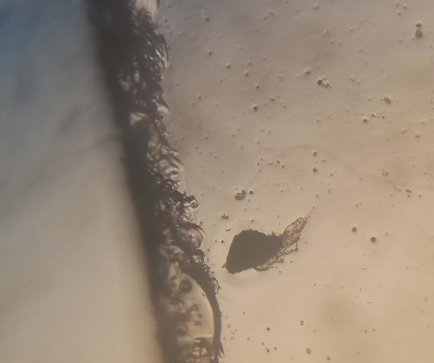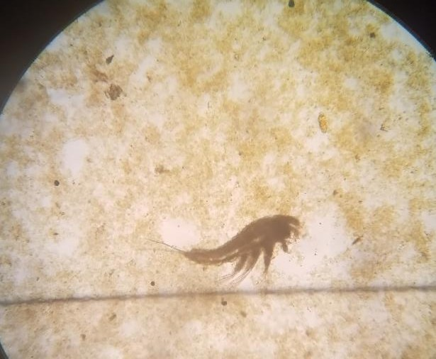
Plate 1: Cheloniba Spp. Plate 2: Ergasilus Spp.
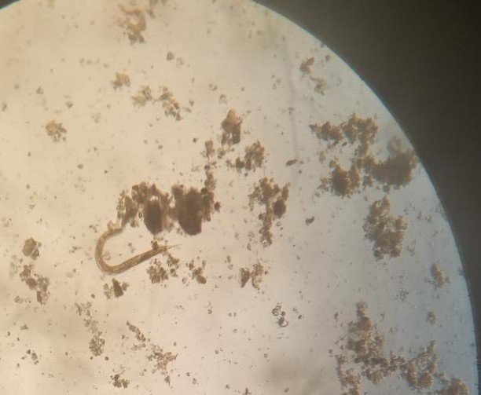
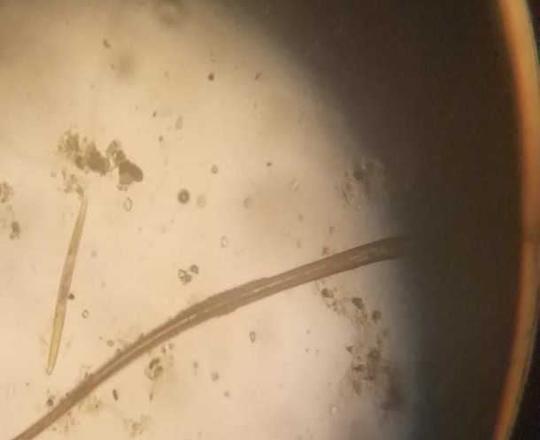

Plate 3: Neoaplacenta Spp. Plate 4: Hysterothylacium Spp.

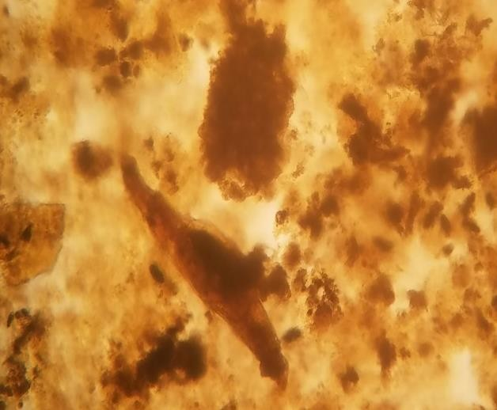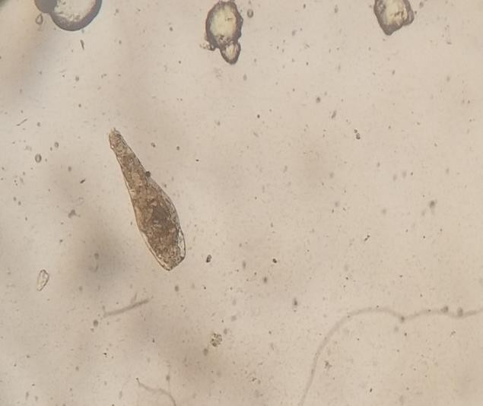
Plate 5: Otostephanos Spp. Plate 6: Habrotrocha Spp.

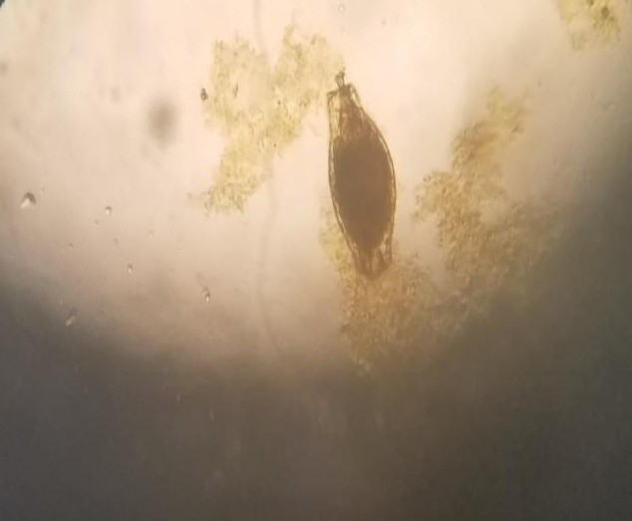
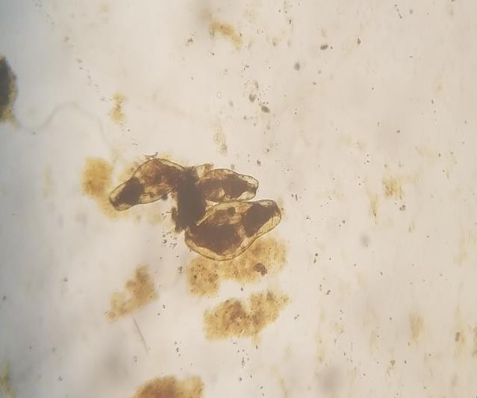
Plate 7: Otostephanos Spp. Plate 8: Adineta Spp.
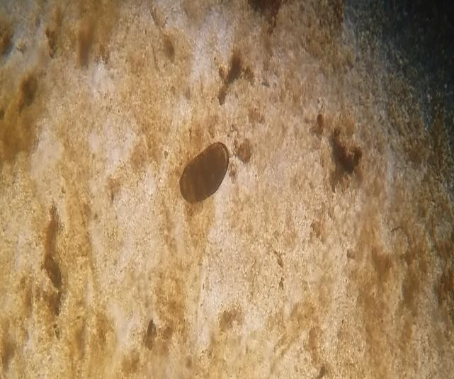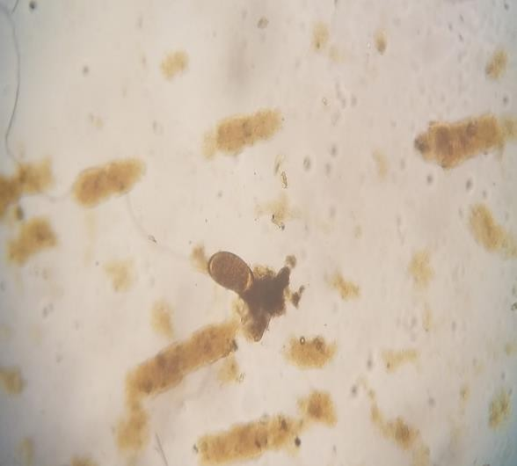
Plate 9: Intact rotifer egg Plate 10: Decomposing remnants of rotifer egg
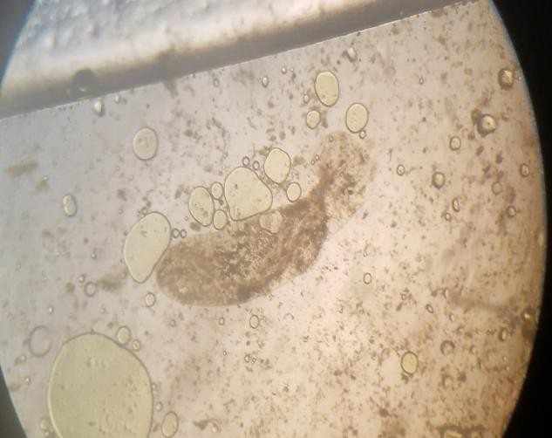
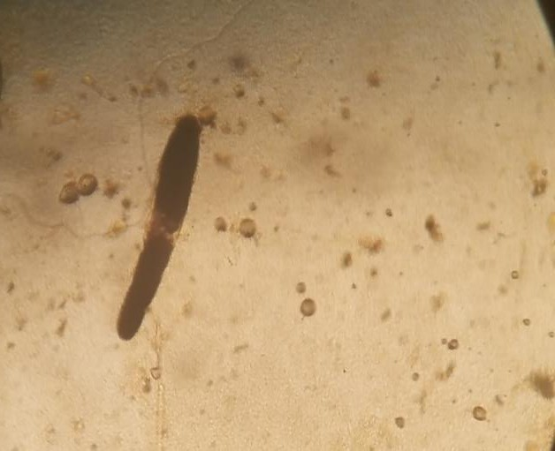
Plate 11: Gyrodactylus Spp. Plate 12: Gregarine Spp.

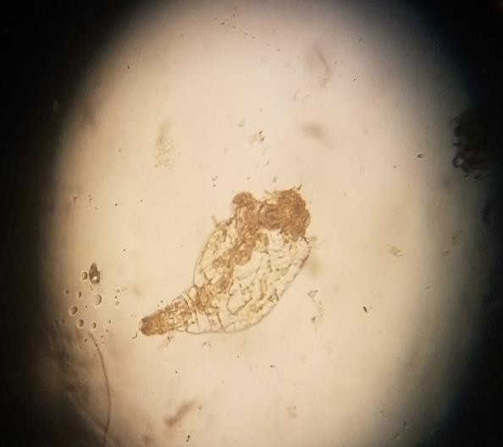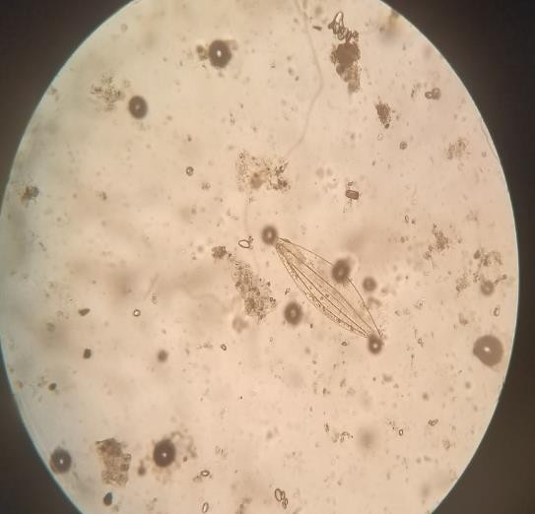
Plate 13: Branchionus Spp. Plate 14: Myxidium Spp.

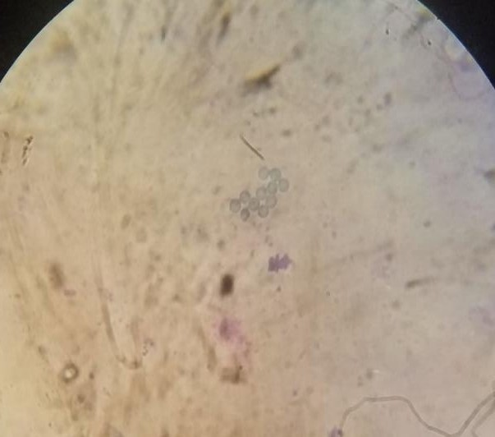
Plate 15: Enterobius Spp. egg Plate 16: Monocystis Spp.

Table 8: Parasitic Fauna of sampled C. amnicola and C. armatum
Crab Species | Phylum | Class | Order | Family | Genus | Abundance  (%)
C. amnicola | Arthropoda | Maxillopoda | Sessilia | Chelonibiidae | Cheloniba spp. | 12 (10.7)
 | “ | “ | Poecilostomatoid | Ergasilidae | Ergasilus spp. | 10 (8.9)
 | Rotifera | Eurotatoria | Bdelloidea | Habrohochidae | Habrotrocha spp. | 16 (14.3)
 | “ | " | " | " | Scepanotrocha spp. | 42 (37.5)
 | “ | " | " | " | Otostephanos spp. | 5 (4.5)
 | “ | " | " | Adinetidae | Adineta spp. | 27 (24.1)
TOTAL |  | 3 | 3 | 4 | 6 | 112 (32.4)
C. armatum | Arthropoda | Maxillopoda | Sessilia | Chelonibiidae | Cheloniba spp. | 9 (3.8)
 |  |  | Poecilostomatoid | Ergasilidae | Ergasilus spp. | 16 (6.8)
 | Protozoa | Sarcomastigophora | Rhizopoda | Monocystidae | Monocystis spp. | 1 (0.4)
 |  | Perkinsea | Perkinsida | Perkinidae | Gregarine spp. | 4 (1.7)
 |  | Myxosporea | Bipolarina | Myxidiidae | Myxidium spp. | 5 (2.1)
 | Nematode | Adenophora | Rhabditida | Raphidascarididae | Hystherothylacium spp. | 5 (2.1)
 |  | Secernentea | Ascarida | Oxyuridae | Enterobius spp. | 1 (0.4)
 |  | " | Rhabditida | Steinernematidae | Neoaplectana spp. | 5 (2.1)
 | Rotifera | Monogononta | Plioma | Brachionidae | Branchionus spp. | 6 (2.6)
 |  | Eurotatoria | Bdelloidea | Habrohochidae | Habrotrocha spp. | 32 (13.6)
 |  | " | " | " | Scepanotrocha spp. | 67 (28.6)
 |  | " | " | " | Otostephanos spp. | 54 (23.1)
 | Platyhelminthes | " | " | Adinetidae | Adineta spp. | 24 (9.8)
TOTAL |  | 9 | 11 | 12 | 14 | 234 (67.6)
GRAND  TOTAL |  | 12 | 14 | 16 | 20 | 346 (100.0)
4. DISCUSSION
Crabs are a rich source of sustainable protein in several parts of Nigeria especially coastal dwellers of the Niger Delta region. Due to the presence of micro-fauna (parasites) in these crabs, human consumers are exposed to contracting both endemic and exotic parasitic zoonotic infections. The overall parasite prevalence in this study was relatively high compared to similar studies in Nigeria (Ikhuoriah & Awharitoma, 2018; Nweke et al., 2018; Eze et al., 2020); the high parasite prevalence could be attributed to the feeding habits of the crabs and effects of anthropogenic activities occurring in the studied water body. Overall, male crabs had slightly higher parasite prevalence than female crabs (not statistically significant) and this agrees with the findings of similar research (Nweke et al., 2018; Eze et al., 2020); male and female crabs are both equally predisposed to parasite infections from their surroundings. Variability existed in parasite prevalence in relation to weight, carapace width and sites of infections in studied crabs; similar disparities were reported by other researchers of similar studies (Jimmy & Arazu, 2012; Rogers, 2014; Nweke et al., 2018; Eze et al., 2020). Parasites from Phyla Rotifera and Arthropoda had the highest in both C. amnicola and C. armatum in this study, this agrees with reports from other similar studies (Ugbomeh & Bajor, 2015; Eze et al., 2020) but disagrees with other studies (Rogers, 2014; Ruhay & Ibrahim, 2016; Nweke et al., 2018).
5. CONCLUSION
C. amnicola and C. armatum are well-known important food commodities especially regarding the diets of coastal dwellers in Nigeria because it serves as a vital cheap source of minerals and proteins. Most parasites identified in this study are naturally associated with the micro-fauna of C. amnicola and C. armatum but the presence of Enterobius spp is of public health concern, therefore all crabs should be properly washed and cooked before human consumption.
ETHICAL APPROVAL
All authors hereby declare that principles of laboratory animal care (NIH publication No. 85 – 23, revised 1985) were followed as well as specific National laws were applicable. All experiments have been examined and approved by the appropriate ethics committee.

DISCLAIMER (ARTIFICIAL INTELLIGENCE)
Authors hereby declare that NO generative AI technologies such as Large Language Models (ChatGPT, COPILOT, etc.) and text-to-image generators have been used during the writing or editing of this manuscript.
ACKNOWLEDGEMENTS
Authors thank the local fishermen that assisted in the collection of crabs and Miss T. Braide for her invaluable input during sample analysis.
REFERENCES
Abby-Kalio, N. J. (2001). Notes on Crabs in the Niger Delta, 1982 Defelice R. C, Eldredge, L. G., Carlton, V. T. non-indigenous invertebrates.
Adeogun, O. A., Adeogun, M. O., Ajulo, O. R., Akinnigbagbe, A. A., Ambrose, E. E. and Bolaji, D. A. (2011). Economic performance of crab fishery in Lagos Lagoon, Nigeria. International Journal of Fisheries and Aquaculture, 3(7): 118 – 125.
Adeyeye, E. I., Olanlokun, J. O. & Falodun, T. O. (2010). Proximate and mineral composition of whole body, flesh and exoskeleton of male and female common in West African freshwater crab Sudananautes africanus. Journal of Food and Nutrition Science, 60(3): 213 – 216.
Davis, J. (2000). Wildlife and exotic animals, how to distinguish between male and female crabs. Retrieved from http://animals.mom.me/distinguish-between-male-female-crabs-1846.html 28th April 2017
Defelice, R. C. L., Eldredge, L. G. & Smith, C. (2001). Coordinators, Guidebook to the introduced marine species in Hawavian waters. Bishops Museums Technical Report, 21: 217 – 274
Eze, C. N., Owhoeli, O. & Chukwuma, D. T. (2020). Isolation of parasites in blue swimming crab (Callinectes amnicola) from Elechi creek in Port Harcourt, Rivers State, Nigeria. Journal of Agricultural Science and food Technology, 6(5): 87 – 93
Fransozo, A. & Negreiros-Fransozo, M. L. (1996). Brazilian coastal Crustacea Decapoda. In: Biodiversity in Brazil: 141 A First Approach (de Bicudo C. E, menezes M. N. A, eds., Proceedings of the Workshop Methods for the assessment of biodiversity in plants and animals, Campos do Jordao, Sao Paulo, Brazil, 26-30 may 1996, CNPq – Conselho Nacional de Desenvolvimen to Cientifico e Technologico, San Paulo, Brazil, 275 – 287.
Hart, A. I. & Chindah, A. C. (1998). Preliminary study on the benthic microfauna associated with different microhabitats in Mangrove Forest of Bonny estuary, Niger Delta, Nigeria. Acta Hydrobiologica, 40(1):9 – 15.
Ikhuoriah, S. O. & Awharitoma, A. O. (2018). Prevalence of parasitic infestation in freshwater crabs Sudanonautes africanus (A. Miine-Edwards, 1869) (Brachyura: Potamonautidae) from selected Rivers in Edo and Delta States, Nigeria. Journal of Applied Science and Environmental Management, 22(11): 1761 – 1767
Jimmy, U. P. & Arazu, V. N. (2012). The proximate and mineral composition of two edible crabs Callinectes amnicola and Uca tangeri (Crustacea: Decapoda) of the Cross River, Nigeria. Pakistan Journal of Nutrition, 11(1): 78 – 82
Kucukgulmez, A., Celik, M., Yanar, Y., Erosy, B. & Cikrikci, M. (2006). Proximate composition and mineral contents of the blue crab (Callinectes sapidus) breast meat, claw meat and hepato-pancreas. International Journal of Food Science and Technology, 41: 1023 – 1026
Lawson, E. O. & Oloko, R. T. (2013). Effect of salinity on survival and growth of blue crab (Callinectes amnicola) from Yewa River, Southwest Nigeria. Advances in Life Science and Technology 7: 24 – 33
Moronkola, B. A., Olowu, R. A., Tovide, O. O. & Adjejuyo, O. O. (2011). Determination of proximate and mineral contents of crab (Callinectes amnicola) living on the shores of the Ojo River, Lagos, Nigeria. Science and Chemistry Communication, 1(1); 1 – 6
Nweke, D. O., Sikoki, F. D. & Nzeako, S. O. (2018). Comparative study of parasitic loads of Callinectes amnicola and Cardisoma armatum from two major river systems in Rivers State, Nigeria. Nigerian Journal of Parasitology, 39(1): 59 – 68
Nzeako, S. O., Uche, A. O., Imafidor, H. O. & Bilabou, T. B. (2015). Flooding induced occurrence of terrestrial nematode species and genera in the Benthos of River Nun, Niger Delta. Journal of Agriculture and Ecology Research International, 2(1): 1 – 9
Omotoso, O. T. (2005). Chemical composition and nutritive significance of the land crabs, Cardisoma armatum (Decapoda). African Journal of Applied Zoology and Environmental Biology, 7: 68 – 72
Onadeko, A. B., Lawal-Ar, A. O. & Igborggbor, O. S. (2015). Habitat diversity and species richness of brachyuran crabs off University of Lagos Lagoon coast, Akoka, Nigeria. The Bioscientist, 3(1): 14 – 28.
Rogers, H. A. (2014). Prevalence of Blue crab (Callinectes sapidus) diseases, parasites and symbionts in Louisiana. Louisiana State University for Science, Masters Thesis, 4 – 8
Ruhay, A. & Ibrahim, C. (2016). The investigation of bacteria, parasite and fungi in blue crabs (Callinectes sapidus Rathbun 1896) caught from Akatan Lagoon in East Mediterranean Sea. 5th International Conference on Agriculture, Environmental and Biological Sciences (ICAEBS-16) April 28-29,2016 Pattaya (Thailand)
Schneider, W. (1992). FAQ species identification sheet for fishery purpose. Field guide to the Commercial Marine resources of the Gulf of FAQ, Rom., 268
Silva, C. C., Schwamborn, R. & Lins-Oliveira, J. E. (2014). Population biology and colour patterns of the blue land crab, Cardisoma guanhumi (Latreille 1828). (Crustacea: Gecareindae) in the Northeastern Brazil. Brazilian Journal of Biology, 74(4): 949 – 958
Skonberg, D. I. & Perkins, B. L. (2002). Nutrient composition of green crab (Carcinus maenas) leg meat and claw meat. Food Chemistry, 77: 404 – 410
Ubong, I. U. & Gobo, A. E. (2001). Fundamentals of Environmental Chemistry and Meteorology, Tom and harry Publications Ltd. Port Harcourt, pp 264
Ugbomeh, A. P. & Bajor, P. (2015). Parasites of the Brachyuran crab Cardisona armatum from Bakana in Rivers State, Nigeria. Journal of Environmental and Applied Bioresearch, 3(02): 56 – 60.
Uzukwu, P. U., Leton, T. G. & Jamabo, N. A. (2014). Survey of the physical characteristics of the Upper Reach of the New Calabar River, Niger Delta, Nigeria. Trends in Applied Sciences Research, 9: 494 – 502

