***Case report***

**Hyper infection with Strongyloides stercoralis in a case of gastric outlet obstruction leading to upper GI haemorrhage: a case report.**

**Abstract**

Aims: Strongyloidiasis is an asymptomatic disease caused by the intestinal helminth Strongyloides stercoralis in immunocompetent individuals and are present for decades. The rarity of our case presents in the facts that an elderly gentleman being immunocompetent before, being evaluated for a surgical condition, circumstances lead to sudden deterioration and within one day of the biopsy report succumbs to the condition .While undergoing retrospective evaluation it was diagnosed as hyper infection and disseminated strongyloidiasis.

Presentation of the case: 77 year old elderly male , a case of chronic idiopathic demyelinating neuropathy admitted with persistent vomiting at other hospital, and on evaluation diagnosed with hiatus hernia with severe gastritis and referred to us, patient underwent Naso jejunal tube placement in view of gastric outlet obstruction and for feeding, post which, patient had initially loose stools and thereafter malena ,upper Gi scopy with cessation of bleed done ,to recur as hematemesis, and within one day of diagnosis of duodenal biopsy suggestive of strongyloides stercoralis ,patient succumbed to the disease.

Discussion: The case emphasizes on the importance of evaluation of various gastrointestinal infections especially caused by pathogens in our country with tropical climate and need to correlate the immunocompetency of patient especially on steroids with underlying infections.

Conclusion: strongyloidiasis infection should be ruled out in all the immunodeficient patients especially on steroids for brief periods and presenting with gastrointestinal symptoms of vomiting and diarrhoea.

# **Introduction:**

# Strongyloidiasis is a parasitic disease caused by Strongyloides stercoralis. The clinical presentation varies according to the stage of infection. Diagnosing strongyloidiasis is a challenge in clinical practice due to the inconsistency of eosinophilia and the low sensitivity of standard microscopic stool examination. Strongyloidiasis infection presenting with shock is rare.[1]

. Human infection with *S. stercoralis* presents as one of three types: autoinfection, hyper infection, or disseminated infection. Autoinfection is a mostly asymptomatic process that enables the parasite to survive indefinitely in the human host. Hyper infection refers to a process of intense autoinfection, during which third-stage larvae can be detected in fresh stool. In the case of disseminated infection, larvae can be found in multiple tissues and body fluids, which can lead to diffuse tissue damage and even death.[2,3] Here, we report a case of severe disseminated infection caused by *S. stercoralis*, diagnosed through duodenal biopsy but within two days of biopsy report pt succumbed to the disease.

*Strongyloides* hyperinfection syndrome (SHS) remains associated with a poor outcome, especially when associated with shock and mechanical ventilation. Deterioration to shock is often related to concomitant bacterial infection. The poor outcome of established SHS pleads for a large application of antiparasitic primary prophylaxis in at-risk patients.(19)

In patients receiving immunosuppressive therapies, *Strongyloides stercoralis* can cause a life-threatening septic shock, with multi-organ failure and infestation. *Strongyloides* hyper-infection should be considered in any immunosuppressed patient who has been exposed to the parasite, even if it is many years since that exposure occurred.(20)

**Case Presentation** :

77-year-old elderly gentleman was brought from local hospital with complaints of multiple episodes of vomiting, generalised abdominal pain and difficulty in breathing with unawareness of the surroundings. Patient was evaluated in the emergency department, arterial blood gas analysis was within normal limits, hence patient was shifted to the wards and thereafter shifted to endoscopy department for ugi scopy and Naso jejunal (NJ) tube insertion. Upon ugi scopy there was pyloric region swelling noted with difficulty in passage of NJ and on reaching duodenum, ulcers were present from which multiple biopsies were taken.

On the second day of admission patient was gradually started on NJ feeds which after tolerating were increased.

On the third day of admission patient passed stools normally but then had multiple episodes of loose stools followed by diarrhoea ,which was managed conservatively with intravenous fluids and pre and probiotics and intravenous antibiotics but within next few episodes of loose stools pt had frank malena and recurrent episodes of the same.

There was a significant drop of haemoglobin and packed cell volume and hence patient was urgently optimized with blood products, shifted to intensive care unit.

He underwent CT scan angiography which showed a blush in the proximal jejunum. (Fig.1) The blush was localised just near the Naso jejunal tube tip and hence was shifted to ENDOSCOPY dept in view of further management.

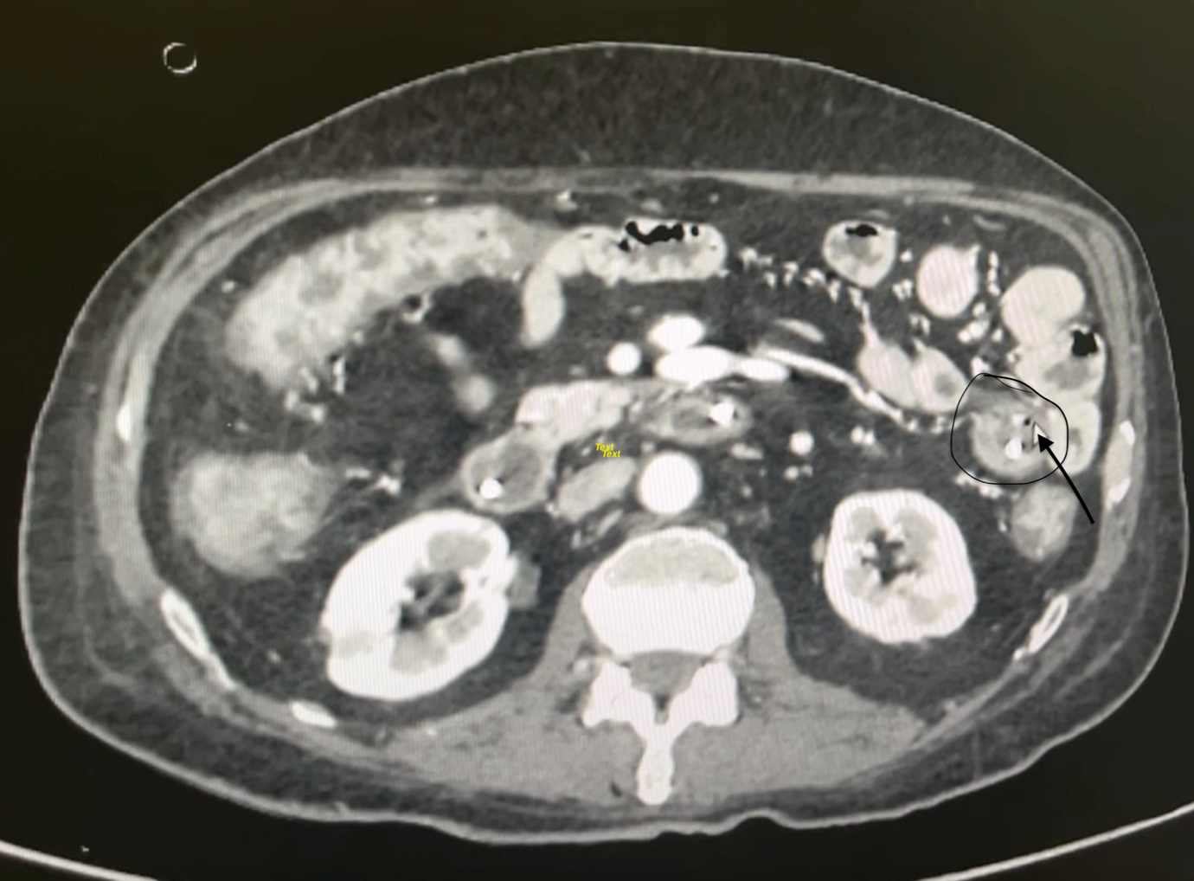

Fig 1 :CT Angiography image

On endoscopy evaluation there was an active bleed noticed near the nasojejunal tip and was localised from proximal jejunal area, ( Fig 2.) small arterial bleed which was controlled by APC coagulation and then clip applied over it.(Fig 3).

Fig 2 : Endoscopy evaluation showed an active bleed noticed near the nasojejunal tip

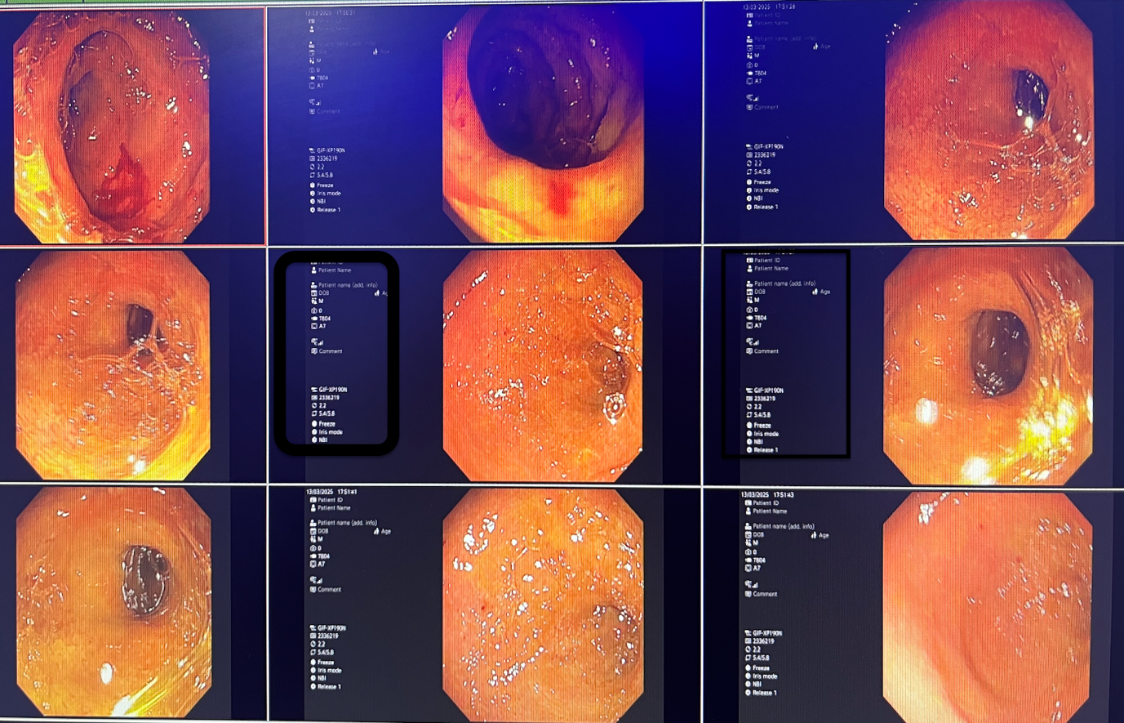

Fig 3 : APC coagulation

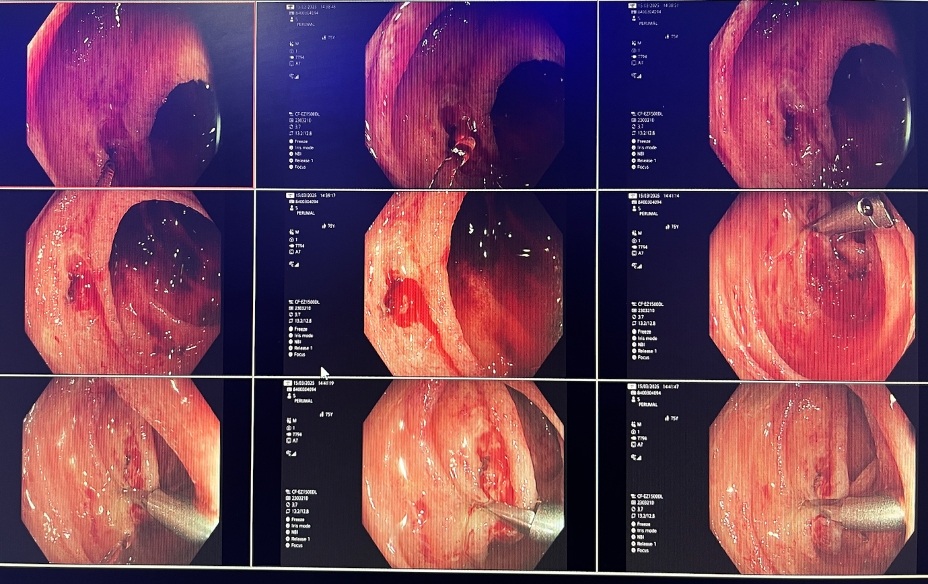

Pt was stabilized and shifted back to the ICU for further management after removing the Nasojejunal tube and placing a Ryle’s tube for preventing any aspiration if any.

Pt was hemodynamically stable for 12 hours, then again the patient started having frank blood oozing from the Ryle’s tube and even after all haemostatic measures pt had persistent hematemesis.

Reference was given to an Interventional Radiologist for further management

who advised DSA and repeat CT Angiography.

Same day we received histopathology report of duodenal biopsy specimen sent on the first Upper Gi scopy which was suggestive of Strongyloides Stercoralis for which immediately the patient was started on tab Albendazole and Ivermectin.

But the patient’s general condition deteriorated, and patient was shifted to another local hospital in view of financial constraints where he succumbed to the disease just within 24 hours of admission.

Fig 4 :Histopathology report 1

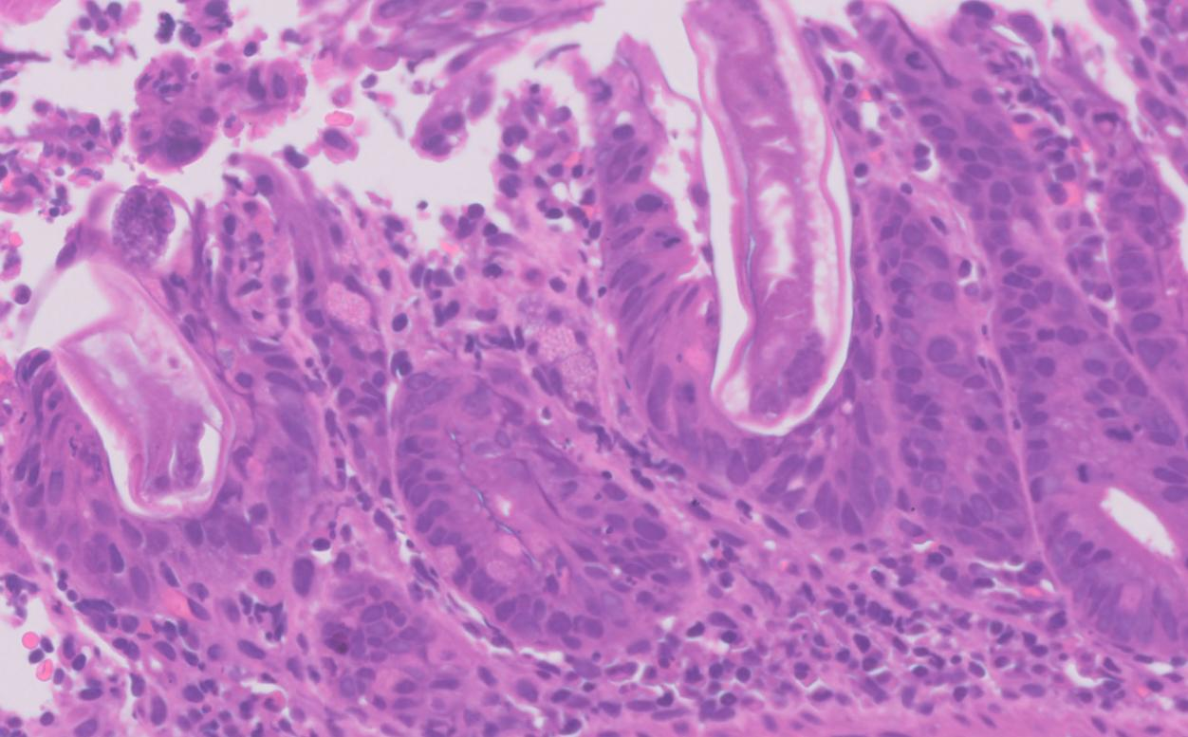

Fig 5 : Histopathology report 2

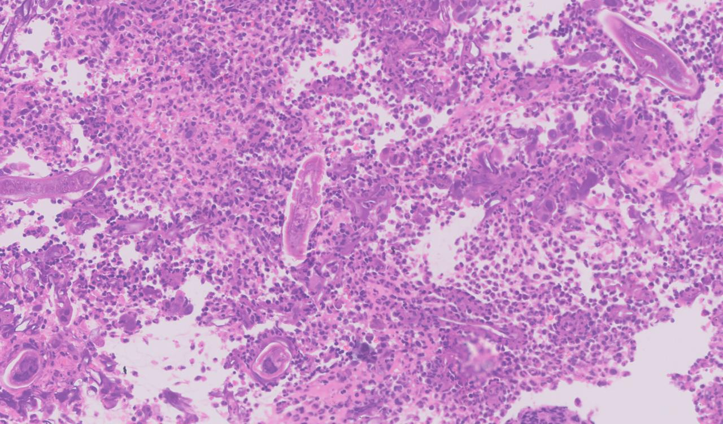

**Discussion:**

Strongyloides stercoralis is distinguished amongst intestinal helminths by several factors of its biology, most impressively by its autoinfective life cycle, leading to potential lifelong infection and capacity to kill its human host, decades after initial infection.

# In its typical life cycle, Strongyloides travels from the skin to the lungs and then to the gastrointestinal (GI) tract of its host. In hyper infection, there is increase in number of worms migrating through different stages of standard lifecycle. While in disseminated disease there is presence of parasites out-side of the traditional life cycle (i.e. in organs other than the skin, GI tract, or lungs). Filariform larvae may enter arterial circulation and lodge in various organs such as lymph node, pericardium, pancreas, liver, kidneys, and brain. The vague clinical presentation of Strongyloidiasis delays clinical suspicion leading to hyperinfection and disseminated Strongyloidiasis. Therefore, persistent and vague gastrointestinal, cutaneous or pulmonary symptoms along with underlying predisposing conditions and prolonged duration of illness should arouse suspicion for this parasitic infection. However, accurate and timely diagnosis of strongyloidiasis is essential, to prevent hyper infection and disseminated Strongyloidiasis both of which have poor outcome.(4)

Infection with S. stercoralis occurs via penetration of the filariform larvae through the skin that directly comes in contact with infested soil. Autoinfection, which occurs when rhabditiform larvae transform into invasive filariform larvae and are capable of reinfecting the host via invasion of the intestinal wall or the perianal skin, can then ensue and result in low level chronic infection for decades. Infection is mostly asymptomatic in the immunocompetent host. When symptoms do occur, it is mainly gastrointestinal (GI). In the immunocompromised host, however, the organism may migrate through the GI mucosa and into the bloodstream. It is during this time where it can infect the lungs and the central nervous system (CNS), potentially resulting in dissemination and fatal hyperinfection.

# Hyper infection with S. stercoralis occurs in immunocompromised hosts with impaired T-cell immunity, such as lymphoma, corticosteroid use, acquired immunodeficiency syndrome, human T-cell lymphotropic virus type-1 infection, and transplant recipients. Geri et al. describe 83.5% of patients with hyper infection syndrome were receiving treatment with corticosteroids, with a median of 42 days of therapy before symptom onset. This form of infection can cause disruption of the GI mucosa. (5)S.*stercoralis* infection was first reported in French soldiers working in Vietnam who had severe diarrhoea, and for many years the disease caused by this organism was known as “Cochin-China diarrhoea” (6)Humans, the main hosts of adult parasites in the parasitic generation, become infected with *S. stercoralis* mainly through skin or mucosal contact with contaminated soil or water, with the main invasion sites being the skin and the respiratory and digestive tracts(7). Human infection with *S. stercoralis* presents as one of three types: autoinfection, hyper infection, or disseminated infection. Autoinfection is a mostly asymptomatic process that enables the parasite to survive indefinitely in the human host. Hyper infection refers to a process of intense autoinfection, during which third-stage larvae can be detected in fresh stool. In the case of disseminated infection, larvae can be found in multiple tissues and body fluids, which can lead to diffuse tissue damage and even death.(8)

Making a definitive diagnosis of Strongyloides infection involves visualization of the larvae by stool exam or through histopathologic findings. Strongyloidiasis is difficult to diagnose by the stool specimens alone if the parasitic load is low, and the larval output is irregular in most patients. Microscopic examination of a stool sample detects the parasite in 25% of cases.(9)

This case highlights the importance of performing an endoscopic study with mucosal biopsy for detection of GI strongyloidiasis (Figs. 4 and 5). Although strongyloidiasis has a broad range of endoscopic features, the most frequent findings on endoscopy include ulcerations, gastritis, or duodenitis. Multiple biopsy specimens could yield the diagnosis in 90% of cases.(10,11)Histopathologic findings may reveal S. stercoralis larvae, eggs, or adult forms located in the gastric and/or duodenal crypts. Eosinophils infiltrating the lamina propria might be found, and the intensity can be correlated with the intensity of the infection.(10)

 In S. stercoralis infections, eosinophilia may be detected during migration of larvae through perianal skin or intestinal mucosa. Furthermore, the host response to parasitic infection is determined by the host’s immune response and the medications being given. Some drugs, especially glucocorticoids, can induce eosinophil apoptosis, resulting in a decreased eosinophil count.(12)The inconsistency of eosinophilia and low sensitivity of a standard microscopic stool examination make strongyloidiasis a disease that is frequently misdiagnosed.(13,14)Therefore, detecting Strongyloides infection requires a high level of suspicion in spite of multiple negative microscopic examinations

Protein-losing gastroenteropathy was the likely cause of the hypoalbuminemia status in this patient. Strongyloides has been documented to cause protein-losing gastroenteropathy and malabsorption,(15,16)due to the inflammatory changes that involve the gastric crypt, duodenum, and small intestine.(15-18)Protein-losing gastroenteropathy caused by parasites is reversible if treated optimally.

**Conclusions:**

* In conclusion, the patient in our case report was not treated early and effectively because the pathogen responsible for the infection was not identified in time at the local hospital .Early diagnosis of such parasitic [infection in immunocompromised patients](https://www.sciencedirect.com/topics/medicine-and-dentistry/infection-in-immunocompromised-patients) is life saving and avoids fatality caused by hyper infection or systemic dissemination. *Strongyloidiasis*  should be suspected in critically ill patients with a pertinent epidemiological background, and for whom conventional therapy and broad-spectrum antibiotics failed. A high index of suspicion and epidemiological risk assessment are the cornerstone for the diagnosis of this condition in both developed and developing countries.
* *Strongyloidiasis* hyper infection often affects immunocompromised patients and can cause severe disease with high mortality.
* Diagnosing strongyloidiasis is challenging due to the low sensitivity of microscopic examination and the inconsistency of eosinophilia.
* In this case, endoscopic study with mucosal biopsy specimens was the most sensitive approach for diagnosing GI strongyloidiasis.
* The clinical manifestations of S. stercoralis infection vary according to the stage of infection and the immune condition of the host. In more than 60% of cases, an infected host may be asymptomatic or may have dermatologic, pulmonary, or gastrointestinal (GI) symptoms. In the immunocompromised host, strongyloidiasis infection can lead to hyper infection or disseminated infection, both of which are associated with high mortality rates.

Disclaimer (Artificial intelligence)

Author(s) hereby declare that NO generative AI technologies such as Large Language Models (ChatGPT, COPILOT, etc.) and text-to-image generators have been used during the writing or editing of this manuscript.

Ethics and others:

As this is a case report and no data or biomaterial sharing is involved and as this study is not related to a specific drug ,hence ethics approval was not sought.

Required consent was taken from immediate family kin.

Acknowledgement:

I sincerely thank the entire Gastroenterology team for their immense co-operation and the pathology team for their timely inputs in order to make this case report possible.

**References :**

# 1..*Strongyloides stercoralis* hyperinfection presenting with shock and intermittent eosinophilia: A case report

Tan, Jih Tze MDa,b; Tseng, Chih-Wei MDa,b,*

2. Farthing, M., Albonico, M., Bisoffi, Z., Bundy, D., Buonfrate, D., Chiodini, P., et al. (2020). World gastroenterology organisation global guidelines: Management of strongyloidiasis February 2018-compact version. *J. Clin. Gastroenterol.* 54 (9), 747–757. doi: 10.1097/MCG.0000000000001369

3. A case report: Severe disseminated infection caused by *Strongyloides stercoralis* in an immunocompromised patient by metagenomic next-generation sequencing

# 4. Clinico-epidemiological spectrum of strongyloidiasis in India: Review of 166 cases

[Manisha Paul](https://pubmed.ncbi.nlm.nih.gov/?term=%22Paul%20M%22%5BAuthor%5D) 1, [Suneeta Meena](https://pubmed.ncbi.nlm.nih.gov/?term=%22Meena%20S%22%5BAuthor%5D) 1,✉, [Pratima Gupta](https://pubmed.ncbi.nlm.nih.gov/?term=%22Gupta%20P%22%5BAuthor%5D) 1, [Sweta Jha](https://pubmed.ncbi.nlm.nih.gov/?term=%22Jha%20S%22%5BAuthor%5D) 1, [U Sasi Rekha](https://pubmed.ncbi.nlm.nih.gov/?term=%22Rekha%20US%22%5BAuthor%5D) 1, [V Pradeep Kumar](https://pubmed.ncbi.nlm.nih.gov/?term=%22Kumar%20VP%22%5BAuthor%5D) 1

# 5. Case Report: Strongyloides stercoralis Hyperinfection in a Patient with Chronic Lymphocytic Leukemia

[Richelle Guerrero-Wooley](https://pubmed.ncbi.nlm.nih.gov/?term=%22Guerrero-Wooley%20R%22%5BAuthor%5D) 1,*, [Ernesto Aranda-Aguirre](https://pubmed.ncbi.nlm.nih.gov/?term=%22Aranda-Aguirre%20E%22%5BAuthor%5D) 1, [Wencheng Li](https://pubmed.ncbi.nlm.nih.gov/?term=%22Li%20W%22%5BAuthor%5D) 2, [Aimee Wilkin](https://pubmed.ncbi.nlm.nih.gov/?term=%22Wilkin%20A%22%5BAuthor%5D) 1, [Elizabeth Palavecino](https://pubmed.ncbi.nlm.nih.gov/?term=%22Palavecino%20E%22%5BAuthor%5D) 2

6. Siddiqui, A. A., Berk, S. L. (2001). Diagnosis of strongyloides stercoralis infection. *Clin. Infect. Dis. an Off. Publ. Infect. Dis. Soc. America* 33 (7), 1040–1047. doi: 10.1086/322707

7.Kassalik, M., Mönkemüller, K. (2011). Strongyloides stercoralis hyperinfection syndrome and disseminated disease. *Gastroenterol. Hepatol.* 7 (11), 766–768.

8. A case report: Severe disseminated infection caused by *Strongyloides stercoralis* in an immunocompromised patient by metagenomic next-generation sequencing

<https://loop.frontiersin.org/people/1803963>

9.  Concha R, Harrington W Jr, Rogers AI. Intestinal strongyloidiasis: recognition, management, and determinants of outcome. J Clin Gastroenterol. 2005;39:203–11.

10. Thompson BF, Fry LC, Wells CD, et al. The spectrum of GI strongyloidiasis: an endoscopic-pathologic study. Gastrointest Endosc. 2004;59:906–10.

11.  Mittal S, Sagi SV, Hawari R. Strongyloidiasis: endoscopic diagnosis. Clin Gastroenterol Hepatol. 2009;7:e8.

12. Geering B, Stoeckle C, Conus S, et al. Living and dying for inflammation: neutrophils, eosinophils, basophils. Trends Immunol. 2013;34:398–409

13. Agrawal V, Agarwal T, Ghoshal UC. Intestinal strongyloidiasis: a diagnosis frequently missed in the tropics. Trans R Soc Trop Med Hyg. 2009;103:242–46

14. Montes M, Sawhney C, Barros N. Strongyloides stercoralis: there but not seen. Curr Opin Infect Dis. 2010;23:500–4.

15. Sullivan PB, Lunn PG, Northrop-Clewes CA, et al. Parasitic infection of the gut and protein-losing enteropathy. J Pediatr Gastroenterol Nutr. 1992;1:404–7.

16. Toh CC, Chow KW. Malabsorption syndrome in a patient infected with Strongyloidiasis stercoralis. Ann Trop Med Parasitol. 1969;63:493–7.

17. Berkmen YM, Rabinowitz J. Gastrointestinal manifestations of the strongyloidiasis. Am J Roentgenol Radium Ther Nucl Med. 1972;115:306–11.

18. Umar SB, DiBaise JK. Protein-losing enteropathy: case illustrations and clinical review. Am J Gastroenterol. 2010;105:43–9, quiz 50.

19. Geri, G., Rabbat, A., Mayaux, J., Zafrani, L., Chalumeau-Lemoine, L., Guidet, B., ... & Pène, F. (2015). Strongyloides stercoralis hyperinfection syndrome: a case series and a review of the literature. Infection, 43, 691-698.

<https://link.springer.com/article/10.1007/s15010-015-0799-1>

20. Potter, A., Stephens, D., & De Keulenaer, B. (2003). Strongyloides hyper-infection: a case for awareness. Annals of Tropical Medicine & Parasitology, 97(8), 855-860.

<https://www.tandfonline.com/doi/abs/10.1179/000349803225002453>