Original Research Article

Floristic inventory of Meghalithic Site Hirebenakal, Koppal District, Karnataka,India

.
ABSTRACT

Meghalithic site, Hirebenkal located near to Hampi, is the ‘Valley of the Dead’, “Mouryaragudda”, one of the seven wonders of Karnataka & selected for obtaining UNESCO World Heritage status from India for 2025. An intensive field surveys have been carried out in this megalithic sites of Koppal district from 2020 to 2023 and collected total of 122 plant species belongs to 107 genera 45 families. Dominant families are Fabaceae with 18 species (16.21%) followed by Apocynaceae with 10 species (9%), Amaranthaceae with 9 species (8.1%), Malvaceae with 7 species (6.3%) and Asteraceae with 5 species (4.5%). Among the habit herbs stands first with 63 species (56.75%) followed by shrubs 43 species (38.73%), trees 10 species (9%) and climbers 5 species (4.5%). Perennials are more with 91 species (81.98%) than annuals (26.12%). This particular hill is the ‘treasure of medicinal plants’ which is under threat by anthropogenic activities. There is an urge to protect and conserve biodiversity rich area with high concentration of medicinal plant species, hence the current study.

Keywords: Wonders of Karnataka, Medicinal plants, Meghalithic dolmens, Conservation, IUCN status.

1. INTRODUCTION

Biodiversity is the foundation of life on Earth and global ecosystems can become unstable if biodiversity is destroyed (Baert et al., 2018). The Conference of the Parties to the Convention on Biological Diversity (CBD) in 2002, adopted, through Decision VI/9, the Global Strategy for Plant Conservation (GSPC), adopted the voluntary complementary actions related to plant conservation. Urbanization alters ecosystem processes through human activities, which can degrade habitats but also increase the availability of other resources, such as garbage containers and urban structures used as food sources and den sites (Prange & Gerht, 2004).
The loss of natural habitat is one of the main causes of biodiversity decline (Brooks et al., 2002). An astonishing site on the banks of River Tungabhadra is covered with thorny bushes, slippery boulders, and uneven trails. It covers village, viz., Hirebenakal & Chikbenakal, which contains around 400 funerary monuments. In the area around the large town site of Kadebakele, more than sixty hectares in extent overall, associated with the Iron Age & Early Historic include a wide range of megaliths or mortuary monuments that vary greatly in scale, form, and placement. In this paper we enumerate the floristic data of megalithic sites of Koppal district, which can gives a elide importance for plants diversity conservation along with historical sites. The present study area belongs to Dry Deciduous scrub Forest (5/DS1) and Southern Thorn scrub Forest (6A/DS1) (Champion & Seth, 1968).

2. material and methods

Study area:
The South Indian Iron Age- megalithic period sites dates back to 800 BCE to 200 BCE, one among seven wonders of Karnataka, Hirebenakal Dolmens, “MouryaraGudda” is situated in the Koppal district of Kalyana Karnataka region in Karnataka, the largest necropolis among 2000-old megalithic sites present in South India, various different structures of prehistoric manmade megalithic funerary monuments carved in stone can be observed here Morrison et al. (2016) (Fig. 1).
Survey, Collection, and Identification:
Field surveys were carried out during 2020 to 2023 to study the floristic diversity of the megalithic site. Twigs with inflorescence were collected, pressed, dried and poisoned with 0.2% Mercuric Chloride solution, herbarium was prepared by following the standard herbarium method suggested by Jain and Rao (1977) & they were deposited in the Herbarium of Karnatak Science College, Dharwad (HKSCD).
Collected species has been identified by using flora (Hooker (1872-97), Cooke (1903), Gamble (1915-25), Sharma (1984), Saldanha and Nicolson (1976), Saldhana (1984 & 1996), Singh (1988), Seetaraman et al., (2000), Katrahalli and Kambar, 2016) and prepared herbarium. Species names were varified with IPNI, POWO.
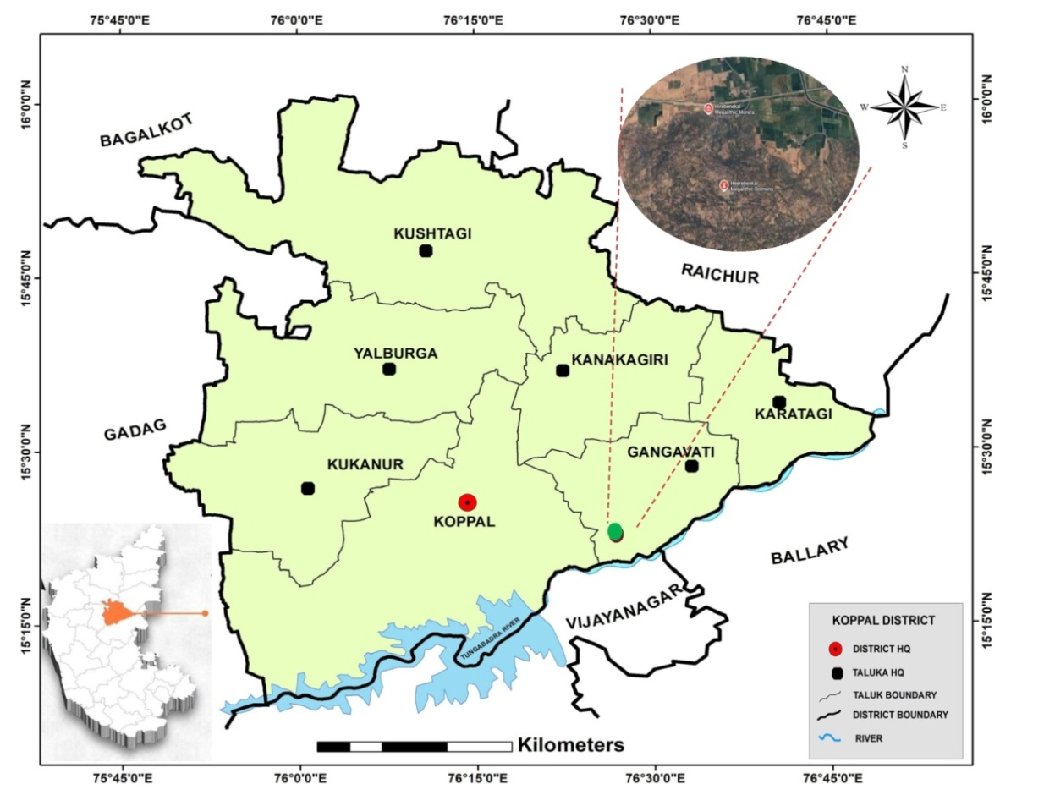
Figure 1. Map of Megalithic site, Hirebenakal, Koppal
3. Result:
The megalithic region comprising predominantly thorny and hardwood species. The comprehensive and unified account on vegetation of this region includes documentation of a total 122 plant species belongs to 107 genera 45 families.
Among the recorded plant species, Fabaceae are the dominant with 18 species (16.21%) followed by Apocynaceae 10 (9%) & Amaranthaceae 9 (8.1%) followed by Malvaceae with 7 species (6.3%) and Asteraceae 5 (4.5%) (Fig. 2). Among the habits, herbs stands first with 63 species (56.75%) followed by shrubs 43 (38.73%), trees 10 (9%), and climbers 5 (4.5%) (Fig. 3). Perennials are more with 91 species (81.98%) than annuals 29 ( 26.12%) (Fig. 4).
Important plant species of the region:
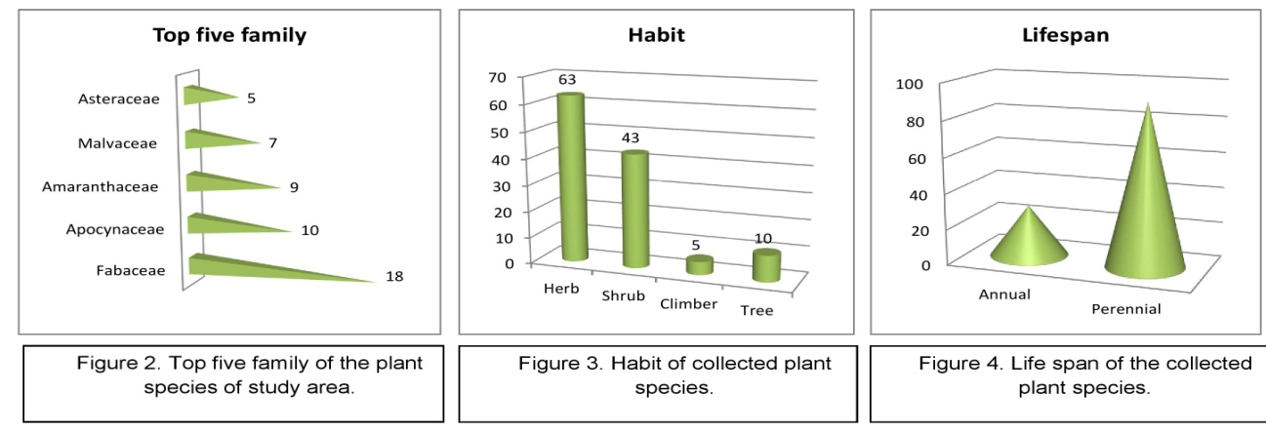
Pteridophytes like Selaginella bryopteris (L.) Baker.A treasure of medicinal properties is present abundantly in the area. Actiniopteris radiata usually found under stone crevices, aquatic plants like Nymphoides indica (L.) Kuntze.,Pistia stratiotis L., and Typha domingensis pers.were abundant in pond near large number of stone buildings at the peak of Moreragudda, which are creating botanical interest about this sites(Fig. 5). 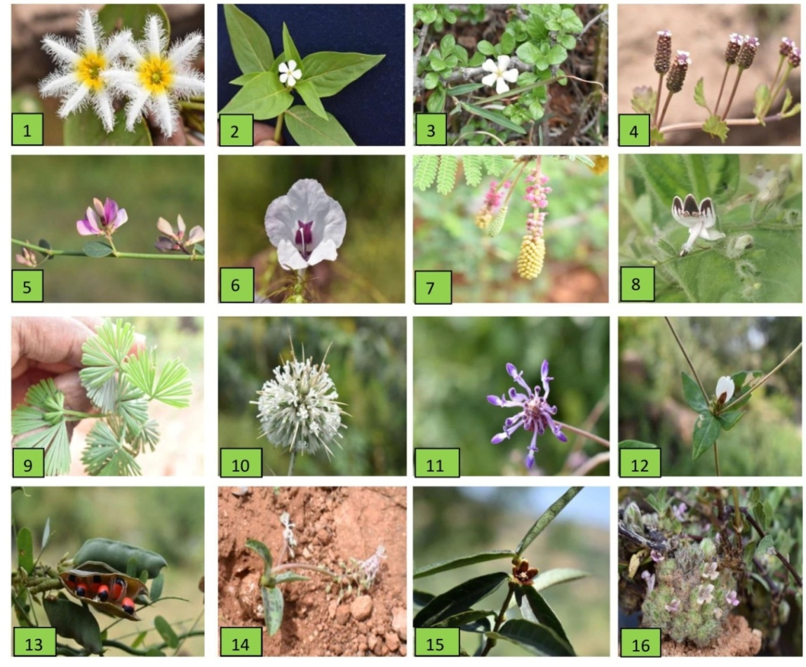
1. Nymphoides indica (L.) Kuntze 2. Catharanthus pusillus (Murray) G.Don
3. Catunaregum spinosa (Thunb.) Tirveng. 4. Phyla nodiflora (L.) Greene
5. Taverniera cuneifolia (Roth) Arn. 6. Parasopubia delphiniifolia (L.)
7. Dichrostachys cinerea (L.)Wight & Arn. 8. Andrographis echioides (L.) Nees
9. Actiniopteris radiate (Sw.) Link. 10. Echinops echinatus Roxb.
11. Anisochilous carnosus (L.f.) Wall. ex Benth. 12. Blepharis maderaspatensis (L.) B.Heyne ex Roth 13. Abrus precatorius L. 14. Ledebouria revulata (L. f.) Jassop.
15. Hemidesmus indica R.Br. 16. Lepidogathis cristata Willd.
Figure. 5. Glimps of floristic diversity of Megalithic sites, Koppal District, Karnataka.

Table 1. Enumeration of Flora of Megalithic sites, Koppal District, Karnataka.
SL. No. | Scientific name | Family | IUCN  status | Habit | Life  span | Uses
1 | Abrusprecatorius L. | Fabaceae | LC | S | p | Treats digestive disorders, jewellery making
2 | Achyranthes aspera L. | Amaranthaceae | NA | H | P | Anti- inflammatory, anti-oxidant, wound healing
3 | Aerva javanica Juss. | Amaranthaceae | NA | H | P | Anti- inflammatory, fodder, ornamental
4 | Aeschynomeneindica L. | Fabaceae | LC | H | P | Phyto-remediation, green manure
5 | Albiziaamara(Roxb.) B. Boivin | Fabaceae | NA | T | P | Anti -inflammatory, fodder, wood , gum
6 | Alternanthera sessilis (L.) DC. | Amaranthaceae | LC | H | P | Anti -inflammatory, anti- microbial, anti-diabitic
7 | Alternanthera pungensKunth | Amaranthaceae | LC | H | P | To treat flatulence, nausea, vomiting, cough,
8 | Alysicarpusmonilifer (L.) DC. | Fabaceae | LC | H | P | Forage and fodder, Cover crop, manure
9 | Alysicarpus vaginalis (L.) DC. | Fabaceae | NA | H | P | Forage and fodder, green manure
10 | Amaranthus caudatus L. | Amaranthaceae | NA | H | A | Leaves edible, anti-microbial
11 | Amaranthus viridis L. | Amaranthaceae | NA | H | A | Wound healing
12 | Andrographis echioides (L.) Nees | Acanthaceae | NA | H | P | Anti -inflammatory, anti- microbial, anti-pyretic
13 | Anisochilous carnosus (L.f.) Wall. | Lamiaceae | NA | H | A | Skin diseases, Gastric ulcers, Stomach ache
14 | Antigononleptopus Hook. & Arn. | Polygonaceae | NA | C | P | Ornamental, crafts and decorations
15 | AristolochiabracteolataLam. | Aristolochiaceae | NA | H | P | Anthelminitic, anti-pyretic, laxative, antidote
16 | AristolochiaindicaL. | Aristolochiaceae | NA | H | P | Anti-microbial, anti-inflammatory
17 | Asparagus officinalis L. | Asparagaceae | DD | H | P | Culinary uses, medicinal and ornamental
18 | Azimatetracantha Lam. | Salvadoraceae | LC | S | P | Rhueutism arthritis, oral health, insect repellent
19 | Barleriaprionitis L. | Acanthaceae | NA | H | P | Anti- inflammatory, anti-oxidant, wound healing
20 | Bauhinia racemosa Lam. | Fabaceae | LC | S | P | Fodder, manure, used in bidi making
21 | Bidens frondosa L. | Asteraceae | LC | H | P | Ornamental, anti-inflammatory
22 | Blepharismaderaspatensis(L.) B.Heyne ex Roth | Acanthaceae | NA | H | P | Anti- inflammatory, anti-oxidant, wound healing
23 | Cadabafruticosa(L.) Druce | Capparaceae | NA | S | A | Treats fever, asthma leaves edible, natural dye
24 | Calotropis gigantea (L.) Dryand | Apocynaceae | NA | S | P | Treats elephantiasis, toothache, tumor
25 | Calotropis procera (L.) W.T.Aiton | Apocynaceae | NA | S | P | Antidote for snake bite
26 | Canavalia rosea (Sw.)DC. | Fabaceae | LC | H | A | Ornamental, fixes nitrogen, seeds are edible
27 | Canthiumcoromandelicum(Burm.f.) Alston | Rubiaceae | NA | S | P | Treats fever, dysentery, diarrhea, respiratory disorders, wood
28 | Capparis spinosa Linnaeus | Capparaceae | NA | S | P | Buds used as spice, extracts used in skin care
29 | Capparis divaricataLam. | Capparaceae | NA | S | P | Flower buds used as spices, medicinal
30 | Cardiospermumhalicacabum L. | Sapindaceae | LC | H | P | Treats skin conditions, insect bites
31 | Carissa caranda L. | Apocynaceae | LC | S | A | Ornamental plant, treats diarrhea, hedge plant
32 | Carissa spinarumL. | Apocynaceae | LC | S | P | Treats cold, fever, digestive issues
33 | Cassia fistula L. | Fabaceae | LC | T | P | Ornamental, treats constipation, anti-microbial
34 | Catharanthuspusillus(Murray) G.Don | Apocynaceae | NA | H | A | To treat cancer and diabetes, root paste is used in septic wounds
35 | Catunaregum spinosa (Thunb.) Tirveng. | Rubiaceae | NA | S | P | to treat gastrointestinal and hepatic problems
36 | Celosia argentea L. | Amaranthaceae | LC | H | P | Ornamental plant, edible, cover crop, anti-fungal
37 | Chloroxylon swietenia DC. | Rutaceae | VU | T | P | Timber used as furniture, oils in perfumery
38 | Cissus quadrangularis L. | Vitaceae | NA | S | P | Promotes bone health, heals fractures
39 | Cleome viscosa L. | Cleomaceae | NA | H | P | Anti-inflammatory, anti-microbial, digestive aid
40 | Cocciniagrandis (L.) voigt | Cucurbitaceae | NA | V | P | Treats bronchitis, asthma, jaundice, fruit edible
41 | Coldeniaprocumbens L. | Boraginaceae | LC | H | A | Anti-inflammatory, anti-microbial, digestive aid
42 | Combretum latifoliumblume | Combretaceae | NA | S | P | Treats cough, sore throats, used as fuel wood,
43 | Corchorus aestuans L. | Malvaceae | NA | S | P | Leaves edible, durable fiber, medicinal
44 | Cressacretica L. | Convolvulaceae | LC | S | P | Treats respiratory ailments, wound healing
45 | Cryptostegia grandiflora Roxb. Ex R.Br | Apocynaceae | NA | V | P | Ornamental, strong and durable fiber
46 | CuscutareflexaRoxb. | Convolvulaceae | LC | S | P | Protects liver, promotes hair growth, anti-cancer
47 | Cyanthilliumcinereum(L.) H.Rob. | Asteraceae | NA | S | P | Anti-inflammatory, anti-pyretic, treats respiratory issues
48 | Cymbopogon citratus (DC.) Stapf | Poaceae | NA | H | P | Culinary uses, insect repellent
49 | CynanchumsarcomediumMeve&Liede | Apocynaceae | NA | S | P | Anti-parasitic, horticulture use
50 | CynodondactylonL.Pers. | Poaceae | NA | H | P | Fodder
51 | DalbergialanceolariaL.f. | Fabaceae | LC | S | A | Anti-diarrheal, astringent, seed oil used for rheumatism
52 | Datura metel L. | Solanaceae | NA | S | P | Treats epilepsy, skin disorders, fever and heart diseases
53 | Dichrostachyscinerea Wight et Arn. | Fabaceae | LC | S | P | Treats sore eyes, rheumatism, anti-inflammatory
54 | Diclipterapaniculata (Forssk.) I.Darbysh. | Acanthaceae | NA | H | P | Treats cancer, anti-bacterial, snake poison
55 | Dodonaeaviscosa Jacq. | Sapindaceae | LC | S | P | Treats gouts, fractures, snake bites, hemorrhoids
56 | EchinopsechinatusRoxb. | Asteraceae | NA | H | P | Stimulant, antipyretic ,anti-fungal
57 | Euphorbia antiquorum L. | Euphorbiaceae | LC | S | P | Anti-inflammation, anti-arthritis, wound healing
58 | Euphorbia hirtaL. | Euphorbiaceae | NA | H | A | Teeth ache, antiasthmatic, anticancer
59 | Euphorbia tirucalli L. | Euphorbiaceae | LC | S | A | Whooping cough, gonorrhea, asthma, leprosy
60 | Evolvulusalsinoides (L,) L. | Convolvulaceae | NA | H | P | Treats neurodegenerative, wound healing
61 | Ficus religiosa L. | Moraceae | NA | S | P | Fruits treats fever, bark treats snake bites
62 | Gomphrena serrata L. | Amaranthaceae | NA | S | P | Used against bronchial asthma, diarrhea, piles
63 | GrewiavillosaWilld. | Malvaceae | LC | S | P | Fodder, fruits edible
64 | Holopteleaintegrifolia(Roxb.) Planch. | Ulmaceae | LC | T | A | Treats leprosy, rickets, scabies and ring worm
65 | Hemidesmusindica R.Br. | Apocynaceae | NA | C | P | Treats Digestive issues, Skin diseases, Urinary diseases,
66 | Ipomoea triloba L. | Convolvulaceae | LC | H | P | Treats headache, stomachache, anti-bacterial and anti-cancer
67 | Ixora pavettaAndrews | Rubiaceae | LC | S | P | Treats fever, skin conditions, Ornamental plant
68 | LagasceamollisCav. | Asteraceae | NA | H | A | Used for hemorrhages, bleeding, snake bites
69 | Lantana camara L. | Verbenaceae | NA | S | P | Anti-tumor, anti-hypersensitive, treats chicken pox
70 | Ledebouriarevulata(L. f.) Jassop. | Liliaceae | NA | H | A | Anti-Poison, Anti-rheumatic agents, Cardio tonic
71 | LepidogathiscristataWilld. | Acanthaceae | NA | S | P | snake bites, wounds, skin diseases.
72 | Mesophaerumsuaveolens(L.) Kuntze | Lamiaceae | NA | H | P | Treats fever and cancer
73 | MollugoverticillataL. | Mollunginaceae | NA | H | P | Immunomodulator, anti-fungal
74 | MorindatinctoriaRoxb. | Rubiaceae | LC | S | A | Treats gastropathy, stomach ulcers
75 | Neltumajuliflora(Sw.) Raf. | Fabaceae | LC | S | P | Pods are edible, treats asthma, dysentery, flowers treat miscarriage
76 | Nymphoidesindica (L.) Kuntze | Menyanthaceae | LC | H | P | Ornamental
77 | Opuntia dilleni (Ker Gawl.) Hawl. | Cactaceae | NA | S | P | Fruits edible, treats burns, liver problems
78 | Ouretlanata(L.) Kuntze | Amaranthaceae | NA | H | P | Anti- inflammatory, anti-oxidant, wound healing
79 | Parasopubia delphiniifolia (L.) H.-P.Hofm. &Eb.Fisch. | Orobanchaceae | NA | H | P | Treats wounds, cuts, malaria, urinary problems, headache
80 | Passiflorafoetida L. | Passifloraceae | NA | C | P | Anti-inflammatory, anti-bacterial, anti-diarrheal
81 | Pavoniazeylanica (L.) Cav. | Malvaceae | NA | H | P | Treats hemorrhage, inflammation, fever, giddiness
82 | Phyla nodiflora (L.) Greene | Verbenaceae | LC | H | P | Fodder, treats liver disorders, nourishing agent
83 | Phyllanthus maderaspatensis Forssk. | Phyllanthaceae | LC | H | P | Treats kidney & urinary diseases
84 | Phyllanthus reticulates Poir. | Phyllanthaceae | LC | H | P | Anti-inflammatory, anti-bacterial, anti-diarrheal
85 | Physalis minima L. | Solanaceae | VU | H | P | Anti-cancer, ethno medicine, anti-pyretic
86 | Pistia stratiotes L. | Araceae | LC | H | P | To treat leprosy, ulcers, piles,
87 | Plumbago zeylanica L. | Plumbaginaceae | NA | H | P | Anti-antherogenic, cardio tonic, nueroprotective
88 | Polycarpaea corymbosa (L.) Lam. | Caryophyllaceae | NA | H | A | Anti-diabetic, treats fever and jaundice
89 | Priva cordifolia (L.f.) Druce | Verbenaceae | NA | H | P | Treats wounds, migranes, dermatitis, insect bites
90 | Pupalia lappacea (L.) Juss. | Amaranthaceae | LC | H | P | Treats wounds, bone fracture, malaria
91 | Rhynchospora minimaL.DC. | Fabaceae | LC | H | A | Anti-inflammatory, anti-bacterial, anti-diarrheal
92 | Schouwia purpurea (Forssk.) Schweinf. | Brassicaceae | NA | H | A | Anti-inflammatory, anticancer
93 | Senna alexandrinaMill. | Fabaceae | LC | S | P | To treat blood cancer, constipation relief
94 | Senna occidentalis (L.) Link | Fabaceae | LC | S | A | Treats fever, hepatitis
95 | Senna uniflora (Mill.) H.S.Irwin & Barneby | Fabaceae | LC | S | P | Organic fertilizer, treats constipation
96 | Sesamum indicum L. | Pedaliaceae | NA | H | P | Anti-oxidant, cholesterol reduction
97 | Sida acuta Burm.f. | Malvaceae | NA | H | A | Treats neurological disorders, abnormal vaginal discharge
98 | Sida cordifolia L. | Malvaceae | NA | H | P | Treats bronchial asthma, cold, flu, chills
99 | Solanum torvum Sw. | Solanaceae | NA | S | A | Treats fever, wounds, reproductive problems
100 | Solanum virginianum L. | Solanaceae | NA | S | P | Treats epilepsy, headache, migraine, hair fall
101 | Strychnos potatorumL.f. | Loganiaceae | NA | S | P | Treats gonorrhea, leucorrhea, dysentery
102 | Striga asiatica (L.) Kuntze | Orobanchaceae | NA | S | P | Anti-androgenic, anti-bacterial, anti-fungal
103 | Striga densiflora (Benth.) Benth. | Orobanchaceae | NA | H | A | Treats malaria, stomach issues, natural pesticide
104 | Striga gesnerioides (Willd.) Vatke | Orobanchaceae | NA | H | P | Traditional medicine
105 | Taverniera cuneifolia (Roth) Arn. | Fabaceae | NA | S | P | Blood purifier, anti-inflammatory, antiulcer,
106 | Tinospora cordifolia (Willd.) Hook.f. & Thomson | Menispermaceae | NA | C | P | used to make beverages like nannarisharbat
107 | Trianthema portulacastrumL. | Aizoceae | NA | H | A | Analgesic, stomachic, laxative
108 | Tribulus terrestris L. | Zygophyllaceae | LC | H | A | Treats chest pain, heart problems, dizziness
109 | Trichodesma indicum (L.)Sm. | Boriginaceae | NA | H | P | Cure arthritis, fever, skin diseases
110 | Tridax procumbensL. | Asteraceae | NA | H | A | Treats bronchial, liver problems
111 | Typha domingensis Pers. | Typhaceae | LC | H | A | Reduces bacterial contamination of water
112 | Urena lobata L. | Malvaceae | LC | H | P | Treats headache, stomachache, gastritis
113 | Vachellia leucophloea (Roxb.) Maslin, Seigler and Ebinger | Fabaceae | LC | T | P | Ornamental, timber, fiber, dye
114 | Vincetoxicum indicum (Burm.f.) Mabb. | Apocynaceae | NA | H | P | Treats bronchial asthma, allergies, dermatitis
115 | Vigna trilobata (L.) Verdc. | Fabaceae | NA | H | P | Treats arthritis, fever, cough, dysentery, urinogenital disorders
116 | Waltheria indicaL. | Malvaceae | LC | H | A | Treats cough, dysentery, bladder disorder
117 | Wrightia tinctoria (Roxb.) R. BR. | Apocynaceae | LC | T | A | Anticancer, wound healing, fights cholesterol
118 | Ximenia americana L. | Olacaceae | LC | T | P | Treats lung abscess, muscle cramp, wounds
119 | Ziziphus oenoplia(L.)Mill. | Rhamnaceae | NA | T | P | Anti-ulcer, anti-plasmodia, anti-cancer, nausea
120 | Ziziphus xylopyrus(Retz.)willd. | Rhamnaceae | NA | T | P | Treats diabetes, obesity, snake bite, insomnia
121 | Zygophyllum indicum (Burm.f.) christenh. & Byng | Zygophyllaceae | NA | S | P | Anti- inflammatory, anti-oxidant, wound healing
122 | Selaginella bryopteris(L.) Baker | Selaginellaceae | NA | H | P | Relief from heat stroke, dysuria, irregular menstruation, and jaundice
* Note: Habit: H-Herb, S-Shrub, T-Tree, C-Climber. Internation Union for Conservation of Nature (IUCN) status: VU- Vulnerable, LC- Least Concerned, DD-Data Deficient, NA: Not Applicable. Growth from: C-Cultivated, W-Wild. Life span: A-Annual and P-Perennial.

5. CONCLUSION
The current paper provides data on the status of vegetation in the Meghalithic hill, Hirebenakal, Koppal District. It is a treasure of Medicinal plant species, as the place is about to recognize globally, hence designated for priority conservation activities. Currently badly affected by the encroachment & other anthropogenic activities, the need for effective control must be emphasized. This research work will serve significant information regarding floristic diversity of the area and will aid in the management strategies and development of conservation plans.
DISCLAIMER (ARTIFICIAL INTELLIGENCE)
Author(s) hereby declare that No AI generative technologies used during to prepare this manuscript.
COMPETING INTERESTS DISCLAIMER:
Authors have declared that they have no known competing financial interests OR non-financial interests OR personal relationships that could have appeared to influence the work reported in this paper.

References

- Bassey, M. E., Umoh, O. T., & Jonah, M. E. (2021). Preliminary Floristic Inventory of the Swamp Forest of Atan Ukwok Village in Ini L.G.A of Akwa Ibom State, Nigeria. Asian Journal of Research in Agriculture and Forestry, 7(2), 31–41. https://doi.org/10.9734/ajraf/2021/v7i230126.
- Brooks, T. M., Mittermeier, R. A., Mittermeier, C. G., Da Fonseca, G. A., Rylands, A. B., Konstant, W. R., Flick, P., Pilgrim, P., Oldfield, S., Magin, G., & Hilton-Taylor, C. (2002). Habitat loss and extinction in the hotspots of biodiversity. Conservation Biology, 16(4), 909–923.
- Champion, H.G. & Seth, S.K. 1968. A Revised Survey of Forest Types of India, Government of India Press, New Delhi.
- Morrison, K.D., Lycett, M.T. and M. Trivedi 2016a. Megaliths and memory: excavations at Kadebakele and the megaliths of Northern Karnataka. In Proceedings of the 20th Conference of the European Association for South Asian Archaeology and Art, Contextualizing Material Culture in South and Central Asia in Pre-modern Times 2: 239-252.
- Gamble. J.S. 1918-35. Flora of the Presidency of Madras. Adlard and Son Ltd. W.c., London Vol.II-III.
- International Plant Name Index 2012. Published on the Internet http://www.ipni.org.
- J.M. Baert et al. (2018) Biodiversity effects on ecosystem functioning respond unimodally to environmental stress, Ecol. Lett.
- Jain, S.K. and R. R. Rao. 1977. A handbook of Field and Herbarium Methods, Today & Tomorrow’s Printers & Publishers, New Delhi.
- https://powo.science.kew.org/
- Prange, S., & Gehrt, S. D. (2004). Changes in mesopredator community structure in response to urbanization.
- Saldanha CJ, Nicolson DH. 1976. Flora of Hassan District. Karnataka India. Amerind Publishing Co. Pvt. Ltd.
- Saldanha CJ. 1984-1996. Flora of Karnataka, Oxford and IBH Publishing Co., New Delhi, I- II.
- Seetharam, Y.N. Kotresha, K. and Uplankar, S.B. 2000. Flora of Gulbarga District. Registrar, Gulbarga University, Gulbarga, India.
- Singh, N.P. 1988. Flora of Eastern Karnataka. Mittal publication. New Delhi, India. 336.
- Sharma, B. D., Singh, N. P., Raghavan, R. S. &Deshapande, U. R. (1984). .Flora of Karnataka analysis. Botanical Survey of India. Calcutta.
- Umrao, R., Mehera, B., & Kumar, H. (2024). Structure and Floristic Composition of Existing Agroforestry Systems in Allahabad District of Uttar Pradesh, India. International Journal of Environment and Climate Change, 14(4), 815–826. https://doi.org/10.9734/ijecc/2024/v14i44160.
- Canadian Journal of Zoology, 82(11), 1804–1817

