Beyond Dye and Medicine: Reviving Indigofera tinctoria L. Cultivation for Water Sustainability, Fodder Resilience, and Economic Opportunity in Iran

.
ABSTRACT

Drought is an inevitable phenomenon that frequently occurs in hot and arid regions, and Iran faces significant challenges in terms of water availability due to its geographical and climatic conditions. Studies suggest that future years will likely witness more severe droughts and water shortages than previously experienced. The cultivation and processing of plants have long attracted global interest, particularly in countries like Iran, where many plant species possess valuable medicinal, industrial, and agricultural properties. Among these, Indigofera tinctoria L., commonly known as indigo, stands out as a neglected yet highly promising plant with diverse applications. Indigo has a long history of use for natural dye production, which is widely applied in the textile industry, cosmetics, and pharmaceuticals. Additionally, it holds potential as a medicinal plant in traditional medicine and as a nutritious fodder crop for livestock. This study aims to investigate the multifaceted uses of indigo—including its pharmaceutical, industrial, and agricultural applications—while emphasizing its role in promoting sustainable agriculture, especially under drought-prone conditions. The research was conducted through a review of library sources and scientific literature. The findings highlight the plant's adaptability to harsh environmental conditions, such as drought and poor soil quality, and its ability to fix atmospheric nitrogen, making it beneficial for soil health. Furthermore, indigo exhibits high nutritional value as fodder, particularly for ruminants, and can contribute significantly to food security and rural employment when cultivated systematically. Given its ecological resilience and multiple benefits, reviving the cultivation of indigo in appropriate agroecological zones of Iran could support sustainable agricultural systems, conserve water resources, and provide economic opportunities.

Keywords: Drought tolerance, Fodder plant, Natural dye, Nitrogen fixation
Sustainable agriculture

1. INTRODUCTION
Indigo (Indigofera tinctoria L.) is a warm-season annual or short-lived perennial plant known for its historical and industrial significance, particularly in the production of natural blue dye. Its leaves are harvested two to four weeks per year, with the cultivation period in Iran typically ranging from late September to mid-December. The plant holds value not only as a source of natural dye but also as a medicinal and fodder crop, making it a versatile species suitable for domestic use and export markets. Native to tropical regions, indigo belongs to the Fabaceae (legume) family and is characterized by its bushy growth habit, reaching heights of 1–2 meters. It features compound leaves composed of 9–13 small, light green leaflets, pink flowers borne on peduncles 5–15 cm long, and leguminous pods containing 8–12 brown seeds. One of its key ecological traits is its extensive root system, which can penetrate up to 2.5 meters into the soil, enabling it to withstand drought conditions. Like other legumes, indigo forms a symbiotic relationship with Rhizobium Indigofera , allowing it to fix atmospheric nitrogen and improve soil fertility (Khoshnam et al., 2019).Iran possesses significant potential for cultivating medicinal and industrial plants, including indigo, particularly in its central and southern regions. Historically, indigo has been cultivated in cities such as Jiroft, Kahnouj, Iranshahr, and Bam since its introduction during the Sassanid and Qajar periods (Olfati, 1995; Mozzafari et al., 2000). Despite this history, indigo has become a neglected crop in recent decades due to the rise of synthetic dyes and limited agricultural attention (Zargaran Khouzani et al., 2018).Given the increasing frequency and severity of droughts in Iran—particularly in arid and semi-arid regions—the cultivation of drought-tolerant plants like indigo offers a sustainable alternative that conserves water while providing economic and environmental benefits. Indigo's ability to thrive in marginal soils, combined with its medicinal, cosmetic, industrial, and fodder applications, makes it a promising candidate for inclusion in sustainable agricultural systems (Aeen et al., 2005).This paper aims to explore the multifaceted utility of Indigofera tinctoria L., emphasizing its role in enhancing water sustainability, improving livestock feed options, and contributing to rural economies. By revisiting traditional knowledge and integrating modern research, this study highlights the importance of reviving indigo cultivation in appropriate agroecological zones of Iran.
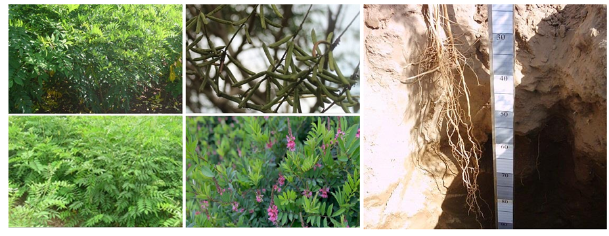Fig1: Growth stages and parts of the indigo plant

2. Distribution of Indigo in the World and Iran
Indigo (Indigofera tinctoria L.) is native to East Asia (Sarhadi et al., 2014), but it has been widely cultivated across tropical and subtropical regions of Africa, Asia, and the Americas. Historical records indicate that indigo cultivation dates back to ancient times, with evidence of its use in Europe as early as the Stone Age. The plant's deep root system enables it to tolerate drought conditions, making it well-suited for arid and semi-arid environments. Today, indigo is grown in various parts of Southeast Asia, Central Europe, and other temperate zones. It is particularly prevalent in countries such as India, Pakistan, Sri Lanka, Indonesia, Saudi Arabia, Egypt, Syria, and several regions of sub-Saharan Africa (Mozzafari et al., 2012). In some areas, including parts of South America, it grows in dense clusters or "Carrizo" formations.
In Iran, indigo was introduced during the Sassanid period (6th century AD) and later cultivated more extensively during the Qajar era (Olfati, 1995; Strobel & Gröger, 1989). Historical references suggest that indigo was once cultivated in Kerman Province during the Sassanid dynasty and in Khuzestan Province during the Qajar rule (Mozzafari et al., 2000). Currently, it is considered one of the most important summer crops in southeastern Iran, particularly in Kerman Province. The plant naturally occurs in mountainous areas such as Khash, Nehbandan, Iranshahr, Zabul, Mirjaveh, Fahraj, and Regan. Historically, significant cultivation took place in the Jiroft and Kahnouj regions, where the planted area reached 520 hectares in 2006 with an average yield of 2,500 kg per hectare (Ministry of Agricultural Jihad of Iran, 2007). However, by 2011, this area had decreased to only 131 hectares (Ministry of Agricultural Jihad of Iran, 2012), indicating a decline in agricultural interest and production. Currently, indigo is mostly grown on small plots (less than 0.5 hectares) intercropped with other species, involving approximately 500 farmers. Cultivation is primarily managed by small-scale landowners. One of the main reasons for the decline in indigo farming has been the substitution of natural dyes with synthetic alternatives (Zargaran Khouzani et al., 2018).
Despite its historical significance and adaptability to local climates, indigo is now regarded as a neglected crop in Iran. Reviving its cultivation could provide economic opportunities, promote biodiversity, and contribute to sustainable agricultural practices in suitable agroecological zones.

3. Ecophysiological Characteristics of Indigo
Indigo (Indigofera tinctoria L.) is a tropical plant that thrives best under warm and humid climatic conditions. It shows optimal adaptation up to an elevation of 1250 meters above sea level. The plant prefers full sunlight and does not perform well in areas with high cloud cover during its growing season. The ideal average temperature for indigo growth and development is around 30°C, with a minimum soil temperature of 18–20°C required for germination. For healthy growth, indigo requires at least a 120-day frost-free growing period. Exposure to sub-zero temperatures can be detrimental to the plant at any developmental stage. One of the most notable features of indigo is its drought tolerance, which is largely attributed to its deep and extensive root system. Numerous studies have confirmed its resilience under water-limited conditions (Ansouri et al., 2015). Research conducted in Jiroft by Aeen et al. (2005) demonstrated that mild drought stress (irrigation at 75% field capacity) had no significant effect on the yield of dry leaves, which is considered the main economic output of the crop. Similarly, moderate drought stress (50% field capacity) did not significantly impact total biomass production. Indigo is a low-input crop that performs well even in marginal soils of low fertility (grade 2 and 3 soils), producing acceptable yields without requiring intensive management. While it can grow in various soil types, medium- to deep-textured soils with good drainage are most favorable for its cultivation. The plant is sensitive to waterlogging and reacts negatively in such conditions, especially during early growth stages. Although indigo is relatively sensitive to salinity during establishment, it can tolerate moderate levels once fully developed (Zargaran Khouzani, 2022).These Ecophysiological traits make indigo a suitable candidate for cultivation in arid and semi-arid regions, particularly in areas facing challenges related to water scarcity and soil degradation. Its ability to thrive under adverse environmental conditions, combined with its multiple uses, positions it as a promising species for sustainable agricultural systems in Iran and similar climates.

4. Cultivation Practices of Indigo
Indigo is a warm-season crop that requires specific agronomic practices to ensure successful establishment and optimal yield. One of the primary challenges in indigo cultivation is its hard seed coat, which causes seed dormancy by limiting water penetration. To overcome this, pre-sowing treatments such as scarification or hot water treatment are recommended to improve germination rates and ensure uniform seedling emergence (Zargaran Khouzani et al., 2018).

4.1. Planting Time
In the tropical and subtropical regions of southern Iran, where spring temperatures are not restrictive, the ideal planting period for indigo is from mid-April to May. If the objective is seed production, planting should be delayed until June. In intercropping systems with wheat or barley, it is advisable to sow indigo immediately after harvesting the preceding cereal crop. However, in cooler temperate zones, planting should be scheduled so that soil temperature remains above 18°C at sowing and the plant’s growth cycle avoids exposure to frost during later stages. In southeastern Iran, indigo is commonly cultivated following winter cereals or kitchen garden crops. The most suitable rotation system involves alternating indigo with cereals such as wheat and barley. This practice helps reduce pest and disease pressure, minimizes weed competition, and benefits from complementary root systems.

4.2. Propagation and Seeding Rate
Indigo is propagated exclusively through seeds. Under traditional broadcasting methods, farmers typically use about 25 kg of seed per hectare. However, when using precision seeding equipment such as a rapeseed drill, the required seed rate decreases significantly to approximately 6 kg/ha. In row planting, recommended spacing includes 35–50 cm between rows and 10 cm between plants within the row.

Seedlings usually emerge 4–5 days after planting under favorable temperature and humidity conditions. In hot southern regions, at least two irrigations spaced 3–4 days apart are necessary shortly after planting to ensure full field coverage and rapid establishment. Once the plants reach a height of about 10 cm, irrigation intervals can be extended to every 10–14 days, depending on soil moisture retention capacity.

4.3. Water Management
Indigo is highly sensitive to waterlogging; therefore, proper irrigation management is crucial. Water should not be allowed to pool around the base of the plants for extended periods. Flood irrigation (Kirti method) is generally unsuitable, while furrow irrigation (Faroese method) is more appropriate. Drip irrigation, particularly the band-type system, is highly recommended for efficient water use and improved yield. The plant has higher water requirements during critical growth stages such as budding, greening, and flowering—especially if seed production is the target (Aeen et al., 2005; Zargaran Khouzani et al., 2018).

4.4. Weed and Pest Management
Due to its slow initial growth, indigo is vulnerable to weed competition. Effective weed control strategies include the application of herbicides such as Pursuit (imazethapyr 10%) at 1.75 L/ha combined with Focus (cycloxydim 10%) at 2 L/ha.Indigo is relatively resistant to pests, and no major insect infestations have been reported in Iranian fields. However, one notable disease affecting indigo is Fusarium wilt, caused by Fusarium solani. Symptoms include wilting, leaf drop, and eventual plant death. Diseased plants often show signs of root and crown rot. Early detection and removal of infected individuals are essential to prevent disease spread (Khorramdel et al., 2015).

4.5. Harvesting
Depending on climatic conditions and farm management, indigo can be harvested once or multiple times per growing season. In hot southern regions, well-managed farms may allow up to three harvests per year, and in fodder production systems, even five cuts are possible (Herdiawan & Krisnan, 2014).
- Single Harvest: Typically performed at full flowering stage when the plant reaches maximum vegetative growth.
- Multiple Harvests: First cut should occur before flowering, when the plant height reaches 50–70 cm. Subsequent harvests are carried out after regrowth reaches at least 50 cm in height.
It is important to maintain a cutting height of at least 10 cm above ground level to promote regrowth. After each harvest, proper irrigation and nutrient management should be implemented to support rapid recovery and maximize subsequent yields.
Post-harvest, the foliage is sun-dried, and woody stems are separated from the leaves. The dried leaves, which constitute the main economic product for dye extraction, are then packaged for storage or processing.
Under optimal conditions, indigo can produce up to 5 tons of dried leaves per hectare per harvest. Fields dedicated to seed production are typically planted later, around the end of June, to avoid high summer temperatures during flowering and pod development. Seed harvesting occurs in late November, with average yields ranging from 800 to 900 kg/ha in southeastern Iran (Ansouri et al., 2015).

5. Industrial Applications of Indigo
Indigo (Indigofera tinctoria L.) is not only valued for its historical significance as a natural dye but also for its diverse industrial applications, including textile processing, pharmaceuticals, and emerging nanotechnology-based industries. The plant produces a unique blue pigment known as indigotin (C₁₆H₁₀N₂O₂), which has been used for centuries in fabric dyeing due to its high color stability and aesthetic appeal. Beyond traditional use, modern research has explored innovative applications of indigo-derived compounds in various sectors.

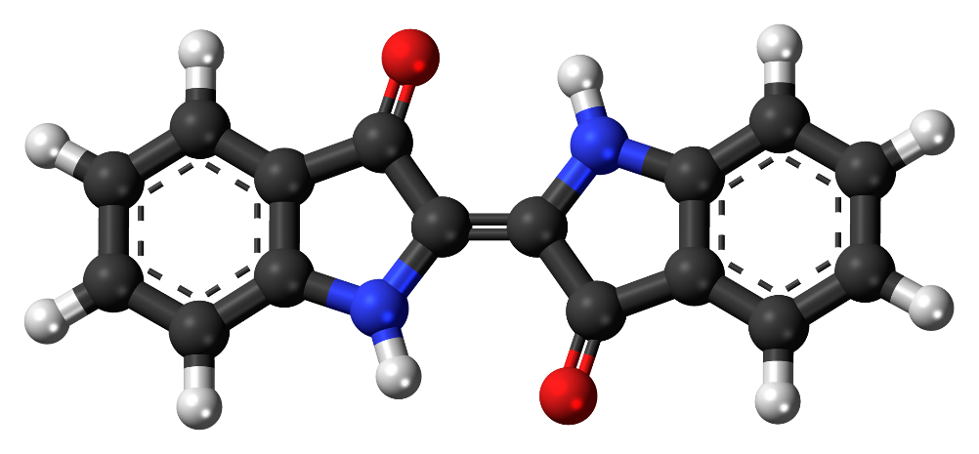
Carbon: black, Hydrogen: white, Oxygen: red , Nitrogen: blue

Fig 2: Ball-and-stick model of the indigo dye molecule, a historically significant dye, used in blue jeans. (This image was created with Discovery Studio Visualizer.)

5.1. Natural Dye Production
The most well-known application of indigo is in the production of natural blue dye, widely used in the textile industry. The leaves of the plant contain precursors such as Indican, which upon hydrolysis and oxidation yield indigo dye. This dye is extensively applied in coloring cotton, silk, and woolen fabrics, particularly in the production of denim and other durable textiles. In addition to indigotin, the plant contains other minor dye compounds such as:
- Indirubin (Indigo red)
- Indirol (Indigo brown)
- Gluten indigo
These derivatives contribute to the versatility of indigo as a coloring agent and are sometimes used in combination with other natural dyes to achieve a broader range of hues. Due to growing consumer demand for eco-friendly and sustainable alternatives, there has been a resurgence of interest in using plant-based dyes like indigo instead of synthetic options that pose environmental hazards(Zargaran Khouzani & Daei Naseri., 2025).
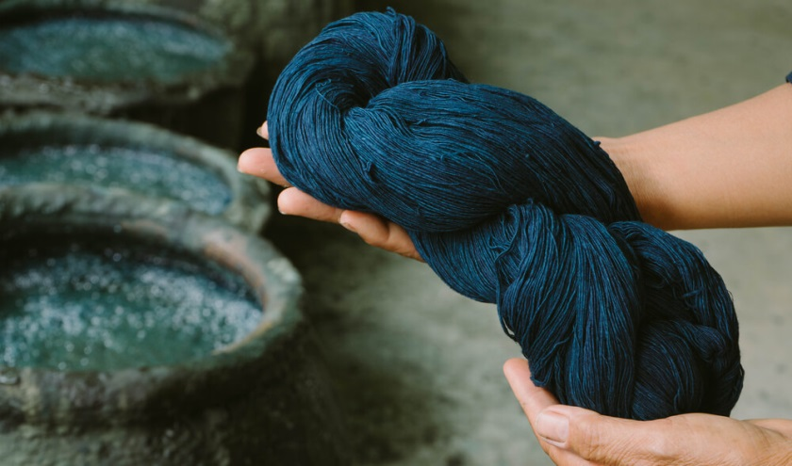
Fig 3: Natural fibers dyed with dye extracted from the indigo plant

5.2. Carbon Quantum Dot Synthesis
Recent studies have demonstrated novel applications of indigo in advanced material sciences, particularly in the synthesis of carbon quantum dots (CQDs). These nanomaterials exhibit excellent optical properties, making them suitable for use in sensors, drug delivery systems, catalysis, and energy storage devices. According to Daei Naseri et al. (2022), carbon quantum dots can be synthesized from indigo plant extracts using hydrothermal methods. This green synthesis approach avoids the use of toxic chemicals and aligns with sustainable manufacturing practices. The resulting CQDs have shown promise in modifying electrode surfaces for electrochemical sensors, contributing to advancements in bio sensing and analytical chemistry. This emerging field highlights the potential of indigo beyond traditional uses, positioning it as a valuable resource for future industrial innovations.
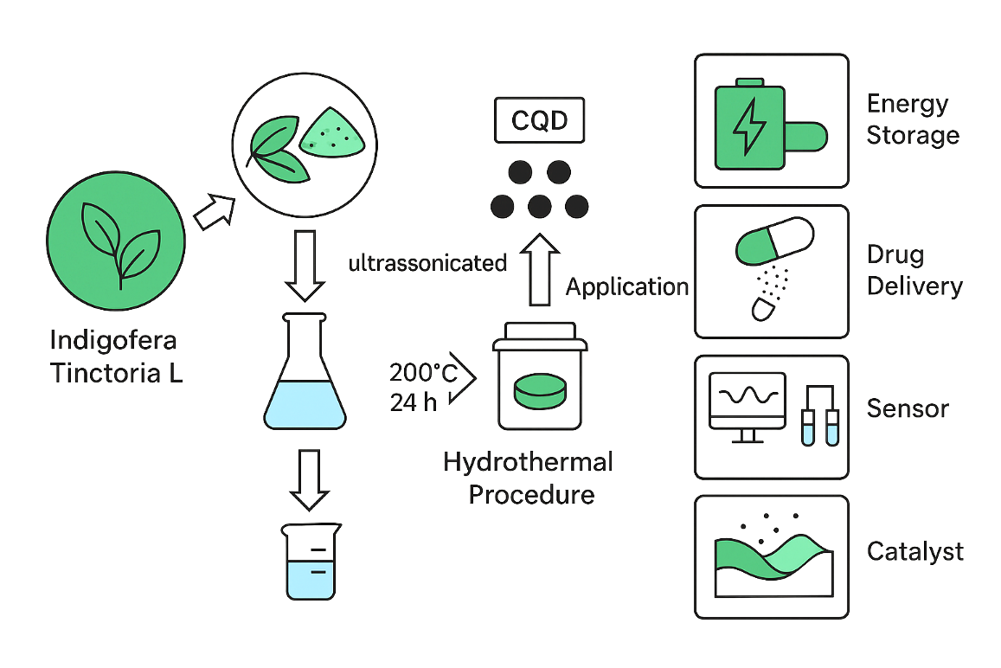
Fig4: Schematic of applications of quantum dot carbon prepared from indigo plant
6. Medicinal Uses of Indigo in Traditional Medicine
Indigofera tinctoria L., commonly known as indigo, has a long history of use in traditional medicine across various cultures. Its therapeutic applications have been documented in both Iranian and international ethnobotanical studies, highlighting its role in treating a range of ailments from inflammatory conditions to nervous disorders. In southeastern Iran, decoctions made from indigo leaves are traditionally used to alleviate foot pain and headaches. Crushed leaves are applied topically to treat burning sensations and cracked feet, suggesting anti-inflammatory and soothing properties. In Cameroon, twigs of the indigo plant are used as natural toothbrushes, indicating potential antimicrobial effects that contribute to oral hygiene.
The root and stem of the indigo plant possess a bitter taste and are valued for their laxative, expectorant, and anthelmintic (anti-parasitic) properties. These parts are also believed to strengthen hair and support scalp health. Across different medicinal systems, all parts of the plant—leaves, roots, and seeds—are reported to exhibit anti-inflammatory activity, making them useful in managing chronic conditions such as bronchitis, asthma (particularly in children), hemorrhoids, insect bites, and skin disorders. Indigo juice is employed in traditional remedies for epilepsy and nervous system disorders. It is often formulated into ointments for treating wounds and hemorrhoids. In veterinary medicine, leaf extracts are applied to burns and injuries in domestic animals like cows and horses. In India, paste made from indigo roots is used to accelerate wound healing, while root infusions serve as antidotes for snakebites and are used to treat scorpion and insect stings.

The seeds of Indigofera tinctoria are traditionally used to relieve watery eyes and may help in reducing eye discharge during the early stages of cataracts. Both leaves and roots are recommended in the treatment of epilepsy and diabetes. Dried powder derived from the plant is used to manage asthma symptoms. Additionally, leaf extracts are believed to counteract hepatotoxicity and act as anti-inflammatory agents. Scientific studies corroborate some of these traditional claims. For instance, methanolic extracts of indigo have demonstrated antiviral properties, including inhibition of HIV replication (Kavimani et al., 2001). Other research highlights its efficacy in treating respiratory conditions such as shortness of breath, whooping cough, and heart palpitations (Bangar & Saralaya, 2008).
7. Fodder use of indigo plant
In the context of livestock nutrition, indigo has emerged as a promising fodder crop, particularly in arid and semi-arid regions where water scarcity limits the cultivation of conventional forage crops such as alfalfa and corn. Given its deep root system, drought tolerance, and high nutritional value, indigo offers a sustainable alternative that aligns with the need to optimize water use while supporting animal husbandry.

7.1. Advantages of Indigo as a Fodder Crop
Indigo possesses several key characteristics that make it an attractive option for inclusion in livestock feeding systems:
- Drought Resistance: Indigo's deep root system enables it to thrive under limited water availability, making it suitable for cultivation in dryland farming systems.
- High Forage Yield: Under proper management, indigo can produce up to 33 tons per hectare of fresh forage annually (Herdiawan & Krisnan, 2014).
- Nutritional Value: The plant is rich in crude protein, low in fiber, and contains essential minerals, contributing to improved livestock productivity.
- High Palatability: Studies indicate that cattle and goats prefer indigo over many other forages (Tarigan, Andi & Ginting, 2011).
- Low Anti-Nutritional Content: Indigo contains minimal anti-nutrients such as tannins (0.6–1.4 ppm), which enhances its digestibility and nutrient absorption.
- Soil Adaptability: It performs well in marginal soils, including acidic and alkaline soils of grade 2 and 3 fertility.
These traits position indigo as a viable solution to address feed shortages, especially during dry seasons when traditional forages are scarce.
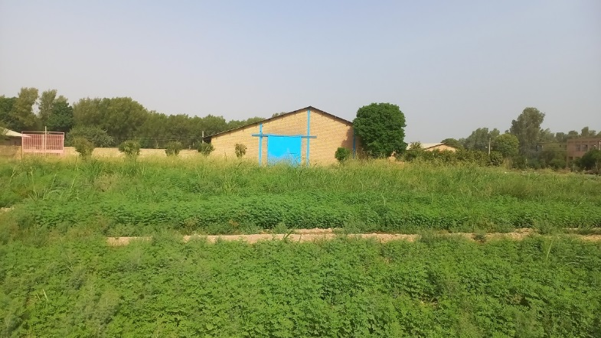
Fig 5: A view of the indigo farm in Shoushtar city - Khuzestan province - Iran in the harvesting stage

7.2. Nutritional Composition of Indigo Fodder
The nutritional content of indigo varies depending on whether it is fed fresh or dried. Table 1 compares the nutritional composition of fresh and dried indigo fodder:
Table 1: Nutritional content of dry and wet indigo plant fodder (Titis Anugraheni, 2011)
Nutritional content | Nile dry fodder | Fresh (fresher)  Nile fodder
dry matter percentage | 88.11 | 21.97
Ash percentage | 6.41 | 6.14
Protein percentage | 25.66 | 24.17
Fiber percentage | 14 | 15.25
Fat percentage | 2.9 | 6.15
The percentage of Beta N | 39.14
The percentage of total digestible energy (TDN) | 75.47

As shown, dried indigo fodder has a significantly higher dry matter content compared to fresh fodder due to moisture removal during drying. However, both forms retain substantial levels of protein and digestibility, making them valuable components of ruminant diets.
7.3. Application in Goat Feeding
Goats, particularly those in growth or lactation phases, require high-protein diets to support optimal performance. Incorporating indigo into their rations has demonstrated significant benefits:
- Growth Performance: Research indicates that supplementing goat diets with indigo improves daily weight gain. A study found that goats fed a ration containing 50% grass and 50% indigo gained an average of 44 g/head/day, compared to 37 g/head/day for those on grass-only diets (Simanihuruk & Sirait, 2009). This represents an 18% increase in weight gain.
- Milk Production: In dairy goats, replacing part of the concentrate with indigo has led to increased milk yield. For example, Saanen goats fed indigo-based rations produced an average of 660 ml/head/day, compared to 539 ml/head/day with concentrate alone. Similarly, Jamunapari goats showed an increase from 379 ml to 762 ml per day (Titis Anugraheni, 2011).
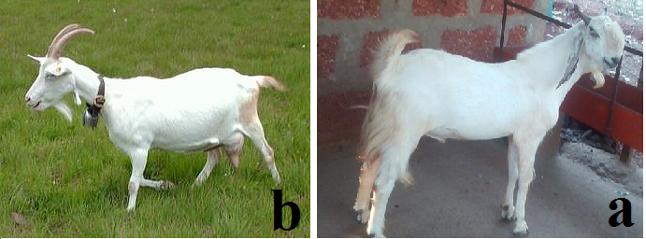
Fig 6: (a) Indian Jamunapari goat; (b) Saanen breed goat.

7.4. Application in Cattle Feeding
Indigo also shows promise in cattle nutrition, particularly when incorporated into mixed rations:
- Weight Gain Improvement: Substituting 60% of elephant grass with indigo in cattle feed resulted in a 39% increase in daily weight gain (Nurhayu & Pasambe, 2016).
- Breed-Specific Responses: While Ongole cattle responded favorably to indigo supplementation, Simmental and Limousin breeds showed less pronounced improvements. Therefore, gradual introduction and monitoring are recommended when adapting new breeds to indigo-based diets.
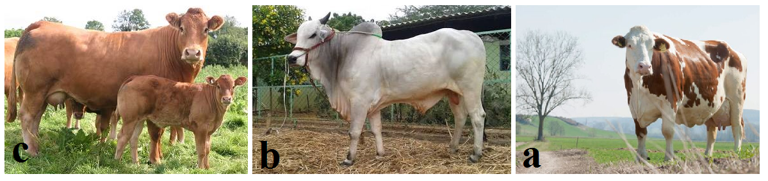Fig 7. (a) Simmental cattle; (b) Ongole breed cattle; (c) Limousin cattle.

7.5. Comparative Advantage over Other Legumes
Among legume species used for fodder, indigo stands out for its:
- Superior Nutritional Quality: High crude protein and low fiber enhance digestibility and energy availability.
- Adaptation to Poor Soils: Unlike many legumes, indigo thrives in low-fertility soils.
- High Biomass Production: Its potential yield of 33 tons/ha/year surpasses many conventional forages.
This makes indigo a competitive choice for integration into mixed cropping systems and agro-pastoral production models. Given its adaptability to harsh environmental conditions, high nutritional value, and positive impact on livestock productivity, Indigofera tinctoria L. holds considerable promise as a sustainable fodder crop. Its ability to grow in marginal lands with minimal inputs makes it particularly relevant in the face of increasing climate variability and water scarcity. With appropriate agronomic practices and strategic integration into livestock feeding programs, indigo can contribute significantly to food security and rural livelihoods in Iran and similar agroecological zones.
8. Conclusion
Despite the limited cultivated area of Indigofera tinctoria L. in Iran today, its diverse applications—ranging from medicinal and industrial uses to fodder production—highlight its significant potential for revitalization. Reviving indigo cultivation can contribute to employment generation, diversification of cropping systems, and the promotion of sustainable agricultural practices across various regions of the country. Understanding the agronomic requirements and management practices of this neglected medicinal and industrial plant is essential not only for enhancing local production but also for reducing dependency on imported chemical dyes and pharmaceutical products. Moreover, as a legume species with high adaptability to drought and poor soil conditions, indigo offers ecological benefits such as nitrogen fixation, soil improvement, and efficient water use—making it particularly valuable in arid and semi-arid regions. Given the increasing demand for natural dyes, medicinal compounds, and sustainable fodder alternatives, expanding indigo cultivation in line with improved agronomic practices could serve as a viable alternative in crop rotations. This would support both environmental sustainability and economic resilience in rural communities.

Furthermore, due to its eco-physiological characteristics—including drought tolerance, high nutritional value for livestock, and palatability—indigo has the potential to be integrated into feeding systems for both light and heavy livestock. Its inclusion in rations can enhance animal productivity while reducing feed costs, especially under conditions of water scarcity and declining forage availability. In summary, this study aimed to explore the multifaceted utility of Indigofera tinctoria L., emphasizing its role in sustainable agriculture, water conservation, and rural development. Considering its historical significance in southern and central Iran, along with its documented benefits in international research, there is a strong case for renewed attention to this versatile plant. By integrating traditional knowledge with modern scientific approaches, indigo can be repositioned as a key component of resilient agricultural systems in Iran and similar agroecological zones worldwide.

9. Disclaimer (Artificial intelligence)
The authors hereby declare that this research is the result of our own work and that artificial intelligence technologies were used only for the purpose of drawing one of the images and also for the literary review and editing of the text of the article.
The details of the use of artificial intelligence are given below:
1. Literary review and editing of the text of the article: Qwen3-235B-A22B
2. Drawing Fig 4: GPT-4o

10. Reference

Aeen, A. (2005). Effects of drought stress on yield and some physiological traits of medicinal and industrial plant Indigofera tinctoria. Seed and Plant Improvement Research Institute.
Anonymous. (2007). Statistics and information of the Ministry of Agriculture, crop year 2006. Statistics and Information Center of the Ministry of Agriculture, Tehran. [In Persian]
Anonymous. (2013). Statistics and information of the Ministry of Agriculture, crop year 2012. Statistics and Information Center of the Ministry of Agriculture, Tehran. [In Persian]
Ansouri, A., Shahqoli, H., Makarian, H., & Qolipour, M. (2015). Investigating the effect of planting date on the growth and performance of the Shahrood plant (Indigofera tinctoria L) in Shahrood conditions. Agricultural Research in Iran. [In Persian]
Bangar, V. A., & Saralaya, M. G. (2008). Anti-hyperglycaemic activity of ethanol extract and chloroform extract of Indigofera tinctoria leaves in streptozotocin induced diabetic mice (Family Papilionaceae). Research Journal of Pharmaceutical, Biological and Chemical Sciences, 2 (1), 445–455.
Daei Naseri, S. M. A., Ghasemi, S., Mousavi, F., Zargaran Khouzani, M. R., & Fotouki, F. (2022). Green synthesis of carbon quantum dots from Indigo plant. In 7th Zeolite Conference of Iranian Chemical Society, Chemistry & Chemical Engineering Research Center of Iran (pp. 30–31 August).
Herdiawan, I., & Krisnan, R. (2014). Productivity and utilization of Indigofera zollingeriana tree legume plants on dry land. WARTAZOA, 24 (2), 75–82.
Kavimani, S., Jaykar, B., De Clercq, E., Pannecouque, C., Witvrouw, M., & De Clercq, E. (2001). Studies on anti-HIV activity of Indigofera tinctoria. Hamdard Medicus, 43 (1), 5–7.
Khorramdel, S., Rizvani Moghadam, P., Houshmand, M., & Banhangi, F. (2015). The effect of manure levels and plant density on the yield and components of grain yield, leaf yield and indigo. Plant Production Research (Agricultural Sciences and Natural Resources). [In Persian]
Khoshnam, Z., Amirinejad, M., Aien, A., & Parsasamtalaq, B. (2019). Evaluation of the intercropping system of Indigofera tinctoria L and Hibiscus sabdariffa L on yield, biodiversity and weed population changes. Production and Processing of Agricultural and Garden Products, 10 (2), 109–121. [In Persian]
Mozzafari, F., Ghorbanli, S., Babai, M., & Farzami, A. (2000). The effect of water stress on the seed oil of Nigella sativa L. Journal of Essential Oil Research, 12, 36–31.
Mozzafari, F., Ghorbanli, S., Babai, M., & Farzami, A. (2012). Identification of medicinal and aromatic plants in Iran. National Network of Medicinal Plants Research and Technology Publications.
Nurhayu, A., & Pasambe, D. (2016). Indigofera as forage substitution in beef cattle feed in Bulukumba Regency, South Sulawesi. South Sulawesi Agricultural Technology Assessment Office. National Seminar on Animal Husbandry 2, Faculty of Animal Science, Hasanuddin University Makassar.
Olfati, H. (1995). History of agriculture and animal husbandry in Iran (Vol. I). Amir Kabir Publishing House.
Sarhadi, H., Afsharmanesh, G. R., & Mokhtari, Z. (2014). Effect of drought stress on some morphological traits and seed yield of indigo (Indigofera tinctoria L.) under different levels of nitrogen. International Journal of Science, 3, 2319–5037.
Simanihuruk, K., & Sirait, J. (2009). Utilization of Indigofera sp. legume tree as Boerka goat basal feed growth phase. North Sumatra Goat Cut Research Station. National Seminar on Animal Husbandry and Veterinary Technology.
Strobel, J., & Gröger, D. (1989). Über das Vorkommen von Indigovorstufen in Isatis -species. Biochem Physiol Pflanzen, 114, 321–327.
Tarigan, A., Ginting, S. P., & Sirait, J. (2011). Effect of the level of administration of Indigofera sp. against feed consumption and digestion and increase in life weight of goats given Brachiaria ruziziensis grass. Jurnal Ilmu Ternak dan Veteriner (JITV), 16 (1), 25–32.
Titis Anugraheni, P. A. (2011). Utilization of Indigofera sp. pellet in the Etawah and Saanen Peranakan dairy sheep at Bangun Karso Farm. Department of Nutrition and Feed Technology, Faculty of Animal Husbandry, Bogor Agricultural University.
Zargaran Khouzani, M. R. (2022). Assessing Indigofera tinctoria L. as a forgotten medicinal-industrial plant and the importance of its revitalization for the sustainability of Iran's agricultural ecosystems. Central Asian Journal of Environmental Science and Technology Innovation, 3 (2), 32–39. https://doi.org/10.22034/CAJESTI.2022.02.01
Zargaran Khouzani, M. R., & Daei Naseri, S. M. A. (2025). Indigo: A reflection on natural and synthetic indigo dye. Arashk Publications.
Zargaran Khouzani, M. R., Gharineh, M. H., Khodayi Joghan, A., & Shojaei, A. (2018). Investigation of the forgotten industrial-medicinal plant Indigofera tinctoria L and the importance of its revival in the sustainability of agricultural ecosystems in Iran. Paper presented at the 7th National Research Conference Applications in Agricultural Sciences, Healthy Food from Farm to Table, Tehran. [In Persian]

