***Sonerila gigantea* (Melastomataceae) : A new species from Western Ghats, India**

**ABSTRACT**

The *Sonerila gigantea* is a new acaulescent species found in Mallalli Falls, Kodagu District, Karnataka, India, part of the Western Ghats. This species has distinguishable characteristics like habit from the genus *Sonerila* worldwide. *S. gigantea* is compared with *Sonerila wallichii* Benn. & *Sonerila grandis* Ridl. The species shown differ in several characteristics like habit, leaf and inflorescence, described in a table form with taxonomic keys and even explained micro morphology characters like pollen and seed. This report deliberates on the new species *Sonerila gigantea* from the Western Ghats, India.

*Keywords****:*** *Acaulescent, Giant habit, Kodagu, Stemless Sonerila, White patches.*

1. **INTRODUCTION:**

The Melastomataceae Juss. is one of the Neotropical widely distributed family in the world which comprises 169 accepted genera (Kew Royal Botanical Garden, POWO, 2025) and currently has 5,858 species (Ulloa *et al*., 2022), The leaf character shows acrodromous venation, making it easy to identify as Melastomataceae (Hicky 1973). The tribe Sonerilae (Melastomataceae) occurs in Southeast Asia and Madagascar, with few species from Neotropical regions (Renner 1993). The genus *Sonerila* Roxb., a complex genus in Melastomataceae, explained in the Old World, is represented by 180 taxa (Cellinese, 1997). In India, the genus *Sonerila* reported 50 species and one variety (about 86%) out of 43 species endemic to the Western Ghats (Resmi *et al*., 2021). In Karnataka, 15 *Sonerila* species have been reported, including *Sonerila talbotii* Giri & Nayar, *Sonerila raghaviana* Ratheesh, Sunil, Nandakumar & Shaju and *Sonerila* *bababudangiriensis* Karadakatti & Kakkalameli, which are endemic to the state (Saldanha 1984; Giri & Nayar 1986; Ratheesh *et al*., 2014; Sanjappa & Sringeswara 2019; Ravikumar *et al*., 2021; Karadakatti & Kakkalameli 2024; Karadakatti & Kakkalameli 2025). The present studies express the macro and micromorphology and the diversity of the rare new species *Sonerila gigantea* from Kodagu District, Karnataka, a region within the Western Ghats. The Reported species is compared with *Sonerila wallichii* Benn. and *Sonerila grandis* Ridl (Ridley 1946). The other micromorphology, like seed and pollen parameters, is discussed using SEM (Fig. 4) (Patel *et al*., 1984; Girish & Nayar 1986; Bhattacharya *et al*., 2006).

1. **MATERIALS AND METHODS:**

The characteristics were explained using taxonomic shreds of evidence (Saldanha 1984; Beentje 2010; Sanjappa & Sringeswara 2019: Ravikumar *et al*., 2021), herbarium specimens (BSI Herbarium 2025) and web-based specimens (Ridley 1946). The collected pollens were stored with 70 % alcohol to follow the further procedure. The species were analysed using a Scanning Electron Microscope to describe the micro-morphological characteristics like pollen and seed parameters (Patel *et al*., 1984; Girish & Nayar 1986; Bhattacharya *et al*., 2006). The coordinates were marked using Garmin – GPS Etrex 10 and later graphed using QGIS 3.28.2 software to create a delimited data map showing species location (Fig. 1). Photographs taken using Nikon D7200 with 140 mm wide angle lens and Oppo A7 smartphone with SKYWIK Signi 20x Macro Lens.

* 1. **Study area:** The *Sonerila gigantea* was collected from Near Kallahalli Tea Estate, Mallalli Falls Road, Kodagu, Karnataka, India (12°40'20.0" N 75°46'22.9" E) elevation of about 1050 m. Well-grown on hill slopes and adapted to shady and wet soil (Fig. 1).

1. **RESULT AND DISCUSSION:**

**Taxonomic treatment:**

***Sonerila gigantea*** **Karadakatti & Kakkalameli sp nov.,**

The *Sonerila gigantea* can be easily distinguished by its size of the habit. Leaf size varies from 15 – 30 cm, and the texture of the lamina shows white patches, 20 – 40 flowers in each inflorescence, fruit glabrous, variations of pollen shape and size, and even seed texture. *S. gigantea* resembles the mentioned key characteristics of *S. grandis* Ridl. from Indonesia and *S. wallichii* Benn. from Karnataka, India described.

**Typus:** INDIA, Karnataka, Kallahalli Tea Estate, Mallalli Falls Road, Kodagu District, 12°40'20.0" N 75°46'22.9" E. 1050 m. 19.09.2024, Prashant Karadakatti & Siddappa B Kakkalameli. M009, (*holo* UASB5782; *Iso* KSCD20649).

**Figs. 2 & 3.**

Herb, erect, c. 25 – 32 cm tall. Acaulescent tuber, 1.5 – 2 cm diameter, spherical, brown. Roots-branched flesh white to pale green from the lower to the upper; Petioles 10 – 25 cm long, claret tinge at the base to pale green at the tip, glabrous, sub-scapose; Leaves 10 – 18 cm × 15 – 30 cm height with petiole, 6 nerved, veins pinnate, three pairs from the base, 1 – 2 pairs from midrib above; lamina dark green dorsal side white spotted patches associated with small spines or papillae scattered measured 0.5 – 1 mm long, pale green at ventral side, glabrous, sparsely gland-dotted, toothed margins, serrate, leaf base orbicular with equal base and cordate; Inflorescence, 2 – 4, bostryx cyme, 2 – 5 cm long, 20 – 40 flowered, unbranched; peduncle 20 – 32 cm long, claret tinge to pale green, glabrous, angular; bracts and bracteoles not prominent; Flowers trimerous 1.5 – 2 cm, pink; pedicel sub-angular, 1 – 1.5 cm longer, pale green, gland-tipped trichomes; hypanthium campanulate, 1.5 – 2 cm long, 3-lobed, pale green base, gland-tipped trichomes; sepals parrot green, 1 – 3 mm long, polysepalous, gland-tipped trichomes; petals three, 0.5 – 1.2 cm long, polypetalous, oblongate, stellate and acute apex, pink adaxial, abaxial light pink, dark pink midrib; Stamens 3 alternate to petals, filaments measured 4 – 7 mm long, pale pink, glabrous; Anthers three, yellow, beaked at apex, glabrous, 3 – 6 mm long, anther lobes dorsifixed, cordate at base, Deeply beaked; Ovary inferior, style filiform 6 – 8 mm long, dark pink, glabrous, many carpels; Fruits capsule, pale green, 1 – 1.5 cm long, pale green, gland-tipped trichomes, sometimes glabrous; Seeds numerous, obovoid, pusticulate.

**Flowering and Fruiting:** August to November

**Habitat:** Hill slopes, water stream, misty places, associated with *Sonerila wallichii* Benn, *Commelina indehiscens* E. Barnes, *Adiantum* sp L.

**Distribution:** Coorg, Karnataka, India 1050 MSL elevation from 3444 ft (Present Record).

**Etymology:** The specific epithet refers to the plant being a giant or large individual (gigantic/gigantea) compared to the existing *Sonerila* species in the world, except the species reported from the Indonesia *Sonerila grandis* Ridl., hitherto the plant described with the word using the largest habit. However, it shows a lot of variation in morphology, with the present report on *Sonerila gigantea*. The plant is located on Mallalli Falls Road, Coorg District, Karnataka, India.

**Specimen examined:** INDIA, Karnataka, Kallahalli Tea Estate, Mallalli Falls Road, Kodagu District, 12°40'20.0"N 75°46'22.9"E. 1050 m. 19.09.2024, Prashant Karadakatti & Siddappa B Kakkalameli. UASB5782 & 19.09.2024, Prashant Karadakatti & Siddappa B Kakkalameli *Iso* KSCD20649.

**Conservation Status:** The surveyed regions from Kodagu District, Karnataka, India, reveal that *Sonerila gigantea* exists in only one mentioned region, which is on the way to Mallalli Falls. Near Kallahalli Tea Estate. Fewer populations are found near the water stream on road cuts (slopes). The species was found within a 50 m range. Being rarely found, hence, this species may be categorised under Data Deficient (DD) due to the lack of knowledge about its distribution (IUCN Standards and Petition Committee 2024).

**Note:** According to Ridley (1946), among *Sonerila* genus, *S. grandis* Ridl. from Indonesia and *S repens* Stapf & King. from Malaysia has since had the biggest size in the world. The evidence indicates that the individual grows to nearly 20 cm maximum, and the present reporting *Sonerila gigantea* from India is about 30 cm and somehow exceeds (Table 1).

**3.1. Micro Morphology:**

**3.1.1. Pollen Morphology**

In the pollen NPC classification by Erdtman (1969), all parameters included Number, Position and Characters (NPC). *Sonerila gigantea* pollen grains usually have a triangular obtuse, convex shape at the polar view, the equatorial view shows a non-angular, elliptic, truncate, obtuse and a heterocolpate aperture. Approximately 16 – 18 × 13 – 15 µm, small fibrous structures on the pollen surface are striate-reticulate. (Fig. 4).

**3.1.2. Seed Morphology**

*Sonerila gigantea* seeds are numerous, ellipsoid, 490 – 525 × 175 – 215 µm, brown to dark brown, raphe remains out with dorsal surface tubercle, well-differentiated smaller and larger tubercles, from micropyle to dorsal shows small pusticles with larger tubercles, large tubercles 24 × 26 µm in upper view, 10 – 24 × 6 – 12 µm in side view, small tubercles 2 – 4 × 2 – 4 µm. less exposed testa cells, margins undulated with each other, 30 – 35 × 20 – 30 µm (Fig. 4).

**Table 01.** Comparison of the morphological characteristics of *Sonerila gigantean*, *Sonerila grandis* Ridl& *Sonerila wallichii* Benn.

|  |  |  |  |
| --- | --- | --- | --- |
| **Parts** | ***Sonerila gigantea***Karadakatti & Kakkalameli. | ***Sonerila grandis*** Ridl. | ***Sonerila wallichii*** Benn. |
| **Habit** | Herb measured 32 cm | Herb measured 19 cm | Herb measured 15 – 18 cm |
| **Root / Tuber** | Small tuber 1.5 – 2 cm diameter, brown in color. | Non-tuberous. | Non–Tuberous |
| **Leaf** | Lamina 10 – 18 cm wide, 15 – 30 cm height, 6-nerved, glabrous petiole, dark green dorsal side with claret tinge spines or papillae scattered measured about 1 – 3 mm, claret at ventral side, glabrous, densely gland-dotted, toothed margins, serrate, leaf base slightly orbicular with equal base and cordate. | Green 5.5 – 14 cm wide, 13 – 18 cm long, 7-nerved, transverse nerves up to 30, glabrous petiole 5 – 9 cm long. Short bristles on the dorsal side, glabrous at the ventral, denticulate, serrate margins, ovate acuminate, acute with rounded cordate base. | Parrot green 4–10 cm wide, 3–14 cm long, 4–6 nerved, four pairs  from the base, 4–12 pairs from the midrib, sparsely gland-tipped  trichomes. |
| **Inflorescence** | 2 – 4 inflorescence from each, unbranched, bostryx cyme, small gland-dotted trichomes, 2 – 5 cm long, 20 – 40 flowered | 2 - 3 inflorescences from each individual, branched, axillary cyme, glabrous, 5 – 9 from each habit and 20 – 22 flowers. | Two to three inflorescences from each individual, unbranched,  scorpioid cyme, 2–5 from each habit, and 5–18 flowers. |
| **Peduncle** | Angular, 20 – 30 cm long claret tinge to pale green & glabrous. | Angular, 7.5 cm long, glabrous. | Quadrangular, 5–18 cm long pale green to white at tip with glandtipped  trichomes. |
| **Petals** | Three, pale pink 0.6 – 1 cm | Three, pink, 4 mm. | Moderate pink to dark pink; 4–10 mm ovate-oblong & acuminate  glandular hairs on abaxial midrib. |
| **Fruit** | Long capsule, angular, glabrous at pedicel, 1.5 × 0.6 cm. | Long capsule, obconical, angular, glabrous, densely minute punctate 5 × 4 mm. | Capsule short, angular, gland-tipped trichomes, 0.5 × 0.7 cm. |

* 1. **Dichotomous Key Characters of Sonerila in Karnataka:**

|  |  |  |
| --- | --- | --- |
| **1a.** | With stem or caulescent, quadrangular | **2** |
| **1b.** | Without stem or acaulescent | **6** |
| **2a** | Well adapted to the rocks | ***S. konkanensis*** |
| **2b** | Well adapted to the soil | **3** |
| **3a** | Inflorescence one in each individual | ***S. bababudangiriensis*** |
| **3b** | Inflorescence more than one in each individual | **4** |
| **4a** | Unequal leaf base with dense pubescent | ***S. cannanorensis*** |
| **4b** | Unequal leaf base with less pubescent | **5** |
| **5a** | Habit 2 branched | ***S. talbotii*** |
| **5b** | Habit 2 – 4 branched | ***S. versicolor* var. *axillaris*** |
| **6a** | Tuberous | **7** |
| **6b** | Non tuberous | ***S. wallichii*** |
| **7a** | Habit within 25 cm | **8** |
| **7b** | Habitat more than 25 cm | ***S. gigantea*** |
| **8a** | Inflorescence unbranched | **9** |
| **8b** | Inflorescence branched | ***S. veldkempiana*** |
| **9a** | More than two inflorescences in each individual | **10** |
| **9b** | Only two inflorescences in each individual | ***S. gadgiliana*** |
| **10a** | Leaf with fewer papillae 1 mm. | **11** |
| **10b** | Leaf with dense papillae 1 – 3 mm. | ***S. raghaviana*** |
| **11a** | Flowers more than 6 in each inflorescence | ***S. scapigera*** |
| **11b** | Flowers up to 6 in each inflorescence | ***S. rotundifolia*** |

**CONCLUSION:**

The present reporting species, *Sonerila gigantea* is new to science, discovered from the Western Ghats region of Mallalli Falls road, Kodagu District, Karnataka state, India. which resembles the characteristics of the Indonesian plant species *Sonerila grandis* Ridl. and Karnataka regional plant *Sonerila wallichii* Benn. with several key points discussed through a table form, and even the note given that the recording species is the biggest *Sonerila* acaulescent species in the world.

**Disclaimer (Artificial intelligence)**

Option 1:

Author(s) hereby declare that NO generative AI technologies such as Large Language Models (ChatGPT, COPILOT, etc) and text-to-image generators have been used during writing or editing of manuscripts.

Option 2:

Author(s) hereby declare that generative AI technologies such as Large Language Models, etc have been used during writing or editing of manuscripts. This explanation will include the name, version, model, and source of the generative AI technology and as well as all input prompts provided to the generative AI technology

Details of the AI usage are given below:

1.

2.

3.

**COMPETING INTERESTS DISCLAIMER:**

Authors hereby declare that NO generative AI technologies such as Large Language Models (ChatGPT, COPILOT, etc.) and text-to-image generators have been used during the writing or editing of this manuscript

**REFERENCES:**

Beentje, H. J. (2010). The Kew plant glossary: an illustrated dictionary of plant terms (pp 1 – 160).

Bhattacharya K., Majumdar, M. R., & Bhattacharya, S. G. (2006). A textbook of palynology. Bijay Publications. 51 – 74.

BSI (2025). *Training Course on Herbarium Techniques and Methodology*. ENVIS Centre on Floral Diversity, Botanical Survey of India, 3rd Floor, CNH Building, Howrah. pp 1-38.

Cellinese, N. (1997). Notes on the systematics and biogeography of the *Sonerila* generic alliance (Melastomataceae) with a special focus on fruit characters. Tropical Biodiversity, 4(1), 83-93.

Erdtman, G. (1969). Handbook of palynology: morphology-taxonomy-ecology: an introduction to the study of pollen grains and spores. 21 – 37.

Giri, G. S., & Nayar, M. P. (1986). A new species of *Sonerila* (Melastomataceae) from India. Journal of Japanese Botany, 61(11), 344-348.

Hickey, L. J. (1973). Classification of the architecture of dicotyledonous leaves. American journal of botany, 60 (1), 17-33. DOI: <https://doi.org/10.1002/j.1537-2197.1973.tb10192.x>.

Karadakatti, P. & S.B. Kakkalameli (2025). *Sonerila bababudangiriensis* (Melastomataceae), a new species of herb from the Western Ghats of India. Journal of Threatened Taxa 17(4): 26917–26922. <https://doi.org/10.11609/jott.9636.17.4.26917-26922>

Karadakatti, P., & Kakkalameli, S. B. (2024). *Sonerila konkanensis* Resmi & Nampy (Melastomataceae)–an addition to the flora of Karnataka, India. Journal of Threatened Taxa, 16 (5), 25279-25282. DOI: <https://doi.org/10.11609/jott.8882.16.5.25279-25282>.

Patel, V. C., Skvarla, J. J., & Raven, P. H. (1984). Pollen characters in relation to the delimitation of Myrtales. Annals of the Missouri Botanical Garden, 858-969.

Ratheesh, M. K., Narayanan, C. N., Sunil, M. K., Nandakumar, T., Shaju, V., Mini, K.T., Satheesh, & Balakrishnan, V. (2014). *Sonerila raghaviana* sp. nov. (Melastomataceae), a new species from southern Western Ghats of Karnataka, India. Int. J. of Adv. Res. 2 (10) 772-777.

Ravikumar, K., Tangavelou, A, C., & Page, N. (2021). Seed Plants of Karnataka – A Concise Dictionary. Foundation for revitalization of local health traditions trans-disciplinary university (FRLHT-TDU), Bengaluru. National Biodiversity Authority Chennai. 836.

Ridley, H. N. (1946). Additions to the flora of Borneo and other Malay Islands: XIX. Kew Bulletin, 1(1), 31-43.

Saldanha, C. J. (1984). Flora of Karnataka, Oxford & IBH Publishing Co. Pvt. Ltd., New Delhi. Calcutta. Vol. II: 37 – 46.

Sanjappa. M., & Sringeswara. A. N. (2019). Flora of Karnataka a checklist. Karnataka Biodiversity Board. Vol. 2. 495 - 497.

Ulloa Ulloa, C., Almeda, F., Goldenberg, R., Kadereit, G., Michelangeli, F. A., Penneys, D. S., & Veranso-Libalah, M. C. (2022). Melastomataceae: global diversity, distribution, and endemism. In Systematics, evolution, and ecology of Melastomataceae Cham: Springer International Publishing. (pp. 3-28).

World Checklist of Melastomataceae, Plants of the world online. Kew Royal Botanic Garden (POWO). 2024. URL: <https://powo.science.kew.org/taxon/urn:lsid:ipni.org:names:30374374-2/general-information> (Accessed 26 January 2025).

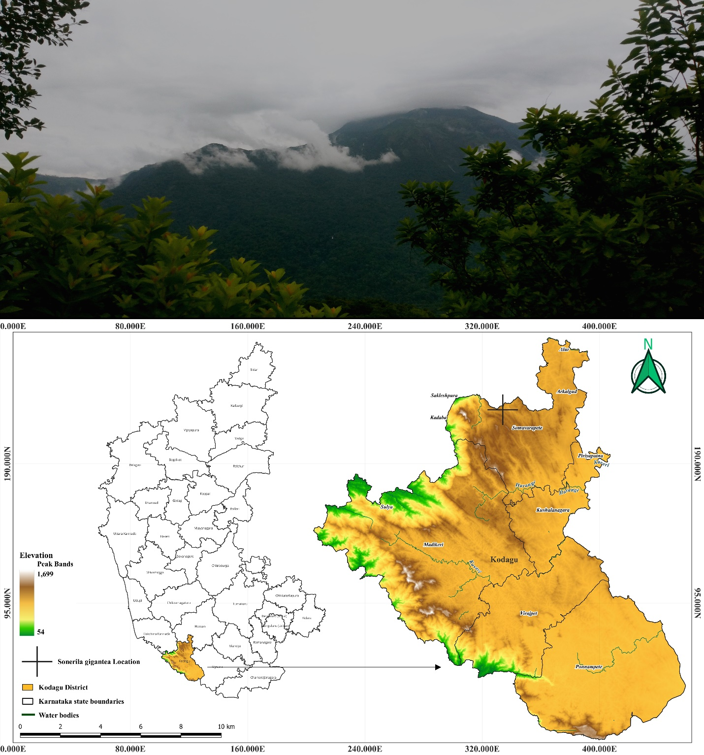

**Figure 1.** *Sonerila gigantea* Upper image landscape of species origin, Lower image species location Map. (Drawn using the software QGIS 3.28.2 version).

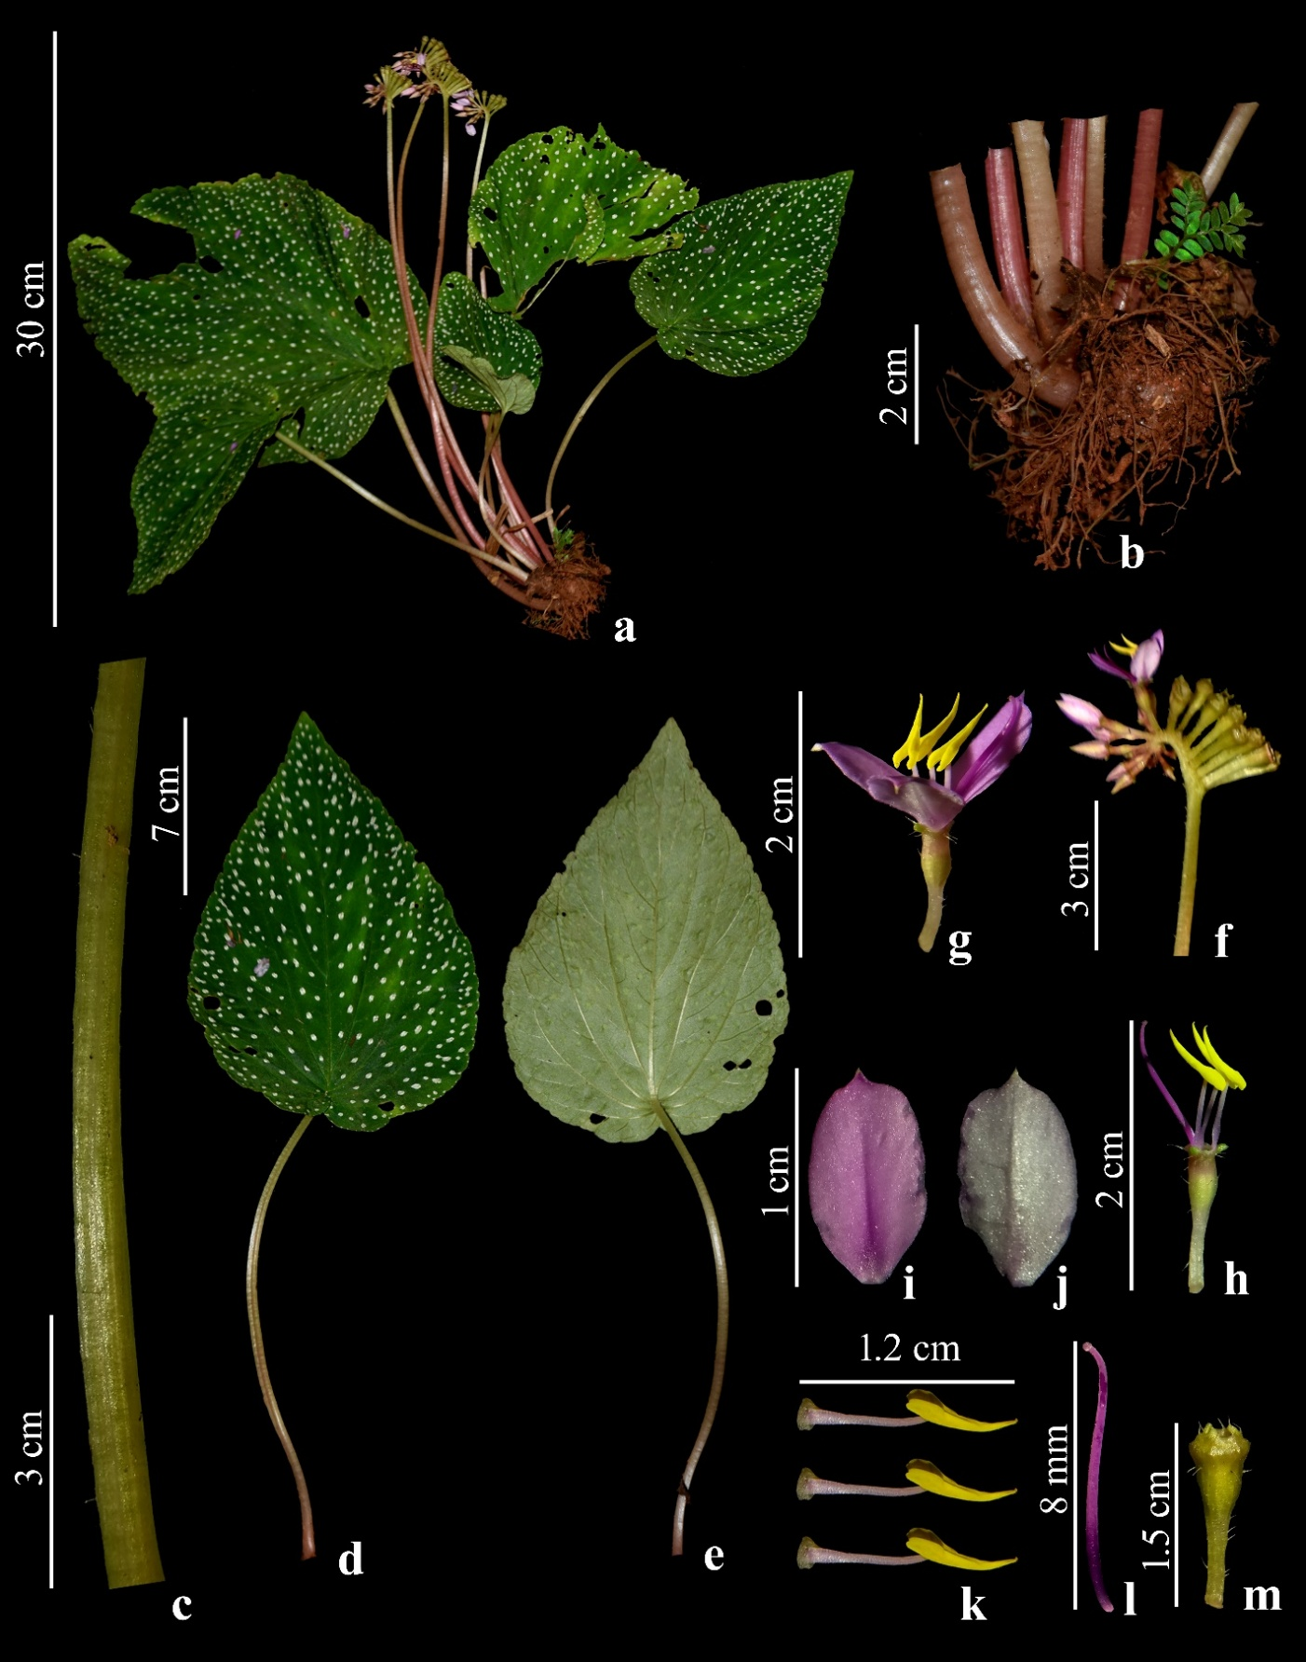**Figure 2.** ***Sonerila gigantea***. **a.** Habit, **b.** Tuber, **c.** Petiole, **d.** Leaf dorsal, **e.** Leaf ventral, **f.** Inflorescence, **g.** Flower, **h.** Hypanthium, **i.** Petal dorsal, **j.** Petal ventral, **k.** Anthers, **l.** Gynaoecium, **m.** Fruit. (© Photograph by Prashant Karadakatti & Shreyas Betageri)

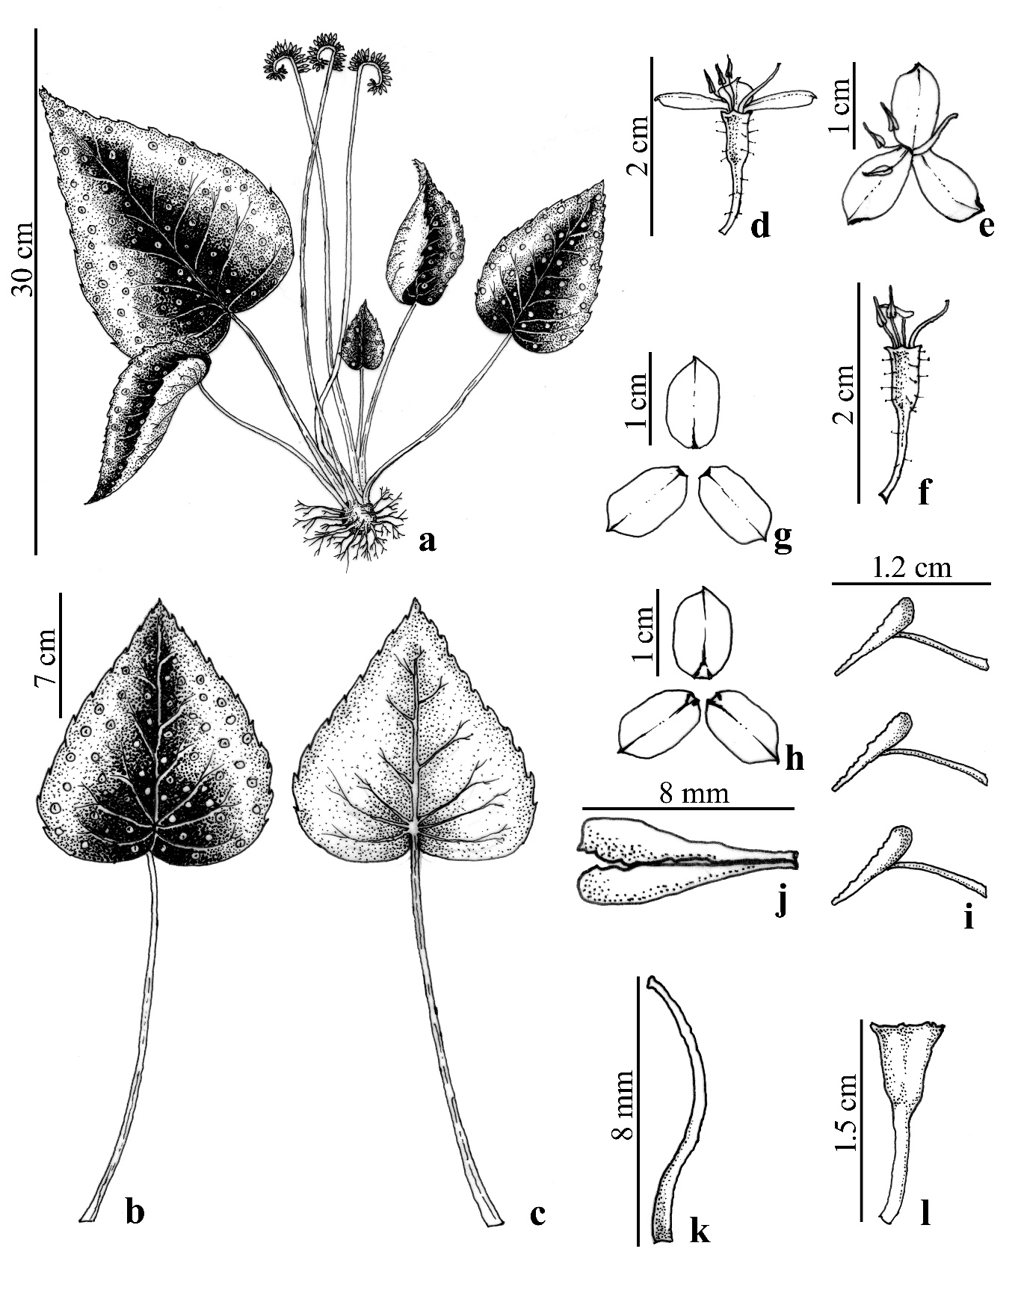**Figure 3.** ***Sonerila gigantea***. **a.** Habit, **b.** Leaf dorsal, **c.** Leaf ventral, **d.** Flower side view, **e.** Flower front view, **f.** Hypanthium, **g.** Petal abaxial, **h.** Petal adaxial, **i.** Anthers, **j.** Anther lobe, **k.** Gynoecium, **l.** Fruit. (© Illustration by Prashant Karadakatti)

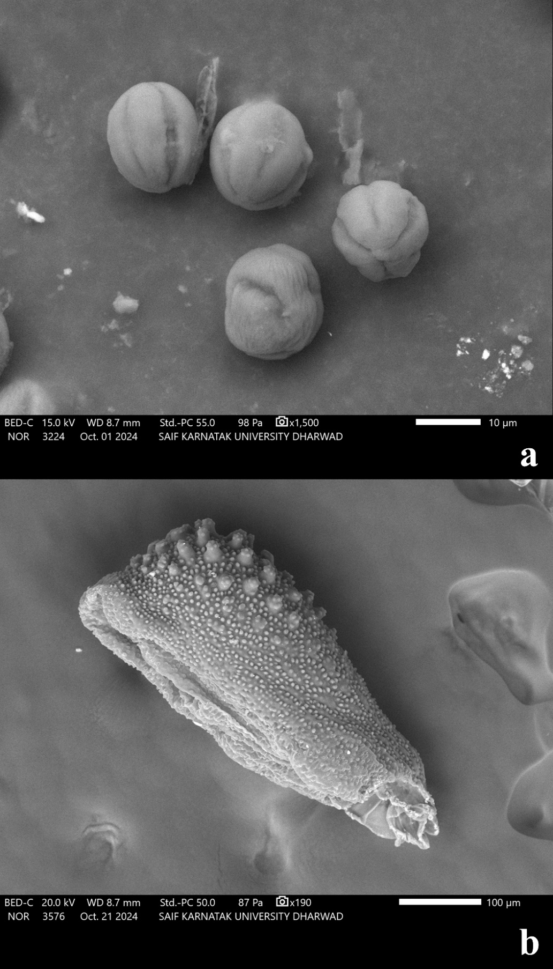

**Figure 4.** ***Sonerila gigantean.*** Scanning Electron Microscope Images **a.** Pollen grains, **b.** Seed. (DST-SAIF, USIC, KUD)