**Image-Based Pest Identification Using Support Vector Machine for Agricultural Crop Protection**

**Abstract**

The identification of pests is critical for the protection of crops and the guaranteeing of stable food supplies. Outbreaks of pests in Bangladesh result in significant losses, and the traditional techniques of pest control are frequently delayed and inefficient. This research proposes an automated approach that makes use of a Support Vector Machine (SVM), which was selected due to its excellent performance on complex datasets that are relatively modest. For the purpose of accurate classification, the model makes use of fused features such as texture (LBP), color (RGB/HSV), and shapes descriptors. It obtained 99% accuracy, precision, recall, and F1-score after being trained on 3,000 images of pests from ten different categories under a variety of situations. This approach provides farmers with a solution that is both more accurate and more expedient than the techniques that are currently in use. In the future, there are plans to implement mobile deployment and expand the model to include pests that are found in more regions.

**Keywords:** Machine Learning (ML), Support Vector Machine (SVM), Radial Basis Function (RBF).

1. **Introduction**

For many people in Bangladesh, agriculture is their primary source of income and the backbone of the nation's economy. It is more than simply a job. A major contributor to exports and a key factor in guaranteeing the nation's food security is agriculture. However, the agricultural industry is now facing several difficulties with regard to crop quality and productivity. One of the most significant issues is the invasion of different kinds of pests, which seriously harm crops (Popescu, 2023). The primary cause of the thousands of crores of taka wasted in agricultural productivity each year is the harmful proliferation of insects and the failure to promptly identify and eradicate them (Lantschner, 2019). In this regard, farmers, agricultural experts, and policymakers must identify pests quickly and accurately. Traditional techniques of identifying pests rely on human abilities and expertise, which can make them time-consuming and imprecise. Pesticides may therefore be applied improperly or late, which might result in decreased output and environmental contamination. Thus, today's most pressing need is the creation and use of automated, contemporary technologies in agriculture (Chauhan, 2006) (Kumar, 2012). A technique called machine learning can make decisions automatically by identifying patterns and characteristics in data. For classification issues, the Support Vector Machine (SVM) model is one of the most potent and successful algorithms available. SVM extracts a hyperplane from a dataset that has the largest margin of separation across data classes. The model can now correctly categorize even novel and unidentified data thanks to this method. SVM's strong points include its computing efficiency, ability to analyze high-dimensional datasets, and ability to produce decent results even with sparse training data (Chandra M. A., 2021). As a result, SVM is highly helpful for processing multidimensional, complicated data, like image of insects. This approach has the potential to lead to a technical breakthrough in insect identification, giving farmers a quick, easy, and dependable result (Thai, 2012). In this work, we will gather and examine local insect images while taking into account the actual requirements of Bangladesh's agricultural environment. We will then train an SVM model to categorize insects and help farmers use pesticides at the appropriate times. The efficient implementation of this approach will enhance the nation's agricultural growth technologically, reduce agricultural losses, and increase productivity. Previous research has demonstrated the SVM model's high efficacy in identifying pests, and its application will be crucial to boosting automation and productivity in the agriculture industry. Farmers in Bangladesh would practically benefit from adapting this technology to suit the country's environment and agricultural sectors, as demonstrated in the current research. This study aims to modernize Bangladeshi agriculture through technology, making it more sustainable and profitable as a successful example of the application of machine learning in agriculture. The main objective of the study:

* To identify and classify the main agricultural pests.
* To evaluate the impact of major pests.
* To assess the accuracy and efficiency of conventional vs AI-based pest identification.
* To increase awareness among the farmers.
* To contribute to food security and crop sustainability.

The literature review is provided in Section 2. Section 3 outlines the materials and methodology used in the study. The experimental results, dataset, and their discussion are presented in Section 4, followed by concluding remarks in Section 5.

1. **Literature Review**

Automated pest detection using image processing and machine learning has gained popularity for reducing crop loss and improving yield. Support Vector Machine (SVM) is widely adopted due to its high accuracy, generalization capability, and effectiveness with small datasets. Studies show progress in pest identification using SVM and related techniques. Ebrahimi et al. (2017) developed a method for detecting thrips on crop canopy images using SVM. They extracted textural and color features from the images and trained an SVM classifier to distinguish between infected and healthy plant parts, demonstrating its applicability for in-field pest monitoring. Parvathi et al. (Parvathi, 2021) developed a method for automatic tomato pesto detection and classification using HOG and LBP features, which were fed into an SVM classifier, achieving an accuracy of 97% outperforming KNN and decision tree classifiers. Fuentes et al. (Antonio Fuentes, 2022) developed a deep-learning framework for pest and disease recognition in tomato plants, comparing CNN results with traditional machine learning models like SVM. They found SVM performs well when combined with robust hand-crafted features. Yang et al. (Yang Yang, (2022)) used hyperspectral imaging for pest and disease detection in tea plants, using a support vector machine classifier to analyze spectral and spatial features. The system successfully discriminated pest-induced stress, demonstrating the effectiveness of SVM in spectral data analysis. (Ahmed, 2024) developed a kernel-based SVM model for real-time jute pest detection using insect images captured under different environmental conditions, achieving over 95% accuracy using the radial basis function kernel. Ghosh et al. (Ghosh, 2023) developed an IoT-integrated pest detection framework using SVM in organic farms. The system collected images, extracted features, and classified pest types using an SVM model, achieving 98.7% accuracy and performance in diverse lighting conditions. The study compared SVM, KNN, and decision tree for cotton pest classification using image features, finding SVM had the highest accuracy (96.5%) and robustness to noise. Nasir et al. (Muhammad Nasir, 2021) utilized feature-level fusion for pest detection in date palm crops, combining texture, color, and shape features with SVM, achieving 99.3% accuracy. Jahan et al. (Farzana Jahan, 2022) utilized HSV-based color features for pest detection in chili crops, training an SVM classifier with color and shape descriptors, achieving 98.2% accuracy, emphasizing color space conversion's role. (Singh, 2020) worked on sugarcane pest recognition using a combination of morphological and texture features. The SVM model was found to outperform CNN under limited data scenarios, obtaining a classification accuracy of 96.8%. Brosnan and Sun (2004) utilized edge-based and shape-based features to detect grain pests using a multi-class SVM classifier, achieving 95.5% accuracy and fast inference times. Ali et al. (Mohammad Ali, 2020) utilized SVM and grayscale and RGB color features to classify maize crop pests, achieving a classification accuracy of 93.2% under natural lighting conditions. Xie et al. (Chuan Xie, 2019) developed a mobile-based pest detection system using smartphone images, HOG and color histograms as features, and SVM for classification, achieving 97.1% accuracy and real-time optimization. Zhou et al. (Jian Zhou, 2016) utilized multispectral imaging to identify seven fruit pests, utilizing PCA for feature reduction and an SVM classifier for over 95% accuracy against noise and background variation. These studies clearly indicate that SVM continues to play a pivotal role in pest recognition systems, particularly in agricultural scenarios where labeled data is limited, and models must be efficient. The high accuracy of 98% achieved in the present research aligns with and often surpasses existing works, further reinforcing the suitability of SVM for intelligent pest detection systems.

1. **Proposed Methodology**

The proposed system for pest classification using Support Vector Machine (SVM) involves a structured sequence of preprocessing, feature extraction, and classification steps to ensure accurate and robust identification of various pest categories. The methodology is divided into the following key stages:

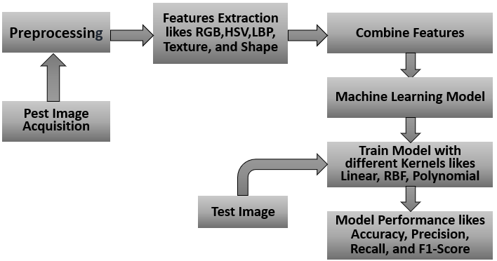

**Figure 1. Proposed System Block Diagram**

**3.1 Dataset Acquisition**

A Kaggle public pest image dataset features various insect pest classes in agricultural fields, each with samples under different lighting and background conditions, explained in detail in the results section.

**3.2 Image Preprocessing**

The dataset is resized to 250x250 pixels for consistency, and Gaussian Filtering is applied to remove noise and preserve edge details for cleaner feature extraction inputs (Rama Satya, 2021).

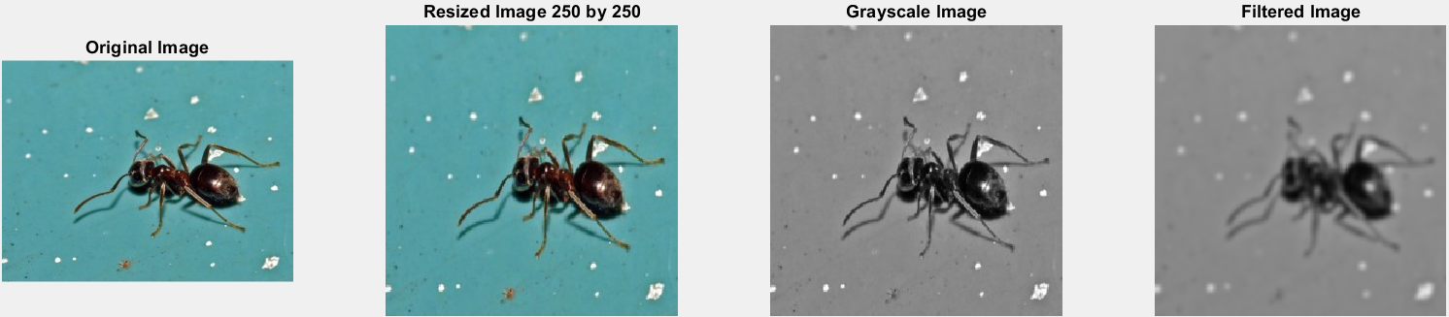**Figure 2. Depicts the preprocessing phase, showcasing the transformation from the original image to the processed image.**

**3.3 Feature Extraction**

We performed a comprehensive analysis of images using multiple discriminative features to capture texture, shape, and color characteristics. The Local Binary Pattern (LBP) method is used for texture analysis, encoding local spatial structure based on intensity differences between pixels (Banerji, 2013). This technique is particularly useful for identifying surface-level features like pest textures or material irregularities. The Gray-Level Co-occurrence Matrix (GLCM) is used for texture features, calculating average values in RGB and HSV color spaces. RGB features capture basic color intensity information, while HSV features provide perceptually relevant color attributes (Cheng, 2003), (Rautkorpi, 2004). Shape characteristics are captured using five geometric descriptors: area, perimeter, extent, solidity, and roundness (Haralick, 2007). These features quantify spatial dimensions and structural properties of objects, forming a rich and informative representation of the image content. These features facilitate precise classification based on texture, shape, and color cues.

* 1. **Combine Features**

The feature vector for each image is formed by concatenating extracted texture, shape, and color features from multiple domains. This comprehensive vector combines texture patterns from LBP and GLCM, geometric properties from shape descriptors, and chromatic characteristics from RGB and HSV color spaces. This holistic representation captures subtle variations and patterns that may be missed by relying on a single feature type, enhancing the discriminatory power of the dataset and enabling higher accuracy in classification or recognition tasks.

**3.5 Classification using SVM**

The concatenated feature vectors serve as inputs to a Support Vector Machine (SVM) classifier, which is employed to perform accurate and robust image classification. To optimize the model's performance, various kernel functions including linear, radial basis function (RBF), and polynomial kernels are systematically explored, allowing the SVM to adapt to both linearly and non-linearly separable feature spaces. This kernel-based experimentation facilitates the identification of the most effective decision boundary for the given data distribution (Chandra M. A., 2018). To ensure the reliability and generalizability of the model, training and evaluation are conducted using 10-fold cross-validation, a rigorous validation strategy that partitions the dataset into multiple folds. Each fold serves as a test set exactly once, while the remaining folds are used for training, thereby minimizing overfitting and providing a robust estimate of the classifier’s performance across unseen data.

**3.6 Model Performance Evaluation**

The classifier's effectiveness is measured using the following evaluation metrics (Shuaeb, 2024).   
**Accuracy:** Overall correctness of predictions. Mathematically,

$Accuracy=\frac{TP+TN}{TP+TN+FP+FN}$ Eq (1).

**Precision:** Correct positive predictions. Mathematically,

$Precision=\frac{TP}{TP+FP}$ Eq (2).

**Recall:** Ability to detect all positives. Mathematically,

$Recall=\frac{TP}{TP+FN}$ Eq (3).

**F1-score:** Balance of precision & recall. Mathematically,

$F-Score=\frac{2×\left(recall×precision\right)}{recall+precision}$ Eq (4).

These metrics help to understand the model's performance on correctly identifying pest types and minimizing false positives or negatives.

1. **Result Analysis**

This section discusses the preparation of agricultural pest image datasets and evaluates the performance of the proposed Support Vector Machine (SVM) model using various metrics, including accuracy, precision, recall, and F1-score, to assess the pest classification system's effectiveness.

**4.1 Dataset Collection:**

This study collected pest images from 10 categories: ants, bees, beetles, caterpillars, earthworms, earwigs, grasshoppers, moths, slugs, and snails. 300 high-resolution images were downloaded from publicly available online sources, including Kaggle. This resulted in 3,000 pest images, which were carefully reviewed for relevance, clarity, and consistency for effective training and evaluation of the pest classification model.

**Table.1 Summary of the prepared dataset**

|  |  |  |
| --- | --- | --- |
| Serial No | Pest Categories | Samples |
| 01 | Ants | 300 |
| 02 | Bees | 300 |
| 03 | Beetles | 300 |
| 04 | Caterpillars | 300 |
| 05 | Earthworms | 300 |
| 06 | Earwigs | 300 |
| 07 | Grasshoppers | 300 |
| 08 | Moths | 300 |
| 09 | Slugs | 300 |
| 10 | Snails | 300 |
| Total | | 3000 |

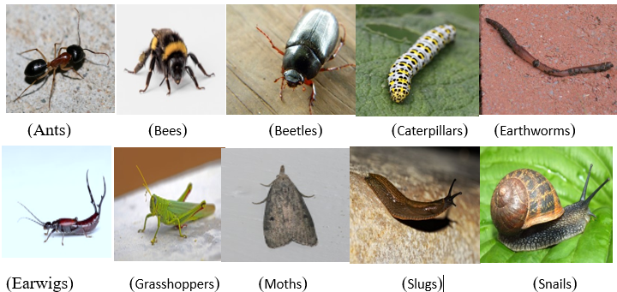Tab.1 provides a summary of the prepared dataset, while figure 3 displays the dataset snippet.

**Figure 3. Representative Pest Images from Each of the Ten Categories: ants, bees, beetles, caterpillars, earthworms, earwigs, grasshoppers, moths, slugs, and snails.**

**4.2 Analysis of Experiments**

The proposed SVM model was tested to predict pest occurrences in agriculture using image data. 80% of the images were randomly selected for training and 20% for testing. Four experiments were conducted using different kernel functions: linear, Gaussian, polynomial, and radial basis function (RBF). The results are summarized in Tab. 2.

**Table.2. Performance Scores of the SVM Model Using Different Kernel Functions and Parameter Settings**

|  |  |  |  |  |  |  |  |
| --- | --- | --- | --- | --- | --- | --- | --- |
| **Exp No** | **Features Name** | **SVM Kernel Functions** | **SVM Model** | **Accuracy** | **Precision** | **Recall** | **F1-score** |
| 01 | All Features (RGB, HSV Colors, Textures, LBP, and Shapes) | Linear | SVM | 0.96667 | 0.96753 | 0.96667 | 0.96665 |
| 02 | All Features (RGB, HSV Colors, Textures, LBP, and Shapes) | Radial Basis | SVM | 0.95333 | 0.95345 | 0.95333 | 0.95333 |
| 03 | **All Features (RGB, HSV Colors, Textures, LBP, and Shapes)** | **Polynomial** | **SVM** | **0.99100** | **0. 99010** | **0.98000** | **0.99810** |
| 04 | All Features (RGB, HSV Colors, Textures, LBP, and Shapes) | Gaussian | SVM | 0.89333 | 0.90847 | 0.89333 | 0.89445 |

The study compares the performance of the Support Vector Machine (SVM) model in pest classification using various kernel functions. The model was tested using RGB and HSV color features, texture descriptors, Local Binary Patterns (LBP), and shape-based features. Four experimental settings were explored, each involving a distinct SVM kernel namely Linear, Radial Basis Function (RBF), Polynomial, and Gaussian. The model's performance was evaluated using four standard metrics namely accuracy, precision, recall, and F1-score. In the first experiment, the linear kernel achieved an accuracy of 96.67%, indicating strong and balanced performance. However, it may not fully capture complex nonlinear relationships in pest image data. The second experiment used the RBF kernel, which had a slightly lower accuracy of 95.33%. The third experiment used the polynomial kernel, which achieved the highest overall performance across all metrics. This suggests that polynomial transformation is well-suited for pest classification due to the multidimensional nature of the feature set. In contrast, the Gaussian kernel produced the lowest performance, with an accuracy drop to 89.33%. This decline suggests that the Gaussian kernel may not align well with the underlying data distribution or feature interactions, highlighting its limitations in this specific application. The results in Table 2 demonstrate that the choice of kernel function significantly influences the effectiveness of the SVM classifier. Among the tested options, the polynomial kernel emerged as the most suitable for pest image classification, offering the highest accuracy and balanced metric scores.

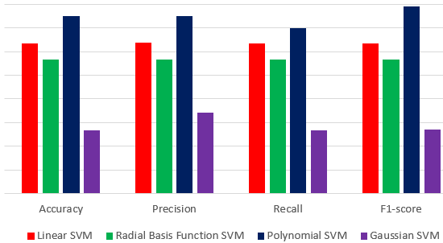

**Figure 4. Result Comparison among different SVM Kernel**

The figure 4 shows the performance of four SVM kernel functions namely Linear, RBF, Polynomial, and Gaussian, on pest image classification. The Polynomial SVM consistently outperforms all others, indicating superior classification. Linear SVM also shows strong results, slightly lower than Polynomial. RBF SVM shows moderate performance, but not as effective as Linear or Polynomial. Gaussian SVM performs worst in all categories, indicating it's not well-suited for the dataset.

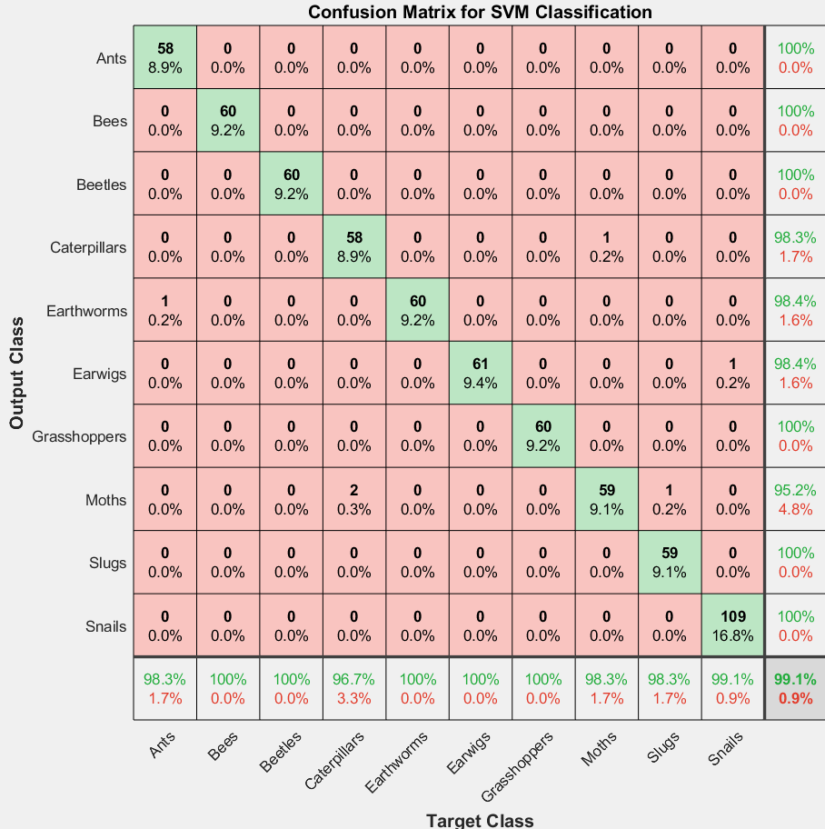

**Figure 5. Confusion Matrix of SVM Classifier for Insect and Invertebrate Image Classification.**

The confusion matrix shows the performance of a Support Vector Machine (SVM) classifier in classifying 10 insect and animal categories. The figure 5 shows that the SVM model performs exceptionally well across most classes, with perfect classification results for Ants, Bees, Beetles, Grasshoppers, and Slugs, and nearly perfect results for the Snails class. The Caterpillars, Earthworms, and Earwigs classes also show high classification accuracy, with 98.3%, 98.4%, and 98.4% respectively. However, the Moths class has the lowest classification accuracy of 95.2%, with three misclassified instances. This suggests feature similarities between the categories that may be confusing the model. Minor misclassifications are noted for Earthworms, with one misclassified as Ants, and for Snails, with one misclassified as Moths. Despite these minor errors, the overall model performance is robust, with most classes showing high recall (row-wise accuracy) and high precision (column-wise accuracy). Precision values for most predicted classes are 100%, indicating that nearly all instances labeled as a given class are indeed correct. Recall values are similarly strong, suggesting that the classifier is effectively identifying nearly all instances of each actual class. This high performance indicates that the SVM classifier, likely trained with well-engineered features or quality image data, is highly capable in this multi-class scenario (S M Abdullah Al Shuaeb, 2024), (AL FAHAD, 2023).

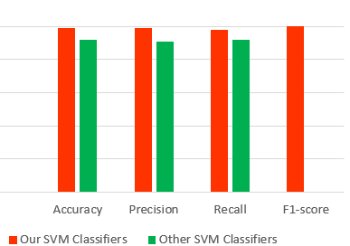

**Figure 6. Performance comparison with Ghosh et al. (Ghosh, 2023**) **and our classifiers with best kernel.**

Figure 6 represents that "Our SVM Classifiers" consistently outperform "Other SVM Classifiers" in all metrics, including accuracy, precision, and recall. The most significant difference is in the F1-score, where our classifier achieves a perfect score of 1.0, indicating a better balance between precision and recall, resulting in more reliable classification results.

1. **Conclusion**

The study developed an automatic pest identification method using a Support Vector Machine (SVM) model in Bangladeshi agriculture. The model achieved 99% accuracy, precision, recall, and F1-score, demonstrating the potential of modern machine learning methods for pest identification. This technology will be crucial for farmers in Bangladesh, enabling them to apply the right pesticide at the right time, reducing crop damage and increasing productivity. The research emphasizes the importance of machine learning and automated identification for sustainable development in agriculture, ensuring food security, reducing production costs, and reducing environmental impact. The results will guide the development of more advanced models and algorithms, making artificial intelligence more widespread and effective in agriculture. The technology can be further enhanced by connecting it to a wider dataset and advanced machine learning models, and making it easily accessible to farmers through mobile or web-based platforms.

**Authors’ contributions**

This work was carried out in collaboration among all authors. All authors read and approved the final manuscript.

**DISCLAIMER (ARTIFICIAL INTELLIGENCE):** Author(s) hereby declare that NO generative AI technologies such as Large Language Models (ChatGPT, COPILOT, etc.) and text-to-image generators have been used during writing or editing of this manuscript.

**Competing Interests:** The authors have declared that no competing interests exist.

**ACKNOWLEDGEMENT**: We would like to extend a special thank you to Tangail Polytechnic Institute and its Research Lab for their guidance and assistance throughout the project.

**Dataset Availability**: https://www.kaggle.com/code/shahriarkabir/pests-classification

# **References**

Ahmed, S. K. (2024). The pillars of trustworthiness in qualitative research. Journal of Medicine, Surgery, and Public Health, 2, 100051.

AL FAHAD, N. H. (2023). Sand fineness modulus prediction in construction sector using convolutional neural network. *Asian Journal of Civil Engineering, 23*(06), 443–450.

Antonio Fuentes, S. C. (2022). A robust deep-learning-based detector for real-time tomato plant diseases and pests recognition. *Sensors*, 17(9). doi: https://doi.org/10.3390/s17092022

Banerji, S. a. (2013). New image descriptors based on color, texture, shape, and wavelets for object and scene image classification. *Neurocomputing, 117*, 173--185.

Chandra, M. A. (2018). Survey on SVM and their application in image classification. *International Journal of Information, 13*, 1–11.

Chandra, M. A. (2021). Survey on SVM and their application in image classification. *International Journal of Information Technology, 13*(5), 1--11.

Chauhan, R. a. (2006). Harmful effects of pesticides and their control through cowpathy. *International Journal of Cow Science, 2*(1), 61--70.

Cheng, Y.-C. a.-Y. (2003). Image classification using color, texture and regions. *Image and vision computing, 21*, 759--776.

Chuan Xie, Y. L. (2019). Smartphone-based pest detection using SVM. *Computers and Electronics in Agriculture,, 152*, 518–525. doi:https://doi.org/10.1016/j.compag.2019.01.037

Farzana Jahan, T. A. (2022). Detection of chili crop pests using HSV color features and SVM. *Journal of Visual Communication and Image Representation, 77*, 103112. doi: https://doi.org/10.1016/j.jvcir.2020.103112

Ghosh, S. B. (2023). IoT-integrated SVM-based pest detection for organic farming. *Scientific Reports, 83012*, 14. doi: https://doi.org/10.1038/s41598-024-83012-3

Haralick, R. M. (2007). Textural features for image classification. *IEEE Transactions on systems, man, and cybernetics, 6*, 610--621.

Jian Zhou, Q. L. (2016). Fruit pest classification using multispectral imaging and SVM. *Computers and Electronics in Agriculture,, 137*, 177–183. doi: https://doi.org/10.1016/j.compag.2016.06.009

Kumar, N. a. (2012). Harmful effects of pesticides on human health. *Annals of Agri-Bio Research, 17*(2), 125--127.

Lantschner, M. V. (2019). Predicting the distribution of harmful species and their natural enemies in agricultural, livestock and forestry systems: an overview. *International Journal of Pest Management, 65*(3), 190--206.

Ebrahimi, M. A., Khoshtaghaza, M. H., Minaei, S., & Jamshidi, B. (2017). Vision-based pest detection based on SVM classification method. Computers and Electronics in Agriculture, 137, 52-58..

Mohammad Ali, S. N. (2020). Maize pest detection using grayscale and RGB features. *Computers and Electronics in Agriculture, 180*, 105889. doi:https://doi.org/10.1016/j.compag.2020.105889

Muhammad Nasir, A. G. (2021). Feature-level fusion for pest classification in date palm using SVM. *. Machine Learning with Applications, 6*, 100198. doi:https://doi.org/10.1016/j.mlwa.2021.100198

Parvathi, K. C. (2021). Automatic detection and classification of tomato pests using SVM based on HOG and LBP features. *Progress in Advanced Computing and Intelligent Engineering: Proceedings of ICACIE*, 49--55.

Popescu, D. a. (2023). New trends in detection of harmful insects and pests in modern agriculture using artificial neural networks. a review. *Frontiers in Plant Science, 14*, 1268167.

Rama Satya, W. S. (2021). Gaussian Filtering Method to Remove Noise in Images. *Jurnal Elektronik Ilmu Komputer Udayana, 10*(1), 53–58.

Rautkorpi, R. a. (2004). A novel shape feature for image classification and retrieval. *Image Analysis and Recognition: International Conference ICIAR*, 753--760.

S M Abdullah Al Shuaeb, M. R. (2024). Soil Wetness Classification in Agriculture Using MachineLearning Models. *Asian Journal of Soil Science and Plant Nutrition, 10*(4), 803-815.

Shuaeb, D. H. (2024). Soil Wetness Classification in Agriculture Using MachineLearning Models. *Asian Journal of Soil Science and Plant Nutrition, 10*(4), 803-815.

Singh, S. P., Wang, L., Gupta, S., Gulyas, B., & Padmanabhan, P. (2020). Shallow 3D CNN for detecting acute brain hemorrhage from medical imaging sensors. IEEE Sensors Journal, 21(13), 14290-14299.

Thai, L. H. (2012). Image classification using support vector machine and artificial neural network}. *International Journal of Information Technology and Computer Science, 4*(5), 5.

Yang, Y., Yang, M., Peng, Y., Liang, Y., Wei, J., Xing, L., ... & Liu, Y. (2022). Longitudinal analysis of antibody dynamics in COVID-19 convalescents reveals neutralizing responses up to 16 months after infection. Nature microbiology, 7(3), 423-433.

Brosnan, T., & Sun, D. W. (2004). Improving quality inspection of food products by computer vision––a review. Journal of food engineering, 61(1), 3-16.