Optimizing Variety and Sowing Date for Mustard-Boro Rice-Fallow Cropping Pattern under Contrasting Land Elevations in the Haor Areas of Kishoreganj, Bangladesh

Abstract
The Haor areas of northeastern Bangladesh are characterized by unique hydro-ecological conditions, significant agricultural potential, and challenges such as recurrent flash floods and low cropping intensity. While previous studies have examined mustard and Boro rice performance in isolation, the combined Mustard–Boro rice cropping pattern under varying sowing dates and land elevations remains underexplored. To address this gap, a field experiment was conducted during the 2022–23 and 2023–24 Boro seasons in Austagram village, Kishoreganj district. The study employed a split-split-plot design with three factors: land elevation, sowing date, and variety, replicated three times. The findings revealed that medium-high land and early sowing significantly reduced maturity and field duration while enhancing yield components and overall productivity for both crops. Rice cultivated on medium-high land produced 4.5% more grain yield (p<0.001), and early sowing increased yield by 4% compared to late sowing (p<0.001). Among rice varieties, BRRI dhan84 and BRRI dhan88 consistently outperformed others, achieving up to 26.34% higher grain yield in 2022–23 (p<0.001) and 11.11% in 2023–24 compared to BRRI dhan89 (p<0.01). Similarly, BARI Sarisha-14 exhibited the highest mustard yield, with a 56% increase in 2022–23 and 43% in 2023–24 over Tori-7 (p<0.001). These results suggest that adopting BRRI dhan84, BRRI dhan88, and BARI Sarisha-14, combined with medium-high land cultivation and early sowing, can enhance cropping intensity, avoid the risks of flash floods, and promote sustainable agriculture in the Haor regions, thereby improving the socio-economic conditions of farmers.
Keywords: Haor, Flash flood, Split-plot, BRRI dhan84, BARI Sarisha-14, Cropping intensity

1. Introduction
Haors, with their unique hydro-ecological characteristics, are large bowl- or saucer-shaped floodplain depressions located in the northeastern region of Bangladesh [1]. These areas remain submerged for approximately half of the year, spanning over 2.0 million hectares and accounting for roughly 14% of the country’s total area. Approximately 19.4 million people reside within the 373 identified Haors, which are primarily located in the districts of Sunamganj, Sylhet, Habiganj, Maulvibazar, Netrakona, Kishoreganj, and Brahmanbaria [2,3].
Despite their agricultural potential, Haor areas face significant constraints, including recurrent floods, flash floods, excessive monsoon rainfall, low winter temperatures, and limited irrigation facilities, all of which hinder agricultural productivity [4,5]. Situated just below the hilly regions of Assam, Meghalaya, and Tripura in India, the Haor regions experience extreme rainfall and subsequent flooding due to their geographical location [6]. Consequently, the cropping intensity in these areas is approximately 91% lower than the national average [7]. In addition, the water dynamics in Haor areas are characterized by fluctuating levels, with water bodies remaining at their lowest from January to March, peaking during June and July, and gradually receding by August [8]. As a result, the dominant cropping pattern is Fallow–Boro rice–Fallow, as identified by Kamruzzaman and Shaw [9].
Dry season irrigated Boro rice contributes approximately 54% of Bangladesh's total rice production, with the Haor region accounting for 18% of this output. This makes the region a vital contributor to national food security [10]. However, flash floods inflict severe damage to paddy fields, especially before harvest, jeopardizing both livelihoods and food security. For instance, in 2017, flash floods destroyed up to 80% of the rice yield, resulting in a loss of 0.88 million metric tons of Boro rice and costing the nation USD 450 million [11]. This highlights the need for alternative cropping systems, as sole reliance on rice production is neither profitable nor sustainable for farmers in this region [12].
A large portion of land remains fallow during the pre- and post-harvest periods of Boro rice in Haor areas, creating opportunities for crop diversification. Incorporating mustard into the Boro rice–Fallow–Fallow cropping pattern offers a quick and economically rewarding solution [13]. The Rabi season, in particular, provides a window for cultivating short-duration mustard varieties after the floodwaters recede and before Boro rice planting. This approach not only avoids damage from early flash floods but also converts monocropped land into double-cropped areas, thereby enhancing cropping intensity and improving livelihoods in the region [14].
Mustard is a cold-loving crop grown primarily during the Rabi season, covering about 80% of Bangladesh’s total oilseed area and contributing more than 60% of its oilseed production [15]. Despite this, domestic oil production falls short of demand, necessitating significant annual imports of oil and oilseeds. Expanding mustard cultivation in the Haor areas could help bridge this edible oil demand-supply gap while boosting local economies [16].
Previous studies have primarily focused on the performance of individual mustard and Boro rice varieties in the Haor regions, often in isolation. However, limited research has examined the performance of the Mustard–Boro rice cropping pattern concerning varying sowing dates and contrasting land elevations. To address this research gap, the present study aims to evaluate the feasibility and identify the most suitable mustard and Boro rice varieties, along with optimal sowing dates, to enhance cropping intensity and maximize productivity under differing land elevations in the Haor regions of Kishoreganj district.

2. Materials and Methods
2.1 Experimental site and soil
The experiment was conducted in Austagram Upazila (24°16'0.12"N, 91°07'30.00"E) under the Kishoreganj district, Bangladesh, during the Boro season (mid-November to mid-March) in the years 2022-23 and 2023-24. The weather pattern during this period is illustrated in Figure 1. The soil at the experimental site belongs to the Sylhet Basin (AEZ-21), which is characterized by slow permeability and medium moisture-holding capacity. Approximately 87% of the cultivable areas in the region consist of low to very low land, with a minimum flooding depth of over 1.8 meters during the monsoon season [17]. The detailed physicochemical characteristics of the experimental field's soil are provided in Tables 1 and 2.
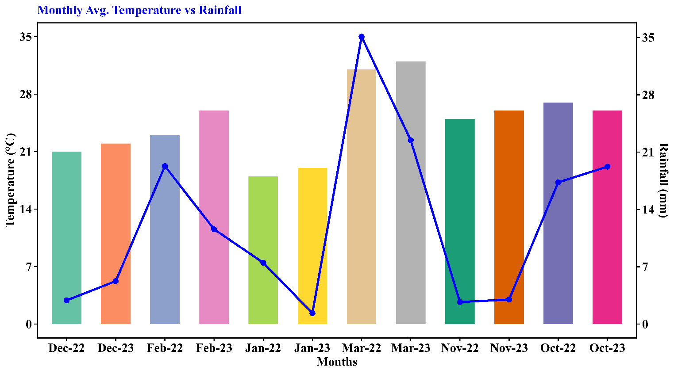
Figure 1. Monthly average temperature and rainfall during the Boro seasons of 2022-23 and 2023-24 at the experimental site.

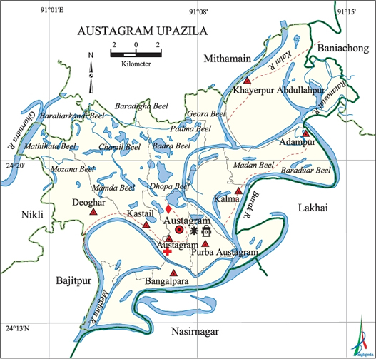
Figure 2. Map of the study location (Austagram, Kishoreganj) (source: Banglapedia [18])
Table 1 Physical properties of initial soil
- Physical Characteristics of Soil | Results | Methods
Sand (%) (0.0-0.02 mm) | 58.50 | Hydrometer [19]
Silt (%) (0.02-0.002 mm) | 33.50
Clay (%) (<0.002 mm) | 8.00
Soil textural class | Sandy loam
Bulk density (g/cc) | 1.28 | [20]
Water holding capacity (%) | 75

Table 2 Chemical properties of initial soil
- Chemical Characteristics of Soil | Results | Methods
pH | 5.56 | Glass Electrode pH Meter [21]
Organic matter (%) | 1.36 | Wet oxidation [22]
Total Nitrogen (%) | 0.08 | Semi-micro Kjeldahl [23]
Available Phosphorus (P) (ppm) | 1.02 | Olsen [24]
Exchangeable Potassium (K) (me%) %) | 0.189 | Ammoniumacetate Extraction [25]
Available Sulfur (S) (ppm) | 9.5 | CaCl₂ Extraction [26]
Available Zinc (Zn) (ppm) | 3.50 | [27]

2.2 Experimental design and layout
2.2.1 Mustard Experiment
The experiment was conducted using a split-split-plot design with three replications, following the cropping pattern of Mustard–Boro rice–Fallow. A total of 120 plots (2×4×5×3=120) were established. Mustard seeds were sown at a rate of 7 t ha⁻¹ in continuous rows, with 30 cm spacing between rows, in accordance with the method demonstrated by Alam et al. [28].
Factor A: Land elevation (Assigned to the main plots)
- Medium high land (L₁)
- Medium low land (L₂)
Factor B: Sowing dates (Assigned to the subplots)
- October 15 (S₁)
- October 20 (S₂)
- October 25 (S₃)
- October 30 (S₄)
Factor C: Variety (Assigned to the sub-subplots)
- BARI Sharisha-14 (V₁)
- BARI Sharisha-15 (V₂)
- BARI Sharisha-17 (V₃)
- BINA Sharisha-09 (V₄)
- Tori-7 (V₅)
Each replication consisted of all combinations of the three factors, arranged in a randomized complete block design (RCBD). This layout ensured adequate randomization and precision in estimating treatment effects.

2.2.2 Rice Experiment
Thirty-five-day-old seedlings were transplanted into well-puddled plots at a rate of 2–3 seedlings per hill, following the method described by Afrad et al. [29]. The same split-plot design and layout were used for the rice experiment, with a spacing of 25 cm × 25 cm, as recommended by Zhimomi et al. [30], and the following treatments:
Factor A: Land elevation (Assigned to the main plots)
- Medium high land (L₁)
- Medium low land (L₂)
Factor B: Sowing dates (Assigned to the subplots)
- January 15 (S₁)
- January 20 (S₂)
- January 25 (S₃)
- January 30 (S₄)
Factor C: Variety (Assigned to the sub-subplots)
- BRRI dhan29 (V₁)
- BRRI dhan84 (V₂)
- BRRI dhan88 (V₃)
- BRRI dhan89 (V₄)
- BRRI dhan92 (V₅)

  - Management of crops
The management of crops followed standard agronomic practices and fertilizer recommendations. For rice, fertilizers were applied based on the Fertilizer Recommendation Guide (FRG-2018) [31], including TSP at 76 kg ha⁻¹, MoP at 76 kg ha⁻¹, gypsum at 33 kg ha⁻¹, and ZnSO₄ at 4.5 kg ha⁻¹, all incorporated during final land preparation. Urea, at 390 kg ha⁻¹, was applied in three equal splits at 15, 30, and 55 days after transplanting [32]. For mustard, fertilizers were applied as per FRG-2018 [31], with 260 kg ha⁻¹ urea, 114 kg ha⁻¹ TSP, 60 kg ha⁻¹ MoP, 50 kg ha⁻¹ gypsum, 4 kg ha⁻¹ ZnSO₄, and 10 kg ha⁻¹ borax (Na₂B₄O₇·10H₂O). Half of the urea and all other fertilizers were applied during final land preparation, while the remaining urea was top-dressed at the initial flowering stage, following [33]. Essential intercultural operations, including irrigation, gap filling, thinning, and weeding, were carried out as needed for both crops.
  - Harvesting and Data Acquisition
The maturity of Boro rice varieties was determined when approximately 80% of the seeds exhibited their characteristic color, following the method described by Islam et al. [34]. Grain yield was adjusted to a 14% moisture content, and straw yield was evaluated under sun-dried conditions as outlined by Nasim et al. [35]. Phenological data for rice, including germination percentage, days to maximum tillering, days to panicle initiation, days to heading, days to flowering, maturity days, and field duration, were meticulously recorded. Biomass data, such as dry matter per hill at different DAT, and growth and yield parameters, including plant height, tiller number, panicle length, grains per panicle, and 1000-grain weight, were also collected. For mustard, phenological parameters such as days to emergence, days to 50% flowering, and field duration (days to harvest) were documented during the growing period. At full maturity, ten plants were randomly selected from each plot to record morphological, yield-contributing, and yield data, following the method described by Motiur et al. [36].

  - Statistical analysis
Statistical analysis was performed to determine the significance of differences in yield and other morphological traits of the crops using the analysis of variance (ANOVA) technique with R Programming Language (version 4.2.2). When F-values were significant, treatment means were compared using the Tukey HSD test at a 5% level of significance, following the procedure described by Gomez and Gomez [37]. The graphs were created using the ggplot2 package and Principal Component Analysis (PCA) was performed under the factoextra package in the R programming environment.

3 Results and discussion
3.1 Phenological traits of Boro rice and Mustard under contrasting land elevation
The phenological traits of crops play a critical role in determining yield potential, guiding agricultural management practices, and ensuring food security. Understanding these traits enables farmers and researchers to optimize essential practices such as irrigation scheduling, fertilization, nutrient management, and harvest timing. These optimizations not only enhance productivity but also promote sustainable agricultural development by adapting to evolving climatic conditions and local environmental factors [38,39].
Notable variations in phenological traits of rice and mustard were observed across land elevations, sowing dates, and varieties (Tables 3 and 4). Rice cultivated on medium-high land demonstrated significantly shorter durations to reach key phenological milestones compared to medium-low land. Specifically, the days to maximum tillering ranged from 38.9 to 39.12, panicle initiation occurred within 67.15 to 67.23 days, and maturity was achieved within 126.15 to 126.32 days, resulting in a total field duration of 146.52 to 146.57 days. In contrast, rice grown on medium-low land required slightly more time to complete these developmental stages, highlighting the influence of land elevation on crop phenology. These findings align with Shahzad et al. [40], who reported that spatial variations in plant phenology rates can alter well-established phenological patterns across geographical gradients. Sowing date had a notable influence on phenological traits. Early sowing (S₁) resulted in the shortest field duration (146.83 to 146.80 days), whereas late sowing (S₄) extended the duration to 149.2 to 149.13 days. A delay in sowing progressively increased the time required for flowering and panicle initiation. Among the rice varieties, BRRI dhan89 exhibited the longest phenological durations, including days to maximum tillering (43.5 to 43.58 days), days to heading (80.46 days), and maturity (132.46 to 132.13 days). Conversely, BRRI dhan88 consistently exhibited the shortest durations, with BRRI dhan84 following closely. This aligns with findings by Kabir et al. [41], who highlighted the shorter life cycle of BRRI dhan88. This variation among varieties could be attributed to differences in genetic makeup and adaptation to environmental stimuli. Consistent with this observation, Yang et al. [42] noted that plant phylogeny plays a crucial role in shaping phenological traits, with closely related species often exhibiting similar patterns. On the other hand, Mustard cultivated on medium-high land consistently demonstrated shorter durations for all phenological events compared to medium-low land. This supports the notion that soil texture and drainage are vital factors influencing the growth rates of different crops, as highlighted by Sarker et al. [43]. For example, days to 50% flowering and maturity under L₁ ranged from 40.85 to 41.72 days and 75.27 to 75.30 days, respectively, compared to 41.85 to 42.8 days and 76.63 days under L₂. Crops sown on 15 October resulted in shorter durations, such as days to maturity (75.03–75.10 days), while late sowing on 30 October extended the maturity period (76.77–76.77 days). Progressively later sowing dates increased durations for flowering, fruit formation, and field duration. Among the varieties, BARI Sarisha-14 exhibited the shortest durations for all traits. For instance, this variety required only 35.17–36.58 days for first flowering, 38.17–39.58 days for 50% flowering, and 70.08–72.08 days for maturity. This result aligns with Haque et al. [44] and Debnath et al. [45], who also reported the shorter duration of this cultivar. Liu et al. [46] further suggested that genetic and ecological factors largely influence phenological variations among coexisting species within similar habitats.

Table 3 Effect of variety and sowing date on the phenological traits of Boro rice under contrasting land elevation
Treatments | Days to max tillering |  |  | Days to panicle initiation |  | Days to heading |  | Days to 1st flowering |  | Days to 50% flowering |  | Maturity Days |  | Field Duration
Land (L) | 2022-23 | 2023-24 |  | 2022-23 | 2023-24 | 2022-23 | 2023-24 | 2022-23 | 2023-24 | 2022-23 | 2023-24 | 2022-23 | 2023-24 | 2022-23 | 2023-24
L₁ | 38.9b | 39.12b |  | 67.15b | 67.23b | 74.31b | 74.27b | 77.32b | 77.25b | 81.31b | 81.25b | 126.32b | 126.15b | 146.57b | 146.52b
L₂ | 40.53a | 40.7a |  | 67.98a | 68.08a | 77.53a | 77.52a | 80.53a | 80.23a | 84.53a | 84.55a | 129.58a | 129.43a | 149.47a | 149.42a
Sig. | *** | *** |  | *** | *** | *** | *** | *** | *** | *** | *** | *** | *** | *** | ***
SEm (±) | 0.15 | 0.16 |  | 0.05 | 0.06 | 0.13 | 0.14 | 0.13 | 0.24 | 0.13 | 0.13 | 0.13 | 0.16 | 0.37 | 0.37
Sowing (S)
S₁ | 2.47a | 41.63a |  | 66.63d | 66.8c | 75.07c | 75.07c | 78.07c | 77.4b | 82.07c | 82c | 127.17c | 127.07c | 146.83b | 146.80b
S₂ | 2.13b | 40.43b |  | 67.5c | 67.53b | 75.77b | 75.73b | 78.77b | 78.73a | 82.77b | 82.73b | 127.77b | 127.53bc | 147.63ab | 147.7ab
S₃ | 2.2b | 39.27c |  | 67.97b | 68.13a | 76.13b | 76.07b | 79.13b | 79.2a | 83.13b | 83.23ab | 128.13b | 128.1ab | 148.4ab | 148.23ab
S₄ | 2.37a | 38.3d |  | 68.17a | 68.17a | 76.73a | 76.7a | 79.73a | 79.63a | 83.73a | 83.63a | 128.73a | 128.47a | 149.2a | 149.13a
Sig. | *** | *** |  | *** | *** | *** | *** | *** | *** | *** | *** | *** | *** | * | *
SEm (±) | 0.21 | 0.21 |  | 0.06 | 0.09 | 0.19 | 0.20 | 0.19 | 0.34 | 0.19 | 0.19 | 0.19 | 0.22 | 0.53 | 0.53
Variety (V)
V₁ | 39.79c | 40c |  | 68.5b | 68.67b | 77.08b | 77.08b | 80.08b | 80.08b | 84.08b | 84.08b | 129.08b | 128.96b | 151c | 151.08c
V₂ | 37.2d | 37.4d |  | 66.32d | 66.36d | 75.44c | 75.4c | 78.44c | 78.44c | 82.44c | 82.44c | 127.44c | 127.32c | 141.4d | 141.32d
V₃ | 35.48e | 35.74e |  | 64.3e | 64.39e | 69.52d | 69.52d | 72.52d | 71.74d | 76.52d | 76.57d | 121.65d | 121.52d | 139.09e | 139e
V₄ | 43.5a | 43.58a |  | 70.5a | 70.58a | 80.46a | 80.46a | 83.46a | 83.46a | 87.46a | 87.46a | 132.46a | 132.13a | 153b | 152.96b
V₅ | 42.54b | 42.75b |  | 68.13c | 68.21c | 76.87b | 76.75b | 79.88b | 79.71b | 83.88b | 83.71b | 128.88b | 128.79b | 155.5a | 155.38a
Sig. | *** | *** |  | *** | *** | *** | *** | *** | *** | *** | *** | *** | *** | *** | ***
SEm (±) | 0.24 | 0.26 |  | 0.07 | 0.1 | 0.22 | 0.22 | 0.22 | 0.39 | 0.22 | 0.22 | 0.22 | 0.25 | 0.61 | 0.59
Interaction
L*S | NS | NS |  | *** | *** | NS | NS | NS | NS | NS | NS | NS | NS | NS | NS
S*V | NS | NS |  | *** | * | NS | NS | NS | NS | NS | NS | NS | NS | NS | NS
L*V | NS | NS |  | *** | *** | NS | NS | NS | NS | NS | NS | NS | NS | NS | NS
L*S*V | NS | NS |  | *** | *** | NS | NS | NS | NS | NS | NS | NS | NS | NS | NS
In a column, figures with the same letter (s) or without a letter do not differ significantly whereas figures with dissimilar letters differ significantly; *** =Significant at 0.1% level of probability,** =Significant at 1% level of probability, * =Significant at 5% level of probability, NS=Non significant. L₁= Medium High Land, L₂=Medium Low Land; S₁= 15 Jan, S₂= 20 Jan, S₃= 25 Jan, S₄= 30 Jan; V₁= BRRI dhan29, V₂= BRRI dhan84, V₃= BRRI dhan88, V₄= BRRI dhan89, V₅= BRRI dhan92; SEm = Standard Error of Mean

Table 4 Effect of variety and sowing date on the phenological traits of mustard under contrasting land elevation
Treatments | Days to 1st flowering |  | Days to 50% flowering |  | Days to 1st pod formation |  | Days to 50% pod formation |  | Maturity Days |  | Field Duration
Land (L) | 2022-23 | 2023-24 | 2022-23 | 2023-24 | 2022-23 | 2023-24 | 2022-23 | 2023-24 | 2022-23 | 2023-24 | 2022-23 | 2023-24
L₁ | 37.85b | 38.72b | 40.85b | 41.72b | 44.9b | 44.72b | 48.92b | 48.83b | 75.27b | 75.30b | 77.27b | 77.30b
L₂ | 38.85a | 39.80a | 41.85a | 42.8a | 45.83a | 45.8a | 49.83a | 49.80a | 76.63a | 76.63a | 78.63a | 78.63a
Sig. | *** | *** | *** | *** | *** | *** | *** | *** | *** | *** | *** | ***
SEm (±) | 0.12 | 0.18 | 0.13 | 0.18 | 0.09 | 0.18 | 0.09 | 0.18 | 0.19 | 0.19 | 0.19 | 0.19
Sowing (S)
S₁ | 36.73d | 38.27c | 39.73d | 41.27c | 44.4d | 44.27c | 48.4c | 48.27c | 75.03b | 75.1b | 77.03b | 77.07b
S₂ | 37.83c | 38.7bc | 40.83c | 41.7bc | 45.1c | 44.7bc | 49.13b | 48.8bc | 75.87ab | 75.87ab | 77.87ab | 77.9ab
S₃ | 38.8b | 39.63ab | 41.8b | 42.63ab | 45.7b | 45.63ab | 49.73a | 49.77ab | 76.13a | 76.13ab | 78.13a | 78.13a
S₄ | 40.03a | 40.43a | 43.03a | 43.43a | 46.27a | 46.43a | 50.23a | 50.43a | 76.77a | 76.77a | 78.77a | 78.77a
Sig. | *** | *** | *** | *** | *** | *** | *** | *** | *** | *** | *** | ***
SEm (±) | 0.18 | 0.26 | 0.18 | 0.26 | 0.13 | 0.26 | 0.14 | 0.27 | 0.28 | 0.28 | 0.28 | 0.28
Variety (V)
V₁ | 35.17e | 36.58d | 38.17e | 39.58d | 39.17e | 42.58d | 43.17e | 46.58d | 70.08d | 70.08d | 72.08d | 72.08d
V₂ | 37.71c | 38.71c | 40.71c | 41.71c | 46.21c | 44.71c | 50.21c | 48.71c | 76.13b | 76.13b | 78.13b | 78.13b
V₃ | 40.58b | 41.08b | 43.58b | 44.08b | 47.42b | 47.08b | 51.46b | 51.13b | 79.04a | 79.04a | 81.04a | 81.04a
V₄ | 42.17a | 43.08a | 45.17a | 46.08a | 49.42a | 49.08a | 53.38a | 53.08a | 79.83a | 79.83a | 81.83a | 81.83a
V₅ | 36.13d | 36.83d | 39.13d | 39.83d | 44.63d | 42.83d | 48.67d | 47.08d | 74.67c | 74.75c | 76.67c | 76.75c
Sig. | *** | *** | *** | *** | *** | *** | *** | *** | *** | *** | *** | ***
SEm (±) | 0.2 | 0.26 | 0.18 | 0.26 | 0.13 | 0.29 | 0.16 | 0.3 | 0.31 | 0.31 | 0.31 | 0.31
Interaction
L*S | NS | NS | NS | NS | NS | NS | NS | NS | NS | NS | NS | NS
S*V | *** | NS | *** | NS | NS | NS | NS | NS | NS | NS | NS | NS
L*V | NS | NS | NS | NS | NS | NS | NS | NS | NS | NS | NS | NS
L*S*V | NS | NS | NS | NS | NS | NS | NS | NS | NS | NS | NS | NS
In a column, figures with the same letter (s) or without a letter do not differ significantly whereas figures with dissimilar letters differ significantly; *** =Significant at 0.1% level of probability,** =Significant at 1% level of probability, * =Significant at 5% level of probability, NS=Non significant. L₁= Medium High Land, L₂=Medium Low Land; S₁= 15 Oct, S₂= 20 Oct, S₃= 25 Oct, S₄= 30 Oct; V₁= BARI Sharisha-14, V₂= BARI Sharisha-15, V₃= BARI Sharisha-17, V₄= BINA Sharisha-9, V₅= Tori-7; SEm= Standard Error of Mean
3.2 Yield Contributing traits of Boro rice and mustard under contrasting land elevation
Marked differences were observed in most growth and yield-contributing traits of both rice and mustard across land elevation, sowing dates, and varieties (Tables 5 and 6). For rice, cultivation on medium-high land consistently resulted in superior yield-related traits compared to medium-low land. Plants grown on medium-high land produced 7.6% more effective tillers during the 2022–23 Boro season and 5% more tillers during the 2023–24 season. This improvement could be attributed to better drainage in medium-high land, which enhanced pore diversity and permeability, facilitating efficient water movement and solute transport to promote crop development, as supported by Han et al. [47]. Furthermore, fertile spikelets and grain weight were notably superior under medium-high land conditions. Earlier sowing dates, such as 15 January and 20 January, also demonstrated higher yield-related traits, while delayed sowing (30 January) significantly reduced these parameters. Early sowing enabled crops to utilize water more efficiently by transferring water use from vegetative to reproductive stages, thus enhancing yield formation. In contrast, late sowing reduced early-stage water consumption, resulting in fewer spikes and lower yields, consistent with findings by Wang et al. [48] and Zhao et al. [49]. For example, plants sown on 15 January produced approximately 12% more effective tillers and fertile spikelets compared to those sown on later dates, a trend observed across both seasons. Among the rice varieties, BRRI dhan84 consistently outperformed others in yield-contributing traits. During the 2022–23 Boro season, this variety produced 32.85% more effective tillers and exhibited 15.17% higher spikelet fertility compared to BRRI dhan89, which had the lowest performance. A similar trend was observed during the 2023–24 season, with BRRI dhan84 generating 25.72% more effective tillers and 16% more fertile spikelets than BRRI dhan89. Although significant individual effects of land elevation, sowing date, and variety were observed, their interactions were statistically non-significant.
For mustard, plant height, pod number, and seed number per pod showed no significant differences between medium-high (L₁) and medium-low (L₂) lands, suggesting stable performance across these elevations. However, branch number and 1000-grain weight exhibited significant differences, with medium-high land providing slightly better growing conditions for these traits. Similar to rice, yield-contributing traits in mustard were higher with early sowing (15 October). Plants sown early produced approximately 18.5% more branches, 17.5% more fertile seeds, and 6% heavier seeds compared to late sowing, a trend consistent across both years. Early sowing enhanced seedling vigor and improved disease and pest control, whereas late sowing reduced plant biomass and crop yield, as observed by Dadrasi et al. [50]. Among the mustard varieties, BARI Sarisha-14 (V₁) and BINA Sarisha-9 (V₄) showed superior performance, whereas Tori-7 (V₅) consistently ranked the lowest. For instance, BARI Sarisha-14 produced nearly 34% more pods and 43% more seeds than Tori-7 across both years. These findings align with Srity et al. [51], who reported the highest yield parameters for BARI Sarisha-14 when grown with recommended fertilizers. While significant individual effects of land elevation, sowing date, and variety were evident, interactions among these factors were largely non-significant for most parameters, except for plant height and branch number.

Table 5 Effect of variety and sowing date on the yield contributing traits of Boro rice under contrasting land elevation
Treatments | Plant Height (cm) |  | Effective Tillers Hill⁻¹ |  | Panicle Length (cm) |  | Grain Panicle⁻¹ (No.) |  | 1000-grain weight (g)
Land (L) | 2022-23 | 2023-24 | 2022-23 | 2023-24 | 2022-23 | 2023-24 | 2022-23 | 2023-24 | 2022-23 | 2023-24
L₁ | 91.1a | 90.97a | 22.58a | 20.5 | 20.61 | 20.33 | 77.77a | 76.96a | 23.37a | 22.38a
L₂ | 89.1b | 88.87b | 20.87b | 19.5 | 20.27 | 20.33 | 74.68b | 74.10b | 22.85b | 21.95b
Sig. | *** | *** | *** | NS | NS | NS | *** | *** | *** | ***
SEm (±) | 0.18 | 0.2 | 0.15 | 0.39 | 0.15 | 0.18 | 0.56 | 0.53 | 0.02 | 0.08
Sowing
S₁ | 91.6a | 91.23a | 23.17a | 21.1a | 21.87a | 21.33a | 81.67a | 80.73a | 23.26a | 22.29
S₂ | 90.6b | 90.17b | 22.17b | 20.33ab | 20.9b | 20.9a | 78.10b | 77.57b | 23.17b | 22.20
S₃ | 89.6c | 89.73b | 21.2c | 19.57ab | 19.97c | 19.93c | 73.23c | 72.47c | 23.06c | 22.18
S₄ | 88.6d | 88.53c | 20.37d | 19b | 19.03d | 19.17b | 71.90c | 71.30c | 22.95d | 22.01
Sig. | *** | *** | *** | *** | *** | *** | *** | *** | *** | NS
SEm (±) | 0.25 | 0.29 | 0.21 | 0.56 | 0.21 | 0.25 | 0.78 | 0.75 | 0.02 | 0.11
Variety (V)
V₁ | 88.4d | 88.13d | 19.65c | 18b | 19.22d | 19.3c | 74.26c | 73.91c | 22.57d | 21.46d
V₂ | 96.5a | 96.33a | 25.08a | 22.67a | 23.29a | 22.71a | 84.5a | 84.13a | 24.12a | 23.37a
V₃ | 92.5c | 92.54c | 22.92b | 21.58a | 20.42c | 20c | 78.63b | 78.17b | 23.83b | 22.8b
V₄ | 79e | 78.92e | 18.48d | 16.84b | 17.84e | 18.36d | 71.68c | 70.84d | 23.15c | 21.97c
V₅ | 94.5b | 94.04b | 22.54b | 20.96a | 21.5b | 21.33b | 72.17c | 70.67d | 21.9e | 21.27d
Sig. | *** | *** | *** | *** | *** | *** | *** | *** | *** | ***
SEm (±) | 0.29 | 0.32 | 0.25 | 0.63 | 0.24 | 0,25 | 0.89 | 0.85 | 0.03 | 0.13
Interaction
L*S | NS | NS | NS | NS | NS | NS | NS | NS | NS | NS
S*V | NS | NS | NS | NS | NS | NS | NS | NS | NS | NS
L*V | NS | NS | ** | NS | NS | NS | NS | NS | *** | ***
L*S*V | NS | NS | NS | NS | NS | NS | NS | NS | NS | NS
In a column, figures with the same letter (s) or without a letter do not differ significantly whereas figures with dissimilar letters differ significantly; *** =Significant at 0.1% level of probability,** =Significant at 1% level of probability, * =Significant at 5% level of probability, NS=Not significant. L₁= Medium High Land, L₂=Medium Low Land; S₁= 15 Jan, S₂= 20 Jan, S₃= 25 Jan, S₄= 30 Jan; V₁= BRRI dhan29, V₂= BRRI dhan84, V₃= BRRI dhan88, V₄= BRRI dhan89, V₅= BRRI dhan92; SEm = Standard Error of Mean

Table 6 Effect of variety and sowing date on the yield contributing traits of mustard under contrasting land elevation
Treatments | Plant Height (cm) |  | No. of Branch |  | No. of Pod Plant⁻¹ |  | No. of Seeds  Pod⁻¹ |  | 1000-grain weight (g)
Land (L) | 2022-23 | 2023-24 | 2022-23 | 2023-24 | 2022-23 | 2023-24 | 2022-23 | 2023-24 | 2022-23 | 2023-24
L₁ | 97.87 | 86.7 | 8.06a | 7.4 | 85.58 | 85.53 | 23.73a | 23.63a | 4.81 | 4.85
L₂ | 98.17 | 87.57 | 7.23b | 7.4 | 85.38 | 85.53 | 23.1b | 23.03b | 4.78 | 4.78
Sig. | NS | NS | *** | NS | NS | NS | * | * | NS | NS
SEm | 0.28 | 1.09 | 0.07 | 0.09 | 0.61 | 0.59 | 0.2 | 0.21 | 0.01 | 0.01
Sowing (S)
S₁ | 97.93 | 85.53 | 8.43a | 7.27 | 85.4 | 85.4 | 25.73a | 25.6a | 4.96a | 4.90a
S₂ | 97.67 | 85.67 | 7.87b | 7.53 | 85.8 | 86 | 24.07b | 24.03b | 4.87b | 4.83b
S₃ | 98.1 | 89.33 | 7.43c | 7.47 | 85.8 | 85.8 | 22.63c | 22.57c | 4.77c | 4.73c
S₄ | 98.37 | 88 | 6.87d | 7.33 | 84.93 | 84.93 | 21.23d | 21.13d | 4.67d | 4.63d
Sig. | NS | NS | *** | NS | NS | NS | *** | *** | *** | ***
SEm | 0.4 | 1.53 | 0.1 | 0.13 | 0.86 | 0.85 | 0.29 | 0.29 | 0.02 | 0.02
Variety (V)
V₁ | 97.33 | 86.33 | 8.25a | 8.83a | 102.54a | 102.92a | 27.42a | 27.17a | 5.54a | 5.49a
V₂ | 98.58 | 88.21 | 7.67b | 7.08c | 90.46c | 90.42c | 21.21c | 21.21c | 4.64d | 4.57d
V₃ | 97.58 | 86.62 | 7.33b | 6.58c | 70.08d | 70.08d | 25.04b | 25.04b | 5.2b | 5.7b
V₄ | 98.33 | 87.75 | 7.71b | 7.92b | 96.25b | 96.25b | 27.75a | 27.75a | 5.07c | 5.12c
V₅ | 98.25 | 86.75 | 7.29b | 6.58c | 68.08d | 68d | 15.67d | 15.5d | 3.64e | 3.59e
Sig. | NS | NS | *** | *** | *** | NS | *** | *** | *** | ***
SEm | 0.45 | 1.72 | 0.12 | 0.15 | 0.96 | 0.95 | 0.32 | 0.32 | 0.02 | 0.02
Interaction
L*S | NS | *** | NS | NS | NS | NS | NS | NS | NS | NS
S*V | NS | NS | *** | NS | ** | ** | NS | NS | NS | NS
L*V | NS | NS | NS | NS | NS | NS | NS | NS | NS | NS
L*S*V | NS | * | ** | NS | NS | NS | NS | NS | NS | NS
In a column, figures with the same letter (s) or without a letter do not differ significantly whereas figures with dissimilar letters differ significantly; *** =Significant at 0.1% level of probability,** =Significant at 1% level of probability, * =Significant at 5% level of probability, NS=Not significant. L₁= Medium High Land, L₂=Medium Low Land; S₁= 15 Oct, S₂= 20 Oct, S₃= 25 Oct, S₄= 30 Oct; V₁= BARI Sharisha-14, V₂= BARI Sharisha-15, V₃= BARI Sharisha-17, V₄= BINA Sharisha-9, V₅= Tori-7; SEm = Standard Error of Mean

3.3 Yield Parameters of Boro rice and mustard under contrasting land elevation
Higher yields were consistently achieved in both seasons when rice was cultivated early on medium-high land using the varieties BRRI dhan84 and BRRI dhan88, as shown in Figure 2. For instance, rice grown on medium-high land produced approximately 4.5% more grain yield in 2022–23 and 2.5% more in 2023–24 compared to medium-low land. Similarly, early sowing on 15 January resulted in about 4% higher grain productivity compared to late sowing. These results may be attributed to the direct influence of transplanting time on the growth and yield-contributing characteristics of rice, as reported by Biswas et al. [52]. Among the rice varieties, BRRI dhan84 consistently demonstrated the highest performance. In the 2022–23 season, it produced 26.34% more grain yield and 13.08% more straw yield than BRRI dhan89, the variety with the lowest yield parameters. During the 2023–24 season, BRRI dhan84 maintained its superiority, yielding 11.11% more grain and 8% more straw compared to BRRI dhan89. This superior performance of BRRI dhan84 was likely due to its adaptability to local Haor conditions and its early maturity, as noted by Kader et al. [53]. The differences in grain yield were largely attributed to the number of effective tillers per hill, grains per panicle, and 1000-grain weight, which were influenced by the genetic makeup of the varieties. This relationship was further supported by the Principal Component Analysis (PCA) shown in Figure 3 and findings by Ahmed et al. [54]. Despite significant differences in land elevation, sowing date, and variety, the interactions among these factors were statistically non-significant.
Mustard showed a similar trend, with medium-high land producing superior yields compared to medium-low land. In 2022–23, stover yield was 8.3% higher on medium-high land, increasing to 11.5% in 2023–24, as illustrated in Figure 4. Early sowing consistently resulted in significantly higher yields across both seasons. Among the mustard varieties, BARI Sarisha-14 outperformed the others, achieving approximately 56% higher grain yield and 53% higher stover yield in 2022–23. This trend persisted in 2023–24, where BARI Sarisha-14 produced 43% more grain yield and 31% higher stover yield compared to Tori-7, the variety with the lowest performance. The high-yielding potential of BARI Sarisha-14 was attributed to its early maturity, allowing it to escape water stress during later stages of growth, as noted by Srity et al. [49]. Enhancing mustard yield can be achieved by selecting traits such as siliqua per plant, plant height, and primary branches per plant, which showed strong positive correlations with grain yield. The importance of these traits was highlighted in the PCA analysis in Figure 3 and supported by Manojkumar et al. [55].

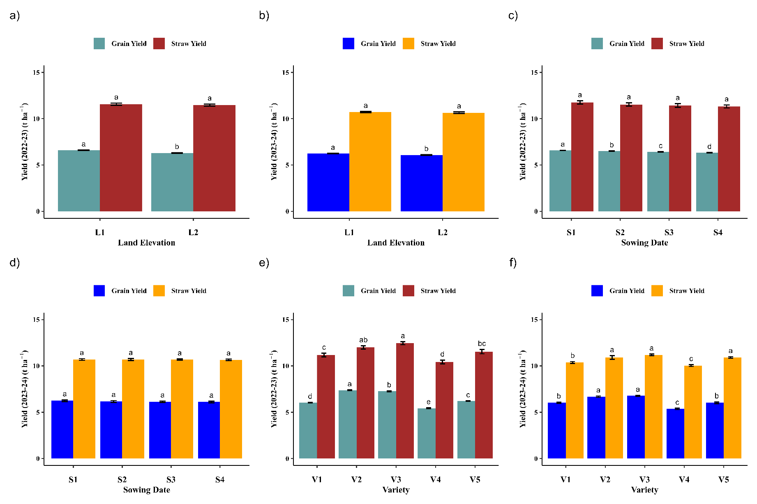
Figure 3. Grain and straw yield of Boro rice across seasons: (a) Yield in 2022–23 influenced by land elevation, (b) yield in 2023–24 influenced by land elevation, (c) yield in 2022–23 influenced by sowing dates, (d) yield in 2023–24 influenced by sowing dates, (e) yield in 2022–23 influenced by varieties, (f) yield in 2023–24 influenced by varieties. Land elevation: L₁ = Medium High Land, L₂ = Medium Low Land; Sowing dates: S₁ = 15 Jan, S₂ = 20 Jan, S₃ = 25 Jan, S₄ = 30 Jan; Varieties: V₁ = BRRI dhan29, V₂ = BRRI dhan84, V₃ = BRRI dhan88, V₄ = BRRI dhan89, V₅ = BRRI dhan92. Data are presented as mean ± SEm.
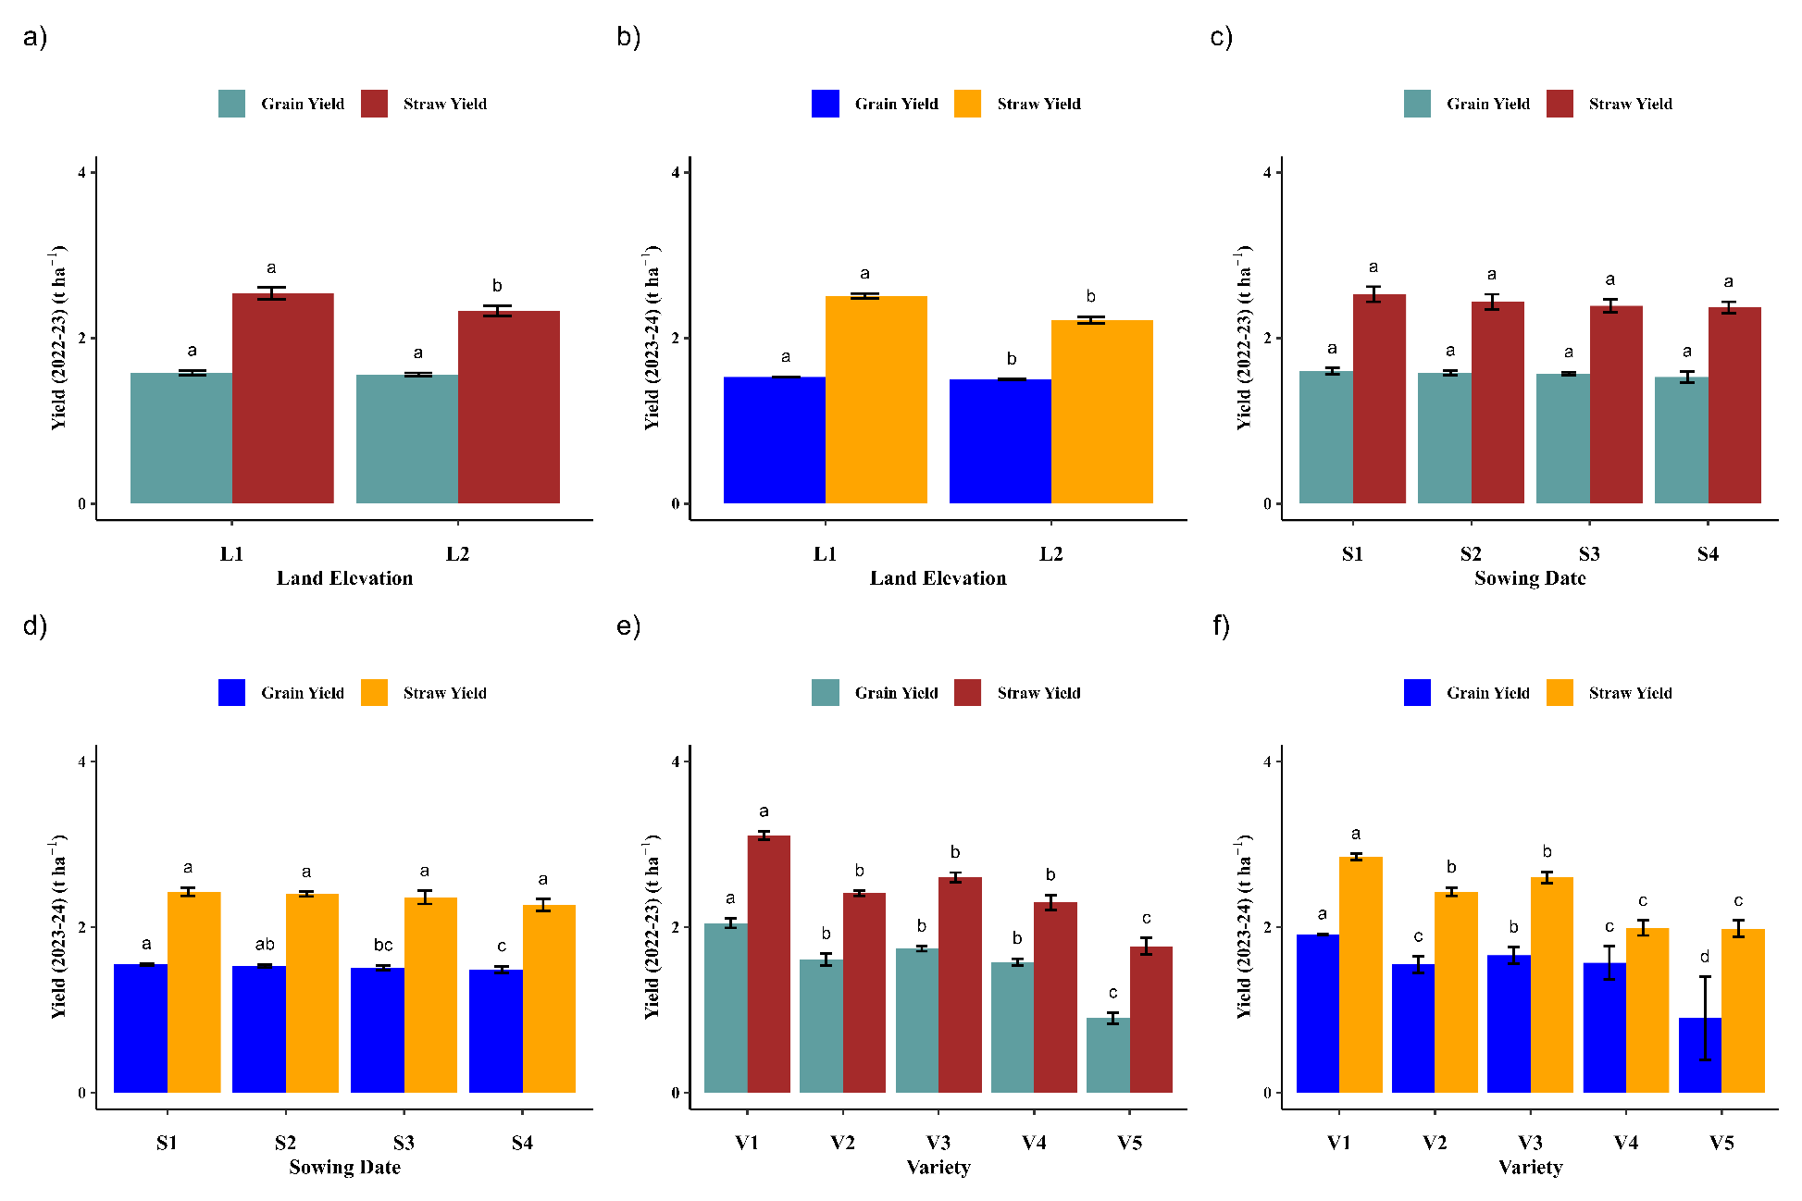
Figure 4. Grain and straw yield of mustard across seasons: (a) Yield in 2022–23 influenced by land elevation, (b) yield in 2023–24 influenced by land elevation, (c) yield in 2022–23 influenced by sowing dates, (d) yield in 2023–24 influenced by sowing dates, (e) yield in 2022–23 influenced by varieties, (f) yield in 2023–24 influenced by varieties. Land elevation: L₁ = Medium High Land, L₂ = Medium Low Land; Sowing dates: S₁ = 15 Oct, S₂ = 20 Oct, S₃ = 25 Oct, S₄ = 30 Oct; Varieties: V₁= BARI Sharisha-14, V₂= BARI Sharisha-15, V₃= BARI Sharisha-17, V₄= BINA Sharisha-9, V₅= Tori-7. Data are presented as mean ± SEm.
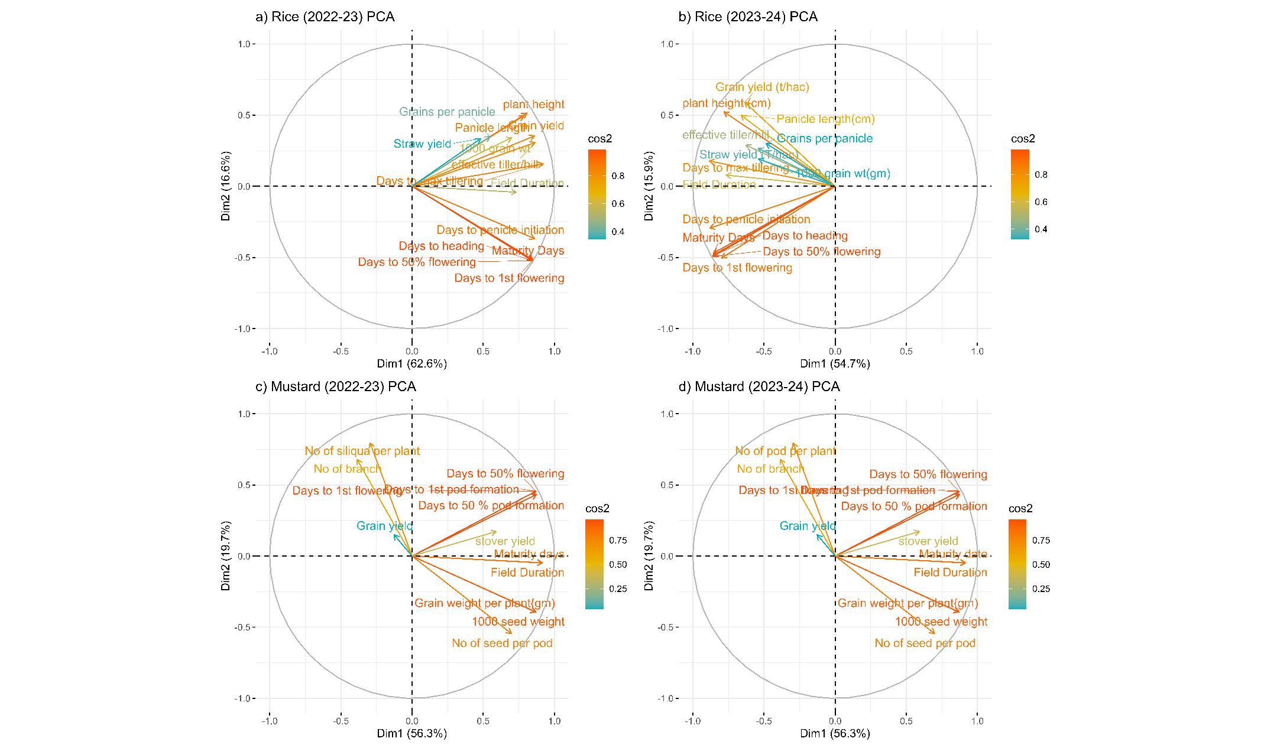
Figure 5. PCA analysis of various parameters for rice and mustard across seasons. a) Boro rice (2022-23), b) Boro rice (2023-24), c) Mustard (2022-23), Mustard (2023-24).

Table 7. Profitability of the Mustard-Boro cropping pattern over the Existing cropping pattern
Cropping pattern | Year | Gross return Tk/ha | TVC Tk/ha | GROSS Margin  Tk/ha | MBCR
Mustard (BARI Sharisha-14-Boro rice (BRRI dhan84) | 2022-23 | 254300 | 120800 | 133500 | 3.31
Mustard (BARI Sharisha-14-Boro rice (BRRI dhan84) | 2023-24 | 251400 | 121900 | 129500 | 3.17
MBCR (Marginal Benefit-Cost Ratio)

4. Conclusion
The findings of this study have significant implications for agricultural practices in the Haor region. Cultivating crops on medium-high land and adopting early sowing were shown to substantially enhance crop growth and yield parameters. Among the tested varieties, BRRI dhan84 and BRRI dhan88 consistently demonstrated superior performance for rice, while BARI Sarisha-14 excelled among mustard varieties due to their short duration and high yield potential. The study highlights the importance of early sowing on medium-high land, which provides more favorable growing conditions by optimizing water and nutrient use, promoting better phenological development, and improving overall yield outcomes. Furthermore, the adaptability of specific varieties to the unique and challenging conditions of the Haor region offers a practical approach to increasing cropping intensity and reducing the risks associated with flash floods. These results provide a pathway for sustainable agricultural development in the Haor regions, with the potential to improve the livelihoods of local farmers. Future research should investigate the long-term impacts of this cropping pattern on soil health, economic returns, and its scalability to other flood-prone areas to further validate and expand its applicability.
Disclaimer (Artificial intelligence)
Author(s) hereby declare that NO generative AI technologies such as Large Language Models (ChatGPT, COPILOT, etc.) and text-to-image generators have been used during the writing or editing of this manuscript.

References

- Bangladesh Haor and Wetland Development Board. (2012). Master Plan of Haor Area (Vol. 1). Center for Environmental and Geographic Information Services.
- Bokhtiar, S. M., Islam, M. J., Samsuzzaman, S., Jahiruddin, M., Panaullah, G. M., Salam, M. A., & Hossain, M. A. (2024). Constraints and Opportunities of Agricultural Development in Haor Ecosystem of Bangladesh. Ecologies, 5(2), 256-278. https://doi.org/10.3390/ecologies5020017.
- Sultana, S., Jui, K. F., Moushumy, N. S., Siddika, H., & Rahman, M. A. (2023). An Analysis of Income Sources and Food Security Status in Haor Regions of Kishoregonj District, Bangladesh. Asian Journal of Economics, Business and Accounting, 23(19), 145–156. https://doi.org/10.9734/ajeba/2023/V₂3i191079
- Jakariya, Md., & Islam, Md. N. (2017). Evaluation of climate change induced vulnerability and adaptation strategies at Haor areas in Bangladesh by integrating GIS and DIVA model. Modeling Earth Systems and Environment, 3(4), 1303–1321. https://doi.org/10.1007/S₄0808-017-0378-9.
- Chakraborty, D., Sarkar, K., & Kashem, M. (2021). Irrigation Practices under Boro Rice Cultivation in Haor Areas of Sunamganj, Bangladesh. Asian Journal of Agricultural and Horticultural Research, 8, 1–12. https://doi.org/10.9734/ajahr/2021/v8i330115.
- Kartiki, K. (2011). Climate change and migration: A case study from rural Bangladesh. Gender & Development, 19(1), 23–38. https://doi.org/10.1080/13552074.2011.554017
- Uddin, M. T., Hossain, N., & Dhar, A. R. (2019). Business prospects and challenges in Haor areas of Bangladesh: Business prospects and challenges in Haor areas. Journal of the Bangladesh Agricultural University, 17(1), Article 1. https://doi.org/10.3329/jbau.V₁7i1.40665
- Nahar, N., Sultana, N., & Miah, J. (2017). Seasonal land cover changes and its effects on essential services of haor and non-haor areas of Kishoreganj district, Bangladesh. Asia-Pacific Journal of Regional Science, 2. https://doi.org/10.1007/S₄1685-017-0067-8
- Kamruzzaman, M., & Shaw, R. (2018). Flood and Sustainable Agriculture in the Haor Basin of Bangladesh: A Review Paper. Universal Journal of Agricultural Research, 6. https://doi.org/10.13189/ujar.2018.060106
- Kabir, M. J., Kabir, M. S., Salam, M. A., Islam, M. A., Omar, M. I., Sarkar, A. R., Rahman, C., Rahaman, S., Deb, L., Aziz, A., & Siddique, M. A. B. (2020). Harvesting of Boro Paddy in Haor Areas of Bangladesh: Interplay of Local and Migrant Labour, Mechanized Harvesters and covid-19 Vigilance in 2020 (302; p. 40). Bangladesh Rice Research Institute.
- Hossain, M., Biswas, P., & Islam, M. R. (2023). Cold-Tolerant and Short-Duration Rice (Oryza sativa L.) for Sustainable Food Security of the Flash Flood-Prone Haor Wetlands of Bangladesh. Sustainability, 15(24), 16873. https://doi.org/10.3390/su152416873
- Rahaman, Md. S., Sarkar, M. A. R., Rahman, M. C., Deb, L., Rashi̇d, M. M., Reza, M. S., & Si̇ddi̇que, M. A. B. (2022). Profitability analysis of paddy production in different seasons in Bangladesh: Insights from the Haor. International Journal of Agriculture Environment and Food Sciences, 6(3), 327–339. https://doi.org/10.31015/jaefs.2022.3.1
- Kakon, S., Mian, M., Begum, A., Chowdhury, J., Saha, R., & Choudhury, D. (2022). Improvement of Existing Cropping Pattern Through Short Duration Mustard Variety In The Chalanbeel Area. Bangladesh Agronomy Journal, 25(1), 83–90. https://doi.org/10.3329/baj.V₂5i1.62850
- Debnath, S., Miah, M. N. H., Biswas, M., Hoque, M., & Foysal, R. A. (2021). Assessment of High-yielding Rapeseed-mustard Varieties in Haor (Wetland) Ecosystem for Development of Mustard-Boro Rice-Fallow Pattern in Sylhet Region of Bangladesh. Asian Journal of Agricultural and Horticultural Research, 12–17. https://doi.org/10.9734/ajahr/2021/v8i230111
- Miah, M. M., Afroz, S., Rashid, M., & Shiblee, S. (2015). Factors affecting the adoption of improved varieties of mustard cultivation in some selected sites of Bangladesh. Bangladesh Journal of Agricultural Research, 40(3), 363–379. https://doi.org/10.3329/bjar.V₄0i3.25411
- Ahmed, Z., & Kashem, M. (2017). Performance of Mustard Varieties in haor Area of Bangladesh. Bangladesh Agronomy Journal, 20, 1. https://doi.org/10.3329/baj.V₂0i1.34875
- DBHWD. (2017). Impact Assessment of Structural Interventions in Haor Ecosystem and Innovations for Solution (Volume 1, p. 9). Department of Bangladesh Haor and Wetlands Development.
- Austagram Upazila—Banglapedia. (n.d.). Retrieved May 31, 2025, from https://en.banglapedia.org/index.php/Austagram_Upazila
- Bouyoucos, G. J. (1936). Directions for making mechanical analyses of soils by the hydrometer method. Soil science, 42(3), 225-230.
- Cresswell, H. P., & Hamilton, G. (2002). Particle size analysis. In N. J. McKenzie, H. P. Cresswell, & K. J. Coughlan (Eds.), Soil physical measurement and interpretation for land evaluation (pp. 224–239). CSIRO Publishing.
- Michael, A. M. (1965). Determination of soil pH by glass electrode pH meter. Journal of Agricultural Science, 65(2), 143-145.
- Walkley, A., & Black, I. A. (1934). An examination of the Degtjareff method for determining soil organic matter, and a proposed modification of the chromic acid titration method. Soil Science, 37(1), 29-38.
- Bremner, J. M., & Mulvaney, C. S. (1982). Nitrogen-total. In A. L. Page, R. H. Miller, & D. R. Keeney (Eds.), Methods of Soil Analysis. Part 2. Chemical and Microbiological Properties (pp. 595-624). American Society of Agronomy, Soil Science Society of America.
- Olsen, S. R., Cole, C. V., Watanabe, F. S., & Dean, L. A. (1954). Estimation of available phosphorus in soils by extraction with sodium bicarbonate. U.S. Department of Agriculture Circular, (939).
- Knudsen, D., Peterson, G. A., & Pratt, P. F. (1982). Lithium, sodium, and potassium. In A. L. Page, R. H. Miller, & D. R. Keeney (Eds.), Methods of Soil Analysis. Part 2. Chemical and Microbiological Properties (pp. 225-246). American Society of Agronomy, Soil Science Society of America.
- Williams, C. H., & Steinbergs, A. (1959). Soil sulphur fractions as chemical indices of available sulphur in some Australian soils. Australian Journal of Agricultural Research, 10(3), 340-352.
- Kalambe, N. (2021). Estimation of zinc from soil sample.
- Alam, M., Ahmed, K. S., Mollah, M., Tareq, Z., & Mottalib, M. (2015). EFFECT OF SEED RATE AND SOWING METHOD ON THE YIELD OF MUSTARD. Bangladesh Journal of Environmental Science, 29, 37–40.
- Afrad, M., Afrad, M. S. I., Kashem, M., Aziz, & Ali, S. (2018). Effect of Fertilizers and Irrigation Practices on the Growth and Yield of Boro Rice in Haor Area of Bangladesh. Journal of Experimental Agriculture International, 24. https://doi.org/10.9734/JEAI/2018/40182.
- Zhimomi, T., Tzudir, L., Reddy, P., & Kumari, S. (2021). Effect of Spacing and Age of Seedling on Yield of Rice under System of Rice Intensification. International Journal of Current Microbiology and Applied Sciences, 10, 763–769. https://doi.org/10.20546/ijcmas.2021.1002.091
- Ahmmed, S., Jahiruddin, M., Razia, M. S., Begum, R. A., Biswas, J. C., Rahman, M., Ali, M. M., Islam, S. K., Hossain, M. M., Gani, N., Hossain, G. A., & Satter, M. A. (2018). Fertilizer recommendation guide–2018 (p. 175). Bangladesh Agricultural Research Council (BARC), Farmgate, Dhaka.
- Islam, S., Hasanuzzaman, M., Rokonuzzaman, M., & Nahar, K. (2014). Effect of split application of nitrogen fertilizer on morpho- physiological parameters of rice genotypes. International Journal of Plant Production, 3, 51–62.
- Azam, M., Akter, R., Rahman, M., Mahmud, S., Alam, M., Faruq, M. O., & Rahman, M. (2018). Optimization of sowing time of BARI Sarisha 14 & BARI Sarisha 15 in Chittagong region. Journal of Bioscience and Agriculture Research, 17, 1431–1435. https://doi.org/10.18801/jbar.170218.177
- Islam, M. S., Mazumder, M. N. N., Sarmin, T., Ali, M. I., Hossain, M. S., & Chowdhury, S. M. A. (2024). Assessing boro rice yield variances across varied seedling ages to address early flash flood vulnerabilities in the Haor area of Bangladesh. Bangladesh Journal of Nuclear Agriculture, 38(1), 41–52. https://doi.org/10.3329/bjnag.V₃8i1.76564
- Nasim, M., Kundu, M., Rahaman, S., Keya, K. K., Ahmed, F., Afroz, H., & Moslehuddin, A. (2024). Integrated Manure and Fertilizer Application: A Pathway to Enhanced Rice Yield and Soil Health. Asian Journal of Research in Crop Science, 9, 37–49. https://doi.org/10.9734/ajrcs/2024/v9i3287
- Motiur, A., Talukder, R., Biswas, M., Miah, M., Kashem, M., Nahar, L., & Al Foysal, Md. R. (2019). Effects of agronomic management practices on yield and field duration of mustard between fallow period of T. Aman and Boro rice. https://doi.org/10.12692/ijb/14.6.151-163
- Gomez, K. A., & Gomez, A. A. (1984). Statistical procedures for agricultural research. John Wiley & sons.
- Jing, H., Xiujuan, W., Haoyu, W., Xingrong, F., & Mengzhen, K. (2017). Prediction of crop phenology—A component of parallel agriculture management. 2017 Chinese Automation Congress (CAC), 7704–7708. https://doi.org/10.1109/CAC.2017.8244172
- Boori, M. S., Choudhary, K., Paringer, R., Sharma, A. K., Kupriyanov, A., & Corgne, S. (2019). Monitoring Crop Phenology Using NDVI Time Series from Sentinel 2 Satellite Data. 2019 5th International Conference on Frontiers of Signal Processing (ICFSP), 62–66. https://doi.org/10.1109/ICFSP48124.2019.8938078
- Shahzad, K., Zhu, M., Cao, L., Hao, Y., Zhou, Y., Liu, W., & Dai, J. (2024). Phylogenetic conservation in plant phenological traits varies between temperate and subtropical climates in China. Frontiers in Plant Science, 15. https://doi.org/10.3389/fpls.2024.1367152
- Kabir, M. S., Khalekuzzaman, M., Latif, A., Rana, R., & Ahmed, R. (2023). ABOUT BRRI A very short introduction (8th ed.). DG, BRRI.
- Yang, Z., Du, Y., Shen, M., Jiang, N., Liang, E., Zhu, W., Wang, Y., & Zhao, W. (2021). Phylogenetic conservatism in heat requirement of leaf-out phenology, rather than temperature sensitivity, in Tibetan Plateau. Agricultural and Forest Meteorology, 304–305, 108413. https://doi.org/10.1016/j.agrformet.2021.108413
- Sarker, B. Hanif, A. Debnath, R. GROWTH AND YIELD EVALUATION OF MUSTARD VARIETIES GROWN IN A MEDIUM HIGHLAND OF KHULNA REGION. (2021). Khulna University Studies, 18(1), 1–8. https://doi.org/10.53808/KUS.2021.18.1.1811-L
- Haque., Md. Ekramul, Rahman, Md. S., & Md, R. (2024). Annual Report 2023-24 (p. 165). Bangladesh Institute of Nuclear Agriculture.
- Debnath, S., Miah, M. N. H., Biswas, M., Hoque, M., & Foysal, R. A. (2021). Assessment of High-yielding Rapeseed-mustard Varieties in Haor (Wetland) Ecosystem for Development of Mustard-Boro Rice-Fallow Pattern in Sylhet Region of Bangladesh. Asian Journal of Agricultural and Horticultural Research, 8(2), 12–17. https://doi.org/10.9734/ajahr/2021/v8i230111
- Liu, Y., Li, G., Wu, X., Niklas, K., Yang, Z., & Sun, S. (2021). Linkage between species traits and plant phenology in an alpine meadow. Oecologia, 195. https://doi.org/10.1007/s00442-020-04846-y
- Han, J., Pan, C., Sun, Y., Chen, Z., Xiong, Y., & Huang, G. (2024). Impact of Land Use Conversion on Soil Structure and Hydropedological Functions in an Arid Region. Land Degradation & Development, 36(2), 643–654. https://doi.org/10.1002/ldr.5385
- Wang, S., Niu, Y., Shang, L., Li, Z., Lin, X., & Wang, D. (2023). Supplemental irrigation at the jointing stage of late sown winter wheat for increased production and water use efficiency. Field Crops Research, 302, 109069. https://doi.org/10.1016/j.fcr.2023.109069
- Zhao, D., deVoil, P., Rognoni, B. G., Wilkus, E., Eyre, J. X., Broad, I., & Rodriguez, D. (2024). Sowing summer grain crops early in late winter or spring: Effects on root growth, water use, and yield. Plant and Soil, 504(1–2), 625–642. https://doi.org/10.1007/S₁1104-024-06648-0

- Dadrasi, A., Soltani, E., Makowski, D., & Lamichhane, J. R. (2024). Does shifting from normal to early or late sowing dates provide yield benefits? A global meta-analysis. Field Crops Research, 318, 109600. https://doi.org/10.1016/j.fcr.2024.109600
- Srity, S. N., Ahmed, Md. T., Upama, S. A., Rashid, Md. H., Uddin, Md. R., Sarker, U. K., & Bangladesh Agricultural University. (2024). Response of Mustard Yield (cv. BARI Sarisha-14) to Different Fertilizer Management Under Subtropical Condition. Journal of Agroforestry and Environment, 17(1), 20–25. https://doi.org/10.55706/jae1704
- Biswas, A., Ahmed, M. M. E., Halder, T., Akter, S., Yasmeen, R., & Rahman, M. (2020). Photosensitive Rice (Oryza sativa L.) Varieties under Delayed Planting as an Option to Minimize Rice Yield Loss in Flood-Affected T. Aman Season. Bangladesh Rice Journal, 23, 65–72. https://doi.org/10.3329/brj.V₂3i1.46082
- Kader, Md. Abdul & Haq, Md Ehsanul & Anisuzzaman, Md & Hore, Tapas & Biswas, Partha & Aditya, Tamal. (2020). Zinc Enriched High Yielding Rice Variety BRRI dhan84 for Dry Season Rice Growing Areas of Bangladesh. Asian Plant Research Journal. 6. 6-13.
- Ahmed, K., Hasan, A., Shams, S., Islam, S., Karim, M., Islam, M., & Rahman, A. (2018). INFLUENCE OF VARIETY AND SOWING DATES ON THE YIELD AND YIELD ATTRIBUTES OF BORO SEASON RICE IN AEROBIC CONDITION.
- Manojkumar, D., Nair, B., Srinivas, T., Suneetha, Y., Reddy, D. V., & Kumar, K. M. (2024). Genetic studies of genetic variability and trait associations in mustard spp. (Brassica juncea L. & Brassica carinata A.). International Journal of Research in Agronomy, 7(2), 435–440. https://doi.org/10.33545/2618060X.2024.v7.i2f.358

