*Original Research Article*

The Future of Cybersecurity: Predicting Trends and Preparing for Emerging Threats

ABSTRACT

|  |
| --- |
| The digital landscape of today’s world is evolving very rapidly, providing both prospects and hurdles, which calls for the vital importance of cybersecurity in the space of technological advancement. Focusing on future trends and emerging threats, this paper provides a forward-looking view to help organizations and individuals be prepared for the risks to come. As remote work, cloud computing, and IoT devices proliferate, traditional security solutions are ineffective. AI and machine learning innovations are changing how threat detection and prevention are being done; frameworks like Zero Trust are changing how safe access is being made. However, adversaries utilize these technologies to fit in highly sophisticated attacks, including AI-based malware and advanced social engineering techniques. We study the application of quantum computing in solving problems of existing cryptographic systems and the importance of post-quantum encryption protocols. The paper also talks about regulatory and ethical challenges and stresses the need for joint efforts between governments, organizations and researchers to design comprehensive security frameworks. This study identifies trends such as the move towards proactive threat intelligence and the combination of behavioral biometrics intended to deliver actionable insights for navigating the evolving cybersecurity landscape. The findings highlight continuous education, adaptive strategies, and investment into cutting-edge technologies to protect against tomorrow’s threat. |

*Keywords: Cybersecurity, Emerging Threats, AI, Machine learning, Zero Trust, Quantum computing, Threat intelligence.*

1. Introduction

The digital age is an age of endless connectivity and innovation that have changed the way businesses work and people connect. But this interconnectedness has meant that cyber threats have come to flourish on fertile ground, making cybersecurity the number one priority for organizations and governments around the world. As technologies become more relied upon, cloud computing, the Internet of Things, and artificial intelligence have increased the attack surface, exposing things never thought possible. These risks only get worse as the move to remote work further compounds the difficulties for traditional security measures to achieve the same level of control over distributed networks and endpoints. [1] With improved cyber adversaries, they have also become more sophisticated, using cutting-edge technologies such as AI to create new and increasingly sophisticated malware, ransomware-as-a-service (RaaS), and social engineering campaigns that challenge conventional defences.

Emerging technologies, such as quantum computing, will create new problems for existing cryptographic systems, which could throw existing systems out of the window, thus creating the need for post-quantum encryption standards. Then, the strategies also evolve with the nature of threats. Reactive measures will no longer suffice, and organizations will need to take forward-looking approaches like Zero Trust architecture, behavioral biometrics, and real-time threat intelligence. Global cybersecurity threats, with the disparity in regulations and resource availability that demand collaboration across borders but cannot unify, make for a difficult issue. This paper presents a number of future trends in cybersecurity, discussed and presented in the light of potential future challenges, to aid in the formulation of preparedness actions. Stakeholders can also ‘thumb the scales in favor’ of innovation, encourage collaboration, and invest in cutting-edge security paradigms as they navigate the uncertainties of the cybersecurity landscape and protect the digital world.

2. Background and Related Work

The combination of technological advances and ever more sophisticated cyber threats have put us into the cybersecurity landscape we find ourselves today. [2-7] With organizations seeking to keep their digital assets safe, it is vital to learn the role of emerging technologies, the expanded reach of the threat landscape, and the need for resilience-driven strategies.

**2.1. Emerging Technologies and Their Impact**

Artificial intelligence (AI) is growing as a transformative force in cybersecurity with defensive and offensive implications. AI is making the defense side more powerful by opening up insights into vast datasets to uncover anomalies and predict malicious activity. Organizations are granted an adaptive defense from machine learning algorithms that can quickly adapt to new attack vectors. At the same time, this same technology is being weaponized by attackers. Today, cybercriminals use AI to automate attacks, craft deepfakes that seem like real people, and execute incredibly targeted phishing campaigns. Also, AI systems themselves are susceptible to attacks on their integrity, like data poisoning attacks, which cause problems for AI-driven security solutions. The dual-use nature of AI makes it necessary to keep sustaining innovation, as well as the attention and vigilance called for when deploying AI-based defenses.

Another major challenge that arises is quantum computing. Quantum computing is still in its infancy but has the potential to completely revolutionize entire industries by solving problems that would be beyond the limits of a classical computer. However, this vast swimming of computing power threatens to crush current cryptographic standards, such as RSA and ECC, that underpin worldwide digital security. These methods could be rendered obsolete by the advent of quantum-capable attackers, for which the development and adoption of quantum-resistant encryption protocols are urgent. However, as these technologies mature, organizations must incorporate them into their cybersecurity strategies while continuing to address important risks that are inherent in the utilization of these technologies.

**2.2. Changing Threat Landscape**

Cybercriminals have become more professionalized and developed increasingly complex threat landscapes. For example, ransomware attacks have gone beyond simply encrypting data to become cases of double extortion, where the attackers exfiltrate sensitive data and threaten public disclosure. This escalation is not just disrupting operations; it does damage to reputations and erodes customer trust. Also, supply chain attacks are finding vulnerabilities in interconnected systems and third-party vendors in increasing numbers. These attacks show us that securing just individual components is simply not enough; organizations need to secure whole ecosystems.

So, the shift to remote work has simply added another layer of complexity to the security environment. Inadvertently, employees using personal devices and unsecured networks were adding new entry points for cyber threats. Coming to terms with these risks calls for strong identity and access management protocols, such as multi-factor authentication and zero-trust architectures as well. Security in a distributed workforce model involves such measures.

**2.3. Cyber Resilience as a New Paradigm**

As longer information breaches become an inevitable part of the playing field, we’re seeing the rise of the theory of resilience by design. No longer is it a traditional security mode that only rests on being a sufficient prevention model. Instead, they should focus on being able to detect, respond to, and recover from attacks. Real-time threat detection requires investment in things such as AI and the development of sensible incident response plans. As a matter of fact, industries, academia and government agencies are equally important to collaborate in the efforts across all to combat cyber threats. Organizations can mitigate the impact of cyber incidents and maintain operational continuity by adopting resilience-focused strategies. The protection of assets is just the first advantage, and in a world where we all depend on each other, which is only one of many, such an approach helps build trust between stakeholders.

3. Cybersecurity Architecture and Frameworks

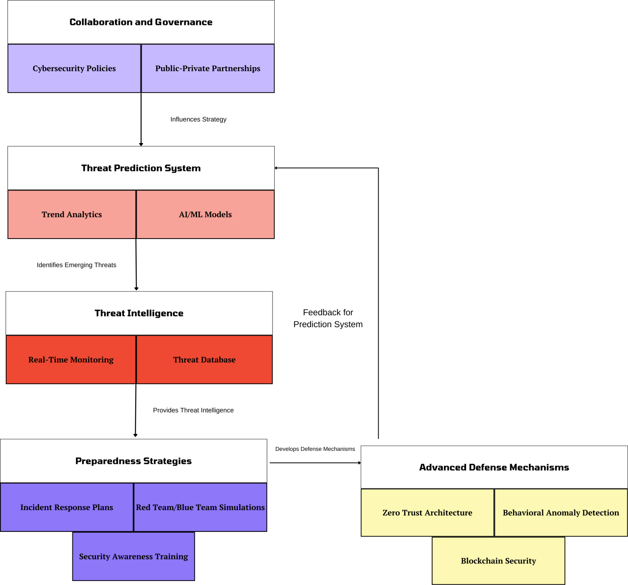

**Figure 1: Cybersecurity Architecture and Frameworks**

The modern cybersecurity architecture picture above shows a prediction and preparation for emerging threats by integration of collaboration, intelligence and advanced defense strategies. [8-10] The behaviour of the framework is shown at its core to be that of different components cooperating in enabling a proactive and adaptive approach to cyber risk mitigation. This architecture first capitalizes on insights from real time monitoring, predictive analytics and governance to establish a resilient cybersecurity ecosystem. Collaboration and governance are the foundation of public-private partnerships with cohesive strategies in cybersecurity policy. They establish direction for the strategic effort, such that all efforts are in line with regulatory measures and industry good practices. The sharing of intelligence and resources through collaboration makes a single response to global cyber threats easier.

The framework’s analytical core is a Threat Prediction System, which turns trend analytics and AI/ML models into future vulnerabilities and attack techniques. This predictive system is powered by threat intelligence data (real-time monitoring and an updated database of known threats). Together, these components make actionable insights available to an organization that can transcend reactionary measures to a proactive defense against emerging threats. The architecture also integrates Preparedness Strategies and Advanced Defense Mechanisms so that response is rapid and security robust. A breach response plan and security training to minimize the impact of a breach. In parallel to that, Zero Trust Architecture, behavioural anomaly detection, blockchain security and other advanced tools bolster defensive measures all the way to guarantee comprehensive protection from a malicious attack. The focus presented in this cohesive approach brings to light the role technology, collaboration and foresight play in solving future cybersecurity problems.

4. Predicting Future Cybersecurity Trends

Cybersecurity is dynamic, which means that organizations have to adapt and predict future challenges continually. Considering the complexity of threats, technology development, and adversaries’ changing tactics, it is important that organizations do not fall off the radar. The future of cybersecurity is, no doubt, shaped by emerging threat landscapes, the development of new technologies, the use of predictive models, the play of big data, and human behavior. As businesses know what these factors will be, they can adjust their defense strategies in such a way that they decrease the risks and improve their overall security posture.

**4.1. Emerging Trends and Innovations in AI for Cybersecurity**

In cybersecurity, Artificial Intelligence (AI) is becoming more and more important and defining the future of how organizations will combat these advanced and dynamic threats. The image graphically reflects the most appealing AI innovation transformations advancing cybersecurity operations. Collectively, these advancements are intended to strengthen digital ecosystems’ defenses of scale against emergent challenges, as well as their proactive and reactive defense capabilities. A circular hub at the center of the image is food labeled “Emerging Trends & Innovations”, which is symbolic of the many ways that AI touches cybersecurity across the dynamic and interdependent landscape of the subject. Surrounding this central hub are six distinct AI-driven cybersecurity technologies addressing each respective area of cybersecurity to form a comprehensive and robust defense mechanism.

AI-Powered Threat Hunting: While this kind of threat hunting has always been manual and time-consuming, you need an expert to analyze it. Using advanced analytics and machine learning, this space is being fully automated and enhanced as AI continues to revolutionize this space. AI-driven tools constantly scan millions of bytes of network traffic, user behavior and runtime events in an attempt to spot anomalies indicative of an attack. Unlike this traditionally designed tool, AI systems are trained and improvised to deal with threats in a previously unheard-of format. This predictive capability allows organizations to identify threats before they can exploit vulnerabilities even before it is able. For one, an AI-powered threat-hunting service can find Advanced Persistent Threats (APTs) that traditional security measures are unable to detect by analyzing small yet important patterns over time.

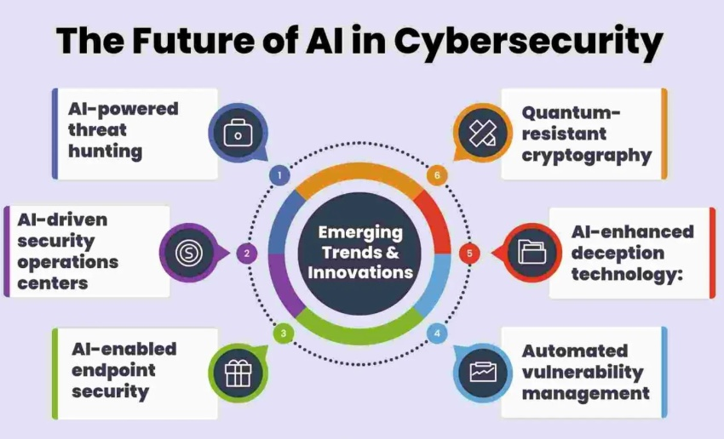**Figure 2: Emerging AI Trends in Cybersecurity** [11]

* **AI-Driven Security Operations Centers (SOCs):** Security Operations Centers or SOCs are the nerve centers for monitoring and cyber security management. AI integration into SOCs has considerably improved their efficiency and effectiveness. On the other hand, AI-enabled SOCs enable the automation of repetitive tasks, including log analysis, threat classification, and incident prioritization, and they enable analysts to focus on handling work. Moreover, AI tools assist in incident response by correlating data from across a wide surface in order to present a broader view of an attack. More specifically, when an anomaly is detected, AI systems come into play, able to trace its origin in a matter of seconds, work out its impact, and immediately suggest appropriate mitigation steps to take. This reduces response times and damages due to cyber incidents by a massive amount.
* **AI-Enabled Endpoint Security:** Endpoint security is obviously a top priority as remote work and the Internet of Things (IoT) devices become the norm. Laptops, mobile devices and IoT (Internet of Things) gadgets are often the weakest link in the network security chain. AI-enabled endpoint protection solutions have to analyze real-time data and detect suspicious activities or even unauthorized access attempts. New attack patterns become constant learning with AI algorithms that learn from new attack patterns and change as your threats evolve. An example of this is being able to detect unusual file modifications and unauthorized access, as well as unusual application behavior, and automatically responding with isolation or neutralization of the threat. In particular, these capabilities are extremely useful in the prevention of zero-day exploits that often target endpoint vulnerabilities.
* **Automated Vulnerability Management:** Cybersecurity includes an essential and challenging activity: vulnerability management. Large organizations manage thousands of systems, each with its own set of vulnerabilities. Finding these holes and ranking them is a difficult task to undertake, given the ongoing stream of new exploits. AI serves to simplify this by automating vulnerability detection, prioritization and remediation. AI tools can scan continuously and compare system vulnerabilities across threat intelligence feeds against the ones they are most likely to be exploited. This predictive capability makes organizations better able to allocate resources such that critical vulnerabilities are patched immediately while lower-priority issues are managed systematically.
* **AI-Enhanced Deception Technology:** Cybersecurity deception technology is a new approach, also known as deception or deception technology, where you put out decoys that trick the attackers. Using AI, this technique has been greatly improved to create highly realistic and adaptive decoys. Any of these decoys look like legitimate systems, files, or networks and lure attackers to work with them rather than real ones. If attackers talk to the decoys, AI systems gain insight into the tactics, techniques and procedures (TTPs) of the attackers. All of the above is used to strengthen defenses and anticipate future attacks. By not only delaying and misleading the attackers but also creating actionable insights for defenders, AI-enhanced deception technology delays, misdirects, and turns attacker actions into insights.
* **Quantum-Resistant Cryptography:** The potential for quantum algorithms to break widely used cryptographic standards; quantum computing brings with it a big threat to traditional methods of encryption. This image is an indication of the need to develop quantum-resistant cryptography in order to adequately protect sensitive information in the aftermath of quantum. Creating and testing quantum-resistant algorithms is a job for AI. AI tries to identify cryptographic schemes resistant to quantum attacks by simulating quantum computing scenarios. AI also helps accelerate and deploy these algorithms at scale so they can be deployed and adopted at scale before quantum computing is a mainstream threat.

**4.2. Emerging Threat Landscapes**

Cyber threats are getting more and more sophisticated as the technology evolves. The rise of AI-driven malware will likely lead to new, more complex attack methods driven on the part of cybersecurity experts, which include social engineering and state-sponsored cyber operations. [12-15] One particular example of AI will be used for automation and large-scale deployment of malware and phishing schemes, making these harder to detect and defend. Ransomware is also evolving, with attackers now hitting critical infrastructure, medical facilities and government agency targets that, in addition to the unfortunate financial impact, may have consequences for national security.

Furthermore, the coming advent of quantum computing will force us to use encryption that’s immune to quantum algorithms, meaning that traditional cryptographic techniques will be outdated. This has allowed IoT devices to be integrated into day-to-day infrastructure, but these devices do not have the security protections needed to fend off clever attacks. We expect supply chain attacks, which take advantage of third-party vendors as a means to access larger networks, to continue to increase in number and expand across interconnected ecosystems. To address these evolving threats, significant proactive investment will be required in threat intelligence, real-time monitoring, and adaptive security practices.

**4.3. Technologies Shaping Future Threats**

The further development of new technologies would have major consequences on defensive and offensive cybersecurity measures. The challenge posed by quantum computing is one of the most fundamental, perhaps able to destroy existing systems of encryption based on the difficult factoring of large numbers. Quantum computers being developed today demand quantum-resistant encryption algorithms to secure data or be rendered obsolete. Although blockchain is often attributed to securing digital currencies, it has great promise for securing data integrity and transparency in cybersecurity. It’s also capable of empowering the tracking of assets across the supply chain, reducing the likelihood of fraud and tampering, and can be used to authenticate transactions.

However, these technologies come with their own defensive advantages and new tools for cybercriminals. Quantum computing can be used to decrypt sensitive data, and AI can be used to automate the design and execution of sophisticated cyberattacks. To make good on these benefits while preserving their dangers will require more innovation and more attention to make sure they are being used responsibly. For instance, AI can help with threat detection, but malicious actors can leverage AI to engineer ultra-targeted attacks like deepfake videos or AI-amplified phishing scams.

**4.4. Predictive Models and Techniques**

Proactive cybersecurity is also now becoming a cornerstone of predictive analysis. Machine Learning (ML) and artificial intelligence (AI) enable organizations to create cyber threat systems that not only identify but also predict these threats before they occur. Security teams use predictive models that will allow them to predict possible attack vectors by looking for behavior patterns, deviations from normal behavior, as well as historical behavior.

**Figure 3: Predicting and Preparing for Emerging Cybersecurity Threats Flowchart**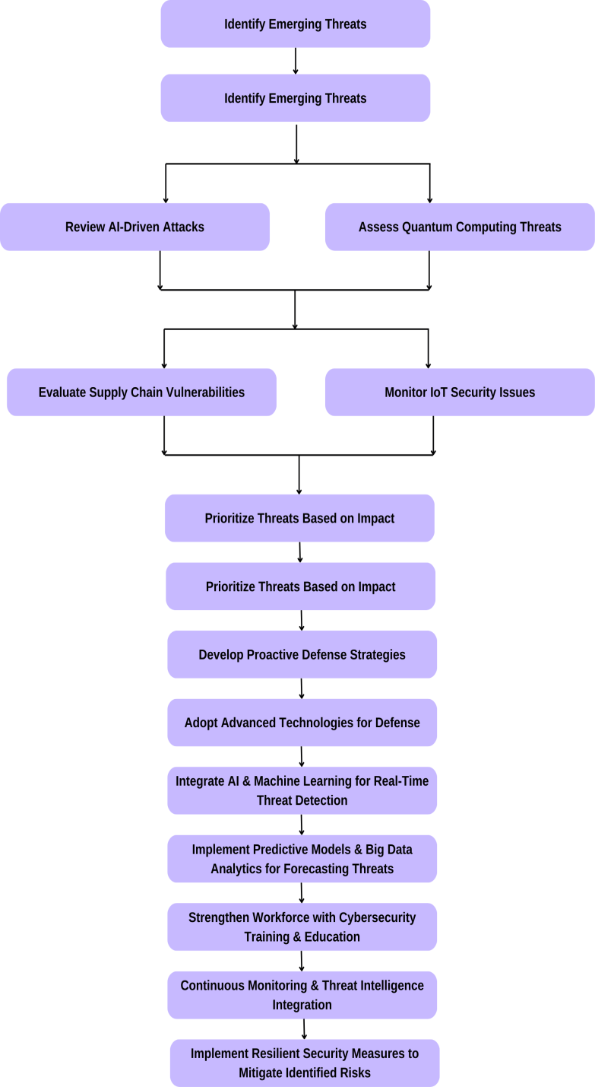

For example, anomaly detection is valuable for detecting signs of an actually impending cyberattack. It can monitor network traffic or a user’s behavior to look for deviations that could be signs of malicious activity. However, threat modeling takes potential vulnerabilities and risks in an organization’s system and maps to help prioritize security measures and work to improve weaknesses before the weaknesses are discovered and exploited. Another technique to accomplish something similar in behavior analysis, which is concerned with monitoring user and system activities for insider threats or for policy violations. All of these predictive techniques allow organizations to take preventative measures to prevent cyber incidents and reduce the likelihood and impact.

**4.5. The Role of Big Data in Cybersecurity Predictions**

The role of big data in uncovering and combating critical cyber threats is huge. Because it allows organizations to gain deeper insights into potential threats, big data analysis is being increasingly utilized, with the amount of structured and unstructured data being generated across different digital platforms. To stay ahead of the threat, without it, it is possible to identify trends in global threat data, predict vulnerabilities, and, in turn, implement proactive security measures.

Another key benefit of big data in cybersecurity is real time monitoring of data streams. This enables faster threat detection and faster response times and dramatically decreases the damage done by an attack. Additionally, pattern recognition can recognize recurring attack techniques or indicators of compromise, which enables more accurate prediction of future threats and preemptive defense against these. To be able to build predictive security capabilities and respond to an ever-changing threat landscape, you will want to have both a big data infrastructure and skilled analysts to invest in.

**4.6. The Human Factor in Future Cybersecurity**

While technology has advanced a lot, the human part is still considered the most essential aspect of cybersecurity. Phishing and spear phishing attacks continue to take advantage of humans’ vulnerability. Exploiting the trust of consumers to the advantage of cybercriminals, they encourage people to allow access to sensitive information or systems. Therefore, human awareness and vigilance are important parts of any cybersecurity strategy.

One of the main risks is posed by insider threats. Security can be compromised intentionally or unintentionally by employees, contractors or partners mishandling sensitive data or falling victim to social engineering attacks. In order to minimize these risks, organizations must have strict access control rules behavioural monitoring, and no one in the organization, other than the authorized individuals, should have access to the critical systems. Cybersecurity professionals are a continually scarce commodity, and the demand for qualified personnel far exceeds the supply. So, to address this, organizations need to invest in education and develop the workforce to build a pipeline of talent able to meet the ever evolving demands of the cybersecurity landscape.

5. Preparing for Emerging Threats

In response to the ever-increasing cyber threat landscape, organizations will need to implement a multi-pronged approach of proactively deploying advanced technologies, [16-20] creating robust policies, and developing a workforce. These efforts will bring resilience and agility in the face of an ever more complex digital world.

**5.1. Proactive Strategies for Threat Mitigation**

ADPs and AITs have outpaced reactive security measures. To beat adversaries, organizations need to follow proactive strategies. The implementation of Zero Trust architectures is one of the effective approaches. Every user and machine is a potential threat and must be continuously verified, even for access privileges. Penetration Testing and red team exercises are regular exercises to find security holes before an attacker targets them.

Proactive cybersecurity is also based on another cornerstone: threat intelligence. Using the intelligence feeds gathered from around the globe, helping organizations to share and take advantage of the information across the different industries, you can plan and anticipate the potential attack vectors. Ensuring the integration of advanced tools such as XDR platforms, these platforms offer a complete network and endpoint to application visibility and enables early detection and prevention of anomalous behavior. A well-tested incident response plan can respond quickly and effectively to real breaches before there is any damage.

**5.2. The Role of AI and Machine Learning in Defense**

Real time detection and mitigation of threats have been revolutionized by Artificial intelligence (AI) and Machine learning (ML). Thousands of different data sets could be processed by AI, which can then find patterns and anomalies that suggest a possible cyberattack. For example, ML algorithms can alert when suddenly an unusual login location occurs or when behaviour pattern indicates a possible account takeover.

In addition, AI-driven solutions also allow automated response services towards the threats, eliminating the gap regarding the time between the detection and the mitigation. For example, there are systems that will automatically quarantine infected devices or block out malicious IP addresses without the need for human inspection. Nevertheless, AI would enable the defense against attacks but at the same time provide challenges to it in that adversarial attacks can be done against AI models. This has made staying ahead in the AI-driven cybersecurity race important, which is why research and innovation continue to be key.

**5.3. Policy and Governance Recommendations**

They become effective by offering good cyber security policies and governance. However, governments and regulatory bodies must set up rules in place for industries to adhere to and uphold secure practices, and they must all implement clear, enforceable standards if we’re to achieve a safer, more secure internet. Take, for example, enforcing data breach notification requirements and mandating multi-factor authentication for critical systems can also strengthen in all regards.

The emergence of global cyber threats implies that international collaboration is equally important. NATO and the UN have led initiatives to encourage cross-border cooperation in the area of cybercrime, such as the Budapest Convention on Cybercrime. In addition, organizations need to match internal policies with industry baselines, like the NIST Cybersecurity Framework or ISO 27001, to be sure that the risk management approach is strong and consistent.

**5.4. Cybersecurity Education and Workforce Development**

Any effective cybersecurity strategy has a backbone, a skilled and aware workforce. In an age of increasingly complicated cyber threats, it is very important to bridge the global skill gap in the cybersecurity domain. There is a need for educational institutions, governments, and private organizations to band together to create programs that offer practical, hands-on training in cybersecurity. There are other initiatives like cyber boot camps, certifications (e.g., CISSP, CEH), or apprenticeships that can build a pipeline of qualified professionals. However, it is also important to foster awareness among all employees of common threats such as phishing and social engineering. To keep them on track, a regular training program should include simulated attacks, which organizations should invest in.

In addition, promoting a diverse group of people has the effect of bringing in a wide number of perspectives and problem-solving approaches to the cybersecurity team. Last, academia-industry university partnerships can help fuel research and innovation enough to keep the workforce prepared to meet future challenges.

6. Challenges and Limitations

With the adoption of cybersecurity evolution in response to threats, various organizations have to deal with several challenges and hard facts. The technologies, operations, and humans are all spanned, complicating the path towards robust and effective defenses.

* **Rapid Evolution of Threats**: The ever changing nature of cyber threats is one of the most challenging. It is an ever-evolving war against attackers that are continually coming up with new ways of attacking, like AI driven malware, fileless attacks, and polymorphic viruses, [21-24] which make traditional security measures useless. New technologies can also spread quickly and faster than it is possible to secure such vulnerabilities. The environment is dynamic, which means that organizations are always in a constant state of adaptation, the costs of which can strain on resources and the infrastructure.
* **Resource Constraints**: Also, implementing and running advanced cybersecurity measures usually requires huge financial and human resources. Small and medium sized enterprises (SMEs) face budget limitations, not being able or not willing to spend money on high tech or on a specialist. Moreover, the shortage of cybersecurity talent on a global scale makes things worse, as critical positions stay open and employees already working in companies are pushed to take up the slack. However, this skills gap also means that an organization can’t respond adequately to threats and can’t innovate and adopt forward-looking initiatives.
* **Balancing Privacy and Security**: Another challenge is finding the right amount of robust cybersecurity measures and user privacy. To catch threats, however, tools like behavioral analytics and data monitoring are needed, along with creating privacy concerns about data. The General Data Protection Regulation (GDPR) and the California Consumer Privacy Act (CCPA) mandate strict procedures concerning user data handling at once; they complicate attempts to implement, even only partial, monitoring solutions. Getting into compliance without sacrificing security is a very delicate balancing act that requires watching every step and execution.
* **Dependence on Global Cooperation**: Cyber threats know no borders, and therefore, governments and industries, as well as global organizations, need collaboration worldwide. However, unlike other plagues, coordinated response is hampered by differing regulations, political priorities and resource disparities between countries. In other words, different approaches to cybercrime legislation and enforcement can make it easy for cybercriminals to find a safe haven. Trust, alignment, and sustained dialogue amongst stakeholders are needed to fill these gaps, which can be difficult in an era of geopolitics.

7. Future Directions

As technology continues to advance, cyber threats become more and more sophisticated, global digital systems will get more complex, and cybersecurity will continue to evolve. Future activities should focus on innovation, collaboration, and sustainability for future security practices.

* **Advancing Technological Integration**: Quantum computing, artificial intelligence (AI), and blockchain will play an important role in future cybersecurity strategies for integrating these technologies. However, to secure data against quantum-enabled attacks, quantum resistant cryptographic methods will be extremely important. Likewise, AI and machine learning (ML) will be essential to improving threat detection and response. Real time decision making and remediation autonomous systems are likely to become the norm, decreasing human intervention and response times. Likewise, blockchain technology can strengthen security by increasing transparency and guaranteeing the integrity of data in supply chains or, more generally, distributed networks. To keep from falling behind the evil and nuanced cyber threats, you will need to spend time and resources in research and development for these technologies.
* **Strengthening Global Collaboration**: Cyber threats are borderless, and future challenges will require international cooperation. In order to create unified frameworks for cyber threat intelligence, joined-up incident response, and coordination of threats against cybercriminal activity, governments, industry leaders, and international organizations must work together. Fostering collaboration is offered through platforms like the Global Forum on Cyber Expertise (GFCE), and partnerships under the Budapest Convention on Cybercrime are some of the templates. The expansion of these efforts to encompass diverse stakeholder representation and emerging economies will result in a more comprehensive, broad based approach to global cybersecurity.
* **Building a Sustainable Cybersecurity Ecosystem**: To address cybersecurity’s long term challenges of the skills gap and resource inequalities, we must consider sustainability. To develop a diverse and skilled cybersecurity workforce, efforts are going to need to be intensified, and an emphasis will be placed on infusing cybersecurity education into curriculums and training for professionals. Meanwhile, resource packs can be bridged through public private partnerships and incentivizing investment in cybersecurity startups that promote innovation. Equally important will be the development of scalable solutions applicable to SMEs and under resourced organizations to build an equitable and resilient cybersecurity ecosystem.
* **Ethical and Regulatory Evolution**: With more technologies, the question of ethics centers as a focal point for issues in how cybersecurity practices will be shaped. Future priorities include ensuring AI and surveillance tools are used responsibly, protecting user privacy, and adhering to evolving regulations such as GDPR and CCPA. For technologies to remain accountable and responsible to all concerned, political, academic, and civil society stakeholders must be equal partners in decisions about how technologies will be developed and when they will become available.

8. Conclusion

The ongoing evolution of the cybersecurity landscape is being shaped by advances in technology and imminently more proficient cyber threats. With organizations moving through this complex ‘environment’, it is clear that traditional approaches to security are no longer sufficient. To handle the AI-directed attacks, quantum computing and the expanding digital attack surface, we need to shift from reactive and reactive response to proactive and proactive response. Advanced technologies like AI, machine learning, and blockchain have great potential to integrate and defend themselves against attacks. With these tools, organizations can see real-time threat detection, automatic response, and enhanced transparency to avoid adversaries. The dual-use nature of these technologies is underscored by the need for vigilance and creative innovation to reduce the associated risks. The urgent development and use of quantum-resistant encryption protocols will be an important priority as quantum computing approaches.

Building any resilient ecosystem requires collaboration and inclusivity; it is just as important, or more important, in the cybersecurity realm. Cyber threats are global and require joint work by governments, industry and international organizations. Cross-border challenges will only be battled through initiatives that promote knowledge sharing, threat intelligence collaboration and joint incident response. Understanding, however, the cybersecurity skills gap at the same time will enable it to address the cybersecurity resource and opportunity gaps for all organizations and create a more tailored defense against emerging threats. The future passes in looking ahead at fostering resilience by design, ethical practices, and alignment of technology and regulation. The cybersecurity community can mitigate the risk of the digital future under one single umbrella by finding a holistic approach that is a combination of proactive strategies, technological integration, workforce development, and global cooperation. Collective action doesn’t just reduce risks, but it also builds the bedrock of trust and security in an ever more globalized world.

Disclaimer (Artificial intelligence)

Option 1:

Author(s) hereby declare that NO generative AI technologies such as Large Language Models (ChatGPT, COPILOT, etc.) and text-to-image generators have been used during the writing or editing of this manuscript.

Option 2:

Author(s) hereby declare that generative AI technologies such as Large Language Models, etc. have been used during the writing or editing of manuscripts. This explanation will include the name, version, model, and source of the generative AI technology and as well as all input prompts provided to the generative AI technology

Details of the AI usage are given below:

1.

2.

3.

References

Raban, Y., & Hauptman, A. (2018). Foresight of cyber security threat drivers and affecting technologies. foresight, 20(4), 353-363.

Husák, M., Komárková, J., Bou-Harb, E., & Čeleda, P. (2018). Survey of attack projection, prediction, and forecasting in cyber security. IEEE Communications Surveys & Tutorials, 21(1), 640-660.

Safitra, M. F., Lubis, M., & Fakhrurroja, H. (2023). Counterattacking cyber threats: A framework for the future of cybersecurity. Sustainability, 15(18), 13369.

What is the future of cybersecurity?, Field Effect, online. https://fieldeffect.com/blog/what-is-the-future-of-cyber-security

Cybersecurity Trends: Looking Over the Horizon to the future, online. https://www.apu.apus.edu/area-of-study/information-technology/resources/cybersecurity-trends/

AL-Hawamleh, A. M. (2023). Predictions of cybersecurity experts on future cyber-attacks and related cybersecurity measures. momentum, 3(14), 15.

Dede, C. J. (1991). Emerging technologies: Impacts on distance learning. The Annals of the American Academy of Political and Social Science, 514(1), 146-158.

5 cybersecurity risks posed by emerging technology – and how we can defend against them, World Economic Forum, online. https://www.weforum.org/stories/2024/10/cyber-resilience-emerging-technology-ai-cybersecurity/

Ahamed Banaf, The Future of Cybersecurity: A 5-Year Outlook, online. https://www.linkedin.com/pulse/future-cybersecurity-5-year-outlook-prof-ahmed-banafa-ziy6c

Kaloudi, N., & Li, J. (2020). The ai-based cyber threat landscape: A survey. ACM Computing Surveys (CSUR), 53(1), 1-34.

The Future of AI in Cybersecurity: Emerging Technologies and Trends, Sigma Solve, online. https://www.sigmasolve.com/blog/the-future-of-ai-in-cybersecurity-emerging-technologies-and-trends/

George, A. S. (2024). Emerging Trends in AI-Driven Cybersecurity: An In-Depth Analysis. Partners Universal Innovative Research Publication, 2(4), 15-28.

Top Ten Cybersecurity Trends, online. Kaspersky, https://www.kaspersky.com/resource-center/preemptive-safety/cyber-security-trends

Balantrapu, S. S. (2023). Future Trends in AI and Machine Learning for Cybersecurity. International Journal of Creative Research In Computer Technology and Design, 5(5).

Top Ten Cybersecurity Trends, online. Kaspersky, https://www.kaspersky.com/resource-center/preemptive-safety/cyber-security-trends

Seven trends that could shape the “official future” of cybersecurity in 2030, Center for Long-term Cybersecurity, 2023. online. https://cltc.berkeley.edu/publication/seven-trends-cybersecurity-2030/

Babate, A., Musa, M., Kida, A., & Saidu, M. (2015). State of cyber security: emerging threats landscape. International Journal of Advanced Research in Computer Science & Technology, 3(1), 113-119.

The Future Of Cybersecurity: Emerging Threats and How to Combat Them, Forbes, online. https://www.forbes.com/councils/forbestechcouncil/2024/07/11/the-future-of-cybersecurity-emerging-threats-and-how-to-combat-them/

2025 Cybersecurity Trends: 7 Trends to Watch, Splunk, online. https://www.splunk.com/en_us/blog/learn/cybersecurity-trends.html

Rawat, S. (2023). Navigating the Cybersecurity Landscape: Current Trends and Emerging Threats. Journal of Advanced Research in Library and Information Science, 10(3), 13-19.

Rawat, D. B., Doku, R., & Garuba, M. (2019). Cybersecurity in big data era: From securing big data to data-driven security. IEEE Transactions on Services Computing, 14(6), 2055-2072.

Sun, N., Zhang, J., Rimba, P., Gao, S., Zhang, L. Y., & Xiang, Y. (2018). Data-driven cybersecurity incident prediction: A survey. IEEE communications surveys & tutorials, 21(2), 1744-1772.

Top 5 Cyber Security Challenges, SentialOne, online. https://www.sentinelone.com/cybersecurity-101/cybersecurity/cyber-security-challenges/

Kristian McCann, Top 10 Cybersecurity Predictions for 2025, online. https://cybermagazine.com/articles/top-10-cybersecurity-predictions-for-2025