Characterization of Autonomic Dysfunction in AL Cardiac Amyloidosis: A Moroccan Case Series Study

.

ABSTRACT

|  |
| --- |
| Cardiac amyloidosis is a rare but serious manifestation of systemic amyloidosis, presenting diagnostic and therapeutic challenges. The AL subtype is the most common, though transthyretin-related forms are increasingly recognized due to population aging. One frequent complication is autonomic dysfunction, resulting from impaired autonomic nervous system regulation.  **Aims:** This study aims to explore autonomic dysfunction in patients with AL cardiac amyloidosis and evaluate the clinical implications through specific autonomic tests.  **Study design:** Cross-sectional descriptive and analytical case series.  **Place and Duration of Study:** Cardiology Department, CHU Ibn Rochd, Casablanca, Morocco; from March 2021 to June 2023.  **Methodology:** Ten patients diagnosed with AL cardiac amyloidosis were included. Diagnosis was based on clinical, biochemical, histological, and imaging criteria. Autonomic function was evaluated using standardized non-invasive tests: deep breathing, isometric handgrip (15s and 3 min), mental stress, and active orthostatic tests. The results were classified using established criteria to identify vagal deficiency, sympathetic dysfunction, and baroreflex impairment..  **Results:** Autonomic dysfunction was identified in 70% of patients. Vagal deficiency was present in 60%, and 40% showed combined sympathetic and parasympathetic failure. Diverse dysautonomic syndromes were observed: severe sympathetic-parasympathetic denervation, sympathetic hyperactivity with vagal impairment, baroreflex abnormalities, and isolated vagal or sympathetic involvement. Clinical manifestations included orthostatic intolerance, cardiovascular symptoms, and vasomotor disturbances.  **Conclusion:** Autonomic dysfunction is frequent and clinically significant in AL cardiac amyloidosis. A structured evaluation is essential for optimizing patient management and improving quality of life. |

*Keywords: Autonomic nervous system, cardiac amyloidosis, AL amyloidosis, dysautonomia, vagal deficiency, sympathetic dysfunction.*

1. INTRODUCTION

Amyloidosis encompasses a heterogeneous group of disorders characterized by the extracellular deposition of insoluble fibrillar proteins, known as amyloid fibrils. These deposits can be localized or systemic, with clinical manifestations depending on the location and type of the amyloid involved.

The most commonly affected organs include the kidneys, liver, gastrointestinal tract, peripheral nervous system, and the heart. Among these, cardiac involvement is the primary determinant of prognosis in systemic amyloidosis.

Cardiac amyloidosis can result from three major amyloid precursors: immunoglobulin light chains (AL type), mutated transthyretin (hereditary ATTR), and wild-type transthyretin (senile ATTR). In contrast, cardiac involvement is rare and typically occurs in advanced stages of secondary (AA) amyloidosis related to chronic inflammation **(1)**

Although AL amyloidosis remains the most prevalent form of cardiac amyloidosis, transthyretin-related forms are increasingly recognized, especially in aging populations, and are likely underdiagnosed.

One critical but often overlooked complication of cardiac amyloidosis is peripheral autonomic neuropathy, marked by a disruption in sympathovagal balance. This dysautonomia is associated with considerable morbidity and mortality due to its multisystem impact **(2)**.

In this context, we report a case series, defined as a descriptive observational study involving multiple patients sharing a common diagnosis and clinical features, without a comparison group. This series includes a group of patients diagnosed with AL cardiac amyloidosis, all of whom demonstrated evidence of clinically significant autonomic dysfunction. The objective of this study is to describe their autonomic profile using a standardized battery of tests targeting both sympathetic and parasympathetic function, and to highlight the importance of timely recognition and tailored management of this complication.

Given the symptomatic burden and therapeutic implications of dysautonomia in AL cardiac amyloidosis, documenting these findings across multiple cases contributes meaningfully to clinical awareness and the emerging literature on this topic.

2. material and methods

**2.1 Study design and population**

This was a cross-sectional, descriptive, and analytical study conducted in the cardiology department of Ibn Rochd University Hospital Center, Casablanca. The study included 10 patients diagnosed with AL cardiac amyloidosis over a period extending from March 2021 to June 2023.

**2.1.1 Inclusion Criteria**

Patients were included if the diagnosis of AL amyloidosis with cardiac involvement was confirmed based on a combination of clinical, biochemical, histological, cytological, and imaging criteria.

In this cohort:

* 80% of patients had monoclonal gammopathy of undetermined significance (MGUS)
* 20% had multiple myeloma, in remission at the time of evaluation
* Cardiac involvement was defined by the presence of heart failure with preserved ejection fraction (HFpEF), manifesting as either restrictive or hypertrophic cardiomyopathy

**2.1.2 Exclusion Criteria**

* Patients with diabetes mellitus
* Non-sinus rhythm
* Heart failure with reduced ejection fraction (LVEF < 50%)

**2.2 Equipment Used for Autonomic Nervous System (ANS) Testing**

The ANS unit at CHU Ibn Rochd was equipped with the following:

* Dynamap (CRITIKON, 1846 XP) for blood pressure monitoring
* LCD display (HELLIGE, EK 512 E) for continuous heart rate and systolic blood pressure monitoring
* 12-lead ECG recorder
* Hand dynamometer for isometric contraction tests
* Tilt table for orthostatic testing
* Electrodes and stopwatch
* Emergency resuscitation equipment: defibrillator, oxygen delivery systems, intubation supplies

**2.3 Testing protocol**

All autonomic evaluations were conducted in the ANS cardiovascular exploration unit.

Each patient gave written informed consent prior to inclusion.

Tests were conducted after a 48-hour washout period off any medications affecting the autonomic system, and patients were required to be fasting on the day of testing.

Patients were initially placed supine in a calm environment, and baseline heart rate (HR) and blood pressure (BP) were measured every 5 minutes over a 30-minute period. A resting ECG was also recorded.

They then underwent a series of autonomic function tests, with resting intervals in between. Each test assessed changes in HR or BP compared to baseline and was expressed as a percentage response.

For tests evaluating sympathetic activity, only systolic BP (SBP) was considered. All calculations were based on changes in SBP and HR.

**2.4 Autonomic function tests**

All tests were performed under standardized conditions. Results were interpreted using predefined thresholds indicating normal function, hyperactivity, or deficiency of sympathetic and parasympathetic responses.

**2.4.1 Deep Breathing Test (DB)**

This test assesses parasympathetic (vagal) function by evaluating the variability of RR intervals during respiratory cycles.

* Patients performed six deep inhalation/exhalation cycles over one minute.
* ECG monitoring was used to measure maximum (RRmax) and minimum (RRmin) RR intervals during inspiration and expiration, respectively.
* The result was expressed as: (RR maximal – RR minimal/RR minimal) x 100

Interpretation:

* Normal vagal activity: ≥30%
* Vagal deficiency: <30%
* Vagal hyperactivity: >30%

**2.4.2 Isometric Handgrip Test**

This test evaluates both sympathetic and parasympathetic components:

* For parasympathetic assessment, patients exerted maximal grip pressure for 15 seconds using a hand dynamometer, and HR variation was measured.
* For α-sympathetic (peripheral) evaluation, patients maintained 50% of maximal grip for 3 minutes. The change in systolic BP (SBP) before and after was calculated using: (SBP after – SBP before) / SBP before)×100

Interpretation (for both HR and BP):

* Normal response: ~10%
* Hyperactivity: >10%
* Deficiency: <10%

**2.4.3 Mental Stress Test**

This test assessed central α- and β-sympathetic activity.

* Patients were asked to subtract 7 serially from 200 aloud for several minutes.
* This activates the central sympathetic nervous system, leading to HR and BP increases.
* Changes in HR and BP were calculated using the same percentage formula.

Interpretation:

* Normal central sympathetic response: 10%
* Hyperactivity: >10%
* Deficiency: <10%

**2.4.4 Active Orthostatic Test (Stand-Up Test)**

This evaluates sympathetic baroreflex activity in response to postural change:

* After lying supine, patients stood up within 5 seconds, and HR and BP were monitored for 10 minutes.
* The test was stopped if the patient experienced pre-syncopal symptoms, chest pain, cyanosis, or significant BP/HR changes.

Interpretation:

* A normal response includes early tachycardia and vasoconstriction.
* Abnormal responses include:
* Orthostatic hypotension (OH): drop in SBP ≥20 mmHg or DBP ≥10 mmHg
* Inadequate HR compensation suggests neurogenic OH
* HR increase >30 bpm without hypotension = Postural Orthostatic Tachycardia Syndrome (POTS)

**2.4.5 Summary of Functional Tests**

*2.4.5.1 Parasympathetic function*

* Deep Breathing Test (gold standard)
* Handgrip (15-second version)

*2.4.5.2 Peripheral sympathetic function:*

* Handgrip (3-minute version)
* Orthostatic test (SBP response)

*2.4.5.3 Central sympathetic function*

* Mental stress test (α and β activity)

3. results

**3.1 Patient characteristics**

Ten patients were included in the study. The mean age was 65 ± 3 years, ranging from 57 to 71 years. The cohort had an equal gender distribution (50% female, 50% male). At baseline:

* Mean systolic blood pressure (SBP): 111.3 ± 4.3 mmHg
* Mean diastolic blood pressure (DBP): 66.5 ± 6.3 mmHg
* Mean heart rate (HR): 60.1 ± 9.4 bpm

**3.2 Clinical and Functional Presentation**

* Two patients (20%) had a history of syncope, one of whom experienced recurrent episodes. Both demonstrated severe autonomic dysfunction on testing.
* The most frequent clinical signs of dysautonomia were orthostatic intolerance, cardiovascular symptoms, neurological disturbances, and gastrointestinal complaints.
* Vasomotor symptoms such as hot flashes and cold extremities were present in 4 patients (40%).
* Genitourinary and sexual dysfunction occurred in 3 patients (30%).
* Two patients (20%) were known to have hypertension.

**3.3 Clinical examination**

* 60% of patients had a normal physical exam.
* Three patients (30%) had a systolic ejection murmur over the aortic area suggestive of aortic stenosis.
* Two patients (20%) had mitral regurgitation murmurs.

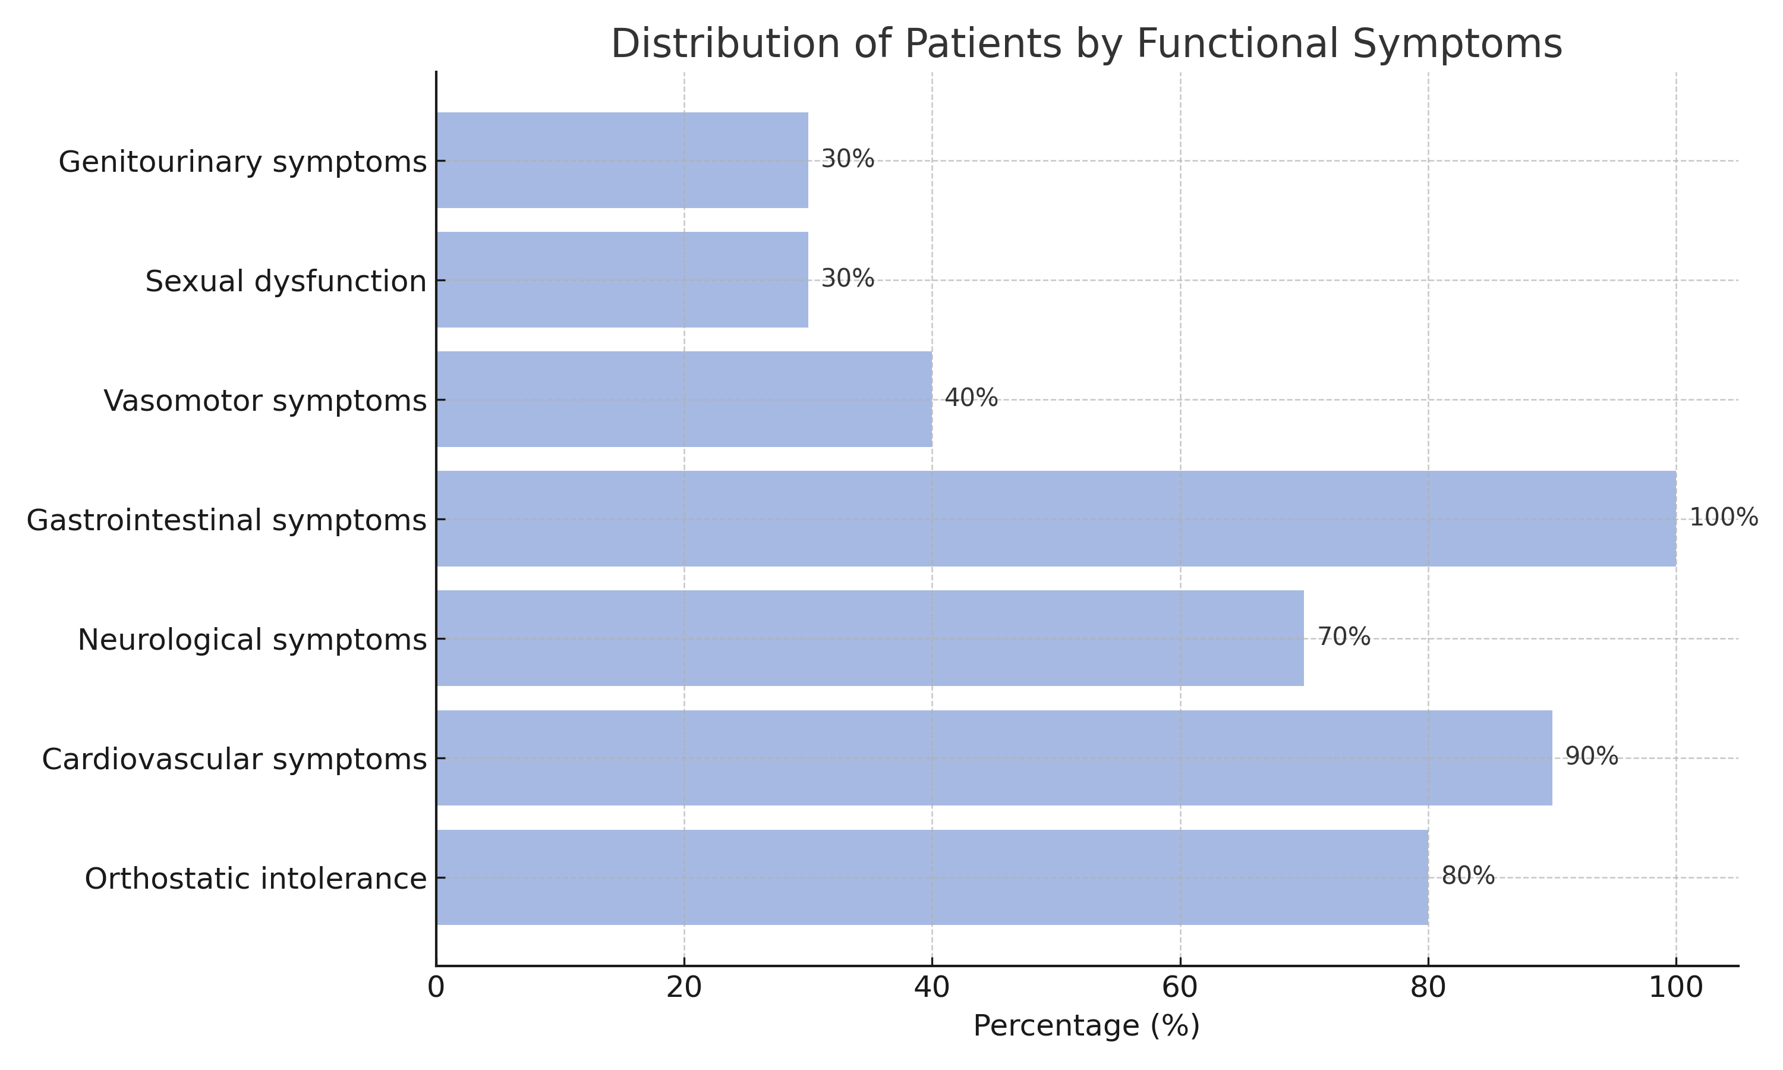

**Fig. 1:** distribution of patients by functional Symptoms

**3.4 Paraclinical investigations**

Transthoracic echocardiography revealed:

* Hypertrophic cardiomyopathy in 60%
* Restrictive cardiomyopathy in 40%
* Severe aortic stenosis in 20%
* Mitral regurgitation in 20%

Coronary angiography was performed in 50% of patients:

* Half had normal coronaries
* Half had non-obstructive atherosclerotic lesions (mono- or bi-vessel)

**3.5. Autonomic Nervous System Assessment**

**3.5.1 Vagal Response (Parasympathetic Function)**

Deep Breathing Test showed:

* Vagal deficiency in 6 patients (60%), predominantly male (70%)
* Normal vagal function in 3 patients (30%)
* Vagal hyperactivity in 1 patient (10%)

Handgrip (15-second) results were consistent with the Deep Breathing findings, confirming the diagnosis of vagal dysfunction.

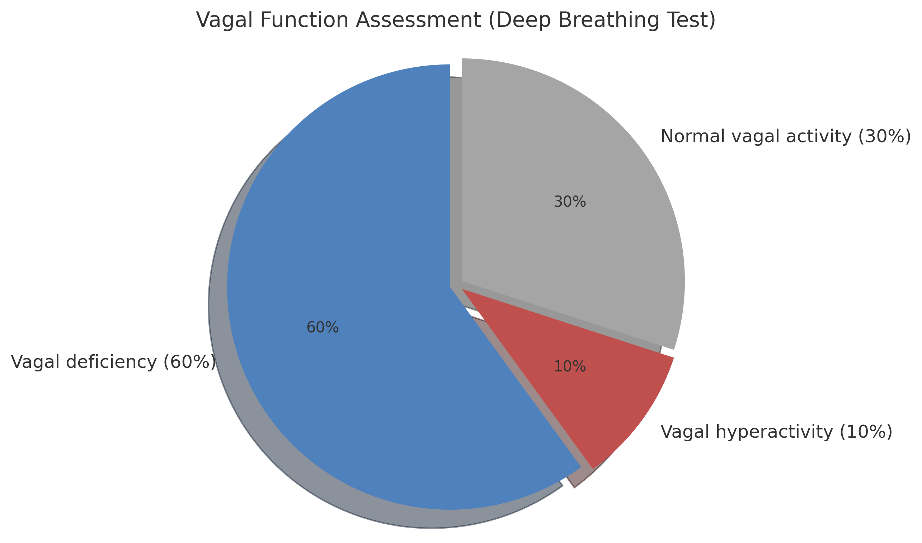

**Fig. 2**: Vagal Function Assessment (DB Test)

**3.5.2 Central Sympathetic Response (Alpha and Beta)**

Mental Stress Test results:

* Beta-sympathetic dysfunction (DSBC): 4 patients (40%), of whom 50% were female
* Normal beta-sympathetic response: 5 patients (50%)
* Beta-sympathetic hyperactivity: 1 patient (10%)
* Alpha-sympathetic dysfunction (DSAC): 3 patients (30%), predominantly female (66%)
* Normal alpha-sympathetic response: 7 patients (70%)
* No patients showed alpha hyperactivity

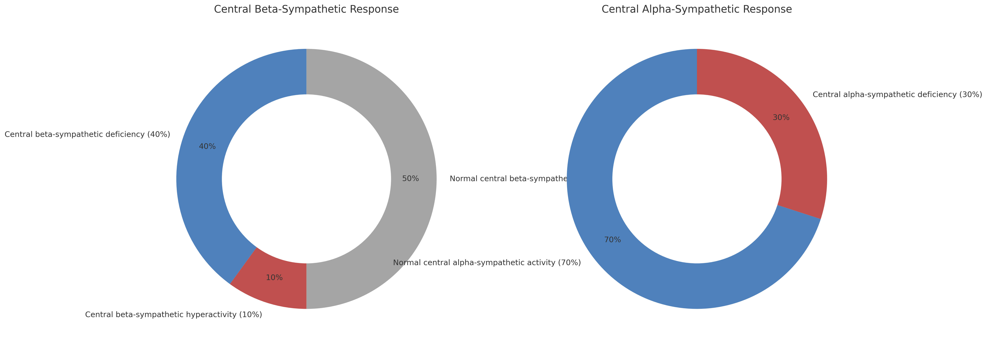

**Fig. 3:** Central Sympathetic Response Results

**3.5.3 Peripheral Alpha-Sympathetic Response**

Measured via handgrip (3 min) and orthostatic BP variation.

Results:

* Deficient response (DSAP): 5 patients (50%)
* Normal response: 3 patients (30%)
* Hyperactivity (HASAP): 2 patients (20%)

**3.5.4 Orthostatic Test Results**

* Normal response: 3 patients (30%)
* Peripheral sympathetic deficiency (DSAP): 4 patients (50%)
* Peripheral beta-sympathetic hyperactivity (HASBP): 2 patients (20%)
* Baroreflex abnormality (AnBR): 1 patient (10%)
* Among those with DSAP, 3 patients experienced orthostatic hypotension, including 2 with a sympathicotonic response, indicating beta-sympathetic failure.

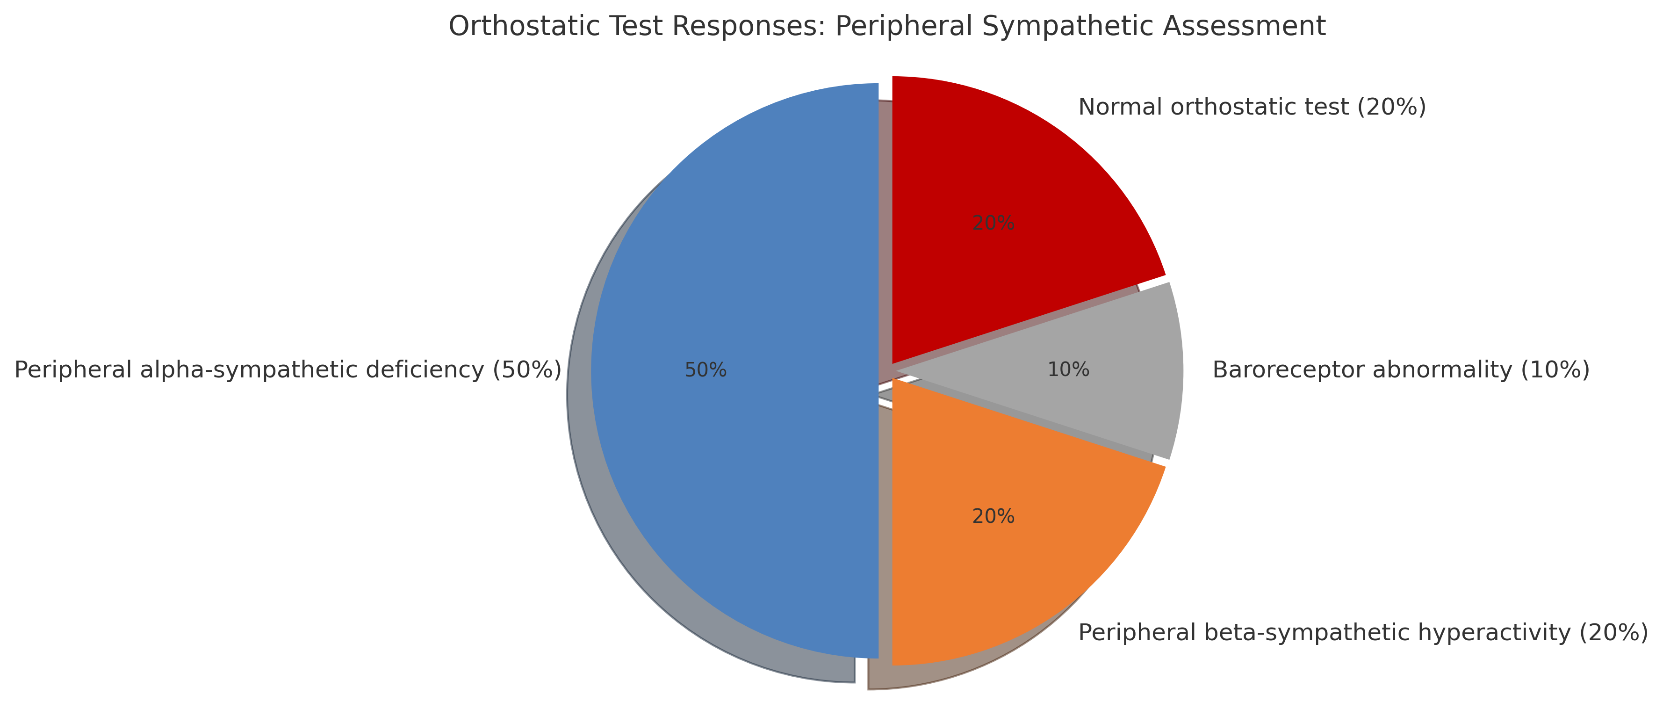

**Fig. 4:** Responses to Active Orthostatic Testing

4. DISCUSSION

Historically, AL amyloidosis has been the most frequently encountered form of cardiac amyloidosis. It results from clonal plasma cell proliferation within the bone marrow, most commonly in the context of monoclonal gammopathy of undetermined significance (MGUS), or less often, multiple myeloma. These abnormal plasma cells overproduce light chains, predominantly lambda, occasionally kappa, which aggregate into insoluble β-amyloid fibrils. These deposits typically affect the kidneys, heart, peripheral and autonomic nervous systems, gastrointestinal tract, liver, and skin **(3).**

The autonomic nervous system (ANS) is a key regulatory system, essential to the proper functioning of all major organ systems. Autonomic dysfunction may result from either excessive activation or failure of the sympathetic and/or parasympathetic branches, whether at central or peripheral levels. Given the polymorphic symptomatology seen in these patients, comprehensive autonomic profiling is clinically warranted.

In systemic amyloidosis, amyloid fibril deposition disrupts the ANS, leading to dysautonomia, a complication that significantly affects patient quality of life and survival **(4).**

In our case series, we found evidence of dysautonomia in 70% of patients. The syndromic presentations were highly variable, consistent with findings in previous literature.

From a functional standpoint, orthostatic intolerance and cardiovascular symptoms were among the most common complaints. This is consistent with the work of El Honsali et al.,**(5)** who also observed a diverse clinical expression of autonomic dysfunction in cardiac patients.

A 2022 study by Barrosso et al. **(6)** identified signs of dysautonomia, such as early satiety, nausea, vomiting, gastrointestinal irregularities, urinary incontinence, erectile dysfunction, dry eyes, and dizziness, in 17% of patients with mutant transthyretin amyloidosis (ATTRm) and 8% with wild-type transthyretin (ATTRwt).

Similarly, González-Duarte et al. **(7)** suggested that dysautonomia may precede overt cardiac symptoms in patients with systemic amyloidosis.

In our study, while the majority of physical exams were normal, 20% of patients exhibited aortic stenosis murmurs, and echocardiography confirmed severe aortic stenosis in 20% of cases.

This is consistent with findings from the Amyloidosis Network, which reports an amyloidosis prevalence of 6–16% among patients with severe aortic stenosis, depending on the population **(8)**.

Based on the autonomic testing results, we identified several distinct dysautonomic syndromes:

**4.1 Severe dysautonomia resembling cardiac denervation**

Observed in 4 patients (40%), this phenotype combined central and peripheral sympathetic dysfunction with parasympathetic failure, and was associated with neurogenic orthostatic hypotension in two cases.

This pattern aligns with the classification by Prof. P.A. Low, and has been linked in literature to impaired cardiac 123I-MIBG uptake, indicating early sympathetic denervation—particularly in transthyretin amyloidosis (ATTR).

Such findings are associated with poor prognosis **(9)**.

**4.2 Sympathetic Hyperactivity with Vagal Deficiency**

Identified in 2 patients (20%), characterized by both peripheral (HASBP) and central (HASAP) sympathetic hyperactivity. One patient met the criteria for Postural Orthostatic Tachycardia Syndrome (POTS), showing HR increases >30 bpm upon standing.

Vagal deficiency was present in both cases. Goldstein **(10)** proposed that such patterns may be due to reduced baroreflex sensitivity, secondary to vascular wall amyloid infiltration, which blunts parasympathetic activation and disinhibits sympathetic tone.

**4.3 Sympathetic Deficiency with Vagal Hyperactivity**

Observed in one patient (10%), who showed both central and peripheral sympathetic dysfunction, alongside vagal hyperactivity and non-syncopal orthostatic hypotension.

Algalarrondo et al. have reported blunted responses to atropine testing in 25% of patients with ATTR, reflecting enhanced parasympathetic tone and muscarinic receptor hypersensitivity.

**4.4 Baroreflex Dysfunction**

One patient (10%) exhibited signs of baroreflex impairment, characterized by large fluctuations in SBP or HR upon orthostatic challenge.

**4.5 Absence of Clinically Apparent Dysautonomia**

Three patients (30%) had normal autonomic profiles on clinical testing, although subtle functional symptoms suggestive of early dysautonomia were noted in two of them.

According to Prof. P.A. Low’s classification (American Autonomic Society), amyloidosis-related autonomic neuropathy is a chronic peripheral neuropathy involving both sympathetic and parasympathetic failure, often with major clinical consequences. However, as seen in our study, the clinical presentations are highly heterogeneous, requiring further research to elucidate pathophysiological mechanisms.

Prognosis in amyloid-related autonomic neuropathy is poor. A median survival of only 9.5 months following the onset of orthostatic hypotension in systemic AL amyloidosis is reported **(11).**

Management requires a comprehensive approach, including **(12)**:

* Etiologic treatment of the underlying plasma cell disorder
* Adjustment of ongoing therapies
* Implementation of non-pharmacological strategies (e.g., salt/fluid loading, compression garments)
* Use of pharmacologic agents for symptomatic relief (e.g., midodrine, fludrocortisone)

5. CONCLUSION

Cardiovascular autonomic dysfunction is a frequent and underrecognized complication in patients with AL cardiac amyloidosis, often dominated by combined sympathetic and parasympathetic failure. Our findings highlight the syndromic diversity of dysautonomia in this population, ranging from severe denervation patterns to paradoxical hyperactivity or baroreflex impairment.

The underlying mechanisms remain incompletely understood, and their complexity underscores the need for more refined diagnostic tools and physiopathological research. Autonomic dysfunction not only worsens the prognosis but also significantly affects quality of life, increasing symptom burden and therapeutic challenges.

Once established, dysautonomia requires strict adherence to lifestyle and pharmacologic interventions, particularly in cases of orthostatic hypotension. Patient education and early detection are key elements of successful long-term management.

Looking ahead, future efforts should focus on the development of standardized diagnostic criteria and novel biomarkers to enable earlier detection of autonomic impairment in amyloidosis. Integration of autonomic function assessment into routine cardiac amyloidosis evaluation may facilitate timely risk stratification and tailored therapeutic strategies. Moreover, prospective studies are needed to explore whether early autonomic profiling can predict clinical outcomes or guide therapy intensity. Advancements in wearable monitoring technologies and autonomic testing protocols may also open new avenues for real-time patient monitoring and proactive care delivery.

Consent

As per international standards or university standards, patient(s) written consent has been collected and preserved by the author(s).

DISCLAIMER (ARTIFICIAL INTELLIGENCE)

Author(s) hereby declare that no generative AI technologies such as large language models (chatgpt, copilot, etc) and text-to-image Generators have been used during writing or editing of this manuscript.

References

1. Montcuquet A, Duchesne M, Roussellet O, Jaccard A, Magy L. Electrochemical skin conductance values suggest frequent subclinical autonomic involvement in patients with AL amyloidosis. Amyloid. 2020 Sep;27(3):215-216. doi: 10.1080/13506129.2020.1757423. Epub 2020 Apr 30. PMID: 32351131.
2. Chiaro G, Stancanelli C, Koay S, et al. [Cardiovascular autonomic failure in hereditary transthyretin amyloidosis and TTR carriers is an early and progressive disease marker](https://link.springer.com/article/10.1007/s10286-024-01038-z). Clin Auton Res. Published online May 20, 2024. doi:10.1007/s10286-024-01038-z
3. F. Martínez-Valle, C. Casasnovas-Pons, M. Romero-Acebal, L. Galán-Dávila,Evaluation of autonomic dysfunction in hereditary transthyretin amyloidosis,Neurología, 2024,
4. Jamal F, Rosenzweig M. Amyloidosis with Cardiac Involvement: Identification, Characterization, and Management. Curr Hematol Malig Rep. 2021 Aug;16(4):357-366. doi: 10.1007/s11899-021-00626-4. Epub 2021 Jun 9. PMID: 34106429; PMCID: PMC8367912.
5. El Honsali I, Benjelloun H, Coghlan CL, Benomar M. Symptomatologie fonctionnelle cardiovasculaire intérêt de l'étude du profil autonomique [Autonomic profile and cardiovascular symptoms]. Ann Cardiol Angeiol (Paris). 2004 Jun;53(3):137-43. French. doi: 10.1016/s0003-3928(04)00020-4. PMID: 15291169.
6. Barroso FA, Coelho T, Dispenzieri A, Conceição I, Waddington-Cruz M, Wixner J, Maurer MS, Rapezzi C, Planté-Bordeneuve V, Kristen AV, González-Duarte A, Chapman D, Stewart M, Amass L; THAOS investigators. Characteristics of patients with autonomic dysfunction in the Transthyretin Amyloidosis Outcomes Survey (THAOS). Amyloid. 2022 Sep;29(3):175-183. doi: 10.1080/13506129.2022.2043270. Epub 2022 Apr 22. PMID: 35451899.
7. Gonzalez-Duarte A, Valdés-Ferrer SI, Cantú-Brito C. Characteristics and natural history of autonomic involvement in hereditary ATTR amyloidosis: a systematic review. Clin Auton Res. 2019 Sep;29(Suppl 1):1-9. doi: 10.1007/s10286-019-00630-y. Epub 2019 Aug 31. PMID: 31473866; PMCID: PMC6763513.
8. Wechalekar AD, Fontana M, Quarta CC, Liedtke M. AL Amyloidosis for Cardiologists: Awareness, Diagnosis, and Future Prospects: JACC: CardioOncology State-of-the-Art Review. JACC CardioOncol. 2022 Nov 15;4(4):427-441. doi: 10.1016/j.jaccao.2022.08.009. PMID: 36444232; PMCID: PMC9700258.
9. Piekarski, E., Chequer, R., Algalarrondo, V. et al. Cardiac denervation evidenced by MIBG occurs earlier than amyloid deposits detection by diphosphonate scintigraphy in TTR mutation carriers. Eur J Nucl Med Mol Imaging 45, 1108–1118 (2018).
10. Goldstein DS. Cardiac Dysautonomia and Survival in Hereditary Transthyretin Amyloidosis. JACC Cardiovasc Imaging. 2016 Dec;9(12):1442-1445. doi: 10.1016/j.jcmg.2016.08.003. Epub 2016 Nov 9. PMID: 27838301.
11. Kokotis P, Manios E, Schmelz M, Fotiou D, Dialoupi I, Gavriatopoulou M, Roussou M, Lykka A, Dimopoulos MA, Kastritis E. Involvement of small nerve fibres and autonomic nervous system in AL amyloidosis: comprehensive characteristics and clinical implications. Amyloid. 2020 Jun;27(2):103-110. doi: 10.1080/13506129.2020.1713081. Epub 2020 Jan 23. PMID: 31971444.
12. Kreiniz N, Gertz MA. Bad players in AL amyloidosis in the current era of treatment. Expert Rev Hematol. 2023 Jan;16(1):33-49. doi: 10.1080/17474086.2023.2166924. Epub 2023 Jan 12. PMID: 36620914; PMCID: PMC9905376.