**Cardiovascular Calcification: Unraveling the Mechanisms, Clinical Impact and Therapeutic Challenges**

.

ABSTRACT

|  |
| --- |
| Cardiovascular calcification is a pathological process characterized by the deposition of calcium phosphate within vascular structures and cardiac valves. Long considered a passive byproduct of aging and degenerative disease, Cardiovascular calcification is now understood to be an actively regulated biological phenomenon driven by cellular differentiation, inflammatory pathways, oxidative stress, and disordered mineral metabolism. Its presence is strongly associated with increased cardiovascular morbidity and mortality, including coronary artery disease, heart failure due to valvular stenosis, and complications of chronic kidney disease. At the cellular level, cardiovascular calcification arises from the transdifferentiation of vascular smooth muscle cells (VSMCs) and valve interstitial cells (VICs) into osteoblast-like cells. This phenotypic shift is orchestrated by key transcription factors such as Runx2, Msx2, and osterix, which induce the expression of bone matrix proteins and enzymes that facilitate calcification. Simultaneously, an imbalance between pro-calcific mediators and anti-calcific inhibitors further accelerates mineral deposition. Inflammation and oxidative stress amplify these effects, while cell death and extracellular matrix remodeling provide the structural basis for calcium accumulation.  Several systemic conditions increase susceptibility to cardiovascular calcification, including advanced age, diabetes, hypertension, chronic kidney disease, and autoimmune disorders. Genetic syndromes such as generalized arterial calcification of infancy (GACI) and pseudoxanthoma elasticum (PXE) highlight the importance of disrupted mineral metabolism and extracellular inhibitors in pathogenesis. Clinically, imaging modalities such as computed tomography (CT) and biomarkers like microRNAs and extracellular vesicles are gaining traction for diagnosis and monitoring. Despite its clinical relevance, effective therapies targeting cardiovascular calcification remain lacking. This review underscores the necessity for early detection strategies, biomarker-guided interventions, and tailored treatments that account for the calcification's type, location, and underlying pathophysiology. Continued research is crucial to improvement is better outcomes in patients affected by this complex and multifaceted disease. |

*Keywords: Cardiovascular Calcification, Vascular Smooth Muscle Cells (VSMCs), cardiac valves, oxidative stress*

1. INTRODUCTION

**1.1 Overview of Cardiovascular Disease (CVD) and its global burden**

Cardiovascular diseases (CVDs) remain the leading cause of mortality worldwide, accounting for an estimated 17.9 million deaths annually, representing approximately 32% of all global deaths (Fig. 1).[1](https://www.zotero.org/google-docs/?VTQKTm) The burden of CVD is particularly pronounced in low- and middle-income countries, where over 80% of these deaths occur.[2](https://www.zotero.org/google-docs/?Azb1K8) This disproportionate impact is attributed to a combination of factors, including limited access to healthcare, lifestyle changes, and socioeconomic disparities.[3](https://www.zotero.org/google-docs/?G3wWa0) The increasing prevalence of risk factors such as hypertension, diabetes, obesity, and sedentary lifestyles further exacerbates the global CVD burden.[4](https://www.zotero.org/google-docs/?agtlNc) Addressing this challenge requires a comprehensive understanding of the underlying mechanisms and contributing factors to develop effective prevention and treatment strategies.

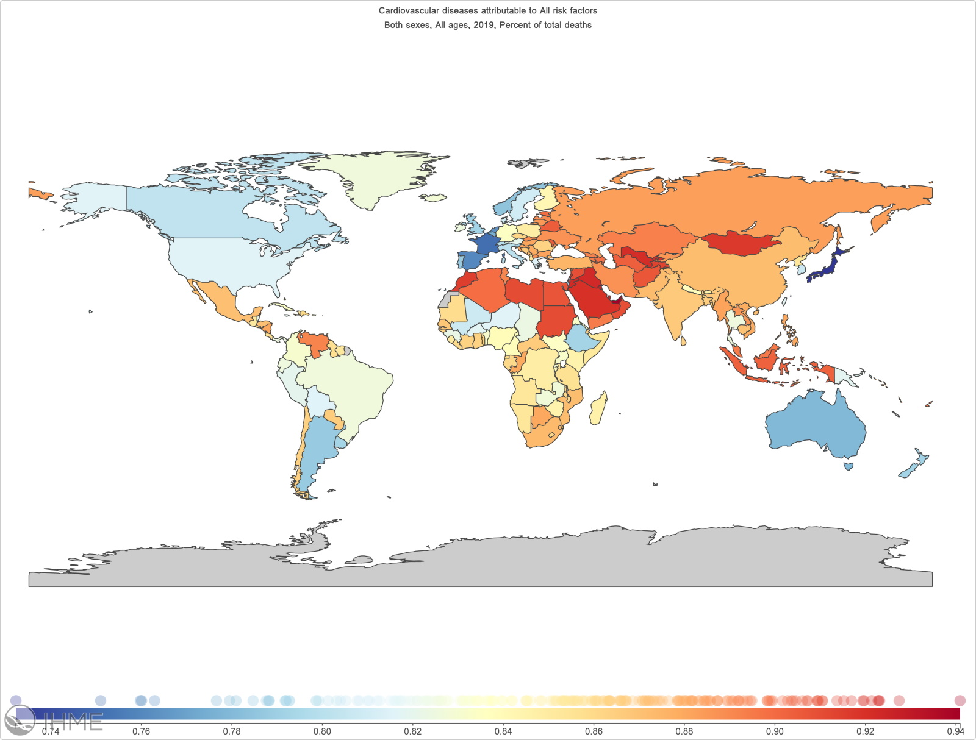

**Figure 1. Cardiovascular diseases attributable to all risk factors in both sexes, all ages, 2019. Percent of total deaths.**[**1**](https://www.zotero.org/google-docs/?TX4afn)(adapted from luo et al., am j prev cardiol, 2024 [1].)

**1.2 Definition and significance of cardiovascular calcification**

Cardiovascular calcification refers to the pathological deposition of calcium phosphate crystals within the cardiovascular system, including the arterial walls and heart valves.3 Traditionally considered a passive, degenerative process associated with aging, recent research has revealed that vascular calcification is an active, regulated process resembling bone formation.4 This calcification contributes to arterial stiffness, reduced compliance, and impaired hemodynamics, thereby increasing the risk of adverse cardiovascular events such as myocardial infarction and stroke. Understanding the mechanisms driving cardiovascular calcification is crucial for developing targeted therapies to mitigate its progression and associated complications.5

**1.3 Specific Mechanisms in Different Cardiovascular Tissues**

Coronary artery calcification is a hallmark of atherosclerosis and serves as a predictive marker for coronary artery disease (CAD). CAC occurs through two primary mechanisms: intimal and medial calcification.[5](https://www.zotero.org/google-docs/?5MKxVh) Intimal calcification is associated with atherosclerotic plaque development and is characterized by the deposition of calcium within the inner layer of the arterial wall (Fig 2.).[6](https://www.zotero.org/google-docs/?BwR4z9) This process is driven by lipid accumulation, inflammation, and smooth muscle cell differentiation into osteogenic phenotypes.[7](https://www.zotero.org/google-docs/?WxAPfv) In contrast, medial calcification, also known as Mönckeberg's sclerosis, involves the calcification of the medial layer of the arterial wall and is commonly observed in patients with chronic kidney disease and diabetes. Medial calcification leads to increased arterial stiffness without necessarily causing luminal obstruction (Fig 2.).[8,9](https://www.zotero.org/google-docs/?TP4ckf)

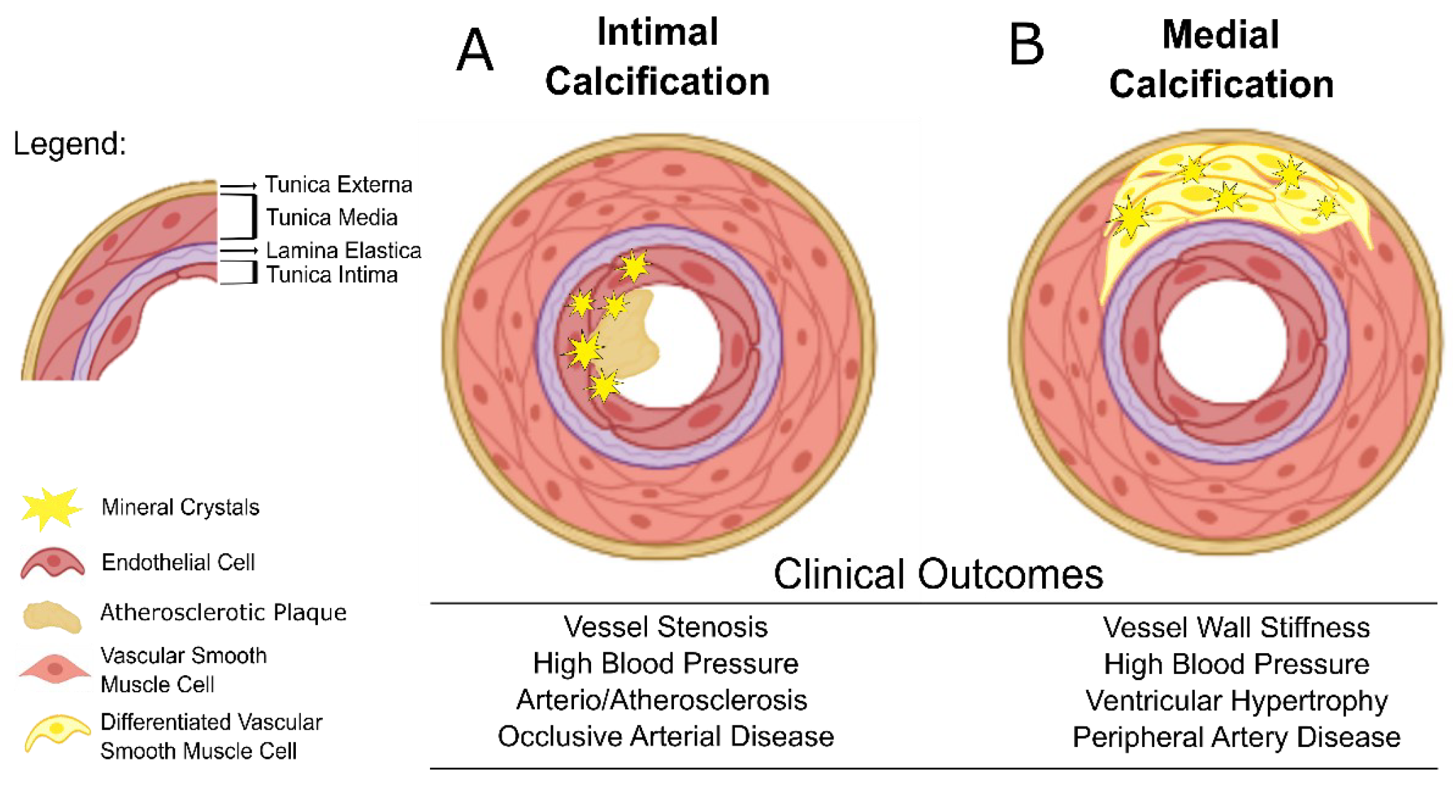

**Figure 2. Intimal versus medial calcification and their pathological distinctions. (Adapted from Marreiros et al., Int J Mol Sci, 2022 [9].)**

The progression of atherosclerosis is closely linked to the extent and pattern of calcification within the arterial wall. While extensive calcification is traditionally associated with stable plaques, emerging evidence suggests that microcalcifications within the fibrous cap can destabilize plaques, making them more prone to rupture.[10](https://www.zotero.org/google-docs/?clmnTj) Plaque rupture can lead to thrombus formation and subsequent acute coronary events. Therefore, the relationship between calcification and plaque stability is complex and depends on the size, location, and morphology of the calcific deposits.[11](https://www.zotero.org/google-docs/?AndNRs) Microcalcifications, defined as small calcium deposits less than 50 micrometers in diameter, are often located within the fibrous cap of atherosclerotic plaques.[12](https://www.zotero.org/google-docs/?4vVt8t) These microcalcifications can create focal points of increased mechanical stress, predisposing the plaque to rupture. In contrast, macrocalcifications are larger, more confluent calcium deposits that may contribute to plaque stability by reinforcing the structural integrity of the plaque.[5](https://www.zotero.org/google-docs/?FvPuyK) Understanding the differential roles of micro- and macrocalcifications is essential for risk stratification and the development of targeted interventions.

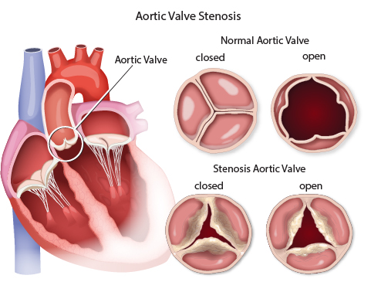

**Figure 3.** Aortic valve stenosis (AS).[13](https://www.zotero.org/google-docs/?k2zEKC)

Heart valve calcification is a progressive condition characterized by the deposition of calcium on the heart valves, leading to valvular dysfunction. The most commonly affected valves are the aortic and mitral valves **(Fig. 3.)**.[13](https://www.zotero.org/google-docs/?Z7vgeW) Aortic valve stenosis (AS) is primarily caused by calcific degeneration of the valve leaflets, leading to obstruction of blood flow from the left ventricle to the aorta. Degenerative AS is common in the elderly and is associated with risk factors such as hypertension, hyperlipidemia, and smoking.[14](https://www.zotero.org/google-docs/?QmCjCi) In younger individuals, congenital bicuspid aortic valve (BAV) is a significant risk factor for early-onset calcific AS. BAV is characterized by the presence of two, rather than three, aortic valve leaflets, which predisposes the valve to increased mechanical stress and subsequent calcification.[15](https://www.zotero.org/google-docs/?8ZgpMK) Mitral annular calcification (MAC) involves the deposition of calcium in the fibrous ring (annulus) of the mitral valve. MAC is associated with aging, chronic kidney disease, and metabolic disorders. While often asymptomatic, extensive MAC can lead to mitral valve dysfunction, including mitral regurgitation or stenosis, and is associated with an increased risk of atrial fibrillation and stroke.[16](https://www.zotero.org/google-docs/?KOuF3J)

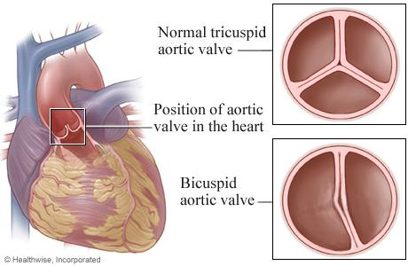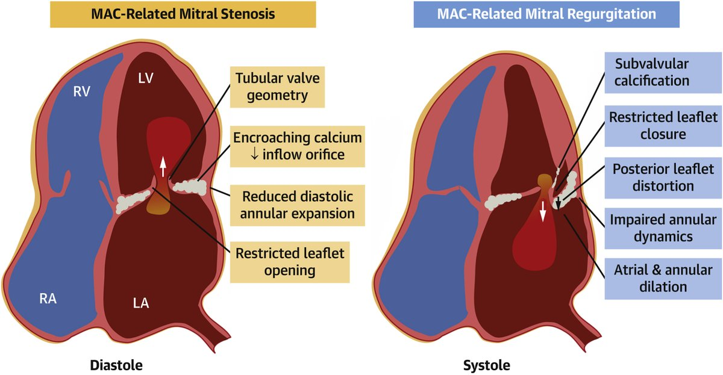

**Figure 4.** (a) Bicuspid aortic valve (BAV) showing two aortic cusps. Adapted from Bulut et al., J Cardiovasc Dev Dis, 2023 [15].  
(b) Mitral annular calcification (MAC) with calcium deposition at the annulus. (Adapted from Museedi et al., J Clin Med, 2024 [16].)

Both vascular and valvular calcifications share common pathophysiological mechanisms, including inflammation, lipid infiltration, and osteogenic differentiation of vascular cells. However, the hemodynamic environment and mechanical stresses differ between blood vessels and heart valves, influencing the pattern and progression of calcification. For instance, the cyclical mechanical stress experienced by heart valves may accelerate calcific deposition compared to the relatively constant pressure in blood vessels.[17](https://www.zotero.org/google-docs/?Gi4pYY) Cardiovascular calcification is a complex, actively regulated process that significantly contributes to the morbidity and mortality associated with cardiovascular diseases. Advancements in imaging and molecular biology have enhanced our understanding of the mechanisms underlying calcification in different cardiovascular tissues. However, therapeutic options remain limited, highlighting the need for continued research into targeted interventions that can prevent or reverse calcific processes without compromising physiological functions. Therefore, this literature review was written to unravel the mechanisms, clinical impact, and therapeutic challenges of cardiovascular calcifications.

2. Pathobiology of Cardiovascular Calcification

Cardiovascular calcification does not occur suddenly. It requires interrelated pathobiological mechanisms that occur progressively so that it can cause real calcification. Some recent literature states that there is a relationship between cell transdifferentiation, imbalance of pro and anti-calcific factors, inflammation and oxidative stress, extracellular matrix remodeling and apoptosis and necrosis to trigger calcification.[18–20](https://www.zotero.org/google-docs/?L5hDl7)

**2.1 Cell Transdifferentiation**

Vascular smooth muscle cells (VSMCs) possess remarkable plasticity, enabling them to transdifferentiate into osteochondrogenic-like cells under pathological conditions. This phenotypic switch is pivotal in the initiation and progression of vascular calcification. Key transcription factors, such as Runt-related transcription factor 2 (Runx2), Msh homeobox 2 (Msx2), and osterix, orchestrate this transdifferentiation process.[18](https://www.zotero.org/google-docs/?NclQMM) Runx2, in particular, is essential for the osteogenic differentiation of VSMCs and its deficiency has been shown to inhibit vascular calcification. Similarly, Msx2 and osterix contribute to the upregulation of osteogenic markers, promoting the calcific phenotype of VSMCs.[21](https://www.zotero.org/google-docs/?9slA1V) Valve interstitial cells (VICs), the predominant cell type in heart valves, can undergo osteogenic differentiation, contributing to valvular calcification.[19](https://www.zotero.org/google-docs/?DcdlmH)

Under pathological stimuli, VICs express osteogenic transcription factors, including Runx2 and osterix, leading to the deposition of calcific nodules within the valvular extracellular matrix. This process mirrors the osteogenic transdifferentiation observed in VSMCs and underscores the shared molecular mechanisms driving calcification in different cardiovascular tissues.[20,22](https://www.zotero.org/google-docs/?x9HKhi) Transcription factors such as Runx2, Msx2, and osterix are central to the osteogenic transdifferentiation of both VSMCs and VICs. Runx2 acts as a master regulator, initiating the expression of downstream osteogenic genes. Msx2 enhances the osteogenic program by promoting Runx2 expression, while osterix functions downstream of Runx2 to further drive the maturation of osteoblast-like cells.[23](https://www.zotero.org/google-docs/?QPcFhG) The coordinated activity of these transcription factors is crucial for the pathological calcification observed in cardiovascular tissues.

**2.2 Imbalance of Pro- and Anti-Calcific Factors**

The progression of cardiovascular calcification is facilitated by various pro-calcific factors. Bone morphogenetic proteins (BMPs), particularly BMP-2, stimulate osteogenic differentiation in vascular cells. Alkaline phosphatase (ALP) contributes by hydrolyzing pyrophosphate, an inhibitor of mineralization, thereby promoting calcification.[24](https://www.zotero.org/google-docs/?Ou9KwW) Extracellular matrix vesicles, released by VSMCs and macrophages, serve as nucleation sites for hydroxyapatite crystal formation. Additionally, the accumulation of calcium-phosphate complexes within the vascular matrix further exacerbates calcific deposition.[25](https://www.zotero.org/google-docs/?AgRyIl)

Counteracting the pro-calcific milieu are endogenous inhibitors that maintain vascular homeostasis. Pyrophosphate (PPi) directly inhibits hydroxyapatite crystal growth, and its deficiency is associated with enhanced vascular calcification. Fetuin-A, a circulating glycoprotein, binds to calcium-phosphate complexes, preventing their deposition.[26](https://www.zotero.org/google-docs/?CRXtQH) Matrix Gla protein (MGP) inhibits BMP activity, thereby reducing osteogenic signaling.[27](https://www.zotero.org/google-docs/?pqObQF) Osteopontin, a phosphorylated glycoprotein, impedes mineralization by binding to hydroxyapatite crystals and modulating inflammatory responses.[28](https://www.zotero.org/google-docs/?6m4fWg)

**2.3 Inflammation and Oxidative Stress**

Inflammatory cytokines play a pivotal role in the pathogenesis of cardiovascular calcification. Interleukin-1β (IL-1β), interleukin-6 (IL-6), and tumor necrosis factor-alpha (TNF-α) are upregulated in calcified vascular tissues and contribute to the osteogenic differentiation of vascular cells . These cytokines activate signaling pathways that enhance the expression of osteogenic transcription factors, thereby promoting calcification.[29](https://www.zotero.org/google-docs/?OcZDc2) Immune cell infiltration is a hallmark of calcified vascular lesions. Macrophages and T-cells accumulate at sites of calcification, secreting pro-inflammatory cytokines and matrix-degrading enzymes that facilitate calcific deposition. Macrophage-derived matrix vesicles also serve as nucleation sites for mineralization, further contributing to the calcification process.[24](https://www.zotero.org/google-docs/?NxyDQh) Oxidative stress, characterized by the excessive production of reactive oxygen species (ROS), disrupts cellular homeostasis and promotes vascular calcification. ROS enhances the expression of osteogenic transcription factors and stimulates the release of matrix vesicles from vascular cells. Additionally, oxidative stress leads to the degradation of extracellular matrix components, compromising vascular integrity and facilitating calcific deposition.[30](https://www.zotero.org/google-docs/?vsacmX)

**2.4 Extracellular Matrix Remodeling**

Matrix metalloproteinases (MMPs) are enzymes that degrade extracellular matrix components, including elastic fibers and collagen. MMP-mediated degradation of these structural proteins disrupts vascular integrity and creates a conducive environment for calcification. Specifically, MMP-2 and MMP-9 have been implicated in the breakdown of elastin and collagen, processes that precede and promote vascular calcification.[31](https://www.zotero.org/google-docs/?X5XGec) Extracellular matrix proteins such as fibronectin and osteonectin influence vascular calcification by modulating cell-matrix interactions and mineral deposition. Fibronectin facilitates cell adhesion and migration, processes essential for tissue remodeling. Osteonectin binds to calcium and hydroxyapatite, promoting mineralization within the vascular matrix. The altered expression and function of these proteins contribute to the pathological calcification observed in cardiovascular diseases.[32](https://www.zotero.org/google-docs/?GgnO4j)

**2.5 Apoptosis and Necrosis**

Apoptosis, or programmed cell death, leads to the formation of apoptotic bodies that can serve as nucleation sites for calcification. These vesicles, rich in phosphatidylserine and other pro-calcific molecules, facilitate the deposition of calcium-phosphate crystals within the vascular matrix . The accumulation of apoptotic bodies thus contributes to the progression of vascular calcification.[33](https://www.zotero.org/google-docs/?A1gYUJ) In advanced atherosclerotic plaques, necrosis of lipid-laden macrophages and other cells leads to the formation of a necrotic core. This core provides a scaffold for calcific deposition, exacerbating plaque instability and increasing the risk of cardiovascular events.[34](https://www.zotero.org/google-docs/?5A6r44) The interplay between cell death and calcification underscores the complexity of atherosclerotic disease progression.

3. Risk Factors and Clinical Associations

**3.1 Traditional Cardiovascular Risk Factors**

Advancing age is a well-established risk factor for cardiovascular calcification, attributed to cumulative exposure to risk factors and age-related changes in vascular biology. Men are generally at higher risk for cardiovascular calcification compared to premenopausal women, possibly due to protective effects of estrogen. However, postmenopausal women experience a rapid increase in risk, highlighting the influence of hormonal changes.[35](https://www.zotero.org/google-docs/?SBSF27) Chronic high blood pressure contributes to endothelial dysfunction and promotes vascular smooth muscle cell (VSMC) proliferation and migration, facilitating calcification. Hypertension-induced mechanical stress can also lead to micro-injuries in the vascular wall, serving as nucleation sites for calcium deposition.[36](https://www.zotero.org/google-docs/?RHm9g2) Diabetes mellitus is associated with accelerated atherosclerosis and vascular calcification. Hyperglycemia induces oxidative stress and inflammation, promoting VSMC osteogenic differentiation and extracellular matrix remodeling, key processes in calcification.[37](https://www.zotero.org/google-docs/?q3JSi6)

Elevated levels of low-density lipoprotein (LDL) cholesterol and reduced high-density lipoprotein (HDL) cholesterol are linked to atherosclerotic plaque formation and calcification. Oxidized LDL particles can stimulate inflammatory responses and VSMC calcification.[38](https://www.zotero.org/google-docs/?8AfzQK) Cigarette smoking introduces toxins that cause endothelial injury, oxidative stress, and inflammation, all of which contribute to vascular calcification. Smoking also affects lipid profiles and promotes a pro-thrombotic state, exacerbating cardiovascular risk.[39](https://www.zotero.org/google-docs/?X6LEWx) Obesity, particularly visceral adiposity, is associated with insulin resistance, dyslipidemia, and systemic inflammation, components of metabolic syndrome that collectively increase the risk of cardiovascular calcification. Adipose tissue secretes pro-inflammatory cytokines that can induce VSMC calcification.[4](https://www.zotero.org/google-docs/?xy6iJx)

**3.2 Chronic Kidney Disease (CKD) and Mineral Bone Disorder (CKD-MBD)**

CKD-MBD encompasses a spectrum of mineral metabolism disturbances that significantly contribute to vascular and valvular calcification. Elevated serum phosphate and calcium levels in CKD patients can lead to supersaturation and precipitation of calcium-phosphate complexes in vascular tissues. These deposits initiate and propagate calcification processes.[40](https://www.zotero.org/google-docs/?5ceW5T) Fibroblast growth factor 23 (FGF23) levels rise in CKD as a compensatory mechanism to excrete phosphate, while Klotho, a co-receptor for FGF23, decreases. This imbalance disrupts mineral metabolism and promotes vascular calcification through direct effects on vascular cells.[41](https://www.zotero.org/google-docs/?eSb4w9) CKD-induced hypocalcemia and hyperphosphatemia stimulate parathyroid hormone (PTH) secretion, leading to secondary hyperparathyroidism. Elevated PTH levels enhance bone resorption, increasing calcium and phosphate release into circulation, further contributing to vascular calcification.[42](https://www.zotero.org/google-docs/?LKxQTP)

**3.3 Inflammatory and Autoimmune Diseases**

Chronic inflammation is a pivotal driver of cardiovascular calcification, with autoimmune diseases such as systemic lupus erythematosus (SLE) and rheumatoid arthritis (RA) exhibiting increased cardiovascular risk. Patients with SLE and RA have heightened systemic inflammation, leading to endothelial dysfunction and accelerated atherosclerosis. Autoimmune-mediated vascular injury and the presence of inflammatory cytokines promote calcific processes in the vasculature.[43](https://www.zotero.org/google-docs/?sQfx9P)

**3.4 Genetic Predisposition**

Genetic factors play a significant role in the susceptibility to cardiovascular calcification, with certain mutations and polymorphisms influencing calcification pathways. Generalized arterial calcification of infancy (GACI) and pseudoxanthoma elasticum (PXE) are rare genetic disorders characterized by early-onset vascular calcification. Mutations in the ENPP1 gene in GACI and ABCC6 gene in PXE disrupt extracellular pyrophosphate metabolism, a key inhibitor of calcification. Polymorphisms in genes such as matrix Gla protein (MGP) and osteoprotegerin (OPG) have been associated with increased risk of vascular calcification. These genes are involved in the regulation of bone metabolism and vascular health.[44](https://www.zotero.org/google-docs/?cQtsQ5)

**3.5 Novel and Emerging Risk Factors**

Alterations in gut microbiota composition, or dysbiosis, have been linked to systemic inflammation and metabolic disturbances, influencing cardiovascular health. Microbial metabolites such as trimethylamine N-oxide (TMAO) have been implicated in promoting atherosclerosis and vascular calcification.[45](https://www.zotero.org/google-docs/?wi7OPV) Exposure to environmental toxins, including heavy metals and particulate matter, has been associated with increased oxidative stress and inflammation, contributing to vascular injury and calcification.[46](https://www.zotero.org/google-docs/?sYUrek) These pollutants may disrupt endothelial function and promote pro-calcific signaling pathways.

4. Clinical Assessment and Diagnostic Modalities

**4.1 Computed Tomography (CT)**

Computed Tomography (CT) has become an indispensable tool in the evaluation of coronary artery calcification (CAC), with the Agatston score being the most widely utilized metric. This scoring system quantifies the extent of calcified plaque in the coronary arteries, providing a non-invasive means to assess atherosclerotic burden. The Agatston score is calculated by identifying areas of calcification with a density above 130 Hounsfield Units (HU) and multiplying the area by a weighting factor based on peak density. Scores are typically categorized as follows: 0 (no calcification), 1–100 (mild), 101–400 (moderate), and >400 (extensive), each correlating with an increasing risk of cardiovascular events.[47](https://www.zotero.org/google-docs/?Etrg0t)

CAC scoring has proven valuable in refining cardiovascular risk stratification, particularly among asymptomatic individuals. Studies such as the Multi-Ethnic Study of Atherosclerosis (MESA) have demonstrated that even low levels of CAC (scores 1–100) are associated with a significantly increased risk of coronary heart disease compared to individuals with a score of 0 . Importantly, a CAC score of 0 has been associated with a low risk of cardiovascular events, effectively reclassifying individuals from intermediate to low risk and potentially reducing the need for pharmacological interventions. Beyond coronary arteries, CT imaging is instrumental in evaluating calcification of cardiac valves, particularly the aortic valve. Quantifying valvular calcification aids in the assessment of disease severity and guides clinical decision-making regarding interventions such as valve replacement.[48](https://www.zotero.org/google-docs/?2tdO1f) CT-derived calcium scores of the aortic valve have been correlated with hemodynamic measurements, providing a comprehensive evaluation of valvular heart disease.

**4.2 Biomarkers**

The pathogenesis of vascular calcification shares similarities with bone formation, involving osteogenic differentiation of vascular smooth muscle cells. Alkaline phosphatase (ALP) is an enzyme that promotes mineralization and has been associated with increased vascular calcification and cardiovascular mortality. Osteoprotegerin (OPG), a glycoprotein acting as a decoy receptor for receptor activator of nuclear factor-kappa B ligand (RANKL), inhibits osteoclastogenesis and has been linked to the inhibition of vascular calcification. Fetuin-A, a systemic inhibitor of calcification, binds to calcium and phosphate, preventing their deposition in vascular tissues. Low levels of Fetuin-A have been associated with increased vascular calcification and cardiovascular events.[49](https://www.zotero.org/google-docs/?OP1s7t)

Inflammation plays a pivotal role in the initiation and progression of atherosclerosis and subsequent calcification. C-reactive protein (CRP), an acute-phase reactant produced by the liver in response to inflammation, has been extensively studied as a marker of cardiovascular risk. Elevated CRP levels have been correlated with increased CAC scores and a higher incidence of cardiovascular events, underscoring the interplay between inflammation and calcification in vascular pathology.[25](https://www.zotero.org/google-docs/?ZaBfkD) Advancements in molecular biology have identified novel biomarkers implicated in vascular calcification. MicroRNAs (miRNAs), small non-coding RNAs that regulate gene expression, have been found to influence vascular smooth muscle cell differentiation and calcification processes. Specific miRNAs, such as miR-125b and miR-204, have been shown to modulate osteogenic pathways in vascular cells. Additionally, extracellular vesicles (EVs), including exosomes and microvesicles, have emerged as mediators of intercellular communication, carrying proteins, lipids, and nucleic acids that can influence vascular calcification. EVs derived from calcifying vascular cells have been found to promote mineral deposition, suggesting their potential role as both biomarkers and therapeutic targets in vascular calcification.[31](https://www.zotero.org/google-docs/?kxni67)

5. CHALLENGES AND FUTURE RESEARCH DIRECTIONS

Cardiovascular calcification remains a formidable clinical challenge, intricately linked to a wide spectrum of cardiovascular morbidities including coronary artery disease, valvular heart disease, and peripheral vascular complications. Despite growing insights into the molecular and cellular mechanisms driving calcification, the clinical translation of this knowledge into effective therapeutic interventions has been slow. Currently, treatment options are largely supportive and aimed at controlling underlying risk factors rather than directly targeting the calcification process. There is an urgent need for novel strategies that not only prevent but also reverse vascular and valvular mineral deposition.

One of the foremost challenges in the field is developing therapies that can effectively prevent and reverse cardiovascular calcification. Most current approaches, such as controlling blood pressure, glucose levels, lipid profiles, or mineral imbalances, only indirectly influence the calcification process. Emerging therapies are exploring the inhibition of osteogenic transdifferentiation of vascular smooth muscle cells (VSMCs) and valve interstitial cells (VICs). This includes targeting key transcription factors such as Runx2, Msx2, and osterix, which are central to the osteoblast-like transformation of these cells. Additionally, modulation of mineral metabolism—especially phosphate and calcium handling—is being pursued through non-calcium-based phosphate binders, calcimimetics, and interventions in the fibroblast growth factor 23 (FGF23)-Klotho axis. Another promising direction is the use of matrix-targeted strategies, such as interfering with extracellular matrix vesicles and inhibiting nucleation sites for hydroxyapatite crystal formation. Drug delivery systems utilizing nanoparticles and gene-editing tools like CRISPR/Cas9 may further enhance the precision and efficacy of these approaches by targeting calcified regions specifically.

Equally critical is the identification and validation of reliable biomarkers for early detection and therapeutic monitoring. Current diagnostic tools, like computed tomography (CT)-based Agatston scoring, primarily detect established calcification. Biomarkers capable of indicating preclinical or early-stage calcific activity are needed to guide timely intervention. Among the most promising are bone-related proteins such as alkaline phosphatase (ALP), osteoprotegerin (OPG), and osteopontin, which are elevated during active mineral deposition. Inflammatory markers including C-reactive protein (CRP), interleukin-6 (IL-6), and tumor necrosis factor-alpha (TNF-α) also correlate with calcific burden. Recently, microRNAs (miRNAs) such as miR-125b and miR-204 have been found to regulate gene expression involved in calcific pathways. Moreover, extracellular vesicles (EVs) secreted by calcifying cells have emerged not only as participants in disease progression but also as circulating indicators of pathological mineralization. The integration of these biomarkers into clinical practice could revolutionize risk assessment, patient stratification, and real-time therapy monitoring.

Another critical consideration is the anatomical and pathological heterogeneity of calcification, which underscores the importance of tailoring therapy based on the type and location of disease. For instance, coronary artery calcification (CAC), often seen in intimal atherosclerotic plaques, is strongly predictive of acute coronary events, especially when microcalcifications destabilize plaques. On the other hand, medial arterial calcification—common in diabetes and chronic kidney disease—contributes more to arterial stiffness and isolated systolic hypertension than to luminal obstruction. Similarly, calcification of the aortic or mitral valve leads to valvular dysfunction and heart failure. Each of these forms differs in etiology, histopathology, and clinical sequelae. As such, therapies should be personalized not only to the patient’s risk profile but also to the location, type, and developmental stage of calcification. For example, phosphate-lowering agents may be more effective in CKD-related calcification, whereas anti-inflammatory agents may be more suitable in autoimmune-related arterial disease.

**Conclusion**

Finally, a comprehensive understanding of how multiple risk factors converge to drive calcification is imperative for designing combination therapies and preventive strategies. cardiovascular calcification is seldom the result of a single pathway but rather emerges from a complex interplay of pro-calcific drivers including oxidative stress, inflammation, mineral imbalance, and genetic predispositions. For example, in chronic kidney disease, elevated phosphate levels interact with systemic inflammation to accelerate VSMC osteogenic transdifferentiation. In contrast, autoimmune conditions like rheumatoid arthritis may promote calcification independently of phosphate handling, largely via cytokine-driven vascular injury. Emerging research using systems biology, network pharmacology, and artificial intelligence is attempting to model these interactions to identify synergistic therapeutic targets. Future clinical trials must also move toward individualized treatment models that incorporate genetic, metabolic, inflammatory, and anatomical data to optimize outcomes.

**Disclaimer (Artificial intelligence)**

Option 1:

Author(s) hereby declare that NO generative AI technologies such as Large Language Models (ChatGPT, COPILOT, etc.) and text-to-image generators have been used during the writing or editing of this manuscript.

Option 2:

Author(s) hereby declare that generative AI technologies such as Large Language Models, etc. have been used during the writing or editing of manuscripts. This explanation will include the name, version, model, and source of the generative AI technology and as well as all input prompts provided to the generative AI technology

Details of the AI usage are given below:

1.

2.

3.

References

[1. Luo Y, Liu J, Zeng J, Pan H. Global burden of cardiovascular diseases attributed to low physical activity: An analysis of 204 countries and territories between 1990 and 2019. Am J Prev Cardiol. 2024 Feb 6;17:100633.](https://www.zotero.org/google-docs/?uXEbRq)

[2. Di Cesare M, Perel P, Taylor S, Kabudula C, Bixby H, Gaziano TA, et al. The Heart of the World. Glob Heart. 2024 Jan 25;19(1):11.](https://www.zotero.org/google-docs/?uXEbRq)

[3. Chaturvedi A, Zhu A, Gadela NV, Prabhakaran D, Jafar TH. Social Determinants of Health and Disparities in Hypertension and Cardiovascular Diseases. Hypertension. 2024 Mar;81(3):387–99.](https://www.zotero.org/google-docs/?uXEbRq)

[4. Powell-Wiley TM, Poirier CP, Burke VCLE, Després JP, Gordon-Larsen P, Lavie CJ, et al. Obesity and Cardiovascular Disease. Circulation. 2021 May 25;143(21):e984–1010.](https://www.zotero.org/google-docs/?uXEbRq)

[5. Wu M, Rementer C, Giachelli CM. Vascular Calcification: an Update on Mechanisms and Challenges in Treatment. Calcif Tissue Int. 2013 Oct;93(4):365–73.](https://www.zotero.org/google-docs/?uXEbRq)

[6. Onnis C, Virmani R, Kawai K, Nardi V, Lerman A, Cademartiri F, et al. Coronary Artery Calcification: Current Concepts and Clinical Implications. Circulation. 2024 Jan 16;149(3):251–66.](https://www.zotero.org/google-docs/?uXEbRq)

[7. Andrews J, Psaltis PJ, Bartolo BAD, Nicholls SJ, Puri R. Coronary arterial calcification: A review of mechanisms, promoters and imaging. Trends Cardiovasc Med. 2018 Nov;28(8):491–501.](https://www.zotero.org/google-docs/?uXEbRq)

[8. Lee HY, Lim S, Park S. Role of Inflammation in Arterial Calcification. Korean Circ J. 2021 Jan 25;51(2):114–25.](https://www.zotero.org/google-docs/?uXEbRq)

[9. Marreiros C, Viegas C, Simes D. Targeting a Silent Disease: Vascular Calcification in Chronic Kidney Disease. International Journal of Molecular Sciences. 2022 Jan;23(24):16114.](https://www.zotero.org/google-docs/?uXEbRq)

[10. Tóth A, Balogh E, Jeney V. In Vitro Models of Cardiovascular Calcification. Biomedicines. 2024 Sep;12(9):2155.](https://www.zotero.org/google-docs/?uXEbRq)

[11. Hashmi S, Shah PW, Aherrahrou Z, Aikawa E, Aherrahrou R. Beyond the Basics: Unraveling the Complexity of Coronary Artery Calcification. Cells. 2023 Jan;12(24):2822.](https://www.zotero.org/google-docs/?uXEbRq)

[12. Siracusa C, Carino A, Carabetta N, Manica M, Sabatino J, Cianflone E, et al. Mechanisms of Cardiovascular Calcification and Experimental Models: Impact of Vitamin K Antagonists. Journal of Clinical Medicine. 2024 Jan;13(5):1405.](https://www.zotero.org/google-docs/?uXEbRq)

[13. Izquierdo M, Merchant RA, Morley JE, Anker SD, Aprahamian I, Arai H, et al. International Exercise Recommendations in Older Adults (ICFSR): Expert Consensus Guidelines. J Nutr Health Aging. 2021 Jul 1;25(7):824–53.](https://www.zotero.org/google-docs/?uXEbRq)

[14. Goody PR, Hosen MR, Christmann D, Niepmann ST, Zietzer A, Adam M, et al. Aortic Valve Stenosis: From Basic Mechanisms to Novel Therapeutic Targets. ATVB. 2020 Apr;40(4):885–900.](https://www.zotero.org/google-docs/?uXEbRq)

[15. Bulut HI, Arjomandi Rad A, Syrengela AA, Ttofi I, Djordjevic J, Kaur R, et al. A Comprehensive Review of Management Strategies for Bicuspid Aortic Valve (BAV): Exploring Epidemiology, Aetiology, Aortopathy, and Interventions in Light of Recent Guidelines. J Cardiovasc Dev Dis. 2023 Sep 18;10(9):398.](https://www.zotero.org/google-docs/?uXEbRq)

[16. Museedi AS, Le Jemtel TH. Mitral Annular Calcification-Related Valvular Disease: A Challenging Entity. J Clin Med. 2024 Feb 3;13(3):896.](https://www.zotero.org/google-docs/?uXEbRq)

[17. Huish S, Sinha S. New therapeutic perspectives for vascular and valvular calcifications in chronic kidney disease. Curr Opin Nephrol Hypertens. 2024 Jul 1;33(4):391–7.](https://www.zotero.org/google-docs/?uXEbRq)

[18. Saba L, Costa F, Cau R. Pathophysiology and clinical implications of coronary artery calcifications. Current Opinion in Cardiology. 2024 Nov;39(6):529.](https://www.zotero.org/google-docs/?uXEbRq)

[19. Jadhav KP, Kavalipatu KNR, Kuchulakanti PK, Reddy RP, Athuluri R, Prakash G, et al. Coronary Artery Calcification: From Cell to Stent—A Review. Indian Journal of Clinical Cardiology. 2021 Jun;2(2):97–109.](https://www.zotero.org/google-docs/?uXEbRq)

[20. Cannata-Andía JB, Carrillo-López N, Messina OD, Hamdy NAT, Panizo S, Ferrari SL, et al. Pathophysiology of Vascular Calcification and Bone Loss: Linked Disorders of Ageing? Nutrients. 2021 Nov;13(11):3835.](https://www.zotero.org/google-docs/?uXEbRq)

[21. Sun Y, Byon CH, Yuan K, Chen J, Mao X, Heath JM, et al. Smooth Muscle Cell-Specific Runx2 Deficiency Inhibits Vascular Calcification. Circ Res. 2012 Aug 17;111(5):543–52.](https://www.zotero.org/google-docs/?uXEbRq)

[22. Jiang W, Zhang Z, Li Y, Chen C, Yang H, Lin Q, et al. The Cell Origin and Role of Osteoclastogenesis and Osteoblastogenesis in Vascular Calcification. Front Cardiovasc Med. 2021 Apr 23;8:639740.](https://www.zotero.org/google-docs/?uXEbRq)

[23. Sivan S, Vijayakumar G, Pillai IC. Non-coding RNAs mediating the regulation of genes and signaling pathways in aortic valve calcification. Gene. 2025 Feb;936:149117.](https://www.zotero.org/google-docs/?uXEbRq)

[24. Passos LSA, Lupieri A, Becker-Greene D, Aikawa E. Innate and adaptive immunity in cardiovascular calcification. Atherosclerosis. 2020 Aug 1;306:59–67.](https://www.zotero.org/google-docs/?uXEbRq)

[25. Lupo MG, Baragetti A, Rattazzi M, Ferri N. PCSK9 stimulates vascular calcification by increasing pro-calcific factors and decreasing anti-calcific modulators in vascular smooth muscle cells under uremic conditions. Atherosclerosis. 2021 Aug 1;331:e30.](https://www.zotero.org/google-docs/?uXEbRq)

[26. Villa-Bellosta R. Vascular Calcification: Key Roles of Phosphate and Pyrophosphate. IJMS. 2021 Dec 17;22(24):13536.](https://www.zotero.org/google-docs/?uXEbRq)

[27. Barrett H, O’Keeffe M, Kavanagh E, Walsh M, O’Connor EM. Is Matrix Gla Protein Associated with Vascular Calcification? A Systematic Review. Nutrients. 2018 Mar 27;10(4):415.](https://www.zotero.org/google-docs/?uXEbRq)

[28. Lok ZSY, Lyle AN. Osteopontin in Vascular Disease: Friend or Foe? ATVB. 2019 Apr;39(4):613–22.](https://www.zotero.org/google-docs/?uXEbRq)

[29. Zhang H, Dhalla NS. The Role of Pro-Inflammatory Cytokines in the Pathogenesis of Cardiovascular Disease. Int J Mol Sci. 2024 Jan 16;25(2):1082.](https://www.zotero.org/google-docs/?uXEbRq)

[30. Zalba G. Oxidative Stress in Vascular Pathophysiology: Still Much to Learn. Antioxidants (Basel). 2021 Apr 26;10(5):673.](https://www.zotero.org/google-docs/?uXEbRq)

[31. Tanase DM, Valasciuc E, Anton IB, Gosav EM, Dima N, Cucu AI, et al. Matrix Metalloproteinases: Pathophysiologic Implications and Potential Therapeutic Targets in Cardiovascular Disease. Biomolecules. 2025 Apr;15(4):598.](https://www.zotero.org/google-docs/?uXEbRq)

[32. Li W, Su S, Chen J, Ma H, Xiang M. Emerging roles of fibroblasts in cardiovascular calcification. J Cellular Molecular Medi. 2021 Feb;25(4):1808–16.](https://www.zotero.org/google-docs/?uXEbRq)

[33. Neels JG, Gollentz C, Chinetti G. Macrophage death in atherosclerosis: potential role in calcification. Front Immunol. 2023;14:1215612.](https://www.zotero.org/google-docs/?uXEbRq)

[34. Li M, Wang ZW, Fang LJ, Cheng SQ, Wang X, Liu NF. Programmed cell death in atherosclerosis and vascular calcification. Cell Death Dis. 2022 May 18;13(5):467.](https://www.zotero.org/google-docs/?uXEbRq)

[35. Wong MYZ, Yap J, Huang W, Tan SY, Yeo KK. Impact of Age and Sex on Subclinical Coronary Atherosclerosis in a Healthy Asian Population. JACC Asia. 2021 Jun;1(1):93–102.](https://www.zotero.org/google-docs/?uXEbRq)

[36. Poznyak AV, Sadykhov NK, Kartuesov AG, Borisov EE, Melnichenko AA, Grechko AV, et al. Hypertension as a risk factor for atherosclerosis: Cardiovascular risk assessment. Front Cardiovasc Med. 2022 Aug 22;9:959285.](https://www.zotero.org/google-docs/?uXEbRq)

[37. Li Q, Li P, Xu Z, Lu Z, Yang C, Ning J. Association of diabetes with cardiovascular calcification and all-cause mortality in end-stage renal disease in the early stages of hemodialysis: a retrospective cohort study. Cardiovasc Diabetol. 2024 Jul 18;23(1):259.](https://www.zotero.org/google-docs/?uXEbRq)

[38. Wang JS, Chiang HY, Wang YC, Yeh HC, Ting IW, Liang CC, et al. Dyslipidemia and coronary artery calcium: From association to development of a risk-prediction nomogram. Nutrition, Metabolism and Cardiovascular Diseases. 2022 Aug;32(8):1944–54.](https://www.zotero.org/google-docs/?uXEbRq)

[39. Oshunbade AA, Kassahun-Yimer W, Valle KA, Hamid A, Kipchumba RK, Kamimura D, et al. Cigarette Smoking, Incident Coronary Heart Disease, and Coronary Artery Calcification in Black Adults: The Jackson Heart Study. J Am Heart Assoc. 2021 Apr 6;10(7):e017320.](https://www.zotero.org/google-docs/?uXEbRq)

[40. Zhou C, Shi Z, Ouyang N, Ruan X. Hyperphosphatemia and Cardiovascular Disease. Front Cell Dev Biol. 2021 Mar 4;9:644363.](https://www.zotero.org/google-docs/?uXEbRq)

[41. Donate-Correa J, Martín-Núñez E, Hernández-Carballo C, Ferri C, Tagua VG, Delgado-Molinos A, et al. Fibroblast growth factor 23 expression in human calcified vascular tissues. Aging (Albany NY). 2019 Sep 22;11(18):7899–913.](https://www.zotero.org/google-docs/?uXEbRq)

[42. Terai K, Nara H, Takakura K, Mizukami K, Sanagi M, Fukushima S, et al. Vascular calcification and secondary hyperparathyroidism of severe chronic kidney disease and its relation to serum phosphate and calcium levels. Br J Pharmacol. 2009 Apr;156(8):1267–78.](https://www.zotero.org/google-docs/?uXEbRq)

[43. Martínez-Ceballos MA, Rey JCS, Granados JPA, Mendoza-Pinto C, García-Carrasco M, Montes-Zabala L, et al. Coronary calcium in autoimmune diseases: A systematic literature review and meta-analysis. Atherosclerosis. 2021 Oct 1;335:68–76.](https://www.zotero.org/google-docs/?uXEbRq)

[44. Rutsch F, Buers I, Nitschke Y. Hereditary Disorders of Cardiovascular Calcification. Arterioscler Thromb Vasc Biol. 2021 Jan;41(1):35–47.](https://www.zotero.org/google-docs/?uXEbRq)

[45. Papadopoulos PD, Tsigalou C, Valsamaki PN, Konstantinidis TG, Voidarou C, Bezirtzoglou E. The Emerging Role of the Gut Microbiome in Cardiovascular Disease: Current Knowledge and Perspectives. Biomedicines. 2022 Apr 20;10(5):948.](https://www.zotero.org/google-docs/?uXEbRq)

[46. Kaufman BP, Guttman-Yassky E, Alexis AF. Atopic dermatitis in diverse racial and ethnic groups-Variations in epidemiology, genetics, clinical presentation and treatment. Exp Dermatol. 2018 Apr;27(4):340–57.](https://www.zotero.org/google-docs/?uXEbRq)

[47. Kalra DK, Heo R, Valenti V, Nakazato R, Min JK. Role of Computed Tomography for Diagnosis and Risk Stratification of Patients With Suspected or Known Coronary Artery Disease. ATVB. 2014 Jun;34(6):1144–54.](https://www.zotero.org/google-docs/?uXEbRq)

[48. Guerreiro RA. Refining the classification of cardiovascular prevention. Revista Portuguesa de Cardiologia. 2024 Mar;43(3):159–62.](https://www.zotero.org/google-docs/?uXEbRq)

[49. Goettsch C, Hutcheson JD, Aikawa E. MicroRNA in Cardiovascular Calcification: Focus on Targets and Extracellular Vesicle Delivery Mechanisms. Circulation Research. 2013 Mar 29;112(7):1073–84.](https://www.zotero.org/google-docs/?uXEbRq)