Type of Article : Original Research article

Comparative Pathophysiology of Canine Parvovirus-2 Variants in Naturally Infected Dogs

Abstract
Canine Parvovirus-2 (CPV-2) is a highly lethal virus that affects the canid family. It targets rapidly dividing cells in organs such as the intestines, thymus, lymph nodes, bone marrow, and heart, often resulting in multi-organ failure. This study aimed to evaluate the impact of CPV-2 variants on clinico-physiological, haematological and biochemical parameters in dogs. Two hundred faecal and blood samples from symptomatic dogs, along with 10 healthy controls, were collected at VCC, PGIVER, Jaipur, from July 2024 to December 2024. PCR identified 166 CPV-2 positive cases, comprising 147 CPV-2a, 141 CPV-2b and 115 CPV-2c cases. A random selection of 52 CPV-2a, 52 CPV-2b, and 44 CPV-2c cases was made for further analysis. Clinical examination showed significantly elevated heart and respiration rates in CPV-2b and CPV-2c groups. Haematological analysis revealed reduced haemoglobin, PCV and TEC across all CPV-2 variants, with CPV-2b and CPV-2c showing the highest neutrophil counts and lowest lymphocyte percentages. Eosinophil and basophil counts were elevated in infected groups. Biochemical analysis showed significantly reduced serum total protein and albumin, with CPV-2c having the lowest values. Elevated AST and ALP levels indicated hepatic damage, while decreased creatinine in CPV-2c suggested possible renal impairment. These findings highlight the distinct pathophysiological impacts of CPV-2 variants and their clinical relevance in diagnosis and disease management.

Key words: Canine Parvo Virus-2 (CPV-2), hemato-biochemical parameters, CPV-2 variants, clinical parameters, polymerase chain reaction.
Introduction

Canine Parvo Virus-2 causes acute haemorrhagic enteritis and myocarditis in dogs. It is highly contagious disease affecting canine worldwide. CPV-2 was first identified in 1977 since then it is well recognised as enteric pathogen of dogs worldwide with high morbidity and mortality rate (Nandi et al., 2010). The virus originated from feline panleukopenia virus and 98% similar to it (Ogbu et al., 2017; Haydon et al. 2002). The mutations occurred in CPV-2 and it convert into different variants, CPV-2a in 1979, CPV-2b in 1984, and recently CPV-2c in 2000, which was first detected in Italy (Parrish, 2005). Canine Parvo Virus-2 contains a single standard linear genome of approximately 5,000 nucleotide (nt). It contains two structural protein VP1 and VP2 and two non-structural protein NS1 and NS2. Structural proteins are responsible for entry of the virus inside the host cell while non structure proteins are responsible for replication of the viral cells inside the host cell (Reed et al., 1988; Zhou et al., 2017).
Studies have shown that CPV-2 infections lead to significant alterations in vital physiological parameters such as heart and respiratory rates, alongside haematological abnormalities including anaemia, leukopenia, and lymphopenia. Moreover, biochemical alterations, particularly in liver and kidney function markers, further complicate disease progression and therapeutic approaches. This study aimed to evaluate the clinico-physiological, hematological and biochemical effects of CPV-2 variants in naturally infected dogs. By analysing faecal and blood samples collected from symptomatic dogs and healthy controls, we sought to determine the distinct pathophysiological profiles of CPV-2a, CPV-2b and CPV-2c.

Material and Methods
A total of 200 faecal samples swab and blood samples from symptomatic dogs, along with 10 healthy controls were collected from the dogs that were brought for treatment at Veterinary Clinical Complex, Post Graduate Institute of Veterinary Education and Research, Jamdoli, Jaipur from different places in and around Jaipur. The dogs having clinical history of lethargy, dehydration, anorexia, fever, with progression to vomiting, diarrhoea (mostly haemorrhagic diarrhoea) were suspected for CPV-2. All samples were collected directly from the rectum of diarrheic dogs using sterile cotton swabs (Himedia®), preserved in sterile tubes containing 1% phosphate-buffered saline (PBS) solution, and stored in a -20°C deep freezer until further processing.
Blood samples (2 mL) were collected from the cephalic and saphenous vein into EDTA vacutainers for haematological analysis and 3 mL of blood was collected in plain (non-EDTA) vacutainers for serum collection to analyse biochemical parameters.

DNA extraction by HiPurA DNA stool purification kit Himedia®
The manufacturer’s protocol was strictly followed for DNA extraction. A 250 mg stool sample was mixed with 1 mL of TE buffer, vortexed, and centrifuged at ≥8,000 x g for 3 minutes, discarding the supernatant. The pellet was resuspended in 500 µL of Lysis Solution (AL), and 200 µL was transferred to a new tube. Proteinase K (20 µL) was added, vortexed, and incubated at 55°C for 30 minutes, followed by 25 µL of RNase A and incubation at room temperature for 5 minutes. Stool Lysis Buffer (200 µL) was added, vortexed, and incubated at 70°C for 10 minutes, followed by 250 µL of Inhibitor Removal Solution and incubation at 4°C for 5 minutes. After centrifugation, the supernatant was transferred to a new tube, mixed with 200 µL of Binding Solution, and loaded onto a spin column. The column was washed twice with 500 µL of diluted Wash Solution and centrifuged to remove ethanol. The column was then transferred to a fresh tube, and 200 µL of Elution Buffer was added. A final centrifugation was performed, and the eluate was collected in a fresh 2 mL capped collection tube.
Polymerase chain reaction
The reaction mixture comprised 10 µl of Taq PCR Master Mix (Qigen), 0.5 µl f each forward and reverse primer, 2µl of DNA and 4.6 µl of nuclease free water, making a total volume of 10 µl. The details of primers given in table 1. Details of thermocycler condition are given in table 2.
S.no. | Forward And Reverse Primer | Primer Sequence 5’…….3’ | Product size | Reference
1. | CPV2a(FP) | AGAGCATTGGGCTTACCACC | 379 bp | Kaur et al., 2014
 | CPV2a(RP) | ATCTTCCTGTATCTTGATGTGCT
2. | CPV2b(FP) | CTTTAACCTTCCTGTAACAG | 427 bp | Peraira et al.,2000
 | CPV2b(RP) | CATAGTTAAATTGGTTATCTAC
3. | CPV2c(FP) | GTGGTTCTGGGGGTGTGG | 479 bp | Kaur et al., 2014
 | CPV2c(RP) | AGCTGCTGGAGTAAATGGCA
Table 1. Details of primers of VP2 gene

Table 2. Thermocycler conditions
Sr No. | Steps | Temperature (CPV-2a) | Temperature (CPV-2b) | Temperature (CPV-2c) | Time
1 | Initial Denaturation | 94°C | 95 °C | 94 °C | 5 Min
2 | Denaturation | 94°C | 95 °C | 94 °C | 1 Min
3 | Annealing | 55°C | 53 °C | 55 °C | 1 Min
4 | Extension | 72°C | 72 °C | 72 °C | 1 Min
5 | Cycle Repeats | 35 cycles | 35 cycles | 35 cycles
6 | Final Extension | 72°C | 72 °C | 72 °C | 10 Min
 | Cooling | 4°C | 4 °C | 4 °C | Hold

Results and discussion
PCR assay was carried out on faecal samples from dogs with gastroenteritis for detection of Canine parvo virus-2. All 200 samples were examined using PCR with VP2 gene primer sets for CPV-2a, CPV-2b, and CPV-2c. The analysis revealed the presence of CPV-2 in 166 samples (83%)
34 samples were found negative for the CPV-2. This finding aligns with previous reports from India, where CPV-2 prevalence has ranged from 72% to 85% in studies using molecular diagnostic methods like PCR (Singh et al., 2021). All 200 faecal samples were examined through PCR using CPV-2a, CPV-2b and CPV-2c primer sets. The result showed that 147 (73.5%) were positive for CPV-2a, 141(70.5%) for CPV-2b and 115 (57.5%) for CPV-2c.

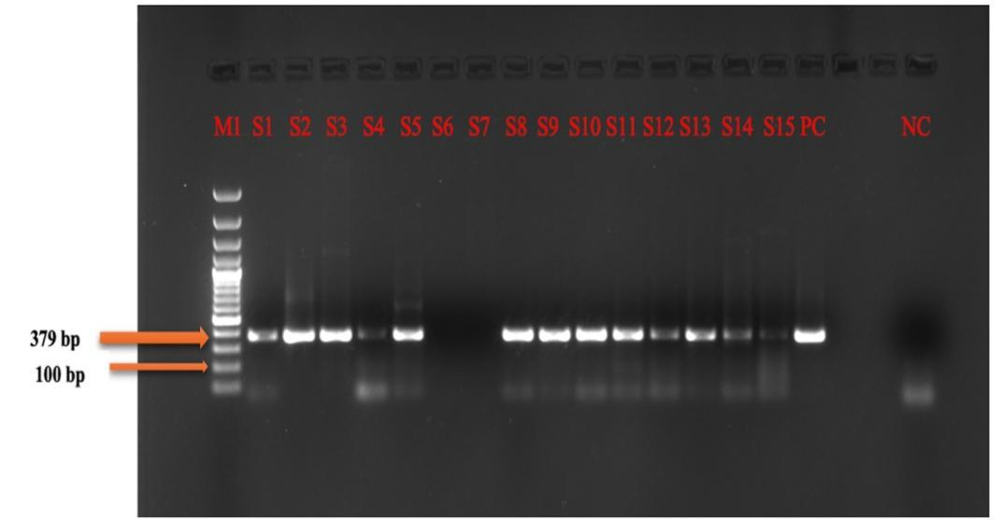
Figure 1- PCR bands after gel electrophoresis indicating presence of CPV-2a in tested faecal samples
M1- ladder, S1 to S15 – samples, PC(Positive control)- Puppy DP, NC(Negative control-nfw)

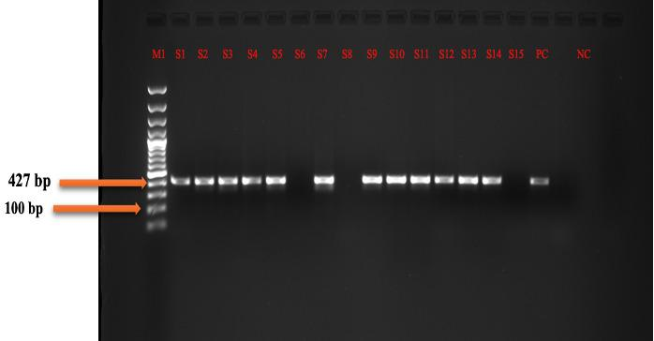
Figure 2- PCR bands after gel electrophoresis indicating presence of CPV-2b in tested faecal samples
M1- ladder, S1 to S15 – samples, PC(Positive control)- Puppy DP, NC(Negative control-nfw)

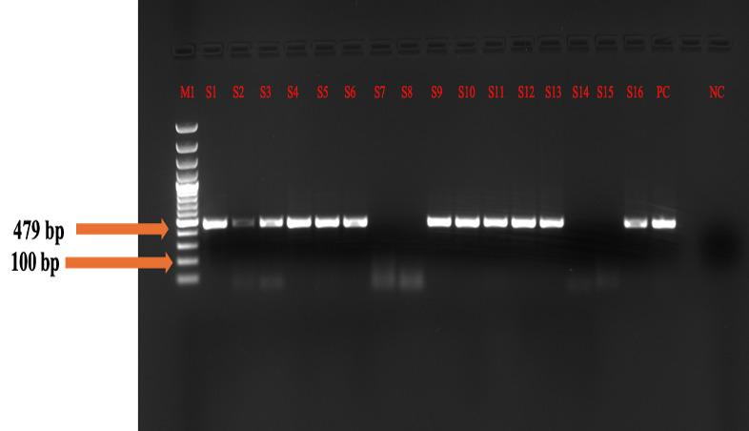
Figure 3.- PCR bands after gel electrophoresis indicating presence of CPV-2c in tested faecal samples
M1- ladder, S1 to S16 – samples, PC(Positive control)- Puppy DP, NC(Negative control-nfw)

Comparison of clinical parameters between healthy and affected dog
A random selection of 52 CPV-2a, 52 CPV-2b, and 44 CPV-2c cases was made for further analysis.
- Heart Rate shows clear elevation in CPV-2b and CPV-2c groups compared to healthy controls and CPV-2a
- Respiration Rate shows a progressive increase from healthy controls through the different CPV-2 variants
- Temperature shows marked elevation in all CPV-2 variants compared to healthy controls.
- Table 3. Comparison of clinical parameters between healthy and affected dog
Parameter | Healthy Control(n=10 ) | CPV-2a*  (n=52) | CPV-2b*  (n=52) | CPV-2c*  (n=44)
Heart Rate | 119.50 ± 4.16 | 118.41 ± 0.39 | 134.34 ± 0.50 | 133.73 ± 0.35
Respiration Rate | 20.42 ± 2.23 | 31.83 ± 0.31 | 37.49 ± 0.23 | 36.43 ± 0.29
Temperature | 101.29 ± 0.21 | 103.20 ± 0.03 | 103.89 ± 0.03 | 103.90 ± 0.02
- *Significant p value < 0.05

These results suggest that CPV-2 infection significantly affects all three vital parameters, with some variations between different viral variants. These findings align with those reported by Souza et al.(2020) and Goddard and leisewitz (2010).

Clinical signs
Depression to lethargy, diarrhoea and haemorrhagic diarrhoea were the most common symptoms. These clinical signs are characteristic of CPV-2 infection and illustrate the virus's aggressive progression and systemic impact

Table 4. Occurrence of clinical signs of CPV-2 affected dogs
Clinical signs | No. of dogs affected | Percentage
Depression to lethargy | 166 | 100%
Inappetence | 162 | 97.59%
Pale mucosa | 112 | 67.47%
Fever | 71 | 42.77%
Diarrhoea | 18 | 10.84%
Haemorrhagic diarrhoea | 148 | 89.15%
Vomition | 123 | 74.09%
Dehydration | 65 | 39.16%

Hematology
The hematological analysis of dogs infected with CPV-2 variants revealed significant alterations compared to the healthy control group. Hemoglobin, PCV, and TEC levels were notably reduced in infected dogs, with CPV-2c showing the lowest values. Total leukocyte count was significantly elevated in all CPV-2 variants, while lymphocyte percentage was markedly decreased, especially in CPV-2c cases. Neutrophil counts were highest in CPV-2b and CPV-2c groups, whereas eosinophil and basophil percentages were elevated across all infected groups. Erythrocyte indices, including MCH, MCV, and MCHC, showed significant reductions, particularly in CPV-2c-infected dogs. Despite these changes, platelet counts remained largely unaffected. These findings align with previous studies, such as those by Goddard and Leisewitz (2010), who reported significant anemia and bone marrow suppression in CPV-2-infected dogs. The observed leukocytosis, characterized by increased neutrophil counts and reduced lymphocyte percentages, supports findings by Miranda and Thompson (2016), who highlighted neutrophilia as a major inflammatory response in CPV-2 infections. Elevated eosinophil and basophil counts correspond with the immune-mediated responses described by Decaro et al. (2009). Additionally, the decrease in erythrocyte indices is consistent with observations by Pereira et al. (2020), who reported significant red blood cell abnormalities in CPV-2-infected dogs. While platelet counts remained unchanged, the overall hematological disturbances, particularly in CPV-2b and CPV-2c, reinforce the severity of these variants, emphasizing their diagnostic and prognostic importance in clinical settings.

Table 5 : Haematological parameters in the healthy/control group and dogs infected with CPV-2a, CPV-2b, and CPV-2c. Values are presented as mean ±SEM. Asterisks indicate statistical significance: *p < 0.05, **p < 0.01.

Parameter | Healthy/control group(n=10) | CPV-2a (n=52) | CPV-2b (n=52) | CPV-2c (n=44)
Haemoglobin | 14.77 ± 0.92 | 12.00 ± 3.14* | 12.06 ± 3.13* | 11.82 ± 3.13*
PCV | 45.05 ± 2.60 | 31.75 ± 10.49** | 32.02 ± 10.40** | 30.93 ± 10.47 **
TEC | 6.48 ± 0.50 | 5.71 ± 1.78* | 5.74 ± 1.78* | 5.90 ± 1.84*
TLC | 10.08 ± 0.88 | 24.26 ± 25.90* | 24.08 ± 26.12* | 23.31 ± 23.74*
Neutrophils ( %) | 69.0 ± 17 | 73.5± 9.3* | 75.8 ± 8.0* | 74.1 ± 10.0*
Lymphocyte (%) | 16.76 ± 1.76 | 14.1± 4.0* | 13.2 ± 5.0* | 12.4 ± 5.0*
Monocyte (%) | 4.0 ± 2.0 | 5.0 ± 0.7 | 5.0 ± 0.9 | 4.0 ± 1.0
Eosinophils(% ) | 0.7 ± 0.9 | 1.0 ± 0.5* | 1.8 ± 0.4** | 2.0 ± 0.4**
Basophils (% ) | 0.07± 0.3 | 1.0 ± 0.2* | 1.0 ± 0.2* | 0.9 ± 0.1*
MCH | 23.15 ± 1.08 | 21.29 ± 3.12 * | 21.27 ± 3.15* | 21.23 ± 2.55 *
MCV | 69.96 ± 2.14 | 51.11 ± 9.44** | 51.20 ± 9.51** | 51.96 ± 10.11**
MCHC | 34.03 ± 0.77 | 38.26 ± 9.39 | 38.06 ± 9.37* | 37.63 ± 10.16 *
Platelet count | 309.07 ± 48.73 | 295.89 ± 171.50 | 293.82 ± 172.60 | 306.62 ± 182.86
*Significant P<0.05 **More significant P<0.01

Biochemical parameters
The biochemical alterations observed in CPV-2-infected dogs in this study align with previous research demonstrating significant metabolic disruptions caused by the virus. The significant reduction in serum total protein and albumin levels, especially in CPV-2c cases, supports the findings of Singh et al. (2019) and Kataria et al. (2020), who reported severe protein loss due to intestinal mucosal damage and malabsorption in parvoviral enteritis. The variations in globulin levels correspond with the observations of Sharma et al. (2018), indicating an altered immune response among infected dogs. The elevated levels of liver enzymes (AST, ALT and ALP), particularly the significantly increased ALP levels in CPV-2c cases, are consistent with the studies by Raj et al. (2016), who reported hepatic stress and liver damage as common biochemical manifestations of CPV-2 infection. These findings collectively reinforce the diagnostic and prognostic significance of biochemical markers in evaluating the severity of CPV-2 infection and guiding clinical management.

This study highlights the clinical, haematological and biochemical alterations caused by Canine Parvovirus-2 (CPV-2) infection in dogs, focusing on the CPV-2a, CPV-2b and CPV-2c variants. The findings indicate that CPV-2b and CPV-2c infections are associated with more severe clinical symptoms, such as increased heart and respiration rates. Hematological analysis revealed a significant decline in haemoglobin, packed cell volume (PCV), and total erythrocyte count (TEC), indicating anaemia and immune suppression. The elevated neutrophil count and reduced lymphocyte percentage in CPV-2b and CPV-2c cases suggest an acute inflammatory response, consistent with prior research. Additionally, increased eosinophil and basophil counts reflect immune system activation due to viral infection.

Biochemical changes further emphasize the systemic impact of CPV-2 infection. The reduced levels of serum total protein and albumin, particularly in CPV-2c cases, indicate severe protein loss due to gastrointestinal damage. Elevated AST and ALP levels suggest liver dysfunction, while lower serum creatinine levels, especially in CPV-2c-infected dogs, may indicate renal impairment. These findings align with existing literature, reinforcing the clinical importance of hematobiochemical parameters in diagnosing and managing CPV-2 infections.

Conclusion : the study underscores the distinct pathological effects of CPV-2 variants, highlighting their role in disease severity. The observed differences among CPV-2a, CPV-2b, and CPV-2c strains provide crucial information for improving early diagnosis and treatment strategies. Future research should focus on molecular and immunological aspects to further understand CPV-2 pathogenesis. Integrating clinical, hematological, and biochemical assessments enhances veterinary knowledge and aids in the effective management of CPV-2 infections in dogs.

References
Decaro, N. and Buonavoglia, C. (2012). Canine parvovirus—a review of epidemiological and diagnostic aspects, with emphasis on type 2c. Veterinary microbiology, 155(1): 1-12.
Decaro, N., Cirone, F., Desario, C., Elia, G., Lorusso, E., Colaianni, M. L. and Buonavoglia, C. (2009). Severe parvovirus in a 12-year-old dog that had been repeatedly vaccinated. The Veterinary Record, 164(19): 593.
Goddard, A., Leisewitz, A. L., Christopher, M. M., Duncan, N. M. and Becker, P. J. (2008). Prognostic usefulness of blood leukocyte changes in canine parvoviral enteritis. Journal of Veterinary Internal Medicine, 22(2): 309-316.

Haydon, D. T., Laurenson, M. K., & Sillero‐Zubiri, C. (2002). Integrating epidemiology into population viability analysis: managing the risk posed by rabies and canine distemper to the Ethiopian wolf. Conservation Biology, 16(5): 1372-1385.
Kataria, D., Agnihotri, D., Kumar, S. and Lohiya, A. (2020). Comparative assessment of oxidative stress in dogs regarding CPV infection. Innov J, 9(2): 115-117.
Kaur, G., Chandra, M., Dwivedi, P. N. and Sharma, N. S. (2014). Antigenic typing of canine parvovirus using differential PCR. Virus disease, 25: 481-487.
Miranda, C. and Thompson, G. (2016). Canine parvovirus: the worldwide occurrence of antigenic variants. Journal of General Virology, 97(9): 2043-2057.
Nandi, S. and Kumar, M. (2010). Canine parvovirus: current perspective. Indian Journal of virology, 21: 31-44.
Ogbu, K. I., Anene, B. M., Nweze, N. E., Okoro, J. I., Danladi, M. M. A. and Ochai, S. O. (2017). Canine parvovirus: a review. International Journal of Sciences and Applied Research, 2: 74-95
Parrish, C. R. and Kawaoka, Y. (2005). The origins of new pandemic viruses: the acquisition of new host ranges by canine parvovirus and influenza A viruses. Annu. Rev. Microbiology., 59(1): 553-586.
Pereira, C. A., Monezi, T. A., Mehnert, D. U., D’Angelo, M. and Durigon, E. L. (2000). Molecular characterization of canine parvovirus in Brazil by polymerase chain reaction assay. Veterinary microbiology, 75(2): 127-133
Raj, J. M., Mukhopadhyay, H. K., Thanislass, J., Antony, P. X. and Pillai, R. M. (2010). Isolation, molecular characterization and phylogenetic analysis of canine parvovirus. Infection, Genetics and Evolution, 10(8): 1237-1241.
Reed, A. P., Jones, E. V. and Miller, T. J. (1988). Nucleotide sequence and genome organization of canine parvovirus. Journal of virology, 62(1): 266-276.
Sharma, S., Dhar, P. and Sharma, M. (2019). Study of different risk factors for canine parvovirus infection by haemagglutination assay. Journal of Animal Research, 9(5): 735-739.
Singh, M., Chander, V. and Nandi, S. (2019). Canine Parvovirus. Recent Advances in Animal Virology: 207-233.
Zhou, P., Zeng, W., Zhang, X., & Li, S. (2017). The genetic evolution of canine parvovirus–A new perspective. PloS one, 12(3): e0175035

