**Epidemiological and clinical profile of canine parvoviral enteritis in Kathmandu and Lalitpur District of Nepal**

# ABSTRACT

Canine parvovirus (CPV) infection is a highly contagious disease in dogs, characterised by vomiting and diarrhoea. CPV primarily targets rapidly dividing cells in the intestinal crypts, resulting in severe gastrointestinal symptoms including vomiting, bloody diarrhoea, dehydration, and electrolyte imbalance. This study assessed the prevalence and some associated risk factors of canine parvoviral enteritis in dogs. A total of 56 dogs presented at the Central Referral Veterinary Hospital (CRVH), Kathmandu, and the Veterinary Hospital and Livestock Service Expert Centre (VHLSEC), Lalitpur, were randomly selected for the study. Diagnosis was conducted through clinical history, physical examination, and CPV antigen kit testing. The dogs were categorised based on vaccination status, sex, age, breed, and clinical signs. The study revealed that the highest prevalence of canine parvoviral enteritis was observed in local indigenous breeds (25%), while the lowest was in Dobermanns (3.57%). Age-wise, the highest prevalence (75%) was noted in the 2–5 months age group, and the lowest (14.29%) in dogs older than 12 months. Sex- wise analysis indicated a higher prevalence in male dogs (37.30%) compared to female dogs (27.47%). Regarding vaccination status, unvaccinated dogs exhibited a significantly higher prevalence (82.14%) compared to vaccinated dogs (17.86%). Clinical signs included vomiting, hemorrhagic diarrhoea, and foul-smelling faeces, most frequently seen in the 2–5-month age group. In conclusion, while dogs of all ages, breeds, and sexes are susceptible to CPV infection, puppies are more likely to be affected. Due to the short duration of the study period, the sample size in the study was limited. As the study was based on hospitalised patients, a broader investigation of the entire dog population is needed to determine the actual prevalence and risk factors of CPV infection in Kathmandu and Lalitpur. Further studies are recommended to enhance understanding of the disease's spread and to improve management strategies.

**Keywords:** Canine Parvovirus, Prevalence, Vaccination Status, Clinical Sign, Haemorrhagic diarrhoea, Nepal

Abbreviation:

CRVH: Central Referral Veterinary Hospital

VHLSEC: Veterinary Hospital and Livestock Service Center

# INTRODUCTION

Canine parvovirus (CPV) is a highly contagious and often fatal viral disease of dogs that primarily affects puppies and immunologically naïve individuals. It is recognised globally as a leading cause of acute hemorrhagic enteritis and myocarditis in young dogs (Hoelzer & Parrish, 2010). First identified in 1977, CPV has established itself as a predominant enteric virus affecting canines globally, with a morbidity rate of 100% and mortality rates reaching up to 10% in treated cases, and potentially 90% if left untreated (Olaifa et al., 2025). CPV primarily targets rapidly dividing cells in the intestinal crypts, resulting in severe gastrointestinal symptoms including vomiting, bloody diarrhoea, dehydration, and electrolyte imbalance (Prittie, 2004; Parthiban et al., 2011). Prevention of CPV infection is based on the use of modified live virus (MLV) vaccines, which are able to stimulate both antibody- and cell-mediated immune responses, inducing a strong, long-lasting protection against subsequent challenge with virulent viruses (Decaro et al., 2020).

Despite the availability of effective vaccines, outbreaks of CPV remain common in many parts of the world, including Nepal, due to factors such as incomplete vaccination, improper vaccine handling, and the presence of maternal antibodies that interfere with immunization in young puppies (Decaro et al., 2008; Deepa & Saseendranath, 2002). Moreover, the virus is remarkably resilient in the environment, surviving for months in contaminated areas such as kennels, food bowls, and clothing, thus facilitating indirect transmission (Reddy et al., 2015). Numerous studies have documented the prevalence of canine CPV infection and its high association with various risk factors. However, the epidemiological study in the study area is still scarce. Large Nepalese regions like Kathmandu have a significantly large stray dog population (Mahato et al., 2023).

Several studies have highlighted that CPV infection is more prevalent in puppies aged 6 weeks to 6 months, likely due to the waning of maternal antibodies and the immature state of their immune system (Stepita & Sykes, 2013; Xu et al., 2013). Breed susceptibility, sex, and vaccination status are also critical risk factors. Previous research has indicated that unvaccinated dogs, males, and certain breeds such as Rottweilers and Dobermanns may be more prone to severe infection (Houston et al., 1996; Kalli et al., 2010).

In Nepal, the epidemiology of CPV has not been extensively studied, particularly in the Kathmandu Valley, where canine populations are dense and vaccination practices vary widely. Understanding local patterns of prevalence and associated risk factors is essential for improving disease control and vaccination strategies.

Therefore, this study aimed to determine the prevalence, clinical presentation, and some risk factors (age, breed, sex, and vaccination status) associated with CPV infection in dogs presented at two major veterinary hospitals in the Kathmandu and Lalitpur districts.

# MATERIALS AND METHODS

## Study Area

The study was conducted at the Central Referral Veterinary Hospital (CRVH), Tripureshwar, Kathmandu, and the Veterinary Hospital and Livestock Service Expert Centre (VHLSEC), Lagankhel, Lalitpur, Nepal, from April – November 2019.

## Study Population

A total of 56 dogs, i.e., 28 dogs at CRVH, Kathmandu and 28 dogs at VHLSEC, Lalitpur, of various breeds were included in the study. The dogs were categorised into groups based on their vaccination status (vaccinated or unvaccinated), age (4–8 weeks, 2–5 months, 6–12 months, and >12 months), breed, and clinical history (vomiting, hemorrhagic diarrhoea, non- hemorrhagic diarrhoea, and foul-smelling diarrhoea).

## Diagnosis of CPV

The confirmatory diagnosis of Canine Parvovirus (CPV) infection was performed using the Anigen Rapid CPV/CCV Ag Test Kit (Bionote, Inc., Republic of Korea), an immunochromatographic assay designed for the qualitative detection of CPV antigen in canine faeces. Fresh faecal samples were collected using the sterile disposable swab provided in the kit, ensuring appropriate sample quantity as per the manufacturer’s guidelines.

The swab was then inserted into the assay diluent tube and mixed thoroughly by stirring at least ten times. After discarding the swab while squeezing it against the tube wall, the mixture was allowed to settle, and the clear supernatant was collected using a disposable dropper. Four drops of the supernatant were applied to the sample well of the test device. Results were interpreted within 5–10 minutes, with the appearance of a control line and test line indicating a positive result. The kit allowed for simultaneous detection of Canine Parvovirus (CPV) and Canine Coronavirus (CCV), offering a high-sensitivity and rapid diagnostic tool for clinical confirmation of CPV.

## Ethical Approval

Ethical approval was not necessary. All the animals under this research were clinical cases and were examined, diagnosed and treated as per standard treatment and examination procedure.

## Statistical Analysis

All the data consisting of various categories as Breed, Age, Sex, Vaccination Status, and clinical signs, was inserted into MS Excel (Office 2016). Descriptive analysis of the data was performed.

# RESULTS

The overall prevalence and risk factor analysis were calculated based on observed clinical signs and symptoms. All 56 cases showed signs and symptoms, which were considered positive cases for parvoviral enteritis.

Based on the present study the prevalence rate of Canine Parvoviral Enteritis was 25% (n:14) for Local Breed, 17.86% (n:10) for Japanese Spitz, 17.86% (n:10) for Mastiff, 10.71% (n:6) for German Shephard, 10.71% (n:6) for Pug, 7.14% (n:4) for Lhasa Apso, 7.143% (n:4) for Labrador, and 3.57% (n:2) for Dobermann. (Table 1)

## Table 1: Breed-wise occurrence and % prevalence

|  |  |  |  |
| --- | --- | --- | --- |
| S.N. | Breed | Occurrence (n) | % Prevalence |
| 1 | Local | 14 | 25 |
| 2 | Japanese Spitz | 10 | 17.86 |

|  |  |  |  |
| --- | --- | --- | --- |
| 3 | Mastiff | 10 | 17.86 |
| 4 | German Shephard | 6 | 10.71 |
| 5 | Pug | 6 | 10.71 |
| 6 | Lhasa Apso | 4 | 7.14 |
| 7 | Labrador | 4 | 7.14 |
| 8 | Dobermann | 2 | 3.57 |

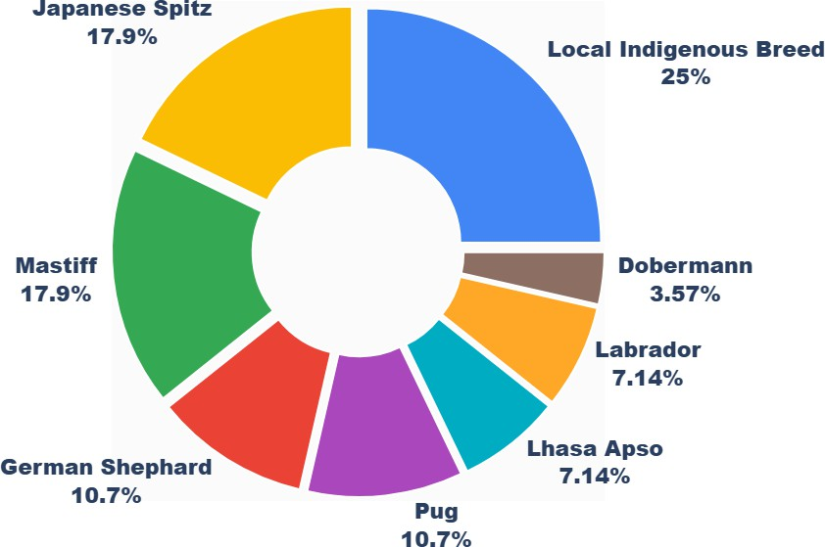

Figure 1: Percentage Prevalence in relation to Breed

## Table 2: Age-wise Occurrence and % Prevalence

|  |  |  |  |
| --- | --- | --- | --- |
| S.N. | Age Group | Occurrence (n) | % Prevalence |
| **1.** | 2-5 months | 42 | 75 |
| **2.** | 6-12 months | 8 | 10.71 |
| **3.** | > 12 months | 6 | 14.29 |

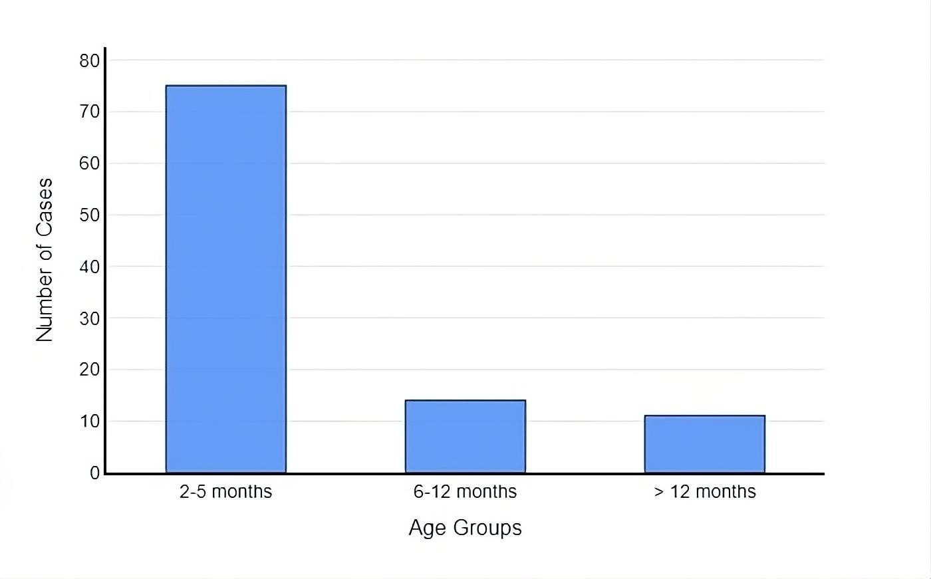

Figure 2: Number of Occurrences in relation to Age Group

## Table 3: Distribution of Clinical Signs Based on Age Groups in Dogs (n = 56)

|  |  |  |  |  |
| --- | --- | --- | --- | --- |
| Age Group | Vomiting (n) | Non-haemorrhagic Diarrhoea (n) | Haemorrhagic Diarrhoea (n) | Foul-smelling Diarrhoea (n) |
| 2–5 months | 14 | 10 | 12 | 9 |
| 6–12 months | 10 | 8 | 6 | 7 |
| >12 months | 6 | 5 | 2 | 3 |
| Total (n = 56) | 30 | 23 | 20 | 19 |

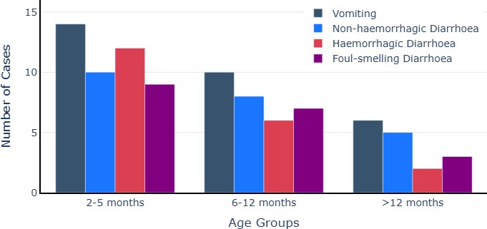

Figure 3: Prevalence (%) of clinical history in Canine Parvoviral Enteritis according to age

## Table 4: Sex wise Occurrence and % prevalence

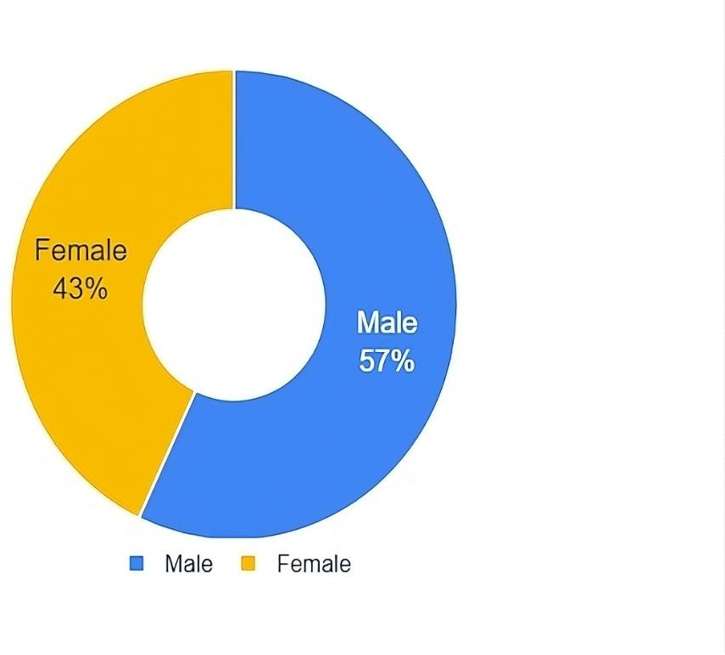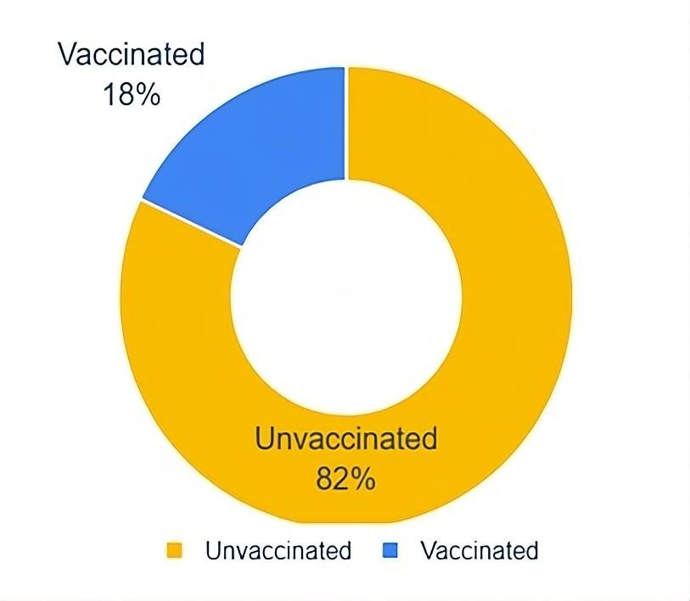

|  |  |  |  |
| --- | --- | --- | --- |
| S.N. | Sex | Occurrence (n) | % Prevalence |
| **1.** | Male | 32 | 57.14 |
| **2.** | Female | 24 | 42.86 |

Fig.4: % Prevalence in relation to Sex Fig.5: % Prevalence by Vaccination Status

**Table 5: % Prevalence and Occurrence in relation to Vaccination status**

|  |  |  |  |
| --- | --- | --- | --- |
| S.N. | Vaccination Status | Occurrence (n) | Prevalence % |
| 1 | Vaccinated | 10 | 17.86 |
| 2 | Unvaccinated | 46 | 82.14 |

# DISCUSSION

The highest infection rate was seen in local or indigenous breeds (25%). This may be due to poor vaccination coverage, lower owner awareness, and the tendency of local breeds to roam freely, increasing their contact with contaminated environments (Tajpara et al., 2009). Similar findings were reported in Ghana, where free-roaming and unvaccinated dogs had significantly higher CPV infection rates (Folitse et al., 2018). These dogs are often exposed to virus-contaminated soil or faeces, as CPV is known to survive in the environment for extended periods (Hoelzer & Parrish, 2010).

In contrast, exotic breeds like Dobermanns had the lowest prevalence (3.57%). This may be because such breeds are often kept indoors, are well cared for, and receive regular vaccinations. However, this finding contrasts with earlier studies from North America and Europe, which reported that Dobermanns and Rottweilers have a higher risk of severe CPVE due to breed-related immune response differences (Houston et al., 1996; Kalli et al., 2010). The lower prevalence in Dobermanns in our setting may also be due to a smaller population of these breeds in the study area.

Exotic breeds such as Japanese Spitz and Mastiffs showed higher infection rates (17.86%). This is supported by findings that larger breed puppies may be more vulnerable due to their rapid growth, which puts higher demands on their immune systems during development (Sellon, 2005; McCaw & Hoskins, 2006). These breeds are also increasingly popular in urban Nepal, which could increase their representation in clinical cases.

Puppies aged 2–5 months were the most affected group (75%). At this age, maternally derived antibodies begin to decline, and the puppies’ immune systems are not yet fully developed. This creates a window of vulnerability (Stepita et al., 2013; Prittie, 2004). Also, CPV targets rapidly dividing intestinal cells, which are more common in growing puppies (Parthiban et al., 2011). Similar findings were reported in India and China, where CPV infection and severity were highest in younger age groups (Mohanraj et al., 2010; Xu et al., 2013). In contrast, dogs older than 12 months had a lower prevalence (14.29%), possibly due to stronger adaptive immunity acquired through vaccination or past subclinical exposure (Carmichael et al., 1983). However, some studies still report CPV cases in older dogs, often linked to incomplete vaccination, waning immunity, or infection with emerging virus variants (Decaro et al., 2008; Truyen, 2006).

In this study, the most severe clinical signs—including vomiting, hemorrhagic diarrhoea, and foul-smelling faeces—were observed predominantly in puppies aged 2–5 months. This age group is known to be immunologically immature, which allows the virus to replicate aggressively and cause extensive damage to the intestinal lining. As the virus attacks rapidly dividing crypt epithelial cells, the destruction of the gastrointestinal tract lining leads to haemorrhage, fluid loss, and a high risk of bacterial translocation, resulting in sepsis (Prittie, 2004; Mohanraj et al., 2010). In contrast, dogs aged more than 12 months in our study showed fewer and less severe symptoms. This trend has been supported by Carmichael et al. (1983), who explained that dogs

with completed core vaccination schedules develop durable immune responses, offering protection from both infection and severe disease.

Unvaccinated dogs had a significantly higher infection rate (82.14%) than vaccinated dogs (17.86%). This supports findings from Hasan et al. (2016) and Carmichael et al. (1983), who confirmed the protective role of CPV vaccines. However, some vaccinated dogs still got infected, which may be due to early vaccination while maternal antibodies were still present (Deepa & Saseendranath, 2002), poor vaccine storage conditions (McCaw & Hoskins, 2006), or the emergence of new virus variants such as CPV-2c (Decaro et al., 2008). Even when infection occurs in vaccinated dogs, the symptoms are often milder and recovery is faster, reinforcing the value of proper vaccination.

Male dogs had a slightly higher infection rate (57.14%) compared to females (42.86%). This may be due to behaviour, as male dogs are more likely to roam and come into contact with contaminated environments (Umar & Ali, 2015). Moreover, in Nepal, male dogs are more commonly kept as pets, which may have led to their overrepresentation in clinical cases. However, other studies like Banja & Pati (2002) found no significant sex-based difference, suggesting that exposure risk is more behavioural than biological.

## CONCLUSION

Canine Parvovirus (CPV) is an infectious and highly contagious viral disease of dogs. Vaccination status, age group, and breed were found to be significantly associated as potential risk factors for CPV. Dogs of all age groups can be infected, but puppies less than 3 months old are more susceptible than adults. Both male and female dogs are affected by CPV infection. Both indigenous and exotic breeds (e.g., German Shepherd, Doberman, Japanese Spitz, Mastiff) are susceptible to CPV infection. The rate of infection is higher in unvaccinated dogs compared to vaccinated ones.

Due to the short duration of the study period, the sample size in the study was limited. As the study was based on hospitalised patients, a broader investigation of the entire dog population is needed to determine the actual prevalence and risk factors of CPV infection in Kathmandu and Lalitpur. Further in-depth research is essential to better characterise the contributing risk factors for CPV infection in dogs.

Based on the findings, the following recommendations are advised:

1. Vaccination is essential for the prevention of Canine Parvoviral Enteritis.
2. Timely and regular booster vaccinations should be administered.

# DISCLAIMER (ARTIFICIAL INTELLIGENCE):

Author(s) hereby declare that NO generative AI technologies such as Large Language Models (ChatGPT, COPILOT, etc) and text-to-image generators have been used during writing or editing of this manuscript.

# REFERENCES

* 1. Banja, B. K., & Pati, H. (2002). Epizootilogical status of canine viral haemorrhagic gastroenteritis in Bhubaneswar. *Indian Veterinary Journal, 79*, 850–851.
  2. Carmichael, L. E., Joubert, J. C., & Pollock, R. V. H. (1983). **A modified live canine parvovirus vaccine. II. Immune response.** *American Journal of Veterinary Research*, 44(9), 1697–1702.
  3. Decaro, N., Desario, C., Campolo, M., Cavalli, A., Ricci, D., Martella, V., & Buonavoglia,

C. (2008). **Clinical and virological findings in pups naturally infected by canine parvovirus type 2 Glu-426 mutant.** *Journal of Veterinary Diagnostic Investigation*, 20(3), 370–373.

* 1. Deepa, P. M., & Saseendranath, M. R. (2002). Incidence of canine parvoviral infection in immunized dogs. *CAB Abstracts*. <https://www.cabidigitallibrary.org/doi/full/10.5555/20023140678>
  2. Folitse, R. D., Emikpe, B. O., Obese, F. Y., & Johnson, S. (2018). **Seroprevalence of canine parvovirus antibodies in apparently healthy dogs in Kumasi, Ghana.** *Veterinary World*, 11(7), 964–969.
  3. Hasan, M. M., Jalal, M. S., Bayzid, M., Sharif, M. A. M., & Masuduzzaman, M. (2016). A comparative study on canine parvovirus infection of dog in Bangladesh and India. *Bangladesh Journal of Veterinary Medicine, 14*(2), 237–241. <https://doi.org/10.3329/bjvm.v14i2.31377>
  4. Hoelzer, K., & Parrish, C. R. (2010). **The emergence of parvoviruses of carnivores.**

*Veterinary Research*, 41(6), 39.

* 1. Houston, D. M., Ribble, C. S., & Head, L. L. (1996). **Risk factors associated with parvovirus enteritis in dogs: 283 cases (1982–1991).** *Journal of the American Veterinary Medical Association*, 208(4), 542–546.
  2. Kalli, I., Leontides, L. S., Mylonakis, M. E., Adamama-Moraitou, K., Rallis, T. S., & Koutinas, A. F. (2010). **Factors affecting the occurrence, duration of hospitalization and final outcome in canine parvovirus infection.** *Research in Veterinary Science*, 89(2), 174–178.
  3. McCaw, D. L., & Hoskins, J. D. (2006). **Canine viral enteritis.** In C. E. Greene (Ed.),

*Infectious diseases of the dog and cat* (3rd ed., pp. 63–73). Saunders Elsevier.

* 1. Mohanraj, G., Balachandran, C., & Nachimuthu, K. (2010). **Histopathological changes in puppies affected with canine parvovirus infection.** *Tamilnadu Journal of Veterinary and Animal Sciences*, 6(6), 297–299.
  2. Parthiban, M., Kumanan, K., & Elankumaran, S. (2011). **Canine parvovirus infection: A review of epidemiology and pathogenesis.** *International Journal of Current Research*, 3(8), 219–222.
  3. Prittie, J. (2004). **Canine parvoviral enteritis: A review of diagnosis, management, and prevention.** *Journal of Veterinary Emergency and Critical Care*, 14(3), 167–176.
  4. Reddy, K. B., Shobhamani, B., Sreedevi, B., Prameela, R. D., & Reddy, B. S. (2015). Diagnosis of canine parvo viral infection in dogs by using haemagglutination and haemagglutination inhibition tests. *International Journal of Veterinary Health Sciences and Research, 3*(3), 46–48.
  5. Sellon, R. K. (2005). **Immune system.** In K. E. Nelson & C. G. Couto (Eds.), *Small animal internal medicine* (3rd ed., pp. 1120–1141). Mosby Elsevier.
  6. Stepita, M. E., & Sykes, J. E. (2013). **Canine parvovirus infection in puppies.**

*Compendium: Continuing Education for Veterinarians*, 35(3), E1–E4.

* 1. Tajpara, P., Patel, J., Patel, K., & Patel, D. (2009). **Incidence of canine parvovirus in relation to age, breed and sex of dogs.** *Veterinary World*, 2(5), 193–194.
  2. Truyen, U. (2006). **Evolution of canine parvovirus—a need for new vaccines?**

*Veterinary Microbiology*, 117(1), 9–13.

* 1. Umar, S., & Ali, A. (2015). Prevalence of Canine Parvovirus Infection at Different Pet Clinics in Lahore, Pakistan. *Pakistan Journal of Zoology, 47*, 657–663.
  2. Xu, J., Guo, H. C., Wei, Y. Q., Zhao, F. M., & Sun, S. Q. (2013). **Serological survey of canine parvovirus in dogs in China.** *Veterinary Microbiology*, 165(1-2), 231–235.
  3. Olaifa, O. S., Rachel, K. A., Akanbi, O. B., Ibironke, O. C., & Victor, T. (2025). Hematological and Serum Chemistry of Canine Parvoviral Enteritis in Diverse Breeds of Dogs. *MEDIA KEDOKTERAN HEWAN*, *36*, 1.
  4. Decaro, N., Buonavoglia, C., & Barrs, V. R. (2020). Canine parvovirus vaccination and immunisation failures: Are we far from disease eradication? *Veterinary Microbiology, 247*, 108760.
  5. Mahato, P., Khanal, S., & Upadhyaya, M. (2023). A Retrospective Study of Parvovirus Infection in Dogs in Kathmandu. *Nepalese Veterinary Journal*, 123-128.