Original Research Article
Study of Haemato-Biochemical Alterations of Canine Monocytic Ehrlichiosis (CME) in Seropositive Dogs of Kathmandu Valley: prevalence and risk factors

ABSTRACT
Aim: A cross-sectional study was conducted to study diagnostic importance of haemato-biochemical alterations of Canine Monocytic Ehrlichiosis (CME) in seropositive dogs. A sampling of 88 dogs of different hospitals and clinics from Kathmandu valley was conducted from June to October, 2024 and testing via rapid antibody kit was done for estimation of haemato-biochemical alterations and its associated risk factors. The prevalence of Ehrlichia canis (E. canis) was highest in mixed breed (35.23%) followed by German shepherd (12.50 %), Spitz (15.91%), Golden retriever (6.82%), Mongrel (5.68%), Labrador (4.55%), Lhasa apso (4.55%), Cocker, Tibetan mastiff and Local (3.41%), and Pug and Husky were least infected breeds. Female dogs were more predisposed to Ehrlichia canis (E. canis) than male dogs (35%). The highest prevalence of Ehrlichia canis (E. canis) was seen in monsoon (62.50%), followed by spring season (30.68%) and the least incidence in autumn. The mean and range of seropositive dogs were 6.52±3.96 and 0.5 to 17 years respectively. Compared to old age, young (43.16%) and middle (44.32%) age group showed a higher predisposition. In addition, significant low PCV, TEC, Hb, albumin, thrombocytes, and significant increase in ALP, total serum bilirubin, direct bilirubin, BUN, Creatinine and leukocyte indicate that haemato-biochemical test can play a significant role in accurate diagnosis of Ehrlichia canis (E. canis). The mean value of neutrophil, lymphocyte, monocyte, eosinophil, basophil, ALT, total protein and random blood was significant at p- value of <0.05. This study showed mark alterations in haemato-biochemcial parameters of in seropositive dogs when compared with apparently healthy dogs.

Keywords: E. canis, haemato-biochemical alterations, incidence, seropositive dogs.

1. INTRODUCTION
Canine monocytic ehrlichiosis (CME) is a multisystemic tick-borne disease (Harrus and Waner, 2013). Gram negative, obligate intracellular rickettsia Ehrlichia canis (E. canis) is the etiological agent, while Rhipicephalus sanguineus is the transmission vector (Mylonakis, M. E. et al., 2019; Aziz et al., 2022). Ehrlichia species viz, Ehrlichia canis, E. ewingii, and E. chaffeens infect dogs, humans and other mammals through tick bites (McDade, 1990; Schudel et al., 2024). Recurrent thrombocytopenia, anaemia, pancytopenia, glomerulonephritis, renal failure, keratitis, fever, anorexia, depression, lymphadenopathy, ocular discharge, pallor of mucous membrane and hemorrhagic tendencies are the clinical signs of E. canis (Chawla et al., 2020). The spectrum of tick-borne diseases (TBDs) affecting animals and humans has increased in recent years; many important zoonotic TBDs, such as anaplasmosis, babesiosis, ehrlichiosis, and Lyme borreliosis are increasingly gaining more attention from physicians and veterinarians (Dantas-Torres et al., 2012, Fuente et al., 2023).
Continuous increase in canine population in different areas of Nepal is evident. In Kathmandu valley, an estimated 22,500 stray dogs live inside the Ring Road of the Valley (WSPA, 2012). There are 60.66 % males, 36.28 % females and 3.06 % puppies in Pokhara valley in Nepal, (Acharya and Dhakal, 2015). Vector borne diseases are highly prevalent in stray dogs of Nepal with 27.14% overall prevalence for Ehrlichia canis and a total of 81.43% of dogs were positive for at least one of the vector-borne pathogens (VBP) tested (Díaz et al., 2020). The prevalence of CME is found to be 26.76 % and 11.85 % in pet dogs of Lalitpur district and Kathmandu valley, respectively. (Sah, 2019). The change in ecosystem, global warming and increased trend of movement throughout world has given favorable environment for adaptation and thriving of tick vector responsible for transmission of E. canis. The increasing incidence of ehrlichiosis with indifferent clinical symptoms like fever, anorexia, distended abdomen, pale mucous membrane, lethargy and uncontrolled bleeding tendencies indulges veterinary practitioner and health workers to conduct more studies on reliable and inexpensive diagnosis of E. canis.
However, it is suggested that the platelet counts may be a good and inexpensive screening test for canine monocytic ehrlichiosis, and that the magnitude of thrombocytopenia may increase the reliability of diagnosis(Bulla et al., 2004).The molecular methods of diagnosis are not readily available and expensive while cytological detection of morula of E. canis is difficult and not accurate due to possibility of false positive. Only few studies have been done in study of hematobiochemical alterations of dog with canine ehrlichiosis in Kathmandu valley.

Objectives
The major objective of this study is to compare haemato-biochemical parameters of E. canispositive and apparently healthy dogs. Secondary objectives are to calculate prevalence of E. canis via rapid test kit and study its associated risk factors.

2. MATERIALS AND METHODS

2.1 Study area
Study was conducted in Kathmandu valley (Fig 1). Samples were collected from different hospitals and clinics.
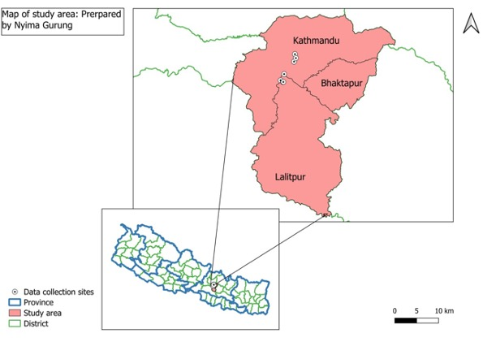
Fig 1: Map of study area

2.2 Study Duration and procedure
A cross-sectional study was conducted from June to October, 2024 with purposive sampling of the secondary blood report of infected dogs tested positive via rapid antibody test kit from different hospitals and clinics such as Animal Medical Center(AMC), Central Referral Veterinary Hospital(CRVH), Advanced Pet Hospital, Lifeline Veterinary Hospital, Jibachha Veterinary Hospital, Patan Veterinary Clinic were done.

2.3 Interpretation of result of rapid test kit
The presence of both C band and T band, no matter how faint the T band appears was considered as positive, whereas the kit with only clear C band was treated as negative and no colored band in C zone, no matter whether T band appears or not was invalid (Fig 2).
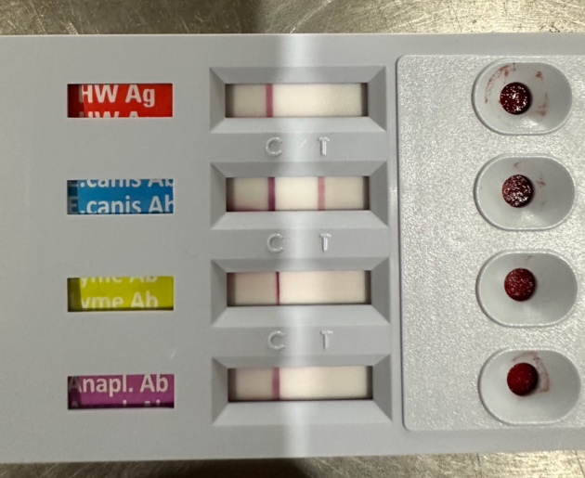
Fig 2: Rapid antibody test kit showing positive result

2.4 Sensitivity and specificity of rapid test kit
- The Antigen Rapid E. canis Ab Test Kit is a chromatographic immunoassay for the qualitative detection of Ehrlichia canis antibodies in canine whole blood, serum, or plasma.
- Working principle: Sandwich lateral flow immune-chromatographic assay.
- Sensitivity:97.6 % vs. Immunofluorescence Assay (IFA).
- Specificity:99.0 % vs. IFA

2.5 Statistical analysis
The data was entered and graphical representation was done in MS-Excel, 2010 and it was analyzed via Statistical Package for Social Science (SPSS) version 25.0 and MS-Excel, 2010 using unpaired t-test. p-value less than 0.05 was considered significant at confidence interval of 95%.

3. RESULTS AND DISCUSSION
3.1 Prevalence of E. canis according to breed
The incidence of E. canis was found to be highest in mixed breed (35.23%) followed by German shepherd (12.50 %), Spitz (15.91%), Golden retriever (6.82%), Mongrel (5.68%), Labrador and Lhasa apso (4.55%), Cocker and Tibetan mastiff (3.41%), and least infected breed were found to be Pug and Husky (2.27 %) shown in (Fig 3). A greater variation was found in the prevalence of E. canis which may be due to significant association between breeds (Harrus et al.,1997).The higher predisposition of German shepherd was in agreement with (Harrus et al. 1997). This might be due to low cell mediated immune response in these breeds as cell mediated plays important role in mitigating Ehrlichiosis (Nyindo et al.,1980).

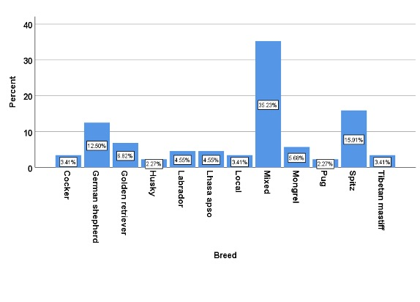
Fig 3: Bar graph showing incidence of E. canis according to breed
3.2 Prevalence of E. canis according to season
The highest 62.50 % incidence of E. canis was seen in monsoon followed by 30.68 % during spring and 12.50 % incidence in autumn season (Fig 4). The result was similar to that of Harrus et al., (1997); Kottadamane et al., (2017) and Singh et al. (2021). The higher incidence of E. canis might be due to seasonal activity of brown dog tick during monsoon season (Soulsby, 2012).

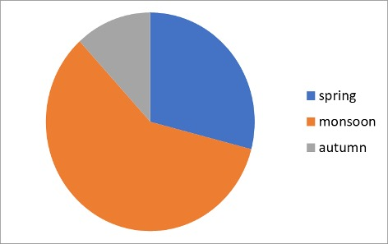
Fig 4: Pie- chart showing incidence of E. canis according to season
3.3 Prevalence of E. canis according to sex
As per the findings of the current study, female dogs (65%) and male dogs (35%) were infected with E. canis infection. (Fig 5). Female were more vulnerable to E. canis than that of male (fig 5) similar to that of Bhadesiya and Raval, (2015).
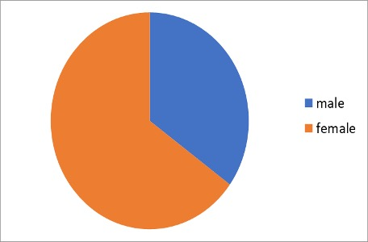
Fig 5: Pie- chart showing incidence of E. canisaccording to sex

3.4 Prevalence of E. canis according to age
Old age (more than 10 years) was less vulnerable than the young (0–5 years) and middle (6–10 years) age groups with 12.50%, 43.16% and 44.32 % respectively. Young and middle age group of dogs were more predisposed to E. canis than old dog similar to finding of Bhadesiya and Raval, (2015) whereas Harrus et al. (1997) and Bhatta et al. (2017) found E. canis in all age groups.

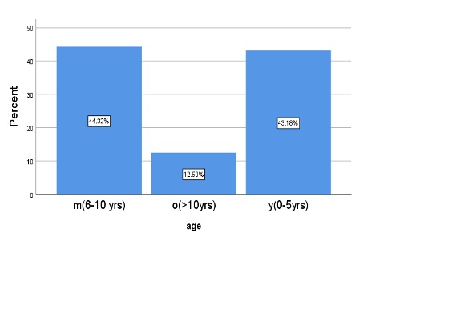
Fig 6: showing incidence of E. canis according to age
3.5 Haemato-biochemical parameters of E. Canis seropositive dogs
A marked alteration in haemato-biochemical parameters in seropositive dogs when compared withealthy one (Fig 7) was observed. PCV (31.22±8.62), haemoglobin (g/dl) 10.54±2.86 , total erythrocyte count(10¹²/L) 4.35±1.46 and thrombocyte count(K/μL) 191.48±87.38 were significantly low in seropositive dogs. Total leukocyte count(10⁹/L) was significantly increased (18.13±11.93). Neutrophil(%), Lymphocyte(%), Monocyte(%), Eosinophil(%) and Basophil(%) was observed to be 76.21±13.86, 18.48±9.83, 2.18±7.02, 1.75±1.61 and 0.54±1.10 respectively (Table 1). Hemoglobin, Packed Cell Volume (PCV) & total erythrocyte count were decreased similar to findings of Kottadamane et al. (2017), Sah, (2019), Singh et al. (2021), Bhadesiya and Raval, (2015), Bai et al.(2017) and Ratnalikar et al. (2022). These changes may be due to secondary immune mediated anemia (Blackwell’s five-minute veterinary consult: Canine and Feline, 2021). Because of bone marrow suppression (Harrus et al., 1997) and secondary immune mediated thrombocytopenia (Blackwell’s five-minute veterinary consult: Canine and Feline, 2021), thrombocyte count was decreased in E. canis seropositive dogs similar to findings of Gyawali et al. (2023), Kottadamane et al. (2017), Sah. (2019), Singh et al. (2021), Bhadesiya and Raval, (2015), Bai et al. (2017),Roopali et al. (2018), Parashar et al. (2016) and Yadav et al. (2017). In addition, significant low PCV, TEC, Hb, albumin, thrombocytes, calcium and significant increase in ALP, total serum bilirubin, direct bilirubin, BUN, creatinine and leukocytes indicates that haemogram can play a significant role in accurate diagnosis of E. canis when used along with other tools of diagnosis (Table 1).
The mean value of neutrophil, lymphocyte, monocyte, eosinophil and total protein was significant (Fig 8) at p- value(<0.05).

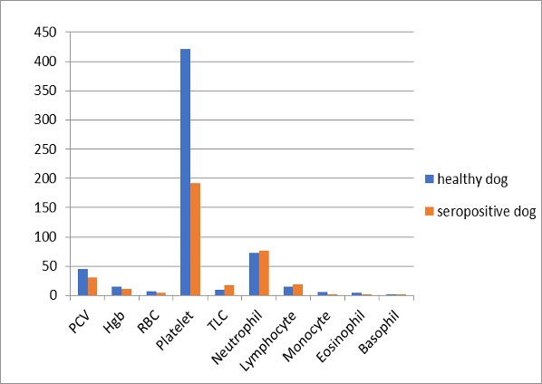
Fig7: Haematological alterations in seropositive dogs
Table 1: Haematological alternations in healthy and seropositive dogs
Hematological parameter | Reference range (Merck Veterinary Manual, 2016) | Healthy dog (Mean±S.D) | E. canis seropositive dogs (Mean±S.D) | p-value
 |  | 45.22±5.96 | 31.22±8.62 | P<0.05
  Packed cell volume(%)
  35-57
Haemoglobin (g/dl) | 11,9-18.9 | 15.27±1.92 | 10.54±2.86 | P<0.05
Total erythrocyte count(10¹²/L) | 4.95-7.87 |  |  | P<0.05
  6.47±0.86
  4.35±1.46
 | 211-621 | 421.30±127.99 | 191.48±87.38 | P<0.05
  Thrombocyte count(K/μL)
Total leukocyte count(10⁹/L) | 5.0-14.1 | 9.60±2.63 | 18.13±11.93 | P<0.05
Neutrophil(%) | 58-85 | 72.69±7.85 | 76.21±13.86 | P<0.05
 | 8-21 | 14.40±3.81 | 18.48±9.83 | P<0.05
  Lymphocyte(%)
Monocyte(%) | 2-10 | 5.80±2.35 | 2.18±7.02 | P<0.05
Eosinophil(%) | 0-9 | 4.64±2.56 | 1.75±1.61 | P<0.05
Basophil(%) | 0-1 | 0.48±0.28 | 0.54±1.10 | P>0.05
*significantp-value (0.05) at 95% confidence interval
3.6 Serum biochemistry of healthy and E. Canis dog
Various alteration were observed in biochemistry profile of seropositive dogs in the study when compared to healthy one (Fig 8) ALP (U/L) was increased significantly (208.88±250.66), total serum bilirubin (mg/dL) was increased significantly (0.32±0.60), whereas serum albumin (g/dL), was decreased significantly (2.37±0.79). In contrast to serum albumin, BUN and creatinine were increased in a significant manner with the value of 54.09±70.90 (mg/dL) and 2.24±3.29 (mg/dL) respectively. Calcium (dL) was found decreased significantly with the value of 5.34±2.61 (Table 2). ALP was increased significantly due to portal and acinar hepatitis (Table 2) caused by infiltration of inflammatory cells (Harrus et al., 1997) similar to results of Singhet al. (2021), Ratnalikaret al. (2022), Bai et al. (2017), Kottadamane et al. (2017), Harrus et al. (1997). Likewise, total serum bilirubin was signigicantly increased similar to findings of Singh et al. (2021) and Bai et al. (2017). Corresponding to findings of Kottadamane et al.(2017), Singh et al. (2021), Harrus et al. (1996), Harru set al. (1997), Gyawali et al. (2023), Ratnalikar et al. (2022), Yadav et al. (2017) serum albumin, in E. canisseropositve dogs, was decreased significantly because of myriad of causes like anorexia, decrease in protein uptake, blood loss and vasculitis (Harrus et al., 1996). In contrast to serum albumin, BUN and creatinine were increased significantly, as a result of glomerulonephritis due to deposition of anti-canine IgG and IgM antibodies (Harrus et al., 1997) and chronic nephritis due to infiltration of inflammatory cells(Harruset al., 1997) respectively, similar to results of Singhet al. (2021), Harrus et al. (1997), Ratnalikar et al. (2022), Roopali et al. (2018) andKottadamane et al., (2017), Harrus et al., (1997), Bhadesiya and Raval, (2015), Ratnalikar et al. (2022), Roopali et al. (2018). Due to hypoalbuminemia, causing reduction of protein bound calcium (Blackwell’s five minute veterinary consult, 2021) in E. canis seropositive dogs, calcium was decreased significantly resulting finding alike to Parashar et al. (2016). It may suggest that despite statistical significance, the observed difference mightn’t be clinically relevant .

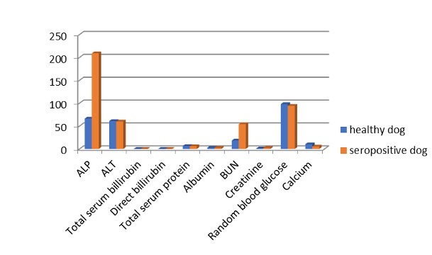
Fig 8: Serum biochemistry of healthy and E. canis dog
Table 2: Statistical analysis of biochemical alternations of seropositive dogs
Biochemical parameters | Reference value (Merck Veterinary Manual, 2016) | Healthy dog (MeanS.D) | E. cani sseropositive dog (Mean±S.D) | p-value
ALP(U/L) |  | 66.33±31.51 | 208.88±250.66 | P<0.05
  1-114
ALT(U/L) | 10-109 | 60.98±30.85 | 60.11±63.88 | P>0.05
Total serum bilirubin (mg/dL) | 0-0.3 | 0.15±0.11 | 0.32±0.60 | P<0.05
Direct billirubin (mg/dL) | 0-0.1 | 0.16±0.09 | 0.18±0.32 | P>0.05
Total protein(g/dL) | 5.4-7.5 | 6.41±1.49 | 5.97±0.60 | P<0.05
Albumin (g/dL) | 2.3-3.1 | 2.69±0.24 | 2.37±0.79 | P<0.05
Blood urea nitrogen(mg/dL) | 8-28 | 18.32±5.86 | 54.09±70.90 | P<0.05
Creatinine(mg/dL) | 0.5-1.7 | 1.10±0.35 | 2.24±3.29 | P<0.05
Calcium(mg/dL) | 9.1-11.7 | 10.35±0.75 | 5.34±2.61 | P<0.05
*Significant (p-value <0.05) at 95% confidence interval

4. CONCLUSION

This study showed marked alterations in haemato-biochemical parameters of E. canis seropositive dogs when compared to apparently healthy dogs. In addition, significant low PCV, TEC, Hb, albumin, thrombocytes, calcium and significant increase in ALP, total serum bilirubin, direct bilirubin, BUN, creatinine and leukocytes indicates that haemogram can play a significant role in accurate diagnosis of E. canis when used along with other tools of diagnosis.
The mean value of neutrophil, lymphocyte, monocyte, eosinophil and total protein was found to be within normal range but with significant p- value (<0.05). It may suggest that despite statistical significance, the observed difference mightn’t be clinically relevant.

Conflict of interest: Authors have no conflict of interest in this study.

Data set generated during research: All data was collected from different hospitals and clinics such as Animal Medical Center (AMC), Central Referral VeterinaryHospital(CRVH), Advanced Pet Hospital, Lifeline Veterinary Hospital, Jibachha Veterinary Hospital, Patan Veterinary Clinic
Disclaimer (Artificial intelligence)
Option 1:
Author(s) hereby declare that NO generative AI technologies such as Large Language Models (ChatGPT, COPILOT, etc.) and text-to-image generators have been used during the writing or editing of this manuscript.
Option 2:
Author(s) hereby declare that generative AI technologies such as Large Language Models, etc. have been used during the writing or editing of manuscripts. This explanation will include the name, version, model, and source of the generative AI technology and as well as all input prompts provided to the generative AI technology
Details of the AI usage are given below:
1.
2.
3.

REFERENCES

Acharya M and Dhakal S, 2015. Survey on street dog population in Pokhara valley on Nepal. Bangladesh J Vet Med, 13 (1): 65-70, DOI:10.3329/bjvm.v13i1.23722
Aziz MU, Hussain S, Song B,Ghauri HN, Zeb Jet al., 2023. Ehrlichiosis in Dogs: A Comprehensive Review about the Pathogen and Its Vectors with Emphasis on South and East Asian Countries. Vet Sci, 10(1):21.
Bai L, Goel P, Jhambh R, Kumar P and Joshi V.G, 2017. Molecular prevalence and haemato-biochemical profile of canine monocytic ehrlichiosis in dogs in and around Hisar, Haryana, India. J Parasitol Dis, 41:647–654. doi: 10.1007/s12639-016-0860-8.
Bhatta T, Acharya N, Prasad K and Thapa B, 2017. Prevalence of Blood Parasites in Hyperthermic Dogs of Kathmandu Valley, Nepal. Asian JAnim Vet Advances, 13(1); 67–72.
BullaC, Takahira RK, Aaujo JP, Trinca LA, Lopes RS etal., 2004. The relationship between the degree of thrombocytopenia and infection with Ehrlichiacanis in an endemic area. Vet Res, 35(1):141-146. doi: 10.1051/vetres:2003038.
ChawlaH,Katoch A, Sharma D, Wadhwa DR and Sharma A, 2020.Diagnosis and therapeutic management of ehrlichiosis Induced chronic kidney disease in dogs.VetPract, 21(1): 71-75.

de Castro MB, Machado RZ, de Aquino LP, Alessi AC, Costa MT, 2004. Experimental acute canine monocytic ehrlichiosis: clinicopathological and immunopathological findings.Vet Parasitol,19(1):73-86. doi: 10.1016/j.vetpar.2003.10.012.
DantasTF, Chomel BB and Otranto D, 2012. Ticks and tick-borne diseases: a One Health perspective. Trends Parasitol, 28(10); 437-446.
DíazRD, Agulla B, Piya B, FernándezRN, Villaescusa Aet al., 2020. Stray dogs in Nepal have high prevalence of vector-borne pathogens: A molecular survey. Parasites Vectors, 13(1):174. doi: 10.1186/s13071-020-04057-7.
FuentedLJ, Estrada-PA, Rafael M, Almazán C, Bermúdez Set al., 2023. Perception of Ticks and Tick-Borne Diseases Worldwide. Pathogens, 19;12(10):1258.
GyawaliCN, Gupta MP, Singh S and Poudyal RP, 2023. Study of Ehrlichiacanis in febrile dogs of Kathmandu valley of Nepal. Int J Vet Sci Anim Husbandry, 8(5): 227-235.
Harrus S, Kass PH, Klement E and Waner T, 1997. Canine monocytic ehrlichiosis: A retrospective study of 100 cases, and an epidemiological investigation of prognostic indicators for the disease. Vet Record, 141(14): 360–363.
Harrus S, Waner T, Avidar Y, Bogin E, Peh H and Bark H, 1996. Serum protein alterations in canine ehrlichiosis. Vet Parasitol, 66(3-4);241-9.
Harrus S andWaner T, 2013. Canine Monocytic Ehrlichiosis - From Pathology to Clinical Manifestations. Israel J Vet Med,68(1): 12-18.

Kottadamane MR, Dhaliwal PS, Singla LD, Bansal BK and Uppal SK, 2017. Clinical and hematobiochemical response in canine monocytic ehrlichiosis seropositive dogs of Punjab. Vet World, 10(2):255-261.
McDade JE, 1990. Ehrlichiosis--a disease of animals and humans. J Infect Dis, 161(4):609-17. doi: 10.1093/infdis/161.4.609.
Mylonakis, M. E., Harrus, S., & Breitschwerdt, E. B. (2019). An update on the treatment of canine monocytic ehrlichiosis (Ehrlichia canis). The veterinary journal, 246, 45-53.
Nyindo M, HuxsollDL, Ristic M, Kakoma I, Brown JL, Carson CA and Stephenson EH, 1980. Cell-mediated and humoral immune responses of German Shepherd Dogs and Beagles to experimental infection with Ehrlichiacanis. Am J Vet Res., 41(2):250-4. PMID: 6989300.
Parashar R, Sudan V, Jaiswal AK, Srivastava A and Shanker D, 2016. Evaluation of clinical, biochemical and haematological markers in natural infection of canine monocytic ehrlichiosis. J Parasit Dis., 40(4):1351-1354. doi: 10.1007/s12639-015-0688-7.
Ratnalikar VM, Kumar VVVA, Nagaraj P and Kumar BA, 2022. Clinical findings and hemato biochemical alterations in dogs affected with Ehrlichiacanis.Pharma Innovation J, 11(9): 820–824.
Roopali B, Roy M, and Roy S, 2018. Clinico, Haemato-Biochemical Changes and Therapeutic Management of Canine Babesiosis. Int J Current Microbiol Applied Sci, 7(08), 1384–1388. doi: https://doi.org/10.20546/ijcmas.2018.708.158
Sah JK, 2019. Prevalence and associated risk factor of Ehrlichiacanis in attenting clinical cases of pet dogs in different clinics and hospitals of Lalitpur district. Unpublished MSc. thesis, Tribhuvan University, Kathmandu, Nepal.
Schudel S, Gygax L, Kositz C, Kuenzli E and Neumayr A, 2024. Human granulocytotropic anaplasmosis-A systematic review and analysis of the literature. PLoSNegl Trop Dis, 18(8):e0012313. doi: 10.1371/journal.pntd.0012313.
Soulsby EJ, 2012. Helminths, arthropods, and protozoa of domesticated animals (7th ed.). Baillière Tindall, London, Affiliated East-West Press Private Limited.
WSPA, 2012. Street Dog Population Survey Kathmandu.https://animalnepal.files.wordpress. com/2013/09/dog-survey-kathmanduvalley-2012.pdf
Yadav J, Bihani DK, Ahuja A, Chahar A, Kashyap SK et al., 2017. Haemato-biochemical and therapeutic evaluation of canine monocytic ehrlichiosis. Vet Pract, 18(2):237-240.

