EVALUATION OF THE AGRICULTURAL PRODUCTIVITY OF THREE MAIZE VARIETIES (*ZEA MAYS*) AND THEIR ADAPTABILITY TO CLIMATIC CONSTRAINTS IN TOLLORÉ (MAYO REY, NORTH CAMEROON).

.

ABSTRACT

|  |
| --- |
| The aim of this study is to evaluate the adaptability of three improved maize varieties (CMS 8704, CMS 8501 and CMS 9015) at Tolloré in Northern Cameroon. Trials were set up at different planting periods (early sowing (ES), normal sowing (NS) and late sowing (LS)), using a Fischer block design with two replications. The different parameters observed concern agronomic parameters: germination, growth and yield. An analysis of variances was carried out and the Tukey test was applied to classify the variables. The results on field parameters revealed that (1) independently of the varieties, the best germination rates were obtained in late sowing, while the highest growth parameters and yields were obtained in normal sowing; (2) independently of the sowing periods, CMS 8704 presented the best germination rate, CMS 8501 stood out at the vegetative and flowering stages, while at maturity CMS 8704 obtained the best results. CMS 8501 has the best yield. The interaction between the sowing period and the variety shows that CMS 8704 is the variety best suited to the study area for normal and late sowing. These climate-intelligent cultivation practices could be resilience techniques to climate change and could contribute to the fight against food insecurity in order to increase maize productivity among producers with low levels of intensification. |

*Keywords****:*** *Climate change, North Cameroon, maize, agronomic parameters, adaptability*

1. INTRODUCTION

Climate change is one of the world's major concerns today because of its potential impact on the environment, and also because of its negative effects on agricultural production (ILO, 2023). Over the past few decades, populations have been running increased risks of food insecurity, not only because of population growth but also because of the effects of global warming due to greenhouse gases, with drought as a direct consequence (Dorenboos et al., 1980; Solorzano and Cárdenes, 2019; WFP, 2019; FAO, 2020). Maize (Zea mays L.) is the most widely grown crop in the world and the leading cereal produced, ahead of wheat (Tahir et al., 2009; Missihoun et al., 2012). It is a cross-pollinating plant in the Poaceae family. It accounts for 41% of global cereal production (wheat 40%; barley 9%) and covers 140 million hectares worldwide (Goalbaye et al., 2019). It directly or indirectly feeds 15-20% of humanity (FAO, 2002). In Cameroon, annual maize production contributes around 25 billion XAF to the country's economy and is a source of income for several cooperatives in farming areas (Ntsama, 2009; Bring and Moussa, 2019). However, despite the expansion of agricultural land in recent years due to population growth, demand for maize remains unsatisfied (Bring and Moussa, 2019; Alioum et al., 2020; Kyung-Hee and Byung-Moo, 2023). In addition, maize production has been severely affected by the effects of climate change, with a sharp drop in yield from 4t/Ha to 1.8t/Ha (Goalbaye et al., 2018). Faced with this thorny problem, leading to a risk of food insecurity, maize production requires a strategy for developing drought-resistant crops, i.e. maize capable of responding effectively to climate change (Nyembo et al., 2014; Alioum et al., 2020; Kyung-Hee and Byung-Moo, 2023). Climate change, which is characterized by high spatial and temporal variability in rainfall, has an impact on crop growth and yields (Alioum et al., 2020). With this in mind, Cameroon's Institute of Agricultural Research for Development (IRAD) has developed various maize varieties that are resistant to various climatic variation including draughts sensitivity and also to certain diseases. The aim of this study is to assess the agronomic performance of three maize varieties under different planting periods in the Sudano-Sahelian zone of Cameroon.

2. material and methods

**I.1 Material**

**I.1.1. Study site**

Tolloré is a village located 7 kilometers from Tcholliré, capital of the Mayo Rey department (North, Cameroon), covers an area of approximately 3 km² (Fig.1). The experimental site with the following geographical coordinates: N 08°43’734’’; E14°19'612‘’ and Alt 370 m. its covers 1hectares of superficies. Environment is characterized by predominantly shrubby vegetation. The area has a flat topography and generally stony soils. The main soil types encountered are ferruginous soils (Brabant and Gavaud, 1985). The hydrology of this village is characterized by a temporary stream. The climate is of the Sudano-Sahelian type, with two seasons of equal length. A dry season that lasts six months and is characterized by extreme harshness. A rainy season that also lasts six months, during which most of the rain falls between July and August (PCD, 2015). Annual rainfall is in the region of 1,300 to 1,500 mm. Rain truces are sudden and long. Temperatures vary between 17°C and 39°C, and rarely fall below 14°C. The highest temperatures occur in March, when the mercury rises to 45°C. The lowest temperatures, at 20°C, are recorded in December (PCD, 2015). Annual temperature variations are around 25°C (PCD, 2015). With climate variations, the prevailing winds that blow from North to South (Harmattan) seem to increase in speed. In recent years, these winds have caused enormous damages.

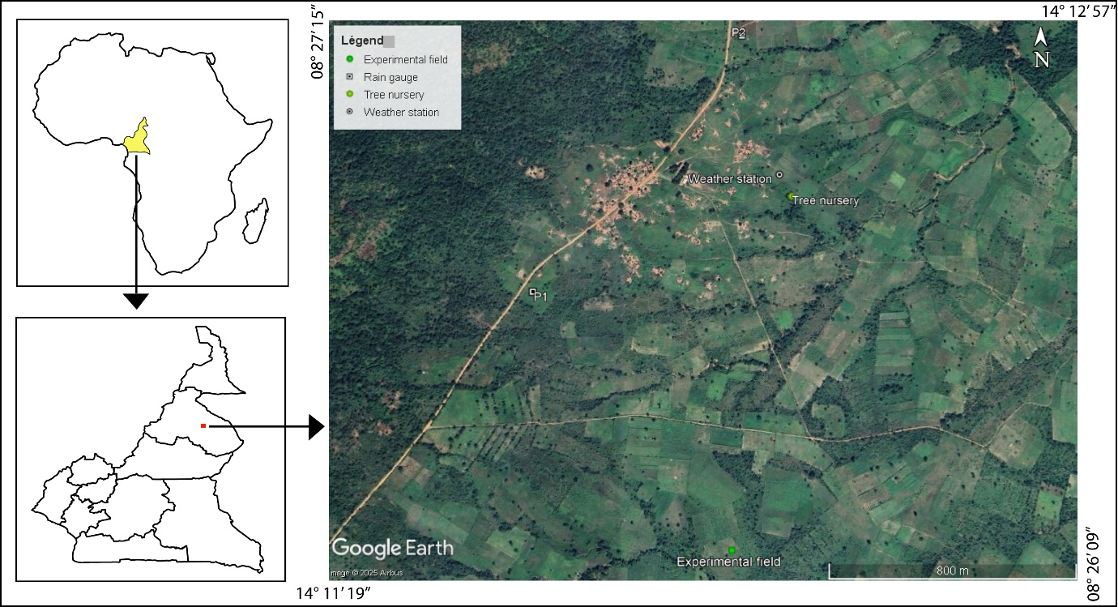

Figure 1: Location map of the study area

**II.1.2. Plant material**

The plant material used consists of three maize varieties developed by IRAD: CMS 8501 and CMS 8704 respectively developed in 1985 and 1987 with 110–115-day cycle; CMS 9015 (POOL16 DR-SR) developed in 1990 with 85–90-day cycle. These varieties were supplied by IRAD. According to the parameters catalogue of the corn varieties, their respective yields are 7 t/Ha (CMS 8501 and CMS 8704) and 4-5 t/Ha (CMS 9015). The respective colors of the cereals are white (CMS 9015 and CMS 8501) and yellow (CMS 8704). They are horny and toothed respectively, and are resistant to drought, disease, insect pests and stem borers (FAO, 2012).

**I.2 Methods**

**I.2.1. Crop management**

The trial was conducted using a Fischer block design with two replications. Two factors were studied: the genetic potential of each variety and crop performance during different planting period. The trials were set up in three planting periods (early, normal and late) which were 29 May, 29 July and 9 September respectively. These planting dates were determined based on the start of rains and the normal planting dates used by local farmers in the communities. The experimental plots were ploughed to a depth of 15-20 cm. To avoid any limiting factors, the seeds were treated with a mixture of insecticide and fungicide thioral (thiram and heptachlor). Sowing was carried out with 2 seeds in each plot, placed at a depth of around 5 cm, with a spacing of 70 cm between rows and 30 cm between plots. A first weeding was carried out 15 days after emergence and a second 30 days after the first, followed by regular maintenance every 2 weeks until maturation. The cereal complex fertilizer N, P, K (14- 23- 14) was applied as a base fertilizer in an equivalent quantity of 150 kg/ha, buried in the planting beds of each plant. Cover fertilizer (urea) was applied in two fractions at the 10-leaf stage and flowering, in equivalent quantities of 50 kg/ha and 30 kg/ha respectively. In addition, phytosanitary treatment was applied twice at early and normal sowing, but three times at late sowing, because of the resistance of weeds and pests. The surface area of the experimental plot is: 4 m x 3 m = 12 m2, the surface area of the experimental plot is: 4 m x 3 m = 12 m2, giving an area of 36 m x 15m = 640 m2 for all the experimental plots. A one-meter border was provided as a passage and another one meter between the blocks and then two meters between the micro plots (Fig. 2).

Figure2:Experimental set-up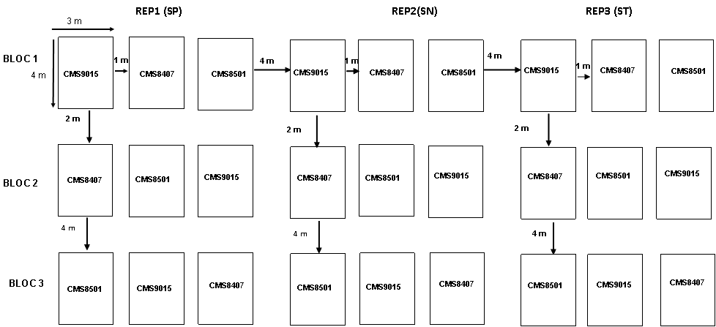

**I.2.2. Data collection and analysis**

* **Climatic parameters: rainfall**

Rainfall data were recorded on two rain gauges (P1 and P2) spaced 1 km apart and recorded in decades (ten days). In one month, three or four decades could be recorded. These rain gauges were installed during the 2023 cropping season by the INNOVACC (Innovation for Adaptation to Climate Change) project (2022). The data were collected when the trials were set up. Between the two rain gauges (P1 and P2), the trend is more or less the same, despite small differences. The climatic parameters considered include: start of rains, end of rains, number of rainy days, number of pockets of drought, the most and least rainy periods, etc.

* **Phenological, measured and calculated parameters**

Phenological observations in maize involve monitoring key developmental stages of the plant throughout its growth cycle, such as germination, leaf development, tassel initiation, silking (female flower emergence), pollination, kernel development, graining, and maturity, allowing farmers to optimize planting dates, irrigation, and harvest timing based on the specific growth stage and environmental conditions (Alioum et al., 2020; Kyung-Hee and Byung-Moo, 2023). Phenological observations on the three maize varieties and the different planting periods covered germination (or emergence), growth, flowering and graining. Here, while flowering signifies the release of pollen from the male tassel (the tassel stage), graining refers to the process of kernel development after pollination occurs when the female silks on the ear are fertilized by the pollen, essentially marking the start of grain formation. The number of days of the phenological stages of the maize crop were noted when 50% and 95% of the plants had reached these stages according to the method of Doorenbos and Kassam (1980), Karam et al. (2002) and Goalbaye (2014).

Data were collected on the following parameters: germination (germination rate) and growth parameters (stem length, root length, number of secondary roots) at different stages. Yield parameters were calculated.

Table 1 shows the observation and data collection periods.

**Table 1:** Observation dates for phenological parameters of different maize varieties according to planting

|  |  |  |  |
| --- | --- | --- | --- |
| **Phenological parameters** | **CMS 9015** | **CMS 8704** | **CMS 8501** |
| Planting period | t | t | t |
| Emergence date | t + 6 | t + 5 | t + 6 |
| Growth stage | t + 21 | t + 22 | t + 20 |
| Vegetative stage | t + 45 | t + 49 | t + 45 |
| Flowering stage | t + 60 | t + 60 | t + 60 |
| Fruiting stage | t + 75 | t + 80 | t + 75 |
| Ripening stage | t + 110 | t + 115 | t +90 |

The data collected was processed using Microsoft Excel and then analysed by ANOVA followed by a pairwise multiple comparison test, in particular the Tukey test, to classify the different variables using XLSTAT 2019.2.2.59614.

3. results and discussion

**II. RESULTS**

The various results obtained are shown in Table 2. The averages obtained for each variety per sowing period were compared (Tab. 3, 4 and 5).

**II.1 Rainfall**

Rainfall was recorded from 23 May (start of rains) to 23 November (end of rains). The rainfall recorded in the two rain gauges (P1 and P2) shows that the wettest month is September (Fig. 2). During the three decades (D11, D12 and D13), the rainfall recorded was high, especially at D13 (249 mm P1 and 258 mm P2, Fig. 2). However, significant rainfall was also recorded in June, during the 4th decade of the year (with 188 mm P1 and 191 mm P2); July at D5 (130 mm P1 and 152 mm P2) and August at D8 (130 mm P1 and 142 mm P2). The lowest rainfall was recorded in October at D 16 (0 mm P1 and 05 mm P2). This decade was also marked by o a pocket of drought with virtually no rainfall. Two other pockets of drought were observed in July (D6) and August (D9). November marks the end of the season in this area. For this reason, rainfall is low (D17 (14 mm P1 and 7mmP2), D18 (26mmP1 and 25 mmP2) (Fig.2), and in the third decade of the month, rainfall is nil, marking the end of the rains.

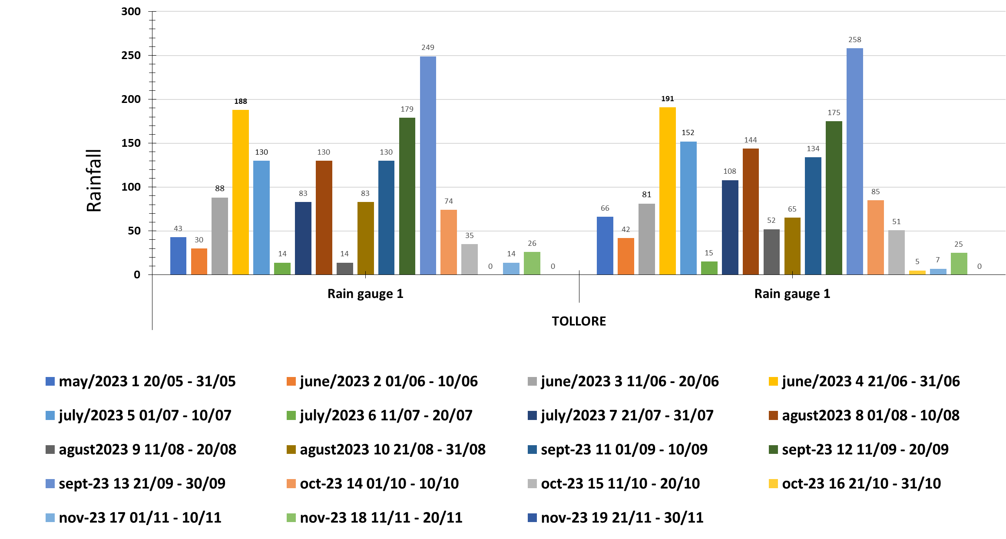

Figure 3. Rainfall in the study area (source: P1 and P2 weather stations, installed by INNOVACC).

**II.2 Germination kinetics**

The germination rate is the parameter taken into account.

**Early sowing**

The best germination rate was observed with CMS 8704, followed by CMS 9015. CMS 8501 has the lowest rate. The comparison between the different averages shows that there is a significant difference between these different varieties.

**Normal sowing**

CMS 8501 has the best germination rate. It is followed by CMS 8704 and then CMS 9015. The analysis of variance shows a significant difference between the different varieties.

**Late sowing**

CMS 8704 has the highest germination rate, followed by CMS 8501 and finally CMS 9015. Analysis of variance shows that there is a significant difference between the three varieties.

Regarding the germination rate, regardless of the variety, the best rate is obtained with late sowing, followed by normal sowing and finally early sowing (Tab. 6).

For varieties, regardless of the planting period, the best rate is obtained by CMS 8704, followed by CMS 8501 and 9015, whose germination rates are not significantly different (Tab. 7).

**II.3 Growth parameters**

The growth parameters taken into account here are stem length, root length and the number of secondary roots at the vegetative, flowering and maturity stages.

**Early sowing**

At the vegetative stage, CMS 8501 has the longest stem (70.25 cm), followed by CMS 8704 and finally CMS 9015. Analysis of variance shows that there is a significant difference between the different varieties. In terms of root length, CMS 8501 had the longest root, but there was no significant difference between the different varieties. The highest number of secondary roots was found on CMS 8501, followed by CMS 9015. There is a significant difference between the different varieties.

At the flowering and ripening stages, the highest values of the parameters vary between the different varieties. There is a significant difference between varieties for all parameters except root length at maturity.

**Normal sowing**

At the vegetative stage, the values for stem and root length were significantly different. The longest stem was observed in CMS 8501, while the longest root was observed in CMS 8704. The number of secondary roots was not significantly different between the different varieties. However, the highest value was observed in CMS 8704.

At flowering, there was no significant difference in stem length. The highest value was observed in CMS 8704. On the other hand, root length and the number of secondary roots showed significant differences. The longest root was measured in CMS 8501 and the highest number of secondary roots was observed in CMS 8704.

At maturity, all growth parameters show significant differences between varieties. CMS 8704 has the highest values for stem length, root length and number of secondary roots.

**Table 2:** Mean values of germination rate, growth components and yields

|  |  |  |  |  |  |  |  |  |  |
| --- | --- | --- | --- | --- | --- | --- | --- | --- | --- |
|  | **Early sowing** | | | **Normal sowing** | | | **Late sowing** | | |
|  | CMS 9015 | CMS 8704 | CMS 8501 | CMS 9015 | CMS 8704 | CMS 8501 | CMS 9015 | CMS 8704 | CMS 8501 |
| **Germination** | | | | | | | | | |
| Germination rate (%) | 89.89 | 91.41 | 77.02 | 83.08 | 92.17 | 95.20 | 90.65 | 97.47 | 92.17 |
| **Vegetative stage** | | | | | | | | | |
| Stem length (cm) | 59.25 | 64.25 | 70.25 | 180.25 | 173.25 | 182.25 | 183.25 | 167.25 | 174.25 |
| Root length (cm) | 1.65 | 1.77 | 1.95 | 31.15 | 32.55 | 30.45 | 29.85 | 30.65 | 32.25 |
| Number of secondary roots | 29.50 | 28.50 | 31.50 | 9.50 | 12.50 | 10.50 | 9.50 | 10.50 | 10.50 |
| **Flowering stage** | | | | | | | | | |
| Stem length (cm) | 150.50 | 130.50 | 130.50 | 190.50 | 191.50 | 190.50 | 190.50 | 201.50 | 201.50 |
| Root length (cm) | 34.75 | 38.75 | 42.75 | 42.75 | 32.95 | 33.75 | 20.08 | 21.85 | 20.77 |
| Number of secondary roots | 8.50 | 10.50 | 14.50 | 14.50 | 18.50 | 16.50 | 10.50 | 13.50 | 12.50 |
| **Fruiting and ripening stage** | | | | | | | | | |
| Stem length (cm) | 208.25 | 224.25 | 171.25 | 200.25 | 220.25 | 205.25 | 197.75 | 201.25 | 245.25 |
| Root length (cm) | 8.50 | 10.50 | 8.50 | 15.50 | 18.50 | 10.50 | 50.50 | 45.50 | 45.50 |
| Number of secondary roots | 59.50 | 44.50 | 44.50 | 59.50 | 59.50 | 44.50 | 64.50 | 71.50 | 59.50 |
| **Yields** | | | | | | | | | |
| Number of cobs per plant | 1.00 | 2.00 | 1.00 | 2.00 | 3.00 | 2.00 | 2.00 | 2.00 | 1.00 |
| Cobs length (cm) | 21.40 | 22.00 | 19.00 | 25.01 | 36.12 | 19.82 | 22.54 | 23.87 | 24.74 |
| Yield (t/Ha) | 0.21 | 0.02 | 0.30 | 0.35 | 0.26 | 0.47 | 0.24 | 0.38 | 0.30 |

**Table 3 :** Summary of the analysis of variances for early sowing

|  |  |  |  |  |  |  |  |  |  |  |  |
| --- | --- | --- | --- | --- | --- | --- | --- | --- | --- | --- | --- |
|  | **Germination Rate** | **Stem length (cm)** | **Root length (cm)** | **Nber of secondary roots** | **Stem length1 (cm)** | **Root length1 (cm)** | **Nber of secondary roots1** | **Stem length2 (cm)** | **Root length2 (cm)** | **Nber of secondary roots2** | **Yield (T/Ha)** |
| R² | 0.99403609 | 0.99691886 | 0.1956242 | 0.86153846 | 0.99719539 | 0.99417476 | 0.96137339 | 0.99987316 | 0.7804878 | 0.99502488 | 0.99683875 |
| F | 250.012933 | 485.333333 | 0.3648 | 9.33333333 | 533.333333 | 256 | 37.3333333 | 11824 | 5.33333333 | 300 | 472.996008 |
| Pr > F | 0.0005 | 0.0002 | 0.7214 | 0.0515 | 0.0001 | 0.0004 | 0.0076 | 0.000001 | 0.1028 | 0.0004 | 0.0002 |

**Table 4 :** Summary of the analysis of variances for normal sowing

|  |  |  |  |  |  |  |  |  |  |  |  |
| --- | --- | --- | --- | --- | --- | --- | --- | --- | --- | --- | --- |
|  | **Germination Rate** | **Stem length (cm)** | **Root length (cm)** | **Nber of secondary roots** | **Stem length1 (cm)** | **Root length1 (cm)** | **Nber of secondary roots1** | **Stem length2 (cm)** | **Root length2 (cm)** | **Nber of secondary roots2** | **Yield (T/Ha)** |
| R² | 0.99066209 | 0.99581979 | 0.92421691 | 0.86153846 | 0.47058824 | 0.99684419 | 0.91428571 | 0.99913536 | 0.97755611 | 0.99502488 | 0.996633 |
| F | 159.1356 | 357.333333 | 18.2933333 | 9.33333333 | 1.33333333 | 473.813333 | 16 | 1733.33333 | 65.3333333 | 300 | 444 |
| Pr > F | 0.0009 | 0.0003 | 0.0209 | 0.0515 | 0.3852 | 0.0002 | 0.0251 | 0.000025 | 0.0034 | 0.0004 | 0.0002 |

**Table 5 :** Summary of the analysis of variances for late sowing

|  |  |  |  |  |  |  |  |  |  |  |  |
| --- | --- | --- | --- | --- | --- | --- | --- | --- | --- | --- | --- |
|  | **Germination Rate** | **Stem length (cm)** | **Root length (cm)** | **Nber of secondary roots** | **Stem length1 (cm)** | **Root length1 (cm)** | **Nber of secondary roots1** | **Stem length2 (cm)** | **Root length2 (cm)** | **Nber of secondary roots2** | **Yield (T/Ha)** |
| R² | 0.97157756 | 0.99854487 | 0.94092938 | 0.47058824 | 0.99078813 | 0.89462148 | 0.86153846 | 0.99986623 | 0.9569378 | 0.98978434 | 0.99245599 |
| F | 51.2752 | 1029.33333 | 23.8933333 | 1.33333333 | 161.333333 | 12.7344 | 9.33333333 | 11212 | 33.3333333 | 145.333333 | 197.333333 |
| Pr > F | 0.005 | <0.0001 | 0.014 | 0.385 | 0.001 | 0.034 | 0.052 | <0.0001 | 0.009 | 0.001 | 0.001 |

**Late sowing**

At the vegetative stage, the values for stem and root length were significantly different. The longest stem and the longest root were observed in CMS 8501. The number of secondary roots was not significantly different between the different varieties. However, CMS 8501 and CMS 8704 had the highest value.

At flowering, stem length and root length show significant differences between varieties. The highest values were observed in CMS 8704. Although there were no significant differences in the number of secondary roots, the highest number was found in CMS 8704.

At maturity, all the parameters studied showed significant differences between the varieties. CMS 8501 has the tallest stem, while CMS 9015 has the longest root. As for the number of secondary roots, the highest number was found in CMS 8704.

At the vegetative and flowering stages, regardless of the variety, the best growth parameters are obtained with normal sowing, then late sowing and finally early sowing. At maturity, the best growth parameters are obtained with late sowing, followed by normal sowing and then early sowing (Tab. 6).

As for the varieties, regardless of the planting period, at the vegetative stage CMS 8501 recorded the best results, followed by CMS 8704 and finally CMS 9015. At the flowering stage, CMS 8501 and CMS 9015 gave the best results, followed by CMS 8704. Finally, at maturity, CMS 8704 obtained the best results, followed by CMS 9015 and CMS 8501 (Tab. 7).

**II.4 Yields**

**Early sowing**

In terms of efficiency, the CMS 8501 achieved the highest efficiency, followed by the CMS 9015. The CMS 8704 achieved the lowest efficiency. All the efficiency values obtained show a significant difference.

**Normal sowing**

The highest yield was observed in the CMS 8501, followed by the CMS 9015 and finally the 8704. There is a significant difference between the averages of the different varieties.

**Late sowing**

The highest yield was observed in CMS 8704, followed by CMS 8501 and finally CMS 9015. The analysis of variance shows that there is a significant difference between the yields of the different varieties.

The best yields, regardless of variety, are obtained for crops sown normally, followed by those sown late and finally those sown early (Tab. 6).

Regarding varieties, regardless of the planting period, the best yields are obtained with CMS 8501, followed by CMS 9015 and finally CMS 8704 (Tab. 7).

**Table 6:** Summary of pairwise multiple comparisons for planting periods

|  |  |  |  |  |  |  |  |  |  |  |  |
| --- | --- | --- | --- | --- | --- | --- | --- | --- | --- | --- | --- |
| **Planting periods** | **Germination rate** | **Stem length (cm)** | **Root length (cm)** | **Nber of secondary roots** | **Stem length1 (cm)** | **Root length1 (cm)** | **Nber of secondary roots1** | **Stem length2 (cm)** | **Root length2 (cm)** | **Nber of secondary roots2** | **Yield (T/Ha)** |
| NS | 90.150 b | 178.583 a | 31.383 a | 10.833 b | 190.833 b | 36.483 b | 16.500 a | 208.583 b | 14.833 b | 54.500 b | 0.355 a |
| LS | 93.430 a | 174.917 b | 30.917 b | 10.167 c | 197.833 a | 20.900 c | 12.167 b | 214.750 a | 47.167 a | 65.167 a | 0.302 b |
| ES | 86.107 c | 64.583 c | 1.790 c | 29.833 a | 137.167 c | 38.750 a | 11.167 c | 201.250 c | 9.167 c | 49.500 c | 0.175 c |
| Pr > F(Model) | < 0.0001 | < 0.0001 | < 0.0001 | < 0.0001 | < 0.0001 | < 0.0001 | < 0.0001 | < 0.0001 | < 0.0001 | < 0.0001 | < 0.0001 |
| Pr > F(Planting periods) | < 0.0001 | < 0.0001 | < 0.0001 | < 0.0001 | < 0.0001 | < 0.0001 | < 0.0001 | < 0.0001 | < 0.0001 | < 0.0001 | < 0.0001 |

ES: Early Sowing, NS: Normal Sowing, LS: Late Sowing

**Table 7:** Summary of pairwise multiple comparisons for varieties

|  |  |  |  |  |  |  |  |  |  |  |  |
| --- | --- | --- | --- | --- | --- | --- | --- | --- | --- | --- | --- |
| **Varieties** | **Germination rate** | **Stem length (cm)** | **Root length (cm)** | **Nber of secondary roots** | **Stem length1 (cm)** | **Root length1 (cm)** | **Nber of secondary roots1** | **Stem length2 (cm)** | **Root length2 (cm)** | **Nber of secondary roots2** | **Yield (T/Ha)** |
| V2 | 93.683 a | 134.917 c | 21.657 a | 17.167 a | 174.500 b | 31.183 b | 14.167 a | 215.250 a | 24.833 a | 58.500 b | 0.217 c |
| V3 | 88.130 b | 142.250 a | 21.550 a | 17.500 a | 174.167 b | 32.423 a | 14.500 a | 207.250 b | 21.500 b | 49.500 c | 0.352 a |
| V1 | 87.873 b | 140.917 b | 20.883 b | 16.167 b | 177.167 a | 32.527 a | 11.167 b | 202.083 c | 24.833 a | 61.167 a | 0.263 b |
| Pr > F(Model) | < 0.0001 | < 0.0001 | < 0.0001 | < 0.0001 | < 0.0001 | < 0.0001 | < 0.0001 | < 0.0001 | < 0.0001 | < 0.0001 | < 0.0001 |
| Pr > F(Varieties) | < 0.0001 | < 0.0001 | 0.009 | 0.024 | < 0.0001 | 0.0001 | < 0.0001 | < 0.0001 | < 0.0001 | < 0.0001 | < 0.0001 |

V1: CMS 9015, V2: CMS 8704, V3: CMS 8501

**Table 8:** Summary of pairwise multiple comparisons for planting periods*varieties

|  |  |  |  |  |  |  |  |  |  |  |  |  |
| --- | --- | --- | --- | --- | --- | --- | --- | --- | --- | --- | --- | --- |
| **Interactions** | **Germination rate** | **Stem length (cm)** | **Root length (cm)** | | **Nber of secondary roots** | **Stem length1 (cm)** | **Root length1 (cm)** | **Nber of secondary roots1** | **Stem length2 (cm)** | **Root length2 (cm)** | **Nber of secondary roots2** | **Yield (T/Ha)** |
| NS*V2 | 92.170 c | 173.250 e | | 32.550 a | 12.500 c | 191.500 b | 32.950 e | 18.500 a | 220.250 c | 18.500 c | 59.500 c | 0.255 e |
| LS*V2 | 97.470 a | 167.250 f | | 30.650 bc | 10.500 d | 201.500 a | 21.850 f | 13.500 cd | 201.250 f | 45.500 b | 71.500 a | 0.375 b |
| LS*V3 | 92.170 c | 174.250 d | | 32.250 a | 10.500 d | 201.500 a | 20.770 g | 12.500 d | 245.250 a | 45.500 b | 59.500 c | 0.295 d |
| NS*V3 | 95.200 b | 182.250 b | | 30.450 c | 10.500 d | 190.500 b | 33.750 d | 16.500 b | 205.250 e | 10.500 e | 44.500 d | 0.465 a |
| NS*V1 | 83.080 f | 180.250 c | | 31.150 b | 9.500 d | 190.500 b | 42.750 a | 14.500 c | 200.250 g | 15.500 d | 59.500 c | 0.345 c |
| LS*V1 | 90.650 de | 183.250 a | | 29.850 d | 9.500 d | 190.500 b | 20.080 h | 10.500 e | 197.750 h | 50.500 a | 64.500 b | 0.235 f |
| ES*V2 | 91.410 cd | 64.250 h | | 1.770 e | 28.500 b | 130.500 d | 38.750 b | 10.500 e | 224.250 b | 10.500 e | 44.500 d | 0.021 h |
| ES*V3 | 77.020 g | 70.250 g | | 1.950 e | 31.500 a | 130.500 d | 42.750 a | 14.500 c | 171.250 i | 8.500 f | 44.500 d | 0.295 d |
| ES*V1 | 89.890 e | 59.250 i | | 1.650 e | 29.500 b | 150.500 c | 34.750 c | 8.500 f | 208.250 d | 8.500 f | 59.500 c | 0.210 g |
| Pr > F(Model) | < 0.0001 | < 0.0001 | | < 0.0001 | < 0.0001 | < 0.0001 | < 0.0001 | < 0.0001 | < 0.0001 | < 0.0001 | < 0.0001 | < 0.0001 |
| Pr > F (Planting periods*Varieties) | < 0.0001 | < 0.0001 | | 0.0003 | 0.007 | < 0.0001 | < 0.0001 | 0.002 | < 0.0001 | < 0.0001 | < 0.0001 | < 0.0001 |

ES: Early Sowing, NS: Normal Sowing, LS: Late Sowing; V1: CMS 9015, V2: CMS 8704, V3: CMS 8501

**III. DISCUSSION**

**III. 1. Germination kinetic**

As the trials were carried out on a homogeneous plot, the germination rates obtained depend on the different varieties tested. The best germination rates were obtained with late sowing, followed by those obtained with normal sowing. This may be due to soil moisture content (Goalbaye et al., 2019 and Alioum et al). This implies that soil moisture was conducive to good seedling emergence. These results show that the amount of precipitated water and therefore the soil moisture content is of key importance for seedling emergence (Goalbaye et al., 2019; Bring and Moussa, 2019; Kyung-Hee and Byung-Moo, 2023).

**III.2 Growth parameters**

Plant growth during the experimental period showed a significant difference between varieties and as a function of sowing time, although a non-significant difference was observed between varieties at the flowering stage of normal sowing. These differences may influence profitability, since spikes with poor growth can produce small spikes, and the lower the spike height, the lower the number of grains. These results were reported by Tsinbigu et al, 2017. The behaviour of the three maize varieties sown at different times of the season also shows an edapho-climatic influence on plant growth. In fact, at the semi-early stage, only the varieties resistant to drought stress were able to grow well, despite the delay in rainfall and drought stress, as well as the incorporation of organic matter and fertilizer into the soil during this period. These results are in line with those of other authors (Fomeko and Ngon, 2011; Goalbaye, 2019; Tsinbigu, 2019 and Alioum, 2020). The relative humidity of the soil and the plant is lower, whereas in NS it is the height of the rainy season, the plants have enough water for their growth and the transfer of nutrients is accentuated because of the availability of transfer water. Adaptation to the consequences of climate change must be seen as an essential complement to the mitigation measures already underway. Climate variability has had a serious impact on crops, which is why yields have fallen in recent decades. Similar results have been obtained by several authors (Alioum et al., 2020; Housseini et al., 2020; Kyung and Byun, 2023). The consequences for plants growth include water stress, plant wilting, stunted growth, drought and heat stress, and rainfall variability (Housseini et al., 2020; Kyung and Byung, 2023).

**III.3 Yields**

Over the last decade, corn cultivation has tended to become a commercial crop. This production gap is all the more worrying as the corn yields obtained in farming areas remain low (1.5 to 2.6 tonnes/ha) and are generally 50% to 80% lower than the optimum yields easily accessible with the technologies available by research (Minader, 2006). Despite the difficulties and constraints linked to climate change (water stress, drought stress, etc.) (Alioum et al, 2020; Kyung and byung, 2023), the different varieties (CMS8704; CMS8501 and CMS9015) obtained an increasing yield, which varies from 0.29 to 4.57 t/ha. The frequency of extreme climatic events, the false starts of the rainy seasons, the recent floods, the recurrent droughts of which the study area is increasingly the victim, prove that climate change has ceased to be a strictly scientific question in which concerns the distant future of the planet to become a real and significant problem for current society (Bring and Moussa, 2019; PNACC, 2015, Housseini et al., 2020; Kyung and byung, 2023).

**III. 4 Interaction between varieties and planting periods**

Rainfall data at Tolloré show that the late-sown maize varieties CMS8501 and 9015 did not receive enough water for fruiting and seed ripening. However, semi-normal sowings (29 July) of all varieties showed favourable growth and fruiting. Early sowings (29 May) also had good emergence and average growth for CMS8405, thanks to rainfall: 43 - 66 mm at emergence and 130 to 144 mm during the ripening period (Doorenbos et, 1980; Ana and Iliana, 2019). On the other hand, yields were not high for early-sown maize because of the intensity of the rain during the ripening phase (July-August), when the seeds suffered more from rotting and regrowth on the cobs. In addition, the wind broke a third of the ears that were already in the fruiting stage. In fact, Ntsama Etoundi (2007) in his study on the adoption of the improved seed ‘CMS8704’ showed that this seed, which is adapted to southern Cameroon despite a high adoption rate from the 90 following the return to rural areas of dismissed civil servants and young people unable to find work. According to Holzkämper and Jürg, 2015, choosing heat- and drought-resistant varieties can also counter the risks inherent in the climate (Lunduka and al., 2019). Varieties that need heat can reduce the limiting effect of the climatic factor due to accelerated development. In addition, shifting the sowing date helps to take better advantage of the longer growing season (Torriani et al. 2007), and may even enable the planting of an additional summer crop. The results of this work also show that this variety is adaptable for the northern part of the country where the climate is Sudano-Sahelian and contrasting (Goalgaye, 2019). The stage of development of corn obtained agrees with those described by Akanvou et al., 2012 and identified in detail by Picard et al., (1985) according to which pedoclimatic conditions and genotypic characters have an influence on the development of crops.

4. Conclusion

The objective of the study was to evaluate the adaptability of three varieties of maize with interesting agronomic characteristics in Northern Cameroon, in a farming environment in the intelligent climate test field set up in Tolloré, in Mayo. Rey. These were the varieties CMS8704, CMS8501 and CMS9015. These seeds tested in three different planting periods (SP, SN and ST) behaved differently depending on their planting period. Indeed, in semi early, the variety CMS8501 had the highest yield, in semi normal, the variety CMS9015 and in semi late, CMS8704. However, if this method of staggered planting of all three varieties was adopted by farmers, it could be an alternative to food security.

Artificial Intelligence Disclaimer

We, the authors, hereby declare that NO generative AI technology such as large language models (ChatGPT, COPILOT, etc.) and text-image generators were used during the writing or editing of this manuscript.

References

Akanvou L., René A., Charles K.K., Hugues A.N. and Kouamé G.C.K. 2012. Agro morphological evaluation of millet accessions (Pennisetumglaucum (L.) R. Br.) collected in Côte d’Ivoire. Journal of Applied Biosciences, (50): 3468-3477.

Anjum S. E., Ashraf U., Tanveer M., Qamar R. and Khan I. (2014) Morphological and Phonological Attributes of Maize Affected by Different Tillage Practices and Varied Sowing Methods. American Journal of Plant Sciences, 5, 1657-1664. doi: http://dx.doi.org/10.4236/ajps.2014.511180

Alioum Paul Sounou, Jacques Djida Housseini and Tontsa Noelle Hortense Mafouasson, 2020. Performance of Drought-tolerant Varieties of Maize (Zea mays L.) under Water Deficit Stress Conditions in the North Region of Cameroon. Journal of Experimental Agriculture International 42(3): 64-73.

Ana Solorzano and Iliana Cárdenes. 2019. Social Protection and Climate Change: WFP Regional Bureau for Latin America and the Caribbean's Vision for Advancing Climate Change Adaptation through Social Protection. WFP: Social Protection and Climate Change 26: 1-50

P. Brabant and M. Gavau, "Soils and Land Resources in the North – Cameroon (North and Far North Provinces)", Maps, ORSTOM – MESRES – IRA, Paris, 46 (1985)103, 285.

Bring and Moussa Foupouapopouo Gnigni Mfendoun, 2019: Drought Conditions and Strategies in Cameroon. Initiative on "Support Capacity Development for National Drought Policy Management" (WMO, UNCCD, FAO, CDB and UNW-DPC). 9.

Doorenbos J., Kassam A.H., 1980. Yield Response to Water. Rome: Food and Agriculture Organization of the United Nations. FAO, Irrigation and Drainage Series, No. 33, 235 p. FAO (Food and Agriculture Organization of the United Nations), 2002. Maize in Tropical Zones: Improvement and Production: Its Effects. Green Policies and the Role of Employer and Business Organizations.

FAO, 2005. FAO Statistics. The Cereal Crisis. The Case of Maize, 5P.

FAO (2012). Catalogue of Species and Varieties of Food Crops of Community Interest.

Félicien FOMEKONG and Gislaine NGONO, 2011. Climate Change, Agricultural Production and Effects on Population in Cameroon. National Institute of Statistics, Cameroon. P1-4.

Goalbaye T., Guissé A., Ndiaye M., and Tissou M., 2013. Increasing Maize Productivity through the Improvement of Local Varieties in Chad. Int. J. Biol. Chem. Sci. 7 (5): 2019-2028.

GOALBAYE Touroumgaye, Mahbou SOMO TOUKAM G, Mariama Dalanda DIALLO, Bienvenu HINNONE KAPAGNON1, Aliou GUISSE, 2019. Evaluation of the agronomic performance of improved maize varieties (Zeamays L.) in a smallholder environment in the Sudanian zone of Chad. Journal of Animal & Plant Sciences (J. Anim.Plant Sci. ISSN 2071-7024) Vol. 41 (3): 6977-6988. https://doi.org/10.35759/JAnmPlSci.v41-3.2.

Holzkämper A., ​​Calanca P. & Fuhrer J., 2013. Identifying climatic limitations to grain maize yield potentials using a suitability evaluation approach. Agricultural and Forest Meteorology 168, 149–159.

Holzkämper A., ​​Fossati D., Hiltbrunner J. & Fuhrer J., 2015. Spatial and temporal trends in agro-climatic limitations to production potentials for grain maize and winter wheat in Switzerland. Regional Environmental Change 15 (1), 109–122.

Holzkämper Annelie and Jürg Fuhrer, 2015. Impacts of climate change on maize cultivation in Switzerland. Swiss Agricultural Research 6 (10): 440–447, 2015

IPCC, 2007. Climate Change 2007 – The Physical Science. Intergovernmental Panel on Climate Change, Geneva. 996 p.

Karam F., Breidy J., Rouphael J., Lahoud R., 2002. Water stress, physiological behavior, and yield of hybrid maize in Lebanon. Cahiers Agricultures, Vol. 11, No. 4, 285-91.

Kyung-Hee Kim and Byung-Moo Lee, 2023. Effects of Climate Change and Drought Tolerance on Maize Growth. Plants 2023, 12, 3548. 18p.

Lunduka RW, Mateva KI, Magorokosho C, Manjeru P. Impact of adoption of drought-tolerant maize varieties on total maize production in south Eastern Zimbabwe. Climate and development. 2019 Jan 2;11(1):35-46.

Missihoun A.A., Agbangla C., Adoukonou Sagbadja H., Ahanhanzo C., Vodouhè R. 2012. Traditional management and status of sorghum (Sorghum bicolor L. Moench) genetic resources in northwest Benin. International Journal of Biological

Chemical Sciences, 6, 1003-1018. Nyembo K., Mpundu M., Baboy L., 2014. Evaluation and selection of new maize (Zea mays L.) varieties with high yield potential in the climatic conditions of the Lubumbashi region, southeastern DRC. International Journal of Innovation and Applied Studies, 21-27.

ILO, 2023. Promoting business adaptation to climate change and mitigation

Picard D., Jordan M.O., Trendel R., 1985. Rhythm of appearance of primary roots of maize (Zeamays L.): 1. Detailed study for a variety in a given location. Agronomy 5 (8): PNACC, 2015. National Climate Change Adaptation Plan of Cameroon

Roy, S.K.; Cho, S.W.; Kwon, S.J.; Kamal, A.H.M.; Kim, S.W.; Oh, M.W.; Lee, M.S.; Chung, K.Y.; Xin, Z.; Woo, S.H. Morphophysiological and prote ome level responses to cadmium stress in sorghum. PLoS ONE 2016, 11, e0150431. [CrossRef]

Sabine Mireille NTSAMA ETOUNDI 2009. PhD. Student in Agricultural Economics at the University of Yaoundé II - Soa

Tahir M., Javed M.R., Tanveer A., ​​Nadeem M.A., Wasaya A., Bukhari S.A.H., Rehman J.U. 2009. Effect of different herbicides and weeds, growth and yield of spring planted maize (Zea mays L.) Pak. J. Life Soc. Sci., 7(2), 168-174.

Torriani D.S., Calanca P., Schmid S., Beniston M. & Fuhrer J., 2007. Potential effects of changes in mean climate and climate variability on the yield of winter and spring crops grown in Switzerland. Climate Research 34, 59–69.

Tshibingu, Théodore Tshilumba Mukadi, Maurice Mpoyi B., Benjamin Mutamba Ntatangolo, Dominique Kabongo Musenge, Meschack Ilunga Tshibingu, Judith Ngoie Kazadi, Dieudonné Ngoyi Nyembo, Theodore Munyuli Mushambani, 2017. Evaluation of the productivity of maize (Zea mays L.) under organic and mineral amendments in Lomami province, Democratic Republic of Congo. Journal of Applied Biosciences 109 : 10571-10579.

Anonymous. (2006). Parallels between tissue repair and embryo morphogenesis: A conceptual framework. Globalization and Health, 16(4). http://www.globalizationandhealth.com/content/1/1/14