Impact of Maritime Environmental Factors on the Deployment of Long-Term Evolution (LTE) Networks: A Case Study of the Forcados-Ogulagha Region of Delta State, Nigeria

.

ABSTRACT

|  |
| --- |
| This study investigates the impact of maritime environmental factors on the deployment of Long-Term Evolution (LTE) networks, focusing on the Forcados-Ogulagha region of Delta State, Nigeria. The research examines how different environmental conditions, such as sea state, atmospheric conditions, and terrain, affect LTE signal propagation. Data were collected over 18 months using Cluster Drive Testing (CDT) to capture various seasons and weather patterns. The results highlight the significant influence of environmental factors on LTE pathloss, with clear air conditions over freshwater showing the least attenuation, while wet air over saltwater presents the most challenging conditions for signal propagation. The combination of high humidity and the reflective nature of saltwater in the study location led to increased path-loss and reduced signal strength, making it the most challenging scenario for LTE network deployment either the saltwater surface causes multipath propagation, potentially affecting signal quality. This study provides valuable insights for optimizing LTE network deployment in maritime environments |

*Keywords: LTE Pathloss, Maritime Environment, Signal Propagation and Network deployment*

1. INTRODUCTION

The deployment of Long-Term Evolution (LTE) networks in maritime environments presents unique challenges, primarily due to the impact of environmental factors on signal propagation. LTE networks are designed to deliver high-speed internet and voice services, which depend heavily on accurate pathloss modelling. Pathloss, the attenuation of signal strength as it travels through space, is influenced by various environmental factors such as sea state, atmospheric conditions, and terrain (Rappaport, 2002). Maritime environments, with their dynamic sea surface, high humidity, and variable atmospheric conditions, introduce additional difficulties to LTE network deployment (Ogherohwo et al., 2017; Zhimwang et al., 2022).

It has been noticed that water acts as an obstruction to radio wave transmission. When water is in the transmission path, the radio wave will be redirected, reflected, and re-transmitted. These processes cause attenuation of the radio wave by absorbing its energy, and this behavior is most prominent in the VHF and UHF bands. However, for frequencies higher than 900 MHz, the direct absorption of energy by water molecules is already significant. This water absorption factor leads to infinite path loss at certain frequencies. This is caused by the behavior of water molecules as dipoles when subjected to electromagnetic waves, which causes them to collide and rotate in sync with the frequency of the electromagnetic field (Igbekele et al., 2019). The rotation of the molecules heats the water. If the frequency increases, the dipole rotation behavior becomes faster, resulting in higher energy absorption. Oxygen molecules also follow the electromagnetic wave field and similarly absorb energy from water molecules (Ogherohwo et al., 2018). This entire water absorption mechanism leads to path loss for radio waves at specific frequencies where the behavior of water and oxygen molecules becomes resonant. According to ITU in Recommendation ITU-R P.841-8: "The mobile radio wave can propagate above the water surface when the received field strength over the water is greater than that over reflecting land for the same distance from the transmitter." This is because there is less absorption above the water surface than the path across water (Igbekele et al., 2020; Zhimwang et al., 2021).

Additionally, reflection, which causes signal pathloss in the maritime terrain, is the process of incident energy impinging on a water surface and then being scattered in many different directions. This occurs from a water surface because of the different refractive indices of air and water. The Fresnel laws give the amount of energy reflected and transmitted at an interface and the angle at which the reflection occurs (Zhimwang et al., 2023).

The Forcados-Ogulagha region in Delta State has faced network interference over the years, resulting in various network challenges and a decline in user experience quality. This environment is a stretch of river that runs through Sagbama in Bayelsa State, Nigeria. It is part of the larger Niger and rises in the swampy lowlands that empty into the Gulf of Guinea. It is an important transportation route for the Niger Delta, connecting the region to the nearby port city of Warri. The river is one of the centers of offshore oil exploration activities and maritime fishing. These economic activities demand effective communication services to aid reliable communication between ship-to-ship, ship-to-shore, and person-to-person communication applications. However, the performance of the present broadband communication system in this region has not been fully optimized for maritime applications. One major setback is the signal interference due to ship movement and the presence of a path mixture of trees and water bodies. This interference from the terrain's heterogeneous nature, ship's movement, sea state, and atmospheric parameters such as humidity, temperature, atmospheric air pressure, and wind speed in no small measure has caused signal path loss in the region (Zhimwang et al., 2018; Anaka et al., 2021).

2. material and methods

**2.1. Experimental Sites**

The Forcados-Ogulagha River and the Escravos water in Delta State are the experimental sites for this study. To measure the signal strength, a total of eighty base transmission sites were surveyed, four maritime sites were chosen to symbolize a typical mixed-path ecosystem. The Warri-Burutu River is position number one, the Forcados-Ogulagha River is location number two, the Yokri-Ogidigbe River is location three, and the Escravos-Okerenkoko River is site four. The surroundings included shipyards, islands, extensive mangrove forests, freshwater and saltwater, and linear communities.

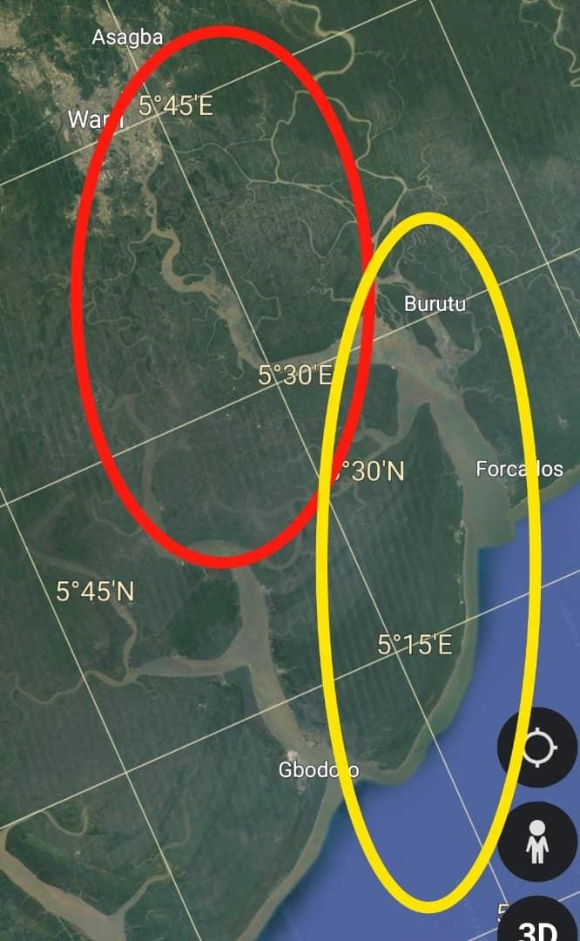 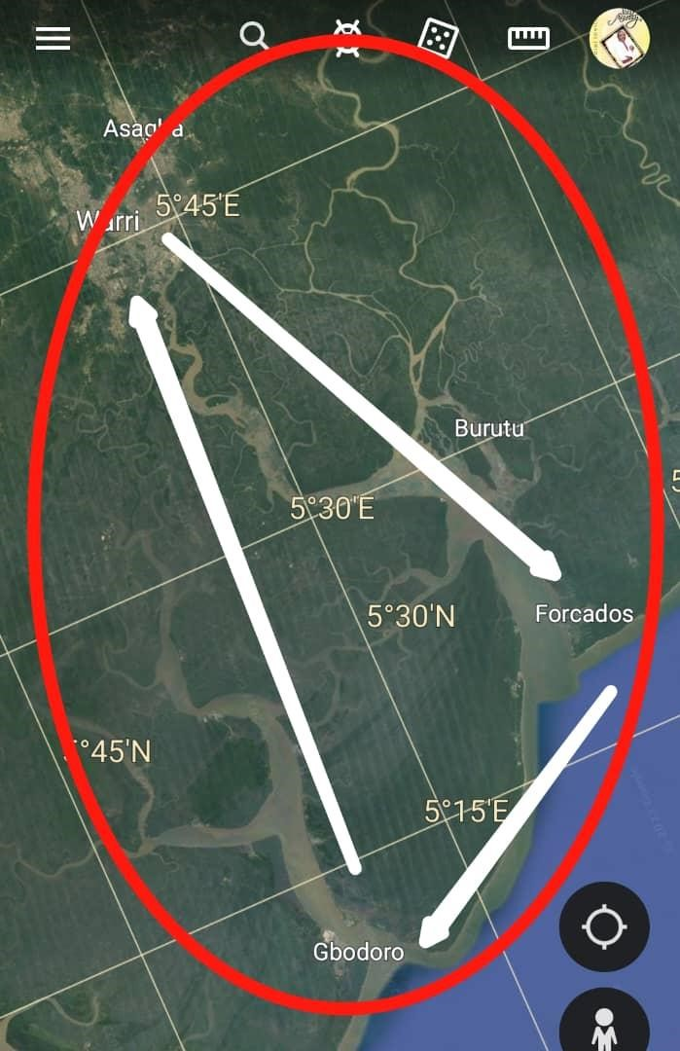

**Fig 1.** Fresh water and saltwater surveyed area **Fig 2.** Map of the direction of the surveyed routes

The survey was conducted in the Old Forcados River, covering a total distance of 172 km and an area of 1,542 km² bounded by latitude 50.151N and longitude 50.451E. The surveyed area is outlined in Fig 1, and the direction of the survey is depicted by arrows in Fig 2. Fig 1 also shows the regions covered by freshwater (red area) and salt water (yellow area). These areas are of interest due to their economic value and unique geographical and environmental conditions, which may impact network performance.

* 1. **Experimental Setup and Data Collection**

LTE signal receiving equipment, high gain directional antenna, a base station, and data logging devices for the recording of the received signal strength were used at each selected measurement location at every 0.02km along the river surface. Both the measuring instruments and the materials used for the study were organized to achieve a comprehensive experimental setup that enabled an efficient signal survey. This setup had two categories; the setup for signal propagation and the setup for the Drive Test (DT).

Data were gathered over 18 months to capture various seasons and weather patterns, including wet and clear air, using Cluster Drive Testing (CDT). The data collection period spanned from July 2022 to November 2023. The CDT survey took into account fluctuations in atmospheric parameters such as temperature, relative humidity, wind speed, and pressure. These atmospheric parameters, combined with the Received Signal Reference Power (RSRP), were measured based on the parameters in Table 1 at different times of the day (morning, afternoon, and evening). The study also factored in sea conditions by collecting data during strong and mild winds, which indicated rough and calm waters, in both freshwater and saltwater environments.

**Table 1.** Network Test Bed Parameters.

|  |  |
| --- | --- |
| Parameters | Values |
| Frequency (MHz) | 800 |
| Transmitter power (𝑃𝑡) (dBm) | 22 |
| Antenna transmitter gain (𝐺𝑡) (dBi) | 40.81 |
| Cable/connecting loss (𝐶𝑙) (dB) | 5 |
| Shadow fading (𝑆𝑓) (dB) | 5.4 |
| Thermal fade margin (𝑑𝐵) | 32.46 |
| Base station antenna height (m) | 34 |
| Height of mobile station (m) | 1.2 |
| EIRPdry air (dBm) | 33.81 |
| EIRPwet air (dBm) | 22 |

From the measured RSRP, signal loss values were calculated using (Rappaport, 2002 & Seybold, 2005):

PL(dB) = EIRP(dBm) − RSRP(dBm) (1)

where EIRP is the effective isotropic radiated power given as;

EIRP = Pt + Gr + Gt − Lt − Lr (2)

where 𝐺𝑟 and 𝐺𝑡 are the receiver and transmitter antenna gains, 𝐿𝑡 and 𝐿𝑟 are transmitter and receiver cable losses in dB and Pt is transmitter power.

3. results and discussion

Results were obtained under various maritime environmental factors such as fresh water clear air, fresh water wet air, salt water clear air and salt water wet air. This is to estimate how LTE network varies under such conditions

**FIGURE 1:** LTE Network received under Fresh water-clear air factor

Figures 1, 2, 3, and 4 show the effects of various maritime environment factors on LTE pathloss. Figure 1 illustrates the signal strength and pathloss characteristics of an LTE network operating over freshwater lakes under clear atmospheric circumstances. The absence of moisture and other meteorological disturbances may have resulted in low signal attenuation, resulting in improved network performance.

**FIGURE 2:** LTE Network received under Fresh water wet air factor

Figure 2 is for the LTE network received under fresh water wet air factor. This figure represents the LTE network performance over freshwater with high humidity or damp air conditions. Moisture in the air increases signal attenuation, resulting in higher path loss compared to clear air conditions. This resulted in a decrease in signal strength compared to Figure 1.

**Figure 3:** LTE Network received under Salt water clear air factor

Figure 3 is for LTE Network received under salt water with clear air factor. This demonstrates the unique challenges posed by the reflective and refractive properties of saltwater. While the air is clear, the saltwater surface can cause multipath propagation, potentially affecting signal quality.

**Figure 4:** LTE Network received under salt water wet air factor

Figure 4 is for the LTE Network received under the Saltwater wet air factor. This combines the effects of saltwater and wet air, which can significantly impact signal propagation. The combination of high humidity and the reflective nature of saltwater can lead to increased path and reduced signal strength, making it the most challenging scenario for LTE network deployment

4. Conclusion

The study found that marine environmental factors have a considerable impact on LTE network performance, with different effects depending on the kind of water and meteorological conditions. Freshwater locations with clean air provide the best conditions for LTE signal transmission, whereas saltwater situations with damp air provide the biggest impediments. These findings highlight the need of taking into account environmental conditions when designing and deploying LTE networks in marine environments. Future research should concentrate on constructing adaptive models that account for these characteristics in order to improve network reliability and performance in such demanding conditions.

**Disclaimer (Artificial intelligence)**

Option 1:

Author(s) hereby declare that NO generative AI technologies such as Large Language Models (ChatGPT, COPILOT, etc) and text-to-image generators have been used during writing or editing of manuscripts.

Option 2:

Author(s) hereby declare that generative AI technologies such as Large Language Models, etc have been used during writing or editing of manuscripts. This explanation will include the name, version, model, and source of the generative AI technology and as well as all input prompts provided to the generative AI technology

Details of the AI usage are given below:

1.

2.

3.

References

Anaka E.R., Zhimwang J.T., Shaka O.S. & E. P. Ogherohwo (2021). Modelling of the Rain Rate and Rain Attenuation for the Design of Line-of-Sight Link Budget over Warri, Delta State. *International Astronomy and Astrophysics Research Journal*. 3(3): 62-72

Igbekele O. J., Zhimwang J.T**.** and Ogherohwo E. P. (2019). Evaluation of propagation losses due to rain attenuated signal on terrestrial radio links over Jos, Plateau State Nigeria. *Physical science international journal*. 23(1). 1-8 https://doi.org/10.9734/PSIJ/2019/v23i130140

Ikeda, N., Murakami, K., & Saito, H. (2006). Pathloss and signal strength modeling in maritime environments. *IEEE Transactions on Antennas and Propagation*, 54(5), 1424-1433.

J. T. Zhimwang, E. P. Ogherohwo, A. A. Alonge, A. O. Ezekiel and S. O. Samuel, (2023). Effect of the Variation of Atmospheric Refractive Index on Signal Transmission for Digital Terrestrial Television in Jos, Nigeria, *2023 IEEE AFRICON, Nairobi, Kenya*, pp. 1-4, http://dx.doi.org/10.1109/AFRICON55910.2023.10293714

J. T. Zhimwang, E. P. Ogherohwo, D. D. Iliya, Ibrahim Aminu and O. S. Shaka (2021). Measurement and Prediction of Received Signal Level and Path Loss through Vegetation. *Asian Journal of Research and Reviews in Physics*. 4(4): 13-18 https://doi.org/10.9734/AJR2P/2021/v4i430148

J.T. Zhimwang, Shaka Oghenemega Samuel, Frank Lagbegha-ebi Mercy, Ibrahim Aminu, and Yahaya Yunisa, (2022). Analysis of Frequency and Polarization Scaling on Rain Attenuated Signal of a KU-Band Link in Jos, Nigeria. *Int. J. Advanced Networking and Applications*. 14(1). https://doi.org/10.35444/IJANA.2022.14111

Liu, S., Wang, X., & Zhang, J. (2015). Machine learning for signal propagation modeling and optimization. *IEEE Communications Surveys & Tutorials*, 17(2), 929-945.

O. J. Igbekele1, B. J. Kwaha, E. P. Ogherohwo and J. T. Zhimwang (2020). Performance Analysis of the Impact of Rain Attenuated Signal on Mobile Cellular Terrestrial Links in Jos, Nigeria. *Physical science international journal*. 24(1). 14-26. https://doi.org/10.9734/PSIJ/2020/v24i130170

O. J. Igbekele1, E. P. Ogherohwo, B. J. Kwaha, and J. T. Zhimwang (2019). Assessment of the impact of durable rain propagation losses on mobile cellular terrestrial links in Jos. *African Journal of Natural Sciences*. 22. 71-78

Ogherohwo E. P., **J. T.** Zhimwang and Ibrahim Aminu (2017). Analysis of satellite transmission losses due to tropospheric irregularities in Guinea Savannah region of Nigeria. *FUPRE Journal* *of Scientific and Industrial Research*. 1(1).9.

Ogherohwo E. P., **J. T.** ZhimwangandIgbekele O. J (2018). Impact of cloud on free space optical signal in Guinea Savannah region of Nigeria. *Nigerian Journal of Physics* (NJP). 27(1). 10

Parsons, J. D. (2000). *The Mobile Radio Propagation Channel*. Wiley.

Rappaport, T. S. (2002). *Wireless Communications: Principles and Practice*. Prentice Hall.

Wang, X., Yang, J., & Li, M. (2009). The WINNER II channel model: Overview and implementation. *IEEE Transactions on Wireless Communications*, 8(6), 3051-3061.

Zhimwang J., T**.**, E., P. Ogherohwo, Agbalagba O. E., Yemi S. O., Shaka O. S., Ibrahim A., and Mamedu C. E. (2023). Nigeria Digital Terrestrial Television Broadcasting: An Evaluation of the Transmitted Signal received under different environmental features in North-Central Region. *Int. J. Advanced Networking and Applications*, 14(6), 5722 – 5726. https://doi.org/10.35444/IJANA.2023.14609

Zhimwang J.T.,Ogherohwo E. P. and Igbekele O. J. (2018). Estimation of the long-term propagation losses due to rain on microwave links over Jos, Nigeria. *FUPRE Journal* *of Scientific and Industrial Research.* 2(2), 14