Case Report

Expanding the Spectrum of Hay–Wells Syndrome: A Trichoscopic Perspective

ABSTRACT

|  |
| --- |
| **Aims:** Hay–Wells syndrome (ankyloblepharon–ectodermal dysplasia–clefting or AEC syndrome) is a rare autosomal dominant disorder caused by TP63 mutations, classically associated with skin, hair, nail, and craniofacial anomalies. Although hair abnormalities are commonly reported, their trichoscopic features remain largely undocumented. We aim to describe, for the first time, the detailed trichoscopic findings observed in a genetically confirmed case of AEC syndrome and to discuss their diagnostic relevance in differentiating this condition from other genodermatoses with overlapping phenotypes.  **Presentation of Case:** We report the case of a 13-year-old girl with genetically confirmed AEC syndrome who presented with progressive hair thinning and breakage. Clinical examination revealed sparse, coarse hair, partial eyebrow and eyelash loss, and nail abnormalities. Trichoscopic evaluation revealed multiple hair shaft anomalies—including pili torti, pili annulati, pseudo-monilethrix, and trichorrhexis nodosa—as well as scalp changes such as peripilar hyperkeratosis and honeycomb-like pigmentation. While these features are not exclusive to AEC syndrome, their recognition in a suggestive clinical context may support early suspicion and guide further evaluation.  **Discussion:** This is, to our knowledge, the first reported case of AEC syndrome with such a broad trichoscopic characterization. The diversity of findings supports the presence of intrinsic structural hair shaft defects in TP63-related ectodermal dysplasias. Moreover, certain features—such as pili annulati and peripilar hyperkeratosis—not previously described in this context, may offer additional diagnostic value.  **Conclusion:** This case expands the trichoscopic profile of AEC syndrome, supporting the hypothesis of intrinsic follicular structural defects. Trichoscopy may serve as a valuable diagnostic tool in differentiating AEC from other ectodermal dysplasias and in guiding genetic evaluation. |

*Keywords: Hay–Wells syndrome; Ankyloblepharon–ectodermal dysplasia–clefting syndrome; Trichoscopy; Hair disorder; Pediatric hair disease;*

1. INTRODUCTION

Hay–Wells syndrome, also known as ankyloblepharon-ectodermal dysplasia-clefting (AEC) syndrome, is a rare autosomal dominant disorder within the ectodermal dysplasia spectrum. Caused by pathogenic variants in the TP63 gene, it is classically defined by the triad of ankyloblepharon filiforme adnatum, cleft lip and/or palate, and variable ectodermal anomalies affecting the skin, teeth, nails, and hair. While hair abnormalities have been reported in AEC syndrome, they remain poorly characterized in the literature—particularly from a trichoscopic perspective.

The diagnosis of AEC can be challenging, especially during early infancy, due to overlapping features with other genodermatoses and ectodermal dysplasias such as Rapp–Hodgkin syndrome, ectrodactyly-ectodermal dysplasia-clefting (EEC) syndrome, Clouston syndrome, and Netherton syndrome. In such contexts, trichoscopy may serve as a valuable, noninvasive tool by revealing specific hair shaft features that can guide clinical suspicion prior to genetic confirmation.

We report a case of AEC syndrome with detailed trichoscopic assessment, revealing a wide range of hair shaft abnormalities. By focusing on appendageal features, this observation offers new insights into the clinical spectrum of TP63-related ectodermal dysplasias and underscores the potential role of trichoscopy in their diagnostic evaluation.

2. Case Presentation

A 13-year-old girl with a history of surgically corrected cleft palate and ankyloblepharon filiforme adnatum was diagnosed with Hay–Wells syndrome by pediatricians, following the identification of a heterozygous missense mutation in the TP63 gene (exon 14).

She presented to the dermatology department with slowly progressive hair thinning and increased breakage upon combing. Clinical examination revealed facial dysmorphism, including a flattened midface, along with hypodontia, eyelid swelling, and right-sided ectropion. Examination of the skin appendages revealed sparse, coarse scalp hair predominantly affecting the mid-scalp and vertex, reduced eyebrow density, and partial eyelash loss. Nail abnormalities were also noted, including pterygium formation and anonychia (Fig. 1).

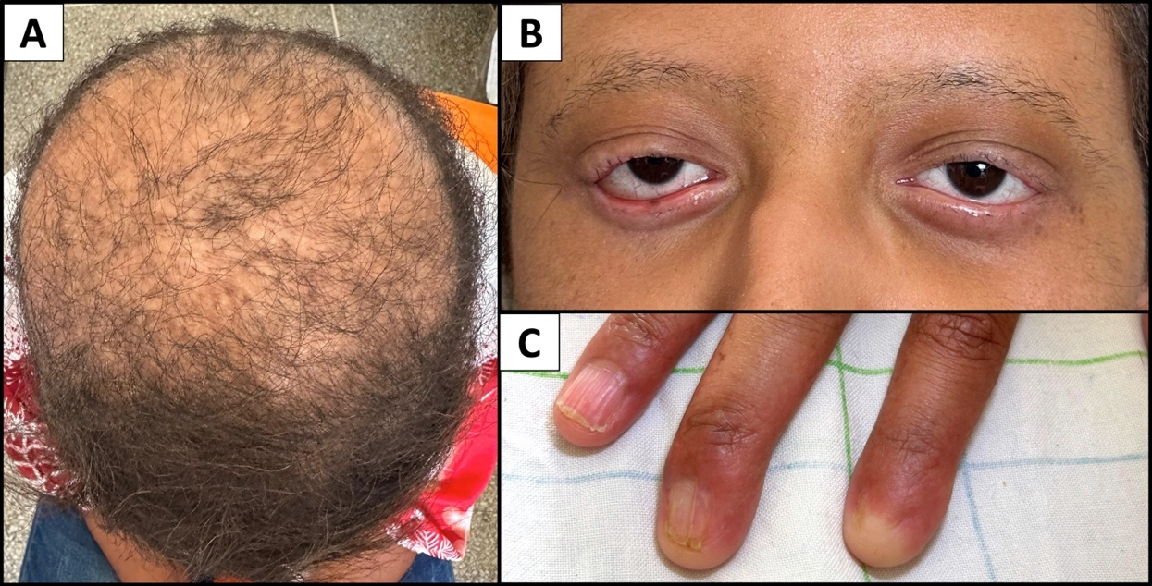

**Fig. 1. Ectodermal manifestations of Hay-Wells syndrome: (A) sparse eyebrows and eyelashes with swollen eyelids and right-sided ectropion (B) sparse and coarse hair on the mid-scalp and vertex; (C) nail abnormalities: pterygium and anonychia.**

Trichoscopic examination of the scalp, eyebrows, and eyelid margins revealed multiple hair shaft abnormalities. Pili torti appeared as flattened and irregularly twisted hair shafts. Monilethrix-like changes were observed in the form of periodic constrictions, frequently interrupted by fractures at the narrowed segments. Pili annulati presented as alternating light and dark bands along the hair shaft, while trichorrhexis nodosa was seen as segmental splitting into frayed, brush-like fibers.

Additional trichoscopic findings included numerous hypopigmented hairs, peripilar hyperkeratosis, and focal loss of follicular openings, consistent with areas of scarring alopecia. The interfollicular background displayed a honeycomb pigment network, suggestive of chronic scalp involvement (Fig. 2).

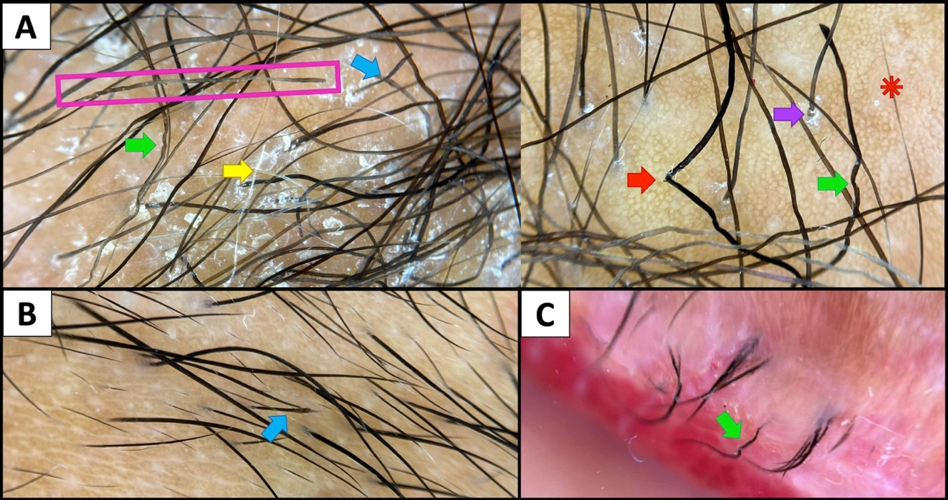

**Fig. 2. Trichoscopy in Hay-Wells syndrome on the scalp (A), eyebrow (B), and eyelid margin (C), revealing multiple hair shaft anomalies: pili torti (green arrows), pseudomonilethrix features (blue arrows), pili annulati (pink rectangle), and trichorrhexis nodosa (red arrow). Additional findings include hypopigmented hairs (yellow arrow), perifollicular scaling (purple arrow), and focal atrichia with honeycomb-like pigmentation (red asterisk).**

The patient’s management focused primarily on symptomatic relief and long-term monitoring. Her parents were counseled regarding the nature of the disease, its prognosis, and the importance of ongoing care. Regular application of emollients was recommended to maintain skin barrier function, along with intermittent use of topical tacrolimus on active lesions under dermatologic supervision. She was also referred for multidisciplinary follow-up to allow early detection of any associated systemic involvement.

3. discussion

Hay–Wells syndrome, also known as ankyloblepharon–ectodermal dysplasia–clefting (AEC) syndrome, belongs to the group of TP63-related ectodermal dysplasias, which includes overlapping entities such as Rapp–Hodgkin syndrome (RHS), ectrodactyly–ectodermal dysplasia–clefting (EEC) syndrome, and limb–mammary syndrome (LMS). These syndromes share varying degrees of cutaneous, hair, nail, and craniofacial anomalies, often making early clinical differentiation challenging [1].

Scalp erosions are among the hallmark features of AEC syndrome. They typically present in the neonatal period and frequently evolve into scarring alopecia. Residual hair is commonly described as sparse, brittle, or wiry [2]. Microscopic examination of hair shafts has revealed characteristic anomalies, including loss of pigmentation, pili torti — flat, twisted shafts rotated 180° along their axis at irregular intervals, and pili canaliculi, defined by longitudinal grooves along the hair shaft surface [2-4].

Trichoscopy offers a rapid, non-invasive method for evaluating these anomalies and can serve as a valuable adjunct to clinical assessment. While pili canaliculi are generally difficult to visualize using dermoscopy, other features—such as pili torti and hypopigmented hairs—are readily detectable and may help raise suspicion for an underlying ectodermal dysplasia [3-5].

To date, only one case of Hay–Wells syndrome in the literature has included trichoscopic examination, with hypopigmented hairs as the only documented finding [6]. To our knowledge, the present case is the first to describe a broader spectrum of trichoscopic features in AEC syndrome, including pili torti, pili annulati, pseudo-monilethrix, trichorrhexis nodosa, peripilar hyperkeratosis, and honeycomb-like pigmentation. These findings further support the hypothesis of intrinsic follicular structural defects in AEC syndrome [7]. Nevertheless, larger series are needed to determine the specificity and diagnostic utility of these trichoscopic features.

Trichoscopy may also help distinguish AEC syndrome from other conditions with overlapping phenotypes, whether within the TP63-related ectodermal dysplasia spectrum or among other forms of ectodermal dysplasia and genodermatoses.

Rapp–Hodgkin, EEC, and limb–mammary syndromes share with AEC the same causative gene (TP63) and similarly present with sparse, brittle, or wiry hair. Several other inherited disorders—including Clouston, Netherton, Menkes, Bjornstad, and trichorhinophalangeal syndromes—may exhibit comparable hair abnormalities, despite distinct genetic backgrounds and associated manifestations [3,5].

In such contexts, trichoscopy can unveil distinctive hair shaft anomalies that serve as supportive diagnostic clues, particularly in early or subtle presentations. While findings such as pili torti or trichorrhexis nodosa may be nonspecific [5], others carry greater diagnostic weight: pili canaliculi is highly suggestive of TP63-related dysplasias (AEC, EEC, RHS) [8–10], pili bifurcati is characteristic of Clouston syndrome [12], and trichorrhexis invaginata is typical of Netherton syndrome [13]. Notably, the presence of pili annulati and peripilar hyperkeratosis in our case—features not described in the differential diagnoses mentioned above—could also represent an additional argument supporting the diagnosis of AEC. A comparative overview of the clinical and trichoscopic features of AEC and its differential diagnoses is outlined in Table 1 [8–16].

|  |  |  |  |  |  |
| --- | --- | --- | --- | --- | --- |
| **Syndrome** | **Mutated Gene** | **Clinical Hair Features** | **Eyelash -Eyebrow Involvement** | **Trichoscopic / Microscopic Hair Shaft Anomalies** | **Main Associated Features** |
| **Ectodermal Dysplasias (ED)** | | | | | |
| **AEC** [8] | TP63 | - Scalp erosions  - Scarring alopecia  - Sparse hair  - Coarse, wiry hair | Yes | - Pili torti  - Pili canaliculi  - Hypopigmented hairs  - Pseudomonilethrix  - Trichorrhexis nodosa  - Pili annulati  - Peripilar hyperkeratosis,  - Honeycomb pigmentation | Ankyloblepharon,  cleft lip/palate, hypodontia, hypohidrosis**, dystrophic nails** |
| **EEC** [9] | TP63 | - Sparse hair (non-scarring alopecia)  - Dry, coarse hair | Eyebrows: Yes  Eyelashes: No | - Pili torti  - Pili canaliculi  - Monilethrix-like nodes  - Hair color heterogeneity | Ectrodactyly, cleft lip/palate, hypodontia; No ankyloblepharon or scalp erosions |
| RHS[10] | TP63 | - Patchy non-scarring alopecia  - Sparse hair  - Wiry, dry hair | Eyebrows: Yes  Eyelashes: No | - Pili torti  - Pili canaliculi  - Hypopigmented hairs | Cleft lip/palate, hypohidrosis, conical teeth, nail dystrophy |
| **LMS** [1] | TP63 | - Sparse hair (non-scarring alopecia)  - Brittle hair | No | Not characterized | Hypoplastic nipples, syndactyly or split-hand malformations |
| **HED** [11] | EDA, EDAR, EDARADD | - Sparse hair  - Delayed hair development | Yes | - Trichorrhexis nodosa  - Pili torti  - Irregular hair shaft diameter  - Hair color heterogeneity | Hypohidrosis, dental agenesis, periorbital wrinkling, frontal bossing |
| **Clouston Syndrome** [12] | GJB6 | - Progressive non-scarring alopecia  - Brittle, thin and pale hair | Yes | - Trichorrhexis nodosa  - Trichoptilosis  - Pili bifurcati  - Irregular helical twist | Nail dystrophy, palmoplantar keratoderma, normal sweating and dentition |
| **Non-ED Genodermatoses** | | | | | |
| **Netherton Syndrome** [13] | SPINK5 | - Short, dull and brittle hair | Yes | - Trichorrhexis invaginata  - Golf tee hairs  - Matchstick hairs  - Rarely: pili torti, trichorrhexis nodosa | Ichthyosis linearis circumflexa, Ichthyosiform erythroderma, atopic diathesis |
| **Menkes Disease** [14] | ATP7A | - Kinky hair: hard to comb, breaks easily | Variable | - Pili torti  - +/- trichorrhexis nodosa | Facial dysmorphism hypotonia, seizures |
| **Bjornstad Syndrome** [15] | BCS1L | - Sparse hair  - Brittle hair | Variable | - Pili torti | Sensorineural hearing loss, hypogonadism |
| **TRPS** [16] | TRPS1 | - Frontal alopecia - Fine, sparse hair | Yes  (Lateral loss) | - Trichorrhexis nodosa - Trichoptilosis - Distal shaft thinning | Pear-shaped nose, cone epiphyses, short stature |

**Table 1. Genodermatoses with Overlapping Trichologic Features: A Comparison of Genetic, Clinical, and Trichoscopic Characteristics.**

4. Conclusion

this case adds new trichoscopic insights into Hay–Wells syndrome, broadening the range of hair shaft features associated with this rare entity. The detection of multiple structural anomalies reinforces the notion of an intrinsic follicular defect in AEC syndrome.

We recommend incorporating trichoscopy as a first-line diagnostic tool in cases of sparse or brittle scalp hair or eyebrows in the pediatric population, and whenever an ectodermal dysplasia is suspected, as it may enhance early recognition, guide differential diagnosis, and support the decision to pursue targeted genetic testing.

**CONSENT**

All authors declare that written informed consent was obtained from the patient’s parent and legal guardian for publication of this case report and accompanying images. A copy of the written consent is available for review by the Editorial office/Chief Editor/Editorial Board members of this journal

Ethical approval

This case report did not require institutional ethical approval as per our institution’s policy for single patient case reports. All procedures performed were in accordance with the ethical standards of the Declaration of Helsinki.

Acronyms, Abbreviations

**ED:** Ectodermal Dysplasias

**AEC:** Ankyloblepharon–Ectodermal dysplasia–Clefting syndrome

**EEC:** Ectrodactyly–Ectodermal Dysplasia–Clefting Syndrome

**RHS:** Rapp–Hodgkin Syndrome

**LMS:** Limb–Mammary Syndrome

**HED:** Hypohidrotic Ectodermal Dysplasia

**TRPS:** Trichorhinophalangeal Syndrome

Disclaimer (Artificial intelligence)

Option 1:

Author(s) hereby declare that NO generative AI technologies such as Large Language Models (ChatGPT, COPILOT, etc.) and text-to-image generators have been used during the writing or editing of this manuscript.

Option 2:

Author(s) hereby declare that generative AI technologies such as Large Language Models, etc. have been used during the writing or editing of manuscripts. This explanation will include the name, version, model, and source of the generative AI technology and as well as all input prompts provided to the generative AI technology

Details of the AI usage are given below:

1.

2.

3.

References

1. Dev A, Malhi K, Mahajan R. Ectodermal dysplasia – An overview and update. Indian Dermatol Online J. 2024;15(3):405–414. DOI:10.4103/idoj.idoj_599_23

2. Julapalli MR, Scher RK, Sybert VP, Siegfried EC, Bree AF. Dermatologic findings of ankyloblepharon-ectodermal defects-cleft lip/palate (AEC) syndrome. Am J Med Genet A. 2009;149A(9):1900–1906. DOI:10.1002/ajmg.a.32797

3. Rakowska A, Głowacka A, Rudnicka L, Olszewska M, Kowalska-Oledzka E, Slowinska M. Trichoscopic hair evaluation in patients with ectodermal dysplasia. J Pediatr. 2015; DOI:10.1016/j.jpeds.2015.04.002

4. Rudnicka L, Olszewska M, Waskiel A, Rakowska A. Trichoscopy in hair shaft disorders. Dermatol Clin. 2018;36(4):421–430. DOI:10.1016/j.det.2018.05.009

5. Ahmed A, Almohanna H, Griggs J, Tosti A. Genetic hair disorders: a review. Dermatol Ther (Heidelb). 2019;9(3):421–448. DOI:10.1007/s13555-019-0313-2

6. Niculescu L, Wagner M, Westphal DS, Thiele T, Zillikens D, Schmidt E, et al. A case of ankyloblepharon-ectodermal defects-cleft lip/palate syndrome with choanal atresia and skin erosions. Acta Derm Venereol. 2019;99(1):111–112. DOI:10.2340/00015555-2997

7. Clements SE, Techanukul T, Lai-Cheong JE, Mee JB, South AP, Pourreyron C, et al. Mutations in AEC syndrome skin reveal a role for p63 in basement membrane adhesion, skin barrier integrity and hair follicle biology. Br J Dermatol. 2012;167(1):134–144. DOI:10.1111/j.1365-2133.2012.10888.x

8. Dishop MK, Bree AF, Hicks MJ. Pathologic changes of skin and hair in ankyloblepharon-ectodermal defects-cleft lip/palate (AEC) syndrome. Am J Med Genet A. 2009;149A(9):1935–1941. DOI:10.1002/ajmg.a.32826

9. Wawrzycki B, Pietrzak A, Chodorowska G, Filip AA, Petit V, Rudnicka L, et al. Ectrodactyly-ectodermal dysplasia-clefting syndrome with unusual cutaneous vitiligoid and psoriasiform lesions due to a novel single point TP63 gene mutation. Adv Dermatol Allergol. 2019;36(3):358–364. DOI:10.5114/ada.2018.73437

10. Park SW, Yong SL, Martinka M, Shapiro J. Rapp-Hodgkin syndrome: a review of the aspects of hair and hair color. J Am Acad Dermatol. 2005;53(4):729–735. DOI:10.1016/j.jaad.2005.05.038

11. Halawani M, Almutairi S, Bukhari I, Almohideb M, AlBalwi M, Al-Issa A, et al. Clinical, trichoscopy, and light microscopic findings in hypohidrotic ectodermal dysplasia: report of 21 patients and a review of the literature. Int J Dermatol. 2021;60(11):1377–1384. DOI:10.1111/ijd.15534

12. Sanches S, Rebellato PRO, Fabre AB, Campos GLM. Do you know this syndrome? Clouston syndrome. An Bras Dermatol. 2017;92(3):417–418. DOI:10.1590/abd1806-4841.20175716

13. Sun JD, Linden KG. Netherton syndrome: a case report and review of the literature. Int J Dermatol. 2006;45(6):693–697. DOI:10.1111/j.1365-4632.2005.02637.x

14. Sáez-de-Ocariz M, Aguilar-Sarmiento AS, Garcés-Abad MA, Vázquez-Arroyo P, García-Romero MT, Durán-McKinster C. Usefulness of trichoscopy over hair light microscopy in Menkes disease. Skin Appendage Disord. 2022;8(1):57–60. DOI:10.1159/000518368

15. Aggarwal D, Sardana K, Kumar P, Dewan V, Anand VK. Bjornstad syndrome. Indian J Pediatr. 2004;71(8):759–761. DOI:10.1007/BF02730670

16. Seitz CS, Lüdecke H, Wagner N, Bröcker EB, Hamm H. Trichorhinophalangeal syndrome type I: clinical and molecular characterization of three members of a family and one sporadic case. Arch Dermatol. 2001;137(11):1437–1442. DOI:10.1001/archderm.137.11.1437