**Dyggve Melchior Clausen Syndrome: A Case Report**

**ABSTRACT**

Dyggve-Melchior-Clausen syndrome (DMC) is a rare autosomal recessive skeletal dysplasia caused by mutations in the *DYM* gene, characterized by disproportionate short stature, intellectual disability, and specific radiographic anomalies [1,3]. It is often misdiagnosed due to clinical similarities with Morquio syndrome and other skeletal dysplasias. This report presents a four-year-old female from a consanguineous union, evaluated for global developmental delay and growth retardation. Clinical findings included coarse facies, thoracic scoliosis, and short extremities. Radiographs revealed characteristic features such as platyspondyly and irregular iliac crests. Genetic analysis identified a homozygous pathogenic variant in the *DYM* gene, confirming the diagnosis. Differential diagnosis with mucopolysaccharidoses and Smith-McCort dysplasia was discussed. The importance of early diagnosis through clinical, radiological, and genetic correlation is emphasized to provide anticipatory care and genetic counseling. Although no curative treatment exists, a multidisciplinary approach can improve quality of life and functional outcomes. This case reinforces the diagnostic value of molecular genetics in rare dysplasias.

**KEYWORDS:** Dyggve-Melchior-Clausen syndrome, spondyloepimetaphyseal dysplasia, skeletal dysplasia, rare genetic disorder

**INTRODUCTION**

Dyggve-Melchior-Clausen syndrome (DMC) is a rare, autosomal recessive spondyloepimetaphyseal dysplasia first identified in 1962, associated with mutations in the *DYM* gene located on chromosome 18q21.1 [1]. The syndrome results in impaired endochondral ossification and manifests with disproportionate short stature, intellectual disability, skeletal abnormalities, and distinctive radiological features. DMC has a prevalence estimated at less than 1 in 1,000,000 live births, with consanguinity often increasing its occurrence [6,7]. Affected individuals commonly present with coarse facial features, progressive kyphoscoliosis, joint stiffness, and short limbs. Due to phenotypic overlap with other skeletal disorders, particularly Morquio syndrome (mucopolysaccharidosis type IV), early diagnosis can be challenging . The hallmark radiological findings such as platyspondyly and lace-like iliac crests assist in narrowing the diagnosis, which can be confirmed through molecular testing [8-10]. We report a pediatric case of DMC, highlighting diagnostic pitfalls, the utility of genetic sequencing, and the importance of a multidisciplinary approach to management and genetic counseling in affected families.

**CASE REPORT**

A four-year-old girl was referred for evaluation of growth retardation and developmental delay. She was the second child of a first-degree consanguineous marriage, born full term via spontaneous vaginal delivery, with a birth weight of 3 kg. Her perinatal course was unremarkable. The family history was notable for two previous miscarriages.

On clinical examination, the child exhibited global developmental delay, especially in language and cognition. She had a short stature (height 88 cm; below -3 SD), low weight (12 kg; approximately -2 SD), and microcephaly. Distinct facial dysmorphism included a broad forehead, flat nasal bridge, midface hypoplasia, and coarse features (Figure 1).

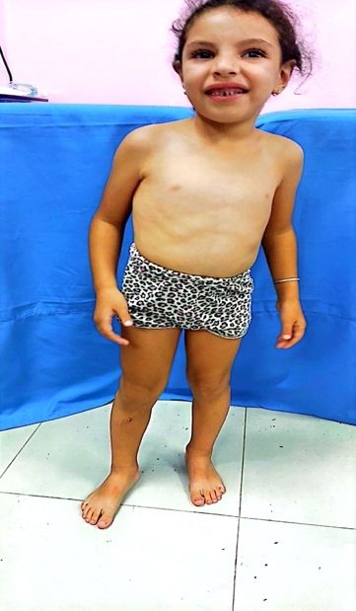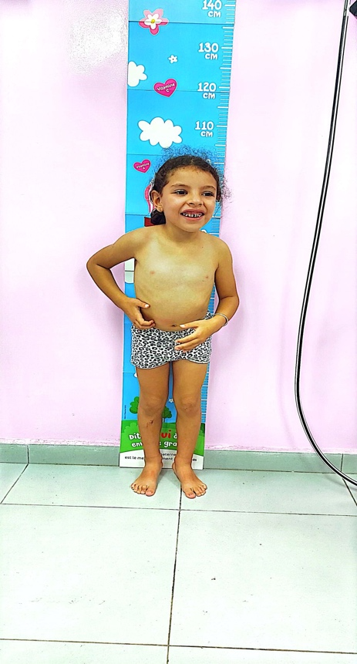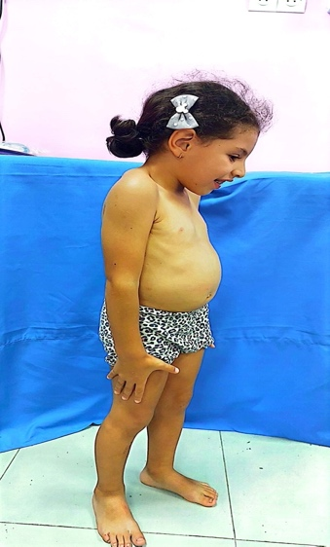

Figure 1

Musculoskeletal anomalies included short limbs, wide wrists and ankles, and early thoracic scoliosis. Neurological examination showed no focal deficits. There was no evidence of hepatosplenomegaly, corneal clouding, or valvular heart defects.

Laboratory evaluations, including thyroid function, cortisol, and growth hormone levels, were within normal limits. Urinary glycosaminoglycan (GAG) levels were normal, excluding mucopolysaccharidoses. Cytogenetic analysis revealed a normal 46,XX karyotype.

A comprehensive skeletal survey demonstrated platyspondyly with anterior beaking, flared iliac wings with lace-like iliac crests, femoral neck widening and early signs of thoracic scoliosis, hallmark signs of DMC(Figure 2). Brain MRI revealed mild cortical and subcortical atrophy with slight ventricular enlargement, but no parenchymal lesions.

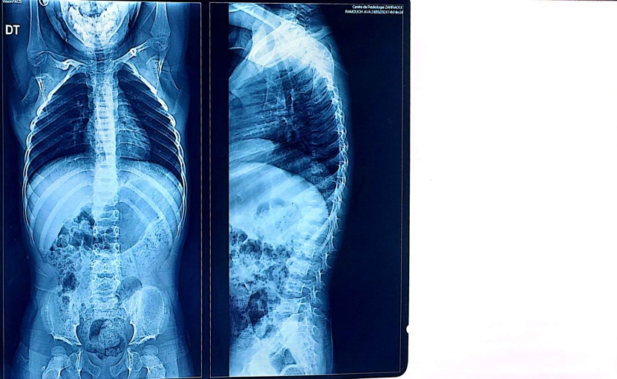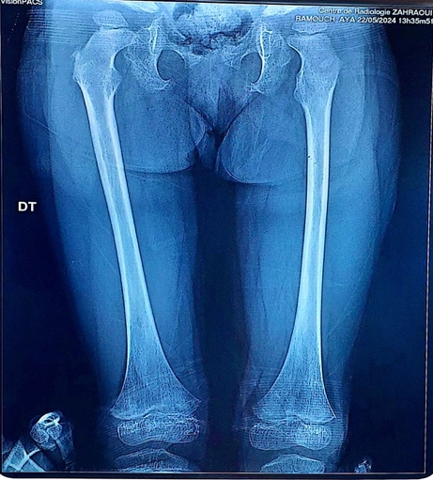

Figure 2: Radiographic features showing platyspondyly and irregular vertebral endplates.

Genetic testing via whole-exome sequencing confirmed a homozygous pathogenic variant [DYM (NM_001353214.3):c.2043del p.(Lys681AsnfsTer94)] of the *DYM* gene, establishing the diagnosis of Dyggve-Melchior-Clausen syndrome. The diagnosis was explained to the family, who received genetic counseling. Sanger sequencing and prenatal testing were offered for future pregnancies.

The child was enrolled in neurodevelopmental and physical therapy programs. Orthopedic referral was made for monitoring of scoliosis and joint mobility. A multidisciplinary care plan involving pediatrics, orthopedics, neurology, and genetics was initiated.

**DISCUSSION**

Dyggve-Melchior-Clausen syndrome (DMC) represents a rare form of spondyloepimetaphyseal dysplasia, attributable to biallelic mutations in the *DYM* gene . The encoded protein, dymeclin, is involved in Golgi apparatus function and plays a pivotal role in skeletal and neuronal development . Dymeclin dysfunction disrupts endochondral ossification and intracellular trafficking, explaining the combined skeletal and neurological manifestations of DMC .

The classic phenotype includes disproportionate short stature, intellectual disability, and dysostosis multiplex with specific features like platyspondyly, flared iliac crests, and metaphyseal irregularities [2,4]. In the present case, these signs, along with normal urinary GAG levels, helped differentiate DMC from Morquio syndrome (MPS IV), which is characterized by GAG accumulation, corneal clouding, and cardiac involvement .

Smith-McCort dysplasia (SMC), a phenotypic mimic caused by similar mutations in the *DYM* gene, must also be considered. However, unlike DMC, SMC typically lacks intellectual impairment, serving as a key discriminating feature. Thus, careful neurological assessment is essential in distinguishing the two.

Radiographic evaluation remains a cornerstone in the diagnostic pathway. The characteristic “lace-like” iliac crest and beaked vertebral bodies provide strong diagnostic clues, as seen in our patient. Definitive diagnosis relies on genetic testing, particularly whole-exome sequencing, which identifies pathogenic variants in *DYM*, enabling appropriate counseling and future family planning .

Currently, treatment for DMC is symptomatic and supportive. Orthopedic intervention may be necessary for severe scoliosis, hip dysplasia, or joint deformities. Early physiotherapy and speech/language therapy improve functional outcomes, while educational interventions address cognitive deficits . Multidisciplinary collaboration optimizes care delivery.

Of particular relevance is the role of genetic counseling. In consanguineous families, the recurrence risk for autosomal recessive disorders like DMC is 25%. Identifying carriers and offering prenatal or preimplantation genetic diagnosis are vital components of reproductive planning. Furthermore, informing families about the inheritance pattern and available options fosters informed decision-making.

Emerging research into gene therapies and pharmacological chaperones targeting Golgi-related disorders could potentially transform DMC management, although such interventions remain experimental [5]. Understanding the broader implications of Golgi dysfunction may yield novel therapeutic approaches for skeletal dysplasias and neurodevelopmental syndromes.

**CONCLUSION**

Dyggve-Melchior-Clausen syndrome is a rare but clinically recognizable skeletal dysplasia. Diagnosis requires an integrated approach of clinical, radiographic, and genetic evaluations. Differentiation from phenotypically similar disorders such as Morquio syndrome and Smith-McCort dysplasia is crucial to avoid mismanagement. Although no curative treatments exist, early supportive interventions and orthopedic management significantly enhance patient outcomes. Genetic counseling is vital for affected families, especially in consanguineous populations. Advances in molecular research may open new therapeutic possibilities in the future. This case underscores the diagnostic value of whole-exome sequencing and the necessity of a multidisciplinary approach in managing rare genetic skeletal disorders.

**Consent**

As per international standards or university standards, patient(s) written consent has been collected and preserved by the author(s).

Disclaimer (Artificial intelligence)

I hereby confirm that no generative AI technologies, including but not limited to large language models (e.g., ChatGPT, Copilot) or text-to-image generators, were used in the writing or editing of this manuscript. All content was written, revised, and finalized solely by the authors based on our clinical observations, expertise, and relevant literature.

### ****REFERENCES****

1. EI Ghouzzi, V.; Dagoneau, N.; Kinning, E.; Thauvin-Robinet, C.; Chemaitilly, W.; Prost-Squarcioni, C.; Al-Gazali, L.I.; Verloes, A.; Le Merrer, M.; Munnich, A.; et al. Mutations in a novel gene Dymeclin (FLJ20071) are responsible for Dyggve-Melchior-Clausen syndrome. *Hum. Mol. Genet.* 2003, *12*, 357–364.
2. Haft CR, Klausner RD, Taylor SI. Involvement of dileucine motifs in the internalization and degradation of the insulin receptor. J Biol Chem 1994;269:26286–94.
3. Lapierre LA, Kumar R, Hales CM, Navarre J, Bhartur SG, Burnette JO, et al. Myosin Vb is associated with plasma membrane recycling systems. Mol Biol Cell 2001;12: 1843–57.
4. Thauvin-Robinet C, El Ghouzzi V, Chemaitilly W, Dago- neau N, Boute O, Viot G, et al. Homozygosity mapping of a Dyggve-Melchior-Clausen syndrome gene to chromosome 18q21.1. J Med Genet 2002;39:714–7.
5. Nilsson O, Baron J. Fundamental limits on longitudinal bone growth: growth plate senescence and epiphyseal fusion. Trends Endocrinol Metab. 2004;15(8):370–374. doi:10.1016/j.tem.2004.08.002
6. Paupe, V., Gilbert, T., Le Merrer, M., Munnich, A., Cormier-Daire, V., & El Ghouzzi, V. (2004). Recent advances in Dyggve–Melchior–Clausen syndrome. Molecular genetics and metabolism, 83(1-2), 51-59.
7. Burns, C., Powell, B. R., Hsia, Y. E., & Reinker, K. (2003). Dyggve-Melchior-Clausen syndrome: report of seven patients with the Smith-McCort variant and review of the literature. Journal of Pediatric Orthopaedics, 23(1), 88-93.
8. Rastogi, S. C., Clausen, J., Melchior, J. C., & Dyggve, H. V. (1977). the DYGGVE-melchior-clausen syndrome. Clinica Chimica Acta, 78(1), 55-69.
9. Chavan, S., Chalipat, S., Verma, S., Kumar, G., Mane, S., & Chavan IV, S. (2024). A Rare Case of Dyggve-Melchior-Clausen Syndrome: A Case Report. Cureus, 16(9).
10. Reyes-Silva, C., Gallardo-Vizuete, J., Guzmán-Acán, J., Jaramillo-Koupermann, G., & Cabrera-Andrade, A. (2025). Dyggve–Melchior–Clausen Syndrome in Ecuador: Expanding Knowledge on a Rare Genetic Disorder. Genes, 16(5), 490.