Conjoined twins at the Centre Hospitalier Universitaire Mère-Enfant, Fondation Jeanne Ebori (CHUMEFJE) in Libreville: Difficulties in the management of 2 cases
Abstract:
Conjoined twins (Siamese twins) are among the rare and complex complications of twin pregnancy, with a prevalence of 1 in 50,000 to 100,000 births. We report two cases of conjoined twins managed at the Mother-Child University Hospital Jeanne Ebori Foundation in Libreville. The first case involved craniopagus twins born prematurely by cesarean section at 30 weeks, both of whom experienced poor adaptation to extra-uterine life. The second case, omphalopagus twins, was a term vaginal delivery where one twin required resuscitation. Both cases highlight the importance of antenatal diagnosis for appropriate obstetric and postnatal management. This report highlights the challenges of managing such cases in resource-limited settings and the need for enhanced prenatal screening and multidisciplinary collaboration to improve outcomes.
Keywords: Conjoined twins, malformation, pregnancy monitoring, ultrasound, antenatal screening

Introduction
Conjoined twins are the result of an incomplete division of the embryonic disc that occurs beyond 13 days after fertilization [1,2]. It is a rare congenital malformation that attracts special attention each time it is discovered. Its prevalence varies from 1 in 50,000 to 1/100,000 with a female predominance [3]. It is a malformation accessible to antenatal diagnosis by ultrasound from the first trimester of pregnancy. Antenatal diagnosis allows for appropriate monitoring, to make an appropriate obstetric decision and finally to plan the most appropriate management. Conjoined twins represent one of the rare congenital anomalies and constitute one of the greatest challenges in pediatric surgery [4]. We report two (2) cases of conjoined twins in Libreville followed at the CHU Mère-Enfant Fondation Jeanne Ebori (CHUMEFJE), a reference hospital dedicated to the care of mothers, newborns and children. The objective of this work was to show the importance of pregnancy monitoring and obstetric ultrasound in prenatal screening for congenital malformations.
Case presentation:
Observation 1: these are premature female newborns, born at 30 weeks in a private establishment by cesarean section indicated in front of a hemorrhagic placenta praevia. They were admitted at 72 hours of life for the management of conjoined twins. The block weighed 2060g. Other anthropometric parameters (height and cranial perimeter) not mentioned. They were born with poor adaptation to extra-uterine life with an Apgar score of 5 at the 1st minute and 8 at the 5th minute after resuscitation measures such as drying, stimulation. The mother was 41 years old, with no particular medical history and with a gyneco-obstetric history of Gestation 8 Parity 2 Abortion 2, alive 5. The parents were of Gabonese nationality with no notion of consanguinity. No toxic intake was noted during the pregnancy. The pregnancy was accepted and monitored by a midwife. She benefited from five prenatal contacts. The biological assessment (retroviral serology, hepatitis B, syphilis, toxoplasmosis and rubella) was negative. Morphologically, an obstetric ultrasound revealed an evolving singleton pregnancy with good cardiac activity. The clinical examination on admission revealed a fusion-type malformation at the level of the cranial vault, left temporal face, one of which looked forward and the other backward. A stable hemodynamic state with an oxygen saturation of 98% for (D1) and 97% for (D2) on room air, a normal heart rate of 156 beats per minute (D1) and 160 beats per minute (D2), a recoloration time of less than 3 seconds with cutaneous-mucosal sub-icterus. Archaic reflexes were present but weak. The pulmonary and cardiac examination was unremarkable. No other visible malformation was noted.
The biological assessment (blood count, C-reactive protein, renal assessment, liver assessment and blood sugar) was unremarkable. Moderate hyponatremia was found at 132.79 mmol/L for (D1) and 133 mmol/L (D2). Hyperbilirubinemia had prompted the initiation of conventional phototherapy. The block was blood group O positive. A brain scan showed a fused posterior fossa and an absence of a 4th ventricle. A brain magnetic resonance imaging (MRI) revealed a single posterior fossa. Cardiac ultrasound could not be performed. At the end of the clinical and morphological assessment, we concluded that it was a conjoined craniopagus twin (figure 1)

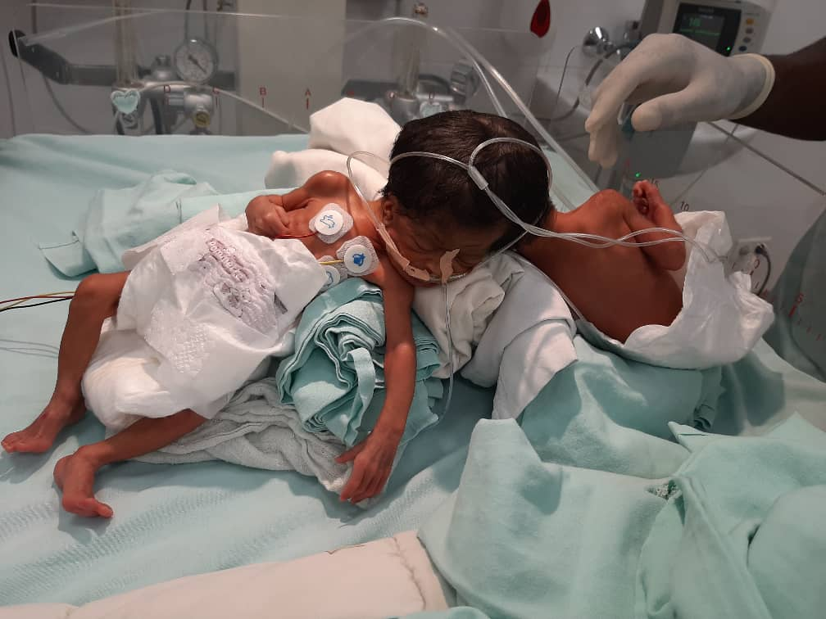
Figure 1: Conjoined craniopagus twins

The treatment consisted of hospitalization in an intensive care unit with an open incubator, cardiorespiratory monitoring, placement of an orogastric tube and an umbilical venous catheter, age-appropriate fluid and carbohydrate intake, essential newborn care and probabilistic dual antibiotic therapy (ceftazidime 35 mg/kg/8h and gentamicin 5 mg/kg/24h). Close monitoring with psychological follow-up of the parents. The evolution was marked by the occurrence of an unrecovered cardiorespiratory arrest at H48 of hospitalization on (D1) then on (D2).

Observation 2: Newborns, female, born vaginally at 39 weeks. They were admitted at H6 of life for the management of conjoined twins. The block weighed 5900g. (J1) was born in good adaptation to extra-uterine life (Apgar score of 7 at the 1st minute and 10 at the 5th minute) with a length of 45cm and a head circumference of 34cm. (J2) was born in a state of apparent death (Apgar score of 3/10 at the 1st minute and 7/10 at the 10th minute) after a well-conducted resuscitation with a length of 41cm and a head circumference of 33.5cm. The mother was 33 years old, with no particular medical or surgical history and with an obstetric history of G4P2A1V2. The father was 35 years old. The parents were of Nigerian nationality. There was no evidence of toxic intake during pregnancy or consanguinity between the parents. The pregnancy was accepted and monitored by a midwife. She had benefited from five prenatal contacts. The biological assessment (retroviral serology, hepatitis B, syphilis, toxoplasmosis and rubella) was negative. Morphologically, she had not had an obstetric ultrasound. No intercurrent pathology was noted. She had received iron and folic acid supplementation.
Physical examination on admission revealed abdominally fused conjoined twins (Figure 2). The neonates were wide awake. (J1) was tonic with effective and vigorous sucking and (J2) was hypotonic with absent sucking. Other archaic reflexes were difficult to assess. Detailed anatomic analysis showed twins each with a single head, a distinct rib cage with visible and normal ribs, two hearts with normal cardiac activity, two normal cervico-dorso-lumbosacral spines and two normal upper and lower limbs. They had a common abdominal wall with a single four-vessel umbilical cord (Figure 3) and a large umbilicus with a ruptured omphalocele (Figure 4).

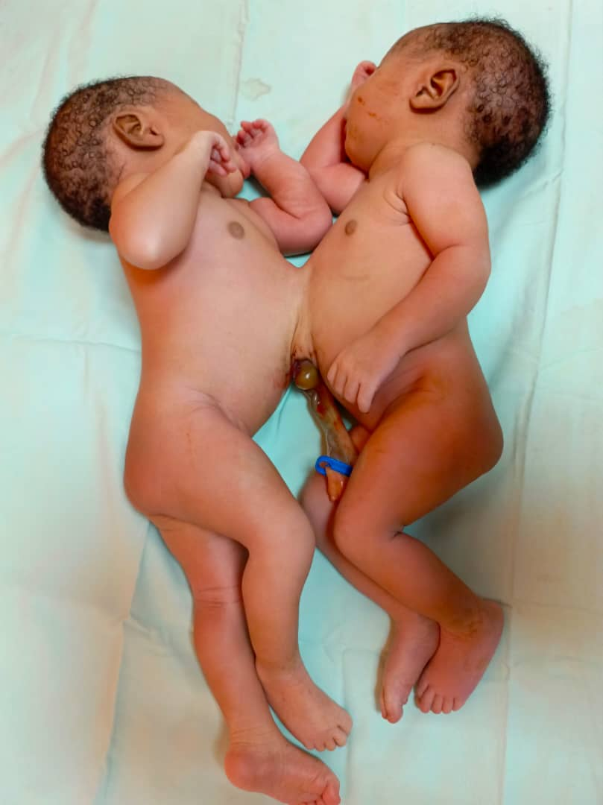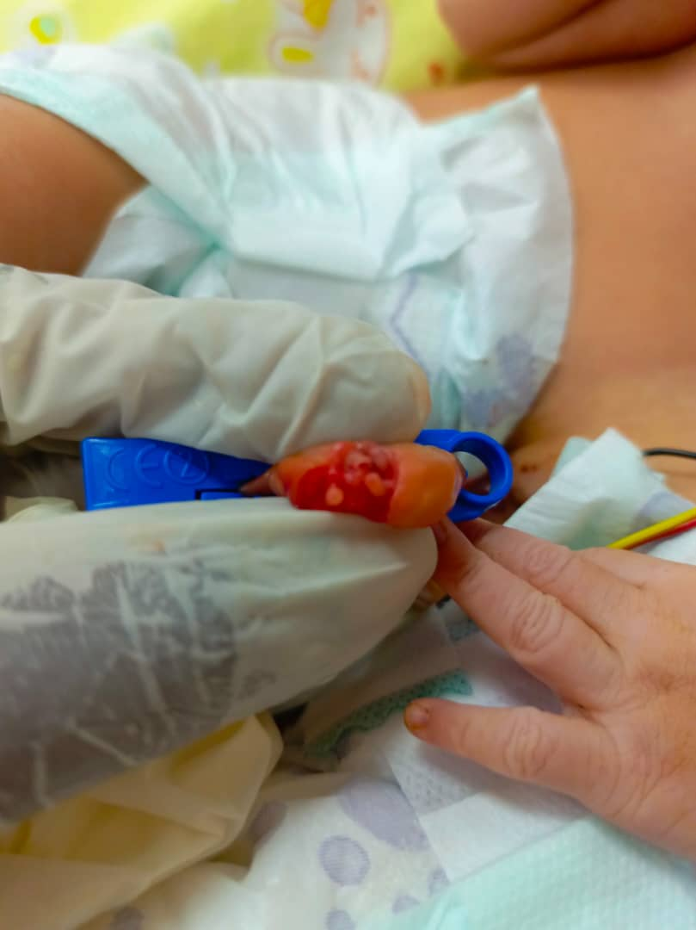

Figure 2: Omphalopagus conjoined twins Figure 3: 4 umbilical vessels

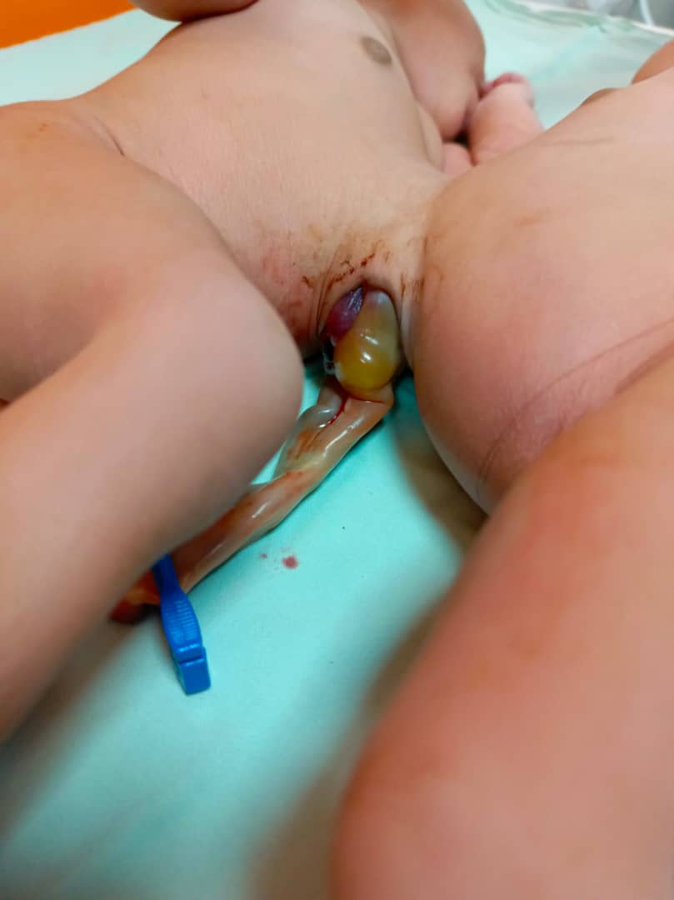

Figure 4: Omphalopagus conjoined twins with ruptured omphalocele

Biology showed normochromic microcytic anemia at 12.7 g/dl (D1) and 13.5 g/dl (D2), hepatic cytolysis in both cases with ASAT: 50 IU/L, ALAT: 24 IU/L (D1) and ASAT: 59 IU/L ALAT: 45 IU/L (D2), a positive infectious assessment with procalcitonin (PCT) at 19.8 ng/ml for (D1) and 24.98 ng/ml for (D2). An unremarkable renal, glycemic, metabolic and field assessment.
Morphologically, the Body-scan of (J1) and (J2) found a communication by the liver with extension of the left liver of J1 into the abdominal cavity of J2 and a communication at the umbilical level with J2, a meningeal hemorrhage and a cerebral edema. The thoraco-abdomino-pelvic angiogram found a bilobed gallbladder for J2, a liver of J2 connected to the distal arteriovenous structures of the left liver of J1 and poor visualization of the gallbladder. The thoraco-abdomino-pelvic MRI (J2) revealed a common liver with poor visualization of the inferior vena cava of J2 and without particularity for J1 (Figure 5).

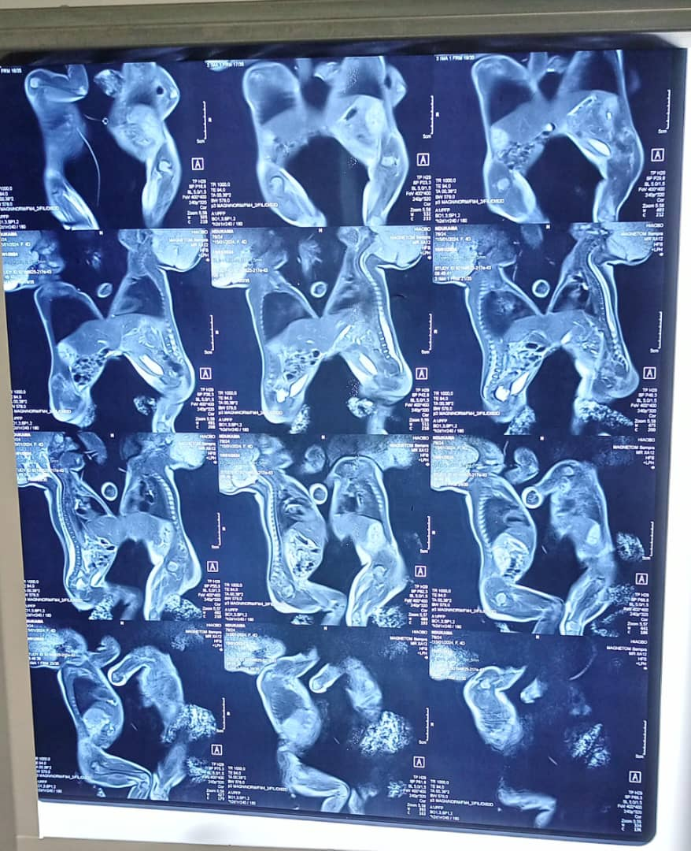
Figure 5: Common liver between D1 and D2
Initial treatment consisted of hospitalization in the intensive care unit, placement in a warming crib, placement of a peripheral venous line and orogastric tubes, essential care of the newborn, fluid and carbohydrate intake, dual probabilistic antibiotic therapy (ceftazidime 35 mg/kg/8 hours and gentamicin 5 mg/kg/24 hours), antiparasitic (metronidazole 10 mg/kg/day intravenously) for 7 days, antimycotic (fluconazole 10 mg/kg/day) for 21 days IV then oral relay. The evolution during hospitalization was favorable. A transfer was made at 1 month of life at the request of parents in Nigeria for continued care in a specialized structure with the technicality and surgical expertise for this type of malformation.
Discussion:
Conjoined twins represent an exceptional malformation in obstetrics occurring once in 50,000 to 60,000 births, with a perinatal mortality of 60% [5]. In our case, they were craniopagus and omphalopagus conjoined twins. A case of thoracopagus male conjoined twins was published in Gabon in 2022 and in Morocco in 2021 [6,7]. A case of craniopagus conjoined twins was described in Ivory Coast in 2007 [8]. This demonstrates the extremely rare nature of this malformation. The female sex is dominant in 70 to 75% of cases according to literature data [3]. This result is consistent with our observation. The pathogenesis of conjoined twins is unclear. The mechanism of conjoined twin formation is based on two explanatory theories. The theory of secondary and partial fusion of the two initially separated monozygotic embryonic discs has been retained, but this theory is rejected in favor of the incomplete and late fission of an embryonic disc [9,10]. It should be noted that there is no associated chromosomal anomaly. Race, heredity, parity and consanguinity would not intervene in the process.
In our observation, the first difficulty encountered was the absence of pregnancy monitoring and obstetric ultrasound, which can be explained by the difficult access to ultrasound in our countries with low medical density, as well as by the cost of this examination which is not always within the reach of our less well-off populations. The antenatal diagnosis of conjoined twins is based on ultrasound [10].Advances in imaging (three-dimensional ultrasound) have made it possible to diagnose and assess the extent of fusion at an early stage of development in most cases of conjoined twins [11,12]. Antenatal diagnosis will be made earlier and earlier thereafter. Indeed, ultrasound must be done in the first trimester of pregnancy (12-14 weeks of amenorrhea) by vaginal route. Early diagnosis is essential for the purposes of medical termination of pregnancy. It is easy in the second trimester of pregnancy (22 weeks of amenorrhea) due to the good development of the morphology and fetal adnexa. At this stage, it is easy to precisely locate the attachment zone, analyze duplicated structures and look for other associated malformations, particularly cardiac [10]. Other imaging techniques, namely MRI, uterine contents and karyotype, are useless for diagnosis but can provide additional information for prognostic purposes.
The survival of conjoined twins depends on the type of union (shared organs) and other associated anomalies. Currently, only a few pediatric surgical teams are able to consider surgery to separate conjoined twins, provided there is no severe malformation association. In the majority of cases, 60% of conjoined twins are stillborn [11]. The real problem with this pathology is the separation of the twins, which is not always possible (49 to 62%) [13,14], not always easy and of uncertain prognosis even with experienced teams [13,14]. Very few teams perform these interventions, the best postoperative results of which are observed in thoraco-omphalopagus with a separate heart [13,14]. Few teams have the surgical expertise of craniopagus twins, with a perioperative risk of death of 50% [15]. Despite these technical problems, this is a heavy, very expensive intervention, which raises ethical questions due to the need to sacrifice one child to the detriment of the other [13, 14]. Complex ethical issues also arise when separation involves unequal sharing of limbs and organs, or when separation results in the death of one of the conjoined twins. Separation could not be performed in our context because our technical platform did not allow it and our teams were not sufficiently trained, equipped and prepared despite multiple multidisciplinary consultations. The steps for a possible transfer to a specialized service were successful for the second observation.
Conclusion
Current technologies help in early diagnosis and open new perspectives on the future of Siamese twins. They represent a real diagnostic and especially therapeutic challenge. The objective of our case was to draw the attention of obstetricians-gynecologists to this rare anomaly, to specify the importance of ultrasound as an essential diagnostic tool to set up an effective management strategy in order to avoid any surprises that could compromise the vital prognosis of newborns and their mothers.

Disclaimer (Artificial Intelligence)
Option 1:
WE DID NOT USE ARTIFICIAL INTELLIGENCE DURING THE STUDY
The authors hereby declare that NO generative AI technologies such as large language models (ChatGPT, COPILOT, etc.) and text-to-image generators were used in the writing or editing of this manuscript.
Option 2:
The authors hereby declare that generative AI technologies such as extended language models, etc. were used in writing or editing the manuscripts. This explanation will include the name, version, model, and source of the generative AI technology as well as any input prompts provided to the generative AI technology.
The details of the use of AI are given below:
1.
2.
3.
Ethical Approval:

As per international standards or university standards written ethical approval has been collected and preserved by the author(s).

Consent
As per international standards, parental written consent has been collected and preserved by the author(s).

References:
1-Herkiloglu D, Baksu B, Pekin O. Early septal diagnosis of thoraco-omphalopathic twins at ten weeks of gestation by ultrasound. Turk J Obstet Gynecol. 2016;13:106-8.
2-Alkhateeb M, Mashaqbeh M, Magableh S, Rafiq H, Quteiba N, Abdelkheleg A. Early prenatal diagnosis of thoracopagus twins by ultrasound. Acta Informed Med. 2015;23:60-2.
3-Mishra N, Rohilla M. Thoracoomphalopagus conjoined twins: case report and literature review. Case Report Gynacol Obstet. 2015;1:3.
4-Bousselamti Amal. Siamese twins about 8 cases with literature review. [Medical thesis]. Rabat: Mohammed-V University Rabat; 2016.
5- Durier M, Vervaet H, Gabriel. Twin pregnancy. Anatomoclinical study and management. EMC (Elsevier Masson SAS, Paris). Elsevier Masson; 2010:5-030-A-10.
6- Lembet Mikolo A, Minko J, Kuissi Kamgaing E, Nkole Aboughe M, Mekame Meye A, Mabery Grodet A et al. Thoracopic conjoined twins: a case report from Libreville and review of the literature. PAMJ Case Report. 2022;1-9.
7- Rhaidouni Mohamed Adnane, Barick.A, Chaara H, Fdili Alaoui FZ, Jayi S, Melhouf My A. Antenatal diagnosis of conjoined twins (about a case and review of the literature). IJAHMR 2022.65-9.
8-Konan Blé R, Seni K, Adjoussou S, Quenum G, Akaffou E, Koné M. Craniopagus-type conjoined twins: management difficulties in the African environment. Gynecology-obstetrics and fertility. 2008;36:56-9
9-Mathew RP, Francis S, Basti RS, Suresh HB, Rajarathnam A, Cunha PD et al. Conjoined twins - role of imaging and recent advances. J Ultrasound. 2017;17(71):259-266.
10-Benchiba I, Saoud MK, Mamouni N, Errarhay S, Bouchikhi C, Abdelaziz B. Term diagnosis of Siamese. Pan Afr Med J. 2020; 56-9.
11-Mian A, Gabra NI, Sharma T, Topale N, Gielecki J, Tubbs RS, Loukas M. Conjoined twins: From conception to separation, a review. Clinical Anatomy. 2017 Apr;30(3):385-96.

12-Liu H, Deng C, Hu Q, Liao H, Wang X, Yu H. Conjoined twins in dichorionic diamniotic triplet pregnancy: a report of three cases and literature review. BMC Pregnancy and Childbirth. 2021 Dec;21:1-3.

13-Al Rabeeah A. Conjoined twins – past, present and future. J Pediatr Surg. 2006;41(5):1000–4.
14-Rode H, Fieggen AG, Brown RA, Cywes S, Davies MR, Hewitson JP, et al. Four decades of conjoined twins at the Red Cross Children's Hospital: lessons learned. S Afr Med J. 2006;96(9pt.2):931-40.
15-Campbell S. Separation of craniopagus twins: the Brisbane experience. Childs Nerv System 2004; 20(8–9): 60

