**Hybrid Model for Under-Five Mortality Rate Forecasting in Nigeria**

**Abstract:** Accurate forecasting of under-five mortality rates (U5MR) is essential for guiding public health planning and achieving child survival targets in Nigeria. This study develops optimal hybrid models for predicting U5MR using annual data from 1980 to 2022, obtained from the United Nations Inter-agency Group for Child Mortality Estimation (UN IGME). Five individual models—autoregressive integrated moving average (ARIMA), exponential smoothing state space (ETS), multilayer perceptron (MLP), Prophet, and extreme gradient boosting (XGBoost)—were assessed alongside four hybrid models: ARIMA-ETS, ARIMA-MLP, ARIMA-Prophet, and ARIMA-XGBoost. Hybrid forecasts were generated using a weighted averaging method, with model weights optimized through a genetic algorithm. Model performance was evaluated using RMSE and MAPE on an out-of-sample test set (2018–2022), with sensitivity analysis performed over three, five, and seven-year forecast horizons. Results indicated that hybrid models, particularly ARIMA-ETS and ARIMA-Prophet, significantly outperformed individual models across all metrics and timeframes, for both male and female U5MR. This study recommends that national agencies adopt these hybrid models for mortality forecasting and planning.

**Keywords:** Under-five mortality rate, Hybrid forecasting models, Time series analysis, Genetic algorithm, Nigeria

**1. Introduction**

Millions of children under five worldwide die each year from preventable causes. The risk of a child under five dying for every 1,000 live births is known as the under-five mortality rate, or U5MR. This rate is a key indicator used by nations globally to assess their economic and health success and is crucial for health policymakers in developing effective policies and initiatives to improve children’s lives.

Countries are making considerable efforts to implement various health strategies aimed at reducing the under-five mortality rate (U5MR) to 25 deaths per 1,000 live births by the end of 2030, in order to achieve Sustainable Development Goal (SDG) 3.2. This requires targeted interventions to eliminate preventable under-five mortality. However, according to the Global Health Observatory (GHO) 2022 report, fifty-nine (59) nations have yet to meet the SDG target for under-five mortality and will deviate from this path unless additional resilience measures are established, such as enhancing the quality of care and health services provided to children under five [1].

Globally, the mortality rate for children under five has significantly decreased since 1990 [2]. Between 1990 and 2022, the number of deaths per 1,000 live births reduced by 59 percent, from 13.8 million in 1990 to 4.9 million in 2022 [2]. However, in Nigeria, the male U5MR was 220.41 deaths per 1,000 live births in 1990, 190.96 in 2000, 142.56 in 2010, 120.11 in 2020, and 113.24 deaths per 1,000 live births in 2022 [2]. This demonstrates that Nigeria has made significant progress from 1990 to 2022, with the male U5MR showing about a 48.62 percent reduction and the female U5MR reflecting a 49.11 percent reduction. However, Nigeria still lags behind, indicating that more work is required to achieve SDG 3.2.

Accurate forecasting of under-five mortality is essential, especially for policymaking, monitoring, and planning future interventions [3][4][5]. Therefore, time series models play a critical role in predicting U5MRs. Various models, including traditional ones like autoregressive integrated moving average (ARIMA), exponential smoothing state space (ETS), neural network autoregression (NNAR), as well as machine learning (ML) models like extreme gradient boosting (XGBoost), multilayer perceptron, and Facebook prophet, have been developed to predict time series data. However, discrepancies exist, as some models do not perform well under specific conditions. For instance, traditional models often struggle with non-linear data, while ML models may falter with linear data. As a result, researchers have proposed many hybrid models that combine two or more individual models. The goal of these hybrid models is to integrate the strengths of each, ultimately improving time series forecasting [6][7]. Another issue is the method of combination; using an inappropriate method to blend models into a hybrid can lead to poor forecast outcomes.

Numerous studies have been conducted regarding the under-five mortality rate in Nigeria, as shown in [8][9][10][11][12][13][14][15][16]. However, most of these studies focused on a univariate time series approach and the factors impacting mortality rates in Nigeria. This study aims to bridge this gap by comparing different proposed hybrid models. It develops hybrid models using weighted averaging with optimized weights via a genetic algorithm for forecasting U5MRs for male and female children in Nigeria.

The rest of this paper is organized as follows: Section 2 discusses the data source and statistical methods used for hybrid model development. Section 3 presents the results, while Section 4 concludes the study.

**2. Methodology**

**2.1 Data and Data Analysis**

The data used in this study are annual U5MR from 1980 to 2022 for both male and female children. We collected the data from the United Nations Inter-agency Group for Child Mortality Estimation (UN IGME). To conduct an out-of-sample forecast, we split the data into a training set, which covers 80 percent of the entire dataset (from 1980 to 2017), and a test set, covering 20 percent (i.e., from 2018 to 2022). The individual models used are ARIMA, ETS, MLP, Prophet, and XGBoost, used as the benchmark models. The hybrid models used are ARIMA-ETS, ARIMA-MLP, ARIMA-Prophet, and ARIMA-XGBoost. For the out-of-sample forecast, the single models were trained on the training set, and the test set was used for evaluation. The hybrid models were developed by combining the forecasts from the single models using the weighted averaging method, where the weights assigned to each model are optimized using the genetic algorithm. The out-of-sample forecast performance of the single and hybrid models was compared with RMSE and MAPE. For the robustness of the study, a sensitivity analysis was conducted across three different forecast horizons: 3 years (short-term), 5 years (medium-term), and 7 years (long-term), for both the single and hybrid models. Here, the performance of both the single and hybrid models was compared with RMSE.

**2.2 ARIMA Model**

Traditional models like the Autoregressive Integrated Moving Average (ARIMA) model are typically fitted to time series data. This model is produced by linearly merging the moving average model (MA) with the stationary autoregressive (AR) model. Utilizing historical time series values to predict future values, the AR component of the ARIMA model indicates that the current value is a function of past values; the MA component demonstrates that the forecast errors are linearly added to the prior errors [17]. $ARIMA(p,d,q)$ is the mathematical representation of the ARIMA model, where $p$ is the order of the AR model, $d$ is the number of times the data is differenced for stationarity, and $q$ is the order of the MA model [17]. It is expressed as follows:

$$Y_{t}^{'}=m_{1}Y_{t-1}^{'}+m_{2}Y_{t-2}^{'}+⋯+m_{p}Y_{t-p}^{'}+θ_{1}e_{t-1}+θ_{2}e_{t-2}+⋯+θ_{q}e_{t-q}+e_{t} (1)$$

where $Y_{t}^{'}$ is the stationary data, $m_{i}$ are the parameters of the AR part, $θ_{j}$ are the parameters of the MA part, and the $e_{t}$ are the error terms assumed to be $iid$ with mean zero. The parameters are estimated using the maximum likelihood estimation method.

**2.3 ETS Model**

One time series modeling framework that automatically creates forecasts and finds trends, errors, and seasonality in time series data is the Exponential Smoothing State Space (ETS) model [18]. ETS(E, T, S) is the mathematical notation for the ETS model, where E represents the error component, which can be either additive (A) or multiplicative (M); T represents the trend component, which can be additive (A), multiplicative (M), or none (N); and S represents the seasonality, which is typically additive, multiplicative, or otherwise. Two ETS models were examined in this study: ETS(A, A, N) and ETS(M, A, N). They can be expressed as:

$$\left.\begin{matrix}l_{t}=αY_{t}+\left(1-α\right)\left(l_{t-1}+T_{t-1}\right) \\ T_{t}=β\left(l_{t}-l_{t-1}\right)+\left(1-β\right)T_{t-1} \\ {\hat{Y}}_{t+h}=l_{t}+hT_{t}\end{matrix}\right\} (2)$$

$$\left.\begin{matrix}l_{t}=α\frac{Y_{t}}{l_{t-1}+T_{t-1}}+\left(1-α\right)\left(l_{t-1}+T_{t-1}\right) \\ T_{t}=β\left(l_{t}-l_{t-1}\right)+\left(1-β\right)T_{t-1} \\ {\hat{Y}}_{t+h}=l_{t}+hT_{t}\end{matrix}\right\} (3)$$

where $l_{t}$ is the level at time $t$, $T_{t}$ is the trend at time $t$, $Y_{t}$ is the observed value at time $t$, $α$ is the smoothing parameter for the level ($0≤α≤1$), $β$ is the smoothing parameter for the trend ($0≤β≤1$), and ${\hat{Y}}_{t+h}$ is the forecast for $h$-steps ahead. Equations (2) and (3) represent ETS(A, A, N) and ETS(M, A, N), respectively.

**2.4 Prophet Model**

A group of data scientists at Facebook created the time series forecasting process known as Prophet. Facebook claims that Prophet works remarkably well in time series that include a lot of seasonality, non-linear trends, and different patterns [19]. Prophet excels at long-term forecasting and exhibits excellent robustness to outliers. The Prophet model can be expressed as:

$$y\left(t\right)=g\left(t\right)+s\left(t\right)+h\left(t\right)+ϵ_{t} (4)$$

where $g\left(t\right)$ represents the linear trend, $s\left(t\right)$ is the seasonal component, $h\left(t\right)$ stands for the holiday effects, and $ϵ_{t}$ is the white noise error term.

**2.5 MLP Model**

An artificial neural network with multiple layers of neurons, or nodes, connected in a unidirectional manner, is called a Multilayer Perceptron (MLP) [20]. An MLP model consists of three layers: input, hidden, and output. After receiving the input data, the input layer passes the data to the hidden layer, where it is transformed. The output layer then provides the final results. Each interconnected neuron in the MLP has a weight (𝑤𝑖) and a corresponding bias, depending on its significance. Each neuron introduces non-linearity into the model using an activation function, specifically the rectified linear unit (ReLU). The MLP minimizes the loss function through backpropagation. An MLP model can be expressed as follows:

$$z^{p}=w^{p}a^{p-1}+b^{p}; a^{p}=σ.z^{p} (5)$$

$$y=w^{k}a^{k-1}+b^{k} (6)$$

where equation (5) is for hidden layers and equation (6) is for the input layer, $z^{p}$ is the weighted sum of the inputs to layer $p$, $a^{p}$ is the activation of layer $p$, $w^{p}$ and $b^{p}$ are the weights and biases of layer $p$, respectively, $σ$ is the activation function, $y$ is the output vector, and $k$ is the number of layers.

**2.6 XGBoost Model**

Decision trees are used as the foundation learners in Extreme Gradient Boosting (XGBoost), an optimized distributed gradient boosting technique that handles missing information and builds a powerful predictive model [21][22]. XGBoost uses built-in cross-validation to assess the model's performance and regularization approaches to prevent overfitting. The following procedures can be used to obtain the XGBoost model:

1. Initialize the model with the number of trees, learning rate, and regularization parameters.

2. Construct a decision tree based on current residuals.

3. Compute the gradient of the loss function concerning the current residuals.

4. Update the weights of the decision tree based on the gradient and the learning rate.

5. Update the residuals based on the new weights.

6. Repeat steps 2 to 5 until the N number of trees is observed.

The objective function ($L\left(θ\right)$) of the XGBoost model is to minimize the loss function, and it can be expressed as:

$$L\left(θ\right)=\sum_{i=1}^{n}{l\left(x_{i},{\hat{x}}_{i}\right)}+Ω (7)$$

$$Ω=ΥT+\frac{1}{2}λ{\left\|w\right\|}^{2} (8)$$

$$\hat{x}=\sum_{k=1}^{K}{f_{k}(y)}; f_{k}\left(y\right)=w_{q}(y) (9)$$

where $L\left(θ\right)$ is the objective function, $l$ is the loss function, $x_{i}$ is the true value, ${\hat{x}}_{i}$ is the predicted value, $Ω$ is the regularization, $Υ$ is the regularization parameter, $T$ is the number of leaves in the tree, $w$ is the weight vector, $f_{k}$ is the $k$-th decision tree, $y$ is the input feature, $K$ is the number of decision trees, $w_{q}$ is the weight of the $q$-th leaf node, and $q$ is the index of the leaf node.

**2.8 Genetic Algorithm**

The Genetic algorithm (GA) is an optimization technique used to select the best solution for an improved model, through the principle of natural selection. The GA involves randomly selecting initial candidates, known as chromosomes $x=\left(x_{1},x_{2},⋯,x_{n}\right)$. These chromosomes are evaluated for fitness, where two of them are taken as parent chromosomes, and combined to produce a new set of population known as offspring. These offspring are used to replace the parent chromosomes that perform poorly. The GA method is executed through the following steps:

1. Select initial candidates known as chromosomes randomly $x=\left(x_{1},x_{2},⋯,x_{n}\right)$.
2. Evaluate the fitness of each chromosome $x_{i}$
3. Select two chromosomes $x_{1}$ and $x_{2}$ and combine them to produce offspring
4. Add a little perturbation for a random change
5. Replace the least performing parent chromosomes with the offspring
6. Confirm if the sample size is equal to $N$; if not, start from step 1.

**2.9 Weighted Averaging Method**

The weighted averaging (WA) method is a statistical technique that involves the combination of two or more models, where each model is assigned a weight, such that the sum of the weights assigned is 1. In this study, the WA combines two models, expressed as:

$${\hat{Y}}_{t}=m_{1}{\hat{Y}}_{t1}+m_{2}{\hat{Y}}_{t1} (13)$$

where ${\hat{Y}}_{t}$ is the weighted average forecast, ${\hat{Y}}_{t1}$ and ${\hat{Y}}_{t2}$ are the forecasts from model 1 and model 2, respectively, and $m_{1}$ and $m_{2}$ are the weights assigned to each model, such that $m_{1}+m_{1}=1$.

**2.10 Hybrid Model**

In this study, our hybrid models are obtained using the following steps:

1. Split the dataset into training set (80% of the data) and test set (the remaining 20 percent)
2. Training the single models (ARIMA, ETS, MLP, Prophet, and XGBoost) on the training set
3. Combine the forecast form ARIMA and any other model using the weighted averaging method; obtain the optimized weight using genetic algorithm (GA), and assign the results weights to the models

**2.11 Model Evaluation**

This study employed two metrics, root mean square error (RMSE) and the mean absolute percentage error (MAPE), to compare the performance of the forecasts. These metrics can be expressed as:

$$RMSE=\sqrt{\frac{1}{n}\sum_{i=1}^{n}{{\left(y_{i}-{\hat{y}}_{i}\right)}^{2}}} (14)$$

$$MAPE=\frac{1}{n}\sum_{i=1}^{n}{\left|\frac{y_{i}-{\hat{y}}_{i}}{y_{i}}\right|×100\%} (15)$$

where $y_{i}$ is the actual value, ${\hat{y}}_{i}$ is the predicted value, and $n$ is the sample size.

**3. Results and Discussion**

**3.1 Visualization and Descriptive Statistics of Male and Female U5MRs**

Figure 1 shows the male and female under-five mortality rates (U5MRs) in Nigeria from 1980 to 2022. From the plot, the male U5MR trend is higher compared to the female U5MR. Between 1981 and 1987, the U5MR trend for both genders showed a slight increase, after which, starting in 1988, both the male and female U5MR began to decrease steadily.

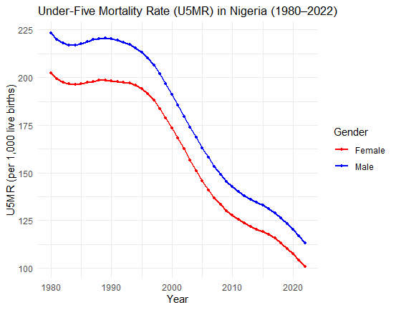

**Figure 1. Under-Five Mortality Rate (U5MR) in Nigeria (1980-2022)**

**Table 1. Descriptive Statistics of Male and Female U5MR**

|  |  |  |
| --- | --- | --- |
|  | **Mean** | **Standard Deviation** |
| Male | 178.21 | 39.12 |
| Female | 160.70 | 35.99 |

Table 1 presents the descriptive statistics for male and female under-five mortality rates (U5MRs) in Nigeria. From the results, the average male U5MR is 178.21 deaths per 1000 live births, while the female average U5MR is 160.70 deaths per 1000 live births, implying a difference of 17.51 deaths per 1000 births. The findings show a standard deviation of 39.12 for male U5MR and 35.99 for female U5MR, suggesting greater variations in male U5MR.

**3.2 Comparison of the Out-of-Sample Forecasts**

**Table 2. Out-of-Sample Forecast Performance of Male and Female U5MRs**

|  |  |  |  |  |
| --- | --- | --- | --- | --- |
|  | Male | | Female | |
| Model | RMSE | MAPE | RMSE | MAPE |
| ARIMA | 2.523 | 1.776 | 0.585 | 0.415 |
| ETS | 2.235 | 1.561 | 2.886 | 2.358 |
| MLP | 2.259 | 1.517 | 1.570 | 1.074 |
| Prophet | 4.968 | 3.939 | 5.258 | 4.639 |
| XGBoost | 9.924 | 7.498 | 9.571 | 8.125 |
| ARIMA-ETS | 0.088 | 0.057 | 0.301 | 0.217 |
| ARIMA-MLP | 1.521 | 1.115 | 0.516 | 0.431 |
| ARIMA-Prophet | 0.093 | 0.059 | 0.199 | 0.132 |
| ARIMA-XGBoost | 0.227 | 0.169 | 0.340 | 0.236 |

Table 2 presents the out-of-sample forecast performance of the single and hybrid models for both male and female U5MRs. For the male U5MR, the results revealed that among the single (benchmark) models, ETS performed better with the RMSE of 2.235 and MAPE of 1.561, while the XGBoost model had the worst performance (RMSE: 9.924, MAPE: 7.498). In contrast, among the hybrid models, the hybrid ARIMA-ETS model outperformed all competing hybrid models with the lowest forecast errors (RMSE = 0.088 and MAPE = 0.057). The ARIMA-Prophet model came in second with an RMSE value of 0.093 and an MAPE value of 0.059, while the ARIMA-MLP underperformed compared to other hybrid models (RMSE: 1.521, MAPE: 1.115).

From the female perspective, the results show that for the single (benchmark) models, the ARIMA model had the best performance with an RMSE of 0.585 and MAPE of 0.415, while the XGBoost model had the highest forecast error (RMSE = 9.571 and MAPE = 8.125). Based on the hybrid models, the result reveals that ARIMA-Prophet performed better than every other model, with the least RMSE (0.199) and MAPE (0.132), while ARIMA-ETS had the second-best performance with RMSE of 0.301 and MAPE of 0.217, and ARIMA-MLP performed worst compared to other hybrid models with an RMSE value of 0.516 and MAPE value of 0.431.

Figures 2 and 3 present the out-of-sample forecasts for male and female U5MR in Nigeria, respectively. These figures visualize the individual models and the hybrid models developed in this study. The plots show the forecasts from 2018 to 2022, with the model having the trendline that best fits the actual U5MRs being considered the best.

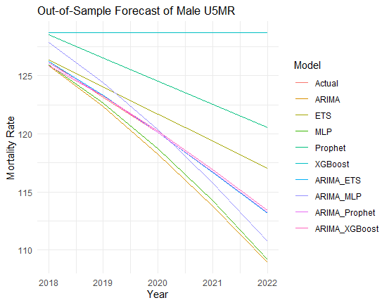

**Figure 2. Out-of-Sample Forecast of Male U5MR**

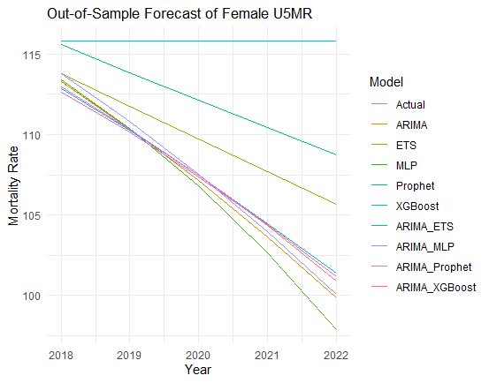

**Figure 3. Out-of-Sample Forecast of Female U5MR**

**3.3 Robustness Analysis**

**Table 3. Sensitivity Analysis of Forecast Horizons (h = 3, 5, and 7years) for Male and Female U5MRs**

|  |  |  |  |  |  |  |
| --- | --- | --- | --- | --- | --- | --- |
|  | **RMSE** | | | | | |
|  | **Male** | | | **Female** | | |
| Model | $$h=3$$ | $$h=5$$ | $$h=7$$ | $$h=3$$ | $$h=5$$ | $$h=7$$ |
| ARIMA | 1.185 | 2.523 | 2.523 | 0.193 | 0.585 | 0.585 |
| ETS | 1.067 | 2.235 | 2.235 | 1.586 | 2.886 | 2.886 |
| MLP | 0.864 | 2.385 | 2.416 | 0.387 | 1.713 | 1.827 |
| Prophet | 3.494 | 4.968 | 4.968 | 3.637 | 5.258 | 5.258 |
| XGBoost | 6.073 | 9.924 | 9.924 | 5.924 | 9.571 | 9.571 |
| ARIMA-ETS | 0.105 | 0.072 | 0.082 | 0.094 | 0.175 | 0.117 |
| ARIMA-MLP | 0.526 | 1.559 | 1.579 | 0.294 | 0.731 | 0.489 |
| ARIMA-Prophet | 0.142 | 0.217 | 0.097 | 0.369 | 0.252 | 0.430 |
| ARIMA-XGBoost | 0.281 | 0.529 | 0.295 | 0.747 | 0.798 | 0.718 |

Table 3 presents the results of the sensitivity analysis. From the male perspective, the results show that at h = 3 years, among the single models, MLP performed better with an RMSE of 0.864, while the XGBoost model performed worst with an RMSE of 6.073. At h = 5 and 7 years, the ETS model outperformed other single models with an RMSE of 2.235, each, while XGBoost continues to perform the worst with the highest RMSE (h = 5, 7 years: RMSE = 2.235). In contrast, under the hybrid model case, ARIMA-ETS model had the best performance compared to other hybrid models across the three forecast horizons (h = 3 years: 0.105, h = 5 years: 0.072, h = 7 years: 0.082), while ARIMA-Prophet came in second with RMSE values of 0.142 at h = 3 years, 0.217 at h = 5 years, and 0.097 at h = 7 years, and ARIMA-MLP came last in all forecast horizons (h = 3: RMSE = 0.526, h = 5: RMSE = 1.559, h = 7: RMSE = 1.579).

From the female perspective, based on the individual (benchmark) models, at a 3-year, 5-year, and 7-year forecast horizons, ARIMA outperformed all other single models with an RMSE value of 0.193, 0.585, and 0.585, respectively, while the XGBoost model underperformed across the three forecast horizons with an RMSE value of 5.924, 9.571, and 9.571, respectively. Looking at the hybrid models, ARIMA-ETS performed better than every other model across the three forecast horizons (3, 5, and 7 years) with the lowest RMSE value (h = 3: RMSE = 0.094, h = 5: RMSE = 0.175, h = 7: RMSE = 0.117), while ARIMA-Prophet came second at 5 and 7 years forecast horizons with RMSE values of 0.252 and 0.430, respectively, and ARIMA-MLP had the second-best performance at 3 years forecast horizon with RMSE of 0.294. Meanwhile, among the hybrid models, the ARIMA-XGBoost model performed less across the forecast horizons with RMSE values of 0.747, 0.798, and 0.718, respectively.

Figures 4 and 5 visualize the forecasts for male and female U5MRs, using both the single and hybrid models across three forecast horizons: 3, 6, and 12 years. From the plots, the models with RMSE closer to zero are considered the best, while those with RMSE near 10 are regarded as the worst models.

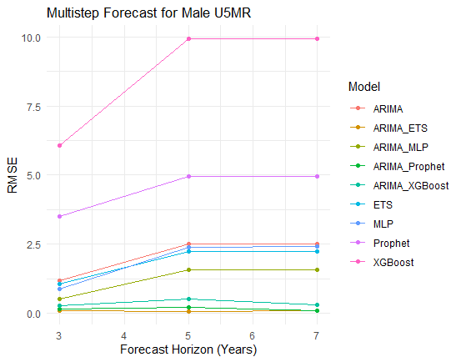

**Figure 4. Multistep Forecast for Male U5MR**

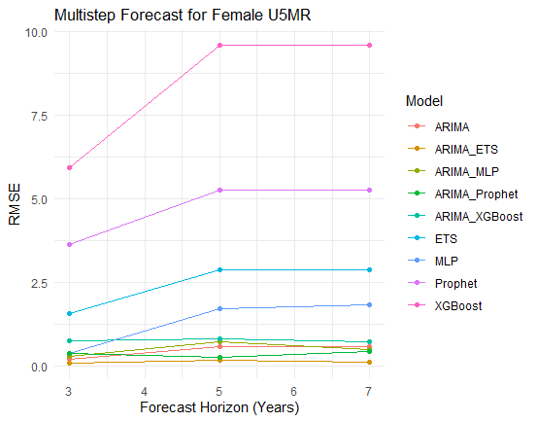

**Figure 5. Multistep Forecast for Female U5MR**

**3.4 Discussion**

From the descriptive statistics, the average U5MR for males was higher than for females and also exhibited greater variation. The out-of-sample results revealed that in the context of single models, the XGBoost model is not suitable for forecasting both male and female U5MRs in Nigeria; the ARIMA model performed better than other single models. Furthermore, the results indicated that among the hybrid models for male U5MR, ARIMA-ETS outperformed its competitors with the lowest RMSE and MAPE, while ARIMA-MLP was the least effective among the hybrid models, although it showed better performance compared to the single models. From the female perspective, the findings indicated that the hybrid ARIMA-Prophet model had the best performance compared to others, while ARIMA-MLP ranked last among the hybrid models, but its forecasting performance was superior to that of the single models.

The results from the sensitivity analysis showed that the ARIMA model is suitable for U5MR forecasting in Nigeria, although its performance was lower than that of the hybrid models across all forecast horizons. The multistep forecast also revealed that XGBoost is not an effective model for predicting both male and female U5MRs. The superiority of the ARIMA-ETS model in forecasting male U5MR was confirmed through the RMSE results across the 3, 5, and 7-year forecast horizons; in contrast, the ARIMA-MLP model performed less effectively compared to other hybrid models, though it performed better than all the single models. From the female perspective, the multistep forecast confirmed the ARIMA-ETS model as more suitable across all forecast horizons, which differed from the findings of the out-of-sample forecast, which identified ARIMA-Prophet as the best hybrid model for forecasting female U5MR.

**4. Conclusion**

In this study, we developed and evaluated hybrid forecasting models for under-five mortality rates (U5MRs) in Nigeria, using annual data from 1980 to 2022. By combining the ARIMA model with other models such as ETS, MLP, Prophet, and XGBoost, through a weighted averaging method with weights optimized by a genetic algorithm, the study identified the hybrid ARIMA-ETS and ARIMA-Prophet models as effective for forecasting male U5MR and female U5MR, respectively. These hybrid models outperformed all other models by producing the lowest root mean square error (RMSE) and mean absolute percentage error (MAPE), and their superiority was confirmed by sensitivity analysis across three forecast horizons: three years (short-term), five years (medium-term), and seven years (long-term). This study suggests that national agencies like the Federal Ministry of Health and the National Population Commission should adopt the hybrid ARIMA-ETS and ARIMA-Prophet models for mortality forecasting and planning. The application of these hybrid models aligns with Nigeria’s commitment to achieving Sustainable Development Goal (SDG) 3.2, which aims to reduce child mortality to 25 deaths per live birth by 2030. There is no doubt that this study has limitations. Explanatory variables such as socioeconomic, environmental, or health-related factors that significantly impact child mortality are excluded, and the study’s scope is limited to Nigeria. However, this study suggests that further research should explore multivariate hybrid models or compare the application of multi-hybrid models in various countries.

Disclaimer (Artificial intelligence)

Option 1:

Author(s) hereby declare that NO generative AI technologies such as Large Language Models (ChatGPT, COPILOT, etc.) and text-to-image generators have been used during the writing or editing of this manuscript.

Option 2:

Author(s) hereby declare that generative AI technologies such as Large Language Models, etc. have been used during the writing or editing of manuscripts. This explanation will include the name, version, model, and source of the generative AI technology and as well as all input prompts provided to the generative AI technology

Details of the AI usage are given below:

1.

2.

3.

**References**

[1] WHO, SDG Target 3.2 End Preventable deaths of newborns and children under 5 years of age. 2023. Available at https://www.who.int/data/gho/data/themes/topics/sdg-target-3_2-newborn-and-child-mortality.

[2] UNICEF, Under-five mortality. 2023. Available at https://data.unicef.org/topic/child-survival/under-five-mortality/

[3] Mwanga MK, Mirau SS, Tchuenche JM, Mbalawata IS. Bayesian prediction of under-five mortality rates for Tanzania. Franklin Open. 2025; 10:100221.

[4] Mejía-Guevara I, Zuo W, Bendavid E, Li N, Tuljapurkar S. Age distribution, trends, and forecasts of under-5 mortality in 31 sub-Saharan African countries: A modeling study. PLoS medicine. 2019; 16(3):e1002757.

[5] Adegbosin AE, Stantic B, Sun J. Predicting under-five mortality across 21 low and middle-income countries using deep learning methods. medRxiv. 2019:19007583.

[6] Hajirahimi Z, Khashei M. Hybridization of hybrid structures for time series forecasting: A review. Artificial Intelligence Review. 2023; 56(2):1201-61.

[7] Khashei M, Bijari M. A new class of hybrid models for time series forecasting. Expert Systems with Applications. 2012; 39(4):4344-57.

[8] Adeyinka DA, Muhajarine N. Time series prediction of under-five mortality rates for Nigeria: comparative analysis of artificial neural networks, Holt-Winters exponential smoothing and autoregressive integrated moving average models. BMC medical research methodology. 2020; 20:1-1.

[9] Eke DO, Ewere F. Modeling and forecasting under-five mortality rate in Nigeria using auto-regressive integrated moving average approach. Earthline Journal of Mathematical Sciences. 2020; 4(2):347-60.

[10] Adama ZK, Mettle FO, Baiden BM, Bii NK. Forecasting progress: analyzing the trajectory of under-five child mortality for Ghana, Niger, Nigeria, and Sierra Leone towards SDG3 using ARIMA time series model. BMC Public Health. 2025; 25(1):1607.

[11] David AE, Raheem MA. A time series modelling and forecasting of under-5 mortality rate in Nigeria. World Journal of Applied Science & Technology. 2023; 15(2):390-6.

[12] Kayode GA, Adekanmbi VT, Uthman OA. Risk factors and a predictive model for under-five mortality in Nigeria: evidence from Nigeria demographic and health survey. BMC pregnancy and childbirth. 2012 Dec;12:1-1.

[13] Ugoh C, Amaeze O, Henry N, Nwabueze N, Ifeanyi A, Godson M. Application of autoregressive integrated moving average model and weighted Markov chains on forecasting under-five mortality rates in Nigeria. Asian Journal of Probability and Statistics. 2022:30-43.

[14] Ntukidem S, Chukwu A, Oyamakin O, James C, Habimana-Kabano I. Trend analysis and determinants of under-5 mortality in Nigeria: A machine learning approach. Asian Journal of Probability and Statistics. 2023; 24(2):10-23.

[15] Agunbiade DA, Fatoki O, Adeleye NF. Predictive Model and Risk Factors of Under-five Mortality in Nigeria: A Study Based on 2018 Nigeria Demographic and Health Survey. Earthline Journal of Mathematical Sciences. 2023; 13(2):399-411.

[16] Fagbamigbe AF, Nnanatu CC. Modelling the spatial distribution and the factors associated with under-five mortality in Nigeria. Spatial Demography. 2022; 10(2):255-82.

[17] Hyndman RJ, Athanasopoulos G. Forecasting: principles and practice. OTexts; 2018.

[18] Hyndman RJ, Koehler AB, Snyder RD, Grose S. A state space framework for automatic forecasting using exponential smoothing methods. International Journal of forecasting. 2002; 18(3):439-54.

[19] Taylor SJ, Letham B. Forecasting at scale. The American Statistician. 2018; 72(1):37-45.

[20] Cybenko G. Approximation by superpositions of a sigmoidal function. Mathematics of control, signals and systems. 1989; 2(4):303-14.

[21] Fatima S, Hussain A, Amir SB, Ahmed SH, Aslam SM. XGBoost and random forest algorithms: an in depth analysis. Pakistan Journal of Scientific Research. 2023; 3(1):26-31.

[22] Trizoglou P, Liu X, Lin Z. Fault detection by an ensemble framework of Extreme Gradient Boosting (XGBoost) in the operation of offshore wind turbines. Renewable Energy. 2021; 179:945-62.