Assessing the Impact of the COVID-19 Pandemic on Nigeria's Economic Performance Using VAR Model: Evidence from Key Economic Indicators.

.

ABSTRACT

|  |
| --- |
| **Aim:** This study aimed to model and analyze the impact of the COVID-19 pandemic on economic growth and stability in Nigeria using the Vector Autoregressive (VAR) model. The study specifically focused on understanding the short-term interactions among confirmed COVID-19 cases, the Nigerian Stock Exchange All Shares Index (ASI), Nigerian crude oil prices (OP), and the Nigerian Naira to US Dollar exchange rate (NGNUSD).  **Study Design**: A comparative analysis approach was employed using VAR and ARDL models to examine the interconnectedness and dynamic relationships between COVID-19 health indicators and key economic variables. The study covered a post-pandemic period in Nigeria, assessing the short-term and potential long-term impacts.  **Methodology:** Daily time series data for the four variables were collected from May 26, 2020, to May 25, 2022, comprising 501 observations. A VAR(8) model was developed to capture the short-run dynamics,. Diagnostic tests including stability tests, Granger Causality/Block Exogeneity Wald Tests, and variance decomposition were conducted to validate the model and interpret the results.  **Results:** The VAR(8) model results indicated the presence of only short-run relationships among the four variables, as confirmed by the absence of cointegration. Stability test results confirmed the reliability of the model, and Granger causality tests revealed significant causal effects between confirmed COVID-19 cases and key economic indicators such as ASI, OP, and NGNUSD. Furthermore, variance decomposition highlighted robust forecasting capabilities of the VAR model, demonstrating the immediate impacts of the pandemic on economic dynamics in Nigeria.  Conclusion:  The study concluded that the COVID-19 pandemic had significant short-run effects on economic growth and stability in Nigeria. The VAR model proved effective in capturing these short-term dynamics, highlighting the importance of understanding the interplay between health crises and economic variables for informed policymaking. The findings emphasized the need for strategic interventions to stabilize the economy during health-related external shocks. |

*Keywords: VAR, COVID-19, Forecasting, Time Series.*

1. INTRODUCTION

With the advent of globalization, urban expansion, and environmental changes, the spread of contagious diseases has become a global threat that necessitates a coordinated response (Sarbu et al., 2021). According to the International Monetary Fund (IMF), the COVID-19 pandemic triggered an economic crisis unlike any previous ones due to its complex nature, marked by the interconnections between health and economic systems, uncertainty about treatment and isolation measures, and its global scale. The pandemic led to simultaneous declines in supply and demand as individuals reduced work and consumption activities, while businesses cut down on productivity and investment (Loayza & Pennings, 2020).

In response, governments worldwide took extraordinary actions, implementing fiscal measures totaling around $8 trillion, while central banks injected liquidity amounting to over $6 trillion (Mishra et al., 2020). The IMF also responded by doubling its emergency lending capacity to $100 billion and suspending debt repayments for low-income countries (Verbeek, 2020). Preparing for economic recovery raised several concerns, such as sustaining fiscal stimulus, managing unconventional monetary policies, tackling high unemployment, maintaining low interest rates, and preserving financial stability (Mishra et al., 2020).

The stock market is a segment of the financial market where long-term funds are traded in the form of securities, including shares, stocks, bonds, debentures, loan stocks, and derivatives. It is highly information-sensitive, meaning its indicators—such as price index, returns, volatility, and market capitalization—are significantly influenced by the availability of information in the market.

Since the emergence of COVID-19 in Wuhan, China, in late December 2019, and its subsequent spread to other countries, including Nigeria, the pandemic has profoundly impacted affected nations. Ibrahim (2020) considers COVID-19 one of the most lethal viruses affecting all aspects of human life. Ali (2020) emphasizes that it is not just a public health issue but a multifaceted crisis impacting every sector. It has affected mental and psychosocial well-being (Ibrahim, 2020; Macapagal, 2020), political and social dynamics (Ibrahim, 2020), and economic activities (Kajo et al., 2020; Ozili, 2020). Ibrahim (2020) further highlights its detrimental effects on employment, productivity, supply chains, and trade, which has resulted in a decline in gross domestic product.

Four main economic agents facilitate economic activities in any economy: the government, central institutions, firms, and households. The efficiency with which these agents perform their roles influences the circular flow of income and, consequently, the overall income level within the economy. The circular flow of income illustrates the movement of money among various sectors. As individuals and firms engage in buying and selling goods and services, monetary exchanges occur, reflecting the dynamic flow of income through the economy. Firms depend on productive resources to produce goods and services, compensating these resources for their contributions. This implies that if one sector of the economy is affected, the rest will by extension equally be affected.

In 2020, Nigeria experienced its worst economic recession in four decades, but a recovery began in the fourth quarter as restrictions eased, oil prices stabilized, and policies were enacted to counteract the economic shock. As a result, the economy contracted by only -1.8 percent in 2020, compared to the initial projection of -3.2 percent. The government responded by implementing several long-overdue policy reforms, often in the face of strong opposition. These included harmonizing exchange rates, removing fuel subsidies, adjusting electricity tariffs, reducing non-essential spending, redirecting funds to COVID-19 responses, improving debt management, and enhancing transparency in the oil and gas sector. These measures created additional fiscal space, preventing a deeper recession and establishing a foundation for early recovery. However, many critical reforms remain incomplete, posing risks to Nigeria’s fragile recovery. The economy is expected to grow by 1.8 percent in 2021 under the baseline scenario (World Bank, 2021).

Chang et al., (2023) investigated the influence of lockdown stringency measures and COVID-19 case counts on food and healthcare prices across six BRICST countries—Brazil, Russia, India, China, South Africa, and Turkey—addressing a gap in prior research that overlooked the relationship between reported COVID-19 cases and these prices. Employing a dynamic autoregressive distributed lag (DARDL) model, the study utilized daily data to analyze how food and healthcare services were affected by COVID-19 case counts and government interventions. The findings revealed that, in the long run, COVID-19 cases had a significant positive impact on both food and healthcare prices in India, South Africa, and China, while the short-term effects were noted in all countries except Russia and Turkey. Additionally, the study found that the government stringency index (GSI) and the Containment and Health Index (CHI) notably influenced healthcare prices in India and South Africa in both the short and long term, and similarly affected food prices in these countries, emphasizing the interconnectedness of health crises and economic conditions. This research contributed original insights by utilizing a novel model that enhanced the understanding of COVID-19's extensive effects on essential commodities.

Ahmed et al., (2023) characterized the COVID-19 epidemic as the most significant global health disaster of the century and the greatest challenge to humanity since World War II. The researchers aimed to determine the effectiveness of measures implemented worldwide to control the spread of the virus. To achieve this, they adopted a dynamic simulated Autoregressive Distributed Lag (ARDL) approach to analyze policy responses to COVID-19 in the ASEAN region, utilizing data from February 1, 2020, to November 8, 2021. Their unit root results indicated that the dependent variable was integrated of order one, while the independent variables were stationary at the level or first difference, validating the use of the dynamic simulated ARDL technique. The findings revealed that government economic support and debt/contract relief for poor families were substantially important in combating COVID-19. Furthermore, the study highlighted the necessity of implementing measures such as closing schools and workplaces, restricting gatherings, canceling public events, enforcing stay-at-home orders, shutting down public transport, and limiting domestic and international travel to reduce the virus's spread. The research also indicated that public awareness campaigns, testing policies, and social distancing significantly decreased COVID-19 transmission. The study concluded with policy implications emphasizing the need for government economic support for impoverished families, the closure of schools and public gatherings during the pandemic, enhanced public awareness, and robust testing policies. Additionally, the reduction in mortality rates suggested that immunization could be a viable strategy to combat COVID-19, necessitating immediate attention to the factors affecting vaccine acceptability through public health policies.

Matuka (2020) investigated the impact of the COVID-19 pandemic on economic policy uncertainty in the United States, focusing on the effects of new COVID-19 cases and brent oil prices using daily data from January 1 to August 25, 2020, and employing an Autoregressive Distributed Lag (ARDL) model. The study found that the number of new infection cases significantly influenced U.S. economic policy uncertainty (EPU), indicating that rising cases heightened uncertainty about economic policies, while no significant effect was observed from COVID-19 death cases. Furthermore, the analysis revealed an inverse relationship between brent oil prices and EPU, where decreasing oil prices correlated with increased economic policy uncertainty. These findings underscore the critical role of health crises in shaping economic policy dynamics and highlight the interconnectedness of public health and economic stability, emphasizing the need for policymakers to consider these relationships in their responses to the pandemic's economic impact.

2. material and methods

**2.1 data**

The data used in this study was obtained from three verified sources. The COVID-19 total cases were obtained from Our World in Data Online Database (https://ourworldindata.org/covid-cases). The Nigerian Stock Exchange All Shares Index as well as Nigerian Crude Oil Price, were obtained from the Central Bank of Nigeria (CBN) official website (www.cbn.gov.ng). USD to NGN exchange rate data was extracted from Exchange Rates (www.exchangerates.org.uk/USD-NGN-exchange-rate-history.html). All Data were collected using daily frequency to confirm with the COVID-19 Daily Data. This study covered daily time series data for the four variables between 26th May, 2020 – 25th May, 2022, a total time period of 501 days.

**2.2: Methodology**

This study adopted event study approach. This approach is considered suitable because specific event, in this case, the coronavirus outbreak, is examined in line with its effect on subject of interest, such as the Nigerian Stock Exchange All Shares Index (NSE-ASI) and daily Naira/Dollar exchange rate. In the same vein, past data on coronavirus, which cannot be manipulated, were examined vis-a-vis historical data NSE-ASI in order to establish relationship and causality between coronavirus and general price movement in the Nigerian stock market. In this study, five variables shall be used. These includes data relating to the Nigerian COVID-19 daily Confirmed Cases (CC), in collaboration with Data of Some macroeconomic indicators including Nigerian Stock Exchange All Shares Index (ASI), Daily Nigerian Naira/United State Dollar Exchange Rate (NGNUSD) and Nigerian Crude Oil Price (OP), in other to understand the trends as well as impact of COVID-19 on the Nigerian Economy in this post pandemic era.

**2.2.1** **Vector Autoregressive (VAR) Modelling**

This study employed firstly the Vector Autoregression (VAR) model as the estimation technique. VAR is a flexible and simple model for multivariate time series data with autoregressive characteristics that can be used for data description, estimation, and forecasting. The model treats all variables as endogenous and expresses each variable as dependent on its lag value and the lagged value of other variables in the model (. Stationarity of data is crucial for VAR modeling, and if the time series is non-stationary, the order of integration is determined, and the stationary form of the variable is added to the VAR model. The error terms in VAR modeling are required to be normal and independent (Suharsono, 2017).

Following the model of Ahmed (2020), This study specifies the functional relationship between COVID-19 (measured as confirmed cases) and economic variables (Daily NSE All-share index, Crude Oil Price, and Daily NGN/USD exchange rate). The general Vector Autoregressive Model of order *k* that is *VAR(k)* model for this study are specified in Equations (2.1) to Equation (2.4) as shown below.

$CC_{t}=α_{1}+\sum_{i=1}^{k}{β_{i}CC_{t-i}+}\sum_{m=1}^{k}{φ_{m}ASI_{t-m}+}\sum_{n=1}^{k}{ϑ_{n}OP_{t-n}+}\sum_{p=1}^{k}{ς_{p}NGNUSD_{t-p}+u_{1t}}$ (2.1)

$ASI_{t}=α_{2}+\sum_{i=1}^{k}{β_{i}CC_{t-i}+}\sum_{m=1}^{k}{φ_{m}ASI_{t-m}+}\sum_{n=1}^{k}{ϑ_{n}OP_{t-n}+}\sum_{p=1}^{k}{ς_{p}NGNUSD_{t-p}+u_{2t}}$ (2.2)

$OP_{t}=α_{3}+\sum_{i=1}^{k}{β_{i}CC_{t-i}+}\sum_{m=1}^{k}{φ_{m}ASI_{t-m}+}\sum_{n=1}^{k}{ϑ_{n}OP_{t-n}+}\sum_{p=1}^{k}{ς_{p}NGNUSD_{t-p}+u_{3t}}$ (2.3)

$NGNUSD_{t}=α_{4}+\sum_{i=1}^{k}{β_{i}CC_{t-i}+}\sum_{m=1}^{k}{φ_{m}ASI_{t-m}+}\sum_{n=1}^{k}{ϑ_{n}OP_{t-n}+}\sum_{p=1}^{k}{ς_{p}NGNUSD_{t-p}+u_{1t}}$ (2.4)

Where:

*CCt* - Daily confirmed cases of COVID-19

*ASIt* - Nigerian stock market all-shares index

OPt - Nigerian crude oil price

*NGNUSDt* - Nigerian Naira/United State Dollar daily exchange rate

 - The constant terms for the four variables respectively

 - the stochastic error

All plots and numerical computations will be carried out using E-views version 10 on a Windows 10 personal computer with the following specifications.

Processor: Intel® Core i5-3230M CPU @ 2.60GHz

Installed Memory (Ram): 4.00GB

System type: 64-bits Operating System.

3.2.2 Model Estimation Technique

The six-stage estimation procedure for VAR, as suggested by Suharsono et al., (2017), is adapted in this study. The steps includes:

i. Testing for stationarity of data

ii. Determining the lag length

iii. Granger causality test

iv. VAR model estimation

v. Residual diagnostics

vi. Forecasting

3. results and discussion

**3.1Descriptive Statistics and Data Representation**

The descriptive statistics of the interacting variables including COVID-19 Daily confirmed cases (CC), Nigerian Stock Exchange All Shares Index ASI), Nigerian Crude Oil Price (OP) and United State Dollar to Nigerian Naira daily exchange rate (NGNUSD) are seen in Table 1. This clearly shows that the data used are normally distributed, following the probability of the Jarque Bera Statistics having p-values greater than 0.05.

Also the four datasets were graphically represented using line plots as seen in Figure1a - Figure 1d . In Figure 1a the time series plot of daily confirmed cases of COVID-19 in Nigerian, within the time specified for the study (501 days). Similarly, in Figure 1b, daily Nigeria Stock Exchange All Shares Index was graphically represented , showing trends.

Also, in Figure 1c, the daily Nigeria Crude oil Price was graphically represented for the time period under study while the daily Nigerian Naira/ United Stated Dollar exchange rate was represented in Figure 1d.

**Table 1: Descriptive Statistics of Variables**

|  |  |  |  |  |
| --- | --- | --- | --- | --- |
|  | **CC** | **ASI** | **OP** | **NGNUSD** |
| Mean | 397.8603 | 37.97757 | 69.26204 | 397.0115 |
| Median | 281.0000 | 39.19875 | 68.61000 | 390.0000 |
| Maximum | 2464.000 | 54.08530 | 139.4100 | 418.1700 |
| Minimum | 0.000000 | 24.09808 | 26.27000 | 375.4653 |
| Std. Dev. | 402.8271 | 7.682307 | 23.58714 | 15.05985 |
| Skewness | 1.749421 | -0.426152 | 0.569067 | 0.001437 |
| Kurtosis | 6.407982 | 2.369564 | 2.656824 | 1.109366 |
|  |  |  |  |  |
| Jarque-Bera | 497.9989 | 23.46085 | 29.49884 | 74.61779 |
| Probability | 0.061421 | 0.210510 | 0.3150.2 | 0.210547 |
|  |  |  |  |  |
| Sum | 199328.0 | 19026.76 | 34700.28 | 198902.8 |
| Sum Sq. Dev. | 81134844 | 29508.92 | 278176.5 | 113399.5 |
|  |  |  |  |  |
| Observations | 501 | 501 | 501 | 501 |

Source: EViews 10 Output

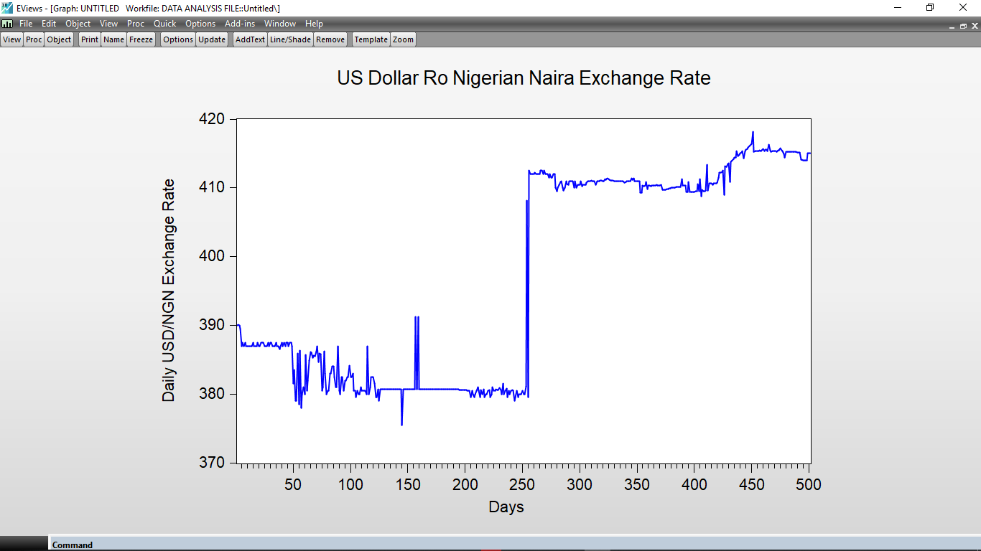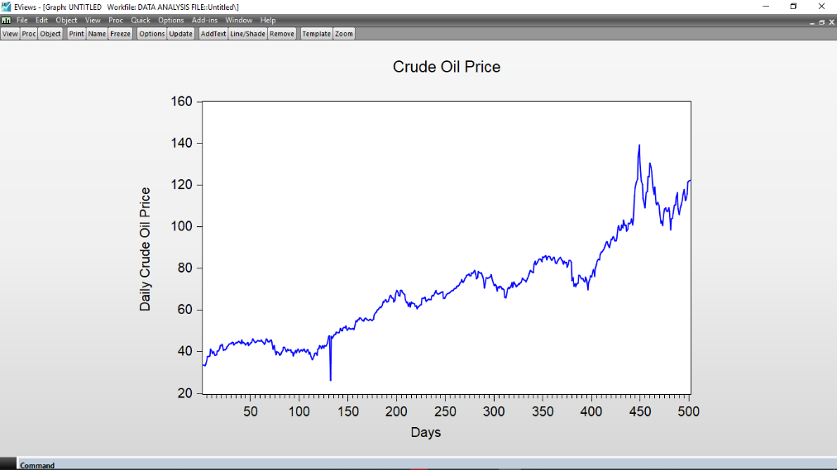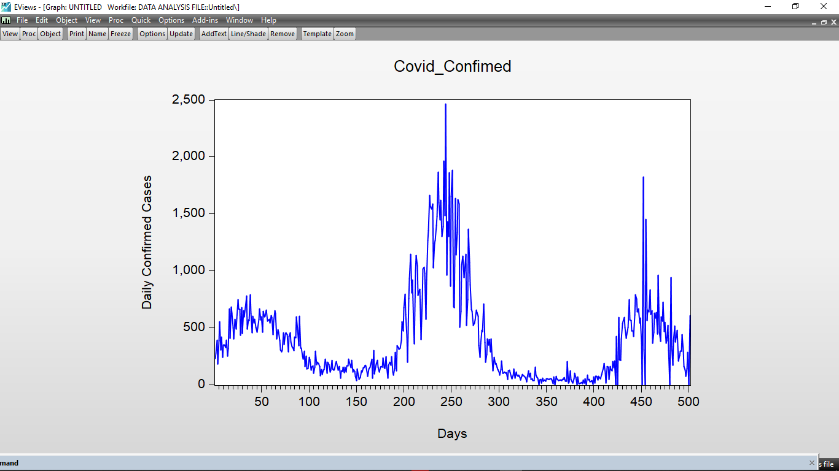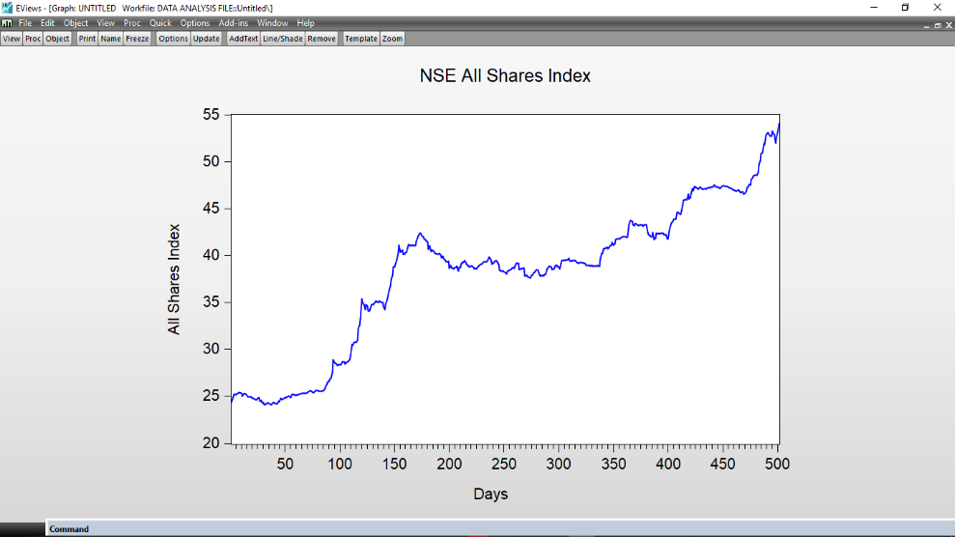

**Figure 1: Time Plot of Variables including: COVID-19 daily confirmed cases, All Shares Index, Crude oil Price and USD/NGN Exchange Rate.**

**Table 2: Unit Root Test using Augmented Dickey Fuller (ADF) Test**

|  |  |  |  |  |  |  |  |  |
| --- | --- | --- | --- | --- | --- | --- | --- | --- |
| Variable (s) | Stat.  level | t-Statistics | | |  | | | |
| 1% | 5% | 10% | | ADFTS | Prob. | Remarks |
| CC | I(0) | -3.44 | -2.87 | -2.57 | | -2.50 | 0.1162 | Not Stationary |
| I(1) | -3.44 | -2.87 | -2.57 | | -3.62 | 0.0057 | Stationary |
| ASI | I(0) | -3.44 | -2.87 | -2.57 | | 0.26 | 0.9800 | Not Stationary |
| I(1) | -3.44 | -2.87 | -2.57 | | -12.55 | 0.0000 | Stationary |
| OP | I(0) | -3.44 | -2.87 | -2.57 | | 0.18 | 0.9700 | Not Stationary |
|  | I(1) | -3.44 | -2.87 | -2.57 | | -10.73 | 0.0000 | Stationary |
| NGNUSD | I(0) | -3.44 | -2.87 | -2.57 | | -0.87 | 0.8000 | Not Stationary |
|  | I(1) | -3.44 | -2.87 | -2.57 | | -10.35 | 0.0000 | Stationary |

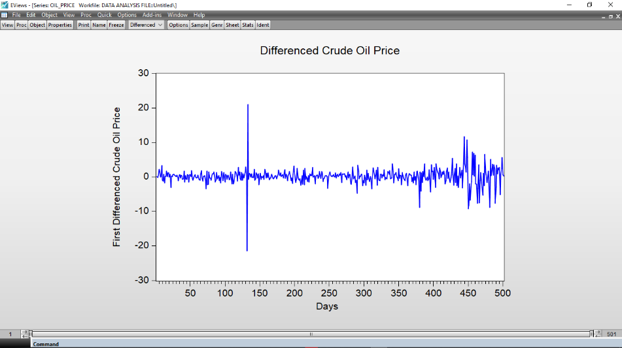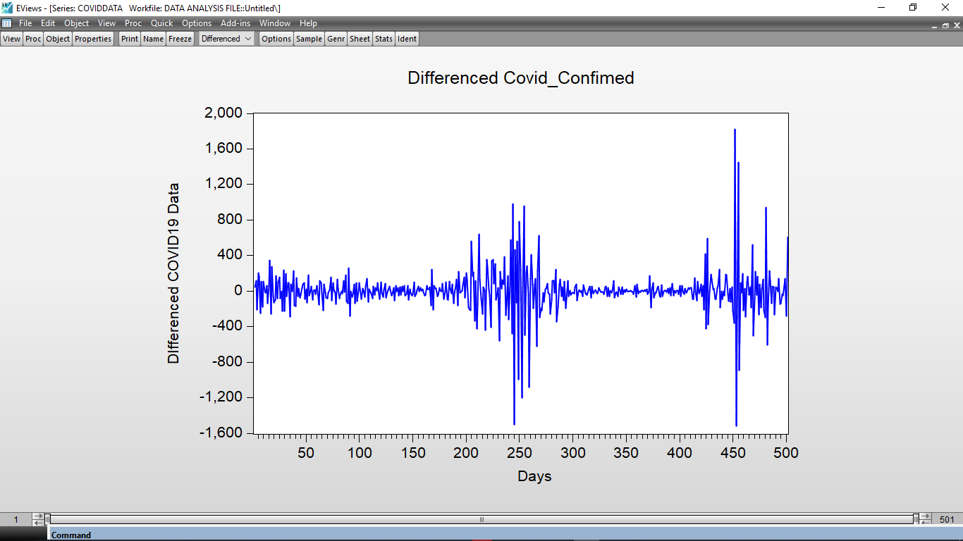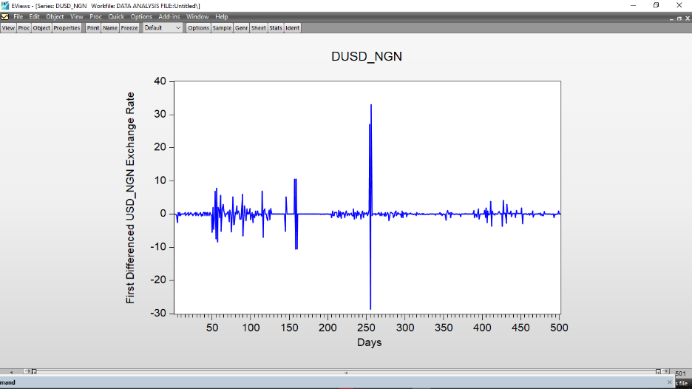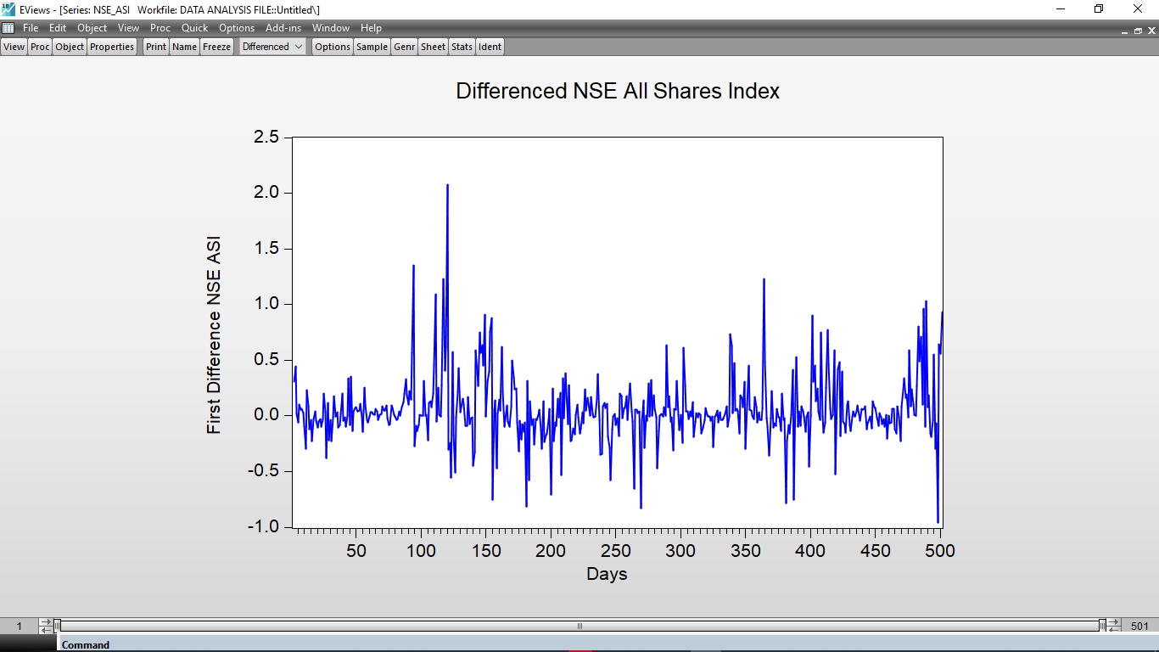The results were tested at 1%, 5%, and 10% level of significance respectively

**Figure 2: Time Plot of First Difference of the Variables including: COVID-19 daily confirmed cases, All Shares Index, Crude oil Price and USD/NGN Exchange Rate.**

**Table 3: Result of Johansen Cointegration Test**

|  |  |  |  |  |
| --- | --- | --- | --- | --- |
| Hypothesized |  | Trace | 0.05 |  |
| No. of CE(s) | Eigenvalue | Statistic | Critical Value | Prob.** |
|  |  |  |  |  |
|  |  |  |  |  |
| None | 0.033809 | 36.59352 | 47.85613 | 0.3670 |
| At most 1 | 0.023098 | 19.67199 | 29.79707 | 0.4453 |
| At most 2 | 0.016145 | 8.174284 | 15.49471 | 0.4470 |
| At most 3 | 0.000338 | 0.166180 | 3.841466 | 0.6835 |

**VAR Model Estimation**

**VAR Model - Substituted Coefficients:**

${∆CC}_{t}$ = - 0.847657996471 ${∆CC}_{t-1}$* - 0.693214530838 ${∆CC}_{t-2}$* - 0.43016783404 ${∆CC}_{t-3}$* - 0.394498829273 ${∆CC}_{t-4}$* - 0.404452063558 ${∆CC}_{t-5}$* - 0.162415725208 ${∆CC}_{t-6}$* + 0.102461531696 ${∆CC}_{t-7}$* + 0.18672968954 ${∆CC}_{t-8}$* + 11.3177752854 ${∆ASI}_{t-1}$* + 23.2234398021 ${∆ASI}_{t-2}$*+ 0.849200613873 ${∆ASI}_{t-3}$* - 26.7007008718 ${∆ASI}_{t-4}$*- 69.5531984035 ${∆ASI}_{t-5}$*+ 1.12456481052 ${∆ASI}_{t-6}$* + 5.48553607979 ${∆ASI}_{t-7}$*+ 42.6023142463 ${∆ASI}_{t-8}$*+ 2.45760481965 ${∆OP}_{t-1}$*- 5.63227094513 ${∆OP}_{t-2}$*+ 3.36714886314 ${∆OP}_{t-3}$*+ 2.21297081401 ${∆OP}_{t-4}$* - 7.57520154136 ${∆OP}_{t-5}$* - 2.39322534416 ${∆OP}_{t-6}$*+ 3.21857293201*D ${∆OP}_{t-7}$ + 11.0921699969 ${∆OP}_{t-8}$* + 4.25370527739 ${∆NGNUSD}_{t-1}$* + 2.67572492244 ${∆NGNUSD}_{t-2}$* - 3.47653409559 ${∆NGNUSD}_{t-3}$* - 3.2528241583 ${∆NGNUSD}_{t-4}$*- 7.36387255146 ${∆NGNUSD}_{t-5}$*- 8.76843625387 ${∆NGNUSD}_{t-6}$*- 10.9571641812 ${∆NGNUSD}_{t-7}$* - 6.48403260128 ${∆NGNUSD}_{t-8}$* + 0.382072962034 (4.1)

${∆ASI}_{t}$ = - 8.68417874977e-05 ${∆CC}_{t-1}$* - 0.000116082217775 ${∆CC}_{t-2}$* - 8.34833204581e-05 ${∆CC}_{t-3}$* - 8.47953945337e-05 ${∆CC}_{t-4}$*- 0.000124933464708 ${∆CC}_{t-5}$* - 1.53174717729e-05 ${∆CC}_{t-6}$* + 1.43592628916e-05 ${∆CC}_{t-7}$* + 3.0408380692e-05 ${∆CC}_{t-8}$* + 0.139430914942 ${∆ASI}_{t-1}$* + 0.114375822361 ${∆ASI}_{t-2}$* + 4.82813596812e-05 ${∆ASI}_{t-3}$*+ 0.071368670074 ${∆ASI}_{t-4}$*+ 0.0211903951526 ${∆ASI}_{t-5}$* + 0.0368626777587 ${∆ASI}_{t-6}$* - 0.00168302421323 ${∆ASI}_{t-7}$*+ 0.0292423604544 ${∆ASI}_{t-8}$*+ 0.00495907011895 ${∆OP}_{t-1}$* + 0.006453759457 ${∆OP}_{t-2}$*+ 0.00496295472522 ${∆OP}_{t-3}$* - 0.00101878610539 ${∆OP}_{t-4}$*- 0.00329501036506 ${∆OP}_{t-5}$* - 0.0060966970307 ${∆OP}_{t-6}$*- 0.00312255126844 ${∆OP}_{t-7}$* + 0.00293249024068 ${∆OP}_{t-8}$*- 0.00204667146914 ${∆NGNUSD}_{t-1}$* + 0.00184271771789 ${∆NGNUSD}_{t-2}$*+ 0.000980273023231 ${∆NGNUSD}_{t-3}$* + 0.00501494685191 ${∆NGNUSD}_{t-4}$* + 0.0191733254578 ${∆NGNUSD}_{t-5}$* + 0.00428657510353 ${∆NGNUSD}_{t-6}$* - 0.0150531143079 ${∆NGNUSD}_{t-7}$*- 0.0211120305053 ${∆NGNUSD}_{t-8}$* + 0.0342595850676 (4.2)

${∆OP}_{t}$ = 0.00179824621508 ${∆CC}_{t-1}$* + 0.00163100731797 ${∆CC}_{t-2}$* + 0.00163244635833 ${∆CC}_{t-3}$* + 0.00147140849602 ${∆CC}_{t-4}$* + 0.000754106910333 ${∆CC}_{t-5}$* + 0.000855842163203 ${∆CC}_{t-6}$* + 0.000591645644515 ${∆CC}_{t-7}$* - 0.000209928713489 ${∆CC}_{t-8}$* - 0.129688628589 ${∆ASI}_{t-1}$* + 0.0459006184979 ${∆ASI}_{t-2}$* - 0.148135448113 ${∆NSE_ASI}_{t-3}$* + 0.652655678354 ${∆ASI}_{t-4}$* - 0.246190858513 ${∆ASI}_{t-5}$* + 0.644136268716 ${∆ASI}_{t-6}$*- 0.369607249367 ${∆ASI}_{t-7}$* + 0.0960581169761 ${∆ASI}_{t-8}$* - 0.122071758019 ${∆OP}_{t-1}$* - 0.0494724519311 ${∆OP}_{t-2}$* - 0.0190523912501 ${∆OP}_{t-3}$* + 0.000441355536131 ${∆OP}_{t-4}$* - 0.0709837110422 ${∆OP}_{t-5}$*- 0.153925295236 ${∆OP}_{t-6}$* - 0.0857158712093 ${∆OP}_{t-7}$* - 0.0397946403748 ${∆OP}_{t-8}$* - 0.00424124324076 ${∆NGNUSD}_{t-1}$* + 0.0113083026158 ${∆NGNUSD}_{t-2}$* + 0.0130721311794 ${∆NGNUSD}_{t-3}$* + 0.0205989484293 ${∆NGNUSD}_{t-4}$* + 0.0455605723958 ${∆NGNUSD}_{t-5}$* + 0.0466049031508 ${∆NGNUSD}_{t-6}$* + 0.0200186168621 ${∆NGNUSD}_{t-7}$* - 0.0143443272433 ${∆NGNUSD}_{t-8}$* + 0.221423067123 (4.3)

D(NGNUSD) = - 0.00127092112455 ${∆CC}_{t-1}$* - 0.00172408601356 ${∆CC}_{t-2}$* - 0.000846562679316 ${∆CC}_{t-3}$* - 0.00132389776401 ${∆CC}_{t-4}$* - 0.002775241329 ${∆CC}_{t-5}$* - 0.00022450556494 ${∆COVIDDATA}_{t-6}$* - 0.000276705959595 ${∆CC}_{t-7}$* + 0.00077659228893 ${∆CC}_{t-8}$* - 0.061461164282 ${∆ASI}_{t-1}$* - 0.540793384087 ${∆ASI}_{t-2}$* + 0.420402987114 ${∆ASI}_{t-3}$* + 0.297542315846*D ${∆ASI}_{t-4}$ + 0.274570792709 ${∆ASI}_{t-5}$* - 0.300586005994 ${∆ASI}_{t-6}$* - 0.438390224244 ${∆ASI}_{t-7}$* - 0.294224605947 ${∆ASI}_{t-8}$* + 0.0344216590771 ${∆OP}_{t-1}$* + 0.0224264447099 ${∆OP}_{t-2}$* + 0.00265817465474 ${∆OP}_{t-3}$* + 0.0180165196639 ${∆OP}_{t-4}$* - 0.00771051945746 ${∆OP}_{t-5}$* - 0.038599881502 ${∆OP}_{t-6}$* - 0.00146721448305 ${∆OP}_{t-7}$* + 0.0134633173596 ${∆OP}_{t-8}$* - 0.716360351492 ${∆NGNUSD}_{t-1}$* - 0.0286537293994 ${∆NGNUSD}_{t-2}$*+ 0.270481988918 ${∆NGNUSD}_{t-3}$* + 0.166497128989 ${∆NGNUSD}_{t-4}$* + 0.0486785646611 ${∆NGNUSD}_{t-5}$* - 0.0446925903718 ${∆NGNUSD}_{t-6}$* - 0.0659197508471 ${∆NGNUSD}_{t-7}$* - 0.0638323384114 ${∆NGNUSD}_{t-8}$* + 0.108125428278 (4.4)

**VAR Residual Diagnostic Tests**

**Table 4:VAR(8) Model Stability Test**

|  |  |  |  |  |  |
| --- | --- | --- | --- | --- | --- |
| **Diagnostic Test** | **Test Statistics** | **df** | **Chi-square Test Statistic Value** | **Prob. Value** | **Remarks** |
| **(p-value)** |
| VAR Residual Normality Test | Orthogonalization: | 2 | 972.124 | 0.08324 | Multivariate residual are normal |
| 2 | 723.181 | 0.20145 |
| 2 | 10107.3 | 0.05105 |
| 2 | 39643.1 | 0.10514 |
|  |  |  |  |  |  |
| VAR Residual | Chi-square | 640 | 1400.368 | 0.51341 | No Heteroscedastic |
| Heteroscedasticity |
| Test |

**Granger Causality Test**

This procedure is conducted to assess the relationship and the direction of influence among the variables being studied in response to external influences. The outcomes derived from the Granger Causality Test estimation are presented in Table 5.

**Table 5 VAR Model Granger Causality/Block Exogeneity Wald Tests**

|  |  |  |  |
| --- | --- | --- | --- |
|  |  |  |  |
|  |  |  |  |
|  |  |  |  |
| Dependent variable: D(CC) | | | |
|  |  |  |  |
|  |  |  |  |
| Excluded | Chi-sq | df | Prob. |
|  |  |  |  |
|  |  |  |  |
| D(ASI) | 8.463900 | 2 | 0.0330 |
| D(OP) | 7.997321 | 2 | 0.0183 |
| D(NGNUSD) | 6.806137 | 2 | 0.0458 |
|  |  |  |  |
|  |  |  |  |
| All | 12.60427 | 6 | 0.0350 |
|  |  |  |  |
|  |  |  |  |
|  |  |  |  |
| Dependent variable: D(ASI) | | | |
|  |  |  |  |
|  |  |  |  |
| Excluded | Chi-sq | df | Prob. |
|  |  |  |  |
|  |  |  |  |
| D(CC) | 8.173574 | 2 | 0.5561 |
| D(OP) | 6.696243 | 2 | 0.0682 |
| D(NGNUSD) | 7.502055 | 2 | 0.0180 |
|  |  |  |  |
|  |  |  |  |
| All | 12.328948 | 6 | 0.0466 |
|  |  |  |  |
|  |  |  |  |
|  |  |  |  |
| Dependent variable: D(OP) | | | |
|  |  |  |  |
|  |  |  |  |
| Excluded | Chi-sq | df | Prob. |
|  |  |  |  |
|  |  |  |  |
| D(CC) | 9.353853 | 2 | 0.8788 |
| D(ASI) | 6.204443 | 2 | 0.1528 |
| D(NGNUSD) | 6.078568 | 2 | 0.0215 |
|  |  |  |  |
|  |  |  |  |
| All | 19.632225 | 6 | 0.0265 |
|  |  |  |  |
|  |  |  |  |
|  |  |  |  |
| Dependent variable: D(NGNUSD) | | | |
|  |  |  |  |
|  |  |  |  |
| Excluded | Chi-sq | df | Prob. |
|  |  |  |  |
|  |  |  |  |
| D(CC) | 9.345545 | 2 | 0.0593 |
| D(ASI) | 2.274007 | 2 | 0.3208 |
| D(OP) | 9.453510 | 2 | 0.0271 |
|  |  |  |  |
|  |  |  |  |
| All | 12.34903 | 6 | 0.0346 |
|  |  |  |  |
|  |  |  |  |

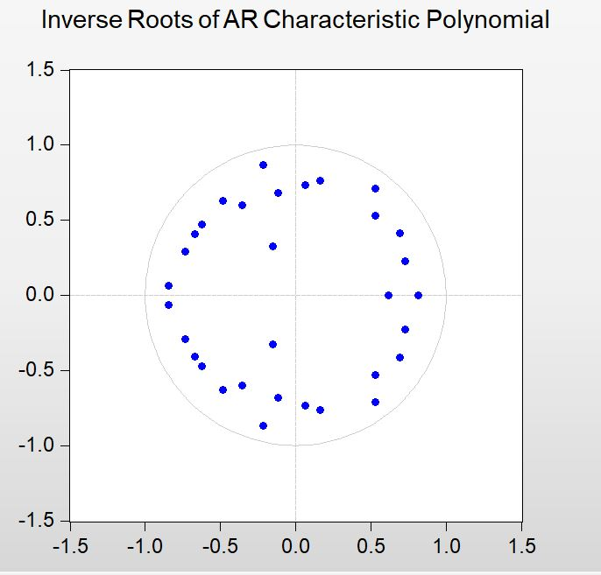

**Figure 3: Inverse Roots of AR Characteristic Polynomial of the VAR(8) Model Showing Dynamic Stability.**

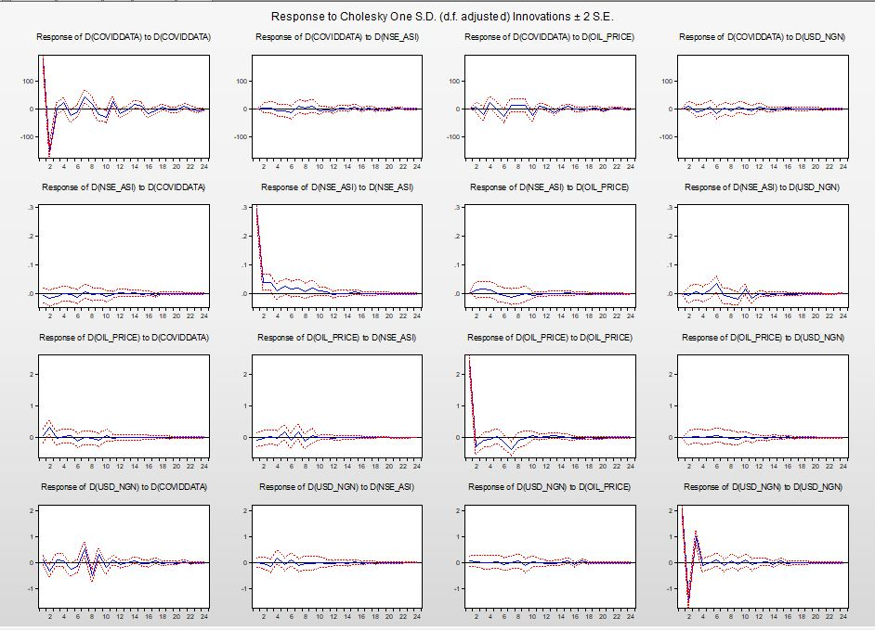

**Figure 4: Plot of Impulse Response Functions of the VAR(8) Model**

**Forecasting using the VAR (8) M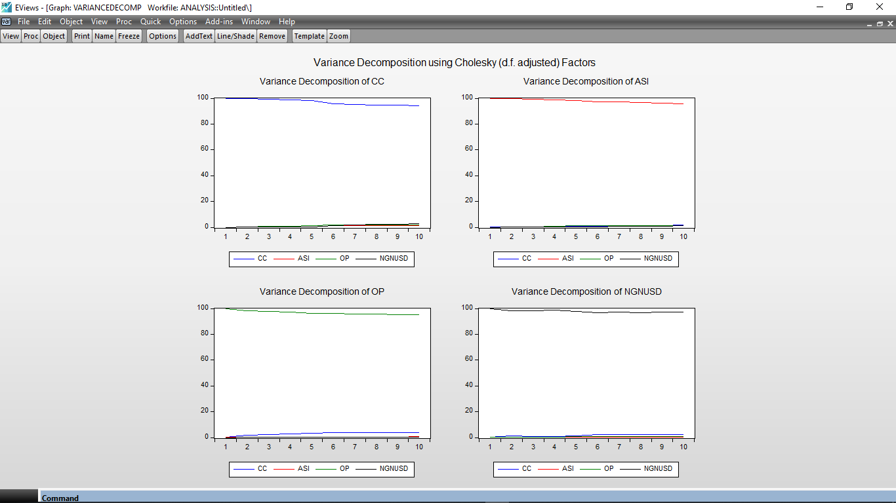odel**

**Figure 5: Variance Decomposition of the VAR(8) Model.**

**3.2: Discussion**

The descriptive statistics of the interacting variables including COVID-19 Daily confirmed cases (CC), Nigerian Stock Exchange All Shares Index ASI), Nigerian Crude Oil Price (OP) and United State Dollar to Nigerian Naira daily exchange rate (NGNUSD) are seen in Table 1. This clearly shows that the data used are normally distributed, following the probability of the Jarque Bera Statistics having p-values greater than 0.05 (Table 1).

Also the four datasets were graphically represented using line plots as seen in Figure1a - Figure 1d . In Figure 1a the time series plot of daily confirmed cases of COVID-19 in Nigerian, within the time specified for the study (501 days). Similarly, in Figure 1b, daily Nigeria Stock Exchange All Shares Index was graphically represented , showing trends.

Also, in Figure 1c, the daily Nigeria Crude oil Price was graphically represented for the time period under study while the daily Nigerian Naira/ United Stated Dollar exchange rate was represented in Figure.1d. After the stationarity test in Table 2, The time plot of the variables at first difference was also taken as seen in Figure 2, this is due to the fact that all variables were stationary at first difference I(1).

Because their ADF test statistics are higher (less negative) than the critical values and have high p-values, The result in Table 2 demonstrate that none of the variables—Carbon Credit (CC), All Share Index (ASI), Oil Price (OP), and Exchange Rate (NGNUSD)—are stationary at level [I(0)]. All variables, however, become stationary following first differencing [I(1)], with p-values less than 0.01 and ADF test statistics substantially below the 1%, 5%, and 10% critical values. This suggests that the variables are integrated of order one, I(1), and supports the use of econometric models like the Vector Error Correction Model (VECM) and the ARDL that are appropriate for non-stationary data that becomes stationary after differencing.

Equation 3.1 – 3.4 presented the VAR model estimation of interacting variables. Table.3 presents the results of the VAR(8) model stability test, including diagnostic tests for residual normality and heteroscedasticity. The VAR Residual Normality Test indicates that multivariate residuals are normal, as evidenced by the Chi-square test statistics and their associated p-values. Moreover, the VAR Residual Heteroscedasticity Test shows no evidence of heteroscedasticity, as the Chi-square test statistic value of 1400.368 with a corresponding probability value of 0.51341 suggests. These findings align with recent works in the field (Uyanto, (2022), which similarly reported normality of residuals and absence of heteroscedasticity in VAR models. Overall, the stability test results support the reliability and robustness of the VAR(8) model in capturing the dynamics of the variables under investigation.

The findings from the VAR Model Granger Causality/Block Exogeneity Wald Tests, as delineated in Table 4, underscore crucial causal relationships among pivotal economic variables within Nigeria, particularly in the context of the COVID-19 pandemic. The results elucidate noteworthy causal connections between fluctuations in various economic indicators. Notably, changes in the Confirmed Cases of COVID-19 (CC) are shown to Granger cause variations in the All Share Index (ASI), Oil Prices (OP), and the Nigerian Naira to US Dollar Exchange Rate (NGNUSD), suggesting the pivotal influence of consumer sentiment on stock market performance, oil price dynamics, and currency valuation. Conversely, changes in ASI and NGNUSD are found to Granger cause alterations in CC, indicative of a reciprocal relationship between stock market fluctuations, currency exchange rate dynamics, and consumer confidence levels. These findings carry profound implications for comprehending the ramifications of the COVID-19 crisis on economic growth and stability in Nigeria, underscoring the intricate interplay among diverse economic variables and the critical significance of factors such as consumer confidence, stock market performance, and exchange rate dynamics in shaping economic trajectories during periods of crisis (Adedeji et al.,, 2021; Odekina et al., 2022).

On the short run effect of COVID-19 on economic growth and stability in Nigeria, the variance decomposition analysis of the Vector Autoregression VAR(8) model as seen in the graph in Figure 5, reveals insightful dynamics in the forecasting strength of the selected model. Across various periods, the model effectively captures the majority of the variance in the variables D(CC), D(ASI), and D(OP), indicating a robust forecasting capability. For instance, in the case of D(CC), the model captures 100% of the variance in the first period and maintains a high level of explanatory power throughout subsequent periods. Similarly, for D(ASI) and D(OP), the model consistently explains a significant portion of the variance. This finding is in line with recent studies highlighting the efficacy of VAR models in forecasting financial time series data (Lütkepohl, 2005). Interpreting the table, the Variance Decomposition analysis delineated how much of the variance in D(CC) could be ascribed to shocks originating from each of the other variables (D(ASI), D(OP), D(NGNUSD)) over the examined timeframe (Ajide, 2021). Considering the global economic context and the timeframe covered, it was reasonable to infer that the analysis encapsulated the repercussions of the COVID-19 pandemic on the Nigerian economy. Hence, it likely captured how pandemic-related shocks, such as financial market disruptions, exchange rate fluctuations, and stock market volatility, impacted credit conditions (D(CC)) in Nigeria. Additionally, the analysis underscored the interconnectedness of these variables, elucidating which factors contributed most significantly to fluctuations in credit conditions during certain periods. This insight was pivotal for policymakers and investors to comprehend how changes in one economic indicator reverberated throughout the system (Adediran et al., 2020). Consequently, understanding the relative importance of different variables in driving credit conditions fluctuations could guide policymakers in formulating targeted measures to stabilize the economy or mitigate the impact of future crises. For instance, if the analysis revealed that exchange rate fluctuations exerted a substantial influence on credit conditions, policymakers could consider implementing policies to enhance currency stability, thereby bolstering overall financial stability and economic resilience (Omotosho et al., 2021).

4. Conclusion

This study aimed to model the impact of the COVID-19 pandemic on economic growth and stability in Nigeria using Vector Autoregressive (VAR) Model. Four variables were used to develop the VAR Model and the ARDL model, including one variable relating to Nigerian COVID-19 daily data (confirmed cases) in collaboration with data from other economic variables such as the Nigerian Stock Exchange (NSE) All Shares Index, Daily Nigerian Naira/United States Dollar Exchange Rate, and Nigerian Crude Oil Price, to understand the trends and impact of COVID-19 on the Nigerian Economy in the post-pandemic era in Nigeria. This study covered daily time series data for the four variables between May 26, 2020, and May 25, 2022, totaling a time period of 501 days. The results obtained from the VAR(8) model showed that there existed only a short-run relationship between the four interacting variables as the cointegration test showed no integrating equation

The VAR model estimation process, provides comprehensive insights into the short-term dynamics among key economic variables, including CC, ASI, OP, and NGNUSD. Coefficients and standard errors for lagged differences of these variables are presented, alongside diagnostic measures such as R-squared values, F-statistics, and information criteria, offering a thorough overview of the model's performance. Furthermore, the stability test results in Table 4 affirm the reliability of the VAR(8) model, with findings consistent with previous studies on the normality of residuals and absence of heteroscedasticity. These outcomes validate the robustness of the VAR model in capturing economic dynamics, particularly amidst external shocks like the COVID-19 pandemic. The results from the VAR Model Granger Causality/Block Exogeneity Wald Tests, outlined in Table 5, highlight crucial causal relationships among economic variables in Nigeria, emphasizing the significant influence of CC on ASI, OP, and NGNUSD, and vice versa. These findings align with recent studies, shedding light on the intricate interplay among diverse economic indicators and their implications for economic growth and stability during crises such as the COVID-19 pandemic. Moreover, the short-run effects of COVID-19 on economic growth and stability, as analyzed through variance decomposition in the VAR(8) model, reveal robust forecasting capabilities. This aligns with prior research emphasizing the efficacy of VAR models in forecasting financial time series data, underscoring the importance of understanding the interconnectedness of economic variables for informed policymaking and investment decisions.

Disclaimer (Artificial intelligence)

Option 2:

Author(s) hereby declare that generative AI technologies such as Large Language Models, etc. have been used during the writing or editing of manuscripts. This explanation will include the name, version, model, and source of the generative AI technology and as well as all input prompts provided to the generative AI technology

Details of the AI usage are given below:

1.ChatGPT 3.0

2.

3.

References

1. Ahmed, N., Khan, D., Oláh, J., & Popp, J. (2023). A comparative study of the policy response to COVID-19 in the ASEAN region: A dynamic simulated ARDL approach. *Plos one*, *18*(1), e0276973.
2. Box G, Jenkins G., Time Series Analysis: Forecasting and Control, 2nd ed. San Francisco, *CA: Holden-Day*, 1970.
3. Box G,Jenkins G., . Time Series Analysis: Forecasting and Control, San Francisco, *CA: Holden-Day,* 1970.
4. Chang, B. H., Gohar, R., Derindag, O. F., & Uche, E. (2023). COVID-19, lockdown measures and their impact on food and healthcare prices: empirical evidence using a dynamic ARDL model. *Journal of Economic Studies*, *50*(5), 1008-1026.
5. Dong, Y., Mo, X., Hu, Y., Qi, X., Jiang, F., Jiang, Z., & Tong, S. (2020). Epidemiology of COVID-19 among children in China. Pediatrics, 145(6).
6. Etuk, E. H., Attoe, S. A., Essi, I. D, A Seasonal Box-Jenkins Model for Nigerian Inflation Rate Series. Journal of Mathematics Research; 2012;4(4), 107–113.
7. Jing C, Mengmeng R, Shuyang X, Ingyu W, Predicting Seasonal Influenza Based on SARIMA Model, in Mainland China from 2915 to 2018. International Journal of Environmental Research and Public Health, 2019; 16(23):47-60.

Lipsitch, M., Swerdlow, D. L., & Finelli, L. (2020). Defining the epidemiology of Covid-19—studies needed. New England journal of medicine, 382(13), 1194-1196.

1. Matuka, A. (2020). COVID-19 outbreak and US economic policy uncertainty: an ARDL approach. *Available at SSRN 3685346*.
2. Napoli PE, Nioi M. Global Spread of Coronavirus Disease 2019 and Malaria: An Epidemiological Paradox in the Early Stage of A Pandemic. J Clin Med. 2020 Apr 16;9(4):1138. doi: 10.3390/jcm9041138. PMID: 32316118; PMCID: PMC7230338.
3. Nwuju, K, Lekara-Bayo I. B, Modelling and Forecasting Daily Confirmed Cases of Covid-19 in Africa: A Case Study of ECOWAS Countries: International Journal of Applied Science and Mathematical Theory; 2020; 6(2), 37-54.
4. Nwuju, K., Lekara-Bayo, IB., Etuk, EH, Intervention Analysis of Daily South African Rand/Nigerian Naira Exchange Rates. International Journal of Management Studies, Business & Entrepreneurship Research, 2019;4, 17-26.
5. Our World in Dat, daily confirmed/death cases of COVID-19 from 20 March 2020 to 5 May 2020. https://ourworldindata.org/coronavirus/country/nigeria
6. Qiuying Yang, Jie Wang, Hongli Ma, Xihao Wang (2020). Research on COVID-19 based on ARIMA model—Taking Hubei, China as an example to see the epidemic in Italy. Journal of Infection and Public Health,2020, 13(10), 1415 - 1418
7. Sahai, A. K., Rath, N., Sood, V., & Singh, M. P. , (ARIMA modelling & forecasting of COVID-19 in top five affected countries. Diabetes & metabolic syndrome, 2020, 14(5), 1419–1427. https://doi.org/10.1016/j.dsx.2020.07.042
8. Stübinger, J., & Schneider, L., Epidemiology of coronavirus COVID-19: Forecasting the future incidence in different countries. Healthcare,2020, 8(2).

APPENDIX

**Appendix A:** Daily Confirmed/Death Cases of COVID-19 in Nigerian from 20th March 2020 to 5th May 2020.

|  |  |  |
| --- | --- | --- |
| S/N | Daily Confirmed Cases | Daily Death Cases |
| 1 | 4 | 0 |
| 2 | 10 | 0 |
| 3 | 8 | 0 |
| 4 | 10 | 1 |
| 5 | 4 | 0 |
| 6 | 7 | 0 |
| 7 | 14 | 0 |
| 8 | 16 | 0 |
| 9 | 16 | 0 |
| 10 | 0 | 0 |
| 11 | 34 | 1 |
| 12 | 0 | 0 |
| 13 | 20 | 0 |
| 14 | 23 | 0 |
| 15 | 16 | 0 |
| 16 | 20 | 2 |
| 17 | 22 | 1 |
| 18 | 6 | 0 |
| 19 | 16 | 1 |
| 20 | 22 | 0 |
| 21 | 12 | 1 |
| 22 | 17 | 0 |
| 23 | 13 | 3 |
| 24 | 5 | 0 |
| 25 | 20 | 0 |
| 26 | 30 | 1 |
| 27 | 34 | 1 |
| 28 | 35 | 1 |
| 29 | 51 | 4 |
| 30 | 49 | 2 |
| 31 | 85 | 2 |
| 32 | 38 | 1 |
| 33 | 117 | 3 |
| 34 | 91 | 3 |
| 35 | 108 | 3 |
| 36 | 114 | 1 |
| 37 | 87 | 3 |
| 38 | 91 | 5 |
| 39 | 64 | 0 |
| 40 | 195 | 4 |
| 41 | 196 | 7 |
| 42 | 204 | 7 |
| 43 | 238 | 10 |
| 44 | 218 | 17 |
| 45 | 170 | 2 |
| 46 | 244 | 6 |
| 47 | 148 | 5 |
| 48 | 195 | 5 |
| 49 | 381 | 4 |
| 50 | 386 | 10 |
| 51 | 239 | 11 |