**Evaluating the Influence of Environmental Factors on Wheat Growth Using Mixed-Effects Modeling**

**Abstract**

Wheat production is an important part of crops, and it is influenced by environmental factors that require advanced statistical techniques for accurate evaluation. This study enumerates the effects of rainfall, temperature, and soil moisture on the growth of wheat in Sokoto using a linear mixed model. This research aims to examine the variability in wheat yield in response to these environmental factors on random effects. The study also illustrates the factors based on variation across different blocks. The data was collected from 10 different environmental blocks, which include temperatures ranging from 24°C to 41°C, soil moisture of 10% to 45%, and rainfall of about 35mm to 150mm, respectively. Due to unobserved heterogeneity, random effects were used on the region and duration by capturing the variability in the growth of wheat due to temporary and spatial differences. The mixed effects model differentiates between environmental systemic and random functions. The model outcome deduced that rainfall has a positive impact on wheat cultivation with $(β=0.39)$, p-value less than 0.001, the temperature also shows a negative effect on $(β=-0.00)$, p-value less than 0.982. The soil moisture shows a slight impact $(β=0.04)$, p-value less than 0.05. The research suggested that optimal irrigation can boost the cultivation of wheat in the state. It also provides a robust framework by formulating policies for farmers to improve wheat production.

***Keywords:*** *Environmental Factors, Mixed Effect Model, Rainfall, Soil Moisture, Sokoto State*

**1.0 Introduction**

Wheat is one of the most consumed and cultivated cereal crops globally, especially in the northern part of Nigeria, where the climatic factors are favorable for germination, which also serves as the main source of food for many regions in the North. The growth of wheat is highly influenced by some environmental factors, including temperature of about 10oC to 30oC, soil moisture between 60% to 80%, and rainfall ranging from 400mm to 600mm, including other climatic factors. Zhang et al. (2022) due to the increased climatic changes, it is necessary to understand those factors that affect wheat production, especially in areas where agricultural activities depend on weather and pollution. The ability to forecast change in environmental conditions helps in formulating ways to combat the adverse effects to improve food security. Climate change in crop production has been subjected to extensive research, highlighting the increase in temperature, which has altered the precipitation pattern by increasing the frequency of the weather. The expansion in climate results in unbalanced effects on the growth of wheat. Liu et al. (2020) indicate that, when there is an increase in temperature, it makes the growth in the cooler regions, which is more suitable for the production of wheat in those regions. However, when there is excess heat on the yield at an early stage, the flowering of the grain filling will be reduced drastically, leading to low output in wheat yield production Wheeler et al. (2013). Additionally, variability in rainfall is another crucial factor that influences wheat productivity. Ousayd et al. (2024) postulated that, when there is high rainfall, it leads to waterlogging, and this can cause oxygen in the root to be reduced, while the shortage of rainfall causes drought, leading to low output of wheat production. The model also serves as a powerful instrument for analyzing environmental variables on crops for both fixed effects. It also uses a hierarchical structure on agricultural data, which shows a flexible framework for examining the yield response to environmental treatment. Southworth et al. (2000) use the model to evaluate the impacts of precipitation and temperature on a particular maize crop in the Midwest of the United States of America, in their study shows that the model is very effective in separating the effects of weather conditions from other factors of variable which gives more accurate on yield prediction. A study conducted by Geng et al. (2023) developed a model to evaluate the impacts of irrigation systems and the soil type on wheat crops in Pakistan due to the texture of the soil. In the aspect of agricultural studies, spilt-plot design is employed when the treatment is deployed to the main plot such as irrigation level, which is very difficult to randomize within the subplot(fertilizer) and this is useful for evaluating large-scale data sets with multiple factors constituting to the output of the production of wheat in large scale. Recent research conducted by Haque et al. (2021) deploys the use of a split-plot design to examine the different irrigation systems and fertilizer types on wheat production in Bangladesh. The result of their research shows that the irrigation system has a germane impact on wheat yield, the type of fertilizer used also collaborates with the availability of water, which is an important factor to be considered for both primary and secondary treatments. Khan et al. (2022) focus their studies on the impact of climatic factors on wheat production by integrating the model with a split-plot design. The study also aims to bridge the gap, thereby employing the model to combine the effects of rainfall, temperature, and soil mixtures on wheat growth and yield. The design also captures the complexity of environmental treatment by examining the impacts of these factors on wheat using a mixed-effects model. It is also used to assess the interaction between fertilizer types and irrigation systems on climatic factors for wheat products. Recent studies carried out by Wegrzyn et al. (2022) enumerate the effects of some selected metrological factors on the germinating rate of seeds during winter, which is sensitive to climatic variation. Research conducted by Zeleke et al. (2023), shows that weather indices are also one of the major factors that affect the reproductive stage of wheat growth, which depicts that, when the weather conditions are favorable, the production of wheat will be high in the area where it is cultivated. Kheyruri et al. (2024) deploy a geographical detector model to evaluate the effects of socio-environmental parameters on the cultivation of wheat in a region, thereby explaining the maximum use of advanced statistical methods in the area of research in agriculture. By employing the model, the aim is to fill the gap through the model and combine numerous climatic factors on wheat products, coupled with the two environmental treatments. Zheng et al. (2025) note that the regional temperature results in the fluctuation of wheat production, most especially in some areas, where there is a highly sensitive climate factor. Southworth et al. (2000) enumerate the importance of wheat growth cycles, which are highly subject to changes in climate factors, thereby enhancing productivity depending on its conditions. For instance, when there is a high temperature, the flowering and grain filling stages will be reduced, which also affects the pollen grain formation. According to Blake et al. (2020), they examined the model through traditional methods, which shows inherent complexities. Several studies have explained the responses of wheat and rice to various irrigation and fertilizer treatments, showing the flexibility and efficiency of split-plot design to analyze different environmental impacts on the growth of wheat crops. This also filled the gap for different comprehensive approaches that can predict the yield of crops accurately due to unstable environmental conditions. By applying the model, it provides an insight into the complex relationship between environmental variables on wheat growth, which offers a practical solution for agricultural management, leading to changes in climatic conditions. Johnson et al. (2020) use a Linear Mixed Model to sensitize the spike in temperature and water deficits due to flooding, and this can disturb the free flow of nutrients in the root of the crop. A study conducted by Zwiers et al. (2013) used the model to predict changes in climate challenges faced by farmers, leading to the high frequency of extreme weather conditions such as drought, heat waves, and heavy rainfall. Research conducted by Arias et al. (2024) found that the same region with high weather conditions is more likely to experience higher instability of yield most especially on wheat crops that are sensitive to changes in temperature. Karuna et al. (2024) use the model for regression by forecasting the yield of wheat. The result of the findings enumerates environmental factors by enhancing the prediction accuracy of the wheat crop, and it is also used as a measurement by farmers in decision-making to ensure sufficient food and allocation of agricultural resources. A study by Jones et al. (2021) enumerates the utility of the model by analyzing the various effects of agronomical practices and weather conditions on the yield of crops, It was deduced that random effects give the model accuracy by providing mere estimates of the environmental factors that strongly affect the yield. Geng et al. (2023) in their research emphasize the importance of both climate and management factors interwoven, predicting the yield of crops under various conditions.

**2.0 Materials and Methods**

This research was carried out in the Northern part of Nigeria (Sokoto), which is known for its harsh climatic conditions with fertile soil for the cultivation of wheat. The site location is approximately (${13.005}^{o}C$, ${5.2476}^{O}E$) having an average annual temperature of 37.05°C (98.690F), 24.01°C (75.220F), with a corresponding annual precipitation of 34.38mm (1.35 inches). The area is characterized by a hot semi-arid climate (BSH) as estimated by the Koppen climate classification, which is typically good for wheat cultivation. The experimental plots were set up on agricultural land of 2,597,300 hectares under natural field conditions.

**3.0 Source of Data**

The data used for this study were obtained from weather stations in Sokoto using a sensory apparatus to track the rainfall, temperature, and soil moisture on wheat crops. The sensory machine is suspended in the center of an individual plot at varying depths to measure the soil moisture. The values were recorded in stages, which include the number of seeds grown per plot, and plant height measured on some specific days after planting. The plant is also assessed at multiple intervals of time during the germination season.

**4.0 Method of Data Analysis**

The Linear Mixed-Effects Model (LMM) was used to analyze the data, accounting for both fixed effects and random effects. The fixed effects in the model included temperature, rainfall, soil moisture, irrigation, fertilization, and wheat variety, while the random effects accounted for spatial variation within the experimental field, such as block-to-block variation and plot-to-plot variation. Suppose we have a single fixed effect predictor X, representing a treatment applied uniformly across all experimental units. The relationship between X and the response variable Y is modeled as:

$Y=β_{0}+β_{1}X_{1}+ϵ$ (1)

here, $β_{0}$ Is the intercept, $β_{1}$ ​ Is the fixed effect coefficient, and ϵ is the error term. In multiple regression with several predictors, this extends to:

$Y=β_{0}+β_{1}X_{1}+β_{2}X_{2}+…+β_{p}X_{p}+ϵ$ (2)

Suppose we want to include a random intercept term to account for variability between groups (e.g., blocks or plots). The model is extended to:

$Y=β_{0}+β_{1}X_{i}+u_{i}+ϵ_{i}$ (3)

here, $u_{i}$ Represents the random effect associated with the i-th group (or block), and it is assumed to follow a normal distribution with mean 0 and variance. $σ_{u}^{2}$

Combining both fixed and random effects:

$Y_{ijk}=β_{0}+β_{1}X_{1ijk}+β_{2}X_{2ijk}+…+β_{p}X_{pijk}+u_{i}+ϵ_{ijk}$ (4)

The random effect $u_{i}$ introduces a correlation between observations from the same group, while $ϵ_{ijk}$ Accounts for the individual variation within each group. For a mixed-effects model with normally distributed random effects and errors, the likelihood function is given by:

$L\left(θ/Y\right)=\prod_{i=1}^{n}{\prod_{j=1}^{m}{\frac{1}{\sqrt{2πσ^{2}}}exp\left(-\frac{{\left(Y_{ijk}-X_{ijk}β-u_{i}\right)}^{2}}{2σ^{2}}\right)}}$ (5)

To make the computation more tractable, we often take the log of the likelihood function to obtain the log-likelihood function:

$l\left(θ/Y\right)=\sum_{i=1}^{n}{\sum_{j=1}^{m}{\left[-\frac{1}{2}log\left(2πσ^{2}\right)-\frac{{\left(Y_{ijk}-X_{ijk}β-u_{i}\right)}^{2}}{2σ^{2}}\right]}}$ (6)

The log-likelihood function is then maximized to estimate the model parameters.

$\left(β,σ_{u,}^{2}σ_{ϵ}^{2}\right)$

The random effects $u_{i}$ and the residuals $ϵ_{i}$ In a linear mixed-effects model are assumed to follow a normal distribution.

The PDF of the random effect is given by:

$f\left(u_{i}\right)=\frac{1}{\sqrt{2πσ_{u}^{2}}}exp\left(-\frac{u_{i}^{2}}{2σ_{u}^{2}}\right)$ (7)

The Probability Density Function for residual is given by:

$f\left(ϵ_{i}\right)=\frac{1}{\sqrt{2πσ_{u}^{2}}}exp\left(-\frac{ϵ_{i}^{2}}{2σ_{ϵ}^{2}}\right)$ (8)

The Cumulative Distribution Function (CDF) of a normal distribution gives the probability that a random variable X will take a value less than or equal to x. For the random effects and residuals, the CDF is:

$F\left(u_{i}\right)=P\left(U_{i}≤u_{i}\right)=\frac{1}{2}\left[1+erf\left(\frac{u_{i}}{\sqrt{2σ_{u}^{2}}}\right)\right]$ (9)

Where erf (x) is the error function.

Similarly, for the residuals:

$F\left(ϵ_{i}\right)=P\left(ϵ_{i}≤ϵ_{i}\right)=\frac{1}{2}\left[1+erf\left(\frac{ϵ_{i}}{\sqrt{2σ_{ϵ}^{2}}}\right)\right]$ (10)

To prove the LMM

$Y=X_{β}+Z_{u}+ϵ$ (11)

$Y\sim N\left(Xβ,Zσ_{u}^{2}Z^{T}+σ_{ϵ}^{2}I\right)$ (12)

Here, $Zσ_{u}^{2}Z^{T}+σ_{ϵ}^{2}I$ Is the covariance matrix of Y, and the likelihood of Y given the parameters $\left(β,σ_{u,}^{2}{ and σ}_{ϵ}^{2}\right)$

$f\left(Y/β,σ_{u}^{2},σ_{ϵ}^{2}\right)=\frac{1}{{\left(2π\right)}^{n/2}{\left|Σ\right|}^{1/2}}exp\left(-\frac{1}{2}{\left(Y-Xβ\right)}^{T}Σ^{-1}\left(Y-Xβ\right)\right)$ (13)

In practice, working with the log-likelihood function is more convenient because it simplifies the product of terms into a sum. The log-likelihood for this model is:

$l{(Y}/β,σ_{u}^{2},σ_{ϵ}^{2})=-\frac{n}{2}log\left(2π\right)-\frac{1}{2}log\left|Σ\right|-\frac{1}{2}{\left(Y-Xβ\right)}^{T}Σ^{-1}\left(Y-Xβ\right)$ (14)

**6.0 Result and Discursion**

**Table 1: Descriptive Statistics for Climatic Factors on Wheat Yield**

|  |  |  |  |  |
| --- | --- | --- | --- | --- |
| **Variables** | **Temperature** | **Rainfall** | **Soil Moisture** | **Wheat Yield** |
| **Mean** | 11.34 | 0.77 | 1.03 | 0.7431 |
| **Minimum** | 0.008 | 0.95 | 0.003 | 0.003 |
| **Maximum** | 99 | 3.919 | 22 | 4.319 |
| **Median** | 0.8545 | 0.5665 | 0.6205 | 0.5735 |
| **Standard Error** | 1.68 | 0.05 | 0.14 | 0.04 |
| **Standard Deviation** | 23.79 | 0.67 | 2.03 | 0.58 |
| **Skewness** | 2.35 | 15 | 7.19 | 1.99 |
| **Kurtosis** | 4.55 | 3.56 | 61.78 | 7.29 |

The distribution in the table above indicates high variability in temperature and soil moisture, with an extreme value of maximum and a standard deviation. All the variables are skewed to the right, indicating lower values with outliers, most especially soil moisture. The mean and median also indicate skewness. Rainfall and wheat yield are very low, suggesting that there is an extremely significant effect on soil moisture and temperature.

**Table 2: Anova Table for Treatment Effects**

|  |  |  |  |  |  |
| --- | --- | --- | --- | --- | --- |
| **Source** | **DF** | **Sum of Squares** | **Mean Square** | **F-Value** | **Pr(>F)** |
| Treatment | 3 | 13764 | 4588 | 34.08 | 2.00E-16 |
| Residual | 796 | 10714 | 135 |  |  |

The table above indicates that the p-value (Pr > f) is 2e^-16 is extremely small, showing that the effect of treatment is significant with a confidence interval of (0.05), which means one of the treatment groups is significant.

**Table 3: Turkey Pairwise Comparison of Treatments**

|  |  |  |  |  |
| --- | --- | --- | --- | --- |
| **Comparison** | **Diff** | **Lwr** | **Upr** | **P-Adj** |
| Soil Moisture - Rainfall | 0.42 | -2.56 | 3.42 | 0.98 |
| Temperature - Rainfall | 9.69 | 6.7 | 12.68 | 0 |
| Wheat - Rainfall | -0.05 | -3.04 | 2.94 | 0.99 |
| Temperature - Soil Moisture | 9.27 | 6.28 | 12.25 | 0 |
| Wheat - Soil Moisture | -9.47 | -3.47 | 2.51 | 0.97 |
| Wheat - Temperature | -9.75 | -12.73 | -6.76 | 0 |

The table above shows the pairwise comparison, presenting the difference between treatment means with their corresponding intervals. It can be deduced that since the confidence interval has a zero (0) value, meaning that the temperature gives a different treatment effect, where other climatic factors are not significantly different from one another.

**Table 4: Linear Mixed Effects Model**

|  |  |  |  |  |
| --- | --- | --- | --- | --- |
|  | **Estimate** | **Standard error** | **t-value** | **pr(>|t|)** |
| **Intercept** | 0.4011 | 0.0555 | 7.219 | 1.13E^-11 |
| **Temperature** | -0.0008 | 0.0015 | -0.524 | 0.601 |
| **Rainfall** | 0.3942 | 0.0554 | 7.114 | 2.07E^-11 |
| **Soil moisture** | 0.0444 | 0.0186 | 2.383 | 0.018 |

Table 4 shows the regression result between the dependent variable and predictors. It can be deduced that some of the climatic factors (temperature, rainfall, and soil moisture) are highly significant when the predictors are zero, while the response variable exhibits a strong positive effect due to an increase in the dependent variable. The soil moisture which has a value of (0.044) with (p = 0.0181) exhibits a weak positive effect, however, the temperature value of -0.0008 has a p-value of 0.601 is not significant due to the negative value, which means that the temperature does not have an impact on the germination of wheat yield.

**Table 5: Model Evaluation Matrix on Wheat Yield**

|  |  |  |  |  |  |
| --- | --- | --- | --- | --- | --- |
| **Residual** | **DF** | **Multiple R-square** | **Adj R-square** | **F-statistics** | **P-value** |
| 0.5016 | 196 | 0.2706 | 0.2593 | 24.22 | 2.24E^-13 |

The table above shows the model evaluation matrix, which explains the variability in the dependent variable. The multiple R-squared (0.2706) indicates the relatively low process of variation. The adjusted R-squared of 0.2593 indicates that the number of predictions hinders the model's capacity. The F-statistics (24.22) with a corresponding P-value of 2.239e-13 indicate a significant.

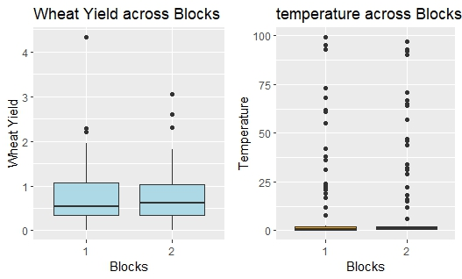

**Figure 1: Temperature and Wheat Yield Distribution across Block**

Figure 1 above deduces that the wheat yield exhibits relative stability across blocks, while the temperature shows a significant variation, including extreme values.

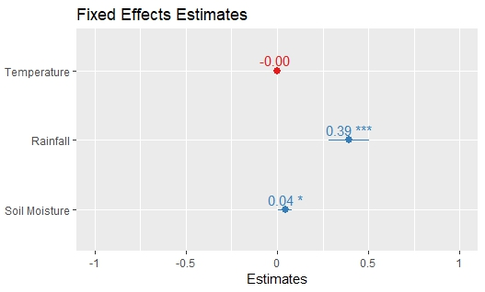

**Figure 2: Fixed Effects Estimates**

Figure 2 indicates that rainfall has a strong positive effect on wheat yield while soil moisture exhibits minor significant effect and the temperature has no significant impact on wheat production.

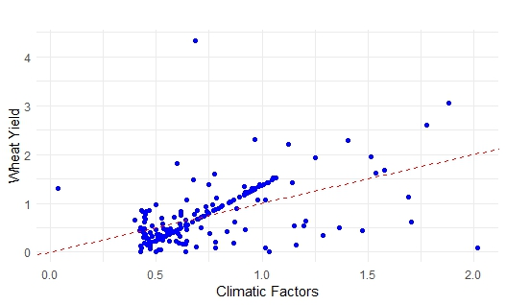

**Figure 3: Relationship Between Wheat Yield and Climatic Factors**

Figure 3 illustrates the scatter plot relationship between climatic factors. The blue dot indicates individual data points, while the red broken line indicates the trend. The positive slope suggests an increase in the climatic factors as well as an increase in the wheat yield trend, showing some variability, like the data.

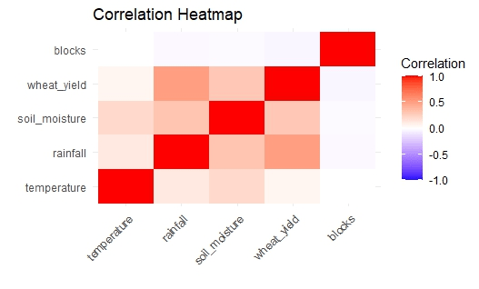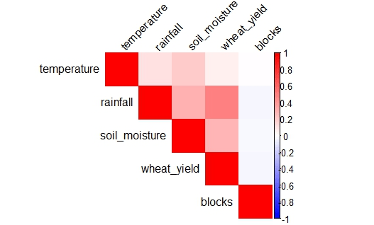

**Figure 4:** **Correlation Heatmaps of Environmental Variables Affecting Wheat Yield**

The figure above describes the correlation between main environmental factors, with color intensity denoting the strength of the correlation. The red color shows a strong positive correlation, while the blue color indicates a negative correlation. Both figures highlight the interrelation between climate factors and soil moisture.

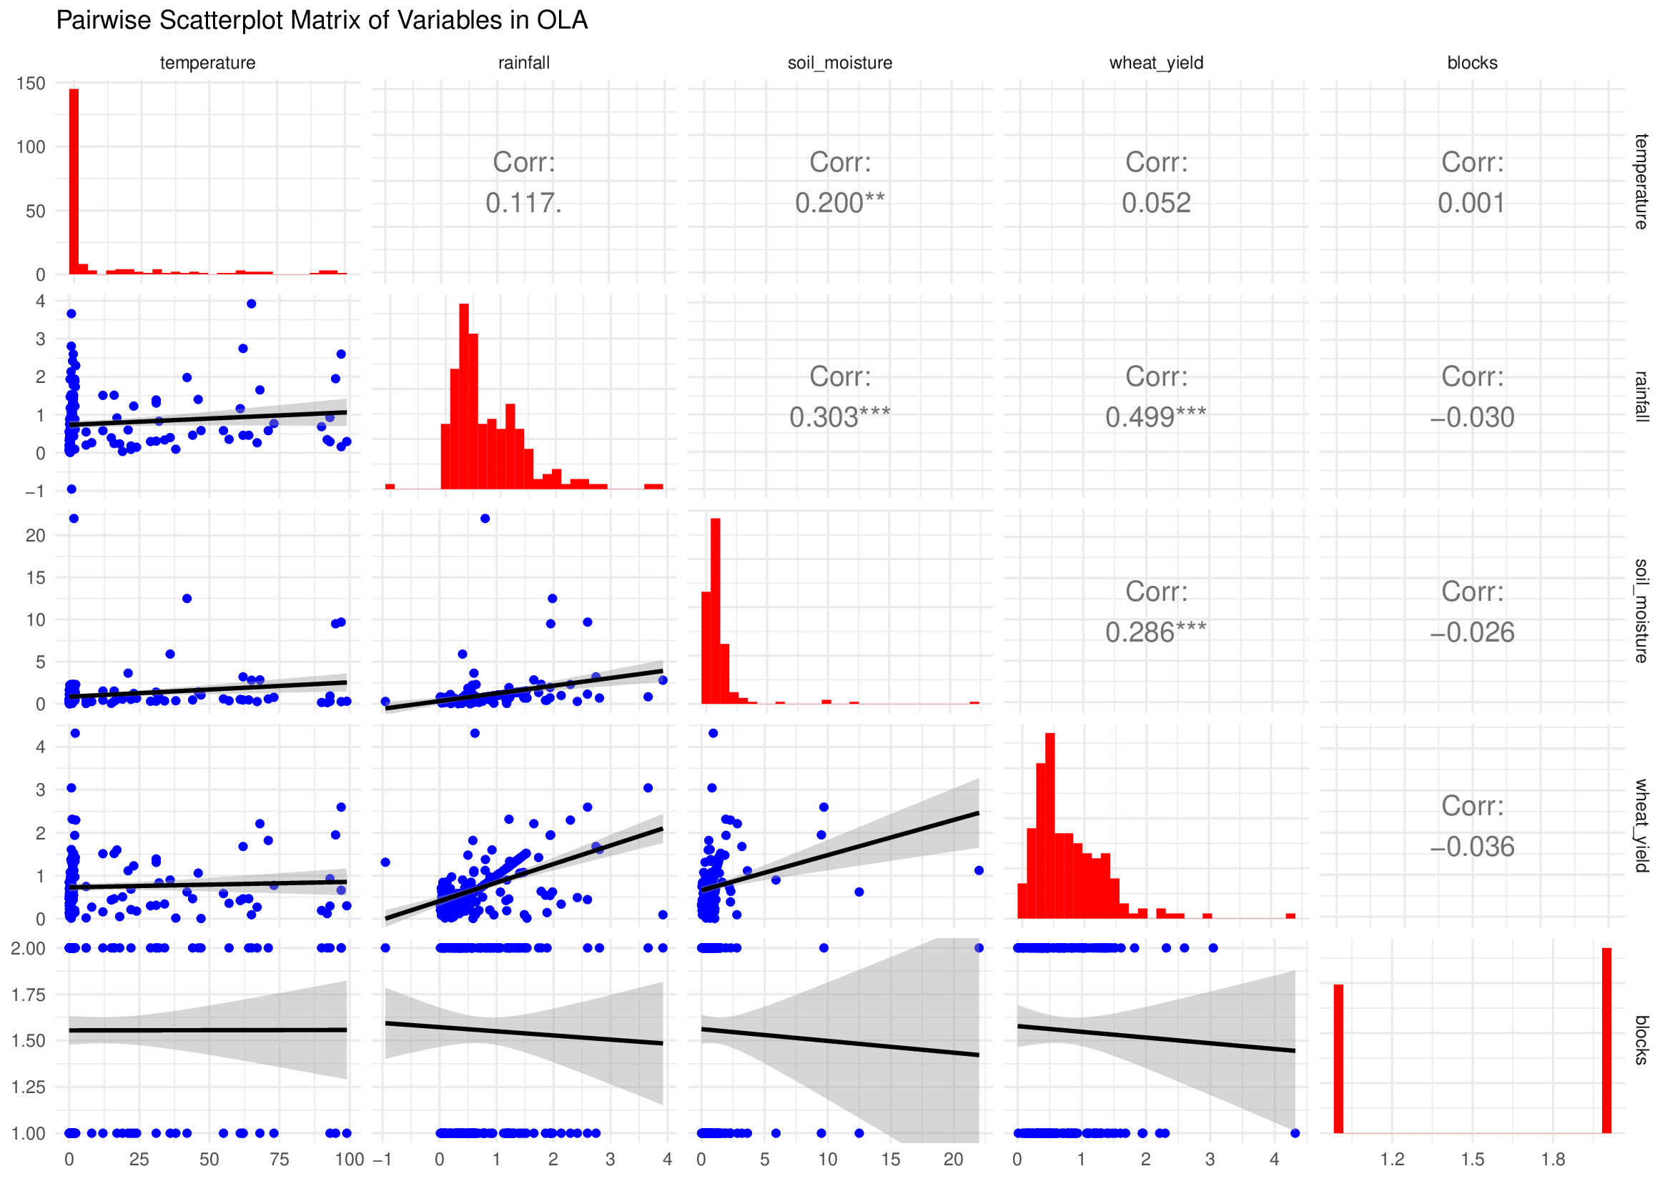

**Figure 5:** **Pairwise Relationship Between Climatic Factors and Wheat Yield**

Figure 5 reveals the scatter plot matrix between the climatic factor and lock treatment. It shows that the diagonal histograms give the distribution of the data. The scatter plots denote the relationship between variables and the correlation values, which indicate strong relations amongst the variables the variable. Soil moisture and rainfall exhibit a positive correlation, while temperature shows a weak correlation, as for the treatment in blocks, it has no correlation with the other variables.

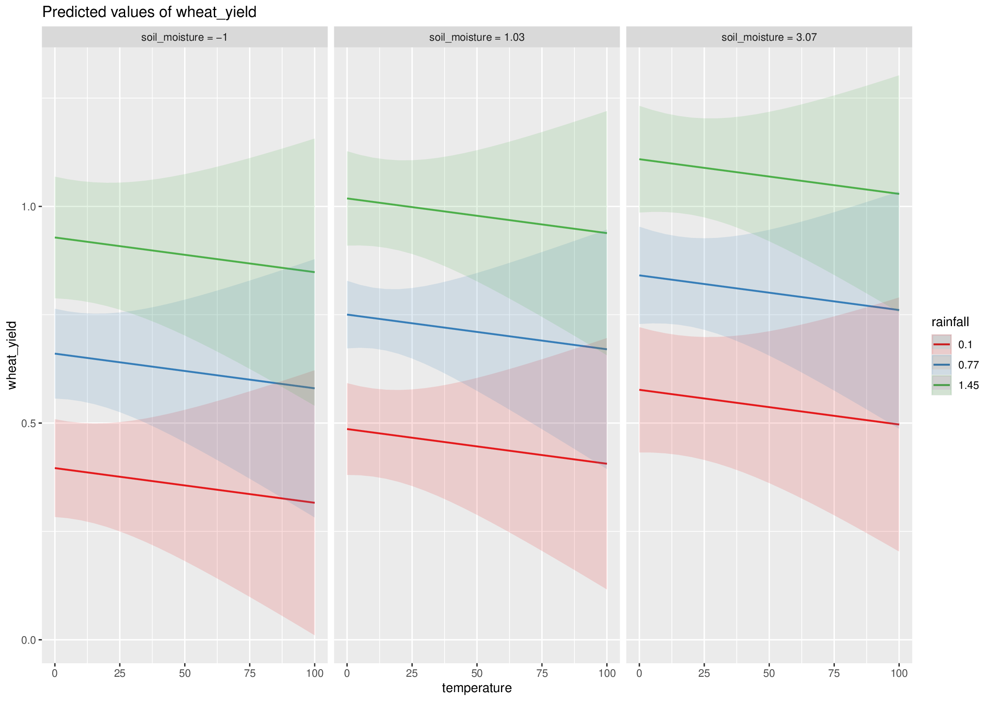

**Figure 6: Interaction of Soil Moisture and Temperature on Wheat Yield**

Figure 6 describes how temperature affects the production of wheat due to different soil moisture levels. It shows that individual panels represent different levels of soil moisture, and the shaded line area suggests an increase in temperature, with a decrease in wheat yield.

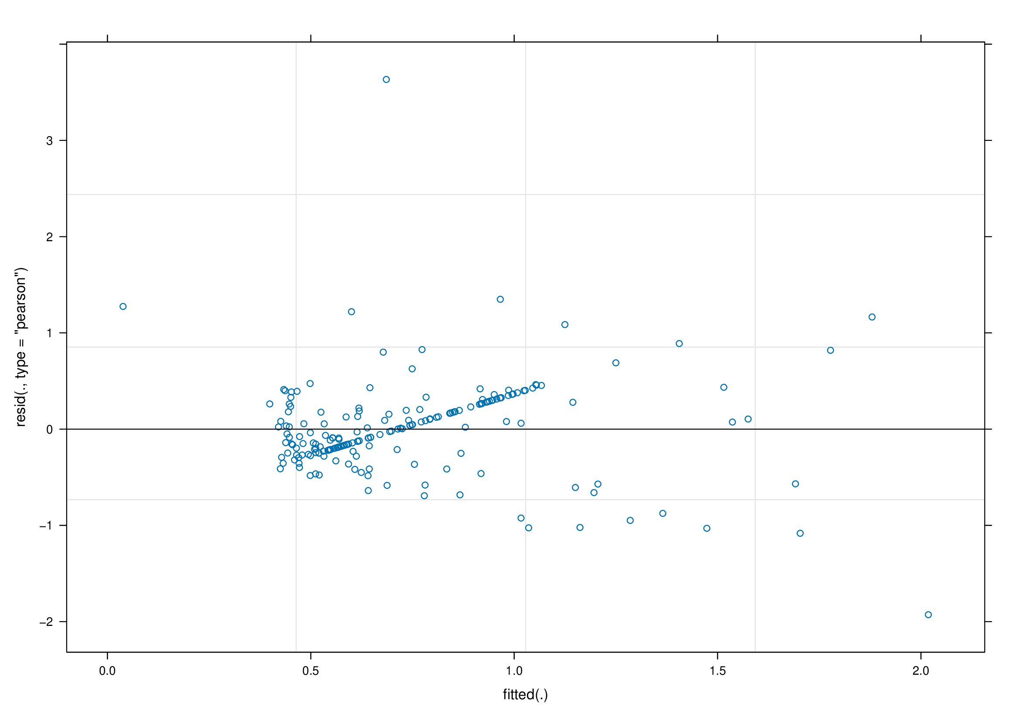

**Figure 7: Plot of Residual vs Fitted Values**

Figure 7 examined the goodness of fit of the model by indicating residual error against the predicted values. Since residuals are randomly scattered around the center of zero despite the clear pattern, however, it appears that some structures are visible around zero, which indicates a partial homoscedasticity of the model, which shows that the model can be improved to avoid misspecifications.

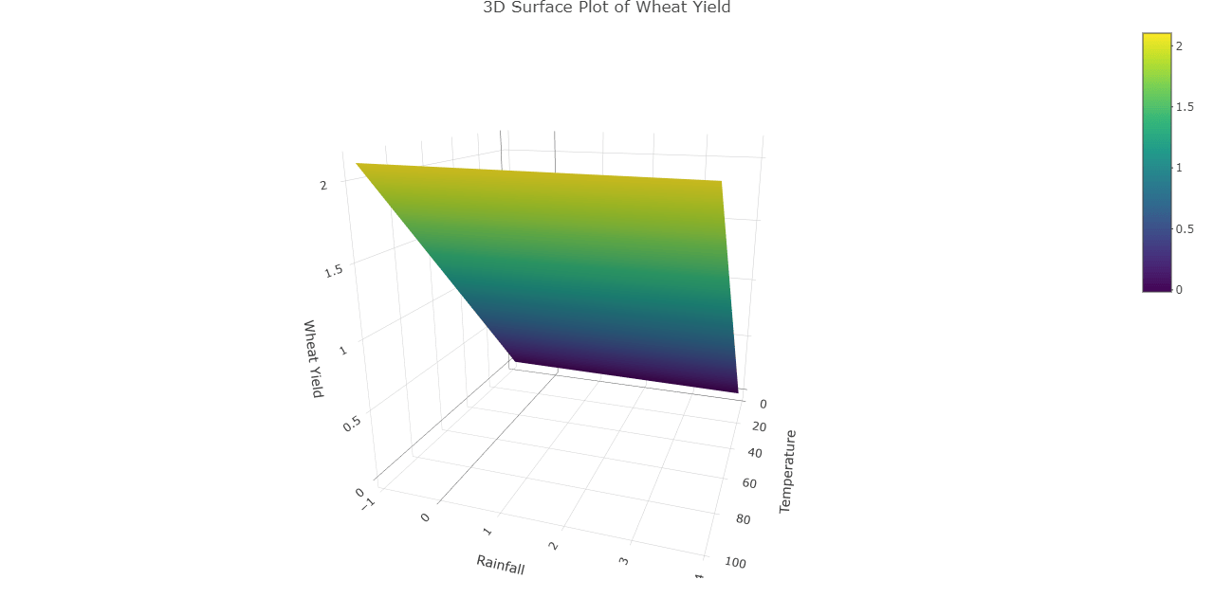

**Figure 8: Surface Plot of Wheat Yield**

Figure 8 above illustrates the visual relationship between rainfall, wheat yield, and temperature. It indicates that the gradient of the wheat yield is influenced by various environmental factors. It also shows that the smooth surface suggests a systematic trend where the temperature is high and low in rainfall, which negatively affects the yield, which denotes balanced environmental conditions leading to optimal crop production.

**8.0 Conclusion**

This study illustrates the impact of environmental factors on wheat cultivation in Sokoto using a linear mixed effects model. Heatmap correlation deduced a positive correlation between rainfall, soil moisture, and wheat yield, while the temperature revealed a weak correlation. The boxplot shows reliability in wheat production, as well as the temperature. The fixed effect model further deduced that rainfall $(β=0.39),$ p-value < 0.001 and soil moisture ( $β=0.04)$ P-value < 0.05, which impacted the wheat yield positively, while the temperature. $β=0.00$ P-values show no significant effects on the cultivation of wheat. Moreover, the result of the research illustrates that soil moisture and rainfall are important factors in wheat production in Sokoto State. Due to high variability in temperature, additional climatic factors such as humidity and wind can enhance the predictive accuracy.

**7.0 Conflict of interest**

The author declares there is no conflict of interest exists

**Ethical Approval**

All experimental procedures followed ethical guidelines for agricultural research. Proper land management practices were maintained to prevent environmental degradation, and the use of chemical fertilizers and irrigation was optimized to reduce environmental impact.

**Disclaimer (Artificial Intelligence)**

The Author(s) declare that NO Artificial intelligence tools, either a large language model, code generation, or reframing of the manuscript, are used in this research.

**Reference**

Arias, P. A., Rivera, J. A., Sörensson, A., Zachariah, M., Barnes, C., Philip, S., et al. (2024). *Interplay between climate change and climate variability: The 2022 drought in Central South America*. *Climatic Change*, *177*(6), 6. <https://doi.org/10.1007/s10584-023-03664-4>.

Blake, H., Bermingham, F., Johnson, G., & Tabner, A. (2020). Mitigating the psychological impact of COVID-19 on healthcare workers: a digital learning package. International journal of environmental research and public health, 17(9), 2997.

Geng, S., Tan, J., Li, L., Miao, Y., & Wang, Y. (2023). *Legumes can increase the yield of subsequent wheat with or without grain harvesting compared to gramineae crops: A meta-analysis*. *European Journal of Agronomy*, *142*, Article 126643. <https://doi.org/10.1016/j.eja.2022.126643>.

Haque, M., Biswas, J.C., Maniruzzaman, M., Hossain, M.B., & Islam, M.R. (2021). *Water management and soil amendment for reducing emission factor and global warming potential, but improving rice yield*. *Paddy and Water Environment*, *19*(4), 515–527. <https://doi.org/10.1007/s10333-021-00851-w>.

Jones, H., Smith, W., & Taylor, K. (2021). *Soil moisture dynamics and their impact on wheat productivity in diverse climates*. *Agricultural Water Management*, *234*, 106123.

Karuna, Solanki, Y. P. S., Singh, V., Rai, N. K., & Gangadhar, N. (2024). Development of Yield Forecast Model in Bread Wheat Using Regression Analysis. International Journal of Plant & Soil Science, 36(7), 875–881. https://doi.org/10.9734/ijpss/2024/v36i74799

Kheyruri, Y., Sharafati, A., Neshat, A., Hameed, A. S., & Rahman, A. (2024). Analyzing the impact of socio-environmental parameters on wheat and barley cultivation areas using the geographical detector model. Physics and Chemistry of the Earth, 135, 103630.

Liu, W., Fedorov, A. V., Xie, S. P., & Hu, S. (2020). Climate impacts of a weakened Atlantic Meridional Overturning Circulation in a warming climate. Science advances, 6(26), eaaz4876.

Khan, G. R., Alkharabsheh, H. M., Akmal, M., Al-Huqail, A. A., Ali, N., Alhammad, B. A., ... & Hoogenboom, G. (2022). Split nitrogen application rates for wheat (Triticum aestivum L.) yield and grain N using the CSM-CERES-wheat model. Agronomy, 12(8), 1766.

Ousayd, L., Epule, T. E., Belaqziz, S., Ongoma, V., Amazirh, A., & Chehbouni, A. (2024). *The impact of precipitation, temperature, and soil moisture on wheat yield gap quantification: evidence from Morocco*. *Agriculture & Food Security*, *13*(1), 55. https://doi.org/10.1186/s40066-024-00509-w.

Zwiers, F. W., Alexander, L. V., Hegerl, G. C., Knutson, T. R., Kossin, J. P., Naveau, P., ... & Zhang, X. (2013). Climate extremes: challenges in estimating and understanding recent changes in the frequency and intensity of extreme climate and weather events. Climate science for serving society: research, modeling and prediction priorities, 339-389.

Węgrzyn, A., Klimek-Kopyra, A., Dacewicz, E., Skowera, B., Grygierzec, W., Kulig, B., & Flis-Olszewska, E. (2022). Effect of selected meteorological factors on the growth rate and seed yield of winter wheat—a case study. Agronomy, 12(12), 2924.

Wheeler, T., & von Braun, J. (2013). *Climate change impacts on global food security*. *Science*, *341*(6145), 508–513. https://doi.org/10.1126/science.1239402

Zeleke, K. T., Anwar, M., Emebiri, L., & Luckett, D. (2023). Weather indices during the reproductive phase explain wheat yield variability. The Journal of Agricultural Science, 161(1), 1-14

Zhao, P., Chen, X., Xue, X., Wang, Y., Wang, Y., Li, H., Xue, R., & Li, Y. (2023). *Improvement of polyamine synthesis maintains photosynthetic function in wheat during drought stress and rewatering at the grain filling stage*. *Plant Growth Regulation*, *102*, 497–513. https://doi.org/10.1007/s10725-023-01075-0

**Southworth, J., Randolph, J. C., Habeck, M., Doering, O. C., Pfeifer, R. A., Rao, D. G., & Johnston, J. J. (2000). Consequences of future climate change and changing climate variability on maize yields in the midwestern United States. Agriculture, Ecosystems & Environment, 82(1-3), 139-158.**

Zheng, J., & Zhang, S. (2025). *Assessing the Impact of Climate Change on Winter Wheat Production in the North China Plain from 1980 to 2020*. *Agriculture*, *15*(5), 449. <https://doi.org/10.3390/agriculture15050449>.