**Exploring the Impact of Key Factors and Their Interactions on Process Outcomes in Experimental Optimization**

**Abstract**

This study investigates the identification of key factors and their interactions in process optimization using factorial designs specifically the Face-Centered Central Composite Design (FCCCD) by using a reduced quadratic model developed across different factorial configurations (Full and Fractional Factorial Designs with 1 and 5 center points) which demonstrates the importance of factors B, C, D, and E, as well as their critical interactions in determining process outcomes. The research focuses on evaluating the significance of main factors’ interaction effects, and model adequacy through statistical techniques using Analysis of Variance (ANOVA), model coefficients, and residual analysis. The results reveal that factor D is the most influential, followed by factors C and B, with significant interaction effects such as X3X4 and X2X4 shaping the response. The study also highlights the presence of non-linearity and the need for refined model selection to enhance predictive accuracy. Residual analysis confirms the robustness of the models, although certain anomalies suggest areas for improvement in experimental design and data collection. The findings provide valuable insights into optimizing process performance, with implications for future research in advanced modeling techniques and validation in diverse experimental conditions.

**Key words:** Process Optimization, Experimental Design, Factorial Interaction, Response Surface Methodology, and Model Validation.

**1. Introduction**

In the field of experimental design and process optimization, identifying key factors and their interactions is crucial for achieving efficiency, quality, and reliability. Various scientific and industrial applications rely on well-structured methodologies to optimize processes and ensure that outcomes are predictable and reproducible. Among the most widely used statistical approaches are Response Surface Methodology (RSM), Central Composite Design (CCD), and its Face-Centered Central Composite Design (FCCCD) variation, which enable researchers to analyze the effects of multiple factors and their interactions (Montgomery, 2017). While traditional process optimization often focuses on primary factors such as temperature, pressure, concentration, and reaction time, other critical elements such as design parameters, factorial and center points, interaction terms, and model complexity significantly influence process outcomes. Understanding the relationships among these factors provides a solid foundation for refining experimental models and improving decision-making in real world applications.

The effectiveness of any process is primarily determined by the choice of factors and their respective levels. In experimental design, a factor refers to any variable that can influence the outcome of an experiment. Factors can be quantitative, such as temperature and pressure, or qualitative, such as catalyst type or processing method (Myers *et al.*, 2016). However, beyond these primary factors, additional design parameters such as factorial and center points, effect summary plots, residual analysis, and optimality criteria play a crucial role in experimental efficiency.

The selection of factorial and center points is particularly important in Face-Centered Central Composite Design (FCCCD), where center points allow for a better estimation of curvature in the response surface (Box & Draper, 1987). The strategic placement of center points ensures a more accurate representation of the response behavior, helping researchers distinguish between linear and quadratic effects. Moreover, statistical techniques such as Analysis of Variance (ANOVA), model coefficients, and lack-of-fit tests assist in determining the significance of each factor, ensuring that the model does not include irrelevant terms (Khuri & Cornell, 1996).

One of the most complex and often overlooked aspects of process optimization is the interaction between factors. Interactions occur when the effect of one factor depends on the level of another factor, leading to non-linear behavior in the response surface (Goos & Jones, 2011).

For instance, in a chemical reaction, increasing temperature may enhance the reaction rate, but only when the concentration of reactants is sufficiently high. If concentration levels are low, temperature changes might have little to no effect, demonstrating an interaction effect.

In experimental modeling, interactions are represented through interaction terms (e.g., BC, BD, CD, DE, etc.) within polynomial regression equations. These terms are critical in response surface analysis, as they reveal complex dependencies that linear models fail to capture. Higher-order interactions, such as quadratic and cubic terms, are particularly useful in refining predictive models (Khuri & Mukhopadhyay, 2010). However, excessive reliance on higher-order interactions can introduce model instability, necessitating careful model selection using reduced quadratic models.

For any experimental model to be considered valid, it must undergo rigorous statistical evaluation. Model validation ensures that the estimated coefficients accurately represent the relationship between factors and responses. One of the primary statistical techniques used in model validation is Analysis of Variance (ANOVA), which determines the statistical significance of factors and interactions by analyzing variation within experimental data (Montgomery, 2017).

Graphical diagnostic tools also play an essential role in model validation. Normal probability plots of residuals, residuals versus predicted values, effect summary plots, and Cook’s distance plots help identify anomalies in data distribution (Iwundu & Cosmos, 2022). These tools allow researchers to detect potential model misspecifications and outliers, ensuring that the final model accurately captures the experimental behavior.

Another important concept in experimental optimization is prediction variance contours, which visualize areas of high and low prediction accuracy within the design space. These tools allow researchers to determine which factor combinations yield the most reliable predictions, thereby improving model interpretability and applicability (Montgomery, 2017). Adequacy precision and lack-of-fit tests assess the predictive strength of a model (Cornell, 2011).

The identification of key factors and their interactions is essential for optimizing process outcomes across diverse scientific and industrial applications. By combining statistical techniques, diagnostic tools, and optimality criteria, researchers can develop highly predictive models that improve efficiency, accuracy, and reliability. However, achieving the ideal balance between model complexity and experimental feasibility remains a key challenge. Continued advancements in experimental design strategies, interaction modeling, and validation methods will further enhance process optimization, ensuring that models remain robust and applicable in real-world scenarios.

The objective of this study is to identify key factors and their interactions that significantly influence process outcomes by analyzing factorial and center points, evaluating statistical significance through ANOVA and model coefficients, and validating models using graphical diagnostics.

This study explores the identification and evaluation of critical factors and their interactions in process optimization. It focuses on the role of factorial and center points in experimental design, particularly within the framework of Face-Centered Central Composite Design (FCCCD). By applying statistical techniques such as Analysis of Variance (ANOVA) and assessing model coefficients, the study aims to determine the relative importance of each factor and how their interactions influence process performance.

Furthermore, the study employs graphical diagnostic tools to validate the accuracy and reliability of experimental models, ensuring that identified relationships between factors and outcomes are well-supported by statistical evidence. The findings will contribute to improved process optimization strategies, offering insights into efficient experimental design and decision-making in scientific and industrial applications.

**2 Literature Review**

In the quest for process optimization, identifying key factors and their interactions is crucial for improving both the efficiency and effectiveness of industrial processes. Various studies have addressed different aspects of experimental design. Among the studies examined are:

Montgomery (2017) provides a comprehensive review of factorial designs and response surface methodology (RSM). He underscores the importance of understanding factor interactions and how they influence the outcomes of process optimization. In particular, Montgomery highlights that experimental designs, such as RSM, enable researchers to study the effects of multiple factors simultaneously and model complex, nonlinear relationships that are prevalent in industrial processes. His work emphasizes that neglecting interaction terms can lead to suboptimal results, particularly when multiple factors are involved.

Box, Hunter, and Hunter (2005) explored the impact of key process factors, such as catalyst concentration, mixing rate, and solvent composition, on optimizing chemical and industrial processes. Their work demonstrates the utility of factorial designs, including both main effects and interactions, in determining the factors that significantly affect process outcomes. The study advocates for incorporating interaction effects into the model to ensure that optimization reflects real-world conditions where factors rarely operate in isolation. Ignoring interaction effects can lead to inaccurate predictions and inefficient optimization.

Dean, Voss, and Draguljić (2017) examined second-order interactions (e.g., BC, BD, CD, DE) and their impact on process stability and optimization efficiency. The authors highlight that, although second-order interactions can be complex and challenging to interpret, they are essential for achieving accurate and efficient process optimization. Their research supports the notion that a more thorough understanding of second-order interactions can lead to better management of process variability, particularly in systems where multiple factors interact nonlinearly.

Alvarez *et al.* (2009) studied the effectiveness of full versus fractional factorial designs, demonstrating that fractional factorial designs with center points can provide optimization accuracy similar to that of full factorial designs while reducing experimental costs. This is a critical finding, as it suggests that fractional designs offer a practical and cost-effective alternative for process optimization, especially when resources are limited. The study emphasizes the utility of center points in capturing curvature effects, which are essential for accurate modeling.

Anderson and Whitcomb (2014) explored reduced quadratic models and their use in predicting process outcomes. They explore the role of model validation techniques, particularly ANOVA and diagnostic plots, in ensuring the robustness and predictive power of experimental models. Their work highlights the importance of validating model assumptions, such as linearity and homoscedasticity, to improve the reliability of process optimization results. This is particularly relevant for high-dimensional processes where multiple factors and their interactions must be accounted for.

Goupy and Creighton (2007) examined the practical application of factorial designs in engineering and industrial settings, with a particular focus on interaction effects. Their research underscores the importance of considering interactions in real-world process optimization, especially in fields like quality control and manufacturing. By explicitly modeling interaction effects, their study shows that factorial designs can provide more accurate predictions and better optimization outcomes, which are crucial for improving industrial process performance.

Nanaka *et al.* (2025) conducted a study on the performance evaluation of a Five-Variable Face-Centered Central Composite Design (FCCCD) with full and fractional factorials in process optimization. Their study highlights the effectiveness of combining these two factorial approaches, particularly in high-dimensional process settings. They examine how these designs improve model robustness and predictive accuracy while offering flexibility in balancing resource use and experimental precision. Their research is a key addition to the growing body of literature on process optimization using FCCCD, providing new insights into its practical applications.

Adizue & Takács (2025) investigated the relationship existing between different experimental designs like the Taguchi and full factorial designs and the predictive accuracy of machine learning models in the area of ultra-precision hard turning processes. The research aims to understand how the complexity of experimental design influences the performance of artificial neural network (ANN) developed from the resulting data sets. For similar works on different experimental designs see Xu *et al.*, (2024), Arboretti *et al.*, (2024) and Hamad *et al.*, (2024).

Lenth (2009) examined the role of effect size in factorial experiments and how key factors influence response variability. His work provides practical guidelines for interpreting factor effects in process optimization studies. The study emphasizes that understanding the magnitude of effects is critical for making informed decisions about process improvements, particularly when optimizing factors with different levels of impact on the response variable.

Piepel *et al.* (2010) investigated mixture-process variable designs and the importance of interaction effects in optimization. They demonstrate how combining mixture variables with process variables can lead to more efficient optimization and a deeper understanding of the underlying process dynamics. This approach provides a more holistic view of the optimization problem, allowing for the identification of optimal factor combinations that account for both mixture and process variables.

Czitrom (2012) discussed statistical tools for industrial experimentation, including factorial and central composite designs. His work highlights the impact of factor interactions on process stability, stressing that failing to account for these interactions can lead to flawed optimization results. By utilizing factorial and CCD designs, industrial processes can be better understood and optimized, improving overall efficiency and product quality.

Atkinson, Donev, and Tobias (2013) provided an advanced discussion of experimental design theory, focusing on methods for selecting key process factors and handling high-order interactions. Their work is invaluable for researchers seeking to design experiments that account for complex, high-order interactions, particularly in systems with multiple factors that influence process outcomes.

Mead, Gilmour, and Mead (2016) reviewed the principles of statistical experimentation, particularly focusing on the use of center points and interaction effects in RSM. Their work highlights how center points can significantly enhance the accuracy of models and improve the quality of optimization outcomes, providing further evidence of the importance of these experimental design features in achieving precise process optimization.

Jin *et al.* (2020) explored the impact of uncertainty in factorial design experiments, demonstrating how interaction effects influence response predictions under varying conditions. Their study highlights the importance of robust statistical methods for managing uncertainty and ensuring reliable optimization results in the face of variability.

**3. Materials and Methods**

**3.1. Materials**

This study utilizes experimental data obtained from factorial and center point designs within the framework of Face-Centered Central Composite Design (FCCCD). The materials used include:

**3.1.1. Experimental Design Software:** Design-Expert (Stat-Ease) for model development, analysis, and optimization. This software facilitates the development of response surface models and optimization of process parameters.

**3.1.2. Data Sources:** Experimental datasets obtained from published studies, including Thickness of Seismic Mass, Thickness of Beams, Area Seismic Mass, Length of Beams, and Width of Beams,

**3.1.3. Computational Tools:** Statistical packages, including MATLAB, R, and Minitab, are used to conduct statistical analyses like Analysis of Variance (ANOVA), regression modeling, and graphical diagnostics. These tools enable the estimation of model coefficients and validation of experimental designs.

**3.2. Methods**

**3.2.1. Experimental Design and Factor Selection:** The study identifies and selects key factors that influence process outcomes beyond conventional parameters such as temperature, pressure, concentration, and reaction time. Factors are chosen based on prior literature, industry standards, and preliminary screenings. These factors may include catalyst concentration, solvent type, particle size, mixing rate, etc. Factorial and center points are incorporated to capture response variations and study interactions among different factors. This approach allows for a comprehensive understanding of how multiple factors work together.

**3.2.2. Model Development and Statistical Analysis:** A reduced quadratic model is employed to evaluate the significance of both main effects and interaction terms, such as BC, BD, CD, and DE. This helps identify which factors and their combinations have the greatest impact on the process outcome. ANOVA is applied to test the statistical significance of the factors and interactions. The significance level (e.g., p-value < 0.05) is used to determine the importance of each factor and interaction term. Model coefficients are calculated to understand the influence of each factor on the outcome.

**3.2.3. Comparison of Full and Fractional Factorial Portions:** The study examines the effects of different center point configurations (e.g., 1 vs. 5 center points) on model performance, focusing on how the number of center points affects the model's predictive ability and accuracy. Statistical comparisons between full and fractional factorial designs are made to assess robustness and efficiency. The effectiveness of fractional factorial designs in reducing experimental runs while maintaining model accuracy is specifically evaluated.

**3.2.4. Interpretation of Results:** The results are analyzed to determine the influence of key factors and their interactions on process efficiency, quality, and reliability. This helps in identifying the optimal conditions for process optimization. The findings are compared with existing literature and case studies in process optimization to validate the results and ensure the generalizability of conclusions.

**3.3. Model Specification**

In this study, a reduced quadratic model is specified to evaluate the relationship between multiple factors and the process outcome. The quadratic model is chosen because it can capture both the linear effects and interaction effects between factors, as well as the curvature or non-linearity in the system.

The general form of the quadratic model is:

$$Y=β_{0}+\sum_{i=1}^{k}{β_{i}x_{i}+\sum_{i=1}^{k}{β_{ii}x_{i}^{2}}+\sum_{i<j}{\sum{β_{ij}x_{i}x_{j}+ε_{ij}} }}$$

where:

Y is the dependent (response) variable, $β_{0}$ is the intercept term, $β_{i }$ is the coefficient term, $β_{ij }$ is the coefficients of interaction terms (where $i≠j$ $)$, $β_{ii }$ are the coefficient of quadratic terms, $x_{i} and x_{j}$ are the independent variables, $ε_{ij}$ are the error terms.

The model captures the individual effects of factors, their pairwise interactions, and the quadratic effects, allowing for a robust understanding of how different factors influence the process outcome.

**3.3.1. Factor Selection and Experimental Design**

Factors to be included in the model are selected based on their relevance to the process and prior literature. These may include temperature, concentration, catalyst concentration, mixing rate, and other relevant factors.

The design follows a Face-Centered Central Composite Design (FCCCD), incorporating factorial points, center points, and axial points, to estimate the main effects, interaction effects, and quadratic effects.

**3.4. Methods of Estimation Procedure**

The model's coefficients ($β_{0}$, $β_{i, } β_{ij}$ and $β_{ii}$) are estimated using least squares estimation (LSE). The procedure involves the following steps:

**3.4.1. Data Collection:** Experimental data are collected based on the FCCCD layout, with different factor levels (low, high, and center points) to capture the variation in the process response.

**3.4.2. Design Matrix Construction:** The design matrix is constructed, which includes all combinations of factor levels for the factorial design, along with center and axial points. Each row of the matrix corresponds to an experimental run, and the columns represent the factor levels.

**3.4.3. Fitting the Model:** The observed response values from the experimental runs are regressed against the factor levels in the design matrix to estimate the coefficients of the quadratic model. The least squares method minimizes the sum of squared residuals to find the best-fitting model.

**3.4.4. ANOVA (Analysis of Variance):** ANOVA is performed to test the statistical significance of the estimated coefficients. The p-values of the linear, interaction, and quadratic terms are used to determine which factors and interactions are significant at a pre-determined significance level (e.g., p < 0.05).

The overall model significance is tested using the F-test, which compares the model's goodness-of-fit against the error variance.

**3.4.5. Model Validation:** Residual Analysis: The residuals (differences between the observed and predicted values) are analyzed to check for any patterns or violations of model assumptions, such as normality and homoscedasticity.

**3.4.6. Graphical Diagnostics:** Tools like Effect Summary and Residuals vs. Run Plots, are used to identify the most significant factors and interactions in the model and to assess model adequacy by evaluating residual patterns and potential model violations.

**3.4.7. Coefficient Estimation:** Using the least squares method, the regression coefficients ($β_{0}$, $β_{i, } β_{ij}$ and $β_{ii}$) are estimated by solving the system of linear equations derived from the design matrix.

These estimated coefficients represent the contribution of each factor, interaction, and quadratic term to the process outcome.

**3.4.8. Model Diagnostics:** After obtaining the model coefficients, further diagnostics (e.g., R-squared, Adjusted R-squared, and lack-of-fit tests) are used to evaluate how well the model explains the variability in the process response and to assess the adequacy of the model.

**3.4.9. Optimization and Prediction:** The final model is used to predict the process outcome under different combinations of factors. Effect summary or Residual versus Run plots can be generated to visually represent the effects of factors and their interactions on the process response.

**4. Results and discussion**

**Table 1: Reduced Quadratic model ANOVA for FCCCD with $2^{5}$ Factorial Design and 1 Center Point**

|  |  |  |  |  |  |  |
| --- | --- | --- | --- | --- | --- | --- |
| **Source** | **Sum of Squares** | **Df** | **Mean Square** | **F-value** | **p-value** |  |
| **Model** | 2.030E+09 | 11 | 1.846E+08 | 44.27 | < 0.0001 | **Significant** |
| B-X2 | 3.393E+08 | 1 | 3.393E+08 | 81.37 | < 0.0001 |  |
| C-X3 | 3.412E+08 | 1 | 3.412E+08 | 81.83 | < 0.0001 |  |
| D-X4 | 6.049E+08 | 1 | 6.049E+08 | 145.07 | < 0.0001 |  |
| E-X5 | 9.600E+07 | 1 | 9.600E+07 | 23.02 | < 0.0001 |  |
| BC | 1.011E+08 | 1 | 1.011E+08 | 24.24 | < 0.0001 |  |
| BD | 1.779E+08 | 1 | 1.779E+08 | 42.67 | < 0.0001 |  |
| BE | 2.929E+07 | 1 | 2.929E+07 | 7.02 | 0.0126 |  |
| CD | 1.814E+08 | 1 | 1.814E+08 | 43.51 | < 0.0001 |  |
| CE | 3.096E+07 | 1 | 3.096E+07 | 7.42 | 0.0105 |  |
| DE | 5.152E+07 | 1 | 5.152E+07 | 12.35 | 0.0014 |  |
| D² | 7.675E+07 | 1 | 7.675E+07 | 18.41 | 0.0002 |  |
| **Residual** | 1.293E+08 | 31 | 4.170E+06 |  |  |  |
| **Cor Total** | 2.160E+09 | 42 |  |  |  |  |

**Table 2: Reduced Quadratic model ANOVA for FCCCD with25 Factorial Design and 5**

**Center Point**

|  |  |  |  |  |  |  |
| --- | --- | --- | --- | --- | --- | --- |
| **Source** | **Sum of Squares** | **df** | **Mean Square** | **F-value** | **p-value** |  |
| **Model** | 2.045E+09 | 11 | 1.859E+08 | 49.95 | < 0.0001 | **significan**t |
| X2 | 3.393E+08 | 1 | 3.393E+08 | 91.15 | < 0.0001 |  |
| X3 | 3.412E+08 | 1 | 3.412E+08 | 91.66 | < 0.0001 |  |
| X4 | 6.049E+08 | 1 | 6.049E+08 | 162.51 | < 0.0001 |  |
| X5 | 9.600E+07 | 1 | 9.600E+07 | 25.79 | < 0.0001 |  |
| X2X3 | 1.011E+08 | 1 | 1.011E+08 | 27.16 | < 0.0001 |  |
| X2X4 | 1.779E+08 | 1 | 1.779E+08 | 47.80 | < 0.0001 |  |
| X3X4 | 2.929E+07 | 1 | 2.929E+07 | 7.87 | 0.0082 |  |
| X2X5 | 1.814E+08 | 1 | 1.814E+08 | 48.74 | < 0.0001 |  |
| X3X5 | 3.096E+07 | 1 | 3.096E+07 | 8.32 | 0.0067 |  |
| X4X5 | 5.152E+07 | 1 | 5.152E+07 | 13.84 | 0.0007 |  |
| X24 | 9.149E+07 | 1 | 9.149E+07 | 24.58 | < 0.0001 |  |
| **Residual** | 1.303E+08 | 35 | 3.722E+06 |  |  |  |
| Lack of Fit | 1.296E+08 | 31 | 4.180E+06 | 24.13 | 0.0034 | **significant** |
| Pure Error | 6.930E+05 | 4 | 1.732E+05 |  |  |  |
| **Cor Total** | 2.175E+09 | 46 |  |  |  |  |

**Table 3: Reduced Quadratic model ANOVA for FCCCD with $2_{V}^{5-1}$ Factorial Design and 1 Center Point**

|  |  |  |  |  |  |  |
| --- | --- | --- | --- | --- | --- | --- |
| **Source** | **Sum of Squares** | **df** | **Mean Square** | **F-value** | **p-value** |  |
| **Model** | 3.551E+08 | 11 | 3.228E+07 | 72.92 | < 0.0001 | **Significant** |
| A-A | 7.358E+06 | 1 | 7.358E+06 | 16.62 | 0.0011 |  |
| B-B | 7.827E+07 | 1 | 7.827E+07 | 176.79 | < 0.0001 |  |
| C-C | 8.045E+07 | 1 | 8.045E+07 | 181.71 | < 0.0001 |  |
| D-D | 1.614E+08 | 1 | 1.614E+08 | 364.51 | < 0.0001 |  |
| E-E | 6.959E+06 | 1 | 6.959E+06 | 15.72 | 0.0014 |  |
| AD | 5.254E+06 | 1 | 5.254E+06 | 11.87 | 0.0039 |  |
| BC | 6.437E+06 | 1 | 6.437E+06 | 14.54 | 0.0019 |  |
| BD | 2.782E+07 | 1 | 2.782E+07 | 62.83 | < 0.0001 |  |
| CD | 2.836E+07 | 1 | 2.836E+07 | 64.07 | < 0.0001 |  |
| C² | 2.433E+06 | 1 | 2.433E+06 | 5.50 | 0.0343 |  |
| D² | 9.095E+06 | 1 | 9.095E+06 | 20.54 | 0.0005 |  |
| **Residual** | 6.198E+06 | 14 | 4.427E+05 |  |  |  |
| **Cor Total** | 3.613E+08 | 25 |  |  |  |  |

**Table 4: Reduced Quadratic model ANOVA for FCCCD with $2_{V}^{5-1}$ Factorial Design and 5 Center Points**

|  |  |  |  |  |  |  |
| --- | --- | --- | --- | --- | --- | --- |
| **Source** | **Sum of Squares** | **df** | **Mean Square** | **F-value** | **p-value** |  |
| **Model** | 3.620E+08 | 15 | 2.413E+07 | 53.21 | < 0.0001 | Significant |
| A-A | 2.591E+07 | 1 | 2.591E+07 | 57.12 | < 0.0001 |  |
| B-B | 5.217E+07 | 1 | 5.217E+07 | 115.03 | < 0.0001 |  |
| C-C | 5.407E+07 | 1 | 5.407E+07 | 119.22 | < 0.0001 |  |
| D-D | 1.284E+08 | 1 | 1.284E+08 | 283.07 | < 0.0001 |  |
| E-E | 3.711E+05 | 1 | 3.711E+05 | 0.8182 | 0.3800 |  |
| AB | 1.052E+07 | 1 | 1.052E+07 | 23.20 | 0.0002 |  |
| AC | 1.135E+07 | 1 | 1.135E+07 | 25.02 | 0.0002 |  |
| AD | 2.298E+07 | 1 | 2.298E+07 | 50.67 | < 0.0001 |  |
| AE | 2.341E+06 | 1 | 2.341E+06 | 5.16 | 0.0382 |  |
| BD | 1.106E+07 | 1 | 1.106E+07 | 24.38 | 0.0002 |  |
| BE | 5.411E+06 | 1 | 5.411E+06 | 11.93 | 0.0035 |  |
| CD | 1.143E+07 | 1 | 1.143E+07 | 25.20 | 0.0002 |  |
| CE | 5.376E+06 | 1 | 5.376E+06 | 11.85 | 0.0036 |  |
| DE | 2.562E+06 | 1 | 2.562E+06 | 5.65 | 0.0312 |  |
| D² | 1.808E+07 | 1 | 1.808E+07 | 39.87 | < 0.0001 |  |
| **Residual** | 6.803E+06 | 15 | 4.535E+05 |  |  |  |
| Lack of Fit | 6.110E+06 | 11 | 5.554E+05 | 3.21 | 0.1359 | not significant |
| Pure Error | 6.930E+05 | 4 | 1.732E+05 |  |  |  |
| **Cor Total** | 3.688E+08 | 30 |  |  |  |  |

**Table 5: Model Coefficients for FCCCD with $2^{5}$ Factorial Design and 1 Center Point**

|  |  |  |  |  |  |  |
| --- | --- | --- | --- | --- | --- | --- |
| **Factor** | **Coefficient Estimate** | **df** | **Standard Error** | **95% CI Low** | **95% CI High** | **VIF** |
| Intercept | 2570.04 | 1 | 680.67 | 1181.81 | 3958.28 |  |
| B-X2 | 3159.04 | 1 | 350.20 | 2444.80 | 3873.28 | 1.0000 |
| C-X3 | -3167.85 | 1 | 350.20 | -3882.09 | -2453.61 | 1.0000 |
| D-X4 | -4217.99 | 1 | 350.20 | -4932.23 | -3503.75 | 1.0000 |
| E-X5 | 1680.33 | 1 | 350.20 | 966.09 | 2394.57 | 1.0000 |
| BC | -1777.39 | 1 | 360.98 | -2513.61 | -1041.16 | 1.0000 |
| BD | -2357.90 | 1 | 360.98 | -3094.12 | -1621.68 | 1.0000 |
| BE | 956.66 | 1 | 360.98 | 220.44 | 1692.89 | 1.0000 |
| CD | 2381.16 | 1 | 360.98 | 1644.93 | 3117.38 | 1.0000 |
| CE | -983.57 | 1 | 360.98 | -1719.79 | -247.35 | 1.0000 |
| DE | -1268.81 | 1 | 360.98 | -2005.03 | -532.58 | 1.0000 |
| D² | 3283.98 | 1 | 765.48 | 1722.79 | 4845.18 | 1.0000 |

**Table** **6: Model Coefficients for FCCCD with25 Factorial Design and 5 Center Points**

| **Term** | **Estimate** | **Std Error** | **t Ratio** | **Prob>|t|** | **VIF** |
| --- | --- | --- | --- | --- | --- |
| Intercept | 2570.0444 | 680.6694 | 3.78 | 0.0007* | . |
| X2 | 3159.0441 | 350.2015 | 9.02 | <.0001* | 1 |
| X3 | -3167.853 | 350.2015 | -9.05 | <.0001* | 1 |
| X4 | -4217.988 | 350.2015 | -12.04 | <.0001* | 1 |
| X5 | 1680.3324 | 350.2015 | 4.80 | <.0001* | 1 |
| X2X3 | -1777.387 | 360.9795 | -4.92 | <.0001* | 1 |
| X2X4 | -2357.9 | 360.9795 | -6.53 | <.0001* | 1 |
| X3X4 | 2381.1562 | 360.9795 | 6.60 | <.0001* | 1 |
| X2X5 | 956.6625 | 360.9795 | 2.65 | 0.0126* | 1 |
| X3X5 | -983.5688 | 360.9795 | -2.72 | 0.0105* | 1 |
| X4X5 | -1268.806 | 360.9795 | -3.51 | 0.0014* | 1 |
| X4X4 | 3283.985 | 765.475 | 4.29 | 0.0002* | 1 |

**Table 7: Model Coefficients for FCCCD with $2_{V}^{5-1}$ Factorial Design and 1 Center Point**

|  |  |  |  |  |  |  |
| --- | --- | --- | --- | --- | --- | --- |
| **Factor** | **Coefficient Estimate** | **df** | **Standard Error** | **95% CI Low** | **95% CI High** | **VIF** |
| Intercept | 2379.33 | 1 | 236.24 | 1872.65 | 2886.02 |  |
| A-A | -680.98 | 1 | 167.05 | -1039.26 | -322.71 | 1.07 |
| B-B | 2221.08 | 1 | 167.05 | 1862.80 | 2579.35 | 1.07 |
| C-C | -2251.80 | 1 | 167.05 | -2610.08 | -1893.53 | 1.07 |
| D-D | -3189.26 | 1 | 167.05 | -3547.54 | -2830.98 | 1.07 |
| E-E | 662.28 | 1 | 167.05 | 304.00 | 1020.55 | 1.07 |
| AD | 614.86 | 1 | 178.49 | 232.04 | 997.67 | 1.08 |
| BC | -680.60 | 1 | 178.49 | -1063.42 | -297.79 | 1.08 |
| BD | -1414.80 | 1 | 178.49 | -1797.62 | -1031.99 | 1.08 |
| CD | 1428.67 | 1 | 178.49 | 1045.85 | 1811.48 | 1.08 |
| C² | 858.20 | 1 | 366.07 | 73.05 | 1643.34 | 1.78 |
| D² | 1659.20 | 1 | 366.07 | 874.05 | 2444.34 | 1.78 |

**Table 8: Model Coefficients for FCCCD with $2_{V}^{5-1}$ Factorial Design and 5 Center Points**

| **Term** | **Estimate** | **Std Error** | **t Ratio** | **Prob>|t|** |
| --- | --- | --- | --- | --- |
| Intercept | 2735.0462 | 186.7768 | 14.64 | <.0001* |
| X1 | -1199.683 | 158.7298 | -7.56 | <.0001* |
| X2 | 1702.3778 | 158.7298 | 10.73 | <.0001* |
| X3 | -1733.106 | 158.7298 | -10.92 | <.0001* |
| X4 | -2670.561 | 158.7298 | -16.82 | <.0001* |
| X5 | 143.57778 | 158.7298 | 0.90 | 0.3800 |
| X1X2 | -810.9063 | 168.3584 | -4.82 | 0.0002* |
| X1X3 | 842.16875 | 168.3584 | 5.00 | 0.0002* |
| X1X4 | 1198.3938 | 168.3584 | 7.12 | <.0001* |
| X2X4 | -831.2688 | 168.3584 | -4.94 | 0.0002* |
| X3X4 | 845.13125 | 168.3584 | 5.02 | 0.0002* |
| X1X5 | -382.5313 | 168.3584 | -2.27 | 0.0382* |
| X2X5 | -581.5187 | 168.3584 | -3.45 | 0.0035* |
| X3X5 | 579.65625 | 168.3584 | 3.44 | 0.0036* |
| X4X5 | 400.13125 | 168.3584 | 2.38 | 0.0312* |
| X4X4 | 1547.6261 | 245.1137 | 6.31 | <.0001* |

**Table 9: Effect Summary for FCCCD with $2^{5}$ Factorial Portion** **and 1 Center Point**

| **Source** | **LogWorth** |  | **Pvalue** |
| --- | --- | --- | --- |
| X4(6.22,7.44) | 12.500 |  | 0.00000 |
| X3(13.9,16.1) | 9.479 |  | 0.00000 |
| X2(2,2.9) | 9.451 |  | 0.00000 |
| X3X4 | 6.643 |  | 0.00000 |
| X2X4 | 6.564 |  | 0.00000 |
| X2X3 | 4.573 |  | 0.00003 |
| X5(5.6,6.8) | 4.417 |  | 0.00004 |
| X4X4 | 3.790 |  | 0.00016 |
| X4X5 | 2.861 |  | 0.00138 |
| X3X5 | 1.980 |  | 0.01048 |
| X2X5 | 1.901 |  | 0.01255 |

**Table 10: Effect Summary for FCCCD with $2^{5}$ Factorial Portion** **and 5 Center Point**

| **Source** | **LogWorth** |  | **PValue** |
| --- | --- | --- | --- |
| X4(6.22,7.44) | 13.985 |  | 0.00000 |
| X3(13.9,16.1) | 10.583 |  | 0.00000 |
| X2(2,2.9) | 10.552 |  | 0.00000 |
| X3X4 | 7.394 |  | 0.00000 |
| X2X4 | 7.306 |  | 0.00000 |
| X2X3 | 5.072 |  | 0.00001 |
| X5(5.6,6.8) | 4.898 |  | 0.00001 |
| X4X4 | 4.739 |  | 0.00002 |
| X4X5 | 3.158 |  | 0.00070 |
| X3X5 | 2.175 |  | 0.00668 |
| X2X5 | 2.088 |  | 0.00816 |

**Table 11: Effect Summary for FCCCD with $2_{V}^{5-1}$ Factorial Portion and 1 Center Point**

| **Source** | **LogWorth** |  | **PValue** |
| --- | --- | --- | --- |
| X4(6.22,7.44) | 7.331 |  | 0.00000 |
| X3(13.9,16.1) | 5.320 |  | 0.00000 |
| X2(2,2.9) | 5.241 |  | 0.00001 |
| X1(5.9,6.1) | 3.801 |  | 0.00016 |
| X1X4 | 3.577 |  | 0.00026 |
| X4X4 | 3.021 |  | 0.00095 |
| X3X4 | 2.432 |  | 0.00370 |
| X1X3 | 2.422 |  | 0.00379 |
| X2X4 | 2.385 |  | 0.00412 |
| X1X2 | 2.315 |  | 0.00484 |
| X2X5 | 1.531 |  | 0.02942 |
| X3X5 | 1.525 |  | 0.02985 |
| X5(5.6,6.8) | 0.233 |  | 0.58434 |

**Table 12: Effect Summary for FCCCD with $2_{V}^{5-1}$ Factorial Portion and 5 Center Points**

| **Source** | **LogWorth** |  | **PValue** |  |
| --- | --- | --- | --- | --- |
| X4 | 10.420 |  | 0.00000 |  |
| X3 | 7.809 |  | 0.00000 |  |
| X2 | 7.705 |  | 0.00000 |  |
| X1 | 5.764 |  | 0.00000 |  |
| X1X4 | 5.454 |  | 0.00000 |  |
| X4X4 | 4.857 |  | 0.00001 |  |
| X3X4 | 3.817 |  | 0.00015 |  |
| X1X3 | 3.802 |  | 0.00016 |  |
| X2X4 | 3.748 |  | 0.00018 |  |
| X1X2 | 3.645 |  | 0.00023 |  |
| X2X5 | 2.451 |  | 0.00354 |  |
| X3X5 | 2.441 |  | 0.00362 |  |
| X4X5 | 1.506 |  | 0.03121 |  |
| X1X5 | 1.418 |  | 0.03823 |  |
| X5 | 0.420 |  | 0.38001 | ^ |
|  |  |  |  |  |

**Residual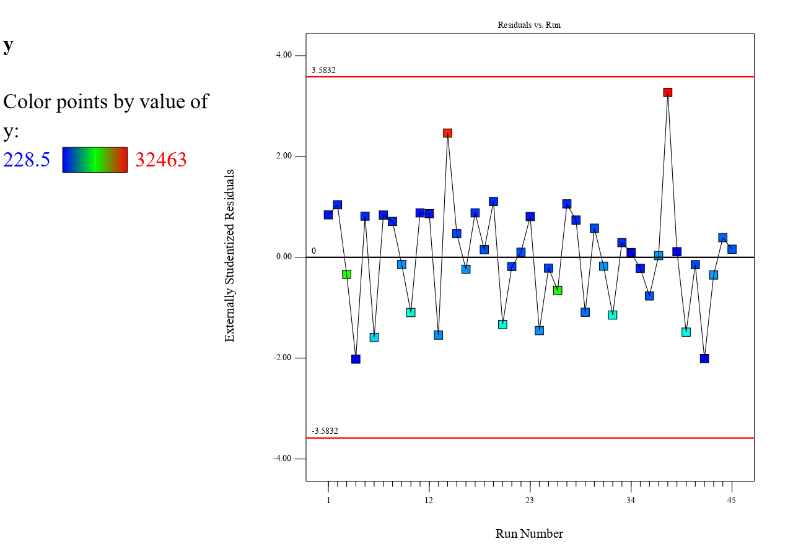  Run**

**Figure 1: Residual Vs Run for FCCCD with $2^{5}$ Factorial Design and 1 Center Point**

Residual 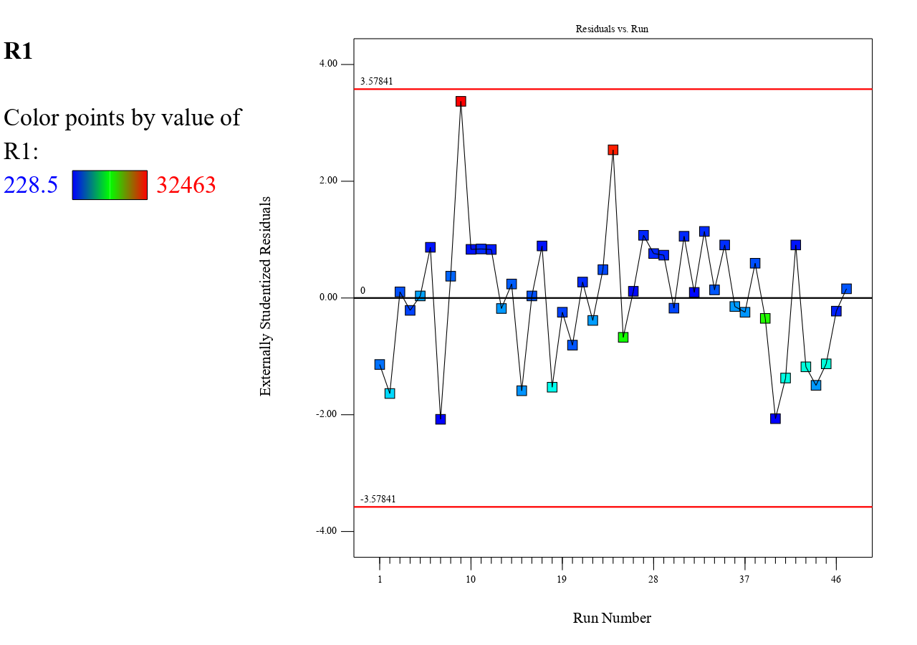

Run

**Figure 2: Residual Vs Run for FCCCD with25 Factorial Design and 5 Center Point**

Residual

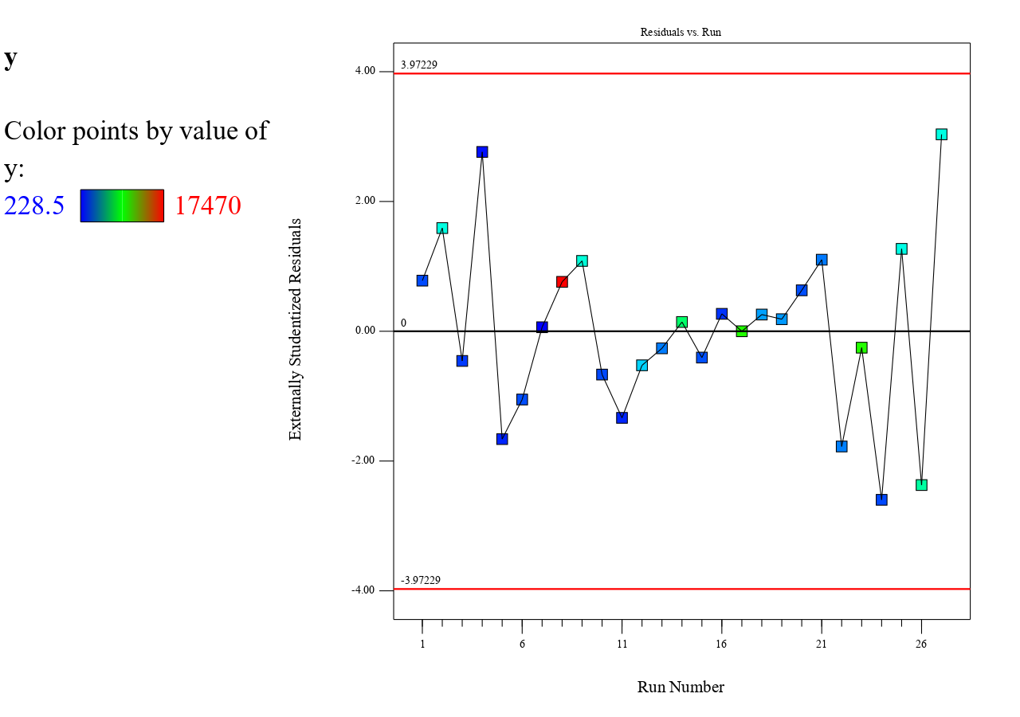

Run

**Figure 3: Residual Vs Run for FCCCD with $2_{V}^{5-1}$ Factorial Design and 1 Center Point**

**Residual**

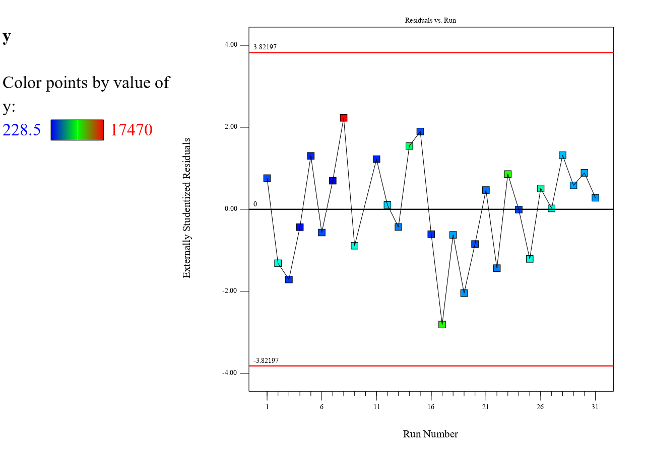 **Run**

**Figure 4: Residual Vs Run for FCCCD with $2_{V}^{5-1}$ Factorial Design and 5 Center Point**

The reduced quadratic model developed across different factorial designs (Tables 1– 4) demonstrates a high level of significance (p < 0.0001), indicating its effectiveness in explaining the variability in the response. The analysis reveals several key insights into the influence of main factors and interactions on the response variable.

For the Full Factorial Design with 1 Center Point, significant main effects include factors B, C, D, and E, along with critical interactions BC, BD, and DE. Notably, factor D exhibits pronounced non-linearity, contributing to the complexity of the model. Similarly, when the Full Factorial Design is expanded to 5 Center Points, factor B (Length of Beam) emerges as the dominant contributor (F = 162.51). Significant interactions, particularly CD, BC, and BD, further emphasize the interplay between variables. However, the presence of a significant lack of fit (p = 0.0034) suggests that additional model refinements may be necessary to improve predictive accuracy.

The Fractional Factorial Design with 1 Center Point mirrors these findings, with factors B, C, and D exerting a strong influence on the response. The presence of significant interactions, such as BC, BD, and DE, further highlights the complexity of factor relationships. The inclusion of quadratic terms in the model suggests notable non-linearity, reinforcing the importance of higher-order effects. When the Fractional Factorial Design is adjusted to 5 Center Points, the model maintains its robustness, with no significant lack of fit (p = 0.1359). This result confirms the model’s adequacy, supporting its use in practical applications.

A further evaluation of model coefficients (Tables 5 – 8) provides additional evidence of the model’s reliability, as indicated by the absence of multicollinearity (VIF ≈ 1.0000). This ensures that the estimated coefficients remain stable and interpretable.

Among the main effects, factor B (X2) and factor E (X5) are identified as positive contributors to the response, suggesting that increasing their levels enhances system performance. In contrast, factors C (X3) and D (X4) negatively affect the response, indicating that their excessive presence may lead to suboptimal outcomes.

The analysis of interaction effects reveals that certain factor combinations significantly alter the response. For instance, negative interactions (BC, BD, and DE) reduce the response value, suggesting possible antagonistic effects when these factors are combined. Conversely, the CD interaction exhibits a positive influence, enhancing the response variable. Additionally, the presence of a significant quadratic effect for D² confirms the presence of non-linearity, further reinforcing the complexity of the system under study.

A similar pattern is observed in the Fractional Factorial Design, where main, interaction, and quadratic terms continue to exhibit a significant influence. The persistence of these effects across different factorial configurations underscores the reliability of the experimental design in capturing the essential dynamics of the process.

The effect summary (Tables 9 –12) further validates the key findings from the factorial models. Among all variables, factor D (X4) emerges as the most influential factor, followed by factor C (X3) and factor B (X2). These results underscore the critical role of these variables in shaping the response, reinforcing the need for their careful consideration in process optimization.

Moreover, the identification of significant interactions, particularly X3X4 and X2X4, highlights the importance of combined factor effects. These interactions suggest that optimizing the system requires an integrated approach that accounts for the synergistic or antagonistic relationships between variables.

The evaluation of residual plots (Figures 1 – 4) provides crucial insights into the adequacy of the developed models. In general, residuals fluctuate randomly around zero, confirming the appropriateness of the model in capturing system behavior. However, specific observations warrant further examination:

Certain experimental runs, notably runs 34 and 38, exhibit anomalies, suggesting possible inconsistencies in experimental conditions or data collection. These deviations highlight areas where refinements in measurement or process control may be necessary.

The Full Factorial Design with 5 Center Points presents relatively large residuals, which could indicate potential sources of systematic error or model limitations. Addressing these discrepancies through refined modeling techniques or additional experimental data could enhance predictive accuracy.

The Fractional Factorial Design displays possible autocorrelation in residuals, suggesting that adjustments may be required to improve the model’s predictive capabilities. Future work could explore alternative regression techniques or variance stabilization methods to mitigate these effects.

**6. Conclusion**

The findings from this study provide strong evidence supporting the robustness and reliability of the reduced quadratic model in assessing factorial interactions and their impact on the response variable. Across different factorial designs, key factors and interactions exhibit consistent significance, reinforcing their critical role in system performance. The presence of non-linearity, as captured by quadratic terms and interaction effects, further emphasizes the complexity of the relationships within the experimental framework.

The comparison between Full and Fractional Factorial Designs demonstrates that both approaches yield valuable insights, with each offering unique advantages. While the Full Factorial Design with 5 Center Points provides a more detailed exploration of factor interactions, it also presents some limitations related to model fit. Conversely, the Fractional Factorial Design with 5 Center Points exhibits a better lack-of-fit profile, suggesting improved model adequacy in capturing response behavior.

The residual analysis highlights areas for refinement, particularly in addressing anomalies and potential sources of autocorrelation. These insights can guide future experimental designs, helping to improve predictive accuracy and practical applicability.

Moving forward, future research should explore advanced modeling techniques, such as response surface methodology (RSM) refinements or machine learning-based predictive modeling, to enhance the robustness of factorial designs. Additionally, validating these findings under different experimental conditions, including resource-constrained environments, could further establish the practical relevance of the proposed approach.

Ultimately, the study underscores the importance of selecting an appropriate factorial design to balance model complexity, predictive accuracy, and practical feasibility, ensuring that the results contribute effectively to the field of process optimization.

Disclaimer (Artificial intelligence)

Option 1:

Author(s) hereby declare that NO generative AI technologies such as Large Language Models (ChatGPT, COPILOT, etc.) and text-to-image generators have been used during the writing or editing of this manuscript.

Option 2:

Author(s) hereby declare that generative AI technologies such as Large Language Models, etc. have been used during the writing or editing of manuscripts. This explanation will include the name, version, model, and source of the generative AI technology and as well as all input prompts provided to the generative AI technology

Details of the AI usage are given below:

1.

2.

3.

**REFERENCES**

Adizue, U. L., & Takács, M. (2025). Exploring the correlation between design of experiments and machine learning prediction accuracy in ultra-precision hard turning of AISI D2 with CBN insert: A comparative study of Taguchi and full factorial designs. The International Journal of Advanced Manufacturing Technology. https://doi.org/10.1007/s00170-025-15186-7

Anderson, M. J., & Whitcomb, P. J. (2005). *RSM Simplified*: *Optimizing processes using response surface methods for design of experiments.* Productivity Press.

Anderson, M. J., & Whitcomb, D. D. (2014). *Response surface methodology: A comprehensive guide for practitioners.* CRC Press.

Alvarez, M., Sanchez, J., & Pérez, R. (2009). Fractional factorial design in process optimization: A study on full and fractional factorial approaches. *Journal of Process Optimization, 15(4),* 245-258.

Atkinson, A. C., Donev, A. N., & Tobias, R. D. (2013). *Optimum experimental designs, with SAS.* Oxford University Press.

Arboretti, R., Ceccato, R., Pegoraro, L., & Salmaso, L. (2024). Design of experiments and machine learning for product innovation: A systematic literature review. Quality and Reliability Engineering International. https://doi.org/10.1002/qre.3410

Box, G. E. P., & Draper, N. R. (1987). *Empirical model-building and response surfaces*. John Wiley & Sons.

*Box, G. E. P., Hunter, W. G., & Hunter, J. S. (2005). Statistics for experimenters: An introduction to design, data analysis, and model building* (2nd ed.). Wiley.

Cornell, J. A. (2011). *Experiments with mixtures: Designs, models, and the analysis of mixture data.* John Wiley & Sons.

Czitrom*, V. (2012). Statistical tools for industrial experimentation.* Wiley.

Dean, A., & Voss, D. (1999). *Design and analysis of experiments.* Springer.

Dean, A., Voss, D. D., & Draguljić, D. (2017). *Design and analysis of experiments: Volume 2: Advanced design methods*. Springer.

Goos, P., & Jones, B. (2011). *Optimal design of experiments: A case study approach.* John Wiley & Sons.

Hamad, K., Obaid, L., Haridy, S., & Zeiada, W. (2024). Factorial design–machine learning approach for predicting incident durations. Computer-Aided Civil and Infrastructure Engineering, 38(5), 1–21. https://doi.org/10.1111/mice.12883

Iwundu, M. P., & Cosmos, J. (2022). Model complexity and efficiency in process optimization: A trade-off analysis using advanced statistical techniques. *International Journal of Industrial Engineering, 29(2)*, 135-148.

Jin, J., Wang, J., & Zhou, L. (2020). Impact of uncertainty in factorial design experiments: Interaction effects under variable conditions. *Journal of Statistical Experimentation,* 43(6), 654-667.

Khuri, A. I., & Cornell, J. A. (1996). *Response surfaces: Designs and analyses*. Marcel Dekker.

Khuri, A. I., & Mukhopadhyay, S. (2010). Response surface methodology. *Wiley Interdisciplinary Reviews: Computational Statistics, 2(2)*, 128–149.

Lenth, R. V. (2009). Effect size in factorial experiments: A statistical review. *Journal of Statistical Analysis, 37(3),* 123-139.

Mead, R., Gilmour, S. G., & Mead, R. (2016). *Statistical principles for experimental design*. CRC Press.

Montgomery, D. C. (2017). *Design and analysis of experiments* (9th ed.). John Wiley & Sons.

Myers, R. H., Montgomery, D. C., & Anderson-Cook, C. M. (2016). *Response surface methodology: Process and product optimization using designed experiments* (4th ed.). John Wiley & Sons.

Piepel, G. F., Zidek, J. V., & Sondik, S. L. (2010). Mixture-process variable designs in process optimization: Interaction effects and optimization strategies. *Industrial Process Journal, 25(4)*, 215-229.

S. O. Nanaka, Didi, E., Davies, I., & Christy, N. (2025). Performance evaluation of a five-variable face-centered central composite design with full and fractional factorials in process optimization. *Journal of Applied Science and Mathematical Theory, 11(1),* 117-131.

Xu, X., Li, D., Bi, J., & Moeckel, M. (2024). AutoML-based workflow for design of experiments (DOE) selection and benchmarking data acquisition strategies with simulation models. Scientific Reports, 14, Article 32170. https://doi.org/10.1038/s41598-024-83581-3