**Case report**

**Clueless eyes in intracranial hypotension- A case report of reverse INO**

Abstract

Background: Internuclear ophthalmoplegia (INO) is generally caused by a lesion in the medial longitudinal fasciculus, characterised by diminished adduction and contralateral abduction nystagmus. Reverse INO, or "INO of abduction," is a rare variation, often linked to elevated intracranial pressure but infrequently connected with intracranial hypotension.  
  
Case Presentation: We present the case of a 39-year-old Indian female, BMI of 28 kg/m2 and no comorbidities, who presented with dizziness, postural headache, cervical pain radiating to the head, and diplopia lasting for 15 days after engaging in heavy lifting. The neurological examination indicated right lateral rectus palsy and horizontal right-beating nystagmus in the left eye during adduction, with no evidence of ptosis or pupillary irregularities. The MRI of the brain (1.5T) demonstrated enlarged dural venous sinuses and effacement of the optic nerve sheath, indicative of intracranial hypotension. The probable cause was a cerebrospinal fluid (CSF) leak originating from the cervical area. The patient displayed characteristics indicative of reverse INO, resulting from cranial nerve VI traction caused by low CSF pressure.  
  
Discussion: Although abducens nerve palsy is typically associated with increased intracranial pressure due to its passage through Dorello’s canal, this case exhibited a reverse INO pattern generated by intracranial hypotension. This paradoxical presentation emphasises the vulnerability of the abducens nerve to both elevated and diminished pressure conditions and illustrates the diagnostic difficulty of reverse internuclear ophthalmoplegia in the context of CSF volume shifts.  
  
Conclusion: Reverse INO may serve as an unusual yet indicative sign of intracranial hypotension. Awareness of this presentation is essential for prompt diagnosis and response, including therapeutic restoration of cerebrospinal fluid volume to avert additional neurological problems.  
  
Keywords: Reverse internuclear ophthalmoplegia, cerebral hypotension, abducens nerve palsy, cerebrospinal fluid leak

Introduction

In the brain, the production, flow, and absorption of CSF determine intracranial pressure. Reduced levels of CSF, referred to as intracranial hypotension, directly result from leaks in the vertebral column or skull. The predominant symptom of spontaneous intracranial hypotension is a headache that typically arises from seconds to hours after the patient adopts an upright posture. The postural headache is typically alleviated by lying down or adopting a reverse Trendelenburg position, generally within 30 minutes. The headache may be characterised as throbbing or non-throbbing, typically localised to the occipital and/or frontotemporal regions. Headaches are seldom unilateral. Patients frequently characterise the discomfort as "tugging sensation extending from the head to the neck." Additional clinical symptoms encompass, but are not restricted to, cervical pain or stiffness, photophobia, interscapular discomfort, tinnitus, hyperacusis, and nausea or vomiting. This sort of headache typically occurs in the afternoon or the latter part of the day. This physiological phenomenon is often connected with a lumbar puncture. Intracranial hypotension is classified as spontaneous when it occurs without a prior lumbar puncture. [1][2]

Case presentation

This is the case of a 39-year middle aged female of Indian origin, body mass index of 28 kg/m2. She came to emergency room of our hospital with dizziness, postural headache, pain around cervical region radiating cephalically with tendency to increase in prolonged lying, and double vision for fifteen days. She gave the history of lifting heavy luggage while travelling. NCCT head which was done prior to her hospitalisation showed no haemorrhage or mass effect.

Neurological examination revealed normal higher mental function, with no motor or sensory deficits in limbs. Cranial Nerve examination suggested right lateral rectus nerve palsy with horizontal right beating nystagmus of left eye on adduction. Pupillary light reaction was preserved with normal size pupils of both eyes. No ptosis or exotropia or esotropia was observed on straight gaze. Blood investigations were normal. Lumbar puncture to rule out infective aetiology was inconclusive. Brain MRI (1.5T) showed distended dural venous sinuses and effacement of optic nerve sheath suggestive of intracranial hypotension.

Discussion

The average yearly incidence rate across all ages was 3.7 per 100,000 population, 4.3 per 100,000 for females and 2.9 per 100,000 for males. [2]

Various intracranial diseases, including neoplastic, viral, traumatic, autoimmune, vascular, degenerative, and congenital disorders, can impair cranial nerve function and disrupt visual reflex circuits. Such abnormalities may manifest with a wide array of neurological symptoms, including extraocular muscular weakness, afferent pupillary deficiencies, oculosympathetic dysfunction (as observed in Horner’s syndrome), internuclear ophthalmoplegia, dorsal midbrain (Parinaud’s) syndrome, or absence of the corneal reflex. Identifying these patterns is crucial for lesion localisation and directing further diagnostic assessment. [3]

The motor nerve responsible for eye abduction is known as the abducens nerve (TA: nervus abducens or cranial nerve VI). It traverses from the abducens nucleus, situated in the dorsal pons, to the cavernous sinus, through an elongated cisternal segment susceptible to damage, culminating at the lateral rectus muscle. [4]

The nerve subsequently traverses the subarachnoid region. It traverses the superior margin of the apex of the petrous portion of the temporal bone towards the clivus within a fibrous sheath known as Dorello's canal. It penetrates the dura beneath the posterior clinoid process. The nerve, being anchored in Dorello's canal, is susceptible to straining with elevated intracranial pressure. However, in our case due to CSF leak from cervical region, the patient had symptoms indicative of cerebral hypotension. These includes diplopia, nausea, somnolence, orthostatic headache, and photophobia. The nystagmus caused by stretching of sixth cranial nerve led to an atypical manifestation in the form of reverse Internuclear ophthalmoplegia (INO). This could have been the reason for contralateral adduction nystagmus. [5]

Downward displacement of the brain, known as sagging, is a distinctive imaging characteristic of spontaneous intracranial hypotension (SIH). It is frequently associated with ventricular collapse. The phenomenon of brain sagging was initially documented in 1975 by Billings, based on a pneumoencephalogram of a patient with spontaneous intracranial hypotension (SIH). This finding can be appreciated in sagittal brain MRI. These characteristics encompass the obliteration of perichiasmatic cisterns accompanied by the The shape of the optic chiasm over the pituitary fossa, the loss of the prepontine cistern causing the pons to flatten against the clivus, and the downward movement of the cerebellar tonsils, which can look like a Chiari Type I malformation. [6]

Myelography, injecting gadolinium into the spinal canal, and then doing an MRI is a reliable way to find CSF leaks. Epidural blood patch is the preferred treatment, and if it fails, fibrin sealant is the next step. In rare cases surgical intervention is required. Meningeal diverticula can be ligated, or a muscle pledget with sealant is placed along the CSF leak area.

The discussion primarily focusses on the characteristics of INO and the associated cerebral hypotension. Internuclear ophthalmoplegia is a pathological condition resulting from a lesion in the medial longitudinal fasciculus (MLF). It is characterised by diminished adduction of one or both eyes during horizontal gazing and nystagmus in the abducting eye. INO of abduction, often referred to as "Lutz posterior INO," "reverse INO," or "pseudo abducens palsy," is an uncommon horizontal gaze palsy that may present unilaterally or bilaterally. The examination reveals abduction restriction and contralateral adduction nystagmus in the patient. This is the “reverse” of standard internuclear ophthalmoplegia, characterised by restricted adduction and contralateral abduction nystagmus. This is an unusual appearance observed in our patient with idiopathic intracranial hypertension (IIH). [5]

Conclusion

The reverse INO finding, along with additional symptoms such as positional headaches, may indicate intracranial hypotension. Timely and precise diagnosis is essential for prompt treatment, which may involve procedures to augment CSF volume, such as blood patching, to avert consequences.

Consent for publication- Not required

Availability of supporting data- Yes

Disclaimer (Artificial intelligence)

Author(s) hereby declares that NO generative AI technologies such as Large Language Models (ChatGPT, COPILOT, etc.) and text-to-image generators have been used during the writing or editing of this manuscript.

References

1. Virgo JD, Plant GT. Internuclear ophthalmoplegia. Practical Neurology. 2017 Apr 1;17(2):149-53.
2. Schievink WI, Maya MM, Moser FG, Simon P, Nuño M. Incidence of spontaneous intracranial hypotension in a community: Beverly Hills, California, 2006–2020. Cephalalgia. 2022 Apr;42(4-5):312-6.
3. Nguyen V, Reddy V, Varacallo MA. Neuroanatomy, Cranial Nerve 6 (Abducens) [Updated 2022 Nov 21]. In: StatPearls [Internet]. Treasure Island (FL): StatPearls Publishing; 2025 Jan-. Available from: <https://www.ncbi.nlm.nih.gov/books/NBK430711/>
4. Khurana A, Brousil J, Russo A, Evans A, Quraishi NA, Boszczyk BM. Intracranial hypotension with a sixth cranial nerve palsy subsequent to massive thoracic CSF hygroma: a rare complication of thoracic disc excision. Eur Spine J. 2013 Sep;22(9):2047-54. doi: 10.1007/s00586-013-2818-1. Epub 2013 Jun 1. PMID: 23728395; PMCID: PMC3777070.
5. Ruggeri-McKinley AN, McKinley BC. The commonly missed diagnosis of intracranial hypotension. Interdisciplinary Neurosurgery. 2016 Jun 1;4:11-2.
6. Schievink WI. Spontaneous spinal cerebrospinal fluid leaks. Cephalalgia. 2008 Dec;28(12):1345-56.

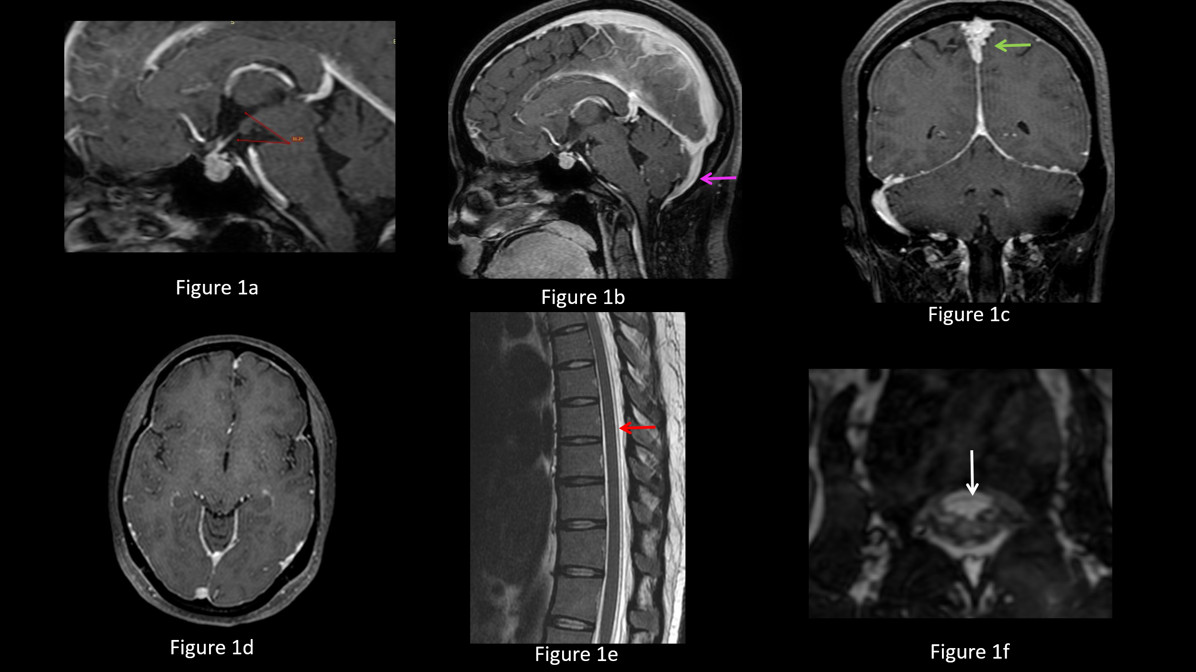

Figure 1a: T1 weighted sagittal image reveals bulky pituitary gland along with reduced ponto-mesencephalic angle.

Figure 1b and 1c : Sagittal and coronal T1Wt post-contrast images reveal engorgement of the major intracranial venous sinuses. Rounding of contour of superior sagittal sinus is seen on the coronal image (green arrow). Note is made of dilated occipital sinus (pink arrow).

Figure 1 d: Axial T1Wt post-contrast images reveals smooth pachymeningeal enhancement.

Figure 1e: T2Wt sagittal image of the dorsal spine shows fluid signal intensity in posterior epidural space with anteriorly displaced posterior dura (red arrow)

Figure 1f: 3D CISS axial image in upper lumbar region reveals thin rim of fluid in extradural space with posteriorly displaced anterior dura (white arrow)