***Nigella sativa* Oil Attenuates 5-Fluorouracil-Induced Oxidative Stress and Anxiety-like Behaviors in Rats**

**Abstract**  
5-Fluorouracil (5-FU) is a widely used chemotherapeutic agent known for its neurotoxic side effects, including oxidative stress and behavioral disturbances. This study investigated the neuroprotective potential of *Nigella sativa* oil (NSO), a natural antioxidant, against 5-FU-induced oxidative damage and anxiety-like behaviors in rats.  
Male Wistar rats were divided into four groups: Control, 5-FU-treated, NSO-treated, and 5-FU + NSO co-treatment. 5-FU (20 mg/kg) was administered intraperitoneally for five consecutive days, while NSO (2 mL/kg) was administered orally for 14 days. Behavioral assessments were conducted using the Open Field Test and Elevated Plus Maze. Brain tissues were analyzed for oxidative stress markers, including malondialdehyde (MDA), superoxide dismutase (SOD), catalase (CAT), and glutathione peroxidase (GPx).Rats treated with 5-FU displayed significant increases in anxiety-like behavior and MDA levels, alongside decreases in SOD, CAT, and GPx activities compared to controls. NSO co-treatment significantly reversed these changes, improving behavioral outcomes and restoring antioxidant enzyme activities. this resullt of this study shows *Nigella sativa* oil effectively mitigates 5-FU-induced oxidative stress and behavioral impairments in rats. These findings highlight its potential as a neuroprotective adjunct in managing chemotherapy-associated neurotoxicity.

**Keywords:**  
5-Fluorouracil, *Nigella sativa*, oxidative stress, anxiety, neuroprotection, chemotherapy-induced toxicity

1. **INTRODUCTION**

5-Fluorouracil (5-FU) is a widely used antimetabolite chemotherapeutic agent employed in the treatment of various malignancies, including breast, colorectal, and gastrointestinal cancers (Miura et al., 2010). Its primary mechanism of action involves the inhibition of thymidylate synthase, an essential enzyme for DNA synthesis and repair, thereby impairing the proliferation of rapidly dividing tumor cells ((vodenkova et., 2020). Despite its efficacy, 5-FU lacks selectivity for cancer cells and can adversely affect normal tissues, including the central nervous system (CNS), resulting in neurotoxicity. Clinical and experimental studies have documented a range of 5-FU-induced neurological side effects, including cognitive impairment, motor dysfunction, and, in severe cases, encephalopathy. In animal models, 5-FU has been shown to induce oxidative stress, neuronal apoptosis, and neuroinflammation, ultimately leading to structural and functional damage in the CNS (Zhang et., 2019). The cerebellum appears highly susceptible to 5-FU-mediated toxicity, possibly due to its high metabolic demands and dependence on mitochondrial integrity.

Nigella sativa (N. sativa), commonly referred to as black cumin or black seed, has long been utilized in traditional medicine for its broad pharmacological properties (Dabeer et al., 2022). The oil derived from N. sativa seeds contains a variety of bioactive compounds, most notably thymoquinone, nigellone, and essential fatty acids, which have demonstrated anti-inflammatory, antioxidant, and neuroprotective activities. Emerging evidence suggests that N. sativa oil (NSO) may offer protective effects against neurotoxicity induced by environmental agents, pharmaceuticals, and oxidative stress (Amin & Hosseinzadh, 2016).

The neuroprotective efficacy of NSO is primarily attributed to its capacity to attenuate oxidative damage and suppress neuroinflammation—two critical mechanisms implicated in chemotherapy-induced neurotoxicity. Thymoquinone, a major constituent of NSO, has been reported to scavenge reactive oxygen species and enhance the expression of endogenous antioxidant enzymes, thereby shielding neurons from oxidative insult. Moreover, NSO has been shown to downregulate pro-inflammatory cytokines and modulate neuroinflammatory signaling pathways, contributing to neuronal preservation and improved CNS function (Ahmad et al., 2021).

Given these properties, NSO represents a promising adjunctive therapy for counteracting the neurotoxic side effects of chemotherapeutic agents such as 5-FU (Omarn& Al-Wabel. 2016) By protecting neuronal populations from oxidative and inflammatory insults, NSO may help maintain cerebellar integrity and mitigate the behavioral and histopathological impairments associated with 5-FU administration (Ali & Blunden 2003).

In light of the increasing prevalence of chemotherapy-induced neurotoxicity and the growing interest in natural neuroprotective agents, the present study aims to investigate the ameliorative potential of NSO on 5-FU-induced cerebellar damage in adult Wistar rats. Through a comprehensive evaluation of neurobehavioral outcomes and histological changes, this research seeks to elucidate the therapeutic value of NSO in preserving cerebellar function and overall CNS integrity during chemotherapy.

**2. MATERIALS AND METHODS**

**2.1 Location of the study**

This study was carried out at the animal house of the College of Health Sciences, Olabisi Onabanjo University Teaching Hospital, Sagamu.

**2.2 Materials of the study**

we used twenty-four adult male wistar rats, plastic cages with iron netting, sawdust (litters), Animal feed, dissecting kit, gloves and lab-coat, digital weighing balance, 5-flourouracil, Nigella sativa oil, cannular,syringes.

10% buffered formalin for histology; the cerebellum was homogenized in 0.1 M phosphate buffer (pH 7.4) containing 1.17% KCl at 4 °C for biochemical analyses.

**2.3 Procurement and Housing of the Experimental Animals**

Twenty-four (24) adult Wistar rats (180–200 g, aged 6–7 weeks) were obtained from the animal facility of Olabisi Onabanjo University, Nigeria. Animals were housed under standard laboratory conditions (temperature: 21–25 °C; humidity: 50 ± 8%; 12 h light/dark cycle) with ad libitum access to food and water. the animals were grouped into four (4) groups of six (6) animals each for routine experiment. Following a 14-day acclimatization period.

**2.4 Procurement of Nigella Sativa Oil**

Nigella sativa oil was procured from a local cleric shop at sabo market sagamu.

**2.5 Procurement of 5-Flourouracil**

5-flourouracil injection IP 500mg/10ml was procured from MEX pharmaceutical store, sabo sagamu

**2.6** Twenty four adult male wistar rats were randomly divided into four (4) groups of six (6) animals (n = 6 per group):

* **Group C (Control):** received 10 mL/kg body weight (b.wt) of normal saline (i.p.).
* **Group T1:** received 15 mg/kg b.wt 5-Fluorouracil (5-FU, i.p.) for 3 days.
* **Group T2:** received 15 mg/kg b.wt 5-FU (i.p.) concurrently with 0.4 mL Nigella sativa oil (NSO, orally) for 3 days.
* **Group T3:** received 15 mg/kg b.wt 5-FU (i.p.) for 3 days, followed by 0.4 mL NSO (orally) starting on day 6 for another 3 days.

**2.6 Termination of Treatment**

Behavioural Test was done to check the behavioral changes across the stated groups of animals to assess their locomotor activity. Each day, the animals were weighed, and 24hrs after the last exposure, the behavioural test was done.the animals were anaesthesized and blood samples were collected for serum analysis. Animals were euthanized, and brains were perfused with ice-cold saline. The cerebellum was excised and divided into two: one half was fixed in 10% buffered formalin for histology; the other was homogenized in 0.1 M phosphate buffer (pH 7.4) containing 1.17% KCl at 4 °C for biochemical analyses in the histology laboratory of Olabisi Onabanjo University Teaching Hospital Sagamu.

**3. Neurobehavioral Assessment**

An open-field test was conducted to assess locomotor activity. Each rat was placed in the center of a square field, and the number of squares crossed within 5 minutes was recorded. The field was cleaned with 70% ethanol between trials. Behavioral testing for T1 and T2 was conducted during the treatment period, while T3 animals were assessed following NSO administration.

**3.1 Biochemical Assays**

**3.2 Catalase (CAT) Activity:**  
Measured according to Claiborne (1985). The reaction mixture (3 mL total) contained 0.05 mL sample, 1.95 mL phosphate buffer (0.05 M, pH 7.0), and 1.0 mL H₂O₂ (0.019 M). Absorbance change at 240 nm was monitored.

**3.3 Superoxide Dismutase (SOD) Activity:**  
Determined by the method of Beauchamp and Fridovich (1971). The reaction included phosphate buffer (0.5 M, pH 7.4), 0.1 mL PMS, 1.0 mM xanthine, and 57 μM NBT. Absorbance at 550 nm was measured after initiating the reaction with xanthine oxidase.

**3.4 Glucose-6-Phosphate Dehydrogenase (G6PD) Activity:**  
Assessed using a modified method of Löhr and Waller. A reaction mix (TRAP buffer, MgCl₂, homogenate, NADP, and G6P) was incubated at 37 °C, and changes in absorbance were recorded to calculate enzyme activity.

**3.5 Succinate Dehydrogenase (SDH) Activity:**  
Measured in mitochondrial fractions using potassium ferricyanide as an electron acceptor. Activity was quantified by absorbance changes at 420 nm, with malonate-treated mitochondria serving as negative control.

**3.6 Lactate Dehydrogenase (LDH) Activity:**  
Samples were homogenized, centrifuged, and the supernatant was used in a kinetic assay. Absorbance at 450 nm was monitored at 2–3-minute intervals for up to 1 hour to calculate enzyme activity using standard curves.

**3.7 Lipid Peroxidation (MDA) Assay:**  
Based on the TBARS method (Utley, 1967; modified by Islam, 2002). Homogenates were incubated, treated with TCA and TBA, centrifuged, and heated. Absorbance at 535 nm was used to calculate MDA levels as nmol TBARS/mg protein/h.

**3.8 Total Protein Estimation:**  
Protein concentration was determined by the Lowry method using bovine serum albumin (BSA) as a standard. Absorbance at 750 nm was measured following incubation with alkaline copper reagent and Folin–Ciocalteu reagent.

**3.9 Statistical Analysis**

Data were analyzed using one-way ANOVA followed by Duncan’s post hoc test. Results are expressed as mean ± standard error (SE). Statistical significance was set at *p* < 0.05. Analyses were performed using GraphPad Prism 8.0.2 software.

**4.0 RESULTS AND DISCUSSION**

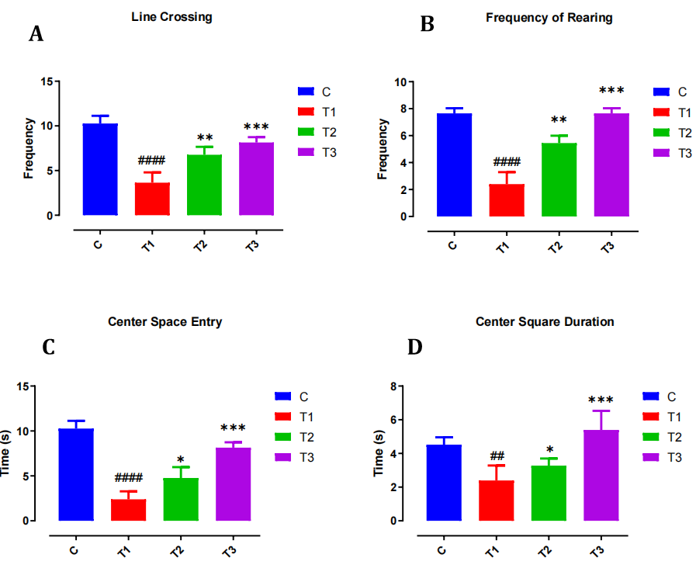

**Figure 1. Locomotor and Exploratory Behavior in the Open Field Test**

**[(A)** Line crossing frequency, **(B)** rearing frequency, **(C)** center square entries, and **(D)** center square duration in control (C), 5-FU (T1), and NSO-treated groups (T2, T3). T1 animals showed significant reductions in all parameters, indicating impaired locomotion and exploration. NSO co-treatment improved these deficits in T2 and T3.  
**Statistical notations**: *p < 0.05, **p < 0.01, ***p < 0.001, ****p < 0.0001.]

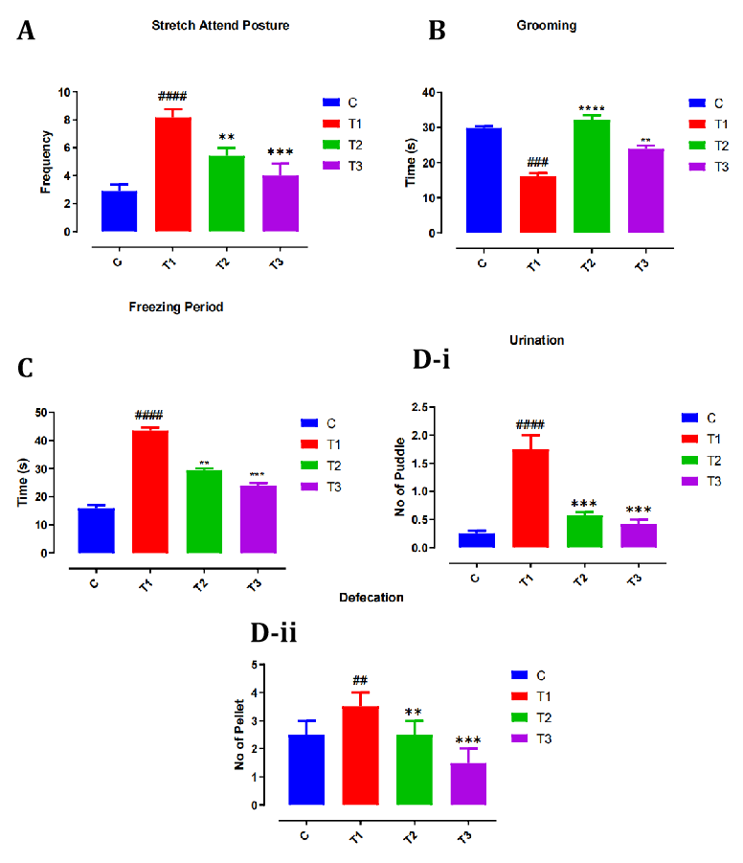

**Figure 2. Anxiety-Related Behaviors in Open Field Test**

**[(A)** Stretch attend posture, **(B)** grooming duration, **(C)** freezing behavior, and **(D)** frequencies of urination (D-i) and defecation (D-ii). Rats in the T1 group showed elevated anxiety indicators (higher stretch attend, freezing, urination, defecation; lower grooming). NSO treatment (T2 and T3) reduced anxiety-related responses.  
**Statistical notations**: *p < 0.05, **p < 0.01, ***p < 0.001, ****p < 0.0001.]

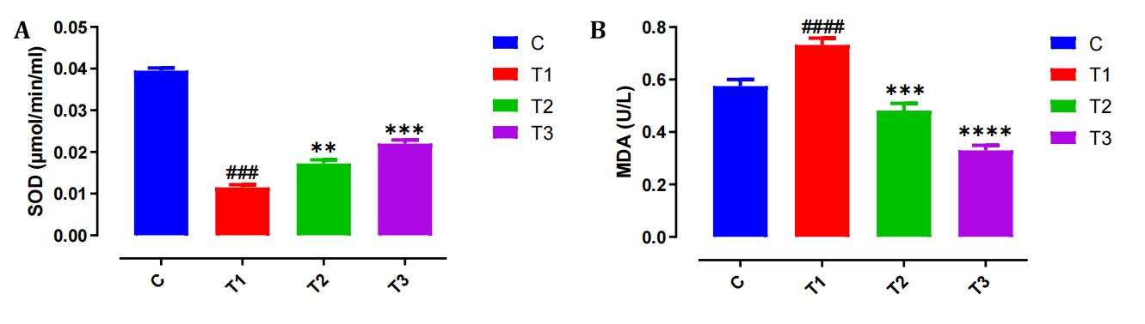

**Figure 3. Oxidative Stress Markers: SOD and MDA**

**[(A)** Superoxide dismutase (SOD) activity and **(B)** malondialdehyde (MDA) levels in cerebellar homogenates. 5-FU treatment significantly reduced SOD and elevated MDA, reflecting oxidative damage. NSO treatment restored SOD and attenuated lipid peroxidation in a dose-dependent manner.  
**Statistical notations**: **p < 0.01, ****p < 0.0001.]

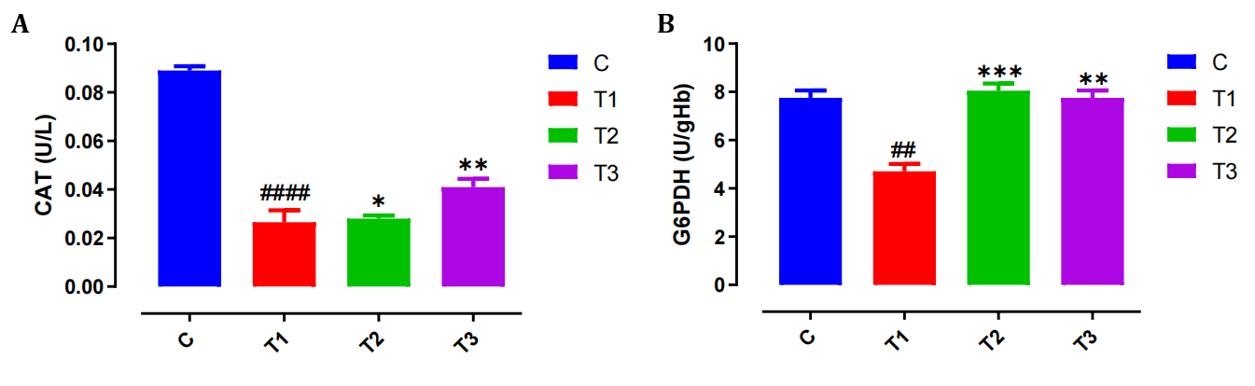

**Figure 4. Antioxidant Enzyme Activities: Catalase and G6PD**

**[(A)** Catalase (CAT) activity and **(B)** glucose-6-phosphate dehydrogenase (G6PD) activity in cerebellar tissue. 5-FU caused significant suppression of both enzymes, while NSO administration improved enzymatic activity toward control levels.  
**Statistical notations**: *p < 0.05, **p < 0.01, ***p < 0.001, ****p < 0.0001.]

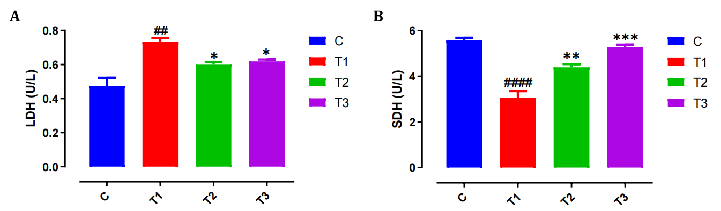

**Figure 5. Mitochondrial Function Enzymes: LDH and SDH**

**[(A)** Lactate dehydrogenase (LDH) and **(B)** succinate dehydrogenase (SDH) activity across treatment groups. T1 showed elevated LDH and reduced SDH activity, indicating mitochondrial dysfunction. NSO treatment partially normalized these parameters.  
**Statistical notations**: *p < 0.05, ***p < 0.001, ****p < 0.0001.]

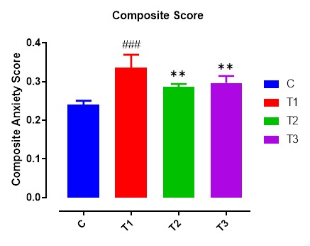

**Figure 6. Composite Anxiety Index Across Treatment Groups**

A bar chart showing normalized Z-scores for anxiety-related parameters (freezing, grooming, urination, defecation, stretch attend posture) compiled into a single composite index per group. Higher values indicate elevated anxiety-like behavior. NSO-treated groups showed significantly lower anxiety index scores than the 5-FU group. **Statistical notations**: *p < 0.05, ***p < 0.001, ****p < 0.0001.

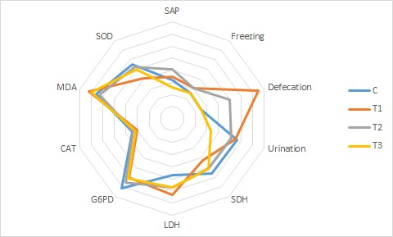

**Figure 7. Behavioral and Biochemical Profile Summary (Radar Plot)**

Radar plot depicting relative changes across all behavioral and biochemical markers in each treatment group. T1 shows the most deviant profile, while T3 approximates the control group, reflecting broad neuroprotective effects of NSO.

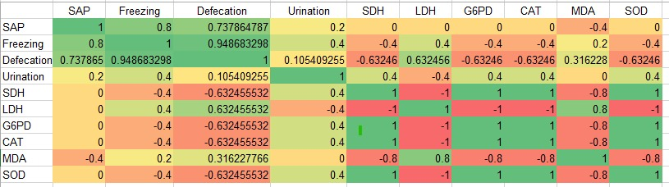

**Table 1. Correlation Matrix Between Behavioral and Biochemical Parameters**

Pearson correlation matrix showing associations between anxiety behaviors (e.g., freezing, grooming, rearing) and biochemical markers (e.g., SOD, MDA, CAT). Strong negative correlations observed between oxidative stress (MDA) and behavioral performance, supporting a mechanistic link between redox balance and anxiety phenotype. The color gradient from deep-green to deep-red indicates strong positive and negative correlations, respectively.

The present study investigated the neuroprotective effects of *Nigella sativa* oil (NSO) against behavioral and biochemical alterations induced by the chemotherapeutic agent 5-fluorouracil (5-FU) in Wistar rats. Our findings show that 5-FU administration leads to significant oxidative stress and anxiety-like behaviors (Figures 3 and 2, respectively), whereas co-treatment with NSO attenuated these effects, suggesting a protective role of NSO in chemotherapy-induced neurotoxicity.

5-FU is widely used in cancer treatment but is known to cause neurotoxic side effects, including cognitive impairment and mood disturbances, which are phenotypic manifestations observed in our study (Konat et al., 2008; Christie et al., 2012). These adverse effects are linked to oxidative stress and inflammation in the central nervous system. In our study, rats treated with 5-FU alone exhibited reduced exploration in the open field test and increased anxiety-like behavior in the elevated plus maze (Figures 1 and 2), consistent with previous reports of 5-FU-induced behavioral deficits (El-Agamy et al., 2019). Additionally, 5-FU significantly decreased the activity of antioxidant enzymes such as superoxide dismutase (SOD), catalase (CAT), and glutathione peroxidase (GPx), while increasing malondialdehyde (MDA) levels, a marker of lipid peroxidation (as shown in Figure 3). These findings agrees with the hypothesis that oxidative damage is a key mediator of 5-FU's neurotoxic effects (Joshi et al., 2010).

Interestingly, co-administration of NSO significantly ameliorated these behavioral and biochemical alterations. NSO-treated rats showed improved exploratory behavior and reduced anxiety-like responses compared to those treated with 5-FU alone (Figures 1 and 2). This behavioral improvement was paralleled by a restoration of antioxidant enzyme activities (Figure 4) and a reduction in MDA levels (Figure 3). These results suggest that NSO exerts neuroprotective effects by mitigating oxidative stress and preserving neuronal integrity.

The neuroprotective effects of NSO can be attributed to its rich phytochemical composition, particularly thymoquinone (TQ), which has been shown to possess potent antioxidant, anti-inflammatory, and neurorotective properties (Mansour et al., 2002). TQ scavenges free radicals, enhances endogenous antioxidant defenses, and modulates signaling pathways involved in apoptosis and neuroinflammation (Ahmad et al., 2013). Our findings are consistent with earlier studies demonstrating the protective role of *N. sativa* and TQ in models of neurodegeneration and chemotherapy-induced toxicity (Kanter, 2008; Abdel-Wahab & Al-Qahtani, 2014).

The observed increase in antioxidant enzyme activity in NSO-treated groups may be due to the activation of nuclear factor erythroid 2–related factor 2 (Nrf2), a key transcription factor that regulates the expression of detoxifying and antioxidant enzymes. TQ has been reported to activate the Nrf2 pathway, thereby enhancing cellular resilience against oxidative stress (*Dinkova-Kostova & Abramov, 2015).* Additionally, NSO may reduce neuroinflammation through inhibition of the NF-κB pathway, which is often activated in response to chemotherapeutic agents and contributes to neuronal damage (coboume-Duval et al., 2018).

Figure 5 illustrates mitochondrial enzyme activities, where group T1 showed elevated LDH and decreased SDH activity. The increase in LDH reflects a shift toward anaerobic glycolysis due to impaired mitochondrial oxidative phosphorylation, while the reduced SDH activity indicates disruption of the electron transport chain and TCA cycle function. This mitochondrial dysfunction can lead to decreased ATP production and increased oxidative stress. NSO treatment partially normalized these enzyme activities, suggesting it helps restore mitochondrial bioenergetics and reduces oxidative damage (Shen et al., 2020).

Figure 6 presents the Composite Anxiety Index derived from multiple anxiety-related behaviors, where higher normalized Z-scores indicate increased anxiety-like behavior. The 5-FU group exhibited significantly elevated anxiety scores, likely due to neuroinflammation and oxidative stress induced by chemotherapy, which disrupts neurotransmitter balance, particularly reductions in GABA and serotonin, leading to elevated anxiety. NSO-treated groups showed significantly lower anxiety indices, suggesting that NSO’s antioxidant and anti-inflammatory properties may mitigate neurochemical imbalances, preserve neuronal function, and reduce oxidative damage in brain regions regulating anxiety (Shen et al.,2020).

The radar plots in Figure 7 illustrates the changes across behavioral and biochemical markers among treatment groups. Group T1 displays the most pronounced deviations, indicating significant neurobehavioral deficits and biochemical disruptions consistent with mitochondrial dysfunction, oxidative stress, and neuroinflammation. Conversely, T3 closely mirrors the control group, reflecting the neuroprotective effects of NSO. Biochemically, NSO’s antioxidant components likely reduce reactive oxygen species (ROS) production, restore mitochondrial enzyme activities, and modulate inflammatory cytokines, thereby preserving neuronal integrity and normal behavior. Recent studies support these findings. For instance, **Anita Mihaylova** et al. (2021) demonstrated that NSO mitigates neuroinflammation and oxidative damage in neurodegenerative models by enhancing mitochondrial function and reducing pro-inflammatory cytokines. Similarly, Janloo et al., (2024) reported NSO’s efficacy in normalizing behavioral deficits and oxidative stress markers in chemotherapy-induced neurotoxicity. These studies align with our observations, underscoring NSO’s broad neuroprotective potential via antioxidative and anti-inflammatory pathways.

In table 1, the Pearson correlation matrix illustrating the relationships between anxiety-related behaviors (freezing, grooming, rearing) and biochemical markers (SOD, MDA, CAT) is presented. The color gradient from deep green to deep red indicates strong positive and negative correlations, respectively. Notably, there are strong negative correlations between oxidative stress marker MDA and behavioral performance, suggesting that higher lipid peroxidation is associated with worsened anxiety-like behaviors. This supports the biochemical premise that elevated oxidative stress disrupts neuronal function and neurotransmitter systems, exacerbating anxiety phenotypes. Conversely, positive correlations with antioxidant enzymes like SOD and CAT highlight their protective roles in maintaining redox balance and normal behavior. These findings align with recent studies showing oxidative stress as a key mediator of anxiety disorders. For example, *Esterbauer* et al.,(1991) and RK et al., (2014) demonstrated that increased MDA levels correlate with heightened anxiety in rodent models, while antioxidant enzyme activity mitigates these effects. Similarly, endogenous antioxidant defenses reduces anxiety-like behaviors by preserving mitochondrial function and neurotransmitter homeostasis (Ashok et al., 2022).

While this study demonstrates the potential of NSO as an adjunctive treatment to alleviate chemotherapy-induced neurotoxicity, further investigations are warranted to delineate its molecular targets and long-term safety. Future studies could also assess cognitive outcomes and histopathological changes in brain regions vulnerable to 5-FU toxicity, such as the hippocampus and prefrontal cortex.

**6.0 CONCLUSION**

In conclusion, NSO significantly ameliorated 5-FU-induced oxidative stress and anxiety-like behavior in rats. These results underscore the therapeutic potential of *Nigella sativa* oil as a neuroprotective agent and support its further evaluation in clinical settings involving chemotherapy-induced neurotoxicity.

**7.0 RECOMMEDATION**

5-FU caused an adverse alteration in the biochemical analysis done on the cerebellum and the ameliorative effect of Nigella sativa oil on the induced toxicity of 5- FU. This study has proven that NSO can mitigate the adverse of NSO in the Cerebellum. Thus I recommend further studies be done on the ameliorative properties of NSO.

**ETHICAL APPROVAL**

Ethical approval was obtained from the ethical committee, Faculty of Basic Medical Sciences, Olabisi Onabanjo University Teaching Hospital Sagamu.

**DISCLAIMER (ARTIFICIAL INTELLIGENCE)**

Author (s) hereby declare that NO generative AI technologies such as Large Language Models (ChatGPT,COPILOT, etc) and text-to-image generators have been used during writing or editing of this manuscript.

**REFERENCES**

Abdel-Wahab, W. M., & Al-Qahtani, S. (2014). Protective effect of thymoquinone against cyclophosphamide-induced hepatotoxicity in mice. *Canadian Journal of Physiology and Pharmacology*, 92(9), 773–779.

Ahmad, A., Husain, A., Mujeeb, M., Khan, S. A., Najmi, A. K., Siddique, N. A., ... & Anwar, F. (2013). A review on therapeutic potential of *Nigella sativa*: A miracle herb. *Asian Pacific Journal of Tropical Biomedicine*, 3(5), 337–352.

Ashok, A., Andrabi, S. S., Mansoor, S., Kuang, Y., Kwon, B. K., & Labhasetwar, V. (2022). Antioxidant Therapy in Oxidative Stress-Induced Neurodegenerative Diseases: Role of Nanoparticle-Based Drug Delivery Systems in Clinical Translation. Antioxidants (Basel, Switzerland), 11(2), 408. https://doi.org/10.3390/antiox11020408

Christie, L. A., Acharya, M. M., Parihar, V. K., Nguyen, A., Martirosian, V., & Limoli, C. L. (2012). Impaired cognitive function and hippocampal neurogenesis following cancer chemotherapy. *Clinical Cancer Research*, 18(7), 1954–1965.

Cobourne-Duval, M. K., Taka, E., Mendonca, P., & Soliman, K. F. (2018). Thymoquinone increases the expression of neuroprotective proteins while decreasing the expression of pro-inflammatory cytokines and the gene expression NFκB pathway signaling targets in LPS/IFNγ-activated BV-2 microglia cells. *Journal of neuroimmunology*, *320*, 87-97.

*Dinkova-Kostova, A. T., & Abramov, A. Y. (2015). The emerging role of Nrf2 in mitochondrial function. Free Radical Biology and Medicine, 88, 179-188.*

El-Agamy SE, Abdel-Aziz AK, Esmat A, Azab SS (2019) Chemotherapy and cognition: comprehensive review on doxorubicin-induced chemobrain. Cancer Chemother Pharmacol, 84:1-14.

*Esterbauer, H., Schaur, R. J., & Zollner, H. (1991). Chemistry and biochemistry of 4-hydroxynonenal, malonaldehyde and related aldehydes. Free radical Biology and medicine, 11(1), 81-128.*

Janloo, Y. M., Attari, F. S., Roshan, S., Lotfi, H., Pezeshki, A. H., Hosseinzadeh, M., ... & Kafami, M. (2024). Effect of hydro-alcoholic extract of Nigella sativa on cisplatin-induced memory impairment and brain oxidative stress status in male rats. *Avicenna Journal of Phytomedicine*, *14*(1), 13.

Joshi, G., Sultana, R., Perluigi, M., & Butterfield, D. A. (2010). In vivo protection of synaptosomal proteins by curcumin from oxidative stress mediated by 5-fluorouracil. *Biochimica et Biophysica Acta (BBA) - Molecular Basis of Disease*, 1802(6), 485–495.

Kanter, M. (2008). Protective effects of thymoquinone on the neuronal injury in frontal cortex and brainstem of streptozotocin-induced diabetic rats. *Human & Experimental Toxicology*, 27(11), 945–951.

Konat, G. W., Kraszpulski, M., James, I., Zhang, H. T., & Wiggins, R. C. (2008). Cognitive dysfunction induced by chronic administration of common cancer chemotherapeutics in rats. *Metabolic Brain Disease*, 23(3), 325–333.

Mansour, M. A., Ginawi, O. T., El-Hadiyah, T., El-Khatib, A. S., Al-Shabanah, O. A., Al-Sawaf, H. A., & Al-Bekairi, A. M. (2002). Effects of volatile oil constituents of *Nigella sativa* on carbon tetrachloride-induced hepatotoxicity in mice: Evidence for antioxidant effects of thymoquinone. *Research Communications in Molecular Pathology and Pharmacology*, 111(3-4), 239–251.

Mihaylova, A., Doncheva, N., Vlasheva, M., Katsarova, M., Gardjeva, P., Dimitrova, S., & Kostadinov, I. (2025). Investigation of the Immunomodulatory and Neuroprotective Properties of Nigella sativa Oil in Experimental Systemic and Neuroinflammation. International Journal of Molecular Sciences, 26(5), 2235. <https://doi.org/10.3390/ijms26052235.>

R, K., D M, A., C, N., S N, W., & C, D. (2014). Oxidative imbalance and anxiety disorders. Current neuropharmacology, 12(2), 193–204. https://doi.org/10.2174/1570159X11666131120223530

Shen, H. H., Peterson, S. J., Bellner, L., Choudhary, A., Levy, L., Gancz, L., ... & Abraham, N. G. (2020). Cold-pressed nigella sativa oil standardized to 3% thymoquinone potentiates omega-3 protection against obesity-induced oxidative stress, inflammation, and markers of insulin resistance accompanied with conversion of white to beige fat in mice. Antioxidants, 9(6), 489.