The Effect of Geometric Adjustments in an Indirect Forced Convection Solar Tunnel Dryer: A Study Based on CFD Simulations and Experimental Investigations

Abstract
The quality of dried agri-food products depends on the uniformity of their moisture content at the end of the drying process. Controlling parameters such as temperature, air velocity, and relative humidity within the dryer is essential to ensure optimal drying. This study presents the design of a tunnel-type indirect solar dryer intended for drying agri-food products. The main scientific challenge lies in the numerical evaluation and proposal of solutions to improve the dryer's performance. With this in mind, a numerical simulation was carried out using computational fluid dynamics (CFD) to analyse the distribution of air flow and temperatures inside the dryer. Three simulation models were developed, with variable input values: air speed (1 m/s, 2 m/s and 3 m/s) and the temperature of the wall exposed to solar radiation (40°C, 50°C and 60°C). To validate the numerical results, an experimental study was conducted. Comparisons revealed high coefficients of determination between the simulated and experimental data: R² = 0.9951 for temperature and R² = 0.9217 for air velocity. Geometric adjustments were then made to the CFD model. The right angles (90°) at the upper ends of the drying chamber were changed to flat angles (0°), while those at the lower ends were replaced by 45° angles. These modifications led to an optimisation of the dryer's thermal performance, as well as a significant improvement in the efficiency of the drying process.
Keywords: Indirect solar tunnel dryer, airflow, air temperature, numerical simulation, CFD, Geometric adjustment effect.
1. Introduction
Since the oil crisis of the 1980s, solar drying technology has attracted considerable interest among researchers, mainly as a response to the energy demands associated with the preservation of fruits and vegetables [1]. This method, the subject of numerous scientific studies, remains one of the most actively researched fields today—particularly in developing countries where simple and low-cost technologies are still widely used [2]. Solar dryers, commonly employed in the agri-food industry, are valued for their simple design, low installation costs, and ease of use in various environments [3]. Several types of dryers have been studied in the scientific literature, each evaluated based on its physical characteristics, thermal performance, and the quality of the dried products [4]. Within the drying chamber, hot air flows from the inlet to the outlet, resulting in faster drying of products located near the inlet compared to those further away. The dehydration rate is directly influenced by the temperature and velocity of the drying air [5][6]. Therefore, achieving a uniform airflow distribution inside the dryer is crucial for ensuring optimal efficiency and homogeneous drying of the products [7]. To better understand the airflow and temperature distribution, Computational Fluid Dynamics (CFD) was employed to analyze a tunnel-type solar dryer. Geometric modifications were then applied to the CFD model in order to optimize the thermal performance of the drying process.
2. Materials and Methods
2.1 Dryer Description
The dryer studied is an indirect solar dryer with forced convection of the tunnel type (see Figure 1). It consists of a parallelepiped frame made of 1 mm thick steel sheet, painted black to optimise solar radiation absorption. The dryer measures 210 cm long and 45 cm wide. On one of the side faces, on the width side, a fan is installed to force air circulation inside the dryer. Opposite this face is the air exhaust vent. One of the side panels, on the long side, is equipped with three doors providing access to the various compartments of the dryer. Inside, each compartment is equipped with racks with a surface area of 490 cm², and each compartment can hold up to six racks spaced 10 cm apart.
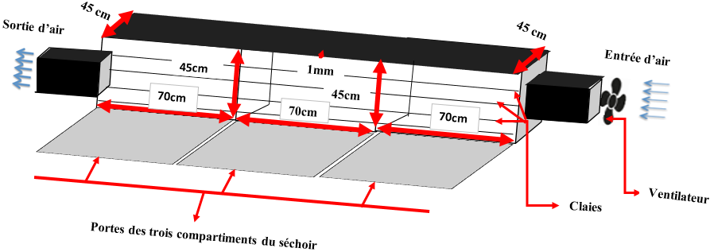

Figure 1: Schematic representation of the dryer
2.3 CFD Numerical Model
Computational Fluid Dynamics (CFD) is widely used to predict air velocity and temperature within drying chambers [8]. It significantly reduces the time required for experimental work, which can often be tedious and challenging. Solving a problem using the CFD method can be structured into the following three main steps [9]:

- Problem setup: This involves defining the geometry, generating a mesh to discretize the computational domain, and selecting appropriate physical models and numerical methods;
- Numerical resolution: The problem is solved through the execution of a computational program;
- Post-processing of results: First, the consistency of the results is verified, then they are analyzed in order to provide answers to the initial research questions.
2.3.1 Model Geometry
Figure 2 shows the geometric configuration of the model built using the FEATool Multiphysics environment. The geometric parameters are presented in Table 1.


Figure 2: Geometric configuration of the model
Table 1: Geometric parameters of the model
Air inlet size (m) | 0.25
Air outlet size (m) | 0.25
Drying chamber length (m) | 2.1
Drying chamber width (m) | 0.45
Distance between the air inlet and the top of the drying chamber (m) | 0.1
Distance between the air inlet and the bottom of the drying chamber (m) | 0.1

2.3.2 Mesh Used
Figure 3 shows the mesh topology and node distribution. The mesh parameters for the generated model are presented in the following Table 2.
Table 2: Mesh parameters of the generated model
Number of grid points | 2940
Number of grid cells | 5593
Minimum cell area | 1.1011x10⁻⁰⁴
Average cell area | 1.7075 x10⁻⁰⁴
Maximum cell area | 2.4540 x10⁻⁰⁴
Minimum cell quality | 0.8175
Average cell quality | 0.9970

2.3.3 Governing Equations of the Numerical Model
The equations governing the numerical model for the distribution of airflow and temperature are inspired by existing models in the scientific literature. These equations are derived from the fundamental laws of mass and energy conservation. They are based on the Navier–Stokes equation and heat transfer equations [10] [11].
Navier–Stokes Equation Used in the Model.
$$ρ_{f}\left(u^{,}+\left(u.∇\right)u\right)=-∇p+∇.\left(μ\left(∇u+{∇u}^{T}\right)\right)+F_{X}.∇u (1)$$
With the following parameters:
$ρ_{f}$ : air density
$u$ : air velocity
$u^{,}$ : rate of change of velocity with respect to time
$p$ : air pressure
$μ$ : kinematic viscosity of air
$F_{X}$: external forces
Heat Transfer Equation Used in the Model
$$ρ_{p}C_{p}T^{'}+∇.\left(-k∇T\right)=Q-ρC_{p}u∇T (2)$$
With the following parameters:
$ρ_{p}$ : density of the dryer wall
$C_{p}$ : specific heat capacity of the sheet metal
$T$ : temperature
$T^{'}$ : rate of change of temperature with respect to time
$k$ : thermal conductivity
$Q$ : heat quantity
Boundary Conditions
For the airflow distribution within the system, the velocity coefficient of the incoming airflow is conditioned by the following relationship [12].
$$U_{in}=\frac{4*u_{max}*(y*\left(h-y\right))}{h^{2}}, 0≤y≤h (3)$$

With:
$U_{in}$: velocity coefficient of the incoming airflow into the system
$u_{max}$: maximum air velocity at the inlet of the drying chamber
$h$ : height of the air inlet opening into the drying chamber
The pressure of the airflow from the outlet to the interior of the system is assumed to be zero. The other sides of the system are considered as slip-free walls.
The temperature values at the inlet of the dryer walls were set to define the temperature diffusion within the system
2.4 Experimental Approach
To validate the model simulated using Computational Fluid Dynamics (CFD), experimental tests were conducted using temperature and wind speed sensors, as shown in Figure 3a and 3b.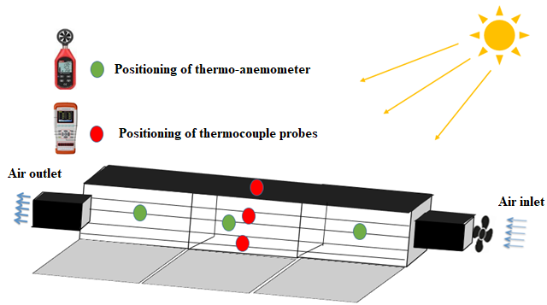
Figure 3(a): Schematic representation of the setup
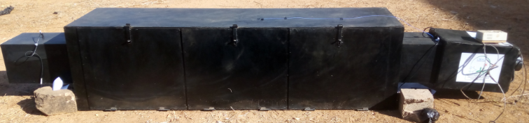
Fig 3(b): Photo of the setup
2.4.1 Equipment Used
The main equipment used for our experimental tests includes:
- Temperature probes of the thermocouple type, coupled with a data acquisition system (JINKO-JK804), to monitor the temperature changes of the product, the walls, and the ambient air in the dryer. The technical specifications are in the table 3.

Table 3: Specifications of Multichannel portable temperature meter (JINKO-JK804) with thermocouples.
B Display: | 5 digits
Min and Max Reading: | -200.0°C to 1800.0°C
Interface: | USB, MICRO SD, PC
Thermocouple Type: | T, K, J, N, E, S, R
Thermocouple Accuracy used | ±0.5°C

- A thermo-anemometer of the UNI-T UT363 BT type, used to monitor the airflow velocity at various locations within the dryer. The technical specifications are in the table 4.

Table 4: Specifications of the UNI-T UT363 BT anemometer
Function | Measurement Range | Resolution |  | Accuracy
Wind speed measurement | 0 to 30 m/s (standard) | 0.1 | ±(5%rdg + 0.5)
 | 1.4 to 108 km/h (reference) |  | ±(5%rdg + 15 digits)
 | 0.7 to 58 knots (reference) |  | ±(5%rdg + 10 digits)
 | 0.8 to 67 mph (reference) |  | ±(5%rdg + 10 digits)
 | 78 to 5905 ft/min (reference) | 1 | ±(5%rdg + 180 digits)
Temperature measurement | -10 to 60°C | 0.1°C | ±2°C
 | 14 to 122°F | 0.2°C | ±4°C
Wind force level | Level 0 to 12 | 1 | —

Result And Discussion
3.1 Airflow Distribution
Figures 4 (a), (b), and (c) present the airflow velocity distribution profile inside the drying chamber. In (a), (b), and (c), we have the inlet velocities of 1 m/s, 2 m/s, and 3 m/s, respectively.

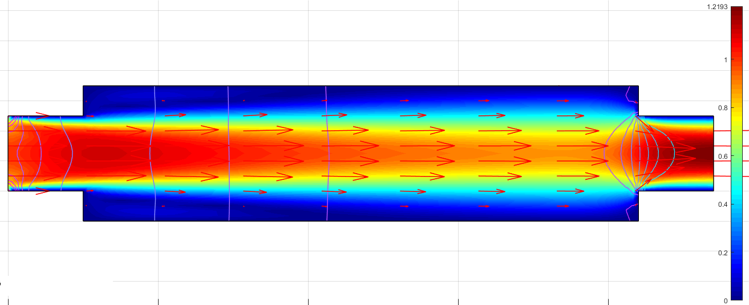
(a)
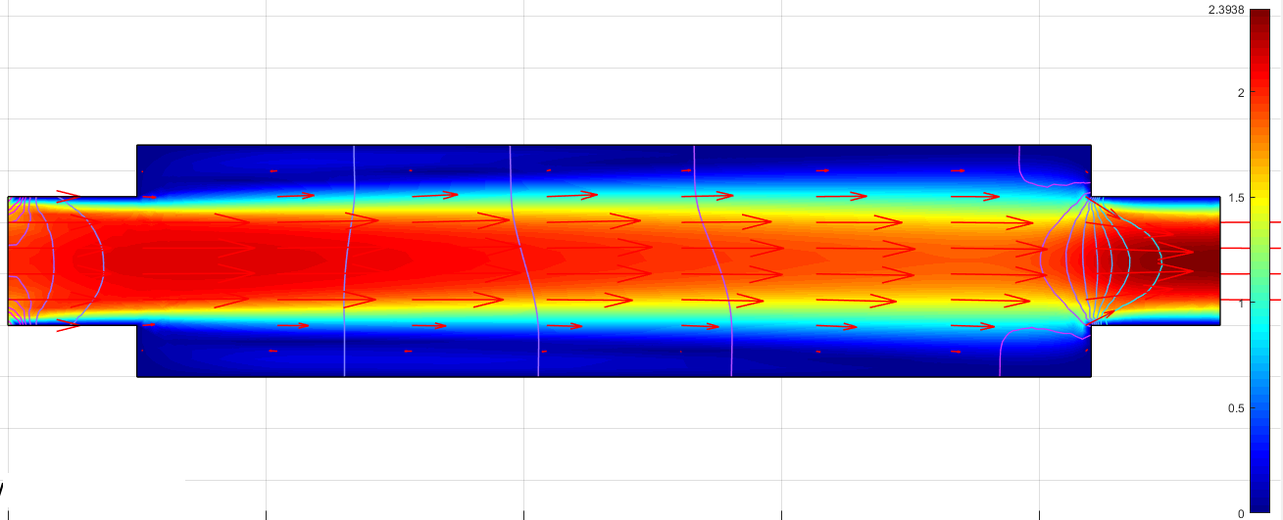
(b)
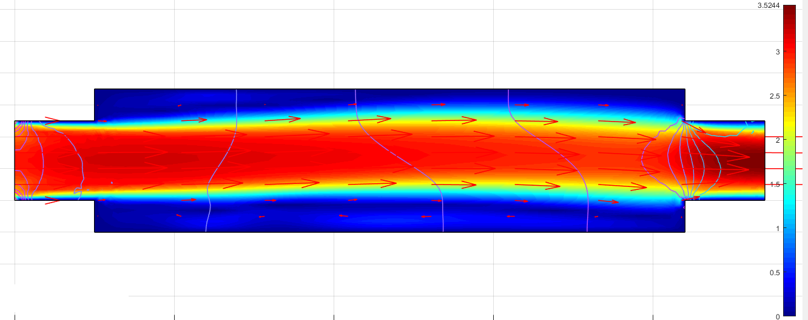
(c)
Figure 4: Air velocity distribution profile inside the drying chamber (in (a), (b), and (c) the inlet velocities are 1 m/s, 2 m/s, and 3 m/s, respectively).
The results reveal a concentration of airflow in the middle of the drying chamber. As the inlet velocity increases, the airflow distribution becomes more uniform. However, insufficient airflow is observed at both the upper and lower ends of the chamber. This limitation is attributed to the geometric configuration of the dryer, particularly the right-angled junction between the fan housing section and the drying chamber. Modifying the chamber’s geometry could help address this issue.
3.2 Temperature Diffusion
Figures 5 (a), (b), and (c) present the heat transfer profile in the drying chamber. In (a), (b), and (c), we have the wall temperature receiving solar radiation set at 40°C, 50°C, and 60°C, respectively.

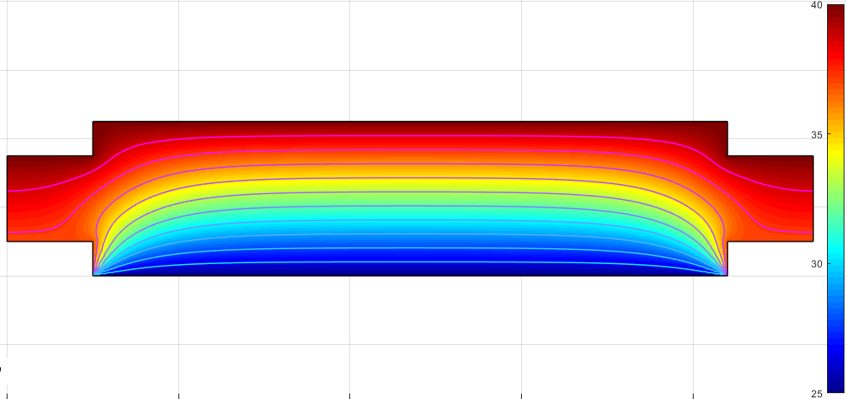
(a)

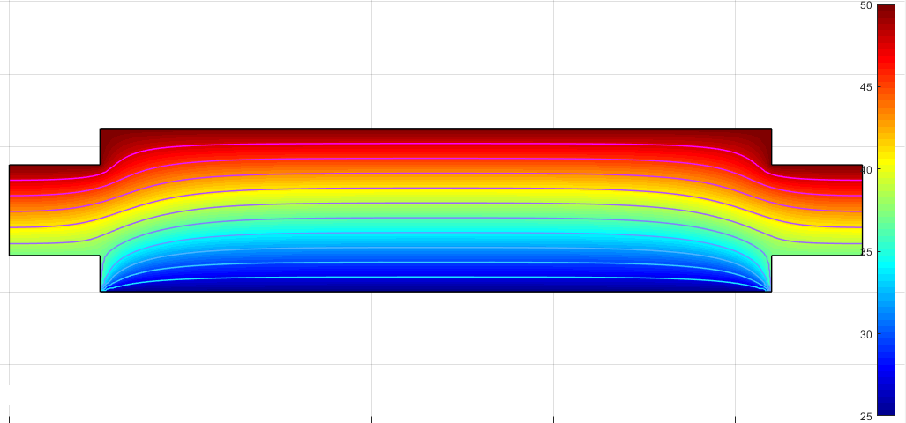
(b)
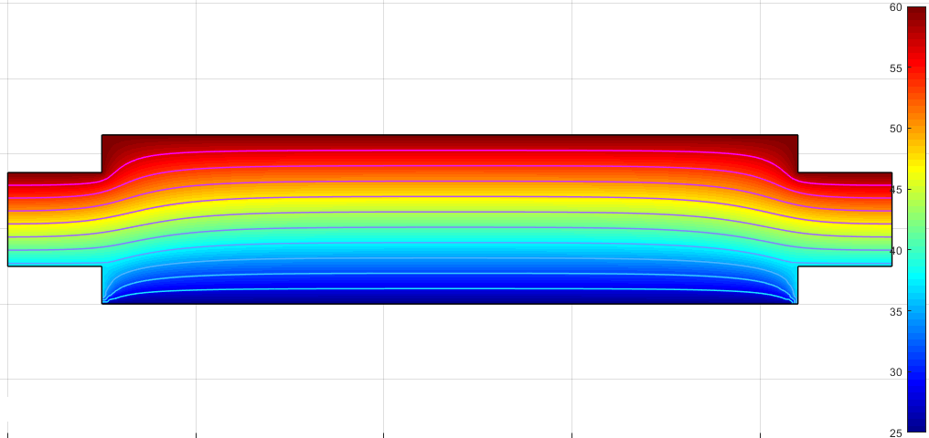
(c)
Figure 5: Temperature distribution profile inside the drying chamber (in (a), (b), and (c), the wall temperature is set at 40°C, 50°C, and 60°C, respectively).
The results indicate a heat distribution pattern originating from the upper wall of the dryer and extending into the interior of the drying chamber, highlighting a temperature difference between the upper and lower sections. This temperature gradient becomes more pronounced as the upper wall temperature increases. The phenomenon is primarily attributed to the geometric design of the dryer. In addition to the right-angled side corners, the dryer rests directly on the ground, limiting heat transfer in the lower part of the chamber unless it is exposed to a high-temperature environment.
3.3 Comparison between Experimental Measurements and CFD Models
The air temperature and velocity measured experimentally within the drying chamber are compared with the data obtained from the CFD models. Figures 6 (a) and (b) present the comparison of the temperature and air velocity profiles, respectively.
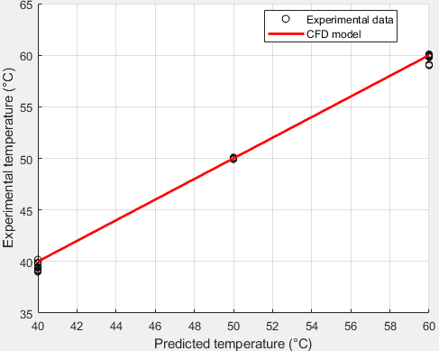 | 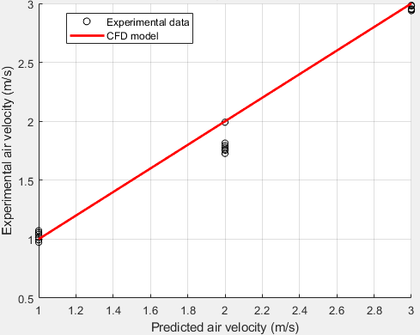
Figure 6 (a) : Comparaison between expérimental température mesurément and model CFD | Figure 6 (b): Comparison between experimental air velocity measurements and CFD model predictions
By analyzing these figures, a good agreement can be observed between the CFD model predictions and a number of experimental data points. The table 5 below presents the statistical parameters of the relative errors between the experimental and simulated results, calculated using the following formulas [11]:
R-Square
$$R^{2}=1-\frac{\frac{1}{n}\sum_{i=1}^{n}{{\left({Yexp}_{i}-{Ymod}_{i}\right)}^{2}}}{\frac{1}{n}\sum_{i=1}^{n}{{\left({Yexp}_{i}-\overline{{Yexp}_{i}}\right)}^{2}}} (4)$$
Table 5: Statistical Parameters
Statistical Parameters | R²
Relative errors between the two sets of temperature results | 0.9951
Relative errors between the two sets of temperature results | 0.9217
The examination of these values shows an R² close to one. We can conclude that the model is satisfactory.
3.4 Optimizing the Dryer Performance through the CFD Model
Although this type of dryer has yielded good results for drying certain agri-food products, modifications to its geometry are necessary to achieve better distribution of air and temperature flows. Figures 7 and 8 present, respectively, the air velocity and temperature distribution profiles inside the drying chamber of the modified dryer.

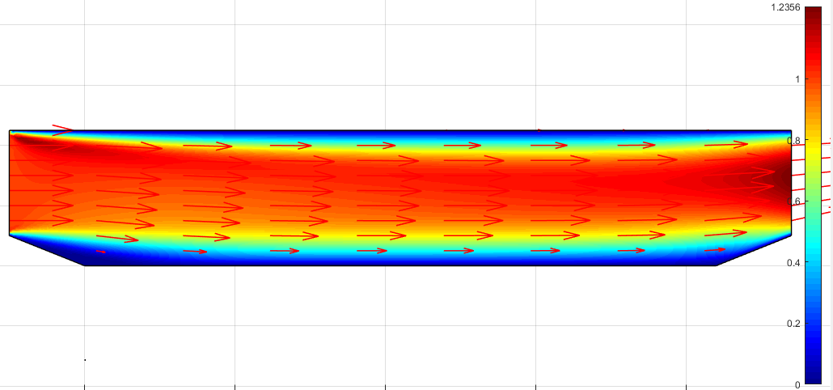
Figure 7 : Air velocity distribution profile inside the drying chamber of the modified dryer
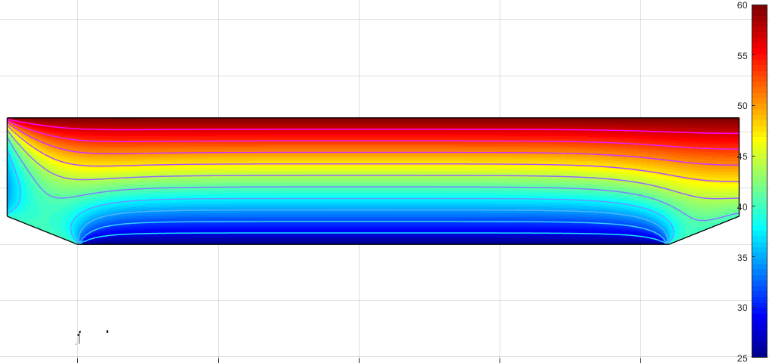
Figure 8: Temperature distribution profile inside the drying chamber of the modified dryer.
As shown in Figure 7, removing the upper corner angles at both ends and modifying those at the bottom of the drying chamber results in a more uniform airflow distribution. Figure 8 further demonstrates an improvement in temperature distribution within the chamber, despite the original configuration—where the dryer rests directly on the ground—being maintained.
IV. Conclusion
This study enhanced the understanding of airflow and temperature distribution within the investigated dryer. The predicted values from the CFD model were compared with experimental measurements, showing strong agreement, with a correlation coefficient (R) close to 1. A geometric modification of the dryer was performed using the CFD numerical model, while preserving its original dimensions and overall architecture. The simulation results for the modified configuration indicate improved performance.

Disclaimer (Artificial intelligence)

Option 1:

Author(s) hereby declare that NO generative AI technologies such as Large Language Models (ChatGPT, COPILOT, etc.) and text-to-image generators have been used during the writing or editing of this manuscript.

Option 2:

Author(s) hereby declare that generative AI technologies such as Large Language Models, etc. have been used during the writing or editing of manuscripts. This explanation will include the name, version, model, and source of the generative AI technology and as well as all input prompts provided to the generative AI technology

Details of the AI usage are given below:
1.
2.
3.

References
[1] Dissa, A. O. (2007). Convective drying of mango: Analysis of the influence of aerolic and intrinsic parameters, design and modeling of an indirect solar dryer. PhD Thesis, University of Ouagadougou, Burkina Faso.
[2] Nganhou, J., & Nganya, T. (2003). Numerical simulation of the dynamic behavior of a solar drying system for cocoa beans in Cameroon. Biological and Food Processing (PBA). Retrieved from http://spip.em.refer.org/tet/pba1/article40.html
[3] Amanlou, Y., & Zomorodian, A. (2010). Applying CFD for designing a new fruit cabinet dryer. Journal of Food Engineering. https://doi.org/10.1016/j.jfoodeng.2010.06.001
[4] Goudjinou, C. (2018). Theoretical and experimental study of solar drying of Moringa oleifera leaves: Thermophysical, physicochemical, and functional characterization of the derived powder. PhD Thesis, University of Abomey-Calavi, Benin.
[5] Mulet, A., Berna, A., Borras, M., & Pinaga, F. (1987). Effect of airflow rate on carrot drying. Drying Technology, 5(2), 245–258.
[6] Karathanos, V. T., & Belessiotis, V. G. (1997). Sun and artificial air-drying kinetics of some agricultural products. Journal of Food Engineering, 31(1), 35–46.
[7] Mirade, P. S. (2003). Prediction of the air velocity field in modern meat dryers using unsteady computational fluid dynamics (CFD) models. Journal of Food Engineering, 60, 41–48.
[8] Norton, T., & Sun, D. W. (2006). Computational fluid dynamics (CFD) – an effective and efficient design and analysis tool for the food industry: A review. Trends in Food Science & Technology, 17, 600–620.
[9] Wikipedia contributors. (2021, June 2). Computational fluid dynamics. Retrieved from
https://fr.wikipedia.org/wiki/M%C3%A9canique_des_fluides_num%C3%A9rique
[10] Kundu, P. K., Cohen, I. M., & Dowling, D. R. (2015). Fluid Mechanics (6th ed.). Academic Press.
[11] ncropera, F. P., DeWitt, D. P., Bergman, T. L., & Lavine, A. S. (2007). Fundamentals of Heat and Mass Transfer (6th ed.). Wiley.
[12] John, V. (2004). Reference values for drag and lift of a two-dimensional time-dependent flow around a cylinder. International Journal for Numerical Methods in Fluids, 44, 777–788.
[13] Montgomery, D. C., & Runger, G. C. (2014). Applied Statistics and Probability for Engineers (6th ed.). Wiley.
[14] Nabh, G. (1998). On higher order methods for the stationary incompressible Navier-Stokes equations (PhD Thesis). Universität Heidelberg, Preprint 42/98.
[15] John, V., & Matthies, G. (2001). Higher-order finite element discretizations in a benchmark problem for incompressible flows. International Journal for Numerical Methods in Fluids, 37(8), 885–903.
[16] John, V., & Rang, J. (2010). Adaptive time step control for the incompressible Navier–Stokes equations. Computational Methods in Applied Mechanics and Engineering, 199, 514–524

