***Original Research Article***

**A Quantitative and Qualitative Study of Modern Oil Extraction Techniques in Aq Darya Area, Afghanistan**

**Abstract**

The Aq Darya oil field in northern Afghanistan represents a strategically important petroleum resource with an estimated reserve of approximately 22 million tons. This study presents a comprehensive evaluation of the geological framework, reservoir characteristics, oil composition, and extraction potential of the Aq Darya field. Using a multidisciplinary approach, the research integrates data from geological field surveys, laboratory analyses and structured questionnaires completed by petroleum engineers with academic and field expertise.The objective of the study is to identify the most effective extraction technique tailored to the field’s specific structural and physical-chemical attributes. Quantitative analysis of the survey data reveals a strong preference over 70% of respondents for mechanized pumping methods, citing advantages aligned with the field’s anticline folding, moderate porosity and permeability and relatively shallow reservoir depth. Qualitative input reinforces this general sentiment, emphasising lithological characteristics such as interbedded clays, carbonate strata and gravelly textures, as well as active neotectonics and groundwater conditions that affect operating efficiency. Alternative methods, including water and gas injection, were also evaluated but generally viewed as less effective due to the reservoir’s permeability and fluid composition. The study concludes that mechanical pumping offers the most technically suitable and economically viable method for hydrocarbon extraction in this field. The findings contribute to strategic planning and decision-making in Afghanistan’s energy sector and provide insights applicable to similar geological environments across the region, where resource optimization is a priority for sustainable development.

**Keywords:** Aq Darya oil field, Mechanical pumping, Oil extraction techniques, Qualitative survey analysis, Quantitative research, Energy sector in Afghanistan

1. **Introduction**

Afghanistan's strategic quest for energy autonomy and economic rejuvenation increasingly depends on the exploration and development of its domestic hydrocarbon resources. In recent years, significant attention has turned to the country's northern oil-bearing regions, which hold untapped potential for national development. Among the most promising of these is the Aq Darya oil field, located approximately 13 kilometers southeast of Sar-e-Pol city and 10 kilometers northeast of the Kashqari block oil field. This field lies within a prominent anticlinal fold structure that is part of the northern Afghan basement uplift zone, an area that has long been recognized for its petroleum-generating capacity (Mahdi et al., 2023). The geological setting of Aq Darya makes it a high-priority target for both domestic and foreign energy investments and an ideal case study for assessing modern oil extraction strategies under local conditions. Figure 1 shows a geological map. The right side of the figure displays a magnified inset of the Kashkari Block for detailed visualisation. Within this inset, the Aq Darya oil field is clearly marked with a red circle. The Ak Darya field is strategically located in the southern part of the Kashkari Block (Faryad et al., 2016).

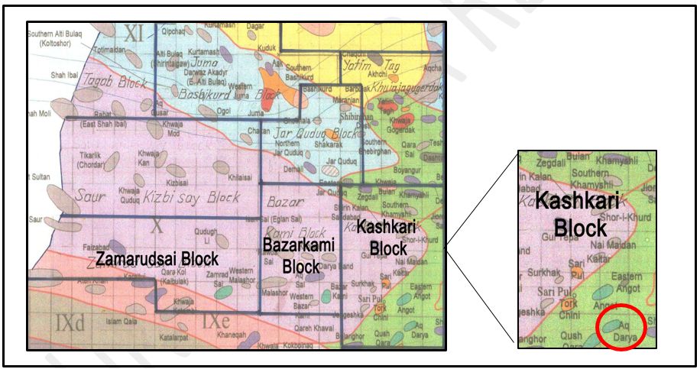

**Figure 1:** illustrates the geological map of the Amu Darya region, with the Kashkari block on the right, where the Aq Darya oil field is indicated by a red circle, in the southern section of the block.

The development of the Aq Darya oil field holds profound implications not only for Afghanistan’s energy security but also for regional economic growth, job creation and the establishment of long-term infrastructure (Majale, 2017). However, tapping into these reserves efficiently and sustainably requires the application of modern extraction technologies tailored to the field’s unique geological characteristics, including its lithology, structural configuration and hydrogeological dynamics. Unlike older oil fields where traditional methods may still be viable, emerging fields like Aq Darya demand innovative, adaptable and environmentally responsible approaches.

In this context, the global petroleum industry has made significant advancements in extraction technologies, such as mechanized pumping, enhanced oil recovery (EOR) techniques and intelligent well systems. These methods are designed not only to maximize recovery rates but also to reduce operational costs and environmental impact (Ackah, 2025). For Afghanistan where infrastructure, security and environmental constraints are persistent challenges the selection of an appropriate extraction method becomes even more critical. Therefore, understanding which technologies align best with the geological and physical-chemical properties of the Aq Darya field is essential to inform future development strategies.

The aim of this study is to conduct a comprehensive evaluation of modern oil extraction techniques suitable for the Aq Darya area by analyzing geological data, reservoir characteristics, fluid properties and expert insights. Through a combination of field surveys, laboratory analyses and professional questionnaires, the study identifies which techniques are most feasible and effective for this field. Particular attention is given to mechanical pumping methods, which are widely used in regions with similar geological features, as well as the potential applicability of water flooding, gas injection and other secondary recovery techniques.

By aligning extraction technologies with local geological realities, this research contributes to more informed and sustainable decision-making in Afghanistan’s oil sector. The findings can guide policymakers, energy investors and technical professionals in optimizing production while preserving environmental and economic sustainability. Ultimately, this study seeks not only to enhance oil recovery in Aq Darya but also to provide a model for the responsible development of Afghanistan’s broader hydrocarbon resources in pursuit of long-term energy independence.

1. **Location and Geology of the study area**

This section provides foundational insights into the Aq Darya oil field by examining the region's geological background, reservoir characteristics and environmental considerations. Understanding these components is essential for selecting and implementing the most appropriate and effective oil extraction methods (Ulmishek, n.d.). The structure was identified during geological aerial photography surveys conducted in 1958–1959 at a scale of 1:200,000 and was later studied in more detail through structural-geological photography at a scale of 1: 50,000 (Frotan et al., 2019). According to Soviet Geologist Gory (Sovit Ghori), the Aq Darya structure exhibits a broad anticlinal folding pattern with a transverse development. It measures approximately 3.5 × 1.5 kilometers with an amplitude of 150 meters (Presentation, 2012).

Table 1: Productive Horizons of the Aq Darya Oil Field (Chai et al., 2024).

|  |  |  |  |  |  |  |
| --- | --- | --- | --- | --- | --- | --- |
| **Wells** | **Inoceramus** | | **Albian** | | **Goterivian** | |
| **Depth** | **Mark** | **Depth** | **Mark** | **Depth** | **Absolute Mark** |
| 1 | 492 | 249 | 663 | 78 | 1180 | 439- |
| 2 | 529 | 208 | 686 | 51 | 1177 | 440- |
| 3 | 495 | 252 | 665 | 82 | 1176 | 429- |
| 4 | 650 | 133 | 813 | 30- | 1310 | 527- |
| 5 | 633 | 133 | 805 | 37- | 1270 | 501- |
| 6 | 667 | 85 | 824 | 72- | 1310 | 558- |
| 7 | 661 | 270 | 829 | 102- | 1374 | 443- |

**Physical and Chemical Properties of Fluids**

In the Aq Darya oil field, a total of 8 exploratory and reconnaissance wells have been drilled, of which 6 wells are productive. The total reserves of this field are estimated at approximately 22 million tons. Since its exploration and discovery, the Aq Darya structure has attracted the attention of various researchers due to its promising potential for oil and gas development and industrialization (Overview, 2015).

This area contains two oil-bearing formations, each of which is described separately below:

1. Productive Hetref Formation: In the Aq Darya area, it is primarily composed of limestone and marlstone and is stabilized by wells numbered (1), (2) and (3). The thickness of Hetref sediments in the Aq Darya area varies between 135 and 145 m (Shroder et al., 2022a). Its open porosity is 17%, the effective oil-saturated thickness is 5.6 meters and the permeability is 620 millidarcies (Mahdi et al., 2021). The protective cover of the Hetref deposit, similar to neighboring oil-bearing areas, consists of a thick layer of greenish clay, marl (marl), chert and barite anhydrite, with a thickness ranging from 60 to 70 meters (Of & Projects, 2014).
2. Alb Formation: This formation, divided into three parts: lower, middle and upper, has its lower part composed of limestone and clay layers and is considered productive in the interval (849-879) meters in the Ak Darya area (Brookfield & Hashmat, 2001) . The lower Alb layer has an overall thickness of about 200 meters, with an effective oil-saturated thickness of 5.7 meters. Its open porosity ranges from 2 to 15% and permeability from 2 to 12 millidarcies, as shown in Table (2) (Siehl, 2017). The middle and upper parts of the Alb formation, with a combined thickness of 45 to 60 meters, consist of alternating layers of chert, marl, and clay (“Mineral Resources in Afghanistan,” 2000). This area is located on the southern flank of the Angout oil zone and its industrial development has been confirmed by drilling 8 exploratory and production wells, with the Alb and Hetref formations proven to be productive. Based on regional data and laboratory analysis of sulfur, paraffin and other hydrocarbons, the oil in the Alb and Hetref formations is characterized by high paraffin content, with the following proportions: paraffin (9.5) % in Alb and (10.2) %, sulfur (0.7) % and (2.88) %, respectively (Sadiq, 2019). The light fractions of oil in the Alb and Hetref formations are 57% and 32%, respectively (Overview, 2015). The asphalt content in the oil of the Alb formation is 4.2%, while in the Hetref formation it ranges from 12.3% to 21.9%. The kinematic viscosity of the fluids in the Alb and Hetref formations vary significantly, with the first being 6.3 centistokes and the second reaching up to 11.82 centistokes (Shroder et al., 2022b).

**Table 2:** Shows the reservoir characteristics of the Aq Darya oil field, specifically the Hetref and Alb formations (Shan et al., 2022).

|  |  |  |
| --- | --- | --- |
| **Parameter** | **Hetref Formation** | **Alb Formation** |
| Location in Field | Aq Darya (Wells 1, 2, 3) | Aq Darya – Lower Interval (849–879 m) |
| Lithology | Limestone, marlstone | limestone, clay, Middle and Upper: chert, marl, clay |
| Formation Thickness | 135–145 | 200 (Lower) 45–60 (Middle and Upper) |
| Effective Oil-Saturated Thickness | 5.6 | 5.7 |
| Open Porosity (%) | 17 | 2–15 |
| Permeability | 620 | 2–12 |
| Seal Rock Thickness | 60–70 m; greenish clay, marl, chert, barite anhydrite | Covered by middle and upper layers (non-productive) |
| Paraffin Content (%) | 10.2 | 9.5 |
| Sulfur Content (%) | 2.88 | 0.7 |
| Light Oil Fraction (%) | 32 | 57 |
| Asphalt Content (%) | 12.3–21.9 | 4.2 |
| Kinematic Viscosity | 11.82 | 6.3 |
| Number of Productive Wells | 6 (out of 8 total drilled) | Same as Hetref (shared wells) |
| Estimated Total Reserves | 22 million tons (total for Aq Darya) | Shared in field estimate |

1. **Materials and Methods**

This study employs a comprehensive approach to examine modern oil extraction techniques in the Aq Darya area, utilizing a combination of data collection and analysis methods outlined as follows:

Data Collection Methods

* 1. **Library Research**

In this method, credible printed sources such as books, scientific articles, encyclopedias and specialized journals related to modern oil extraction techniques in the Aq Darya region were reviewed. The researcher visited these sources to identify relevant information, recording key data in note cards (fiches). Each fiche included source details such as title, author, publisher, publication date and the extracted information. The collected data were systematically organized and categorized to facilitate analysis.

* 1. **Field Survey**

To gather empirical data, a structured questionnaire was developed comprising 12 closed questions with four multiple-choice options (mechanized pumping, water injection, gas injection and (I don't know) and 2 open-ended questions allowing respondents to express their opinions freely. The questionnaires were distributed among oil and gas engineers, field engineers in the Aq Darya oil zone, officials from the Northern Oil and Gas Exploration Departments, members of the Afghan Gas Company in Jowzjan Province, and academic staff from relevant institutions. This facilitated the collection of expert insights and operational experiences regarding the application of modern extraction techniques in the area.

**3.3 Population and Sampling**

The statistical population consisted of all individuals and units involved in the oil industry within the Aq Darya region, totaling 115 participants. These included oil and gas engineers, regional engineers, officials from exploration departments and academic staff all sharing common professional attributes pertinent to the study's focus.

**3.4 Data Analysis Procedures**

Following data collection, initial data screening and cleaning were performed. The responses from questionnaires were coded systematically and the data were entered into the SPSS statistical software package. Both quantitative (numerical) and qualitative (descriptive) analyses were conducted, including descriptive statistics, frequency distributions and inferential tests as appropriate. The results were thoroughly analyzed and interpreted.

* 1. **Validity and Reliability of Data Collection Tools**

The questionnaires and data collection instruments were validated through expert review to ensure content validity. Reliability was assessed using appropriate statistical measures (such as Cronbach's alpha) to confirm the consistency and dependability of the instruments, ensuring that the data collected would produce accurate and trustworthy results.

Overall, this mixed-method approach combining library research and field surveys provides a comprehensive understanding of modern oil extraction techniques in the Aq Darya area, establishing a solid foundation for subsequent analysis and conclusions.

**4. Results and Discussion**

The responses and data obtained through questionnaires are analyzed in both quantitative and qualitative formats. The first part involves analyzing numerical data related to closed questions, while the second part focuses on qualitative analysis of open-ended responses. Figure 2 shows the types of information analysis.

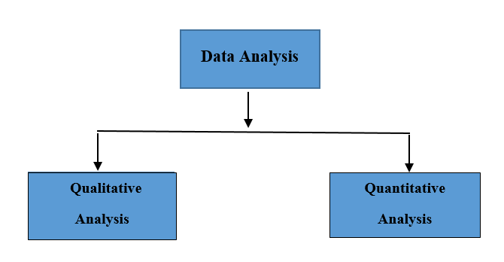

**Figure 2**: Types of information analysis

**4.1 Quantitative Data Analysis**

In this section, the information and data from the first and second parts of the questionnaires, which include respondent characteristics and closed-ended questions, are analyzed. The third part, consisting of open-ended questions, will be analyzed qualitatively.

* + 1. **Survey based on respondents' education level**

Surveys done with geoscientists and engineers who have advanced degrees usually show that they are more aware and have a better understanding of technical topics, especially in energy development, resource management, and modern oil extraction methods, as shown in figure 3. This conclusion is contingent upon the broader focus of the research.

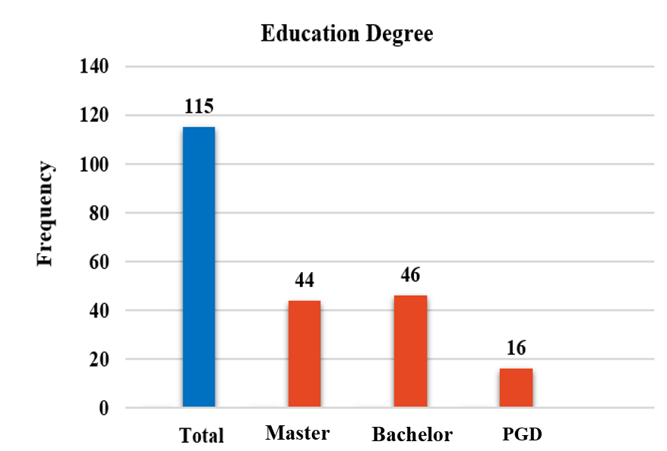

**Figure 3:** Respondents' education level

Another topic included in the first section of the questionnaire was the respondents' educational level. Among the 115 respondents, 44 individuals hold a master's degree. Additionally, 46 respondents, who constitute the majority, have a bachelor's degree. Furthermore, 16 respondents possess a postgraduate diploma.

Therefore, it can be concluded that the majority of respondents who provided answers to the questionnaires have a bachelor's or master's degree, while the remaining respondents have various educational levels, including postgraduate diplomas and higher education qualifications.

* + 1. **Survey on the choice of oil extraction method in the Aq Darya oil field**

The review of modern methods of oil extraction and the selection of the most appropriate method for the Aq Darya oil field, as mentioned above, has transformed the extraction of oil from the Amu Darya basin in northern Afghanistan into a comprehensive and debatable strategy by the Ministry of Mines and Petroleum for economic growth.

Over the past 20 years, oil extraction from mineral-rich areas in the country has involved contracts with several foreign companies. However, due to various factors, particularly the lack of knowledge about extraction methods from these areas, implementation has been slow and some contracts have even been canceled.

In oil extraction, knowing the suitable method for each oil field is a fundamental condition, and the absence of an appropriate extraction technique represents a significant challenge to the operation of oil wells. In figure 4 show the opinion distribution on the choice of oil extraction technique in the Aq Darya oil field.

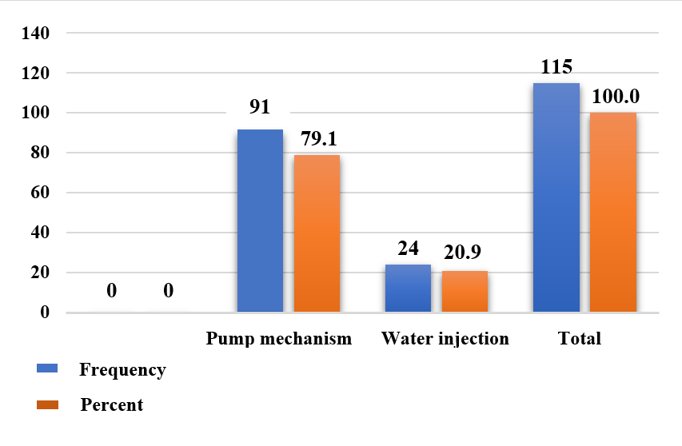

**Figure 4:** The distribution of opinions regarding the selection of the method for oil extraction in the Aq Darya oil field.

Therefore, the first question included in this research questionnaire was to gather professional engineers' opinions regarding the selection of the most appropriate method for the Aq Darya oil field. Participants in this study responded to this question and the following results were obtained: out of 115 individuals, 91 (which is 79.1%) favored the mechanical pumping method and 24 individuals (20.1%) preferred the water injection option as the suitable extraction method for the Aq Darya oil field. As a result, considering the data collected, the majority of oil and gas engineers recommended the mechanical pumping method for the Aq Darya oil field.

* + 1. **Survey according to geological structure**

Regarding the geological structure of the Aq Darya oil-bearing area, layers of different ages, from the Paleozoic to the Cenozoic, are present. The Sweit Guri stone in the dome-shaped part of Aq Darya and the Sweit Shafa and Qashtegin sediments emerge at the surface. The dome-shaped part of Aq Darya has a gentle dip, with the bedding planes inclined at angles ranging from 12 to 18 degrees. The industrial oil potential of this area was confirmed through exploratory borehole No. 1, where the production capacity was measured at 17.1 tons per day in the Heitref, Opt and Alb formations. In total, eight exploratory and prospecting boreholes, with a combined depth of 1,153 meters, have been drilled to determine the extent of the Heitref, Opt and Alb reservoirs and to obtain reservoir parameters. The presence of oil and gas has been confirmed with positive results, especially in the hydrocarbon industrial reservoirs.

For this reason, the geological structure of the Aq Darya oil field, which includes anticline folds, is one of the topics raised in the questionnaire. Which approach do you suggest for this task? Figure 5 shows the answers provided based on the geological structure. The choice of oil extraction method from the Aq Darya area is shown in Figure 5.

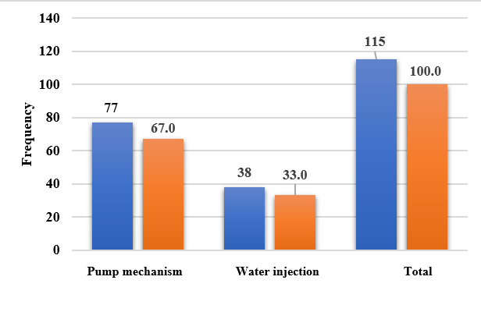

**Figure 5:** Illustrates the Selection of the method for extracting Aq Darya oil based on the geological structure.

Among the respondents to this question, 77 individuals (which is 67%) preferred the mechanical pumping method, while 38 individuals (33%) chose water injection as the suitable approach. As a result, considering the above information, the suitable extraction method for the Aq Darya area, which has an anticline folding geological structure, has been selected as the mechanical pumping method.

* + 1. **Analysis in terms of porosity and permeability**

Based on the results of laboratory (Core) investigations, the productive section or cross-section indicates that the porous rocks with permeability less than one Darcy retain up to 80% or more of the remaining water. As a result, effective permeability in these rocks is practically not observed and consequently, the lower permeability limit is considered to be one Darcy. Based on the collected information and conducted research, the porosity of the rocks forming the productive layers is one of the fundamental parameters in oil extraction, significantly impacting the oil recovery process. The respondents' opinions regarding this matter, as depicted in Figure 6, are summarized in the following result.

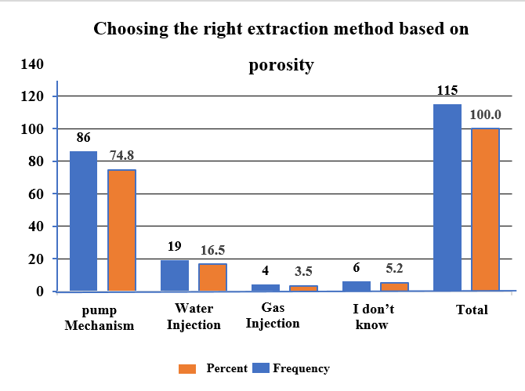

**Figure 6:** Displays the selection of the suitable extraction method based on rock porosity.

Out of 115 respondents, 86 individuals (which accounts for 74.8) % favor the mechanized pumping method, while 19 respondents (16.5) % support water injection and 4 respondents (3.5) % believe that gas injection is effective. Additionally, 6 respondents (5.2) % chose "I don’t know," citing the lack of porosity data for the rocks constituting the productive layers and therefore refrained from expressing an opinion on the effectiveness of porosity in oil extraction in Aq Darya.

* + 1. **Appropriate method according to the depth of the mine**

The fourth question of the questionnaire pertains to the choice of extraction method based on reservoir depth, which reflects the impact of reservoir depth and the thickness of oil-bearing layers.

The layers of the Aq Darya field are primarily composed of gravel and olivine rocks, stabilized by wells numbered (1), (2) and (3). The thickness of the Hetref sediments in the Aq Darya field varies from 135 to 145 meters. Its open porosity is 17%, the effective oil-saturated thickness is 5.6 meters and the permeability is 620 millidarcies. The protective cover of the Hetref deposit, similar to adjacent oil-bearing areas, consists of thick greenish clay layers, marl, chert and barite anhydrite, with a thickness ranging from 60 to 70 meters.

The lower Alb layer has an overall thickness of about 200 meters, with an effective oil-saturated thickness of 5.7 meters. Its open porosity ranges from 2% to 15% and its permeability varies from 2 to 12 millidarcies.

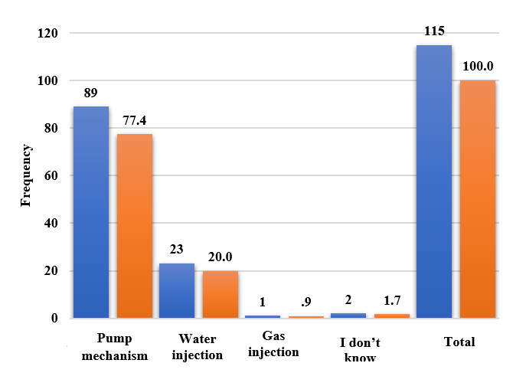

**Figure 7:** Diagram Showing the effectiveness of mine depth on oil extraction methods.

As shown in the figure above, out of 115 respondents, 89 individuals selected the first option mechanized pumping. This indicates that the majority of respondents believe that oil extraction using the mechanized pumping method is effective in the shallow Aq Darya oil field.

Meanwhile, 23 respondents (20) %considered water injection a suitable method for oil extraction in Aq Darya. Only 1 respondent (0.9) % recommended gas injection for the oil-bearing area of Aq Darya. In addition, 2 respondents (1.7) % refrained from expressing any opinion on this matter.

* + 1. **The appropriate method of oil extraction considering the physical-chemical properties of fluid**

In the Ak Darya region, the physical and chemical properties of fluid hydrocarbons indicate that the oil contains high paraffin content (9.5-10.2) %, asphalt (4.2-21.9) % and sulfur (0.7-2.88%)%. The dynamic viscosity in the Hethrif and Albeh formations is 11.82 and 6.3 centistokes, respectively. These characteristics necessitate the use of specialized methods such as vertical and horizontal drilling, along with thermal and chemical techniques, to achieve efficient and economical oil extraction in this area. In figure 8, demonstrate the appropriate method of oil extraction for the Aq Darya field in light of the physical-chemical properties.

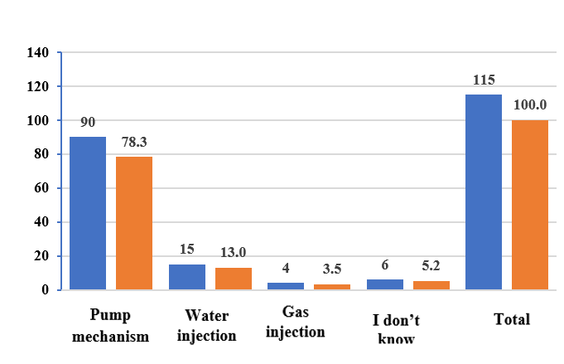

**Figure 8:** Diagram Showing the Suitable Method of Oil Extraction for the Aq Darya Field Considering the Physical-Chemical Properties.

Regarding this, the respondents’ opinions were expressed as follows in the questionnaire: Out of 115 respondents, 90 individuals (which accounts for 78.3) % favor the mechanized pumping method for oil extraction in the Aq Darya field, while 15 respondents (13) % support water injection. Meanwhile, 4 respondents (3.5) % believe that gas injection is ineffective for oil extraction in this area. Additionally, 6 respondents (5.2) % chose I don’t know and refrained from giving an opinion.

**4.2 Qualitative Data Analysis**

In this section, the data derived from open-ended questions are analyzed qualitatively to gain a deeper understanding of experts' perspectives and opinions regarding extraction methods and the hydrogeological features of the Aq Darya field.

* + 1. **Open-ended Question 1: Proposed Extraction Methods Based on Hydrogeological Characteristics**

In the questionnaire, respondents were asked to suggest suitable recovery methods for the Aq Darya field considering the effective reservoir thickness. A variety of responses were received, many of which shared similarities. The most important responses can be summarized as follows:

Based on the results of drilled wells, the productive reservoirs in Cretaceous sediments consist of sandstone, claystone and dense limestone layers, located at depths between 60 and 145 meters. These reservoirs have permeability around 1 to 4 millidarcies. Most respondents believed that, given these reservoirs are situated above the anticline fold structure, extracting oil via mechanical pumping is technically efficient.

Additionally, many noted that the thickness of the productive layers in the Aq Darya field ranges between 60 and 145 meters and considering the relatively limited volume of oil reserves, pumping methods are more economical and practical compared to other extraction techniques.

* + 1. **Open-ended Question 2: Extraction Methods Based on Hydrogeological Features**

Respondents were asked to propose the most suitable extraction method based on the hydrogeological characteristics of the Aq Darya field. Their opinions highlighted the following points:

**1. Geological Location**

The Aq Darya oil field is located in the southeast part of the Karakum region and is fed by the Neogene recharge system. It lies within a large tectonic structure known as the Toran Plate and is situated in an orogenic platform area, with stratigraphic sequences ranging from the Permian and Triassic periods to recent sediments.

**2. Neotectonic Activity and Pressure Anomalies**

Active neotectonic processes have complicated groundwater recharge and discharge relationships, causing abnormal high and low pressures within the reservoir. Additionally, infiltrated waters from the Neogene and anthropogenic periods have temporarily affected the Middle Mesozoic sediments.

**3. Basin and Watershed Characteristics**

The field lies in the southeastern development zone of the Dowlat Abad geological basin. The semi-mountainous watershed system in its foothill areas is well-developed, and hydrochemical profiles reveal distinct hydrogeological features.

**4. Exploratory Drilling Observations**

During exploratory drilling, hydrogeological properties of the Graft, Aptian, and Lower Albian units were studied. In tests related to the Aptian unit, static groundwater levels and pressures were measured at the wellhead, and water samples were collected for chemical analysis.

**5. Well Penetration and Reservoir Characteristics**

In wells No. 2, 3, and 4, the full thickness of the Graft sediments consisting of sandstone and claystone was penetrated. Geophysical assessments and core samples show that this unit ranges from 150 to 170 meters in thickness, with permeable layers of 4 to 6 meters, making them effective reservoirs with high filtration capacity. Well No. 5 recorded a production rate of 197 cubic meters per second.

**6. Fluid Flow and Oil-Water Contact**

The permeability characteristics of the productive layers vary with fluid flow. Uniform pressure observed in the oil-water contact within the Graft unit indicates that the contact is nearly horizontal.

**7. Groundwater Chemistry**

The groundwater in the lower part of the Graft unit is predominantly sodium-bicarbonate with sulfate groups, exhibiting a slightly alkaline to neutral pH. This supports the presence of infiltrated waters from recharge areas.

**8. Comparative Salinity Analysis**

Compared to neighboring oil fields such as Angut and Kashqari, the Graft unit in Aq Darya exhibits higher salinity levels. The reservoir is enclosed by sandstone with favorable hydrochemical conditions, including the presence of hydrogen sulfide gas.

**9. Conclusion Based on Field and Lab Analysis**

These qualitative findings, supported by fieldwork and laboratory testing, enhance the understanding of the Aq Darya field’s hydrogeological characteristics. They help identify the most suitable extraction techniques, in line with the study's objectives.

**5. Conclusion**

The comprehensive analysis of both quantitative and qualitative data reveals a strong consensus among oil and gas professionals regarding the most appropriate extraction method for the Aq Darya oil field. A significant majority of respondents over 70% favored mechanical pumping as the primary extraction technique. This preference is supported by geological, hydrogeological and physical-chemical parameters specific to the Aq Darya reservoir.

The educational background of the respondents comprising primarily Bachelor's and Master's degree holders in petroleum engineering and geosciences provides credibility to their insights. Their academic qualifications and technical expertise are evident in their ability to assess the geological structure, fluid behavior and practical constraints of the field with a high degree of accuracy.

From a geological and reservoir engineering standpoint, the Aq Darya field is characterized by anticline folding, moderate permeability and relatively shallow reservoir depths, all of which align well with the application of mechanical pumping methods. Porosity and permeability analyses confirm that key productive units, such as the Graft formation, possess permeable layers between 4 and 6 meters thick sufficient to support consistent fluid flow and reservoir productivity. The presence of a nearly horizontal oil-water contact and stable pressure distribution further affirm the suitability of this approach.

The physical-chemical properties of the formation fluids also support this extraction strategy. The reservoir contains sodium bicarbonate type groundwater, with neutral to slightly alkaline pH and traces of hydrogen sulfide gas, which require the use of corrosion-resistant materials but remain within operational norms for mechanical systems. The moderate salinity and viscosity of the fluids further diminish the necessity for enhanced recovery techniques, such as water or gas injection.

Qualitative responses reinforce these conclusions by emphasizing the importance of lithological composition, reservoir thickness and hydrogeological conditions. Respondents noted the role of gravelly, interbedded clay and carbonate layers as productive collectors, demonstrating a strong understanding of the field’s complex depositional environment. Additionally, acknowledgment of neotectonic activity and groundwater recharge dynamics reflects an awareness of the broader hydrogeological context that may influence extraction efficiency.

Although some respondents mentioned alternative methods like water and gas injection, the divergence of opinion was minimal. The overwhelming preference for mechanical pumping likely stems from its efficiency, technical simplicity and cost effectiveness under the specific conditions of the Aq Darya reservoir. In summary, the integration of geological structure, porosity and permeability data, fluid chemistry and expert opinion points decisively toward mechanized pumping as the most effective and sustainable extraction method for the Aq Darya oil field. These conclusions provide a solid foundation for strategic planning, operational implementation and further research in similarly structured petroleum reservoirs.

Disclaimer (Artificial intelligence)

Author(s) hereby declare that NO generative AI technologies such as Large Language Models (ChatGPT, COPILOT, etc.) and text-to-image generators have been used during the writing or editing of this manuscript.

**Reference**

1. Ackah, D. (2025). Enhanced Oil Recovery ( EOR ) Techniques in Mature Reservoirs Enhanced Oil Recovery ( EOR ) Techniques in Mature Reservoirs. March. https://doi.org/10.4314/dasjr.v10i2.4
2. Brookfield, M. E. & Hashmat, A. (2001). The geology and petroleum potential of the North Afghan platform and adjacent areas (northern Afghanistan, with parts of southern Turkmenistan, Uzbekistan and Tajikistan). Earth-Science Reviews, 55(1–2), 41–71. https://doi.org/10.1016/S0012-8252(01)00036-8
3. Chai, H., Wang, H., Guo, C., Zhang, L., Chen, P., Xing, Y., Cheng, M. & Zhang, T. (2024). Geological characteristics and developmental achievements of the large presalt carbonate gas fields in the Amu Darya Basin. Unconventional Resources, 4(November 2023), 100089. https://doi.org/10.1016/j.uncres.2024.100089
4. Faryad, S. W., Collett, S., Finger, F., Sergeev, S. A., Čopjaková, R. & Siman, P. (2016). The Kabul Block (Afghanistan), a segment of the Columbia Supercontinent, with a Neoproterozoic metamorphic overprint. Gondwana Research, 34, 221–240. https://doi.org/10.1016/j.gr.2015.02.019
5. Frotan, M. S., Nakaza, E. & Schaab, C. (2019). Afghanistan ’ S Natural Resources Afghanistan ’ S Natural Resources. June 2020.
6. Mahdi, Z., Abe, K., Seddiqi, K. N., Chiyonobu, S. & Fujii, H. (2023). Increasing Recoverable Oil in Northern Afghanistan Kashkari Oil Field by Low-Salinity Water Flooding. Energies, 16(1). https://doi.org/10.3390/en16010534
7. Mahdi, Z., Abe, K., Seddiqi, K. N. & Fujii, H. (2021). Corrigendum to “Waterflooding Technique to the Kashkari Oilfield in the North Part of Afghanistan.” Proceedings of the 5th International Conference on Chemical Investigation and Utilization of Natural Resource (ICCIUNR-2021), 2, 3979. https://doi.org/10.2991/ahcps.k.211004.025
8. Majale, M. (2017). Afghanistan: Housing Profile.
9. Mineral Resources in Afghanistan. (2000). Mineral Resources in Afghanistan. https://doi.org/10.2458/azu_acku_pamphlet_qe290_m56_1992
10. Of, O. & Projects, S. (2014). Special Inspector General for. 2008(July).
11. Overview, S. (2015). Afghanistan : Oil & Gas Industry. July.
12. Presentation, I. B. (2012). Oil & Gas Development in Afghanistan Afghanistan ’ s hydrocarbon resources are significant. February.
13. Sadiq, M. E. (2019). Opportunies and Challenges of Investing in Oil and Gas Industry of Mohammad Ehsan Sadiq Opportunities and Challenges of Investing in the Oil and Gas Industry of Afghanistan – Case Study of Sheberghan Volume | 041 Bochum / Kabul | 2017. February 2017.
14. Shan, Y., Chai, H., Wang, H., Zhang, L., Su, P., Kong, X., Bai, Z., Cheng, M. & Zhang, H. (2022). Origin and Characteristics of the Crude Oils and Condensates in the Callovian-Oxfordian Carbonate Reservoirs of the Amu Darya Right Bank Block, Turkmenistan. Lithosphere, 2022(1). https://doi.org/10.2113/2022/5446117
15. Shroder, J. F., Eqrar, N., Waizy, H., Ahmadi, H. & Weihs, B. J. (2022a). Review of the Geology of Afghanistan and its water resources. International Geology Review, 64(7), 1009–1031. https://doi.org/10.1080/00206814.2021.1904297
16. Shroder, J. F., Eqrar, N., Waizy, H., Ahmadi, H. & Weihs, B. J. (2022b). Review of the Geology of Afghanistan and its water resources. International Geology Review, 64(7), 1009–1031. https://doi.org/10.1080/00206814.2021.1904297
17. Siehl, A. (2017). Structural setting and evolution of the Afghan orogenic segment - A review. Geological Society Special Publication, 427(1), 57–88. https://doi.org/10.1144/SP427.8
18. Ulmishek, G. F. (n.d.). Petroleum Geology and Resources of the Amu-Darya Basin , Turkmenistan. U.S. Geological Survey Bulletin 2201-H.