***This work is an Original Research Article***

**GEOCHEMICAL CONTRIBUTION TO THE UNDERSTANDING OF GROUNDWATER MINERALIZATION IN SOUTHEASTERN COASTAL CÔTE D'IVOIRE**

**Abstract**

The main objective of the study carried out in the south-eastern coastal region of Côte d'Ivoire was to determine the hydrogeochemical origin of groundwater mineralization. Understanding the interactions between water and the surrounding rocks is essential for identifying the root causes of mineralization, anticipating changes in water quality, and proposing strategies for sustainable management of aquifer resources The methodology adopted was based on a hydrochemical study, a projection of chemical concentrations in the Korjinski diagram and a geochemical analysis on total rock.

The results of the hydrochemical study showed that the groundwater is acidic, with pH ranging from 1.57 to 6.77. The groundwater is well oxygenated and exhibits low mineralization, consistent with regional hydrochemical characteristics. In these waters, the order of ion abundance is as follows: NO3- > Cl- > HCO3- > SO42- for anions and Ca2+ > Na+ > Mg2+ > K+ for cations, giving groundwater (wells and boreholes) a calcic hydrogen carbonate, calcic chloride and sodi-potassium chloride facies. In the Korjinski diagram, groundwater belongs to the kaolinite stability domain, which is formed by the alteration of anorthite and muscovite. From a geochemical point of view, the study reveals that the enrichment of groundwater in Na+ and Ca2+ compared to K+ and Mg2+ is mainly linked to the hydrolysis of reservoir rock minerals. Moreover, the chemical composition of the water in these elements evolves identically to that of the aquifer rocks.

**Key words:** Geochemistry, water mineralization, Korjinski diagram, mineral hydrolysis, southeastern coastal of Côte d'Ivoire.

**INTRODUCTION**

Water, a vital and cross-cutting resource, is essential for human survival, economic development, and ecosystem stability (Gleick, 1993; UN-Water, 2021). Historically, water availability has guided the establishment of human societies, and in the contemporary era, it continues to determine the success of development projects (FAO, 2017). However, freshwater resources are increasingly threatened by rising demand, widespread pollution, and the effects of climate change (WWAP, 2018; UNESCO, 2015; IPCC, 2022). The 4th World Water Forum (2006) warned of this growing global crisis, calling for sustainable, integrated, and equitable water management to meet global challenges. Systemic reforms are therefore necessary to secure access to water, ensure resilience, and achieve sustainable development goals (UN-Water, 2023). In Côte d'Ivoire, the problem of regular drinking water supply is perceived in both rural and urban areas. Despite a dense hydrographic network in the south of the country, drinking water for human consumption in the region is mainly supplied by the Continental Terminal (CT) aquifer reservoir, the largest sedimentary aquifer in the region, and by the Quaternary (Q) sandy aquifer along the coast (Oga, 1998). Groundwater is the main source of drinking water, which is obtained from boreholes and traditional wells. Previous studies have increased knowledge of the bedrock, CT, and Quaternary aquifers (Jourda (1987), Soro (1987)), Oga (1998), Soro (2002) and Adiaffi (2008), Oga et al (2015)). These authors have shown that silicate hydrolysis is the main phenomenon of groundwater mineralization.

Apart from the work of Oga (1998), Adiaffi (2008) and Oga et al. (2015), which explore water-rock interactions, most existing research has been limited to conventional hydrochemical approaches, without in-depth analysis of the geochemical processes at the scale of the solid medium through which the water flows. However, the chemical composition of groundwater does not depend solely on atmospheric or anthropogenic inputs, but also results from a series of complex reactions between water and the surrounding rocks: dissolution, ion exchange, precipitation, and mineral alteration (Manu, et al., 2023; Olea-Olea et al., 2014). Understanding these interactions is essential for identifying the root causes of mineralization, anticipating changes in water quality, and proposing strategies for sustainable management of aquifer resources (Manu et al., 2023). In order to better understand these interactions, this study aims to establish an explicit link between the chemistry of the water and that of the geological formations it passes through, using an integrated approach combining mineralogical, geochemical, and hydrochemical analyses. It is part of an effort to strengthen knowledge about the processes involved in the formation of dissolved element concentrations in the aquifers of southern Côte d'Ivoire.

**1. GENERAL INFORMATIONS**

**1.1 General informations on the study area**

The study area is located in southeastern Côte d'Ivoire between longitudes 3°00 and 4°00 West and latitudes 5°00 and 5°45 North. Covering an area of 5,056 km2, it stretches from Gonzagueville (Port-Bouet municipality) to Aboisso. The area includes the department of Alépé in the north, the region of Aboisso in the east, the Atlantic Ocean in the south, and the sub-prefecture of Bingerville in the west. The hydrographic network of the study area (**Figure 1**) is very dense. The main rivers are the Comoé, the Mé, and the Bia. In addition to these are secondary watercourses: the Djibi, Bganbgo, Bété, Toumanguié, Soumié, and Eholié, which are heavily used by local populations for their daily activities such as fishing, livestock farming, agriculture, and other domestic activities. The region is crossed by the Ebrié, Adjin, Ono, and Potou lagoons.

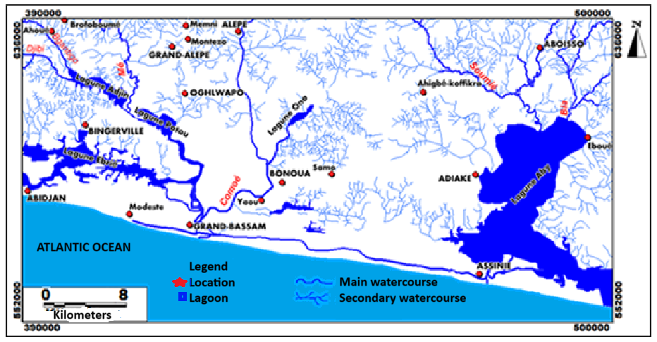

**Figure 1:** Hydrographic network of the study area

**1.2 Geology**

**1.2.1. Geological overview of the study area**

Côte d'Ivoire is located on the Man Ridge and belongs to the West African craton (Bessoles, 1977). Two Precambrian geological domains separated by a third domain (transition domain) meet in Côte d'Ivoire and cover approximately 97% of its surface area.

The study area straddles the sedimentary basin to the south and the crystalline basement to the north and northeast (Figure 2). The sedimentary basin, which is larger in area, has a geology dominated by a Mesozoic-Cenozoic formation of Miocene-Pliocene age or Continental Terminal (CT). This formation is characterized by the presence of sand, clay, and ferruginous sandstone from the high plateaus and dominates the central part of the area with a layer of Pleistocene fluvial sand and clay. The formations found south of the lagoon fault are Quaternary, more specifically Holocene, and consist of marine sandbars, mud, and leached sand from fluvial-lagoon depressions. The northwestern end is dominated by ferruginous sands, clays, and sandstones from the high plateaus and a small amount of fine gneiss with biotite and amphibole. In the Alépé sector to the north, fine gneiss with biotite and amphibole can be observed (Soro, 1987). In the Aboisso area, biotite and/or hornblende metagranodiorites, biotite metamonzogranites and metamonzonites are found in places (Dibi et al., 2004). It should also be noted that chlorite and amphibole schists and metadiorites and metatonalites are present in this area.

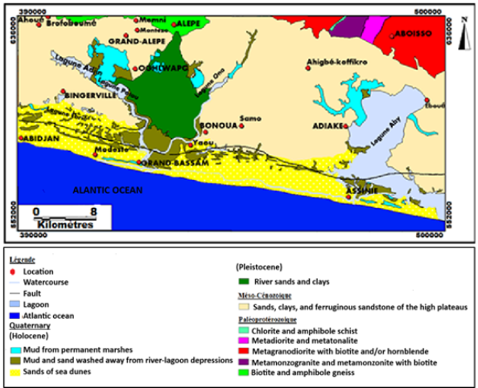

**Figure 2:** Geological map of the study area

**1.2.2 Alteration of silicate rocks**

The alteration of silicates is thought to be the most important source of dissolved elements in water due to their abundance. They are the most widespread mineral elements in the Earth's crust (Maman, 2012).

The hydrolysis of silicates is facilitated by infiltration water rich in dissolved CO2. Contact between this water and silicate minerals leads to the release of the most mobile cations (Na+, K+, Mg2+, Ca2+), silica, and aluminum as a result of the hydrolysis process. The destruction of primary minerals by incongruent dissolution (plagioclases, ferromagnesian minerals, etc.) generally leads to the appearance of a sequence of newly formed clays such as montmorillonite, kaolinite, illite, or gibbsite, depending on their base content or the degree of pluvial leaching (Hamdi et al., 1997; Dekayir and El-Maataoui 2001; Nguetnkam et al., 2008).

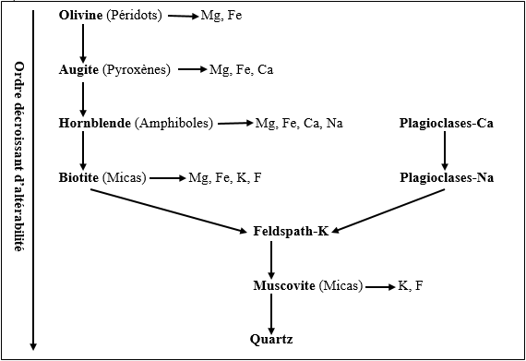The rate of rock weathering varies depending on its constituent minerals. Goldich (1938) established an order of alterability for primary minerals (Figure 3). This figure shows that ferromagnesian minerals, the major constituents of basic rocks, are more alterable than those constituting acidic rocks.

**Figure 3:** Goldich's mineral alteration sequence (1938).

**2. MATERIALS AND METHODS**

**2.1. Materials**

**2.1.1. Hydrochemical data**

The hydrochemical data obtained for each water sample are the physical and chemical parameters measured in situ and the chemical parameters measured in the laboratory. The former include temperature (T), hydrogen potential (pH), electrical conductivity (EC), oxidation-reduction potential (Eh), dissolved oxygen (DO), and salinity (NaCl). The latter are calcium (Ca2+), magnesium (Mg2+), sodium (Na+), and potassium (K+), which represent the major cations, and sulfates (SO42-), chlorides (Cl-), hydrogen carbonate (HCO3-), and nitrates (NO3-), which are the major anions, and the total hydrotimetric titre (THT). The silica (SiO2) content of the water was also measured. These data were obtained from 41 groundwater samples taken from 21 boreholes and 20 wells.

**2.1.2. Rock sampling equipment**

The various items mentioned in this section are shown in Plate 1.

• A sledgehammer and hammer to break up blocks of bedrock (in Aboisso and Alépé) in order to take a sample;

• A machete was used to clear a path and also to remove vegetation cover before digging soil pits;

• A shovel, a pickaxe, and a pair of gloves were used to open the soil pits;

• A clean knife for collecting sedimentary rocks;

• A tape measure to measure the depth of the pits and the different soil horizons;

• A notebook to record information such as GPS coordinates (latitude, longitude, and altitude, etc.), the name of the location, and the type of geological formation. It was also used to record descriptions of soil horizons in sedimentary areas and in the case of bedrock rock samples.

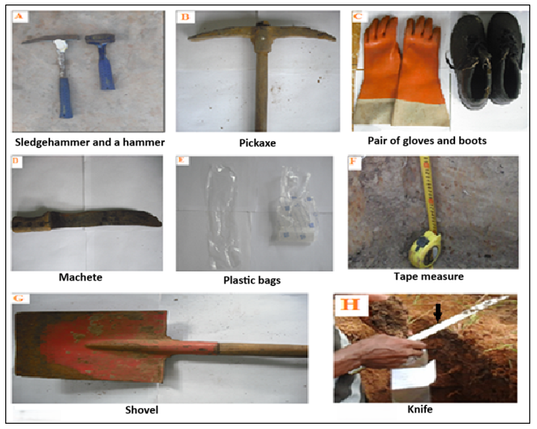• Plastic bags for collecting and storing samples.

**Plate 1:** Rock sampling equipment

**2.1.2. Data processing equipment**

Data collected directly in the field, as well as the results of chemical analyses in the laboratory, were processed by computer. The specific processing of certain data required other software such as:

- Paint for improving the presentation of photos and creating map legends;

- DIAGRAMMES version 5.1 for determining Korjinski diagrams (water stability range). It is also used to calculate certain parameters such as ion balance, hardness, saturation index (calcite, dolomite, aragonite, gypsum), etc.

**2.2. Methods**

**2.2.1. Statistical analysis of physico-chemical parameters**

In order to easily use hydrochemical data, it is important to produce statistics showing the minimum, maximum, average, and standard deviation values. This makes it possible to determine whether or not there is significant variation in the data.

**2.2.2. Rock sampling methods**

Rocks constitute a reservoir of mineralization for the groundwater that flows through them. These rocks can provide us with information on water mineralization and the relationships between them. In this study, rock samples were collected as follows:

- Sedimentary rock sampling sites were chosen in the bush, far from areas of significant anthropogenic influence. At these locations, soil pits 1.20 m deep, 1 m long, and 0.8 m wide were dug on the upper surface in an east-west position (Plate 2). These precautions were taken to ensure comprehensive sampling across all soil horizons, to guarantee sample quality while avoiding anthropized soils, and to maximize light exposure in the pit regardless of the sun's position. However, the depth of the pit sometimes does not reach 1.20 m due to the phenomenon of induration (soil rejuvenation), which makes the soil hard and difficult to dig, as was the case at Andou M'batto; in this case, orange-ochre spots can be observed in the lower horizon of the soil (Plate 4).

- Samples were taken from the bottom to the top of the pit to avoid contaminating one horizon with sediments from another. Then, an identical quantity of the different horizons for each soil sample was thoroughly mixed to obtain a single sample for each locality; these different mixtures were then placed in plastic bags for storage.

- As the samples were moist, they were dried in the open air, protected from any solid contamination, before being ground and analyzed in the laboratory (Photo 4). After sampling, all the pits were closed again to restore the original natural conditions.

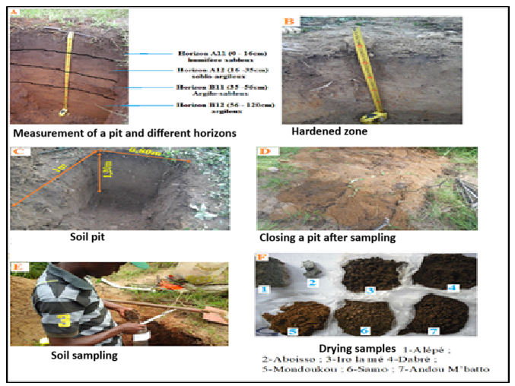

**Plate 2:** Opening of pits and collection of rock samples

**2.2.2. Geochemical methods**

**2.2.2.1. Whole rock analysis**

Whole rock analysis is essential for correlating the chemistry of the water with that of the host rock. Each lithological formation sampled in the study area containing the water tables under investigation underwent whole rock analysis. Bedrock sampling was carried out on rock outcrops in the localities of Aboisso and Alépé, while sedimentary rock sampling was carried out in Mondoukou, Samo, Andou M'batto, and Dadré (Oghlwapo) (Figure 4). After drying for three days, the rock samples were sent to the PETROCI Research and Analysis Center (CAR) laboratory in the Yopougon industrial zone. The study method used was point microanalysis by energy dispersive spectrometry coupled with (SEM/EDS). The tool shown in Plate 3 is the one we used for this work. It is the D.C.AR. Variable Pressure SEM-EDS (MEB FEG Supra 40 VP Zeiss).

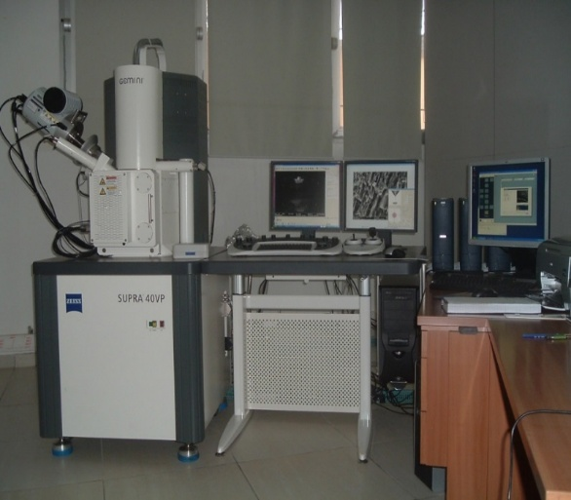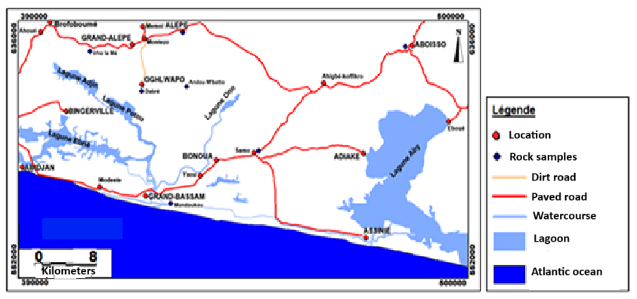

**Plate 3:** Variable Pressure SEM-EDS from D.C.AR, characteristics: Magnification: 12X to 1,000,000X, Resolution: 2 nm, Variable voltage: 0.1 kV to 30 KeV

**Figure 4:** Site where rock samples were collected

**2.2.2.2. Silicate and aluminosilicate stability diagrams**

The classification of waters in relation to silicate and aluminosilicate stability diagrams can provide information on the local or regional predominance of the type of clay that may be present. In such a study, it is important to know the thermodynamic data calculated at 25°C (a temperature close to the average temperature of the waters studied, which is 27.68°C) and at atmospheric pressure, as well as the main groups of minerals found in the study area. The abundance of minerals identified in aquifers makes it possible to study the equilibria between the aqueous phase and rock alteration minerals (Soro et al., 1995). This is done using Korjinski activity diagrams, which provide a graphical representation of the stability domains of silicates and aluminosilicates. This study must take into account the following systems: Na₂O-Al₂O₃-SiO₂-H₂O, K₂O-Al₂O₃-SiO₂-H₂O, and CaOAl₂O₃-SiO₂-H₂O, primary minerals, albite (NaAlSi3O8), anorthite (CaAl2Si2O8), microcline (KAlSi3O8), alteration minerals, montmorillonite, kaolinite, and gibbsite (Gallo, 1978). Korjinski diagrams are used in geochemistry, specifically in hydrogeology, to understand the chemical interactions between water and minerals. They help visualize and analyze which minerals are stable under specific water compositions and how water chemistry changes as it interacts with different rock types. These diagrams are constructed by plotting the activities (concentrations) of key chemical species in water, such as dissolved ions, against each other, with lines representing the equilibrium conditions for mineral reactions

* **Imbalance indices**

The calculation of the imbalance index (equation 2) is based on the activities of ions in the solution and the variation in the free enthalpy of a reaction. It is frequently used to interpret the stability between solid mineral phases involved in reversible (between clays) and irreversible (between primary minerals and clays) dissolution reactions (Adiaffi, 2008).

The state of stability of water with respect to minerals depends on several factors, including the chemical nature and temperature of the water, the residence time of the water in the aquifer, and the intensity of drainage. If leaching is low, two-layer silica clay (illite, montmorillonite) forms, a process known as bisialization. On the other hand, if drainage is intense, gibbsite-type hydroxides are formed, a process known as allitization (Oga, 1998).

The imbalance index (I) is noted as: I=log Q/K ( 2 )

Where Q = ionic activity product and K = equilibrium constant

If I = 0, then the primary mineral and the secondary mineral are in equilibrium.

If I < 0, then the primary mineral undergoes incongruent dissolution in favor of the secondary mineral.

If I > 0, then the primary mineral is stable and does not undergo any dissolution.

The purpose of determining the imbalance indices in this study is to determine whether or not there is alteration of primary minerals in favor of clays.

The calculation of imbalance indices associated with dissolution equations is formulated according to Paces (1972) as follows:

- anorthite (an)-kaolinite (k): Ian-k = log [Ca2+] + 2pH – (18.84 – 0.07114T)

- albite (ab)-kaolinite (k): Iab-k = log [Na+] + 2log [H4SiO4] + pH – (0.046 + 0.00323T)

- microcline (kf)-kaolinite (k): Ikf-k = log [K+] + 2log [H4SiO4] + pH – (0.01629T – 2.931)

- muscovite (mu)-kaolinite (k): Imu-k = log [K+] + pH – (5.5 – 0.02T)

- Kaolinite (k)-gibbsite (g): Ik-g = 2log [H4SiO4] – (0.02T – 8.79)

with temperature (T) in °C.

This will allow the waters to be located according to their Na, K, Ca, pH, quartz, and dissolved silica contents in the Korjinski diagram.

* **Content (in ppm) of chemical elements in the rocks studied**

The content (in ppm) of chemical elements in the rocks studied was obtained using the following equation 3:

**(3)**

Where:

mE: is the concentration of the chemical element expressed in ppm

ME: is the molar mass of the chemical element in grams per mole

Y: is the weight percentage of oxide of the chemical element given by analysis on total rock

MEO: is the molar mass of the oxide of the chemical element

**3. RESULTS**

**3.1. Results of physico-chemical and chemical analyses of water**

Physicochemical and chemical analyses of groundwater in the Southeast region show wide variations in the concentrations of chemical and physicochemical elements. In some cases, these concentrations exceed the drinking water standards set by the WHO.

**3.1.1. In situ physical and chemical parameters**

Table 1 summarizes all the results for these parameters. The temperatures recorded in this part of southeastern Côte d'Ivoire range from 26.2°C in Irho La Mé to 29.5°C in Aboisso, with an average of 27.68°C. The pH of the sampled water varies from 1.57 in an abandoned borehole in Memni to 6.77 in a well in Aboisso, with an average of 4.24. In the study area, conductivity varies from 27.5 µScm-1 (in a borehole in Domolon) to 1500 µS.cm-1 (in a well in Grand-Bassam), with an average of 193.46 µS.cm-1. In boreholes, conductivity ranges from 27.5 to 243 µS.cm-1, while in wells, values range from 78.6 to 1500 µS.cm-1. Water from wells is therefore more conductive than water from boreholes. The measured Eh values range from 148 to 466.6 mV with an average of 310.61 mV and are higher in wells than in boreholes. The different DO concentrations measured are summarized in Appendix 1. OD concentrations range from 2.1 to 7.5 with an average of 4.01 mg.L-1. Furthermore, the values show that we are in an oxidizing environment. The salinity values measured range from 13.58 to 712 mg L-1 with an average of 87.90 mg.L-1. In wells, salinity varies from 35.6 to 712 mg.L-1; in boreholes, it varies from 13.58 to 104.5 mg.L-1. The lowest salinity values are measured in borehole water.

**Table 1:** Results of in situ measurements of physical and chemical parameters

|  |  |  |  |  |  |
| --- | --- | --- | --- | --- | --- |
| **Physicochemical parameters** | **Units** | **Min** | **Max** | **Avg** | **Standard deviation** |
| Temperature | °C | 26,20 | 29,50 | 27,68 | 0,93 |
| Hydrogen potential |  | 1,57 | 6,77 | 4,24 | 1,00 |
| Electrical conductivity | µS.cm-1 | 27,50 | 1500 | 193,46 | 249,37 |
| Oxidation-reduction potential | mV | 148,00 | 466,60 | 310,61 | 70,11 |
| Dissolved oxygen | mg.L-1 | 2,10 | 7,50 | 4,01 | 1,29 |
| Sodium chloride | mg.L-1 | 13,58 | 712 | 87,90 | 116,77 |

Min=minimum; Max = maximum; Avg = average; number of samples = 41

**3.1.2. Chemical parameters**

Table 2 presents the basic statistical parameters of the measurements and analyses of the major ions in the sampled wells and boreholes.

Chloride ion values range from 0.77 mg.L-1 in the Montezo borehole to 125 mg.L-1 in the Palmafrique borehole, with an average of 14.53 mg.L-1. Sulfate concentrations in the region's groundwater range from 0 to 32 mg.L-1, with an average of 6.73 mg.L-1. The majority of values (80%) are between 0 and 10 mg.L-1 (Figure 5). Within this range, the most representative levels (in boreholes) vary between 0 and 5 mg.L-1. In addition, five well water points show sulfate levels. The levels vary from 0 mg.L-1 in 17 boreholes and wells to 84.96 mg.L-1 in a well in Aboisso. These levels are acceptable, with an average of 8.31 mg.L-1. The majority of these values (88%) are between 0 and 20 mg.L-1. Figure 5 summarizes the different classes of concentrations. The values range from 0.7 mg.L-1 in a well in Anan to 63.5 mg.L-1 in a borehole in Krinjabo, with an average of 16.50 mg.L-1. The most abundant represent 52% and 22%. Calcium concentrations range from 0.6 mg.L-1 in the Assalékro borehole to 96 mg.L-1 in the Assinie borehole, with an average of 11.28 mg.L-1. Magnesium concentrations range from 0 mg.L-1 in a well in Aboisso to 61.7 mg.L-1 in the Palmafrique borehole, with an average of 4.84 mg.L-1. The findings show that 98% of the water analyzed (40 samples) has levels that do not exceed those recommended by the WHO (≤50 mg.L-1) for drinking water. Sodium is the second most abundant cation in these waters (31%) after calcium. Concentration values range from 0.5 mg.L-1 in the Montézo borehole to 44.8 mg/L in a well in Assouindé. The average is 9.20 mg.L-1. All values are very low (Figure 5) and below 200 mg.L-1. The most frequent concentrations are between 0 and 10 mg.L-1 and between 10 and 20 mg.L-1. In the area, potassium levels range from 0 mg.L-1 in the Assinie well and in a borehole in Bonoua to 31.22 mg.L-1 in the Assouindé well, with an average of 4.06 mg.L-1.

|  |  |  |  |  |
| --- | --- | --- | --- | --- |
| **Chemical parameters** | **Min** | **Max** | **Avg** | **Standard deviation** |
| Chlorides | 0,77 | 125 | 14,53 | 20,80 |
| Sulfates | 0 | 32 | 6,73 | 8,56 |
| Hydrogen carbonates | 0 | 84,96 | 8,31 | 18,59 |
| Nitrates | 0,7 | 63,5 | 16,50 | 14,58 |
| Calcium | 0,6 | 96 | 11,28 | 18,72 |
| Magnesium | 0 | 67,1 | 4,84 | 12,04 |
| Sodium | 0,5 | 44,8 | 9,20 | 9,78 |
| Potassium | 0 | 31,22 | 4,06 | 6,12 |

**Table 2:** Basic statistics of chemical parameters in mg.L-1

**3.2 Results of whole rock analyses**

The results of this analysis, recorded in Table 3 show four types of rock (intermediate, ultrabasic, basic, and acidic). Intermediate rocks are the fluvial sands and clays of Andou M'Batto; the gneisses of Alépé and the muds of the permanent marshes of Irho la Mé (SiO2 between 52 and 66%); the latter are very close to acidity (65.14% by weight of SiO2). Ultrabasic rocks (SiO2 less than 45%) are the metagranodiorite of Aboisso and the sands, clays, and sandstones of Samo. These first two types of rock are the most dominant. Basic rocks include the sands of the Mondoukou marine bars (SiO2 between 45 and 52%). The sands, clays, and sandstones of Dabré are the only acidic rocks (69.95% SiO2). The oxide percentage data are converted to ppm (Table 4).

Analysis of Table 4 shows that the rocks of Irho la Mé and Dabré are the richest in minerals, with Mg and Ca dominating over Na and K in Irho la Mé and vice versa in Dabré. The alkali and alkaline earth metal contents are low and practically identical in the rocks of Alépé and Andou m'batto. The rocks of Mondoukou, Samo, and Aboisso have the lowest Mg and Ca contents. Overall, the rocks are richer in alkaline earth metals than in alkali metals.

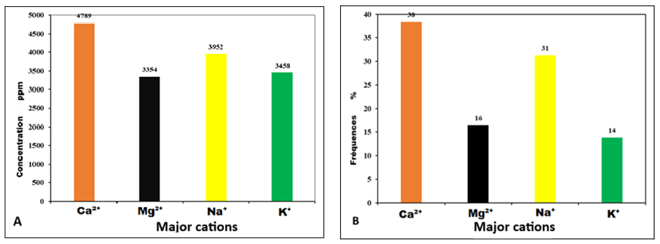The graphs in Figure 5 show that, among the alkalis, the concentration of sodium is higher than that of potassium, which is absent in the rocks of Mondoukou, Samo, and Aboisso. As for the alkaline earth metals, calcium dominates over magnesium. These same graphs in Figure 5 show that there is a perfect similarity in the evolution of the relative proportions of alkali and alkaline earth metals in the sampled waters (A) and in the rocks of the region (B).

**Figure 5:** Alkaline and alkaline earth content of water (A) and rocks (B)

**Table 3:** Results of analysis of whole rock samples

|  |  |  |  |  |  |  |  |
| --- | --- | --- | --- | --- | --- | --- | --- |
|  | **Sands of sea dunes**  **(Mondoukou)** | **Sands, clays and sandstones**  **(Samo)** | **River sand and clay (Andou M’Batto)** | **Sands, clays and sandstones**  **(Dabre)** | **Vases of permanent marshes**  **(Iro La Me)** | **Gneiss**  **(Alepe)** | **Metagranodiorite**  **(Aboisso)** |
| **Parameters** | **Percentage of oxide** | | | | | | |
| **CO2** | 27.21 | 36.68 |  |  |  | 17.96 | 29.69 |
| **Na2O** |  |  | 0.29 | 5.13 | 4.87 | 0.36 | 0.10 |
| **MgO** | 0.16 | 0.08 | 0.38 | 1.31 | 3.12 | 0.37 |  |
| **Al2O3** | 13.51 | 12.02 | 12.24 | 13.48 | 14.08 | 11.90 | 17 |
| **SiO2** | 46.33 | 44.35 | 60.15 | 69.95 | 65.14 | 60.05 | 43.10 |
| **SO3** |  |  | 0.06 |  |  |  |  |
| **K2O** | 0.27 | 0.17 | 1.11 | 3.14 | 2.36 | 1.09 | 0.19 |
| **CaO** |  |  | 0.22 | 2.54 | 3.73 | 0.21 |  |
| **TiO2** | 1.34 | 1.12 | 1.79 | 0.48 | 0.60 | 1.68 | 1.28 |
| **MnO** | 0.02 | 0.05 | 0.13 |  |  | 0.19 | 0.11 |
| **FeO** | 10.16 | 5.00 | 5.57 | 3.70 | 5.43 | 5.65 | 7.64 |
| **CuO** | 0.07 | 0.04 |  |  |  | 0.22 | 0.15 |
| **Tl2O** | 0.14 |  |  |  |  | 0.32 | 0.17 |
| **Ga2O3** |  |  |  | 0.10 |  |  |  |
| **As2O3** |  |  |  | 0.16 | 0.28 |  |  |
| **P2O5** | 0.53 |  | | | |  | 0.37 |
| **ZnO** |  | | | | |  | 0.05 |
| **MoO3** | 0.25 |  | | | |  | 0.17 |
| **TeO2** |  | | | | 0.38 |  |  |
| **Dy2O3** |  | 0.50 |  | | | | |
| **Total** | 99.99 | 100.01 | 99.97 | 99.99 | 99.99 | 100.00 | 100.02 |

**Table 4:** Concentration of alkaline and alkaline earth metals in rocks

|  |  |  |  |  |  |  |  |
| --- | --- | --- | --- | --- | --- | --- | --- |
|  | **Sands of sea dunes**  **(Mondoukou)** | **Sands, clays and sandstones**  **(Samo)** | **River sand and clay (Andou M’Batto)** | **Sands, clays and sandstones**  **(Dabre)** | **Vases of permanent marshes (Iro La Me)** | **Gneiss**  **(Alepe)** | **Metagranodiorite**  **(Aboisso)** |
| **Parameters** | **ppm** | | | | | | |
| **Ca2+** | 0 | 0 | 157 | 1816 | 2666 | 150 | 0 |
| **Mg2+** | 97 | 49 | 231 | 796 | 1895 | 225 | 61 |
| **Na+** | 0 | 0 | 108 | 1903 | 1807 | 134 | 0 |
| **K+** | 112 | 71 | 461 | 1303 | 980 | 452 | 79 |

**3.3. Results of water-rock interactions**

**3.3.1. Results of imbalance indices**

The results of the imbalance indices are recorded in Appendix 2. These indices are positive for equations 4, 9, and 11 in Table 5, which means that kaolinite is stable with respect to albite, microcline, and gibbsite; there is no dissolution of these primary minerals (albite and microcline) in favor of kaolinite. However, the imbalance indices are negative in the water samples for equations 1 and 4, except for those from locations 1, 2, 3, 5, 7, 8, 9, 15, 22, and 29, which are positive. At these locations, there is also no dissolution of muscovite in favor of kaolinite. For all the rest, the anorthite and muscovite present in the aquifer hydrolyze in favor of kaolinite.

**3.3.2. Stability diagrams for silicates and aluminosilicates**

Apart from quartz, which is stable at low temperatures, the alteration of other minerals leads to the formation of alteration products. In aquifers with a relatively high renewal rate (such as the CT aquifer, for example), the weathering products undergo leaching, the degree of which leads to the formation of a specific newly formed clay (kaolinite, illite, montmorillonite, etc.).

The projection of the waters in the three equilibrium diagrams (Figures 6a, 6b, and 6c) shows that they are all within the stability range of kaolinite. In this southeastern part, primary minerals such as albite and muscovite present in the aquifers are hydrolyzed to form kaolinite through weathering reactions 3 and 8 (Table 5). Furthermore, no water reaches the solubility range of amorphous silica. All waters are close to or within the solubility range of quartz. As a result, the phenomenon of residence time mineralization remains one of the important mechanisms in the ion acquisition process. When this is sufficiently long, the composition of the water within the aquifer approaches the chemical composition of the surrounding rocks. Upon contact with the rocks it passes through, the groundwater becomes enriched with ions.

**Table 5:** Transformation reactions of certain primary minerals in rocks

|  |
| --- |
| 1 Mg2SiO4 (S) + 4H2CO3 2Mg2+ + 4HCO3- + H4SiO4  *Forsterite (Péridot) Silica* |
| 2 KMg3AlSi3O10(OH)2 (S) + 7H2CO3 + 0,5H2O K+ + 3Mg2+ + 2H4SiO4 + 0,5Al2Si2O5(OH)4  *Phlogopite (Mica) Silica Kaolinite* |
| 3 CaAl2Si2O8 (S) + 2H2CO3 + H2O Ca2+ + 2HCO3- + Al2Si2O5(OH)4  *Anorthite Kaolinite* |
| 4 NaAlSi3O8 (S) + H2CO3 + 4,5H2O Na+ + HCO3- + 2H4SiO4 + 0,5Al2Si2O5(OH)4  *Albite**Silica Kaolinite* |
| 5 2,33NaAlSi3O8 (S) + 8,64H2O + 2CO2 Na0,33Al2,33Si3,67O10(OH)2 + 2Na+ + 2HCO3-+ 3,32H4SiO4  *Albite Montmorillonite* *Silica* |
| 6 KAlSiO3O8 (S) + H2CO3 + 4,5H2O K+ + HCO3- + 2H4SiO4 + 0,5Al2Si2O5(OH)4  *Orthose Kaolinite* |
| 7 3KAlSiO3O8 (S) + 12H2O + 2H2CO3 2K+ + 2HCO3- + 6H4SiO4 + KAl3Si3O10(OH)2  *Orthose Silica Muscovite* |
| 8 KAl3Si3O10(OH)2 (S) + H2CO3 + 1,5H2O K+ + HCO3- + 1,5Al2Si2O5(OH)4  *Muscovite Kaolinite* |
| 9 Al2Si2O5(OH)4 + 5H2O 2[Al(OH)3] + 2H4SiO4  *Kaolinite Gibbsite Silica* |
| 10 SiO2 (S) + 2H2O H4SiO4  *Quartz Silica* *Ou* *Silica amorphe*  11 KAlSi3O8 + H+ + 4,5H2O 0,5Al2Si2O5(OH)4 + 2H4SiO4 + K+  *Microcline Kaolinite Silica* |

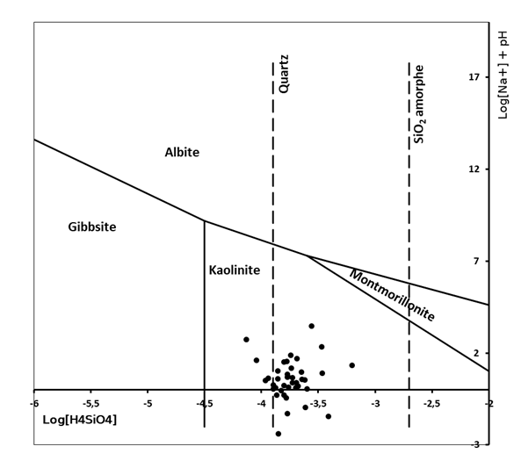

**Figure 6a:** Water stability diagram in the partial equilibrium system Na₂O-Al₂O₃-SiO₂-H₂O

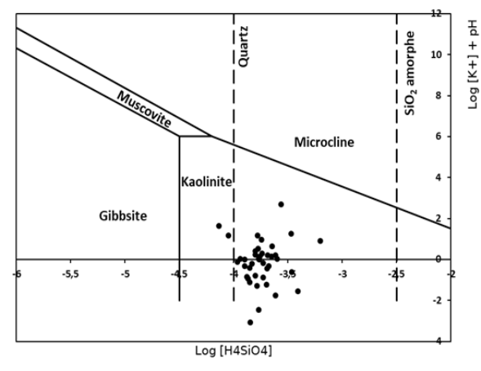

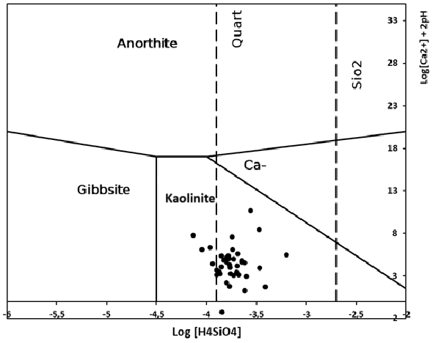**Figure 6b:** Water stability diagram in the partial equilibrium system K2O-Al2O3-SiO2-H2O

**Figure 6c:** Water stability diagram in the CaOAl2O3-SiO2-H2O partial equilibrium system

**4. DISCUSSION**

The geochemical study revealed that water temperatures in this part of southeastern Côte d'Ivoire range between 26.2 and 29.5°C. Studies conducted by other authors (Soro and Goula (1997); Oga (1998); Ahoussi and al. (2010)) in the same area have yielded the same temperature values. According to these authors, these temperature values, which are linked to the climate and therefore vary according to the seasons, indicate the homogeneity of the water in the aquifer.

The waters in this region are all acidic, with pH values ranging from 1.57 to 6.77. These waters are aggressive and have very significant corrosive effects. This acidity is one of the characteristic features of the waters of the southern coast of Côte d'Ivoire, according to the work of several authors (Oga (1998); Adiaffi (2008); Ahoussi and al. (2010); Aké and al. (2009); Eblin and al. (2014)). According to Ahoussi and al. (2010), it is linked to the presence of high levels of free CO2 in the soil.

The conductivity of the water in the study area varies from 27.5 to 1500 µS.cm-1, with an average of 193.46 µS.cm-1. The considerable differences observed between the extreme conductivity values in the two types of structures indicate a high degree of heterogeneity in water mineralization. Most of these waters are weakly mineralized, especially those from CT structures. This trend is consistent with the observations made by Soro and Goula (1997), Adiaffi (2008), and Ahoussi (2008). These low values are thought to be related to water mixing. Once the water from the bedrock enters the CT aquifer, it undergoes significant dilution by less mineralized and more acidic water (surface recharge water). The distribution of salinity and conductivity measurements in the structures indicates that water from boreholes is less saline and less conductive than water from wells. This could be because the piezometric level of well water, which is close to the ground surface, is a major factor in the vulnerability of these aquifers to pollution. The water in these aquifers is therefore influenced by human activities in these cities.

The values for dissolved oxygen (DO between 2 and 7 mg.L-1) and oxidation-reduction potential (Eh between 148 and 466.6 mV) show that the water in the area is well oxygenated. These values thus demonstrate the ease of surface water infiltration and therefore imply significant variations in physico-chemical parameters (Soro, 2010). Previous work by Ahoussi (2008) in the Abidjan-Agboville region showed that redox potential values vary between 24 and 182 mV, with an average of 151.18 mV for CT waters. The presence of a low pH and positive Eh may indicate easy replenishment of the aquifers.

The groundwater studied is divided into three hydrofacies: sodium-potassium chloride (63%), calcium chloride (30%), and calcium hydrogen carbonate (7%). Work carried out by Oga (1998) in the Greater Abidjan region showed that CT waters are dominated by sodium-potassium chloride facies (87%). Studies conducted by Adiaffi (2008) in the southeast show that calcium and magnesium hydrogen carbonate waters are from the bedrock; those of the CT are sodium-potassium chloride facies (more prevalent), calcium chloride and magnesium chloride. Furthermore, recent studies by Eblin and al. (2014) in the Adiaké region show that sodium-potassium chloride facies represent 80.8% of the waters analyzed, with the remainder being calcium chloride facies. The abundance of chloride and potassium ions can be explained by the phenomenon of coastal aquifer pollution due to the intrusion of saline and brackish water into the aquifers. According to Choudhury and al. (2001), this mechanism is influenced by several factors, including the geological formations present. In this area, these formations are represented in part by Quaternary sands and fine to coarse sands with high permeability ranging from 10-3 to 4.10-5 m.s-1 (Aghui and Biémi, 1984). Excessive pumping to meet various needs is often the cause of saline and brackish water intrusion into the aquifer. Recent work by Oga and al. (2009) and Kahé (2014) confirms this trend.

The hydrolysis of silicate minerals present in rocks is the main mechanism for the production of ions in groundwater. The hydrolysis of silicates and aluminosilicates appears here as the phenomenon by which water uses its hydrolyzing power to alter rocks and enrich itself with a large proportion of these minerals. In addition to the hydrolysis of silicate minerals, Korjinski's diagram showed that the waters studied belong to the kaolinite stability domain. In fact, the composite clays of the sediments in the study area are mainly composed of kaolinite. Moreover, kaolinite is the most widespread clay mineral in humid tropical Africa (Millot, 1964). These results are consistent with the work carried out in the south and southeast of Côte d'Ivoire by Soro et al. (1995), which shows that the waters belong to the stability domain of montmorillonite and kaolinite. Oga (1998) and Adiaffi (2008) showed that the waters also belong to the kaolinite domain. According to Oga (1998), the stability of kaolinite relative to other minerals in the case of the waters of the Greater Abidjan region reflects intermediate conditions favorable to monosialization. This was identified in our study.

The geochemical characterization of reservoir rocks through total rock analysis revealed that the rocks are acidic, intermediate, basic, and ultrabasic. The results obtained by Adiaffi in 2008 in Aboisso (granodiorite) and Alépé (gneiss in Nianda) show acidic and basic rocks for these locations, respectively. Furthermore, this study shows that within the alkali metals, sodium dominates over potassium; similarly, calcium dominates over magnesium in the alkaline earth metals. Abdallah and al. (2023) and Adiaffi's work (2008) showed the same order of abundance of these mineral elements. Furthermore, there is an evolutionary correlation between the chemistry of the sampled waters and that of the rocks in the region. This suggests that most of the mineralization of the waters with these major cations is provided by the reservoir rocks through the phenomenon of hydrolysis.

**CONCLUSION**

The hydrogeochemical characterization of groundwater in southeastern Côte d'Ivoire has enabled us to obtain several results on the physicochemical quality and geochemical characteristics of water in this part of the southeast.

From a physical standpoint, the waters studied have temperatures above 25°C (WHO 2011 guideline value) and range from 26.2°C to 29.5°C. The pH of the waters is acidic, ranging from 5.3 to 6.99. The conductivity of the waters ranges from 27.5 to 1500 µScm-1, which has made it possible to classify the waters as low, normal, and high mineral content. There are 27 samples in the first category, 13 in the second, and one in the last category. All waters are less salty and well oxygenated (Eh between 148 and 466.6 mV; OD between 2.1 and 7.5 mg.L-1), indicating redox reactions in the environments.

The chemical analyses carried out during this study show that magnesium and potassium levels remain low in all waters, while calcium and sodium levels remain the highest. However, some structures require monitoring and/or improvement of water quality, as is the case in Krinjabo, where the nitrate content is 63.5 mg.L-1, and in Bingerville, Grand Alépé, and Asouindé, where the potassium content is high compared to that recommended by WHO guidelines. There is also the case of calcium (96 mg.L-1) and magnesium (61.7 mg.L-1) in the Assinie and Palmafrique boreholes, respectively, where the levels are also high. The water is generally soft, with very low hardness due to the clayey-sandy and sandstone soils of the region.

Analysis of the total rock showed that the area is dominated by intermediate and ultrabasic rocks and, to a lesser extent, by basic and acidic rocks. It showed that the evolution of the chemical composition of the water within the aquifer is similar to that of the reservoir rocks. The silicate and aluminosilicate stability diagram showed that the water is within the stability range of kaolinite and silica (quartz). Kaolinite is formed from the alteration of anorthite and muscovite and is stable with respect to albite, microcline, and gibbsite.

**COMPETING INTERESTS DISCLAIMER:**

Authors have declared that they have no known competing financial interests OR non-financial interests OR personal relationships that could have appeared to influence the work reported in this paper.

**DISCLAIMER (ARTIFICIAL INTELLIGENCE)**

Author(s) hereby declare that NO generative AI technologies such as Large Language Models (ChatGPT, COPILOT, etc.) and text-to-image generators have been used during the writing or editing of this manuscript.

**THIS WORK IS AN ORIGINAL RESEARCH ARTICLE**

**REFERENCES**

**ABDALLAH M. N., MOURSAL A. B., ABDRAMAN M. A. and HAMIT A. (2023).** Study of the Hydrochemical Characterization of Drinking Water from the Aquifer of the Town of Guitté at Hadjer Lamis. International Journal of Environment and Climate Change, 13(10), 4085–4097. https://doi.org/10.9734/ijecc/2023/v13i103085

**ADIAFFI B. (2008).** Contribution of isotopic geochemistry, hydrochemistry, and remote sensing to the understanding of aquifers in the “bedrock-sedimentary basin” contact zone in southeastern Côte d'Ivoire. Doctoral thesis, University of Paris-Sud 11, France, 230 p.

**AGHUI N. and BIEMI J. (1984).** Sedimentary basin of Côte d'Ivoire. Geology and hydrogeology of the aquifers in the Abidjan region and risks of contamination. University of Abidjan, series C (sciences), vol. 20, pp. 313-347.

**AHOUSSI K. E. (2008).** Quantitative and qualitative assessment of water resources in southern Côte d'Ivoire. Application of hydrochemistry and environmental isotopes to the study of continuous and discontinuous aquifers in the Abidjan-Agboville region. Doctoral thesis, University of Cocody-Abidjan (Côte d'Ivoire), 270 p.

**AHOUSSI K. E., SORO N., KOUASSI A. M., SORO G., KOFFI Y. B., ZADE G. P. S. (2010).** Application of multivariate statistical analysis methods to the study of the origin of heavy metals (Cu2+, Mn2+, Zn2+, Pb2+) in groundwater in the city of Abidjan. Int. J. Biol. Chem. Sci., Vol. 4, No. 5, pp. 1753-1765.

**AKE G. E., KOUASSI D., KOUADIO B. H., BROU D., MAHAMAN B. S., BIEMI J. (2009).** Contribution of the DRASTIC and GOD intrinsic vulnerability methods to the study of nitrate pollution in the Bonoua region (southeastern Côte d'Ivoire), European Journal of Scientific Research, Vol. 31, No. 1, pp. 157-171.

**CHOUDHURY K, SAHA D. K., CHAKRABORTYP. (2001**). Geophysical study for saline water intrusion in a coastal alluvial terrain. Appl Geophys 46, 189-200.

**DEKAYIR A. and EL-MAATAOUI M. (2001).** Mineralogy and material balance of supergene alteration of an alkaline basalt in the Middle Atlas Mountains of Morocco. Journal of African Earth Sciences, Vol. 32, No. 4, pp. 619-633.

**DIBI B., INZA D., GOULA B. T. A., SAVANE I., BIEMI J. (2004).** Statistical analysis of parameters influencing the productivity of water wells in crystalline and crystallophyllian environments in the Aboisso region (southeastern Côte d'Ivoire). Revue Sud Sciences & Technologie, No. 13, pp. 22-31.

**EBLIN S. G., SORO G. M., SOMBO A. P., AKA N., KAMBIRE O., SORO N. (2014).** Hydrochemistry of groundwater in the Adiaké region (southeastern coast of Côte d'Ivoire). Larhyss Journal, ISSN 1112-3680, Vol. 75, No. 17, pp. 6259-6271.

**FAO (2017).** The World food and agriculture situation. Making food systems serve inclusive rural transformation. <https://openknowledge.fao.org/server/api/core/bitstreams/92068abe-80de-4da0-a774-f13a158e84f0/content>

**GALLO G. (1978).** Complementary Use of Environmental Isotopes and Hydrochemistry for the Hydrogeological Study of Groundwater in the Ribeirao Preto Region (Brazil). IAEA-SM-228/21, 367-406. Management, 8p.

**GLEICK, P.H. (1993).** Water in Crisis: A Guide to World's Freshwater Resources, Oxford University Press, New York, 473 p.

**HAMDI E. M., BOULANGER B., COLIN F. (1997).** Weathering of a Triassic basalt from the Elhadjeb region, Middle Atlas, Morocco. African Earth Sciences. Vol. 24. No. 1/2, pp. 141-151.

**IPCC (2022).** <https://www.ipcc.ch/report/ar6/wg2/>

**JOURDA R. J. P. (1987).** Contribution to the Geological and Hydrogeological Study of the Greater Abidjan Region (Côte d'Ivoire). Postgraduate Thesis, University of Grenoble I, Dolomieu Institute 1987, France, 317 p.

**KAHE A. P. (2014).** Hydrochemical Characterization of the Surface Waters of the Continental Terminal in the Bingerville Sub-Prefecture. Master's Degree, Félix Houphouët Boigny University, 78 p.

**MAMAN S. A. BABAYE (2012).** Groundwater Resource Assessment in the Dargol Basin (Liptako – Niger). PhD. Abdou Moumouni University, Niger, 244p.

**MILLOT G.** (1964). Clay Geology: Alterations, Sedimentology, Geology. Masson et Cie Publishers, 499p.

**NGUETNKAM J. P., RICHARD KAMGA R., VILLIERAS F., EMMANUEL EKODECK G., YVON J. (2008).** Differential Weathering of Granite in Tropical Zones. Example of two sequences in Cameroon (Central Africa). C. R. Géoscience 340, pp. 451-461.

**OGA M.S. (1998).** Groundwater Resources in the Greater Abidjan Region (Côte d'Ivoire): Hydrochemical and Isotopic Approaches. Thesis, University of Orsay Paris XI (France), 241p.

**OGA M. S., LASM T., YAO T. K., SORO N., SALEY M. B., KOUASSI D., GNAMBA F. (2009).** Chemical characterization of fracture aquifer waters: The case of the Tiassalé region in Côte d'Ivoire. European Journal of Scientific Research, 31(1):72-87.

**OGA M. S., ADIAFFI B., GNAMBA F., MARLIN C., BAKA D., AMANI E. M., BIEMI J. (2015).** Application of the inverse model to water-rock interactions in groundwater from metagranodiorites, southeastern Côte d'Ivoire. European Journal of Scientific, Vol 11, No. 3 ISSN: 1857-7431, 67p.

**SORO G. (2010).** Quantitative and qualitative assessment of groundwater resources in the lake region (central Côte d'Ivoire): hydrogeology and hydrochemistry of discontinuous aquifers in the Yamoussoukro district and the Tiébissou department. Doctoral thesis, University of Cocody-Abidjan, Côte d'Ivoire, 301 p.

**SORO N. (1987).** Contribution to the Geological and Hydrogeological Study of Southeastern Côte d'Ivoire. Postgraduate Thesis, University of Grenoble, France, p. 243.

**SORO N., BIEMI J., DOUMOUYA., TAPSOBA A. (1995).** Origin and Mechanism of Ion Production in the Aquifers of Southern Côte d'Ivoire. Annals of the University of Abidjan, Series C Sciences and Technology, Vol. B, Natural and Biological Sciences, Volume XXVI-B, No. 2, 1995.

**SORO N. and GOULA BI (1997).** Hydrochemistry and Environmental Isotopes Applied to the Study of Groundwater in Southern Côte d'Ivoire. Hydrochemistry (Proceedings of the Rabat Symposium, April 1997), IAHS Publ. No. 244, pp. 105-113.

**SORO N. (2002).** Hydrochemistry and Isotopic Geochemistry of Groundwater in the Grand-Lahou Square Degree and Surrounding Area (Southwest Côte d'Ivoire). Hydrological and Hydrogeological Implications. Doctoral Thesis in Sciences, University of Cocody-Abidjan, Côte d'Ivoire, p. 261.

**UN WATER (2021).** World Water Development Report (2021), <https://www.unwater.org/publications/un-world-water-development-report-2021>

**UN WATER (2023).** United Nations Water Conference, 22 – 24 mars 2023, New York, <https://sdgs.un.org/fr/conferences/water2023>

**UNESCO (2015).** <https://unesdoc.unesco.org/ark:/48223/pf0000244834_fre>

**WWAP (2018).** <https://delegazioneunesco.esteri.it/fr/news/dalla_rappresentanza/2018/04/wwap-perugia-presentata-nella-sede-2/>