**Geochemical and Petrogenetic Study of Basaltic Rocks Along the Kharrouba Fault, North Eastern Jordan**

**Abstract**

Kharrouba basalticfaultrocks (KBR) were investigated aiming to understand their mineralogy, petrography, geochemistry and Petrogenesis features. The basalt rocks occupy 18% of Jordan's area. The basalt is associated with continental rifting and is associated with magmatism and section activities that have produced melted generation into the fissure system. The main objective of this study is to investigate the of the Basalt rocks along kharrouba basaltic dyke Qasr Al_ Hallabat Area to investigated Mineralogy, Petrology, Geochemistry and Petrogenesis of the inter-continental basaltic flow. The study was conducted in the northeastern part of Jordan. Eighteen representative rock samples were selected for both geochemical and petrographic analysis from several sites in the study area. Petrographic characteristics were analysed by optical microscopy after preparation of thin sections, for representative rock samples, which show that all basalt samples have minerals comprising: olivine, clinopyroxene (augite), plagioclase (labradorite), opaque and some secondary minerals such as (Iddingsite). Normative mineralogy by using CIPW norm showed that the basalt samples were dominated by olivine, Diopside, hematite, apatite, sphene, anorthite, albite, orthoclase and nepheline. The basalt can be normatively classified as alkali olivine basalt. Some textures that may be evident on microscopic examination are seriate, such as Porphyritic, vesicular, glomeroporphyritic, intergranular, embayment, trachytic, zoning olivine and ophitic to subophitic texture. X-ray Fluorescence (XRF) was used for whole rock major elements (SiO2, TiO2, Al2O3, Fe2O3, MnO, MgO, CaO, Na2O, K2O and P2O5 in wt%) and trace elements (Cr, Sr, Zr, Ni, Ba in ppm were selected in some samples). Geochemical analysis reveals that the basalt is alkaline and belongs to the sodic series. The normalised trace element diagrams suggest that A product of the asthenosphere part of the mantle at >100km depth. The geochemical variation trends of A basaltic samples, supposing that the composition of these magmas has been influenced by fractional crystallisation without clear evidence for crustal contamination. These findings contribute to understanding the mantle source characteristics and magmatic evolution in the context of the Arabian Plate intraplate volcanism.

**Keyword**: Mineralogy, Petrography, Geochemistry and Petrogenesis, Kharrouba Basaltic Fault rocks, Qasr Al Hallabat Area, Jordan.

1. **Introduction**

Basaltic rocks show a high affinity to precipitate carbonate minerals upon reaction with carbonic acid (Hammam et al., 2025). The basalt in Jordan occurs as a sporadic volcanic centre along the eastern side of the Dead Sea (1). In Jordan, the volcanic province covers an area of about 12.000 km2. They are represented by basalt flows and tephra cones (Al-Fugha & Al-Malabeh,2023). The basalt rocks occupy 18% of Jordan's area (**2**). The basalt is associated with continental rifting and is associated with magmatism and section activities that have produced melted generation into the fissure system (**3**). The basalt in Jordan investigated by (**4**) and reported similar to alkaline Arabian interplate volcanic field erupted with the main fissure systems (**5**). The basaltic in Jordan covers a large area from Syria to Yemen through Jordan and Saudi Arabia. It covers an area of 180.000 Km2 (**6) (7)** (**Fig. 1**). The Basalt in Jordan occurs as sporadic small volcanic centres along the eastern side of the Dead Sea boundary and as a really extensive intraplate volcanic field to the northeast of the plate boundary (**8).** The North-South striking of Dead Sea Transform (DST) was accompanied by substantial horizontal sinoatrial displacement and by sinoatrial fan-like rotation of Arabian plate. These tectonic activities led to opening ways (fissure systems) for the ascent of magmas. Fissures System Trending E_W and NW_SE direction along the eastern margin of the Dead Sea rift, on the large, basaltic plateau (Barberi,1979). In Jordan, the most important locations are in northeast Jordan, which belong to Harrat Ash Sham. Basaltic Super Group, which covers more than 11,000 km2 in this part of the country (**Fig. 1**). Jordanian basalt belongs to Neogene-Quaternary age (**9**). The basalt flows are mainly distributed in Jordan from the northeast to the north and from the middle parts to the east of the Dead Sea In general, the extent of the wadi fault zone that probably caused by tensional forces parallel to the Red Sea. The basalts in central Jordan have been found to occur in seven places (Tfila, Wadi Dana, Jabal Shahan, Jurf Al_ Al-Darawish, El-Lajjoun, Ghor Al-Katar and Wadi Zarqa _Main) in the form of plateau basalts, local flows (wadi fills), or individual volcanic bodies (cones, plugs, and dikes). The mineralogy of basalt is characterised by the presence mainly of calcic plagioclase, and pyroxene, olivine can also be a significant constituent. In addition to the minerals in relatively minor amounts, include iron oxides such as magnetite, ilmenite and iron titanium Oxides and spinel (**10**). Basalts are aphanitic igneous extrusive volcanic rocks formed by the rapid cooling of lava, composed of five grains of plagioclase, pyroxene, olivine, hornblende and less than 20% quartz (**11**). It is a kind of volcanic rock that originates from mafic lava flows. It is widely distributed on the earth and has been used for the construction of roads, bridges, and buildings (Liang et al.,2023; Luchese et al.,2023). Basalt is the most common rock in earth’s crust, it forms from the melting of upper mantle and its chemistry closely like the upper mantles composition was classified the eruptions of basaltic according to (**1)** their distribution in three groups as follow: Central Jordan Basalt volcanoes within the rift, South Jordan Basalt “the eastern margin basalt and Northeast Basalt “plateau Basalt. The study area along kharrouba basaltic dyke at Qasr Al_ Hallabat area located in northeast Jordan. The main objective of this study is to investigate the of the Basalt rocks along kharrouba basaltic dyke Qasr Al_ Hallabat Area to investigated Mineralogy, Petrology, Geochemistry and Petrogenesis of the inter-continental basaltic flow.

1. **Geological setting**

The study area is located in North Eastern part of Jordan. It is about 35 km away from Mafraq to Rewashed city. The JTM Coordinates for Kharrouba dyke from 36o 15ʹ 440 ʺ “36o 45ʹ 450ʺ E and from 32o 00ʹ 560ʺ to 32o 00ʹ 570ʺ N, **Fig. 1**. The exposed rock formations at study area are covered by volcanic rocks, these rocks are one part of super group of Harrat Ashaam Basalt, these formations are Abed Olivine Basalt Formation (AOB): (Late Miocene) of the Safawi Group represents the oldest volcanic in the study area. It is composed of massive basaltic flows, blocky, grey, holocrystalline, fine-grained, porphyritic texture with olivine altered to Iddingsite **(12**). Bishriyya Formation (BY): (Pleistocene) is the youngest volcanic rock. The basalt is fine-grained, aphanitic and clustered in texture, containing olivine dark green crystals. Kharrouba Basaltic Dyke (Bd) is the main basaltic dyke represent in the study area. It is trending NW-SE, and forms isolated hills and linear ridges. The study area covered by sedimentary formation, such as Amman Silicified Limestone (ASL): (Santanian _ Campanian), consists of thick bedded limestone and marly limestone interbedded with black, whitish grey thin to medium bedded Chert. The formation includes trace fossils, gastropods, bivalves and shell fragments. The formation was deposited in the shallow marine environment (**13**). The superficial deposits for alluvium and Soil Sediments: (Pleistocene) soil sediments covered part of the study area, consisting of stony or boulder deposits along with unsorted gravel, sand and silt derived from diverse bedrock Lithology. The Structural Setting of the Kharrouba Fault covered the study area from southwest to northeast direction, it is composed mainly of volcanic rocks. A few geomorphology features are present in the study area, such as ridges and isolated hills, which occupy a large part of the study area elevation from 600 to 700 m. These features are present in plateau basalt, which occurs mainly in the eastern part of the study and has a gentle undulating surface, and Mud flats occupy the low topographic areas and are located in the southeastern part.

1. **Sampling and Analytical Techniques**

A total of eighteen chip representative rock samples were collected from several sites in the study area **Fig. 1**. The samples were crushed and powdered by using geochemical techniques. The major elements were analysed on fused glass discs-like pellets (beads) by using a Phillips X-Ray Fluorescence Spectrometry (XRF) Majex PW-2424 Model at the Al-Bayt University. A total of 2 g of the powder samples were mixed with 8 g of lithium tetra borate and fused in platinum crucibles over gas burners (1000˚C) for 1 h. The melts were poured into a mould to create glass disks **(14) (15)**. The Loss on Ignition (LOI) was determined by the weight lost after melting at 1000˚C. The trace elements were analysed by decomposition using an Atomic absorption Spectrophotometer (AAS) and thin section was prepared at the University of Al al Bayt and examined under a polarised microscope. Photomicrographs of the samples were obtained by using a LEICA-DMEP Canon camera in the petrography unit at the Natural Resources Authority. The geochemical data were processed and pictorially represented by using the computer program Igpet 32. GCEkite, CIPW-Norm calculations were carried out using the Excel.

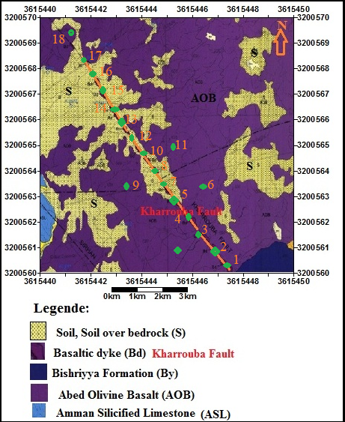

Figure 1: Geological and sample location map of the study area (**16**).

**4. Results and discussion**

**4.1. Petrography and Mineralogy**

The Kharrouba basaltic rock samples study was holocrystalline, fine to medium grained and exhibited aphanitic to vesicular texture, with spherical to elongate to oval-shaped vesicles. The hand specimen is black in colour and fine-grained. The Melanocratic rocks typically showed aphanitic and vesicular texture and are characterised by plagioclase, olivine, and pyroxene. Phenocrysts are embedded in a fine-grained groundmass that mainly consists of plagioclase, olivine, and opaque minerals. The average modal composition is 65% vol. plagioclase, 13 vol.% clinopyroxene, 14% vol. olivine, 7% vol. opaque minerals (magnetite) and 4 vol.% Vesicles. The secondary minerals included calcite and iron oxide (Iddingsite). The main common texture of the studied samples was porphyritic, glomeroporphyritic, vesicular, seriate, embayment, and ophitic to sub-ophitic texture.

**4.1.1. Plagioclase**

Plagioclase is the most abundant mineral in thin section, it occurs in a lath shape phenocrystal range from fine to medium grain. It had many unique properties. It is euhedral tabular shape, simple and multiple twinning are present in thin section **Fig. 2.** The extinction angles on plagioclase ranged from 27˚ to 32˚. The ternary diagram for plagioclase after [**17**] shows all the samples presented in labradorite and Bytownite field (**Fig. 4a). The** Classification of pyroxene from Kharrouba Basaltic rocks plotted within diopside and Augite Field (**18**) **Fig. 4b.** The Glomerophyritic texture (plagioclase, pyroxene, and olivine) are enclosed in ground mass and it is divided into clusters of four crystals (**Fig. 3**). Ophitic and Sub ophitic texture are formed for plagioclase crystal partially enclosed by pyroxene crystals **Fig. 3b**. The oscillatory zoning of plagioclase (**Fig. 3)** is present in rock samples study, as a result of the mineral chemistry which continuously oscillates between high and low-temperature compositions going from the core to the rim during crystal growth.

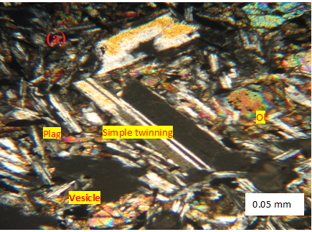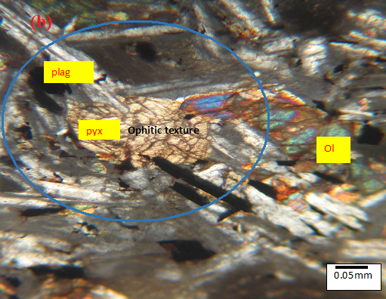

Figure 3. Photomicrograph (a): showing simple twinning of plagioclase where the mineral chemistry continuously oscillates between high and low temperature compositions going from the core to the rim during crystal growth, (b): Ophitic texture, where Plagioclase laths are completely enclosed by Pyroxene mineral (XPL, 10x mag. Where 10x=0.25mm, Ol: Olivine, Plag: Plagioclase, Vesicle: Vesicles), Sample, sample No. 14.

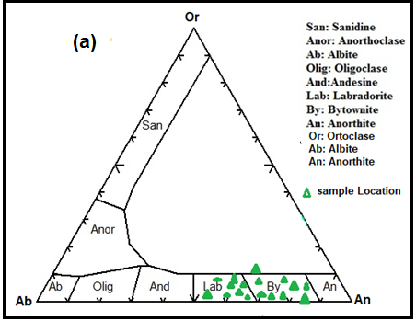

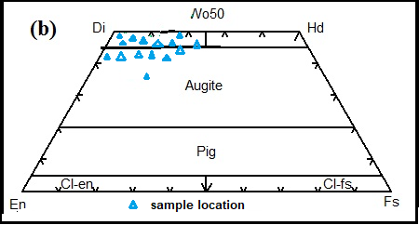

Figure 4: (a) Ab-An-Or ternary for plagioclase of Kharrouba basaltic rock samples, modified after **(17).** (b) Classification of pyroxene from Kharrouba Basaltic rocks after (**18**), all the samples studied plotted within the diopside and Augite fields

**4.1.2. Pyroxene**

Pyroxene occurs as colourless at (PPL), and second to third order in interference colour (XPL) to greyish brown in color with anhedral to subhedral crystals, have about 13 to 15 vol. % for modal. The crystals had a size between 0.62_2mm, with a perfect tow set of cleavage, which intersected at 90˚ in the cross section **(Fig. 5).** The pyroxene crystals had an inclined extinction between 46˚ and 52˚, indicating the presence of clinopyroxene for diopside. The clinopyroxene intersected with plagioclase crystals to form ophitic to subophitic texture.

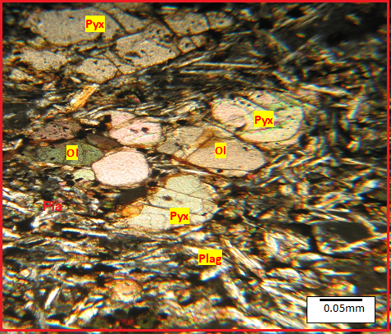

Figure 5: Photomicrograph showing Pyroxene and olivine crystal (XPL image, 4x *10x mag. Where 4x=0.1mm. Ol: Olivine, Plag: Plagioclase) Sample No. 15

**4.1.4. Olivine**

Olivine occurs as single or clustered subhedral to anhedral crystals, which are partly altered to Iddingsite along cracks at rims and ranging between 0.2 to 0.9mm in diameter in the groundmass and forming 14 vol.% for modal. Olivine is colourless in plane polarized Light (PPL) and second to third order interference colour in Crossed polarised Light (XPL) with a high degree of alteration to Iddingsite **Fig. 6**. Subhedral Phenocrysts had high relief, cracks and fractures, it light grey to colourless crystals, parallel extension. The Glomeroporphyritic texture has bunched plagioclase and olivine crystals in aggregate. Iddingsite is common, particularly the edge (rim) of the crystal, which produces corona texture and Trachyte texture is formed by the olivine crystal surrounded by plagioclase laths **Fig. 6**.

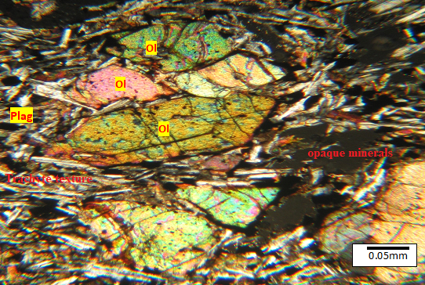

Figure 6: Photomicrograph showing Olivine euhedral to subhedral crystal, Iddingsite are shown in the rem of olivine crystals and opaque minerals (XPL, magnification, X10). Where Ol: Olivine, Plag: Plagioclase. Sample No. 1

**4.1.5. Opaque Minerals**

Opaque minerals were commonly found in Kharrouba Fault basalt, forming about 7vol% of the rocks and ranging from 0.03_0.05mm in size. They mostly occurred as iron oxide Phenocrysts scattered throughout the rock and as inclusion within olivine or pyroxene crystals produced Poikilitic texture, where olivine crystals completely enclose numerous grains of opaque minerals (iron oxide) such as hematite and Ilmenite **Fig. 6**. The optical properties of iron oxide were black color with PPL and XPL optics. The norm calculation of the oxide mineral represented by 10 wt% Norm of ilmenite (FeTiO3) and hematite (Fe2O3).

**4.1.6. Vesicles**

The Kharrouba Fault basalt showed irregular elongated or rounded holes (vesicles) size range from 0.05 to 0.38mm. The Vesicles tend to range in shape from spherical to elongate to Oval. The vesicles were filled with secondary minerals such as calcite and clay minerals **Fig. 3a**  and formed about 4vol% of the model of the rocks.

* 1. **Geochemistry** 
     1. **Major Oxide**

The major element is a chemical element represents the rock samples studied, referring to the concentration of the oxide composition. These are SiO2, Al2O3, MgO, Na2O, CaO, Fe2O3 and P2O5. The major oxide elements are useful in the rock classification, construction of variation diagrams and as a means of comparison with experimentally determined rock composition (**14**). The results analysis of Eighteen chip rock samples study for major and trace elements are listed in **Table 1**. The rocks samples study exhibits a narrow range of silica (SiO2) saturation (between 47.08 to 49.93 wt%), with an average of 48.5 wt%, which is within the average value reported by several authors for alkali basalt and basanite (**2) (3) (19) (20),** and it can be classified as basalt to Trachy basalt using the Total Alkalis Vs. Silica classification scheme (**21)** and [22] (**Fig. 7(a) and (b)).** The TiO2 concentration between1.54 to 2.07 wt%, with an average of 1.80 wt%. Al2O3 content ranges from 15.40 to 16.95 wt% with an average of 16.17 wt%. The total Fe2O3 and FeO content was between 10.41 and 13.41 wt% with an average of 11.91 wt%, indicating that the rocks were enriched in Fe. According to **[3],** the SiO2 under saturated magma had a high FeO and MgO content of more than 11 wt% and 7 wt%, respectively. MnO ranges between 0.05 and 0.12 wt% with an average of 0.085 wt%. MgO ranges between 3.87 and 5.86 wt% with an average of 4.86 wt%. CaO range between 7.80 and 10.46 wt% with an average of 9.13 wt%. The Na2O range is between 3.52 and 4.67 wt% with an average of 4.095 wt.%. K2O ranges between 0.79 and 1.27 wt.% with an average of 1.03 wt%. The total alkali (Na2O + K2O) ranged between 4.31 wt% to 5.88 wt%, with an average of 5.27 wt%. The SiO2 Vs. Alkalinity shows the rock samples study for KBR plotting in the alkaline field, these result indicates that KBR has alkaline rocks **(Fig. 8).** These results have been documented by many authors, such as **(23), (24), (25) (26), (27).** P2O5 ranges between 0.24 to 0.41 wt% with an average of 0.32 wt%. The Mg number (Mg#), defined as the molecular proportion of Mg+2\(Mg+2+Fe+2). The Mg# for **KBR** varies from 35 to 60. Mg#, with an average of 46.39, was used as a petrogenetic indicator for magma fractionation and its primitive volcanic rocks (**28)**. The Mg# of the indicated **KBR** evolved within moderately basaltic. The relationship between Mg# and SiO2 shows a decrease in Mg# with increasing concentration of SiO2 (**Fig. 9).** These relationships tend to be that fractional crystallisation probably plays a role in decreasing Mg-number as a function of increasing SiO2 **(3).** The magnesium value was considered for Fe content in the rocks. **(29)** reported that the values of Mg≠ > 70 can be considered as a threshold that characterizes primitive magmas.

Table 1: Chemical analyses of the Rock samples from KBR, major oxides (wt%), trace elements (ppm) and CIPW wt% Norm.

|  |  |  |  |  |  |  |  |  |  |
| --- | --- | --- | --- | --- | --- | --- | --- | --- | --- |
| Sample. No. | A1 | A2 | A3 | A4 | A5 | A6 | A7 | A8 | A9 |
| SiO2 wt.% | 47.18 | 49.40 | 48.87 | 47.79 | 49.11 | 47.99 | 48.95 | 47.08 | 49.23 |
| TiO2 | 1.84 | 1.86 | 1.54 | 2.06 | 1.55 | 1.86 | 1.67 | 1.97 | 1.98 |
| Al2O3 | 16.67 | 15.81 | 16.95 | 16.16 | 15.96 | 16.82 | 16.16 | 15.40 | 15.60 |
| Fe2O3 | 12.55 | 11.39 | 10.85 | 12.50 | 13.41 | 11.84 | 12.53 | 12.86 | 12.66 |
| MnO | 0.12 | 0.08 | 0.05 | 0.06 | 0.05 | 0.09 | 0.06 | 0.06 | 0.06 |
| MgO | 5.14 | 3.87 | 4.68 | 5.19 | 4.22 | 5.44 | 4.30 | 4.94 | 4.31 |
| CaO | 8.45 | 10.46 | 8.41 | 7.94 | 8.43 | 8.37 | 8.36 | 9.62 | 9.22 |
| Na2O | 4.22 | 3.52 | 4.49 | 4.57 | 3.87 | 4.48 | 4.03 | 3.68 | 3.61 |
| K2O | 0.79 | 0.79 | 0.94 | 1.27 | 0.80 | 0.89 | 0.83 | 1.08 | 1.07 |
| P2O5 | 0.29 | 0.37 | 0.32 | 0.39 | 0.24 | 0.29 | 0.26 | 0.34 | 0.31 |
| Sum | 97.23 | 97.56 | 97.10 | 97.92 | 97.64 | 98.07 | 97.14 | 97.02 | 98.04 |
| LOI | 2.77 | 2.44 | 2.90 | 2.08 | 2.36 | 1.93 | 2.86 | 2.98 | 1.96 |
| Mg # | 50 | 40 | 50 | 50 | 35 | 50 | 40 | 40 | 40 |
| Na2O\K2O | 5.3 | 4.5 | 4.80 | 3.60 | 4.80 | 5.03 | 4.85 | 3.40 | 3.40 |
| Al2O3\TiO2 | 9.10 | 8.50 | 11.00 | 7.80 | 10.30 | 9.04 | 9.67 | 7.80 | 7.90 |
| K2O\TiO2 | 0.43 | 0.42 | 0.61 | 0.62 | 0.52 | 0.48 | 0.49 | 0.54 | 0.54 |
| P2O5\K2O | 0.37 | 0.47 | 0.34 | 0.31 | 0.30 | 0.33 | 0.31 | 0.31 | 0.30 |
| Trace Elements (PPM) | | | | | | | | | |
| Cr | 35.60 | - | - | - | 55.20 | - | - | - | 33.70 |
| Ni | 36.80 | - | - | - | 45.00 | - | - | - | 29.30 |
| Ba | 62.50 | - | - | - | 56.90 | - | - | - | 71.70 |
| Sr | 161.00 | - | - | - | 72.00 | - | - | - | 178.00 |
| Zr | 151.70 | - | - | - | 148.60 | - | - | - | 147.50 |
| CIPW Norms | | | | | | | | | |

|  |  |  |  |  |  |  |  |  |  |
| --- | --- | --- | --- | --- | --- | --- | --- | --- | --- |
| Qz |  | 4.19 |  |  | 3.52 |  | 2.31 |  | 3.34 |
| An | 24.89 | 25.63 | 24.04 | 20.22 | 24.42 | 23.59 | 24.24 | 23.01 | 23.67 |
| Di | 7.90 | 14.58 | 8.90 | 8.04 | 8.89 | 8.17 | 8.53 | 13.26 | 10.95 |
| SPh | 4.31 | 4.47 | 3.76 | 2.06 | 3.76 | 3.71 | 4.05 | 4.82 | 4.79 |
| Hy | 2.89 | 3.13 | 3.05 |  | 6.64 |  | 7.08 | 5.01 | 5.88 |
| Al | 36.72 | 30.55 | 39.09 | 39.52 | 33.51 | 38.67 | 35.12 | 32.07 | 31.14 |
| Or | 4.79 | 4.79 | 5.73 | 7.68 | 4.85 | 5.38 | 5.02 | 6.56 | 6.44 |
| Pf | - | - | - | 2.03 | - | 0.49 | - | - | - |
| Ol | 4.65 | - | 3.38 | 6.64 | - | 7.03 | - | 1.06 | - |
| AP | 0.70 | 0.88 | 0.76 | 0.93 | 0.58 | 0.70 | 0.63 | 0.81 | 0.74 |
| Il | 0.26 | 0.17 | 0.11 | 0.13 | 0.11 | 0.19 | 0.13 | 0.13 | 0.13 |
| He | 12.90 | 11.68 | 11.17 | 12.76 | 13.73 | 12.07 | 12.90 | 13.25 | 12.91 |

|  |  |  |  |  |  |  |  |  |  |
| --- | --- | --- | --- | --- | --- | --- | --- | --- | --- |
| Sample. NO | A10 | A11 | A12 | A13 | A14 | A15 | A16 | A17 | A18 |
| SiO2 wt.% | 48.55 | 48.34 | 49.93 | 47.19 | 47.20 | 48.30 | 49.50 | 48.62 | 48.78 |
| TiO2 | 1.87 | 1.98 | 2.07 | 1.72 | 1.90 | 1.77 | 1.78 | 1.92 | 1.74 |
| Al2O3 | 16.02 | 15.67 | 15.52 | 16.75 | 16.42 | 16.24 | 16.01 | 15.97 | 16.39 |
| Fe2O3 | 10.55 | 11.63 | 12.66 | 11.49 | 12.59 | 11.85 | 12.59 | 10.41 | 11.38 |
| MnO | 0.06 | 0.06 | 0.06 | 0.06 | 0.06 | 0.06 | 0.06 | 0.06 | 0.05 |
| MgO | 5.63 | 5.21 | 4.98 | 5.42 | 5.39 | 5.30 | 4.30 | 5.86 | 4.41 |
| CaO | 9.59 | 8.86 | 7.80 | 8.09 | 8.15 | 8.03 | 8.20 | 8.86 | 8.31 |
| Na2O | 4.20 | 4.28 | 4.28 | 4.67 | 4.38 | 4.30 | 4.32 | 4.52 | 4.47 |
| K2O | 1.13 | 1.20 | 1.25 | 1.21 | 1.16 | 1.16 | 1.15 | 1.25 | 1.15 |
| P2O5 | 0.36 | 0.35 | 0.36 | 0.41 | 0.35 | 0.35 | 0.35 | 0.36 | 0.37 |
| Sum | 97.94 | 97.59 | 98.91 | 97.01 | 97.58 | 97.35 | 98.25 | 97.83 | 97.07 |
| LOI | 2.06 | 2.41 | 1.08 | 2.99 | 2.42 | 2.65 | 1.75 | 2.17 | 2.93 |
| Mg # | 60 | 50 | 40 | 50 | 50 | 50 | 40 | 60 | 40 |
| Na2O\K2O | 3.70 | 3.60 | 3.40 | 3.90 | 2.91 | 3.70 | 3.80 | 3.60 | 3.90 |
| Al2O3\TiO2 | 8.60 | 7.91 | 7.50 | 9.80 | 8.60 | 9.20 | 8.90 | 8.30 | 9.40 |
| K2O\TiO2 | 0.60 | 0.61 | 0.60 | 0.70 | 0.60 | 0.70 | 0.60 | 0.70 | 0.70 |
| P2O5\K2O | 0.31 | 0.29 | 0.30 | 0.30 | 0.30 | 0.30 | 0.30 | 0.30 | 0.30 |
| Trace Elements | | | | | | | | | |
| Cr | - | - | - | 43.60 | - | - | - | 53.40 | - |
| Ni | - | - | - | 43.80 | - | - | - | 33.90 | - |
| Ba | - | - | - | 94.40 | - | - | - | 91.10 | - |
| Sr | -- | - | - | 180.00 | - | - | - | 113.00 | - |
| Zr | - | - | - | 131.00 | - | - | - | 263.80 | - |
| CIPW Norms | | | | | | | | | |

|  |  |  |  |  |  |  |  |  |  |
| --- | --- | --- | --- | --- | --- | --- | --- | --- | --- |
| Qz |  |  | 0.78 |  |  |  | 0.75 |  |  |
| An | 21.96 | 20.48 | 19.65 | 21.84 | 22.23 | 22.16 | 21.24 | 20.01 | 21.91 |
| Di | 13.84 | 11.97 | 7.86 | 8.46 | 8.01 | 8.03 | 9.16 | 12.40 | 9.37 |
| SPh | 2.21 | 4.82 | 4.96 | - | 2.09 | 4.30 | 4.28 | - | 4.25 |
| Hy | - | 0.04 | 8.89 | - | - | 3.54 | 6.67 | - | 2.94 |
| Al | 36.30 | 37.15 | 36.64 | 37.99 | 37.99 | 37.40 | 37.23 | 38.35 | 39.01 |
| Or | 6.80 | 7.27 | 7.45 | 7.39 | 7.03 | 7.03 | 6.91 | 7.56 | 6.97 |
| Pf | 1.61 | - | - | 2.90 | 1.75 | - | -- | 3.22 | - |
| Ol | 5.54 | 5.40 | - | 7.01 | 7.03 | 4.40 | - | 6.43 | 2.82 |
| Ap | 0.86 | 0.83 | 0.83 | 0.97 | 0.83 | 0.83 | 0.83 | 0.86 | 0.88 |
| Il | 0.13 | 0.13 | 0.13 | 0.13 | 0.13 | 0.13 | 0.13 | 0.13 | 0.11 |
| He | 10.77 | 11.92 | 12.80 | 11.84 | 12.90 | 12.17 | 12.81 | 10.64 | 11.73 |
|
| Qz: Quartz An: Anorthite Di: Diopside SPh: Sphene Al: Albite  Hy: Hypersthene Or: Orthoclase Ol: Olivine Ap: Apatite Il: Ilmenite  Pf: Perovskite He: Hematite Ne: Nepheline | | | | | | | | | |

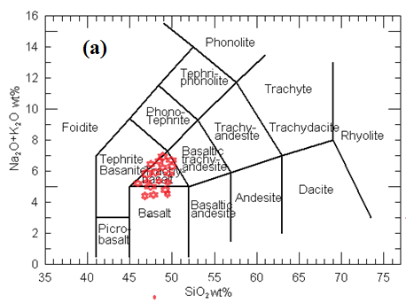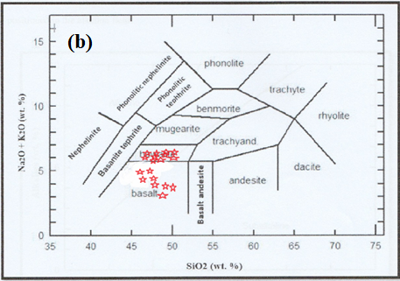

Figure 7. (a) SiO2 vs. (Na2O + K2O) (TAS) diagram after [29], the rock samples (KBR) study plotted within basalt to Trachy basalt Field; (b) SiO2 vs. (Na2O + K2O) diagram after (**22)**, the rock samples study plotted within basalt Trachy filed.

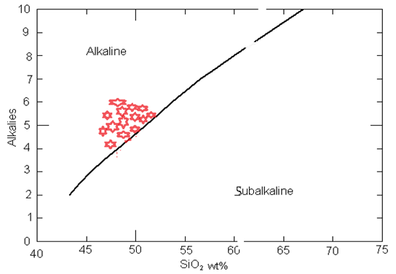

Figure 8: The total alkali - Silica diagram with the (**30**) boundary line which show that (KBR) samples plot within alkaline field.

**4.2.2. Trace elements**

The trace elements analysis of Cr, Ni, Br, Sr and Zr shows high content in the samples studied of **KBR**. The content of Cr range between 33.7 to 55.2 ppm with an average 44.3, Ni range between 29.3 to 45 ppm with an average 37.76, Ba range between 56.9 to 94.4 ppm with an average 75.32, Sr ranged between 72 to 180 ppm within range 140.8 and Zr range between 130 to 268.3 within average 168.52 (**Table 1**). The high content of Cr and Ni indicated by the parental magma has been derived through partial melting of peridotite mantle source, with the presence of olivine and pyroxene fractions in the KBR **[3] [20] [29] [31].** The binary diagram in **Fig. 9** shows that Mg# versus Cr, Ni, Ba, Sr, and Zr shows a general increase with increasing Mg# (wt%) content. The simple decrease of Ni and a simple increase of Cr (ppm) with increasing Mg# indicate that Olivine and Clinopyroxene played a dominant role during crystal fractionation (**32**). The negative correlation between Mg# and Ni indicates the absence of fractional crystallisation of olivine **(Figure 9 a),** and the clinopyroxene crystallisation occurs on the basis of a simple increase between Mg# and Cr **(Fig. 9 b)** (**33) (34).** The simple concentration of Ni and Cr of KBR basalt in general may indicate for derivation of parental magmas from a peridotite mantle source of KBR magmas (**29**). The Strontium (Sr) have ability to substitution for (Ca) in plagioclase and for (K) in K - feldspar because of similar elemental properties also Sr or Ca/Sr ratio is a good indicator of plagioclase involvement at shallow levels and behaves as an in compatible element under mantle conditions (**35).** The Sr, Zr and Ba are increasing with the increasing Mg# content which is a common feature of alkaline rocks (**36).**

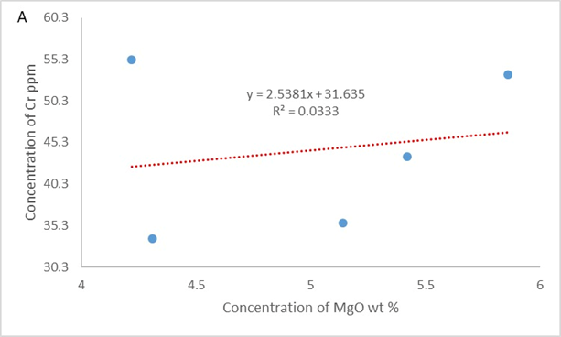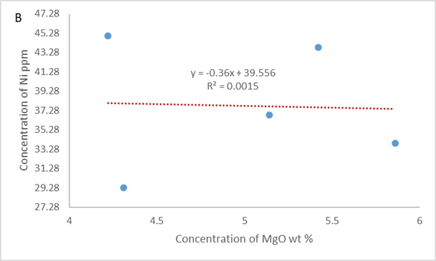

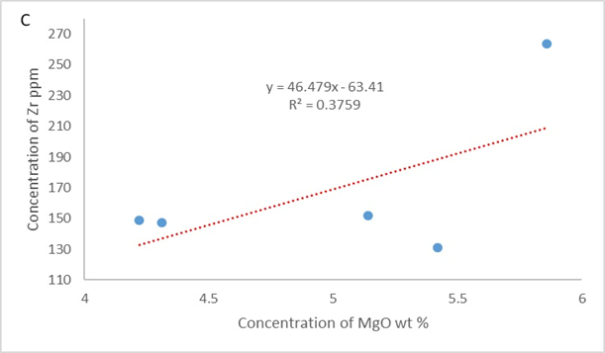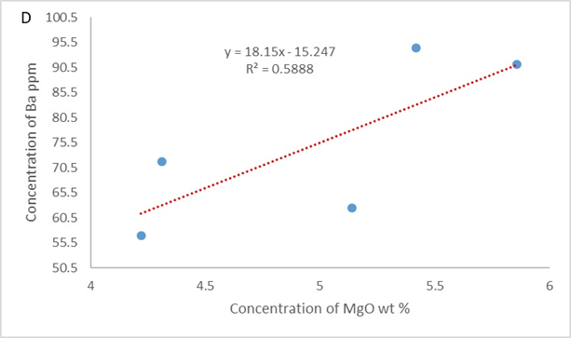

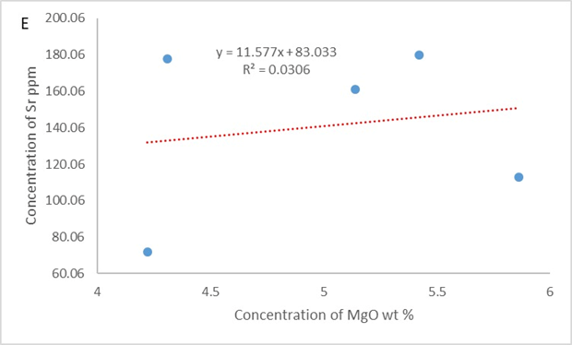

Figure 9: Mg# Vs. Cr, Ni, Zr, Ba, Sr Data for KBR samples study.

* 1. **Petrogenesis**

The chemical analysis of the KBR samples study for major and trace elements was used to construct discriminatory diagrams, which help in the classification of rocks. The Classification for **[30]** includes all the KBR samples plotted within the alkaline rock field (**Fig. 8**). The AFM diagram shows the KBR rock samples plotted within the calcalkaline series (**Fig. 10a).** The ternary diagrams for Ti-Zr-Sr diagrams (**Fig. 10b**) after **[37**], show all the KBR rock samples studied plotted within the calcalkaline basalt field. The MgO-FeO(tot)-Al2O3 diagram after **[38],** shows the KBR rock samples were plotted within continental basaltic field (**Fig. 10c**). The low content of SiO2 range between 47.08 to 49.93 wt%) and high content of MgO between (3.87 to 5.86 wt%) with an average of 4.86 wt%, and total FeO + Fe2O3 range between (10.41 to 13.41 wt% with an average of 11.91 wt%) indicated the natural fractionation of the KBR (**20)**. The high concentration of Cr and Ni, ranging between 33.7 to 55.2 ppm with an average of 44.3 ppm and Ni between 29.3 to 45 ppm with an average 37.76 ppm, respectively, is consistent with findings reported for primary magma **[3] [39] [40] [39**]. The high Mg# within an average of 46.39 for KBR is similar to that reported for rock affected by fractionation or accumulation of pyroxene, as well as olivine and plagioclase **[14].**

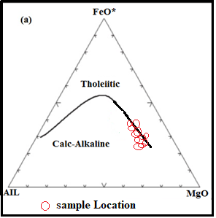 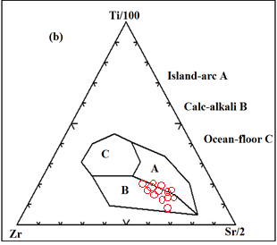

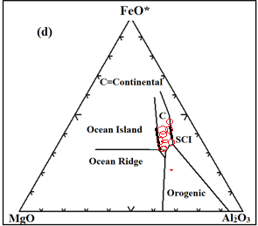

Figure 10: (a) AFM diagram after **[30]**), shows the basalt rock samples study (KBR) were located within the Calc-Alkaline basalt field; (b): Ti-Zr-Sr discrimination diagram after **[38],** shows the KBR rock samples were plotted within the Calc-alkali basalt field;(c): Discrimination diagram MgO-FeO(tot)-Al2O3 after **[38],** shows the KBR rock samples plotted within the continental basaltic field.

1. **Conclusion**

The following presents the study area for Mineralogy, petrology, geochemistry and Petrogenesis of the KBR demonstrates the following conclusions:

1. All samples of the KBR mainly contain olivine, pyroxene, plagioclase, and opaque minerals (iron oxide). Secondary minerals such as Iddingsite, which is a result of the alteration process of olivine.
2. Many types of textures have been observed in the sample study, such as: porphyritic, intergranular, vesicular, glomeroporphyritic, radiate, embayment, zoning olivine, ophitic and subophitic texture.
3. Petrographically, we can classify KBR as Alkali-olivine basalt.
4. Normative mineralogy by using CIPW Norm showed that KBR basalt samples are dominated by anorthite, albite, olivine, orthoclase, Diopside, hematite, nepheline, olivine and a low per cent of apatite, perovskite and ilmenite.
5. The chemical classification of KBR basalt suggests that the samples can be classified as alkaline basalt and belong to the sodic series.
6. The normalised trace element diagram suggests that the A product of the asthenosphere part and without clear evidence for crustal contamination.
7. The simple concentration of Ni and Cr of KBR basalt in general may indicate for derivation of parental magmas from a peridotite mantle source of KBR magmas.
8. The discrimination diagram for Ti-Zr-Sr shows that the KBR rock samples were plotted within the Calc-alkali basalt and MgO-FeO(tot)-Al2O3 diagram shows the KBR rock samples plotted within the continental basaltic field.
9. The high Mg# within an average of 46.39 for KBR is similar to that reported for rock affected by fractionation or accumulation of pyroxene, as well as olivine and plagioclase.

Disclaimer (Artificial intelligence)

Option 1:

Author(s) hereby declare that NO generative AI technologies such as Large Language Models (ChatGPT, COPILOT, etc.) and text-to-image generators have been used during the writing or editing of this manuscript.

Option 2:

Author(s) hereby declare that generative AI technologies such as Large Language Models, etc. have been used during the writing or editing of manuscripts. This explanation will include the name, version, model, and source of the generative AI technology and as well as all input prompts provided to the generative AI technology

Details of the AI usage are given below:

1.

2.

3.

**References:**

1. Bender, F. Geology of the Arabian Peninsula, Jordan. In: Open-File Report, US Geological Survey, Reston, 1974, VA, 560-561. https://doi.org/10.3133/ofr74215

2. El-Hasan, T. and Al-Malabeh, A. Geochemistry, Mineralogy and Petrogenesis of El-Lajjoun Pleistocene Alkali Basalt of Central Jordan. Jordan Journal of Earth and Environmental Sciences, 2008, 1, 53-62

3. Shaw, J.E., Baker, J.A., Menzies, M.A., Thirlwall, M.F. and Ibrahim, K.M. Petrogenesis of the Largest Intraplate Volcanic Field on the Arabian Plate (Jordan): A Mixed Lithosphere-Asthenosphere Source Activated by Lithospheric Extension. Journal of Petrology, 2003, 44, 1657-1679. <https://doi.org/10.1093/petrology/egg052>.

4. Barberi, F., Capaldi, P., Gasperihi, G., Marinelli, G., Santacroce, R., Treuil, M. and Varet, J. Recent Basaltic Volcanism of Jordan and Its Implication on the Geodynamic History of the Dead Sea Shear Zone. In: International Symposium Geodynamic Evolution of the Afro-Arabian Rift System, Academia Nazionale Dei Lincei, 1979, 47, Rome, 667-683.

5. Ibrahim, K.M. and Al-Malabeh, A. Geochemistry and Volcanic Features of Harrat El Fahda: A Young Volcanic Field in Northwest Arabia, Jordan. Journal of Asian Earth Sciences, 2006, 27, 147-154. <https://doi.org/10.1016/j.jseaes.2005.01.009>.

6. El-Akhal, H. Contribution to the Petrography, Geochemistry, and Tectonic Setting of the Basalt Flows of the Umm-Qais Plateau, North Jordan. Geological Bullletin of Turkey, 2004, 47, 1-10.

7. Ibrahim, K.M., Moh’d, B.K., Masri, A.I., Al-Taj, M.M., Musleh, S.M. and Alzughoul, K.A. Volcano Tectonic Evolution of Central Jordan: Evidence from the Shi-han Volcano. Journal of African Earth Sciences, 2014, 100, 541-553. <https://doi.org/10.1016/j.jafrearsci.2014.07.021>.

8. Shaw, J. Geochemistry of Cenozoic Volcanism and Arabian Lithospheric Mantle in Jordan. Unpublished Ph.D. Thesis, University of London, 2003, London.

9. Alnawafleh, H., Tarawneh, K., Ibrahim, K., Zghoul, K., Titi, A., Rawashdeh, R., Moumani, K. and Masri, A. Characterization and Origin of the Miocene Mudawwara-Quwayra Basaltic Dike, Southern Jordan. International Journal of Geosciences, 2015, 6, 869-881. <https://doi.org/10.4236/ijg.2015.6807>.

10. Bany Yaseen, I.A. Contribution to the Petrography, Geochemistry, and Petrogenesis of Zarqa-Ma’in Pleistocene Alkali Olivine Basalt Flow of Central Jordan. International Journal of Geosciences, 2014, 5, 657-672. <https://doi.org/10.4236/ijg.2014.56059>.

11. Özdemir, Y., Mercan, Ç., Oyan, V. and Özdemir, A.A. Composition, Pressure, and Temperature of the Mantle Sources Region of Quaternary Nepheline-Basanitic Lavas in Bitlis Massif, Eastern Anatolia, Turkey: A Consequence of Melts from Arabian Lithospheric Mantle. Lithos, 2019, 328-329, 115-129. <https://doi.org/10.1016/j.lithos.2019.01.020>.

12. Ibrahim, K.M. The Regional Geology of Al-Azraq Area Map Sheet No. 3553I. Bulletin No. 36, Natural Resources Authority, Geological Mapping Division, 1996, Amman.

13. Ibrahim, K.M. Geological Map of Al Azraq Area, Map Sheet No. 35531. Natural Resources Authority (NRA), Geology Directorate, 1993, Amman

14. Rollinson, H. Using Geochemical Data, Evaluation, Presentation, Interpretation, Longman Scientific and Technical. John Wiley & Sons, In, 1993.

15. Guthrie, J.M., Overview of X-Ray Fluorescence. University of Missouri Research Reactor, 2012.

16. Ahmad Al Hiyari. Geological map of Qasr Al Hallabat, 3254 II, scale 1:50,000, Geological mapping Division, Natural Resources Authority, Geology Directorate, Amman Jordan, 2004.

17. Yazdi, A., Ashja-Ardalan, A., Emami, M., Dabiri, R. and Foudazi, M. Chemistry of Minerals and Geo Thermobarometry of Volcanic Rocks in to located in Southeast of Bam Kerman Province. Open Journal of Geology, 2017, 7, 1644-1653. <https://doi.org/10.4236/ojg.2017.711110>

18. Morimoto, N. Nomenclature of Pyroxenes. Mineralogical Magazine, 1988, 52, 535-550. <https://doi.org/10.1180/minmag.1988.052.367.15>

19. Al-Malabeh, A. Cryptic Mantle Metasomatism: Evidences from Spinel Lherzolite Xenoliths/Al-Harida Volcano in Harrat Al-Shaam, Jordan. American Journal of Applied Sciences, 2009, 6, 2085-2092. <https://doi.org/10.3844/ajassp.2009.2085.2092>.

20. Al-Fugha, H. and Bany Yaseen, I.A.A. Petrography, Geochemistry and Petrogensis of Pleistocene Basaltic Flow from Northwest Atarous Area, Central Jordan. International Journal of Geosciences, 2019, 10, 613-631. https://doi.org/10.4236/ijg.2019.106035

21. Le Maitre, R.W., Bateman, P., Dudek, A., Keller, J., Lameyre Le Bas, M.J., Sabine, P.A., Schmid, R., Sorensen, H., Streckeisen, A., Woolley, A.R. and Zanettin, B. A. Classification of Igneous Rocks and Glossary of Terms. Blackwell, Oxford, 1989.

22. Cox, K., Bell, J. and Pankhurst, R. The Interpretation of Igneous Rocks. Springer, London. 1979, <https://doi.org/10.1007/978-94-017-3373->

23. Bany Yaseen, I.A. A. Contribution to the Petrography, Geochemistry, and Petrogensis of Zarqa-Ma’in Pleistocene Alkali Olivine Basalt Flow of Central Jordan. International Journal of Geosciences, 2014, 5, 657-672.

24. Bany Yaseen, I.A. A. Petrography, Geochemistry and Petrogenesis of Basal Flow from Ar-Rabba Area, Central Jordan. International Journal of Geosciences, 2016, 7, 378-396. <https://doi.org/10.4236/ijg.2016.73030>.

25. Bany Yaseen, I. and Abidrabbu, A. (2016) Mineralogy, Petrology and Geochemistry of the Basalt Flows at Ash-Shun Ash-Shamaliyya Area, North West Jordan. Earth Sciences, 5, 82-95. [28] Al Smadi, A., Al-Malabeh, A. and Odat, S. (2018) Characterization and Origin of Selected Basaltic Outcrops in Harrat Irbid (HI), Northern Jordan. Jordan Journal of Earth and Environmental Sciences, 9, 185-196

26. Al Smadi, A., Al-Malabeh, A. and Odat, S. (2018) Characterization and Origin of Selected Basaltic Outcrops in Harrat Irbid (HI), Northern Jordan. Jordan Journal of Earth and Environmental Sciences, 9, 185-196.

27. Ma, G.S.-K., Malpas, J., Xenophontos, C. and Chan, G.H.-N. (2011) Petrogenesis of Latest Miocene-Quaternary Continental Intraplate Volcanism along the Northern Dead Sea Fault System (Al-Ghab-Homs Volcanic Field), Western Syria: Evidence for Lithosphere-Asthenoshere Interaction. Journal of Petrology, 52, 401-430. <https://doi.org/10.1093/petrology/egq085>.

28. Winchester, J.A. and Floyd, P.A. (1977) Geochemical Discrimination of Different Magma Series and Their Differentiation Products Using Immobile Elements. Chemical Geology, 20, 325-343. https://doi.org/10.1016/0009-2541(77)90057-2

29. Wilson, M., (1989). Igneous Petrogenesis a Global Tectonic Approach. Unwin Hyman, London. 466p.

30. Irvin, T.N. and Baragar, W.R. (1971) A Guide to the Chemical Classification of the Volcanic Rocks. Canadian Journal of Earth Sciences, 8, 523-548.

31. Winter, J.D. (2001) An Introduction to Igneous and Metamorphic Petrology. Prentice Hall Inc., Upper Saddle River, NJ, 697.

32. Espinoza, F ., Morata, D., Pelleter, E., Maury, R. C., Suarez, M., Lagabrielle, Y., Polve, M., Bellon, H., Cotton, J., De la Cruz, R., Guivel, C., (2005). Petrogenesis of the Eocene and Mio_Pliocene alkaline basaltic magmatism in Meseta Chile Chico, southern Patagonia, Chile: evidence for the participation of two slab windows. Litho 82, 315_343.

33. Frost, B, R., and Frost C, D, (2014). Essentials of Igneous and Metamorphic Petrology. Cambridge University Press. 314 P.

34. Reichow, M.K., Saunders, A.D., White, R.V., Al Mukhamedov, A.I., and Medvedev, A.Ya., (2005). Geochemistry and Perogenesis of basalts from the West Siberian Basin: an extension of the Permo_Triassic Siberian Traps, Russia. Lithos 79 (3 _4), 425_452.

35. Scareberry, K. C., (2003). Volcanology, Geochemistry and Stratigraphy of the F Basalt Flow Group, Eastern Snake River Plain, Idaho. MSc thesis State University, Idaho USA, 139 P.

36. Kucuk, A.A., (2014). Petrography and mineral chemistry of the basaltic rocks and dykes from the burunkoy (Corum) region, Turkey. MSc thesis, Middle East Technical University, Ankara Turkey, 165 p.

37. Pearce, J.A. and Cann, J.R. (1973) Tectonic Setting of Basic Volcanic Rocks Determined Using Trace Element Analyses. Earth and Planetary Science Letters, 19, 290-300. https://doi.org/10.1016/0012-821X(73)90129-5

38. Pearce, T.H., Gorman, B.E. and Birkett, T.C. (1977) The Relationship between Major Element Chemistry and Tectonic Environment of Basic and Intermediate Volcanic Rocks. Earth and Planetary Science Letters, 36, 121-132. <https://doi.org/10.1016/0012-821X(77)90193-5>

39. Watts, B.G., Bennett, M.E., Kopp, O.C. and Mattingly, G.L. (2004) Geochemistry and Petrography of Basalt Grindstones from the Karak Plateau, Central Jordan. Geoarchaeology, 19, 47-69. <https://doi.org/10.1002/gea.1010>.

40. Alnawafleh, H., Tarawneh, K., Ibrahim, K., Zghoul, K., Titi, A., Rawashdeh, R., Moumani, K. and Masri, A. (2015) Characterization and Origin of the Miocene Mudawwara-Quwayra Basaltic Dike, Southern Jordan. International Journal of Geosciences, 6, 869-881. <https://doi.org/10.4236/ijg.2015.68071>

41. Hammam, A., Nagy, A., Abu-Mahfouz, I. S., & Al-Yaseri, A. (2025). Assessing CO2 Sequestration Potential in Cenozoic Basaltic Rocks of Harrat Al-Shaam, Jordan. Ore and Energy Resource Geology, 100105.

42. Al-Fugha, H., & Al-Malabeh, A. (2023). Mineralogy, geochemistry and petrogensis of pleistocene volcanism from dear Al-kahef basaltic field (Harrat Al-Shaam), Northeast Jordan. Jordan Journal of Earth and Environmental Sciences, 14(4).

43. Liang, C. G., Guo, Z. S., Yue, X., Li, H., & Ma, P. C. (2023). Microwave-assisted breakage of basalt: A viewpoint on analyzing the thermal and mechanical behavior of rock. Energy, 273, 127225.

44. Luchese, A. V., de Castro Leite, I. J. G., da Silva Giaretta, A. P., Alves, M. L., Pivetta, L. A., & Missio, R. F. (2023). Use of quarry waste basalt rock powder as a soil remineralizer to grow soybean and maize. Heliyon, 9(3).