Two Species of Moss Inhabitant Testate Amoebae (Centropyxidae And Lesquereusiidae) Join Indian Testate Fauna

ABSTRACT

The epiphytic bryophytes as a microbial habitat on trees in terrestrial environment holds diverse microscopic organisms. These moss habitats are suitable for testate amoebae which are bioindicators of envirornment. The present investigation on testate amoebae population in tree mosses, collected during various surveys from Parambikulam Tiger Reserve, Kerala and Taluka, Uttarakhand. The study recorded two species of testate amoebae viz., Centropyxis bipilata Bakovic et al., 2019 and Paraquadrula discoides (Penard, 1893) Deflandre,1932 are new additions to Indian testate fauna.

Key Words: Protozoa, Testate Amoebae, Moss, Epiphytic bryophytes

- INTRODUCTION

The importance of mosses in Indian Ramsar wetlands must be studied by considering their contribution to ecological well-being through biodiversity support and soil moisture regulation as well as their function in nutrient cycling. Nonvascular micro-organisms help to maintain environmental well-being by ensuring waterstability while offering living conditions to testate amoebae and various other microorganisms (Sathish Kumar et al., 2025). Testate amoebae are tiny shelled amoebae, occurs in aquatic and moist terrestrial habitats, and plays an important role in biomonitoring and palaeoecological studies (Simova et al., 2022). Their shorter life cycle relates to indicating the ecological changes in the habitat. Testate amoebae are present in large quantities and high densities in Sphagnum biotopes and play essential roles in the microbial loop, nutrient cycling, and ecosystem processes.

Testate amoebae community engaged their survivorship highly influenced by the environmental factors and nutrients, moisture and temperature available in the mosses (Mitchell and Gilbert, 2004; Warner et al., 2007; Charman, 2001). The importance of moisture to testate amoebae is well known with some taxa and they are occurring most abundantly in wet environments. Studies in various environments have proved the significance of moisture on testate amoebae biology and ecology (Wanner, 2007; Charman, 2001) and present study also proves that the abundance of testate amoebae was found in tree mosses where moisture content was more. The geographical distribution of testate amoebae has been reported all over the world. Globally about 675 species under 104 genera, 22 families were reported from testate amoebae. The diverse testate amoebae of about 209 species under 37 genera were explored from India (Bindu et al., 2024). The research on moss dwelling testate amoebae have been reported from India (Chattopadhyay and Das, 2003).

- MATERIAL AND METHODS

The moss/bryophytes samples for the present study were collected during the faunistic surveys of Zoological survey of India by scraping from tree bark from Taluka at Uttarakhand and Parambikulam Tiger Reserve of Kerala. The collected bryophytes were processed by non-flooded petri dish method developed by Foissner (1992). The testate amoebae population were sorted and the isolated specimen were permanently mounted in DPX medium and subjected to identification under 400 to 1000x magnification using Leica DM 2000 microscope. Permanent slides were prepared and deposited in the National Zoological collection of Marine Biology Regional centre, Chennai and Western Ghat Regional Centre, Kozhikode, Kerala. The classification followed is Adl et al. (2019).

- RESULTS AND DISCUSSION
The details of the new additions of testate species are provided below.

Systematic Account

Phylum: Tubulinea Smirnov et al., 2005
Class: Corycida Kang et al., 2017
Order: Arcellinida Kent, 1880
Infraorder: Excentrostoma Lahr et al., 2019
Family: Centropyxidae Jung, 1942
Genus: Centropyxis Stein, 1857

Description of species

- Centropyxis bipilata Bakovic et al., 2019 (Fig.1)

Material examined: Reg No. Mi-1149; 2 examples, Date of collection: 13.x.2019 (31.0781°N and 78.2454° E); Tree moss, Taluka, Uttarakhand.

Diagnostic characters: Test is round and wider in lateral view, composed or granular organic cement with mineral particles. Colour of the test yellowish to brown. The aperture is eccentric, invaginated, elliptical, spherical and ovoid. The edge of pseudosome curves inward, creating a small but clear ring, differentiated by slightly darker than the rest of the area in the test. Two struts connected more or less U shaped opening with anterior part and inner anterior dorsal wall of the test. Lack of spines on the test.

Family: Lesquereusiidae Jung, 1942
Genus: Paraquadrula Deflandre, 1932

Description of species

2. Paraquadrula discoides (Penard, 1893)) Deflandre, 1932 (Fig.2)

Material examined: Reg. No. INV.27662 /3; Date of collection, 27.vii. 2024; (10.4463 N and 76.8129 E); tree moss, Anappady, Parambikulam TR, Kerala

Diagnostic characters: Test broad oval slightly compressed, transparent composed of quadrangular calcite shell- plates in rows, sheet like cement on shell surface and the neck slightly raised ended up with shell plate without any border at oral aperture.

- CONCLUSION
Perusal of literature revealed that 27 species under the genus Centropyxis and 1 species under the genus Paraquadrula were recorded so far from India (Bindu et al., 2024). The present record of Centropyxis bipilata has close similarities with the morphology of Centropyxis laevigata and Centropyxis delicatula. Globally about 8 species were reported under the genus Paraquadrula whereas P. irregularis was reported from Kashmir and Kerala (Jheelani et al. 2018). The present record of P. discoides has similarities with the already reported P. irregularis. In conclusion the present communication reports two species of testate amoebae viz., Centropyxis bipilata Bakovic et al., 2019 and Paraquadrula discoides (Penard, 1893)) Deflandre, 1932 as new additions to Indian testate fauna.

Disclaimer (Artificial intelligence)

Option 1:

Author(s) hereby declare that NO generative AI technologies such as Large Language Models (ChatGPT, COPILOT, etc.) and text-to-image generators have been used during the writing or editing of this manuscript.

REFERENCES
Simova, A., Jirousek, M., Singh, P., Hajkova,P., & Hajek, M., (2022). Ecology of testate amoebae along an environmental gradient from bogs to calcareous fens in East- Central Europe: development of transfer functions for palaeoenvironmental reconstructions. Paleogeography, Palaeoclimatology, Palaeoecology., 601:111145.
Mitchell, E.A. D., & Gilbert, D. (2004). Vertical micro-diustribution and response to nitrogen deposition of testate amoebae in Sphagnum. Journal of Eukaryotic Microbiology, 51(4): 480 – 490.
Warner, B.G., Asada, T., & Quinn, N.P., (2007). Seasonal influences on the ecology of testate amoebae (Protozoa) in a small sphagnum peatland in southern Ontario, Canada. Microb. Ecol., 54(1): 91-100.
Charman, D.J. (2001). Biostratigraphic and palaeoenvironmental applicatiuons of testate amoebae. Quarternary Science Review., 20: 1753 – 1764.
BIndu, L., Purshothaman, J., Ambili, A., & Chaudhury, A. (2024). Testate Amoeba (Protozoa: Tubulinea; Cercozoa; Stramenopiles). Version 1.0.Zoological Survey of India.
Chattopadhyay, P., & Das, A.K. (2003). Morphology, morphometry and ecology of moss dwelling testate amoebae (Protozoa: Rhizopoda) of North and North-East India. Memoirs of the Zoological Survey of India. 19(4): 1- 113.
Foissner, W. (1992). Estimating the species richness of soil protozoa using non-flooded petridish method. In J. J. Lee & A. T. Soldo (Eds.), Protocols in Protozoology (p. 119). Allen Press.
Adl, S.M., Bass, D., Lane, C.E., Lukes, J., Schoch, C.L., Smirnov A., et al. (2019). Revisions to the classification, nomenclature, and diversity of eukaryotes. Journal of Eukaryotic Microbiology.66: 4– 119.
Jeelani, M. Kaur., Mudasir, H., Huma,S., Sheikh,B., & Sarwar, S.G. (2018). Use of protozoa as Biological indicators of water quality and Pollution. International Journal of Advance Research in Science and Engineering., 7(4): 2021-2030.
V. M, Sathish Kumar., Bindu. L, and Anil Kumar. 2025. “Pioneering Study of Testate Amoebae in Nagi Bird Sanctuary of Bihar, India: A Contribution to Ramsar Site Microfauna”. Annual Research & Review in Biology 40 (2):81-89. https://doi.org/10.9734/arrb/2025/v40i22204.

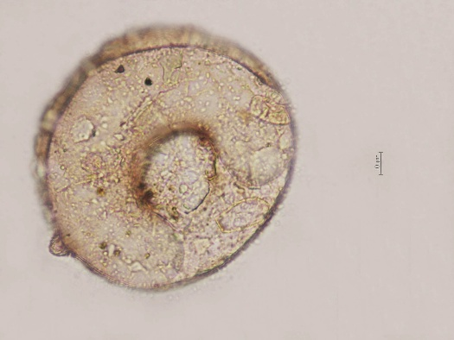 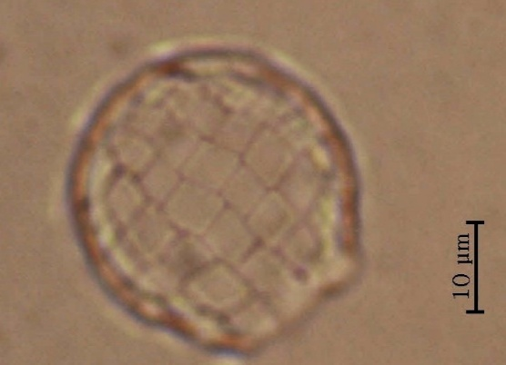 Fig. 1. Centropyxis bipilata Bakovic et al., 2019 Fig. 2. Paraquadrula discoides (Penard, 1893)
Deflandre, 1932

