**The application of** **sustainable herbs as therapeutic substitutes for treating goat scabies infestations.**

**Abstract**

Mange mite infestations, particularly those caused by *Sarcoptes scabiei*, are a significant concern in goat farming due to their severe impact on animal health, productivity, and welfare. These infestations are not only highly contagious among livestock but also zoonotic, posing health risks to humans. Traditional chemical acaricides such as Ivermectin have been widely used for treating mange; however, the emerging need for sustainable and eco-friendly alternatives has led to increased interest in herbal formulations. This study evaluates and compares the long-term efficacy of Ivermectin and a herbal oil-based mixture comprising neem oil, karanj oil, and camphor in the management of *Sarcoptes scabiei* infestation in goats over a period of 10 months.A long term control of *Sarcoptes scabiei* infestation study was conducted by using the Ivermectin @ 200 µg/kg body weight s/c in group I (Six goats) and herbal mixture ( Neem oil 50 ml+ Karanj oil 50 ml+ Camphor 10 gm) applied on the body in group II (Six goats) for seven consecutive days along with supportive therapy against sarcoptic mange in goats. The results suggest that both treatment protocols are highly effective and safe, with the herbal mixture showing promising potential for sustainable mange control in small ruminants.

**Introduction**

Mange is a parasitic skin disease primarily caused by mite infestations and is characterized by intense itching, inflammation, scab formation, and in severe cases, extensive hair loss and secondary infections (*Murray etal.,* 2023 and Nowland*et al* 2015). Among the various types of mange affecting goats, sarcoptic mange caused by *Sarcoptes scabiei* is particularly serious due to its zoonotic potential and high morbidity(*Bhardwaj et al,2010,Falohun et al* 2015&*Jalajakshi et al* 2023).

The infestation severely affects the economic returns from goat farming due to reduced weight gain, milk production, fertility issues, and hide damage. Furthermore, if left untreated, mange can lead to death from secondary infections and immune suppression. Conventional treatments rely heavily on chemical acaricides like Ivermectin, which, although effective, may lead to resistance with overuse and raise concerns regarding residues in meat and milk products(*Emily et al* .,2017 and Sinha *et al* 2024).

Given the growing emphasis on organic livestock farming and sustainable animal husbandry practices, herbal remedies have gained prominence as alternative treatments. Indigenous knowledge and traditional veterinary practices have identified neem, karanj, and camphor as potential herbal acaricides due to their anti-inflammatory, antiseptic, and antiparasitic properties(*Jesse,et al* 2016 and *Khalafallah et al.,* 2020).

This study explores a sustainable approach to mange treatment by evaluating a herbal formulation and comparing its efficacy with a standard chemical treatment, while also assessing long-term results, safety, and practicality in field conditions.

**Materials and methods**

The present study was conducted on 18 goats naturally infested with *Sarcoptes scabiei* mites as confirmed by clinical and skin scraping examination of the lesions for their morphological features (Soulsby, 1982, Sen and Fletcher, 1962). Goats infested with mites were segregated into three groups of six animals in each. Six goats of group I were injected Ivermectin 200 µg/kg body weight and Group II (6) goats were applied with a herbal mixture ( Neem oil 50 ml +karanj oil 50ml +camphor 10 gm ) for seven consecutive days. For local application of the drugs goats were bathed with savlon to remove dirt, crust and scales. Then the mixture was applied on the animals. Group IIIrd (6) goats were kept as infected untreated control throughout the observation period of 10 months. The percentage efficacies of the two acaricides were assessed on 3rd ,7th ,9th , and 11th day as per the method of Srivastava *et al*. (1993).

All the experimental animal used for the trials were kept as far as possible free of erroneous infection other than the ectoparasite by suitable therapeutic management while the reinfection of the mites were cured by repeating the herbal mixture only at 30 days interval. All the goats were maintained on concentrates with sufficient grazing.

**Results and Discussion**

The therapeutic efficacies of Ivermectin and herbal mixture ( Neem oil 50 ml +Karanj oil 50ml +Camphor 10 gm ) were evaluated and presented in the **Table 1.**

**Table 1.**

**Percent efficacies of Ivermectin and herbal mixture ( Neem oil 50 ml +karanj oil 50ml +camphor 10 gm )packages against *Sarcoptes scabiei* infestation in goats**

|  |  |  |  |  |  |  |
| --- | --- | --- | --- | --- | --- | --- |
| Groups (No of animals) | Drugs dosage and administration | Average total pre treatment mite count in 6 cm2  Area. | Average post treatment mite count & percent efficacies on different days. | | | |
| 3rd day | 7th day | 9th day | 11th day |
| I (6) | Ivermectin 200 µg/kg body weight + supportive drug as per need | 248.33 ±18.02 | 124.33±9.77 (50.03) | 62.33  ±5.56  (75.08) | -  (100) | -  (100) |
| II (6) | Herbal mixture ( Neem oil 50 ml +karanj oil 50ml +camphor 10 gm ) + supportive drug as per need | 245.00  ±14.48 | 143.33±8.39 (41.35) | 87.00± 6.25 (64.48) | 43.50±2.93  (82.25) | -  (100) |
| III (6) | infected untreated | 243.33±14.47 | 260.00± 13.33 | 361.66±13.23 | 264.16±13.27 | 264.16±13.27 |
| NOTE  1.All the treated animals were kept free from mite infestation by repeating treatment at 30 day interval in herbal mixture ( Neem oil 50 ml +Karanj oil 50ml + Camphor 10 gm )  2. Supportive treatment : Liverstimulant, Antidiarrhoel, Appetizers, Vitamins, Haematinics, Antibiotics and other drugs used as and when needed.  3. Figures in parentheses indicate the percent efficacies of drugs. | | | | | | |

The results obtained revealed that treatment with Ivermectin completely cured sarcoptic mange infected animals on 9th day post treatment (DPT). Almost similar findings have been reported by Rehbein *et al.* (2002) and Sinha *et al.,* 2024 in cattle and dog respectively.

The responses of the goats to the herbal mixture ( Neem oil 50 ml + Karanj oil 50ml + Camphor 10 gm ) showed improvement from 3rd day post treatment, reddening and irritation of the affected skin was reduced. Marked improvement in overall condition of the skin with hair growth and shining was seen seventh DPT(Pic1 and Pic 2). Goats became negative for mites or their eggs on 11th day post treatment. The usefulness of herbalmixture ( Neem oil 50 ml +karanj oil 50ml +camphor 10 gm )as a good ectoparasiticidal agent have also been reported in pigs Sinha *et al.,* 2024.Azeem *et al* 2023 and Souza *et al* 2017also reported the use of neem as ectoparasite control.

Repeated application of both the specific and supportive drugs in mange affected animals kept all the treated animals free from *S. scabiei* infection upto 10 months which showed that the treatment protocol were quite safe and pose as a suitable remedy for mange in goats.

The findings of this study confirm the high efficacy of both Ivermectin and the herbal oil mixture in controlling *Sarcoptes scabiei* infestation in goats. Ivermectin, being a systemic macrocyclic lactone, acts rapidly by disrupting neurotransmission in parasites. Its proven efficacy in mange control has been documented across various species including cattle and dogs (Rehbein et al., 2002; Sinha et al., 2024).

However, the excessive reliance on chemical acaricides presents several changes. One of the most pressing concerns is the potential development of drug resistance among parasite populations, which can render treatments ineffective over time . Additionally, the use of these chemicals may lead to residual toxicity in animal derived products, raising concerns about food safety. Environmental pollution is another significant issue, as chemical runoff can contaminate soil and water sources. In contrast herbal treatments such as neem and karanj oils offer a sustainable alternative with numerous benefits. These plant based oils are ecofriendly,being both biodegradable and non –toxic to the environment. They also pose minimal risk of toxicity to animals and humans, making them a safer choice for parasite control. Moreover, they are widely available in rural and semi-urban areas of India, ensuring accessibility for small scale farmers. Beyond their acaricidal properties, neem and karanj oils also exhibit anti- inflammatory, antibacterial, and wound healing effects, making them multifunctional agents in the treatment and management of parasitic infestations.Studies such as Peryasamy et al. (2018) have also validated the use of neem-based treatments in camels, and Sinha *et al.* (2024) observed similar outcomes in pigs.

The present study effectively highlights that both conventional (Ivermectin) and alternative (herbal oil-based) treatment protocols are capable of managing sarcoptic mange infestations in goats with high efficacy. Ivermectin, due to its systemic mode of action and rapid onset, demonstrated faster symptomatic relief and quicker clinical recovery. However, the repeated use of chemical acaricides raises legitimate concerns regarding drug resistance, residue accumulation in animal products, and environmental contamination, all of which have long-term implications for sustainable livestock production and food safety.

On the other hand, the herbal formulation comprising neem oil, karanj oil, and camphor provided a comprehensive and environmentally safe treatment option. Although the herbal treatment exhibited a slightly slower onset of action compared to Ivermectin, it ultimately achieved complete clinical and parasitological recovery by day 11. Moreover, its ability to prevent reinfestation over a 10-month observation period underscores its potential not only as a therapeutic agent but also as a prophylactic measure in endemic areas

**Conclusion**

.

The broader significance of this research lies in its contribution to sustainable veterinary practices. The use of readily available, cost-effective, and eco-friendly plant-based resources aligns with the principles of One Health by reducing chemical inputs and promoting animal welfare without compromising efficacy. This is especially relevant for resource-poor farmers, organic producers, and remote communities where access to commercial pharmaceuticals may be limited or economically burdensome.

Based on the findings, several key recommendations emerge for sustainable mange mite management in goats. The integration of herbal therapies, particularly the herbal oil mixture used in the study, is suggested as a viable component of an integrated parasite management strategy. This approach is especially suited for organic and backyard goat farming systems where chemical use is limited or discouraged. To maintain the protective effects and reduce the risk of reinfestation, it is recommended that the herbal mixture be reapplied monthly. Additionally, further research through large- scale studies is essential to validate the formulation’s effectiveness across various goat breeds, environmental conditions, and mite species. These studies should also assess the impact of herbal treatment on important production parameters such as milk yield and growth rates. Lastly, extension and awareness programs should be implemented to educate farmers and veterinary practitioners on the preparation, application and advantages of herbal treatments, thereby promoting broader adoption of this sustainable approach.

In conclusion, the herbal mixture offers a promising, practical, and sustainable alternative to conventional acaricides. Its dual role in treatment and prevention, coupled with its safety profile and affordability, makes it a valuable tool in the long-term management of mange mite infestations in goats. Embracing such indigenous and eco-conscious solutions is pivotal to achieving resilient and responsible animal husbandry in the face of growing environmental and public health challenges.

**Acknowledgement**

Authors are thankful to the Dean, Faculty of Veterinary Science and AH, Ranchi for providing necessary physical and financial fascilities to conduct these trials.

**Disclaimer (Artificial intelligence)**

Author(s) hereby declare that NO generative AI technologies such as Large Language Models (ChatGPT) and text- to- image generators have been used during the writing or editing of this manuscript.

**References:**

Azeem, Shahan., Akbar, Haroon., Ahmad, Liaquat and Ashraf, Muhammad (2023) . When used in animals, a neem (Azadirachta indica) based ectoparasiticide performs better than a synthetic one.Journal of the Hellenic Veterinary Medical Society 73(4): 4833-4840 SOI: 10.12681/JHVMS.27963

Bhardwaj, R. K., Singh, R., and Kotwal, S. K. (2010). Sarcoptic mange in goats and its transmission to man. Journal of Veterinary Public Health, 8(2): 131 –133.

Emily J. Nixon, Hannah Rose Vineer,Richard Wall 2017. Treatment strategies for sheep scab: An economic model of farmer behaviour Preventive Veterinary MedicineVolume 137, Part A, 1 February 2017, Pages 43-51

Himonas, C. A. and Liakos, V.D. (1989). Field trial of cypermethrin against lice infestation. Vet. Rec 125 (16): 421 (En)Dep Applied Helminthology and Entomology. Aristotalian University, Thessaloniki, Greece.

Falohun, O. O., Sadiq, N. A., Onyiche, E. T., Obebe, O. O. and OKE, P. O. (2015). Sarcoptic mange infestation in West Africa dwarf goat herd in Ibadan, South West Nigeria. World Journal of AgriculturalResearch, 3(1): 24 – 27.

Jalajakshi, K., Reddy, L. S. S. V. and Chandrakala, M. (2023). A case study of chorioptic mange infestation in sheep and goat. Indian Journal of Veterinary and Animal Sciences Research, 52(1): 107 – 111.

Jesse, F. F. A., Hambali, I. U., Abba, Y., Sadiq, M. A., Bitrus, A. A., Chung, E. L. T.,Lila, M. A. M., Haron, A. W. and Saharee, A. A. (2016). Therapeutic options in management of a clinical case of Chorioptic mange in a goat. Research Journal for Veterinary Practitioners, 4(2): 39 – 41.

Khalafallah, S. S., Metawea, Y. F. and EL Sayad, E. E. M. (2020). Epidemiology and control of mange in sheep and goat in Menofia Governorate. Benha VeterinaryMedical Journal, 39: 111 – 116.

Murray, R. L. and Crane, J. S. (2023). Scabies. In: StatPearls [Internet]. StatPearls Publishing, Treasure Island, Florida, USA. https://www.ncbi.nlm.nih.gov/boo ks/NBK544306/

Nowland, M. H., Brammer, D. W., Garcia, A. and Rush, H. G. (2015). Biology and diseases of rabbits.. In:fox, J. G., Whitman, P. M. and Anderson, R. C. (Eds.). Laboratory Animal Medicine. 3rd Edition, Academic Press, Cambridge, Massachusetts, United States. Pages 411 – 461

Peryasamy V., Vijayakumar G., Sivaraman S., Reddy B.S., Ravi R. 2018. Evaluation of turmeric neem leaves paste and ivermectin for management of sarcoptic mange in camels. *Indian Veterinary Journal* 95: 87-88

Rehbein, S., Visser, M., Winter, R and Macial, A.E. (2002). Efficacy of a new long acting formulation of Ivermectin and other injectable avermectins against induced *Psoroptes ovis* infestation in Cattle *Parasitol Res* 88: 12, 1061-1065, 32 ref

Rehbein S a, D Barth a,M Visser a, R Winter a, L.G Cramer b, W.K Langholff b (2000). Effects of Psoroptes ovis infection and its control with an ivermectin controlled-release capsule on growing sheep: 1. Evaluation of weight gain, feed consumption and carcass value.*Veterinary Parasitology*Volume 91, Issues 1–2, 24 July 2000, Pages 107-118

Sen, S.K. and Fletcher, T. B.(1962) Veterinary Entomology and Acarology for India Pubn: Indian Council of Agricultural Research,New Delhi.

Souza de L R J.M., Remedio NR., (2017) The effect of neem oil(Azadirachta indica A. JUSS) enriched with different concentrations of azadirachtin on the integument of semiengorged Rhipicephalus sanguineus sensu lato (Acari: Ixodidae) females. DOI 10.1002/JEMT.22871

Shrivastava, P.S., Samanta Ray,S., Pathak, P.K., Sinha S.R.P. and Sinha A.K.(1993). Efficacy of Deltamethrin (Butox) against ixodid ticks of cattle. *Indian Vet. J.* 70(3) : 219-222

Sinha Shreya., Singh Shreeniwas., Murmu Kumari Sunita. And Sahay Swati 2024. Impact of herbal and chemical miticidal treatments in growth performance in pigs infested with *Sarcoptes scabiei*. *Asian Journal of Agricultural Extension, Economics &Sociology* Volume 42,issue 12, page 413-414.

Sinha Shreya ., Sahay Swati., Singh Shreeniwas and Murmu Kumari Sunita 2024. Therapeutic Management of Generalized Scabies in a Dog : A Case Report*. JKrishi Vigyan* 12(3) : 735-736

Soulsby, E.J.L., (1982). Helminths, Arthropods and Protozoa of Domestic Animals. 7th edn. The Williams and Wilkins Co., Baltimore.

.

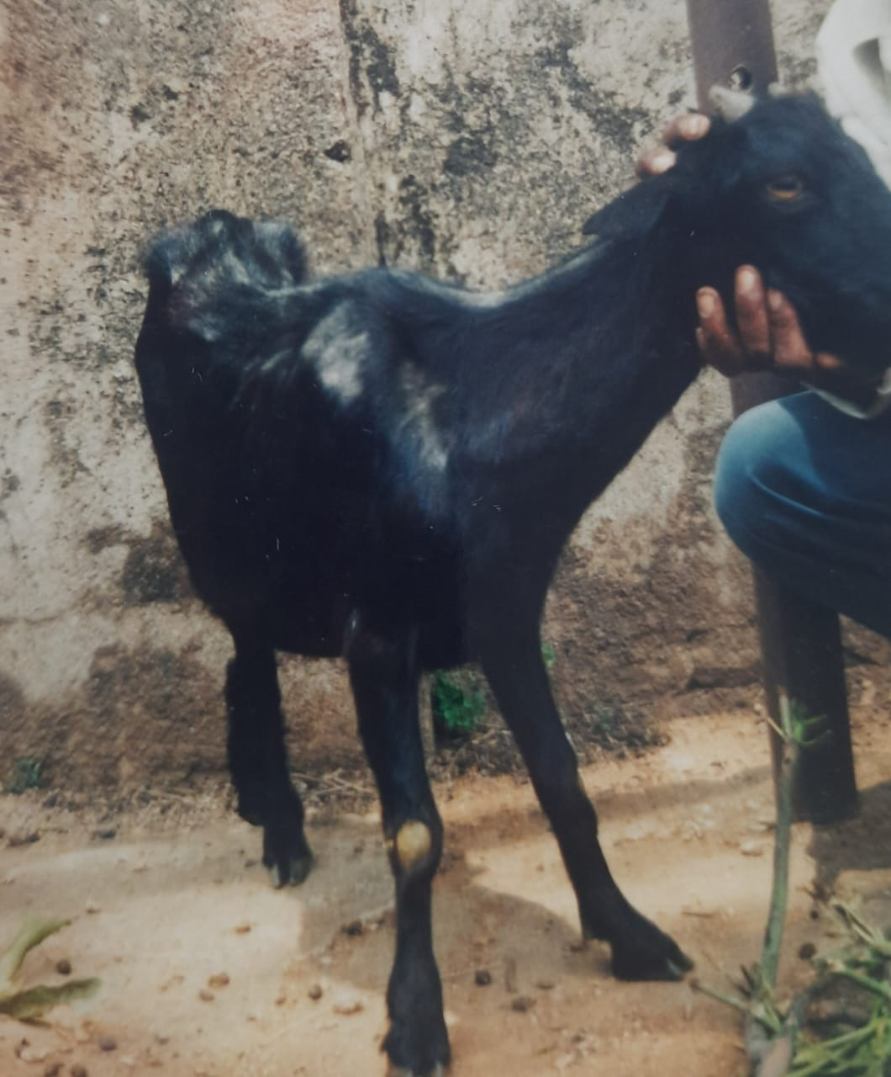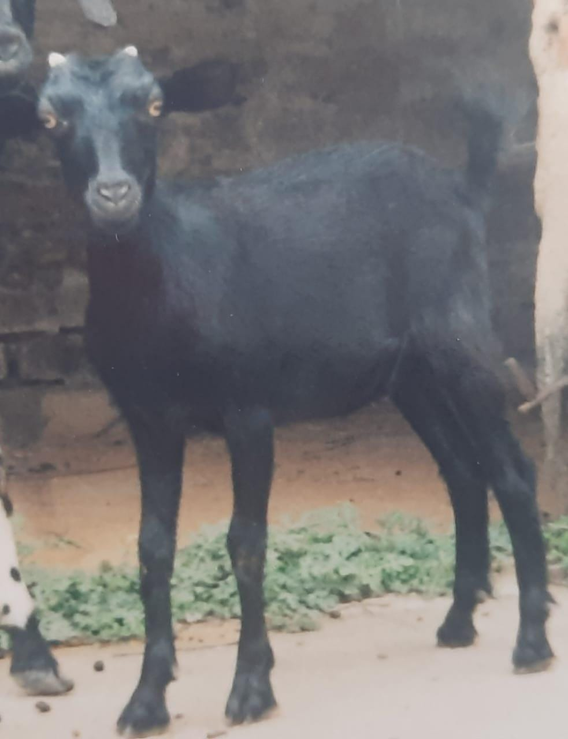

Pic 1 Pic 2