Species of Nepenthes (Pitcher Plant) in
Selected Areas of San Isidro, Northern Samar

ABSTRACT
Nepenthes is a genus in the Nepenthaceae family of the order Nepenthales that is also known as a carnivorous plant. Thus, a study was conducted to identify the diversity of Nepenthes species in nine (9) areas of San Isidro, Northern Samar. The descriptive method of research was applied in this study. A total of nine (9) species were identified in the sampling sites. These species mostly grow in forest and woodland areas. In terms of economic importance, residents used Nepenthes species as ornamental plant, for barter with any goods, and an albolaryo used Nepenthes pitchers to treat snake and dog bites, “kulam”, and “usog”. Furthermore, habitat destruction, cultivation, and overexploitation of Nepenthes species were identified as anthropogenic activities. Results implied that the gathered environmental conditions data were normal and optimal for the growth and development of Nepenthes species in the sampling sites. Further study on the plant will be helpful for future conservation, more economic value, and possible pharmaceutical applications. Moreover, DENR may coordinate with LGU and strictly implement ordinances against habitat destruction, cultivation, collection, and trading of Nepenthes species to assist conservation.
Keywords:
anthropogenic activities, conservation, species composition, Northern Samar, Nepenthes

INTRODUCTION
The Philippines is one of the world's 18 mega-biodiverse countries, accounting for two-thirds of the earth's biodiversity and between 70% to 80% of the world’s plant and animal species. Together with the Indonesian islands of Sumatra and Borneo, the Philippines is considered as the center of diversity for carnivorous pitcher plants of the genus Nepenthes. The country's current total of Nepenthes species is fifty-nine (59), greatly exceeding the totals for neighboring phytogeographic regions such as Sumatra and Borneo (Pelser, et al., 2011).
Nepenthes is a genus in the Nepenthaceae family that is widely known as a carnivorous plant species. It is the sole genus in the Nepenthaceae family of the order Nepenthales that produces specialized pitchers for catching and digesting insect prey to obtain nutrients in nitrogen-deficient habitats (Wan-Nor-AdibahWan, et al., 2016). Since the first encounter of Nepenthes in the mid-17th century, interest in the genus has profoundly altered knowledge on its taxonomy, diversity, and distribution, particularly with respect to understanding the Nepenthes of Indochina and the Philippines (McPherson, 2009; 2012).
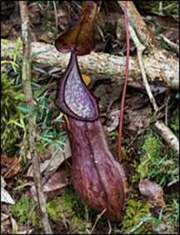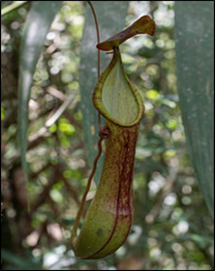
Figure 1. Photos of lower (left) and upper pitcher (right) of Nepenthes talaandig (Source: Gronemeyer, et al., 2014).
In traditional medicine, Nepenthes species have been used to treat numerous illnesses. It has been reported that Northeast Indian herbalists prescribe the fluid contained in an unopened pitcher of Nepenthes khasiana for the treatment of diabetes mellitus. In addition, the fluid from unopened pitcher of N. khasiana is prescribed to cure night blindness, conjunctivitis, ear troubles, and gynecological problems (Shil, et al., 2014).
N. ampullaria and N. gracilis are the two most common species used in folk medicine, where the liquid contained in an unopened pitcher are administered to regulate the menstrual cycle, ease childbirth, relieve asthma, treat eye inflammation, and act as a stamina booster (Ismail, et al., 2015).
The blended leaves of some Nepenthes spp. have been used as an astringent in Malaysia. In addition, the decoction of the stem of N. ampullaria has been consumed to treat malaria (Shin, et al., 2007). In Vietnam, traditional medical practitioners use N. mirabilis in the treatment of gastric ulcer, jaundice, high blood pressure, urethral stones, and hepatitis (Thanh, et al., 2015).
According to the International Union for Conservation of Nature (IUCN) Red List, the global status of Nepenthes spp. is currently critical. Around the world, 8.1% of Nepenthes spp. are critically endangered, 11.4% are threatened with extinction, and 17.2% are vulnerable. Forest fires, logging, conversion of forest land or bushes to residential areas, cultivation, plantations, and forest degradation are all common causes (Azwar, et al., 2006).
Natural habitat destruction is widespread in the Philippines, resulting in the extinction of many plant and animal species. There are already conducted studies about the Nepenthes species in Luzon and Mindanao but not in Northern Samar. Exploring the possible presence of Nepenthes in San Isidro and identifying them will be crucial to aid in their future conservation, hence, this study.
Thus, this study was conducted to ascertain the presence of Nepenthes species in selected areas of San Isidro, Northern Samar.
Locale of the Study
The Nepenthes species was photo-documented in the selected areas of San Isidro, Northern Samar. Northern Samar lies in the northernmost portion of the island of Samar. It is one of the six (6) provinces comprising the region of Eastern Visayas (Region VIII). The province consists of twenty-four (24) municipalities, five (5) of which are island municipalities, fifteen (15) are coastal towns, and four (4) are found in interior.
The Municipality of San Isidro is one of the twenty-four (24) municipalities of Northern Samar. It is a coastal town located in the southwestern part of the province facing the Samar Sea. It is about sixty-four (64) kilometers from Catarman and approximately fifty-four (54) kilometers northwest of Calbayog City. It is comprised of fourteen (14) areas , which are San Roque, Poblacion Norte, Poblacion Sur, Buenavista, Balite, Seven Hills, Happy Valley, Alegria, Salvacion, San Juan, Palanit, Mabuhay, Veriato, and Caglanipao. The total population of the Municipality of San Isidro is 27,867 broken down into 5,545 households (www.philatlas.com).
Research Design
Descriptive type of research was utilized in this study. It is a method of research which is a fact-finding study with adequate and accurate interpretation of findings. The data was gathered by using an interview guide, through actual interview with the respondents, and by means of determining the environmental conditions in the sampling sites with the help of specific instruments. Also, photo documentation of the species was done in order to identify the samples.
Research Instrument
This study used an interview guide to obtain relevant data about the economic importance and anthropogenic activities that influence the condition and conservation of Nepenthes species found in the sampling sites. The interview guide was prepared in English and translated into the Ninorte Samarnon dialect so that the respondents will have a clear idea about the questions.
The Respondents
The respondents were purposively chosen by the researcher. In each area, fifteen (15) respondents were purposively identified, specifically the elderly villagers, who are aged 60 years old or older, have resided in the area for most of their lives, and regardless of their sex. Also, the “albolaryos” was included as respondents regardless of their age and sex.
The Interview Guide
In order to gather data for the economic importance and anthropogenic activities that may influence the condition of the Nepenthes, an interview guide that was composed of two parts was prepared. The first part was about the economic importance of Nepenthes that was known by the respondents. The second part was about the anthropogenic activities that might influence the condition of Nepenthes. In order to record the data, the responses of the respondents were written in a field notebook.
Identification and Authentication of the Plants
Photos of the plants was sorted for the ease of classification and identification. For the preliminary identification, references about Nepenthes in the internet was used. Verification of the preliminary identification was done by an expert botanist from the College of Science, University of Eastern Philippines, University Town, Northern Samar

Result and Discussions
Species Composition of Nepenthes species in San Isidro, Northern Samar
Table 1 shows that there were nine (9) species of Nepenthes present in the sampling areas which are Nepenthes alata, N. graciliflora, N. gracilis., N. mirabilis, N. reinwardtiana, N. sanguinea, N. tentaculata, N. truncata, and N. ventricosa. Both N. alata and N. gracilis. had upper and lower pitcher, N. mirabilis and N. reinwardtiana with upper pitcher only, and lower pitchers only of N. graciliflora, N. sanguine, N. tentaculata, N. truncata, and N. ventricosa. All of these species were locally known as “pitchel-pitchel” or “pitchel-pitchelay”.
Table 1 also revealed that N. gracilis lower pitcher was the most found species as it was present in all sampling areas, followed by N. mirabilis upper pitcher that was found in seven (7) sampling areas which are Poblacion Sur, Seven Hills, Happy Valley, San Juan, Palanit, Veriato, and Caglanipao. Moreover, N. gracilis upper pitcher was present in six (6) sampling sites which are Seven Hills, Happy Valley, Alegria, San Juan, Palanit, and Veriato while lower pitcher of N. alata was also present in six (6) sampling areas which are Balite, Seven Hills, Happy Valley, Alegria, San Juan, and Caglanipao. Upper pitcher of N. alata Blanco was found in five (5) sampling sites which are Seven Hills, Happy Valley, Palanit, Veriato, and Caglanipao. N. graciliflora lower pitcher was present only in four (4) sampling areas which are Balite, Seven Hills, Happy Valley, and Palanit while N. ventricosa lower pitcher was also present in four (4) sampling areas which are Poblacion Sur, Seven Hills, Happy Valley, and Palanit. Furthermore, three (3) species were present in three (3) sampling sites which are N. reinwardtiana - in Happy Valley, San Juan, and Palanit, N. sanguinea – found in Poblacion Sur, Seven Hills, and Caglanipao, and N. truncata – found in Balite, Happy Valley, and Veriato. Lastly, N. tentaculata lower pitcher was present only in two (2) sampling sites which are Happy Valley and Palanit.
Results in Table 1 indicated that Barangay Happy Valley appears to have the largest number of Nepenthes species with a total of eight (8) species. It was observed that Barangay Happy Valley was the most undisturbed forest area compared to others. Moreover, Barangay Palanit has a total of seven (7) species, Barangay Seven Hills has a total of six (6) species, and Barangays Poblacion Sur, Balite, San Juan, Veriato, and Caglanipao were all have a total of four (4) species. On the other hand, Barangay Alegria has the least number of Nepenthes species with a total of two (2) species only. It was observed that forest area of Barangay Alegria was frequently visited by the residents compared to other sampling areas.
Economic Uses of Nepenthes species in San Isidro, Northern Samar
Based on the interviews conducted by the researcher through an interview guide, it was revealed that the local residents used Nepenthes species as ornamental plant. In addition, sometimes Nepenthes species was used as a source of income or for barter for any goods like rice and instant coffees. According to Rizqiani, et al., (2018) the uniqueness and variation of the pitchers will attract people to collect Nepenthes for ornamental plants.
On the other hand, the result of conducted interviews with albolaryos showed that they were all familiar with the plant, however, they do not know if it can be used as medicine since they have not tried it before except from one albolaryo from Barangay Caglanipao who used Nepenthes species as a treatment for snake and dog bites, “kulam”, and “usog”. It was prepared during Lenten seasons only, specifically, during Good Friday by finely chopping the Nepenthes pitchers, by adding the chopped roots of different woods, and then by adding some coconut oil. The mixture will be contained in a bottle and ready to be used. For snake and dog bites, the mixture will be applied directly in the bitten area. For “kulam” and “usog” the mixture will be applied by the albolaryo in the form of the cross in the head, stomach, and navel of the patient. However, this result was not anchored with other studies since there is no similar finding that was found and it was based only in the practice and belief of the said albolaryo.
Anthropogenic Activities that Influence the Conditions of Nepenthes species in the Sampling Sites
Through the interview guide, the interviews conducted with the local residents of the sampling sites revealed that habitat destruction, cultivation, and overexploitation of Nepenthes species were the human activities that influence the growth and condition of the plants. According to the respondents, during the surge of COVID-19 and the emergence of “Plantitas” and “Plantitos”, Nepenthes species was harvested by the farmers from its natural habitats and they will trade it or use it for an exchange of any goods. Considering its unique characteristics, many residents from the sampling sites and even from the other towns were attracted to buy, collect, and cultivate Nepenthes, resulting to the great deduction in the population of the plants. Moreover, since Nepenthes usually grow in the areas with high humidity, plants brought in the barrios sometimes died due to too much exposure to sun.

Table 1. Distribution of Nepenthes Species in San Isidro, Northern Samar
Species | Type | SS
Species | Type | 1 | 2 | 3 | 4 | 5 | 6 | 7 | 8 | 9
Nepenthes  alata | Upper pitcher | * | * | √ | √ | * | * | √ | √ | √
Nepenthes  alata | Lower pitcher | * | √ | √ | √ | √ | √ | * | * | √
N. graciliflora | Lower pitcher | * | √ | √ | √ | * | * | √ | * | *
N. gracilis | Upper pitcher | * | * | √ | √ | √ | √ | √ | √ | *
N. gracilis | Lower pitcher | √ | √ | √ | √ | √ | √ | √ | √ | √
N. mirabilis | Upper pitcher | √ | * | √ | √ | * | √ | √ | √ | √
N. reinwardtiana | Upper pitcher | * | * | * | √ | * | √ | √ | * | *
N. sanguinea | Lower pitcher | √ | * | √ | * | * | * | * | * | √
N. tentaculata | Lower pitcher | * | * | * | √ | * | * | √ | * | *
N. truncata | Lower pitcher | * | √ | * | √ | * | * | * | √ | *
N. ventricosa | Lower pitcher | √ | * | √ | √ | * | * | √ | * | *
TOTAL NO. OF SPECIES |  | 4 | 4 | 6 | 8 | 2 | 4 | 7 | 4 | 4
Legend:
(√) Present (*) Absent
SS- Sampling Sites
SS 1: Barangay Poblacion Sur SS 6: Barangay San Juan
SS 2: Barangay Balite SS 7: Barangay Palanit
SS 3: Barangay Seven Hills SS 8: Barangay Veriato
SS 4: Barangay Happy Valley SS 9: Barangay Caglanipao
SS 5: Barangay Alegria
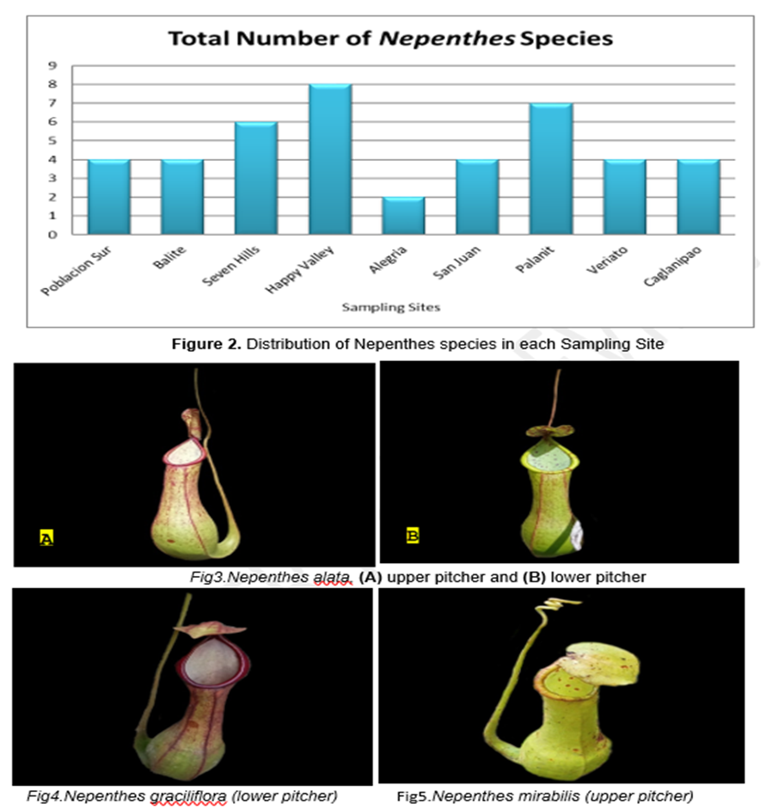
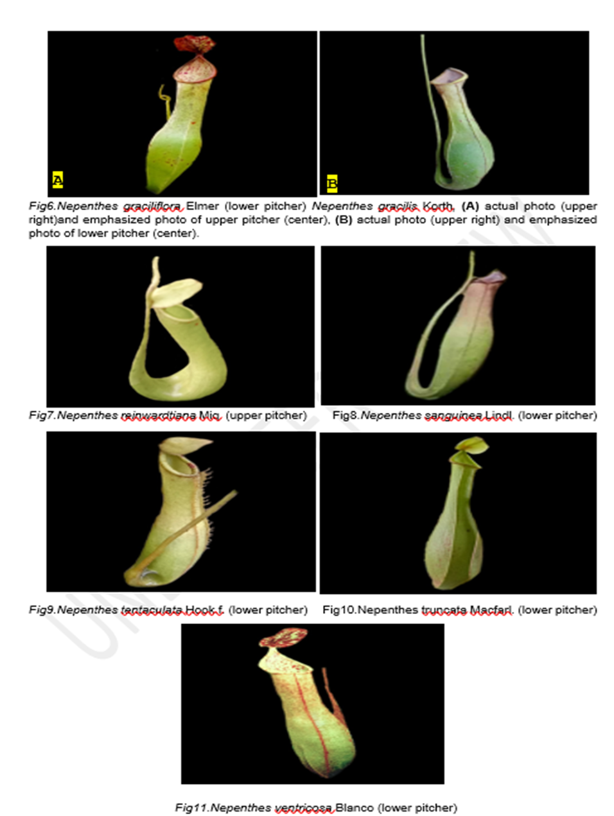

Conclusions

There were nine (9) Nepenthes species that have been photo-documented in the sampling sites which are upper and lower pitcher of Nepenthes alata and N. gracilis, upper pitchers of N. mirabilis and N. reinwardtiana, and lower pitchers of N. graciliflora, N. sanguinea, N. tentaculata N. truncata, and N. ventricosa

Residents usually used Nepenthes species as ornamental plants or for barter for any goods like rice and instant coffees. On the other hand, an albolaryo from Barangay Caglanipao used the finely chopped Nepenthes pitchers together with chopped roots of different woods and some coconut oil as a treatment for snake and dog bites, “kulam”, and “usog”.

Anthropogenic activities such as habitat destruction, cultivation, and overexploitation of Nepenthes species were the anthropogenic activities that influence the condition of the plant that were identified by the residents of the sampling sites.

Recommendations

Same study maybe conducted but in other Barangays of San Isidro or in other Municipalities of Northern Samar for possible additional species and for future conservation. In addition, the Local Government Unit (LGU) may implement ordinances that will strictly prohibit the habitat destruction, collection, cultivation, and trading of Nepenthes species to aid the conservation of the plant in San Isidro. Lastly, the Department of Environment and Natural Resources (DENR) may conduct an assessment in San Isidro, Northern Samar to ascertain the status of Nepenthes species and they may coordinate with the LGU to take an immediate action on how to conserve the pitcher plants.

REFERENCES

- Azwar, F., A. Kunarso, and S.T. Rahman. 2006. Kantong Semar (Nepenthes sp.) di Hutan Sumatera, Tanaman yang Unik Semakin Langka. Article for research exose Padang.

- Ismail, NA, AS Kamariah, LB Lim, and N Ahmad. 2015. Phytochemical and pharmacological evaluation of methanolic extracts of the leaves of Nepenthes bicalcarata Hook. F. Int J Pharmacogn Phytochem Res.7(6):1127-38.

- McPherson, S. 2009. Pitcher Plants of the Old World. Redfern Natural History Productions, Poole, U.K.

- McPherson, S. 2012. The New Nepenthes. Redfern Natural History Productions, Poole, U.K.

- Pelser PB, JF Barcelona, and DL. Nickrent (eds.). 2011 onwards. Co's Digital Flora of the Philippines. Available at www.philippineplants.org

- Rizqiani S, NS Ariyanti, and Sulistijorini. 2018. Diversity of Lowland Nepenthes (Pitcher Plants) in Bangka Belitung Islands. IOP Conf. Ser.: Earth Environ. Sci. 197 012021.

- Shil D, JP Mohanty, TS Saleem, J Debnath, T Uriah. 2014. Anti-diabetic activity of leaf extract of Nepenthes khasiana hook on dexamethasone induced diabetic rats. J Pharm Chem Biol Sci. 1(1):6-11.

- Shin KS, S Lee, and BJ Cha. 2007. Suppression of phytopathogenic fungi by hexane extract of Nepenthes ventricosa x maxima leaf. Fitoterapia. 78(7-8):585-6.

- Thanh NV, NP Thao, D Dat le, PT Huong, SH Lee, and HD Jang. 2015. Two new naphthalene glucosides and other bioactive compounds from the carnivorous plant Nepenthes mirabilis. Arch Pharm Res. 38(10):1774-82.

- Wan-Nor-AdibahWan, Z., K.K. Loke, M.M. Zulkapli, I.M. Salleh, H.H. Goh, and N.M. Noor. 2016. RNA-seq analysis of Nepenthes ampullaria. Int J Plant Sci. 164(4):635-9.

