Effects of exposure to Electromagnetic fields (EMFs) on biological systems

.

ABSTRACT

|  |
| --- |
| Electromagnetic Field (EMF) is a natural phenomenon; however, anthropogenic activities have significantly shifted its equilibrium, leading to potential deleterious effects on biological systems. As technology becomes more integrated into daily life, the increased use of electronic devices has contributed to a rise in man-made EMF exposure. This exposure can affect biological systems on physiological and molecular levels, raising concerns about its potential effects on animal development, reproductive systems, and overall ecosystem health. The review explores the physiological effects of exposure to static, extremely low-frequency (ELF), and radiofrequency (RF) fields, analyzing how EMF impacts oxidative stress, reproductive physiology, cardiovascular function, brain and nervous system activity, and DNA/RNA integrity. It also acknowledges the emerging concern of EMF in aquatic environments, where underwater power supplies and extensive underwater cable networks are sources of EMF exposure that may affect marine and freshwater species. The potential effects on marine life include disruptions to migratory patterns, altered reproductive cycles, and changes in aquatic biodiversity. The review acknowledges that research on EMF has improved over time, but significant gaps and information remain. It emphasizes the need for immediate attention to address the challenges and opportunities in this field. |

*Keywords* *Electromagnetic field; Fenton reaction; Physiology; Biological systems*

1. INTRODUCTION

Electromagnetic fields (EMFs) pervade the whole of the earth’s environment and have been present throughout the earth and life might have been influenced by EMF evolution. Life has evolved in the sea and it must have been under the influence of natural EMFs. Moreover, organisms have very peculiar electromagnetic properties. From the origin of life to now we are continuously exposed to electromagnetic radiation (EMR), the natural electric fields are one of the mainstays of life on earth (Hafizi et al. 2014), and are particularly noticeable based on physical limitations and biological effects (Martin and Rosaria 2010). Many marine fish use electric currents to search for food or to migrate (Gill, Bartlett, and Thomsen 2012). However, their natural sensory system can be altered by the anthropogenic magnetic fields and electrical currents emitted by electrical conductors (Otremba et al. 2019).

Since the 1950s an increased use of technology began where man-made EMFs were used. Increased use of devices like mobile, Wi-Fi, or Bluetooth-enabled devices has enhanced the level of exposure to radiofrequency electromagnetic radiation by about 1018 times. These levels are expected to increase again in the future due to the significant contribution of technologies like the Internet of Things and 5G (Bandara and Carpenter 2018). EMFs usually produce a low-frequency field (usually 50 or 60 Hz) and have a quasi-stationary component consisting of two components – electric fields (E-fields) and magnetic fields (B-fields). The earth creates its geomagnetic field (GMF) with E-fields. E-fields are stationary but can be influenced by moving charges or changing magnetic fields. Their intensity and direction are governed by Coulomb's law, which describes the force between electric charges. In contrast, changing magnetic fields can induce electric fields, as described by Faraday's law of electromagnetic induction (Gill et al. 2014). Electromagnetism involves the interaction between electric and magnetic fields, resulting in an electric current (Raj, Lee, and Sidek 2020). Ampère's law describes the relationship between electric currents and magnetic fields, while Faraday's law of electromagnetic induction explains how changing magnetic fields can induce electric fields. Maxwell's equations demonstrated the interconnectedness of electricity and magnetism, ultimately resulting in the prediction of electromagnetic waves (Gill, A. B., and Bartlett, M. D. 2010). EMFs are non-ionizing radiation, and they have a wave character on short frequencies and act as a magnetic field on long frequencies (Gye and Park 2012). These fields are considered to have a potential negative impact on biodiversity.

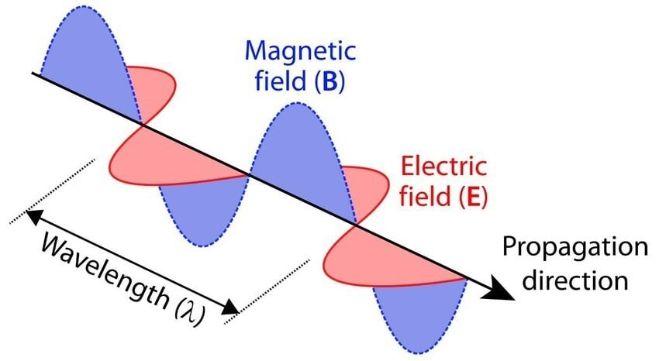

Figure 1: Electromagnetic wave with electric and magnetic oscillating fields (Verhoeven 2017).

Along the lengths, cables emit EMFs, in the marine environment and transmit high-voltage direct current (DC) or sinusoidal alternating current (AC). In DC cables, a static field is emitted, while in AC cables, a sinusoidal field (Gill and Desender 2020). AC fields generate thermal and DC fields, which are static and move in one direction, cause chemical effects.

2. Effects of Emf:

2.1. EMF: OXIDATIVE STRESS, FENTON REACTION, AND REACTIVE OXYGEN SPECIES

The use of electronic devices for communication and their public exposure, including LF-EMF and radio frequencies, are becoming significant environmental health concerns (Schuermann and Mevissen 2021). ELF-EMF is crucial in various life activities as organisms can swiftly detect and respond to lower environmental levels (Lai et al. 2019; Levitt, Lai, and Manville 2021).

EMF exposure generally disturbs free radical production (Hardell and Sage 2008) and results in oxidative stress due to disturbances in free radicals on cellular or systemic oxidative stress (Lai 2019; Schuermann and Mevissen 2021). The study found that acute exposure to 5G RF-EMF in guinea pigs caused oxidative stress, ultra-structural damage to the auditory cortex, and mitochondrial cell apoptosis (Yang et al. 2022). These free-radical responses depend on the exposure period (Lai 2019). However, the impact of ELF-EMF on cellular free radical processes is not yet fully comprehended (Lai 2019).

Free radicals are important for cellular functions (Lai et al. 2019). Therefore, maintaining a critical physiological homeostatic level of free radicals is crucial to protect against potential biological harm (Lai et al. 2019). Disrupting this balance can cause oxidative stress, leading to cellular damage (Panagopoulos, D. J. et al., 2022), and the destruction of mitochondria, microfilaments, and proteins, ultimately impairing metabolic processes (Schuermann and Mevissen 2021). 1. The oxidative stress is a result of disturbances in voltage-gated calcium channels (VGCCs), increasing calcium ions entering the cells. This influx then triggers the generation of reactive oxygen species (ROS), resulting in DNA damage and other forms of cellular injury (Panagopoulos, D. J. et al., 2022; Pall, M. L., 2018), also a notable rise in the risk of cancer, infertility (Tenorio, B.M. et al., 2012) and various health issues. These oxidative stress effects also include damage to sperm and testicular function (Tas, M. et al., 2014), alterations in neuropsychiatric health, and disturbances to the endocrine system (Panagopoulos, D. J. et al., 2021).

The Fenton reaction, a significant source of reactive oxygen (ROS), induces oxidative stress, with the EMF playing a crucial role in enhancing the conversion of hydrogen peroxide into a hydroxyl radical-driven metal-like transformer (Lai and Singh 2004, 2010; Lai 2019)

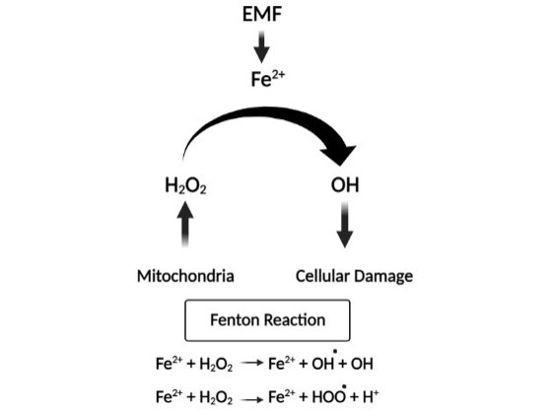

Figure 2: Effect of EMF exposure on Fenton Reaction (Lai and Singh 2004, 2010; Lai 2019)

Fenton’s reaction to a 60-Hz magnetic field increased free radical formation in brain cells, leading to DNA strand fragmentation and cell death (Lai and Singh 2004). The free radicals in normal conditions are maintained by various antioxidant enzymes including superoxide dismutase (SOD), catalase (CAT), and glutathione peroxidase (GPx) (Ustunova et al. 2022; Chen et al. 2022). Decreased endogenous Glutathione (GSH) inhibits glutathione peroxidase 4 (GPX4), leading to ferroptosis by increasing lipid peroxidation (LPO) levels, resulting in cell death (Chen et al. 2022).

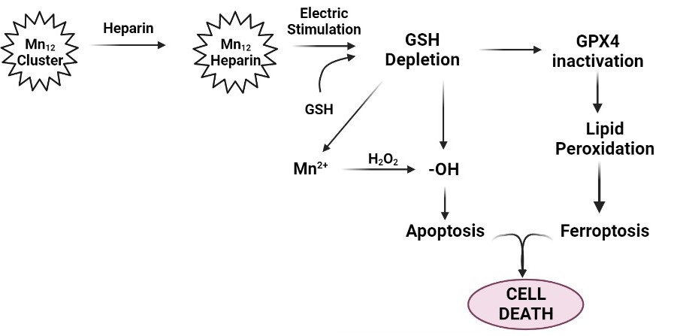

Figure 3: EMF exposure and Cell death (Chen Y et al. 2022).

EMF exposure alters free radical activities, including cellular reactive oxygen (ROS)/nitrogen (RNS) species (Xing et al. 2016; Marjanovic Cermak et al. 2018; Hinrikus, Lass, and Bachmann 2021) and endogenous antioxidant enzymes to maintain physiological free radical concentrations in cells. These changes affect many biochemical (Guleken et al. 2022), and physiological functions (Lai and Singh 2010; Lai 2019; Calcabrini et al. 2017; Schuermann and Mevissen 2021) and also cause structural and quantitative chemical changes in brain and liver tissue (Guleken et al. 2022). Chronic exposure changes the biological material, as well as genetic and epigenetic information, resulting in health-related malfunctions (Schuermann and Mevissen 2021). The cell alterations induced by ELF-EMF are not irreversible (Calcabrini et al. 2017).

2.2. EFFECT OF EMF ON REPRODUCTIVE PHYSIOLOGY

The infant developmental stages are more vulnerable to EMR because it inhibits the formation and dissociation of neural stem cells during development (Ali et al. 2016; Kaplan et al. 2016. Li Y et al. (2014) in Zebrafish reported that LF-EMF affected embryonic growth, lowered heart rate, and apoptosis. Studies have confirmed the effect of EMF on the reproductive physiology of animals (Kumar, Behari, and Sisodia 2013; Ebrahim et al. 2016). Hafizi et al. (2014) and Gye and Park (2012) reported an increase in the estrous cycle. Ali et al. (2016) reported uterine contraction, bleeding, dead embryos, and re-sucking in the exposed groups during the 2nd and 3rd trimesters of pregnancy. The EMF affects the testicular tissues (Okechukwu 2020), and a decrease in testosterone levels was attributed to a decrease in testicular size (Kumar, Behari, and Sisodia 2013). Saygin et al (2011) and Tenorio B.M. et al. (2011) reported that EMF affects spermatogenesis and apoptosis in the testicular tissue.

The ELF-EMF influences sperm mobility in rabbits and the breeding rate (Roychoudhury et al. 2009). A reduction in active sperm with an increase in lipid peroxidation and a lower GSH content in the testicles and epididymis was reported by Mailankot et al. (2009) and reduced sperm count in rats (Kumar S et al., 2014) and in humans (Negi and Singh 2021). Histo-morphometric analysis showed delayed testicular development (Tenorio et al. 2011) and histopathological changes in the kidneys and testicles due to prolonged exposure (Khayyat 2011; Tenorio B.M. et al. (2011), Al-Mayyahi, R. S. et al., 2020).

2.3. EFFECT OF EMF ON THE CARDIOVASCULAR SYSTEM

The impact of electromagnetic field (EMF) exposure on biological systems has raised concerns about various health risks. It has been associated with histopathological changes in the heart and blood vessels, which could lead to conditions such as myocardial infarction (Roshangar et al. 2012). EMF exposure can also increase certain enzymes like serum creatinine phosphokinase, lactate dehydrogenase, and aspartate aminotransferase while reducing plasma calcium levels and total antioxidant capacity (Azab and Ebrahim 2017). A study on prolonged RF-EMF exposure in Swiss Albino Mice revealed changes in blood count parameters (Usman, A. D. et al., 2012) which aligned with the findings of Gagnon, Z. E. et al., 2003, Forgács, Z. et al., 2006, Rusnani, A. et al., 2008, Aziz, I. A. et al., 2010) along with increased aggressiveness and hyperactivity (Gagnon, Z. E. et al., 2003, Usman, A. D. et al., 2012).

EMF in rats increased the blood pressure (Azab and Ebrahim 2017), reduced the heart rate, altered the histopathology of the heart, irregular myocardial cells, ruptured sarcomeres, loss of mitochondria cristae, and blebs of mitochondria (Khaki and Khaki 2012). Prolonged exposure to microwave radiation increased red blood cell (RBC) count (Al-Uboody 2015; Kumari, Manjula, and Gautham 2016; Sani, Labaran, and Dayyabu 2018), while a decrease in white blood cell (WBCs) and lymphocytes was observed by Kumari, Manjula, and Gautham (2016). However, EMF decreased RBCs and their indices (Marzook et al. 2016; Mhaibes and Ghadhban 2018). EMFs also cause an increase in the viscosity of blood, and cell adhesion (Alghamdi and El-Ghazaly 2012). The alteration in RBC shape was similar to the effect with free radicals (Rifat et al. 2014). The free radicals cause the leaking of hemoglobin out of cells (Al-Uboody 2015; Eid et al. 2015).

2.4. EFFECT OF EMF ON THE BRAIN AND NERVOUS SYSTEM

A number of studies have investigated the effects of radio frequency (RF) waves and electromagnetic fields (EMF) on brain health. Al-Mayyahi and Wa’il (2021) studied RF on adolescent mice and concluded that RF exposure lead to severe histopathological alterations in the brains, causing brain necrosis. This study also concluded that effect of RF is more pronounced in adolescent mice compared to adults, suggesting younger individuals might be more susceptible to RF-induced brain damage (Redmayne, M., and Johansson, O. 2015; Cabré-Riera, A et al., 2021). These results indicate the need for additional research to understand the underlying mechanisms and the broader implications for human health, especially among children and adolescents. Studies by Cuccurazzu et al. (2010), Podda et al. (2014), Hasan et al. (2022), and Deniz and Kaplan (2022) has shown that cell phone radiofrequency radiation can cause structural damage to the hippocampus, affecting cell proliferation, neurogenesis, memory, hippocampus-dependent cognition, and learning processes. This can lead to broader detrimental brain changes. Khalimovich et al. (2022) reported that exposure to RF-EMF can cause autonomic dysfunctions, weakness, irritability, rapid fatigue, sleep disturbance, disturbed higher nervous activity, weakening of memory, and increased stress reactions. Juutilainen et al. (2011) and Hinrikus, Lass, and Bachmann (2021) found that RF-EMF at low frequencies affects brain physiology, causing periodic alterations in neuronal electric parameters. Further studies by Kim et al. (2019) and Maurya et al. (2022) indicated that mobile phone radiation can damage brain cells and alter the activities of neurons. Research by Okatan et al. (2018), Adebayo et al. (2019), Kishore, Venkateshu, and Sridevi (2019), and Luo et al. (2021) supports the idea that EMF radiation can cause changes in the central nervous system (CNS), with Maurya et al. (2022) demonstrating effects on the brain cells of Drosophila and alterations in organ morphology. Bertagna et al. (2021) noted that the CNS is sensitive to EMF stimuli. Alarming study by Morgan et al. (2015) suggested that daily use of mobile phones for an hour increases the risk of developing a brain tumor over a decade or more of exposure.

These findings from various studies indicate a range of negative effects from RF and EMF exposure, emphasizing the importance of understanding these risks and their potential long-term consequences. Further research is needed to fully comprehend the impacts and guide regulatory decisions regarding RF and EMF exposure, particularly among younger and more vulnerable populations. EMF is reported to cause Neurodegeneration cancer and mental disorders, are shown in Figure 4.

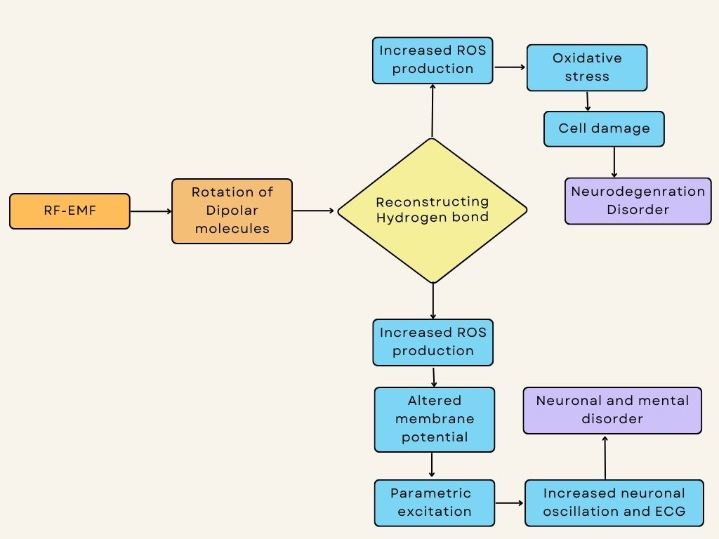

Figure 4: Effects of RF-EMF on Neurodegeneration Cancer and Mental Disorders (Hinrikus, Lass, and Bachmann 2021).

Gut microbes are crucial in maintaining brain physiological function, neuropsychiatric behavior, brain development, aging, and neurodegenerative processes (Sun et al. 2020; Luo et al. 2021), and EMF being a physical environmental factor, can impact gut microbes and cause central nervous system disorders (Luo et al. 2021). Gut microbes are also linked to depression (Kleiman et al. 2017; Luo et al. 2021).

2.5. EFFECT OF EMF ON DNA AND RNA

RF-EMR (1800 MHz) with a low specific absorption rate (SAR) creates a toxic effect and damages cell components like proteins, lipids, and DNA (Ali et al. 2016). At higher levels of EMF, DNA strand fragmentation and mutations occur (Hardell and Sage 2008). Increased free radicals and (Ca2+) at the cellular level can mediate the effect of EMFs, causing cell growth inhibition, impaired protein synthesis, and DNA breakdown (Gye and Park 2012). The

RF-EMF exposure causes cellular mutations and induces single-strand DNA and double-stranded fibers in human diploid fibroblasts and mice granulosa cells (Diem et al. 2005). A recent study reported that Radio frequencies emitted by mobile phones disturb the mRNA expression of Bax/Bcl2 in the hippocampus of mice (Fatemeh et al. 2020). In contrast, it significantly increased the expression of c-fos mRNA in pregnant mice (Shi et al. 2005)

The effects of exposure to EMF mentioned above are summarized below in Table 1.

Table 1: Summarizes the effects of EMF

|  |  |
| --- | --- |
| Effects of EMF | References |
| *In Mice, DNA damage of single and double-strand in brain cells, cell death* | Lai and Singh. 2004 |
| *Decreases diameter of seminiferous tubes and reduced germinal epithelium* | Ozguner et al. 2005 |
| *DNA strand fragmentation, mutation* | Hardell and Sage 2008 |
| *Damage to chromosomes, DNA breakage* | Phillips, Singh, and Lai 2009 |
| *In rabbits, motility, breeding rate, and fertility affected* | Roychoudhury et al. 2009 |
| *DNA breakage and damage to brain cells* | Singh et al. 2009 |
| *Tissue separation in non-differentiating cells* | Anissian and Valiollahi 2010 |
| *More pronounced histopathological changes in kidneys and testicles* | Khayyat 2011 |
| *In rats, increased heart rate, hypocalcemia* | Mohamed et al. 2011 |
| *Affects spermatogenesis, and induces apoptosis in testicular tissue* | Saygin et al. 2011 |
| *Delayed testicular development* | Tenorio et al. 2011 |
| *In mice, increased blood viscosity and cell size variation, pale color of RBCs* | Alghamdi and El-Ghazaly 2012 |
| *In rats, increased blood pressure; altered myocardial cells* | Khaki and Khaki 2012 |
| *Affects the nucleus of the cell; damages DNA, and mRNA; shortens cell life* | Liu et al. 2012 |
| *Alters metabolism of heart, liver, kidneys, and brain tissues* | Martínez et al. 2010 |
| *Histopathological changes in heart and blood vessel structure* | Roshangar et al. 2012 |
| *Altered heart palpitations, pain in the chest area* | Havas et al. 2013 |
| *In zebrafish, reduced heart rate, growth, and hatching* | Li et al. 2014 |
| *Alteration in RBC shape* | Rifat et al. 2014 |
| *Toxic effects; damaged proteins, lipids, and DNA of the cell* | Ali et al. 2016 |
| *During fetal development, neural stem cell formation inhibited* | Kaplan et al. 2016 |
| *Increases CPK, LDH, AST; decreases plasma calcium, antioxidant capacity* | Azab and Ebrahim 2017 |
| *Decreased White Blood cell (WBC) and lymphocyte count* | Azab and Ebrahim 2017 |
| *Reduced superoxide dismutase and increased glutathione; increased ROS* | Calcabrini et al. 2017 |
| *In Cyprinus carpio, damage to muscles and necrosis* | Samiee and Samiee 2017 |
| *Increased Red Blood cell (RBC) count* | Sani, Labaran and Dayyabu 2018 |
| *Disturbed mRNA expression of Bax/Bcl2 in the hippocampus of mice* | Fatemeh et al. 2020 |
| *Alters free radicals; neuronal parameters; RNS; changes in brain physiology* | Hinrikus, Lass and Bachmann 2021 |
| *Affects gut microbes* | Luo et al. 2021 |
| *Central nervous system dysfunction* | Luo et al. 2021 |
| *Changes in biological, genetic, and epigenetic material* | Schuermann and Mevissen 2021 |
| *Increased level of ROS, cell death via Ferroptosis* | Chen et al. 2022 |
| *Affects neurogenesis, hippocampus-dependent cognition, brain physiology* | Deniz and Kaplan 2022 |
| *Structural and quantitative chemical changes in the brain and liver* | Guleken et al. 2022 |
| *In Swiss albino male mice, changed structural integrity of the hippocampus* | Hasan et al. 2022 |
| *Disruption in nerve impulses, autonomic dysfunctions* | Khalimovich et al. 2022 |
| *Damages brain cells, neurons, and Purkinje cells, alters hypothalamic region* | Maurya et al. 2022 |
| *In guinea pigs, induced oxidative stress damages ACx, and cell apoptosis.* | Yang et al. 2022 |
| *Alters biomolecules; DNA, RNA, and protein* | Perez et al. 2022 |

2.6. Other effects of EMF

The EMF causes tissue separation in non-differentiating cells (Anissian and Valiollahi 2010). EMF exposure has both adverse and beneficial effects, including aiding in the treatment of bone fractures and promoting bone and wound healing (Lai and Singh 2010; Sunkari et al. 2011), including regeneration of embryos and, tissues (Ly and Poole-Warren 2008, Halgamuge and Abeyrathne 2011). RF-EMF long-term exposure has been found to enhance the cognitive abilities of transgenic Alzheimer's mice (Maurya et al. 2022). Malaria treatment involves a low-frequency magnetic field inducing hemozoin vibration in malaria parasites, potentially causing free radical damage and mechanical damage, ultimately leading to parasite death (Lai and Singh 2010). EMF exposure can selectively kill cancer cells through the Fenton Reaction (Lai 2019).

3. CONCLUSION:

Electromagnetic radiation (EMF) is a natural phenomenon that contributes to health hazards through anthropogenic activities. It causes oxidative stress, and DNA damage, alters mRNA expression, and affects gut microbes. However, the mechanism of EMF altering biological systems is controversial and unfocused. Further research is needed to develop preventive potential measures. For this, the study of the aquatic ecosystem can be helpful, as EMFs are directly present inside water yet this system is mostly untouched.

References

1. Adebayo, E. A., Adeeyo, A. O., Ogundiran, M. A., & Olabisi, O. 2019. Biophysical effects of radiofrequency electromagnetic radiation (RF-EMR) on blood parameters, spermatozoa, liver, kidney, and heart of albino rats. Journal of King Saud University – Science, 31(4), 813–821. <https://doi.org/10.1016/j.jksus.2018.11.007>
2. Alghamdi, M. S., & El-Ghazaly, N. A. 2012. Effects of exposure to the electromagnetic field on some hematological parameters in mice. Open Journal of Medicinal Chemistry, 02(2), 30–42. <https://doi.org/10.4236/ojmc.2012.22005>
3. Almášiová, V., Holovská, K., Cigánková, V., Račeková, E., Fabianová, K., & Martončíková, M. 2014. Structural and ultrastructural study of rat testes influenced by electromagnetic radiation. Journal of Toxicology and Environmental Health. Part A, 77(13), 747–750. <https://doi.org/10.1080/15287394.2014.890988>
4. Al-Mayyahi, R. S., Al-Tumah, W. A. G., & Ahmed, Z. A. (2020). The Effects of X Band Radar Frequency Exposure on Mice Testis and Kidney. Pollution Research, 39, 142-148.
5. Al-Uboody, W. S. H. 2015. Effect of mobile phone electromagnetic waves on the hematological and biochemical parameters in laboratory mice (Mus musculus). Bas. Journal of Veterinary Research, 14(2), 250–264.
6. Anissian, A., & Valiollahi, S. 2010. Effects of electromagnetic field (50 Hz) on mouse embryonic tissue differentiation. Feyz Journal of Kashan University of Medical Sciences, 14(3).
7. Azab, A. E. 2017. Exposure to electromagnetic fields induces oxidative stress and pathophysiological changes in the cardiovascular system. Journal of Applied Biotechnology and Bioengineering, 4(2). <https://doi.org/10.15406/jabb.2017.04.00096>
8. Aziz, I. A., El-Khozondar, H. J., Shabat, M., Elwasife, K. H. I. T. A. M., & Mohamed-Osman, A. (2010). Effect of electromagnetic field on body weight and blood indices in albino rats and the therapeutic action of vitamin C or E. Romanian Journal of Biophysics, 20(3).
9. Bandara, P., & Carpenter, D. O. 2018. Planetary electromagnetic pollution: It is time to assess its impact. Lancet. Planetary Health, 2(12), e512–e514. <https://doi.org/10.1016/S2542-5196(18)30221-3>
10. Bertagna, F., Lewis, R., Silva, S. R. P., McFadden, J., & Jeevaratnam, K. 2021. Effects of electromagnetic fields on neuronal ion channels: A systematic review. Annals of the New York Academy of Sciences, 1499(1), 82–103. <https://doi.org/10.1111/nyas.14597>
11. Cabré-Riera, A., van Wel, L., Liorni, I., Thielens, A., Birks, L.E., Pierotti, L., Joseph, W., González-Safont, L., Ibarluzea, J., Ferrero, A. and Huss, A., (2021). Association between estimated whole-brain radiofrequency electromagnetic fields dose and cognitive function in preadolescents and adolescents. International journal of hygiene and environmental health, 231, p.113659.
12. Calcabrini, C., Mancini, U., De Bellis, R., Diaz, A. R., Martinelli, M., Cucchiarini, L., Sestili, P., Stocchi, V., & Potenza, L. 2017. Effect of extremely low‐frequency electromagnetic fields on antioxidant activity in the human keratinocyte cell line NCTC 2544. Biotechnology and Applied Biochemistry, 64(3), 415–422. <https://doi.org/10.1002/bab.1495>
13. Chen, Y., Chen, M., Zhai, T., Zhou, H., Zhou, Z., Liu, X., Yang, S., & Yang, H. 2022. Glutathione-responsive hemodynamic therapy of manganese (III/IV) cluster nanoparticles enhanced by electrochemical stimulation via oxidative stress pathway. Bioconjugate Chemistry, 33(1), 152–163. <https://doi.org/10.1021/acs.bioconjchem.1c00512>
14. Cuccurazzu, B., Leone, L., Podda, M. V., Piacentini, R., Riccardi, E., Ripoli, C., Azzena, G. B., & Grassi, C. 2010. Exposure to extremely low-frequency (50 Hz) electromagnetic fields enhances adult hippocampal neurogenesis in C57BL/6 mice. Experimental Neurology, 226(1), 173–182. <https://doi.org/10.1016/j.expneurol.2010.08.022>
15. Deniz, Ö. G., & Kaplan, S. 2022. The effects of different herbals on the rat hippocampus exposed to the electromagnetic field for one hour during the prenatal period. Journal of Chemical Neuroanatomy, 119, 102043. <https://doi.org/10.1016/j.jchemneu.2021.102043>
16. Deshai, R. B., Katore, B. P., V. D. Shinde, & Ambore, N. E. 2012. The effect of endosulfan on behavioral activity on freshwater female crab Barytelphusa guerini. Int. Journal of Multidisciplinary Research, J2, 11–14.
17. Diem, E., Schwarz, C., Adlkofer, F., Jahn, O., & Rüdiger, H. 2005. Non-thermal DNA breakage by mobile-phone radiation (1800 MHz) in human fibroblasts and in transformed GFSH-R17 rat granulosa cells in vitro. Mutation Research, 583(2), 178–183. <https://doi.org/10.1016/j.mrgentox.2005.03.006>
18. Ebrahim, S., Azab, A. E., Albasha, M. O., & Albishti, N. (2016). The biological effects of electromagnetic fields on human and experimental animals. Inter Res J Natur Appl Sci, 3(10), 106-121.
19. Forgács, Z., Somosy, Z., Kubinyi, G., Bakos, J., Hudak, A., Surjan, A., & Thuróczy, G. (2006). Effect of whole-body 1800 MHz GSM-like microwave exposure on testicular steroidogenesis and histology in mice. Reproductive Toxicology, 22(1), 111-117.
20. Gagnon, Z. E., Newkirk, C., Conetta, J. A., Sama, M. A., & Sisselman, S. (2003). Teratogenic effect of broad-band electromagnetic field on neonatal mice (Mus musculus). Journal of Environmental Science and Health, Part A, 38(11), 2465-2481.
21. Gill, A. B., & Bartlett, M. D. 2010. Literature review on the potential effects of electromagnetic fields and subsea noise from marine renewable energy developments on Atlantic salmon, sea trout and European eel. Scottish Natural Heritage Commissioned Report.
22. Gill, A. B., & Desender, M. 2020. Risk to animals from electromagnetic fields emitted by electric cables and marine renewable energy devices. OES-environmental 2020 State of the Science report: Environmental effects of marine renewable energy development around the world (pp. 86–103).
23. Gill, A. B., Bartlett, M., & Thomsen, F. 2012. Potential interactions between diadromous fishes of UK conservation importance and the electromagnetic fields and subsea noise from marine renewable energy developments. Journal of Fish Biology, 81(2), 664–695. <https://doi.org/10.1111/j.1095-8649.2012.03374.x>
24. Gill, A. B., Gloyne-Philips, I., Kimber, J., & Sigray, P. 2014. Marine renewable energy, electromagnetic (EM) fields, and EM-sensitive animals. In. Humanity and the Sea. Springer, (61–79). <https://doi.org/10.1007/978-94-017-8002-5_6>
25. Guleken, Z., Kula-Maximenko, M., Depciuch, J., Kılıç, A. M., & Sarıbal, D. 2022. Detection of the chemical changes in blood, liver, and brain caused by electromagnetic field exposure using Raman spectroscopy, biochemical assays combined with multivariate analyses. Photodiagnosis and Photodynamic Therapy, 38, 102779. <https://doi.org/10.1016/j.pdpdt.2022.102779>
26. Gye, M. C., & Park, C. J. 2012. Effect of electromagnetic field exposure on the reproductive system. Clinical and Experimental Reproductive Medicine, 39(1), 1–9. <https://doi.org/10.5653/cerm.2012.39.1.1>
27. Hafizi, L., Sazgarnia, A., Mousavifar, N., Karimi, M., Ghorbani, S., Kazemi, M. R., Emami Meibodi, N., Hosseini, G., & Mostafavi Toroghi, H. 2014. The effect of extremely low frequency pulsed electromagnetic field on in vitro fertilization success rate in N MRI mice. Cell Journal, 15(4), 310–315.
28. Halgamuge, M. N., & Abeyrathne, C. D. 2011. Behavior of charged particles in a biological cell exposed to AC-DC electromagnetic fields. Environmental Engineering Science, 28(1), 1–10. <https://doi.org/10.1089/ees.2010.0045>
29. Hardell, L., & Sage, C. 2008. Biological effects from electromagnetic field exposure and public exposure standards. Biomedicine and Pharmacotherapy, 62(2), 104–109. <https://doi.org/10.1016/j.biopha.2007.12.004>
30. Hasan, I., Rubayet Jahan, M., Nabiul Islam, M., & Rafiqul Islam, M. 2022. Effect of 2400 MHz mobile phone radiation exposure on the behavior and hippocampus morphology in Swiss mouse model. Saudi Journal of Biological Sciences, 29(1), 102–110. <https://doi.org/10.1016/j.sjbs.2021.08.063>
31. Havas, M. 2013. Radiation from wireless technology affects the blood, the heart, and the autonomic nervous system. Reviews on Environmental Health, 28(2–3), 75–84. <https://doi.org/10.1515/reveh-2013-0004>
32. Hinrikus, H., Lass, J., & Bachmann, M. 2021. Threshold of radiofrequency electromagnetic field effect on human brain. International Journal of Radiation Biology, 97(11), 1505–1515. <https://doi.org/10.1080/09553002.2021.1969055>
33. Juutilainen, J., Höytö, A., Kumlin, T., & Naarala, J. 2011. Review of possible modulation‐dependent biological effects of radiofrequency fields. Bioelectromagnetics, 32(7), 511–534. <https://doi.org/10.1002/bem.20652>
34. Kaplan, S., Deniz, O. G., Önger, M. E., Türkmen, A. P., Yurt, K. K., Aydın, I., Altunkaynak, B. Z., & Davis, D. 2016. Electromagnetic field and brain development. Journal of Chemical Neuroanatomy, 75(B), 52–61. <https://doi.org/10.1016/j.jchemneu.2015.11.005>
35. Khaki, A. A., & Khaki, A. 2012. Amelioration of myocardial apoptosis by using Ocimum basilicum in rats after exposure to electromagnetic field: Light and transmission microscopic study. International Journal of Biological Sciences, 2(10), 1–10.
36. Khalimovich, J. M., Narzullaevna, X. S., Ulashovich, U. S., & Muxiddinovich, J. X. 2022. Influence of electromagnetic fields (EMF) on cells and human organs and methods of protection against their harmful effects. Web of scientist: International scientific research, 3(1), 826–829.
37. Khayyat, L. 2011. The histopathological effects of an electromagnetic field on the kidney and testis of mice. Eurasian Journal of Biosciences, 5, 103–109.
38. Kim, J. H., Lee, J. K., Kim, H. G., Kim, K. B., & Kim, H. R. 2019. Possible effects of radiofrequency electromagnetic field exposure on central nerve system. Biomolecules and Therapeutics, 27(3), 265–275. <https://doi.org/10.4062/biomolther.2018.152>
39. Kishore, G. K., Venkateshu, K. V., & Sridevi, N. S. 2019. Effect of 1800–2100-MHz electromagnetic radiation on learning-memory and hippocampal morphology in Swiss albino mice. Journal of Clinical and Diagnostic Research, 13(2), 14–17. <https://doi.org/10.7860/JCDR/2019/39681.12630>
40. Kleiman, S. C., Bulik-Sullivan, E. C., Glenny, E. M., Zerwas, S. C., Huh, E. Y., Tsilimigras, M. C., Fodor, A. A., Bulik, C. M., & Carroll, I. M. 2017. The gut-brain axis in healthy females: Lack of significant association between microbial composition and diversity with psychiatric measures. PLOS ONE, 12(1), article e0170208. <https://doi.org/10.1371/journal.pone.0170208>
41. Klimek, A., & Rogalska, J. 2021. Is extremely low-frequency magnetic field as a stress factor detrimental? -Insight into Literature from the last decade. Brain Sciences, 11(2), 174. <https://doi.org/10.3390/brainsci11020174>
42. Kumar, S., Behari, J., & Sisodia, R. 2013. Influence of electromagnetic fields on reproductive system of male rats. International Journal of Radiation Biology, 89(3), 147–154. <https://doi.org/10.3109/09553002.2013.741282>
43. Kumar, S., Nirala, J. P., Behari, J., & Paulraj, R. (2014). Effect of electromagnetic irradiation produced by 3G mobile phone on male rat reproductive system in a simulated scenario.
44. Kumari, P., Manjula, S. D., & Gautham, K. 2016. In vitro study of effect of radiation emitted by mobile phone on osmotic fragility and other blood parameters. Research Journal of Pharmaceutical, Biological and Chemical Sciences, 7(4), 1283–1292.
45. Lai, H. 2019. Exposure to static and extremely low-frequency electromagnetic fields and cellular free radicals. Electromagnetic Biology and Medicine, 38(4), 231–248. <https://doi.org/10.1080/15368378.2019.1656645>
46. Lai, H. C., & Singh, N. P. 2010. Medical applications of electromagnetic fields. In IOP Conference Series. Earth and environmental science (Vol. 10, No. 1, p. 012006). IOP Publishing.
47. Lai, H., & Singh, N. P. 2004. Magnetic-field-induced DNA strand breaks in brain cells of the rat. Environmental Health Perspectives, 112(6), 687–694. <https://doi.org/10.1289/ehp.6355>
48. Levitt, B. B., Lai, H. C., & Manville, A. M. 2021. Effects of nonionizing electromagnetic fields on flora and fauna, Part 2. Reviews on Environmental Health. <https://doi.org/10.1515/reveh-2021-0050>
49. Li, Y., Liu, X., Liu, K., Miao, W., Zhou, C., Li, Y., & Wu, H. 2014. Extremely low-frequency magnetic fields induce developmental toxicity and apoptosis in zebrafish (Danio rerio) embryos. Biological Trace Element Research, 162(1–3), 324–332. <https://doi.org/10.1007/s12011-014-0130-5>
50. Liu, Y. X., Tai, J. L., Li, G. Q., Zhang, Z. W., Xue, J. H., Liu, H. S., Zhu, H., Cheng, J. D., Liu, Y. L., Li, A. M., & Zhang, Y. 2012. Exposure to 1950-MHz TD-SCDMA electromagnetic fields affects the apoptosis of astrocytes via caspase-3-dependent pathway. PloS One, 7(8), e42332. <https://doi.org/10.1371/journal.pone.0042332>
51. Luo, X., Huang, X., Luo, Z., Wang, Z., He, G., Tan, Y., Zhang, B., Zhou, H., Li, P., Shen, T., Yu, X., & Yang, X. 2021. Electromagnetic field exposure-induced depression features could be alleviated by heat acclimation based on remodeling the gut microbiota. Ecotoxicology and Environmental Safety, 228, 112980. <https://doi.org/10.1016/j.ecoenv.2021.112980>
52. Ly, M., & Poole-Warren, L. A. 2008. Acceleration of wound healing using electrical fields: Time for a stimulating discussion. Wound Practice and Research, 16(3), 138–151.
53. Mailankot, M., Kunnath, A. P., Jayalekshmi, H., Koduru, B., & Valsalan, R. 2009. Radiofrequency electromagnetic radiation (RF-EMR) from GSM (0.9/1.8GHz) mobile phones induces oxidative stress and reduces sperm motility in rats. Clinics (São Paulo, Brazil), 64(6), 561–565. <https://doi.org/10.1590/s1807-59322009000600011>
54. Marjanovic Cermak, A. M., Pavicic, I., & Trosic, I. 2018. Trosic, I. Oxidative stress response in SH-SY5Y cells exposed to short-term 1800-MHz radio-frequency radiation. Journal of Environmental Science and Health. Part A, Toxic/Hazardous Substances and Environmental Engineering, 53(2), 132–138. <https://doi.org/10.1080/10934529.2017.1383124>
55. Martin, E., & Rosaria, J. 2010. Behavioral Changes in Freshwater Crab, Barytelphusa cunicularis after Exposure to Low-Frequency Electromagnetic Fields. World Journal of Fish and Marine Sciences, 2, 487–494.
56. Martínez-Sámano, J., Torres-Durán, P. V., Juárez-Oropeza, M. A., Elías-Viñas, D., & Verdugo-Díaz, L. 2010. Effects of acute electromagnetic field exposure and movement restraint on antioxidant system in liver, heart, kidney and plasma of Wistar rats: A preliminary report. International Journal of Radiation Biology, 86(12), 1088–1094. <https://doi.org/10.3109/09553002.2010.501841>
57. Marzook, E.A., Marzook, F.A., atomic, E, & authority, E. 2016. Glutathione enhancer protects some biochemical and hematological parameters from the effect of electromagnetic fields. Egypt J Rad Sci Applic, 29(1–2), 33–48.
58. Maurya, R., Singh, N., Jindal, T., Pathak, V. K., & Dutta, M. K. 2022. Computer-aided automatic transfer learning-based approach for analyzing the effect of high-frequency EMF radiation on brain. Multimedia Tools and Applications, 81(10), 13713–13729. <https://doi.org/10.1007/s11042-020-10204-0>
59. Mhaibes, A. A, & Ghadhban, R. F. 2018. Study effect electromagnetic field (emf) and mobile phone radiation on some hematological, biochemical and hormonal parameters in female rats. Bas j vet res, 17(1), 155–164.
60. Mohamed, F. A., Ahmed, A. A., El Kafoury, B. M. A., & Lasheen, N. N. 2011. Study of the cardiovascular effects of exposure to electromagnetic field. Life Science Journal, 8(1), 260–274.
61. Morgan, L. L., Miller, A. B., Sasco, A., & Davis, D. L. 2015. (Review). Mobile phone radiation causes brain tumors and should be classified as a probable human carcinogen (2A) (review). International Journal of Oncology, 46(5), 1865–1871. <https://doi.org/10.3892/ijo.2015.2908>
62. Negi, P., & Singh, R. 2021. Association between reproductive health and nonionizing radiation exposure. Electromagnetic Biology and Medicine, 40(1), 92–102. <https://doi.org/10.1080/15368378.2021.1874973>
63. Okatan, D. Ö., Okatan, A. E., Hancı, H., Demir, S., Yaman, S. Ö., Çolakoğlu, S. C. E., & Odacı, E. 2018. Effects of 900-MHz electromagnetic fields exposure throughout middle/late adolescence on the kidney morphology and biochemistry of the female rat. Toxicology and Industrial Health, 34(10), 693–702. <https://doi.org/10.1177/0748233718781292>
64. Okechukwu, C. E. 2020. Does the use of mobile phone affect male fertility? A mini-review. Journal of Human Reproductive Sciences, 13(3), 174–183. <https://doi.org/10.4103/jhrs.JHRS_126_19>
65. Otremba, Z., Jakubowska, M., Urban-Malinga, B., & Andrulewicz, E. 2019. Potential effects of electrical energy transmission – The case study from the Polish Marine Areas (southern Baltic Sea). Oceanological and Hydrobiological Studies, 48(2), 196–208. https://doi. <https://doi.org/10.1515/ohs-2019-0018>
66. Ozguner, M., Koyu, A., Cesur, G., Ural, M., Ozguner, F., Gokcimen, A., & Delibas, N. 2005. Biological and morphological effects on the reproductive organ of rats after exposure to electromagnetic field. Saudi Medical Journal, 26(3), 405–410.
67. Pall, M. L. (2018). Wi-Fi is an important threat to human health. Environmental research, 164, 405-416.
68. Panagopoulos, D. J., Karabarbounis, A., Yakymenko, I., & Chrousos, G. P. (2021). Human‑made electromagnetic fields: Ion forced‑oscillation and voltage‑gated ion channel dysfunction, oxidative stress and DNA damage. International Journal of Oncology, 59(5), 1-16.
69. Panagopoulos, D. J., Yakymenko, I., & Chrousos, G. P. (2022). Electromagnetic Field-induced Dysfunction of Voltage-Gated Ion Channels, Oxidative Stress, DNA Damage, and Related Pathologies. In Electromagnetic Fields of Wireless Communications: Biological and Health Effects (pp. 481-508). CRC Press.
70. Perez, F. P., Bandeira, J. P., Perez Chumbiauca, C. N., Lahiri, D. K., Morisaki, J., & Rizkalla, M. (2022). Multidimensional insights into the repeated electromagnetic field stimulation and biosystems interaction in aging and age-related diseases. Journal of Biomedical Science, 29(1), 39.
71. Phillips, J. L., Singh, N. P., & Lai, H. (2009). Electromagnetic fields and DNA damage. Pathophysiology, 16(2-3), 79-88.
72. Podda, M. V., Leone, L., Barbati, S. A., Mastrodonato, A., Li Puma, D. D., Piacentini, R., & Grassi, C. 2014. Extremely low-frequency electromagnetic fields enhance the survival of newborn neurons in the mouse hippocampus. European Journal of Neuroscience, 39(6), 893–903. <https://doi.org/10.1111/ejn.12465>
73. Raj, A. A., Lee, C. P., & Sidek, M. F. 2020. Protection against EMF at transmission line and tower. IEEE International Conference on Power and Energy, 376-381.
74. Redmayne, M., & Johansson, O. (2015). Radiofrequency exposure in young and old: different sensitivities in light of age-relevant natural differences. Reviews on environmental health, 30(4), 323-335.
75. Rifat, F., Saxena, V. K., Srivastava, P., Sharma, A., & Sisodia, R. 2014. Effects of 10-GHz MW exposure on hematological changes in Swiss albino mice and their modulation by Prunus domestica Fruit extract. International Journal of Advanced Research, 2(2), 386–396.
76. Roshangar, B., Soleimani Rad, J., Ansaree, R., & Roshangar, L. 2012. Effect of low-frequency Electromagnetic Field on cardiovascular system: An ultrastructural and immunohistochemical study. Annals Biol. Res, 3(1), 81–87.
77. Roychoudhury, S., Jedlicka, J., Parkanyi, V., Rafay, J., Ondruska, L., Massanyi, P., & Bulla, J. 2009. Influence of a 50 hz extra low-frequency electromagnetic field on spermatozoa motility and fertilization rates in rabbits. Journal of Environmental Science and Health Part A, 44(10), 1041-1047.
78. Rusnani, A., Norhayati, M. N., Noraini, S. S., & Marina, M. (2008, December). Microwave radiation effect—a test on white mice. In 2008 IEEE International RF and Microwave Conference (pp. 262-267). IEEE.
79. Samiee, F., & Samiee, K. 2017. Effect of extremely low-frequency electromagnetic field on brain histopathology of Caspian Sea Cyprinus carpio. Electromagnetic Biology and Medicine, 36(1), 31-38.
80. Sani, A., Labaran, M. M., & Dayyabu, B. 2018. Effects of electromagnetic radiation of mobile phones on hematological and biochemical parameters in male albino rats. European Journal of Experimental Biology, 08(2), 11. <https://doi.org/10.21767/2248-9215.100052>
81. Saygin, M., Caliskan, S., Karahan, N., Koyu, A., Gumral, N., & Uguz, A. 2011. Testicular apoptosis and histopathological changes induced by a 2.45-GHz electromagnetic field. Toxicology and Industrial Health, 27(5), 455–463. <https://doi.org/10.1177/0748233710389851>
82. Schuermann, D., & Mevissen, M. 2021. Manmade electromagnetic fields and oxidative stress—Biological effects and consequences for health. International Journal of Molecular Sciences, 22(7), 3772. <https://doi.org/10.3390/ijms22073772>
83. Shi, Y., Bao, X., Huo, X., Shen, Z., & Song, T. 2005. 50‐Hz magnetic field (0.1‐mT) alters c‐fos mRNA expression of early post-implantation mouse embryos and serum estradiol levels of gravid mice. Birth Defects Research. Part B, 74(2), 196–200. <https://doi.org/10.1002/bdrb.20036>
84. Singh, V. P. et al. (2009). 2.45-GHz low-level CW microwave radiation affects embryo implantation sites and single-strand DNA damage in brain cells of mice, mus musculus International Conference on Emerging Trends in Electronic and Photonic Devices and Systems (pp. 379–382). <https://doi.org/10.1109/ELECTRO.2009.5441089>.
85. Sun, Q., Cheng, L., Zeng, X., Zhang, X., Wu, Z., & Weng, P. 2020. The modulatory effect of plant polysaccharides on gut flora and the implication for neurodegenerative diseases from the perspective of the microbiota-gut-brain axis. International Journal of Biological Macromolecules, 164, 1484–1492. <https://doi.org/10.1016/j.ijbiomac.2020.07.208>
86. Sunkari, V. G., Aranovitch, B., Portwood, N., & Nikoshkov, A. (2011). Effects of a low-intensity electromagnetic field on fibroblast migration and proliferation. Electromagnetic Biology and Medicine, 30(2), 80-85.
87. Tas, M., Dasdag, S., Akdag, M.Z., Cirit, U., Yegin, K., Seker, U., Ozmen, M.F. and Eren, L.B., 2014. Long-term effects of 900 MHz radiofrequency radiation emitted from mobile phone on testicular tissue and epididymal semen quality. Electromagnetic biology and medicine, 33(3), pp.216-222.
88. Tenorio, B. M., Jimenez, G. C., Morais, R. N., Torres, S. M., Albuquerque Nogueira, R., & Silva Junior, V. A. 2011. Testicular development evaluation in rats exposed to 60 Hz and 1-mT electromagnetic field. Journal of Applied Toxicology, 31(3), 223–230. <https://doi.org/10.1002/jat.1584>
89. Tenorio, B.M.(a), Jimenez, G.C., de Morais, R.N., Peixoto, C.A., de Albuquerque Nogueira, R. and da Silva, V.A., 2012. Evaluation of testicular degeneration induced by low‐frequency electromagnetic fields. Journal of Applied Toxicology, 32(3), pp.210-218.
90. Usman, A. D., Ahmad, W. W., Ab Kadir, M. Z., Mokhtar, M., & Ariffin, R. (2012). Effect of radiofrequency electromagnetic field exposure on hematological parameters of mice. World applied sciences journal, 16(5), 656-664.
91. Ustunova, S., Kilic, A., Bulut, H., Gurel-Gurevin, E., Eris, A. H., & Meral, I. 2022. Impaired memory by hippocampal oxidative stress in rats exposed to 900-MHz electromagnetic fields is ameliorated by thymoquinone. Toxicological and Environmental Chemistry, 1–12.
92. Verhoeven, G. 2017. The reflection of two fields – Electromagnetic radiation and its role. In (aerial) imaging, 55, 13–18. <https://doi.org/10.5281/zenodo.3534245>
93. Xing, F., Zhan, Q., He, Y., Cui, J., He, S., & Wang, G. 2016. 1800-MHz microwave induces p53 and p53-mediated caspase-3 activation leading to cell apoptosis in vitro. PLOS ONE, 11(9), e0163935. <https://doi.org/10.1371/journal.pone.0163935>
94. Yang, H., Zhang, Y., Wu, X., Gan, P., Luo, X., Zhong, S., & Zuo, W. 2022. Effects of acute exposure to 3500 MHz (5G) radiofrequency electromagnetic radiation on anxiety‐like behavior and the auditory cortex in guinea pigs. Bioelectromagnetics, 43(2), 106–118. <https://doi.org/10.1002/bem.22388>