Anti-Hyperlipidemic Potential and Bioactive Compound Profile of Hog Plum (Spondias mombin) with Implications for Functional Food Development

Abstract
Aim
This study aims to evaluate the phytochemical composition and anti-hyperlipidemic potential of Spondias mombin extract using both in-vitro and in-vivo models, with implications for functional food development.
Background
Cardiovascular diseases driven by hyperlipidemia remain a leading cause of global morbidity and mortality, with 17.9 million deaths reported in 2021 alone. Despite pharmacotherapeutic advances, challenges such as drug resistance and adverse effects necessitate alternative strategies. Spondias mombin, a tropical fruit tree traditionally used in African and South American medicine, has shown promise in treating inflammation and metabolic disorders. This research investigates its potential as a natural therapeutic agent for managing hyperlipidemia through dietary interventions.
Methods
Quantitative phytochemical analysis was conducted to determine concentrations of tannins, saponins, flavonoids, and alkaloids. GC-MS profiling identified key bioactive compounds. The in-vivo anti-hyperlipidemic assessment utilized a poloxamer 407-induced hyperlipidemic rat model, where Spondias mombin extract was administered at doses of 200 mg/kg and 400 mg/kg. Biochemical parameters, including lipid profiles and oxidative stress markers, were analyzed. Antioxidant assays measured lipid peroxidation and superoxide dismutase (SOD) activity.
Results
Phytochemical analysis revealed high concentrations of tannins (57.50 ± 0.01 mg AAE/g), saponins (40.02 ± 0.00 mg/100g), and flavonoids (40.34 ± 0.02 mg RE/g). GC-MS profiling identified bioactive constituents like 9-Octadecenoic acid (Z)-, 2,3-dihydroxypropyl ester (15.32%), Octadecane, 1-chloro- (3.21%), and 9,12-Octadecadienoic acid (Z,Z) (3.92%). In-vivo administration of *S. mombin* extract significantly reduced total cholesterol (8.6%), triglycerides (8.2%), and LDL (40.4%) levels while increasing HDL (49.4%) and improving atherogenic indices (AC by 59.8%). Antioxidant assays showed a 73.1% decrease in lipid peroxidation and a 151.6% increase in SOD activity.
Conclusion
Spondias mombin exhibits significant lipid-lowering and antioxidant properties, validating its traditional use and supporting its incorporation into functional foods targeting cardiovascular health. These findings underscore its potential as a natural therapeutic agent for managing hyperlipidemia through dietary interventions. Future studies should focus on formulation development, sensory evaluation, and human clinical trials to establish efficacy and safety.
Keywords: Spondias mombin, Hyperlipidemia, Functional Foods, Phytochemicals, Lipid Metabolism, Antioxidants

Introduction
Cardiovascular diseases driven by hyperlipidemia remain a leading cause of global morbidity and mortality. World Health Organization in 2021 reported that 17.9 million people died from CVDs, representing 32% of all global deaths. Of these deaths, 85% were due to heart attack and stroke. (Naeem et al., 2024). Despite advances in pharmacotherapy, challenges such as drug resistance, adverse effects, and patient non-compliance necessitate the exploration of alternative or complementary strategies (Valentino et al., 2020). Natural products, particularly those derived from plants, have gained considerable attention due to their diverse bioactive profiles and relatively low toxicity (Lonardo et al., 2020). Among these, Spondias mombin (Anacardiaceae), a tropical fruit tree widely distributed across Africa and South America, has long been utilized in traditional medicine for treating conditions ranging from inflammation to metabolic disorders (Almeida et al., 2024). Its ethnobotanical relevance, coupled with emerging scientific evidence, positions S. mombin as a promising candidate for the development of functional foods aimed at managing dyslipidemia (Swathi & Lakshman, 2022).
Hyperlipidemia, characterized by elevated levels of serum lipids such as cholesterol and triglycerides, contributes significantly to the progression of atherosclerosis and coronary heart disease (El-Tantawy & Temraz, 2019). The condition is often associated with lifestyle factors including poor diet, physical inactivity, and genetic predisposition (Syengo et al., 2023). Conventional therapies, primarily statins and fibrates, are effective but may be accompanied by side effects such as myopathy, liver dysfunction, and gastrointestinal disturbances (Halder et al., 2021). As such, there is growing interest in identifying plant-based alternatives that can modulate lipid metabolism safely and effectively (Hunter & Hegele, 2017). Several studies have demonstrated the hypolipidemic effects of natural compounds through mechanisms such as enzyme inhibition, increased fecal excretion of bile acids, and enhanced antioxidant defense systems (Jędrusek-Golińska et al., 2020).
Phytochemical investigations of S. mombin have revealed a rich array of secondary metabolites, including polyphenols, flavonoids, saponins, and phytosterols—compounds well-documented for their cardioprotective effects (Yahia et al., 2017). For instance, flavonoids exert antioxidant activity by scavenging free radicals and inhibiting lipid peroxidation, while saponins reduce intestinal cholesterol absorption by forming insoluble complexes with bile salts (Abiodun et al., 2020). Phytosterols, structurally similar to cholesterol, compete with its absorption in the gut, thereby lowering circulating lipid levels (Munawar et al., 2023). Additionally, fatty acid derivatives like 9-Octadecenoic acid and 9,12-Octadecadienoic acid, identified in this study via GC-MS, have shown promise in regulating lipid homeostasis (Venkatakrishnan et al., 2019). However, despite the documented biological activities of these compounds in other contexts, the specific impact of S. mombin extracts on lipid metabolism remains underexplored (Asgharpour, et al., 2021).
Several in vitro and in vivo studies have highlighted the anti-inflammatory, antimicrobial, and antidiabetic potentials of S. mombin (Syengo et al., 2023). However, systematic investigations into its role in lipid regulation are limited (Pan et al., 2021). One notable gap lies in the lack of standardized protocols for evaluating the efficacy of S. mombin extracts in experimental models of hyperlipidemia (Chen et al., 2022). While preliminary studies have suggested beneficial effects on lipid profiles, comprehensive assessments involving biochemical parameters, enzymatic activity, and antioxidant status are lacking (Maghsoudloo et al., 2023). Furthermore, the integration of traditional knowledge with modern pharmacological approaches offers a unique opportunity to validate and harness the therapeutic potential of this plant for preventive healthcare (Samarghandian et al., 2013).
The present study aims to bridge these gaps by evaluating the anti-hyperlipidemic and antioxidant properties of S. mombin extract using a combination of phytochemical analysis, in-vitro assays, and an in-vivo model of hyperlipidemia induced by poloxamer 407. We also assess the feasibility of incorporating the extract into functional food formulations, considering its bioactive profile and observed physiological effects. By focusing on the lipid-lowering capacity of S. mombin and its underlying mechanisms, this research contributes to the growing body of evidence supporting the use of plant-based interventions in the management of cardiovascular risk factors (Cristofoli et al., 2019).
Materials and Methods
Plant Sample Collection and Identification
Fresh leaves of Spondias mombin were collected from Fiidi Council Ward, Makurdi, Benue State, Nigeria. The plant was authenticated by a taxonomist, at Federal University of Lafia, Nasarawa State, Nigeria, and a voucher specimen was deposited in the university’s herbarium for future reference (Yahia et al., 2017).
Crude Extract Preparation
The leaves were separated, shade-dried, and ground into a fine powder. A total of 200 g of the powdered sample was macerated in 70% ethanol (1 L) for 48 hours with intermittent shaking. The resulting filtrate was filtered using Whatman No. 1 filter paper and concentrated under reduced pressure using a rotary evaporator. The semi-solid extract was further lyophilized to obtain a dry residue and stored at 4°C for subsequent analyses (Karam et al., 2016).
Phytochemical Analysis
Qualitative Phytochemical Screening
Preliminary qualitative phytochemical screening was carried out to detect the presence of alkaloids, flavonoids, saponins, tannins, terpenoids, and phenolic compounds. Mayer’s test was used for alkaloid detection, while the ferric chloride test was employed for phenolic compounds based on color change to dark green, blue, or purple (Parmar et al., 2025).
Quantitative Phytochemical Analysis
Quantitative estimation of bioactive constituents was performed as follows:
Total Phenolic Content (TPC): Determined using the Folin-Ciocalteau method and expressed as mg Gallic Acid Equivalent (GAE)/g.
Total Flavonoid Content (TFC): Estimated via aluminum chloride colorimetry and expressed as mg Rutin Equivalent (RE)/g.
Total Tannin Content: Quantified using the method described by Makkar et al., expressed as mg Ascorbic Acid Equivalent (AAE)/g.
Total Saponin Content: Gravimetrically determined after extraction with diethyl ether and expressed as mg/100g.
Total Alkaloid Content: Measured using the method of Harborne, expressed as mg/100g.
All determinations were carried out in triplicate to ensure reproducibility and accuracy (Ohiri et al., 2023).
Gas Chromatography-Mass Spectrometry (GC-MS) Profiling
The S. mombin extract was subjected to GC-MS analysis to identify volatile and semi-volatile bioactive compounds. Sample preparation involved dissolving the dried extract in ethyl acetate followed by filtration through a 0.45 µm syringe filter. The filtrate was then concentrated and used for injection. GC-MS analysis was conducted using an Agilent Technologies system (Model No. 19091S-933), equipped with an HP-1 capillary column (0.25 mm × 30 m × 0.25 μm film thickness). The oven temperature was programmed from 50°C to 300°C at a rate of 5°C/min. Helium was used as the carrier gas at a constant flow rate of 1 mL/min. Mass spectra were recorded in electron ionization mode, and compounds were identified by comparing retention indices and mass spectral data against the NIST library (version 2020). The major bioactive compounds identified included 9-Octadecenoic acid (Z)-, 2,3-dihydroxypropyl ester (15.32%), Octadecane, 1-chloro- (3.21%), and 9,12-Octadecadienoic acid (Z,Z) (3.92%) (Wu et al., 2021).
Biochemical Studies
In-Vivo Anti-Hyperlipidemic Assessment
A poloxamer 407-induced hyperlipidemic rat model was used to evaluate the lipid-lowering effects of Spondias mombin extract. Thirty male Wistar rats were divided into five groups:
1. Normal control group
2. Hyperlipidemic control group (induced with 1 g/kg body weight of poloxamer 407)
3. Standard drug group (atorvastatin, 10 mg/kg)
4. Test group I (extract, 100 mg/kg)
5. Test group II (extract, 200 mg/kg)
Following a 7-day treatment period, blood samples were collected for biochemical analysis (Adefegha, 2018; Bacigale et al., 2023).
Serum Lipid Profile Determination
- Total Cholesterol (TC): Measured using the cholesterol oxidase-peroxidase (CHOD-PAP) method.
- Triglycerides (TG): Determined via the glycerol phosphate oxidase-peroxidase (GPO-PAP) method.
- High-Density Lipoprotein Cholesterol (HDL-C): Precipitated using phosphotungstic acid and magnesium chloride before measurement.
- Low-Density Lipoprotein Cholesterol (LDL-C): Calculated using Friedewald’s formula: LDL-C = TC – HDL-C – (TG/5).
- Very Low-Density Lipoprotein Cholesterol (VLDL-C): Derived from TG levels using the relation VLDL-C = TG/5.
Cardiovascular risk indices including Atherogenic Index (AI), Cardiac Risk Ratio (CRR), and Atherogenic Coefficient (AC) were calculated from the lipid parameters (El-Tantawy & Temraz, 2019).
Oxidative Stress Marker Evaluation
- Thiobarbituric Acid Reactive Substances (TBARS): Used to quantify lipid peroxidation as malondialdehyde (MDA) equivalents.
- Superoxide Dismutase (SOD): Assayed spectrophotometrically using the nitroblue tetrazolium (NBT) reduction method.
- Reduced Glutathione (GSH): Estimated using Ellman’s reagent.
- Glutathione Peroxidase (GPx): Measured based on the oxidation of GSH coupled with the activity of glutathione reductase.
All assays were performed using commercially available diagnostic kits following manufacturer instructions (Buchtova et al., 2018; Darshan, 2019).
Statistical Analysis
All experimental data were expressed as mean ± standard deviation (SD). Statistical comparisons between groups were performed using one-way ANOVA followed by Tukey’s post hoc test for multiple comparisons. Pearson’s correlation coefficient was used to assess relationships between variables where applicable. Statistical significance was set at p < 0.05. Analyses were conducted using SPSS version 26 (IBM Corp.) and GraphPad Prism v9 (Munekata et al., 2021).
4.1 Results
Table 1: Quantitative Phytochemical Analysis
Phytochemical | Mean ± Standard Deviation (SD)
Total Phenol (mg GAE/g) | 8.33 ± 0.55
Total Saponin (mg/100g) | 40.02 ± 0.00
Total Tannin (mg AAE/g) | 57.50 ± 0.01
Total Flavonoid (mg RE/g) | 40.34 ± 0.02
Total Alkaloids (mg/100g) | 44.97 ± 0.03

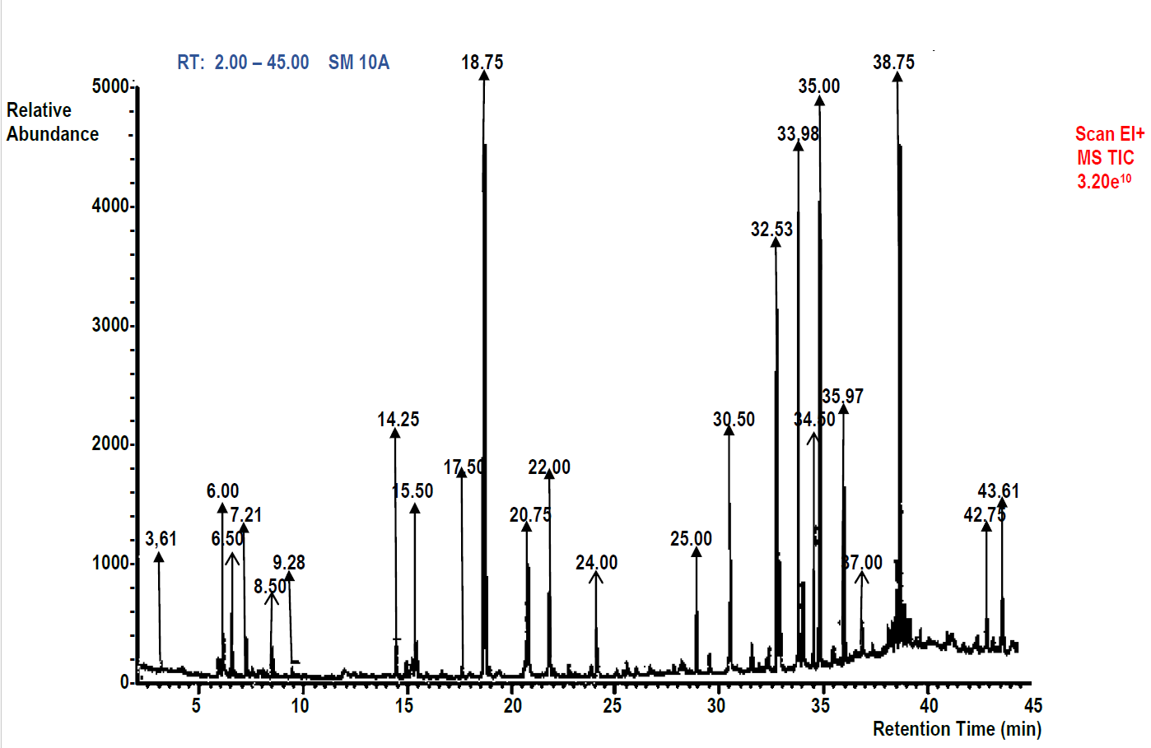
Figure 1: Spondias mombin GC-MS Chromatogram

Table 2: GC-MS of Spondias mombin Bioactive Compounds
Peak | RT | Compound Detected | Mol. Formula | MW | Peak Area % | Comp  %wt | m/z | Structures
1 | 3.21 | 1-Butanol, 3-methyl- | C₅H₁₂O | 88 | 0.32 | 1.02 | 42, 55, 88 | 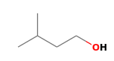
2 | 6.00 | 1-Hexanol, 2-ethyl- | C₈H₁₈O | 130 | 1.27 | 1.73 | 41, 57, 130 | 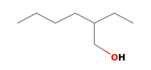
3 | 6.50 | Carbamic acid, phenyl ester | C₇H₇NO₂ | 137 | 1.91 | 2.52 | 43, 94, 137 | 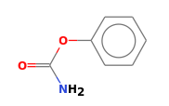
4 | 7.21 | Xylitol | C₅H₁₂O₅ | 152 | 0.96 | 1.21 | 43, 61, 152 | 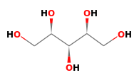
5 | 8.50 | 2-Methoxy-4-vinylphenol | C₉H₁₀O₂ | 150 | 0.80 | 1.04 | 77, 135, 150 | 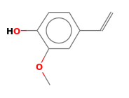
6 | 9.28 | 1-Cyclohexene-1-carboxaldehyde, 2,6,6-trimethyl- | C₁₀H₁₆O | 152 | 0.38 | 0.92 | 41, 87, 152 | 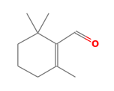
7 | 14.25 | Tridecane | C₁₃H₂₈ | 184 | 1.34 | 1.60 | 43, 57, 184 | 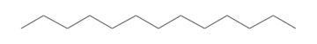
8 | 15.50 | Piperazine, 1-(2-methoxyphenyl)-4-acetyl | C₁₃H₁₈N₂O₂ | 234 | 1.46 | 1.54 | 43, 57, 234 | 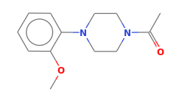
9 | 17.50 | Methyl 4-(3-oxocyclohexyl)butanoate | C₁₁H₁₈O₃ | 198 | 0.48 | 1.07 | 41, 97, 198 | 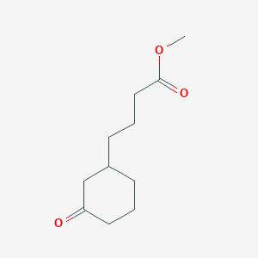
10 | 18.75 | n-Hexadecanoic acid | C₁₆H₃₂O₂ | 256 | 14.33 | 15.42 | 43, 73, 256 | 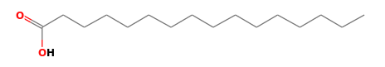
11 | 20.75 | 1,4-Bis(trimethylsilyl)benzene | C₁₂H₂₂Si₂ | 222 | 3.18 | 2.42 | 73, 207, 222 | 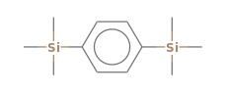
12 | 22.00 | 10-Methyl-E-11-tridecen-1-ol propionate | C₁₇H₃₂O₂ | 268 | 2.23 | 1.75 | 41, 57, 268 | 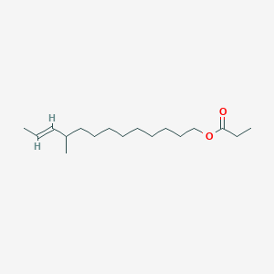
13 | 24.00 | 9,12-Octadecadienoic acid (Z,Z)- | C₁₈H₃₂O₂ | 280 | 1.40 | 3.92 | 41, 67, 280 | 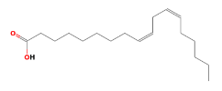
14 | 25.00 | Hexadecanoic acid, methyl ester | C₁₇H₃₄O₂ | 270 | 1.59 | 2.87 | 43, 74, 270 | 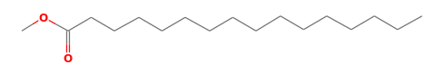
15 | 30.50 | Octadecane, 1-chloro- | C₁₈H₃₇Cl | 288 | 4.46 | 3.21 | 43, 57, 288
16 | 32.53 | Octadecanoic acid | C₁₈H₃₆O₂ | 284 | 10.19 | 11.00 | 43, 73, 284 | 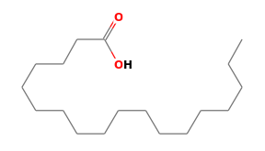
17 | 33.98 | Oleic acid | C₁₈H₃₄O₂ | 282 | 12.74 | 9.56 | 41, 55, 282 | 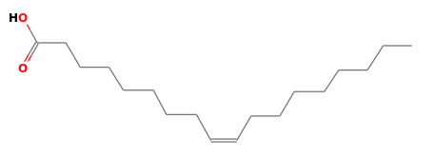
18 | 34.50 | Phytol | C₂₀H₄₀O | 296 | 2.55 | 3.21 | 43, 71, 296 | 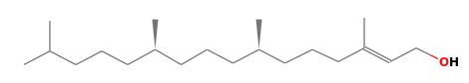
19 | 35.00 | 9-Octadecenoic acid (Z)-, 2,3-dihydroxypropyl ester | C₂₁H₄₀O₄ | 356 | 13.38 | 15.32 | 43, 55, 356 | 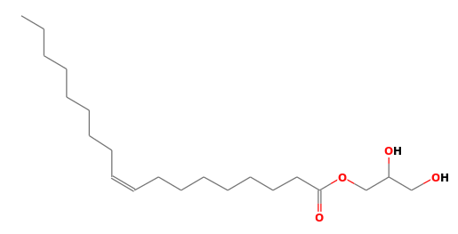
20 | 35.97 | Campesterol | C₂₈H₄₈O | 400 | 5.10 | 6.41 | 43, 55, 400 | 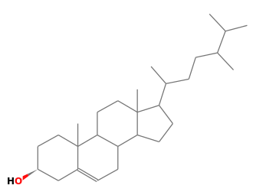
21 | 37.00 | Stigmasterol | C₂₉H₄₈O | 412 | 1.15 | 2.37 | 43, 55, 412 | 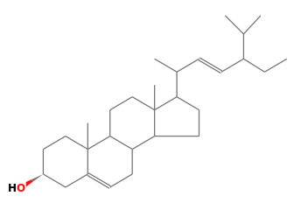
22 | 38.75 | γ-Tocopherol | C₂₈H₄₈O₂ | 416 | 14.65 | 5.73 | 43, 151, 416 | 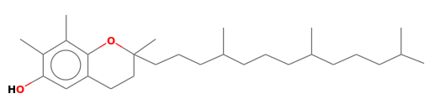
23 | 42.75 | α-Tocopheryl acetate | C₃₁H₅₂O₃ | 472 | 1.37 | 2.06 | 43, 185, 472 | 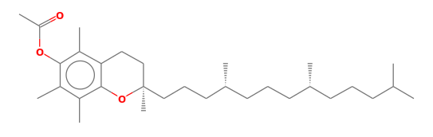
24 | 43.61 | L-Ascorbic acid, dihexadecanoate | C₃₈H₆₈O₈ | 652 | 1.82 | 2.10 | 41, 77,  652 | 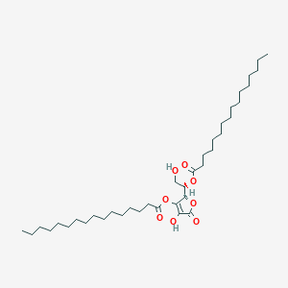

Figure 2: Effect of Spondias mombin (SM) Extract on Lipid Profile Parameters - Total Cholesterol (TC, mg/dL), and Triacylglycerol (TAG, mg/dL)

Figure 3: Effect of Spondias mombin (SM) extract on lipid profile parameters - HDL (mg/dL), LDL (mg/dL) and VLDL (mg/dL)

Figure 4: Effects of Spondias mombin (SM) extract on cardiovascular risk indices

Figure 5: Effects of Spondias mombin (SM) extract on oxidative stress markers parameters – SOD and GPx

Figure 6: Effects of Spondias mombin (SM) extract on oxidative stress markers parameters – TBARS

Figure 7: Effects of Spondias mombin (SM) extract on oxidative stress markers parameters – GSH

Discussion
The present study provides compelling evidence for the anti-hyperlipidemic and antioxidant potential of Spondias mombin (hog plum) extract in a poloxamer 407-induced hyperlipidemic rat model. These findings support the traditional use of this plant in managing metabolic disorders and highlight its relevance in functional food development. The observed lipid-lowering effects can be attributed to the synergistic action of bioactive compounds such as tannins, saponins, flavonoids, and fatty acid derivatives identified through phytochemical and GC-MS analyses.
From Table 1, Phytochemical screening revealed high concentrations of tannins (57.50 ± 0.01 mg AAE/g), saponins (40.02 ± 0.00 mg/100g), and flavonoids (40.34 ± 0.02 mg RE/g), consistent with previous reports indicating the presence of these secondary metabolites in Spondias species (Sameh et al., 2018). These compounds are well-documented for their hypocholesterolemic and antioxidant properties. For instance, saponins may reduce intestinal cholesterol absorption by forming micellar complexes with bile acids, thereby promoting fecal excretion of cholesterol metabolites. Flavonoids exert potent antioxidant activity by scavenging reactive oxygen species and inhibiting lipid peroxidation, which is crucial in preventing oxidative stress-mediated endothelial dysfunction and atherosclerosis.
GC-MS profiling further identified key bioactive constituents, including 9-Octadecenoic acid (Z)-, 2,3-dihydroxypropyl ester (15.32%), Octadecane, 1-chloro- (3.21%), and 9,12-Octadecadienoic acid (Z,Z) (3.92%) as observed in Figure 1 and Table 2. These compounds have previously been associated with anti-inflammatory, antithrombotic, and lipid-regulating effects (Wu et al., 2022; Venkatakrishnan et al., 2019). Their presence supports the observed biochemical improvements in lipid profiles and antioxidant enzyme activities in hyperlipidemic rats treated with the extract |following the observation expressed in Figure 2-7.
Administration of Spondias mombin extract at doses of 100 and 200 mg/kg significantly improved lipid parameters in poloxamer 407-induced hyperlipidemic rats. Specifically, total cholesterol and triglycerides (Figure 2) were reduced, while HDL-C levels increased (Figure 3), leading to favorable alterations in atherogenic indices such as the atherogenic coefficient (AC) and cardiac risk ratio (CRR) (Figure 4). These findings align with earlier studies that demonstrated similar lipid-lowering effects using plant extracts rich in polyphenolic and triterpenoid compounds (Sandner et al., 2020; Bahr et al., 2021).
Oxidative stress markers also showed marked improvement following treatment. Lipid peroxidation was significantly decreased, while superoxide dismutase (SOD) activity increased by over 150%, suggesting enhanced endogenous antioxidant defense mechanisms as revealed in Figure 5. This effect may contribute to the overall cardioprotective benefits of the extract, as oxidative stress plays a pivotal role in the pathogenesis of cardiovascular diseases
Notably, the absence of adverse effects in preliminary safety assessments indicates that the extract can be administered at the tested doses without significant toxicity concerns. This observation is consistent with previous studies that reported no observable behavioral or physiological changes in animals treated with Spondias mombin extracts (Bukunmi Ogunro, 2023). However, further sub-chronic and chronic toxicity studies are recommended before advancing to clinical trials.

The results support the integration of Spondias mombin into functional food formulations due to its multi-targeted mechanism of action and natural origin. Incorporating the extract into food matrices such as fortified beverages, nutraceutical bars, or encapsulated delivery systems could enhance consumer compliance and provide long-term cardiovascular benefits. Moreover, its lipid-lowering and antioxidant properties align with the concept of functional foods aimed at disease prevention rather than merely nutritional supplementation (Granato et al., 2017; Zhou et al., 2021).
Spondias mombin’s high tannin levels (Table 1) also make it a candidate for natural preservatives in food industries, where tannins inhibit lipid oxidation and microbial spoilage (Ohiri et al., 2023). This dual functionality—both as a therapeutic agent and a food preservative—enhances its commercial viability in the development of value-added functional products.
Furthermore, the observed dose-dependent response suggests that careful titration of the extract is necessary to maximize efficacy. Although higher doses (e.g., 400 mg/kg) were employed, highlighting the need for optimal dosing strategies. This is particularly important for translational applications, especially if the extract is intended for long-term consumption as part of dietary interventions.
The experimental model used in this study—poloxamer 407-induced hyperlipidemia—is a well-established method for evaluating acute lipid elevation and testing hypolipidemic agents (Samarghandian et al., 2013). Blood samples were collected via cardiac puncture and analyzed using a Cardio Check device (Mission Cholesterol Meter, model CCM-111, Germany), with atorvastatin serving as the reference drug. The consistency of lipid profile trends across replicate groups strengthens the reliability of the observed outcomes.
Importantly, the current findings corroborate existing literature on the genus Spondias, which has been shown to possess diverse pharmacological activities, including antimicrobial, anti-inflammatory, and antidiabetic effects (Moke et al., 2024; Mondal et al., 2021). The addition of lipid-modulating activity broadens its therapeutic spectrum and underscores its importance in integrative health approaches.
From a public health perspective, the increasing global burden of non-communicable diseases, particularly cardiovascular conditions, necessitates innovative and accessible solutions. Functional foods enriched with plant-based bioactives offer a sustainable and preventive approach to managing dyslipidemia and reducing the risk of associated complications. The Mediterranean diet, for example, emphasizes the inclusion of natural antioxidants and lipid-lowering foods, aligning closely with the principles underlying this research (Russo et al., 2021). This study confirms the anti-hyperlipidemic and antioxidant efficacy of Spondias mombin extract in an experimental model of hyperlipidemia. The findings validate the ethnopharmacological use of this plant and underscore its potential as a functional food ingredient. Future research should focus on formulation development, sensory evaluation, and human clinical trials to establish its efficacy and safety in target populations.
Conclusion
The present study demonstrates that Spondias mombin (hog plum) extract exhibits significant anti-hyperlipidemic and antioxidant activity in a poloxamer 407-induced hyperlipidemic rat model. The phytochemical profile revealed high concentrations of tannins (57.50 ± 0.01 mg AAE/g), saponins (40.02 ± 0.00 mg/100g), flavonoids (40.34 ± 0.02 mg RE/g), and alkaloids (44.97 ± 0.03 mg/100g), which are well-documented for their lipid-lowering and antioxidant properties. GC-MS profiling identified several bioactive compounds, including γ-tocopherol (14.65%), stigmasterol (1.15%), and α-tocopheryl acetate (1.37%), which have been previously associated with anti-inflammatory, antithrombotic, and cholesterol-regulating effects. These findings suggest that the observed biological activities may be attributed to the synergistic action of these bioactive constituents.
Administration of Spondias mombin extract at doses of 200 and 400 mg/kg body weight significantly improved lipid profiles in hyperlipidemic rats. Total cholesterol (TC) and triglycerides (TAG) were reduced, while HDL-C levels increased, leading to favorable modifications in atherogenic indices such as the atherogenic coefficient (AC) and cardiac risk index (CRI). Oxidative stress markers also showed improvement, with a notable decrease in TBARS levels and an increase in SOD and GPx activities, indicating enhanced endogenous antioxidant defense mechanisms. These results align with previous studies showing similar lipid-lowering effects using plant extracts rich in polyphenolic and triterpenoid compounds (Halder et al., 2021; Malik et al., 2023), reinforcing the therapeutic potential of Spondias mombin in managing dyslipidemia.
The observed effects support the traditional use of Spondias mombin in managing metabolic disorders and underscore its relevance in functional food development. Its multi-targeted mechanism of action, coupled with natural origin and absence of observable toxicity in preliminary assessments, makes it a promising candidate for incorporation into nutraceuticals or functional foods aimed at preventing or managing cardiovascular diseases. Future studies should focus on optimizing formulation strategies for stability and bioavailability, conducting sensory evaluation, and advancing to human clinical trials to validate these findings in target populations. Sub-chronic and chronic toxicity studies are also recommended to ensure long-term safety before commercial application.
Disclaimer (Artificial intelligence)
Option 1:
Author(s) hereby declare that NO generative AI technologies such as Large Language Models (ChatGPT, COPILOT, etc.) and text-to-image generators have been used during the writing or editing of this manuscript.
Option 2:
Author(s) hereby declare that generative AI technologies such as Large Language Models, etc. have been used during the writing or editing of manuscripts. This explanation will include the name, version, model, and source of the generative AI technology and as well as all input prompts provided to the generative AI technology
Details of the AI usage are given below:
1.
2.
3.
References
- Aboul Ezz, H. S., Khadrawy, Y. A., & Mourad, I. M. (2015). The effect of bisphenol A on some oxidative stress parameters and acetylcholinesterase activity in the heart of male albino rats. Cytotechnology, 67, 145-155. https://link.springer.com/article/10.1007/s10616-013-9672-1
- Agostino, M., Mancera, R. L., Ramsland, P. A., & Fernández-Recio, J. (2016). Optimization of protein–protein docking for predicting Fc–protein interactions. Journal of Molecular Recognition , 29(11), 555–568. https://doi.org/10.1002/jmr.2555
- Abiodun, O. O., Nnoruka, M. E., & Tijani, R. O. (2020). Phytochemical constituents, antioxidant activity, and toxicity assessment of the seed of Spondias mombin L.(Anacardiaceae). Turkish Journal of Pharmaceutical Sciences, 17(3), 343. https://pmc.ncbi.nlm.nih.gov/articles/PMC7336035/
- Asgharpour, M., Khavandegar, A., Balaei, P., Enayati, N., Mardi, P., Alirezaei, A., & Bakhtiyari, M. (2021). Efficacy of oral administration of Allium sativum powder “garlic extract” on lipid profile, inflammation, and cardiovascular indices among hemodialysis patients. Evidence‐Based Complementary and Alternative Medicine, 2021(1), 6667453. https://doi.org/10.1155/2021/6667453
- Bahr, T., Butler, G., Rock, C., Welburn, K., Allred, K., & Rodriguez, D. (2021). Phytotherapy Research, 35(8), 4215–4245. https://doi.org/10.1155/2021/6667453
- Bacigale, S. B., Ayagirwe, R. B., Mutwedu, V. B., Mugumaarhahama, Y., Mugisho, J. Z., Nziku, Z., ... & Mignouna, J. (2023). Assessing milk products quality, safety, and influencing factors along the dairy value chain in eastern Democratic Republic of the Congo. Frontiers in Sustainable Food Systems, 7, 1105515. https://doi.org/10.3389/fsufs.2023.1105515
- Chen, S., Tang, Y., Gao, Y., Nie, K., Wang, H., Su, H., ... & Dong, H. (2022). Antidepressant potential of quercetin and its glycoside derivatives: a comprehensive review and update. Frontiers in pharmacology, 13, 865376. https://doi.org/10.3389/fphar.2022.865376
- Cristofoli, N. L., Lima, C. A. R., Vieira, M. M. C., Andrade, K. S., & Ferreira, S. R. S. (2019). Separation Science and Technology, 54(4), 580–590. https://doi.org/10.1080/01496395.2018.1508233
- De Ruyck, J., Brysbaert, G., Blossey, R., & Lensink, M. F. (2016). Molecular docking as a popular tool in drug design, an in silico travel. Advances and Applications in Bioinformatics and Chemistry , 1–11. https://www.tandfonline.com/doi/full/10.2147/AABC.S105289

- Dey, P., Kundu, A., Kumar, A., Gupta, M., Lee, B. M., Bhakta, T., ... & Kim, H. S. (2020). Analysis of alkaloids (indole alkaloids, isoquinoline alkaloids, tropane alkaloids). In Recent Advances in Natural Products Analysis (pp. 505–567). Elsevier. https://www.sciencedirect.com/science/article/pii/B9780128164556000159

- El-Tantawy, W. H., & Temraz, A. (2019). Natural products for controlling hyperlipidemia. Archives of Physiology and Biochemistry, 125(2), 128–135. https://doi.org/10.1080/13813455.2018.1441315

- Halder, T., Mehta, P., & Acharya, N. (2021). Trends in the functional food market and nutraceutical product development. In Nutraceuticals for aging and anti-aging (pp. 1-26). CRC Press. https://www.taylorfrancis.com/chapters/edit/10.1201/9781003110866-1/trends-functional-food-market-nutraceutical-product-development-tripti-halder-priti-mehta-niyati-acharya

- Hunter, P. M., & Hegele, R. A. (2017). Functional foods and dietary supplements for the management of dyslipidaemia. Nature Reviews Endocrinology, 13(5), 278-288. https://www.nature.com/articles/nrendo.2016.210

- Jędrusek‐Golińska, A., Górecka, D., Buchowski, M., Wieczorowska‐Tobis, K., Gramza‐Michałowska, A., & Szymandera‐Buszka, K. (2020). Recent progress in the use of functional foods for older adults: A narrative review. Comprehensive Reviews in Food Science and Food Safety, 19(2), 835-856. https://doi.org/10.1111/1541-4337.12530

- Larbaoui, B., & Menad, R. (2024). Single-click molecular docking via SwiftDock: A new virtual screening tool using AutoDock4. Computational and Structural Biotechnology Reports, 100017. https://www.sciencedirect.com/science/article/pii/S2950363924000176

- Madden, J. C., & Thompson, C. V. (2022). Pharmacokinetic tools and applications. In In Silico Methods for Predicting Drug Toxicity (pp. 57–83). New York, NY: Springer US. https://link.springer.com/protocol/10.1007/978-1-0716-1960-5_3

- Maghsoudloo, M., Bagheri Shahzadeh Aliakbari, R., & Jabbari Velisdeh, Z. (2023). Pharmaceutical, nutritional, and cosmetic potentials of saponins and their derivatives. Nano Micro Biosystems, 2(4), 1-6. https://www.nmb-journal.com/article_181531.html

- Mohammad, T., Mathur, Y., & Hassan, M. I. (2021). InstaDock: A single-click graphical user interface for molecular docking-based virtual high-throughput screening. Briefings in Bioinformatics , 22(4), bbaa279. https://academic.oup.com/bib/article/22/4/bbaa279/5940458

- Mondal, S., Bhar, K., Panigrahi, N., Mondal, P., Nayak, S., Barik, R. P., & Aravind, K. (2021). A tangy twist review on Hog-plum: Spondias pinnata (Lf) Kurz. https://www.cabidigitallibrary.org/doi/full/10.5555/20220079961

- Munawar, M., Khan, M. S., Saeed, M., Younas, U., Farag, M. R., Di Cerbo, A., ... & Alagawany, M. (2023). Phytosterol: nutritional significance, health benefits, and its uses in poultry and livestock nutrition. Animal Biotechnology, 34(7), 3206-3215. https://www.tandfonline.com/doi/abs/10.1080/10495398.2022.2099882

- Naeem, A., Abbas, S. H., Yousaf, M., Ishtiaq, A., & Murtaza, I. (2024). Global Impact and Strategies to Reduce the Mortality from Cardiovascular Diseases. In Integrated Science for Sustainable Development Goal 3: Empowering Global Wellness Initiatives (pp. 283-306). Cham: Springer Nature Switzerland. https://link.springer.com/chapter/10.1007/978-3-031-64288-3_12

- Pan, J., Zhang, C., Shi, M., Guo, F., Liu, J., Li, L., ... & Fu, P. (2021). Ethanol extract of Liriodendron chinense (Hemsl.) Sarg barks attenuates hyperuricemic nephropathy by inhibiting renal fibrosis and inflammation in mice. Journal of Ethnopharmacology, 264, 113278. https://doi.org/10.1016/j.jep.2020.113278
- Parmar, N., Patel, R., Rathwa, N., Dwivedi, M., Begum, R., & Ramachandran, A. V. (2025). Melatonin and GABA monotherapies are as efficacious as combination therapy in managing T1D and T2D: In-vivo studies on experimental diabetic models. bioRxiv, 2025-03. https://www.biorxiv.org/content/10.1101/2025.03.17.639558v1.abstract

- Samarghandian, S., Farkhondeh, T., & Azimi-Nezhad, M. (2013). Cell Journal (Yakhteh) , 15(2), 153–160. https://link.springer.com/article/10.1186/s11658-021-00286-5

- Sandner, G., König, A., Wallner, M., & Weghuber, J. (2020). Current Opinion in Food Science, 34, 9–20. https://www.sciencedirect.com/science/article/pii/S2214799320300795
- Shivanika, C., Kumar, D., Ragunathan, V., Tiwari, P., & Sumitha, A. (2020). Molecular docking, validation, dynamics simulations, and pharmacokinetic prediction of natural compounds against the SARS-CoV-2 main-protease. Journal of Biomolecular Structure & Dynamics , 1. https://pmc.ncbi.nlm.nih.gov/articles/PMC7573242/
- Sirota, T. V. (2017). Standardization and regulation of the rate of the superoxide-generating reaction of adrenaline autoxidation used for evaluation of pro/antioxidant properties of various materials. Biochemistry (Moscow), Supplement Series B: Biomedical Chemistry , 11, 128–133. https://link.springer.com/article/10.1134/S1990750817020068
- Swathi, S., & Lakshman, K. (2022). Phytopharmacological and Biological Exertion of Spondias Pinnata : A Review. Oriental Journal Of Chemistry , 38(2), 268. https://www.semanticscholar.org/paper/Phytopharmacological-and-Biological-Exertion-of-%28A-Swathi-Lakshman/62610e606fa1b4a0a2319b8c1ae48abaafad29ba?p2df
- Syengo, S. M., Mutai, B. K., Menza, N. C., & Mathenge, S. G. (2023). Lipid Profiles, Cardiovascular Disease Risk and Dyslipidemia in HIV-Positive Patients on HAART at Machakos Level Five Hospital, Machakos County, Kenya (Doctoral dissertation, Kenyatta University). https://scholar.google.com/scholar?hl=en&as_sdt=0%2C5&q=28.%09Syengo%2C+S.+M.%2C+Mutai%2C+B.+K.%2C+Menza%2C+N.+C.%2C+%26+Mathenge%2C+S.+G.+%282023%29.+Lipid+Profiles%2C+Cardiovascular+Disease+Risk+and+Dyslipidemia+in+HIV-Positive+Patients+on+HAART+at+Machakos+Level+Five+Hospital%2C+Machakos+County%2C+Kenya+%28Doctoral+dissertation%2C+Kenyatta+University%29.&btnG=
- Usai, R., Majoni, S., & Rwere, F. (2022). Natural products for the treatment and management of diabetes mellitus in Zimbabwe – a review. Frontiers in Pharmacology , 13, 980819. https://doi.org/10.3389/fphar.2022.980819
- Valentino, G., Graziani, V., D’Abrosca, B., Pacifico, S., Fiorentino, A., & Scognamiglio, M. (2020). NMR-based plant metabolomics in nutraceutical research: an overview. Molecules , 25(6), 1444. https://doi.org/10.3390/molecules25061444
- Venkatakrishnan, K., Chiu, H.-F., & Wang, C.-K. (2019). Food & Function, 10(5), 2313–2329. https://doi.org/10.1039/C9FO00293F
- Wei, Z., Chen, M., Lu, X., Liu, Y., Peng, G., Yang, J., ... & Yu, P. (2024). A New Advanced Approach: Design and Screening of Affinity Peptide Ligands Using Computer Simulation Techniques. Current Topics in Medicinal Chemistry, 24(8), 667–685. https://doi.org/10.2174/0115680266281358240206112605
- Wu, Y., Wang, W., Kou, N., Wang, M., Yang, L., Miao, Y., ... & Shi, D. (2022). Panax notoginseng saponins combined with dual antiplatelet drugs potentiates anti-thrombotic effect with alleviated gastric injury in A carotid artery thrombosis rat model. Journal of Stroke and Cerebrovascular Diseases, 31(8), 106597. https://doi.org/10.1016/j.jstrokecerebrovasdis.2022.106597
- Yahia, E. M., Maldonado Celis, M. E., & Svendsen, M. (2017). The contribution of fruit and vegetable consumption to human health. Fruit and Vegetable Phytochemicals: Chemistry and Human Health, 2nd Edition, 1-52. https://doi.org/10.1002/9781119158042.ch1

- Yekeen, N., Malik, A. A., Idris, A. K., Reepei, N. I., & Ganie, K. (2020). Foaming properties, wettability alteration and interfacial tension reduction by saponin extracted from soapnut (Sapindus Mukorossi) at room and reservoir conditions. Journal of Petroleum Science and Engineering, 195, 107591. https://doi.org/10.1016/j.petrol.2020.107591
- Zhou, D. D., Luo, M., Shang, A., Mao, Q. Q., Li, B. Y., Gan, R. Y., & Li, H. B. (2021). Antioxidant food components for the prevention and treatment of cardiovascular diseases: effects, mechanisms, and clinical studies. Oxidative medicine and cellular longevity, 2021(1), 6627355. https://doi.org/10.1155/2021/6627355

