Original Research Article

A Comparative Study between Purse-String and Linear Skin Closure after Intestinal Ostomy Reversion and Post Operative Outcome

ABSTRACT
Introduction: The use of a temporary diverting stoma has been shown to decrease septic consequences after high risk intestinal anastomosis. Following an ileostomy or colostomy reversal, wound infection is a well-accepted complication. Bacteria on the skin near the ileostomy or colostomy that have come into prolonged contact with bowel contents, are the main reason behind post-operative wound infections. As of yet, there is no consensus on the best stoma closure method to reduce postoperative SSI.
Materials and Methods: This prospective study was conducted in different surgery units of Mymensingh Medical College Hospital from May, 2015 to November, 2015. The patients were distributed into two groups: linear skin closure (group L) and purse string closure (group P). Surgical site infection, cosmetic outcome, patient’s satisfaction, mean hospital stay were compared between two groups. Quantitative data were analyzed by t-test while qualitative data were evaluated by chi-square test.
Result: In the present study, 50 patients with ileostomy or colostomy (end, loop or double barrel) were included where 25 patients were included in each study group. There were no significant differences in demographic variables between two groups. The mean time duration from ileostomy or colostomy to reversal was 126.48±4.7 days in group L and 131.96±6.7 days in group P. The mean operative time was 96.2±12.6 minutes in group L and 89.6±2.3 minutes in group P. Mean hospital stay was between group-L and group-P were 10.68±± days and 6.68±1.2 days respectively which was statistically significant (p<0.05). Surgical site infection was found in 3 cases (12%) in group L and in 0 case (0%) in group p. Operative complications like lower GI bleeding, diarrhea, paralytic ileus and sub-acute intestinal obstruction were not significantly varied between two groups. The mean score of cosmetic outcome between group-L and group-P done by visual analog scale were 4.2 and 8.7 respectively which was statistically significant (p=0.001).
Conclusion: This study shows that, purse string skin closure after intestinal ostomy reversion is superior to conventional linear skin closure in some circumstances. The SSI rate is significantly lower in purse string than linear closure group. Patient’s satisfaction level is higher in purse string closure group, cosmetic outcome is also better. Less limitation of daily activity as hospital stay period is shorter in purse string group.
Keywords: purse-String closure, linear skin closure, intestinal ostomy reversion, outcome

Introduction:
The use of diverting stoma has been shown to be a safe and effective adjunct in the treatment of colorectal surgery. Stoma reversal is often associated with different types of post-operative morbidities. Surgical site infection (SSI) is the most common complication and the main cause of prolonged hospital stay and bed occupancy.¹ The incidence of wound infection ranges from 0% to as high as 41%, depending on investigators, a rate higher than expected for a clean contaminated wound.² The causes of wound infection are a contaminated wound due to bacteria on the skin residing in close proximity to the stoma. Getting exposed to intestinal contents is also an important factor for wound infection. To date, there is no consensus on ideal closure technique of the stoma to minimize postoperative SSI and multiple techniques have been proposed: continuous or interrupted stitch wound closure, primary closure with drain, delayed primary closure, or no closure and healing by secondary intention.³ Primary closure leads to rapid healing but has been associated with higher postoperative SSI. Moreover conventional linear closure of the wound produces ugly scarring which is cosmetically embarrassing, healing time is also prolonged.⁴ Following an ileostomy reversal, Banerjee et al. found that purse-string skin closure reduces wound infection and scarring, making the procedure more aesthetically acceptable .⁵ According to Sutton et al. 51 patients who had purse-string skin closure did not experience any wound infections after being monitored for 6 weeks.⁶ Besides, Reid et al. conducted a randomized prospective study on 61 patients who had an ileostomy reversal. The patients were split into two groups: one group (n = 31) had wound closure done by traditional linear skin closure, and the other group (n = 30) had purse-string skin closure. Wound infection was 6.7% (2 instances) in the purse-string skin closure group, compared to 38.7% (12 cases) in the linear skin closure group.⁷ In this study we’ll compare linear vs. purse-string closure of the ostomy wound to verify whether purse-string closure is better, so that it could be more frequently utilized to obtain a better outcome in most of patients.

Materials and Method:
This study was conducted in the Department of Surgery, Mymensingh Medical College Hospital, Mymensingh, Bangladesh during the period from May’ 2015 to November’ 2015 with an ultimate view to find out the post-operative outcome of linear vs. purse-string skin closure method after intestinal stoma reversal. In this study, 50 patients were selected using the purposive sampling method.
The patients were selected as a case of temporary ileostomy or colostomy in situ (loop, end or double barrel). A detailed history of each patient on admission was taken by using pre-designed questionnaire for the study. Then every case was examined thoroughly and findings like anaemia, jaundice, dehydration, pulse, blood pressure were examined, stomal condition, peri stomal skin condition, stomal complication were noted and digital rectal examination was done.
Diagnostic procedure that included a detailed history, meticulous physical examination. Investigations including Barium enema and Distal loopogram were done in all cases.
The patients were explained and given a sample description of the technique in understandable terms. It highlighted the potential benefits & the patients were informed about the anticipated discomfort. The patients were informed about the invasiveness of this procedure, the risk of complications that have to be weighed against the expected benefits. A signed informed consent was obtained which confirms the patient understands and accepts the procedure.
Participants of the study were randomly divided into two groups (25 patients in each group). The two techniques used to close ileostomy stoma wound were:
1. Linear closure: An elliptical incision was used for the closure of intestinal stoma (ileostomy or colostomy). After restoration of the gut by traditional method muscles of abdominal wall were closed by continuous non-absorbable stitches. Skin was approximated using interrupted non-absorbable suture resulting in a linear scar.
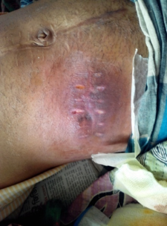
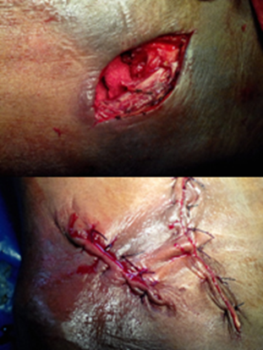

Fig-1 Linear closure technique

2. Purse-string closure: A circular incision was used for the reversal of intestinal stoma. Restoring the gut by traditional method, muscles of abdominal wall were closed by continuous non-absorbable stitches. Skin wound was closed using single continuous subcuticular stitch with non-absorbable suture material (Proline No 1) resulting in a rounded wound leaving approximately 0.5cm skin defect in the middle.

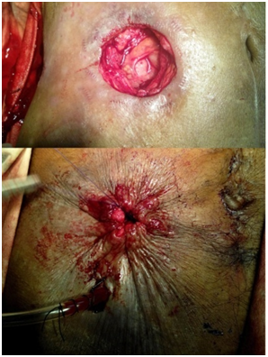
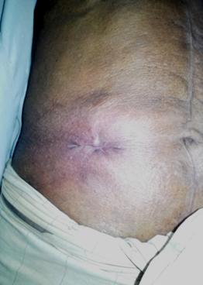

Fig-2 Purse-string closure

The two groups were compared for the presence of post-operative surgical site infection. Presence of wound infection was assessed by looking for erythema or cellulitis around the wound, purulent discharge from the wound or systemic indications of infection like fever or tachycardia. These assessments were made on 5th post-op day while the patient was still admitted. All patients were called to outpatient department for follow-up visit on the 14th post-op day and one month later to see other postoperative complications .The cosmetic result was evaluated by using visual analog scale. A Visual Analogue Scar (VAS) scale is ranging from 0–10, which is a feasible tool in the visual assessment of skin scars as well as the maturation process of a normal skin scar. Data will be processed and analyzed using computer software SPSS (Statistical Package for Social Sciences). The test statistics to be used are descriptive statistics, Chi-square and Student’s t-Test. A p value < 0.05 was considered statistically significant.

Result:
In the current study, 50 patients with ileostomy or colostomy (end, loop or double barrel) were included, 25 patients were chosen for linear and 25 for purse-string skin closure technique. The age of the patients were ranging from 15-75 years with a mean age was 41.36 ±4.2 years. Out of them, 60% were male and 40% were female with a male female ratio of1.5: 1.
The skin around the stoma (Ileostomy or colostomy) was mostly normal and that was 41 in number (82%). Only 3 patients (6%) had ulceration around the stoma. 6 patients (12%) had peristomal dermatitis.

Fig-3 Showing peristomal skin conditions of the patients (n=50)

Benign conditions were the main indications of stoma creation (82% vs 18%). Most of the benign conditions for stoma creation were typhoid ulcer perforation and sigmoid volvulus (16% each). Others were TB ulcer perforation (12%), blunt trauma in abdomen (10%), small gut volvulus (8%), stricture with gut necrosis (6%), penetrating injury in abdomen (4%), band and adhesion with gut necrosis (4%), intussusceptions, caecal gangrene and burst appendix with caecal blowout (2%). Among these 41 patients, 20 had linear and 20 had purse-string skin closure. Malignant conditions were carcinoma of the colon (10%) and carcinoma of the rectum (8%). Five patients underwent linear while four had purse string closure.

Table-1 Showing Indications for stoma creation

Indication of previous operation |  | Skin closure group |  | Total (%)
 |  | Linear | Purse string | Total (%)
Malignant  Benign | Typhoid Ulcer Perforation | 4 | 4 | 8(16%)
Malignant  Benign | TB Ulcer Perforation | 3 | 3 | 6(12%)
Malignant  Benign | Stricture with Gut Necrosis | 1 | 2 | 3(6%)
Malignant  Benign | Small Gut Volvulus | 2 | 2 | 4(8%)
Malignant  Benign | Sigmoid volvulus | 3 | 5 | 8(16%)
Malignant  Benign | Penetrating Injury | 1 | 1 | 2(4%)
Malignant  Benign | Intussusception | 1 | 0 | 1(2%)
Malignant  Benign | Caecal Gangrene | 0 | 1 | 1(2%)
Malignant  Benign | Blunt Trauma | 2 | 3 | 5(10%)
Malignant  Benign | Band Adhesion with Gut Ischemia | 2 | 0 | 2(4%)
Malignant  Benign | Burst Appendix with ceacal blow out  Total  Ca Rectum  Ca Colon  Total | 1  20  2  3  5 | 0  21  2  2  4 | 1(2%)  41(82%)  4(8%)  5(10%)  9(18%)

There were 6 types of temporary intestinal stoma created in previous operations. Most of the patients had loop ileostomy (n=19). The second most common was double barrel ileostomy (n=17). The mean time duration from ileostomy or colostomy to reversal was 126.48±4.7 days in group L and 131.96±6.7 days in group P.
Mean hospital stay in linear closure method is 10.68±±2 days where as in purse string method it is 6.68±1.2 days which was statistically significant (p<0.05).Mean per-operative time was more in linear skin closure group than purse string group 96.2±12.6 minutes vs 89.6±2.3 minutes which was not statistically significant.

After stoma reversal operation of 50 patients, 47 patients had no surgical site infection (SSI) and 3 patients had SSI. In L group, 3 (12%) patients had SSI, where as in P group, none of the patient had SSI (0%). Only in 1 (4%) patient had anastomotic leakage which was in group-L. GI bleeding were same (2%) in each group. Post-operative diarrhea occurred in 2% patients which was found only in linear group. Paralytic ileus occurred only in purse string group (2%). Sub-acute intestinal obstruction occurred equall in both groups and that was 2%.
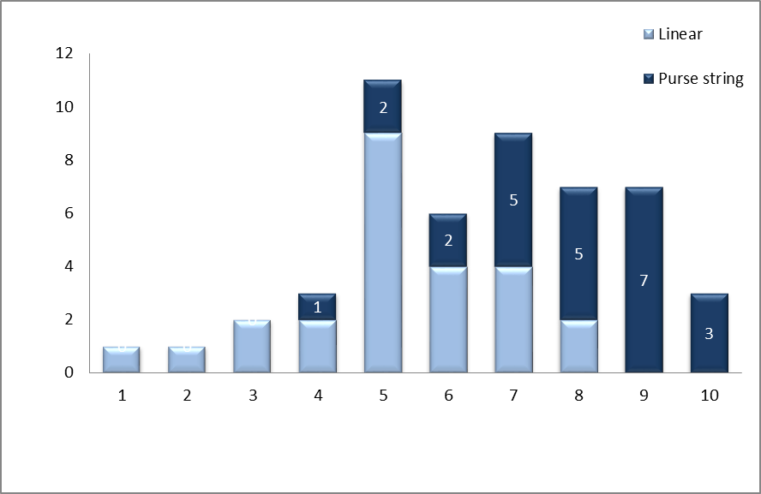
The cosmetic outcome has been analyzed by visual analog scar (VAS) scale. In linear group, 68% patients scored between from 5 to 7. In purse string group, 80% patient’s score ranged from7 to 10. The mean scores of linear and purse string groups were 4.2±1.3 and 8.7±1.6 respectively which was statistically significant (p<0.05).

Fig-4 Showing cosmetic outcome according to visual analog scale

Fig-5 Showing satisfaction level of patients

All patients came for follow-up after 1 month. Patient satisfaction levels were then graded as very satisfied, satisfied, unsatisfied and very unsatisfied. 28% patients were very satisfied in purse string group .In linear group, 60% patient were satisfied, 24% were unsatisfied and 16% were very unsatisfied. In purse string group 52% were satisfied, 20% were unsatisfied and none was very unsatisfied though the differences were not statistically significant.

Discussion:

Construction of a diverting temporary Intestinal stoma is a routine procedure nowadays often dealt by surgeons. An intestinal stoma is an opening, which is surgically created, with a portion of the intestine to the outside of abdominal wall to provide an alternative channel for feces and digestive waste.⁸ A temporary stoma, which has protected an anastomosis, may be closed as soon as the anastomosis is soundly healed.⁹ Early closure, at around 2 weeks, is practiced by some surgeons but is technically more difficult at this stage.¹⁰ A delay of 6–8 weeks allows the stoma to mature and the planes around the stoma to become better defined.¹⁰ The additional wait will also allow the patient to regain nutritional and immunological status after a major operation, and will also reduce the risk of thromboembolic complications. There are many techniques for stoma reversal. The purpose of this study was to assess the post-operative outcome in purse-string and linear skin closure method of intestinal stoma closure after reversion of ileostomy or colostomy.

Wound infection after an ileostomy or colostomy reversal is a relatively common complication.¹¹ Many trials have been conducted in an attempt to reduce the high rates of wound infection related to stoma closure.^{12,13} Dusch et al. reported in his study that rate of SSI is significantly lower after purse string suture (0%) compared with direct suture (24%).¹⁴ Besides, Jung et al. reported a retrospective analysis that compared linear skin closure with purse-string skin closure for ileostomy reversal.¹⁵ The incidence of wound infection of the purse-string skin closure group (1 case, 5.6%) was lower than the linear skin closure group (5 cases, 16.7%). In our study purse string closure was superior in terms of less wound infection but the results were not significant.
Several studies have reported that the hospitalization period after an ileostomy reversal did not differ according to the wound closure technique.^{16,17,18} kaider et al. reported shorter duration of stay in purse string group.¹⁹ In our present study, purse string technique was also associated with less hospital stay (p<0.05). There is no significant difference of per-operative time duration between any type of stoma take-down. In our study, we did not find noticeable differences in either group (96.2±12.6 minutes in linear and 89.6±2.3 minutes in Purse string group) regarding stoma type, making both groups comparable.
In case of linear skin closure long scar is formed, whereas it is avoided in purse string method.²⁰ However, the skin is creased radially, so skin cosmesis after wound healing is of concern. Song et al. objectively compared the cosmetic satisfaction level of patients about scars from linear skin closure and purse-string skin closure after an ileostomy reversal by applying the visual analog scale (VSA) and a statistically significant difference was found between two techniques regarding the cosmetic outcome by VSA mean scores which coincides with our results (Linear technique=4.2±1.3 and purse string =8.7±1.6, p<0.05)).²⁰ In the purse-string skin closure cases, after the epithelialization process that occurred within 2-4 weeks, scabs were formed on the skin, and the scars that finally remained on the skin were circular shaped, with a diameter smaller than 2 cm, whereas in linear closure group the scars were 4-6 cm in length.²¹ The overall satisfaction of the patient significantly differs between two groups. Daniel et al. reported in his study that 70% of patients with purse-string closure were very satisfied in comparison with 20 % in linear group which was similar to our results.²² This study was not without a limitation. This study was done within a short period of time having a small size. Further studies with larger sample size can give a better conclusion.

Conclusion:
In conclusion, our trial shows that we have introduced two methods of skin closure technique namely conventional liner closure and purse-string closure after intestinal stoma has taken down.
Purse string skin closure is better than traditional linear skin closure in many ways. Compared to the linear closure group, the purse string group has a substantially decreased surgical site infection (SSI) rate. Patient’s satisfaction level is also higher in purse string closure group. The body images are a clear evidence of better cosmetic outcome in patients who have gone through purse-string closure method. Above all hospital stay period is shorter in purse string closure group than linear. Other post-operative outcomes are not significantly differing between these two groups.

ETHICAL APPROVAL
As per international standards or university standards written ethical approval has been collected and preserved by the authors.
DISCLAIMER (ARTIFICIAL INTELLIGENCE)
Authors hereby declare that NO generative AI technologies such as Large Language Models (ChatGPT, COPILOT, etc.) and text-to-image generators have been used during the writing or editing of this manuscript.

References:

- Haase o, Raue W, Böhm B, neuss h, scharfenberg m, schwenk W. Subcutaneous gentamycin implant to reduce wound infections after loop-ileostomy closure: a randomized, double-blind, placebo controlled trial. Dis Colon Rectum.2015; 48: 2025–2031.
- Matthiessen P, Hallbook O, Rutegard J, Simert G, Sjodahl R. Defunctioning stoma reduces symptomatic anastomotic leakage after low anterior resection of the rectum for cancer: a randomized multicenter trial. Annl. of Surg. 2017; 246: 207– 214.

- Law WI, Chu KW, Ho JW, Chan CW. Risk factors for anastomotic leakage after low anterior resection with total mesorectal excision. Am J Surg. 2020; 179: 92–96.

- Edwards DP, Leppington-Clarke A, Sexton R, Heald RJ, Moran BJ. Stoma-related complications are more frequent after transverse colostomy than loop ileostomy: a prospective randomized clinical trial. Br J Surg. 2021; 88: 360–363.

- Banerjee A. Pursestring skin closure after stoma reversal. Dis Colon Rectum 2017; 40: 993–994.

- Sutton CD, Williams N, Marshall LJ, Lloyd G, Thomas WM. A technique for wound closure that minimizes sepsis after stoma closure. ANZ J Surg. 2022; 72: 766–767.

- Reid K, Pockney P, Pollitt T, Draganic B, Smith SR. Randomized clinical trial of short-term outcomes following purse-string versus conventional closure of ileostomy wounds. Br J Surg. 2020; 97: 1511–1517.

- Rullier E, Le Toux N, Laurent C, Garrelon JL, Parneix M, Saric J. Loop ileostomy versus loop colostomy for defunctioning low anastomoses during rectal cancer surgery. W J Surg. 2021; 25: 274–277.

- Rondelli F, Reboldi P, Rulli A, Barberini F, Guerrisi A, Izzo L. Loop ileostomy versus loop colostomy for fecal diversion after colorectal or coloanal anastomosis: a meta-analysis. Int J Colorectal Dis 2019; 24: 479–488.

- Hackam DJ, Rotstein OD. Stoma closure and wound infection: an evaluation of risk factors. Can J Surg. 2015; 38: 144–148.

- Garcia-Botello SA, Garcia-Armengol J, Garcia-Granero E, Espi A, Juan C, Lopez-Mozos F. A prospective audit of the complications of loop ileostomy construction and takedown. Dig Surg. 2014; 21: 440–446

- Sang Il Y, Sun MB, Hwan N, Dong GP. Clinical Trial on the Incidence of Wound Infection and Patient Satisfaction after Stoma Closure: Comparison of Two Skin Closure Techniques. Ann Coloporoctol. 2015; 31(1): 29-33 .

- Williams LA, Sagar PM, Finan PJ, Burke D. The outcome of loop ileostomy closure: a prospective study. Colorectal Dis. 2018; 10: 460–464.

- Mileski WJ, Rege RV, Joehl RJ, Nahrwold DL. Rates of morbidity and mortality after closure of loop and end colostomy. Surg Gynecol Obstet 2020; 171: 17–21

- Jung RL, Young WK, Jong JS, Ok-Pyung S, et al. Conventional Linear versus Purse String Closure after Loop Ileostomy Reversal: Comperison of Wound Infection Rates and Operative Outcomes. J Korean Soc Coloproctol. 2021; 27(2): 58-63.

- Akiyoshi T, Fujimoto Y, Konishi T, Kuroyanagi H, Ueno M, Oya M, et al. Complications of loop ileostomy closure in patients with rectal tumor. World J Surg. 2020; 34: 1937–1942.

- Song GW, Yu CS, Lee HO, Kim MS, Namgung H, Lee GH, et al. Ileostomy related complications. J Korean Soc Coloproctol. 2013; 19: 82–89.

- Kim JY, Kim JS, Hur H, Min BS, Kim NK, Sohn SK, et al. Complication and relevant factors after an ileostomy for fecal diversion in a patient with rectal cancer. J Korean Soc Coloproctol. 2019; 25: 81–87.

- Kaidar-Person O, Person B, Wexner SD. Complications of construction and closure of temporary loop ileostomy. J Am Coll Surg. 2015; 201: 759–773.

- Song GW, Yu CS, Lee HO, Kim MS, Namgung H, Lee GH, et al. Ileostomy related complications. J Korean Soc Coloproctol. 2003; 19: 82–89.

- Gachabayov, M., Lee, H., Chudner, A., Dyatlov, A., Zhang, N., & Bergamaschi, R. Purse-string vs. linear skin closure at loop ileostomy reversal: a systematic review and meta-analysis. Techniques in Coloproctology.2019;23:207-220.

- Daniel C, Jose L, Noel SN, Quintin H, Gonzalez M, Omar VF. Randomized Clinical Trial of Intestinal Ostomy Takedown Comparing Pursestring Wound Closure vs Conventional Closure to Eliminate the Risk of Wound Infection. Dis Colon Rectum. 2023; 56: 205–211.

