Pinworms and Appendicitis: About 10 Cases with Review of Literature

ABSTRACT
The pinworm is due to helminthes, Enterobius Vermicularis. It is a cosmopolitan digestive parasitosis and very frequent. It is a colic parasitosis because adult’s pinworms live in the cecum. Since the pinworm was found in the lumen of the appendix, its role in triggering inflammatory processes responsible for appendicitis was raised, with the persisting question: what is the role of pinworms in the appendicitis?
In our retrospective study, we analyzed a series of 10 cases of appendicular pinworms (5 males/ 5 females, aged between 6 and 54 years) among 1224 appendectomies, collected over the period (February 2008-December 2015) at the 5th Military Hospital of Guelmim. We studied epidemiological, clinical, paraclinical, therapeutic and pathological aspects. A literature review has been given, in order to compare our data with those published from different hospitals around the world.
An important part of the literature, concerning the appendicular pinworm, has raised the issue related to the high rates of negative appendectomies. Indeed, the presence of pinworms in the appendix can lead to appendicular syndrome independently of the presence of a histological inflammation. Moreover, the low incidence of pinworms in appendectomy specimens and the high rate of negative appendectomies with presence of Enterobius Vermicularis, support the hypothesis that pinworms do not cause appendicitis.
As conclusion of this work, we emphasize the importance of thinking about the possibility of pinworms infection for patients with appendicitis syndrome. In the absence of surgical emergencies, a comprehensive examination with repeated parasitic scotch-test is recommended. The positivity of these tests would reduce the number of negative appendectomies. In this case, a simple antiparasitic treatment is sufficient.

Keywords: pinworm, Enterobius vermicularis, appendicitis, appendectomy, laparoscopy Appendicular Oxyuriasis, ,
INTRODUCTION
Pinworm infection, caused by Enterobius vermicularis, is an extremely common, ubiquitous nematode infection: one billion people are affected worldwide, especially the school-aged population, which is often 80% infected [1]. It is very common in both temperate and tropical zones. It is a colonic parasitosis, as adult threadworms live in the cecum. The only reservoir of the parasite is humans. Transmission is direct from the anus to the mouth via fingers, particularly in children, indirect via contaminated objects and food, or by inhalation of eggs suspended in dust [2].
Threadworms are sometimes found on the surgical specimen after appendectomy. The association of E. vermicularis and appendicitis was recognized towards the end of the 19th century, when a 19% incidence of appendiceal infestation in children with appendicitis was reported [4]. Other studies have shown that the link between this parasitosis and appendicitis varied from 0.2 to 41.8% worldwide [5]. Since the threadworm was highlighted in the lumen of the appendix, its role in triggering the inflammatory phenomena responsible for appendicitis has been raised [6]. However, the majority of authors exonerate the parasite [3] [7,9]. The location of adult worms in the terminal ileum and the cecum (irritative action) could explain the digestive symptoms of appendicitis [8] [9] [14].
The aim of our work is to contribute to discussions related to the role of pinworm in appendicitis based on our cases as well as the literature. Conclusions will be made in light of recently published work.
STUDY SCOPE
In this work, we propose to conduct a retrospective study on a series of 10 cases of appendicular oxyuriasis among 1224 appendectomies, collected over a period of 7 years and 10 months from February 2008 to December 2015 at the 5th military hospital of Guelmim. We studied the epidemiological, clinical, paraclinical, therapeutic and anatomopathological characteristics in 10 patients aged 6 to 54 years, including 5 men and 5 women. A literature review allowed us to compare our own data with those collected in different hospitals around the world.

Case series and results
Case 1:
A 6-year-old child admitted via the emergency room with right iliac fossa pain that had been developing for two days, with afebrile symptoms and diarrhea.
The clinical examination showed a positive McBurney sign; the rest of the examination was unremarkable.
A laboratory assessment was performed and revealed hyperleukocytosis at 11,500 e/mm3 and CRP at 10 mg/L. The neutrophil count was 42%.
Abdominal ultrasound revealed acute appendicitis.
The child underwent laparoscopic surgery with an appendectomy.
The postoperative course was uneventful, and the patient was discharged two days after admission. The pathology report showed a normal-appearing appendix with no signs of inflammation, and the presence of neutrophils and threadworms in its lumen (Figure 1).
Albendazole was prescribed, with a second dose 15 days later.
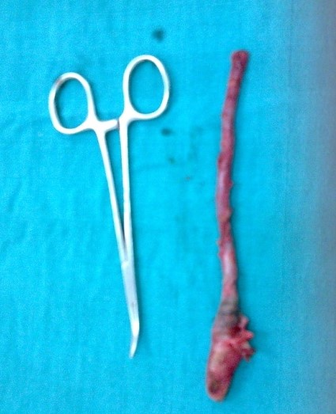
Figure 1: Surgical specimen of patient 1

Case 2:
A 54-year-old woman, presented right iliac fossa pain.
The clinical examination showed a positive McBurney sign,
Laboratory tests showed leukocytosis at 14,500 e/mm3 with a CRP of 14 mg/L. A neutrophil count was 40% and eosinophilia at 120/mm3. Abdominal CT scan revealed an enlarged appendix measuring 17 mm in thickness surrounded by infiltration of the surrounding fat (Figure 2). The CT scan pattern was consistent with acute appendicitis.
The patient was taken to the operating room where a conventional appendectomy was performed. The appendix was congested and inflamed in the pelvic position. A simple appendectomy was performed (Figure 3).
The postoperative course was uneventful, and the patient was discharged two days later.
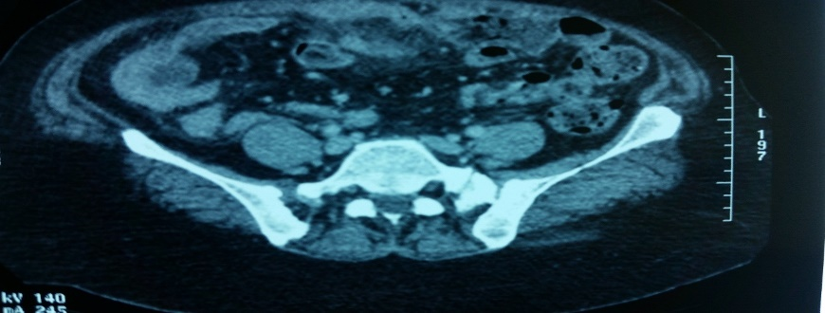
Albendazole treatment was initiated for her and her family, with a second dose 15 days later.

Figure 2: Swollen appendix and infiltration of the surrounding fat
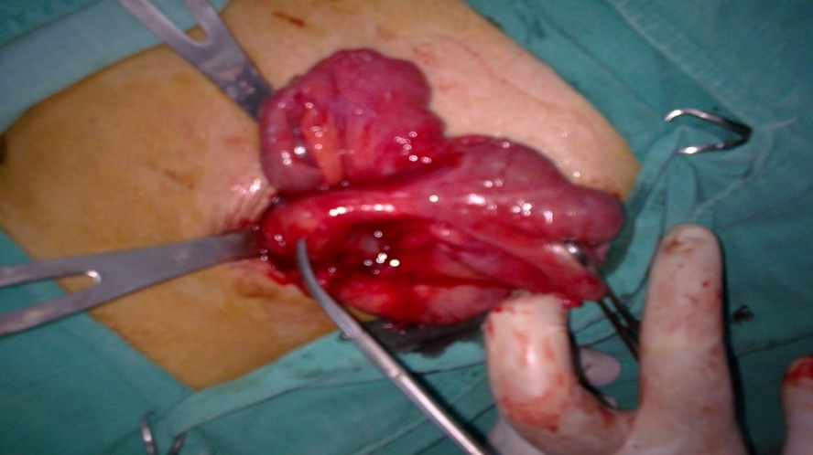

Figure 3: Surgical specimen of patient 2

Case 3:
A 35-year-old male, with no particular medical history, admitted for abdominal pain localized in the right iliac fossa, and a fever of 38°C.
The clinical examination showed right iliac fossa defenses with a positive McBurney sign; the remainder of the clinical examination was unremarkable.
Laboratory assessment showed leukocytosis at 13,500 e/mm3 and CRP at 10 mg/L. The neutrophil count was 50% and eosinophilia at 210/mm3.
Abdominal CT scan showed a swollen retrocecal appendix with a thickened and enhanced wall associated with peripheral fat remodeling. It contained a stercolith at its tip, celiomesenteric adenomegaly, and no abdominal effusion (Figure 6).
An appendectomy was performed laparoscopically and revealed a localized effusion with an abscessed appendix (Figure 7).
The patient was prescribed albendazole based treatment and repeated 15 days later.
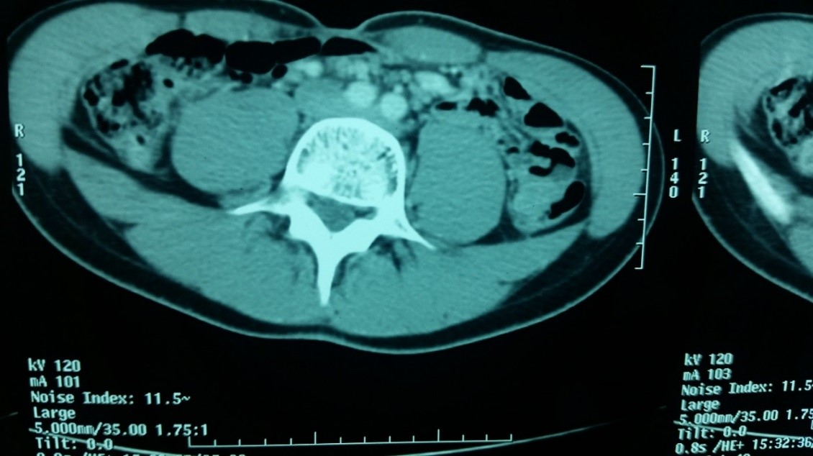
Figure 6: Retrocecal appendix with thickening of the adjacent fat
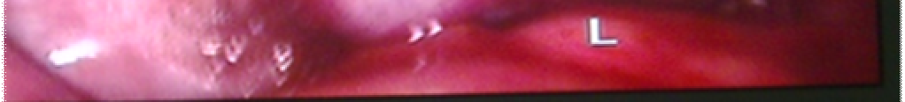
Figure 7: Swollen appendix with periappendicular effusion (viewed by laparoscopy)

Case 4:
A 22-year-old man, with no particular medical history, admitted in our department for right lower quadrant pain.
Clinical examination revealed a positive McBurney sign.
The laboratory assessment showed leukocytosis of 12,000 cells/mm3 and CRP of 54 mg/L. The neutrophil count was 30% and eosinophilia was 180/mm3.
The abdominal ultrasound revealed the presence of a 7.5 mm-sized, incompressible, intestinal structure in the right lower quadrant, painful upon passage of the catheter.
Abdominal CT showed a latero-caecal appendix measuring 14 mm in thickness, containing a stercolith associated with a slight densification of the adjacent mesenteric fat and some mesenteric lymph nodes. The CT appearance was in favor of acute appendicitis. A laparoscopic appendectomy was performed.
Albendazole treatment was prescribed and then repeated 15 days later.
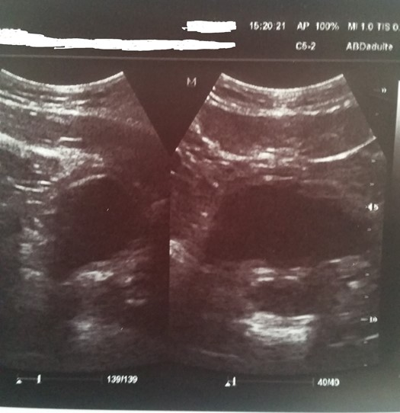
Figure 8: Digestive structure in a cockade at the level of the FID.
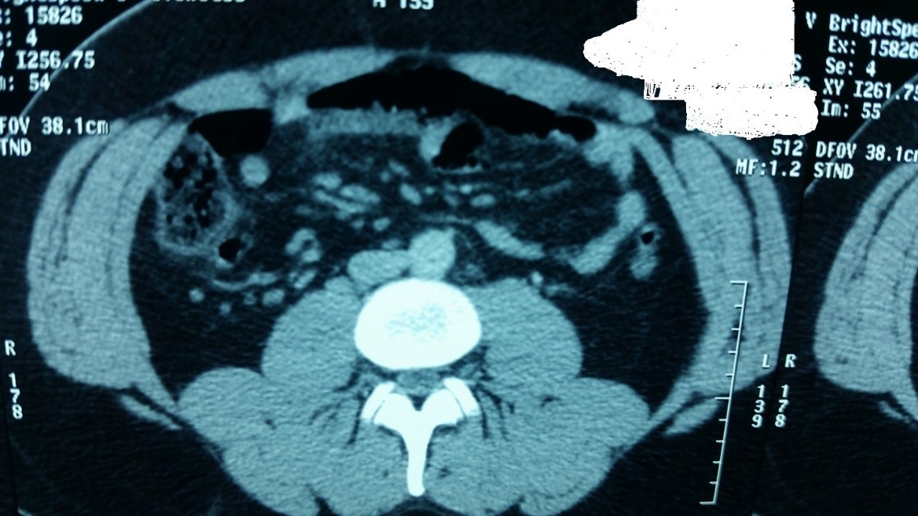
Figure 9: Laterocecal appendix containing a stercolith.
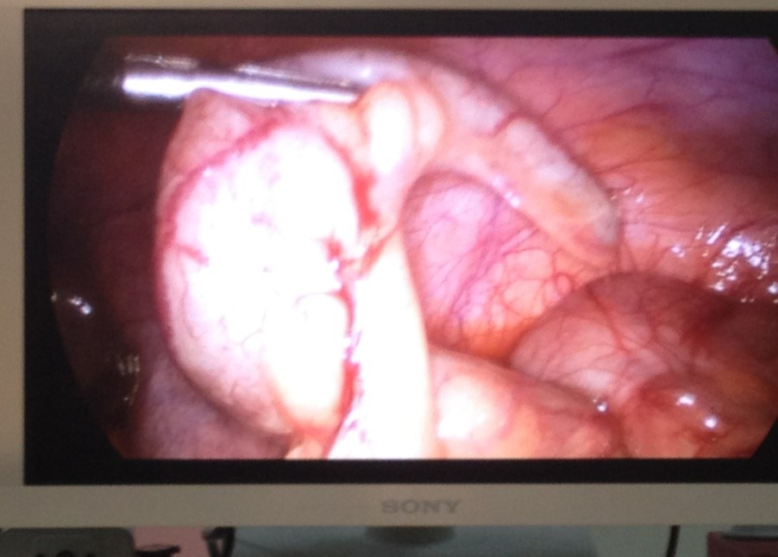
Figure 10: Swollen erectile appendix confirming appendicitis.

Case 5
A 25-year-old man, with no particular history, consulting for abdominal pain.
The clinical examination showed a tenderness with a positive McBurney sign.
The laboratory assessment showed leukocytosis at 12,000 e/mm3 and CRP at 20 mg/L. The neutrophil count was 66% and eosinophilia at 180/mm3.
The abdominal CT scan showed a 12-mm thick swollen latero-cecal appendix associated with infiltration of the mesenteric fat. This was accompanied by circumferential thickening of the lower cecal wall, resembling a reaction. The CT scan was in favor of acute appendicitis.
A simple conventional appendectomy was performed (Figure 12).
The postoperative course was uneventful.
Albendazole was prescribed and was repeated 15 days later.
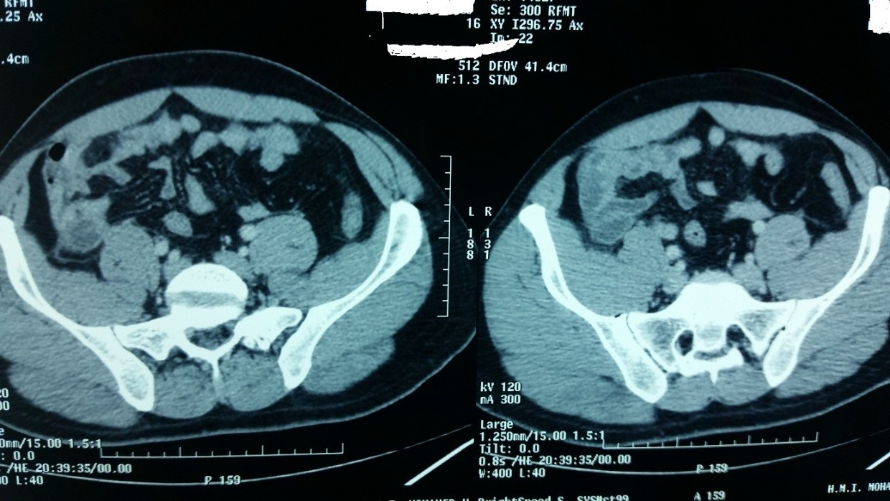
Figure 11: Swollen lateral cecal appendix with infiltration of mesenteric fat.
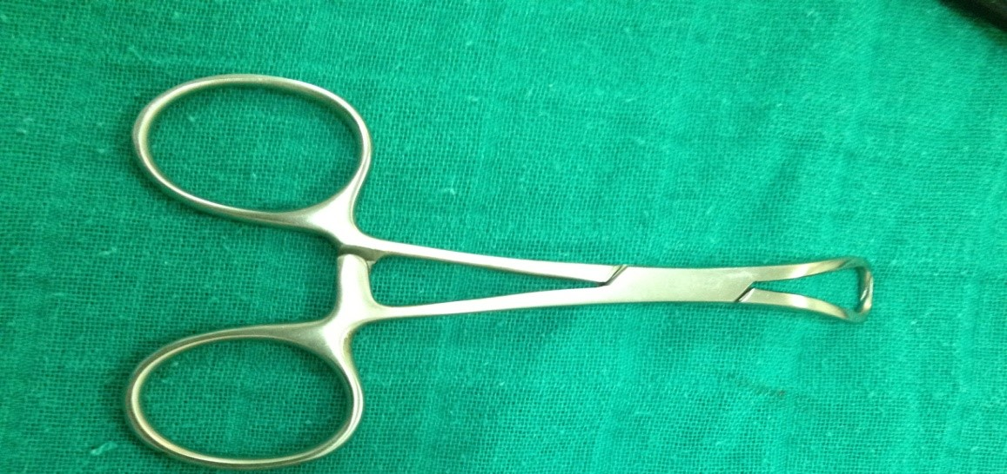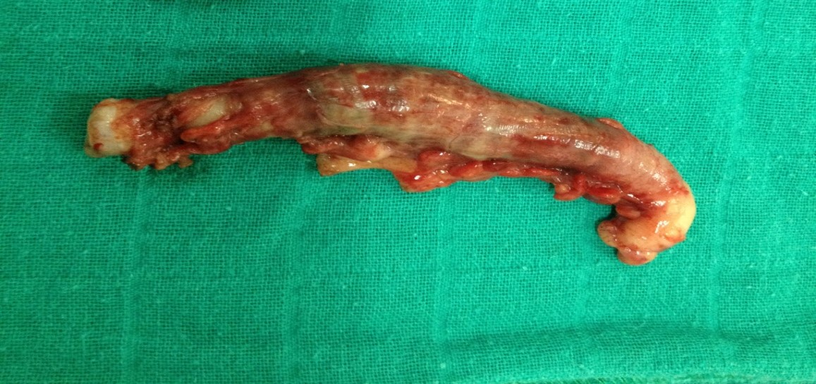
Figure 12: Appendectomy specimen.

Case 6
An 8-year-old girl was admitted for right lower quadrant pain, with diarrhea and vomiting for two days,
Clinical examination revealed the presence of a tenderness in the right lower quadrant.
Given the persistence of right lower quadrant pain with the presence of a guard, a laboratory assessment was requested and revealed a leukocytosis of 15,600 cells/mm3 and a CRP of 25 mg/L. The neutrophil count was 72% and eosinophilia of 340/mm3.
Abdominal ultrasound revealed a pattern consistent with acute appendicitis. A surgical intervention, by simple appendectomy, was performed with discovery of an inflamed appendix complicated with abscess. The post-operative evolution was good.
The pathological report suggested appendix worm infection.
Additional treatment with Albendazole was initiated, a second dose given 15 days later.

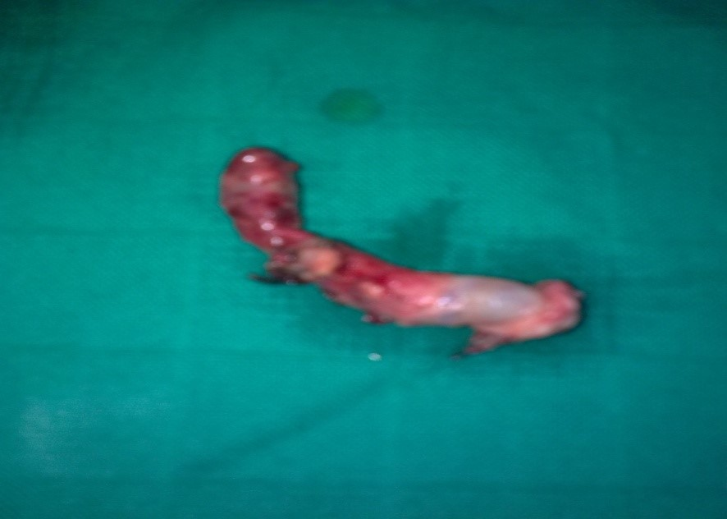
Figure 13: Appendectomy specimen.

Case 7
A 20-year-old girl, with no particular history, was admitted for abdominal pain predominantly in the right iliac fossa.
Laboratory assessment showed leukocytosis at 15,000 cells/mm3 and CRP at 34 mg/l. The neutrophil count was 52% and eosinophilia at 420/mm3.
Abdominal CT scan showed a swollen laterocecal appendix associated with infiltration of the mesenteric fat and a layer of periappendiceal effusion (Figure 14). The patient was admitted to the operating room, where a laparoscopic examination revealed a congested and inflamed appendix in the pelvic position. An appendectomy was performed (Figure 15).
The postoperative course was hampered by persistent abdominal pain and vomiting for two days until bowel movements resumed, and by shoulder pain related to pneumoperitoneum.
The pathological report suggested appendiceal pinworm infection. The appendiceal mucosa was the site of an acute inflammatory process with a collection of polymorphonuclear leukocytes of varying degrees of alteration. The pinworms were endoluminal.
Treatment with albendazole was initiated and repeated 15 days later, with good clinical progress.
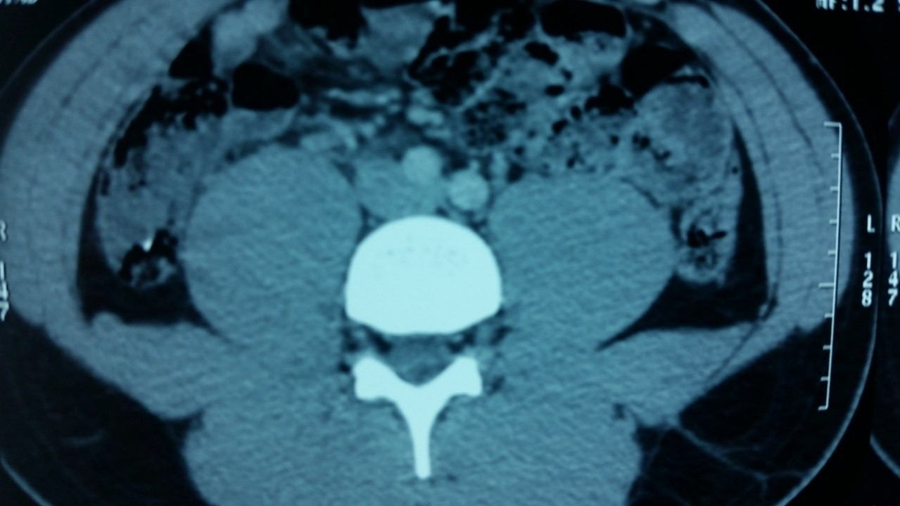
Figure 14: Swollen laterocecal appendix with infiltration of mesenteric fat.
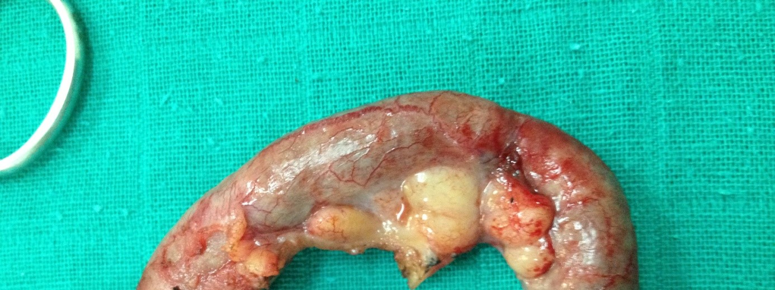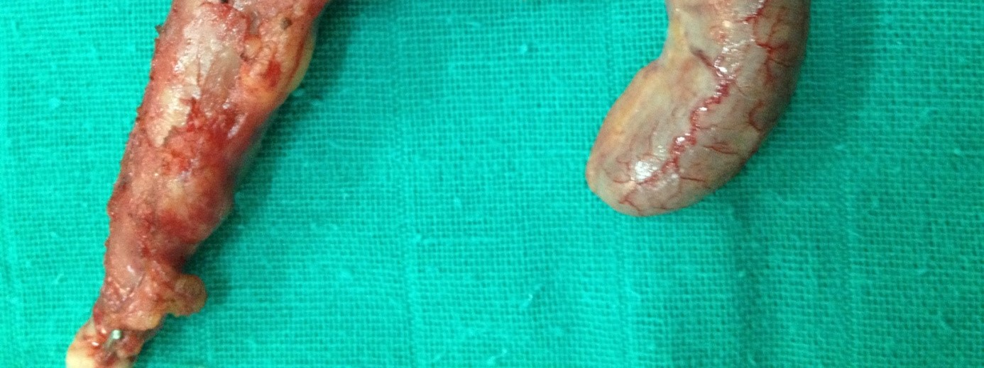
Figure 15: Surgical specimen of appendicitis.

Case 8
A 46-year-old woman, with no particular medical history, was admitted for right lower quadrant pain,
clinical examination found a positive MacBurney sign with guarding of the right lower quadrant.
Laboratory examination showed leukocytosis at 18,000 cells/mm3. The neutrophil count was 68% and eosinophilia at 320/mm3.
Abdominal CT scan revealed an enlarged appendix measuring 17 mm in thickness with infiltration of the surrounding fat and no clearly visible collection.
Laparoscopic surgery was decided upon, revealing a congested and inflamed appendix; an appendectomy was performed (Figure 17). Examination of the appendix revealed millimeter-sized white worms within the appendicular lumen.
The pathological report confirmed appendicular pinworm infection.
The postoperative course was uneventful.
The patient has started albendazole, which was repeated 15 days later.
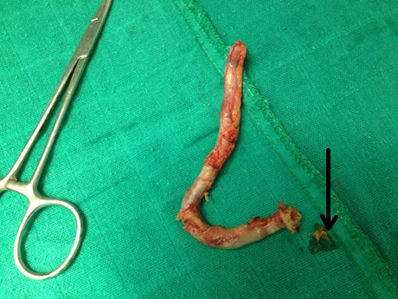
Figure 17: Appendectomy specimen with pinworms.

Case 9
A 10-year-old child was admitted for right lower quadrant pain, with low-grade fever and diarrhea for two days.
clinical examination revealed right lower quadrant guarding with a positive MacBurney sign.
Laboratory assessment showed leukocytosis at 12,400 cells/mm3 and a CRP level of 45 mg/L. The neutrophil count was 43% and eosinophilia at 278 μl/mm3.
conventional surgery was performed with a simple appendectomy (Figure 18).
The postoperative course was uneventful, and the child was discharged on POD 3.
The pathology report suggested appendicular pinworm infection. The appendicular mucosa appeared normal, with a few polymorphonuclear leukocytes of varying degrees of alteration. The threadworms were located within the lumen.
The child, along with all members of his family, was referred for further treatment with albendazole. A second dose was given 15 days later.
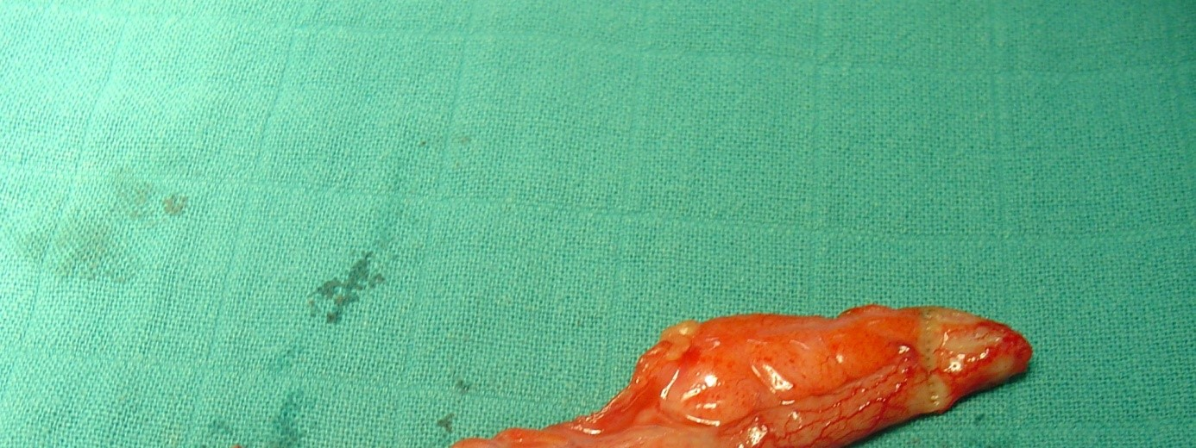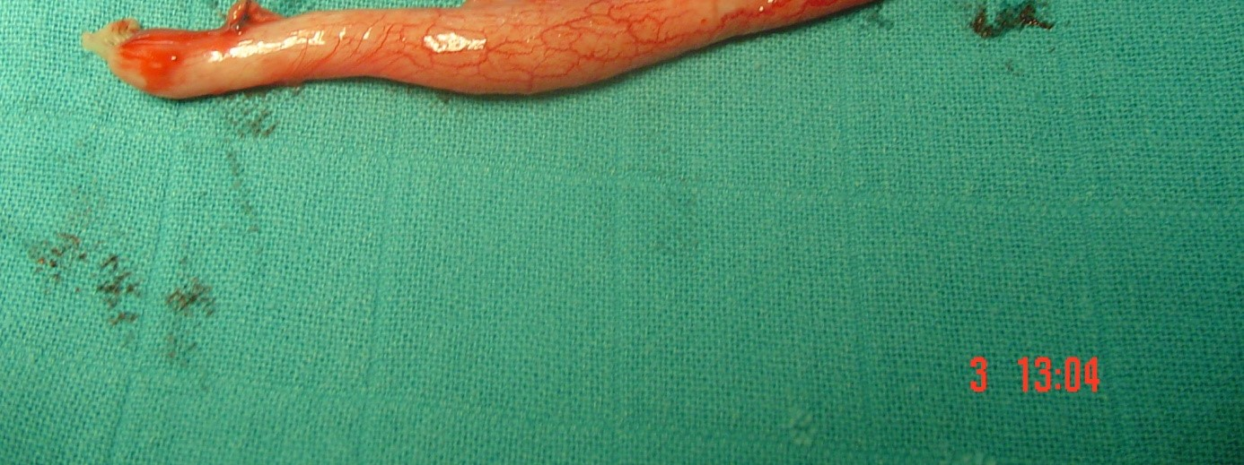
Figure 18: Appendectomy specimen.

Case 10:
a 34-year-old woman, with no particular medical history, admitted for abdominal pain that had been developing for three days.
clinical examination revealed pain localized to the right iliac fossa with a positive MacBurney sign.
The laboratory assessment showed hyperleukocytosis at 12,000 cells/mm3 and a CRP level of 36 mg/l. The neutrophil count was 82% and eosinophilia at 380/mm3.
Abdominal ultrasound showed the presence of a low-abundance echogenic fluid effusion in the right iliac fossa with agglutination of the loops and a supporting guard (Figure 19). The appearance was in favor of acute appendicitis; an appendiceal abscess could not be ruled out.
Abdominal pelvic CT scan showed the presence of diffuse infiltration of the fat with a heterogeneous appearance of the digestive loops opposite (Figure 20). The appendix was retrocecal. The CT appearance was in favor of locally complicated acute appendicitis. The patient was admitted directly to the operating room where a laparoscopic appendectomy was performed (Figure 21). The operative surprise, during the section of the base of the appendix, was the discovery of numerous millimeter-sized white worms suggesting a Appendicular threadworm infection.
The patient was placed directly into postoperative treatment with albendazole, with a second course 15 days later.
The postoperative course was uneventful.
The pathology report confirmed the diagnosis of inflamed appendicitis, with the presence of threadworms within the appendicular lumen.

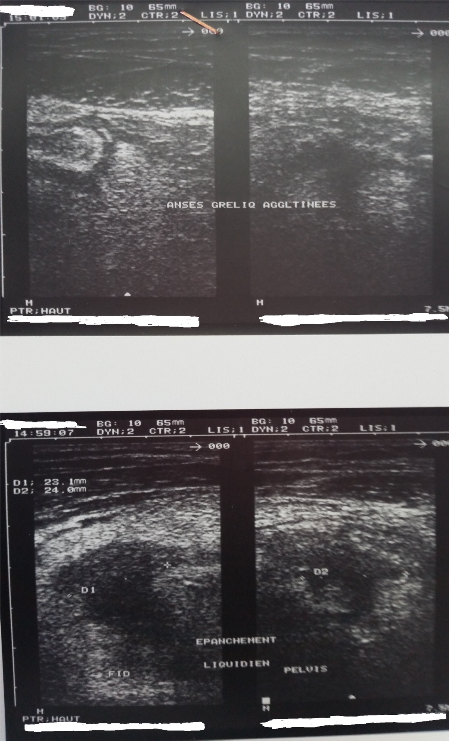
Figure 19: Low-abundance echogenic fluid effusion with agglutination of the loops.

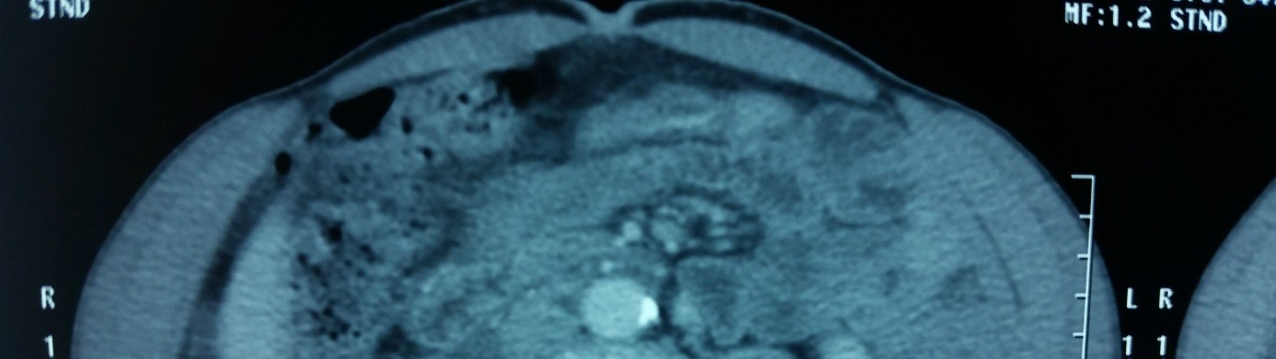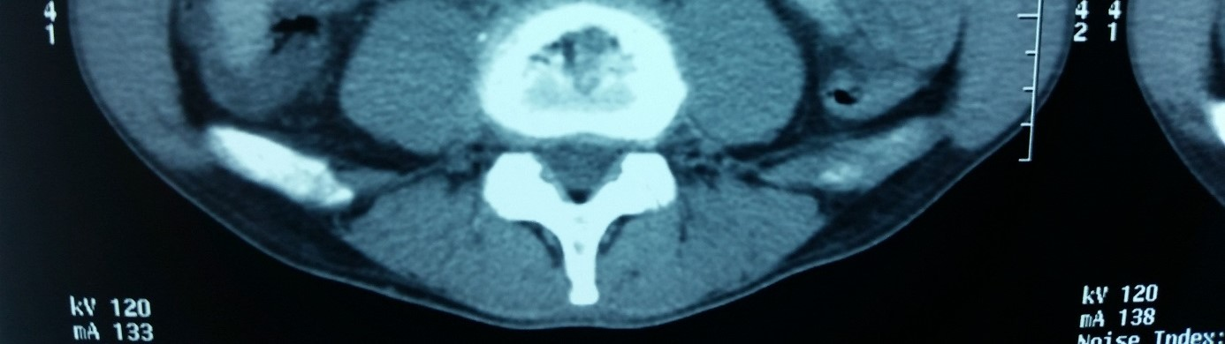
Figure 20: Fat infiltration with heterogeneous appearance of the loops, retrocecal appendix.
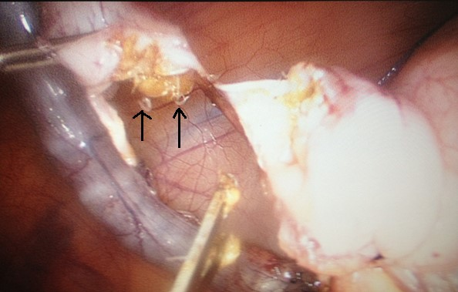
Figure 21: Laparoscopic view showing numerous pinworms.

DISCUSSION
Appendicitis, which results from an obstruction in the appendix's hollow portion, is the leading cause of abdominal pain and a frequent reason for emergency gastrointestinal surgery [8]. Common triggers include fecal stasis, fecaliths, and lymphoid hyperplasia [9]. In addition to these causes, other factors such as undigested vegetable matter, fruit seeds, tumors, and intestinal parasites have also been implicated in the development of appendicitis [10]. While parasitic infections of the appendix are uncommon, certain parasites—like Schistosoma species, Taenia species, and Ascaris lumbricoides—have been identified as potential causes [11,12]. According to existing literature, only a few cases of appendicitis linked to Enterobius vermicularis have been reported, primarily in Asia and Canada [13,14]. this parasite is widespread, especially in tropical regions [2], However, the involvement of E. vermicularis in causing appendicitis remains debated, as histological examinations of resected appendices often reveal minimal or no inflammation [6]. When present in the appendix, pinworms can imitate appendicitis symptoms but are rarely associated with definitive histopathological signs of acute inflammation [15]. The question of whether pinworms are a true cause of appendicitis or merely incidental findings during surgery has been discussed for over a century. Still, E. vermicularis continues to be reported as a possible cause of acute appendicitis [7,13]. Due to the absence of specific laboratory tests for appendicitis, a combination of histopathological and parasitological evaluations, along with imaging, led to the diagnosis of acute appendicitis in this patient, attributed to E. vermicularis.
As for the transmission of enterobiasis, preventive measures mainly involve maintaining good hygiene, especially in cases of recurrent infection. Surgical removal of the appendix—via laparotomy or laparoscopy—remains the standard treatment for acute appendicitis. Antiparasitic medical treatment is indicated postoperatively.
Conclusion
Pinworm infection due to Enterobius vermicularis is an extremely common cosmopolitan nematode infection. Since the pinworm was first identified in the lumen of the appendix, its role in triggering the inflammatory phenomena responsible for appendicitis has been raised.
In our retrospective study of a series of 10 cases of appendicular threadworm infection in 1,224 appendectomies, collected over a period of 7 years and 10 months from February 2008 to December 2015 at the 5th Military Hospital in Guelmim, we investigated the epidemiological, clinical, paraclinical, therapeutic, and pathological characteristics of 10 patients aged 6 to 54 years, including 5 men and 5 women. A literature review allowed us to compare our own data with those collected in different hospitals around the world.
The prevalence of threadworms in appendectomy specimens was found to vary between studies from 0.7 to 8.1%. It primarily affects the pediatric population, with a female predominance.
IDF pain, sometimes accompanied by moderate fever, vomiting, and diarrhea, are the main clinical signs found in patients on admission. Clinical examination most often finds a positive MacBurney sign with more or less defense at the IDF level. Hyperleukocytosis accompanied by elevated CRP are most often found in the laboratory assessment; the neutrophil count varies between 30% and 82%, while eosinophilia remains moderate. Abdominal ultrasound is sometimes requested, although its reliability is reduced. For this, CT remains the most commonly used.
Laparoscopic treatment is most commonly used for diagnostic and therapeutic purposes. Macroscopic examination of the appendectomy specimen reveals various aspects ranging from normal to perforation. Pathological findings often show the presence of threadworms in the appendix lumen. Patients are routinely given antiparasitic medical treatment, with a second course 15 days later.
Much of the literature has raised the issue of high rates of white appendectomies in appendiceal pinworm infections. The consensus on the role of E. vermicularis in the pathogenesis of appendicitis maintains that its presence in the appendix can lead to clinical signs of appendiceal colic independently of the presence of histological inflammation. Furthermore, the low incidence of threadworms in appendectomy specimens and the high rate of negative appendectomies in appendiceal pinworm infections support the hypothesis that parasitic diseases do not cause appendicitis. In our series, we noted two cases of so-called white appendicitis.
At the end of this work, we emphasize the importance of considering the possibility of appendicular pinworm infection in patients with appendicular syndrome. Aside from surgical emergencies, a complete parasitic examination with repeated scotch tests is recommended. A positive result from these tests would reduce the number of white appendectomies. In this case, a simple antiparasitic treatment is indicated.

Consent
As per international standards or university standards, patient(s) written consent has been collected and preserved by the author(s).

Disclaimer (Artificial intelligence)
Option 1:
Author(s) hereby declare that NO generative AI technologies such as Large Language Models (ChatGPT, COPILOT, etc) and text-to-image generators have been used during writing or editing of manuscripts.
Option 2:
Author(s) hereby declare that generative AI technologies such as Large Language Models, etc have been used during writing or editing of manuscripts. This explanation will include the name, version, model, and source of the generative AI technology and as well as all input prompts provided to the generative AI technology
Details of the AI usage are given below:
1.
2.
3.

REFERENCE

- Caumes JL, Chevalier B, Klotz F (2002): « Oxyures et oxyurose», Encycl Med Chir, maladies infectieuses, 8-515-A-20, 5p.
- Duzing AP, Moran M, Uzun S, et al (2004): “Unusual findings in appendectomy
specimens: evaluation of 2,458 cases and review of the literature”, Ind J S 66(4):221–6.
- Makni S, Makni F, Ayadi A, et al. (1998): “Appendicular enterobiasis. Apropos
of 205 cases”, Ann Chir 52(7):668.
- Still GF (1899): « Observation on Oxyuris vermicularis in children », Br Med J 1:898.
- Arca MJ, Gates RL, Groner JI, Hammond S, Caniano DA (2004): “Clinical
manifestations of appendiceal pinworms in children: an institutional experience and a review of the literature”, Pediatr Surg Int 20:372–375.
- M. Moujahid M et M. Daali (2009): « Oxyurose appendiculaire : à propos de dix
cas. Les oxyures sont-ils en cause ? », J. Afr. Hépatol. Gastroentérol. 3:157-159. DOI 10.1007/s12157-009-0101-1.
- Zrara I, Bouzidi A, Zentar A (1998): « Appendicite et Enterobius vermicularis », Médecine du Maghreb 67:39–40.
- De Gentile L, Puiffoulloux L (1998): « Oxyurose appendiculaire— Étude
rétrospective sur pièces d’appendicectomies », Med Chir Dig 17(5):369–70.
- Budd JS, Armstrong C (1987): “Role of Enterobius vermicularis in the
aetiology of appendicitis”, Br Surg 74:748–749.
- Odalys MGD, Fidel ANF (2001): « Appendicitis parasitarias », Rev Mex Patol Clin 48(1):42–5.
- Bohand X, Aupée O (2006) Nouveautés thérapeutiques dans les traitements
antihelminthiques. Med Trop 66:329–30.
- Dahlstrom JE, Mc Arthur EB (1994) : « Enterobius vermicularis: a possible cause
symptoms resembling appendicitis », Aust NZ J Surg 64:692–694.
- Herd ME, Cross PA, Dutt S (1992): “Histological audit of acute appendicitis”, J Clin Pathol 45:456–458.
- Wiebe BM (1991): “Appendicitis and Enterobius vermicularis”, Scand J Gastroenterol 26:336–338.
- P. Meglitch : « Zoologie des invertébrés, protistes et métazoaires primitifs », Oxford university 1972 p: 264-283.

