Understanding Anemia of Odisha: Evidence from National Family Health Surveys

Abstract
Introduction: Anemia is a public health problem in Odisha, an eastern state of India. In this context, it is necessary to understand the regions and socio-economic-demographic groups had more prevalence of anemia of different levels in the last round of NFHS and also want to assess the regions and socio-economic and demographic groups had continuously more prevalence of anemia of different levels among children, women and men across NFHS and also want to examine the regions and socio-economic and demographic groups had changed their pattern of high prevalence of anemia of different levels among children, women and men in Odisha across the datasets.
Methodology: A cross sectional design with quantitative techniques like trend analysis, spatial distribution analysis, geographic information system analysis and finally bi-variate analysis are carried out among children, women and men across different NFHSs in Odisha.
Results: It is found that the trend of anemia of different levels were mostly declining among children, women and men however the prevalence was more in the latest round compare to immediate previous round. The southern and western region of Odisha had more prevalence of anemia however the other region of Odisha had also significant amount of anemia. Lastly, culture had an important role in deciding disease pattern among groups, particularly anemia of different levels, while there was also cultural shift of prevalence of anemia of different levels among groups in Odisha.
Conclusions: The study suggests that focus should be on every district and also socio-economic-demographic groups of children and women with high prevalence of anemia of different levels in the last round of NFHS along with continuous more prevalence of anemia of different levels among socio-economic-demographic groups of children and women across NFHSs. Lastly, NFHS should collect socio-economic and demographic data on men for proper understanding about anemia.
Keywords: Anemia, Non-communicable Diseases, Public Health, Iron-Deficiency, Culture, Inclusion
1. INTRODUCTION
Anemia, one of the non-communicable diseases, occurs due to low level of hemoglobin in the blood. The most important factor responsible for anemia is iron deficiency. Besides, the other responsible factors are malaria, hookworms and other helminthes, nutritional deficiency, chronic infections and genetic conditions as per fifth round of national family health survey (NFHS) report. Anemia leads to premature delivery, low birth weight, maternal mortality and perinatal mortality, weakness, diminished physical and mental capacity and lastly affects overall development of individuals. The most target groups of anemia are young children, menstruating adolescent girls and women and lastly both pregnant and post-partum women, according to world health organization. As per world health organization, 40% of children of 6-59 months, 37% pregnant women, 30% of women of 15-49 years of age are anemic in the world. In India, the anemic population across children, women and men are 67%, 57% and 25% respectively whereas the proportion for children, women and men for Odisha, are 64%, 64% and 29% respectively, according to fifth round of NFHS report. To address Anemia, various initiatives were taken at India level like promoting and distributing free Iron and folic acid supplements (IFA), the safe and effective method to prevent anemia, for pregnant and lactating women since 1970 (Sedlander et al., 2020). Besides, Adolescent Girls Anemia Control Programme, an weekly supplementation to adolescents girls at school level, was also implemented in India. Later, National Iron Plus Initiative (NIPI), a life- cycle approach to address anemia was implemented in 2013 to supplement weekly iron to all women with reproductive age. Again to intensify the above initiative, the government of India started the ‘Anemia Mukta Bharat’ in 2018. However, at Odisha level, Anemia Mukta Lakhya Abhiyan (AMLAN) was launched to address the anemia among targeted groups in 2022 whereas previously, in 2013, two programmes like weekly iron folic acid supplementation (WIFS) and iron and folic acid supplementation under observation (IFSO) were also launched, as per an English daily newspaper, The Times of India.
However after many programmatic efforts by both state and central governments still a significant amount of anemia exist in Odisha. In this context, it is necessary to understand the regions and socio-economic-demographic groups had more prevalence of anemia of different levels in the last round of NFHS among children, women and men in Odisha. Besides, it is also imperative to know the regions and socio-economic and demographic groups had continuously more prevalence of anemia of different levels among children, women and men in Odisha across different rounds of NFHS data sets. In addition to, it is also to examine the regions and socio-economic and demographic groups had changed their pattern of high prevalence of anemia of different levels among children, women and men in Odisha across the datasets for proper policy and programme level decision in anemia elimination in Odisha, an eastern state of India where various socio-economic and demographic groups are residing in different regions of Odisha and its development indices are mostly complex in nature in comparison to India (Mohapatra, 2023). More specifically, the specific objectives of the study are to understand the trend of prevalence anemia of different levels among children, women and men of Odisha from first round to fifth round NFHS and to examine regional prevalence of anemia of different levels among children, women and men of Odisha across the five NFHS data sets and also to assess the prevalence of anemia of different levels among various socio-economic and demographic groups of children, women and men of Odisha from first round to fifth round of NFHS.
2. MATERIALS AND METHODS
To understand the above mentioned objectives, a cross sectional study design with quantitative techniques like trend analysis, spatial distribution analysis, geographic information system (GIS) analysis and lastly bi-variate analysis are carried out. Trend analysis tries to understand the exact prevalence of anemia among children, women and men from first round to fifth round of NFHS in Odisha while spatial distribution tries to examine the exact prevalence of anemia among children, women and men in different regions of Odisha and geographic information system analysis displays distribution of anemia among children, women and men in specific locations of Odisha lastly bi-variate analysis, known as co-relation analysis, assesses the prevalence of anemia among different socio-economic and demographic groups of children, women and men of Odisha and also understands the relationship between dependent variable and various independent variables. There are two dependent variables. One is prevalence of anemia among children and another is the prevalence of anemia among women. The independent variables are different socio-economic and demographic variables. The social variables are social groups, religion, educational level, exposure to mass media, place of residence. Social groups are basically classified as different castes and tribes of Odisha like other/general castes, other backward castes, scheduled castes and scheduled tribes. Religion is categorized as Hindus, Muslims, Christians and others, whereas other religions are combination of Buddhism, Jainism and Sikhism etc. Educational levels are categorized as no education, primary level of education, secondary level of education and higher level of education. Exposure to mass media, which is one of the social variables, shows the awareness level is divided into no-exposure to mass media and exposure to mass media. Besides, place of residence though geographically defined as rural and urban, but consider as social category. The economic variables are standard of living/wealth index and work status. Standard of living is categorized as low, medium and high whereas wealth index, the combination of some household assets, is categorized as poorest, poorer, middle, richer and richest. Work status is an important indicator to assess the economic condition and it is categorized as working and not-working. The demographic variable is Age. The age groups are categorized into less than 25 years, 25 years to 35 years, more than 35 years for children’s mothers whereas for women, the groups are like, 15 years to 19 years, 20 years to 29 years, 30 years to 39 years and 40 years and above. The socio-economic and demographic variables are coded into different format as per the nature of the data like binary, nominal and ordinal. The binary variables are exposure to mass media, place of residence and work status. The ordinal variables are standard of living/wealth index and age groups and educational level and the nominal variables are social groups and religion. The first, second, third, fourth and fifth rounds of national family and health survey (NFHS) datasets are used for this analysis and the reports are published during 1992-93, 1998-99, 2005-06, 2015-16 and 2019-21 respectively. The NFHS datasets are prepared as per demographic health survey (DHS) and international institute for population science (IIPS) is the nodal agency to conduct this entire process. The ArcGIS software is used for Geographic Information System Analysis whereas SPSS-20 software is used for Bi-variate analysis. Samples, from second to fifth rounds of NFHS, are 1132, 1454, 9060 and 5794 respectively for children. Samples of women are 4282, 4356, 33022 and 26987 respectively from second to fifth rounds of NFHS. Samples, from third to fifth rounds of NFHS, are 1386, 4013 and 3300 respectively for men.
3. RESULTS
The result section is the compilation of different level of Anemia for children, women and men of Odisha using both different quantitative techniques and rounds of NFHS data sets.
3.1. Trends of Prevalence of Anemia of Different Levels among Children, Women and Men in Odisha from NFHS-1 to NFHS-5
There were no data available on anemia (Figure 1) for children, men and women in first round of NFHS and even the anemia for men was not collected in second round NFHS. Both men and women prevalence, were declining gradually, from NFHS-2 to NFHS-4, later it was increasing again in NFHS-5, however, the prevalence was minimal in case of men. Interestingly, there was two set of data with some variation in NFHS-3, however after all scrutiny, one data set was taken into consideration. But, in case of children, the trend was not like the pattern of men and women. Initially, it was increasing, later it was declining and again it was increasing. However, the prevalence of anemia in the latest round was lower than initial round in case of both children and men but anemia was high for the women in the latest round compare to immediate previous rounds and also high among children, men and women in the latest round.
Figure 1: Trends of Prevalence of Anemia among Children, Women and Men in Odisha from NFHS-2 to NFHS-5
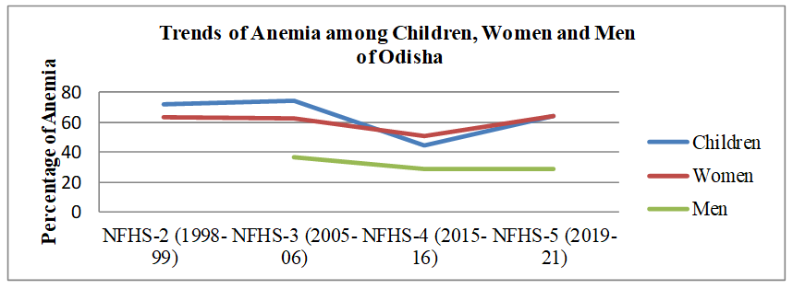
Sources: Computed from data files NFHS-2, NFHS-3, NFHS-4 and NFHS-5
The prevalence of anemia was the lowest in fourth round of NFHS in all the groups of the population. The prevalence of anemia was more in children and men in third round of NFHS and the prevalence of anemia for women was more in fifth round of NFHS. There were no data on different levels of anemia for children in first round of NFHS (Figure 2). The trend of mild anemia among children was initially increasing, then it was declining and again it was increasing in the last round of NFHS and in moderate and severe category of anemia, initially, it was declining and again it was increasing in the last round. The moderate anemia was more among children in both second and third rounds of NFHS whereas the mild anemia was high in both fourth and fifth rounds of NFHS. The prevalence of anemia was the lowest among fourth round of NFHS in all categories of anemia. The prevalence of mild anemia was more in fifth round of NFHS whereas the prevalence for moderate and severe anemia was more in second round of NFHS.
Figure 2: Trends of Prevalence of Anemia of Different Levels among Children in Odisha from NFHS-2 to NFHS-5
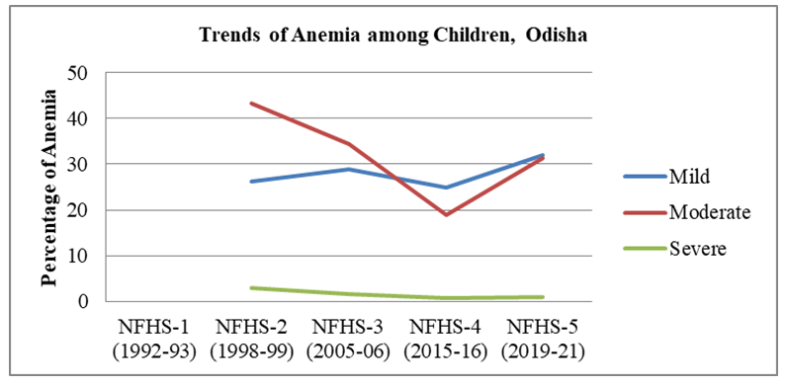
Sources: Computed from data files of NFHS-2, NFHS-3, NFHS-4 and NFHS-5
Again, no data were available on different levels of anemia for women in first round of NFHS (Figure 3). The trend of mild level anemia among women was declining in all rounds of NFHS. In moderate and severe level of anemia, it was declining gradually but again it increased in fifth round of NFHS which was the highest among all rounds of NFHS. The prevalence of mild anemia was more in second round of NFHS and low in fifth round of NFHS. The moderate and severe levels of anemia were low in fourth rounds of NFHS.
Figure 3: Trends of Prevalence of Anemia of Different Levels among Women in Odisha from NFHS-2 to NFHS-5
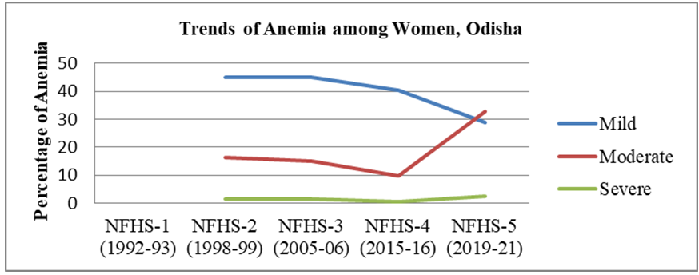

Sources: Computed from data files of NFHS-2, NFHS-3, NFHS-4 and NFHS-5
The data on different levels of anemia for men were not available in both first and second round of NFHS (Figure 4). Both mild and moderate level of anemia for men were initially declining, later increased in fifth round of NFHS while severe anemia for men was declining in all rounds of NFHS.
Figure 4: Trends of Prevalence of Anemia of Different Levels among Men in Odisha from NFHS-3 to NFHS-5
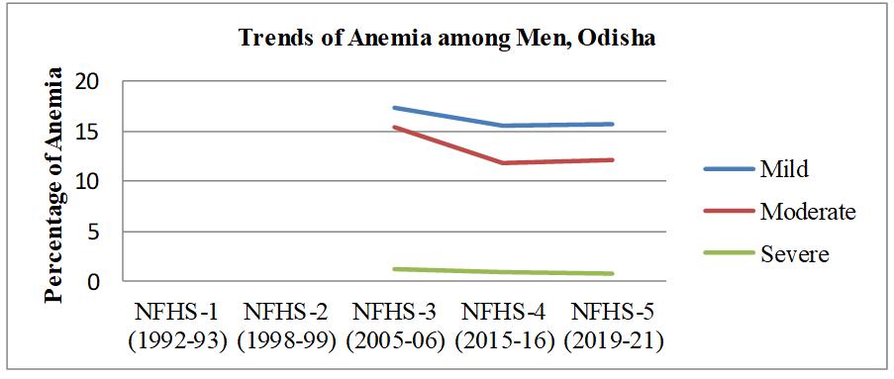
Sources: Computed from data files of NFHS-3, NFHS-4, NFHS-5
All the categories of anemia for men were more in third round of NFHS. Both mild and moderate level of anemia for men was less in fourth round of NFHS and the severe anemia was less in fifth round of NFHS.
3.2. Regional Prevalence of Anemia among Children, Women and Men in Odisha across Different NFHS Data sets
To add more clarity in understanding regional distribution of Anemia in Odisha (Table 1), three categories of anemia prevalence like less than 30 (low), 30 to 50 (medium) and more than 50 (high) are made for children and women however the categories are slightly different for men, according to the prevalence of anemia. The categories are less than 20 (low), 20-30 (medium) and more than 30 (high) for men. The analysis is done for both fourth and five rounds of NFHS, as district wise NFHS data are available after the third round of NFHS.
Table 1: Prevalence of Anemia among Children, Women and Men in Odisha, NFHS-4, 2015-16 and NFHS-5, 2019-21
 | NFHS-4  Children  (Less than 30, 30-50, More than 50) |  | NFHS-4  Women  (Less than 30, 30-50, More than 50) |  | NFHS-4  Men  (Less than 20, 20-30, More than 30) |  | NFHS-5  Children  (Less than 30, 30-50, More than 50) |  | NFHS-5  Women  (Less than 30, 30-50, More than 50)
Districts | Percentage | Category | Percentage | Category | Percentage | Category | Percentage | Category | Percentage | Category
Anugul | 37.4 | Medium | 44 | Medium | 27 | Medium | 75.3 | High | 75.8 | High
Balangir | 67.3 | High | 61.1 | High | 37.1 | High | 74.9 | High | 59.3 | High
Baleshwar | 28.6 | Low | 41.1 | Medium | 21.4 | Medium | 43.2 | Medium | 61.8 | High
Bargarh | 68.3 | High | 68.5 | High | 35 | High | 56.2 | Medium | 62.6 | High
Baudh | 44.1 | Medium | 49.8 | Medium | 27.3 | Medium | 56.2 | Medium | 54.1 | High
Bhadrak | 22.7 | Low | 43.5 | Medium | 22 | Medium | 68.7 | High | 64.0 | High
Cuttack | 18.9 | Low | 37.8 | Medium | 18.4 | Low | 63.8 | High | 64.5 | High
Debagarh | 30.0 | Medium | 42.6 | Medium | 28.4 | Medium | 61.5 | High | 72.2 | High
Dhenkanal | 39.4 | Medium | 39.4 | Medium | 31.3 | High | 61.9 | High | 65.9 | High
Gajapati | 57.9 | High | 58.5 | High | 33.6 | High | 64.4 | High | 66.1 | High
Ganjam | 37.4 | Medium | 41.3 | Medium | 34.5 | High | 61.3 | High | 56.7 | High
Jagatsinghapur | 23.4 | Low | 35.8 | Medium | 10.4 | Low | 58.2 | High | 59.8 | High
Jajpur | 30.0 | Medium | 43.3 | Medium | 18.8 | Low | 66.4 | High | 63.4 | High
Jharsuguda | 67.1 | High | 69.2 | High | 34.1 | High | 65.5 | High | 67.8 | High
Kalahandi | 67.2 | High | 68.7 | High | 36.4 | High | 68.8 | High | 64.2 | High
Kandhamal | 42.7 | Medium | 52.7 | High | 27.9 | Medium | 55.3 | High | 48.9 | Medium
Kendrapara | 28.7 | Low | 42.3 | Medium | 35.2 | High | 61.5 | High | 58.8 | High
Kendujhar | 32.7 | Medium | 40.5 | Medium | 18.8 | Low | 64.6 | High | 69.2 | High
Khordha | 19.0 | Low | 45.3 | Medium | 13.6 | Low | 56.1 | High | 68.1 | High
Koraput | 71.4 | High | 63.3 | High | 40 | High | 69.7 | High | 58.2 | High
Malkangiri | 72.2 | High | 71.3 | High | 47.2 | High | 78.7 | High | 71.9 | High
Mayurbhanj | 34.5 | Medium | 42.4 | Medium | 23.4 | Medium | 71.7 | High | 72.2 | High
Nabarangapur | 71.9 | High | 71.5 | High | 41.4 | High | 70.8 | High | 69.2 | High
Nayagarh | 26.5 | Low | 39.8 | Medium | 19.2 | Low | 55.2 | High | 62.5 | High
Nuapada | 63.9 | High | 64.0 | High | 43.8 | High | 73.5 | High | 64.0 | High
Puri | 29.2 | Low | 44.3 | Medium | 16.1 | Low | 51.0 | High | 63.3 | High
Rayagada | 49.8 | Medium | 55.4 | High | 29.3 | Medium | 70.5 | High | 69.1 | High
Sambalpur | 70.5 | High | 73.0 | High | 45 | High | 64.5 | High | 66.7 | High
Subarnapur | 75.0 | High | 69.2 | High | 34.4 | High | 73.1 | High | 58.8 | High
Sundargarh | 75.3 | High | 71.4 | High | 39.6 | High | 77.0 | High | 69.8 | High
Sources: Computed from data files of NFHS-4 and NFHS-5
As per NFHS-4 data (Table 1, Figure 5), The high level anemia districts for children were Bolangir, Bargarh, Gajapati, Jharsuguda, Kalahandi, Koraput, Malkangiri, Nabarangpur, Nuapada, Sambalapur, Subarnapur and Sundargarh. The medium level districts for children were Anugul, Baudh, Debagarh, Dhenkanal, Ganjam, Jajpur, Kandhamal, Kendujhar, Mayurbhanj and Raygada. The low level anemia districts for children were Balesore, Bhadrak, Cuttack, Jagatsinghpur, Kendrapara, Khorda, Nayagarha and Puri.
Figure 5: Prevalence of Anemia among Children in Odisha, NFHS-4, 2015-16
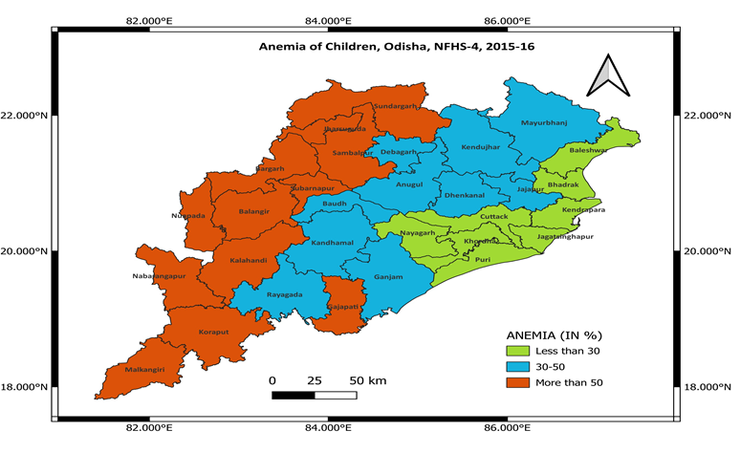
Source: Computed from data files of NFHS-4
The high anemia prevalence districts for women (Table 1, Figure 6) were Bolangir, Bargarha, Gajapati, Jharsuguda, Kalahandi, Kandhamal, Koraput, Malkangiri, Nabarangapur, Nuapada, Rayagada, Sambalpur, Subarnapur and Sundaragarha. In the medium category, the districts were Anugul, Balesore, Boudh, Bhadrak, Cuttuck, Debagarh, Dhenkanal, Ganjam, Jagatsighpur, Jajpur, Kendrapara, Kendujhar, Khorda, Mayurbhanj, Nayagarha, Puri for women. There were no districts in the category of low level of anemia for women.
Figure 6: Prevalence of Anemia among Women in Odisha, NFHS-4, 2015-16
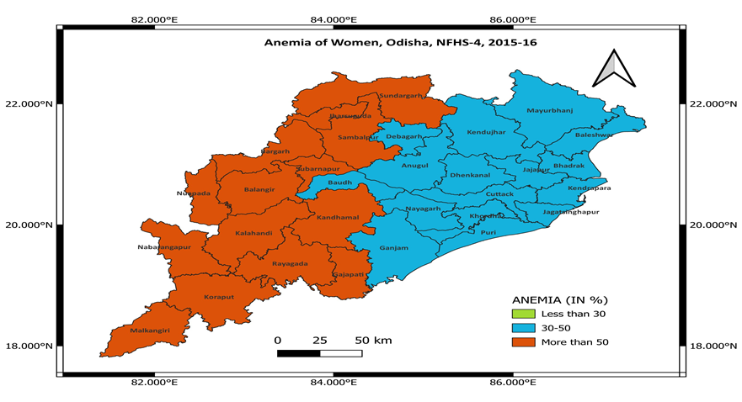
Source: Computed from data files of NFHS-4
The high level of anemia districts for men (Table 1, Figure 7) were Bolangir, Bargarha, Dhenkanal, Gajapati, Ganjam, Jharsuguda, Kalahandi, Kendrapada, Koraput, Malkangiri, Nabarngapur, Nuapada, Sambalpur, Subarnpur and Sundargarha. The medium level districts were Anugul, Balesore, Baudh, Bhadrak, Debagarha, Kandhmal, Mayurbhanj and Raygada. The low level of anemia districts for men was Cuttack, Jagatsinghpur, Jaipur, Kendujhar, Khorda, Nayagarha and Puri.
Figure 7: Prevalence of Anemia among Men in Odisha, NFHS-4, 2015-16
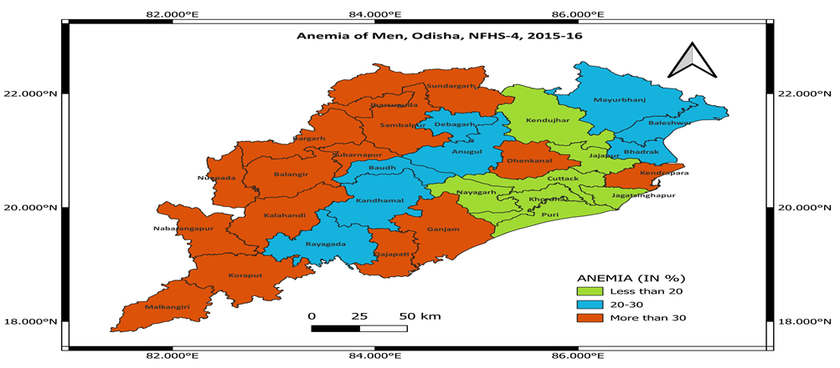
Source: Computed from data files of NFHS-4
As per NFHS-5, there were no districts level data on men in Odisha. The districts come under high level of anemia for children (Table 1, Figure 8) were Anugul, Bolangir, Bhadrak, Cuttuck, Debgarh, Dhenkanal, Gajapati, Ganjam, Jagatsinghpur, Jajpur, Jharsuguda, Kalahandi, Kandhamal, Kendrapara, Kendujhar, Khorda, Koraput, Malkangiri, Mayurbhanj, Nabarangpur, Nayagarh, Nuapada, Puri, Raygada, Sambalpur, Subarnapur, Sundargarh. The medium level of anemic districts for children was Balesore, Bargarha and Baudh.
Figure 8: Prevalence of Anemia among Children in Odisha, NFHS-5, 2019-21
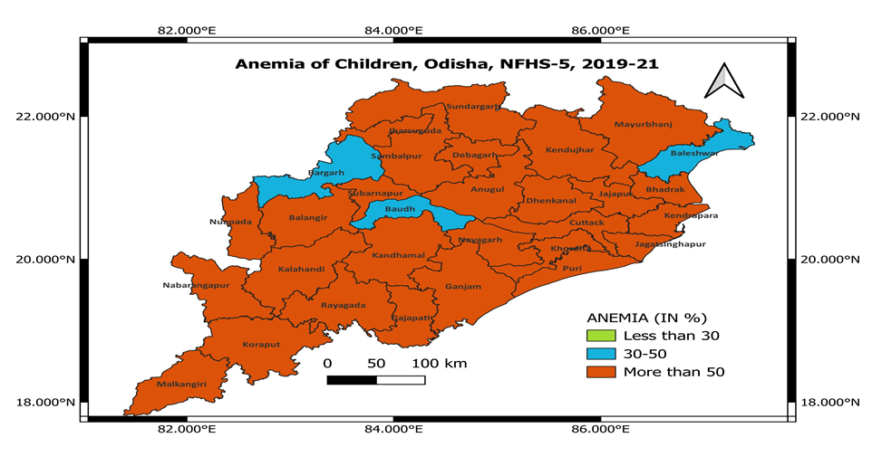
Sources: Computed from data files of NFHS-5
All districts, except Kandhmal, the medium category of anemia, were under high level of anemia for women (Table 1, Figure 9). There were no districts in low level of anemia category among both children and women.
Figure 9: Prevalence of Anemia among Women in Odisha, NFHS-5, 2019-21
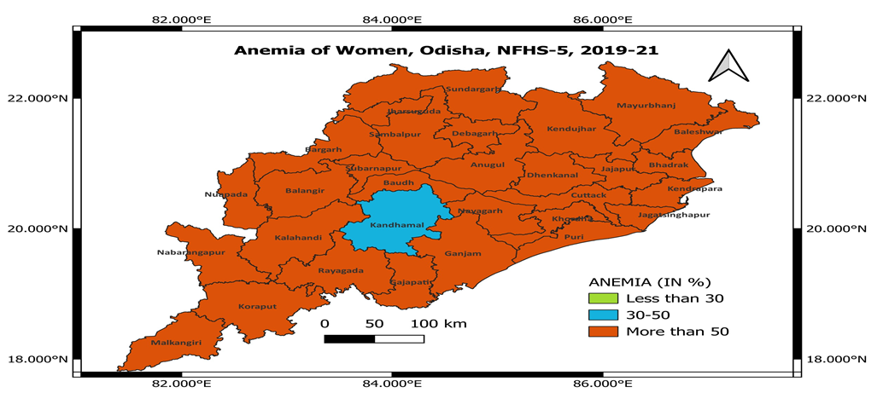
Sources: Computed from data files of NFHS-5
3.3. Changes in Prevalence of Anemia of Odisha from NFHS-4 to NFHS-5
For children (Table 2, Figure- 10 and Figure- 11), the districts of maximum increase in anemia percentage from NFHS-4 to NFHS-5 were chronologically Bhadrak, Cuttack, Anugul, Mayurbhanj, Khorda, Jajpur, Kendrapara, Kendujhar, Jagatsinghpur, Deogarh, Nayagarh, Ganjam, Dhenkanal, Puri, Rayagada, Balesore, Kandhmal, Baudh, Nuapadha, Bolangir, Gajapati, Malakangiri, Sundargarh and Kalahandi. For women, the districts had maximum percentage of increase in anemia from NFHS-4 to NFHS-5 were chronologically Anugul, Mayurbhanj, Debagarh, Kendujhar, Cuttack, Dhenkanal, Jagatsinghpur, Khorda, Nayagarha, Balesore, Bhadrak, Jajpur, Puri, Kendrapara, Ganjam, Rayagada, Gajapati, Baudh, Malakangiri and Nuapada. Interestingly, there was also maximum decline in anemic percentage of anemia among children and women between fourth and fifth round. The maximum decline districts for children were Bargarh, Sambalpur, Subarnpur, Koraput, Jharsuguda and Nabarangpur. The maximum decline districts for women were Subarnpur, Sambalpur, Bargarh, Koraput, Kalahandi, Kandhamal, Nabrangpur, Bolangir, Sundargarh and Jharsuguda.
Table 2: Percentage Change in Prevalence of Anemia among Children and Women in Odisha from NFHS-4 and NFHS-5
Districts | Prevalence of Anemia in Children in NFHS-4  (Percentage) | Prevalence of Anemia in Children in NFHS-5  (Percentage) | Total Percentage Change in Prevalence of Anemia between NFHS-4 and NFHS-5 | Prevalence of Anemia in Women in NFHS-4  (Percentage) | Prevalence of Anemia in Women in NFHS-5  (Percentage) | Total Percentage Change in Prevalence of Anemia between NFHS-4 and NFHS-5
Anugul | 37.4 | 75.3 | 37.9 | 44 | 75.8 | 31.8
Balangir | 67.3 | 74.9 | 7.6 | 61.1 | 59.3 | -1.8
Baleshwar | 28.6 | 43.2 | 14.6 | 41.1 | 61.8 | 20.7
Bargarh | 68.3 | 56.2 | -12.1 | 68.5 | 62.6 | -5.9
Baudh | 44.1 | 56.2 | 12.1 | 49.8 | 54.1 | 4.3
Bhadrak | 22.7 | 68.7 | 46 | 43.5 | 64.0 | 20.5
Cuttack | 18.9 | 63.8 | 44.9 | 37.8 | 64.5 | 26.7
Debagarh | 30.0 | 61.5 | 31.5 | 42.6 | 72.2 | 29.6
Dhenkanal | 39.4 | 61.9 | 22.5 | 39.4 | 65.9 | 26.5
Gajapati | 57.9 | 64.4 | 6.5 | 58.5 | 66.1 | 7.6
Ganjam | 37.4 | 61.3 | 23.9 | 41.3 | 56.7 | 15.4
Jagatsinghapur | 23.4 | 58.2 | 34.8 | 35.8 | 59.8 | 24
Jajpur | 30.0 | 66.4 | 36.4 | 43.3 | 63.4 | 20.1
Jharsuguda | 67.1 | 65.5 | -1.6 | 69.2 | 67.8 | -1.4
Kalahandi | 67.2 | 68.8 | 1.6 | 68.7 | 64.2 | -4.5
Kandhamal | 42.7 | 55.3 | 12.6 | 52.7 | 48.9 | -3.8
Kendrapara | 28.7 | 61.5 | 32.8 | 42.3 | 58.8 | 16.5
Kendujhar | 32.7 | 64.6 | 31.9 | 40.5 | 69.2 | 28.7
Khordha | 19.0 | 56.1 | 37.1 | 45.3 | 68.1 | 22.8
Koraput | 71.4 | 69.7 | -1.7 | 63.3 | 58.2 | -5.1
Malkangiri | 72.2 | 78.7 | 6.5 | 71.3 | 71.9 | 0.6
Mayurbhanj | 34.5 | 71.7 | 37.2 | 42.4 | 72.2 | 29.8
Nabarangapur | 71.9 | 70.8 | -1.1 | 71.5 | 69.2 | -2.3
Nayagarh | 26.5 | 55.2 | 28.7 | 39.8 | 62.5 | 22.7
Nuapada | 63.9 | 73.5 | 9.6 | 64.0 | 64.0 | 0
Puri | 29.2 | 51.0 | 21.8 | 44.3 | 63.3 | 19
Rayagada | 49.8 | 70.5 | 20.7 | 55.4 | 69.1 | 13.7
Sambalpur | 70.5 | 64.5 | -6 | 73.0 | 66.7 | -6.3
Subarnapur | 75.0 | 73.1 | -1.9 | 69.2 | 58.8 | -10.4
Sundargarh | 75.3 | 77.0 | 1.7 | 71.4 | 69.8 | -1.6
Sources: Computed from data files of NFHS-4 and NFHS-5
Figure 10: Change in Prevalence of Anemia among Children in Odisha from NFHS-4 to NFHS-5
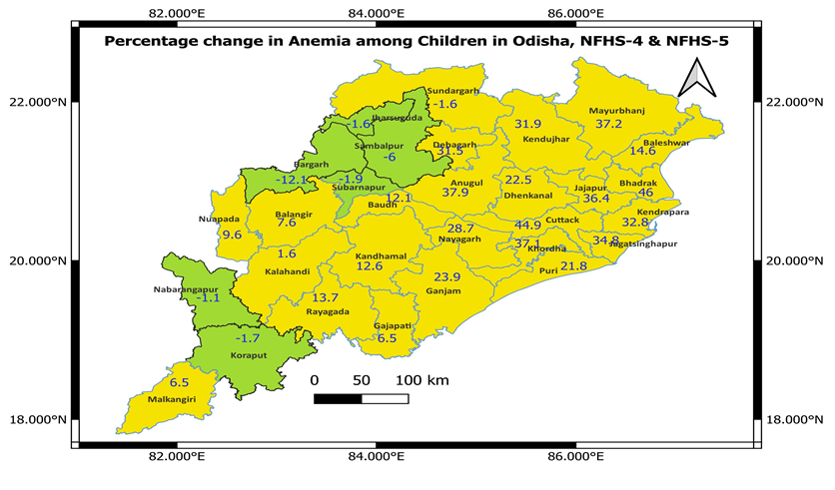
Sources: Computed from data files of NFHS-4 and NFHS-5
Figure 11: Change in Prevalence of Anemia among Women in Odisha from NFHS-4 to NFHS-5
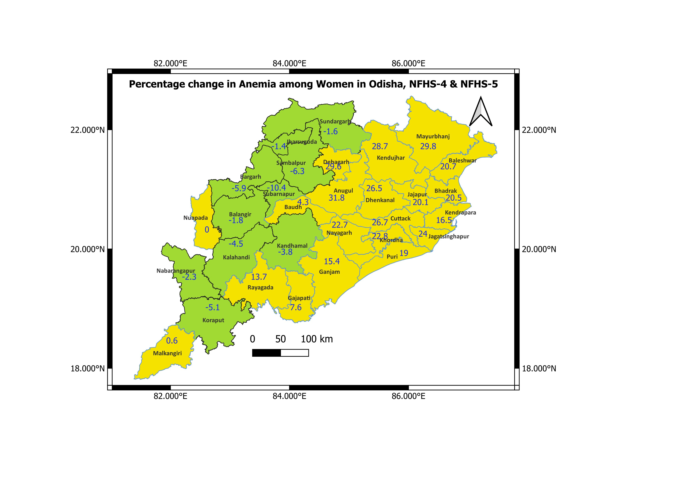
Sources: Computed from data files of NFHS-4 and NFHS-5
3.4. Prevalence of Anemia of Different Levels by Different Socio-Economic-Demographic Groups of Children and Women in Odisha
In NFHS-2 level (Table 3), scheduled caste children had more anemia followed by general, OBC and tribes. Muslim children had more anemia followed by Christian and Hindu children. Mothers of primary level of education had more anemia for followed by secondary level of education, no education and high education. Mothers, not expose to mass media had more anemia. Children of rural areas had more anemia. Mothers with low economic status had more anemic. Not working mothers had more anemia. Mother’s age groups belong to less than 25 years had more anemic followed by more than 35 years and 25 to 35 years.
Table 3: Prevalence of Anemia among Children by Various Background Characteristics, Odisha, NFHS-2, 1998-99
Background Factors | Categories | Anemia
Social groups | Scheduled Caste  Scheduled Tribe  OBC  General | 26.5  16.4  23.5  24.7
Religion | Hindu  Muslim  Christian | 22.7  28.6  27.6
Educational level of Mother | No education  Primary  Secondary  Higher | 21.1  29  23.5  18.2
Exposure to mass media | Yes  No | 21.8  23.4
Place of residence | Rural  Urban | 25.7  22.3
Standard of Living | Low  Medium  High | 21.7  21.5  21.5
Work status | Not working  Working | 23.5  22.6
Age | Less than 25  25-35  35 and above | 25  20.8  24.7
Sources: Computed from data files of NFHS-2
In NFHS-3 level, (Table 4), tribal children had more mild anemia, followed by general, other backward castes and scheduled castes. In moderate level of anemia, tribal children had more anemia followed by scheduled castes, other backward castes and generals. Lastly in sever category of anemia, children belongs to other backward castes had more anemia and children belong to scheduled castes had low level of anemia whereas tribal and other/general children had an equal level of anemia. Muslim children had more mild anemia followed by Christian and Hindu. Christian children had more moderate anemia followed by Muslim and Hindu. Lastly, the severe anemia was more among Hindu children. Mostly, there was a negative relationship between mother’s education level and different levels of anemia among children. In mild and moderate level of anemia, mothers with no exposure to mass media had more anemia but mothers those expose to mass media had more severe anemia. Urban children had more both mild and severe anemia whereas rural children had more moderate anemia. Mostly, there was an inverse relationship, though not linear, between wealth index and different categories of anemia among children. In both mild and severe category of anemia, not-working mothers had more anemia whereas working mothers had more moderate anemia. Mostly, there was a positive relationship existing between mother’s age and different levels of anemia.
Table 4: Prevalence of Anemia of Different Levels among Children by Various Background Characteristics, Odisha, NFHS-3, NFHS-4 and NFHS-5
Background Factors | Categories | Anemia (NFHS-3) |  |  | Anemia (NFHS-4) |  |  | Anemia (NFHS-5)
Background Factors | Categories | Mild | Moderate | Severe | Mild | Moderate | Severe | Mild | Moderate |  | Severe
Social groups | Scheduled Caste  Scheduled Tribe  OBC  General | 41.9  51.2  42.4  44 | 21  23.3  15.8  9.9 | 0.6  1.5  2.7  1.5 | 45.2  50  42.5  38 | 12.3  16.4  8.9  7 | 0.5  0.8  0.3  0.3 | 28.1  29.3  30.3  30.5 | 39  41  30.1  30.1 |  | 2.8  2  1.7  2
Religion | Hindu  Muslim  Christian  Others | 45.4  50  45.5 | 16.3  20  22.7 | 1.7  0  0 | 44.7  34.1  51.3  40.9 | 11.8  5.2  11.8  18.2 | 0.5  0  0.2  0 | 29.4  30.2  31  57.1 |  | 35.9  16.3  33.9  14.3 | 2.1  0  0.9  4.8
Educational level of Mother | No education  Primary  Secondary  Higher | 47.6  43.7  44.2  36.2 | 20.9  16.6  13.6  7.2 | 2.1  1.5  1.3  0 | 48.6  45.2  43.1  38.1 | 16.2  12.7  9.2  6.2 | 1.1  0.1  0.3  0.2 | 27.8  29.6  30.2  29.7 |  | 41.8  36  33.8  27 | 2.6  2  1.9  1.2
Exposure to mass media | Yes  No | 44.4  45.6 | 12.7  18.9 | 1.8  1.6 | 43.6  46 | 9  14.2 | 0.4  0.6 | 30.4  28.5 |  | 32.6  39.1 | 1.7  2.5
Place of residence | Rural  Urban | 37.1  47.7 | 17.8  16.9 | 0.8  1.9 | 45.3  44.8 | 9.8  12 | 0.4  0.5 | 32.8  29.1 |  | 30.2  36.1 | 1  2.2
Wealth Index | Poorest  Poorer  Middle  Richer  Richest | 47.9  47.6  42.5  42.9  37.5 | 21.8  11  19.2  12.7  11.3 | 2.4  1.5  1  0.5  1.2 | 47.5  46.4  41.8  40.2  35.4 | 15.2  12.1  7.4  6.3  6.7 | 0.8  0.3  0.4  0.2  0.5 | 29  27.6  32.7  30.3  30.9 |  | 40.2  36.2  29.1  29.7  27.4 | 2.9  2  0.6  1.4  0.9
Work status | Not working  Working | 45.7  44.2 | 12.7  18.9 | 1.8  1.6 | 46.6  52.1 | 12.8  14.6 | 0.7  0.5 | 29.7  32.4 |  | 35.9  29.4 | 2.7  2.7
Age | Less than 25  25-35  35 and above | 44  45.4  50.7 | 19.3  14.8  21.6 | 1  1.7  4.5 | 44.5  44.9  45.9 | 10.7  11.7  14.8 | 0.3  0.3  1.9 | 31.6  28.8  27.7 |  | 36  34.8  37.7 | 1.8  2.1  2.6
Sources: Computed from data files of NFHS-3, NFHS-4 and NFHS-5
In NFHS-4 level (Table 4), tribal children had more anemia in all categories of anemia followed by scheduled castes, other backward castes and general. Christian children had more mild anemia followed by Hindu, others and Muslim whereas children belongs to other religion had more moderate anemia followed by Christian, Hindu and Muslim and lastly, Hindu children had more anemia followed by Christian. There was negative relationship between different categories of anemia and mother’s educational level. Mothers having no exposure to mass media had more anemia in all categories. Children residing in rural area had more moderate and severe anemia whereas urban children had more mild anemia. Wealth index of mothers had a negative relationship between all the categories of anemia. Children of working mothers had more mild and moderate anemia whereas not working mothers had more severe anemia. Mother’s age group and different level of anemia had a positive relationship.
In NFHS-5 level, (Table 4), others/general children had more mild anemia followed by other backward castes, scheduled tribes and scheduled castes whereas tribal children had more moderate anemia followed by scheduled castes, general and OBC. Lastly, scheduled castes children had more severe anemia followed by tribes, general and other backward castes. Children belong to others religion had more mild anemia followed by Christian, Muslim and Hindu. Similarly, Hindu children had more moderate anemia followed by Christian, Muslim and others. Lastly, others had more severe anemia followed by Hindu, Christian and Muslim. There was negative relationship between mother’s educational level and both moderate and severe anemia but it was positive in mild anemia. Mothers expose to mass media had more mild anemia whereas mothers not expose to mass media had more moderate and severe anemia. Urban children had more mild anemia whereas rural children had more both moderate and severe anemia. There was negative relation existing between wealth index and both moderate and severe levels of anemia but in case of mild anemia it was positive but not uniform. Working mothers had more mild anemia whereas not-working mothers had more moderate anemia and lastly, both not-working and working mothers had equal percentage of severe anemia. There was a negative relation between mild anemia and age group of mothers and there was positive relation with moderate category of anemia though not uniform. Lastly, there was a positive relationship between age group of mothers and severe anemia of children.
In NFHS-2 level, (Table 5), Anemia was more among scheduled caste women followed by generals, OBCs and tribes. Anemia was high among Christian women, followed by Muslim and Hindu. Women with primary level of education had more anemia followed by secondary level of education, no education and lastly high level education. Women not expose to mass media had more anemia. Anemia was high among urban women. Women with medium level of economic status had more anemia followed by low and high level of economic status. Not-working women had more anemia. There was a positive relationship between age of women and anemia.
Table 5: Prevalence of Anemia among Women by Various Background Characteristics, Odisha, NFHS-2, 1998-99
Background Factors | Categories | Anemia
Social groups | Scheduled Caste  Scheduled Tribe  OBC  General | 26.7  17  23.6  24.3
Religion | Hindu  Muslim  Christian | 22.8  28.1  28.6
Educational level of Mother | No education  Primary  Secondary  Higher | 21  29.5  23.3  20
Exposure to mass media | Yes  No | 22.1  23.4
Place of residence | Urban  Rural | 27  22.2
Standard of Living | Low  Medium  High | 21.5  25.8  21.3
Work status | Not working  Working | 24  21.1
Age | 15-19 age  20-29 age  30-39 age  40 and above | 32.6  22.2  22  15

Sources: Computed from data files of NFHS-2
In NFHS-3 level, (Table 6), Tribal women had more mild and moderate level anemia followed by scheduled caste, other backward class and general. Lastly, tribal women had more severe anemia followed by other backward caste, scheduled caste and general. Christian women had more mild anemia followed by others, Hindu and Muslim and Christian women also had more moderate anemia followed by Muslim, others and Hindu. Lastly, women in other religion had more severe anemia followed by Hindu, Christian and Muslim. Educational level of women had a negative relationship with all levels of anemia. Women not expose to mass media had more moderate and severe anemia whereas women with both exposure and non-exposure to mass media had more mild anemia. Rural women had more both mild and moderate anemia whereas urban women had more severe anemia. Women’s economic status had a negative relation with different level of anemia. Working women had more anemia of different levels. Women with the age group of 40 years and above, had more anemic of different levels followed by adolescent age group of 15 to 19 years, 30 to 39 years and 20 to 29 years respectively except some minor changes in mild category.
Table 6: Prevalence of Anemia of Different Levels among Women by Various Background Characteristics, Odisha, NFHS-3, NFHS-4 and NFHS-5
Background Factors | Categories | Anemia (NFHS-3) |  |  | Anemia (NFHS-4) |  |  | Anemia (NFHS-5)
Background Factors | Categories | Mild | Moderate | Severe | Mild | Moderate | Severe | Mild | Moderate | Severe
Social groups | Scheduled Caste  Scheduled Tribe  OBC  General | 43.1  51.7  42.4  41.8 | 18.8  20.9  12.8  10.5 | 1.7  2  1.8  0.9 | 43.9  48.5  39.9  35.6 | 12  16.2  9  6.3 | 0.9  1.1  0.6  0.5 | 29.8  29.9  28.4  29.3 | 34.2  38.4  29.9  27.5 | 2.7  2.7  2.2  1.7
Religion | Hindu  Muslim  Christian  Others | 44  43.9  50.0  47.1 | 14.6  15.8  20.5  14.7 | 1.5  0.0  1.3  2.9 | 42.2  33.7  49.2  38.3 | 11.1  5.1  12.5  12.8 | 0.8  0  0.3  0 | 29.1  29.6  31.4  38.5 | 32.8  24.1  33.8  27.7 | 2.4  0.3  2  4.6
Educational level of Mother | No education  Primary  Secondary  Higher | 48.9  44.2  41.2  34.0 | 19.3  15.1  11.3  7.9 | 1.9  1.4  1.3  0.4 | 46.4  42.8  40.6  37.2 | 14.7  11.4  9.4  6.8 | 1  0.8  0.7  0.5 | 29  28.4  29.4  30.5 | 37.2  34.1  31.7  24.6 | 2.8  2.5  2.2  1.6
Exposure to mass media | Yes  No | 44.2  44.2 | 12.7  15.8 | 1.0  1.7 | 40.8  44.1 | 9.4  12.9 | 0.6  1 | 29.5  28.9 | 30.7  35.6 | 2.2  2.5
Place of residence | Urban  Rural | 40.2  45.8 | 14.2  15 | 1.6  1.4 | 42.2  42.4 | 10.1  11.3 | 0.6  0.8 | 30.6  29 | 29.1  33.4 | 2  2.4
Wealth Index | Poorest  Poorer  Middle  Richer  Richest | 48.2  45.4  44.5  39.1  38.9 | 19.1  14.1  14.8  12.5  9 | 1.9  1.6  1.5  0.8  1 | 45.5  43.2  39.2  37.4  38.4 | 13.9  11.4  8.8  7.6  6.8 | 1.1  0.8  0.5  0.4  0.3 | 28.7  29.1  30.2  28.6  31.4 | 37.6  32.6  28.9  27.5  26.3 | 2.9  2.4  1.8  1.9  1.4
Work status | Not working  Working | 42.7  46.9 | 13.4  17.3 | 1.3  1.7 | 42.6  48.8 | 11.6  14.5 | 1.1  0.5 | 28.6  29.1 | 31.4  33 | 2.7  2.3
Age | 15-19  20-29 age  30-39 age  40 and above | 44.7  42.8  42.7  48.9 | 15.1  13.2  15.0  17.2 | 1.7  1.2  1.5  1.9 | 42.3  41.1  42.4  43.9 | 10.7  10.9  10.9  11.7 | 0.9  0.6  0.8  0.8 | 29.3  30.2  29.5  27.5 | 33.4  32  31.3  35.2 | 2.7  1.9  2.2  2.9

Sources: Computed from data files of NFHS-3, NFHS-4 and NFHS-5
The (Table 6), the analysis of NFHS-4, shows that scheduled tribal women had more prevalence of anemia at all level followed by scheduled castes, other backward castes and general. Christian women had more mild anemia followed by Hindu, others and Muslim whereas women of other religion had more moderate anemia followed by Christian, Hindu, Muslim. Lastly, Hindu women had more severe anemia followed by Christian. Educational level of women and different levels of anemia had negative relationship. Women not expose to mass media had more anemia in all levels. Rural women had more anemia in all levels of anemia. There was negative relationship between women’s economic status and different level of anemia. Working women had more both mild and moderate anemia whereas not-working women had more severe anemia. Women in the age group of 40 years and above had more mild anemia followed by 30 to 39 years of age group, 15 to 19 years of age group and 20 to 29 years of age group. There was a positive relationship exist between age group of women and moderate level of anemia. Women in the age group of 15-19 had more severe anemia followed by 30 to 39 years of age group and 40 and above and 20 to 29 years of age group.
The analysis of NFHS-5 (Table 6) shows that tribal women had more mild level of anemia followed by scheduled castes, generals and other backward castes whereas tribal women had more moderate anemia scheduled castes, other backward castes and general women. But scheduled castes and tribes had more severe anemia followed by other backward castes and general. Women belong to other religion had more prevalence of mild anemia followed by Christians, Muslims and Hindus whereas Christian women had more moderate anemia followed by Hindu, others and Muslims and lastly, women belong to other religion had more severe anemia followed by Hindu, Christian and Muslims. There was a negative relationship exist between educational level of women and both moderate and severe levels of anemia. But, mother’s education had mostly positive relationship with mild anemia. Women with exposure to mass media had more mild anemia and women with no exposure to mass media had more moderate and severe anemia. Women belong to urban area had more mild anemia whereas rural women had more moderate and severe anemia. There was a positive relationship between economic status of women and mild anemia and had a negative relationship between economic status of women and both moderate and severe anemia. Working women had more mild and moderate anemia whereas not working women had more severe anemia. Women in the age group of 20 to 29 years had more anemia followed by 30 to 39 years, 15 to 19 years and 40 and above. Women of age group 40 and above had more moderate anemia followed by the age groups of 15 to 19 years, 20 to 29 years and 30 to 39 years. Lastly, the severe anemia was more among women of age group of 40 years followed by 15 to 19 years, 30 to 39 years and 20 to 29 years.

Table 7: Pattern of High Prevalence of Anemia of Different Levels among Children by Various Socio-Economic-Demographic Groups of Odisha from NFHS-3 to NFHS-5
Background Factors | Prevalence of Anemia of Different Levels among Children by Background Characteristics across the Data Sets
Background Factors | Mild |  |  | Moderate |  |  | Severe
 | NFHS-3 | NFHS-4 | NFHS-5 | NFHS-3 | NFHS-4 | NFHS-5 | NFHS-3 | NFHS-4 | NFHS-5
Social Groups | ST | ST | Others/General | ST | ST | ST | OBC | ST | SC
Religion | Muslim | Christian | Others | Christian | Others | Hindu | Hindu | Hindu | Others
Educational level of Mother | No Education | No Education | Secondary Education | No Education | No Education | No Education | No Education | No Education | No Education
Exposure to Mass Media | No | No | Yes | No | No | No | Yes | No | No
Place of Residence | Urban | Urban | Urban | Rural | Rural | Rural | Urban | Rural | Rural
Wealth Index | Poorest | Poorest | Middle | Poorest | Poorest | Poorest | Poorest | Poorest | Poorest
Work Status | Not Working | Working | Working | Working | Working | Not Working | Not Working | Not Working | Not Working
Age | 35 and Above | 35 and Above | Less than 25 | 35 and Above | 35 and Above | 35 and Above | 35 and Above | 35 and Above | 35 and Above
Sources: Computed from data files of NFHS-3, NFHS-4 and NFHS- 5
Pattern of high prevalence of anemia of different levels among various groups of children of Odisha from third to fifth rounds of NFHS is presented in the Table 7. Initially, the prevalence of mild anemia was more among tribal children but later the prevalence was more in others/general category. In moderate level of anemia, tribal children had continuously more prevalence across the last three data sets and in sever level of anemia, there was a change of high prevalence anemia from other backward castes to scheduled tribes to scheduled castes. In religion wise, the high prevalence of mild anemia was changed from Muslim to Christian to others whereas others are Buddhism, Jainism, Sikhism etc. In moderate level of anemia, the high prevalence of anemia was changed from Christianity to others to Hindu whereas in severe level of anemia, the high prevalence of anemia was changed from Hindu to Others. Initially, the high level mild anemia was more among mothers with no education later the prevalence was more among mothers with secondary level of education however mothers with no education had continuously more moderate and severe anemia across NFHSs. The high level mild anemia was changed from mothers not expose to mass media to mothers expose to mass media. Mothers not expose to mass media had continuously more moderate anemia across the NFHS rounds. Lastly, in severe level of anemia, the high prevalence of anemia was changed from mothers expose to mass media to mothers not expose to mass media. Both urban and rural children had continuously more mild and moderate anemia respectively whereas in severe anemia, the high prevalence was changed from urban to rural children. The high prevalence of mild anemia was changed from poorest mothers to mothers belong to middle level of wealth. Mothers belong to poorest level of wealth had continuously high prevalence of both moderate and severe anemia across NFHSs. The high prevalence of mild anemia had changed from not working mothers to working mothers whereas the prevalence of moderate anemia was changed from working mothers to not working mothers. Lastly, not working mothers had continuously more severe anemia across NFHSs. The high prevalence of mild anemia had changed from mothers belong to 35 years and above to mothers belong to less than 25 years of age whereas mothers belong to 35 years and above had continuously both more moderate and severe anemia across NFHSs.
Table 8: Pattern of High Prevalence of Anemia of Different Levels among Women by Various Socio-Economic-Demographic Groups of Odisha from NFHS-3 to NFHS-5
Background Factors | Prevalence of Anemia of Different Levels among Women by Background Characteristics across the Data Sets
Background Factors | Mild |  |  | Moderate |  |  | Severe
 | NFHS-3 | NFHS-4 | NFHS-5 | NFHS-3 | NFHS-4 | NFHS-5 | NFHS-3 | NFHS-4 | NFHS-5
Social Groups | ST | ST | ST | ST | ST | ST | ST | ST | ST=SC
Religion | Christian | Christian | Others | Christian | Others | Christian | Others | Hindu | Others
Educational level of Mother | No Education | No Education | Higher Education | No Education | No Education | No Education | No Education | No Education | No Education
Exposure to Mass Media | Yes=No | No | Yes | No | No | No | No | No | No
Place of Residence | Rural | Rural | Urban | Rural | Rural | Rural | Urban | Rural | Rural
Wealth Index | Poorest | Poorest | Richest | Poorest | Poorest | Poorest | Poorest | Poorest | Poorest
Work Status | Working | Working | Working | Working | Working | Working | Working | Not Working | Not Working
Age | 40 Years and Above | 40 Years and Above | 20 to 29 Years | 40 Years and Above | 40 Years and Above | 40 Years and Above | 40 Years and Above | 15 to 19 Years | 40 Years and Above
Sources: Computed from data files of NFHS-3, NFHS-4 and NFHS- 5
Pattern of high prevalence of anemia of different levels among different groups of women of Odisha from third to fifth rounds of NFHS is presented in the Table 8. Tribal women had continuously more mild, moderate and severe level of anemia across the NFHSs however scheduled castes women had also more prevalence of severe anemia equivalent with tribes in the last round of NFHS. Initially, Christian women had more prevalence of mild anemia later it was changed to others category. In moderate level of anemia, the high prevalence was changed from Christian to others and again to Christians. The severe anemia was changed from women belong to others to Hindu to again others. Initially, women with no education had more mild anemia later it was changed to women with higher level of education. Women with no education had continuously more moderate and severe anemia across NFHSs. Initially, the mild anemia was more among both women with exposure to mass media and not exposure to mass media. Later, the high prevalence of mild anemia was changed to women with no exposure to mass media to exposure to mass media. Lastly, women with no exposure to mass media had continuously more both high moderate and severe level of anemia across NFHSs. The high prevalence of mild anemia among women was changed from rural to urban. Rural women had continuously more moderate anemia across NFHSs. The high prevalence of severe anemia was changed from urban to rural women. The high prevalence of mild anemia was changed from poorest women to richest women whereas the poorest women had continuously more moderate and severe anemia across NFHSs. Working women had continuously more mild and moderate level of anemia across NFHSs whereas in severe level of anemia the high prevalence was changed from working to not-working women. The high mild anemia was changed from women in the age group of 40 years and above to 20 to 29 years. Women belong to more than 40 years and above age had continuously more moderate anemia across NFHSs. Lastly, the high severe anemia of women was changed from 40 years of age and above to 15 to 19 years of age group and again to 40 years and above age group.
4. DISCUSSIONS
It is clear from the result that the trend of overall anemia and anemia of different levels were mostly declining among children, women and men however the prevalence was more in the latest round among all groups of population compare to immediate previous round. Various literatures highlighted the increase in anemia levels in fifth round of NFHS due to capillary blood method instead of venous blood method however this justification seems irrelevant due to NFHS consistently accept the same capillary method across the NFHSs. Shifting focus from testing method to other reasons, as literature suggests anemia is a multi-factorial aetiology, (Given et al., 2024) can effectively address anemia of different levels in Odisha.
In fourth round of NFHS, the district wise data were available for children, women and men but the prevalence of district-wise anemia data did not include men in fifth round of NFHS, which should be for clear understanding. Study also suggests, recognize anemia among men as a public health issue (Sing et al., 2022). As per fourth round of NFHS analysis, mostly, southern and western parts of Odisha had more anemia for children followed by central-cum-northern part and coastal part of Odisha. Mostly, southern and western parts had more anemia for women followed by coastal, central and northern part of Odisha. For men, southern and western part had more anemia. Besides, some central including some northern districts had medium level of anemia and some coastal including some northern part of Odisha had low level of anemia among men. As per fifth round of NFHS analysis, most of the districts from different regions had more anemia for both women and children, except very few districts had medium level of anemia. It means the regional prevalence of anemia had changed from some specific regions to other part of Odisha from fourth to fifth round of NFHS. Mostly the western and southern parts had more anemia for all groups (women, children and men) but interestingly, more negative growth occurred from this regions and both the coastal and central part had more positive growth between fourth to fifth round NFHS. This analysis clearly indicates, though the southern and western part of Odisha had more prevalence of anemia but the other part of Odisha had also significant amount of anemia and focus should be on every region, more specifically every districts, that means entire Odisha for the elimination of anemia. Apart from this study, study confine to only women and aspirational districts, also highlighted the importance of district specific intervention is necessary to mitigate anemia (Let et al., 2024).
After having a clear understanding regarding trend and regional prevalence of anemia of Odisha now the discussion will move forward to understand the relationship between various socio-economic and demographic factors and anemia among children and women, as there are no data on men. Children belong to other/general castes and other religion, mothers with secondary level of education, mothers expose to mass media, urban children, mothers having middle level of wealth, working mothers, mothers less than 25 years of age had more mild anemia in the last round of NFHS. Children belong to tribes and Hindu religion, mothers with no education, mothers not expose to mass media, rural children, poorest mothers, not working mothers, mothers with 35 and above had more moderate anemia in the last round of NFHS. Children belong to scheduled castes and other religion, mothers with no education, mothers not expose to mass media, rural children, poorest mothers, not-working mothers, mothers with 35 and above age group had more severe anemia in the last round of NFHS. Women belong to tribes and other religion, women with high level of education, women expose to mass media, urban women, richest women, working women and women of 20-29 years of age group had more mild anemia in last/fifth round of NFHS. Women belong to tribes and Christian, women with no education, women not expose to mass media, rural women, poorest women, working women, women with 40 years and above had more moderate anemia in the last round of NFHS. Both tribes and scheduled castes women, others religious women, women with no education, women not expose to mass media, rural women, poorest women, not working women and women with 40 years and above had more severe anemia in the fifth round of NFHS. Study suggested that understanding the association between dependent and independent variables will help in elimination of anemia⁴.
Urban children and both tribal and working women had continuously more mild anemia. Children and women belong to tribes, mothers and women with no education, mothers and women with not expose to mass media, rural children and women, poorest mothers and women, mothers belong to 35 years and above age group and women belong to 40 years of age and above had continuously more moderate anemia. Besides, working women also had more continuous prevalence of moderate anemia. Mothers and women with no education, poorest mothers and women had continuously severe anemia. Besides, not-working mothers and mothers belong to 35 years and above age group and tribal women and women not expose to mass media had also continuously severe anemia. Lastly, only tribal women had continuously more mild, moderate and severe anemia. The pattern of mild anemia of children and women were mostly similar groups with some exception and also beyond perception whereas the pattern of moderate and severe anemia of children and women were mostly similar groups with some exception.
This analysis shows while various groups had continuously sustained the high prevalence of anemia of different levels at the same time various groups also had changed their pattern of high prevalence of anemia of different levels among children and women in Odisha. That means culture had an important role in deciding disease pattern, particularly anemia of different levels, while there was also cultural shift of prevalence of anemia of different levels in Odisha. Research also highlighted that cultural norms play a significant role in determining both anemia and also its prevention and management through dietary practices, healthcare seeking behaviors, treatment adherence and acceptance of medical interventions (Garg et al., 2024 & Mohapatra, 2025). So, for elimination of anemia across Odisha, focus should be on socio-economic-demographic groups of children and women with high prevalence of anemia of different levels of the last round of NFHS along with continuous high prevalence of anemia of different levels across the NFHS datasets among socio-economic-demographic groups of children and women. Literatures also reiterated that by recognizing and respecting cultural norms of the communities and by adopting culturally sensitive approaches by health system will prevent anemia (Garg et al., 2024).
5. CONCLUSIONS
So, in nutshell, as anemia is a public health issue, in this context, the strategic solution for elimination of anemia of different levels in Odisha is to focus on every districts and also socio-economic-demographic groups of children and women with high prevalence of anemia of different levels in the last round of NFHS along with continuous more prevalence of anemia of different levels among socio-economic-demographic groups of children and women. Lastly, inclusion of men’s socio-economic and demographic data on anemia in NFHS is necessary for understanding of men’s anemia with more clarity.
Disclaimer (No generative AI technologies such as Large Language Models (ChatGPT, COPILOT, etc.) and text-to-image generators have been used during the writing or editing of this manuscript)
REFERENCES
- Sedlander, E., Long, M.W., Mohanty, S., Munjral, A., Bingenheimer, J.B., Yilma, H., & Rimal, R.N. (2020). Moving beyond individual barriers and identifying multi-level strategies to reduce anemia in Odisha India. BMC Public Health, 20:457: 1-16.
- Mohapatra, M. (2023). Understanding unmet need for family planning through background characteristics of women: Evidence from National Family Health Survey and District Level Health Survey. Journal of Studies in Dynamics and Change (JSDC), 10(2):45-64.
- Givens, D.I., Anitha, S., & Giromini, C. (2024) Anemia in India and its Prevalence and Multifactorial Aetiology: A Narrative Review. Nutrients, 16(11): 1673.
- Singh, A., Ram, S., Singh, S., & Tripathi, P. (2022). Prevalence and Determinants of Anemia among Men in Rural India: Evidence from a Nationally Representative Survey. PLoS Global Public Health, 2 (12).
- Let, S., Tiwari, S., Singh, A., & Chakrabarty, M. (2024). Prevalence and Determinants of Anemia among Women of Reproductive age in Aspirational Districts of India: An Analysis of NFHS-4 and NFHS-5 data. BMC Public Health, 24:437.
- Garg, R.K., Bala, J., Garg, P., Subasini, S.P., Jasline, M., Vedamurthy, R., Mudhol, B., Mole, V. (2024). Cultural Determinants in Anemia Prevention and Management: Insights from Women and Caregivers. Indian Journal of Obstetrics & Gynecology Research, 11(3), 308-314.
- Mohapatra, M. (2025). Understanding Anemia and Food Practices of India: Evidences from National Family Health Survey. Manuscript submitted to International Journal of Community Medicine and Public Health.

