**Psychological Healing through Cultural Expression: The Case of Theyyam**

**Abstract**

**Objective:** This paper aims to explore the psychological dimensions of Theyyam, a ritualistic performance from Kerala, India, particularly focusing on its role in emotional expression, identity formation, and healing. It seeks to understand how Theyyam serves as a medium through which psychological and cultural elements intersect **Methodology:** The study is a review article that adopts a theoretical and conceptual review design, drawing on existing literature related to Theyyam and integrating psychological frameworks such as catharsis, expressive arts therapy, and narrative therapy to interpret its functions. **Findings:** The analysis reveals that Theyyam operates as both a cultural and psychological tool. It provides a structured outlet for emotional expression and catharsis, facilitates personal and collective identity formation, and offers a form of psychological healing for both performers and audience members. **Conclusion:** Through its symbolic rituals and emotional intensity, Theyyam emerges as a powerful cultural practice with significant therapeutic potential. Review of psychological theories have helped highlight that Theyyam is more than just a traditional performance and plays an important role in helping people process emotions and support psychological healing.

***Keywords: Theyyam, cultural psychology, ritualistic performance, cultural therapy, trance***

**Introduction**

Theyyam is an ancient ritualistic art form of northern Kerala that combines dance, music, and spiritual worship. It’s meaning can vary depending on the region, making it hard to define in just one way. Many scholars and linguists in Kerala agree on this. According to the famous scholar Hermann Gundert (1872), the word "Theyyam" comes from "Daivam," which means God. The performance of Theyyam is called Theyyattam, and when multiple Theyyams are performed in a sacred space, the event is referred to as Kaliyattam. This term comes from two Malayalam words: Kali (meaning play) and Attam (meaning dance). C. M. S. Chanthera (1978) believed that Theyyam is a dance dedicated to the goddess Kali, and others also describe Kaliyattam as Kali's dance. Theyyams take many forms, including gods, goddesses, good and evil spirits, heroes, and animals. It is thought that a similar ritual art from Karnataka, called Bhothakola, had a strong influence on Theyyam. Some styles found in Thirayattam, a ritual art from South Malabar, are also present in Theyyam. The form and style of Theyyam have been shaped by the unique culture and traditions of the regions where it developed (Damodaran M P., 1998). One of the grandest Theyyam festivals, held every twelve years or more, is called Perumkaliyattam.

At its core, Theyyam is rich in symbolism, where the detailed makeup, bright costumes, and rhythmic movements help express spiritual beliefs and emotions. These elements allow performers to communicate a range of emotions, fears, and aspirations within the context of their familial and communal settings (V.R., Reshma & Sheeja, S., 2023). The communal aspect of Theyyam fosters a strong sense of belonging, reinforcing familial ties and contributing to psychological well-being. Exploring the psychological dimensions of Theyyam reveals a profound connection between symbolism, communal identity, and familial bonds, particularly within the sacred spaces of family temples (Manaswini K Ram, 2025). Rituals performed in family temples bring order and a comforting routine to family life, helping people feel more secure in times of uncertainty. The beliefs and superstitions tied to these rituals also help reinforce cultural values and strengthen family bonds (Kurup K.K.N., 1996). Within the sacred space of family temples, Theyyam supports cultural identity, spiritual connection, and relationships across generations. From a psychological point of view, Theyyam can be seen as a way for people to release emotions, form their identities, and feel a sense of unity with the community (Jayaraj & Krishnamurthy, 2024). This paper explores the psychological side of Theyyam and how it helps people express their feelings and strengthen social harmony.

While Theyyam has been widely studied from anthropological, religious, and cultural perspectives, its psychological dimensions remain underexplored. Existing literature often focuses on its ritualistic symbolism, historical context, and sociocultural significance, but there is limited research that critically examines Theyyam through the lens of psychological theories such as catharsis, expressive arts therapy, and narrative therapy. This study addresses this gap by offering a theoretical framework that connects Theyyam to contemporary psychological concepts, thus contributing to a more holistic understanding of its function as a culturally embedded form of psychological expression and transformation.

**Method**

This study employs a qualitative, theoretical research design to examine the psychological aspects of Theyyam, a ritualistic performance tradition from North Kerala. The research is rooted in an interdisciplinary approach, drawing upon theoretical frameworks from psychology, history, and cultural studies to explore the therapeutic and emotional dimensions of the ritual. The central aim is to interpret Theyyam as a culturally embedded form of psychological healing and emotional expression.

A comprehensive review of 40 scholarly articles was undertaken to build the theoretical foundation of this study. These sources include peer-reviewed journal articles, books, and critical essays that discuss the ritual’s structure, symbolic elements, and its socio-psychological significance. The analysis focuses on integrating classical psychological theories such as Freudian catharsis, Jungian archetypes, and concepts from transpersonal and somatic psychology with the lived realities and cultural practices associated with Theyyam. This study relies on interpretative analysis of existing literature and theoretical discourse. The research design emphasizes the importance of context, particularly the intersection of ritual performance, caste dynamics, and communal participation, to understand how psychological processes such as emotional release, identity transformation, and collective healing are facilitated through the ritual.

***Table 1: "Core Analytical Themes and Frameworks from Literature on Theyyam"***

| **Variable** | **Description** |
| --- | --- |
| **Thematic Focus** | Topics such as ritual structure, symbolism, psychological healing, caste dynamics, mythology. |
| **Disciplinary Lens** | Insights from psychology, folklore studies, history, and performance studies. |
| **Theoretical Framework** | Includes Freudian catharsis, Jungian archetypes, psychodrama, transpersonal and somatic psychology. |
| **Methodological Approach** | Theoretical, historical, literary analysis, discourse analysis. |
| **Geographical & Cultural Context** | Primarily focuses on North Kerala, contextualizing Theyyam within local traditions and communities. |
| **Population Studied** | Theyyam performers, community participants, marginalized castes, ritual experts. |
| **Key Findings/Insights** | Psychological transformation, emotional release, resistance, empowerment, cultural preservation. |

**Results and Discussion**

1. **Historical Roots of Theyyam**

To understand Theyyam, it’s essential to explore the historical and geographical context of the region where it originated. Theyyam developed in the northern part of Kerala, particularly in areas stretching from Payyanur to the Chandragiri River. These lands include parts of today’s Kannur and Kasaragod districts. During British rule, this region was divided between the South Canara and Malabar districts. The land north of the Kavvayi River belonged to South Canara, and the land to the south was part of the Malabar district (Sreedhara Menon, A., 2017). After the formation of Kerala in 1956, all these regions became part of northern Kerala, known collectively as Malabar. Historically, this area saw large waves of migration. People came from the south, north of the Chandragiri River, and from the eastern regions. Among the major settlers were the Brahmins, who played a crucial role in spreading agriculture. They were supported by the Maniyani caste, who not only helped with farming but also trained in Kalaripayattu (a traditional martial art) and gradually rose in social status, becoming part of the Nair community (Narayanan, M.T., 2003). With the arrival and growing power of Brahmins and Nairs, there were major social and political changes, especially in Kolathunad, the area between the Zamorin Kingdom of Kozhikode and the Kavvayi River (Veluthat, Kesavan, 1978). Nairs gained dominance as landlords and leaders, and their influence led to changes in local customs and rituals, including Theyyam (Gough, E. Kathleen, 1981). These shifts in power brought about modifications in the way Theyyam was performed. As rituals were adapted to suit the new social order, the structure and style of Theyyattam evolved. Thus, the development of Theyyam is closely tied to the region’s history, social structure, and cultural changes, making it a living tradition that reflects the transformations of its time.

As Thurston (1970) points out, "In North Kerala, the cult of Theyyam was converted to regulate the agrarian relations as part of a feudal system" (p. 296). In its early history, Theyyam functioned as a form of social control within a feudal framework, primarily influencing the agricultural laborers. The ritualistic and folkloric aspects of Theyyam were deeply embedded in the lives of the local community, particularly the illiterate peasants who were burdened by the rigid norms, social taboos, and religious beliefs of the time. For these laborers, including the Pulaya and Mavila castes, failure to properly fulfill their agricultural duties was believed to invoke the wrath of Theyyam, who was seen as a divine force capable of punishing them. This belief created a psychological compulsion to labor diligently on the land, particularly for the landlords, known as the naduvazhi, to maintain agricultural productivity (Saranya & Senguttuvan, 2024).

Until the 1980s, Theyyam performances were typically held throughout the night, from dusk to dawn, ensuring minimal disruption to the workday. In this context, Theyyam served as a tool to perpetuate the feudal agrarian system, reinforcing the hierarchical power dynamics between the ruling and laboring classes (Narayanan, M.T., 2003). It was not only a ritualistic performance but also a psychological mechanism that supported the social and economic exploitation of the lower castes by the higher castes (Menon, Dileep, 1993). However, the 1940s marked a significant shift in the region, as peasant movements led by communist leaders began to challenge the cultural and spiritual significance of Theyyam. These movements sought to demystify the ritual and argued that Theyyam was not a divine representation but a form of folk art that had been used to maintain the psychological and social control of the people. As a result, these movements contributed to a broader reevaluation of Theyyam’s role in the socio-political landscape of Kerala, particularly in terms of its use in reinforcing class divisions and feudal relationships (Kurup, 1996, p. 69).

Historically, Theyyam performers came from marginalized and lower-caste communities, such as Malayan, Vannan, Velan, Pulayan, Mavilan, and others (Damodaran, 1998). These groups were often excluded from mainstream society due to caste-based discrimination. However, in the space of the Theyyam ritual, these same individuals were transformed into divine figures, temporarily reversing social hierarchies and giving them a unique place of spiritual power and respect. While caste barriers were strong in Kerala society, some exceptions existed. For instance, tribal groups were often not subjected to the same level of untouchability, and skilled occupational castes like goldsmiths (Thattan) and carpenters (Asari) were allowed into upper-caste households for specific tasks (Kannan, Y. V., 2015). Converts to other religions also sometimes gained more freedom to interact with higher castes. These contradictions in the caste system led Swami Vivekananda to famously describe Kerala as a "lunatic asylum" (Sreedhara Menon, 2017). Theyyam was more than just performance, it played a vital role in shaping the social, political, and economic life of North Malabar. From the 13th century onwards, rulers and landlords used Theyyattam as a way to assert control and legitimacy over their lands and people. It became a tool to reinforce authority, resolve disputes, and maintain order.

At its core, Theyyam is a deeply spiritual and emotional experience for both the performer and the audience. It allows space for emotional release, communal bonding, and psychological healing (L, Deleep, 2024). The performances are traditionally held with the cooperation of different caste groups in Hindu society, but they have also historically welcomed participants from other religions especially during festivals that included trade fairs (chanda), fostering wider social and economic exchange (Jayaraj & Krishnamurthy, 2024). Most Theyyam rituals are performed in sacred spaces such as kavus (sacred groves), kottams, madams, palliyaras, and tharavads. The kavus, in particular, are closely connected to ancient forms of nature worship and are believed to be the spiritual homes of the deities portrayed in Theyyam. These sites continue to hold cultural and religious importance (Freeman, John Richardson, Jr., 1999). Theyyam draws from tribal, folk, and religious traditions. It blends myths, rituals, and art into a living tradition that has been passed down through generations. This rich combination of spiritual belief, social structure, and emotional depth gives Theyyam its lasting power and relevance in Kerala's cultural and psychological landscape. Another interesting change is that while Theyyam has always been performed by men, it is now beginning to include women. This shift challenges traditional social norms and is helping to reshape the way gender roles are understood within the practice (Manaswini K Ram, 2025).

Despite the hierarchical nature of the ritual, it acted as a hegemonic structure rather than a form of resistance, supporting the existing social order. Over the centuries, social, political, and cultural transformations influenced the practice of Theyyam. During the colonial period, missionaries and social reform movements criticized and attempted to suppress Theyyam, labeling it as barbaric or superstitious. However, these efforts were largely unsuccessful, and Theyyam remained central to the lives of marginalized communities, providing spiritual, emotional, and social meaning (Koga, 2003).

Over the years, Theyyam has transitioned from a purely sacred and community-based ritual to a form increasingly recognized in academic, cultural, and even tourist domains. While modern influences have led to changes in performance contexts, audience composition, and media representation, the essence of Theyyam as a medium of divine embodiment and communal expression persists. This evolution reflects the dynamic interplay between tradition and modernity, highlighting Theyyam’s adaptability while preserving its psychological, cultural, and spiritual significance. Today, despite criticisms from various quarters, Theyyam continues to serve as an essential part of local identity, fostering a structure of belonging and resilience in the face of social challenges.

1. **The Psychological Aspects of Theyyam**

**2.1 Theyyam and Psychological Expression**

Theyyam, through its elaborate rituals, costumes, and makeup, provides a powerful means of psychological expression, allowing performers to undergo a transformation from ordinary individuals to divine figures. This transformation has deep psychological significance, as it allows performers to transcend their personal identities and embody supernatural beings. This process not only provides them with a sense of empowerment but also enables them to connect with broader spiritual and cultural archetypes, as described by Carl Jung's theory of archetypes. According to Jung, individuals tap into the collective unconscious, channelling universal symbols and experiences, which can lead to profound psychological experiences during the performance (Vibhute, S.J. & Suresh, K.B., 2024).

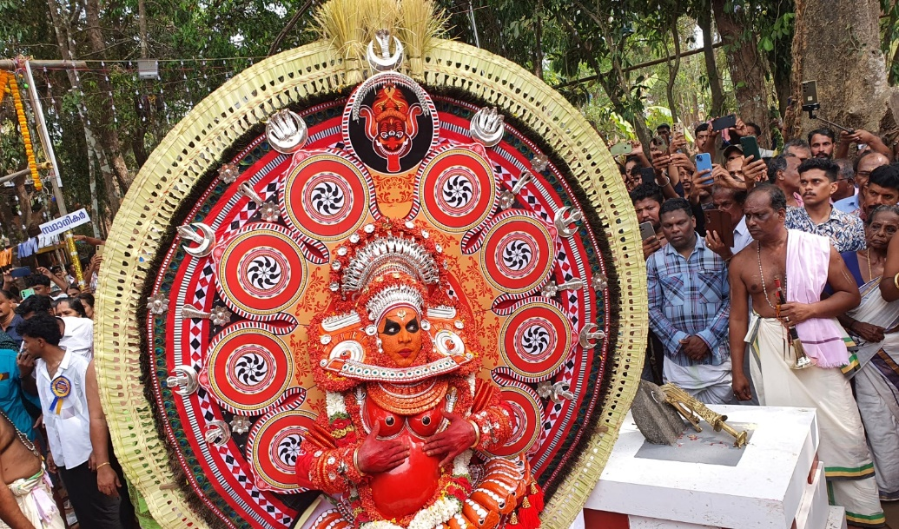

**Figure 1: A Theyyam performer in elaborate costume and trance, embodying a deity before an engaged audience.**

For spectators, Theyyam also serves as a medium for emotional release and catharsis. The visual and auditory elements of the performance like vibrant costumes, rhythmic drumming, and sacred chants, evoke strong emotional responses. The belief in the presence of the divine during the performance amplifies this effect, providing a psychological outlet for repressed emotions. Furthermore, the direct interaction between the deities (as embodied by the performers) and the devotees helps alleviate psychological distress, offering reassurance and healing. This interaction fosters not only individual emotional release but also strengthens communal bonds, reinforcing a sense of shared identity and collective consciousness. Through this dynamic, Theyyam becomes not just a performance, but a therapeutic process that facilitates psychological healing for both performers and spectators.

**2.2.** **Archetypal Representation and Psychological Transformation**

In Theyyam, the transformation of the performer is more than just a physical change; it signifies a profound psychological metamorphosis that impacts both the individual and the collective consciousness of the community. The ritual serves as a therapeutic and symbolic experience, where the performer undergoes a psychological and spiritual journey through elaborate makeup, costumes, rhythmic drumming, and ritual invocations. This process symbolizes a death of the self and a rebirth into a divine form, enabling the performer to embody deities, ancestral spirits, and mythic heroes revered by the community.

Carl Jung's theory of archetypes and the collective unconscious provides a useful framework for understanding this transformation. According to Jung, archetypes are universal symbols or motifs that exist deep within the human psyche and appear across cultures and mythologies (Vibhute, S.J. & Suresh, K.B., 2024). In Theyyam, the performer channels archetypal figures associated with protection, justice, fertility, and wisdom. Through embodying these symbols, the performer transcends their individual identity and temporarily adopts a larger-than-life persona, which leads to psychological empowerment and spiritual catharsis.

This transformation is especially significant for performers from historically marginalized communities. The opportunity to be revered as a living god, even for a short period, represents a powerful inversion of the traditional caste hierarchy. In the sacred space of the ritual, social order is symbolically realigned, offering a fleeting but profound sense of justice and equality. This shift in identity where a person transforms from an ordinary human to a divine being facilitates not only personal transformation but also reinforces a collective identity among the oppressed.

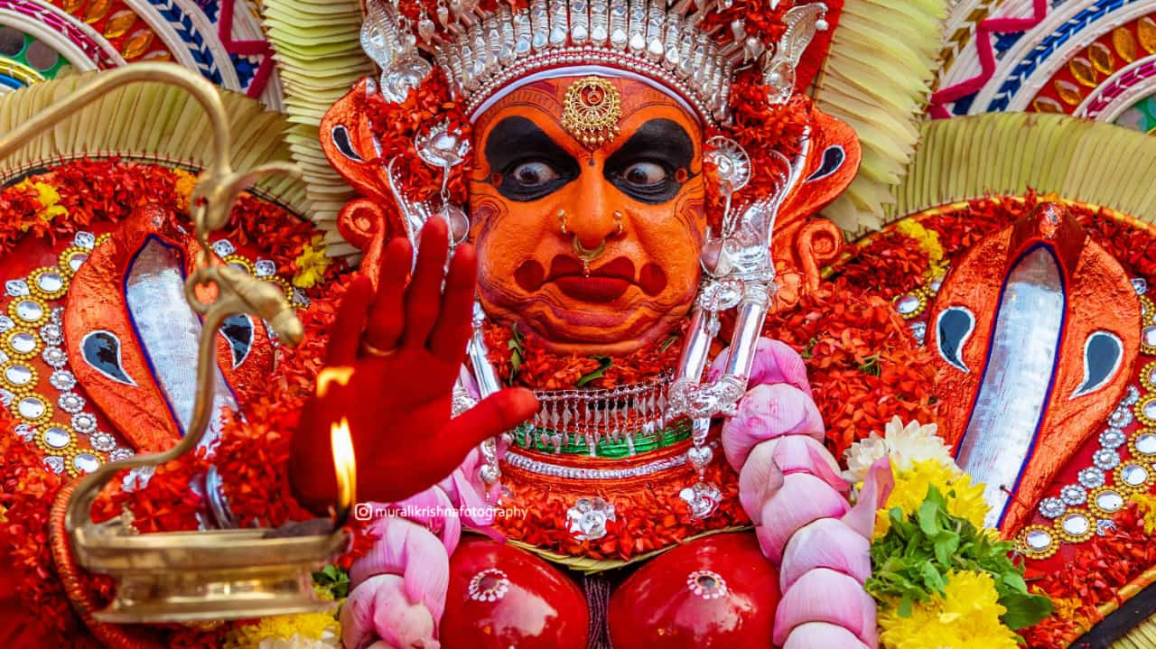

**Figure 2: A close-up of a Theyyam performer channelling a fierce deity through intense facial expressions and symbolic attire.**

The psychological benefits of this transformation are vast. For the performer, entering an altered state of consciousness through chanting, rhythmic movements, and possession allows for the release of personal and communal emotions. This catharsis functions similarly to psychodrama, where symbolic roles are enacted to explore and resolve inner tensions. As the performer assumes the identity of the deity, they are momentarily freed from the limitations of their social roles, fears, and personal insecurities. In this suspended state, the individual taps into a reservoir of cultural strength and legitimacy drawn from generations of mythological and ritual continuity. The community, in turn, responds with reverence, creating a feedback loop that strengthens both the performer's transformation and the communal experience.

Despite its transformative power, Theyyam remains entrenched within the caste system, which continues to influence its practice. Although performers are treated as gods during the ritual, this reverence ends once the performance concludes. Performers, primarily from marginalized communities like the Thiyyas or Maniyanis, are often still excluded from temples, particularly those dedicated to deities such as Shiva or Vishnu. While they are revered temporarily during the ritual, they remain subject to social and caste-based restrictions in daily life. This reflects a tension between the ritual's symbolic challenge to the social order and its inability to fully disrupt entrenched caste hierarchies.

Even though some performers have begun to challenge these caste-based practices, particularly in instances like Maari Theyyam, where exclusion persists despite historical reforms like the Temple Entry Proclamation, the resistance remains limited. This reflects the complex role of Theyyam as both a source of empowerment and a reinforcement of social divisions. While the ritual provides marginalized individuals with a sense of strength and divine status, it also maintains the status quo, underlining the contradiction between the ritual’s symbolic empowerment and the ongoing social realities of caste-based segregation. While Theyyam serves as a powerful tool for personal transformation and empowerment, especially for marginalized communities, it also highlights the limitations of ritual in effecting real, lasting change in social status. This duality underscores the complex and sometimes contradictory role that rituals like Theyyam play in reinforcing and challenging social structures simultaneously.

**2.3 Theyyam and Identity Formation**

Theyyam plays a crucial role in shaping both individual and collective identities in the communities of North Kerala. As a cultural and ritualistic performance, it serves as a unifying force that strengthens cultural and communal identity. French sociologist Émile Durkheim’s concept of collective consciousness can be applied here to understand how the shared experience of witnessing a Theyyam performance reinforces societal values and creates a strong sense of belonging. The narratives embedded in Theyyam, rooted in folklore and mythology, help preserve cultural memory and ensure continuity across generations, offering a psychological sense of rootedness and identity (Gopi, Anil., 2021).

For the performers, who are often from historically marginalized communities, the transformation into divine figures during Theyyam rituals temporarily elevates their social status. This role reversal allows them to transcend traditional social hierarchies, offering a sense of empowerment, agency, and validation. This temporary subversion of social norms has a profound psychological impact, allowing performers to engage with their identities in a new and transformative way.

For the audience, participation in Theyyam reinforces a shared cultural identity and a collective sense of belonging. The performance, often taking place in sacred spaces like kavus (sacred groves), creates an emotional bond between the participants and the broader community. The communal aspect of Theyyam serves to strengthen social cohesion, making it a powerful tool for maintaining psychological resilience, especially during times of cultural and social change.

As Appadurai (1996) notes, Theyyam plays an integral role in creating a sense of “locality” and a “structure of feeling” that helps individuals cope with uncertainty and social entropy. Thus, Theyyam remains a vital expression of local identity, providing both individual and collective empowerment within the broader context of social and cultural transformation (Tarabout, 2005).

**2.4** **The Trance State in Theyyam**

The trance state in Theyyam is a powerful psychological and spiritual experience that facilitates individual empowerment and communal connection. This altered state of consciousness is marked by a dissociation from everyday reality, heightened suggestibility, and a deep emotional involvement in the ritual. It is induced by a combination of rhythmic drumming, repetitive movements, elaborate rituals, and intense emotional engagement. The trance enables performers to temporarily transcend their personal identities, embodying divine figures or ancestral spirits, creating a profound psychological experience of empowerment.

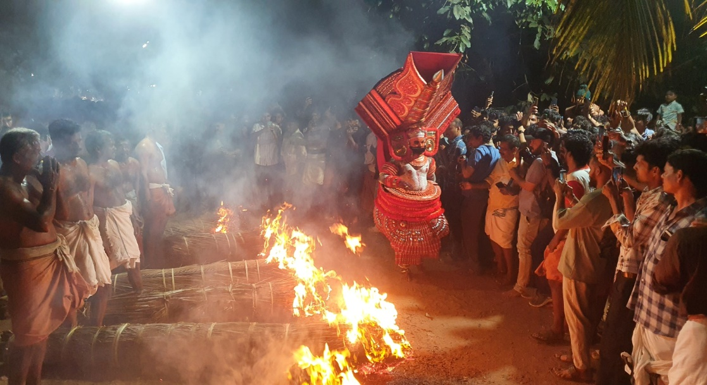

**Figure 3: Trance State and Ritual Intensity in Theyyam**

From a psychological and neuroscientific perspective, trance states are understood as a significant phenomenon that alters an individual’s consciousness. In the case of Theyyam, the trance allows performers to express emotions that might be repressed or inaccessible in their daily lives. The rhythmic drumming and repetitive movements act as catalysts for this shift, leading to a form of catharsis. For the performer, the trance provides a space to release pent-up emotional energy and access a sense of spiritual transcendence. This process also serves as a therapeutic outlet, enabling the performer to break free from the constraints of everyday identity and temporarily inhabit a divine or mythological persona. For the audience, witnessing the trance state in Theyyam also holds psychological significance. The emotional intensity of the performance, driven by the trance experience, provides the audience with an opportunity for emotional release. The shared experience of witnessing the performer’s embodiment of divine figures fosters a sense of collective participation and catharsis, as the ritual allows for communal expression of repressed emotions. This collective involvement strengthens emotional bonds within the community and enhances the sense of belonging. The embodied performance of sacred narratives during the trance state serves as a reminder of the community's cultural roots, rituals, and moral codes. This reinforces a sense of continuity, connecting the present with the past, and emphasizing the collective values that define the group’s identity. The trance experience thus helps sustain cultural heritage and provides an avenue for expressing shared beliefs and traditions.

1. **The Therapeutic Dimensions of Theyyam**

Theyyam is far more than a cultural performance. Theyyam can be seen as a form of indigenous therapy, an intersection of spirituality, culture, and mental well-being, addressing emotional pain through ritual, storytelling, and symbolic transformation. Theyyam facilitates healing on both individual and communal levels. It provides a culturally rooted mechanism for coping with trauma, restoring self-worth, and sustaining psychological resilience. The ritual offers emotional and psychological relief through its unique ability to provide divine reassurance, community validation, and a temporary inversion of rigid caste hierarchies. For many participants and spectators, Theyyam becomes a space where spiritual and psychological healing converge.

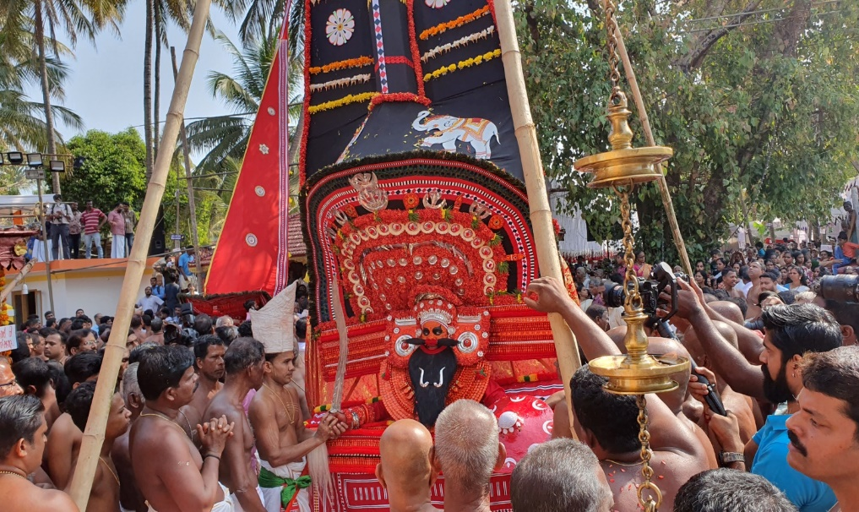

**Figure 4: The Therapeutic Potential of Theyyam as Collective Healing**

From the psychotherapeutic lens, the performative elements of Theyyam such as, chanting, rhythmic drumming, vibrant costumes, and trance induction mirror several techniques used in contemporary psychological practices. These include guided imagery, somatic experiencing, expressive arts therapy, and meditative or altered states of consciousness. The trance state, in particular, allows for a release of repressed emotions, enabling performers to process internal conflicts and experience emotional catharsis. This aligns with theories in transpersonal psychology, which explore the spiritual dimensions of psychological healing, as well as somatic psychology, which emphasizes the body’s role in emotional processing (Verrier, Monique, 2021).

The collective nature of Theyyam further enhances its therapeutic impact. The community’s active participation through prayer, offerings, and emotional engagement creates a supportive environment in which personal and collective struggles can be externalized and ritualistically addressed. As individuals seek divine intervention for personal problems, health issues, or social injustice, the ritual provides symbolic resolutions and emotional reassurance. These shared experiences reinforce communal bonds, reducing isolation and fostering a sense of belonging.

**3.1 Catharsis and Emotional Release**

At the core of Theyyam’s therapeutic function lies the concept of catharsis, a psychological process first emphasized in psychoanalytic theory by Sigmund Freud. Freud argued that the release of repressed or unconscious emotions through expressive channels could lead to psychological relief and healing (Tarzian, M., Ndrio, M., & Fakoya, A. O., 2023). Theyyam creates a shared space where everyone can let out their feelings and experience emotional healing together.

The structure of Theyyam is thoughtfully designed to encourage emotional expression. Elements like careful preparations, rhythmic drumming, powerful chanting, and trance states come together to create an intense and sacred atmosphere. In this emotionally charged space, both the performer and the audience are taken beyond their everyday lives into a different space, one where expressing deep emotions such as sorrow, anger, joy, or hope is not only accepted but welcomed. In Theyyam, the performer’s change into a divine being is more than just a visual transformation, it causes a deep psychological change that helps them express strong emotional and cultural stories, much like in a healing role-play. For the audience, the ritual becomes a space for emotional release and support. Devotees often connect with the performer to share personal worries and seek guidance, which can lead to intense emotional responses. The performer’s role as a deity creates a sense of safety, making it easier for people to express feelings they normally keep hidden.

The narratives performed during Theyyam which are often centered around themes of oppression, injustice, divine punishment, and redemption tends to resonate deeply with the lived experiences of the community. These stories function as cultural scripts, providing a framework through which individuals can process trauma, loss, and social suffering. As these stories are performed, the audience often sees their own emotions reflected in the mythical struggles of gods and ancestors, creating a strong sense of connection, recognition, and emotional relief. Theyyam thus provides a psychosocial container for emotional expression, offering a sacred space where personal experiences transform into communal ones. In this space, the act of witnessing becomes a form of healing. Through the shared experiences of trance, storytelling, and emotional release, the ritual promotes not only individual catharsis but also strengthens the psychological resilience and unity of the community.

1. **Drawing Parallels: Theyyam and Contemporary Psychological Practices**

In examining the practice of Theyyam, it is striking how its various elements parallel contemporary psychotherapeutic techniques. Each of these modern therapeutic frameworks shares common ground with the ritual’s transformative and cathartic functions, demonstrating how ancient cultural practices and modern psychotherapy may converge in their psychological effects.

* 1. **Theyyam as Psychodrama**

Psychodrama is a therapeutic approach that uses guided drama and role-playing to work through problems (López-González, M. A., Morales-Landazábal, P., & Topa, G., 2021). Similarly, Theyyam is a ritual art that involves impersonation of deities, ancestors, and mythological figures, primarily by performers from marginalized castes. The symbolic narratives, emotional expression, and performative elements of Theyyam are similar in nature to the core components of psychodrama. his parallel allows for a deeper understanding of Theyyam not only as a religious or artistic expression but also as a communal psychological process.

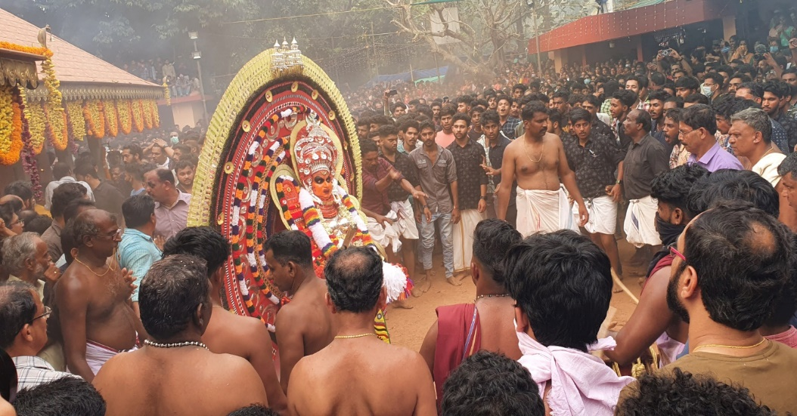

**Figure 5: A Theyyam performer, encircled by a crowd, enacts mythological narratives in a highly expressive and emotionally charged setting.**

Theyyam performances can be viewed as a form of psychodrama where mythological narratives serve as symbolic representations of personal and communal struggles. The ritual reenactment of divine justice offers a framework for understanding suffering and finding meaning (Turner, V., 1979). Each Theyyam performance is deeply structured and symbolically dense. The costumes, face painting, and music act as transformative tools, similar to psychodrama techniques like "role reversal" and the use of an "auxiliary ego." The audience does not merely observe but interacts with the performer-as-deity, creating a therapeutic exchange where suppressed emotions, desires, and grievances are often expressed and resolved symbolically.

One of the core techniques in psychodrama is role reversal, where individuals act out roles other than their own to gain insight and empathy (Miranda Wu, Jacob Cameirao, Steven Brown, 2025). The psychodramatic effect lies in fostering empathy and disrupting rigid social roles, even if momentarily. As in psychodrama, the group process in Theyyam helps individuals feel seen, heard, and supported, which contributes to psychological resilience and social cohesion. Viewing Theyyam as psychodrama opens up new possibilities for understanding the psychological dimensions of ritual performance. As an indigenous form of psychodrama, Theyyam offers a culturally resonant framework for emotional expression, role exploration, and communal healing.

**4.2 Expressive Arts Therapy and the Visual Elements of Theyyam**

Expressive Arts Therapy combines creative activities such as art, music, and movement to facilitate emotional expression and healing. It helps individuals explore their inner experiences and promotes personal growth through non-verbal communication (Dunphy, K., Mullane, S., & Jacobsson, M., 2014). Theyyam, with its visual and performance-based aspects, is similar to this type of therapy. The ritual's multi-sensory experience such as detailed face painting, elaborate costumes, symbolic weapons, rhythmic drumming, and dance tells stories of mythology, identity, and social justice. The process in Theyyam, where the performer becomes a deity or ancestral spirit, is similar to the emotional release found in expressive arts therapy. Through this transformation, the performer expresses their emotions and struggles, offering a strong outlet for psychological relief. In expressive arts therapy, creating or performing helps people explore emotions they may find hard to express with words. Similarly, in Theyyam, the performer channels deep fears, desires, and community concerns by embodying divine figures. This act of performance is not only about physical appearance but also about channeling a collective emotional experience. Just as expressive arts therapy helps people share their inner emotions through art, Theyyam uses visual, auditory, and performance elements to create a shared emotional journey for both the performer and the audience.

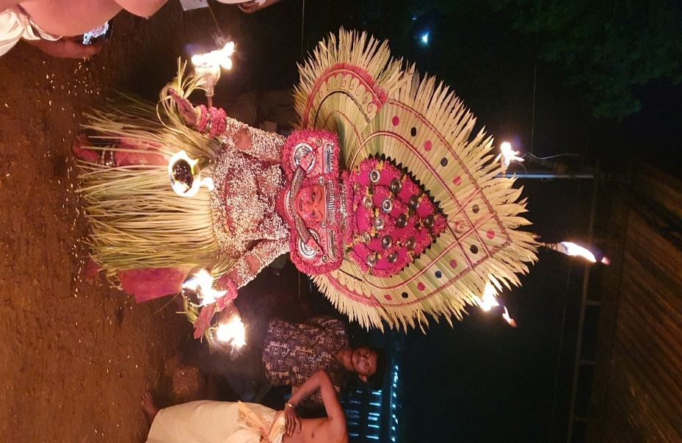

**Figure 6: Theyyam as a Form of Expressive Arts Therapy**  
**A Theyyam performer adorned in intricate costume and holding fire torches embodies the fusion of visual art, dance, drama, and ritual.**

**4.3 Narrative Therapy and Mythological Storytelling in Theyyam**

Narrative therapy focuses on the idea that people can rewrite their life stories, understanding that their identities are shaped by the stories they tell themselves. It believes that by changing their personal narrative, individuals can break free from limiting beliefs and behaviors (Hutto, Daniel & Gallagher, Shaun, 2017). In a similar way, Theyyam uses mythological storytelling as a key part of its ritual. The performance often reenacts stories of gods, ancestors, and mythical heroes, dealing with themes like oppression, redemption, and justice. These stories help the community process historical pain and societal struggles, much like how narrative therapy helps clients reshape their personal histories. In Theyyam, the performer can be seen as "re-authoring" collective and individual histories, acting out both divine and human parts of the myth to restore balance and justice. The act of retelling these myths through performance can be seen as a way of resolving past conflicts, offering emotional healing. Just as narrative therapy allows clients to rewrite their personal stories, Theyyam allows participants to reframe societal narratives, especially those related to caste oppression and injustice. This process creates a symbolic space for emotional healing, helping both the performer and the community reimagine their identities and roles in society.

**4.4 Mindfulness, Meditation, and the Trance State in Theyyam**

Mindfulness and meditation are well-known techniques in modern psychotherapy that help with mental clarity, emotional balance, and self-awareness. These practices encourage people to stay focused on the present moment, which helps them feel more aware and emotionally stable (Keng, S. L., Smoski, M. J., & Robins, C. J., 2011). In Theyyam, the trance state created by rhythmic drumming, repetitive movements, and chants works in a similar way, helping the performer enter a focused, meditative state. In this trance, the performer disconnects from their personal identity and becomes a channel for divine energy, taking on the role of gods or spirits. This process is similar to the mental clarity and emotional balance that mindfulness aims to achieve. The repetitive rituals and drumming in Theyyam create a calming effect similar to meditation. The rhythm helps both the performer and the audience stay focused on the present moment, promoting a shared emotional connection. Just like mindfulness practices help reduce anxiety and increase emotional awareness, the trance in Theyyam provides both performers and participants with emotional release and spiritual insight.

**Conclusion**

Theyyam exists at the crossroads of culture and psychology, offering a distinctive perspective on human emotions, social dynamics, and spiritual experiences. It not only preserves cultural identity but also serves as a psychological outlet, making it a tradition with significant contemporary relevance. Examining Theyyam through both cultural and psychological lenses deepens our understanding of how art, ritual, and human consciousness intersect, highlighting the valuable psychological insights embedded in traditional practices. More than a cultural spectacle, Theyyam is a profound psychological experience that facilitates emotional expression, identity formation, and communal healing. Viewing it through a psychological framework reveals how art forms function as mechanisms for emotional and social well-being. Beyond its artistic and ritualistic aspects, Theyyam represents a psychological phenomenon that enables emotional release, strengthens social identity, and induces altered states of consciousness. Its therapeutic potential, coupled with its role in reinforcing collective consciousness, makes it a compelling subject for psychological inquiry.

Although Theyyam has a strong psychological impact, it also reflects the complexities of social structures, especially caste hierarchies. This shows that rituals can both empower individuals and reinforce social norms. Still, the ability of Theyyam to go beyond personal and collective boundaries provides valuable lessons on how traditional rituals can help with modern psychological healing. In the end, Theyyam demonstrates the connection between culture, psychology, and spirituality, emphasizing how important ritual practices are in meeting the psychological needs of both individuals and communities. Theyyam continues to be an interesting topic for psychological research, showing the lasting importance of traditional practices in promoting emotional and social well-being. Future research can focus on understanding the neuropsychological aspects of trance states in Theyyam and their applications in modern therapeutic practices. This could further enhance our understanding of its role in emotional and social healing.

**Significance of the paper:**

This paper helps to deepen the understanding of Theyyam as a culturally significant ritual with significant psychological implications. It provides insights into how traditional cultural practices can enhance contemporary psychological theories and therapeutic methods. The paper further emphasizes the role of cultural rituals in promoting emotional expression, identity formation, and psychological healing, offering a model for integrating indigenous practices into modern psychological frameworks.

**Limitations**:

The theoretical study of the psychological aspects of Theyyam has limitations, such as relying on Western psychological theories that may not fully fit the cultural context of Kerala. There's also a lack of empirical studies on the ritual's effects, and individual emotional experiences can vary widely. Social and historical changes are often ignored, and the focus on group healing might miss personal benefits. Additionally, caste hierarchies are not fully addressed, and the use of limited psychological theories may not capture the complexity of the ritual. Lastly, using Western frameworks can lead to cultural bias.

**Acknowledgement**

The author acknowledges the use of ChatGPT, an AI language model developed by OpenAI (GPT-4-turbo, November 2023 version), as a writing assistance tool during the preparation of this manuscript. The tool was used specifically to improve sentence structure, enhance clarity, and refine academic language. All AI-generated suggestions were carefully reviewed, edited, and verified by the author to maintain the originality, accuracy, and integrity of the content. The prompts provided to the model were limited to language-level refinements.

Types of prompts entered into the AI system:

* Restructure the following paragraph to improve clarity and coherence.
* Improve the grammar and flow of this section of the research paper.
* Provide a formal version of this sentence suitable for academic writing.
* Disclaimer (Artificial intelligence)
* Option 1:
* Author(s) hereby declare that NO generative AI technologies such as Large Language Models (ChatGPT, COPILOT, etc.) and text-to-image generators have been used during the writing or editing of this manuscript.
* Option 2:
* Author(s) hereby declare that generative AI technologies such as Large Language Models, etc. have been used during the writing or editing of manuscripts. This explanation will include the name, version, model, and source of the generative AI technology and as well as all input prompts provided to the generative AI technology
* Details of the AI usage are given below:
* 1.
* 2.
* 3.

**Reference**

A., S. J., & M., S. (2024). Upending the norms: the representation of Theyyam in Kerala’s popular culture. *Cogent Arts & Humanities*, *11*(1). <https://doi.org/10.1080/23311983.2024.2438488>

Boddy, J. (1994). Spirit Possession Revisited : Beyond Instrumentality. Annual Review of Anthropology, 23, 407–434. DOI: <https://doi.org/10.1146/annurev.an.23.100194.002203>

Bourguignon, E. (2008). Suffering and Healing, Subordination and Power : Women and Possession Trance. Ethos, 32(4), 559. DOI: <https://doi.org/10.1525/eth.2004.32.4.557>

C.M.S. Chandera, *Kaliyattam* (Kottayam: Published by the author and distributed by National Book Stall, 1978).

Chandran, S. M. (2016). ‘Myth as a Symbolic Narrative: A Study of the Selected Myths of Malabar Theyyam Cult’. Research Journal of English Language and Literature (RJELAL), 4(4).

Chandran, Ritual as Ideology, 5; Dasan, Theyyam, 8–9; R.C. Karippathu, The World of Theyyam: A Study on Theyyam, the Ritual Art Form of North Kerala (Kannur: Kairali Books, 2019): 29–49.

Damodaran M P. (1998) The Malayan of North Malabar and Their Teyyam. Kerala: Kannur University Press

Damodaran, M. (2008). Teyyam is the Best Tool for Reconstructing the History of North Malabar. The Anthropologist. 10. 10.1080/09720073.2008.11891063.

Saranya, J. A., & Senguttuvan, M. (2024). Upending the norms: the representation of Theyyam in Kerala’s popular culture. Cogent Arts & Humanities, 11(1).

Dunphy, K., Mullane, S., & Jacobsson, M. (2014). The effectiveness of expressive arts therapies: A review of the literature. *Psychotherapy and counselling journal of Australia*, *2*(1).

Fawcett, Fred (1901) ‘Nâyars of Malabar’, Madras Government Museum Bulletin, III

Freeman, John Richardson, Jr. (1999) Gods, Groves and the Culture of Nature in Kerala. Modern Asian Studies, 33(2):257-302.

Gardner, J., and Maier, J. R. (1996). Masked Performance: The Play of Self and Other in Ritual and Theatre. Philadelphia: University of Pennsylvania Press.

Geetha, E. (2022). ‘The Theyyams of North Kerala: The Little Gods of Little Kingdom’ Quest Journals Journal of Research in Humanities and Social Science, 10(2), 16-20.

Gopi, Anil. (2021). Gods and the Oppressed: A Study on Theyyam Performers of North Malabar. Contemporary Voice of Dalit. 13. 199-207. 10.1177/2455328X211008363.

Gough, Kathleen, (1981) Rural Society in South East India, Cambridge University Press, Cambridge

Gundert, H. (1872). *A Malayalam and English dictionary*. Mangalore: C. Stolz.

Jayaraj, G., & Krishnamurthy, M. (2024). Contemporary Ritual: Teyyam and the Creation of Its Epistemic World. South Asia: Journal of South Asian Studies, 47(1), 17-34.

Y.V. Kannan, *Teyyangalum Anushtanangalum: Oru Padanam*, (Thiruvananthapuram: Kerala Bhasha Institute, 3rd ed., 2019): 148–68.

K.K.N. Kurup, ‘Peasantry and the Anti-Imperialist Struggles in Kerala’, Social Scientist 16, no. 9 (1988): 35–45.

L, Deleep. (2024). Rituals Of Resistance: Discourse Analysis of Theyyam in Kerala's Folk Traditions. ShodhKosh: Journal of Visual and Performing Arts. 5. 10.29121/shodhkosh. v5.i6.2024.3093.

López-González, M. A., Morales-Landazábal, P., & Topa, G. (2021). Psychodrama Group Therapy for Social Issues: A Systematic Review of Controlled Clinical Trials. *International journal of environmental research and public health*, *18*(9), 4442. <https://doi.org/10.3390/ijerph18094442>

Menon, Dileep, (1993) The Moral Community of the Teyyattam: Popular Culture in Late Colonial Malabar, Studies in History, 9, 2, n.s, Sage Publications New Delhi/Thousand Oaks/London

Miller, J. E. (1954). Caste and territory in Malabar. American Anthropologist, 56(3), 410–420.

Reshma, V. R., & Sheeja, S. A. (2023). Theyyam: A performer’s journey of transformation from man to god. ShodhKosh Journal of Visual and Performing Arts, 4(2), 270-280.

Namboodiri, V. M. V. (2012). Folklore: Identity of Culture. Kerala: Department of Information and Public Relations, 47.

Namboodiri. Vishnu, (1990) M.V., Thottampattukal Oru Patanam, National Bookstall, Kottayam

Narayanan, M.T., (2003) Agrarian Relations in Late Medieval Malabar, Northern Book Centre, New Delhi

Payyanad, Raghavan, (1998) Folklorinu oru Padanapaddati,(Mal) Kerala Sahitya Academi,. Thrissur

Sreedhara Menon, A. (2021). *Kerala Samskaram* (13th ed.). DC Books. (Original work published 2017)

Koga, M. (2003). The politics of ritual and art in Kerala: controversies concerning the staging of teyyam. Minamiajiakenkyu, 2003(15), 54-79.

Tarabout, Gilles. (2005). Malabar Gods, Nation-Building and World Culture: On Perceptions of the Local and the Global. 10.7135/UPO9781843313823.009.

Tarzian, M., Ndrio, M., & Fakoya, A. O. (2023). An Introduction and Brief Overview of Psychoanalysis. *Cureus*, *15*(9), e45171. <https://doi.org/10.7759/cureus.45171>

Thurston, E. (2015). *Castes and tribes of Southern India* (Vol. 5). Cosmo Publications.

Turner, V. (1979). Dramatic Ritual/Ritual Drama: Performative and Reflexive Anthropology. The Kenyon Review, 1(3), 80–93.

V.R., Reshma & Sheeja, S. (2023). Theyyam: A Performer’s Journey of Transformation from Man to God. ShodhKosh: Journal of Visual and Performing Arts. 4. 10.29121/shodhkosh. v4.i2.2023.541.

Veluthat, K. (1978). *Brahmin settlements in Kerala: Historical studies*. Sandhya Publications.

Verrier, Monique. (2021). A Psychospiritual Exploration of the Transpersonal Self as the Ground of Healing. Religions. 12. 725. 10.3390/rel12090725.

Vibhute, S.J. & Suresh, K.B. (2024). Unraveling the Depths of the Psyche: A Review of Carl Jung's Analytical Psychology. International Journal of Indian Psychology, 12(1), 628-642. DIP:18.01.059.20241201, DOI:10.25215/1201.059

Vishwakarma, Deepak. (2023). Exploring the Cultural Significance and Artistry of Theyyam's Elaborate Headgear: An In-depth Study of Craftsmanship and Symbolism.". 10.13140/RG.2.2.19191.19366.

Wu, Miranda & Cameirao, Jacob & Brown, Steven. (2025). Role reversal enhances an understanding of the other, but not of the self. The Arts in Psychotherapy. 93. 102288. 10.1016/j.aip.2025.102288.

Hutto, Daniel & Gallagher, Shaun. (2017). Re-Authoring narrative therapy: Improving our selfmanagement tools. Philosophy, Psychiatry, & Psychology. 24. 157-167. 10.1353/ppp.2017.0020.

Keng, S. L., Smoski, M. J., & Robins, C. J. (2011). Effects of mindfulness on psychological health: a review of empirical studies. *Clinical psychology review*, *31*(6), 1041–1056. https://doi.org/10.1016/j.cpr.2011.04.006

**Appendix 1**

***Table 2: Summary of Reviewed Literature on Cultural and Psychological Dimensions of Theyyam***

| **Author(s) and Year** | **Focus Area** | **Theoretical Contribution** |
| --- | --- | --- |
| A., S. J., & M., S. (2024) | Representation of Theyyam in popular culture | Cultural theory |
| Boddy, J. (1994) | Spirit possession and anthropological perspectives | Anthropology of spirit possession |
| Bourguignon, E. (2004) | Trance and healing among women | Gender and healing |
| Chandera C M S (1978) | Traditional insights on Theyyam | Cultural documentation |
| Chandran, S. M. (2016) | Symbolic narrative in Theyyam myths | Myth and psychology |
| Chendera, C. M S. (2004) | Origins and evolution of Theyyam | Folklore evolution |
| Damodaran M P. (1998) | Cultural role of Malayan community | Caste and ritual linkages |
| Damodaran, M. (2008) | Theyyam and historical reconstruction | Historical anthropology |
| Saranya & Senguttuvan (2024) | Power and appropriation in Theyyam | Postcolonial theory |
| Dunphy, K. et al. (2014) | Effectiveness of expressive arts therapies | Expressive arts in therapy |
| Fawcett, F. (1901) | Ethnographic account of Nâyars | Ethnographic methods |
| Freeman, J. R. Jr. (1999) | Ecology and culture in Kerala | Eco-cultural theory |
| Gardner & Maier (1996) | Self and other in ritual theatre | Ritual and performative identity |
| Geetha, E. (2022) | Cultural identity and Theyyam | Cultural memory |
| Gopi, A. (2021) | Theyyam performers and marginalization | Dalit studies and performance |
| Gough, K. (1981) | South Indian rural society | Historical context |
| Gundert, H. (1872) | Linguistic reference for Malayalam | Language and cultural tools |
| Jayaraj & Krishnamurthy (2024) | Artistic expressions in Theyyam | Cultural aesthetics |
| Kannan, Y.V. (1971) | Rituals and traditions of Theyyam | Ritual structure |
| Kurup, K.K.N. (1996) | Theyyam as ritual dance | Ritual symbolism |
| L, Deleep. (2024) | Discourse analysis of Theyyam | Folk traditions and resistance |
| López-González et al. (2021) | Psychodrama for social issues | Psychodrama in group therapy |
| Menon, D. (1993) | Popular culture in colonial Malabar | Historical and cultural studies |
| Miller, J. E. (1954) | Caste and territory in Malabar | Caste dynamics |
| Reshma & Sheeja (2023) | Masks in Theyyam and deification | Symbolism and identity |
| Namboodiri, V. M. V. (2012) | Folklore and cultural identity | Folklore studies |
| Namboodiri, M.V. (1990) | Thottampattukal study | Vernacular traditions |
| Narayanan, M.T. (2003) | Agrarian relations in medieval Malabar | Socio-economic history |
| Payyanad, R. (1998) | Study methods in folklore | Folklore methodology |
| Sreedhara Menon, A. (2017) | Kerala culture and history | Cultural heritage |
| Koga (2003) | Theyyam performer narratives | Autobiographical folklore |
| Tarabout, G. (2005) | Local and global perceptions in Malabar | Cultural globalization |
| Tarzian et al. (2023) | Introduction to psychoanalysis | Psychoanalytic theory |
| Thurston, E. (2015) | Castes and tribes of Southern India | Ethnographic history |
| Turner, V. (1979) | Performance and reflexive anthropology | Performative anthropology |
| V.R., Reshma & Sheeja, S. (2023) | Performer’s transformation in Theyyam | Transformation and embodiment |
| Veluthat, K. (1978) | Brahmin settlements in Kerala | Historical demography |
| Verrier, M. (2021) | Transpersonal healing | Psychospiritual theory |
| Vibhute, S.J. & Suresh, K.B. (2024) | Review of Jung’s analytical psychology | Analytical psychology |
| Vishwakarma, D. (2023) | Symbolism in Theyyam headgear | Cultural symbolism |
| Wu et al. (2025) | Role reversal in psychotherapy | Role reversal in therapy |