**Original Research Article**

**Integrated Geomorphological Assessment of the Nirguna (Bhikund) River Watershed Using Remote Sensing and GIS Technique**

**Abstract:**

It has been attempted to define the different groundwater potential zones based on hydro geomorphological studies through detailed morphometric research of the Nirguna (Bhikund) river watershed in Akola and Washim Districts. Morphometric analysis is the measuring and quantitative examination of the landforms' dimensions, shapes, and configurations on Earth. A low to moderate drainage density is indicated by the research area's drainage density (D) value. Maps have been created to illustrate many topics by applying remote sensing and GIS technology. Portion and enhancing the possibility for groundwater. Additional research using high-resolution remote sensing and GIS in the field, integrating remote sensing data with ground control data is more efficient for creating the right kind of Mechanisms for managing natural resources. The examination of all morphometric parameters indicates that the drainage development has been influenced by lithology and that the erosional development of the land by the streams has advanced well. Planning for rainwater collecting and watershed management can greatly benefit from this study. The detail study of geomorphological aspects have been carried out which suggests that there are five mainly landforms have been depicted such as anthropogenic origin, denudational origin, Fluvial origin, structural origin and water bodies mainly.

**Keywords:** Groundwater, Geomorphology, Drainage, Flooding, Lithology, GIS.

**Introduction:**

By utilizing cutting-edge geospatial methods, it provides insightful information about the watershed behavior and geomorphic features of a river basin that has received little attention.   
By using remote sensing and GIS techniques, the study improves knowledge of drainage patterns, terrain morphology, and potential watershed management zones. These findings are important for natural resource management, flood mitigation strategies, and sustainable planning in Maharashtra's semi-arid regions. They also provide a reproducible methodology for similar geographic settings in India and abroad.Measuring linear characteristics, aerial aspects, and the gradient of the drainage basin's channel network are necessary for morphometric analysis (Nautiyal, 1994). This natural resource is under increasing strain due to the growing demand for water for domestic, agricultural, and industrial uses. This is a concern in highly populated and developed countries around the world, including China, India, and African nations (Das S., 2017., Manap MA, Sulaiman WNA, Ramli MF, Pradhan B, Surip N. A., 2011). Additionally, GWPZ is required to create a projected reference map for groundwater exploration and exploitation in order to support the most efficient and sustainable management and development of this precious resource (Abdessamed Derdour, Yacine Benkaddour, Brahim Bendahou, 2022). Studied the runoff and soil loss under various land-use regimes using remote sensing and GIS technology. The expansion of the Himalayan Watershed in India has benefited from this study (Mishra, 2017). Even if rainfall and population continue to influence water availability and demand, the influence of geomorphological processes on hydrology is essential in identifying the causes of the basin's water scarcity (J. Harsha, A. S. Ravikumar, B. L. Shivakumar, 2020). For groundwater resources to be developed sustainably, a precise quantitative evaluation founded on largely reliable scientific concepts is necessary. The designation of groundwater potential zones (GWPZ) has therefore become extremely important (Dabral S, Bhatt B, Joshi JP, Sharma N,. 2014). An essential component in characterising watersheds is the morphometric analysis of a river basin, which yields a numerical representation of the drainage system (Strahler, 1964). Different methods can be used to identify drainage networks within basins or watersheds; alternatively, more sophisticated techniques like remote sensing and GIS can be used (Macka 2001; Sreedevi et al., 2009). A helpful metric for evaluating runoff, the drainage system's geographic features, surface and groundwater resource management, and groundwater potential is provided by the research of river basin morphometry analysis. Morphometry is the measuring and quantitative analysis of the landforms' dimensions, shapes, and configurations on Earth (Clarke, 1966). It is becoming more widely acknowledged that remote sensing (RS) and geographic information system (GIS) techniques are useful instruments for monitoring, managing, and researching groundwater potential. Since its integration makes it possible for improved spatial analysis and management of geospatial data, it has emerged as a key strategy for raising the precision and effectiveness of hydrological investigations. In order to identify areas with groundwater potential, the combination of remote sensing data with Geographic Information System (GIS) approaches has proven to be a very effective way (Sonal Bariaa and H.D. Rank*., et al*, 2024). The morphometry analysis comprises two parts: the aerial part calculates the drainage density, stream frequency, form factor, circulatory ratio, and elongated ratio, while the linear part calculates the stream ordering, length, bifurcation ratio, and length ratio.

1. **Materials and methods**

**2.1 Study Area:**

The region of research chosen for this project is a portion of the Maharashtra state's Nirguna (Bhikund) river watershed in Akola and Washim Districts. The research area is located in Toposheets .55D/14, 55D/15 and 55D/16 bounded by latitude 20°11’30.24" - 20° 42’44.55"N and longitude 76°52’42.80" - 76°45" 56.92"E. A total of 726 square kilometres make up the study area. Nirguna (Bhikund) river watershed in Akola and Washim Districts. The distance from Akola city to it is 40-45 km and from Washim is 50-60km.

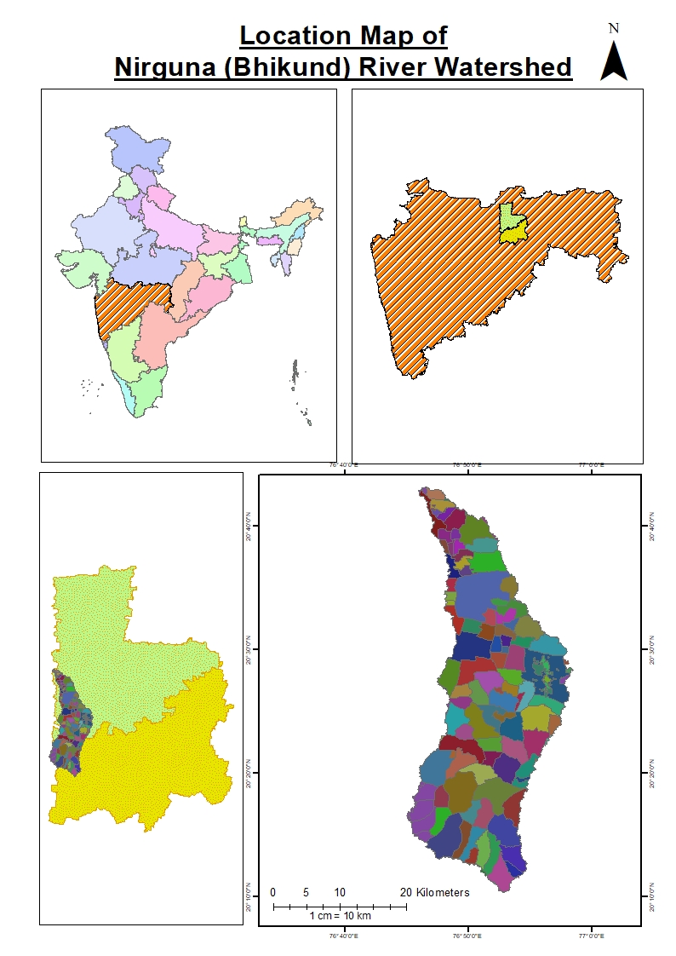

Fig 1- Location map of study Area.

### 2.2 METHODOLOGY:

Developing a workable process for creating a GIS data model for the initial location of the Nirguna (Bhikund) river using Arc Map 10.3 and Arc GIS 10.3 is the main objective of this project. From Survey of India the foundation map for the stream network is toposheet Nos. 55D/14, 55D/15 and 55D/16 at a scale of 1:50000. Using the digitisation technique and the stream ordering approach proposed by Strahler (1964), the scanned toposheet was georeferenced using Arc GIS 10.3.

**2.3 Composition of Maps**:

The maps have been produced at 1:50,000 sizes, pending the completion of the geodatabase containing morphometry data. The style file created for this purpose, which defines the symbols for landforms and base features, was used to compose the map in the ARC GIS-ARC MAP environment. This allowed for the accurate representation of the relevant features in the final geohydrological map.

The integration process entails the subsequent steps:

1. The process of creating base map coverages within the ARC MAP environment.  
2. Editing the coverages to eliminate mistakes such undershoots, overshoots, and dangling nodes.  
3. Constructing the topology when the mistakes are reduced to within tolerance bounds.  
4. Labelling the features with the hydrogeological / base map unit standard codes / symbols.

5. The creation of maps for the final output.

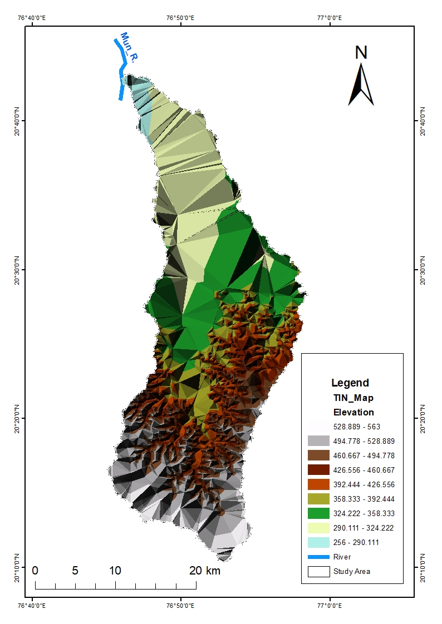

Fig 2 Triangular Irregular Network map with the digital elevation model.

**3. Results and discussion**

**3.1 Morphometric Analysis:**

Morphometrics is the measuring and quantitative analysis of the landforms' dimensions, shapes, and configurations on Earth (Agarwal, 1998; Obi Reddy et al., 2002). The creation of quantitative physiographic techniques to explain the history and behaviour of surface drainage networks is considered very important from the geomorphological study point of view. (Horton, 1945; Leopold & Maddock, 1953; Abrahams, 1984). The Nirguna (Bhikund) river watershed covers 726 square km in total. Figure 2 illustrates the sub dendritic pattern of drainage in the area, which is primarily dendritic. The specifics of the stream characteristics are consistent with Horton's (1932) "law of stream numbers," which claims that the number of streams in a drainage basin varies in order and tends to resemble a geometric ratio. It also supports Horton's (1932) "law of stream length," which asserts that the average length of a stream in a watershed tends to resemble a direct geometric ratio for each of the four orders.

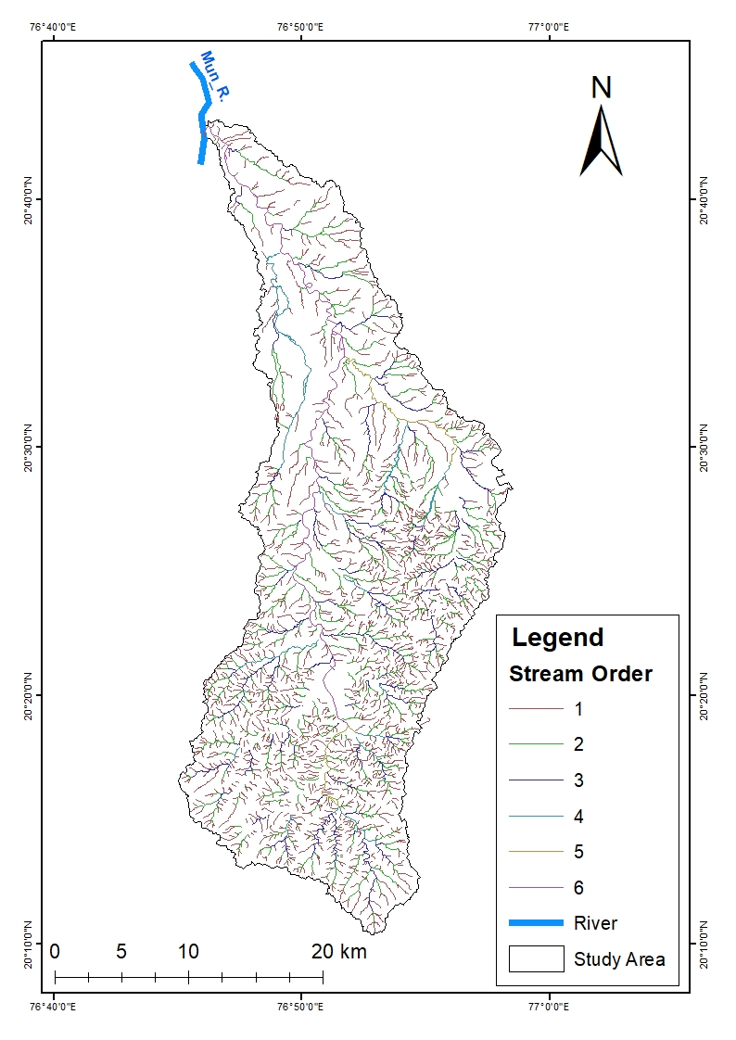

Fig 3 Drainage map of study area.

The linear aspects of the channel system are; 1 Stream Order

1. Stream Length
2. Bifurcation Ratio
3. Stream Number

**3.1.1 Stream Order:**

Identifying the stream order is the initial stage in morphometric examination of a drainage basin. Strahler's stream ordering system has been used to rank the drainage basin's channel segment in the current study. The tiniest fingertip tributaries are classified as order I, according Strahler (1964). Including up to VI stream order in the Bor river basin (Figure 2 and Table 1

**3.1.2 Stream Length (Lu):**

As per Horton, the average stream length can be calculated as the ratio between the length of each order's stream and the number of segments within the same order. According to this study, the stream's length decreases with stream order, which reflects the typical size of the drainage network's component parts and the basin surface they contribute to.

**Table 1: Stream order, Number of streams, Total length of streams, mean stream length and Bifurcation ratio and mean bifurcation ratio.**

|  |  |  |  |  |  |  |
| --- | --- | --- | --- | --- | --- | --- |
| **Sr.**  **No.** | **Stream order**  **(u)** | **Number of Stream (Nu)** | **Total Length of Stream in km (Lu)** | **Mean Stream Length (Km)** | **Bifurcation ratio (Rb)** | **Mean Bifurcation ratio(Rbm)** |
| 1 | I | 1552 | 946 | 0.61 | 4 | 4.9 |
| 2 | II | 388 | 363 | 0.94 | 3.6 |
| 3 | III | 108 | 168 | 0.64 | 3.6 |
| 4 | IV | 30 | 71 | 2.37 | 10 |
| 5 | V | 3 | 26 | 8.67 | 3 |
| 6 | VI | 1 | 65 | 65 | -- |
| **Total** |  | 2082 | 1639 |  |  | 4.9 |

**3.1.3 Bifurcation Ratio (Rb):**

The term "bifurcation ratio" (Rb) refers to the proportion of stream segments of one order to those of the next higher order in a drainage basin. The Strahler method was also used to calculate these results. According to Nautiyal (1994), Strahler (1964), and Chow (1964), bifurcation ratios are connected to the structural control over drainage. In addition, the bifurcation ratio might indicate which areas of a drainage basin are most vulnerable to flooding. Because of variations in the drainage basin's topography, the bifurcation ratio varies from one to the next (Table 1).

**3.1.4 Stream Number (Nu):**

Stream number refers to the counts of each stream channel in their order. As the order rises, there are fewer stream segments; a higher stream order denotes reduced permeability and infiltration.  
Following the assignment of stream orders, the number of segments for each order is determined by counting them all (u). GIS software is used to measure the stream lengths of the different segments. Within the study area, there are 2082 total streams, with 1552 segments belonging to the first order stream and so on as shown in (Table 1).

**3.1.5 Drainage Density (Dd):**

The research area's drainage density (D), which ranges from low to moderate, is 2.3 km. It is proposed that the basin has thick to moderate vegetative cover and extremely permeable subsurface soil based on the low drainage density.

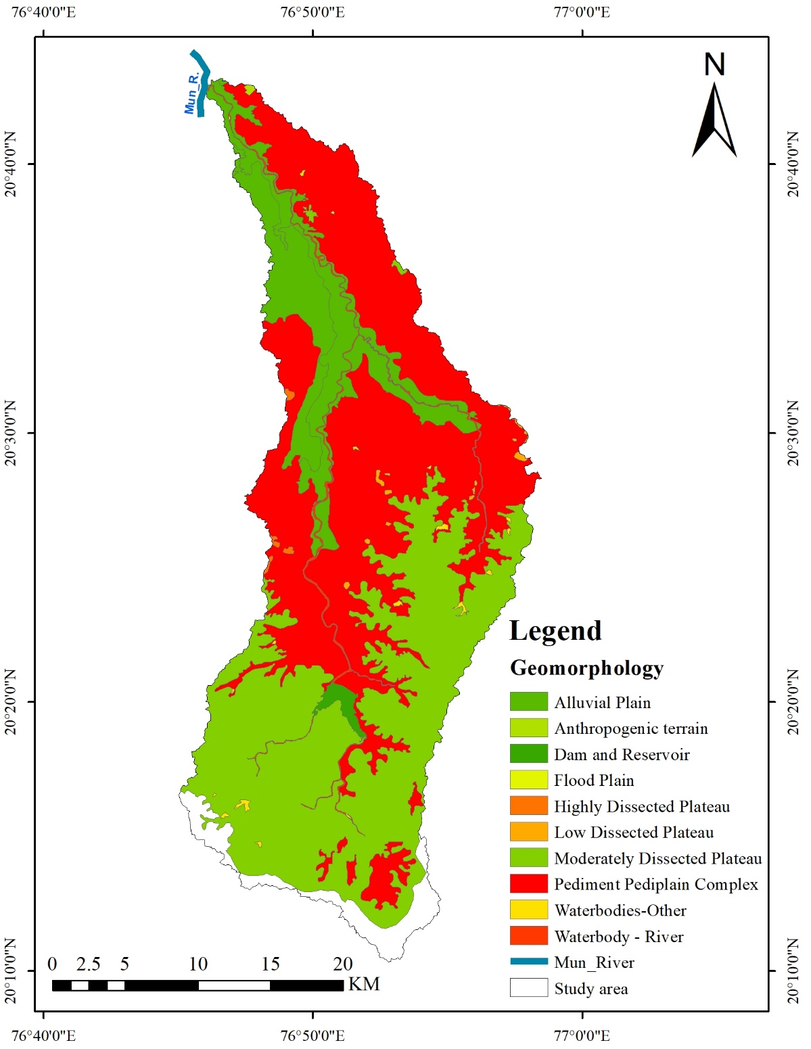

Fig 4 Geomorphology map of study area.

**3.1.6 Texture Ratio (T):**

Texture ratio (T) is the ratio of the area's perimeter to the total number of streams in any given order. The underpinning lithology, infiltration capacity, and relief aspect of the terrain all play a significant role in this drainage morphometric analysis.

The formula is used to express it.

T is equivalent to N1/P.

When,

Study area texture ratio T

P is the perimeter of the research area is 187 km,

N1 is the total number of first order streams (1552).

As a result,

T= 1552/187=8.3

**3.1.7 Stream Frequency (Fs):**

The total number of stream segments of all kinds per unit area is known as the stream frequency, also known as the channel frequency (Horton, 1932).Stream segments are dependent on various factors such as the kind and structure of rocks, the amount and type of vegetation, soil permeability, and rainfall patterns. Additionally, it is the ratio of the size of the basin in which it is located to the total number of streams, regardless of sequence. So the value of stream frequency is 2.87 for the study area.

**3.1.8 Circularity Ratio (Ra):**

According to Miller (1953), a dimensionless circularity ratio is the ratio of the area of a basin to the area of a circle whose perimeter is equal to that of the basin. Strongly elongated and extremely permeable homogenous geologic materials are indicated by the circularity ratio, which is defined as falling between 0.26. Miller's range is supported by the basin's circularity ratio result of 0.26, which shows that the basin has an elongated shape, modest runoff discharge, and high subsurface permeability.

**3.1.9 Elongation Ratio (Re):**

The ratio of the diameter of a circle in the same area as the basin to the greatest length of the basin is known as the elongation ratio, and Schumm (1956) employed it. An impression of the hydrological nature of a drainage basin can be obtained by utilising this highly relevant index in the analysis of basin form. The Re value for the study area is 0.38.

**3.1.10 Form Factor (Rf):**

The ratio of basin area to basin length squared, according to Horton (1932), can be used to define form factor. When a basin is exactly round, the form factor value is always smaller than 0.754. The basin will be longer if the form factor value is lower. On the other hand, elongated watersheds with low form factors (ranging from 0.1, indicating they are elongated in shape and flow for longer duration) have high peak flows of shorter duration in their basins.

**3.1.11 Area (A):**

726 square kilometres make up the basin. Because the basin is small, rainwater will probably reach the main channel faster than it would in a larger basin, where the water would have a considerably longer distance to go. Thus, in the smaller basin, lag time will be reduced. The 'L' is the basin's longest length, according to Gregery and Walking (1973). The drainage development in a certain basin leads directly to the area of the basin. According to Padmaja Rao (1978), the basins are typically pear-shaped in the early phases of the cycle, but as the cycle progresses, the form tends to grow more elongated. Because it influences the stream discharge, the basin's shape is important.

### Table 2 - Areal aspects of drainage basin

|  |  |  |
| --- | --- | --- |
| **Morphometric parameters** | ***Formula*** | **Values** |
| Area (sq.km) | A | 726 Km2 |
| Perimeter (km) | P | 187 |
| Drainage density (km / km2) | D = Lu/A | 2.3 km |
| Stream frequency | Fs = Nu/A | 2.87 |
| Texture ratio | T =N1/P | 6.6 |
| Basin length (km) | Lb | 85 |
| Circulatory ratio | Rc =4 𝜋A/ P2 | 0.26 |

**3.2 Geomorphology:**

The geomorphological studies reveals that the different landforms which are present in the study area formed by the different geological agents such water, wind glaciers etc. Here in the study area water plays major role in order to form different landforms. Geomorphology: Geomorphology is the methodical study of landforms in relation to their geology, climatology, and structural characteristics (Schumm and Hadley, 1961). Landforms and drainage are the two primary determinants of an area's geomorphology. Thomas et al. (2012) and Schumm and Hadley (1961) claim that the geomorphological records provide the finest description of the landforms, plains, and plateau. Generally, areas can be separated into a number of plateaus and plains (fig. Depressed, fragmented plateaus and flood pains are the dominant features of this area. According to the above studies there are five mainly landforms have been depicted such as anthropogenic, denudational origin, Fluvial origin, structural origin and water bodies mainly as shown in the fig. 4.

**4. Conclusion:**

The process of computing morphometric and morpho-tectonic parameters and analysing them was made easier by the current study's use of GIS tools for the morphometric analysis. Different Geomorphic and Morphometric characteristics are crucial for integrated decision-making in water resource management, flood control, and soil erosion evaluation. By identifying possible aquifers, several prospective zones in the watershed of the Nirguna (Bhikund) River were defined. By identifying groundwater potential zones in the area where hydrogeological circumstances are uncertain, the study's findings will undoubtedly aid in comprehending the groundwater regime of the area. Numerous area which are having the potential of groundwater are identified by the help of groundwater potential zone map which helps to recognise the watersheds sustainable development based on the findings of this study. Digital elevation models (DEM) and GIS-based techniques provide the study a more contemporary relevance and resilience while expanding our scientific understanding of the ways in which various activities impact watershed dynamics. Both local farmers and policymakers will gain more from these research. The geomorphological studies reveals that there are five mainly landforms of different origin have been depicted such as anthropogenic, denudational origin, Fluvial origin, structural origin and water bodies mainly which depicts that the how different landforms of different origin have been formed in the study area. The present study also helps to identify suitable sites for watershed management structures.

**DISCLAIMER (ARTIFICIAL INTELLIGENCE)**

Author(s) hereby declare that NO generative AI technologies such as Large Language Models (ChatGPT, COPILOT, etc) and text-to-image generators have been used during writing or editing of this manuscript.

### References

Agarwal, C. S (1998), study of Drainage pattern through Aerial Data in Naugarh area of Varanasi

district, UP. Journal of Indian Society of remote Sensing, 26(4), pp 169-175

Abdessamed Derdour, Yacine Benkaddour, Brahim Bendahou, (2022): Application of remote

sensing and GIS to assess groundwater potential in the transboundary watershed of the

Chott‑El‑Gharbi (Algerian–Moroccan border), Applied Water Science (2022) 12:136

https://doi.org/10.1007/s13201-022-01663-x

Chow Ven T (1964) (ed) handbook of Applied hydrology. McGraw Hill Inc, New York.

Das, S (2017) Delineation of groundwater potential zone in hard rock

terrain in Gangajalghatiblock, Bankura district, India using remote sensing and

GIS techniques. Modeling Earth Systems and Environment. 2017;3(4):1589-

1599.5.

Dabral S, Bhatt B, Joshi JP, Sharma N,. (2014): Groundwater suitability recharge zones

modeling –A GIS application, Int. Arch. Photogramm. Remote Sens. Spatial Inf. Sci.

2014;8:347–353.

J. Harsha, A. S. Ravikumar, B. L. Shivakumar., (2020): Evaluation of morphometric

parameters and hypsometric curve of Arkavathy river basin using RS and GIS

techniques Applied Water Science (2020) 10:86 <https://doi.org/10.1007/s13201-020->

1164-9

Manap MA, Sulaiman WNA, Ramli MF, Pradhan B, Surip N. A, (2011) knowledge-

driven GIS modeling technique for groundwater potential mapping at the

Upper Langat 157 basin, Malaysia. Arabian Journal of Geosciences.

2011;6:1621-1637.

Gregory KJ, and Walling DE (1973), drainage basin form and process a geomorphological

approach. Arnold, London.

Horton, R. E (1932), drainage basin characteristics, Trans.Aer.Geophy.Union, 13, pp 350-361

[http://www.gisdevelopement.net.](http://www.gisdevelopement.net/)

Horton, R. E., (1945), Erosiona! development of streams and their drainage basins; hydrophysical

approach to quantitative morphology.Geol Surv Profess, 282-A.

Jawaharraj, N., Kumaraswami, K., and Ponnaiyan, K (1998), Morphometric analysis of the Upper

Noyil basin (Tamil Nadu). Journal of the Deccan Geographical Society, 36, pp 15-29.

Kumaraswamy.K and Sivagnanam., N (1998), Morphometric characteristics of the vaippar

Basin,Tami! Nadu: A qualitative approach, Indian Journal of Landscape System and

Ecological Studies, 11(11), pp 94-101.

Macka, Z., 2001, Determination of texture of topography from large scale

contour maps. Geografski Vestnik, 73(2):53–62.

Miller, V. C (1953), a quantitative geomorphic study of drainage basin characteristics in Clinch

Mountain Area, Virginia and Tennessee. Technical report, 3, Office of the Naval

Research. Dept. of Geology, Columbia Univ., New York.

Nisha Sahu, G. P. Obi Reddy, Nirmal Kumar, M. S. S. Nagaraju, Rajeev Srivastava, S.

K. Singh (2017) 'Morphometric analysis in basaltic Terrain of Central India using GIS

techniques: a case study'. Appl Water Sci (2017) 7:2493–2499.

Praveen Kumar Rai, Kshitij Mohan, Sameer Mishra, Aariz Ahmad, Varun Narayan Mishra., (2017):

A GIS-based approach in drainage morphometric analysis of Kanhar River Basin,

India, Appl Water Sci (2017) 7:217–232 DOI 10.1007/s13201-014-0238

Nautiyal, M. D (1994), Morphometric Analysis of a Drainage Basin using Aerial photographs: A

case study of Khairakulli Basin, District Dehradun, Uttar Pradesh. *Journal* of the Indian

Society of Remote Sensing, 22(4), pp 251-261.

Padmaja Rao G (December 1978), some Morphometric Techniques with Relation to Discharge of

Musi basin, Andhra Pradesh, pp168-176, proc. Sump on Morphology and Evolution of

Landforms, Department of geology, university of Delhi, New Delhi 110 007, pp 22-23

Schumm, S. A (1956), evolution of drainage systems and slopes in badlands at Perth Amboy, New

Jersy. National Geological Society of American Bulletin, 67, pp 597-646.

Sonal Baria,H.D. Rank,B.B. Limbasiya, Akansha Grites and R.M. Satasiya, (2024), Determining

Potential Groundwater Recharge Zones in the North Gujarat Region of Gujarat State

Using Techniques of Geoinformatics and Multi-Criteria Decision Analysis; Volume 28,

Issue 10, Page 143-158, 2024; Article no.JGEESI.123843ISSN: 2454-7352

Smith KG (1950), standards for grading texture of erosiona! topography.

Strahler, A. N (1964), quantitative Geomorphology of drainage basins and channel networks.

Handbook of Applied Hydrology; edited by V.T Chow (Newyork; Me Graw hill) Section,

pp 4-11.

Sreedevi, P.O. Srinivasalu. S. and Kesava Raju, K (2001), Hydrogeomorphological and groundwater

prospects of the Pageru River basin by using remote sensing data. Environ Geol, 40(8),

pp1088-10.