**Original Research Article**

**Evaluating the Efficiency of Green Landscaping on Abdullah Awiz Airport Street, Basra Province: Challenges and Recommendations for Urban Afforestation**

**Abstract**

The study was conducted to evaluate the efficiency of green landscaping on Abdullah Awiz airport street, Basra province, challenges and recommendations for urban afforestation, based on the standards and regulations for afforestation within cities, with regard to their health, climate, aesthetic, social, and urban dimensions by utilizing field assessments and afforestation standards to quantify vegetation coverage and design adequacy. The analysis results showed that the implementation rate of afforestation standards and regulations on Abdullah Awiz airport street reached 19%, with the standard being present, while the percentage of somewhat present reached 23.8%. The highest percentage of non-existent was 57.2%. This indicates that the implementation indicators for afforestation standards and regulations in the study site are very weak and almost non-existent, and the neglect and lack of a design vision are very evident. This also requires the implementation of a afforestation campaign in accordance with afforestation standards and regulations that reflect the importance of this vital street, in addition to the environmental and health significance of the issue. The study recommended that in order to ensure the coordination of outdoor spaces within cities and main streets, emphasis must be placed on including their natural and artificial components to complete the engineering drawing of the outdoor spaces, and the sustainability can be achieved by utilizing green and water features, shading elements, and local and recycled materials in furnishings. Also, use solar energy and energy-saving lamps for lighting, and design them in an elevated manner to create open viewing angles.

Keywords: Green Infrastructure, street landscaping, New Airport Street (Abdullah Awiz) in Basra Province

**Introduction**

Planning and utilizing parks within the urban fabric is an important and fundamental process and a civil and human requirement. Plants and urban planning are essential to planning the overall location of the city to achieve the best and easiest civil services, ultimately achieving an attractive and integrated landscape to meet human needs and recreational requirements.

Caring for green spaces is one of the most important indicators or elements of environmental concern due to their many benefits. Maintaining ecological balance within cities is a top priority, as they are a source of livelihood for many living organisms on Earth, including humans. They are also of great importance in reducing environmental pollutants, as they reduce noise and preserve soil cohesion from erosion. They also aim to preserve the aesthetic appeal of the city. (Qadouri and Bushka, 2021(.

The population's need for green spaces, represented by trees and parks, has become an urgent necessity that should not be underestimated and should not be overlooked. It can be said that there is a marriage between the city and the environment. Green spaces are an integral part of urban development and cannot be neglected. They are an important element for any city seeking to provide well-being and recreation for its residents, and they are considered the lungs of the city (Amr, 2018). Green areas contribute to improving the urban environment in cities from a climatic, social, and aesthetic perspective, through their multiple functions, including psychological and recreational impacts, environmental and climatic impacts, aesthetic urban impacts, and social and educational impacts (Handhal, 2023). Afforestation and increasing green spaces are among the most important facilities that municipalities compete to demonstrate their commitment to the city, especially in areas suffering from high temperatures and dust storms. This is due to the critical importance of plants in preserving the environment, improving and moderating the local climate, improving soil fertility, reducing pollution and dust storms, reducing wind intensity, and reducing noise and disturbing sounds. This is in addition to the aesthetic, coordination, and economic aspects. Municipalities and secretariats also work to select plant species adapted to the surrounding conditions and implement and follow scientific principles and controls for afforestation within cities and plant distribution. They are also careful not to plant poisonous plants in the streets (Saudi Geographical Society, 2010). Airport Street (Abdullah Awez) is one of the most important streets recently constructed in the center of Basra Province . Its importance stems from the fact that it directly connects Basra International Airport to the Sports City (Palm Trunk Stadium) next to the Shatt al-Basra, east of the city. This research aims to evaluate the current efficiency of the green spaces on Airport Street (Abdullah Awez), given their importance from an aesthetic, environmental, and urban perspective. It also aims to provide the necessary recommendations using modern scientific methods for afforestation and selecting plants that are compatible with the environmental conditions of Basra and suitable for landscaping streets and central refuges, besides the enhancement of airport street landscape and the green spaces.

**METHODOLOGY**

**Field Study**

**1. Basra city**

Basra is a famous ancient Iraqi city, built by Utbah ibn Ghazwan during the reign of Caliph Umar ibn al-Khattab in the year 14, or perhaps 15 AH, at the confluence of the Tigris and Euphrates. Its confluence is known as the Shatt al-Arab, and it is located in the far south of Iraq on the western bank of the Shatt al-Arab. It is the administrative and political center of Basra province. In the past, Basra was one of the most famous cities, renowned for its literature, knowledge, trade, and glory, and its most prestigious and vibrant center, especially during the Abbasid era, when the city expanded its urbanization and constructed beautiful buildings, including monuments, shrines, and mosques. It was second only to Baghdad in importance and prestige. It was a center of trade between Iraq and other countries. Basra is distinguished by its location in an area rich in oil fields in southern Iraq. Therefore, the largest oil refineries and petrochemical plants are located there and nearby. The city is also distinguished by its location amidst an area rich in palm trees, which has led to the presence of lush palm and tree groves in most of its areas.

**2. Description of Airport Street (Abdullah Awiz) (Personal interview with the road engineer at the private company)**

Airport Street is one of the most important streets in the center of Basra Province . It extends from Basra International Airport, passing through the traffic junction on the Basra Expressway, crossing the Basra River via a bridge under construction (Figure 1). It passes through several residential areas, as well as Al-Sayyab Medical Hospital, a newly constructed gas station, and the Basra Lights Village entertainment city. It bypasses Al-Zubair Street via a bridge that wraps around the entertainment city and ends at the Sports City and the Palm Trunk International Stadium. The street was recently constructed by an Iraqi company and was opened prior to the 25th Gulf Cup Championship, which was held in Basra in 2023.

The street is 14 km long and 86 m wide. It contains two main streets, each 15 m wide, separated by a 6 m wide median strip. There is also a service street on each side, 7.5 m wide, separated from the main street by a median strip. Its median width is 7.5 meters.

Airport Street (Abdullah Awiz) is considered one of the most important streets in the center of Basra Province , due to its importance in connecting Basra International Airport in the north of Basra City Center with the Sports City and the Palm Trunk International Stadium. It is also used to connect the expressway to the main road linking Al-Zubair and Basra City Center (Al-Zubair Street), without passing through Basra City Center. Currently, there are two bridges on the road: the first, which is under construction, crosses the Shatt al-Basra, and the second, which is completed, crosses Al-Zubair Street and leads directly to the Sports City. There are numerous residential complexes on Airport Street, some of which are completed, others under construction, as well as the recently completed Al-Sayyab Hospital. The company implementing the road planted the central island as well as the island on both sides along the road, and the planting was limited to Washingtonia palms, the thill, and some bougainvillea plants. Through field visits and on-site observations, it was shown that most of the Washingtonia palms had died, along with the disappearance of the thill areas and the bougainvillea plants. The Central Refuges became numbers of dead Washingtonia palms and barren land, some of which was covered with desert grasses.

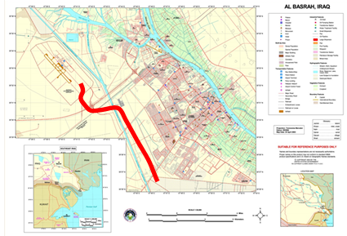

Figure (1) the location of Airport Street (Abdullah Aweez) in Basra Province .

Source: www.wikimedia.org

**3. Street Information Analysis**

Airport Street (Abdullah Aweez) in Basra is one of the most important, newly constructed streets in the center of Basra Province . Observations were recorded during field visits to the street, and despite its importance and the presence of rest stops, they lacked any necessary amenities, such as seating areas, shade canopies, and waste containers. Despite the presence of lighting poles, most of them were not operational, and the street was dark at night. Signposts were observed. Green spaces were limited to palm trees, particularly Washingtonia, and a few date palms. In some places, the bougainvillea plant was observed in the median strip between the two main streets and on their approaches separating them from the service road. Irrigation was carried out by tanker trucks.

**4. Uses of Green Land in Basra Province**

Green spaces in Basra Province continue to suffer from significant neglect, both in practice and in urban planning. Although Basra was once known for its lush orchards spread throughout most of its areas, both in the city center and in the districts and sub-districts, the circumstances that Basra experienced in the 1980s and after 2003 led to the emergence of informal settlements in planning and implementation. Many projects were implemented in the city, demonstrating a lack of concern for green spaces and their conversion to other uses, whether in the form of citizen violations or violations that took on an official character by issuing laws requiring a change in the type of use. Because the current local government in Basra felt this neglect of green spaces and the resulting negative environmental and health impacts, it directed efforts to increase green spaces in the city, establish parks, and focus on central street refuges. Given the importance of Airport Street (Abdullah Awiz Street) and the importance of research, it was chosen to study its green spaces. The study site is located in the center of Basra city. The climate of Basra will be discussed in general. Basra is known for its hot, dry summers and cold, dry winters. Temperatures rise, especially in the summer, which extends from May to October, gradually rising from March and reaching their highest in July and August. They then decline until they reach their lowest in December and December in the winter. Regarding rainfall, it is clear that Basra is located in an area with little rainfall, in addition to its fluctuations from year to year. The prevailing winds in Basra are northwesterly, which blow throughout the year. In winter, they are cold and dry, but in summer, they are moderate and reduce the rise in temperatures. Southeastern winds, on the other hand, have little impact.

**5. The Importance of Green Spaces in Cities**

Open spaces are the cornerstone of urban planning, providing a fixed proportion of them within the overall planning of modern cities. These spaces have a significant impact on the planning of city centers and suburbs. Their purpose is not to achieve openness and alleviate population and traffic congestion, but rather to take into account planning requirements and climatic factors, as they are the city's sole outlet. They are important in the design of green spaces, and therefore, they are an important element that must be present in every city and every region, due to their many benefits. Their importance lies in several aspects:

1. Green spaces are of great environmental importance, as they increase the percentage of oxygen and reduce the percentage of gases emitted from industries and heavy traffic, especially carbon dioxide. This is achieved through plants performing photosynthesis, which consumes carbon dioxide and produces oxygen. They also purify and renew the air from dust, moderate the atmosphere, and reduce noise pollution through afforestation.

2. From a climatic perspective, they contribute to Influencing and reducing solar radiation, and increasing the humidity in the atmosphere through transpiration in plants, which contributes to lowering temperatures. This depends on the density of vegetation, which generally contributes to reducing the impact of solar radiation compared to open squares and fields. This is in addition to the mechanical obstruction of air movement, which leads to changes in wind strength, direction, and speed.

3. Green spaces within the cityscape revitalize residents by providing a beautiful, relaxing view. Their sight inspires comfort and reassurance, restoring psychological balance. Green lawns reduce noise pollution, as they absorb sound waves and significantly reduce their impact. It has been found that a green area reduces noise by 30%-40% within a 200-meter radius.

4. Economic and social importance: The use of afforestation provides adequate shade and can be used to stimulate recreational tourism, particularly in parks and gardens, which generate economic returns. Socially, it plays a role in strengthening social relations by bringing people together in these areas.

5. Engineering importance: Plants have many engineering functions, the most important of which is resisting erosion by acting as windbreaks. They also block noise and mitigate its impact on some elements. They also purify the air of pollutants by controlling gaseous pollution and eliminating other air pollutants such as dust, dirt, smoke, fly ash, and unwanted odors. They also reduce unwanted glare and control light reflections.

6. The Aesthetic Urban Impact. Gardens contribute to shaping the overall appearance of any urban space within cities. Consequently, they play a role in improving the visual environment, resulting from human visual perception of its physical and moral components, and the resulting psychological feelings within. Gardens are also an element of urban design, highlighting the two dimensions (length and width), the vertical dimension, and the fourth dimension (time) of the urban space through the growth and development of its living components (plants), and the changes that occur in size, shape, color, and structure over time. Plants contribute to dividing the urban space into smaller subspaces and separating them (Shura, 2016).

**6. Controls for Urban Afforestation**

**First:** Streets (on both sides of the street and on the sidewalks):

Given the significant increase in pollution rates and the major role plants play in mitigating this damage, it is preferable to plant the streets with plants, taking into account the relationship between the shape and nature of plant growth and their location within the landscape.

Among the most important general controls that should be taken into account when selecting and planting plants on public streets (sidewalks) are the following:

1. Plants planted on streets must be of species that can withstand the environmental conditions of the area and are resistant to disease, insect pests, and environmental pollution.

2. The distance between each tree must be no less than 5-8 meters on urban or rural streets, and 10-12 meters on highways and ring roads.

3. Street planting within cities should be done according to the discretion of specialists, and it is preferable that the sidewalk be no less than 3 meters wide. Regular, upright trees are chosen for street landscaping, such as palm trees, albizia, and some species that can be pruned, such as Ficus sylvatica, to achieve a regular shape.

4. The growth characteristics and size of the plants must be compatible with the size and nature of the street, the conditions of the site in which they are planted, and the surrounding permanent structures. Such that tree branches are not exposed to entanglement with wires and other debris, the trees should be upright or scattered according to the street conditions. Therefore, upright or sprawling trees are chosen according to the street conditions. In the case of streets with many wires, choose trees that can be easily pruned and shaped.

5. Each street should be planted with one type of tree for ease of maintenance and to highlight its landscaping value. In the case of long streets, more than one type may be planted. A tree-to-tree system should be followed, taking into account the proportionality between them in terms of height, color, shape, and environmental needs.

6. Trees should be planted in holes measuring 1.5 x 1.5 x 1.5 m³, spaced 5–8 meters apart, depending on their species and growth pattern. Early in life, trees may require support or a steel net to support and protect their trunks.

7. When determining the size of tree beds on sidewalks, it is essential to allocate sufficient space for pedestrian traffic. The sidewalk width should be sufficient for tree planting, pedestrian traffic, and the natural growth and branching of plants in the future.

8. Plants and advertising and commercial signs should be arranged along sidewalks to avoid overlapping.

9. Trees planted along roadsides should have limited vegetative growth to prevent their branches from extending to nearby buildings or pedestrians. It is preferable to plant small, flowering trees with limited growth, such as Bauhinia (Camel's Hoof) or Tecoma. Avoid planting trees on sidewalks designated for pedestrians.

10. Do not plant thorny trees on sidewalks.

11. Avoid planting fruit trees on sidewalks, as they are polluted by dust and carbon dioxide. This is in addition to the fruit falling, which distorts their appearance and exposes them to vandalism by pedestrians. The primary goal of planting trees along streets is aesthetically pleasing, in addition to their environmental importance.

12. In areas of tree planting along roads and streets with a particular topography, such as sloped areas within cities, and in large areas, cover them with certain plants, such as Hay Al-Alam, Rijlat Al-Zohour, and Abu Khanjar, among others.

**Second:** Central Refuges:

Central islands are an important means of beautifying streets by planting them with trees and shrubs. This depends on the width of the islands. If they are wide, they can be planted with shade-promoting and aesthetically pleasing trees and shrubs, carefully trimmed. If they are narrow, it is preferable to plant them with flowering, shaped hedges. If the islands are long and wide, they can be planted with two types of trees with similar water requirements for ease of maintenance. It is preferable for the trees to be flowering to add beauty to the streets.

Among the most important general guidelines to consider when selecting and planting trees in central islands are the following:

1 .It is preferable that the trees planted, especially in the center of the islands, have tall trunks and high branching, so as not to impede the movement of pedestrians or vehicles (the trunk length should not be less than 3-4 meters), such as date palms, Washingtonia palms, Parkinsonia, and Ficus. The size of the trees should be proportional to the width of the island.

2. Avoid planting large trees at intersections or at the top of road islands, as this may obstruct drivers' vision. A minimum of 5-8 meters should be left around intersections without planting large trees or plants. Low-growing grasses and green spaces may be used.

3. Consider the distribution of plants and the placement of advertising and commercial signs in medians to avoid overlapping.

4. Avoid planting trees near openings and allow U-turns in medians. Fences no higher than 50 cm should be planted on newly constructed roads. Previously constructed roads should be reviewed and trees that obstruct vision should be removed.

5. Advertising and commercial signs should be placed at least 20 meters from the end of the island openings for U-turns on roads being improved. Signboards that obstruct vision should be relocated to existing and previously constructed roads. 6- It is preferable to plant palm trees in the median strips if the width of the strip is not less than 4 m, as they are distinguished from other trees in that they provide shade without crowding other plant formations, and after their full growth, they do not obstruct the view. It is worth noting here the planting of poor-yielding or male species, as the goal of planting palm trees is not the fruits, but rather the aesthetic and coordination aspect of the sites in which they are planted. (Saudi Geographical Society, 2010).

**Results and Discussion**

Airport Street (Abdullah Aweez) and its approaches were selected to evaluate the efficiency of green spaces on this central and main street in Basra Province . A statistical evaluation form was prepared, assigning a weight to each of the criteria studied in the questionnaire model.

**Table 1. Form of the questionnaire** (Al-Anbari *et al*., 2014)

|  |  |
| --- | --- |
| Standards and Controls for Urban Afforestation | |
| First: Fundamentals of Urban Afforestation | |
| **1** | Plant types that are compatible with the natural environment. |
| **2** | Achieving environmental functions. |
| **3** | Achieving structural, engineering, and aesthetic functions. |
| **Second: Planting trees on the street approaches.** | |
| **1** | Plants are tolerant of the natural environment. |
| **2** | Spaces between plants should not be less than 5-8 meters. |
| **3** | Spaces on highways and ring roads should be 10-12 meters. |
| **4** | If the street is 3 meters wide, plants that can be trimmed and shaped should be preferred. |
| **5** | Suitable for the size of the street and plant growth. |
| **6** | Plants should not be exposed to entanglement with electrical wires. |
| **7** | One type of tree should be planted on the street to achieve coordination. |
| **8** | Long streets should be planted with more than one type of plant, achieving contrast in height and color. |
| **9** | Planting in basins should be within spaces that do not impede pedestrian movement. |
| **10** | Plants on both sides of the street should have appropriate vegetative growth. |
| **11** | Avoid planting thorny plants. |
| **12** | Avoid planting fruit-bearing plants. |
| **13** | Provide coordination and beautification elements. |
| **Third: Planting the median strip in the street** | |
| **1** | If the islands are wide and tall, plant shade and flowering trees. If the islands are narrow, plant hedges. Trees should have tall, tall stems and not obstruct movement or vision. Do not plant trees at road intersections, especially large ones. Leave a 5-8m distance at road intersections without planting. |
| **2** | If the islands are wide and tall, plant shade and flowering trees. If the islands are narrow, plant hedges. Trees should have tall, tall stems and not obstruct movement or vision. Do not plant trees at road intersections, especially large ones. Leave a 5-8m distance at road intersections without planting. |
| **3** | If the islands are wide and tall, plant shade and flowering trees. If the islands are narrow, plant hedges. Trees should have tall, tall stems and not obstruct movement or vision. Do not plant trees at road intersections, especially large ones. Leave a 5-8m distance at road intersections without planting. |
| **4** | If the islands are wide and tall, plant shade and flowering trees. If the islands are narrow, plant hedges. Trees should have tall, tall stems and not obstruct movement or vision. Do not plant trees at road intersections, especially large ones. Leave a 5-8m distance at road intersections without planting. |
| **5** | If the islands are wide and tall, plant shade and flowering trees. If the islands are narrow, plant hedges. Trees should have tall, tall stems and not obstruct movement or vision. Do not plant trees at road intersections, especially large ones. Leave a 5-8m distance at road intersections without planting. |

**Table 2. Number of controls for afforestation standards**

|  |  |
| --- | --- |
| **Standard** | **Number of controls** |
| **Urban Landscaping Principles** | **3** |
| **Street Approach Landscaping** | **13** |
| **Medium Landscaping** | **5** |
| **Total** | **21** |

From Table (3), the results indicate that among the indicators of implementing the standards and controls for afforestation of the green spaces of Airport Street (Abdullah Awiz) and its approaches in Basra Province , (19%) were for the “existent” standard, (23.8%) were for the “to some extent” standard, and (57.2%) were for the “non-existent” standard. The results showed that the highest percentage among the percentages that appeared in the study was (57.2%) for the “non-existent” criterion, which is within the controls and standards for afforestation prepared in this study. These percentages may be due to the fact that the reality of the green spaces in the study site lacks many of the natural and artificial components that are supposed to be present and that enable these spaces to perform their environmental, aesthetic, and social role. The environmental function, as well as the structural, engineering, and aesthetic function, were not achieved. Furthermore, the distances were distributed randomly with respect to the plants that were planted, as plants such as trees and shrubs are considered natural elements that influence outdoor spaces, as the nature of the changes that occur in them and their various life cycles add a kind of dynamism to outdoor spaces (Abawi, 2008; Okonkwo *et al*.,2025). Plants are a key and important element in the design and coordination of outdoor spaces. They enhance the appearance of the landscape when selected and distributed appropriately, in keeping with their shapes and colors. This creates aesthetic appeal and reflects psychological comfort. It is also essential to have a thorough understanding of these plants, their life cycles, final forms, flowering periods, and the nature of their blooms. Successful designers typically choose plants that harmonize with existing architectural structures, as well as varying plant plantings. This ensures a beautiful garden throughout the year, not just during a specific period. This completes the overall picture, and the plants have fulfilled their intended purpose (Al-Qaiei, 2007; Joy *et al*.,2024). Artificial components of gardens and outdoor spaces are also complementary accessories, whether artistic or architectural, to the design of these gardens and spaces. Without them, the coordination and design of gardens and outdoor spaces cannot be completed. They complete the artistic picture created by the designer, enhancing their aesthetics and increasing their functional efficiency (Handal, 2023).

**Table 3. Indicators for implementing the standards and controls for afforestation in the green spaces of Airport Street (Abdullah Awiz) and its approaches in Basra Province**

|  |  |  |  |  |
| --- | --- | --- | --- | --- |
| **Airport Street** | **Number of controls** | **Present** | **Somewhat** | **None** |
| **(Abdullah Awiz)** | **3** | **0** | **1** | **2** |
| **Urban Landscaping Principles** | **13** | **3** | **3** | **7** |
| **Street Approach Landscaping** | **5** | **1** | **1** | **3** |
| **Medium Landscaping** | **21** | **4** | **5** | **12** |
| **Total** | **100** | **19%** | **23.8%** | **57.2%** |

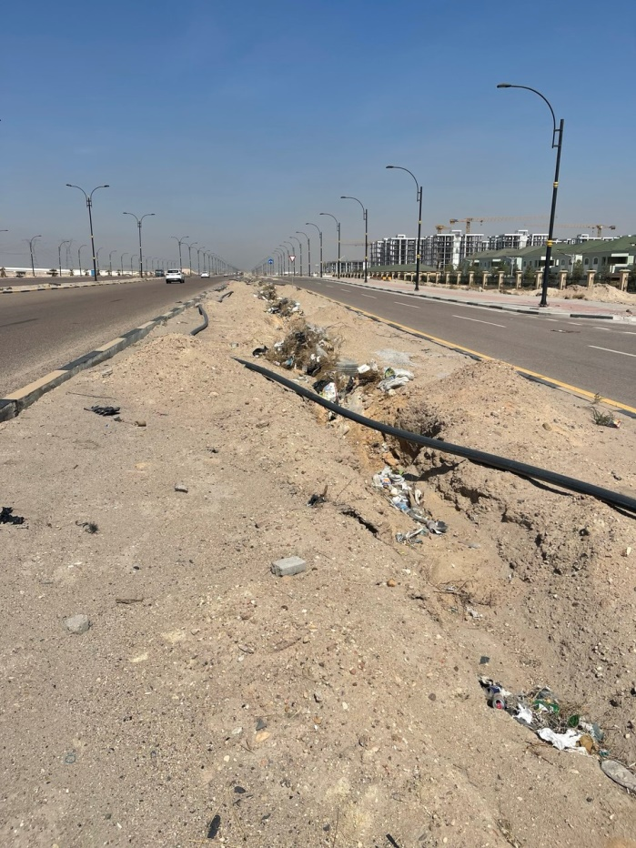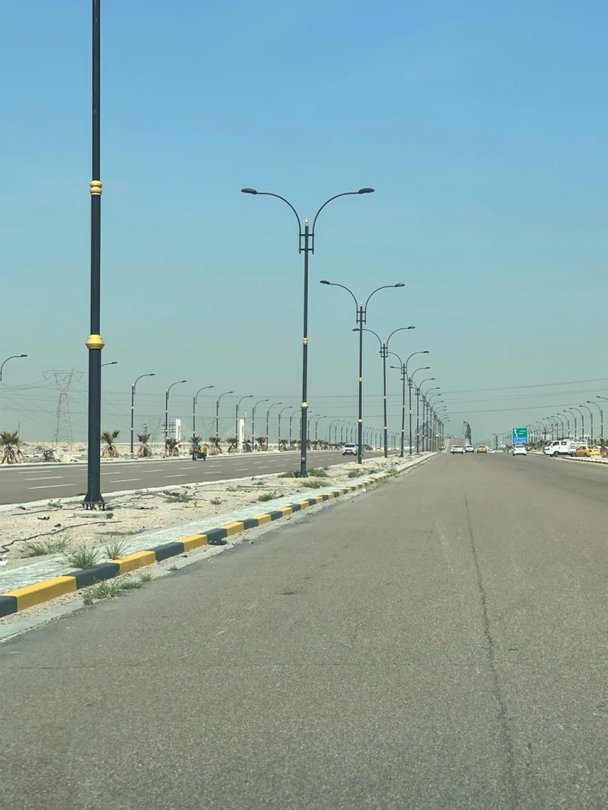

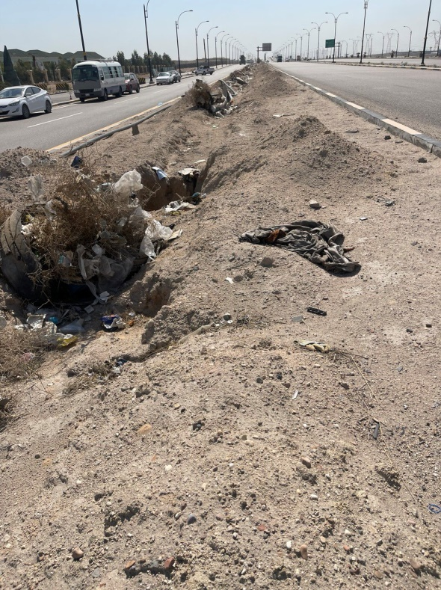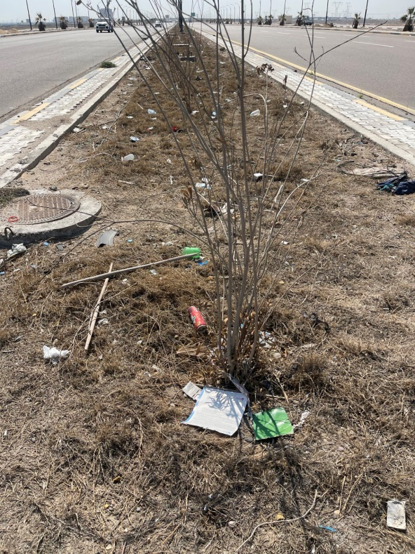

**Figure 2: Images illustrating the current state of the street under study, including the lack of landscaping and clear neglect.**

**Conclusions**

Upgrading outdoor spaces within cities and main streets and transforming them into spaces that meet the needs and desires of their users requires the provision of design elements and components, both natural and artificial, so that designers can achieve the goals and objectives for which they were created through the design of these spaces. Through the study, we conclude the following:

1- The current green spaces are insufficient, in addition to the lack of attention to the design aspects of existing green spaces, whether in the median strip or along the street approaches, which has negatively impacted the use of these spaces by users.

2- Despite the lack of attention to the site and its lack of most design components, whether natural or artificial, this calls for greater attention to the design aspect of outdoor spaces, given their positive impact on their users.

3- The necessity of working to provide the water element in some form, as highlighting water features was important to site users due to their aesthetic and environmental role, such as the use of fountains.

4- The lack of vegetation cover led to a lack of plant diversity, including trees, shrubs, green spaces, and flowers, which would enhance the aesthetic, environmental, and functional color effects. This would positively reflect on increasing the efficiency of outdoor spaces.

5- The lack of attention to green spaces, for several reasons, played a major role in their deterioration and the emergence of empty spaces within the site.

6- There was no clear focus on selecting and planting evergreen trees, as natural elements that increase shade and reduce the environmental impacts of Basra's hot climate.

7- The desire of site garden users to incorporate color and visual diversity into the site's outdoor spaces through the sight and presence of a variety of perennial and seasonal flowers.

8- The lack of irrigation water sources, with existing plants being watered by watering tank trucks.

9. The lack of aesthetic appeal of the lampposts, their apparent neglect, and the disappearance of existing ones, despite their small number.

10. The percentage of afforestation and vegetation cover at the study site was unsatisfactory, reaching 57.2%. It was even limited to the planting of very limited tree species, such as Washingtonia.

**Recommendations**

This study is a specialized study of Airport Street (Abdullah Aweez), one of the newly constructed main streets in Basra Province . After completing its findings, and in order to improve the design aspect of the outdoor spaces of the study site in particular, the study presents a set of recommendations:

1. To ensure the coordination of outdoor spaces within cities and main streets, emphasis must be placed on including their natural and artificial components to complete the engineering drawing of the outdoor spaces.

2. The need to emphasize the study of environmental conditions and work to integrate them with the concepts the designer presents in his design proposals, including the natural and artificial components of the gardens.

3. Advocating for "forest-based" planting, focusing primarily on trees.

4. Diversifying the selection of plants in gardens and not limiting them to one or two species, while taking into account the local environmental conditions of Basra.

5. Incorporating the water element into the design, given its aesthetic and environmental roles, whether through the creation of water basins, canals, or fountains.

6. Paying attention to irrigation methods and establishing a fixed irrigation system, avoiding reliance on watering tanks.

7. Working to provide rest areas along the road, including shaded seating, due to their positive impacts on both the users of these spaces and the environmental aspect, and working to reduce, even if relatively, environmental extremism.

8. Emphasizing the need to ensure the sustainability and maintenance of these spaces, including medians and street approaches, throughout the day, week, month, and agricultural season, to ensure the continued achievement of these green spaces' objectives at all times.

9- Raise awareness of the need to plant trees in cities and main streets, in accordance with established tree planting regulations and standards.

10- The concept of sustainability can be achieved by utilizing green and water features, shading elements, and local and recycled materials in furnishings. Also, use solar energy and energy-saving lamps for lighting, and design them in an elevated manner to create open viewing angles.

**COMPETING INTERESTS DISCLAIMER:**

Authors have declared that they have no known competing financial interests OR non-financial interests OR personal relationships that could have appeared to influence the work reported in this paper.

Disclaimer (Artificial intelligence)

Author(s) hereby declare that NO generative AI technologies such as Large Language Models (ChatGPT, COPILOT, etc.) and text-to-image generators have been used during the writing or editing of this manuscript.

**References**

Abawi, R.F. N. (2008). *The Role of the Fourth Dimension in Achieving Sensory Pleasure in Outdoor Spaces - An Analytical Study of Design Characteristics*. PhD Thesis, Department of Architecture, University of Technology, Iraq. https://ae.uotechnology.edu.iq/index.php/ar/108-2016-06-22-09-18-59

Al-Anbari, M. A. & Muhammad, L.T. & Al-Araji,I.Z.( 2014). Evaluation of the Green Reality of Hillah City and the Required Greening Policies. *Journal of Geographical Research* (20): 147-208. https://journal.uokufa.edu.iq/index.php/kjg/article/view/6923

Al-Qaiei, T. M. (2007). *Garden Design and Coordination,* Maaref Printing and Publishing House, Alexandria, Arab Republic of Egypt. https://www.agro-lib.site/2020/04/blog-post_485.html

Amr, E. M. (2018). *A Study of Green Spaces in Master Plans*, Master's Thesis in Geography, Beirut University, Palestine. https://search.emarefa.net/ar/detail/BIM-836667.

Hanzel, Z. A.,( 2023). *Design of Outdoor Spaces for the College of Agriculture*, University of Basra. PhD Thesis, College of Agriculture, University of Basra. https://iqdr.iq/search?q=&field=0&type=reg&filter=S8b11844d720ge22b_S89c84ed0b3f0c4bc%2CS31e8a82948b889af_S432ebf32d3319f355839%2CSfcf4f5b9d6ae1aa4_S2c5c36ac65f74

Joy, M.S.; Jha, P.; Yadav, P.K.; Bansal,T.; Rawat,P.; Begam,S. (2024). Site suitability analysis of urban green parks in Ranchi city using GIS–AHP based multi-criteria decision analysis. Urbanization, Sustainability and Society journal 1(1):169-198. https://www.emerald.com/insight/2976-8993.htm**.**

Okonkwo , U.U.; Babatunde,E.T.; Onuche,P.U.;  Francis,M.F.; Osazuwa,P.; Ogungbemi, O.S.( 2025). Transforming the Urban Environmental Aesthetics of the Nigerian City through the Introduction of Advanced GeoAI Technologies: Issues and Challenges. Journal of Geography, Environment and Earth Science International 29 (5):110-24. https://doi.org/10.9734/jgeesi/2025/v29i5897.

Qaddouri ,B., Fatima Z. & Bakhta ( 2021). *The Legal System of Green Spaces in Algeria*, Master's Thesis, Faculty of Law and Political Science, Ibn Khaldoun University, Algeria. http://dspace.univ-tiaret.dz/handle/123456789/2890.

Saudi Geographical Society. (2010). *Geographical Standards for Green Spaces and Gardens and Their Design Systems in Arab Cities. Regulations and Requirements*. Ministry of Municipal and Rural Affairs. Kingdom of Saudi Arabia.

Shura, G. (2016). *Garden Design and Coordination*. Damascus University Publications, Faculty of Agriculture. Syrian Arab Republic. http://ebook.damascusuniversity.edu.sy/agri/Garden-design.pdf