**Evaluation of Petrophysical and Geomechanical analysis of Subsurface Geological information for Sustainable Groundwater and Engineering development in parts of Anaocha Local Government, Anambra State,** **Nigeria**

**ABSTRACT**

A well log is the recording of the measurement of a geophysical parameter plotted continuously against depth in the well bore. It is used to identify and correlate underground rocks, determine their lithology, generate their physical properties and the nature of the fluids they contain. The study aimed to conduct a geophysical evaluation of geologic formations for sustainable groundwater and engineering development. Electrical resistivity logging was carried out on the existing wells at Anoacha to evaluate the geological formation of the subsurface and well efficiency. The study area is positioned within the geographical coordinates of 6° 12' 25''N latitude and 7° 04' 04''E longitude. In the study area Aguluzibo location showed resistivity range from top to 40 m sandstone, 40 m – 60 m shaly sand and 60 m – 180 m is sandstone, the resistivity signal became irregular in ranges at the depth of 162 m – 180 m, this reflects the negative deflection of Spontaneous Potential (SP) long. At Awkaeze location, the lithology from the resistivity log revealed shaly sandstone at a depth of 50 m, sandstone at 50 m – 135 m, shale at a depth range of 135 m – 152 m and at terminal depth 152 m – 204 m of the drilled well is sandstone. In this location, the SP log shale baseline showed at two occurrences beds of 20 m – 75 m and 135 m – 204 m, respectively. The existing well at the Amatutu Agulu location revealed irregular deflection of SP long. The range of negative and positive deflection depicts the presence of salinity, and the resistivity value shows the predominant formation of shaly sand and sandstone. The results revealed the geological constituents of the study area. For the shaly sandstone reservoir, the presence of both top and bottom seals, along with the resistivity characteristics, helps in identifying it as a potential reservoir zone. However, the infrastructural and structural integrity concerns due to the presence of shale and the variation in resistivity with depth necessitate careful planning and advanced engineering solutions to ensure successful development and production.

**Key Words:** Logging, Resistivity, Shale Baseline and Cutting Sampling.

1. **INTRODUCTION**

“As the most sizable and accessible freshwater resource on Earth, groundwater is fundamentally important to safeguarding human health, economic development, and ecosystem services. This is particularly true considering that society is demanding an exponentially increasing amount of clean water, scilicet, water good enough for drinking, municipal use, and irrigation” (Xie et al., 2023). “A well log is the recording of the measurement of a geophysical parameter plotted continuously against depth in the well bore” (Rider, 1996). “It is used to identify and correlate underground rocks, determine their lithology, generate their physical properties and the nature of the fluids they contain. Well logging technology primarily utilises the geological and physical properties of rock formations, such as electrical conductivity, electrochemical properties, acoustic properties, and radioactivity, to measure their parameters” (Sui, 2025). “The continuous recordings of geophysical parameters (acoustic, electrical and nuclear properties) along the borehole produce geophysical well logs” (Lai et al., 2024). “Geological sampling during drilling (‘cutting sampling’) leaves a very imprecise record of the formations encountered. Likewise, entire formation samples can be brought to the surface by mechanical coring, but this is both slow and expensive” (Rider, 1996). “Even though geophysical logs need interpretation to bring it to the level of geological or petrophysical experience, the strong points are in the precision and ability to bridge the gap between well cuttings and core samples. Many different modern geophysical well logs exist. The most popular among others are wireline geophysical well logs. They are made using highly specialised equipment entirely separate from that used for drilling. They can be run as ‘open-hole ‘logs immediately after drilling and before casing, or as MWD (Measurement While Drilling) and LWD (Logging While Drilling) logs, simultaneously as the formation is drilled. MWD are usually run to determine the deviation of a directional well, and LWD to reduce costs as they will refer to log-type measurements such as resistivity, density and so on” (Rider, 1996). “To run ‘open-hole’ wireline logs, the hole is cleaned and stabilised, and the drilling equipment is extracted. The first logging tool is attached to the logging cable (wireline) and lowered into the hole to the maximum drilled depth. Most of the logs are run while pulling the tool up from the bottom of the hole and sampling the formation once every 15cm” (Rider, 1996). Necessary geophysical measurements are obtained to allow a quantitative evaluation of hydrocarbon in place. Therefore, it is imperative to get accurate, well-calibrated and complete data. Therefore, the study aimed to conduct a geophysical evaluation of geologic formations for sustainable groundwater and engineering development.

1. **STUDY AREA**

Anaocha covered an approximate land area of 171.62 km². Anaocha is a Local Government Area (LGA) in Anambra State, Southeast Nigeria. Anambra Basin is a sedimentary basin formed during the Late Cretaceous to Paleogene period (Onyenweife et al. 2024).  The area's geology is characterised by sandstone, shale, and clayey sand. The fig. 1 below represents the drainage map of Anaocha. Anaocha is positioned within the geographical coordinates of 6° 12' 25''N latitude and 7° 04' 04''E longitude, bordering Dunukofia to the north, Njikoka to the west, and Awka North to the southwest (Onyenweife et al. 2024).

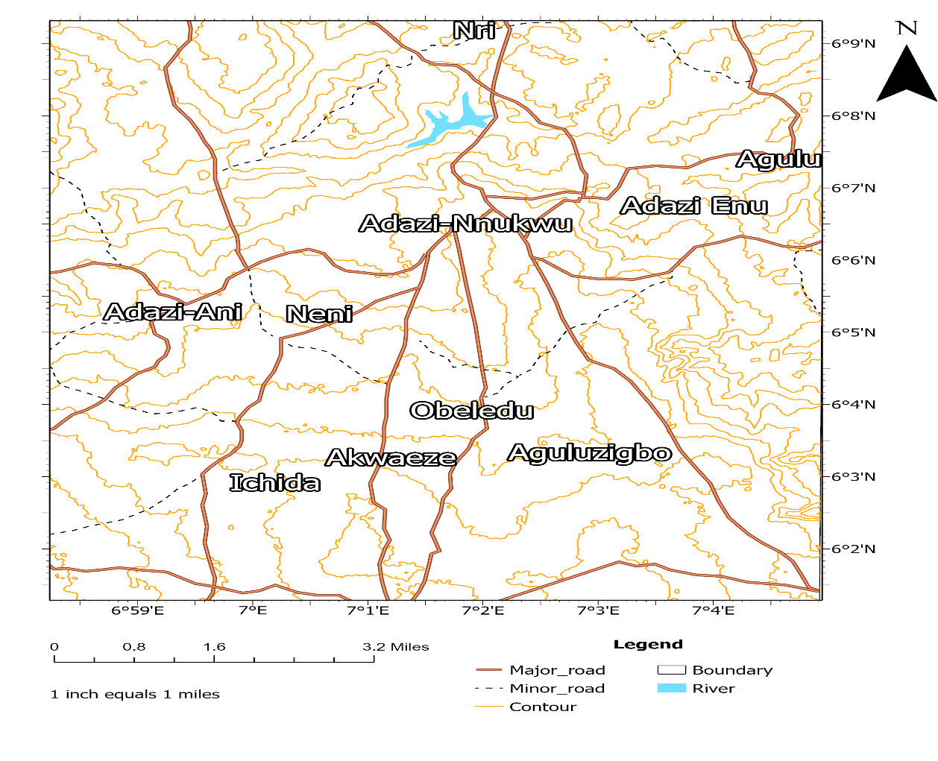

* **Study Locations**

**Fig. 1: Arc. GIS map showing the drainage pattern of Anaocha and the study locations (Onyenweife et al. 2024).**

1. **METHODOLOGY**

Resistivity and Spontaneous Potential (SP) Logging were conducted on three (3) locations of existing borehole wells in the study area, which involved the lowering of ABEM SAS 200 Logger Sonde Probe to the subsurface drilled terminal depth. The essence of this survey was to determine the depth of groundwater occurrence and evaluate the lithological order for awareness in infrastructural development in the study area. This reduces the records of abortive boreholes and failed infrastructure.

**3.1 Acquisition of well logs**

“Logging is a general term which means to “make a record” of something. Geoscientists use many types of “logging” including core-logging, cuttings-logging, radioactive logging and geophysical well logging. Geophysical well logging was first developed for the petroleum industry by Marcel and Conrad Schlumberger in 1927” (Papp, 2002). Well logs can now measure a large number of physical properties of the geological formation (and the surrounding environment) intersected by a well, and both in open and cased hole conditions. Well logging technology plays a pivotal role in the exploration and production process of hydrocarbon resources. Some of the well logging applications include:

1. Petrophysics and Formation Evaluation;
2. Reservoir Characterisation;
3. Reservoir Management and Production Optimisation;
4. Geology and Geomechanics (the geologic study of the behaviour of soil and rock); and
5. Geosteering (in the process of drilling a borehole, geosteering is the act of adjusting the borehole position, i.e., inclination and azimuth angles, to reach one or more geological targets), etc.

The different log types are explained below, and the relevant logs to this research are Resistivity and Spontaneous Potential Logs.

**3.2 Gamma ray log**

“The simplest radioactive method in geophysical well logging is the natural gamma log. These logging tools record the level of naturally occurring gamma ray emissions from the rocks around a borehole. The simplest of these types of tools records only the total gamma ray signal. This signal is comprised essentially of gamma ray emissions at different energy levels from the radioactive isotopes of the elements potassium (40 K), Thorium (232 Th) and Uranium (238 U) and the daughter products in the decay series of each” (Papp, 2002). Logging of the gamma ray signal emanating from the rocks around a borehole can provide considerable information about the geology and the processes that have operated. Papp (2002) elucidated that “in sedimentary rock sequences, relatively high natural gamma counts are recorded in shales and other clay-rich sediments and relatively low counts are recorded in clean quartz sandstones and limestones. The high signals observed in clay-rich sediments are largely due to the affinity of clay minerals for potassium. However, many regolith clays are leached and do not contain a substantial amount of potassium. Therefore, this interpretation is not always applicable to regolith units. Gamma Ray log can be run in both open and cased hole, and it gives a reflection of shale or clay content or, better still lithology indicator within a formation, correlation between wells, determination of bed boundaries, mineral analysis, etc”.

* 1. **Neutron porosity log**

According to Papp (2002), “neutron porosity logging uses an active neutron source to emit neutrons into the rocks around a borehole. Because free neutrons are almost unknown on Earth, the flux of neutrons subsequently recorded at the detector in the tool can be used as an indicator of the condition of the surrounding rocks. The neutrons entering the rocks of the borehole wall from the tool are at high energy and generally have great penetrating power. The exception is when significant concentrations of hydrogen exist. In this case, the neutrons rapidly lose energy due to collisions with the hydrogen nuclei and become what are known as “thermal neutrons”. These thermal neutrons behave in many respects like a diffusing gas and form a spherical shell around the source in the probe. The radius of this sphere will depend primarily on the concentration of hydrogen in the environment around the probe. Because the technique is sensitive to lithological differences, neutron porosity logs can be very useful in cross plots with other log data to help determine lithology. The parameter of interest obtained from the Neutron Log is Porosity”.

**3.4 Density log**

The formation density log is a porosity log that measures electron density of a formation (Yilmaz, 2001). Dense formations absorb many gamma rays, while low-density formations absorb fewer. Thus, high count rates at the detectors indicate low-density formations, whereas low count rates at the detectors indicate high-density formations. Therefore, scattered gamma rays reaching the detector are an indication of formation density, which in turn is related to the porosity and grain density.

**3.5 Sonic log**

As explicitly explained and illustrated by Schlumberger (1972), sonic tools work by transmitting a sound (i.e. waves) through the rocks of the borehole wall. A basic sonic tool generally consists of two modules, one with the transmitter and the other containing two or more receivers. The two parts are separated by a rubber connector to reduce the amount of direct transmission of acoustic energy along the tool from the transmitter to the receiver. The transmitter injects a sinusoidal wave-train of acoustic energy into the formation. The detectors subsequently receive a complex signal because of the multiplicity of ray paths that the wave-train can take through the formation. The fastest arrival (in uncased holes) will generally be through the rocks near the borehole wall. Detection of this signal uses a signal processing algorithm involving cross-correlation between the original wave train generated by the transmitter and the coda (closing section) received by the detectors. In practice, sonic logging actually measures the “time of flight” along the fastest signal path. Because this time of flight is dependent on the density of the medium, it can be used to calculate the average density of the rocks through which the signal passed.

Acoustic tools measure the speed of sound waves in subsurface formations. While the acoustic log can be used to determine porosity in consolidated formations, it is also valuable in other applications, such as: indicating lithology (using the ratio of compressional velocity over shear velocity), determining integrated travel time (an important tool for seismic/wellbore correlation), correlation with other wells, detecting fractures and evaluating secondary porosity, evaluating cement bonds between casing, and formation, detecting over-pressure, determining mechanical properties (in combination with the density log), and determining acoustic impedance (in combination with the density log).

Sonic logging tools were initially developed for the petroleum industry as porosity measuring devices, and they have a similar use in regolith (a layer of loose rock resting on bedrock and covering most of the earth's land surface). In hard rock environments, where porosities are generally low, sonic logs can be very useful lithological probes. A very important use of sonic logs is for the correction of interval velocities used in seismic processing and interpretation. This leads to better velocity models for seismic processing and analysis.

**3.6 Resistivity log**

“Resistivity logging measures the electrical resistance of the formation to the flow of current. If a material containing unbound charged particles is subjected to a voltage difference, then an electrical current will flow. The impedance to this flow is called the electrical resistance, and it is a function of the geometry of the current flow and the intrinsic resistivity of the material” (Papp, 2002). “In other words, resistivity measures the electrical properties of the formation, and it is the inverse of conductivity. The ability to conduct electric current depends on the volume of water, temperature and salinity of the formation. Some materials, such as quartz and muscovite, have high resistivity, while others have more moderate values (e.g., sand), and for some, the resistivity is low, e.g. clay, saline groundwater” (Yilmaz, 2001).

The factors that affect the resistivity of a formation include resistivity of water, porosity of the formation, pore geometry (tortuosity), lithology of the formation, degree of cementation, and type and amount of clay in the rock. This resistivity log is used to determine the hydrocarbon versus water-bearing zones, indicate permeable zones and determine resistivity porosity. From the resistivity log, values for formation resistivity are obtained and, in turn, are related to the water saturation.the resistivity of the rock is measured using a four-electrode array, analogous to DC resistivity surveys at the ground surface. A constant current is introduced into the rock between two current electrodes in the logging tool. The potential measured between two other electrodes (potential electrodes) is proportional to the electrical resistivity of the rock. Water is a better conductor of electricity. The first electrode sends electric current into the fluid–filled formation, and the current flows back to the second electrode located at the other end of the tool, forming an electric circuit. Depending on the conductivity of the formation fluid, the intensity of the current varies as the tool is slowly pulled toward the surface. The tools used for conventional resistivity logging have the following lengths (current electrode spacing): short normal (L= 10 cm – 50 cm), long normal (L = 50 cm – 200 cm), 16 inch normal (L = 40 cm) and 64 inch normal (L = 160 cm) respectively. The measured value is called the apparent resistivity and is dependent on the size of the borehole, the adjacent rock and the overlying and underlying rock. The true resistivities of the rock can be derived from the apparent resistivities using master curves. The measured resistivity logs are symmetric. Use to measure the resistivity of the formation. A rock which contains an oil and/or gas saturation will have a higher resistivity than the same rock which completely saturated with formation water.

**3.7 Self-potential (SP)**

This measures natural electrical potential differences between the formation and the borehole fluid. It helps in identifying permeable formations and determining the direction of fluid movement. This natural potential is caused by electrochemical processes occurring between different fluids (the drilling fluid and the groundwater). A prerequisite for an interpretable SP log is a distinct difference between the resistivities of the drilling fluid and the formation pore water, together with an alternating sand /clay sequence with a distinct difference between the potentials of the sand and clay layers. Self-potential (SP) is one of the earliest logging tools in the industry. The self-potential (SP) is used to measure the potential difference between the borehole and the surface by lowering an electrode into the borehole and measuring the difference in potential with a reference electrode at the surface. As a permeable formation is encountered by the tool, noticeable deflection in electrochemical potential occurs, which is dependent upon the clay content of the formation and water salinity. Self-Potential (SP) is commonly used to detect permeable beds and their thickness. Locating their boundaries and permitting correlation of such beds. Determining formation water resistivity and qualitative indication of bed shaliness.

1. **RESULTS & DISCUSSION**

In petrophysical analysis, the SP and Resistivity logs are essential in distinguishing between different rock formations, primarily shale and sandstone.

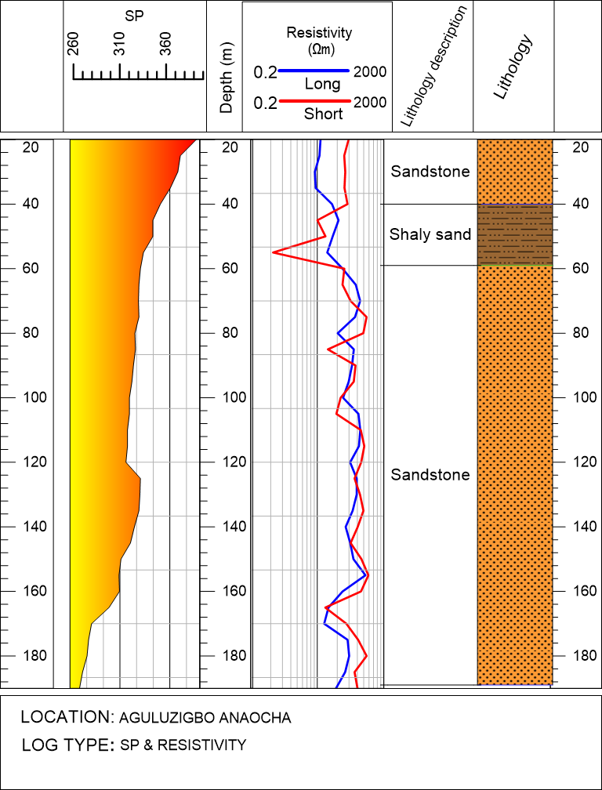

**Reservoir zone**

**Reservoir zone?**

**Shale Baseline**

**Fig. 2: SP and Resistivity plot of Aguluzibo, Anaocha LGA**

In Fig. 2, two zones appear to be of interest among the three lithological layers in the resistivity plot. The SP curve typically forms a straight line, being the baseline from 50 m depth – 120 m depth. Then a deviation (deflections) tends to range from 120m to 170 m before it reaches a constant level. On the right-hand side is the resistivity log with lithology defined from the ranging signature. The resistivity log indicates a lowering of ABEM SAS 200 Longer Sonde to the depth of 180 m -190 meters and continued to 190 m where the probe stopped. This further supports the interpretation from the SP log. The short resistivity track likely represents the resistivity of the invaded zone, while the long resistivity track indicates the uninvaded zone. The observation from the resistivity of this location revealed the sandstone unit of 40 m with a suspicion of fluid at a decrease in resistivity of the underlying shale volume from 40 m – 58 m as the formation deflected to the left. At a depth of 58 m is a discontinuous deviation of short and long, slightly increased resistivity signature sandstone, which is termed a reservoir zone. It is of interest to infer that the depth of the water-bearing zone should be recommended at 120 m. It is wise that this well should be drilled further to a depth of 213.4. This is to ensure that there are enough water columns to supply the population.

**Infrastructure and Structural Integrity**

The long interval of sandstone layers recognised in this location posed it can affect the overall infrastructural integrity. This is because the formation tends to be more prone to erosion or collapse. The lenses of shale identified at the shaly sand interval do not contribute much to enhancing cementation and compaction of the formation.

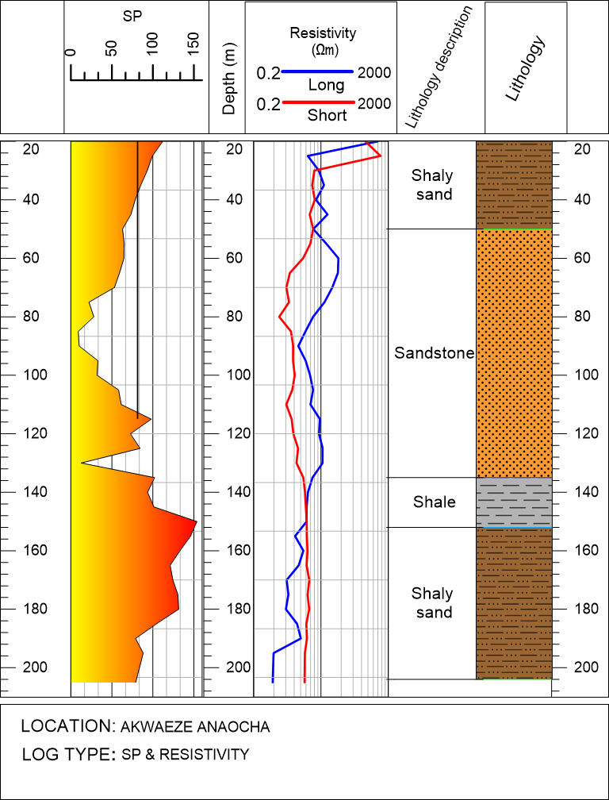

**Reservoir zone**

**Reservoir zone?**

**Shale Baseline**

**Fig. 3: SP and Resistivity plot of Akwaeze, Anaocha LGA**

Fig. 3, SP and Resistivity Logs ofAkwaeze location, Anocha Local government. From the SP log, noticed an increase from 20 m to 70 m, which is an impermeable layer, then a lowering of SP which discontinued at 100 m depth. At 70 m-100 m, the deflection indicates a zone of salty fluid and an abrupt depletion of lower SP at 130 m (permeable zone of high salinity). There is a variation of increase in SP from 130 m – 194 m (impermeable zone). The petrophysical information from the SP log is been supported with the resistivity log. There was a lowering of the Longer Sonde to a depth of 194 m, where the borehole was terminated. The formation of the short and long resistivity signature revealed four layers composed of shaly sand, sandstone, shale and shaly sand. The zone with relatively lower resistance indicates the saturation zone. In the location above, the saturation began at a depth of 155 m. The zone with a seal above is observed to be a better reservoir. It is recommended that at the screening of this well, the casing should be lowered between 170 m (560 ft) – 195 m (640 ft) for accuracy assurance in supply.

**Infrastructure and Structural Integrity**

The composition of lithologies in the figure above posed an interest in infrastructural integrity. There is a balance of sandstone zone and shale/shaly sand zones, which indicates a better zone of infrastructural development. Except in the case of recognised salinity in the zone of interest, which triggers fracture in the formation and is a pointer for erosion in that location, such that buildings sited in that area need better engineering.

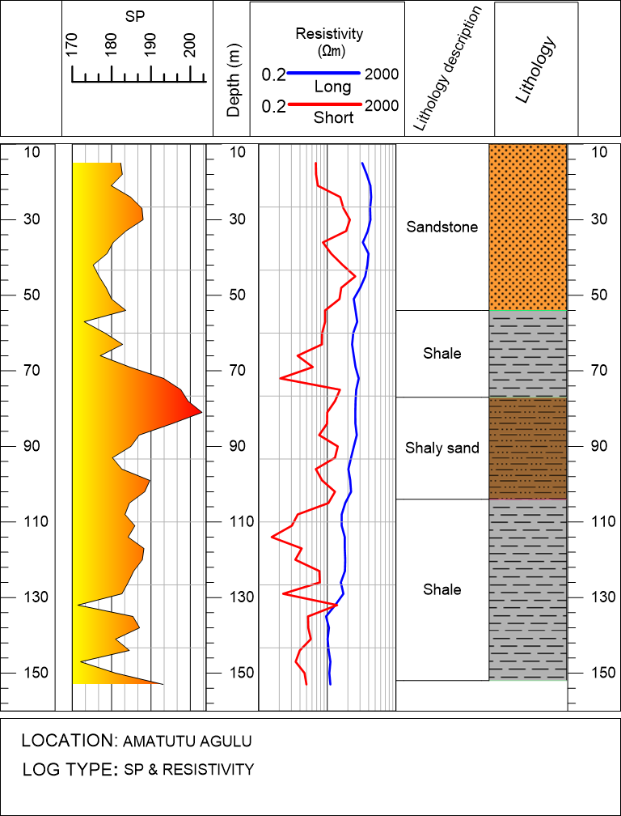

**Reservoir zone**

**Reservoir zone?**

**Shale Baseline**

**Fig. 4: SP and Resistivity plot of Amatutu Agulu, Anaocha LGA**

The SP log is instrumental for petrophysicists in distinguishing between different rock formations, primarily shale and sandstone. In Figure 4, two zones appear to be of interest. The SP curve typically forms a straight line opposite shale, referred to as the shale baseline. Opposite permeable formations, the curve shows deviations from this baseline; in thick beds, these deviations (deflections) tend to reach a constant level, defining a sand line. The lithology log further supports the interpretation from the SP log.

The deflection observed indicates that the formation water salinity is lower than the mud filtrate salinity, as evidenced by the deflection to the right in both zones of interest. This suggests that the resistivity of formation water in the region is low due to the high salinity inferred from the SP signature.

The shaly sand interval is identified as the reservoir zone because it has both top and bottom seals (shale zone), essential for a reservoir. The sandstone at the top zone could potentially be a reservoir, but the lack of an established top seal and the fact that it is at a shallow depth make this uncertain. In contrast, for the shaly sandstone reservoir, the resistivity is slightly lower and very close to the short resistivity, indicating that this zone could be water-bearing (maybe brackish water due to the relatively high resistivity).

1. **CONCLUSION**

A general rule of thumb is that as resistivity increases, so does compaction, making such areas suitable for engineering structures. However, in the Amatutu Agulu location, resistivity generally decreases with depth, indicating that structural integrity may be compromised by the shale and permeable shaly sand zones in the formation.

* Compaction and Integrity: The decreasing resistivity with depth suggests lower compaction, which might impact the suitability for erecting engineering structures.
* Infrastructure Planning: Special attention should be given to foundation design and other structural engineering aspects due to the potential for lower structural integrity in the shaly zones.
* Geomechanical Analysis: Conducting a geomechanical analysis is crucial to assess the stress regimes and potential for ground subsidence or instability.

The SP log in this study, complemented by resistivity logs, provides crucial insights into the formation's lithology and fluid content. For the shaly sandstone reservoir, the presence of both top and bottom seals, along with the resistivity characteristics, helps in identifying it as a potential reservoir zone. However, the infrastructural and structural integrity concerns due to the presence of shale and the variation in resistivity with depth necessitate careful planning and advanced engineering solutions to ensure successful development and production.

Disclaimer (Artificial intelligence)

Option 1:

Author(s) hereby declare that NO generative AI technologies such as Large Language Models (ChatGPT, COPILOT, etc.) and text-to-image generators have been used during the writing or editing of this manuscript.

Option 2:

Author(s) hereby declare that generative AI technologies such as Large Language Models, etc. have been used during the writing or editing of manuscripts. This explanation will include the name, version, model, and source of the generative AI technology and as well as all input prompts provided to the generative AI technology

Details of the AI usage are given below:

1.

2.

3.

**REFERENCES**

Akpoborie, I. A. (2011). Groundwater conditions in the mangrove swamps of the Western Niger 14.

Delta: Case study of Ughoton area, Delta State, Nigeria. Journal of Environmental Hydrology, 20:1 –5.

Corriols, M. and Dahlin, T. (2008). Geophysical characteristics of the leon-chinandega Aquifer.

Hydrogeology Journal, 16 (2): 355 - 387.

Croft, M.G. (1971). A method of calculating permeability from electrical logs, in geological

survey research, US Geol. Surv. Prof. Pap., 750-B: B265-B269.

Egboka, B. C. E., & Nwankwo, E. A. (2015). Hydrogeological Characteristics and Groundwater

Quality Assessment of the Ogbaru Wetlands, Anambra State, Nigeria. International Soil and Water Conservation Research, 3(4): 213-223.

Ehirim, C.N. and Ebeniro, J.O. (2010). Evaluation of aquifer characteristics and groundwater

potentials in Awka, South East Nigeria, using vertical electrical sounding. Asian Journal of Earth Sciences 3 (2), 7381.

Ekwe, A.C., Nnodu, I.N., Ugwumbah, K.I. and Onwuka, O.S. (2010). Estimation of aquifer

Hydraulic characteristics of low permeability formation from geosounding data: a case study of Oduma town, Enugu State. Online journal of earth sciences, 41 (1): 19-26.

Emenike, E.A. (2001). Geophysical Exploration for Groundwater in a Sedimentary Environment. A case study from Nanka over Nanka Formation in Anambra Basin, southeastern Nigeria. Global Journal of Pure and Applied Sciences, 7: 7-110.

Evamy, B.D., Haremboure, J., Kamerling, P., Knaap, W.A., Molloy, F.A., and Rowlands, P.H. (1978). Hydrocarbon habitat of Tertiary Niger Delta: American Association of Petroleum Geologists Bulletin, 62: 1-39.

Eze, C.C. (2012). Hydro-geophysical studies for the delineation of potential groundwater

zones in Enugu State, Nigeria. Int Res J Geol Min, 2 (5): 103-112.

Ezenwaji, E.E. (2013). The relative contributions of climatic elements and environmental factors

to flooding in Awka urban area. Afr. J. Environ. Sci. Technol, 7 (8): 666 – 766.

Ezenwaji, E.E, Phil-Eze, P.O., Otti V.I. and Eduputa B.M (2013). Household water demand in

the peri-urban communities of Awka, Capital of Anambra State, Nigeria. JGRP, 6 (6): 237–243.

Fatoba, J.O., Omolayo, S.D. and Adigun, E.O. (2014). Using geo-electric soundings for estimation

of hydraulic characteristics of aquifers in coastal area of Lagos, southwestern Nigeria. International Letters of Natural Sciences; 6:30-39.

Garland, G. (2007). Geology of the Carolinas and Georgia. In The teacher-friendly guide to the

geology of the southeastern U.S. 13-14.

Gebrehiwot, A.B., Tadesse, N. and Jigar, E. (2011). Application of water quality index to assess

Suitability of groundwater quality for drinking purposes in Hantebet watershed, Tigray, Northern Ethiopia. ISABB J Food Agric Sci., 1 (1): 22–30.

George, N., Obianwu, V. and Udofia, K. (2011). Estimation of aquifer hydraulic parameters via

complimentary surficial geophysical measurement by laboratory measurements on the aquifer core samples. Int. Rev Phys., 5 (2): 88-96.

Griffiths D.H and Ring F. (1981). Theory of Electrical Resistivity Surveying Practical and

Applications in Resistivity Surveying for Geologist and Engineers. Pergamon Press, 2:70 -111.

Ibekwe, A.M. and Anyaduba, J.C. (2015). Hydrological Processes in changing Climate and land.

Journal of Water and Land Development, 24 (1): 1 – 10.

Igwe, P. C. and Orji, E. C. (2019). Gully erosion in southeastern Nigeria: The roles of geology,

geotechnical properties, and land use. Environmental Systems Research, 8 (1): 1-11.

Keys, W. S. (1990). Borehole geophysics applied to groundwater investigation, United States

Geological Survey techniques of water resource investigation, Techniques of Water Resources Investigations, 150.

Kelly, W.E. (1977). Geoelectrical sounding for estimating aquifer hydraulic conductivity.

Groundwater, 15 (4): 420-424.

Keller, G.V. and Frischnechk, F.C. (1979). Electrical Methods in Geophysical Prospecting. Program

Press: New York, 91-135.

Kearey, P. and Brooks, M. (2002). An introduction to geophysical exploration. 3rd Edition,

Blackwell Scientific Publications, London, 257.

Khan, N. A. and Ahmed, K. M. (2020). Groundwater vulnerability assessment and its sustainable

management in Pakistan. Environmental Earth Sciences, 79 (20): 1-22.

Lenkey, L., Hamori, Z. and Mihalffy, P. (2005). Investigating the hydrogeology of a water-supply

area using direct current vertial electrical sounding. Geophysics, 70: 1-19.

Mabey, D.R. (1990). Application of surface Geophysics to groundwater investigation. USGS

publications. 4th Edition. 116.

Milson, J. (2003). Field geophysics – the geological field guide series, 3rdedition. John Wiley &

Sons Ltd West Sussex England, 109 - 232.

Misstear, B. D., Banks, D. and Clark, L. (2021). Groundwater Management: Optimizing

Sustainability. Annual Review of Environment and Resources, 46: 245-273.

Muoghalu, L.N. and Okonkwo, A.O. (1998). Drainage of Awka and environs. Atmospheric

and Climate Sciences, 4 (4): 69 – 80.

Onyenweife, G. I., Nwozor, K. K., Onuba, L.N., Mgbolu C. C., Omezi I. and Okoronkwo U. E.

(2024) Subsurface Investigation for Infrastructural Development in Anaocha, Anambra State Southeast Nigeria, Using Electrical Resistivity Method. *International Journal of Innovative Scientific & Engineering Technologies Research 12(4):9-25,* DOI:10.5281/zenodo.13988698.

Rider, M. (1996) the Geological Interpretation of Well Logs. 2nd Edition, Rider-French Consulting Ltd Sucherland.

Xie, X., Shi, J., Pi, K., Deng, Y., Yan, B., Tong, L., ... & Jiang, G. (2023). Groundwater quality and public health. *Annual Review of Environment and Resources*, *48*(1), 395-418.

Sui, Y. (2025). The application of well logging technology in stratigraphic deposition. *Advances in Engineering Research : Possibilities and Challenges, 1*(1)*,* 137-151.

Lai, J., Su, Y., Xiao, L., Zhao, F., Bai, T., Li, Y., ... & Qin, Z. (2024). Application of geophysical well logs in solving geologic issues: Past, present and future prospect. Geoscience Frontiers, 15(3), 101779.