Value addition through malting: Development of legume-based soup premix

***Abstract*— Legumes are seed belonging to *Leguminosae* family who are often underappreciated and not utilized to their full potential. They are a rich source of proteins, dietary fibers and micronutrients who traditionally been consumed in form of soup and curries. They have multiple health benefits and assist in prevention of diseases. Process like malting enhance the bioavaliabity of these nutrients by eliminating antinutritional factors present. This study was done with an objective to develop a soup premix from legumes whilst increasing its bioavailability of nutrients through the process of malting. Three main legumes included in this are Horse gram (*Macrotyloma uniflorum*), Green gram (*Vigna radiata*), Chickpea (*Cicer arietinum*), are included in the base of soup premix. Horse gram is the most underexplored legume with the potential to sustain in extreme weather conditions and has the ability in treating bile and kidney stones along with other benefits. Chickpea rich in lysine and essential PUFA (linoleic acid) enhance protein quality and helps in protecting against metabolic disorders who enhance protein quality. Green mung of the *Fabaceae* family has low methionine content but have good functional properties like foam stability, water retention and emulsification required in food processing industry. Other additives like Spinach powder, tomato powder, potato starch are incorporated to enhance the flavor and consistency of the soup respectively. Consistent efforts were being made to completely eliminated use of artificial additives and added sugar. Sensory evaluation was carried out using a 9-point hedonic scale and such type of soup premix has thus been developed. The said soup premix has a moisture content of 5.8-6% showing good shelf stability; ash content is 11-13 % representing high amount of minerals and protein content is 15-20% and 60-65% carbohydrate which comes from naturally present sugars in the ingredients**

***Keywords—Legumes, Malting, Soup premix, Horse gram, Green gram***

1. *INTRODUCTION*

Increasing demand towards instant foods in modern population is shifting towards foods with health benefits post covid. These health-conscious consumers prefer for high quality, convenient, shelf-stable and ready-to-use processed food products which also assist in promoting health [1]. Food consisting of an extracted flavorful broth prepare by boiling together meat or vegetables in stock is known as soup. It is often consumed as an appetizer or even recommended as remedy where the patient is advised to consume liquids only. But legume soups take good amount of time in preparation and neither can be stored for a long time due to its perishable nature. Thus, in order to reduce its preparation time and increasing its shelf stability, an effort has been made to develop malted legume soup premix [2].

Legumes belong to *Leguminosae* family, known for the fruits whose seeds, split open when the pods undergo dehiscence. These seeds are often called as pulses, beans, legumes and ranks second after cereals, as one of the important sources of nutrients in the world. Along with high amounts of protein content ranging from 16% to 50%, they are rich in carbohydrates, fats, calcium, iron, thiamine, riboflavin [3]. Legumes have presence of bioactive compounds in a good quantity which has assisted in preventing multiple chronic non-communicable illness like T2DM, CVDs. They also have anti-inflammatory and anti-carcinogenic properties, with low glycemic index (GI) and high fiber content contributing in the human diet for more than 60,000 years [4].

Despite having higher number of advantages, legumes are not used to their full potential as it has flaws who mitigate the benefits. Legume protein is hard-to-digest as well as cooking it is quite a task. The antinutritional compounds (ANFs) in legumes affect the bioavailability of the vitamins and minerals present in seeds. These include phytic acid, lectins, trypsin inhibitors, saponins, goitrogens, etc. These ANFs can be eliminated or reduced to tolerable levels using physical and chemical procedures like soaking, germination, fermentation, malting. These process helps in increasing the protein and starch digestibility rather than altering the protein content [4].

The process of malting is combination of multiple unit operations like steeping, germination and kilning. Malting helps in activation of many metabolic pathways and which initiates the release of phytochemical. This is achieved by altering the physical and chemical structure of grain [3]. The process of soaking legumes in water for prolonged time period in known as steeping, that helps in activation of multiple endogenous components which leach in water. Following steeping is germination where the legumes are stored in humid air along with water till, they sprout. This increases the hydrolytic activity breaking down starch, proteins [5]. Lastly germinated legumes are exposed to hot air around 50℃ to terminate germination, develop color and flavor, often termed as kilning [6].

Each legume is known to have different nutraceuticals present in the who assist in various metabolic activities in human beings [7]. Out of many legumes present following 3 have been chosen for their respective reasons as follows-

Horse gram is a good source of carbohydrate, protein, and energy and is the most underutilized and underexplored legume. The crop has the potential to sustain extreme weather conditions but is neglected due to its negative image as Poor man’s food by the farmers in Punjab. According to traditional medicinal practices its is used as remedial in treating bile and kidney stones, diabetes mellitus and dysuria [7].

Chickpea flour is rich in lysine but has limited methionine, tryptophan and other Sulphur containing amino acids and thus enhances the protein quality when mixed with other cereals. It is rich in fiber and essential fatty PUFA primarily linoleic acid. Compared to wheat flour it has high amount of Phosphorous, potassium and magnesium and other beneficial factors who potentially protect against obesity and other metabolic disorders upon consumption in adequate quantity [8].

Green Mung is a legume belonging to the family *Fabaceae* and contains about 20-30 % of low methionine protein which reduces the protein efficiency ratio due to presence of trypsin inhibitors. Mung beans also contain compounds who assist in reduction in fat accumulation like vitexin, stigmasterol [9]. Mung beans are also used in food processing for its functional properties like water retention, emulsification and foam stability [10].

1. *Materials and methods*
   1. *Market Study*

A market survey was carried out to understand consumer perspective regarding current soup premixes available in the market using Google Forms. The form was circulated among individual with age group ranging from 15 years to 60 years to introspect the kind of soup premix they would prefer. A conclusion was derived from this survey that established soup premix giants in the market has high amounts of sugar present in their premixes along with other additives as compared to the nutritional value they provide. This helped in curating a premix with the benefits of legumes with no added sugar, no artificial additives and thus aligning with consumer needs.

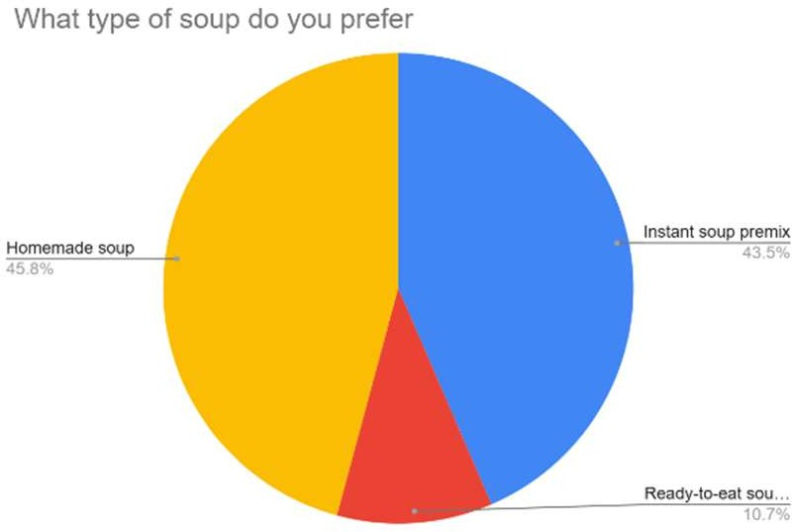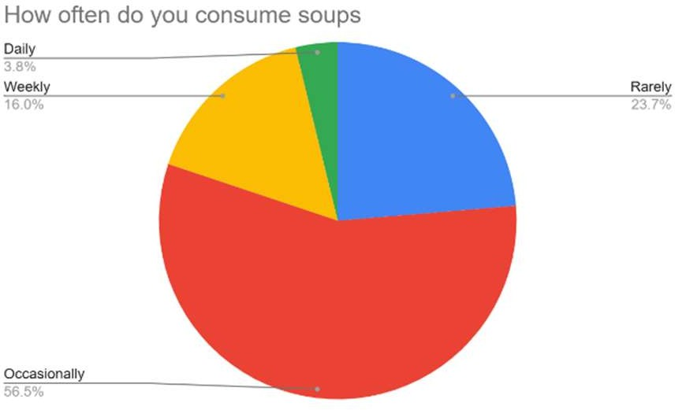

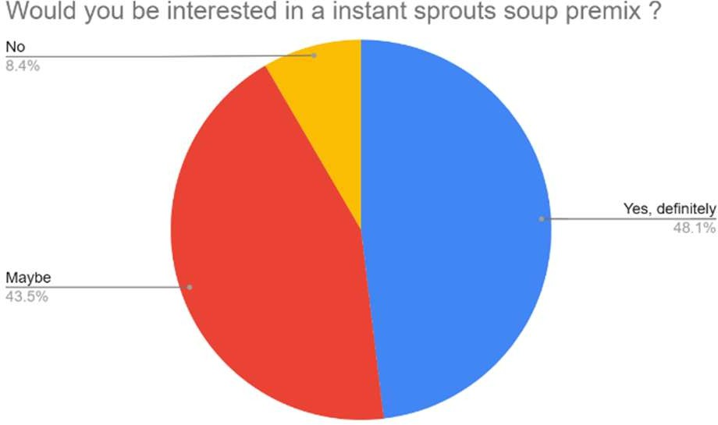

Fig *1. Market Analysis Soup Premix*

* 1. *Raw material procurement*

Selection of core raw materials was done by analyzing the nutritional profile of legumes ,meanwhile different natural thickening agent were also identified by studying their contribution in determining the viscosity of final product. Legumes like horse gram (*Macrotyloma uniflorum*), green gram (*Vigna radiata*), chickpea (*Cicer arietinum*), soy chunks, and vegetables like potato, cabbage, carrot, were procured form local market of Loni Kalbhor, Pune. Other additives like dehydrated spinach powder, tomato powder, and skimmed milk powder were brought from online platform due to its limited availability in local market.

* 1. *Processing of raw material*

Legumes were acquired from Local Market of Loni Kalhor, Pune and were manually sifted to discard the seeds which were damaged and discolored. The good quality legumes were then washed with distilled water to remove dirt and other contaminants, and were kept for steeping in potable water at 28℃ at relative humidity of 32 % for 18 hrs. followed by process of germination. The sprouts and legumes were then put for dehydration till final moisture content of 5.8% was achieved. The dehydrated legumes were milled to reduce particle and improve hydration rate during soup preparation and were stored in airtight containers to avoid adsorption of moisture.

Meanwhile dehydration of vegetables was also carried out is same manner post preliminary operations . Out of the procured vegetables carrot and cabbage are used to give a bite in soup and potato was transformed in powder to assist in maintain the viscosity of the final product.

* 1. *Development of formulation*

The legume powder of all 3 legumes .i.e. Horse gram, green gram and Chickpea were added in same quantity in a single serving premix packet of approximant 20 gm. Different trials were conducted to analyze the original flavor profile and adjust the viscosity of according to commercially available premixes in the market. The viscosity was achieved by adding potato starch and to develop taste and flavor balance appreciated by consumer a sensory analysis was conducted.

|  |  |  |  |
| --- | --- | --- | --- |
| ***Ingredients*** | ***Sample 1*** | ***Sample 2*** | ***Sample 3*** |
| Horse gram flour (g) | 5 | 5 | 5 |
| Green gram flour (g) | 5 | 5 | 5 |
| Chickpea flour (g) | 5 | 5 | 5 |
| SMP (g) | 4 | 4 | 4 |
| Soy flour (g) | 1 | 1 | 1 |
| Potato flour (g) | 1 | 1 | 1 |
| Dehydrated vegetables (g) | 1.5 | 1.5 | 1.5 |
| Salt (g) | 1 | 1 | 1 |
| Turmeric powder (g) | 2 | - | - |
| Tomato powder (g) | - | 5 | - |
| Spinach powder (g) | - | - | 1 |
| Black pepper powder (g) | 2 | 0.3 | 0.3 |
| Cinnamon powder (g) | - | 0.2 | 0.2 |
| Ginger power (g) | 1 | 0.4 | - |
| Garlic powder (g) | - | 0.6 | - |
| Onion powder (g) | - | 0.6 | - |
| Italian herbs mix (g) | - | - | 1 |

*Table* 1*. Flavor Trails*

* 1. *Sensory analysis*

Evaluation of the sensory attributes of the standardized recipe for flavor development is a scientific approach which integrates the human senses of vision, palatability, texture, color and overall acceptability. Sensory evaluation was carried out by semi trained reviewers from School of Food Technology, MIT ADT University, Pune, India. Soup was prepared by reconstituting 20 gm of soup premix and 250 ml of water which was boiled for 4 mins and was served to panelist. Analysis was carried on a 9-point hedonic scale where the sample was scored on a scale of 1-9 where “ 1” represents extremely disliked and “9” is extremely likeable [11].

* 1. *Chemical Analysis*

The chemical analysis for sample S-2 and S-3 that was most approved according to the sensory analysis performed. The chemical parameters analyzed were moisture content, protein, fat, total ash content, carbohydrate. The moisture content was measured using Oven drying method AOAC Official Method 990.19. Kjeldahl Method was used to determine protein content based on the standard procedure in AOAC Official Method 973.48. The fat was quantified using AOAC Official Method 960.39 using Soxhlet based extraction .The product was converted to ash in the muffle furnace using the dry ashing method AOAC Official Method 999.11. The carbohydrate content was calculated using the differential weight of all compounds. The value was obtained by subtracting with the percentages of all other components such as moisture, protein, fat, and ash[12] .

* 1. *Microbial Analysis*

Microbial analysis was carried out for premix powder for total plate count (TPC) and Yeast and Mold (YMC). Total plate count was studied using nutrient agar as medium for growth while for Yeast and Mold using potato dextrose agar (PDA) was used as growing medium. Serial dilution up to 10⁻⁶ was done and out of which 1 ml from alternate dilutions( 10⁻², 10⁻⁴, 10⁻⁶ ) were inoculated on sterile petri plate of NA and PDA using spread plate method of inoculation in a laminar flow hood. The nutrient agar was incubated at 37 ° C for 24 hours and PDA at room temperature for 3 days.

1. *Results and Discussion*
   1. *Sensory analysis of flavors of Legume Malt soup*

The soup premix was formulated to create various flavor profiles whose sensory analysis was carried out to design the best flavor profile (Table 2). Among the 3 samples it was observed that Sample S-1 was least appreciated due to similarity in flavor profile to when compared to Indian Dal and its overall acceptability was 5.2. Sample S-2 which was prepared to create a profile of classic tomato and cinnamon soup was highly liked due to its sweet and spicy flavors and got good overall acceptability score of 8.7. Meanwhile sample S-3 received score of 8.4 with a mild and earthy flavor due to spinach powder and Italian herbs ranked second as it provides the feeling of comfort during sickness. The addition of dehydrated vegetables was also highly appreciated as it aids to maintain the texture and palatability of the soup.

|  |  |  |  |  |  |  |
| --- | --- | --- | --- | --- | --- | --- |
| **Sample** | **Color & Appearance** | **Aroma** | **Flavor** | **Taste** | **Mouthfeel** | **Overall Acceptability** |
| **S1** | 7.0 | 6.0 | 4.3 | 4.5 | 6.2 | 5.2 |
| **S2** | 8.6 | 8.2 | 9.1 | 9.0 | 7.5 | 8.7 |
| **S3** | 7.5 | 8.0 | 8.0 | 8.2 | 8.4 | 8.4 |

*Table* 2*.Sensory analysis findings*

*Each value is the average of 6 determination*

* 1. *Proximate analysis*

Proximate analysis was carried out for the most acceptable samples which were the tomato and the spinach variant. The turmeric variant i.e. S-1 was eliminated as it was not received well by the reviewers.

Moisture content of both the samples was measured by drying them in controlled time and temperature conditions until constant weight was achieved. The range of moisture in premix came out to be from 5.8-6% ensuring low susceptibility for a microbial contamination and thus ensuring shelf stability.

Ash content are mineral residues left after completely burning the sample. These minerals are important in regulating various metabolic and biological activities in the body [7]. It is determined by burning the sample in muffle furnace at 600℃ for 4 hrs. to remove all organic content from the sample. This is done to quantify the mineral content which is an important parameter in determining micronutrient content in the premix as legumes are said to be a rich source of minerals which is ranging from 11- 13%.

The protein content was estimated using Kjedhal method where the nitrogen content is achieved by the process of digestion followed by evaporation of solvent. Lastly protein content is calculated using the values of the amount of nitrogen which came to around 15-20 % and thus pointing about that soup premix can be said as a good source of natural protein.

|  |  |  |
| --- | --- | --- |
| **Parameters** | **Sample (S-2)** | **(Sample S-3)** |
| Moisture content (%) | 5.8 | 6 |
| Ash content (%) | 13.27 | 11.19 |
| Fat content (%) | 1.69 | 3.5 |
| Protein content (%) | 19.38 | 15.12 |
| Carbohydrate (%) | 59.89 | 64.19 |

*Table* 3*. Proximate analysis of legume malt-based soup premix for samples S-2 and S-3.*

*Each value is the average of 3 determination*

* 1. *Microbial analysis*

Evaluation of raw material, processing conditions and storage can be assessed effectively on the basis of microbial analysis. Soup premix having low moisture makes it inaccessible for microbial growth when stored in shade by maintaining airtight conditions. But natural additives used like potato and the dehydrated vegetables have their own microbial load. This load can be effectively reduced by the various unit operations carried out on them and can be analyzed microbiologically.

The test was carried out for TPC and Yeast and mold under controlled conditions like at 37 ° C for TPC and at room temperature for YMC for 24 hours and 3 days respectively. The test confirmed that the microbial load form vegetables was effectively reduced by the processing done on them as no growth was seen during the testing period.

This test improved the products safety and thus assuring its effectiveness in preventing microbial contamination. Detailed analysis studies can be carried out in future for accurate shelf-life estimation

|  |  |
| --- | --- |
| ***Microorganisms Tested*** | ***Result*** |
| Total Plate Count | <102 CFU/g |
| Yeast and Mold | <10 CFU/g |
| *Salmonella spp.* | Not detected |
| *E.coli* | Not detected |
| *Staphylococcus aureus* | Not detected |

*Table* 4*. Microbial analysis of legume malt-based soup premix for samples S-2 and S-3.*

*Each value is the average of 3 determination*

1. *Conclusion*

The process of development of a soup premix as a value addition to malting, created scope to develop such products utilizing the full potential of legumes. The developed product is a healthier alternative to mid-day snacks for people with diabetes or even for children with, complete eliminating of artificial additive and sugar unlike traditional soups available in market. This soup is a good source of protein with its increased bioavailability due to the process of malting.

Unit operations carried upon legumes like steeping, and malting enhanced its micronutrient content and were carried out in complete hygienic conditions, ensuring microbial safety. Sensory evaluation confirmed that consumers seek for healthier alternatives for commercially available products. The final products have satisfied the panelist on the terms like color, flavor, appearance, and overall acceptability.

Chemical analysis helped to understand the increase in nutritional content and thus proving the effectiveness of the process done for the preparation of soup. Moisture content 5.8-6% ensuring low susceptibility for a microbial contamination, Ash content was determined for mineral content came out from 11-13% and protein content was estimated to be 15-20%.

Thus, the present study on value addition of malting legumes can give rise to products like soup premix with good market viability, improved shelf life, and enhanced nutritional profile and healthier approach to snacking in near future.

Disclaimer (Artificial intelligence)

Option 1:

Author(s) hereby declare that NO generative AI technologies such as Large Language Models (ChatGPT, COPILOT, etc.) and text-to-image generators have been used during the writing or editing of this manuscript.

Option 2:

Author(s) hereby declare that generative AI technologies such as Large Language Models, etc. have been used during the writing or editing of manuscripts. This explanation will include the name, version, model, and source of the generative AI technology and as well as all input prompts provided to the generative AI technology

Details of the AI usage are given below:

1.

2.

3.

1. *References*

[1] N. Joshi, K. Bains, and H. Kaur, “Evaluation of Antioxidant Activity of Developed Instant Soup Mixes using Vegetable Leaf Powders from Unconventional Greens,” *Int J Curr Microbiol Appl Sci*, vol. 9, no. 1, pp. 711–721, Jan. 2020, doi: 10.20546/ijcmas.2020.901.077.

[2] A. Srivastava, B. Attri, and S. Verma, “Development and evaluation of instant soup premix using oyster mushroom powder,” *Mushroom Res*, vol. 28, no. 1, 2019, doi: 10.36036/mr.28.1.2019.91960.

[3] A. Gasiński, J. Błażewicz, J. Kawa-Rygielska, J. Śniegowska, and M. Zarzecki, “Analysis of physicochemical parameters of congress worts prepared from special legume seed malts, acquired with and without use of enzyme preparations,” *Foods*, vol. 10, no. 2, 2021, doi: 10.3390/foods10020304.

[4] A. E. Yanni, S. Iakovidi, E. Vasilikopoulou, and V. T. Karathanos, “Legumes: A Vehicle for Transition to Sustainability,” 2024. doi: 10.3390/nu16010098.

[5] S. Nurmomade, S. Basu, I. de Carvalho, M. Eduardo, and R. Andersson, “Effect of pre-treatment on physicochemical, microstructural and pasting properties of pearl millet and cowpea,” *LWT*, vol. 198, p. 115951, Apr. 2024, doi: 10.1016/J.LWT.2024.115951.

[6] A. Gasiński and J. Kawa-Rygielska, “Mashing quality and nutritional content of lentil and bean malts,” *LWT*, vol. 169, 2022, doi: 10.1016/j.lwt.2022.113927.

[7] S. P. Kaundal and R. Kumar, “Comparative Proximate Nutraceutical Study of Poor Man’s Pulse, Horsegram [Macrotyloma uniflorum] with the Other Common Legume Crops: A Review,” *Eur J Nutr Food Saf*, 2020, doi: 10.9734/ejnfs/2020/v12i930280.

[8] S. Dandachy, H. Mawlawi, and O. Obeid, “Effect of processed chickpea flour incorporation on sensory properties of mankoushe zaatar,” *Foods*, vol. 8, no. 5, 2019, doi: 10.3390/foods8050151.

[9] S. Vindika and I. Wijesekara, “Short Communication Flour Properties of Whole and Dehulled Mung Beans (Vigna radiata) and Development of Food Gels Incorporated with Kithul (Caryota urenus) Flour,” *Vidyodaya Journal of Science*, vol. 21, no. 1, 2021, doi: 10.31357/vjs.v24i01.4959.

[10] F. Wang *et al.*, “Nutritional, phytochemical and antioxidant properties of 24 mung bean (Vigna radiate L.) genotypes,” *Food Production, Processing and Nutrition*, vol. 3, no. 1, 2021, doi: 10.1186/s43014-021-00073-x.

[11] J. K. Sugumar and P. Guha, “Comparative study on the hedonic and fuzzy logic based sensory analysis of formulated soup mix,” *Future Foods*, vol. 5, 2022, doi: 10.1016/j.fufo.2022.100115.

[12] N. Albarbary, M. Karmi, and M. Maky, “Proximate Composition Analysis of Beef Sausage (Correction Manuscript 2),” *Aswan University Journal of Environmental Studies*, vol. 0, no. 0, 2021, doi: 10.21608/aujes.2021.71850.1018.