***Original Research Article***

**Fisheries conflict resolution as an instrument for community empowerment in Sebatik Island, North Kalimantan, Indonesia**

**ABSTRACT**

Coastal areas and outer islands have abundant fishery resources and have the potential to become the basis of the local economy. Communities living on outer islands face various challenges in the form of limited infrastructure, access to education, health services, and geographical isolation. In addition, they are also vulnerable to various socio-economic and resource management issues, including horizontal conflicts between coastal community groups that can hinder economic and social development and growth. This study aims to identify sources, types, conflict resolutions and community empowerment strategies on Sebatik Island, North Kalimantan, Indonesia. The study was conducted from March to May 2025 in the villages of Liang Bunyu and Binalawan, Sebatik Island. The study used a descriptive qualitative method in exploring sources, types, resolutions and community empowerment strategies. The results of the study indicate that the sources of conflict in the research area are related to competition for space and resources, differences in technology and business scale, non-existent and unclear zoning and regulations, weak local institutions, economic and social pressures. Conflict resolution solutions are carried out through participatory marine spatial planning and zoning, strengthening local institutions and mediation forums, economic integration and livelihood diversification, environmental education and social dialogue, restorative and legalistic approaches and community social mapping. Empowerment strategies offered through participatory mapping and zoning actions, strengthening institutions and multi-party forums, livelihood diversification, social education and conflict literacy, inter-sectoral collaboration and ecosystem approaches. Sources and types of conflict if not managed properly can hinder sustainable development in border areas.

Keywords: Sources of conflict, conflict solutions, community empowerment strategies, Sebatik Island; North Kalimantan

1. **INTRODUCTION**

Indonesia as the largest archipelagic country in the world has more than 17,000 islands, with around 111 islands categorized as outermost small islands. These islands have ecological and economic functions, strategic in state sovereignty (Ministry of Maritime Affairs and Fisheries 2017). Communities living in this region face various structural challenges such as limited infrastructure, access to education, health services, and geographical isolation that hinder economic and social development (Pranadji *et al* 2020).

Corresponding author: aryakantun@gmail.com

Coastal areas and outer islands of Indonesia have abundant fishery resources and have the potential to become the basis of the local economy. However, these areas are also vulnerable to various socio-economic and resource management issues, including horizontal conflicts between coastal community groups. Sebatik Island in North Kalimantan, as one of the outermost islands directly bordering Malaysia, is a strategic area that reflects these dynamics. On this island, the potential for conflict between seaweed farmers and fishermen often occurs due to overlapping operational areas, competition for access to sea space, and differences in economic interests (Arifin *et al* 2021; Rusmilyansari & Mahreda 2019).

Prolonged conflicts risk reducing the productivity of fisheries resources, weakening social cohesion, and hampering the sustainable development agenda in border areas. Dahlet *et al* (2021) argue that conflicts that occur in society can act as triggers for social transformation. In this context, community empowerment strategies are a very relevant approach to creating resolutions that are not only reactive, but also transformative. Empowerment that is designed inclusively and based on local potential can strengthen the social, economic, and institutional capacities of communities, as well as facilitate dialogue and cooperation between marine resource user groups (Prasetya and Tjitjik 2024).

The community empowerment approach as a conflict resolution mechanism emphasizes the importance of active community involvement in marine spatial planning, livelihood integration, strengthening local institutions, and environmental education. This strategy not only serves as a technical solution, but also improves social relations and builds collective awareness of the importance of fair and sustainable resource management (Irfadat and Haeril 2021).

Empowering communities on outermost islands is one approach to building regional resilience and improving the welfare of coastal communities. This strategy emphasizes strengthening local capacity, utilizing community-based resources, and increasing community participation in the development process (Yuliati *et al* 2022). The participatory approach can encourage community independence in managing local potential, especially in the fisheries, coastal agriculture, and conservation-based ecotourism sectors (Wulandari & Nugroho 2021).

Therefore, this study aims to identify the sources, types, conflict resolution and community empowerment strategies in Sebatik Island, North Kalimantan, Indonesia. This study is expected to provide theoretical and practical contributions in enriching the empowerment-based conflict resolution approach in border areas and small islands of Indonesia, while encouraging a more equitable, participatory and sustainable management of fisheries resources.

1. **MATERIALS AND METHODS**

**2.1 Time and place of research**

The study was conducted from March to May 2025 in Liang Bunyu Village and Binalawan Sebatik Island, Nunukan Regency, North Kalimantan. The selection of these two villages was based on the consideration that their populations are predominantly seaweed farmers, fish catchers and fishery product processors and are geographically isolated compared to other places in the same district..

**2.2 Research Procedures**

This study began by determining the respondents. Respondents consisted of representatives of government elements, community leaders, religious leaders, seaweed and fish farming groups, fishing and fishery product processing groups, and related institutions that have a direct relationship in empowerment activities. Research respondents were selected based on purposive sampling (Dharmariza *et al* 2020). In this study, the respondents selected already knew the problem in depth so they could provide complete information.

**2.3 Data collection techniques**

Data was collected from respondents who were deliberately determined and then conducted in-depth interviews, both personally and through Focus group discussions and participant observations, document studies relevant to empowerment activities. In addition, it is also supported by information related to age, education, type of work, social status, ethnic origin and participation in local institutions. On the other hand, detection of relationships between individuals in the community, social mapping to visualize the distribution of social groups, latent conflicts and potential collaboration in finding conflict dynamics and their resolution formally and informally (Emirbayer & Goodwin 1994).

**2.4 Data Analysis**

The collected data was then summarized according to its intended use and analyzed using descriptive narrative methods.

1. **RESULT AND DISCUSSION**

**3.1 Sources and types of conflict**

The empowerment structure in Liang Bunyu and Binalawan villages is supported by education, health, road, clean water infrastructure with easy access for the community. Meanwhile, the difficulty in empowering is due to the lack of training and assistance and frequent conflicts between groups in utilizing space. The conflict between seaweed farmers and fishermen on Sebatik Island reflects the complex dynamics in the utilization of limited coastal resources. Similar phenomena also occur in various coastal areas of Indonesia. However, based on the identification results, the potential causes of conflict can be caused by competition for space and resources, differences in technology and business scale, the absence of clear zoning and regulations, economic and social pressures.

**Competition for Space and Resources**

Conflicts arise due to the struggle for space and resources in coastal areas. Seaweed farmers need calm and clean water areas for cultivation installations, while fishermen need wide access for fishing activities. When cultivation areas expand into areas previously used for fishing, or vice versa, the potential for conflict increases. Lasut and Kumurur (2001) argue that conflict can arise due to the struggle for cultivation and fishing land, as well as competition for the same resources.

**Differences in Technology and Business Scale**

Differences in technology and scale of business between fish farmers and fishermen can cause tension. Fishermen with more sophisticated fishing technology are considered to disturb or damage the cultivation area, while farmers may be considered to limit the fishermen's space. Kusnadi (2002) noted that differences in values, interests, and conflicts among fishermen can be triggered by differences in the fishing technology used.

**Zoning and Regulations are absent and unclear**

The lack of clear zoning and regulations in the use of coastal areas can exacerbate conflicts. Without a clear division of areas between cultivation and fishing areas, overlapping use of marine land becomes inevitable. Sumandyar (2022) emphasized that conflicts between fishermen can occur because regional autonomy opens up space for fishermen to claim certain marine areas, which can lead to conflicts with other groups.

**Weak Local Institutions**

Weak and ineffective local institutions in mediation and conflict resolution can prolong and exacerbate tensions between groups. Rusmilyansari and Mahreda (2019) are of the view that conflict resolution between fishermen can be resolved through family negotiations without written agreements so that similar conflicts do not recur

**Economic and Social Pressure**

Economic and social pressures, such as declining fish catches or fluctuating seaweed prices, can increase tensions between groups. As resources become increasingly scarce, competition to exploit them becomes more intense, which can trigger conflict. Ginting (2021) states that conflict can arise due to gaps in goals, objectives, planning, and functions between various parties involved in managing fisheries and marine resources.

**3.2** **Conflict resolution**

Conflict between seaweed farmers and fishermen is a form of competition for space and resources that is common in coastal areas of Indonesia. On Sebatik Island, this type of conflict arises because there is no clarity on marine spatial planning, unequal access to resources, and weak local institutions in mediating interests between coastal community groups. To realize inclusive and sustainable coastal management, a collaborative, participatory, and contextual conflict resolution approach is needed. Dahlet *et al* (2021) argue that in the fisheries sector, the main institutions tasked with resolving conflicts are the public fisheries management authority and/or the legal system

**Participatory Marine Spatial Planning and Zoning**

The preparation of the Coastal Area and Small Islands Zoning Plan is an important foundation in preventing overlapping utilization of marine space. This approach provides clear spatial boundaries between cultivation areas, fishing routes, and conservation zones. The results of research by Arifin *et al* (2021) explain that a participatory approach in preparing the Coastal Area and Small Islands Zoning Plan can reduce the potential for conflict and increase community compliance with zoning regulations. On Sebatik Island, the participation of fishermen and cultivators in this process will be able to strengthen the sense of ownership of the results of spatial planning policies.

**Strengthening Local Institutions and Mediation Forums**

Local institutions have an important role as a liaison between interests between groups of marine resource users. Coastal community forums or coastal councils consisting of community leaders, fishermen groups, cultivators, village governments, and academics can be used as a space for conflict mediation. Rusmilyansari and Mahreda (2019) emphasized that institutional forums based on local values ​​are effective in reducing horizontal conflicts in the capture fisheries and aquaculture sectors.

**Economic Integration and Livelihood Diversification**

Conflicts can also be resolved by integrating economic activities between fishermen and cultivators. For example, fishermen are involved as guards of cultivation areas or in post-harvest logistics chains. This synergy builds positive interdependence. In addition, business diversification such as fisheries processing or coastal ecotourism can reduce single dependence on one type of resource (Kusnadi 2020).

**Environmental Education and Social Dialogue**

Public education about marine ecosystems, carrying capacity limits, and sustainable utilization practices are part of conflict resolution strategies. Ginting (2021) states that environmental education combined with regular social dialogue forums can form new norms that encourage tolerance and cooperation across groups.

**Restorative and Legalistic Approaches**

In cases of escalating conflict, a restorative justice approach can be used to rebuild social relations based on justice and deliberation. However, the existence of fair and firm legal instruments is still needed as a basis for preventing and responding to recurring conflicts. A balance is needed between a community-based restorative approach and formal legal regulations in the context of coastal management.

**Social Mapping**

Social structure related to patterns of relationships between individuals and groups in outer island communities, including norms, status, roles, and social institutions that regulate collective life (Rahmawati and Fadli 2024). In the context of outer islands such as Sebatik Island, social structure is formed by geographical factors, migration history, economic stratification, dominant livelihoods and access to services and infrastructure. The people of Liang Bunyu and Binalawan Villages which are the research locations are predominantly seaweed farmers, followed by fishery product processors, fish catchers and a small number who become state civil servants. The community comes from various regions in Indonesia and fills various fields that are relevant to their skills. Interaction between communities is generally good due to the habit of helping each other and being easy to adapt, although sometimes there are conflicts between groups in the struggle for water utilization space.

**3.3 Community empowerment strategy**

Coastal community empowerment is not only interpreted as an effort to improve economic welfare, but also as an instrument to build an inclusive and just social order. In the context of Sebatik Island, which is inhabited by community groups with different work backgrounds—such as fishermen and seaweed farmers—the potential for conflict can arise due to competition for space, access to resources, and unequal distribution of benefits (Kusnadi 2020; Nasution *et al* 2023). To prevent future conflicts, community empowerment strategies must be designed multidimensionally, taking into account local socio-economic characteristics and available institutional mechanisms. The empowerment strategies include:

**Participatory Mapping and Zoning**

Involving all groups of marine resource users in the process of mapping marine space and planning fishing activity zones, thus avoiding overlapping operational areas (Wibowo *et al* 2020). This strengthens the sense of ownership and reduces the potential for unilateral claims to the area.

**Institutional Strengthening and Multi-Stakeholder Forums**

Building or revitalizing communication forums between groups such as Coastal Resource Management Groups, cross-sector cooperatives, or coastal thematic village deliberations, as a space for dialogue, coordination, and collaboration in finding conflict resolutions. This forum can also be a formal channel for conveying aspirations in local policies (Bidayani and Kurniawan 2020).

**Diversification of Livelihoods**

Developing alternative businesses that can be accessed across groups, such as coastal ecotourism, fisheries processing, or maritime-based micro-enterprises. Diversification will reduce dependence on one type of resource and reduce the potential for friction due to competition for marine space (Siahaan and Sahran 2023).

**Social Education and Conflict Literacy**

Implementing non-formal training and education programs on conflict resolution, shared resource management, and collective maritime values ​​to raise social awareness and build a culture of dialogue and tolerance between groups (Abidin 2017; Sumandiyar 2022).

**Inter-Sector Collaboration and Ecosystem Approach**

Encourage cooperation between village governments, the Marine and Fisheries Service, local non-governmental organizations, academics, and communities in ecosystem-based coastal development planning. This approach strengthens integration, collaboration, and partnerships in reducing sectoral egos (Rahmawati and Fadli 2024).

**CONCLUSIONS**

Inclusive, participatory, and local wisdom-based community empowerment strategies are quite effective as conflict resolution between fisheries groups in outer island areas such as Sebatik Island. This approach not only improves economic welfare, but also strengthens social cohesion and fair resource governance. Through participatory zoning, institutional strengthening, and business diversification, coastal communities can build sustainable social harmony and resilience to potential future conflicts.

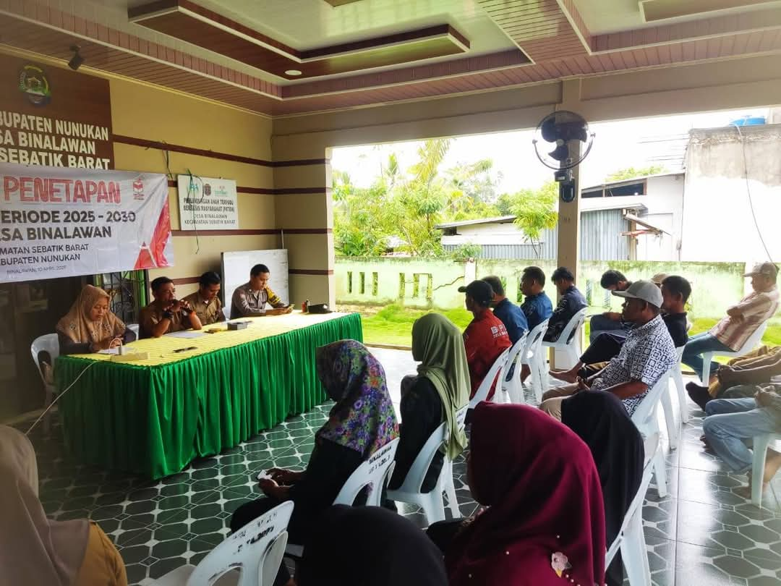

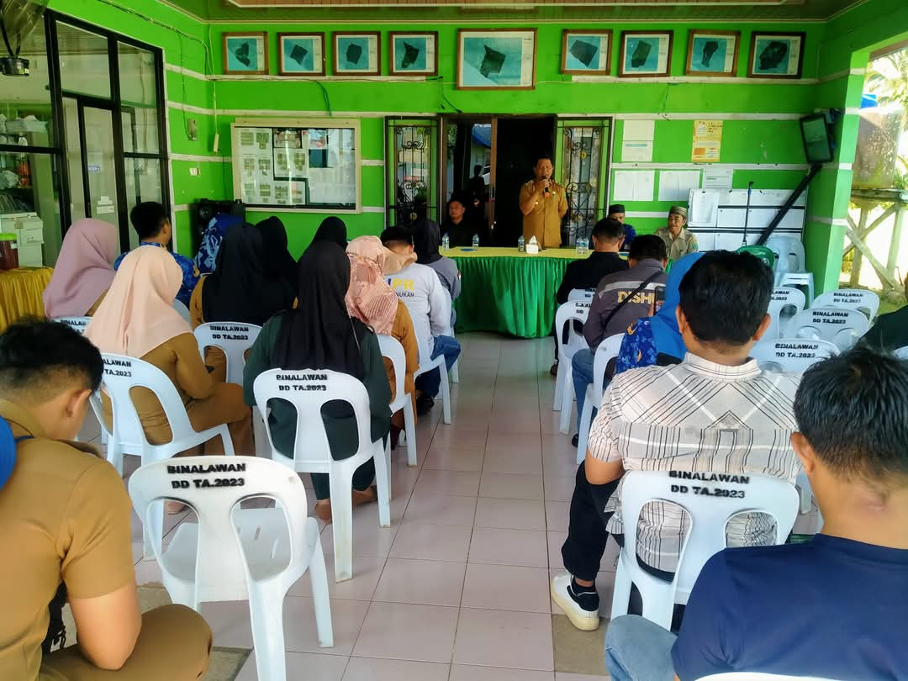

igure 1. Focus Group Discussion

Disclaimer (Artificial intelligence)

Author(s) hereby declare that NO generative AI technologies such as Large Language Models (ChatGPT, COPILOT, etc.) and text-to-image generators have been used during the writing or editing of this manuscript.

**REFERENCES**

Abidin, Z., AS. (2017). Empowerment of Fishermen's Communities on the Coast of Blanakan Beach, Subang Regency. Caraka Prabu Journal,, 1(2), 84-122: <https://ejournal.fisip.unjani.ac.id/index.php/jurnal-caraka-prabu/article/view/95>

Arifin, Z., Kurniawan, F. & Syahrir, M. (2021). Implementasi Rencana Zonasi Wilayah Pesisir dan Pulau-Pulau Kecil dalam Pengelolaan Sumber Daya Kelautan. Jurnal Ilmu Kelautan Tropis, 23(2), 145–156. <https://doi.org/10.29244/jpkt.v23i2.2021>

Bidayani, E. & Kurniawan (2020). Conflict Resolution on Coastal Resource Utilization between Fishermen and Unconventional Tin Miners. Jurnal Society. 8 (1), 14-24. <https://www.societyfisipubb.id>

Dahlet, L. I., Himes-Cornell, A., & Metzner, R. (2021). Fisheries conflicts as drivers of social transformation. Current Opinion in Environmental Sustainability, 53, 9-19. <https://sci-hub.se/downloads/2021-06-29/c5/dahlet2021.pdf>

Dharmariza, M., Rahmad, H. & Miftah. F.W. (2020). Community empowerment as a social conflict resolution strategy. <https://www.researchgate.net>

Emirbayer, M. & Goodwin, J. (1994). Network Analysis, Culture, and the Problem of Agency. American Journal of Sociology, 99(6), 411-1454. <https://www.researchgate.net/publication/273044843_Network_Analysis_Culture_and_the_Problem_of_Agency>

Ginting, M. (2021). Dynamics of Marine and Fisheries Resources Conflict in Indonesia: Institutional and Coastal Area Planning Perspectives https://text-id.123dok.com/document/6qm394d8y

Irfadat, T. & Haeri. (2021). Community Empowerment Based Conflict Resolution In Rato Village, Lambu District, Bima District. Journal of Governance and Local Politics (JGLP). 3 (1): 48-62. <https://journal.unpacti.ac.id/index.php/JGLP/article/view/181/137>

Ministry of Marine Affairs and Fisheries Number 6 (2017). Determination of Indonesia's Outermost Small Islands. 18 pages. <https://jdih.kkp.go.id/peraturan/keppres-6-2017-ppkt.pdf>

Kusnadi, E. (2020). Fishermen's Class Conflict in Indonesia: A Study of Technological Differences and Access to Coastal Resources. <https://www.academia.edu/43537393/Konflik_Kelas_Nelayan_di_Indonesia>

Lasut, L.S. & Kumurur, V.A. (2020). Managing Capture Fisheries Conflicts in Coastal Areas: A Case Study in Eastern Indonesia. <https://text-id.123dok.com/document/6qm394d8y-pengelolaan-konflik-perikanan-tangkap.html>

Nasution, M. I., Hasibuan, S.H. & Lubis, R. D. (2023). Economic Empowerment Strategy in Outermost Islands Based on Local Wisdom and Climate Adaptation. Journal of Development Economics, 24(1), 1–15. <https://doi.org/10.14710/jep.24.1.1-15>

Pranadji, T., Rachmawati, R. & Fitriani, D. (2020). Community Empowerment Model for Small Outer Islands of Indonesia. Jurnal Masyarakat dan Budaya, 22(1), 85–98. <https://doi.org/10.14203/jmb.v22i1.965>

Prasetya, M.W. & Tjitjik, R. (2024). Community Empowerment Based on Local Potential Through Creative and Independent Villages. Intellectual Journal of Public Administration and Communication Science. 11 (1): 14-24. <https://ejournal.ubhara.ac.id/intelektual/article/view/1148>

Rahmawati, R. & Fadli, A. (2024). The Existence of Maritime Traditional Institutions in Sustainable Management of the Aceh Coastal Area: A Literature Review. Journal of Fisheries and Marine Extension. 18(1): 45-62. <https://jppik.id/index.php/jppik/article/viewFile/455/239>

Rusmilyansari, S. & Mahreda, A. (2019). Conflict Resolution Between Fishermen in the Utilization of Fishery Resources Based on Local Institutions in Takalar Regency. Indonesian Fisheries Policy Journal, 11(2), 103–112. <https://ejournal-balitbang.kkp.go.id/index.php/jkpi/article/view/6058>

Siahaan, H.M.C. & Sahran, S. (2023). Diversification of coastal community economy in the formation of a resilient maritime village in Bagan Serdang village. Independent Community Journal. 7 (3): 2676-2687. <https://journal.ummat.ac.id/index.php/jmm/article/view/14981>

Sumandiyar, A. (2022). Empowerment of Fishermen Communities in Coastal Areas of Marusu District, Maros Regency. Indonesian Journal Of Community Services. 1 (2): 88-93. https://www.ojs.literacyinstitute.org

Wibowo, R.C., Klok, H.B.& Sarkowi,M. (2020). Community Empowerment in Making Participatory Zoning Maps in the Ceramic Tourism Object Area and Nirwana Crater, Sukamarga Village. <https://www.researchgate.net/publication/343138047_Pemberdayaan_Masyarakat_Dalam_Pembuatan_Peta_Zonasi_Partisipatif_di_Kawasan_Obyek_Wisata_Keramikan_dan_Kawah_Nirwana_Desa_Sukamarga>

Wulandari, C. & Nugroho, H.S. (2021). Ecotourism and Community Empowerment in Remote Islands: A Case from Eastern Indonesia. Ocean & Coastal Management, 206, 105584. <https://doi.org/10.1016/j.ocecoaman.2021.105584>

Yuliati, L. N., Haryadi, S. & Setiawan, B. (2022). Participatory Approach in Developing Coastal Community-Based Development Programs. Marine Policy, 137, 104941. <https://doi.org/10.1016/j.marpol.2022.104941>