**Population dynamics of *Hydrocynus forskahlii* (Cuvier, 1819) from Roseires Dam Reservoir, Sudan.**

**Abstract**

This study examines the growth, mortality, and recruitment patterns of *H. forskahlii* in Sudan's Roseires Dam Reservoir. During the study period, 675 fish specimens were collected from November 2021 to November 2022. The collected samples ranged in total length from 14.3 cm to 57.0 cm, with an average length of 30.599 ± 10.167 cm. Growth parameters, derived from the von Bertalanffy equation, yielded an asymptotic length of 58.8 cm and a growth coefficient of 0.260 yr.⁻¹. Mortality analysis showed a total mortality rate of 0.69 yr.⁻¹, natural mortality: 0.58 yr.⁻¹ and fishing mortality: 0.11 yr.⁻¹. Two recruitment peaks were identified in March/May and July/October. The exploitation rate was 0.17 yr.⁻¹, indicating under-exploitation at sustainable fishing pressure. The length-weight relationship revealed a negative allometric growth. Measures for improved fishery practices based on the study's findings are recommended.

**Keywords:**

*Hydrocynus forskahlii*, growth parameters, mortality rates, recruitment, length-weight relationship, fishery management.

**Introduction**

The family Characidae represents one of the most diverse groups of freshwater Teleosts, with global distribution across tropical and neotropical basins [1,2]. Within this family, the genus *Hydrocynus* includes three species in Sudanese waters: *H. brevis*, *H. vittatus*, and *H. forskahlii* [3–5], though some surveys report only two species, i.e. *H.* *brevis* and *H. forskahlii* [6].

Globally, *Hydrocynus forskahlii* (African tigerfish) supports artisanal and commercial fishery, contributing to food security across African river basins [7]. In Sudan, *H. forskahlii* is of considerable importance and is usually processed and consumed as wet-salted fish, locally called “faseekh” in parts of the country [8]. It is a key species in the Roseires Reservoir on the Blue Nile and other tributaries of the Nile River in Sudan, providing protein-rich food and income for local communities [9]. Moreover, it plays an ecological role as an apex predator and helps maintain aquatic ecosystem balance [10].

Sustainable fishery management is critical for livelihoods, socio-economic stability and biodiversity conservation in the region [11]. As a major predator, *H. forskahlii* exhibits consistent piscivorous feeding patterns across its range, primarily consuming fish (particularly *Alestes spp*.) with occasional crustaceans and insects [12,13]. While its feeding ecology is well-documented in other African regions [14,15], the stocks of *H. forskahlii* populations still remain understudied, except for a few sporadic reports [13].

The study of population dynamics of a fish provides critical data on growth, mortality, and exploitation rates, which can be used in assessing the health of fish stocks and applying sustainable exploitation measures. Furthermore, understanding recruitment patterns ensures that fishing regulations are consistent with the breeding cycles and prevent overexploitation. Estimating mortality rates (total, natural, and fishing) guides harvest limits and maintains balanced fish stocks. Analyzing size and age structure supports science-based quotas, ensuring long-term fishery productivity and food security [16].

Spawning of this species occurs during the rainy season (March-October), with Fecundity ranging from 10,000 to 45,000 eggs/female [13], White Nile, Sudan, and [15], Oyan Reservoir, (Nigeria), and a bimodal recruitment pattern, usually linked to annual flood pulses [12] in Lake Kariba, (Zimbabwe).

**Materials and Methods**

**Study area**:

The Roseires Reservoir, created by the Roseires Dam, is located on the Blue Nile at Ed Damazin, just upstream of the town of El Roseires, approximately 550 km southeast of Khartoum, the Capital of Sudan. The reservoir has a surface area of approximately 290 km² and a storage capacity of about 3.0 km3. Built in 1966, the Dam Reservoir is crucial for agricultural irrigation, hydropower generation, and water supply for Sudan. A second phase of construction was completed in 2013 to raise its height by 10.0 meters, from 68.0 m to 78.0 m, increasing its storage capacity from 3.0 billion m³ to 7.30 billion m³. to increase storage capacity for further agricultural irrigation, in addition to supporting valuable local fisheries, create employment opportunities, livelihoods, and income for the nearby communities (Fig.1).

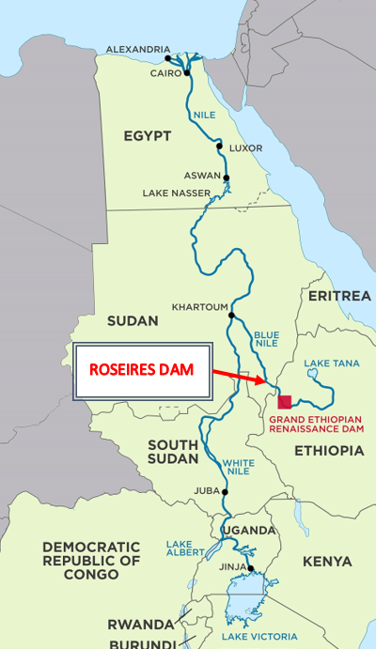

Fig. 1. Roseires Dam in Sudan, Africa (11°47′53″N 34°23′15″E﻿ / ﻿11.79806°N 34.38750°E﻿ / 11.79806; 34.38750). From Ayn network (https://3ayin.com/en/sudan-authorities-support-while-affected-communities-fear-africas-largest-dam/)

Table 1. Coordinates of the fish sampling sites at Roseires Reservoir (Blue Nile, Sudan) and the distance from Ed Damazin City.

|  |  |  |  |
| --- | --- | --- | --- |
| **Site** | **Distance (km)** | **Coordinate** | **Elevation (m)** |
| **Awal Bab** | 4 | 11°45'14"N 34°21'51"E | 487 |
| **EL Regiba** | 16 | 11°38'39"N 34°20'51"E | 497 |
| **Kirma** | 43 | 11°41'09"N 34°30'35"E | 506 |
| **Wad EL Mahi** | 80 | 11°25'27"N 34°40'17"E | 507 |

**Samples collection:**

Fish samples were collected from four designated sites in the study area. A total of 675 specimens of fish were collected monthly from the four sampling sites between November 2021 and October 2022, as shown in (Table 1). Gillnets with stretched mesh sizes of 2.0 cm, 4.0 cm, 6.0 cm, and 8.0 cm, lengths of 50.0 m, 90.0 m, 95.0 m, and 100,0 m, and depths of 2.0 m, 4.0 m, and 4.50 m, were used (Table 2). Fish identification followed [6]. The total length (TL) of the fish was measured to the nearest 1.0 mm from the tip of the snout to the tip of the upper lobe of the caudal fin using a measuring board. Body weight was recorded to the nearest 1.0 g using a digital balance (FRUIT 2000B).

Table 2. Specifications of gillnets used in fish sampling.

|  |  |  |  |
| --- | --- | --- | --- |
| **Gear No.** | **Length (m)** | **Depth (m)** | **Mesh size (cm)** |
| **2** | 50.0 | 2.0 | 2.0 |
| **12** | 90.0 | 4.0 | 4.0 |
| **12** | 95.0 | 4.0 | 6.0 |
| **12** | 100.0 | 4.50 | 8.0 |

**Length-Weight Relationship:**

The length-weight relationship for *H. forskahlii* was determined using [17] equation:

Log (W) = log (a) + b log (L)

where: W: represents total weight, L: total length, *a*: the intercept, and *b*: the regression coefficient.

**Growth Parameters:**

The von Bertalanffy growth model was applied to estimate growth patterns, with key parameters including asymptotic length (*L∞*) and growth coefficient (*K*) derived from the von Bertalanffy growth function [18]:

Lt =*L∞* (1-e-k(t-t0)).

**The theoretical age at zero length (t0)** was calculated as:

log10 (−*t*0) = − 0.3922 − 0.2758 × log10 *L∞*− 1.038 × log10 *K*. [19].

**Longevity T*max***was estimated as 3/*K* + *t*0*.*

**The growth performance index (*ϕ* ′)**

was calculated as:

*ϕ* ′ = 2 *log10* *L∞* + log10 K. [20].

**Mortality Parameters:**

The total annual instantaneous mortality rate (Z) was estimated using length-converted catch curves. Natural mortality (M) was calculated following [21]:

log10M = - 0.0066 - 0.279 × log10*L*∞+ 0.6543 × log10K + 0.4634 × log10T.

Where: M = instantaneous natural mortality, *L∞* asymptotic length, “T” mean surface temperature (24.5 °C), and “*K*” = growth rate.

**Fishing mortality (F)** was derived as [22]:

F = Z – M.

**The exploitation rate (E)** was obtained using [23]:

E = F/Z.

**Relative Yield and Biomass per Recruit:**

The model by [24] was used to predict Y′/R, while relative biomass per recruit (B′/R) was estimated following [25].

Key reference points included:

**Maximum exploitation rate** (E*max*),

**Exploitation rate at 10% virgin biomass** (E0.1),

**Exploitation rate at 50% virgin biomass** (E0.5).

**Length at First Capture,** *Lc*​, was determined using Beverton and Holt's equation:

*Lc* = *L̄*-*K* × (*L∞* - *L̄*) ÷ Z. [22].

Where: *L̄* = mean length of the fish catch; *K* = growth coefficient; *L*∞ = asymptotic length; and Z = the total mortality.

**The age at first capture (*t****c*) was determined from the estimated growth parameters (*L∞*, *K*, and *t*0) using the ELEFAN I method following [25].

**Recruitment Patterns** were analyzed using FiSAT’s "Percent of sample total" option. when the samples had dissimilar sizes.

**Maximum fishing effort (F*max*)** was determined as:

0.67×*K*/0.67-*L*c [26].

**The precautionary limit reference point (F*limit*)** was set at:

⅔×M [27].

**Precautionary target reference point (F*opt*)** was calculated as:

0.4×M [28].

**Virtual Population Analysis:**

Structured virtual population analysis was conducted using FiSAT II software, incorporating parameters such as *L∞*​, *K*, M, and *F*. Biological reference points were derived [22].

**Optimum cohort biomass** **length** was calculated as:

*Lopt* = *L∞* × (3÷3 + M÷*K*).

**Data Analysis:**

Length-weight relationships were analyzed in Microsoft Excel, while population parameters were estimated using FiSAT [29,30].

**Results**

**Fish size:** A total of 675 specimens of *Hydrocynus forskahlii* were collected monthly from four sites in Roseires Reservoir between November 2021 and October 2022. The total length of the specimens ranged from 14.3 cm to 57,0 cm, with a mean length of 30.599 ± 10.167 cm.

**Growth Parameters:** Length-frequency analysis, conducted using the ELEFAN module in FiSAT, provided growth parameters based on the von Bertalanffy growth function (VBGF). The estimated asymptotic length (*L*∞) was 58.8 cm, with a growth coefficient (*K*) of 0.260 yr.⁻¹ and a theoretical age at zero length (*t*0 of -0.272 years. The VBGF equation for *H. forskahlii* was:

*Lt* = 58.8×(1−e−0.26(t+0.272))

The growth curve is illustrated in Fig. 2 and summarized in Table 3.

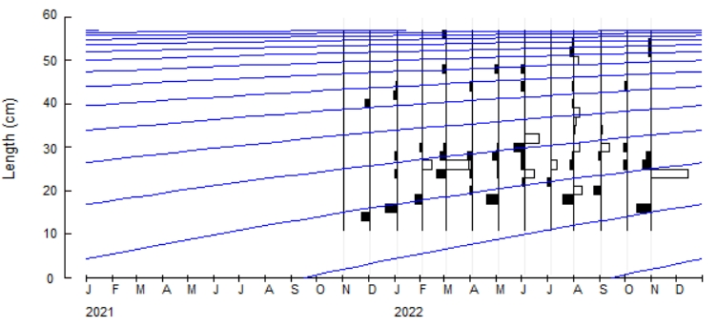

Fig. 2. Von Bertalanffy growth curve for *H. forskahlii* in Roseires Reservoir.

**The length-weight relationship** of *H. forskahlii* showed a strong correlation (*r =* 0.786). This relationship indicates a negative allometric growth pattern, characterized by a b-value of 2.553, as depicted in Fig. 3.

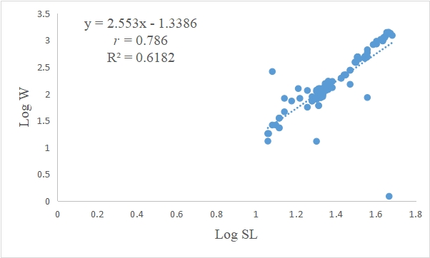

Fig. 3. Length-weight relationship of *H. forskahlii* in Roseires reservoir.

**Mortality and Exploitation Rates:** Mortality parameters of the studied fish species were estimated as follows:

Total mortality (Z): 0.69 yr.⁻¹.

Natural mortality (M): 0.58 yr.⁻¹.

Fishing mortality (F): 0.11 yr.⁻¹.

Exploitation rate (E): 0.17 yr.⁻¹.

**The growth performance index (*ϕ*′):** was 2.954 (Table 3). The length-converted catch curve and mortality estimates are presented in Fig. 4.

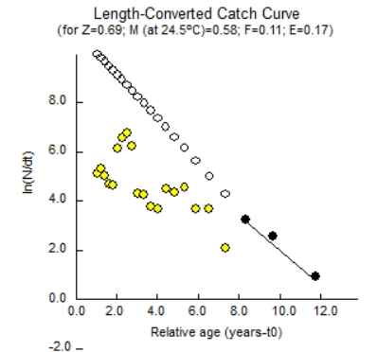

Fig. 4. Von Bertalanffy growth curve (a) (*L∞*= 58.8 cm; *K* = 0.260 yr.-1) overlaid on length-frequency distribution, and (b) linearized length-converted catch curve for *H. forskahlii* in Roseires reservoir.

**Recruitment Pattern:** *H. forskahlii* demonstrated two recruitment peaks that occurred in March/May during the dry season and July/October during the rainy season. This pattern is illustrated in Fig. 5.

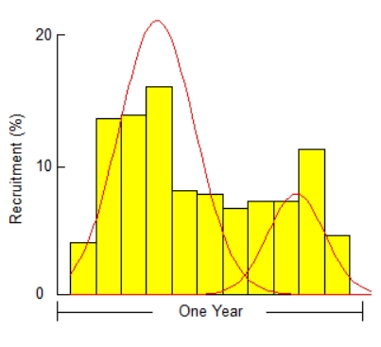

Fig. 5. Recruitment pattern of *H. forskahlii* in Roseires reservoir.

**Length at first capture (*L*c)**, was estimated from the probability of capture for *H. forskahlii* as 14.3 cm. The lengths corresponding to vulnerability at 25%, 50%, and 75% were 14.94 cm, 21.10 cm, and 22.60 cm, respectively (Fig. 6 and Table 3).

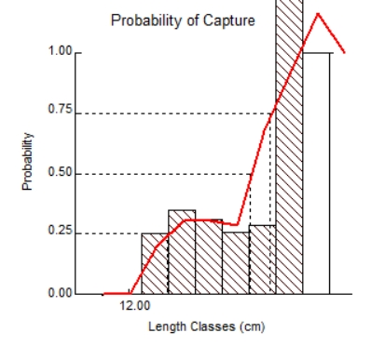

Fig. 6. The probability of capture of *H. forskahlii* in the Roseires reservoir obtained from the selective curve.

**Relative Yield and Biomass per Recruit (Y/R):** The maximum yield per recruit (Y/R) occurred at an exploitation rate (E*max*) of 0.499. The exploitation rates corresponding to 10% and 50% of the maximum Y/R (E01 and E05) were 0.418 and 0.312, respectively. The ratio of length at first capture to asymptotic length (*Lc*/*L∞*) was calculated as 0.05, and the probability distribution of length showed *M*/*K* equal to 0.260. Additionally, the length at optimum cohort biomass (*Lopt*) was determined as 33.72 cm (Fig. 7 and Table 3).

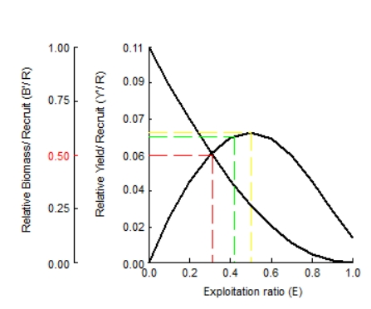

Fig. 7. Beverton and Holt's relative yield per recruitment (Y/R) and biomass per recruit (B/R) for *H. forskahlii* in Roseires reservoir.

**Population Structure and Mortality Patterns:** Population dynamics analysis revealed that younger age classes had higher abundances, which decreased progressively with age due to natural mortality (predation, disease, environmental factors) and fishing pressure. The length-structured virtual population analysis (VPA) for *H. forskahlii* is presented in Fig. 8, illustrating that Survival rates(green) decline with increasing age/size.

Natural mortality(purple) is highest in smaller length classes, but decreases as fish grow. While fishing mortality (yellow): Begins at 14.3 cm, peaks at 28 cm, and declines in larger size classes due to reduced abundance caused by fishing mortality (red line).

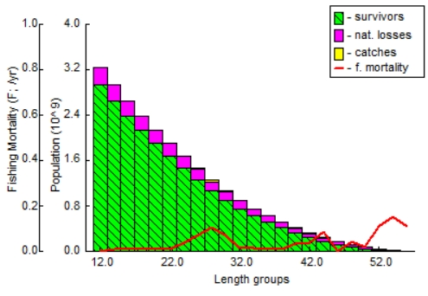

Fig. 8. Length-structured virtual population analysis (VPA) of *H. forskahlii* in Roseires Reservoir, showing survival (green), natural mortality (purple), and fishing mortality (yellow).

Table 3. Key biological parameters of *H. forskahlii* in Roseires Reservoir, Sudan.

|  |  |  |  |
| --- | --- | --- | --- |
| **Parameters** | **Estimated values** | **Parameters** | **Estimated values** |
| ***L∞* (cm)** | 58.8 | **E** | 0.17 |
| ***K*-1** | 0.260 | **E0.1** | 0.418 |
| **t0** | -0.273 | **E0.5** | 0.312 |
| **Phi ꝋ** | 2.954 | **E*max*** | 0.499 |
| **Z** | 0.69 | ***L25*** | 14.94 |
| **M** | 0.58 | ***L50*** | 21.10 |
| **F** | 0.11 | ***L75*** | 22.60 |
| ***Lc/L∞*** | 0.05 | ***Lopt*** | 33.72 |
| **M/K** | 0.260 | **Z/K** | 2.65 |
| **F*max*** | 0.387 | ***L*c** | 14.3 |
| **F*limit*** | 0.210 | **T*max*** | 11.27 |
| **F*opt*** | 0.232 |

The fisheries reference points in the study area (F*max*, F*limit*, F*opt*) are estimated as 0.387, 0. 210 and0. 232, respectively (Table 3).

**Discussion**:

**Growth and Population Dynamics of *Hydrocynus forskahlii* in Roseires Reservoir:**

Despite its ecological and economic importance, comprehensive studies of the population dynamics of the stocks of *H. forskahlii* in Sudanese inland water are very scarce. The present study attempts to address this gap through the first systematic study of its growth, mortality, recruitment, and reproductive aspects in Roseires Dam Reservoir, providing essential baseline data necessary for the sustainable management of its fisheries.

In the current study, the total length of *H. forskahlii* ranged from 14.3 cm to 57 cm, with an average of 30.599 ± 10.167 cm. This measurement was slightly greater than that recorded for the same species by [31] in Yobe River (Nigeria), and comparable to those reported by [13], 10.0 - 60,0 cm. The maximum reported length for this species was 78.0 cm SL [32].

**Growth Parameters**

Growth parameters of *H. forskahlii* obtained from the von Bertalanffy model varied across different regions. For example, asymptotic length (*L*∞) ranged from 52.0–65.0 cm, while the growth coefficient (*K*) varied from 0.2–0.38 year¹ in Ethiopia and the Zambezi Basin [14,7], respectively. Mortality rates in Lake Turkana, Kenya, showed total mortality (*Z*) of 0.73 year⁻¹ and fishing mortality (F) of 0.11 year⁻¹ [33]. The length-weight relationship indicated negative allometric growth (*b* < 3), with b = 2.8 in Ethiopia [14] and 2.7–2.9 in West Africa [34].

In this study, the growth parameters derived from the von Bertalanffy growth model for *H. forskahlii* were as follows: the asymptotic length (*L*∞) was 58.8 cm with a growth coefficient (*K*) of 0.260 year-1 and a theoretical length at age zero (*t*0) of -0.273 years. The *L*∞ obtained in this study exceeds the 52.40 cm reported by [35] for *H. vittatus* in the Olifants River and the 56.06 cm in the Letaba River (South Africa). This study's growth coefficient (*K*) is lower than the 0.387 - 0.449 year-1 obtained by [35]. [36] reported *L*∞ = 39.2 cm and *K* = 0.56 yr.⁻¹ for *Hydrocynus* *spp*. in the Rufiji River (Tanzania). [37] studied *H. vittatus* in the Okavango Delta (Botswana) and reported asymptotic length, growth coefficients, and *t*0 for males as 73.8 cm, 0.159 yr.-1 and -1.89, respectively, and 57.1 cm, 0.279yr.-1 and -1.43 for females. These differences may be attributed to variations in species and geographical areas. However, it must be realized that, when comparing von Bertalanffy growth parameters (*L*∞ and (*K*) across studies, their cumulative effect-expressed through the “growth performance index ϕ′” (ϕ′ = 2 log *L*∞ + log *K*) provides a more robust metric than individual values, as it integrates both asymptotic length and growth rate into a single standardized measure [38,20]. For *H. forskahlii*, the ϕ′ value of 2.954 obtained in the present study is almost similar to estimates from Ethiopia of ϕ′ ≈ 2.92 [14] and the Zambezi Basin (ϕ′ ≈ 3.05; [7]), suggesting a consistent growth pattern despite regional variations in *L*∞ (52–65 cm) and *K* (0.2–0.38 yr.⁻¹). This approach minimizes biases when comparing isolated parameters, as *K* and *L*∞ are often inversely correlated [19], and highlights ecological adaptations to local conditions (e.g., reservoir productivity, temperature).

In the present study, the length-weight relationship of *H. forskahlii* had a strong correlation (b-value of 2.553), indicating negative allometric growth. Similar growth value was also reported by [31] for the same species in the River Yobe (Nigeria).

The total mortality (Z) was estimated at 0.69 yr.⁻¹, natural mortality (M) at 0.58 yr.⁻¹, and the fishing mortality (F) at 0.11 yr.⁻¹. The very high mortality rate of 70% (Z = 0.69) of tigerfish during their first growth season highlights the advantage of faster growth rates and critical lengths to evade predation [39,40]. [35] reported total mortality rates of Z = 1.488 in the Olifants River and Z = 1.067 in the Letaba River with exploitation rates of 34.4% and 22.6% for the two rivers, respectively. noted high mortality rates of tigerfish were reported by [40] in the Okavango River (Botswana) and [41] at Z = 0.851 and Z = 2.58 respectively. However, [39], in Lake Kariba, recoded low mortalities of Z = 0.557 (1975) reported Variations in mortality rates within the same species may be attributed to the influence of ecological factors and differing fishing techniques.

[35] reported total mortality rates of Z = 1.488 in the Olifants River and Z = 1.067 in the Letaba River in South Africa with exploitation rates of 34.4% and 22.6% for the two rivers, respectively. High total mortality rates of tigerfish were noted by [40] in the Okavango River, Botswana, at Z = 0.851, and [41] reported a very high mortality of Z = 2.58 in(Central Delta of Niger, Nigeria)**.** Conversely, [39], in Lake Kariba, recorded low values of mortality of this species at Z = 0.557. These variations in total mortality rates for the same species in different geographical regions may be attributed mainly to the influence of some ecological factors and the different fishing gear used in fishing.

The exploitation rate, E = 0.17, obtained in the present study is half of that reported in the Olifants River at 34.4% but slightly lower than the rate in the Letaba River at 22.6% for *H. vittatus* [35], and below the theoretical optimum rate of 0.50.

Analysis of the probability of capture revealed that the length at first capture (*L*c) for *H. forskahlii* was 14.3 cm, with vulnerable lengths at 25%, 50%, and 75% of the catch being 14.94 cm, 21.10 cm, and 22.60 cm, respectively. The maximum relative yield per recruit (Y/R) was observed at an exploitation rate (E*max*) of 0.5, while the exploitation rates corresponding to 10% and 50% of the maximum Y/R (E01 and E05) were estimated at 0.418 and 0.312, respectively. The length at first catch estimated in this study was 14.3 cm.

*H. forskahlii* exhibited two recruitment peaks occurring in March-May (dry season) and July-October (rainy season). [42] in his two-year study of *Hydrocynus vittatus* in Lake Kariba (Zambia) observed four generations within this time frame. Breeding occurred annually, coinciding with the rainy season, starting at age two and a breeding size of 35.0 cm, indicating two recruitment periods. [35] also noted two cohorts of tigerfish species (*H. vittatus*) in the Olifants River and Letaba River (South Africa), which agrees with our findings in this study.

In this study, the ratios *L*c/*L*∞ and *M*/*K* were estimated at 0.05 and 0.260, respectively. The calculated length for optimal cohort biomass or yield prior to recruitment (*Lopt*) was 33.72 cm. The potential longevity T*max* for *H. forskahlii* of 11.27 years is similar to that reported for *H. vittatus* in Lake Bangweulu and the Zambezi River by [43] (11 years). This longevity is greater than the 9 years reported for the same species in Lake Kariba by [44], but less than the 20 years observed for *H. vittatus* in the Okavango Delta (Botswana) according to [37]. These differences in longevity may be attributed to species-specific traits, levels of exploitation, and various biological and ecological factors.

**Comprehensive Assessment of *Hydrocynus forskahlii* Fishery in Roseires Reservoir shows the following points:**

Asymptotic length of (*L*∞ = 58.8 cm) and growth coefficient of (*K* = 0.26 yr.⁻¹) indicate moderate growth, typical for this species in African reservoirs [14].

Length at first capture (*L*c = 14.3 cm) is significantly smaller than optimal cohort biomass length (*Lopt* = 33.72 cm) and the average length of the fish (30.599 cm), indicating early harvest before peak reproductive value.

The probability of capture increases sharply at 21.1 cm (*L*50), suggesting gear selectivity targets smaller fish.

Natural mortality (M = 0.58 yr.⁻¹) dominates over fishing mortality (F = 0.11 yr.⁻¹), especially for smaller fish (Total mortality Z = 0.69 yr.⁻¹), reflecting that high natural losses limit population resilience. Relative Yield per Recruit (Y/R) peaks at E = 0.5, but current effort (E = 0.17) harvests only about 34% of the potential yield. Biomass per Recruit (B/R) shows significant virgin biomass remains, supporting increased effort.

**Recommendations for Managing *H. forskahlii* Fishery in Roseires Reservoir:**

**Reference points:**

**Flimit** (0.210 yr.⁻¹): Absolute upper limit to prevent overfishing.

**Fopt** (0.232 yr.⁻¹): Target for sustainable yield.

**Fmax** (0.387 yr.⁻¹): Theoretical maximum effort (risky).

**Control Effort:** Gradually raise effort toward F*opt* (0.232 yr.⁻¹) to optimize yield without exceeding F*limit* (0.210 yr.⁻¹).

**Size-Limit Regulations:** Increase minimum capture size toward *L*50 (21.1 cm) to protect juveniles and improve spawners biomass. The identification of two distinct recruitment peaks offers valuable information for timing conservation efforts and fishing regulations.

**Gear Selectivity Adjustments:** Use of larger mesh sizes to shift *L*c closer to *Lopt* (33.72 cm), enhancing yield quality.

**Seasonal closure:** Protect March/May and July/October recruitment pulses with seasonal closures if effort increases.

**Risks and Uncertainties**

High natural mortality limits stock resilience.

Early harvest (*L*c < *Lopt*) reduces long-term yield potential.

Regional variability in growth /mortality suggests local adaptations; hence, management should be reservoir-specific.

**Conclusion**

The Roseires Reservoir *H. forskahlii* population shows **moderate growth** and **high natural mortality**, with **underutilized fishing potential**. However, **early harvest** and **gear selectivity threaten long-term sustainability**. Adopting **size limits**, **seasonal closures**, and **effort controls** could **optimize yield** while **conserving the stock**.

**Acknowledgement:**

The authors would like to thank the staff of the Fish and Aquatics Research Center and the Roseires Fisheries Research Station for their valuable help in making this study possible.

Disclaimer (Artificial intelligence)

Option 1:

Author(s) hereby declare that NO generative AI technologies such as Large Language Models (ChatGPT, COPILOT, etc.) and text-to-image generators have been used during the writing or editing of this manuscript.

**References**:

1. van der Lann, R. *Freshwater Fish List*; 26th ed.; 2019; ISBN 2468-9157.

2. Melo, C.E.D.; Machado, F.D.A.; Pinto-Silva, V. Feeding Habits of Fish from a Stream in the Savanna of Central Brazil, Araguaia Basin. *Neotropical Ichthyol.* **2004**, *2*, 37–44, doi:10.1590/S1679-62252004000100006.

3. Mahmoud, Z.N.; Hagar, E.S.A.; Abdalla, M.Y. Fish Diversity in the Nile System and Ephemeral Water Bodies in Sudan: Records and a Review. *Int. J. Fish. Aquat. Stud.* **2024**, *12*, 01–08, doi:10.22271/fish.2024.v12.i4a.2938.

4. Abdalla, M.Y.M.; Adam, A.E.B. Diversity and Distribution of Ichthyofauna in the Inland Waters of Sudan: A Review. *Asian J. Res. Zool.* **2024**, *7*, 1–13.

5. Bailey, R. Guide to the Fishes of the River Nile in the Republic of the Sudan. *J. Nat. Hist.* **1994**, *28*, 937–970.

6. Neumann, D.; Obermaier, H.; Moritz, T. Annotated Checklist for Fishes of the Main Nile Basin in the Sudan and Egypt Based on Recent Specimen Records (2006-2015). *Cybium* **2016**, *40*, 287–317.

7. Tsevenda, C.; Annune, P.; Olufeagba, S.; Ataguba, G. Food and Feeding Habits of Three Selected Fish Species of Lower River Benue, Benue State, Nigeria. *Niger. J. Fish. Aquac.* **2024**, *12*, 1–15.

8. Elsheikh, W. Traditional Dried and Salted Nile Fish Products in Sudan: A Review. *Eurasian J. Food Sci. Technol.* **2021**, *5*, 1-5.

9. Hamza, W. The Nile Fishes and Fisheries. In *Biodiversity - The Dynamic Balance of the Planet*; Grillo, O., Ed.; InTech, 2014 ISBN 978-953-51-1315-7.

10. Olaosebikan, B.D.; Raji, A. *Field Guide to Nigerian Freshwater Fishes.*; 2nd ed.; Federal College of Freshwater Fisheries Technology, New Bussa: Nigeria, 2013;

11. FAO *The State of Food and Agriculture 2022*; FAO, 2022; ISBN 978-92-5-136043-9.

12. Dalu, T.; Clegg, B.; Marufu, L.; Nhiwatiwa, T. The Feeding Habits of an Introduced Piscivore, Hydrocynus Vittatus (Castelnau 1861) in a Small Tropical African Reservoir. *Pan-Am. J. Aquat. Sci.* **2012**, *7*, 85–92.

13. Hagar, E.A. Predator Prey Relationship of Hydrocynusforskalii (Cuvier 1819) in White Nile Reservoir around Kosti and Eljabalain Area. *J. Aquat. Sci. Mar. Biol.* **2019**, *2*, 1–6.

14. Dadebo, E.; Mengistou, S. Feeding Habits, Ontogenetic Dietary Shift and Some Aspects of Reproduction of the Tigerfish Hydrocynus Forskahlii (Cuvier 1819)(Pisces: Characidae) in Lake Chamo, Ethiopia. *Ethiop. J. Biol. Sci.* **2008**, *7*, 123–137.

15. Olojo, E.; Olurin, K.; Osikoya, O. Food and Feeding Habits of Synodontis Nigrita from the Osun River, SW Nigeria. **2003**.

16. Gebremedhin, S.; Bruneel, S.; Getahun, A.; Anteneh, W.; Goethals, P. Scientific Methods to Understand Fish Population Dynamics and Support Sustainable Fisheries Management. *Water* **2021**, *13*, 574, doi:https://doi.org/10.3390/w13040574.

17. Le Cren, E.D. The Length-Weight Relationship and Seasonal Cycle in Gonad Weight and Condition in the Perch (Perca Fluviatilis). *J. Anim. Ecol.* **1951**, *20*, 201, doi:10.2307/1540.

18. von Bertalanffy, L. Quantitative Laws in Metabolism and Growth. Quarterly Review of Biology. *Stony Brook* 217–231.

19. Pauly, D. Gill Size and Temperature as Governing Factors in Fish Growth: A Generalization of von Bertalanffy’s Growth Formula. **1979**.

20. Moreau, J.; Bambino, C.; Pauly, D. Indices of Overall Growth Performance of 100 Tilapia (Cichlidae) Populations. **1986**.

21. Pauly, D. On the Interrelationships between Natural Mortality, Growth Parameters, and Mean Environmental Temperature in 175 Fish Stocks. *ICES J. Mar. Sci.* **1980**, *39*, 175–192, doi:10.1093/icesjms/39.2.175.

22. Beverton, R.J.; Holt, S.J. *On the Dynamics of Exploited Fish Populations*; Springer Science & Business Media, 1957; Vol. 11; ISBN 94-011-2106-0.

23. Gulland, J. Science and Fishery Management. *ICES J. Mar. Sci.* **1971**, *33*, 471–477.

24. Pauly, D.; Soriano, M. Some Practical Extensions to Beverton and Holt’s Relative Yield-per-Recruit Model.; Asian Fisheries Society Manila, 1986; pp. 491–496.

25. Gayanilo, F.; Sparre, P.; Pauly, D. FAO-ICLARM Stock Assessment Tools II: Revised Version: User’s Guide. *FAO Comput. Inf. Ser. Fish.* **2005**, I.

26. Hoggarth, D.D. *Stock Assessment for Fishery Management: A Framework Guide to the Stock Assessment Tools of the Fisheries Management and Science Programme*; Food & Agriculture Org., 2006; ISBN 92-5-105503-3.

27. Patterson, K. Fisheries for Small Pelagic Species: An Empirical Approach to Management Targets. *Rev. Fish Biol. Fish.* **1992**, *2*, 321–338.

28. Pauly, D. *Fish Population Dynamics in Tropical Waters: A Manual for Use with Programmable Calculators*; ICLARM, 1984;

29. Gayanilo, J.R.; Sparre, P.; Pauly, D. FAO-ICLARM Fish Stock Assessment Tools (FISAT) Software Package User’s Manual. *Food Agric. Organ. U. N. FAO Rome* **1996**.

30. Pauly, D.; Morgan, G. *Length-Based Methods in Fisheries Research*; WorldFish, 1987; Vol. 13; ISBN 971-10-2228-1.

31. Segun, A.-D.S.; Ijabo, O.S.; Yusuf, B. Length-Weight Relationship and Condition Factor of Hydrocynus Forskahlii (Cuvier, 1819) in River Yobe, Northeast, Nigeria. *Aceh J. Anim. Sci.* **2022**, *7*, 53–58, doi:10.13170/ajas.7.2.23519.

32. Paugy, D.; Lévêque, C.; Teugels, G.G. The Fresh and Brackish Water Fishes of West Africa, Vols 1 & 2. *Muséum Natl. Hist. Nat. Paris* **2003**, *1 & 2*, 1272.

33. Goodier, S.A.M.; Cotterill, F.P.D.; O’Ryan, C.; Skelton, P.H.; De Wit, M.J. Cryptic Diversity of African Tigerfish (Genus Hydrocynus) Reveals Palaeogeographic Signatures of Linked Neogene Geotectonic Events. *PLoS ONE* **2011**, *6*, e28775, doi:10.1371/journal.pone.0028775.

34. Roux, F.; Steyn, G.; Hay, C.; Wagenaar, I. Movement Patterns and Home Range Size of Tigerfish (Hydrocynus Vittatus) in the Incomati River System, South Africa. *Koedoe* **2018**, *60*, doi:10.4102/koedoe.v60i1.1397.

35. Gagiano, C.L. An Ecological Study on the Tiger-Fish Hydrocynus Vittatus in the Olifants and Letaba Rivers with Special Reference to Artificial Reproduction. M. Sc., Department of Zoology, Faculty of Science, Rand Afrikaans University: South Africa, 1997.

36. Payne, A.I.; McCarton, B. Estimation of Population Parameters and Their Application to the Development of Fishery Management Models in Two African Rivers. *J. Fish Biol.* **1985**, *27*, 263–277, doi:10.1111/j.1095-8649.1985.tb03247.x.

37. Gerber, R.; Smit, N.J.; Pieterse, G.M.; Durholtz, D. Age Estimation, Growth Rate and Size at Sexual Maturity of Tigerfish Hydrocynus Vittatus from the Okavango Delta, Botswana. *Afr. J. Aquat. Sci.* **2009**, *34*, 239–247, doi:10.2989/AJAS.2009.34.3.5.981.

38. Pauly, D.; Munro, J. ICLARM’s Activities in Tropical Stock Assessment: 1979-1984, and Beyond. **1984**.

39. Balon, E.K. Replacement of Alestesimberi (Peters, 1852) by A. Lateralis (Boulenger, 1900) in Lake Kariba, with Ecological Notes. *Fish Res Bull Zamb.* **1971**, *5*, 119–162.

40. Van Zyl, B.J. ’N Visekologieseondersoek van Die Okavango-enKuneneriviere Met Spesialeverwysingnavisontginning. Ph. D Dissertation, University of Johannesburg: South Africa, 1992.

41. Dansoko, F.D. Contribution a l’etude de La Biologie Des Hydrocyom Dans Le Delta Central Du Niger. **1975**.

42. Badenhuizen, T.R. Some Notes on the Population Dynamics of Hydrocynus Vittatus (Castelnau) in Lake Kariba. *Hydrobiologia* **1967**, *30*, 527–540, doi:10.1007/BF00964031.

43. Griffith, J.S. Annulus Formation and Growth of Tigerfish, Hydrocynus Vittatus, in Lake Bangweulu, Zambia. *Trans. Am. Fish. Soc.* **1975**, *104*, 499–505, doi:10.1577/1548-8659(1975)104<499:AFAGOT>2.0.CO;2.

44. Winemiller, K.O.; Kelso‐Winemiller, L.C. Comparative Ecology of the African Pike, Hepsetus Odoe, and Tigerfish, Hydrocynus Forskahlii, in the Zambezi River Floodplain. *J. Fish Biol.* **1994**, *45*, 211–225, doi:https://doi.org/10.1111/j.1095-8649.1994.tb01301.x.