Revisiting Educational Assessment and Examination in Teaching of History in The University System

Abstract
Assessment has become part of university curriculum. However, overtime this has been a major challenge in the teaching and learning of history at the university level as there is no unified system of assessments. It is in the light of this that this study examined methods of students’ educational assessments overtime. The study intends to identify, evaluate or assess the system of educational assessments and examination of history in university system and suggest ways out. As a historical study, the study shall use content methods (Key Informant Interview and related literatures) of data collection and analysis before drawing conclusion. From data collected, it was observed that pen and paper method of assessments and examination were used. The study therefore recommended that apart from this, oral method of question and answer and students’ more involvement in the process be promoted.
Teaching and learning of history started when man became conscious of himself, his environment and began to share ideas and knowledge from one generation to another. This has become formal in modern schools with defined curriculum. This has led to the systematic introduction of assessment and grading of learners for placement and other reasons.
Key Words: Assessment, Curriculum, History and Nigerian University System
Introduction
The National Policy on Education (NPE,2014) has described education as an effective tool for economic, social, cultural and political transformation and national development. This led the NPE to further state that education is aimed at developing individuals into morally sound, patriotic, and effective citizens. It also seeks to foster the development of appropriate skills, as well as mental, physical, and social competencies that empower individuals to live fulfilling lives and contribute positively to society (NPE, 2014). This explains why nations around the world allocate a sizeable portion of their resources to education particularly to tertiary and university education.
In Nigeria, Western education was introduced by Christian missionaries in the second half of the 19th century. During the 20th century, as Western education became crucial for meeting the manpower needs of the colonial civil service and aligning with the objectives of colonialism, the colonial government began to participate and eventually became the driving force in the provision of education.
Later, to meet the demand for middle-level manpower in the colonial civil service and to prepare for the manpower needs of an independent Nigeria, tertiary education institutions began to emerge. The first university, University College Ibadan established in 1948 was initially a campus or affiliate of a British university. In the early 1960s, four additional universities were established, while the University College Ibadan evolved into a full-fledged university.
As of 2025, Nigeria has nearly 300 universities (NUC, 2025). From the inception of university education, History has featured in the curriculum and has remained a consistent subject in most universities, except in specialized institutions
University education is run for between four to six years depending on the curriculum of the programme. For instance, humanities, education and life science programmes are run for four years, engineering, architecture, and agricultural programmes are for five years while medical courses that require clinical courses lasted for six years. In all the programmes learning is stratified in such a way that learner’s performance has to be assessed and adjudge satisfactory before moving to the next level or even graduating. In history as with humanity courses, the main system of assessment of students’ performance has been through the use of pen and paper or examination where learners are required to read, understand and respond to the test or examination items within a giving time. However, irrespective of the success attained in the use of test items in assessing students at university level, teachers are faced with a number of challenges in the process either directly from him or from individualistic nature of students. For instance, test items are teacher’s centre and non-clarity in the sentences of the item from the teacher’s angle while students may have the challenges of disorder in understanding test items and socio- metric issues.
Understanding the Concepts
Educational Assessment
The measure of quality of education is often seen and accepted from the learners’ output or performance in school- based or public examinations. (Nwana,2007 in Apara, 2010) Educational assessment serves as a bridge between teaching and learning—it doesn't just evaluate student performance; it helps teachers adapt their instruction, supports students' growth, and informs educational policies and practices. This includes both formative assessments (like quizzes and observations during learning) and summative assessments (like final exams or standardized tests), each playing a role in shaping the learning journey (Rown,1977; Yakassai 2006; Baji and Wachiko,2008). This led Nwana (2007), as cited in Apara (2010), to conclude by likening assessment to evaluation. This includes not only the process of determining educational outcomes or comparing them with expected outcomes, but also involves making judgments about the nature and desirability of behavioral changes. From this perspective, educational assessment is the method used to collect information to ascertain the attainment of educational objectives, particularly in terms of the efficacy of teaching and learning outcomes in a given educational program."
I removed redundancy (“the nature the nature”), clarified the structure, and replaced a few awkward phrases to improve readability. Let me know if you'd like it simplified even further or tailored for a particular audience.

Examination
Examination refers to an instrument use to judge learning outcome. According to Yakassai(2006) and Baji and Wachiko(2008) examination is a measurement tool used in order to find out about students ‘learning process and achievement. They also added that it is used to measure students’ knowledge, attitude, skills, and other dispositions in order to determine the quality of learners. Whatever the instrument used the drawing line is that assessment and examination are concern with passing judgement on learners’ performance.
According to Assobie (2016), the university is a universal phenomenon responsible for the generation and dissemination of knowledge for the benefit of humanity and society. Salahu (2024) described the university as “an apex tertiary institution.” It is a universal institution established as a community of scholars that is self-governing, with its own unique character, structure, and culture
Research Methodology
The way researchers conduct researches irrespective of discipline depend on a number of factors. Some of these factors include: i. Ontology, the researcher’s beliefs about the nature of the social world and what can be known about it. ii. Epistemology, the nature of knowledge and how it is generated. Objectives of the research. iv. The character of the research participants/ audience of the researcher. v. The financier of the research and the position and environment of the researchers themselves (Snape & Spencer, 2003) are crucial considerations. In line with these factors, and given that historical research is often devoid of statistics, a qualitative approach is employed. This method focuses on the description and analysis of human behavior from the perspective of the group being studied, which does not necessarily produce quantifiable findings (Strauss & Corbin, 1990)
Methods of Data Collection
In the collection of data for the study being a qualitative research, relevant literatures or documented materials either published or not such as books and journals were read and analysed in seeking answers to the unstructured questions and objectives of the study. Also, Key Informant Interviews (KII) were held to collect data from Lecturers, students and Researchers and Educationist.
Sample and Sampling Technique
The respondents were purposely selected based on them being members of a group within the area of research, their knowledge and relevance to the subject of research. To achieve the goals of the study, six interviews were conducted.

Educational Assessment of History Undergraduate Programmes in Nigeria University System
Teaching of history in Nigeria universities began with the establishment of University College, Ibadan in 1948. With the attainment of independence and establishment of what came to be known as first generation universities in early 1960s, that is, University of Nigeria, Nsuka, University of Lagos, University of Ife(now Obafemi Awolowo University, Ife),and Ahmadu Bello University, Zaria while University College was renamed University of Ibadan.(Omer-Cooper,1980) Despite the growth in the number of universities in Nigeria to almost 300, history remained a major discipline of study. The only key exceptions where history is not taught are the specialised universities of agriculture, medicals and technology and few private ones.
In Nigeria as in most parts of the world the outcome of teaching and learning process and indeed the quality of education are measured by level of the performance of learners in schools and public examinations. The success attained by individual candidates at the public examinations determined his/her possibility of gaining admission into tertiary institutions including universities. However, at the university level, being autonomous community, self- governing and a supranational organisation (Assobie,2016) performance of learners are determined internally based on internal mechanism of examinations as put in place by the University.
The educational assessment of learners in Nigeria universities’ undergraduate programmes including history is determined through pen and paper examination process conducted progressively from lower to the apex year of graduation. The process is divided into two segments of Continuous Assessment (CA) and end of the year, later semester basis. This is in agreement with Stiggens (1997) cited in Edmunds division of assessment into formative and summative. The scoring is on 30%-40% C.A and 60%-70% semester examinations. The entire process is driving by Teacher-made test where test items or questions are generated by the teacher and administered on learners to measure the level of students’ achievement after undergoing a learning programme based on certain stated objectives (Omoruan, 2018).
The test-items may be in different forms or types that may include multiple- choice items, True-False items, Matching items, Short-Answer or Fill-in- the Blanks and Essay items. In history programme, only the Essay- items type is being used and account for virtually the basis for assessment of learners. The essence is to promote independent study, critical thinking, rationale decision in organisation of thoughts and opinions by the learners. (KII) To the teacher or lecturer the essay item test or examination is more of teacher’s centre because he determines what the questions are to be, easy to construct and take less time, and gave advantage of assessing complex applications. In addition to these, Sanju et al(2014),Evroro (2015) and Sahoo and Singth (2017) cited in Zakariyya and Sadiq (2020) noted that the use of test item analysis to teachers enhances quality of test items, increases teachers’ skills in test construction, give room to discuss test results in the class with the learners, make open the learners differences from the test result and save teachers time and energy.
Despite the advantages and uses of essay test items assessment method, the following shortcomings are noted; difficult to mark, it is not time friendly, grading is not reliable because of its subjective nature, individual differences or socio-metric factor not considered in marking, ambiguity in the sentence or question structure, quality of question may be questionable and only fraction of subject areas are covered.
Assignment is a commonly used assessment strategy in the evaluation and grading of university history students. According to an informant, an assignment in history refers to work given by a professor for students to complete and submit within a limited timeframe—typically between one to four weeks or more. It is designed to assess students’ investigative skills, creativity, and ability to organize thoughts and opinions. Assignments also encourage learners to work independently or even ahead of classroom activities.
However, the use of assignments is sometimes constrained by ambiguity in the test items, limited access to relevant textbooks or reading materials, and students’ tendency to copy from one another (KII).
In addition to assignments and examinations, another method of assessing undergraduate history students is the project method. This involves an investigative exercise conducted by learners over an extended period, the results of which are presented either in the classroom or at the end of the academic program. Presentations may take the form of seminars, debates, or projects assigned credit units as a graduation requirement.
Although the project method fosters creativity, curiosity, and independent thinking, its use is often limited due to time constraints, high costs, and practicality in classes with large student populations
Alternative Method of Assessment and Examination of Undergraduate History Learners
We have examined traditional methods of assessment and examination, which focus primarily on essays, assignments, and project-based approaches, often overlooking other forms of test items. Although objective test formats are commonly used in other university disciplines, we believe they can also be effectively applied in the teaching and assessment of history. These approaches include:
Table 1: Traditional methods of assessment and examination
S/N | Types of Questions | Sample
1 | Multiple choice | A-D
2 | True or False | True/False
3 | Matching item: | Basic software applications-Computer Skills
3 | Fill-in- the Gap | Statement-Answer

- Multiple choice: This involves each test item constructed is assigned a suggested number of options of possible answers ranging from A- D for candidates to choose from. It has the advantage of covering broad domain and large questions or items presented to learners to attempt in a short period. The constrain may include difficulties to construct and encourages memorisation of facts.
- True or False: The difference with multiple choice is in the options in test items. The options are limited to either yes or no/ true or force. The test can easily be marked and encourages guess work.
- Matching item: This is a test construction that task learners to associate one item with the other in different column. The column by the left contains the problems while the second column on the right is made up of possible answers. (Clay,2001) It is easy to construct and also mark.
- Fill-in- the Gap: This is a test construction that leaves space in the item to be filled by the learners. It measures cognitive ability of learners.
Tertiary education and indeed university education in particular is meant to expose learners to acquisition of knowledge, skills and its application in problem solving, critical reflection and reasoning. However, in the assessment of learners many courses including history to some extent rely heavily on assessment tools that encourage memorisation with limited application. This made Mazur (2015) to opined that assessment through test and exams only encourages the learners to memorise factual information in order to have good grade in the examination but virtually everything a week later. This accounts for the thought of alternative assessment methods of students. Some of these are
Dialogue and Oral Responses: This assessment approach is often neglected by most teachers because it is an informal way of assessing students’ performance. The approach according to Stiggens (1994) cited in Edmunds (2006) may include classroom discussions, questions and answers and debates. The use of this can assess students’ level of factual retention, thinking ability, reasoning and communication skills.
- Classroom discussion: It is a sort of dialogue or conversation on a giving topic in the classroom. It can be between teacher and students or between students but moderated by the teacher but the organisation may varies depending on the topic and social condition of the learners. (KII)It may be a whole class or a small group.
- Question and Answer: This may also involve a whole class, or a small group with the teacher as moderator.
- Debate: This can be likened to a discussion but involves two opposing camp or teams with one arguing for and the other against on a giving topic.
- Interview: Interview is also an alternative method of assessing learners. Learner can be subjected to a number of questions by the professor on a studied topic “To ascertain his or her level of understanding, thinking, and reasoning, this assessment approach has the power to install listening skills, arouse interest, stimulate critical thinking, build confidence, and enhance communication skills.”

Fig 1: Picture of the interview with students
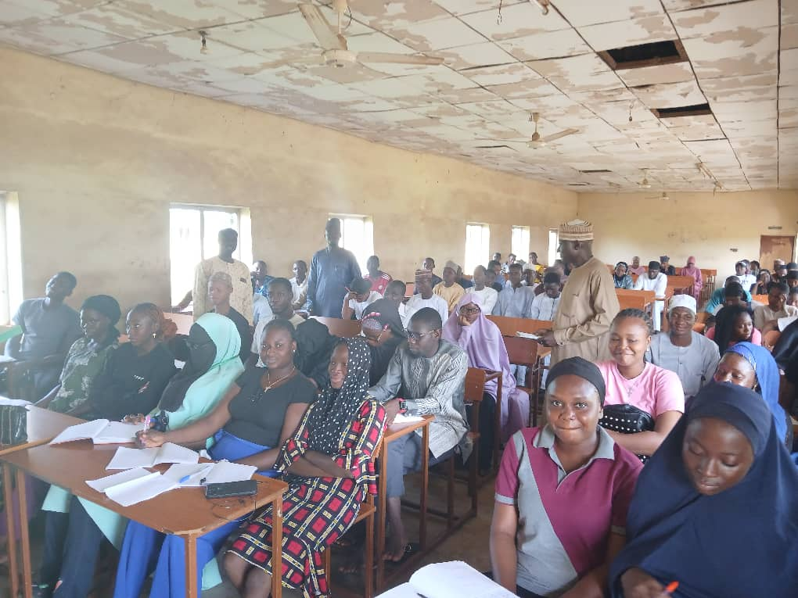

Fig: Picture of Interview with lecturers
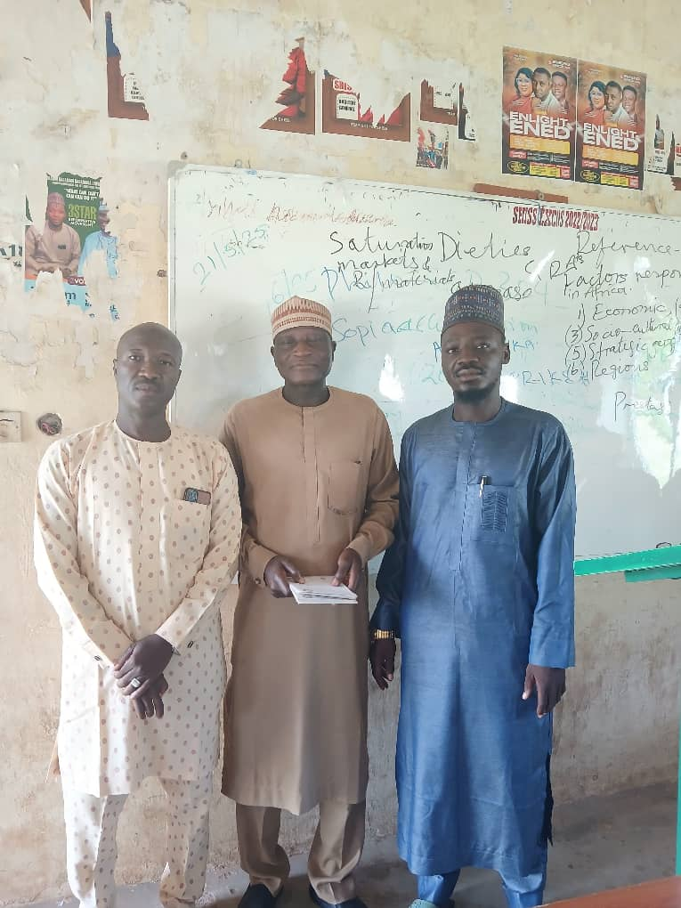

Conclusion
One of the functions of university education is the production of highly qualified human capital with requisite knowledge, skills, ability for critical reflection and reasoning towards solving societal problems. These attributes expected of a learner is affirmed by issuing of a certificate after being subjected to assessment and examination. In most institutions and history courses such assessment is often limited to test items constructed in form of assignments and essay questions. This has the limitation of measuring whole aspects of learning. In this study apart from examining the traditional methods we have also discuss other alternatives that can be used. These includes closed- ended type of exams (multiple choice, fill-in the gap, true or false and matching type) and varieties of dialogues and oral responses. Based on this we conclude that assessment and examination in history undergraduate courses be diversified.

Disclaimer (Artificial intelligence)
Option 1:
Author(s) hereby declare that NO generative AI technologies such as Large Language Models (ChatGPT, COPILOT, etc.) and text-to-image generators have been used during the writing or editing of this manuscript.
Option 2:
Author(s) hereby declare that generative AI technologies such as Large Language Models, etc. have been used during the writing or editing of manuscripts. This explanation will include the name, version, model, and source of the generative AI technology and as well as all input prompts provided to the generative AI technology
Details of the AI usage are given below:
1.
2.
3.
References
Anene, Chidi Pensive (2021). The Imperative of Quality Assurance for Sustainable Quality Education in the Tertiary Institutions: A Case Study of Imo State University, Owerri, Nigeria. International Policy Brief Series Social Science and Law Journal of Policy Review and Development Strategies p-ISSN: 2315-8387 | e-ISSN: 2354-1628
Okafor Ogechukwu Juliet & Dr. Uju P. Egenti.(2021). Education For Sustainable Development In Nigeria UNIJERPS Unizik Journal of Educational Research and Policy Studies VOL.8;
Steven M. Cahn (1990) Morality, Responsibility, and the University: Studies in Academic Ethics Published by: Temple University Press Pages: 288
Ben Clay (2001) Is This a Trick Question? A Short Guide to Writing Effective Test Questions Spiral-bound 1, 2001
Edmunds, J.(2006). How to Assess Students Performance in History. Going beyond Multiple – Choice Test, Green House, University of North Carolina, Server Centre
Federal Government of Nigeria (2014), National Policy on Education. Revised Edition Educational Research and Development Council (NERDC). 6th Edition, 17-29
Mazur, Eric (2014). Assessment: The Silent Killer of Learning. The Brainwaves Video Anthology. Retrieved from https:// www.youtube.com/watch?v=zB-MxdOjl9w 7/5/2024
Omoruan, B.E.(2018). Valid teacher-made tests. Its implication on students’ achievement in Bussiness Education. ATBU, Journal of Science, Technology and Education,6(2),65-77
Eyarefe, Deborah Ibitola and DAKU, Jeremiah Ndazhaga (2020) Leadership Effectiveness and Efficiency in the Administration of University Education In Nigeria: Challenge and Prospects. Nigerian Social Science Education Review Volume 4, Issue 1
Snape, D. and Spencer, L.(2003). The Foundations of Qualitative Research in J. Ritchie and J. Lewis(eds), Qualitative Research Practice: A Guide for Social Science Students and Researchers. London; Sage Publications
Straus,A. and Corbin, J.(1990). Basics of Qualitative Research; Grounded Theory Procedures and Techniques, Newbury Park, CA; Sage publications
Zakariyya, A.A. & Sadiq, H.O.(2020). Item Analysis in Teacher-Made Test: Key to Assurance of Quality in Nigeria Educational System, in Journal of Arts and Education, Lapai, IBB University, 8(1) 134-146

