Improving Grade 11 Students’ Understanding on the
Law of Inertia with PhET Simulations

ABSTRACT
The action research aimed to assess the challenges experience by in learning the First Law of Motion and whether integrating Physics Education Technology (PhET) Interactive Simulations improves students’ conceptual understanding of the Law of Inertia. This aimed to alleviate students’ challenges in learning Law of Inertia due to lack of real-life examples and classroom demonstration of its concepts. The participants were 43 Grade 11 students from General Academic Strand sections, selected through purposive sampling from the entire population. To collect data, an in-depth interview and the Undesrtanding Newton’s First Law of Motion Test were administered to measure the students’ conceptual understanding of the Law of Inertia. Based on the Analysis of Covariance (ANCOVA), the results showed that the students have difficulty in understanding Law of Inertia due to the lack of real-life examples and engagement in learning. Moreover, the findings showed that, although the students’ test performance was generally poor, both the traditional and PhET-integrated approaches were effective and had the potential to improve conceptual understanding among the students. Furthermore, the results indicated that students' conceptual understanding improved significantly more with the use of PhET Interactive Simulations compared to the traditional approach. The researchers recommend the utilization and integration of PhET Interactive Simulations in the classroom to enhance students learning by providing concrete simulations and real-life applications.
Keywords: Science education, conceptual understanding, Grade 11, experimental, PhET Interactive Simulations, Philippines

INTRODUCTION

The research highllights several challenges students face in learning the Law of Inertia, which underpins Newton's First Law of Motion. One of the major difficulties faced by students is conceptual misunderstanding, which primarily rooted from the inability to recognize the connection of inertia with mass (Fadli et al., 2019). Additionally, Supeno et al. (2018) reveals that, even though students are capable of manipulating equations and dealing with unit systems, they face conceptual difficulties like recognizing coordinate axes, drawing free-body diagrams, and understanding vector relationships. These challenges suggest that students frequently lack a functional understanding of fundamental concepts related to forces and motion, including the Law of Inertia.
Several studies have examined the underlying causes of student misconceptions in learning the Law of Inertia. Instructional procedures play a significant role in shaping how students learn and perceive inertia. As stressed by Stocklmayer et al. (2012), Newton's Laws, of which inertia is a functional element, are a complex topic. They further observe that teachers and students face considerable challenges despite efforts to reform pedagogical practices. One particularly challenging factor is the abstract nature of the definition of inertia. Unlike many other physical phenomena, inertia lacks concrete real-world examples and common scenarios, making it difficult for students to fully comprehend. However, Roemmele and Sederberg (2017) demonstrate that everyday experiences—such as being pushed forward in a car seat when the car accelerates—provide valuable opportunities for students to grasp the concept of inertia. Misconceptions often lead students to identify effects of inertia with unrelated causes, which can hinder their ability to effectively apply these concepts in practical situations (Jannah & Ermawati, 2020).
In the local scenario, teaching Law of Inertia is often overlooked by teachers because the recommended curriculum schedulesandate it for the final weeks of the fourth quarter. As a result, many new learners commonly experience conceptual misunderstanding, which contribute to their low academic performance across various subjects. A study by Liu and Fang (2016) revealed that major misconceptions persist in physics and engineering mechanics education, specifically force and acceleration. Accordingly, for both K-12 and college students the most reported misconception about force is it implies force. Additionally, acceleration is often misunderstood as the direction of motion. The same study has identified factors causing students to have various misconceptions about force and acceleration including preconceived misunderstanding and incomplete or partial understanding (Erfan & Ratu, 2018; Liu & Fang, 2016; Yerdelen-Damar, 2015).
The literatures highlighted the existing crisis on students’ difficulty in understanding the Law of Inertia due to lack of conceptual knowledge, lack of real-world demonstration, and time-constraints. Hence, the researchers recognized the necessity of conducting a study to address the identified gaps in the literature by providing a practical intervention to help students conceptually learn the Law of Inertia. There is a need of employ an intervention that enables students to deeply and fully understand the basic principles of Newton’s First Law of Motion. The researchers recommend the urgent impementation of this study, as the interventio allows studnts to use ICT integrated manipulatives, enabling them to explore how the Law of Inertia operates in real-life scenario.
Theoretical Framework
Realizing that student struggles to conceptually understand the First Law of Motion, the researchers began employing a different approach by integrating ICT into Physical Science lessons, particularly focusing on Law of Inertia. Specifically, the researchers utilized PhET Interactive Simulations to help students develop a conceptual understanding of the First Law of Motion. PhET Interactive Simulations are a collection of online simulations developed by the PhET Interactive Simulations project at the University of Colorado Boulder. These simulations provide dynamic, graphical representations of various physics, chemistry, biology, and math concepts, serving as educational tools that enable students to visualize complex phenomena and engage in inquiry-based learning (Khaeruddin & Bancong, 2022). Moreover, the founders of PhET Simulations designed it to be highly engaging and educationally effective where student's interaction with the simulation is directed by the student's own questioning (Adams, et al. 2008).
The simulations provided by PhET are valuable due to its ability to visualize abstract physical phenomena. As reported by Verawati et al. (2022), utilizing PhET virtual simulations in kinematics has shown a statistically significant positive impact on student learning outcomes compared to traditional methods. This supports the idea that visual aids can help students conceptualize motions and forces more effectively, thereby improving their grasp of physics concepts. Similarly, Jebuni-Adanu et al. (2023) found that PhET simulations significantly enhance student interest in physics, clarify misconceptions, and help learners relate concepts to real-life applications.
Moreover, PhET simulations appear to foster higher-order thinking skills. These interactive tools facilitate the understanding of abstract concepts and encourage students to develop analytical and critical thinking abilities (Salame & Makki, 2021). This assertion is reinforced by the study of Sari et al. (2021), which argues that PhET media prompts students to engage in inquiry-based learning, a crucial process for developing higher cognitive skills. By providing scenarios where students can manipulate variables and observe outcomes, these simulations stimulate inquiry and exploration. Shown in Figure 1 is the conceptual framework of this study.
PhET Simulations Integration
Conceptual Understanding of Law of Inertia
Figure 1. Conceptual Framework of the Study
This study investigated the impact of integrating PhET Simulations on students’ conceptual understanding of the Law of Inertia. By integrating PhET simulations, the researchers were able to engage students in meaningful learning experiences, allowing them to develop a deeper conceptual grasp of the Law of Inertia.
Integrating PhET Simulations in classrooms gives students the benefits of virtual simulation, experiential learning, and ICT integration, which collectively contribute to meaningful and effective learning. Research indicates that PhET simulations effectively improve students' conceptual understanding across various STEM subjects, including physics and chemistry. These interactive tools facilitate the visualization of abstract concepts, providing representations that make difficult ideas more accessible and engaging (Lahlali et al., 2023).
METHOD
Research Respondents
The participants of this action research were Grade 11 students of Heracleo Casco Memorial National High School enrolled during the Second Semester of SY 2024 – 2025. Specifically, three students participated in in-depth interviews while two General Academic Stand (GAS) sections were selected to be part of the study. One class underwent the traditional method of teaching, while the other experience the intervention integrating PhET Simulations. These students were the most appropriate participants for this action research since they were introduced to the concepts of the First Law of Motion during the fourth quarter of the second semester. To ensure uniformity among respondents, the researchers employed purposive sampling. Purposive sampling is used as a nonprobability sampling method to intentionally select respondents based on specific criteria relevant to the objectives of the study (Memon et al., 2024).
The Grade 11 GAS students were purposively selected as participants in the study. Specifically, the first section, which received no intervention, consisted of 43 students, while the group that received the intervention consisted of 38 students. Moreover, only regular students who were able to present signed informed consent forms (ICF) were allowed to participate in the study. Students who have failing grades, have back subjects or advance subjects were not allowed to participate.
Materials and Instrument
In collecting the necessary data to investigate the effectiveness of integrating PhET Simulations, the researchers utilized guide questions for the first phase of the data collection. For the second phase, the pre-test and post-test from Quarter 2 Module 6: Understanding Newton’s First Law of Motion by Lat (2020), from the Department of Education, were employed. Both the pre-test and post-test consisted of 15 multiple-choice items assessing students’ conceptual understanding of Newton’s First Law Motion.
Design and Procedure
In realizing the objective of this study, the researchers employed convergent mixed methods design. Mixed methods of research, a complex approach, combines both quantitative and qualitative data within a single study or a series of studies. This design is particularly useful for exploring complex research questions that cannot be fully addresed using only one research approach. Moreover, a mixed methods design is essential for examining relationships between different variables, as such relationships cannot be adequately investigated through a single research design alone (Sharma et al., 2023). For the qualitative phase of this study, three students underwent in-depth interviews. In the quantitative phase, one GAS section was taught using the traditional method, while the other section received the intervention. Furthermore, to analyze the data collected, an independent samples t-test was used to determine the significance of the difference in post-test scores between the two groups. The comparison of these scores indicates the effectiveness of integrating PhET Simulations in improving students' conceptual understanding of the Law of Inertia.
Moreover, the researcher followed a systematic and rigid procedure in collecting the data for this study. Firstly, a letter of permission to conduct the intervention were submitted to the School Principal and Senior High School Coordinator of Heracleo Casco Memorial National High School. Informed assent forms were given to the participants since all of them are 18 years old above. The parents and students were required to affix their signature to the consent and failure in doing so forfeits their participation in the study. The consent forms were translated into vernacular and read aloud to the participants to ensure full understanding. Additionally, the consent forms were collected after one day to allow ample time for the participants to consider their decisions. Upon receiving approval, the researchers immediately commenced the intervention program.
Afterwards, the researchers obtained the class schedule of both GAS sections to allow ample preparation of the lesson to be taught. One section was taught using the traditional method, while the other section was taught with the integration of PhET Simulations.
To examine the efficiency of the intervention, the following data were gathered: (1) pre-test and post-test of the participants from both groups. The test scores served as the basis of the conceptual understanding of the students after learning through traditional method and through the integration of PhET simulations. Further, an Analysis of Covariance (ANCOVA) was employed to determine the significance of the difference on the post-test given that the student groups might have unequal prior knowledge abou the Law of Inertia.
This study adhered to ethical guidelines to safeguard the participants. The manuscript was submitted to the school principal and Senior High School coordinator for a comprehensive review of the ethical aspects of the investigation. Strict compliance with the principles of respect for individuals, beneficence, and justice were considered.
RESULTS AND DISCUSSION
This section presented the discussion of the results and reflection after the implementation of PhET Interactive Simulations in improving the student’s conceptual understanding of the Law of Inertia.
Standpoints of the Participants on Challenges in Learning the First Law of Motion

Using the guide questions, the students were able to express the challenges and difficulty they experience in learning the First Law of Motion. This consisted of a thematic analysis of this research's qualitative data, collected through in-depth interviews. Table 1 shows the focal point on the first column. The second column contains the interview responses' core ideas, combined according to the common essential themes in the third column. In addition, sample responses from the respondents in the in-depth interviews are also presented here.
Table 1: Standpoints of the Participants on Challenges in Learning the First Law of Motion

Focal Point | Core Ideas | Essential Themes
Challenges in Learning the First Law of Motion | This topic is hard to understand because we can't see it.  The examples are very abstract. | Lack of Real-Life Examples
Challenges in Learning the First Law of Motion | I get tired of listening because it's all discussion.  It is boring sometimes, so I do not listen anymore.  I do not like it because there are no activities. | Lack of Engagement or Interest

Lack of Real-Life Examples or Visual Aids. The participants claimed that they are having difficulty understanding the Law of Inertia since the concept is too abstract and they are not able to do activities that can show them how it looks in a real scenario. These responses on the lack of real-world examples appear in the interview responses 1 and 2. Below are the sample responses:
“Ang kani na topic ma’am kay lisod siya sabton kay dili namo makita unya wala sad mi example mabuhat.” – IDIP2

Ma'am, this topic is hard to understand because we can't see it and we also don't have any examples we can do.
The participants have a common theme regarding the lack of real-life examples which makes understanding the Law of Inertia difficult for them. This supports Langi (2024) who emphasized the critical role of real-life applications in understanding fundamental physics concepts, particularly in relation to Newton's Laws of Motion. He further highlighted that students often struggle with low learning outcomes due to a lack of connection between theoretical concepts and real-world scenarios.
Lack of Engagement or Interest. This essential theme emerged from the responses of all the participants. Based on interview responses, their class in the First Law of Motion often gets boring since it is mostly a lecture and only few activities are done. Here are the sample responses:
“Kapuyan ko maminaw kay puro discussion.” – IDIP1

I get tired of listening because it's all discussion.
The essential themes reflected the difficulty and challenges faced by students in learning the First Law of Motion. Mainly, their difficulty is due to lack of concrete examples and activities that may engage them, hence it is necessary for students to work on something they can see and manipulate to be able to learn the topic completely. This finding corroborates with the results of Hai et al. (2023) who highlighted students' tendencies to focus solely on quantitative problem-solving in physics while neglecting conceptual understanding and real-world applications. Accordingly, the lack of engagement with more complex, real-life applications directly correlates to a superficial understanding of fundamental physics concepts, including the Law of Inertia. Students demonstrated a minimal deep understanding of the core competencies required for effective problem-solving, suggesting that their engagement is limited to procedural tasks rather than meaningful explorations of underlying physical principles.
The initial findings of the current study urged the researchers to implement an intervention to help identify and address students’ challenges in understanding Law of Inertia. This allowed immediate and actionable change which focused on improving students’ conceptual understanding among students.
Pre-Test Scores of the Grade 11 GAS Students
Prior to the implementation of the intervention, both groups of students undergone a pre-test assessing their background knowledge regarding the first Law of Motion. Table 2 showed the mean score of the students during the pre-test
Table 2: Mean Score of Students’ Pre-test
Type of Test | Mean | Standard Deviation | Performance Level (%)
Group without intervention | 8.65 | 2.18 | 57.67
Group with intervention | 7.50 | 2.06 | 50.00

It was revealed that during the pre-test, the first group got a mean score of 8.65 while the second group obtained a mean score of 7.50. Both groups performed poorly as seen by their performance barely reaching 50 percent. This implies that the students do not possess yet the knowledge and conceptual understanding about the topic Law of Inertia.
Further, an independent sample t-test was performed to determine any significance difference on the performance level of the students in both groups set at α = 0.05 level of significance. As shown in Table 3, it was revealed that although both groups had poor performance, the first group (M = 8.65) have significantly higher performance than the second group (M = 7.50) as indicated by the p-value of (0.017). This implies that the prior to the introduction of the new topic, the first group had a better conceptual understanding of the first Law of Motion than the second group.

Table 3: Significance of the Difference Between the Pre-test Scores of Groups Without and with Intervention Prior to the Introduction of New Topic

Factor | Group |  |  |  |  |  | t | p-value | Decision  on H_{o}
Factor | Without intervention |  | With intervention |  | Total |  | t | p-value | Decision  on H_{o}
Factor | Mean | SD | Mean | SD | Mean | SD | t | p-value | Decision  on H_{o}
Pre-test | 8.65 | 2.18 | 7.50 | 2.06 | 8.11 | 2.19 | 2.43 | .017 | Reject
* significant at α = 0.05
Post-Test Scores of the Grade 11 GAS Students
After conducting a class on the Law of Inertia, the researchers administered a post-test to assess the conceptual understanding of students who received the intervention and those who did noy. Table 4 shows the post-test scores of the students, revealing that the group taught using the traditional method had a mean score of 10.16, while the group that received the intervention had a mean score of 11.45. Clearly, both groups demonstrated improved performance, implying that both teaching methods helped students build their conceptual understanding of the Law of Inertia.
Table 4: Mean Score of Students’ Post-test
Type of Test | Mean | Standard Deviation | Performance Level (%)
Group without intervention | 10.16 | 2.63 | 67.67
Group with intervention | 11.45 | 2.15 | 76.33

To further confirm the effectiveness of PhET Simulations, an Analysis of Covariance (ANCOVA) was employed to determine the significance of the difference between the post-test scores of student groups while accounting the differennce in their knowledge entry level. As shown in Table 5, the mean score of the group that received the intervention (M = 11.45) is significantly higher than that of the group that did not receive the intervention (M = 10.16), as indicated by the p-value of 0.019. This implies that integrating PhET Simulations in teaching the Law of Inertia did not only improve the conceptual understanding of students but also
Table 5: Analysis of Covariance of Post-test Scores of Groups Without and with Intervention After the Introduction of New Topic

Factor | Group |  |  |  |  |  | F | p-value | Decision  on H_{o}
Factor | Without intervention |  | With intervention |  | Total |  | F | p-value | Decision  on H_{o}
Factor | Mean | SD | Mean | SD | Mean | SD | F | p-value | Decision  on H_{o}
Post-test | 10.16 | 2.62 | 11.45 | 2.15 | 10.77 | 2.49 | 5.701 | .019 | Reject
* significant at α = 0.05

had an advantage over the traditional method of teaching. This finding confirms the notion raised by numerous research and theories. As emphasized by Verawati et al. (2022), utilizing PhET virtual simulations in kinematics has shown a statistically significant positive impact on student learning outcomes compared to traditional methods. In addition, Jebuni-Adanu et al. (2023) found that PhET simulations significantly clarify misconceptions and help learners relate concepts to real-life applications. As Wancham et al. (2023) argued, it is critical that students learn the first Law of Motion, with the realization that misconceptions about force and Laws of Motion constrain students' performance in understanding mechanics and physics.
CONCLUSION
The findings from the qualitative phase of the study indicate that the students face difficulty in understanding the topic due to the absence of real life examples and engaging activities in the classroom. This implies that their learning can be improved by involving them to more real-life activities and simulations related to the First Law of Motion.
Moreover, the findings of the current study suggest that both traditional method and ICT integration strategies helped students develop conceptual understanding of the First Law of Motion. This highlights that teaching methods and strategies are not the only underlying factor which could impact student learning.
Furthermore, the integration of PhET Interactive Simulation in classroom offers significant advantages over traditional teaching methods. Through this integration, students developed deeper conceptual understanding of the First Law of Motion.
Lastly, the findings suggest that integrating different ICT-based simulations and manipulatives in physics classes enhances students’ conceptual understanding. These interactive tools facilitate the visualization of abstract concepts by providing representations that make difficult ideas more accessible and engaging. Utilizing this strategy benefits not only teachers but, more importantly, students, as the simulations offer student-friendly and engaging activities that promote effective learning.
RECOMMENDATION
It is recommended that educators combine traditional teaching methods with ICT-based strategies, such as simulations and interactive tools, to enhance students’ conceptual understanding of physics concepts. While teaching methods play a crucial role, this study suggests that other factors also influence learning outcomes, emphasizing the need for a more holistic instructional approach.
Specifically, integrating tools like PhET Interactive Simulations into physics lessons can significantly improve students’ understanding by making abstract concepts more visual and engaging. Teachers should incorporate a variety of digital simulations and manipulatives to support active learning and better concept retention.

Ethical Approval:
As per international standards or university standards written ethical approval has been collected and preserved by the author(s)
Consent
As per international standards or university standards, Participants’ written consent has been collected and preserved by the author(s).

ACKNOWLEDGMENT
The researchers could have never reached this accomplishment without the aid of the individuals who invested time and effort in the process of completing this research. For this very reason, we would like to acknowledge all the people who offered their sincere assistance to this study, to wit:
Dr. Mayjury P. Garcia, our research adviser, for her constant support, motivation, patience, and enthusiasm in the pursuit of this study and for her immense knowledge and advice that significantly contributed to making the research meaningful;
Mr. Joseph P. Enero, the statistician, for sharing his immense knowledge and expertise in statistics that immensely helped in developing the accuracy of the results;
To the school head of Heracleo Casco Memorial National High School: Dr. Estrelita A. Ramos, for extending her support and cooperation in gathering the data from their respective schools;
Dr. Nerwyn Z. Samoro, the coordinator of HCMNHS Senior High School department, for his invaluable supervision and encouragement;
Above all, to the Almighty Father, for His love, wisdom, and strength, guiding the researchers each day. They trusts in His plan, knowing all falls into place through Him.

Disclaimer (Artificial intelligence)
Option 2:
Author(s) hereby declare that generative AI technologies such as Large Language Models, etc. have been used during the writing or editing of manuscripts. This explanation will include the name, version, model, and source of the generative AI technology and as well as all input prompts provided to the generative AI technology
Details of the AI usage are given below:
1. The authors used Grammarly to maintain consistency and accuracy of grammars. The same software was also used to paraphrase some statements to better convey its theme.

REFERENCES
Adams, W.K., Reid, S., LeMaster, R., McKagan, S.B., Perkins, K.K., Dubson, M. & Wieman, C.E. (2008). A Study of Educational Simulations Part I - Engagement and Learning. Journal of Interactive Learning Research, 19(3), 397-419. Waynesville, NC: Association for the Advancement of Computing in Education (AACE). Retrieved June 18, 2025 from https://www.learntechlib.org/primary/p/24230/.
Erfan, M., & Ratu, T. (2018). Analysis of student difficulties in understanding the concept of Newton's law of motion. JIPF (Jurnal Ilmu Pendidikan Fisika), 3(1), 1-4. http://dx.doi.org/10.26737/jipf.v3i1.161
Fadlli, M. R., Sutopo, S., & Wartono, W. (2019). Analisis kesulitan siswa dalam menyelesaikan soal hukum newton. Jurnal Pendidikan: Teori, Penelitian, Dan Pengembangan, 4(8), 993. https://doi.org/10.17977/jptpp.v4i8.12652
Hai, N., Le, H., Thanh, H., & Le, V. (2023). Perception and behavior of high school students towards developing problem solving and creativity skills to solve physics assignments. International Journal of Education and Practice, 11(3), 692-701. https://doi.org/10.18488/61.v11i3.3479
Jannah, E. M. and Ermawati, F. U. (2020). Identify 11th grade of senior high school jogoroto students’ misconceptions on dynamic rotation and rigid body equilibrium concepts using four-tier diagnostic test. Journal of Physics: Conference Series, 1491(1), 012010. https://doi.org/10.1088/1742-6596/1491/1/012010
Jebuni-Adanu, C., Antwi, V., Michael, D., Fortune, G., Wuver, A., Sontaa, I., … & Acquah, I. K. (2023). Utilizing physics education technology (phet) for improving students' understanding of energy conversion and conservation in a senior high technical school. Journal of Education and Practice. https://doi.org/10.7176/jep/14-8-06
Khaeruddin, K. and Bancong, H. (2022). Stem education through phet simulations: an effort to enhance students’ critical thinking skills. Jurnal Ilmiah Pendidikan Fisika Al-Biruni, 11(1), 35-45. https://doi.org/10.24042/jipfalbiruni.v11i1.10998
Lahlali, A., Chafiq, N., Radid, M., Moundy, K., & Srour, C. (2023). The effect of integrating interactive simulations on the development of students’ motivation, engagement, interaction and school results. International Journal of Emerging Technologies in Learning (iJET), 18(12), 193-207. https://doi.org/10.3991/ijet.v18i12.39755
Langi, J. (2024). The influence of problem-based learning models on student learning outcomes on dynamic fluid material. Jurnal Syntax Transformation, 5(3), 757-764. https://doi.org/10.46799/jst.v5i3.940
Lisnawati, D., Elvirasari, D., Santoso, I. (2019). Improving student writing ability in narrative text through think talk write method at tenth grade of smk pgri 3 cimahi. project (professional journal of english education), 2(3), 306. https://doi.org/10.22460/project.v2i3.p306-309
Liu, Gang & Fang, Ning. (2016). Student misconceptions about force and acceleration in physics and engineering mechanics education. International Journal of Engineering Education, 32(1), 19-29.
Memon, M., Thurasamy, R., Ting, H., & Cheah, J. (2024). Purposive sampling: a review and guidelines for quantitative research. Journal Of Applied Structural Equation Modeling, 9(1), 1-23. https://doi.org/10.47263/jasem.9(1)01
Roemmele, C. and Sederberg, D. (2017). Lazy days: an active way to put newton’s first law into motion (or rest). The Physics Teacher, 55(5), 285-287. https://doi.org/10.1119/1.4981035
Salame, I. I. and Makki, J. (2021). Examining the use of phet simulations on students’ attitudes and learning in general chemistry ii. Interdisciplinary Journal of Environmental and Science Education, 17(4), e2247. https://doi.org/10.21601/ijese/10966
Sari, E. D. R., Khairani, D., Subchi, I., Durachman, Y., Rifai, A., & Rosyada, D. (2021). Application of phet simulation media in physics learning during a pandemic covid-19. Proceedings of the 3rd International Colloquium on Interdisciplinary Islamic Studies, ICIIS 2020, 20-21 October 2020, Jakarta, . https://doi.org/10.4108/eai.20-10-2020.2305146
Sharma, L., Bidari, S., Bidari, D., Neupane, S., & Sapkota, R. (2023). Exploring the mixed methods research design: Types, purposes, strengths, challenges, and criticisms. Glob Acad J Linguist Lit, 5 (1), 3-12. https://doi.org/10.36348/gajll.2023.v05i01.002
Stocklmayer, S., Rayner, J., & Gore, M. (2012). Changing the order of newton's laws—why &amp; how the third law should be first. The Physics Teacher, 50(7), 406-409. https://doi.org/10.1119/1.4752043
Supeno, S., Subiki, S., & Rohma, L. (2018). Students’ ability in solving physics problems on Newtons’ law of motion. Jurnal Ilmiah Pendidikan Fisika Al-Biruni, 7(1), 59. https://doi.org/10.24042/jipfalbiruni.v7i1.2247
Verawati, N. N. S. P., Handriani, L. S., & Prahanı, B. K. (2022). The experimental experience of motion kinematics in biology class using phet virtual simulation and its impact on learning outcomes. International Journal of Essential Competencies in Education, 1(1), 11-17. https://doi.org/10.36312/ijece.v1i1.729
Wancham, K., Tangdhanakanond, K., & Kanjanawasee, K. (2023). Sex and grade issues in influencing misconceptions about force and laws of motion: an application of cognitively diagnostic assessment. International Journal Oo Instruction, 16(2), 437-456. https://doi.org/10.29333/iji.2023.16224a
Weng, MC., Liao, CH., Kwok, OM., & Wu, J. (2024). Breaking the law of inertia for students with poor grit and achievement: The predictive mechanism of grit on the short-term and long-term achievement. Asia-Pacific Edu Res 33(1), 1303–1314. https://doi.org/10.1007/s40299-023-00802-5
Yerdelen-Damar, Sevda. (2015). Obstacles to reasoning about inertia in different contexts. European Journal of Physics Education, 6(1), 1-11. http://dx.doi.org/10.20308/ejpe.14243

APPENDICES
APPENDIX A
Guide Questions
Research Question: What are the challenges faced by students in learning the First Law of Motion?
Guide Questions:
- Do you consider learning the Law of Inertia difficult? Why?
- What do you think makes the topic difficult?
- In the classroom, how does your teacher teach you about the topic?
- What makes learning the topic difficult for you?
- What do you think can be improved for you to learn the topic better?

APPENDIX B
Undesrtanding Newton’s First Law of Motion Test
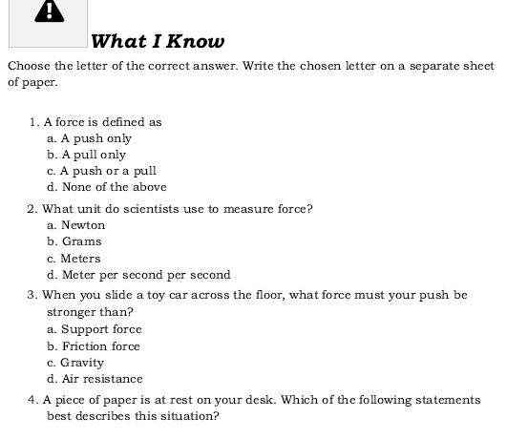
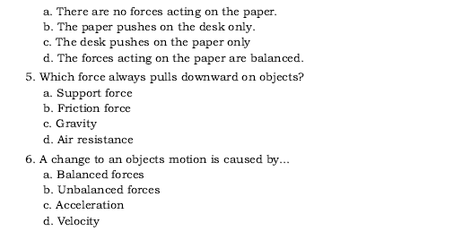
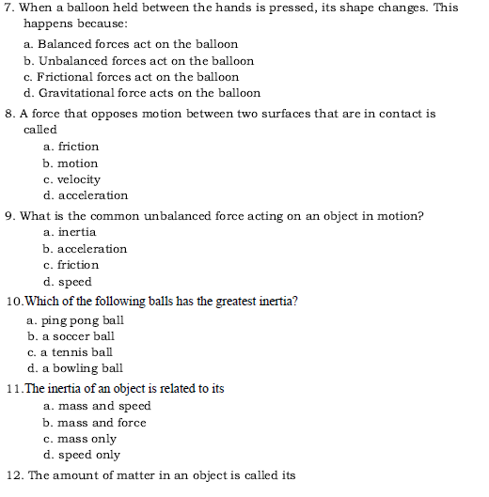
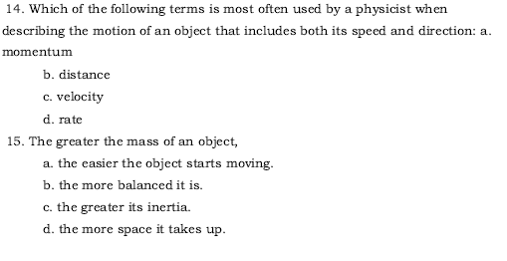
APPENDIX C
Data Analysis Result
Pre-Test
Descriptives

Inferential (t-test)

Post-Test
Descriptives
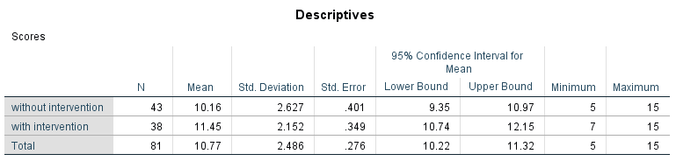

Inferential (ANCOVA)


