**Promoting Intangible Cultural Heritage through New Media: A Case Study of Nuo Culture Dissemination by a Chinese NGO**

**ABSTRACT**

This study aims to explore how non-governmental organizations (NGOs) navigate the balance between tradition and innovation in the preservation of intangible cultural heritage (ICH) in the rapidly digitalizing world. Focusing on the Anshun Mask and Nuo Sculpture Culture Company’s promotional efforts on new media platforms, this research examines how digital storytelling and visual culture enhance public engagement with Nuo culture, an indigenous ICH facing modern challenges. Based on fieldwork, individual interviews, and focus group discussions, and participation in ICH among different stakeholders. Findings suggest that visually engaging, context-based communication on new media platforms are particularly effective in capturing the attention of younger audiences and raising cultural consciousness. The study also highlights both the opportunities and tensions that NGOs are struggling with in their efforts to advocate for both intangible and tangible cultural heritage preservation in an increasingly complex media landscape.

Keywords: Intangible Cultural Heritage, NGOs, Nuo Culture, New Media Platform, Digital Media, Cultural Preservation, Youth Engagement

**INTRODUCTION**

Ever since the adoption of the Convention for the Safeguarding of the Intangible Cultural Heritage (CSICH) in 2003, indigenous and minority intangible cultural heritage (ICH) have enjoyed increasing recognition (Eichler, 2021). However, with the accelerated progress of globalization, ICH plays a crucial role in the development of cultural identity and diversity (Neyrinck, 2017). To date, thousands of years of civilization, a vast area, and the joint efforts of people of all ethnic groups have created these cultural heritages, which represent the important cultural wealth of human civilization (Joy & Charlotte, 2017). However, the preservation of the ICH has become a big challenge for any country in the world that has the will to safeguard this wealth and to win the battle of cultural safeguarding (Hammou et al., 2020). In this context, social media plays an important role in the protection of cultural identity by offering a platform for individuals to express and protect their cultural heritage (Indah et al., 2024). Research shows that social media allows users to navigate polymedia settings, displaying various aspects of their identity, including national and cosmopolitan expressions (Echesony, 2022). Conversely, the use of social media significantly influences the cultural and behavioral perspectives of young people (Lajnef, 2023). Various oversea studies show that social media channels such as Instagram, Twitter, and YouTube play an important role in shaping adolescent behavior and building patterns for future generations (Vidal et al., 2020). Compared to the increasing number of international studies on digital heritage practices, Chinese scholarship has paid relatively little attention to the role of new media in promoting intangible cultural heritage. Accordingly, this study examines the dissemination practices of the Anshun Mask and Nuo Carving Art Culture Company on Douyin and Xiaohongshu, aiming to provide actionable recommendations that can guide future communication strategies for the promotion of ICH.

**PROBLEM STATEMENT**

In recent decades, the preservation and transmission of ICH have become increasingly complex due to the dual forces of globalization and digitalization. Although international frameworks such as the Convention for the Safeguarding of the Intangible Cultural Heritage (UNESCO, 2003) have significantly raised awareness of cultural diversity and traditional practices, many local and indigenous forms of ICH continue to face erosion, neglect, or commercial distortion. In China, despite a rich reservoir of ICH practices, there remains a notable disconnect between traditional forms of cultural expression and the media consumption habits of younger generations. Moreover, generational and technological gaps pose challenges for the effective dissemination of ICH in the digital era, especially in attracting youth engagement and fostering cultural identification.

To better understand how digital platforms influence the relationship between traditional culture and contemporary audiences, this study draws upon the Stimulus-Organism-Response (S-O-R) theoretical framework. The Stimulus–Organism–Response (S-O-R) model is a widely recognized theoretical framework originally developed by Mehrabian and Russell (1974). Originally developed in psychology and later extended to media and consumer behavior studies, the model categorizes the process into three fundamental components. Stimulus (S): the external environment encountered by the individual at a specific moment (Jacoby, 2002).Organism (O): the individual’s internal processing system, including

prior experiences, knowledge, beliefs, attitudes, emotions, values, and personality traits (Jacoby, 2002); Response (R): the resulting behaviors or reactions, often conceptualized as approach or avoidance actions (Vieira, 2013). In the context of this study, stimuli may include visual storytelling, livestreamed performances, or interactive features such as bullet comments and hashtag engagement on platforms like Douyin and Xiaohongshu. These media stimuli influence how individuals interpret, emotionally connect with, and respond to cultural content.

Within this qualitative inquiry, the S-O-R model serves not as a rigid causal schema but as a sensitizing framework that guides the exploration of meaning-making processes among different actors involved in ICH dissemination. Rather than testing fixed hypotheses, the model helps structure observations and interpretations of how new media affordances shape cultural engagement, reinterpretation, and participation. By examining the interplay between mediated stimuli and audience responses, this study aims to reveal how NGOs, cultural practitioners, and digital platforms co-construct new pathways for sustaining intangible heritage in a rapidly evolving media landscape. Therefore, this study aims to explore the communication practices of the Anshun Mask and Nuo Carving Art Culture Company in the context of new media, with the intention of identifying meaningful strategies and insights that could inform and inspire similar efforts by other non-profit organizations engaged in intangible cultural heritage dissemination.

Figure 1. Conceptual Framework: Application of the S-O-R Model in ICH Dissemination(Adapted from Mehrabian & Russell, 1974)

Organism (O)

Response (R)

Stimulus (S)

1. Engagement
2. Participation
3. Reinterpretation
4. Cultural Advocacy
5. Interpretive Expression
6. Cultural identification
7. Cognitive processing
8. Emotional resonance
9. Value judgment
10. Identity negotiation
11. Douyin videos
12. Xiaohongshu text posts
13. Storytelling-based documentary
14. Live-streamed performances with real-time bullet comments

**RESEARCH OBJECTIVES AND QUESTIONS**

This study sets out to achieve the following objectives:

i. To explore how non-governmental organizations (NGOs) engage with intangible cultural heritage (ICH) through new media platforms in the 21st century.

ii. To examine the perceptions and experiences of ICH practitioners regarding the integration of new media in their cultural practices.

iii. To investigate the strategies and storytelling methods employed by NGOs to disseminate ICH content in the digital media landscape

RQ1: How do NGOs utilize new media platforms to promote and preserve intangible cultural heritage in the digital era?

RQ2: What are the perceptions and lived experiences of ICH practitioners regarding the use of digital tools in their cultural dissemination efforts?

RQ3: What communication strategies and narrative techniques are adopted by NGOs to engage audiences, particularly youth, with ICH content online?

**METHODOLOGY**

**Research Design**

This study adopted a qualitative interview design to explore participants’ subjective experiences and interpretations regarding the dissemination of intangible cultural heritage (ICH) through new media platforms. A qualitative approach is particularly suited for in-depth exploration of meaning-making processes, especially in cultural and communicative contexts (Lim, 2024). This method is expected to provide a deep understanding of the relationship between social media use and the maintenance of cultural identity.

**Data Collection**

To elicit rich and context-sensitive narratives, semi-structured interviews were employed. This format allowed for flexibility in probing unanticipated yet relevant themes, while still aligning with the study’s guiding questions (Smith & Osborn, 2015). Interviews were conducted in person in Liu Guan Town, Anshun City, Guizhou Province, a key cultural site associated with Nuo performance and mask carving traditions.

Thirteen (13) participants were recruited through purposive sampling, a non-probability method appropriate for selecting individuals with specific knowledge or experience related to the research focus (Palinkas et al., 2015). Sampling continued until data saturation was achieved—that is, when no new significant themes emerged from the interviews (Guest et al., 2020). The final sample included a diverse mix of stakeholders:

Table 1. List of Participants in the Research Interview

Number of Position in the Whether working

Participants dissemination of ICH for a NGO

2 Participants 1 Manager and 1 Staff from local Yes, both of

Non-Governmental Organization them

3 Participants 2 drama performers from Yes, they’re

local community partnership

2 Participants 2 Mask Craftsman from Yes, both of

Non-Governmental Organization them

4 Participants 3 Audiences in the 16-60 age ranges No, they are

from the local community villagers

2 Participants 1 Master’s student from Spain No, they are

who is interested in Nuo culture students

1 Bachelor’s student from China

who did fieldwork in that village

Total 13

This diversity ensured a range of perspectives across creators, mediators, and recipients of ICH communication.

**Figure 2.** Interview Schedule and Affiliation Structures

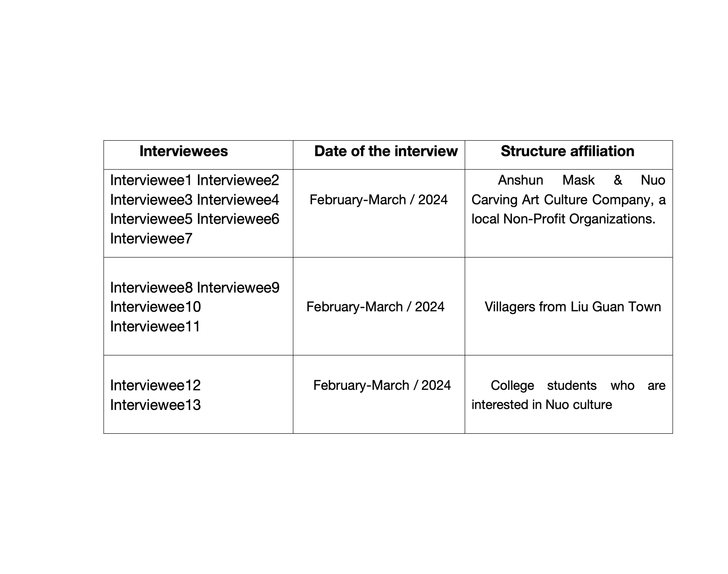

**Data Analysis**

Thematic Analysis (TA), as outlined by Braun and Clarke (2021), was used to identify and interpret recurrent patterns in participants’ narratives. This six-phase process included familiarization with data, initial coding, theme generation, theme review, theme definition, and final report production. NVivo 14 software was employed to systematically manage, code, and retrieve data, enhancing transparency and analytical rigor (Nowell et al., 2017).

To ensure trustworthiness, codes and themes were reviewed iteratively. Coding reliability was established through multiple rounds of review by the primary researcher. Thematic saturation was achieved after 13 interviews, as no new insights emerged in the final transcripts. A coding framework was developed to trace how initial codes evolved into themes. Participants’ identities were anonymized, and ethical approval was granted by the Universiti Putra Malaysia Research Ethics Committee.

All participants were informed of the research purpose, procedures, and their right to withdraw at any time. Informed consent was obtained prior to participation. The identities of participants were anonymized to protect confidentiality, and the study adhered to the ethical guidelines set forth by the University Putra Malaysia Research Ethics Committee.

**FINDINGS AND DISCUSSION**

This study aimed to explore the interplay between non-profit organizations (NPOs), intangible cultural heritage (ICH), and new media in the context of Anshun, China. Through thematic analysis of 13 in-depth interviews with various stakeholders, craftspeople, performers, NGO staff, audience members, and students, three major themes emerged, aligning with the research objectives.

1. **Interconnected roles of NGOs, ICH and New Media**

The first objective focused on understanding the evolving relationships among NGOs, ICH, and new media. Participants consistently described NGOs as critical vehicles for the transmission and preservation of ICH. In this regard, NGOs were not merely support systems but cultural agents whose planning and operations revolved around heritage advocacy.

As illustrated by one craftsman:

“*Every day I see him in the office editing videos or live-streaming. Most of the time, I hear him talking about Nuo culture.*” — Mr. Gong, mask craftsman

This exemplifies how NGO leaders integrate digital tools into their daily cultural routines, using media to sustain visibility and engagement.

New media platforms were widely recognized as playing an amplifying and bridging role. Several interviewees pointed out that social media enhances accessibility and helps bridge generational gaps in cultural communication. Participants saw these platforms as creating broader access and audience interaction, especially among youth.

“*He filmed our performances during COVID-19 and uploaded them to Douyin. That attracted attention from outside the province.*” — Mr. Lei, Nuo drama performer

This suggests that digital media enables localized ICH practices to gain national and even international visibility, thereby reinforcing the significance of NGOs in using media affordances to support cultural revitalization.

1. **Current Media Practices among ICH Practitioners**

The second objective examined how ICH practitioners currently use different types of new media in their cultural activities. Most participants actively used platforms like **Douyin (TikTok)** and **Xiaohongshu (RED)**. Douyin was praised for its immediacy and wide reach, while Xiaohongshu was preferred by those targeting younger, urban audiences due to its visual and narrative appeal.

“*I often record our theatre performances and post them on Douyin. The feedback motivates our team to keep performing.*” — Mr. Sun, theatre team leader

“*I prefer Xiaohongshu because it attracts young people. More students are now visiting our organization*.” — Mr. Qin, NGO manager

These insights reflect a growing digital literacy among ICH practitioners and a pragmatic approach to platform selection based on audience engagement and strategic cultural positioning.

Interestingly, several young interviewees stated that they discovered Nuo culture through social media, often before visiting the site physically. This indicates the strong influence of online platforms on offline cultural tourism and academic interest.

*“I found Mr. Qin’s Xiaohongshu account, which led me to visit Liu Guan Town and study Nuo culture for my documentary production.*” — Miss Li, student, Yibin College

Such cases underscore the persuasive impact of well-managed cultural social media presences in attracting public and scholarly attention.

**3. Sustainable Dissemination Strategies of NGOs in the New Media Era**

The third objective addressed the sustainability of cultural dissemination strategies. Interview data revealed four main mechanisms: academic collaboration, media coverage, livestreaming, and continuous content production.

“*He partners with universities and invites students for fieldwork. It’s a great model for cultural exchange*.” — Anonymous participant

*“I saw his interview on Douyin. That’s how I got to know his organization and visited during the Spring Festival.*” — Miss He, postgraduate student in Spain

These strategies reflect a multilateral approach to public engagement that combines traditional outreach (e.g., university partnerships) with contemporary digital tools. Such integration contributes to the long-term visibility and viability of ICH practices.

**4. Synthesis and Implications**

The findings reveal that NGOs serve as both cultural custodians and digital communicators. They simultaneously preserve heritage and innovate in its dissemination through new media. This dual function not only strengthens community ties but also attracts attention from younger demographics, scholars, and tourists. Moreover, platforms like Douyin and Xiaohongshu are more than distribution channels; they are spaces where cultural narratives are negotiated and reimagined. NGO leaders, especially those like Mr. Qin, play pivotal roles in mediating these narratives and ensuring their resonance across diverse publics.These insights support prior literature on the role of digital media in heritage communication (e.g., Giaccardi, 2012; Knudsen & Waade, 2010) and offer a grounded example of how grassroots NGOs can achieve sustainable cultural dissemination in a rapidly evolving media ecosystem.

**CONCLUSION**

This study has examined the current status, advantages, challenges, and strategic approaches adopted by non-governmental organizations (NGOs) in the dissemination of intangible cultural heritage (ICH) in the new media era. Using the case of the Anshun Mask and Nuo Sculpture Culture Company, it highlights how digital platforms such as Douyin and Xiaohongshu have been effectively leveraged to promote ICH. By showcasing the craftsmanship, cultural narratives, and symbolic meanings of Nuo sculpture and drama in engaging and visually appealing ways, the organization has succeeded in reaching wider audiences and generating positive public response. Nevertheless, despite these achievements, the sustainable development of cultural dissemination remains a pressing concern. Based on empirical findings and insights derived from interview data, this study has proposed a series of practical strategies intended to inform both theory and practice in the field of ICH preservation. These recommendations are grounded in real-world challenges and possess meaningful applicability to similar heritage-related efforts elsewhere, thereby contributing to the continued inheritance and development of traditional culture.

**RECOMMENDATION**

Drawing on the perspectives of interviewees, this study underscores the importance of integrating textual and visual elements in the dissemination of ICH through digital media. While many NGOs acknowledge the value of this integrated communication approach, they often encounter challenges due to limited professional expertise and financial constraints. To address these issues, several recommendations are proposed. First, continued and stable financial support from local authorities is crucial, especially for smaller NGOs with constrained resources. Second, capacity-building initiatives—such as regular workshops and knowledge-sharing sessions—are needed to enhance the media literacy and digital production skills of NGO staff. Lastly, collaboration with professional short video production or digital storytelling teams can significantly improve the quality, appeal, and reach of heritage-related content, thereby supporting the long-term sustainability of ICH dissemination in the digital age.

**LIMITATION**

This study employed in-depth interviews and focus group discussions as primary data collection methods, which may introduce certain biases. Some participants, particularly those residing in remote areas for extended periods, may have misunderstood the questions or responded based on individual perceptions shaped by their unique socio-cultural backgrounds. To mitigate this limitation, the interview questions were designed to be clear, simple, and unbiased, aiming to reduce potential misinterpretation. Additionally, confidentiality was assured to all participants, encouraging them to respond truthfully. The use of multiple data sources also helped to minimize subjective bias and enhance the credibility of the findings. Despite efforts to address these challenges, the study has several limitations. Firstly, the findings may not be generalizable to other regions or cultural contexts, as the sample was limited to a single area in southwestern China. Secondly, due to time constraints, the fieldwork was conducted over a relatively short three-month period during the 2024 Chinese New Year, potentially limiting the depth and longitudinal understanding of the phenomena. Lastly, because of financial, equipment, and technical constraints, only a 30-minute documentary film on ICH and NGOs was produced following the interviews. While it serves as a valuable supplement to the research, it may not capture the full complexity of the social dynamics under investigation.

**REFERENCE**

Abraham, S., & Abraham, J. (2015). The role of curiosity in making up digital content promoting cultural heritage. Procedia - Social and Behavioral Sciences, 184, 259–265. <https://doi.org/10.1016/j.sbspro.2015.05.089>

Echesony, G. (2024). Impact of social media on cultural identity in urban youth. American Journal of Arts, Social and Humanity Studies, 4(2), 1–11.

Eichler, J. (2020). Intangible cultural heritage, inequalities and participation: Who decides on heritage? The International Journal of Human Rights, 25(5), 793–814. <https://doi.org/10.1080/13642987.2020.1822821>

Giaccardi, E. (2012). Heritage and social media: Understanding heritage in a participatory culture. Routledge.

Guest, G., Namey, E., & Chen, M. (2020). A simple method to assess and report thematic saturation in qualitative research. PLOS ONE, 15(5), e0232076. <https://doi.org/10.1371/journal.pone.0232076>

Hammou, I., Aboudou, S., & Makloul, Y. (2020). Social media and intangible cultural heritage for digital marketing communication: Case of Marrakech crafts.

Indah, K., Candraningtyas, R., Nabilah, S., Hafiz, A. R. Y., Huseini, L. I., Purwanto, E., ... & Ghanistyana, L. P. (2024). The use of social media in maintaining cultural identity. International Journal of Progressive Sciences and Technologies (IJPSAT), 45(1), 103–112.

Jacoby, J. (2002). Stimulus–organism–response reconsidered: An evolutionary step in modeling consumer behavior. Journal of Consumer Psychology, 12(1), 51–57. <https://doi.org/10.1207/S15327663JCP1201_05>

Joy, C. (2017). UNESCO on the ground: Local perspectives on intangible cultural heritage. Journal of Anthropological Research, 73(4), 507–523.

Knudsen, B. T., & Waade, A. M. (Eds.). (2010). Re-investing authenticity: Tourism, place and emotions (Vol. 20). Channel View Publications.

Lajnef, K. (2023). The effect of social media influencers on teenagers’ behavior: An empirical study using cognitive map technique. Current Psychology. Advance online publication. <https://doi.org/10.1007/s12144-023-04273-1>

Lim, W. M. (2025). What is qualitative research? An overview and guidelines. Australasian Marketing Journal, 33(2), 199–229.

Manghisi, V. M., Uva, A. E., Fiorentino, M., Gattullo, M., Boccaccio, A., & Monno, G. (2018). Enhancing user engagement through the user-centric design of a mid-air gesture-based interface for the navigation of virtual tours in cultural heritage expositions. Journal of Cultural Heritage, 32, 186–197. <https://doi.org/10.1016/j.culher.2018.02.014>

Mehrabian, A., & Russell, J. A. (1974). An approach to environmental psychology. MIT Press.

Neyrinck, J. (2017). Intangible cultural heritage in times of ‘superdiversity’: Exploring ways of transformation. International Journal of Intangible Heritage, 12, 157–174.

Palinkas, L. A., Horwitz, S. M., Green, C. A., Wisdom, J. P., Duan, N., & Hoagwood, K. (2015). Purposeful sampling for qualitative data collection and analysis in mixed method implementation research. Administration and Policy in Mental Health, 42(5), 533–544. <https://doi.org/10.1007/s10488-013-0528-y>

Smith, J. A., & Osborn, M. (2015). Interpretative phenomenological analysis as a useful methodology for research on the lived experience of pain. British Journal of Pain, 9(1), 41–42. <https://doi.org/10.1177/2049463714541642>

UNESCO. (2003). Convention for the safeguarding of the intangible cultural heritage. Proceedings of the 32nd Session of the General Conference of the United Nations Educational, Scientific and Cultural Organization, Paris, France, 29 September–17 October 2003.

Vieira, V. A. (2013). Stimuli–organism–response framework: A meta-analytic review in the store environment. Journal of Business Research, 66(9), 1420–1426. <https://doi.org/10.1016/j.jbusres.2012.05.009>

Vidal, C., Lhaksampa, T., Miller, L., & Platt, R. (2020). Social media use and depression in adolescents: A scoping review. International Review of Psychiatry, 32(3), 235–253. <https://doi.org/10.1080/09540261.2020.1720623>

**Appendix 1: Sample coding framework table**

| **Initial Code** | **Focused Code** | **Theme** |
| --- | --- | --- |
| Video editing, livestreaming | Use of visual media | New Media as Catalyst for Dissemination |
| Comments and reactions on Douyin | Audience feedback | Community Engagement via Douyin |
| Free performances in museum | Cultural outreach | NPOs as Agents of ICH Promotion |
| Student found NGO via Xiaohongshu | Youth discovery through visuals | Xiaohongshu for Youth Engagement |
| University collaboration | Strategic outreach | Sustainable NPO Promotion |
| Participation in academic conferences | Institutional presence | Visibility through Academia |

**Appendix 2: Secondary school students are visiting this NGO**

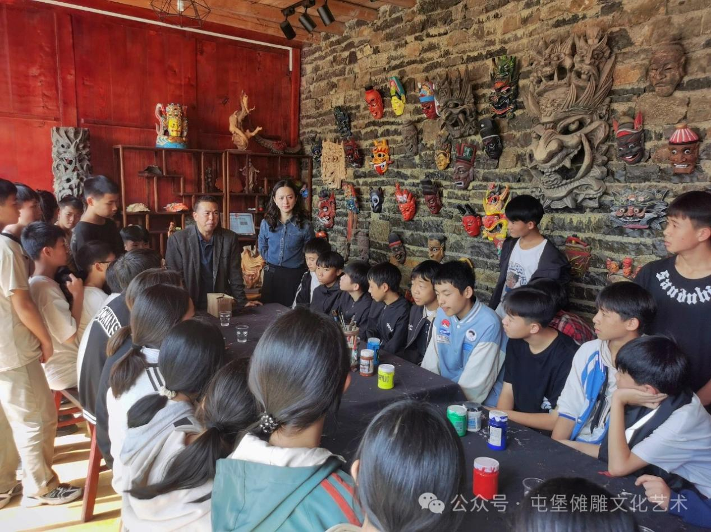

**Appendix 3: The leader of this NGO is explaining the history of local ICH**

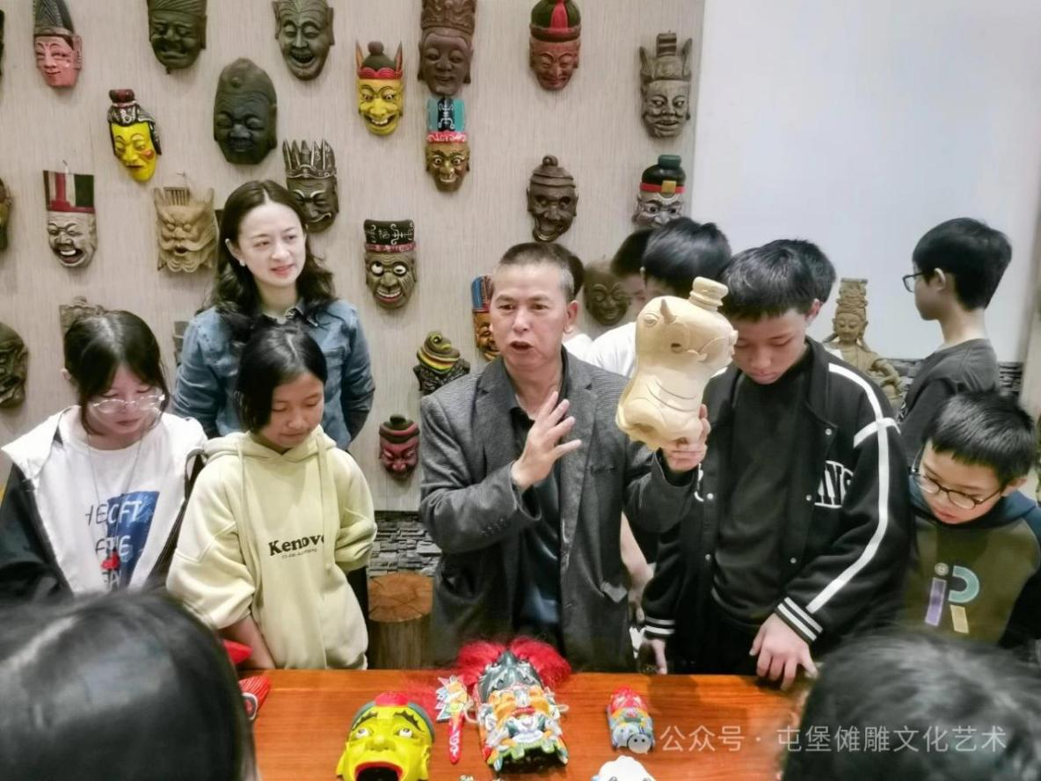

**Appendix 4: The wall of awards of this NGO**

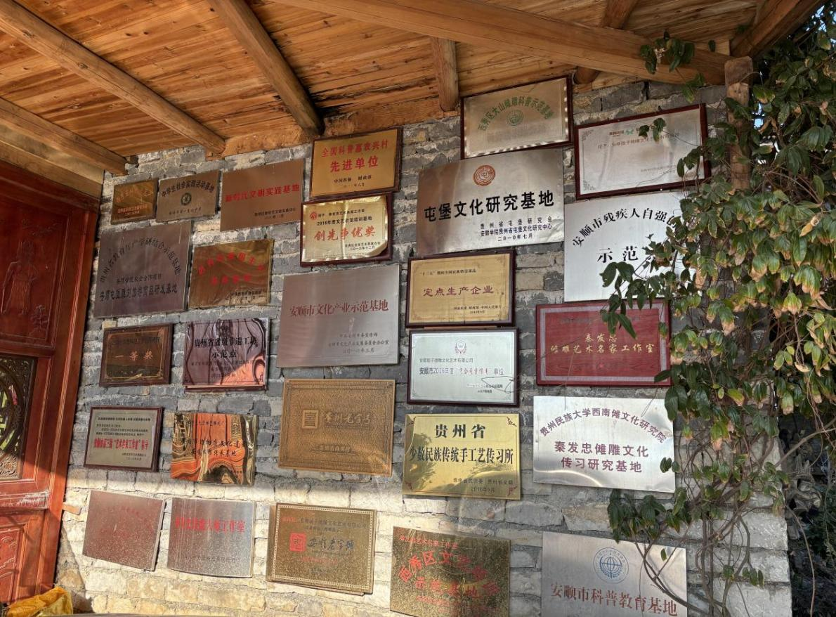

**Appendix 5. The overlook picture of Liuguan town**

